Ethnomedicinal and phytochemical studies on sacred Indian plants

Abstract
Sacred groves in India represent a unique convergence of cultural heritage, ecological sustainability, and traditional healthcare practices. These community-managed forest patches safeguard plant species of both religious and therapeutic significance, but are increasingly threatened by anthropogenic pressures. The present study highlights their ethnomedicinal value through documentation, phytochemical profiling, and quantitative estimation of total phenols and flavonoids. Sacred groves from Odisha, Jharkhand, Madhya Pradesh, Uttarakhand, and Bihar were surveyed between 2023–2025, documenting 12 sacred medicinal plants from 11 families. Qualitative phytochemical analysis revealed the presence of bioactive secondary metabolites such as alkaloids, flavonoids, phenols, saponins, tannins, and terpenoids. Quantitative assays indicated that Emblica officinalis exhibited the highest total phenolic content (4.86 mg/100 g), while Ocimum sanctum showed the highest flavonoid concentration (2.18 mg/100 g). These findings emphasize the dual ecological and pharmacological importance of sacred plants, underscoring the need for sustainable conservation and integration of traditional knowledge with modern healthcare systems.
Keywords: Sacred groves, ethnomedicine, biodiversity, cultural heritage, therapeutic uses, conservation
Introduction
India is globally recognized for its rich cultural, spiritual, and ecological heritage, where humans have coexisted with nature for millennia. Sacred groves which are community-protected forest patches often associated with temples or religious rituals (Das et al., 2022). These groves conserve a wide diversity of plant species that hold deep cultural, religious, and therapeutic significance. Despite their importance, increasing urbanization, deforestation, and unsustainable resource extraction threaten these unique ecosystems. Studying sacred plants is therefore crucial not only to preserve biodiversity but also to document traditional knowledge that may otherwise be lost. Such documentation provides a foundation for integrating community-led conservation with scientific research. The medicinal relevance of sacred plants has long been recognized in traditional healthcare systems such as Ayurveda, Siddha, and Unani (Pandey et al., 2013). Many species found in sacred groves like Aegle marmelos, Azadirachta indica, Ficus religiosa, and Ocimum sanctum have been used for centuries to treat gastrointestinal disorders, respiratory ailments, skin diseases, and inflammatory conditions (Das et al., 2020). Scientific investigation of these plants has revealed the presence of bioactive secondary metabolites including alkaloids, flavonoids, phenols, saponins, tannins, and terpenoids. These compounds have significant pharmacological potential, providing a rationale for exploring sacred plants as sources of new therapeutic agents. Investigating their phytochemical composition and bioactivity can help bridge traditional knowledge with modern drug discovery. In addition to their medicinal value, sacred plants contribute substantially to ecosystem stability and ecological services. These species support soil fertility, prevent erosion, regulate microclimates, and maintain water cycles. Trees like Ficus religiosa release oxygen continuously and provide habitats for diverse fauna, while other species stabilize sand dunes, prevent runoff, and maintain forest structure. By conserving sacred groves, local communities inadvertently protect ecosystem functions that sustain both human livelihoods and biodiversity. Understanding these ecological services underscores the multidimensional importance of sacred plants, beyond their cultural and therapeutic roles. Given their combined cultural, medicinal, and ecological significance, sacred plants are invaluable resources for sustainable development. Documenting and analysing their ethnomedicinal uses, phytochemical composition, and bioactive potential can guide the sustainable utilization of these species while promoting conservation. Such studies also highlight opportunities for novel drug development and the creation of eco-friendly management strategies. By integrating traditional knowledge with modern science, research on sacred plants can ensure the preservation of both biodiversity and cultural heritage for future generations.
Materials and methods
A systematic field survey was conducted (2023–2025) across sacred groves, temple premises, and community-protected forests in Odisha, Jharkhand, Madhya Pradesh, Uttarakhand, and Bihar. Data were collected through field observations, semi-structured interviews with local priests, healers, and community elders (Kumar et al., 2021; Jena et al., 2025. Kumar, 2025). Species identification was carried out using standard floras and regional checklists (Kumar et al., 2021). Phytochemical screening was performed on aqueous extracts of selected plant parts to detect alkaloids, phenols, flavonoids, saponins, tannins, terpenoids, and other metabolites. Quantification of total phenolic and flavonoid content was carried out using spectrophotometric methods (Jena et al., 2025).
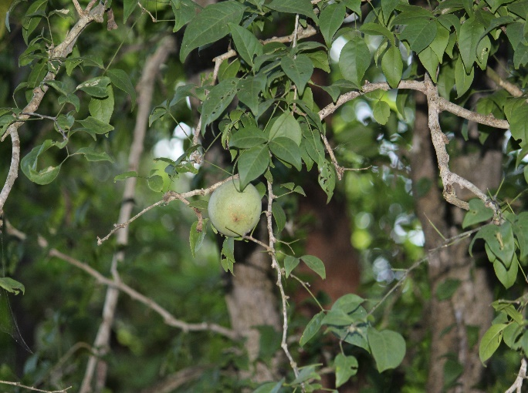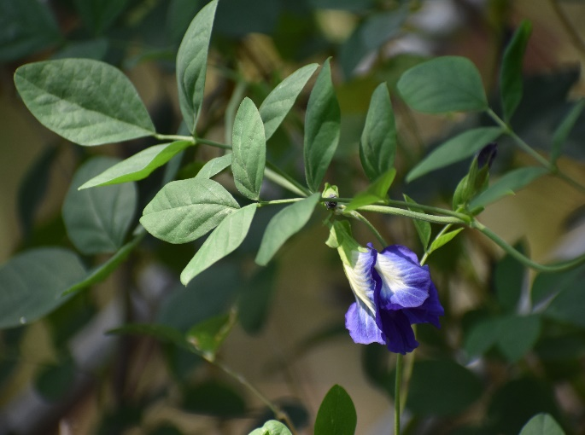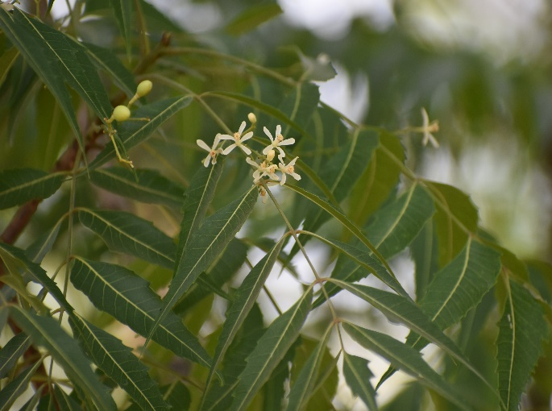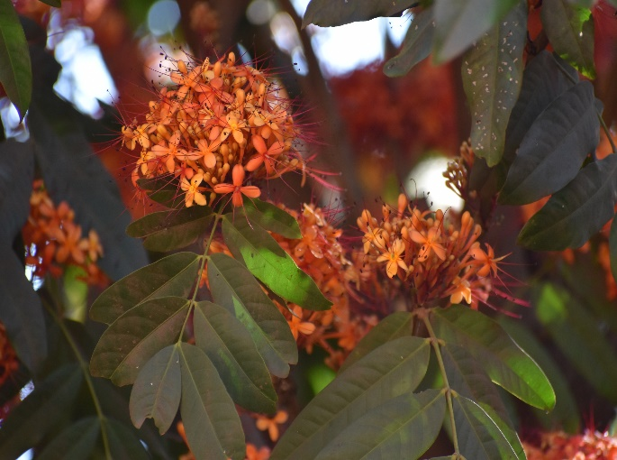
a
b
c
d
Plate 1: Important medicinal plants of sacred groves of India; (a) Aegle marmelos, (b) Clitoria ternatea, (c) Azadirachta indica, and (d) Saraca asoca.
Results and discussion
The survey undertaken for present study in selected ecologically important sacred groves of above-mentioned states revealed 12 prevalent plant species belonging to 11 families with therapeutic values (Table 1; Plate 1). It was noticed that Aegle marmelos offered to Lord Shiva is used for the treatment of gastric problems Bark of Saraca asoca is responsible for the treatment in skin diseases. S. asoca is also considered a sacred plant under which mother Sita sat in the famous ancient epic The Ramayana. Azardirachta indica or the neem leaves is offered to Lord Jagannath. Again, the divine idol of the Lord Jagannath in Puri Temple is made from neem wood with specific pattern. Phyllanthus emblica tree is worshipped as Lord Vishnu on the 11th day of waxing moon in the lunar calendar. Cardiospermum halicacabum is used for the treatment of arthritis. Leaves of Ficus religiosa or Ashvath is used for the treatment of cough, asthma, and gastric problems. In details, along with name, family, vernacular name, religious purposes and medicinal uses of enumerated plants are discussed below.
- Aegle marmelos (Linn.) Corr.
Family: Rutaceae; Vernacular name: Bael
Religious purpose: The leaves are an essential element in all types of worship in each & every temple, particularly in the Shiva temple.
Medicinal uses: Roots are one of the ingredients in dasamularishta and are used against dysentery, diarrhoea, fever, and vomiting. Three leaves given once a day for 15 days against constipation and indigestion. Tender leaves juice mixed with 2-3 drops of honey is given twice daily on an empty stomach to reduce blood pressure. A twig with fruit intact is hung on the southern wall of the home after delivery to keep evil eye spirits away.
- Azadirachta indica A. Juss.
Family: Meliaceae; Vernacular name: Neem
Religious purpose: It is the sacred plant conserved in the temples of Goddess Parvati. The leaves of the plant are hung on the doors to eradicate the evil spirits during the chicken pox and smallpox period.
Medicinal uses: The tree is considered a good purifier of air. Decoction of leaves is an antiseptic and is used to clean ulcers and wounds. Green twigs are used as a brush. Oil extracted from the seeds is effective in the treatment of skin diseases. The tree trunk, which was embraced seven times, is used for scorpion poison treatment.
- Cardiospermum halicacabum Linn.
Family: Sapindaceae; Vernacular name: Sakralata
Religious purpose: It is one of the members of dasapushpa and is used to worship Goddess Laxmi.
Medicinal uses: The roots are used for chronic rheumatism and, fever, and arthritis. The leaf extract is taken to treat menstrual disorders and an irritable uterus. The seeds are tonic and diaphoretic and are good for arthritis and fever.
- Saraca asoca (Roxb.) de Wilde
Family: Caesalpiniaceae; Vernacular name: Ashoka
Religious purpose: The name is given to the plant as Ashoka, which eliminates the shoka or sadness. It is a sacred plant in temples.
Medicinal uses: The stem bark decoction is taken to regulate menstrual disorders and haemorrhoids of the uterus. The paste of flowers is used for skin diseases. The extract of the flower mixed with cow milk is used to treat stomach pain during the menstrual period.
- Cassia fistula Linn.
Family: Fabaceae; Vernacular name: Sunari
Religious purpose: The flowers are made into a garland for Sri Krishna. So, it is sacred in Srikrishna temples. During the time of Vishnukani, Malayalees used the flowers for pooja.
Medicinal uses: The roots are astringent, cooling, purgative, febrifuge, and are useful in skin diseases, syphilis, and burning sensations. The bark is laxative, diuretic, and is useful in boils, leprosy, ringworm, and diabetes.
- Clitoria ternatea Linn.
Family: Fabaceae; Vernacular name: Aparajita
Religious purpose: The flowers are used for worshiping Lord Shiva and Vishnu.
Medicinal uses: The roots are used against burning sensations, inflammation, vitiated conditions of pitas, bronchitis, asthma, ulcers, fever, etc.
- Crateva religiosa G. Forst.
Family: Capparaceae; Vernacular name: Varuna
Religious purpose: It is a sacred tree, and the name religiosa indicates its growth near the places of worship.
Medicinal uses: The bark is used for various kinds of urinary disorders, as an antiemetic, an antidote in snakebite, and to improve digestion.
- Eclipta prostrata (L.) Linn.
Family: Asteraceae; Vernacular name: Bhringraj
Religious purpose: It is one of the members of dasapushpa.
Medicinal uses: It is very effective for blackening and strengthening hair. The roots are used in snakebite and scorpion sting. The plant is used in the treatment of vata, skin diseases, and jaundice.
- Emblica officinalis Gaertn
Family: Euphorbiaceae; Vernacular name: Aonla
Religious purpose: The whole plant is worshipped on ‘Aonla Navami’ day in November.
Medicinal uses: The fruit is used as a cardiac and liver tonic.
- Emilia sonchifolia (Linn.) DC.
Family: Asteraceae; Vernacular name: Binj-kudo
Religious purpose: It is one of the members of dasapushpa.
Medicinal uses: The plant is antipyretic and anti-asthmatic. It is useful in vitiated conditions of vata, diarrhoea, cuts, and wounds.
- Ficus religiosa Linn.
Family: Moraceae; Vernacular name: Ashvath
Religious purpose: It is a sacred tree worshipped on ‘Savitribrata’ in May.
Medicinal uses: Traditionally, the leaf juice has been used to help alleviate cough, asthma, haematuria, and gastric problems.
- Ocimum sanctum Linn.
Family: Lamiaceae; Vernacular name: Tulasi
Religious purpose: The leaves of the plant are used to worship the God Vishnu.
Medicinal uses: A mixture of leaf extract with cloves and jaggery is used for cough. The juice of the leaf is used as a stimulant and as a remedy for bronchitis. The leaf extract is used to cure an ear infection. Leaf juice is mixed with cow milk and used to relieve pain after delivery.
The above ethnomedicinal uses revealed that these plant parts have diverse secondary metabolites. Therefore, phytochemical screening was carried out. The phytochemical screening of twelve sacred medicinal plants (Table 1) revealed the widespread presence of bioactive compounds, particularly alkaloids, flavonoids, phenols, saponins, tannins, terpenoids, and steroids. These metabolites are known to play significant roles in plant defense and pharmacological activity. Notably, Eclipta prostrata exhibited the broadest phytochemical spectrum, containing almost all tested classes of compounds, which justifies its extensive use in traditional medicine for hair growth, liver protection, and skin disorders. Similarly, Cassia fistula bark and Clitoria ternatea roots were found to be rich in flavonoids and tannins, supporting their ethnomedicinal applications in wound healing and anti-inflammatory remedies. The presence of diverse phytoconstituents across species indicates that sacred groves act as reservoirs of phytochemically rich plants with strong therapeutic potential. Quantitative analysis (Table 2) showed significant variations in total phenolic content among the studied plants. Emblica officinalis fruits exhibited the highest phenolic concentration (4.86 mg/100 g), consistent with its reputation in Ayurveda as a potent rejuvenator and antioxidant. High phenolic levels are associated with free radical scavenging, hepatoprotective, and anti-aging properties, explaining its inclusion in formulations like Chyawanprash. On the other hand, Emilia sonchifolia showed negligible phenolic content, reflecting its relatively limited role as a phenolic-rich therapeutic agent. These variations suggest that phenolic accumulation is plant- and organ-specific, and fruits and barks tend to store higher amounts compared to leaves. Flavonoid content also varied substantially among the studied species. Ocimum sanctum exhibited the highest flavonoid concentration (2.18 mg/100 g), followed closely by Eclipta prostrata (1.94 mg/100 g) and Ficus religiosa (1.36 mg/100 g). Flavonoids are well-documented for their antioxidant, antimicrobial, and anti-inflammatory roles, and their abundance in Tulsi validates its long-standing use as an immunity booster and adaptogen in traditional medicine. Interestingly, Clitoria ternatea roots showed very low flavonoid content despite being valued in traditional practices, suggesting that other bioactive classes (such as alkaloids and tannins) may be responsible for its therapeutic efficacy. Taken together, the combined results of qualitative and quantitative analyses confirm that the religiously significant plants of sacred groves are not only culturally symbolic but also scientifically validated sources of pharmacologically active compounds. Plants such as Emblica officinalis and Ocimum sanctum stand out as particularly rich in phenolics and flavonoids, while metabolically diverse species like Eclipta prostrata provide broad-spectrum therapeutic potential. These findings strengthen the argument for conserving sacred groves as hotspots of both cultural heritage and pharmacological resources, while also pointing toward their relevance in modern drug development.
Table 1: Phytochemical analysis of sacred plants parts
Scientific name | Plant part(s) used | Extract | Detected secondary metabolites
Aegle marmelos (Linn.) Corr. | Leaves | Aqueous | Alkaloids, flavonoids, saponins, steroids, tannins, and carbohydrates
Azadirachta indica A. Juss. | Leaves | Aqueous | Alkaloids and flavonoids
Cardiospermum halicacabum Linn. | Leaves | Aqueous | Alkaloids, carbohydrates, saponins, amino acids, and steroids
Saraca asoca (Roxb.) de Wilde | Stem | Aqueous | Flavonoids, saponins, phenols, steroids, and terpenoids
Cassia fistula Linn. | Bark | Aqueous | Alkaloids, flavonoids, phenols, carbohydrates, saponins, tannins, and terpenoids
Clitoria ternatea Linn. | Roots | Aqueous | Alkaloids, phenols, flavonoids, and tannins
Crateva religiosa G. Forst. | Bark | Aqueous | Alkaloids, flavonoids, and saponins
Eclipta prostrata (L.) Linn. | Whole plant | Aqueous | Tannins, phenols, terpenoids, steroids, saponins, alkaloids, flavonoids, carbohydrates, and amino acids
Emblica officinalis Gaertn | Fruits | Aqueous | Tannins, saponins, steroids, terpenoids, alkaloids, and phenols
Emilia sonchifolia (Linn.) DC. | Whole plant | Aqueous | Alkaloids, terpenoids, flavonoids, steroids, saponins, phenols, tannins, and carbohydrates
Ficus religiosa Linn. | Leaves | Aqueous | Phenols, alkaloids, flavonoids, steroids, reducing sugar, and terpenoids
Ocimum sanctum Linn. | Leaves | Aqueous | Phenols, flavonoids, saponins, carbohydrates, and tannins

Table 2: Quantification of total phenol and flavonoids
Scientific name | Plant part(s) used | Total Phenol (mg/100 g) | Flavonoids (mg/100 g)
Aegle marmelos (Linn.) Corr. | Leaves | 0.23 ± 0.06 | 0.09 ± 0.02
Azadirachta indica A. Juss. | Leaves | 0.71 ± 0.05 | 1.19 ± 0.23
Cardiospermum halicacabum Linn. | Leaves | 0.27 ± 0.07 | 0.22 ± 0.05
Saraca asoca (Roxb.) de Wilde | Stem | 0.26 ± 0.06 | 0.46 ± 0.03
Cassia fistula Linn. | Bark | 0.86 ± 0.41 | 0.16 ± 0.15
Clitoria ternatea Linn. | Roots | 0.83 ± 0.14 | 0.025 ± 0.06
Crateva religiosa G. Forst. | Bark | 1.04 ± 0.15 | 1.2 ± 0.42
Eclipta prostrata (L.) Linn. | Whole plant | 0.15 ± 0.08 | 1.94 ± 0.75
Emblica officinalis Gaertn | Fruits | 4.86 ± 0.05 | 1.42 ± 0.62
Emilia sonchifolia (Linn.) DC. | Whole plant | 0.001 ± 0.003 | 0.09 ± 0.02
Ficus religiosa Linn. | Leaves | 0.63 ± 0.28 | 1.36 ± 1.23
Ocimum sanctum Linn. | Leaves | 0.88 ± 0.56 | 2.18 ± 0.46

Future works on sustainable utilization and conservation
The present study highlights the cultural and pharmacological importance of sacred medicinal plants; however, long-term sustainability requires integrated strategies. Future research should focus on comprehensive ethnobotanical documentation that captures not only medicinal applications but also local beliefs, rituals, and seasonal patterns of plant use. Many tribal and rural communities still possess orally transmitted knowledge that is at risk of being lost. Digitizing and archiving such traditional knowledge, while respecting intellectual property rights, will create a robust resource for both scientific validation and cultural preservation. Establishing ex-situ conservation measures, such as herbal gardens, seed banks, and tissue culture repositories, would ensure the availability of these plants even if their natural habitats face degradation. Overharvesting of bark, roots, or whole plants often threatens wild populations. Awareness programs should encourage practices like selective pruning, rotational harvesting, and use of leaf/fruit parts instead of destructive methods. Training local healers and temple committees in non-destructive collection methods can balance medicinal use with conservation. In addition, value-addition through herbal formulations, nutraceuticals, and plant-based products can provide livelihood opportunities, incentivizing local people to conserve rather than exploit these resources. Another future pathway lies in policy integration and legal protection. Sacred groves should be recognized as Community Conserved Areas (CCAs) under existing biodiversity frameworks. Collaborative models involving forest departments, research institutions, NGOs, and village councils can help safeguard these groves.
Conclusion
Sacred groves in India represent a remarkable convergence of cultural heritage, ecological stability, and traditional medicinal knowledge. Present study highlights the significance of Sacred Groves and their medicinal plants by documenting twelve culturally and therapeutically important plant species across Eastern and Northern India. The ethnomedicinal uses recorded reveal a rich tapestry of traditional practices. Phytochemical profiling of sacred plants highlighted the presence of diverse bioactive compounds. These secondary metabolites validate the traditional therapeutic claims. Quantitative analysis revealed notable variations in total phenolic and flavonoid contents, with Emblica officinalis fruits showing the highest phenolic concentration and Ocimum sanctum leaves exhibiting the maximum flavonoid content. These findings emphasize the potential of sacred grove species as reservoirs of pharmacologically active compounds, highlighting opportunities for modern drug discovery and nutraceutical development. Beyond pharmacological importance, this study emphasizes the critical role sacred groves play in ecological and cultural conservation. By preserving plant diversity, these groves maintain ecosystem services such as soil stabilization, air purification, and microclimate regulation. Sacred groves thus serve as living laboratories where culture, ecology, and medicine intersect, offering valuable lessons for biodiversity conservation, sustainable development, and future pharmaceutical innovations. Preserving and valorising these unique landscapes is not merely an act of cultural preservation, it is a necessary strategy to safeguard ecological balance, medicinal heritage, and the well-being of future generations.

References

Das L, Mishra S, Das A, Dimri R and Kumar S. (2022). Some common flora of temple city of Odisha, India: source for ethno-medico-cultural values. Indian Forester, 148(2): 207-212.

Das MK, Das PK, Kumar S and Singh NR. (2020). Flora of Khandagiri & Udayagiri, an urban heritage of Odisha. Indian Forester, 146(6): 509-518.

Jena N, Vimala, Singh B, Patra A, Sharma BP, Hossain E and Kumar S. (2025). Methods for ethnobotanical data collection, phytochemistry, antioxidant, anthelmintic, and antimicrobial activities for pharmacological evaluation of medicinal plants. Journal of Biodiversity and Conservation, 9(2): 87-107.

Kumar S. (2025). Data collection from literature for biological sciences, medicinal plants research, ethnobotany, and pharmacology: a methodological overview. Journal of Biodiversity and Conservation, 9(2): 167-169.

Kumar SN, Mishra S and Kumar S. (2021). Documentation of Indigenous Traditional Knowledge (ITK) on Commonly Available Plants in Koira Range, Bonai Forest Division, Sundargarh, Odisha, India. Asian Plant Research Journal, 8(4): 83-95.

Pandey MM, Rastogi S and Rawat AK. (2013). Indian traditional ayurvedic system of medicine and nutritional supplementation. Evidence-Based Complementary and Alternative Medicine. 2013: 376327.

