Original Research Article

Biochemical constituents of silk gland of silkworm, Bombyx mori L. after feeding on leaves of selected mulberry genotypes

Abstract
The silkworm, Bombyx mori is a beneficial silk producing insect which exclusively feeds on mulberry plant. It belongs to Phylum Arthopoda, Class Insecta and Order Lepidoptera and undergoes complete metamorphosis (Holometabolous). In the current research study, the leaves of mulberry genotypes namely Kokuso-21, SKM-33 and Goshoerami were fed to the silkworm, B.mori during spring seasons of 2019 and 2020. The ANOVA table revealed significant variations among these genotypes with regard to different biochemical constituents in the silk gland of silkworm fed on these genotypes. The significantly highest total protein (12.537 %), total free amino acids (2.072 %), total carbohydrate (1.124 %) and total lipid (0.029 %) content in the silk gland was recorded in Goshoerami fed silkworm batch with respect to control.
Key words: Sericulture, Goshoerami, significant, fibroin, total free amino acids, cocoons
Introduction
The silkworm, Bombyx mori is an important economical insect extensively used for silk production. Silk gland is a tubular structure and consists of three parts viz., anterior, middle and posterior regions. The anterior region which measures 2 cm contains 250 secretory cells, middle region which measures 7 cm contains 300 secretory cells and posterior region which measures 15 cm contains about 500 secretory cells (Valluzzi et al., 1999). The fibroin protein which is rich in amino acids like glycine, alanine, serine and tyrosine (Kirimura and Suzuki, 1962) is produced in the posterior silk gland (PSG) and is made up of three protein types: H-chain, 350 KDa (Shimura et al., 1982, Zhou et al., 2000), L-chain, 26 KDa (Yamaguchi et al., 1989) and Glycoprotein P25, 30 KDa (Chevillard et al., 1986a, 1986b). The middle silk gland (MSG) region is responsible for the production of sericin protein. The silk protein synthesized from silk gland gets stored in the lumen of silk gland. After this it changes into liquid silk fibre and passes out through the spinneret of silkworm (Shimizu, 2000). The quality and quantity of sericin play a crucial role in determining key cocoon characteristics (Sadov et al., 1987). Sericin can be divided into sericin I, II, III and IV on the basis of solubility in hot water measured by UV absorption method. Maximum sericin content is present on the outer surface of cocoons and vice versa (Robson, 1985, Rui, 1998). Sericin being insoluble in cold water gets hydrolyzed and breaks into smaller fractions and is soluble in hot water (Gulrajani, 1988). Sericin is important because it is resistant to oxidation and UV radiation, exibits anti bacterial properties and readily absorbs and releases moisture . After the degumming process the leftover is called as fibroin protein and it consists of two brins. It is widely used in textile, industrial and medical fields. It is long, soft, light and is regarded precious as it shows water absorbency, affinity for dyes, thermo tolerance, insulating properties and great lusture. It also provides raw materials for producing precious fabrics, tyre lining materials, parachutes, artificial blood vessels and surgical sutures. Wound healing properties of silk fibroin has been found by Wu et al. (1996). Silk gland has the potential to produce large quantity of silk proteins. Foreign proteins namely procollegen III were synthesized by using several promoters by using piggyBac vectors to express the transgenes in the silk gland of B. mori (Chavancy, 2005). The silkworm nutrition acquires great importance for the smooth growth of larva and overall success of sericulture industry. The impact of mulberry genotypes (Islam et al., 2023, Islam et al., 2022a, 2022b) and other nutritional supplements (Islam et al., 2020a, 2020b) for healthy growth and development of larvae and formation of good quality cocoons has been extensively studied worldwide.
Material and methods
The disease free layings (DFL’S) of silkworm race viz., PAM-117 was collected from College of Temperate Sericulture, Mirgund, SKUAST-K. The rearing of said race was carried out on the leaves of three different mulberry genotypes namely Kokuso-21, SKM-33 and Goshoerami, from brushing until spinning, following the standard rearing protocol.Four replications per treatment, each consisting of 100 larvae, were maintained, along one control for comparison . In case of control, silkworms were given Ichinose leaves up to fourth instar and afterwards in fifth instar upto spinning were fed on Goshoerami leaves. The silk gland was dissected out (Plate 1) from the fifth instar mature silkworm larvae and biochemical analysis done by following the standard methods.
Total Protein (%)
Total protein content was estimated by Lowry et al. (1951) using Bovine serum albumin (BSA) as the standard. A known weight of sample was taken and 5 ml of alkaline copper solution was added to it and kept for 10 minutes. 0.5 ml of Folin ciocalteu reagent (FCR) was added to it, mixed well and kept in dark at room temperature for 30 minutes and the optical density was measured at 660 nm against blank after the appearance of blue colour. Protein content was then calculated by plotting a graph of absorbance values and expressed in percentage.
Total free amino acid (%)
Total free amino acid content was estimated by Moore and Stein (1968) method using leucine as the working standard solution. A known weight of sample was taken and 1ml of ninhydrin reagent was added to it and the volume was made upto 2ml by adding distilled water. The solution was placed in boiling water bath for 20 minutes and 5ml of diluent was added while still in the water bath and mixed and cooled under running tap water. The absorbance of purple colour was estimated at 570nm.
Total carbohydrate (%)
Total carbohydrate content was estimated by Hedge and Hofreiter (1962) using glucose as the working standard solution. Known weight of sample was taken to which 4ml of anthrone was added and heated for 8 minutes in hot water bath and optical density was taken at 630nm for the appearance of green colour.
Total lipid (%)
The total lipid was estimated by the standard method of Folch et al. (1957). The known amount of sample was homogenized with 2 ml of chloroform and methanol (2:1) and centrifuged at 10,000 rpm for 15 minutes. After this the supernatant was mixed with 0.6 % saline solution and then the weight was taken. The samples were separated using separating funnel and placed in dark conditions overnight and the lower organic part was separated by using vacuum evaporator. The residues of samples were weighted for total lipids and expressed in percentage.
Results
The total protein content of the silk gland varied significantly among treatments, with the highest value (12.537%) recorded in silkworms fed on Goshoerami leaves and the lowest (12.338%) in those fed on SKM-33 (Table 1; Fig. 1). Similarly, the total free amino acid content of the silk gland also showed significant differences, being highest in the Goshoerami-fed batch (2.072%) and lowest in the SKM-33-fed batch (1.745%) (Table 1; Fig. 1). The total carbohydrate content in the silk gland differed significantly as well, with the highest value (1.124%) recorded in the Goshoerami-fed silkworms and the lowest (0.927%) in SKM-33-fed silkworms (Table 1; Fig. 1). Likewise, the total lipid content of the silk gland was significantly higher in silkworms reared on Goshoerami leaves (0.029%) and lowest in those reared on SKM-33 (0.020%) (Table 1; Fig. 1).
Table 1: Effect of mulberry genotypes on selected biochemical constituents of silk gland (Pooled data of 2019 and 2020 spring seasons)
Genotypes | Total protein (%) | Total free amino acids (%) | Total carbohydrate (%) | Total lipid (%)
Kokuso-21 | 12.370^{c} | 1.769^{b} | 0.953^{c} | 0.022^{c}
SKM-33 | 12.338^{c} | 1.745^{b} | 0.927^{c} | 0.020^{d}
Goshoerami | 12.537ª | 2.072ª | 1.124ª | 0.029ª
Control (Ichinose + Goshoerami) | 12.459^{b} | 1.861^{b} | 1.015^{b} | 0.025^{b}
CD (p≤ 0.05) | 0.710 | 1.660 | 0.406 | 0.001

Fig. 1: Effect of mulberry genotypes on total protein, total free amino acids, total carbohydrate and total lipid

Discussion
The protein is an important macromolecule required for the growth and development of silk gland of silkworm, as it is needed for the silk synthesis of silk gland. The nutrients viz., proteins have great impact on physiological and biochemical activities of silkworm body (Ohmura et al., 1989). Significant variations with regard to total proteins in haemolymph and silk gland of silkworm was recorded and highest total protein was recorded on last day of fifth instar larva, whereas lowest was recorded on first day (Murthy, 2014). The mulberry leaves supply around 70% of proteins which are directly utilized for the silk synthesis in silk gland of silkworm (Kawase, 1975). The significantly highest total protein content in silk gland was recorded in Goshoerami fed silkworm batch. The current results are in agreement with the findings of Ruth et al. (2019) who found considerable variations among mulberry varieties with regard to total protein and recorded highest total protein content in silkworms fed with TR-10 variety followed by Jorhat. The free amino acids which are building blocks of protein formation are derived from protein source through histolysis and also from non protein sources and transamination reactions determine the synthesis of amino acids in silk gland. Certain enzymes viz., Glutamate oxaloacetate transaminase and Glutamate pyruvate transaminase help in the active transportation of these amino acids (Saravanan et al., 2011), which are needed for the silk synthesis. In current research study the significantly high total free amino acids was recorded in silkworm batch fed with Goshoerami which may be due to high total free amino acids present in the leaves of the genotype. The present research findings are in conformity with Shamitha and Rao (2008) who recorded highest total free amino acids (1033.0 ± 134.3 mg/100ml) in haemolymph of Antheraea mylitta when reared indoors as compared to outdoor rearing. The carbohydrate content in silkworm is an important biochemical constituent as it supplies energy to the silkworm for carrying out different physiological and metabolic activities and is directly related to the health of silkworm (Manjula and Vijaya Kumari, 2015). In our results the significantly highest total carbohydrate content was recorded in silkworm batch fed with Goshoerami which may be due to optimum carbohydrate content in the leaves. The current results are in agreement with research findings of Mahmoud (2017) who after studying mulberry varieties recorded highest total carbohydrate content in M. laevigata fed silkworm batch. The lipid is yet another important macromolecule for maintaining the cell structure and are the main source of energy for carrying out several physiological processes like embryogenesis, reproduction and metamorphosis in the insect body (Gilbert, 1967). In the current research study the highest total lipid content was recorded in Goshoerami fed silkworm batch which may be due to optimum lipid level present in the leaves of this genotype. The similar findings were reported by Monoroma et al. (2010) who recorded lipid content of 0.1430-0.1436 mg/mg in silkgland of Antheraea proylei after feeding on Quercus serrata leaves.
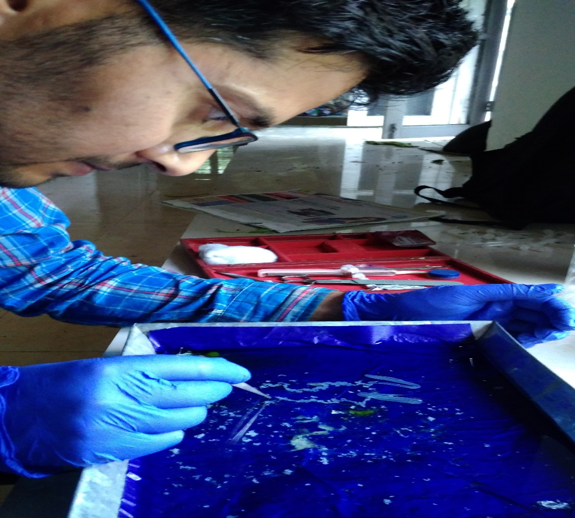
Plate 1: Dissection of silk gland
Conclusion
The silkworms exhibited distinct responses when fed on leaves of different mulberry genotypes, and the biochemical constituents of their silk glands also varied significantly. The parameters related to total protein, total free amino acids, total carbohydrate, and total lipid content were recorded as significantly highest in the Goshoerami-fed silkworm batch. This may be attributed to the superior nutritional composition of the Goshoerami genotype. Based on the present findings, it can be concluded that the Goshoerami mulberry genotype holds great potential for silkworm rearing and can be effectively utilized by rearers to obtain a high-quality cocoon crop.
Declaration of Competing Interest
The authors declare that they do not have any kind of competing interests which may have influenced the publication of this research work in this journal.

References
- Chavancy, G., 2005. Silkworm for non-textile industries. Souveni, 20th congress of the international sericultural commission, Bangalore, India 15-18th December 2005, 1-6.
- Chevillard, M., Couble, P., Prudhomme, J.C., 1986a. Complete nucleotide sequence of the gene encoding the Bombyx mori silk protein P25 and predicted amino acid sequence of the protein. Nucleic Acids Res 14, 6341-6342.
- Chevillard, M., Deleage, G., Couble, P., 1986b. Amino acid sequence and putative conformational characteristic of the P25 silk protein of Bombyx mori. Sericologia 26, 435-449.
- Folch, J., Lees, M., Sloane Stanley, G.H., 1957. A simple method for the isolation and purification of total lipides from animal tissues. J Biol Chem. 226, 497-509.
- Gilbert, L.I., 1967. Lipid metabolism and function in insects. Advances of Insect Physiology 4, 69-211.
- Gulrajani, M.L., 1988. Degumming of silk; in Silk dyeing printing and finishing, M. L. Gulrajani (ed), Department of Textile Technology Indian Institute of Technology, New Delhi, 63-95.
- Hedge, J.E., Hofreiter, B.T., 1962. Carbohydrate chemistry 17. Whistler, R. L. and Be Miller, J. N., Eds., Academic Press, New York.
- Islam, T., Bhat, S.A., Malik, F.A., Khan, F.A., Mir, S.A., Nazir, N., Wani, S.A., 2022a. Evaluation of some mulberry genotypes for nutritional consumption parameters of silkworm, Bombay mori L. under temperate conditions of Kashmir, India. Plant Archives 22, 136-139.
- Islam, T., Bhat, S.A., Malik, F.A., Khan, F.A., Mir, S.A., Nazir, N., Wani, S.A., 2022b. Rearing of silkworm, Bombyx mori L. on different mulberry genotypes and its impact on post cocoon parameters. Plant Archives 22, 380-382.
- Islam, T., Bhat, S.A., Malik, F.A., Wani, S., Khan, F.A., Mir, S.A., Nazir, N., 2023. Feeding of different Mulberry Varieties and its Impact on Silk Gland of Silkworm, Bombyx mori L. Biological Forum – An International Journal 15, 488-492.
- Islam, T., Khan, I.L., Ganie, N.A., Sahaf, K.A., Jan, N., Gora, M.M., 2020b. Impact of egg albumen (egg white) fortified mulberry leaf on rearing and some cocoon parameters of silkworm, Bombyx mori L. (CSR6 × CSR26) × (CSR2 × CSR27) double hybrid. International Journal of Chemical Studies 8, 267- 271.
- Islam, T., Khan, I.L., Gora, M.M., Khan, M.Y., Bhat, T.A., Jan, N., 2020a. Influence of egg albumen supplemented mulberry leaf on some reeling parameters of Silkworm, Bombyx mori L. The Pharma Innovation Journal 9, 19-22.
- Kawase., 1975. Text book of tropical sericulture. Japan overseas co-operation volunteers, Tokyo, 155-169.
- Kirimura, J., Suzuki, N., 1962. Bull. Agr. Chem. Soc. Japan 36, 265-336.
- Lowry, O.H., Rosebrough, N.J., Farr, A.L., Randall, R.J., 1951. Protein measurement with folin-phenol reagent. Journal of biological chemistry 193, 265-275.
- Mahmoud, K., 2017. Impact of Nutritional Composition of Wild and Cultivated Mulberry Varieties on Productivity and some Biochemical Parameters of Silkworm Bombyx mori L. (Bombycidae: Lepidoptera). Journal of Applied Plant Protection 6, 25-30.
- Manjula, M., Vijaya Kumari, N., 2015. Nutritional analysis of mulberry leaves. American International Journal of Research in Science, Technology, Engineering and Mathematics 15, 332-334.
- Monoroma, O.K., Chinamen, M., Kumar, M., Prasad, B., 2010. Studies on Lipids Content in the Healthy Full Grown Larval Haemolymph, Silkglands and Food Leaves of Antheraea proylei Jolly (Saturniidae: Lepidoptera). Journal of Experimental Sciences 1, 18-19.
- Moore, S., Stein, W.H., 1968. A modified ninhydrin reagent for the photometric determination of amino acids and related compounds. J. Biol. Chem 211, 907-913.
- Murthy, V.N.Y., Ramkumar, B., Jayaram, G.N., Lokesh, G., 2014. Critical Biochemical Analysis in Different Body Tissues in Three Commercial Silkworm (Bombyx mori L.) Races. Asian Journal of Natural and Applied Sciences 3, 20-30.
- Ohmura, H., Matsuka, Y., Fukuda, T., 1989. Effect of mulberry leaf proteins and other proteins on the feeding of larvae of the silkworm Bombyx mori L. J. Seric. Sci. Japan 58, 96-100.
- Robson, R.M., 1985. Silk composition, structure and properties; in Hand book of fibre Science and Technology, Lewin, M and E. M pearce (ed), Mercel. Dekker Inc, New York 4, 649-700.
- Rui, H.G., 1998. Quality of Cocoon Filament; in Silk reeling. H. G Rui (ed), Oxford & IBH Publication Co. Pvt. Ltd., New Delhi, 58-69.
- Ruth, L., Ghatak, S., Subbarayan, S., Choudhury, B.N., Gurusubramanian, G., Kumar, N.S., Bin, T., 2019. Influence of micronutrients on the food consumption rate and silk production of Bombyx mori (lepidoptera: bombycidae) reared on mulberry plants grown in a mountainous agro-ecologicalcondition. Frontiers in Physiology 10, 1-11.
- Sadov, F., Korchagin, M., Matetsky, A., 1987. Chemical technology of fibrous materials. Mir Publication, Moscow, 306-307.
- Saravanan, M., Selvi, S., Veeranarayanan, M., Nadanam, S., 2011. Modulations in the haemolymph of silkworm [Bombyx mori (L). (Lepidoptera: Bombycidae)] fed with mulberry leaves augmented with cowpeas (Vigna unguiculata). International Journal of Nutrition, Pharmacology, Neurological Diseases 1, 64-68.
- Shamitha, G., Rao, A.P., 2008. Estimation of amino acids, urea and uric acid in tasar silkworm, Antheraea mylitta Drury. J. Environ. Biol. 29, 893-896.
- Shimizu, M., 2000. Structural basis of silk fibre; in Structure of silk yarn” vol I biological and physical aspects. N. Hojo (ed.), Oxford & IBH Publication Co. Pvt. Ltd., New Delhi, 7-17.
- Shimura, K., Kikuchi, A., Katagata, Y., Ohtomok, K., 1982. The occurrence of smallest component protein in the cocoon of Bombyx mori. J. Seric. Sci. Jpn 51, 20-26.
- Valluzzi, R., He, S.J., Gido, S.P., Kaplan, D.L., 1999. Bombyx mori silk fibroin liquid crystallinity and crystallization at aqueous fibroin–organic solvent interfaces. Int. J. Biol. Macromol. 24, 227–236.
- Wu, C.Y., Tian, B.Z., Zhu, D., Yan, X.M., Chen, W., Xu, G.Y., 1996. Properties and application of wound protective membrane made from fibroin. In International silk congress, Suzou Institute of silk technology, Suzou, China, 25-28th October, 79-87.
- Yamaguchi, K., Kikuchi, Y., Takagi, T., Kikuchi, A., Oyama, F., Shimura, K., Mizuno, S., 1989. Primary structure of the silk fibroin light chain determined by cDNA sequencing and peptide analysis. J. Mol. Bio 210, 127-139.
- Zhou, C.Z., Confalonieri, F., Medina, N., Zivanovic, Y., Esnault, C., Jacquet, T., Janin J., Duguet, M., Perasso, R. and Liz, G., 2000. Fine organization of Bombyx mori fibroin heavy chain gene. Nucl. Acids Res 28, 2413-2419.

