Forest fires in India and their mitigation measures

Abstract: The increasing population, urbanization, and several other factors, including the frequent occurrence of forest fires, pose a serious threat to the forests, which serve as ecosystem balancers. Without exception, forest fires have significantly increased in India, impacting biodiversity, wildlife, and other natural resources. Burning of vegetation releases huge amounts of carbon, greenhouse gases, and other gaseous compounds into the atmosphere, leading to global warming and climate change. Human-influenced activities such as Jhum cultivation, deforestation, and firewood burning are the major causes of forest fires in India. Therefore, monitoring and management of forest fires is essential for countries like India. To effectively monitor and manage forest fires in India, it is crucial to possess knowledge about the forest types, vegetation patterns, and forest fire causes. Therefore, government organizations have reviewed the forest fire conditions in India, adopted several mitigation measures, and implemented various initiatives and policies to detect and control forest fires. There has been development of satellite sensing and GIS to visualize the scales and periods of forest fires in real-time. Joint Forest Management (JFM) Committees are also working with the local communities to control forest fires in villages, providing them lucrative incentives for their beneficial work. The paper delves into the challenges and mitigation strategies that can aid in effectively managing forest fire issues.

Keywords: Anthropogenic activities, biodiversity, climate change, GIS, global warming, mitigation

INTRODUCTION

Forests are one of the most beautiful assets on the surface of planet Earth. They are home to diverse plants and animals. It holds together several ecosystems and provides life to plants, humans, faunal species, and microorganisms (Aju et al., 2015). They are crucial in managing biodiversity, soil conservation, tackling the climate crisis, cleaning the forest floor, promoting seed germination, and maintaining ecological balance (Forest Fire Impacts Mitigation Management Report, 2023). They act as a storehouse of carbon, a reservoir of water, and provide shelter, timber, firewood, medicines, wild edible fruits, leafy vegetables, and other non-timber forest products (NTFPs) (Ickowitz et al., 2022). People are deeply interconnected with forests, which play a crucial role in their homes and livelihoods. Any disturbance to the forests immediately harms the human race, decreases biodiversity, and impacts all ecosystems (Bodo et al., 2021). These days, harmful natural and anthropogenic activities continuously cause severe disturbances to forests. The increasing impacts of human action on forests are also reducing their productivity. Forest fire practice exacerbates the forest problems. Various communities worldwide have long practiced it, primarily for crop rotation through Jhum cultivation and to increase animal production in pastureland (Malmer et al., 2005). Fire has been a part of India’s landscape and culture. Many forests have evolved with fire and rely on it for regeneration (Schmerbeck et al., 2015). Before, forest fires used to shape the forests, but now uncontrolled wildfire burns the trees and makes the forest bald (Priya et al., 2024). Some factors, like climatic conditions, rainfall patterns, temperature, slope, humidity, fire frequency, and vegetation type, define the type and intensity of forest fires in any area (Barik and Roy, 2023). Certain areas may benefit from fires, while others may experience harm. In the past, when the human population was smaller, people relied less on forests, leading to fewer instances of controlled forest fires, however, now the forest cover is diminishing, and the human population has surged to approximately 1.425 billion by the end of April 2023 (The Economic Times 20 April 2023), leading to a greater reliance on forests and a rise in the frequency of forest fires. Forest fires in India typically occur from February to June, a time when the ground accumulates large amounts of dry wood, logs, dead leaves, and dry grass, which can ignite the forest in the presence of any fire trigger (Mishra et al., 2022). Dry deciduous forests experience severe forest fires, whereas evergreen, semi-evergreen, and montane forests are less vulnerable to fires in India (Kumar et al., 2022). In southern India, fire starts from January to May, and it extends from April to June in the northern part of the country. In the Himalayan regions, fires are common in the May and June months of the year (Saha et al., 2023). Keeping in mind the variety of landscape patterns in India, an intensive literature survey has been done to summarize the causes and impacts of forest fires in India and discuss the mitigation measures suitable to minimize fires in the Indian forests.

CATEGORIES OF FOREST FIRE

About 90-95% of forest fire incidences in India are mainly due to human-influenced activities like slash-and-burn farming practices, deforestation, firewood burning, campfires, unattended and intentional forest fires (Mina et al., 2023). Other 5-10% of forest fires are caused by natural sources like lightning, bamboo rubbing, stone rolling, etc (Savita et al., 2018).

Based on the cause of the fire, forest fires are divided into 3 categories.
- Natural forest fires: Forest fires are caused due to natural causes like lightning which sets trees on fire. However, these fires are not harmful and can be extinguished by the rainfall. High temperature, dryness, and low precipitation provide favourable circumstances for the fire to ignite and spread rapidly.
- Intentional forest fires: These forest fires are purposely caused by the local inhabitants for their benefit like the clearance of the forest paths for cattle and goat grazing, minimizing tick infection while cattle grazing, collection of NTFPs, etc. Poachers set fires in the forest to divert the attention of forest officials or erase the evidence of their crimes. Controlled deliberate fires are set in the forests for the management of forests to reduce dry leaves and other litter found on the forest floor to prevent the risk of uncontrolled forest fires.
- Accidental forest fires: Sometimes people throw lit cigarette butts or bidis inside the forest. During summer, this activity is dangerous as the high temperatures, low precipitation, and dry climate facilitate the catching and spreading of fire in the forest. In winter, people ignite fires in the forest for warmth but leave them unattended afterward which turns into uncontrolled big fires due to the dry climate. All these types of fires are accidental, but if fires are ignited to clear the forest floor for a smooth collection of forest produce, then they turn intentional.

Based on the area burning in fire, forest fires are divided into 3 categories viz., ground fire, surface fire, and crown fire. However, groundfire is not prevalent in India, with surface and crown fires being dominant.
- Surface forest fires: The fire primarily burns the surface litter found on the forest floor and spreads along the ground. The dry grasses, leaf litter, and fallen twigs facilitate the spread of fire on the forest floor. These are the easiest fires to put out and cause the least damage to the forest. Sometimes surface fires are beneficial as they clear the forest floor for the growth of new plants, mushrooms, etc. but in comparison to the heavy loss suffered from fires, their numbered benefits are dismissed. The uncontrolled surface fires may burn down the whole forest, therefore, these fires must be managed by controlled burning of fuel load before the beginning of the fire season.
- Crown or canopy forest fires: These fires occur when fire spreads through the upper canopy of trees in the forest or from treetop to treetop. High winds, dry climatic conditions, steep slopes, and heavy fuel load facilitate the fires. They are very intense and difficult to control. Canopy fires burn the entire forest, so overcrowded forests should be thinned and cleared out. In India, most forest fires are low-intensity surface fires, however, crown fires are also seen in the mountain pine forests.

FOREST FIRE OCCURRENCES

Many forest types in India experience frequent fires. The dominant forest types in India are dry deciduous, evergreen, semi-evergreen, and montane temperate forests. The highly fire-prone forests are dry deciduous forests, followed by evergreen, semi-evergreen, and montane temperate forests, which are less fire-prone. Broadly, there are four forest fire clusters in India, viz., North-Western Himalayas, North-East India, Central India, and Western and Eastern Ghats (Savita et al., 2018). Forest fires in the North-Western Himalayas are due to the abundance of pine forests, which have resin canals making the forest vulnerable to fire, along with the accumulated thick litter. The graziers traditionally lit a fire in the forest for the growth of new, tender, and supple grass (Kumar and Kumar, 2022). The Himalayan forests, like those in Uttarakhand and Himachal Pradesh, are highly susceptible to forest fires, especially during the summer months, due to the accumulation of pine needles on the forest floor, which increases the likelihood of fire (Murthy et al., 2019). In 2016, the hills of Uttarakhand and Himachal Pradesh witnessed severe forest fires, capturing the attention of the entire nation (Savita et al., 2018). The majority of forest fires happen in northeast India due to shifting cultivation practices among the local communities. Mizoram has had the highest frequency of fire incidences in the last two decades, with more than 95% of its districts being forest fire hotspots (Forest Fire Assessment in Northeast India, 2014). Dry deciduous and moist deciduous Teak and Sal forests dominate Central India, encouraging forest fires essentially for the collection of non-timber forest products (NTFPs) (Jain et al., 2021). Despite the long rainfall season and high moisture content in the Western and Eastern Ghats, the moist deciduous and semi-evergreen forests experience frequent fires, primarily due to various anthropogenic activities (Neeraja et al., 2021). FSI has detected the highest forest fire points between November 2020 and June 2021 in Odisha, followed by Madhya Pradesh, Chhattisgarh, Maharashtra, Jharkhand, and Uttarakhand (India State of Forest Report, 2021).

CAUSES OF FOREST FIRE (STATE-WISE)

Natural and anthropogenic activities both constitute the main causes of forest fires. Lightning strikes during thunderstorms can ignite natural fires within forests. Occasionally, high temperatures and dry climates due to low rainfall can also ignite fires and burn the vegetation. Additionally, the heat generated by microbial decomposition activity can also cause a fire with the accumulated dry leaves and plant matter (Kumar and Chintala, 2024). Natural forest fires do not cause harm to the forest, unlike anthropogenic activities. Anthropogenic activities such as campfires, the careless tossing of cigarette butts inside forests, the lighting of fires during winter for warmth near fringes, and the setting of fires inside forests by local communities for the collection of non-timber forest products (NTFPs) are examples of anthropogenic activities.

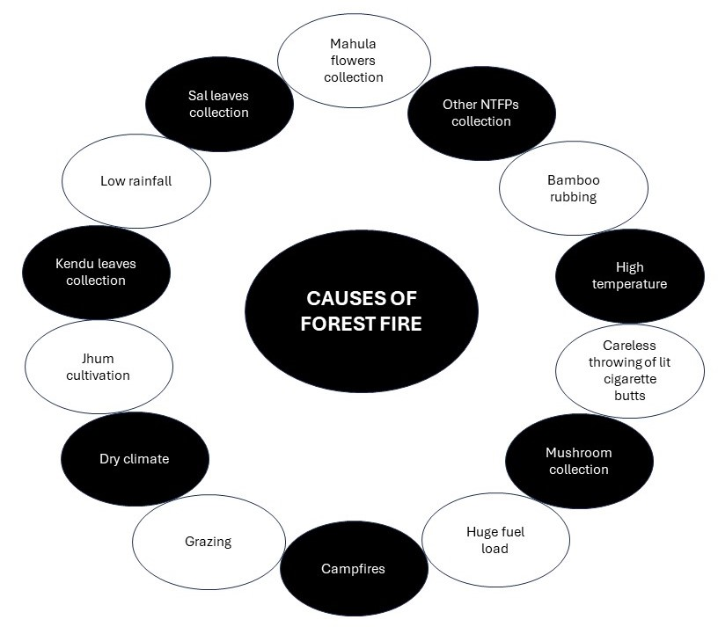

Figure 1: Illustration on causes of forest fire

In Uttarakhand, the lack of soil moisture is a key factor for forest fires, along with the land use dynamics. Locals intentionally lit fires to encourage the growth of edible mushrooms and revitalize grazing lands for cattle grazing (Mina et al., 2023). Slash-and-burn cultivation practices and lighting fire in dry and humid deciduous forests for NTFP collection cause forest fires in Madhya Pradesh, Chhattisgarh, Rajasthan, Maharashtra, and Telangana (Sewak et al., 2021). Other than Jhum cultivation, which most Indian states practice, the collection of Kendu leaves (Diospyros melanxylon) for the preparation of bidis also contributes to forest fires in Chhattisgarh and Madhya Pradesh (Chandra and Bhardwaj, 2015; Figure 1).

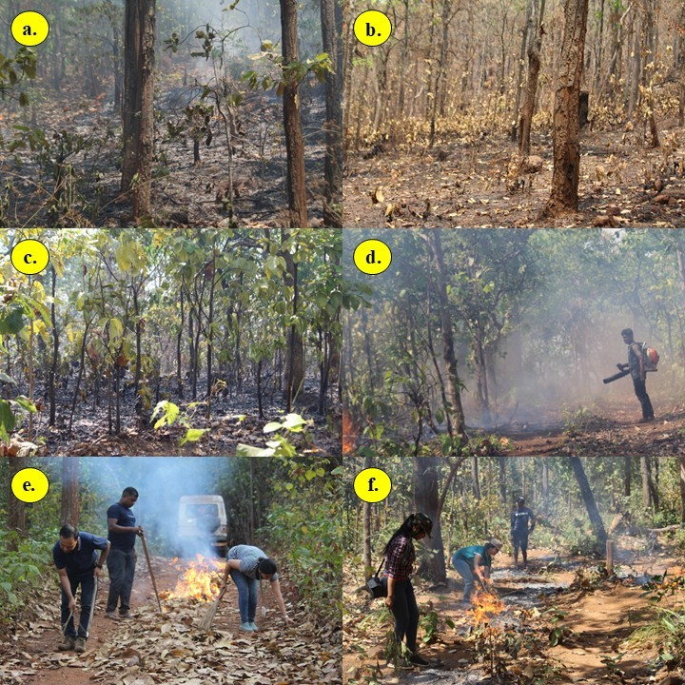

Figure 2: Impacts of forest fire (a-d) and fire line creation (e-f)

In Odisha and Jharkhand, the primary cause of forest fires occurs when villagers ignite dry leaves to collect Mahula flowers (Madhuca longifolia) for their traditional drink preparation. Suppression of tick infection, clear pathways to avoid snakebites, and firewood collection also contribute to fires. The villagers ignite the forests to harvest fresh, lush leaves such as leaves of Sal (Shorea robusta) and Kendu (Diospyros melanoxylon), which are also used to make plates for their livelihood (Kumar et al., 2023). The main cause of natural fires in Jharkhand's bamboo-mixed forests is the collision of dry bamboo due to high winds during summer (Ahmad and Goparaju, 2017). Tamil Nadu and other southern districts of India are vulnerable to fires due to human activities, as the tropical moist deciduous forest of Tamil Nadu is more susceptible to fires than the dry deciduous forests (Mishra et al., 2022).

IMPACTS OF FOREST FIRE

Forest fires have multiple adverse effects on the forest cover, soil, tree growth, vegetation, and all the flora and fauna found inside the forest (Figure 2). Sometimes, fires are beneficial, but in recent times they have caused severe damage due to the aggressive behaviour of humans toward forests and climate change. Fires help in controlling the insect and pest population, remove exotic species from an ecosystem that generally competes with native species, and stunt their growth.

Plants: Forest fires stimulate flowering, seed production, and seed germination in plants. The carbon, magnesium, phosphorous, sulphur, and other nutrients required for plant growth are present in the fire ash. Fire also clears the undergrowth, allowing sunlight to reach the forest floor and promotes the growth of small native species. However, fires also have negative impacts on plants. The size of the forest decreases, and trees that endure fire often show stunted growth, leading to severe damage. Short-term intense fires not only reduce species richness but also harm the natural regeneration process (Forest Fire Impacts Mitigation Management Report, 2023).

Animals: Several animals die attributable to the heat of forest fire. The fire brutally affects the eggs and young ones, sometimes causing them to burn to death. The fire destroys the habitats of animals, making them vulnerable to poachers, changing weather conditions, predators, etc. The demise of wild animals hampers the natural equilibrium and ecological balance by taking out an important component of the ecosystem. The disruption of food webs adversely affects the vegetation (Tamrakar et al., 2024).

Ecology: Forest fires not only destroy vegetation but also severely affect the properties of the soil, making it unfit for plant growth (Gajendiran et al., 2024). Fire destroys the composition and structure of the soil by burning down the small shrubs and grasses, making it vulnerable to erosion and increasing the chances of flood havoc. Soil quality, moisture, and fertility also decrease due to fire. The nitrogen pool of the soil also gets depleted. Several beneficial insects and microorganisms responsible for the healthy growth of plants also die with the plants in the fires. However, the fire ash is beneficial, providing additional nutrients to the plants, maintaining the pH of the soil, and neutralizing its acidity (Chandra and Bharadwaj, 2015).

Environment: Forest fire has severe negative impacts on the environment due to its high carbon emissions, loss of biodiversity, chemical changes in the atmosphere, large amounts of gases, soot, and aerosol particle emissions. Additionally, it releases black carbon into water resources through water runoff and rainfall. Wildfires are also responsible for changes in climate and rainfall patterns (Arshad et al., 2022).

Livelihood: Many tribal communities depend on forests for their livelihoods through resources like grazing, timber, and non-timber forest products. Fires destroy bio-resources and reduce their availability, disrupting the livelihoods of forest-dependent communities (Islam et al., 2013).

MANAGEMENT OF FOREST FIRE

Detection by field staff: Prompt detection of fires through a well-functioning network of observation points, efficient ground patrolling, and communication networks. There are several advancements in the field of technology to detect the early signs of forest fire, but ground monitoring by field staff is essential. The forest department employs seasonal local fire watchers to help with fire detection and management. However, India underfunds its field staff. They do not receive proper training or equipment to combat forest fires that pose risks to their lives. Ground-based fire detection systems and their management are required (Strengthening Forest Fire Management in India, 2018).

GIS and remote sensing: At the national level, forest fire monitoring employs remote sensing and GIS technology to identify active forest fires in their early stages and provide real-time updates to the State Forest Departments (Carta et al., 2023). The Moderate Resolution Imaging Spectroradiometer (MODIS) data aids in the close-period monitoring of forest fires at 6-hour intervals. There is a mapping of the coordinates of fire hotspots on the forest cover map of India, and then state, district, latitude, longitude, and other relevant information are added for simple understanding. This information is converted into a KML (Keyhole Markup Language) file format compatible with Google Earth software. Using this software, the State Forest Departments (SFDs) can precisely locate the active forest fire spots with Google Earth pictures, Excel tables, and maps updated on the official website of FSI daily. The State Forest Department’s registered users of the FSI website also receive an SMS containing visual active forest fire locations for confirmation and quick response (Ahmad and Goparaju, 2017).

PREVENTION AND MITIGATION MEASURES

Public awareness and education: The public should be educated on the causes and consequences of forest fires. People should be encouraged for their responsible behaviour in the forests, which can help reduce anthropogenic fire incidences. Fire safety campaigns should be organized explaining the dangers of leaving unattended campfires and cigarette butts inside the forest. More emphasis should be given to the participation of people through Joint Forest Management (JFM) Committees for the prevention of fires. Local communities should be involved in forest fire prevention and management through training programs, awareness campaigns, etc. Training and resources should be provided to the forest department and local volunteers to increase their capacity and capability to suppress fires (Kumar et al., 2023).

Strict enforcement of rules and regulations: Laws and regulations should be enforced strictly to prevent forest fires. Strict surveillance on poachers and suspicious-looking people in the forests and restriction of public entry inside the forest during fire season. Campfires and the burning of forest surface litter during dry seasons should be banned to reduce accidental fires. If fire safety regulations are violated, penalties should be strictly enforced to stop irresponsible activities. The collection of NTFPs should be restricted during summer to limit accidental fires. Grazing activities should be denied in fire-prone areas for people who set fire to dry grass and leaves to get early and lush green grass and leaves for their cattle, according to the Indian Forest Act 1972 (Carta et al., 2023).

Firebreaks and fuel management: The clearance of fire lines and conduction of controlled burning to limit fuel loads. Selective thinning, clearing deadwood, and planting fire-adapted trees in fire-prone areas can also reduce the chances of forest fire occurrences (Forest Fire Monitoring, India State of Forest Report, 2021).

Early detection systems: Early warning and fire danger rating systems such as surveillance cameras, satellite monitoring, weather monitoring, fire danger indices, and lookout towers can detect fires in their early stages and help prevent large forest fires. Timely circulation of fire alerts and advice among forest departments, local communities, and others involved in the department of fire management can also reduce frequent forest fires. Early and rapid detection provides scope for quicker response to minimize the size and impact of fires (Kasyap et al., 2022).

Government initiatives and policies: An initiative like the National Action Plan for Forest Fires (NAPFF) was started by the Ministry of Environment, Forests, and Climate Change (MoEF & CC), Government of India, to reduce forest fires by informing and empowering forest fringe communities and rewarding them incentives for their collaboration with state forest departments. The Forest Fire Prevention and Management Scheme (FPM) is a centrally sponsored scheme dedicated to assisting different states in dealing with forest fires. The Forest Rights Act 2005 facilitates the conservation of the forest by the forest-dwelling communities, which includes minimizing the practice of shifting cultivation and preventing the spreading of forest fires (Sewak et al., 2021).

Research: Investments of time and money should be made towards research to develop new technologies, tools, and methodologies for the prevention, detection, and suppression of forest fires. Collaborations should be done with scientists, policymakers, and stakeholders of the forests to share knowledge about proper forest management (Giannakidou et al., 2024). The Forest Survey of India (FSI) has been working with the National Centre for Medium-Range Weather Forecasting (NCMRWF) on the development of an Early Warning Fire Forecasting System using satellite data and a Fire Danger Rating System for early detection of forest fires (Savita et al., 2018).

CONCLUSION

Forest fire prevalence in India is a major area of concern for government organizations, the public, and other stakeholders in forests, as it is deteriorating the forest condition. It causes acute loss of biodiversity, destroys wildlife and their habitat, changes the topographic structure of the soil, and affects the ecological balance of the ecosystem. The literature study summarizes that the driving factor of forest fires is influenced by human activities for agricultural purposes; the collection of NTFPs and poaching are some of the causes of fires, among others. These activities must be halted to preserve the forests, which are an integral part of India's heritage and culture. Many wildlife species and tribes rely on forests for their survival. Therefore, appropriate measures should be adopted to protect the forest ecosystem, including the employment of ground-based staff and advanced technologies such as remote sensing, GIS, and MODIS. Public awareness should be raised and people should be encouraged to be responsible toward forests and strict actions should also be taken against those who violate forest laws and regulations. The forest staff must minimize the collection of non-timber forest products (NTFP) from the forests during summers and carefully reduce the fuel load that litters the forest floor. The early detection of fires is the main key to controlling forest fires, and several government initiatives and policies facilitate the conservation of forests.

REFERENCES

Ahmad, F. Goparaju, L. 2017. Geospatial assessment of forest fires in Jharkhand (India). Ind. J. Sci. Technol., 10(21): 1-7. DOI:

Aju, PC., Iwuchukwu, J.J.I. Ibe, C.C. 2015. Our forests, our environment, our sustainable livelihoods. Eur. J. Acad. Essays., 2(4): 6-19.

Arshad, A., Azhar, A.A. Anjali, K.S. 2022. Impact of forest fire on forest ecosystem. J. Adv. Agric. Technol., 9(1&2): 18-29.

Barik, A. Roy, S.B. 2023. Climate change strongly affects future fire weather danger in Indian forests. Commun. Earth. Environ., 4: 452. DOI: 10.1038/s43247-023-01112-w.

Bodo, T., Gimah, B.G. Seomoni, K.J. 2021. Deforestation: human causes, consequences and possible solutions. J. Geogr. Res., 4(2): 22-30.

Carta, F., Zidda, C., Putzu, M., Loru, D., Anedda, M. and Giusto, D. 2023. Advancements in forest fire prevention: a comprehensive survey. Sensors., 23(14): 6635. DOI: 10.3390/s23146635.

Chandra, K.K. and Bhardwaj, A.K. 2015. Incidence of forest fire in India and its effect on terrestrial ecosystem dynamics, nutrient and microbial status of soil. Int. J. Agric. For., 5(2): 69-78.

Forest Fire Assessment in Northeast India. 2014. North Eastern Space Applications Centre, Department of Space, Government of India, Meghalaya, India.

Forest Fire Impacts Mitigation Management Report. 2023. Ambika Prasad Research Foundation, India and Forest, Environment and Climate Change Department, Baripada Forest Division, Odisha, India.

Forest Fire Monitoring, India State of Forest Report (ISFR). 2021. Forest Survey of India. Ministry of Environment, Forest & Climate Change. Government of India.

Gajendiran, K., Kandasamy, S. Narayanan, M. 2024. Influences of wildfire on the forest ecosystem and climate change: a comprehensive study. Environ. Res., 240(Pt 2): 117537. DOI: 10.1016/j.envres.2023.117537

Giannakidou, S., Radoglou-Grammatikis, P., Lagkas, T., Argyriou, V., Goudos, S., Markakis E.K. Sarigiannidis P. 2024. Leveraging the power of internet of things and artificial intelligence in forest fire prevention, detection, and restoration: a comprehensive survey. IEEE Internet. Things. J., 26: 101171. DOI: 10.1016/j.iot.2024.101171.

Ickowitz, A., McMullin, S., Rosenstock, T., Dawson, I., Rowland, D., Powell, B., Mausch, K., Djoudi, H., Sunderland, T., Nurhasan, M., Nowak, A., Gitz, V., Meybeck, A., Jamnadass, R., Guariguata, M.R., Termote, C. and Nasi, R. 2022. Transforming food systems with trees and forests. Lancet. Planet. Health., 6: e632–39.

Islam, M.A., Quli, S.M.S., Rai, R. and Sofi, P.A. 2013. Livelihood contributions of forest resources to the tribal communities of Jharkhand. Ind. J. Fund. Appl. Life. Sci., 3(2): 131-144.

Jain, M., Saxena, P., Sharma, S. and Sonwani S. 2021. Investigation of forest fire activity changes over the central India domain using satellite observations during 2001–2020. GeoHealth., 5: e2021GH000528. DOI: 10.1029/2021GH000528

Kasyap, V.L., Sumathi, D., Alluri, K., Reddy, P.C., Thilakarathne, N. and Shafi, R.M. 2022. Early detection of forest fire using mixed learning techniques and UAV. Comput. Intel. Neurosc., 3170244. DOI: 10.1155/2022/3170244

Kumar, G., Kumar, A., Saikia, P., Roy, P.S. and Khan, M.L. 2022. Ecological impacts of forest fire on composition and structure of tropical deciduous forests of central India. Phys. Chem. Earth., 128: 103240. DOI: 10.1016/j.pce.2022.103240

Kumar, K.P. and Chintala, R.R. 2024. A review of forest fires: causes, impacts, and management strategies. Int. J. Intell. Syst. Appl. Eng., 12(3): 229-234.

Kumar, S. Kumar, A. 2022. Hotspot and trend analysis of forest fires and its relation to climatic factors in the western Himalayas. Nat. Hazards., 114(3): 3529-3544.

Kumar, S.N., Kumar, S. and Biswal, S.K. 2023. Community, forest fire and conservation. Indian. For., 149(5): 487-496.

Malmer, A., Noordwijk, M. and Bruijnzeel, L.A. 2005. Effects of shifting cultivation and forest fire. In: Bonell M, Bruijnzeel LA (eds.). Forests, Water and People in the Humid Tropics. Cambridge University Press, New York.

Mina, U., Dimri, A.P. and Farswan, S. 2023. Forest fires and climate attributes interact in central Himalayas: an overview and assessment. Fire. Ecol., 19: 14. DOI: 10.1186/s42408-023-00177-4.

Mishra, A., Udhayan, A., Palani, P. and Ramachandran, A. 2022. Forest fires occurrence and management – a critical review with respect to Tamil Nadu, India. In: Disaster Monitoring and Prevention; Asian Conference on Remote Sensing. Proceedings. ACRS22_123. 3-5 October, Ulaanbaatar, Mongolia.

Murthy, K.K., Sinha, S.K., Kaul, R. Vaidyanathan, S. 2019. A fine-scale state-space model to understand drivers of forest fires in the Himalayan foothills. For. Ecol. Manag., 432(2019): 902-911.

Neeraja, U.V., Rajendrakumar, S., Saneesh, C.S., Dyda, V. and Knight T.M. 2021. Fire alters diversity, composition, and structure of dry tropical forests in the Eastern Ghats. Ecol. Evol., 11(11): 6593-6603. DOI: 10.1002/ece3.7514

Priya, A., Kumar, R., Lal, A.K. and Singh, U.S. 2024. Forest fire in India: a threat to Indian forest. Int. J. Creat. Res. Thoughts., 12(1): a185-a193.

Saha, S., Bera, B., Shit, P.K., Bhattacharjee, S., Sengupta, D., Sengupta, N. and Adhikary, P.P. 2023. Recurrent forest fires, emission of atmospheric pollutants (GHGs) and degradation of tropical dry deciduous forest ecosystem services. Total. Environ. Res. Themes. 7: 100057. DOI: 10.1016/j.totert.2023.100057

Savita, G.N., Singh, O. and Verma, A.K. 2018. Forest fire in India. Forest Research Institute, Indian Council of Forestry Research & Education (Ministry of Environment, Forests and Climate Change), Dehradun, Uttarakhand, India.

Schmerbeck, J., Kohli, A. and Seeland, K. 2015. Ecosystem services and forest fires in India -context and policy implications from a case study in Andhra Pradesh. For. Policy. Econ., 50: 337-346. DOI: 10.1016/j.forpol.2014.09.012

Sewak, R., Vashisth. M. and Gupta. L. 2021. Forest fires in India: a review. J. Univ. Shanghai. Sci. Technol., 23(7): 247-259.

Tamrakar, A., Dixit, B., Singh, S., Prajapati, L. Chandrakar, S. 2024. Forest fires and non-timber forest products: assessing impacts and management strategies. J. Propuls. Technol., 45(2): 4583-4591.

