Expression and Association of Thyroid Stimulating Hormone Beta (TSHβ) Gene with Growth Performance Traits in FUNAAB Alpha and Ross 308 Broiler Chickens
ABSTRACT
Thyroid stimulating hormone beta (TSHβ) plays a central role in avian growth and development by regulating thyroid hormone production, thereby influencing metabolism, skeletal formation and growth rate. This study investigated growth performance and TSHβ gene expression in two broiler breeds (FUNAAB Alpha and Ross 308), assess breed and sex specific variations and their association with growth traits. A total of 200 day-old chicks (100 per breed) were reared under intensive management for 8 weeks. Weekly measurements included body weight and 8 linear body traits: BL, BG, DS, DC, SL, SC, WL and KL. At 8 weeks, liver tissues from 32 birds (8 males and 8 females per breed) were collected for RNA extraction and quantitative PCR analysis. Data were analyzed using analysis of variance, correlation and regression models. Ross 308 exhibited significantly (p < 0.001) higher body weight and superior linear measurements compared to FUNAAB Alpha, while males generally outperformed females at later ages. Relative expression analysis revealed higher TSHβ expression in Ross 308, whereas sex effects were minor. Correlation analysis indicated stronger associations of TSHβ expression with skeletal traits, particularly KL and DC, than with overall body weight. These results identify TSHβ as a candidate gene influencing skeletal development and growth efficiency in broilers and highlight its potential utility in marker-assisted selection strategies aimed at improving productivity, efficiency and profitability in poultry breeding programs.
Keywords: FUNAAB Alpha, gene expression, growth performance, Ross 308, skeletal traits, thyroid stimulating hormone beta

INTRODUCTION
Thyroid stimulating hormone (TSH) plays a central role in regulating growth, development, and metabolic balance in poultry through the hypothalamic pituitary thyroid (HPT) axis, with the beta subunit (TSHβ) conferring biological specificity to its activity (Huang et al., 2012; Zhang et al., 2023). Variations in TSHβ expression have been shown to influence feed efficiency, body weight gain and thermoregulation, making it a promising candidate gene for poultry genetic improvement (Saleh et al., 2020; Park et al., 2021). While commercial broilers such as Ross 308 exhibit high growth potentials associated with elevated TSHβ activity, synthetic breeds like FUNAAB Alpha developed in Nigeria are selected for resilience and adaptability to tropical environments (Adenaike et al., 2023; Chen et al., 2022). However, despite its significance, studies on TSHβ expression remain limited in Nigerian synthetic breeds, leaving gaps in understanding the molecular basis of their growth and adaptive traits.
The growing demand for poultry meat and eggs emphasizes the importance of genetic improvement strategies that balance productivity with environmental adaptability. Marker assisted selection has been increasingly adopted in poultry breeding, yet endocrine markers such as TSHβ remain underutilized due to limited comparative data across divergent genotypes. Specifically, little is known about how TSHβ gene expression differs between fast growing commercial broilers like Ross 308 and resilient indigenous derived lines like FUNAAB Alpha. This lack of data restricts opportunities for integrating endocrine biomarkers into breeding programs aimed at enhancing both efficiency and resilience. Addressing this knowledge gap is essential for optimizing breeding strategies in commercial and smallholder systems across Nigeria and other tropical regions.
This study was designed to evaluate TSHβ gene expression and its association with growth performance traits in FUNAAB Alpha and Ross 308 broilers, considering both breed and sex effects. By linking molecular data with performance indicators such as body weight and feed conversion, it seeks to generate novel insights into the role of endocrine regulation in poultry growth. The findings will help fill the gap in molecular characterization of Nigerian synthetic breeds, provide foundational data for marker-assisted selection and support the development of sustainable poultry breeding strategies that integrate productivity with adaptability in challenging environments.

MATERIALS AND METHODS
Experimental site
The study was conducted at the Poultry Breeding Unit of the Teaching and Research Farm, University of Uyo, Akwa Ibom State, Nigeria. The site is located within a tropical rainforest zone characterized by a mean rainfall of about 2000 mm, relative humidity of 79% and an average annual temperature of 28℃.
Experimental animals and management
A total of 200 day-old chicks were used, comprising 100 FUNAAB Alpha and 100 Ross 308 broilers sourced from the Federal University of Agriculture, Abeokuta. Birds were raised intensively in partitioned pens with appropriate space allowance. Standard brooding practices, vaccination against diseases and routine bio-security measures were implemented. Anti-stress supplements were administered at arrival and the chicks were wing-tagged for identification. Birds were fed a starter diet (22.40% crude protein, 2967 kcal/kg ME) from hatch to three weeks, followed by a finisher diet (17.41% crude protein, 3139.96 kcal/kg ME) until eight weeks, with water provided ad libitum.
Growth performance measurements
Body weight was recorded on arrival and subsequently on a weekly basis using a sensitive digital scale during brooding and an analog scale afterward. Linear body measurements including BL, BG, DS, DC, SL, SC, WL and KL were also taken weekly using a tailor’s tape.
Tissue collection and RNA extraction
At 8 weeks, 32 birds (8 males and 8 females per breed) were randomly selected for liver tissue harvesting. Samples were preserved in RNA/DNA shield and transported to the laboratory. Total RNA was extracted using the Zymo Quick-RNA Mini Prep Plus Kit, following homogenization, lysis, DNA removal, DNase treatment and purification steps. RNA concentration and purity were determined using a Nano Drop spectrophotometer, with quality assessed by 260/280 and 260/230 absorbance ratios.
cDNA synthesis and primer design
First-strand complementary DNA (cDNA) was synthesized from purified RNA using the LunaScript RT SuperMix Kit. Primers specific to the TSHβ gene and the housekeeping GAPDH gene were used for amplification.
Quantitative PCR (qPCR)
Quantitative PCR was performed using the Bio-Rad CFX96 Real-Time thermal cycler with Luna Universal qPCR Master Mix. Amplification efficiency was validated and expression levels of TSHβ were quantified relative to GAPDH using the 2−ΔΔCt method. Amplicons were further sequenced, aligned with GenBank reference sequences for quality control, and deposited with accession numbers PV126564–PV126579 (Udoh et al., 2025).
Statistical analysis
Growth and gene expression data were analyzed using the Generalized Linear Model procedure of SAS (2000). Breed, sex and their interactions were evaluated. Duncan’s multiple range tests was applied for mean separation at p < 0.001. Correlation and stepwise regression analyses were conducted to examine relationships between growth performance traits and TSHβ expression levels.
Ethical considerations
Ethical approval for animal handling and genetic analysis was granted by the Ethical Committee of Animal Science, University of Uyo, ensuring compliance with established animal welfare standards.

RESULTS
4.1.1 Effect of sex, breed and their interaction on growth performance traits of Ross 308 and FUNAAB_Alpha chickens at 2 weeks old
Growth performance traits differed significantly between the two genotypes, with Ross 308 chickens consistently outperforming FUNAAB Alpha chickens across all ages. At two weeks of age, Ross 308 broilers recorded significantly higher body weight (337.37 g vs. 166.00 g; P<0.001) and superior values for all linear body traits, including body girth, body length, shank dimensions, drumstick size, and keel length. By contrast, FUNAAB Alpha chickens showed lower growth values across traits. Sex, however, had no significant effect at this early stage, and the interaction between breed and sex was not significant, confirming that the main driver of performance differences was breed.

Table 1-Effect of sex, breed and their interaction on growth performance traits of Ross 308 and FUNAAB_Alpha chickens at 2 weeks old
Trait | Breed |  | Sex |  |  | Breed*Sex
 | F/Alpha | R/ 308 | Female |  | Male | F/Alpha female | F/Alpha male | R/308 female | R/308 male
BW (g) | 166.00±10.73^{b} | 337.37±19.17ª | 237.12±34.46 | 266.25±36.49 |  | 155.5±16.38 | 176.5±18.17 | 318.75±21.27 | 356.00±22.01
BG (cm) | 12.12±0.20^{b} | 16.75±.43ª | 14.00±0.90 | 14.87±0.96 |  | 11.75±0.25 | 12.50±0.27 | 16.25±0.68 | 17.25±0.79
BL (cm) | 20.37±0.53^{b} | 23.81±0.62ª | 22.13±0.89 | 22.063±0.85 |  | 20.25±0.75 | 20.50±0.87 | 24.00±0.96 | 23.62±0.89
WL (cm) | 13.62±0.36^{b} | 14.37±0.87ª | 14.63±0.61 | 13.75±0.67 |  | 13.38±0.69 | 13.86±0.99 | 15.88±1.67 | 12.88±0.75
DS (cm) | 6.69±0.23^{b} | 8.83±0.39ª | 7.75±0.48 | 7.75±0.54 |  | 6.63±0.38 | 6.75±0.45 | 8.88±0.35 | 8.75±0.50
DC (cm) | 3.81±0.18^{b} | 6.69±0.76ª | 5.25±0.70 | 5.25±0.83 |  | 3.88±0.38 | 3.75±0.47 | 6.63±0.31 | 6.75±0.53
SL (cm) | 7.69±0.18^{b} | 8.63±0.23ª | 8.12±0.29 | 8.19±0.25 |  | 7.65±0.31 | 7.75±0.34 | 8.62±0.52 | 8.62±0.42
SC (cm) | 3.25±0.09^{b} | 4.00±0.21ª | 3.56±0.19 | 3.68±0.23 |  | 3.25±0.14 | 3.25±0.65 | 3.87±0.13 | 4.12±0.32
KL (cm) | 5.50±0.19^{b} | 7.69±0.34ª | 6.62±0.47 | 6.56±0.51 |  | 5.50±0.35 | 5.50±0.21 | 7.75±0.14 | 7.63±0.41
^{a,b}: Means with different superscripts within the same row are significantly different (P>0.001) F/ Alpha: FUNAAB Alpha; R/308: Ross 308; BW: Body weight; BG: Body girth; BL: Body length; WL: Wing length; DS: D; DC: D; SL: Shank length; SC: Shank circumference; KL: Keel length; g: grams; cm: centimeter.
4.1.2 Effect of sex, breed and their interaction on growth performance traits of Ross 308 and FUNAAB_Alpha chickens at 4 weeks old
At four weeks, Ross 308 broilers maintained their growth advantage with a mean body weight of 964.62 g compared to 380.62 g in FUNAAB Alpha (P<0.001). Linear body traits also followed this trend, with Ross 308 displaying larger girth, length, drumstick, and keel dimensions. Sex differences emerged at this stage, with males showing significantly higher body weight and girth than females (725.7 g vs. 619.5 g; P<0.001). Breed by sex interaction was significant for drumstick size, where Ross 308 females were particularly larger than their male counterparts and FUNAAB Alpha chickens.

Table 2: Effect of sex, breed and their interaction on growth performance traits of Ross 308 and FUNAAB_Alpha chickens at 4 weeks old
Trait | Breed |  | Sex |  | Breed*Sex
 | F/Alpha | R/ 308 | Female | Male | F/Alpha female | F/Alpha male | R/308 female | R/308 male
BW (g) | 380.62±21.09^{b} | 964.62±36.01ª | 619.50±109.05^{b} | 725.7±115.78ª | 338.00±21.28 | 423.25±20.33 | 901.00±47.02 | 1028.25±33.80
BG (cm) | 15.81±0.49^{b} | 23.37±0.74ª | 18.63±1.31^{b} | 20.56±1.69ª | 15.37±0.69 | 16.25±0.75 | 21.87±0.77 | 24.87±0.66
BL (cm) | 27.87±0.79^{b} | 34.87±0.69ª | 31.13±1.79 | 31.63±1.16 | 26.75±0.97 | 29.00±1.06 | 35.50±1.19 | 34.25±0.75
WL (cm) | 17.75±1.15 | 19.62±0.98 | 18.13±1.02 | 19.25±1.18 | 17.00±1.67 | 18.50±1.76 | 19.25±1.10 | 20.00±1.77
DS (cm) | 9.00±0.38^{b} | 10.94±0.33ª | 10.00±0.61 | 9.94±0.39 | 8.50±0.35^{b} | 9.50±0.65^{b} | 11.50±0.35ª | 10.37±0.42^{ab}
DC (cm) | 5.56±0.17^{b} | 9.50±0.83ª | 7.50±0.94 | 7.56±0.97 | 5.63±0.31 | 5.50±0.20 | 9.37±1.29 | 9.63±1.24
SL (cm) | 10.44±0.40^{b} | 12.06±0.29ª | 10.87±0.48 | 11.62±0.41 | 9.88±0.52 | 11.00±0.54 | 11.88±0.37 | 12.25±0.47
SC (cm) | 3.69±0.09^{b} | 4.75±0.13ª | 4.19±0.25 | 4.25±0.21 | 3.63±0.13 | 3.75±0.14 | 4.75±0.25 | 4.75±0.14
KL (cm) | 7.06±0.19^{b} | 12.00±0.38ª | 9.13±0.93 | 9.94±1.00 | 6.75±0.14 | 7.38±0.31 | 11.50±0.54 | 12.50±0.46
^{a,b,ab}: Means with different superscripts within the same row are significantly different (P>0.001) F/ Alpha: FUNAAB Alpha; R/308: Ross 308; BW: Body weight; BG: Body girth; BL: Body length; WL: Wing length; DS: D; DC: D; SL: Shank length; SC: Shank circumference; KL: Keel length; g: grams; cm: centimeter.

4.1.3 Effect of sex, breed and their interaction on growth performance traits of Ross 308 and FUNAAB_Alpha chickens at 6 weeks old
By six weeks, the performance gap widened. Ross 308 chickens reached a mean body weight of 1910.13 g, significantly higher than the 729.63 g recorded for FUNAAB Alpha (P<0.001). Differences extended to all linear traits, with Ross 308 outperforming FUNAAB Alpha in girth, shank size, drumstick, and keel length. Sex effects became more pronounced, with males being significantly heavier than females (1438.13 g vs. 1201.63 g; P<0.001). Breed by sex interaction was also significant for body weight and shank circumference, showing that Ross 308 males grew disproportionately faster than both their female counterparts and FUNAAB Alpha chickens.

Table .3: Effect of sex, breed and their interaction on growth performance traits of Ross 308 and FUNAAB_Alpha chickens at 6 weeks old
Trait | Breed |  | Sex |  | Breed*Sex
 | F/Alpha | R/308 | Female | Male | F/Alpha female | F/Alpha male | R/308 female | R/308 male
BW (g) | 729.63±43.53^{b} | 1910.13±76.96ª | 1201.63±206.31^{b} | 1438.13±246.58ª | 668.75±68.61 | 790.50±40.81 | 1734.50±.67.95 | 2085.75±.49.59
BG (cm) | 20.56±0.43^{b} | 30.25±1.12ª | 23.88±1.63^{b} | 26.94±0.2a19 | 19.87±0.66 | 21.25±0.32 | 27.87±1.16 | 32.63±0.85
BL (cm) | 39.50±1.47^{b} | 42.44±0.68ª | 39.94±1.32 | 42.00±1.08 | 38.25±2.28 | 40.75±1.98 | 41.63±1.07 | 43.25±0.75
WL (cm) | 27.13±0.47^{b} | 23.94±0.63ª | 24.69±0.93^{b} | 26.38±0.52ª | 26.87±0.69 | 27.37±0.75 | 22.50±0.65 | 25.38±0.24
DS (cm) | 10.50±0.26^{b} | 14.13±0.54ª | 11.81±0.71 | 12.81±0.85 | 10.00±0.00 | 11.00±0.41 | 13.63±0.43 | 14.63±1.01
DC (cm) | 8.33±0.37^{b} | 12.50±0.42ª | 10.00±0.74 | 10.81±0.98 | 8.25±0.43 | 8.37±0.69 | 11.75±0.59 | 13.25±0.32
SL (cm) | 13.25±0.21^{b} | 14.63±0.38ª | 13.56±0.34 | 14.31±0.40 | 13.00±0.41 | 13.50±0.00 | 14.13±0.43 | 15.13±0.55
SC (cm) | 4.25±0.09 | 6.31±0.41ª | 4.81±0.28^{b} | 5.75±0.58ª | 4.13±0.13^{c} | 4.38b±0.13^{c} | 5.50±0.20^{b} | 7.13±.55ª
KL (cm) | 11.50±0.23^{b} | 14.69±0.41ª | 12.63±0.53^{b} | 13.56±0.77ª | 11.38±0.43 | 11.63±0.24 | 13.88±0.31 | 15.50±0.50
^{a,b,c}: Means with different superscripts within the same row are significantly different (P>0.001) F/ Alpha: FUNAAB Alpha; R/308: Ross 308; BW: Body weight; BG: Body girth; BL: Body length; WL: Wing length; DS: D; DC: D; SL: Shank length; SC: Shank circumference; KL: Keel length; g: grams; cm: centimeter.

4.1.4 Effect of sex, breed and their interaction on growth performance traits of Ross 308 and FUNAAB_Alpha chickens at 8 weeks old
At eight weeks, Ross 308 chickens achieved an average body weight of 2822.00 g, more than double that of FUNAAB Alpha chickens (1144.87 g; P<0.001). All measured traits reflected this superiority, with Ross 308 recording higher body girth, body length, drumstick circumference, shank size, and keel length. Sex differences were again evident, with males significantly outperforming females in body weight (2219.87 g vs. 1747.00 g; P<0.001), wing length, drumstick circumference, and shank circumference. Breed by sex interaction was significant for body weight and shank circumference, as Ross 308 males reached the highest growth performance (3198.50 g), followed by Ross 308 females, while FUNAAB Alpha males and females lagged behind.

Table 4: Effect of sex, breed and their interaction on growth performance traits of Ross 308 and FUNAAB_Alpha chickens at 8 weeks old
Trait | Breed |  | Sex |  | Breed*Sex
 | F/Alpha | R/308 | Female | Male | F/Alpha female | F/Alpha male | R/308 female | R/308 male
BW (g) | 1144.87±53.14^{b} | 2822.00±170.23ª | 1747.00±277.69^{b} | 2219.87±373.66ª | 1048.50±45.92^{c} | 1241.25±69.83^{c} | 2445.50±180.24^{b} | 3198.50±90.76ª
BG (cm) | 25.13±0.57^{b} | 34.25±1.37ª | 28.50±1.83 | 30.87±2.09 | 24.75±1.16 | 24.50±0.29 | 32.25±.2.21 | 36.25±1.11
BL (cm) | 44.81±1.54^{b} | 51.50±1.19ª | 46.19±2.01 | 50.13±1.34 | 41.50±1.21 | 48.13±1.53 | 50.88±1.71 | 52.13±1.85
WL (cm) | 31.50±0.50 | 30.63±0.71 | 29.87±0.58^{b} | 32.25±0.25ª | 30.50±0.65 | 32.50±0.29 | 29.25±0.95 | 32.00±0.41
DS (cm) | 13.18±0.42^{b} | 16.44±0.54ª | 14.31±0.68 | 15.31±0.82 | 12.75±0.66 | 13.63±0.52 | 15.87±0.31 | 17.00±1.02
DC (cm) | 10.12±0.41^{b} | 15.93±0.50ª | 12.31±1.09^{b} | 13.75±1.22ª | 9.50±0.46 | 10.75±0.59 | 15.13±0.38 | 16.75±0.77
SL (cm) | 14.86±0.25^{b} | 16.56±0.54ª | 15.56±0.39 | 15.87±0.63 | 15.13±0.37 | 14.62±0.31 | 16.00±0.68 | 17.13±0.82
SC (cm) | 5.00±0.16^{b} | 7.63±0.57ª | 5.62±0.26^{b} | 7.00±0.80ª | 5.00±0.20^{b} | 5.00±0.29^{b} | 6.25b±0.14 | 9.00±0.50ª
KL (cm) | 14.06±0.36 | 17.94±0.49 | 15.88±0.72 | 16.13±0.95 | 14.37±0.55 | 13.75±0.48 | 17.37±0.80 | 18.50±0.50
^{a,b,c}: Means with different superscripts within the same row are significantly different (P>0.001) F/ Alpha: FUNAAB Alpha; R/308: Ross 308; BW: Body weight; BG: Body girth; BL: Body length; WL: Wing length; DS: D; DC: D; SL: Shank length; SC: Shank circumference; KL: Keel length; g: grams; cm: centimeter.

4.2.1 Gel electrophoresis plate of GAPDH (Housekeeping) and TSHβ gene expression
Gel electrophoresis confirmed the successful amplification of the TSHβ gene alongside the housekeeping gene GAPDH, with distinct bands appearing at expected sizes (Figure 1). The absence of bands in the no-template control (NTC) confirmed the reliability and contamination free status of the qPCR reactions. Variations in band intensity across samples suggested differential expression of TSHβ between genotypes.

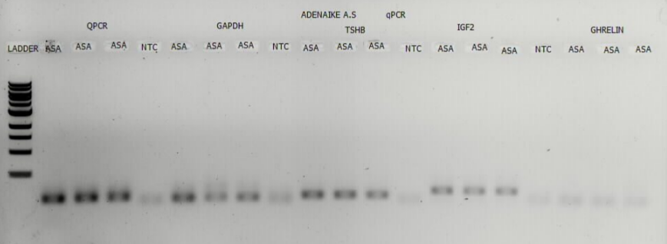
Figure 1: Gel electrophoresis plate of GAPDH (Housekeeping) and TSHβ gene expression

4.2.2 Amplification curves for thyroid stimulating hormone beta (TSHβ) in Ross 308 and FUNAAB Alpha chickens
Amplification curves from the real-time PCR further validated these findings. Both Ross 308 (Figure 2) and FUNAAB Alpha (Figure 3) chickens displayed clear sigmoidal amplification patterns with consistent replicates, while negative controls showed no amplification. Lower cycle threshold (Ct) values in Ross 308 indicated higher baseline TSHβ expression compared to FUNAAB Alpha.

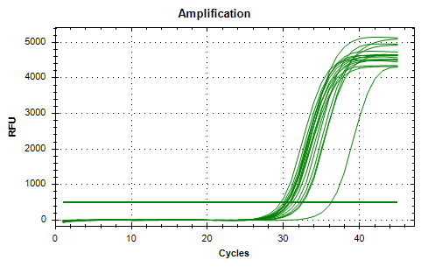
Figure 2: Amplification curves for thyroid stimulating hormone beta (TSHβ) in Ross 308 chickens

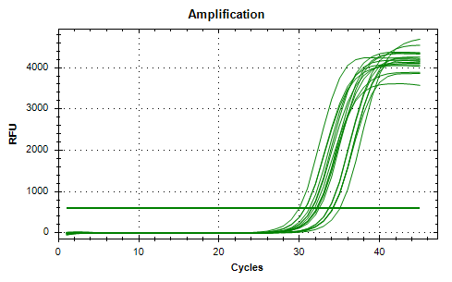
Figure 3: Amplification curves for thyroid stimulating hormone beta (TSHβ) in FUNAAB Alpha chickens
4.2.3 Melt curve analysis (melt peak) of TSHβ expression in Ross 308 and FUNAAB Alpha chickens
Melt curve analysis demonstrated the specificity of amplification in both breeds. Ross 308 (Figure 4) and FUNAAB Alpha (Figure 5) chickens showed sharp single peaks at ~80°C, confirming amplification of a single, specific product. Melting curve profiles (Figures 6 and 7) reinforced these results, with steep fluorescence declines at the same temperature range, excluding the possibility of non-specific products.
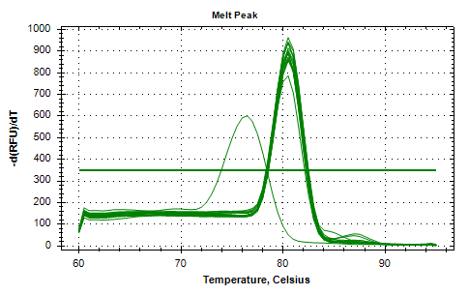
Figure 4: Melt curve analysis (melt peak) of TSHβ expression in Ross 308 chickens
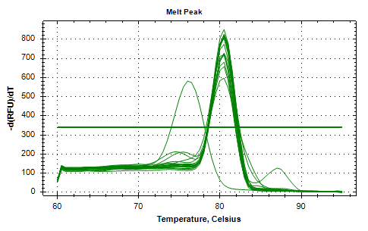
Figure 5: Melt curve analysis (melt peak) of TSHβ expression in FUNAAB Alpha chickens
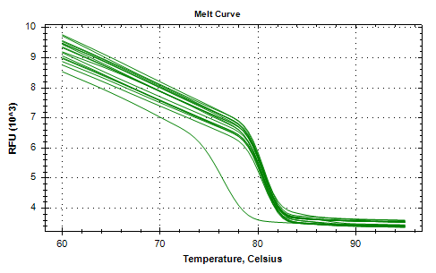
Figure 6: Melting curve of real time polymerase chain reaction of thyroid stimulating hormone gene in Ross 308 broiler chickens
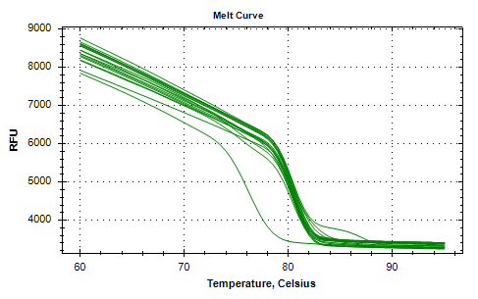
Figure 7: Melting curve of real time polymerase chain reaction of thyroid stimulating hormone gene in FUNAAB Alpha broiler chickens

4.2.4 Standard curve analysis for amplification efficiency of thyroid stimulating hormone gene
The standard curve analysis (Figure 8) showed a strong negative correlation between log-transformed mRNA quantity and ΔCt values, indicating high amplification efficiency and validating the quantification of TSHβ expression.

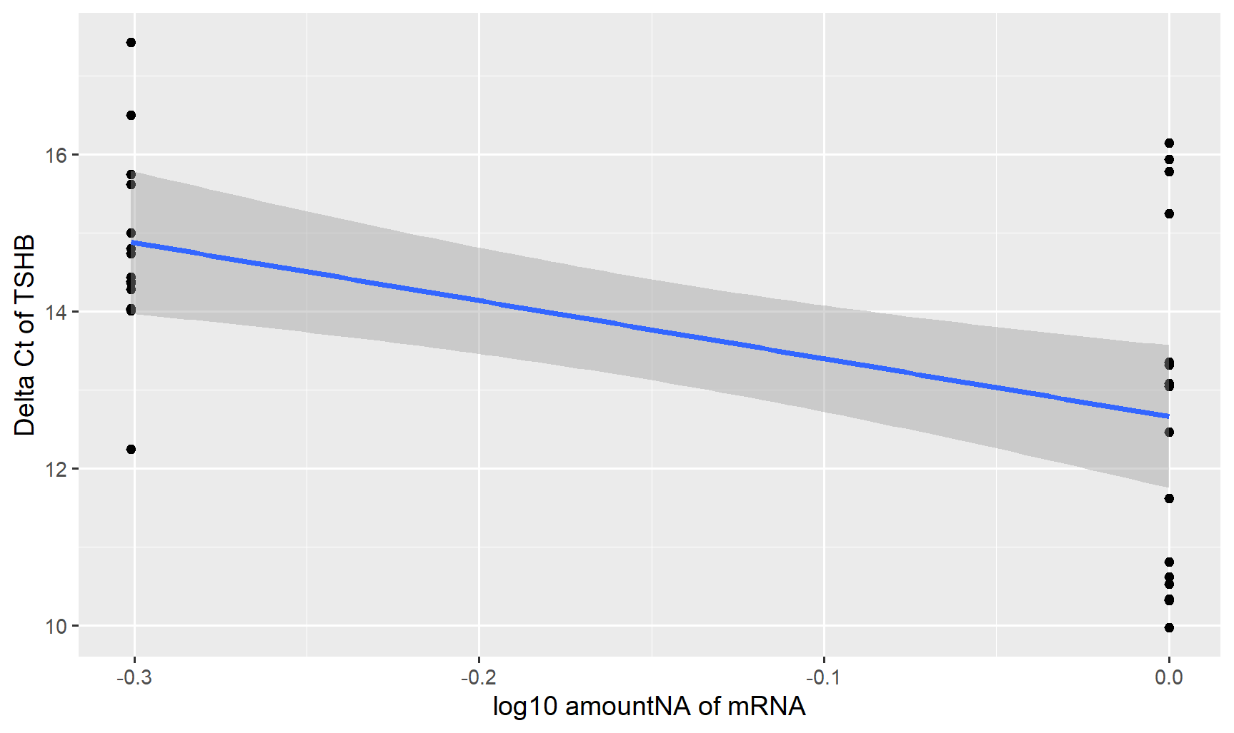
Figure 8: Standard curve analysis for amplification efficiency of thyroid stimulating hormone gene

4.2.5 Relative fold change of two GAPDH genes (GAPDH1 and GAPDH2) between FUNAAB Alpha and Ross308 broiler chickens
Relative fold change analysis of GAPDH isoforms (Figure 9) confirmed stable expression across breeds, although Ross 308 showed greater variability compare to FUNAAB Alpha. This stability supports the reliability of GAPDH as an internal control.
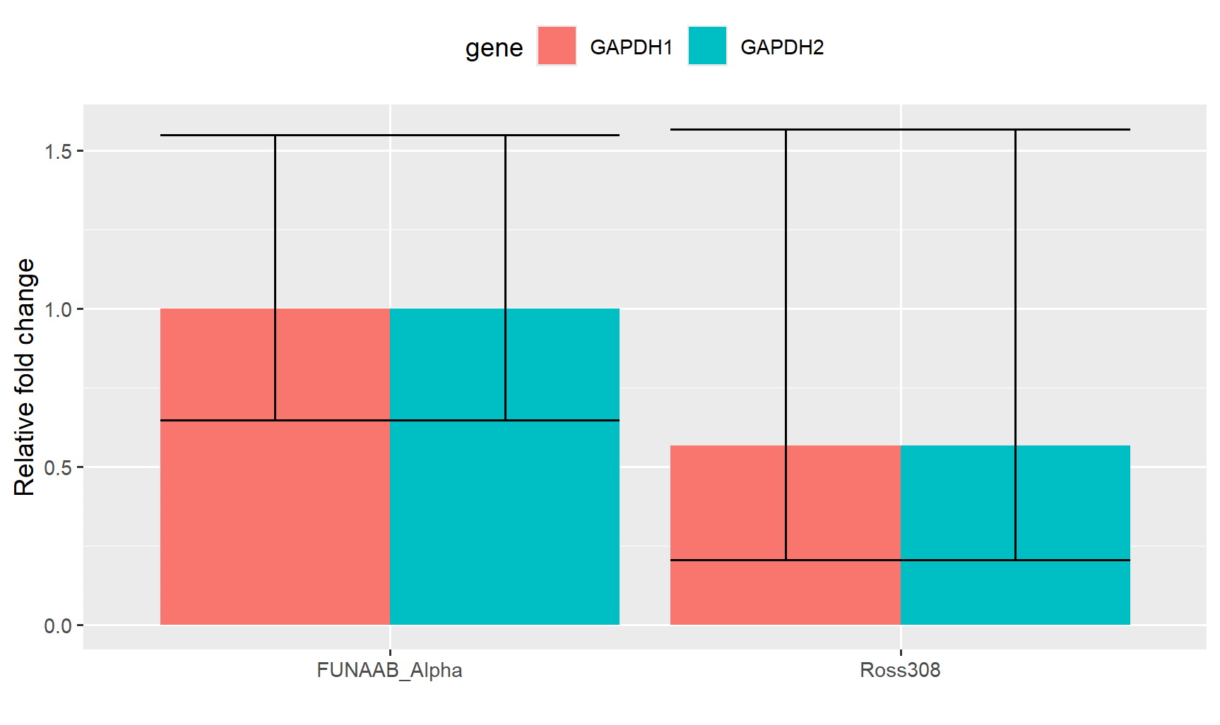
Figure 9: The relative fold change of two GAPDH genes (GAPDH1 and GAPDH2) between FUNAAB Alpha and Ross308 broiler chickens

4.3.1 Relative expression of TSHβ gene in different sex of broiler chicken
When sex was considered, males showed slightly higher TSHβ expression than females (Figure 10). However, the difference was not statistically significant (p = 0.71), suggesting that sex alone does not exert a major influence on TSHβ regulation compared with breed.
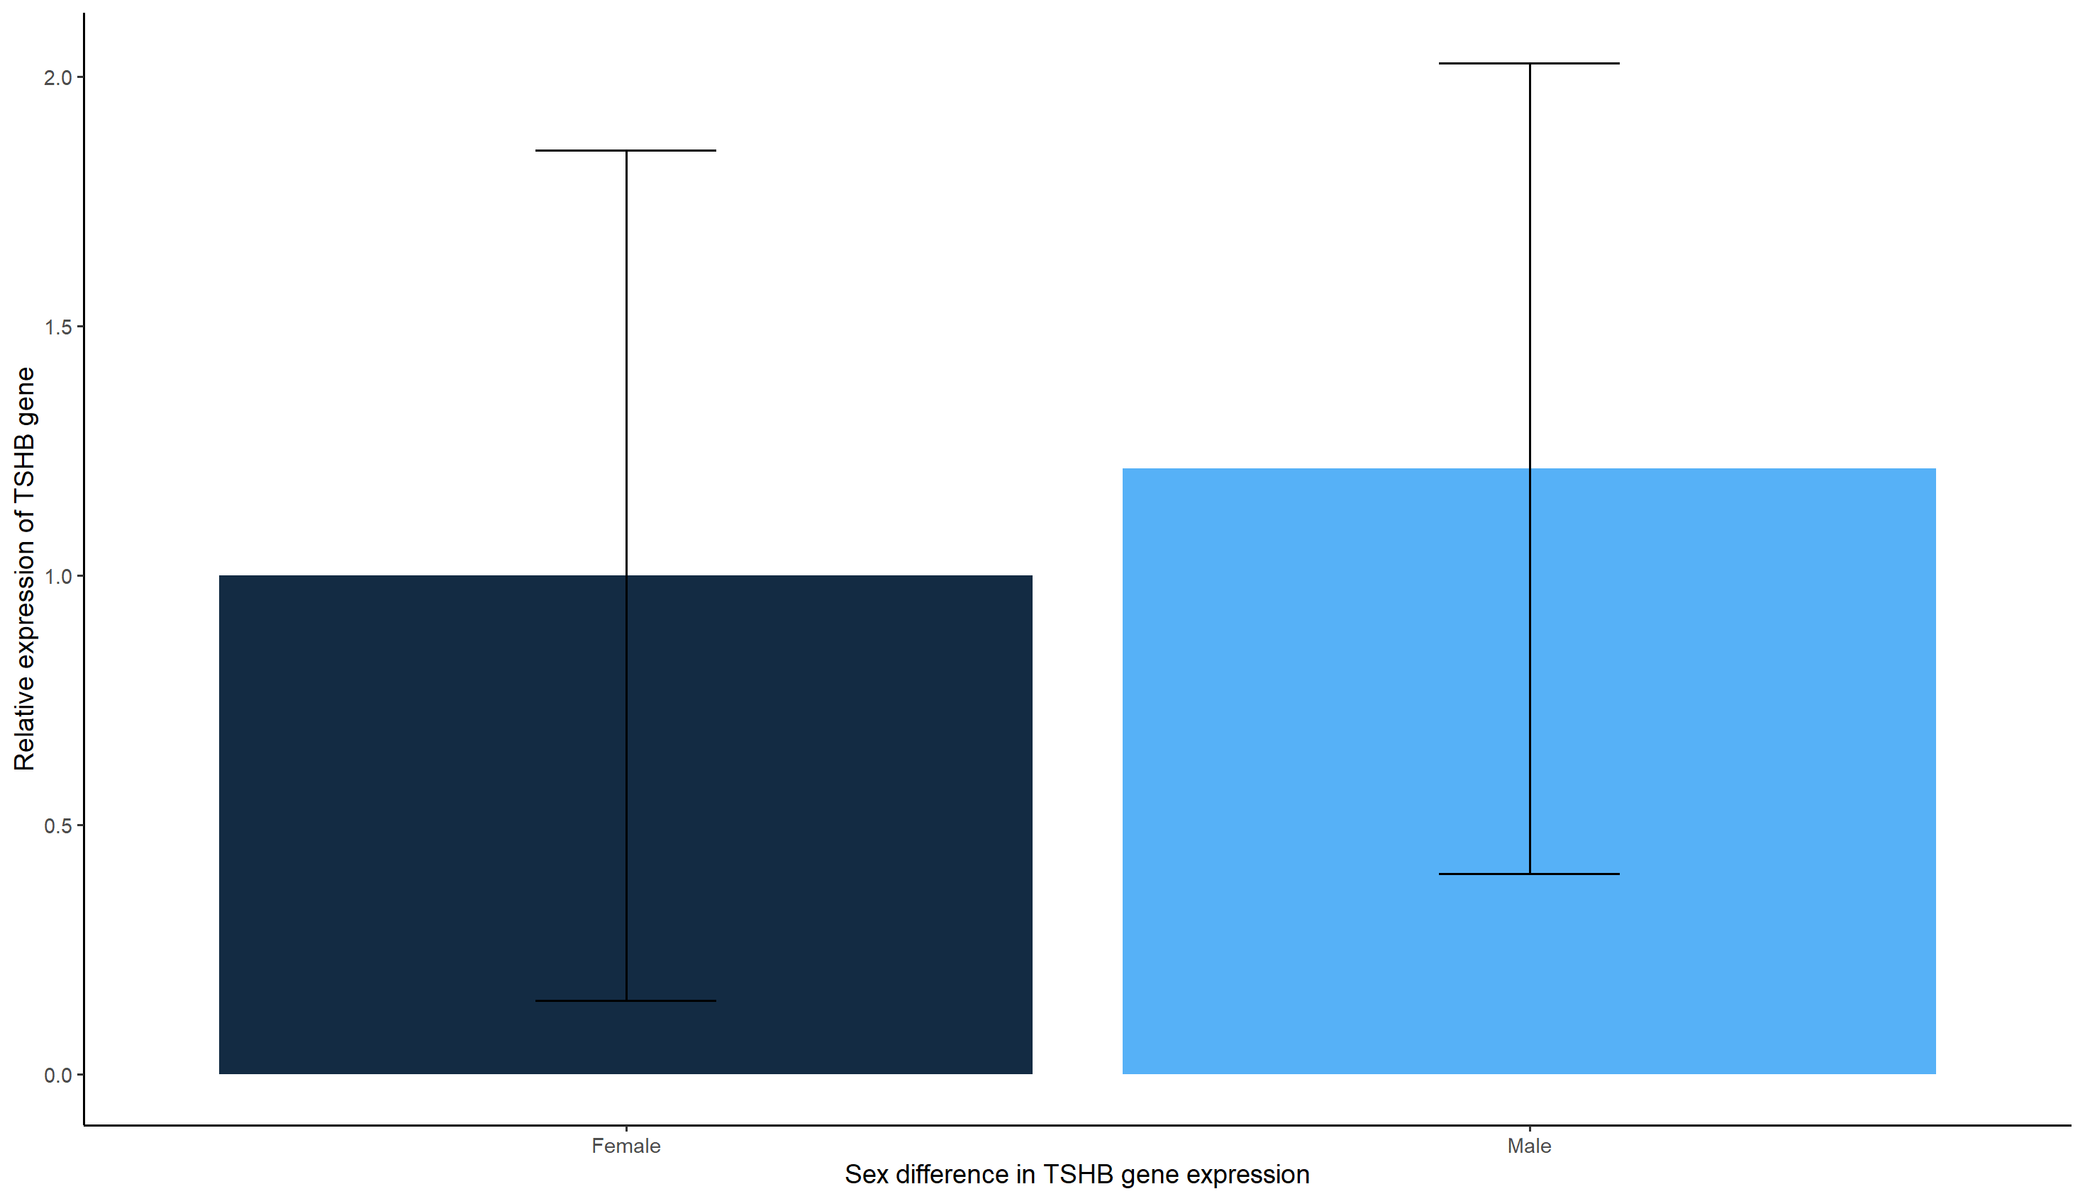
Figure 10: Relative expression of TSHβ gene in different sex of broiler chicken

4.3.2 TSHβ gene expression in FUNAAB_Alpha and Ross308
Breed differences were more pronounced. Ross 308 chickens consistently exhibited significantly higher TSHβ expression than FUNAAB Alpha (Figure 11), highlighting a breed-associated genetic advantage in thyroid hormone regulation and growth performance.

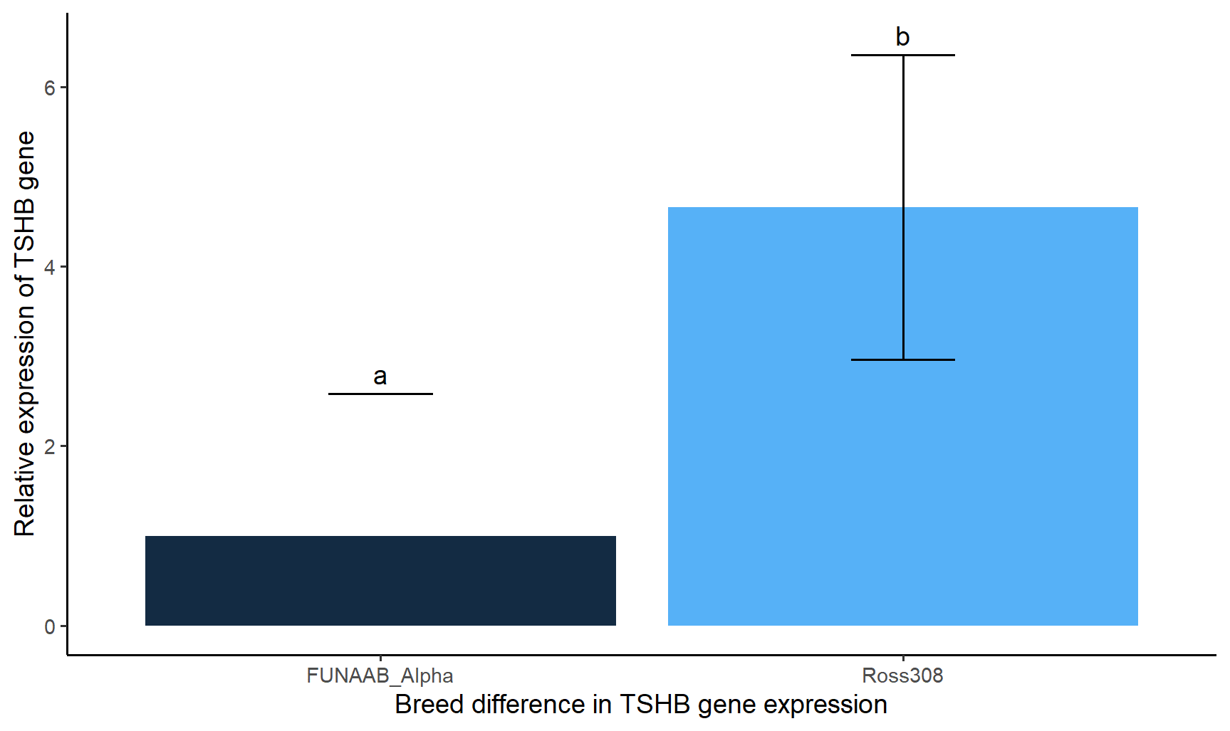
Figure 11: Bar graph of TSHβ gene expression in FUNAAB_Alpha and Ross308

4.3.3 Sex by breed interaction effect on TSHβ gene expression
Analysis of breed sex interaction (Figure 12) revealed additional nuance. Within FUNAAB Alpha, males had higher TSHβ expression than females, whereas Ross 308 showed high expression in both sexes with greater variability in males. These findings suggest that while Ross 308 maintains strong TSHβ expression regardless of sex, FUNAAB Alpha is more sensitive to sex-based regulatory differences.

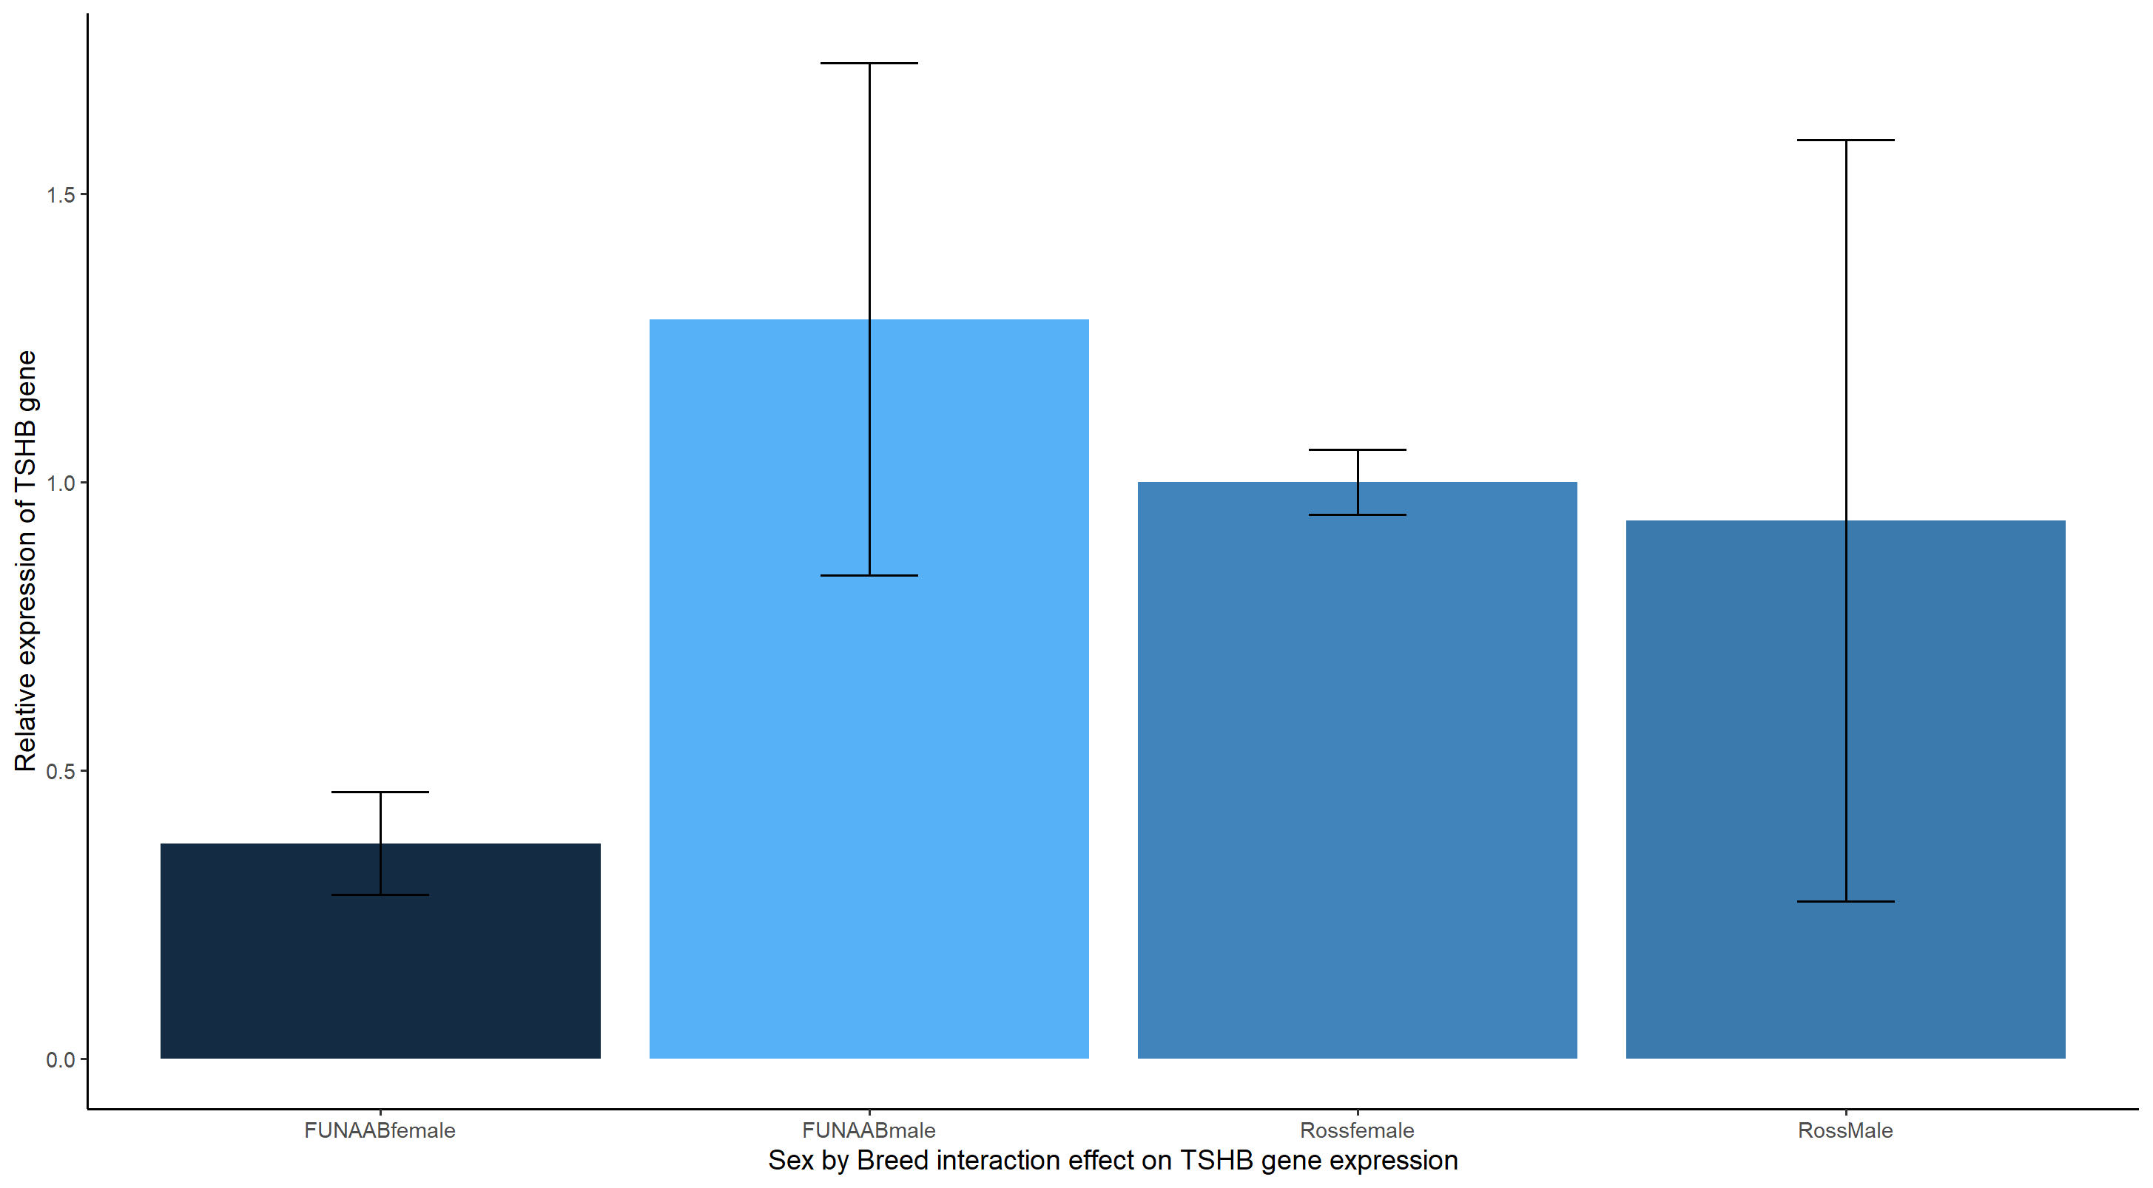
Figure 12: Sex by breed interaction effect on TSHβ gene expression

4.4.1 Relationship between thyroid stimulating hormone gene expression (Ct/dCt ) and growth performance traits in Ross 308 female broiler chickens
In Ross 308 females, TSHβ expression showed a weak negative correlation with body weight, suggesting that higher gene activity was not linked to weight gain. Instead, strong positive correlations were observed with keel length and drumstick circumference, indicating that TSHβ expression in this group is more closely associated with skeletal development than with muscle accretion. Negative correlations with shank length further suggest variation in leg growth dynamics.
Table 5: Relationship between thyroid stimulating hormone gene expression (Ct) and growth performance traits in Ross 308 female broiler chickens
 | CT  TSHβ | BW | BG | BL | WL | DS | DC | SL | SC | KL
CT  TSHβ | 1.000
BW | -0.191 | 1.000
BG | 0.035 | 0.818 | 1.000
BL | 0.109 | 0.569 | 0.937 | 1.000
WL | 0.573 | 0.684 | 0.627 | 0.443 | 1.000
DS | 0.031 | 0.007 | 0.554 | 0.803 | -0.105 | 1.000
DC | 0.159 | 0.768 | 0.992** | 0.949* | 0.675 | 0.574 | 1.000
SL | 0.520 | -0.889 | -0.501 | -0.198 | -0.390 | 0.293 | -0.410 | 1.000
SC | -0.071 | 0.729 | 0.978* | 0.969* | 0.458 | 0.689 | 0.962* | -0.426 | 1.000
KL | 0.036 | 0.754 | 0.994** | 0.969** | 0.564 | 0.641 | 0.989* | -0.423 | 0.992** | 1.000
CT: Cycle Threshold; TSHβ: Thyroid Stimulating Hormone Beta; BW: Body weight; BG: Body girth; BL: Body length; WL: Wing length; DS: Drumstick length; DC: Drumstick circumference; SL: Shank length; SC: Shank circumference; KL: Keel length.
Table 6: Relationship between thyroid stimulating hormone gene expression using dct values and growth performance traits in Ross 308 female broiler chickens
 | DCT  TSHβ | BW | BG | BL | WL | DS | DC | SL | SC | KL
DCT  TSHβ | 1.000
BW | -0.226 | 1.000
BG | 0.131 | 0.818 | 1.000
BL | 0.275 | 0.569 | 0.937 | 1.000
WL | 0.489 | 0.684 | 0.627 | 0.443 | 1.000
DS | 0.273 | 0.007 | 0.554 | 0.803 | -0.105 | 1.000
DC | 0.257 | 0.768 | 0.992** | 0.949* | 0.675 | 0.574 | 1.000
SL | 0.608 | -0.889 | -0.501 | -0.198 | -0.390 | 0.293 | -0.410 | 1.000
SC | 0.067 | 0.729 | 0.978* | 0.969* | 0.458 | 0.688 | 0.962* | -0.426 | 1.000
KL | 0.157 | 0.754 | 0.994** | 0.969* | 0.564 | 0.641 | 0.989* | -0.423 | 0.992** | 1.000
DCT: Delta Cycle Threshold; TSHβ: Thyroid Stimulating Hormone Beta; BW: Body weight; BG: Body girth; BL: Body length; WL: Wing length; DS: Drumstick length; DC: Drumstick circumference; SL: Shank length; SC: Shank circumference; KL: Keel length.
4.4.2 Relationship between thyroid stimulating hormone gene expression (Ct/dCt) and growth performance traits in Ross 308 male broiler chickens
Ross 308 males presented a different trend. Here, TSHβ expression correlated positively with body weight, implying a potential supportive role in growth. Strong correlations with keel length reinforced its importance in skeletal regulation, while weaker associations with wing and body length suggested limited impact on overall body size. These findings imply that in Ross 308 males, TSHβ may contribute more directly to both bone development and weight gain.
Table 7: Relationship between thyroid stimulating hormone gene expression (Ct) and growth performance traits in Ross 308 male broiler chickens
 | CT  TSHβ | BW | BG | BL | WL | DS | DC | SL | SC | KL
CT  TSHβ | 1.000
BW | 0.461 | 1.000
BG | 0.049 | 0.877 | 1.000
BL | -0.165 | 0.624 | 0.908 | 1.000
WL | 0.272 | 0.220 | 0.368 | 0.606 | 1.000
DS | -0.598 | 0.435 | 0.736 | 0.716 | -0.100 | 1.000
DC | 0.405 | 0.875 | 0.894 | 0.832 | 0.657 | 0.368 | 1.000
SL | 0.328 | 0.365 | 0.489 | 0.677 | 0.988* | -0.025 | 0.763 | 1.000
SC | 0.767 | 0.516 | 0.376 | 0.382 | 0.817 | -0.327 | 0.750 | 0.858 | 1.000
KL | 0.391 | 0.975* | 0.827 | 0.517 | 0.000 | 0.490 | 0.750 | 0.151 | 0.333 | 1.000
CT: Cycle Threshold; TSHβ: Thyroid Stimulating Hormone Beta; BW: Body weight; BG: Body girth; BL: Body length; WL: Wing length; DS: Drumstick length; DC: Drumstick circumference; SL: Shank length; SC: Shank circumference; KL: Keel length.

Table 8: Relationship between thyroid stimulating hormone gene expression using dct values and growth performance traits in Ross 308 male broiler chickens
 | DCT  TSHβ | BW | BG | BL | WL | DS | DC | SL | SC | KL
DCT  TSHβ | 1.000
BW | 0.135 | 1.000
BG | 0.050 | 0.877 | 1.000
BL | 0.188 | 0.624 | 0.908 | 1.000
WL | 0.865 | 0.220 | 0.368 | 0.606 | 1.000
DS | -0.551 | 0.435 | 0.736 | 0.716 | -0.100 | 1.000
DC | 0.478 | 0.875 | 0.894 | 0.832 | 0.657 | 0.368 | 1.000
SL | 0.844 | 0.365 | 0.489 | 0.677 | 0.988* | -0.025 | 0.763 | 1.000
SC | 0.917 | 0.516 | 0.376 | 0.382 | 0.817 | -0.327 | 0.750 | 0.858 | 1.000
KL | -0.069 | 0.975* | 0.827 | 0.517 | 0.000 | 0.490 | 0.750 | 0.151 | 0.333 | 1.000
DCT: Delta Cycle Threshold; TSHβ: Thyroid Stimulating Hormone Beta; BW: Body weight; BG: Body girth; BL: Body length; WL: Wing length; DS: Drumstick length; DC: Drumstick circumference; SL: Shank length; SC: Shank circumference; KL: Keel length.
4.4.3 Relationship between thyroid stimulating hormone gene expression using Ct/dCt values and growth performance traits in FUNAAB Alpha female broiler chickens
In FUNAAB Alpha females, higher TSHβ expression correlated strongly and negatively with body weight, body girth, and body length, indicating that elevated expression may suppress growth and favor leaner body composition. Negative correlations with shank circumference further suggest an adverse effect on bone thickness, although modest positive association with drumstick size hints at some role in leg development.
Table 9: Relationship between thyroid stimulating hormone gene expression using Ct values and growth performance traits in FUNAAB Alpha female broiler chickens
 | CT  TSHβ | BW | BG | BL | WL | DS | DC | SL | SC | KL
CT  TSHβ | 1.000
BW | -0.559 | 1.000
BG | -0.567 | -0.274 | 1.000
BL | -0.580 | 0.819 | -0.326 | 1.000
WL | -0.259 | 0.565 | -0.555 | 0.909 | 1.000
DS | 0.267 | -0.443 | -0.271 | 0.130 | 0.488 | 1.000
DC | -0.150 | 0.688 | -0.157 | 0.151 | -0.141 | -0.897 | 1.000
SL | -0.855 | 0.367 | 0.788 | 0.138 | -0.258 | -0.630 | 0.365 | 1.000
SC | -0.941 | 0.791 | 0.351 | 0.676 | 0.316 | -0.463 | 0.447 | 0.817 | 1.000
KL | 0.265 | -0.664 | 0.597 | -0.934 | -0.989* | -0.369 | 0.000 | 0.225 | -0.368 | 1.000
CT: Cycle Threshold; TSHβ: Thyroid Stimulating Hormone Beta; BW: Body weight; BG: Body girth; BL: Body length; WL: Wing length; DS: Drumstick length; DC: Drumstick circumference; SL: Shank length; SC: Shank circumference; KL: Keel length.

Table 10: Relationship between thyroid stimulating hormone gene expression using dct values and growth performance traits in FUNAAB Alpha female broiler chickens
 | DCT  TSHβ | BW | BG | BL | WL | DS | DC | SL | SC | KL
DCT  TSHβ | 1.000
BW | -0.098 | 1.000
BG | -0.906 | -0.274 | 1.000
BL | 0.148 | 0.819 | -0.326 | 1.000
WL | 0.507 | 0.565 | -0.555 | 0.909 | 1.000
DS | 0.617 | -0.443 | -0.271 | 0.130 | 0.488 | 1.000
DC | -0.261 | 0.688 | -0.157 | 0.151 | -0.141 | -0.897 | 1.000
SL | -0.957* | 0.367 | 0.788 | 0.138 | -0.258 | -0.630 | 0.365 | 1.000
SC | -0.614 | 0.791 | 0.351 | 0.676 | 0.316 | -0.463 | 0.447 | 0.817 | 1.000
KL | -0.491 | -0.664 | 0.597 | -0.934 | -0.990* | -0.369 | 0.000 | 0.225 | -0.368 | 1.000
DCT: Delta Cycle Threshold; TSHβ: Thyroid Stimulating Hormone Beta; BW: Body weight; BG: Body girth; BL: Body length; WL: Wing length; DS: Drumstick length; DC: Drumstick circumference; SL: Shank length; SC: Shank circumference; KL: Keel length
4.4.4 Relationship between thyroid stimulating hormone gene expression using Ct/dCt values and growth performance traits in FUNAAB Alpha male broiler chickens
FUNAAB Alpha males showed a contrasting pattern. While correlations with body weight were weakly positive, strong associations were recorded with keel length, suggesting that TSHβ expression supports skeletal development in this group. Negative correlations with body girth and body length again indicated a trade-off, where higher expression promotes bone structure at the expense of overall mass.

Table 11: Relationship between thyroid stimulating hormone gene expression using ct values and growth performance traits in FUNAAB Alpha male broiler chickens
 | CT  TSHβ | BW | BG | BL | WL | DS | DC | SL | SC | KL
CT  TSHβ | 1.000
BW | 0.224 | 1.000
BG | -0.659 | 0.333 | 1.000
BL | -0.558 | 0.126 | 0.047 | 1.000
WL | -0.659 | 0.333 | 0.999*** | 0.047 | 1.000
DS | 0.948 | 0.371 | -0.700 | -0.270 | -0.700 | 1.000
DC | -0.351 | 0.780 | 0.485 | 0.674 | 0.485 | -0.102 | 1.000
SL | -0.573 | -0.537 | -0.229 | 0.767 | -0.229 | -0.418 | 0.056 | 1.000
SC | 0.447 | -0.242 | 0.000 | -0.989* | 0.000 | 0.140 | -0.728 | -0.688 | 1.000
KL | 0.881 | 0.651 | -0.302 | -0.440 | -0.302 | 0.887 | 0.073 | -0.761 | 0.302 | 1.000
CT: Cycle Threshold; TSHβ: Thyroid Stimulating Hormone Beta; BW: Body weight; BG: Body girth; BL: Body length; WL: Wing length; DS: Drumstick length; DC: Drumstick circumference; SL: Shank length; SC: Shank circumference; KL: Keel length.

Table 12: Relationship between thyroid stimulating hormone gene expression using dct values and growth performance traits in FUNAAB Alpha male broiler chickens
 | DCT  TSHβ | BW | BG | BL | WL | DS | DC | SL | SC | KL
DCT  TSHβ | 1.000
BW | 0.138 | 1.000
BG | -0.711 | 0.333 | 1.000
BL | -0.562 | 0.126 | 0.047 | 1.000
WL | -0.711 | 0.333 | 0.999*** | 0.047 | 1.000
DS | 0.935 | 0.371 | -0.700 | -0.270 | -0.700 | 1.000
DC | -0.420 | 0.780 | 0.485 | 0.674 | 0.485 | -0.102 | 1.000
SL | -0.519 | -0.537 | -0.229 | 0.767 | -0.229 | -0.418 | 0.056 | 1.000
SC | 0.458 | -0.242 | 0.001 | -0.989* | 0.000 | 0.140 | -0.728 | -0.688 | 1.000
KL | 0.835 | 0.651 | -0.302 | -0.440 | -0.302 | 0.887 | 0.073 | -0.761 | 0.302 | 1.000
DCT: Delta Cycle Threshold; TSHβ: Thyroid Stimulating Hormone Beta; BW: Body weight; BG: Body girth; BL: Body length; WL: Wing length; DS: Drumstick length; DC: Drumstick circumference; SL: Shank length; SC: Shank circumference; KL: Keel length
4.4.5 Regression model for prediction of TSHβ expression (Ct/dCt) from growth performance traits for different breeds at 8 weeks old
Regression modeling provided further insights into predictors of TSHβ expression. At eight weeks, shank circumference emerged as the strongest predictor in FUNAAB Alpha females, while both drumstick length and shank circumference significantly influenced TSHβ expression in males. In Ross 308, however, no significant predictors were identified, indicating that gene expression in this commercial line may be less dependent on external growth traits. When ΔCt values were considered, shank and drumstick traits consistently predicted TSHβ expression in FUNAAB Alpha, whereas in Ross 308 males, shank circumference and keel length together explained almost all variability.
Table 13: Regression model for prediction of TSHβ expression (Ct) from growth performance traits for different breeds at 8 weeks old
Breed | Sex | Model | R2 | MSE | P value
FUNAAB_Alpha | Female | Y =46.815 - 2.965SC | 0.885 | 0.284 | 0.050
 | Male | Y =13.053 + 1.166DS + .738SC | 0.999 | 0.008 | 0.030
Ross 308 | Female | No variable met prediction condition
 | Male | No variable met prediction condition
R²: Coefficient of determination; MSE: Mean Square of Error; P value: Probability value; Y: Dependent variable; SC: Shank circumference; DS: Drumstick length.

Table 14: Regression model for prediction of TSHβ expression (DCt) from growth performance traits for different breeds at 8 weeks old
Breed | Sex | Model | R² | MSE | P value
FUNAAB_Alpha | Female | Y =29.57 - 1.267SL + 0.855SC | 0.9998 | 0.00031 | 0.014
 | Male | Y =-0.725 + 1.160DS | 0.8747 | 0.30708 | 0.064
Ross 308 | Female | No variable met prediction condition
 | Male | Y =9.83 + 1.45SC - 0.58KL | 0.9999 | 0.000013 | 0.001
R²: Coefficient of determination; MSE: Mean Square of Error; P value: Probability value; Y: Dependent variable; SC: Shank circumference; DS: Drumstick length; KL: Keel leng

DISCUSSION
5.1 Effect of Sex, Breed and their Interaction on Growth Performance Traits of Ross 308 and FUNAAB_Alpha Chickens
The comparative growth performance of FUNAAB Alpha and Ross 308 broiler chickens across developmental stages revealed consistent differences attributable to breed, sex and their interactions. Ross 308 demonstrated clear superiority in body weight and linear body measurements at all time points, outperforming FUNAAB Alpha in traits such as BL, KL, DS, SL and BG. At two weeks, Ross 308 recorded nearly double the body weight of FUNAAB Alpha (337.37 g vs. 166.00 g), a difference that persisted through week eight, where Ross 308 attained 2822.00 g compared to 1144.87 g for FUNAAB Alpha. This aligns with Aviagen’s (2019) description of Ross 308 as a fast growing commercial line with superior feed conversion efficiency and carcass yield. The observed differences corroborate with findings by Ojedapo et al. (2015), who noted that exotic broilers generally surpass indigenous or tropically adapted breeds under standardized rearing conditions. The superior growth of Ross 308 is linked to long term genetic selection for rapid muscle accretion, feed efficiency and early maturity (Zuidhof et al., 2014). This performance may also reflect endocrine mechanisms, particularly the up regulation of growth regulating genes such as TSHβ, growth hormone (GH) and insulin-like growth factor-1 (IGF-1); all of which have been associated with accelerated protein synthesis and tissue development (Zhang et al., 2022; Xu et al., 2021). By contrast, FUNAAB Alpha, a genetically improved Nigerian chicken, demonstrates more conservative metabolic regulation with selection focused on disease tolerance, adaptability and survivability under tropical conditions (Ajayi et al., 2018). These findings corroborate earlier reports of indigenous chickens showing slower growth rates but superior resilience compared to exotic lines (Ojedapo et al., 2012).
Sex had a consistent effect on growth with males outperforming females in body weight and linear body traits measured across both breeds. This sexual dimorphism has been attributed to higher androgen activity in males which stimulates protein accretion and skeletal development (Yakubu et al., 2007; Dauda et al., 2020). At eight weeks, Ross 308 males (3198.50 g) significantly outgrew all groups. These findings agree with earlier observations by Ogunpaimo et al. (2020) and Ojoawa et al. (2022), who reported that males consistently exhibit higher growth potential in both indigenous and commercial broilers. Breed by sex interactions became evident from week six onwards, highlighting that Ross 308 males benefit most from additive effects of breed and sex. This agrees with Adeleke et al. (2011), who emphasized the need to account for genotype by sex interactions in poultry breeding programs. Linear body measurements particularly keel length, shank length and drumstick traits followed the same pattern, confirming their predictive value for carcass yield (Ogah, 2013; Ajayi and Igbalajobi, 2020).
5.2 Molecular Analysis of TSHβ Gene in FUNAAB_Alpha and Ross 308 Chicken
The molecular analysis provided insights into the endocrine underpinnings of these phenotypic observations. Gel electrophoresis confirmed specific amplification of GAPDH and TSHβ, validating the qPCR assay in line with MIQE guidelines (Bustin et al., 2009). Expression data revealed that Ross 308 consistently displayed earlier cycle threshold values and higher TSHβ expression compared to FUNAAB Alpha, consistent with reports by Zhou et al. (2021) and Nishimura et al. (2020) linking TSHβ expression with metabolic activity and growth in fast-growing poultry strains. Melt curve analysis further confirmed product specificity, while standard curve regression demonstrated assay efficiency and reliability, as recommended by Kang et al. (2012).
5.3 Relative Expression of TSHβ Gene in Different Sex and Breed of Broiler Chicken
The breed differences in TSHβ expression mirrored their phenotypic performance. Ross 308 exhibited significantly higher expression (4.65 fold increase), supporting the role of TSHβ in thyroid hormone synthesis and subsequent metabolic regulation (Shahid et al., 2023). Similar findings were reported by Shahir et al. (2020), who observed elevated thyroidal activity in fast growing broiler lines compared to indigenous breeds. In contrast, FUNAAB Alpha maintained lower expression, which may be adaptive under tropical production systems emphasizing environmental resilience (Ajayi and Ejiofor, 2020). Sex had limited influence on TSHβ expression with only marginally higher levels in males, a difference not statistically significant. This agrees with Liu et al. (2016) and Fallahshahroudi et al. (2021), who found minimal sex differences in pituitary hormone expression in broilers. However, breed by sex interactions were more pronounced, with FUNAAB Alpha males showing higher TSHβ expression than females, Ross 308 displayed minimal sex-related variation. These patterns may be attributed to differences in estrogen and testosterone regulation of the hypothalamic pituitary thyroid axis (Wilson and McNabb, 1997; Han et al., 2022).
5.4 Association between TSHβ Gene Expression (Ct/DCt) and Growth Performance in FUNAAB Alpha and Ross 308 Broiler Chickens
Associations between TSHβ expression and growth traits revealed breed and sex specific patterns. In Ross 308, elevated TSHβ supports both skeletal robustness and rapid growth, whereas in FUNAAB Alpha, excessive expression appears to constrain body weight while promoting skeletal integrity. This aligns with Nir et al. (1996) and Leclercq (1998), who noted that genetic background strongly modifies endocrine regulation of growth. Ross 308 males, TSHβ expression correlated positively with body weight and skeletal measurements, this was consistent with Bassett and Williams (2016), who linked thyroid signaling to bone development. In Ross females and FUNAAB Alpha females, TSHβ was negatively correlated with body weight, suggesting energy partitioning towards skeletal rather than muscular growth. Regression models revealed leg traits such as drumstick and shank dimensions for TSHβ expression, particularly in FUNAAB Alpha chickens and Ross 308 males. This revelation is in consonance with findings by Ali et al. (2020) and Ogunnupebi et al. (2023). However Ross 308 female did not show strong predictive relationships, likely due to reduced phenotypic variability from intense selection. This finding corroborates with findings by Zhao et al. (2018).

CONCLUSION
This study provides strong evidence that growth performance and thyroid-stimulating hormone beta (TSHβ) expression in broiler chickens are both breed and sex dependent. Ross 308 superior growth efficiency across developmental stages, with higher body weight, skeletal robustness and elevated TSHβ expression compared to FUNAAB Alpha confirms that endocrine regulation through TSHβ is a driver of growth, linking molecular activity to observable production traits. FUNAAB Alpha, though slower growing compared to Ross 308, retains adaptive qualities that make it valuable for rural and resource limited systems. The results from the study establish TSHβ as a promising molecular marker for predicting growth performance, especially in fast growing breeds. The study also highlights the importance of leg traits as strong predictors of endocrine activity and the need to consider sexual dimorphism when designing feeding, breeding and management programs. The study also integrates genetic and hormonal insights into poultry improvement strategies, which offers an opportunity to enhance productivity while maintaining resilience and adaptability in indigenous breeds.

REFERENCES
Adeleke, M. A., Peters, S. O., Ozoje, M. O., Ikeobi, C. O. N. and Adebambo,O. A.(2011).Growth performance of local and exotic chicken genotypes in Nigeria. Tropical Animal Health and Production. 43(3); 569–575.
Adenaike, A. O., Ajayi, F. O. and Alamu, A. O. (2023). Endocrine gene expression in FUNAAB Alpha and Commercial broilers: insight into metabolic resilience. Nigerian Journal of Animal Genetics. 12(1): 55–63.
Ajayi, F. O. and Ejiofor, O. (2020). Evaluation of growth performance and carcass characteristics of FUNAAB Alpha broiler chickens. Nigerian Journal of Animal Science. 22(1): 15–22.
Ajayi, F. O. and Igbalajobi, A. O. (2020). Prediction of live body weight from linear body measurementsof FUNAAB Alpha chicken using linear regression analysis. Nigerian Journal of Animal Science. 22(2): 275–282.
Ajayi, F. O., Ejiofor, O. and Esan, O. (2018). Comparative growth performance and carcass traits of FUNAAB Alpha and commercial broiler chickens. Journal of Anima lProduction Research. 30(2): 55–62.
Ali, A., Wang, Q., Wang, T., Liu, C. and Liu, W. (2020). Association of body measurements with carcass traits and meat quality parameters in broiler chickens. Poultry Science. 99(2): 772–778.
Aviagen, (2019). Ross 308 Broiler Performance Objectives. Available online at https://en.aviagen.com
Bassett, J. H. and Williams, G. R. (2016). Role of Thyroid Hormones in Skeletal Development and Bone Maintenance. Endocrine Reviews. 37(2): 135–187.
Bustin, S. A., Benes, V., Garson, J. A., Hellemans, J., Huggett, J., Kubista, M., Mueller, R., Nolan, T., Pfaffl, M. W., Shipley, G. L., Vandesompele, J. and Wittwer, C. T. (2009). The MIQE guidelines: minimum information for publication of quantitative real-time PCR experiments. Clinical chemistry. 55(4): 611–622. Available online at https://doi.org/10.1373/clinchem.2008.112797
Chen, H., Liu, W. and Zhang, Z. (2022). Transcriptome profiling reveals thyroid hormone signaling as a key regulator in feed efficient broilers. Frontiers in Genetics. 12: 654987. https//doi.org/10.3389/fgene.2021.6549867
Dauda, G. M., Yakubu, A. and Musa, I. S. (2020). Sexual dimorphism and growth pattern in broiler chickens under tropical conditions. Nigerian Journal of Animal Production. 47(3): 94–100.
Fallahshahroudi, A., Johnsson, M., Sorato, E., S J Kumari, S. J., Ubhayasekera, A., Bergquist, J., Altimiras, J. and Jensen, P. (2021). Effects of the domestic thyroid stimulating hormone receptor (TSHR) variant on the hypothalamic-pituitary-thyroid axis and behavior in chicken. Genetics. 217(1):iyaa050. doi: 10.1093/genetics/iyaa050
Han, L., Zhang, C., Liu, Z., Li, J. and Huang, Y. (2022). Differential expression of thyroid axis genes among fast- and slow-growing broiler breeds. Frontiers in Veterinary Science. 9: 831257. https://doi.org/10.3389/fvets.2022.831257
Huang, W., Wang, J., Liu, Q., Chu, M., Di, R., He, J., Cao, G., Fang, L., Feng, T. and Li Barr, N. (2012). Analysis on DNA sequence of TSHB gene and its association with reproductive seasonality in goats. Molecular biology reports. 40(2). 10.1007/s11033-012-2245-0.
Kang, S. W., Kim, C. W., Kim, H. S. and Park, J. W. (2012). Expression of thyroid-stimulating hormone β-subunit and glycoprotein hormone α-subunit mRNA in the chicken. Journal of Poultry Science. 49(1): 45–49.
Leclercq, B. (1998). Genetic selection of meat-type chickens for yield and quality. World's Poultry Science Journal. 54(3): 277–295.
Liu, W., Li, D., Zhang, Y., Wang, L. and Zhang, Y. (2016). Comparative analysis of pituitary gene expression in fast- and slow-growing chicken breeds. BMC Genomics. 17: 564. Available online at https://doi.org/10.1186/s12864-016-2901-5
Nir, I., Nitsan, Z., Dunnington, E. A. and Siegel, P. B. (1996). Aspects of food intake and growth in young broiler chicks of lines differing in body weight. British Poultry Science. 37(3): 595–606.
Nishimura, N., Komiyama, T. and Naito, K. (2020). Regulation of thyroid hormone in broiler chickens and its impact on growth performance. Poultry Science. 99(8): 3860–3870.
Ogah, D. M. (2013). Assessing of the relationship between body weight and body measurements in Nigerian indigenous chicken using regression analysis. Scientific Journal of Animal Science. 2(3): 72–78.
Ogunnupebi, J. T., Igwe, R. O., Olorunleke, S. O., Nwakpu, P. E. and Osakwe, I. I. (2023). Meat yield and sensory evaluation of two commercial hybrid strains of broiler chicken reared in Abaliki, Ebonyi State, Nigeria. Nigerian Journal of Animal Production. 49(5):103 – 111.
Ogunpaimo, O. J., Wheto, M., Ojoawo, H T., Adebambo, A. O., Adebambo O. A. and Durosaro, S. O. (2020). Use of growth models to predict the body weight of FUNAAB Alpha chicken, its crossbreds and two other exotic chickens at early stage of growth. FUDMA Journal of Sciences (FJS). 4(1): 686–694.
Ojedapo, L. O., Akinokun, O. and Amao, S. R. (2021). Productivity of FUNAAB Alpha chickens under different feeding regimens. Agricultural Science Research Journal. 2(1): 29–34.
Ojedapo, L. O., Amao, S. R., and Akinokun, O. (2015). Genetice valuation of exotic and local broiler breeds for growth traits. International Journal of Livestock Production. 6(4): 35–41.
Ojoawo, H. T., Wheto, M., Ogunpaimo, O. J., Odah, E. O., Ladejobi A. K. and Oluyide T. I. (2022). Growth performance and feed utilization potential of funaab broiler alpha chicken in comparison with two exotic broiler breeds. Nigerian Journal of Animal Production. 102–106.
Park, J., Kim, J. H. and Kwon, E. G. (2021). Endocrine responses to genetic selection for growth in chickens: implications on thyroid function. Genes Genomics. 43(3): 305 - 312.
Saleh, M., Iraqi, M., Khalil, M. and Camarda, A. (2020). Crossbreeding analyses and polymorphic associations of gallinacin genes with growth traits in chickens. Livestock Science. 240:104118
Shahid, M. A., Ashraf, M. A. and Sharma, S. (2023). Physiology, Thyroid Hormone. In: StatPearls. Treasure Island (FL): StatPearls. Available online at https://www.ncbi.nlm.nih.gov/books/NBK500006.
Shahir, M. H., Borji, H. and Alijani, S. (2020). The influence of selection on growth-related gene expression in broiler lines. Journal of Animal Breeding and Genetics. 137(4): 365–373.
Udoh, J. E., Eliezer, G. U., Ibanga, G. L., David, E. G. and Adenaike, A. S. (2025). TSHβ expression and pathway analysis in two breeds of chickens in Nigeria. Genbank.
Wilson, C. M. and McNabb, F. M. A. (1997). Maternal thyroid hormones in Japanese quail eggs and their influence on embryonic development. General and Comparative Endocrinology. 107(2): 153–165.
Xu, H., Liu, J., Chen, Y. and Zhaa, W. (2021). Integrated transcriptomic analysis reveals regulatory votes of thyroid hormones pathways in broiler muscle growth. BMC Genomics. 22: 431. Available online at https//doi.org/10.1186/s12864-021-07804-6.
Yakubu, A., Ogah, D. M. and Idahor, K. O. (2007). Morphological characteristics and body weight of broiler and indigenous chickens under tropical conditions. Journal of Animal and Veterinary Advances. 6(5): 658–661.
Zhang, L., Wang, Y. and Liu, H. (2023). Characterization of glycoprotein hormone subunit expression and function in the chicken anterior pituitary. Frontiers in Endocrinology (Lausanne). 14: 1189296. doi:10.3389/fendo.2023.1189296.
Zhang, Y., Wang, L., Xu, Y. and Chan, H. (2022). Thyroid stimulating hormone beta subunit gene expression modulates energy balance and growth rate in broiler chickens. Journal of Animal Physiology and Animal Nutrition. 106(5): 1089–1098.
Zhao, J., Xu, G., Liu, D., Li, J. and Zhang, T. (2018). Comparative study of growth performance and gene expression patterns in different broiler breeds. Journal of Applied Poultry Research. 27(3): 321–330.
Zhou, Y., Sun, H., Wang, W. and Li, D. (2021). Expression analysis of thyroid axis genes in fast- and slow-growing chickens during post-hatch development. Genes and Genomics. 43(6): 731–739.
Zuidhof, M. J., Schneider, B. L., Carney, V. L., Korver, D. R. and Robinson, F. E. (2014). Growth, efficiency and yield of commercial broilers from 1957, 1978 and 2005. Poultry Science. 93(12): 2970 – 2982.

