NUTRIGENOMICS AND MOLECULAR NUTRITION APPROACHES IN LIVESTOCK DEVELOPMENT: A REVIEW

ABSTRACT
Nutrigenomics and molecular nutrition represent innovative approaches in livestock development, providing insight into how nutrients influence gene expression, metabolism and overall animal performance. This review examines recent advances in understanding nutrient gene interactions and their implications for improving growth, health and productivity in livestock species. Through omic technologies such as genomics, transcriptomics, proteomics and metabolomics, researchers can identify nutrient responsive genes and molecular pathways that regulate metabolic efficiency, immune response and feed conversion. Molecular nutrition strategies have further enabled the formulation of precision diets and functional feeds that enhance genetic potential while minimizing environmental impact. The integration of genomic data with nutritional management promotes sustainable animal production by optimizing resource utilization and reducing emissions. Despite challenges related to high implementation costs, bioinformatics capacity and limited genomic databases in developing regions, nutrigenomics holds great promise for advancing livestock breeding and management. This review highlights emerging applications, benefits and future prospects of nutrigenomic tools in modern livestock development.
Keywords: nutrigenomics, molecular nutrition, livestock production, gene nutrient interaction, omic technologies, precision feeding.

INTRODUCTION
The production of an adequate amount of nutritious animal protein for the world’s growing population is a challenge faced globally. By 2050, the world’s population is expected to reach 9. 4 billion (Fukase and Martins, 2020; Molotoks et al., 2021), and the global food supply will increase at an annual rate of 2. 3% to meet the growing demand of the increasing population (Tian et al., 2021). Animal protein makes up an essential part of the human diet globally, but its demands especially in developed countries, is expected to increase by many folds with the increase in the GDP of these countries (Sun and Guan 2018). An 11% increase in the global population is expected to support a 14% increase in global meat consumption by 2030 (Hamid et al., 2022).
Furthermore the livestock industry has been using antibiotic indiscriminately to increase production, which has led to the emergence of anti-microbial-resistant bacteria and the spread of antimicrobial resistant genes, a global health concern (Kimura et al., 2022). Therefore, the only logical way is by increasing per unit plant and animal productivity which will allow us to meet the growing nutrient demand of our population (Barros-Rodriguez et al., 2021).
However, this requires introducing modern production technology to improve animal husbandry, such as precision animal husbandry using molecular methods (Hasan et al., 2019). As we know, the animal kingdom is a sequence of gene expression pathways and nutrition is the driving force behind these processes, including the fact that they are genetic. Therefore, animal nutrition study aims to thoroughly comprehend how nutrients influence animal genetic programming throughout their lifetime (Haq et al., 2022).
Nutrigenomics is a short term assessment of genomic activity in response to dietary changes, while nutrigenetics is the study of population diversity (Malgwi,et al., 2021). However, this requires introducing modern production technology to improve animal husbandry, such as precision animal husbandry using molecular methods (Hasan et al., 2019). As we know, the animal kingdom is a sequence of gene expression pathways and nutrition is the driving force behind these processes, including the fact that they are genetic. Therefore, animal nutrition study aims to thoroughly comprehend how nutrients influence animal genetic programming throughout their lifetime (Haq et al., 2022).
Interactions using a variety of genomic sequence include microarray (transcriptomics), proteomics, metabolomics and epigenomics.This are modern production technology and molecular methods used to improve animal husbandry (Hasan et al., 2019).). Nutrigenomics (molecular animal nutrition) is a relatively recent topic that deals with animal nutrition on a molecular level (Pal, 2022).
The goal is the use of contemporary molecular biological sciences and technology to examine animal biological processes at the gene expression level or to examine the interaction between nutrients and gene (Malgwi et al., 2022). At the end, it is about studying the complex bi-directional process interactions between nutrients and genes that will clarify the fundamental molecular mechanism that regulate the expression of nutrients in the diet of the animal genes, the biochemical reaction, as well as the physiological and phenotypic processes (Ahluwalia, 2021).
This review aims to provide current advances in nutrigenomics and molecular nutrition highlighting how nutrition gene interactions influence growth, health and productivity in live stock and to evaluate their potential applications for improving sustainable animal breeding and nutritional management.

NUTRIGENOMICS IN LIVESTOCK SECTOR
The molecular era and advanced molecular techniques apply to resolve unexplained queries of nutrition at the gene level. The field of nutrigenomics paves a way by which nutritional disease/metabolic disorders can be prevented or clinically managed. Differential gene expression studies will allow the identification of candidate genes and the pathways accountable for economically important traits.
In the changing nutrition scenario, nutrigenomics examines the impact of nutrition on gene expression or regulatory systems that could be linked to various biological processes affecting animal health and production (Haq et al., 2022). Nutrigenomics has effect on dietary ingredients that result in changes in gene expression.
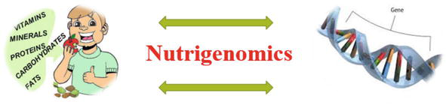
Fig1. Interaction of nutrient and gene
Source: Batool et al. (2022).

For years functional genomics methods like transcriptomic, proteomics and metabolomics have been hailed as having immense potential for advancing nutritional science by offering a new technology of diet-gene interactions and discovery of novel nutritional biomarkers (Akanbi, 2019). It can be said that genomics summarizes the instruction given by the DNA, whereas transcriptomics summarizes that which is concerned with the pattern of gene expression. The study of complex protein production and their interaction is called proteomics, whereas a step toward comprehending an organism’s entire metabolism is called metabolomics (Muthubharathi et al., 2021).
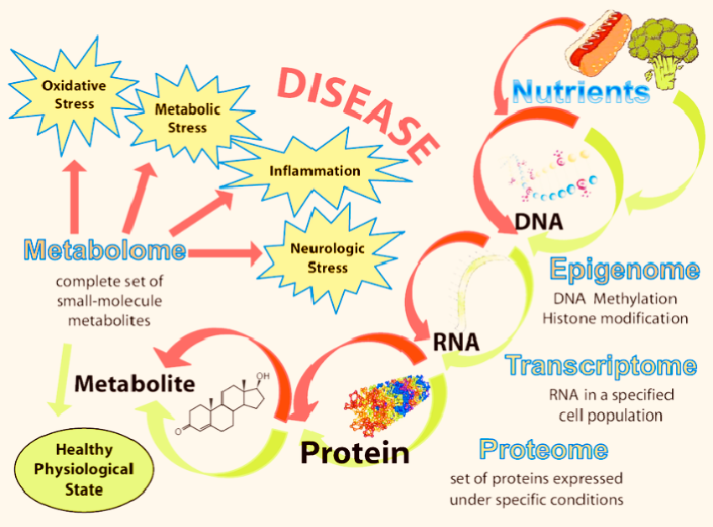
Fig2. Interaction of nutrient and gene
Source: Gonzalez (2020).

Technologies available for practical genomic testing are constantly revolving and improving. The field of nutrigenomic is continually expanding due to this development. The relationship between nutrition and gene can be assessed using DNA microarray methods, Real-Time Quantitative, Polymerase Chain Reaction (PCR) and DNA sequencing. Chip technology now enables the sequencing of many genes and the development of an accurate understanding of changes in gene expression, contrary to expensive transgenesis (Haq et al., 2022). Nutrigenomics can be successfully and cheaply used to increase animal production, growth rate, milk production, feed utilization, disease resistance and fertility.
Genomics can help bridge the gap between the genetic map of animal husbandry and feeding, improving transformation efficiency and productivity. In the past nutrigenomics studies have used approaches like Differential Display PCR and Real-Time Quantitative PCR to monitor the expression of some genes.
Modern advances in genomics analysis offer more effective solution to a wide variety of biological problems. Thanks to the discovery of microarrays and massive transcriptome sequencing (RNA sequencing), it is now possible to analyze gene expression on a large scale (Haq et al., 2022). These innovative technologies were based on the idea of accumulating high-through put data by automating and parallelizing protein and DNA/RNA synthesis. The most extensively utilized omics methods for gathering proteomic, transcriptomic and metabolomic data have been created. However, Scientist now may use current systematic methodologies to examine interaction occurring within living animals using developing bioinformatics tools in tandem with biological data provided by genomics and transcriptomics (Chakraborty et al., 2022).
Nutrigenomics investigates the effect and interaction of nutrition on gene expression using large-scale gene expression method (Hasan et al., 2019).
Researchers can learn more about the molecular basis of observed phenotypic differences within organisms by studying gene expression in animals subjected to different nutritional condition and the metabolic pathways directly involved in regulating tissue structures thus contributing to tissues quality.
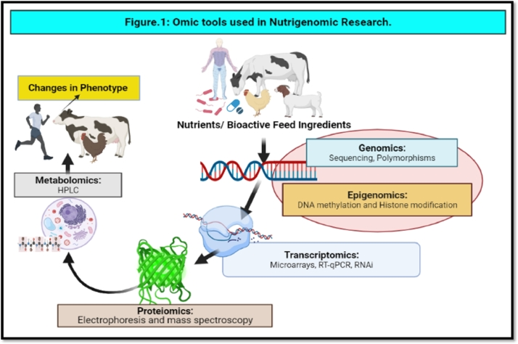Fig3. Omics tools used in Nutrient Research
Source: Andrabi and Saleem (2022).

Transcriptomics
With technical advancements in the microarrays and RNA sequences, the expression of virtually all the transcribed genes in a sample could be quantified, hence, the transcriptome.
A trascriptome is a snapshot of all the transcripts present in a cell at a particular point in time (Haq et al., 2022). Transcriptome research has improved our understanding of the RNA-et based gene regulating network as next-generation high-through put sequencing technology.
For the first time in small ruminants, a nutrigenomic analysis of goat mammal transcriptome responses was performed in feed deprived goats (Haq et al., 2022). This research showed the genes responsible for reduction of milk fat, lactose and protein, genes responsible for the impediment in the proliferation and differentiation of mammalian cells and the increase in programmed cell deaths, contribute to early mammalian involution.
RNA sequencing has been in used since 2011 and has recently replaced microarray systems in omics science. This technology was used to study the transcriptome and the micro RNAome from small ruminants such as goat and sheep (Martyniuk et al., 2020). RNA sequencing with high-throughput has become the method of choice for animal nutritionist to set up a framework for developing feeds or feed additives, promoting animal growth, health and production.
This method is used to investigate global gene expression patterns in tissues linked to economically significant features like feed efficiencies or quantitative determination of the genes or transcripts, which can be used as potential biomarkers for production traits (Haq et al., 2022).
Eventhough its application faces some technical challenges in both experimental and computational aspect; the novel RNA sequence technology for transcriptomics analyses in invivo organism is considered a powerful approach to better understanding molecular mechanisms in terms of nutrient gene interaction.

Proteomics
The word proteomics was coined in 1995 describing it as the broad scale characterization of cells lines, the tissues or organism’s entire protein compliment, simply defining it as a study of protein, chiefly their functions and structure (Hossain, 2020). Proteomics is a crucial component of nutrigenomics, which aims to comprehend how our genomics is expressed in response to nutrition on a holistic level.
The main objectives of proteomics are to achieve a more global and integrated view of biology by analyzing all of a cells protein at a time.
The application of proteomics in livestock has been limited in past due to a lack of optimized protocols and high cost (Haq et al., 2022). However new occupational tools and analystical method for the analysis of proteomic data, have led to an increased understanding of animal health, production, reproduction efficiency (Kaya et al., 2022; Ye et al., 2022).
The use of proteomic approaches for studying reproductive problems has dramatically increased in the past-decade (Andrabi and Saleem 2022). Targeting robusi-profein markers is useful in disease monitoring, surveillance, health monitoring and overall well-being of the animal which will help assess pharmacologic responses to therapeutics (Maihanguzi et al., 2022).
Proteomics is used to identify genetic variants with traits desirable for breeding and selection of various animal products post-harvest like milk, meat, cheese etc (Li and Liu, 2024). Proteomics approaches of farm animals have been applied to improve animal welfare to prevent a negative effect on animal production and human health besides clinical management and treatment of human diseases (Haq et al., 2022).
Since the animal genome has not been fully sequenced as in humans, the serum proteome analysis and characterization in most farm animals are in the preliminary states or phase (Haq et al., 2022). Protein and metabolites level expression measurement provides new ways and knowledge to determine and manage the nutrient balance in farm animals. Hypothesis for such studies can be translated from similar human studies which help to optimize diet composition and dietary nutrient supply in defined population of livestock species or individual animals (Haq et al., 2022).
In farm animals, proteomics could help evaluate the risk of zoonosis, increase productivity and fertility, and improve the safety and quality of animal products thus, reducing financial loses as well.
The application of proteomics can identify fertile bulls to increase productivity and reduce the non-return rate (NRR). For selective breeding proteomic tools are utilized to identify superior genetic variants (Mullins et al., 2021) and can identify protein markers which will help in the selection of genetics variants, accelerate-genetics gain and increase profitability (Mullins et al., 2021).
The last decade has marked proteomics as the main forum for interviewing plama/serum proteomics for exploration of next generation biomarkers in the veterinary and human sector, with introducing standard pre-analytical sample therapies MS-based systems for data management (Casteli et al., 2021; Gbodasara et al., 2022). Thanks to the vast number of serum protein that can be investigated concurrently, the proteomic approach is quicker than the ELISA and PCR methods.

Metabolomics
Metabolomic deals with screening the small molecule metabolites in biological samples like animals, plants and microbes (Bishai and Palm, 2021). By comparison, the metabolome profiles (Metabolic phenotypes or metabotypes), one can establish patterns of variation among different groups, i.e. control versus treated, healthy versus diseased. Metabolomic in livestock has made significant advancements to livestock welfare, reproduction and development as well as the dictation of biomarkers for transformation diseases, production traits in dairy and beef cattle (Hao et al., 2021; Miggiels et al., 2019; Haq et al., 2022) and all to incorporate prognostic techniques in animal health and improve prediction accuracies. In addition, many bio-fluids have been investigated for metabolomic research, including metabolic profiling of plasma, milk, urine and serum which has abridged animal welfare concerns (Haq et al., 2022).
Currently two fundamental techniques are being used in metabolomics i.e. nuclear magnetic resonance (NMR) spectroscopy and mass spectrometry (MS). However, mass spectrometry is often coupled together with a separation technique, such as gas chromatography (GC), liquid chromatography (LC) or capillary electrophosis (CE). Nuclear magnetic resonance (NMR) is now more advanced than mass spectrometry (MS) for high throughput analysis in terms of analysis, time and cost per sample. The NMR spectrum usually takes 5 to 8 minutes, while the LC analysis takes 5 to 30 minutes (Wishart et al., 2022). Due to its high sensitivity, mass spectrometry (MS) has a broader range of coverage. It has potential performance advantages in terms of metabolites per minute, which explains why more innovative technologies than NMR have been developed in this field (Wang et al., 2021). For metabolomics, there have been recent technical advancements and movements towards quicker and more comprehensive processes using a smaller number of samples at a low cost per-sample (more for less) (Wishart et al., 2022).

Lipidomics
Meat production worldwide has recently concentrated on improving meat quality in fatty acid profile and marbling. Induced marbling requires a better understanding of the pathways that regulate fat formation (Laderia et al. 2018; Haq et al., 2022).
Vitamin A has recently been discovered to positively impact almost all adipogenesis stages in animals. Retinoic acid is the active metabolite of Vitamin A, which can induce retinoic acid receptor (RAR) and retinoid * receptor (R*R), reading to epigenetic mutations in the central regulating genes of adipogenesis (Chen, 2021). Further, dietary manipulation during specific periods of pregnancy, like in the pre-natal period, nutrients acts not only on the developing fetus but also on the primary germ cells that give rise to the next generation (Dimofskir et al., 2021), thus, feeding specific nutrients will have both short term and long-term consequences.
By using these newly developed methods, functional lipidomics can help profile and understand the unique functions of each lipid subtype (Haq et al., 2022). Lipidomics can be applied directly to human plasma, potentially identifying novel and predictive disease biomarkers such as coronary diseases progression and responsiveness to treatments. Lipidomics provides a promising method for investigating the relationship between dietary lipids and cardiometabolic risk, allowing the identification of lipid biomarkers.

IMPACT OF THE RELATIONSHIP BETWEEN NUTRIENTS AND GENOME IN ANIMAL HEALTH AND PRODUCTION.
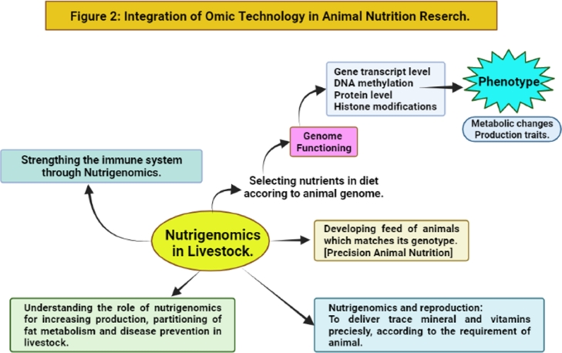
Fig4. Integration of omic technology in animal nutrition research
Source: Haq et al. (2022).
Nutrigenomics research aims to explain the molecular interactions between genes and diet, and identify necessary molecular signatures to develop effective nutritional strategies. There has been a prodigious increase in facing the substantial challenges from a sharp projected increase in global demand for food and high quality animal protein besides adaptation to environmental stresses and effect of disease etiology (Haq et al., 2022).
Studies of gene expression analysis are carried out in response to dietary regiments because the biochemical parameters depend on the particular gene transcripts (Mierziak et al., 2021). In dairy cattle, the experiments are focused on milk yield and composition. In contrast, in beef cattle, experiments are focused on obtaining the fatty acid profile in muscles tissues and thus modulating specific diets.
Animal health is essential in both pigs and poultry, so supplement such as amino acid, vitamins and a prebiotics are used, affecting transcription of genes and playing a virtual role in the immune system function (Alagawany et al., 2021).
The effect of diet on genome functioning have usually been performed on experimental models like pigs, rats, mice. Studies of specific life period (pregnancy) have been conducted in rats and mice (Christians et al., 2019) and the phenomenon of fetal programming, wherein maternal nutrition affect progeny genome functioning have been studied in rodents (Haq et al., 2022).

EPIGENETIC CONTROL ON LIVESTOCK PRODUCTION
The study of nutritional epigenetic relates to genes diet interactions (Lucini et al., 2021). Nutritional epigenetic in livestock production is still in the infancy stage. However a foundation of nutritional epigenetic research has been established and validated. Diet might play a regulatory role in the epigenetic makeup of the first generation consumer, but it also affects progeny performance (Roberts, et al., 2019).
There are multiple genes and environmental interactions while considering the phenotypic variation. One of the critical environmental players in these phenotypes is nutrient quality and quantity. For example nutrient induced epigenetic events can be found in honey bee and mice (Alhosin 2023). Nutritional phenotypes are primarily studies from the growth, feed intake and efficiency perspectives. In livestock and genome under nutritional epigenomics studies, association between epigenetic modification and nutritional phenotype are well documented (Haq et al., 2022). Epigenetic mechanism, genetic variation and subsequently economically improved phenotypes have been identified in livestock.
One of the overarching goals is to investigate the economically essential traits to determine the extent to which phenotypic variation can be accounted for by genetic variation in the livestock community. Nevertheless to comprehend the mechanistic link between phenotype and genotype, tools must be generated that will allow us to interrogate the epigenetic modifications.
In the past epigenetic studies in livestock animals have utilized DNA methylation-based next generation sequencing methods to investigate the role of methylation in the phenotypic variation of their economically important trait (Haq et al., 2022).
NUTRIGENOMICS IN POULTRY
In poultry, the intestinal tract (GIT) expands allometrically compared to the rest of the body during the 1st week after hatching. Because of this rapid expansion rate supplemental feed during the first 96hrs of hatching has a long term impact on the animals (Van Every, 2021). For this animal to reach their genetic potential, they must have a stable digestive system. Intensive poultry rearing causes stress in birds, resulting in the lowered immune response that enhances intestinal colonization of pathogens and gastrointestinal disturbance (Arif et al., 2021).
Scientist has used modern genomic approaches to investigate how the duct interacts with the gut immune system to further understand the processes and efficacy of various food therapy strategies. In namaldehyde, carvacrol, oleoresin from Capsicum Spp and turmeric (Abd E-Back et al., 2022), according to studies are all effective on the GIT immune response. Plants derived phytochemicals have been shown to control the gene expression involved in physiology and immunity (e.g. protein and energy metabolism) implying that they can help chickens become more immune.
Gene expression profile in yeast cell wall supplemented broilers demonstrated that biological processes and pathways connected to enhanced health and metabolism were activated compared to a common antibiotics (bacitracin)(Jha and Mishra, 2021). According to the findings of this microarray study birds that were provided with yeast cell wall underwent genomic changes that corresponded to slower gut cell turnover and as a result, improved energy utilization for growth (Haq et al., 2022).
The latest nutrigenomics finding explicitly open up new opportunities for developing effective drug free diseases prevention strategies for poultry infectious diseases. The effect of micronutrient supplementation on transcriptional protein of ducks was also studied including vitamins and minerals in the diet of hens. Supplementation increased the gene in RNA level of intestinal cells and proliferation, which corresponded to the number of villi proliferating cells and the transitional area of the supplemented population. As a result gene expression has been modified and could affect feed absorption metabolism and the gut immune system (Mousavinasab et al., 2023). Elmeria acervulina induces intestinal damages in commercial poultry production. It has been tested for its efficacy against anethole, turmeric and garlic metabolites (Nahed et al., 2022; Abdeli, et al, 2021).
The expression of oxidative phosphorylation genes and other cellular stress response genes in the jejunum was improved by prebiotics such as yeast cell walls. Gene expression profiles in yeast cell-wall supplemented broilers demonstrated that biological processes and pathways connected to enhance health and metabolism was activated compared to a common antibiotic (Jha and Mishra, 2021).
According to this micro array studies, birds that were provided yeast cell walls underwent genomic changes that corresponded to slower gut cell turnover, and as a result, improved energy utilization for growth
Probiotics have also been studied with the use of omics techniques. Among the enterocyte protoem of broilers fed enterococcuss faecum,some differently expressed proteins were associated with antioxidant and immune processes,suggesting that the chickens used fewer nutrients and energy to cope with antioxidant and immune stress (Khan et al., 2018)
The recent increase in mycotoxin content in feed stuff due to shifting climatic conditions has sparked curiosity about their effect on the liver genome, At concentrations as low as 2 to 2.5 mg/kg per feed,aflatoxin B1 may affect this organ. Absorbents such as clay are used as tactile solution to reduce the consumption of mycotoxins.(Yang et al., 2022).

NUTRIGENOMICS OF MEAT.
Marbling is an essential characteristic of ruminant meat consistency because it affects juiciness and flavor. Adding together, since the fatty acid content of lipids in meat is critical for human health, this issue has gotten much attention in recent decades.
Nutrigenomic research has aided researchers in better understanding the cellular pathways that affect fatty acids profile and meat marbling this way. This information could benefit the livestock industry by encouraging it to produce substances or chemical compounds that can modulate the expression of genes, resulting in better meat quality (Haq et al., 2022). Nutritionist will now be able to use feedstuff and other foods due to this experience.
Adipogenesis and marbling are programmed in the womb and has long term implications for meat quality and fat deposition (Desoye and Herrera, 2021). There is a concern about manipulating the fatty acid profile of meat due to their potential beneficial or harmful effects on human health.
PUFA is involved in many biological processes vital to human health (Haq et al., 2022). Because of the observed per cholesterolemic linoleic and palmetic fatty acids are hypercholesterolemic. Controversely, because of the pragmated increase in low density lipoprotein content in the blood, lauric and palmetic fatty acids are hypercholesterolemic (McPherson et al., 2020).

ROLES OF NUTRIGENOMICS IN HUMAN LIVESTOCK INTERFACE
The expanding number of research on humans, animals and cell culture indicates that nutrients and other bioactive chemicals in the diet can affect the expression of genes in a variety of ways (Felishino et al., 2021).
Thus studying the molecular mechanisms of nutrients and other bioactive food ingredients is necessary to understand the effect of diet on health. Because of the intricacy of human behavior and the human genome, studying animals is a helpful way to understand genetic implications on food selection. As a result the applied study of the human nutrition, the use of animals for food consumption studies was a natural development.
Nutrigenomic studies in domestic animals are much less common. They focus on a minmal number of genes that are specifically related to a specific treatment, which is usually associated with the energy content of the diet or the content of some of the components, such as polyunsaturated fatty acid (PUFA), protein or L. carnitine (Haq et al., 2022). Nutrigenomics will help create a genotype matched animal feed by selecting nutrients that are fine tuned to the particular animals gene improving health and productivity significantly.

CURRENT PROGRESS
With the help of Omics approaches, such as metabolomics, transcriptomics and protoeomics, molecular genetics technology can apply to inheritable traits like growth rate, body weight, carcass quality and feed intake (Kasper et al., 2020).
Nutrigenomics promotes animal growth by focusing on an animal physiological and nutritional rate and adjusting metabolism to nutrient status in bodily fluid such as blood, saliva and excretion (faeces, urine and breath).
Detecting nutrient imbalance and using other omics approaches in livestock feeding research gives new means and more significant knowledge to assess and regulate the balance of nutrients in farm animals (Hasan et al., 2019). The same human investigations may translate the hypotheses of this research.
Nutrigenomics help scientist discover genes and DNA in each animal’s cell or tissue by assisting them in selecting nutrients. As a result nutrigenomics is a technique for creating genotype-matched animal feed/food, selecting fine-tuned nutrients for animal genes and understanding how nutritional management influences animal performance (Malgwi et al., 2022).

CONCLUSION
Humans and animals have a complex relationship (the human-animal interface) by which improvements in animal health and products will leave positive changes to human life such as access to good protein, equitable development globally and low cholesterol meat for reducing cardiovascular problems in the society.
Recent advances in nutrigenomics research have led to several high-performance tools being developed for livestock like full genome sequencing, global RNA sequencing and chromatin immuo-precipitation sequencing.
In conclusion, even though its application faces some technical challenges in both experimental and computational aspect, omic technology is considered a powerful approach to better understanding molecular mechanisms in terms of nutrient gene interaction

REFERENCE
Abd El-Hack E.M., El-Saadony M.T., Salem H.M., El-Tahan A.M., Soliman M.M., et al. (2022). Poultry Science. [PMC free article] [PubMed] [Google Scholar]
Abdelli N., Solà-Oriol D., Pérez J.F. (2021). Phytogenic feed additives in poultry: Achievements, prospective and challenges. Animals. 11(12):3471. [PMC free article] [PubMed] [Google Scholar]
Ahluwalia M.K. (2021). Nutrigenetics and nutrigenomics—A personalized approach to nutrition. Advances in Genetics. 2021;108:277–340. [PubMed] [Google Scholar]
Akanbi O.M. ( 2019). Animal nutrigenomics: opportunities and challenges for sustainable animal products in Nigeria. Emergency Medicine and Trauma Care Journal: EMTCJ-100007, 2019.(02) [Google Scholar]
Alagawany M., Elnesr S.S., Farag M.R., Tiwari R., Yatoo M.I., Karthik K., et al. (2021). Nutritional significance of amino acids, vitamins and minerals as nutraceuticals in poultry production and health–A comprehensive review. Veterinary Quarterly. 41(1):1–29. [PMC free article] [PubMed] [Google Scholar]
Alhosin M. (2023). Epigenetics Mechanisms of Honeybees: Secrets of Royal Jelly. Epigenetics insights, 16, 25168657231213717. https://doi.org/10.1177/25168657231213717
Andrabi, S. and Saleem, A. (2022). Nutrigenomics in Livestock Sector and its Human-Animal Interface-A Review. Veterinary and animal science. 17. doi = 10.1016/j.vas.2022.100262
Arif M., Akteruzzaman M., Islam S.S., Das B.C., Siddique M.P., Kabir S.L. (2021). Dietary supplementation of Bacillus-based probiotics on the growth performance, gut morphology, intestinal microbiota and immune response in low biosecurity broiler chickens. Veterinary and Animal Science. 14 [PMC free article] [PubMed] [Google Scholar]
Barros-Rodríguez A., Rangseekaew P., Lasudee K., Pathom-Aree W., Manzanera M. (2021) Impacts of agriculture on the environment and soil microbial biodiversity. Plants. 10(11):2325. [PMC free article] [PubMed] [Google Scholar]
Batool, A., Farooq, U., Shafi, A., and Khan, Z. (2022). Nutrigenomics: Challenges and Opportunities. IntechOpen. doi: 10.5772/intechopen.104438
Bishai, J. and Palm, N. (2021). Small molecule metabolites at the host-microbiota interface. The journal of immunology. 207(7): 1725-1733.
Castelli F.A., Rosati G., Moguet C., Fuentes C., Marrugo-Ramírez J., Lefebvre T., Junot C. (2021). Metabolomics for personalized medicine: The input of analytical chemistry from biomarker discovery to point-of-care tests. Analytical and Bioanalytical Chemistry. 2021:1–31. [PMC free article] [PubMed] [Google Scholar]
Chakraborty D., Sharma N., Kour S., Sodhi S. S., Gupta M. K., Lee S.J.and Son Y. O. (2022). Applications of Omics Technology for Livestock Selection and Improvement. Frontier Genetic.13:774113. doi: 10.3389/fgene.2022.774113. PMID: 35719396; PMCID: PMC9204716. June 2, 2022.
Chen G. (2021). The interactions of insulin and Vitamin A signaling systems for the regulation of hepatic glucose and lipid metabolism. Cells. 2021;10(8):2160. [PMC free article] [PubMed] [Google Scholar]
Christians, J.K., Lennie, K.I., Wild, L.K. et al. ((2019). Effects of high-fat diets on fetal growth in rodents: a systematic review. Reprod Biol Endocrinol 17, 39 (2019). https://doi.org/10.1186/s12958-019-0482-y
Desoye G. and Herrera E. (2021). Adipose tissue development and lipid metabolism in the human fetus: The 2020 perspective focusing on maternal diabetes and obesity. Progress in Lipid Research. 2021;81 [PubMed] [Google Scholar]
Dimofski P., Meyre D., Dreumont N., Leininger-Muller B. (2021). Consequences of paternal nutrition on offspring health and disease. Nutrients. 2021;13(8):2818. [PMC free article] [PubMed] [Google Scholar]
Felisbino K., Granzotti J.G., Bello-Santos L. and Guiloski I.C. (2021). Nutrigenomics in regulating the expression of genes related to type 2 diabetes mellitus. Frontiers in physiology. 2021:1109. [PMC free article]
Fukase E. and Martin W. (2020). Economic growth, convergence, and world food demand and supply. World Development. 132:12. 104954. [Google Scholar]
Ghodasara P., Satake N., Sadowski P., Kopp S., Mills P.C. (2022). Investigation of cattle plasma proteome in response to pain and inflammation using next generation proteomics technique, SWATH-MS. Molecular Omics. 18(2):133–142. [PubMed] [Google Scholar]
Gonzalez, M. (2020). Nutrigenomics, Metabolic Correction and Disease: The Restoration of Metabolism as a Regenerative Medicine Perspective - Scientific Figure on ResearchGate. Available from: https://www.researchgate.net/figure/Illustrates-the-concept-of-Nutrigenomics-as-the-effects-of-the-balance-of-nutrients-on_fig1_292944164.
Hamid, A., Pien, L., Rahimi, N., Balang, R., Yuniarti, F. (2022). The Impact of COVID-19 Lockdown Towards Social Media Usage and Body-Esteem among Adolescents in Kuantan, Pahang. International Journal of Care Scholars, 5(3), 44-51.
Hao D, Bai J, Du J, Wu X, Thomsen B, Gao H, Su G, Wang X. (2021). Overview of Metabolomic Analysis and the Integration with Multi-Omics for Economic Traits in Cattle. Metabolites. 2021; 11(11):753. https://doi.org/10.3390/metabo11110753
Haq, Z. U., Saleem, A., Khan, A. A., Dar, M. A., Ganaie, A. M., Beigh, Y. A., Hamadani, H. and Ahmad, S. M. (2022). Nutrigenomics in livestock sector and its human-animal interface-a review. Veterinary and Animal Science. 2022 Jul 6;17:100262. doi: 10.1016/j.vas.2022.100262. PMID: 35856004; PMCID: PMC9287789.
Hasan M.S., Feugang J.M. and Liao S.F. (2019). A nutrigenomics approach using RNA sequencing technology to study nutrient–gene interactions in agricultural animals. Current Developments in Nutrition. 3(8):82. [PMC free article] [PubMed] [Google Scholar]
Hossain M. (2020). Selected reaction monitoring mass spectrometry (SRM-MS) in proteomics. Springer; Cham: 2020. Selected Reaction Monitoring Mass Spectrometry; pp. 53–88. [Google Scholar]
Jha R. and Mishra P. (2021). Dietary fiber in poultry nutrition and their effects on nutrient utilization, performance, gut health, and on the environment: A review. Journal of Animal Science and Biotechnology. 2021;12(1):1–16. [PMC free article] [PubMed] [Google Scholar]
Kasper C., Ribeiro D., Almeida A.M.D., Larzul C., Liaubet L. and Murani E. (2020). Omics application in animal science—A special emphasis on stress response and damaging behaviour in pigs. Genes. 2020;11(8):920. [PMC free article] [PubMed] [Google Scholar]
Kaya A., Dogan S., Vargovic P., Kutchy N.A., Ross P., Topper E., et al. (2022). Sperm proteins ODF2 and PAWP as markers of fertility in breeding bulls. Cell and Tissue Research. 2022;387(1):159–171. [PubMed] [Google Scholar]
Khan, A. A., Ganai, A. M., and Haq, Z. (2018). Advances in nutrigenomics and its application in poultry. International Journal of Current Microbiology and Applied Sciences, 7, 2866–2872.
Kimura J., Kudo H., Fukuda A., Yamada M., Makita K., Oka K., et al. (2022). Decreasing the abundance of tetracycline-resistant Escherichia coli in pig feces during nursery using flavophospholipol as a pig feed additive. Veterinary and Animal Science. 2022 [PMC free article] [PubMed] [Google Scholar]
Ladeira, M. M., Schoonmaker, J. P., Swanson, K. C., Duckett, S. K., Gionbelli, M. P., Rodrigues, L. M., et al. (2018). Nutrigenomics of marbling and fatty acid proile in ruminant meat. Animal : An International Journal Of Animal Bioscience, 12(s2), s282–s294.
Li, H., and Liu, X. (2024). Introductory Chapter: Applications of Omics Techniques on Livestock Genetics and Breeding. IntechOpen. doi: 10.5772/intechopen.113934
Lucini, L., Marti-Quijal, F.J., .Barba, F.J., .Rocchetti, G., Quilez, F., Cuesta, L. et al. (2020). Nutrigenomics and public health. In Agri-Food industry strategies for healthy diets and sustainability (pp. 219–233). Academic Press.
Malgwi I.H., Halas V., Grünvald P., Schiavon S. and Jócsák I. (2022). Genes related to fat metabolism in pigs and intramuscular fat content of pork: A focus on Nutrigenetics and Nutrigenomics. Animals. 2022;12:150. [PMC free article] [PubMed] [Google Scholar]
Martyniuk C. J. ( 2020). Perspectives on transcriptomics in animal physiology studies. Comparative Biochemistry and Physiology Part B: Biochemistry and Molecular Biology. 2020;250 [PubMed] [Google Scholar]
McPherson, R. and Spiller, G.A. (.2020). Effects of dietary fatty acids and cholesterol on cardiovascular disease risk factors in man. In Handbook of lipids in human nutrition (pp. 41–50). CRC Press.
Mierziak J., Kostyn K., Boba A., Czemplik M., Kulma A., Wojtasik W. (2021). Influence of the bioactive diet components on the gene expression regulation. Nutrients. 2021;13(11):3673. [PubMed] [Google Scholar]
Miggiels P., Wouters B., van Westen G.J., Dubbelman A.C. and Hankemeier T. (2019). Novel technologies for metabolomics: More for less. TrAC Trends in Analytical Chemistry. 2019;120 [Google Scholar]
Molotoks A., Smith P. and Dawson T.P. (2021). Impacts of land use, population, and climate change on global food security. Food and Energy Security.10(1):261. [Google Scholar]
Mousavinasab, F., karimi, R., Taheri, S. et al. (2023). Microbiome modulation in inflammatory diseases: Progress to microbiome genetic engineering. Cancer Cell Int 23, 271 https://doi.org/10.1186/s12935-023-03095-2
Muhanguzi D., Ndekezi C., Nkamwesiga J., Kalayou S., Ochwo S., Vuyani M., et al. (2022). Anti-tick vaccines: Current advances and future prospects. Vaccine Design. 2022;2411:253–267. [PubMed] [Google Scholar]
Mullins Y., Keogh K., Blackshields G., Kenny D.A., Kelly A.K., Waters S.M. (2021). Transcriptome assisted label free proteomics of hepatic tissue in response to both dietary restriction and compensatory growth in cattle. Journal of Proteomics. 2021;232 [PubMed] [Google Scholar]
Muthubharathi B.C., Gowripriya T. and Balamurugan K. (2021). Metabolomics: Small molecules that matter more. Molecular Omics. 2021;17(2):210–229. [PubMed] [Google Scholar]
Nahed A., El-Hack Abd M.E., Albaqami N.M., Khafaga A.F., Taha A.E., Swelum A.A., El-Saadony M.T., Salem H.M., El-Tahan A.M., AbuQamar S.F. and El-Tarabily K.A. (2022). Phytochemical control of poultry coccidiosis: A review. Poultry Science. 2022;101(1) [PubMed] [Google Scholar]
Pal A. (2022). Springer; New York, NY: 2022. Nutrigenomics. in protocols in advanced genomics and allied techniques; pp. 559–569. [Google Scholar]
Roberts A.J. (2019). Multigenerational effects. Veterinary Clinics of North America. Food Animal Practice. 2019;35(2):355–364. [PubMed] [Google Scholar]
Sun H. Z and Guan L. (2018). Luo Feedomics: Promises for food security with sustainable food animal production. Trends in analytical chemistry. 2018;107 :130–141. [Google Scholar]
Tian X., Engel B.A., Qian H., Hua E., Sun S., Wang Y. ( 2021). Will reaching the maximum achievable yield potential meet future global food demand? Journal of Cleaner Production. 2021;294 [Google Scholar]
Van Every H.A. ( 2021). Transcriptomic and metabolomic characterization of post-hatch metabolic reprogramming during hepatic development in the chicken. BMC genomics. 2021;22(1):1–21.[PubMed] [Google Scholar]
Wang, M., Wang, H., Zheng, H. et al. (2021). Comparison of HPLC and NMR for quantification of the main volatile fatty acids in rumen digesta. Science Report. 11, 24337 (2021). https://doi.org/10.1038/s41598-021-03553-9
Wishart, D. S., Cheng, L. L., Copié, V., Edison, A. S., Eghbalnia, H. R., Hoch, J. C., Gouveia, G. J., Pathmasiri, W., Powers, R., Schock, T. B., Sumner, L. W., and Uchimiya, M. (2022). NMR and Metabolomics-A Roadmap for the Future. Metabolites, 12(8), 678. https://doi.org/10.3390/metabo12080678
Yang H., Wang Y., Yu C., Jiao Y., Zhang R., Jin S., et al. (2022). Resveratrol alleviates AFB1-induced ileum damage in ducks via the Nrf2 and NF-κB/NLRP3 signaling pathways and CYP1A1/2 expressions. Agriculture. 2022;12:54.
Ye J., Yan X., Qin P., Gong X., Li H., Liu Y., et al. ( 2022). Proteomic analysis of hypothalamus in prepubertal and pubertal female goat. Journal of Proteomics. 2022;251 [PubMed] [Google Scholar]

