GUT MICROBIOTA DIVERSITY AND GROWTH PERFORMANCE IN THE THREE GENOTYPES (NORMAL FEATHERED, FRIZZLED FEATHERED AND NAKED NECKED) OF IMPROVED NIGERIAN INDIGENOUS CHICKENS IN UYO

ABSTRACT
This study investigated the gut microbiota composition and growth performance of three genotypes of improved Nigerian indigenous chickens; Normal Feathered (NF), Frizzled Feathered (FF), and Naked Neck (NN) raised under intensive management conditions. A total of 200 day-old FUNAAB-Alpha chicks were reared for eight weeks at the University of Uyo Teaching and Research Farm. Growth parameters, including body weight and linear body measurements, were recorded weekly. Cecal samples were collected from 12 birds (four per genotype) for microbial analysis using 16S rRNA gene sequencing on a PacBio platform. Bioinformatics analysis was performed with QIIME2, SILVA databases, and PICRUSt2 to identify taxa, assess diversity indices, and predict functional roles. Results revealed that Bacteroidota and Firmicutes dominated the gut microbiota across genotypes, with Lactobacillus johnsonii and Lactobacillus crispatus emerging as key species. Notably, the Naked Neck genotype exhibited superior growth performance, with significantly higher body weight at weeks 6 and 8 (p<0.05). Sex significantly influenced growth, with males consistently outperforming females. The findings suggest that host genotype and sex significantly shape gut microbial composition and growth traits in Nigerian indigenous chickens. These insights provide a foundation for improving poultry productivity through genotype selection and microbiome-informed management strategies.

INTRODUCTION
Continuous research is being conducted by the poultry industry to enhance bird performance, food safety, and meat quality while also considering the well-being of the birds. The intestinal microbiota of chickens plays a crucial role in several physiological and metabolic processes essential for maintaining optimal health and productivity (Carrsaco et al., 2019; Alshelmani et al., 2016). The microbiota present in the gastrointestinal tract significantly affects the overall health and functioning of chickens. Numerous studies have demonstrated the vital role of microbes in essential processes such as nutrient absorption, feed digestion, and bolstering the immune system (Shaufi et al., 2015; Tan et al., 2019; Kang et al., 2021). Furthermore, the makeup of the chicken feed has the potential to influence the presence of microorganisms in the chicken's gastrointestinal system, ultimately influencing their overall well-being and productivity (Zhang et al., 2019). A thorough examination of the gut microbiota is essential for researchers to enhance their understanding of microbial interaction and diversity. This understanding is crucial for developing effective measures to improve the overall gut health of chickens. The microbial community found in the caecum of chickens is the most complex and diverse in their digestive system. It serves crucial functions such as preventing the growth of harmful pathogens, removing toxins, absorbing nutrients, and recycling nitrogen from uric acid (Shaufi et al.,2015). Several factors, comprising the age of the organism, genotype, sex, and dietary aspects, have a substantial impact on the taxonomic makeup of the microbiota (Clavijo Florez, 2018). As mentioned above, the genotype of chickens plays a vital role in determining the productivity of these birds, thereby influencing the overall production outcomes, also in recent years, there has been a growing interest in understanding the intricate factors that influence their growth performance, with particular attention to sexual dimorphism and the gut microbiota (Alshelmani et al., 2013; Alshelmani, 2015). To search on diverse microorganisms occupied in the gastrointestinal tract of the chicken, metagenomics which is a widely utilized method for quantifying the population of individual microorganisms in each colony within the chicken's gastrointestinal tract during research on its diverse microbiota is considered (Frank et al. 2016; Ardui et al. 2018; Pearman et al. 2018; Wick et al. 2018 and Nicholls et al. 2019). Metagenomics is an effective method for examining the structure of the microbial community, evaluating the range of species present, and acquiring knowledge about the relationships between various groups of microorganisms. The initial stage in investigating the assortment and fluctuations of microorganisms harbored by chickens involves quantifying the population of individuals in each colony (Frank et al. 2016; Ardui et al 2018; Pearman et al 2018; Wick et al 2018 and Nicholls et al., 2019). The Nigerian indigenous chickens, which are recognized for their great meat quality and ability to adapt to tropical situations should also be assesses on the structure, composition and the cecal microbiota of these chickens which have not been fully explored yet (Zamani et al., 2016, 2017). Understanding the microbiota is crucial for maintaining gut integrity, as it directly impacts the birds' performance and production potential and the production parameters will be negatively affected by any modifications or changes made to the microbiome (Atansuyi et al., 2017). The growth and immune response of Nigerian indigenous chicken, which are well adapted to tropical regions, may differ depending on major genes. Thus, it is crucial to conduct research on the structure and operation of cecal microbiota and investigate on the diversity among the three improved Nigerian indigenous chicken genotypes. Hence, the aim of this study is to evaluate the effect of caecal microbiota on the growth of three improved Nigerian indigenous chicken.

MATERIALS AND METHODS
3.1 Experimental Site
The study was carried out at the Poultry unit, Teaching and Research Farm of the Department of Animal Science, University of Uyo. Akwa Ibom State. Uyo is found between latitude 4°31′ N and 45°31′ S and longitude 7°31′ E and 45°35′ W. The altitude of the area is 38m above the sea level and a mean rainfall of 200mm. The relative humidity is 79% with average Temperature of 28⁰ C (University of Uyo meteorology station, 2019).
Genomic analysis was carried out at the sub unit of Inqaba Biotechnology Laboratory Centre at Ibadan, Oyo state.
3.2 Procurement of Experimental birds
A total of 200 FUNNAB-Alpha day old chicks (Improved Nigerian indigenous) chickens which comprises of 3 genotypes of chicken (Normal feathered, Frizzle feathered and Naked necked) was purchased from the teaching and research farm of the Federal University of Agriculture, Abeokuta, Ogun state.
3.3 Housing and Management of experimental animal.
The management system used in this research was intensive system. On arrival, the initial body weight of the birds was taken using an electronic weighing balance with the capacity of 0.1g – 7000g and vaccinated with intraocular (IO) vaccine against new castle disease. The birds were sorted and placed into an already prepared disinfected brooder according to their genotypes and glucose in water solution was administered as anti-stress while feed and water was made available ad-libitum for the three weeks of brooding and standard management procedure was strictly adhered to.
The birds were tagged according to genotypes and was placed on starter mash (CP 23% and ME 3000kcal/kg of ME) from 0-4weeks and thereafter, broiler finisher mash (CP 20% and 2800Kcal/kg of ME). Throughout the course of the research, strict adherence to routine vaccination and feeding was ensured. The birds were raised in pens according to their genotypes and the project terminated at 8 weeks
3.4 Data Collection
3.4.1 Growth Data
The birds were weighed weekly for body weight using a digital weighing scale calibrated 0.01g while linear body traits were measured with measuring tape (tailors’ tape), ensuring accuracy and consistency across all samples. The following traits were recorded for each bird:
- Body weight (BW) - The total body weight of the bird
- Keel length (KL) - Distance from the base of the breast to the end of the sternum
- Wing length (WL) - Distance from the shoulder joint to the tip of the wing
- Wing span (WS) - Distance from one tip of the wings to the other tip of the wing
- Breast gird (BG) – Measurement around the body
- Thigh length (TL) – Distance from the body joint to shank joint
- Shank length (SL) – distance from the shank joint to the pad of the foot

3.4.2 Metagenomics Sample Collection
The randomly selected birds were slaughtered and the ceaca harvested, which the content was immediately extracted and placed in an Eppendorf tube containing DNA/RNA shield and immediately dropped in the icebox to prevent the microbes from degradation until it was taken to the laboratory for the analysis to be carried out. Electrophoresis was done to confirm present of DNA. PCR amplification was conducted to obtain amplicons. After confirmation of quality PCR products, the amplicons were then sent to Inqaba Biotech Centre at South Africa for Sequencing. The 16S rRNA gene Sequencing method (platform) was used for the sequencing.
3.4.4 Microbial DNA Extraction and Sequencing
The sample collected was taken to the Inqaba biotech unit at Ibadan for DNA extraction. DNA extraction was performed using the QIAGEN DNeasy PowerSoil Kit by following the procedure strictly. The DNA extracted was amplified through PCR method to obtain the amplicons. Electrophoresis was done to ensure the quality of amplicons with aganose gel electrophoresis at 80°c presence of DNA. The V1-V9 region of the 16S rRNA gene was amplified using universal primers (27F and 1450R). Sequencing was performed on a Pacbio platform (1350 single-end reads). Raw sequence data were deposited in a public repository (NCBI Sequence Read Archive).
3.5 Bioinformatics and Data Analysis
3.5.1 Bacterial Species Identification
Quality control and filtering were done using DADA2 hosted in QIIME2 to generate an operational taxanomic unit (OTU). Amplicon Sequence Variants (ASVs) were assigned using SILVA databases. Taxonomic classification was conducted at the phylum, family, class, genus, and species levels.
3.5.2 Microbiome data analysis.
Identified bacteria were classified into beneficial, opportunistic, and pathogenic groups based on literature. The potential impact of each bacterial group on gut health, immunity, and disease susceptibility was evaluated. Functional analysis of microbial communities was performed using PICRUSt2 (Phylogenetic Investigation of Communities by Reconstruction of Unobserved States).
3.5.3 Gut Microbiota and Growth Performance
Taxa influencing growth traits were recorded. The relationship between microbial composition and growth performance was assessed using linear mixed models (LMMs) in R. Correlation networks were generated to identify key bacterial
3.5.4 Interaction Effects of genotype and Sex on Microbial Composition
All data collected were subjected to analysis of variance using SAS software package version 2.0. A two-way ANOVA was used to assess the effects of genotype × sex on microbial diversity indices. Microbial interactions were examined using co-occurrence network analysis and means were separated by DUNCAN multiple range test.
3.6 Experimental Design
A total of 27 birds (9 birds per genotype) were randomly selected. The birds were subjected to same dietary treatments to assess the effect of genotype and sex on gut microbiota composition. A RCDB experimental design (Genotype × Sex) was used, with birds assigned to same feeding regimens. Means were separated at the alpha level of 95% (p<0.05)
3.7 Statistical model
Yijk = μ + Gi + Si + Gij + Є_{ijkl}
Y = the individual observed traits for i^{th} breed of j^{th} sex
μ = population mean
Gi^{th} = the fixed effect of breed (NF, FF, NN)
Sj^{th} = the fixed effect of sex (male and female)
Є_{ijk} = the random residual error which is assumed to be normally and independently distributed with zero means and variance

RESULTS
4.1: DETERMINATION AND EVALUATION OF GUT MICROBIAL COMMUNITY STRUCTURE IN 3 GENOTYPES OF IMPROVED NIGERIAN INDIGENOUS CHICKENS AT 8 WEEKS RAISED IN UYO.
4.1.1: The result of the analysis showing the microbial community structure in frizzled feathered improved Nigerian indigenous chicken at 8 weeks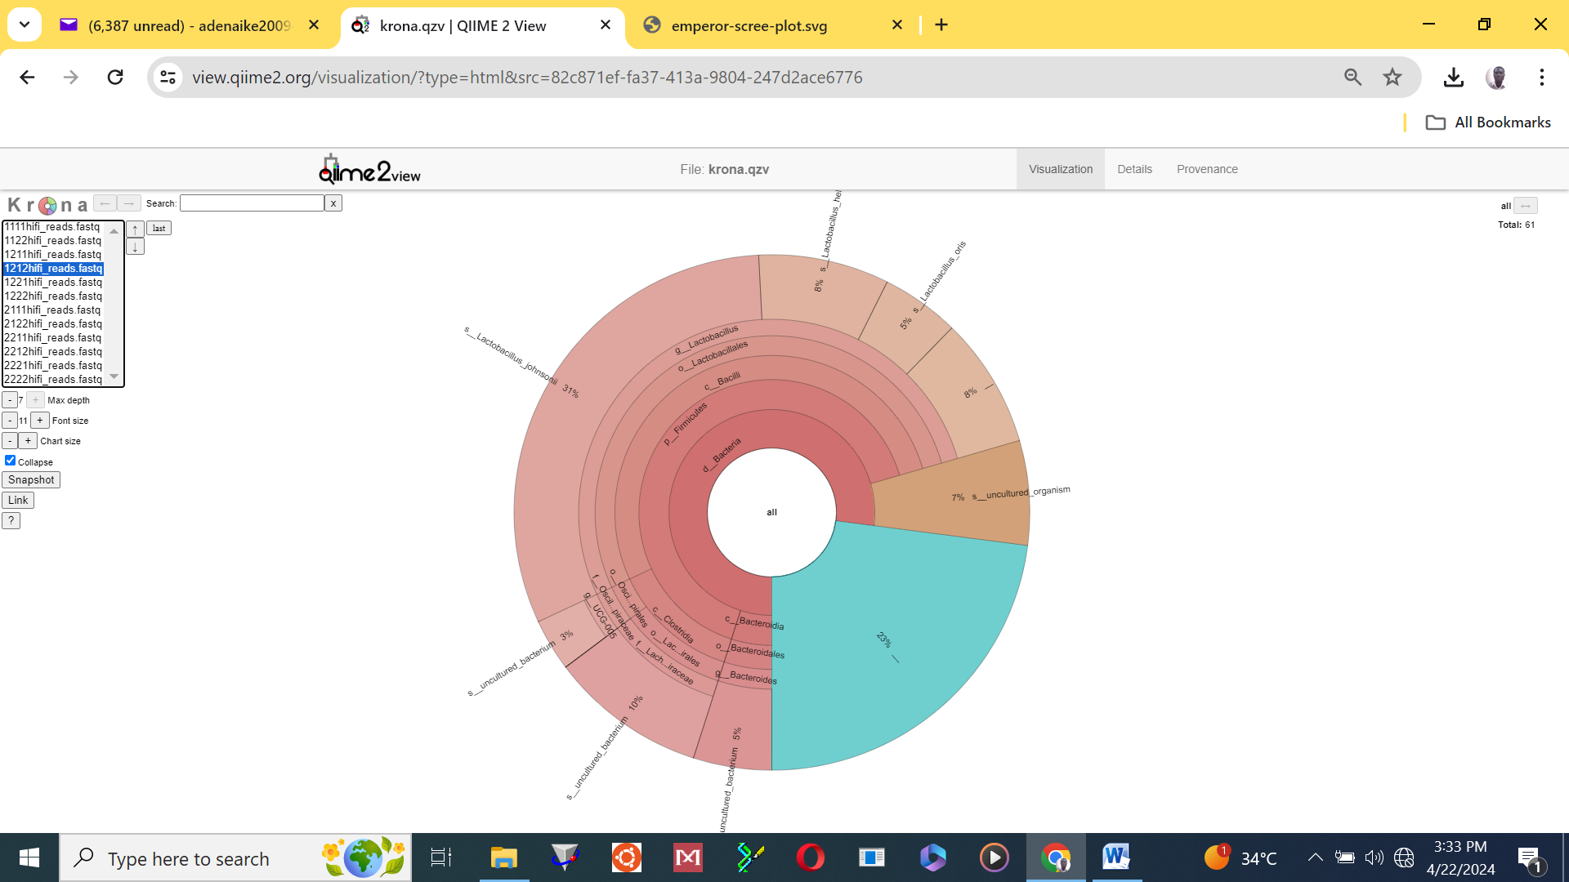
Figure 1: Microbial Community Profile Dominated by Lactobacillus johnsonii (31%)
4.1.2: The result of the analysis showing the microbial community structure in naked necked improved Nigerian indigenous chickens at 8 weeks.

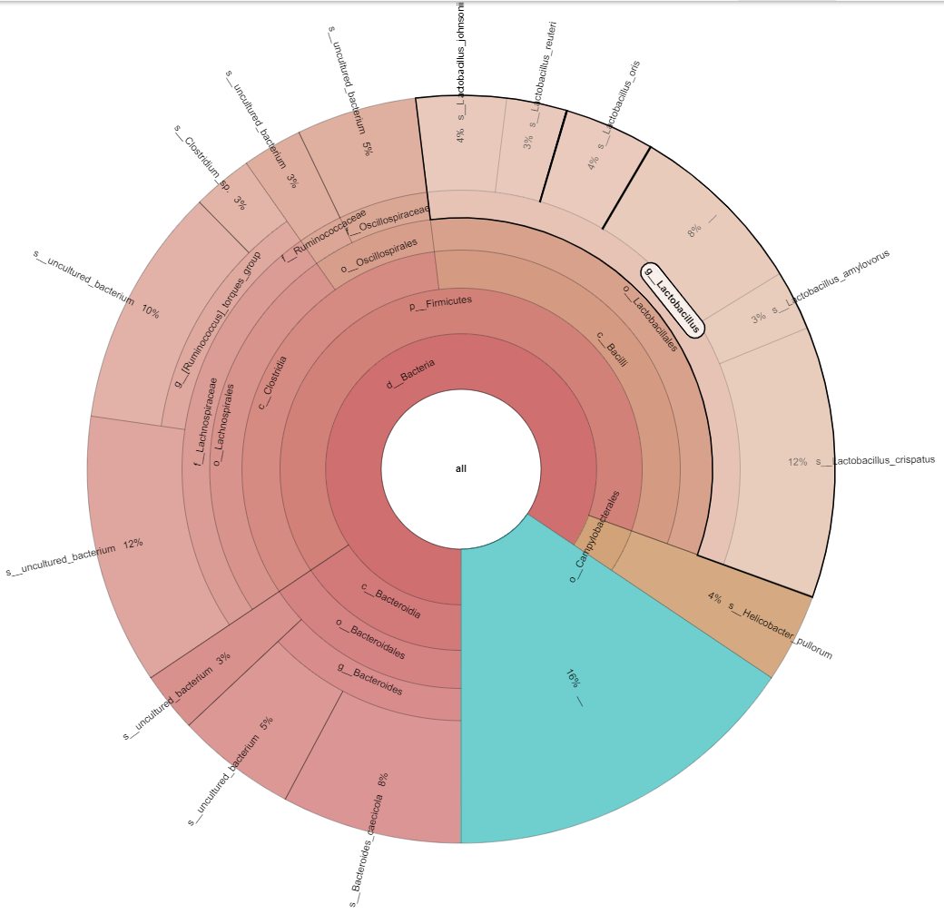
Figure 2: Microbial Community Composition and Relative Abundance at the Species Level
4.1.3: The result of the analysis showing the microbial community structure in normal feathered improved Nigerian indigenous chickens at 8 weeks.
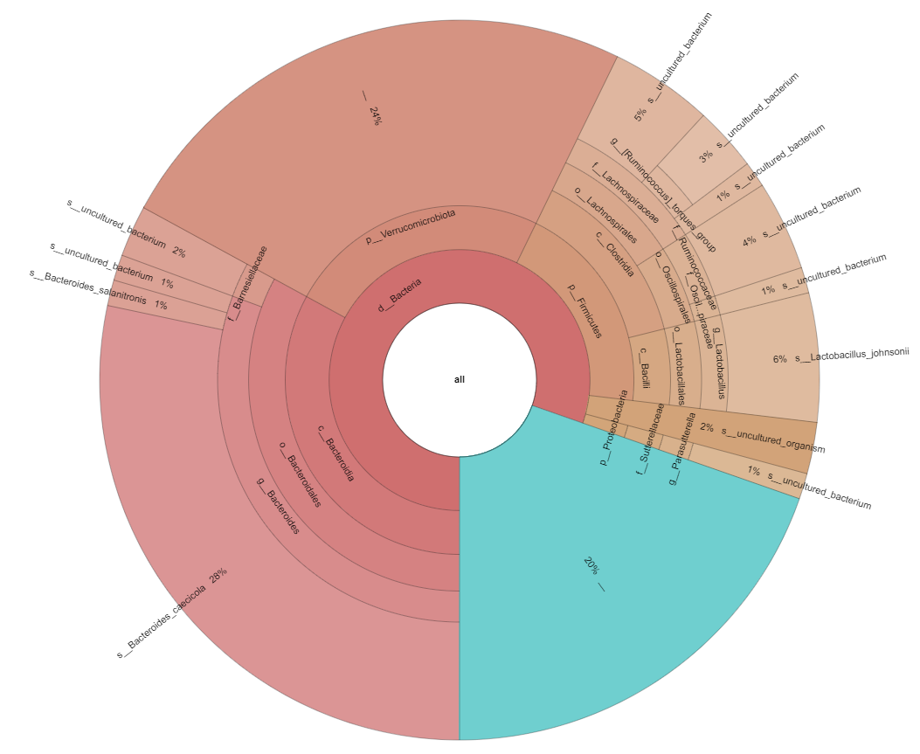

Figure 3: Microbial Community Composition Highlighting Dominant Phyla Verrucomicrobiota and Bacteroidetes

4.2: Evaluation of effect of genotype and sex on the morphological traits of the improved Nigerian indigenous chickens at weeks 2 to 8 of age.
Table 1: The result of the data analysis showing the effect of genotype on morphometric traits of improved Nigerian indigenous chickens from week 2 to 8.
WEEKS | GENOTYPES | MORPHOMETRIC TRAITS
WEEKS | GENOTYPES | KL | BG | SHL | WL | SPL | TL | BW
2 | FF  NN  NF | 5.470±0.23  5.257±0.27  4.500±0.22 | 13.786±1.15  12.256±1.32  11.200±1.92 | 3.735±0.18  4.469±0.21  3.700±0.17 | 4.541±0.31  4.914±0.35  4.300±0.29 | 10.067±1.17  10.776±1.34  10.025±1.11 | 4.737±0.21  5.133±0.25  4.725±0.20 | 125.870±16.97ª  138.700±16.06ª  116.057±19.44^{b}
4 | FF  NN  NF | 7.030±15.22  6.629±17.47  6.036±13.08 | 14.319±1.96  13.880±2.25  12.376±1.68 | 5.059±7.67  8.540±8.80  4.588±6.59 | 6.458±0.44  7.340±0.50  5.829±0.38 | 12.857±0.81  14.683±0.93  11.432±0.69 | 6.453±0.45  6.777±0.52  6.591±0.39 | 237.849±33.18ª  239.241±38.07ª  234.376±28.52ª
6 | FF  NN  NF | 9.269±0.52  8.911±0.29  7.992±0.44 | 16.461±1.89  13.577±2.83  13.415±1.60 | 5.709±0.48  6.082±0.68  5.649±0.39 | 8.378±0.50  9.643±0.75  9.000±0.42 | 16.636±1.28  19.326±1.92  18.000±1.09 | 7.841±0.40  8.517±0.60  8.358±0.34 | 419.069±69.04^{b}  494.110±10.50ª  402.607±58.77^{b}
8 | FF  NN  NF | 11.317±0.42  10.425±0.48  9.625±0.39 | 18.449±1.96  16 .923±2.25  15.825±1.86 | 7.714±0.56  6.744±0.64  6.750±0.53 | 9.703±0.70  9.281±0.80  11.675±0.66 | 19.584±1.24  18.401±1.42  23.250±1.17 | 8.691±0.56  9.582±0.64  9.500±0.53 | 569.188±65.00ª  672.892±74.44ª  537.050±61.53^{b}
The result of the effect of genotype on growth showed that genotype significantly (p<0.05) influenced body weight of improved Nigerian indigenous chickens at age 2, 6 and 8 but had no effect on the linear body parameters for the same weeks.
FF: Frizzle Feather, NN: Naked Neck, NF: Normal Fether, KL: Keel Length, BG: Body Girth, SH: Shank Length, WL: Wing Length, SPL: Span Length, TL: Tigh Length, BW: Body Weight.
ab: means in the same column with different superscript are significantly different at (p<0.05)

Table 2: The result of the analysis showing the effect of sex on morphometric traits of improved Nigerian indigenous chickens from week 2 to8
WEEKS | SEX | MORPHOMETRIC TRAITS
WEEKS | SEX | KL | BG | SHL | WL | SPL | TL | BW
2 | FEMALE  MALE | 5.235±0.20  5.116±0.21 | 11.508±0.98  11.653±1.01 | 3.932±0.16  3.671±0.16 | 5.554±0.26  5.016±0.26 | 12.989±1.00  12.257±1.03 | 4.490±0.18  4.439±0.19 | 121.885±14.54  131.866±14.88
4 | FEMALE  MALE | 6.391±13.06  6.901±12.67 | 12.801±1.68  13.581±1.63 | 4.266±6.59  4.865±6.39 | 7.109±0.38  6.642±0.37 | 13.949±0.69  14.379±0.67 | 6.599±0.39  6.614±0.37 | 228.956±28.52^{b}  245.355±27.63ª
6 | FEMALE  MALE | 7.869±0.56  8.246±0.43 | 14.062±1.98  15.907±1.55 | 5.895±0.48  6.731±0.37 | 8.995±0.53  9.608±0.41 | 18.189±1.34  19.536±1.05 | 8.656±0.42  8.821±0.33 | 468.705±72.53^{b}  498.485±56.75ª
8 | FEMALE  MALE | 10.571±0.36  11.339±0.37 | 16.334±1.68  18.130±1.72 | 6.941±0.47  7.196±0.49 | 10.963±0.60  11.976±0.61 | 21.560±1.05  23.396±1.09 | 9.375±0.47  10.140±0.49 | 592.334±55.70^{b}  627.085±57.00ª
The result of the analysis showed that sex influenced the body weight of improved Nigerian indigenous chickens at weeks 4, 6 and 8 but had no effect on the linear parameters for the same weeks.
FF: Frizzle Feather, NN: Naked Neck, NF: Normal Fether, KL: Keel Length, BG: Body Girth, SH: Shank Length, WL: Wing Length, SPL: Span Length, TL: Tigh Length, BW: Body Weight.
ab: means in the same column with different superscript are significantly different at (p<0.05)

DISCUSSION
Figure 1-3 showed the microbial communities present in the gut of the 3 genotypes of the Improved Nigerian Indigenous Chickens (INIC) - Alpha FUNAAB raised in Uyo at 8 weeks.
The analysis of the Krona chart indicates a significant presence of Bacteroidota, Firmicutes Lactobacillus and helicobacter highlighting notable aspects of the caecal microbiome that may be leveraged for their probiotic potential. The results presented regarding the relative abundances of prominent bacterial phyla and genera are indeed consistent with recent findings in avian microbiome research.
5.1 MICROBIAL COMMUNITY FOUND IN THE CAECAL CONTENT OF FRIZZLED FEATHERED GENOTYPE SAMPLE OF IMPROVED NIGERIAN INDIGENOUS CHICKEN RAISED IN UYO AT 8 WEEKS.
The result of the analysis of the caeca microbiota of the frizzled feathered genotype of the improved Nigerian indigenous chicken raised in uyo at 8 weeks revealed the dominance of bacteroidota. The majority of the microbiota belongs to Bacteroidota were between 40-50%. Firmicutes was another significant phylum, primarily represented by Lactobacillales. This result is in consonance with the study of Stanley et al. (2016) who reported that Bacteroidota and Firmicutes were found to be the dominant phyla. Specifically, Firmicutes accounted for approximately 50-60%, and Bacteroidota was around 20-30%. Lactobacillus johnsonii was present at 31%, suggesting its dominance in caecal content of this genotype sample. This aligns with the study of Gong et al. (2017) who found Lactobacillus johnsonii as one of the abundance species in their study. In their analysis of the ileal mucosa, which is a key site for nutrient absorption. L. johnsonii had a relative abundance of 21% which is greatly comparable to the 31% obtained in the study, suggesting a robust population of this beneficial microbe. Bacteroides and other Bacteroidales members also appear in moderate proportions. This is supported by the study of Li et al. (2019) whom in their studies of gut microbiome contained 30% Bacteroidetes. A notable portion (7%) was classified as uncultured organisms, indicating unknown or poorly characterized taxa. Uncultured bacteria contribute 3%, which may indicate novel microbial species and around 23% remains unclassified making up a total of 33% uncharacterized proportion. This corroborates with the discovery of Zhu et al. (2002) who found in their study of gut microbiota that 39.41% of chicken cecal samples belonged to uncultured bacteria. The result of this study agrees with that of Stanley et al. (2014) which also highlighted that a large proportion of bacteria in the chicken cecum, a site of intense microbial activity, belong to unclassified species or genera. Lactobacillales contribute significantly, with subcategories such as Lactobacillus amylovorus (8%) and other Lactobacillus species. The dominance of Lactobacillus johnsonii indicates a healthy probiotic presence which aid in maintaining gut barrier functions and modulating the immune response, which may have implications for poultry health and productivity. A moderate proportion of Bacteroides is typical for gut microbiota, contributing to digestion and metabolism. The presence of a large unclassified portion suggests that microbial diversity is still not fully understood, which is consistent with findings of Thompson et al., (2017) who discovered in his study the unexplored microbial taxa might represent novel species with unknown metabolic functions or capabilities.
5.2 MICROBIAL COMMUNITY FOUND IN THE CAECA CONTENT OF NAKED NECK GENOTYPE SAMPLE OF IMPROVED NIGERIAN INDIGENUOUS CHICKEN RAISED IN UYO AT 8 WEEKS OF AGE.
The result of the analysis of the caeca microbiota of the naked neck genotype of the improved Nigerian indigenous chicken raised in uyo at 8 weeks showed that Bacteroidota formed a major component, making up a significant portion of the microbiota (~30-40%) This corroborates with the findings of Song et al. (2021) who observed that Bacteroidota could constitute approximately (25-50%) of the microbiota in healthy naked neck chicken guts. Firmicutes is another dominant phylum, represented largely by Lactobacillales and Bacilli. This agrees with the study of Wei et al. (2013) who found in their study that the most abundant phyla was Firmicutes (70.0%), Lactobacillus crispatus (12%) was abundant, indicating a potential role in host health. This confirmed the discovery of Li et al. (2019) who reported a substantial presence of lactobacillus crispatus. Lactobacillus amylovorus (3%) and other Lactobacillus species were present, contributing to the Firmicutes composition. The Firmicutes phylum, dominated by Lactobacillus, has also been established as a crucial player in maintaining gut health and nutrient absorption as observed by Xu et al., (2023). Helicobacter (4%) is also present, which is relevant for gut health and potential pathogenicity. This result agrees with the study of Bejgarn et al., (2022) who reported various Helicobacter strains in their study to be either commensal or pathogenic. Therefore, further characterization and identification of the specific Helicobacter species present are vital to determine their role in the chicken gut microbiome. The finding of Uncultured bacteria (12%) obtained suggests a significant portion of microbes that are yet to be fully identified. Additional uncultured or unclassified taxa (10%) appear in various sections of the chart. This result suggests vital roles of both Bacteroidota and Firmicutes in optimizing digestion and immune responses in chickens. Lactobacillales remains a major order, supporting the presence of probiotic bacteria. A high Lactobacillus crispatus presence is often linked with a healthy microbiota, particularly in vaginal and gut environments. The presence of Helicobacter indicated their roles in gastric diseases. However, its presence suggested the need to check whether this is a commensal strain or a potentially pathogenic one. The large proportion of uncultured bacteria (12%) pointed out a familiar challenge in microbiome research which is the inadequacy of current culture-dependent methods to capture the full biodiversity of microbial life. However, Genetic sequencing technologies, especially metagenomics, have been instrumenetal in identifying and characterizing these uncultured taxa. According to a study by Bäckhed et al. (2015), advancements in sequencing techniques have dramatically improved the resolution of microbial communities, aiding in the discovery of previously uncharacterized microbes and their potential functions.
5.3: MICROBIAL COMMUNITY FOUND IN THE CAECA CONTENT OF THE NORMAL FEATHERED GENOTYPE SAMPLE OF IMPROVED NIGERIAN INDIGENUOUS CHICKEN RAISED IN UYO AT 8 WEEKS OF AGE.
The result of the analysis of the caeca microbiota of the normal feathered genotype of the improved Nigerian indigenous chicken revealed the major taxonomic groups present to be Bacteroidota (~30%) of total community, Verrucomicrobiota, Firmicutes and Proteobacteria. This result aligns with the findings of Wang et al. (2019) who found Firmicutes (~40%) and Bacteroidetes (~20%). Notably, Proteobacteria and Actinobacteria were also present at lower abundances roughly 15% and 10%, respectively. This resssult also agrees with the observation by Jin et al. (2018) who discovered Firmicutes ~38%, followed by Bacteroidota (~22%), and Proteobacteria (~10%) in their study of gut microbiota. The dominant species was Lactobacillus johnsonii (6%) relative abundance. this is in consonance with the findings of Wang et al. (2019) whose research reported that Lactobacillus spp represented about 5% of total sequences. This result also reported the present of several uncultured bacterium classifications (ranging from 1% to 5%) and Bacteroides uniformis (1%), around 24% of sequences were unclassified at different levels which supports the findings of Zhuang et al. (2020) whose research discovered the present of Bacteroides at around 5% and unclassified organism of 20%.
The microbiome domination by Bacteroidota suggested that these bacteria were the key players in digestion, particularly in the fermentation of complex carbohydrates, which can lead to improved gut health. This corroborates with recent studies which have highlighted the essential contributions of Bacteroidetes in maintaining gut homeostasis and their role in various metabolic pathways (Aagaard et al., 2019). Verrucomicrobiota and Bacteroides species playing a significant role. The presence of Lactobacillus johnsonii is noted for its probiotic properties, reinforcing gut integrity and influencing host immune response. Recent clinical trials emphasizing the benefits of Lactobacillus supplementation in improving gut health and mitigating symptoms of gastrointestinal disorders corroborate the potential of this species as a functional probiotic (Sato et al., 2021). A significant proportion of unclassified bacteria (~24%) indicates the presence of novel or less-characterized species. The presence of Bacteroides suggests a role in digestion and metabolism in the gut microbiome sample. A study by Wu et al. (2020) shows that Bacteroides species significantly influence the metabolism of dietary fibers, leading to beneficial short-chain fatty acid (SCFA) production, which has implications for gut health and immune regulation. The observation showed that around 24% of sequences are unclassified indicates the complexity and diversity of gut microbiota. This aligns with a recent meta-analysis by Huang et al. (2022) which emphasizes the vastness of microbial diversity in the gut and the critical need for advanced sequencing techniques to uncover these novel taxa.
5.4 Morphometric Traits of Improved Nigerian Indigenous Chickens
In this research, the growth performance of improved Nigerian indigenous chickens was assessed from week 2 to week 8 across three genotypes: Normal Feather (NF), Frizzle Feather (FF), and Naked Neck (NN) of improved Nigerian indigenous chicken. Morphometric traits including body weight (BWt), keel length (KL), breast girth (BG), shank length (SHL), wing length (WL), spur length (SPL) and thigh length (TL) were recorded.
Across all weeks, males consistently exhibited significantly higher body weights and growth-related traits compared to females. This result agreed with the observation of Bamaiyi et al. (2021), which shows that sexual dimorphism in chickens causes notable variations in growth performance, with males frequently surpassing females because of their larger body frames, more advantageous development rates and hormonal influence which result in aggressive eating habit.
The Normal Feather chickens generally displayed moderate values, while Frizzled Feathered chickens showed superior performance in wing length and thigh length, particularly evident at weeks 6 and 8. This result is in consonance with research by Abdul-Aziz et al. (2020) which showed that Frizzle Feather chickens can have improved skeletal development because of their distinctive feather structure. According to their findings of Abdul-Aziz et al. (2020), certain growth traits can be positively influenced by features of Frizzle Feather chickens' morphology, even if they may not excel in total body weight.
On the other hand, Naked Neck chickens, (NN genotype) demonstrated the highest body weight, reaching 672.892±74.44 at week 8. Notably, all other body parameters were also highest in NN genotypes in weeks 8, suggesting potential growth advantages associated with this genotype. Several studies highlighting the benefits of this genotype are supported by the superior body weight gains in the Naked Neck chickens. This finding is in agreement with the report of Oladele et al (2022) who found that, under comparable dietary and environmental settings, Naked Neck chickens consistently displayed higher growth rates and body weights than other genotypes. This points to a potential genetic adaptation that benefits the Naked Neck genotype's development efficiency, especially in hotter climates where they have been observed to thrive. This study demonstrates that the growth rates of native chickens varied by genotype, with genetic factors significantly influencing characteristics such as body weight and morphometric measurements, this finding is in consonance with the study of Tona et al (2019). Similar studies have emphasized the advantages of various genetic traits, especially with regard to the Naked Neck genotype, which is renowned for its enhanced growth characteristics and adaptability (Sosnówka-Czajka et al., 2020).
DISCLAIMER (ARTIFICIAL INTELLIGENCE)
Author(s) hereby declare that NO generative AI technologies such as Large Language Models (ChatGPT, COPILOT, etc.) and text-to-image generators have been used during the writing or editing of this manuscript.
ETHICAL APPROVAL
The authors hereby declare that “Principles of laboratory animal care” (NIH Publication No. 85-23, revised 1985) and specific national laws were followed. All experiments have been examined and approved by the Ethics Committee of the Animal Science Department, University of Uyo, Nigeria.

REFERENCES

Aagaard, K., Petrosino, J. F., Keitel, W. A., Watson, M., Katancik, J., Garcia, N., Patel, S., Cutting, A., T., & Versalovic, J. (2019). The human microbiome: A key player in gastrointestinal health. Current Opinion in Gastroenterology, 35(2), 106-112.
Abdul-Aziz, L., Osondu, R.U., and Erondu, E.S. (2020). Comparative Growth and Morphometric Traits Between Frizzle and Smooth Feathered Chickens in Nigeria. Tropical Animal Health and Production, 52(6), 1234-1240.
Alshelmani, M. I., Loh, T. C., Foo, H. L., Sazili, A. Q., & Lau, W. H. (2016). Effect of feeding different levels of palm kernel cake fermented by Paenibacillus polymyxa ATCC 842 on nutrient digestibility, intestinal morphology, and gut microflora in broiler chickens. Animal Feed Science and Technology, 216, 216-224.
Alshelmani, M. I., Loh, T. C., Foo, H. L., Sazali, A. Q., & Lau, W. H. (2013). Effect of feeding fermented palm kernel cake on performance of broiler chickens. Advancing Poultry Production for Food Security, 83.
Alshelmani, M. M. I. (2015). Effect of Feeding Palm Kernel Cake Fermented by Fiber Degrading Bacteria on Performance of Broiler Chicken. Doctor of Philosophy Thesis, UPM, Malaysia.
Ardui S, Ameur A, Vermeesch JR,and Hestand MS (2018) Single molecule real-time (SMRT) sequencing comes of age: applications and utilities for medical diagnostics. Nucleic Acids Res 46(5):2159–2168
Atansuyi, A. J., Lasore, C. O. and Chineke, C. A. (2017). Growth performance characteristics and linear body measurement of four chicken genotypes raised under intensive management in SouthWestern Nigeria. Applied Tropical Agriculture, 22(1) 121-127.
Bäckhed, F., Roswall, J., Peng, Y., Feng, Q., Jia, H., Kovatcheva-Datchary, P., Li, Y., Xia, Y., Xie, H., Zhong, H., & Wang, J. (2015). Genetic Control of the Gut Microbiota. Nature, 525(7568), 444-448. doi:10.1038/nature15708
Bejgarn, S., Uno, K., Engstrand, L., & Nilsson, I. (2022). Detection and characterization of Helicobacter species in poultry. Veterinary Microbiology, 275, 109199.
Carrasco D, J.M.; Casanova, N.A.; Fernandez Miyakawa, M.E. (2019) Microbiota, gut health and chicken productivity: What is the connection? Microorganisms 2019, 7, 374.
Clavijo, V., and M. J. Vives Florez. 2018. The gastrointestinal microbiome and its association with the control of pathogens in broiler chicken production: a review. Poul. Sci. 97:1006–1021.
Frank JA, Pan Y, Tooming-Klunderud A, Eijsink VGH, McHardy AC and, Nederbragt AJ (2016) Improved metagenome assemblies and taxonomic binning using long-read circular 19 consensus sequence data. Sci Rep 6:25373. https:// doi. org/ 10. 1038/ srep2 537328
Gong, J., Yu, H., Joerger, R. D., & Yu, M. (2017). Analysis of Culturable Lactobacillus in the Chicken Gastrointestinal Tract. Frontiers in Microbiology, 8, 1389.
Huang, S., Xu, J., Chen, Y., Li, Y., and Wang, J. (2022). Unclassified bacterial diversity in the human gut: A meta-analysis. Microbiome, 10(1), 12.
Ikpeme, E. V., Ekerette, E. E., Efienokwu, J. N. and Ozoje, M. O. (2019). Immune response of Nigeria chicken genotype to salmonella and Newcastle vaccine. Trends in Applied Sciences Research. 121; 296 - 302
Jin, Dan; Wang, Dong; Wang, Yachun; Zhang, Liying; & Wu, Shugang. (2018). Dietary changes influence the gut microbiota composition in broilers. PLOS ONE, 13(5), e0197772.
Kang, K.; Hu, Y.; Wu, S. and Shi, S. 2021. Comparative Metagenomic Analysis of Chicken Gut Microbial Community, Function, and Resistome to Evaluate Noninvasive and Cecal Sampling Resources. Animals 11, 1718. 10.3390/ ani11061718.
Li, X., Xie, T., and Jiang, W. (2019). The effect of different chicken breeds on microbial composition in the gut. Journal of Animal Science and Biotechnology, 10, 28. doi:10.1186/s40104-019-0356-7.
Li, X., Xie, T., and Jiang, W. (2019). The effect of different chicken breeds on microbial composition in the gut. Journal of Animal Science and Biotechnology, 10, 28. doi:10.1186/s40104-019-0356-7.
Nicholls SM, Quick JC, Tang S, and Loman NJ (2019) Ultra-deep, longread nanopore sequencing of mock microbial community standards. Gigascience 8(5). https:// doi. org/ 10. 1093/ gigas cience/ giz04 329
Oladele, O.E., Adeyemo, M.O., and Ige, A.O. (2022). An Analysis of Body Weight and Growth Traits in Naked Neck and Normal Feathered Chickens. Poultry Science, 101(6), 495-502.
Pearman W, Smith ANH, Breckell G, Dale J, Freed NE, and Silander OK (2018) New tools for diet analyses: nanopore sequencing of metagenomic DNA from stomach contents to quantify diet in an invasive population of rats. bioRxiv. p. 363622. https:// www. biorx iv.org/content/early/2018/07/06/363622
Sato, T., Ito, S., Kanno, T., Horigome, C., & Uchida, T. (2021). Lactobacillus johnsonii supplementation in gastrointestinal disorders: A systematic review. Gut Microbes, 13(1), 1-12.
Shaufi, M. F., Sazili, A., Zulkifli, Q. I. and Goh, Y. M. (2015). Gut microbiota and its role in nutrient digestion, absorption, and host immune system modulation in poultry. Poultry Science, 94 (7), 1719-1734.
Song, Y., Liu, L., Wang, J., Zhang, H., Wu, S., & Qi, G. (2021). Characterization of gut microbiota in chickens: analysis of diversity and composition. Poultry Science, 100(1), 63–76.
Sosnówka-Czajka, E., Kołodziejski, P., and Kaczmarek, Z. (2020). Parameters of Growth and Development of Various Chicken Breeds. Archives Animal Breeding, 63(1), 10
Stanley, D., Geier, M. S., Chen, H., Hughes, R. J., & Moore, R. J. (2014). The chicken gastrointestinal microbiome. FEMS Microbiology Reviews, 38(5), 873-901.
Stanley, D.; Geier, M.S.; Chen, H.; Hughes, R.J.; Moore, R.J. (2016). Microbial ecology of the chicken gastrointestinal tract. Microbiology, 162(2), 173-184.
Tan Z, Luo L, Wang X, Wen Q, Zhou L, Wu K, 2019 Characterization of the cecal microbiome composition of Wenchang chickens before and after fattening. PLoS ONE 14(12): e0225692. https:// doi.org/10.1371/journal. Pone.0225692
Thompson, L. R., Sanders, J. G., McDonald, D., Amir, A., Ladau, J., Locey, K. J., Prill, R. J., Tripathi, A., Gibbons, S. M., Ackermann, G., Navas-Molina, J. A., Kopylova, E., Momeni, B., Janssen, S., Kuenen, J. G., Kelley, S. T., Cavanaugh, C. M., Sogin, M. L., Raes, J., & Knight, R. (2017). A communal catalogue reveals Earth’s multiscale microbial diversity. Nature, 551(7681), 457–463.
Tona, K., Tete, A. A. F. G. and M. Gbeassor. (2019). Influence of genotype on body weight and morphometric measurements of local chickens in Togo. International Journal of Poultry Science, 18(1), 20-25.
Wang, J., Li, Y., Wang, X., Zhang, W., and Li, N. (2019). The dynamics of the gut microbiome in chickens and its influence on intestinal health. Microbial Ecology, 77(3), 923–934.
Wang, J., Li, Y., Wang, X., Zhang, W., and Li, N. (2019). The dynamics of the gut microbiome in chickens and its influence on intestinal health. Microbial Ecology, 77(3), 923–934.
Wei, S., Morrison, M., and Yu, Z. (2013). The gut microbiota of broiler chickens is affected by dietary zinc oxide. The Journal of Nutritional Biochemistry, 24(12), 2028–2035.
Wick R, Judd LM, Holt KE (2018) Comparison of Oxford nanopore basecalling tools. https://zenodo.org/record/118846930
Wu, S., Wang, G., Yang, R., Zhang, L., & Li, J. (2020). Probiotic potential of Lactobacillus in chickens: A review. Poultry Science, 99(4), 1765–1773.
Xu, B., Chen, L., Wang, T., Liu, J., Miao, X., Zeng, B., & Li, D. (2023). Gut Microbial Diversity Analysis of Different Native Chickens and Screening of Chicken-Derived Probiotics. Animals, 13(23), 3672. https://doi.org/10.3390/ani13233672
Zamani, H. U., Loh, T. C., Foo, H. L., Samsudin, A. A., & Alshelmani, M. I. (2016). Comparative evaluation of cellulolytic enzyme production by cellulolytic bacteria via solid state fermentation on palm kernel cake, rice bran, and wheat pollard. Scientific Times Journal of Agricultural Science, 1(1), 1002.
Zamani, H. U., Loh, T. C., Foo, H. L., Samsudin, A. A., & Alshelmani, M. I. (2017). Effects of feeding palm kernel cake with crude enzyme supplementation on growth performance and meat quality of broiler chicken. Int. J. Microbiol. Biotechnol, 2, 22-28.
Zhang, J., Wang, J., Feng, Y., Yao, K., Chen, Y., Liu, X., and Gao, X. (2019). The effect of dietary fiber on gut microbiota in chickens. Animal Nutrition, 5(4), 390-398.
Zhang, Z., Pan, K., and Wu, S. (2020). Impact of feed on gut microbiota variation in poultry. Frontiers in Microbiology, 10, 481.
Zhu, X. Y., Zhong, T., Pandya, Y., and Joerger, R. D. (2002). Compositions of uncultured bacteria in human and chicken gut microbiotas grown in vitro. FEMS Microbiology Letters, 212(1), 121-126.

