Ethnomedicinal plants used in Malaria: an ethnopharmacological approach

Abstract
Malaria continues to be a significant life-threatening parasitic disease, particularly in tropical and subtropical regions. It is transmitted by infected Anopheles mosquitoes that carry Plasmodium species. In India, the predominant species are P. falciparum and P. vivax, with the emergence of drug-resistant strains highlighting the urgent need for alternative treatment options. Traditional and ethnomedicinal plants have long been used by rural and tribal communities for the prevention and treatment of malaria. This review systematically compiles information on 33 indigenous plant species used across India, detailing the plant parts used, preparation methods, and bioactive compounds present. Key phytochemicals, such as alkaloids, terpenoids, flavonoids and glycosides, demonstrate potent antiplasmodial, immunomodulatory and symptomatic relief activities. Important ethnomedicinal species, including Andrographis paniculata, Swertia chirata, Azadirachta indica and Artemisia nilagirica, demonstrate efficacy against both chloroquine-sensitive and resistant strains of malaria. These findings demonstrate the scientific and therapeutic relevance of ethnomedicinal plants as accessible, affordable and effective alternatives for malaria management. They also emphasize the importance of traditional knowledge in drug discovery and public health policies.
Keywords: Mosquito, fever, infection, ethnomedicinal plants, treatment, phytochemicals

INTRODUCTION
Malaria is one of the most prevalent and life-threatening parasitic diseases worldwide, particularly in tropical and subtropical regions (Fikadu & Ashenafi, 2023; Daily et al., 2022). It is transmitted to humans through the bite of infected female Anopheles mosquitoes, which act as vectors for protozoan parasites of the genus Plasmodium (Gogoi et al., 2021; Behera et al., 2025). Despite ongoing national and global control programmes, malaria remains a significant public health issue in India, especially in rural and tribal areas where people often rely on traditional and ethnomedicinal practices for prevention and treatment. The infection begins when an infected mosquito introduces Plasmodium sporozoites into the human bloodstream (Kanatani et al., 2024; Loubens et al., 2021). These sporozoites travel to the liver, multiply, and then invade red blood cells, leading to characteristic cycles of red blood cell rupture, which results in fever and chills associated with the disease (Singh et al., 2015; Raut et al., 2025). Environmental factors such as stagnant water, high temperature, and humidity promote mosquito breeding, while poor sanitation and limited access to healthcare further exacerbate the prevalence of the disease (Mahato et al., 2024; Shankar et al., 2012). Five species of Plasmodium are known to infect humans: P. falciparum, P. vivax, P. malariae, P. ovale and P. knowlesi (Bahekar and Kale 2013; Singh et al., 2020). Among these, P. falciparum is the most virulent and is responsible for the most severe and fatal cases. P. vivax is the most widespread and known for its recurring relapses due to dormant liver stages called hypnozoites. P. malariae can cause chronic infections, P. ovale is relatively rare and primarily found in Africa, while P. knowlesi is a zoonotic species transmitted from macaques to humans in Southeast Asia. In India, P. falciparum and P. vivax are the common species, with regional variations in their distribution (Gogoi et al., 2021; Behera et al., 2025).
Symptoms of malaria can vary depending on the infecting species and the host’s immunity. Typically, the disease presents with periodic high fever, chills, sweating, headaches, nausea, and fatigue (Gogoi et al., 2021; Behera et al., 2025; Laskar and Das 2025). In chronic cases, enlargement of the spleen and liver is common. Severe infections caused by Plasmodium falciparum infections may lead to complications such as cerebral malaria, severe anaemia, jaundice, renal failure, and metabolic acidosis. Without timely treatment, malaria can result in coma or death, particularly among children, pregnant women and immunocompromised individuals. Despite ongoing eradication efforts, malaria remains a major vector-borne disease in India. The emergence of drug-resistant strains of P. falciparum and P. vivax has heightened the need for alternative therapies derived from natural sources. Ethnomedicinal plants, traditionally used by indigenous communities, offer significant potential in this regard. These plants provide accessible and affordable remedies and contain bioactive compounds with proven antiplasmodial activity (Gogoi et al., 2021; Mahato et al., 2024). Traditional plant-based treatments, practiced for generations, represent a vital component of healthcare in remote and forested regions where modern medicine is less accessible (Behera et al., 2025; Rajpoot & Kareti, 2025).
Several studies have scientifically validated the antimalarial potential of indigenous plants used by tribal groups in regions such as Jharkhand, Odisha, and West Bengal (Singh et al., 2015; Mahato et al., 2024). For instance, extracts from species like Andrographis paniculata, Swertia chirata, Nyctanthes arbor-tristis and Azadirachta indica have demonstrated notable efficacy against both chloroquine-sensitive and resistant strains of Plasmodium falciparum (Shankar et al., 2012; Saikia et al., 2021). Additionally, traditional polyherbal formulations are believed to exhibit synergistic effects that enhance therapeutic outcomes and help prevent relapse (Raut et al., 2025). In this context, an effort has been made to document and review the ethnomedicinal plants traditionally used to combat malaria and alleviate its symptoms across different regions of India.
METHODOLOGY
The systematic literature-based review of antimalarial plants was conducted following the approach as outlined by Kumar (2025). Relevant information was gathered from peer-reviewed journals, books, and ethnobotanical surveys using keywords such as “antimalarial plants,” “ethnomedicinal plants, and “phytochemicals.” Studies reporting in vitro, in vivo, or traditional antimalarial activity were selected, and data regarding plant names, parts used, phytochemicals, bioactivity, and references were collected. The botanical identities of the plants were verified using authoritative plant databases. The compiled information was then organized and analyzed to provide a comprehensive overview of plants with potential antimalarial properties.
RESULTS AND DISCUSSION
A diverse range of ethnomedicinal plants is traditionally used across India to treat malarial fever, reflecting the deep-rooted indigenous knowledge of local and tribal communities. The table highlights 33 plant species from various families that are widely employed for managing malaria and related febrile conditions. These plants represent different growth forms, including herbs, shrubs, and trees, and are utilized in various forms such as decoctions, infusions, juices, pastes, or powders prepared from leaves, bark, roots or whole plants. Among these several species, such as Andrographis paniculata, Swertia chirata, Nyctanthes arbor-tristis, Azadirachta indica, and Tinospora cordifolia, are well-documented for their potent antiplasmodial and immunomodulatory properties (Gogoi et al., 2021; Behera et al., 2025; Singh et al., 2015). Andrographis paniculata, known for its bioactive compound andrographolide, exhibits strong activity against Plasmodium falciparum, including strains resistant to chloroquine. Similarly, Artemisia nilagirica, has shown promising in vitro inhibition of Plasmodium growth (Gogoi et al., 2021).
Tree species such as Alstonia scholaris, Holarrhena pubescens, Rauvolfia serpentina and Terminalia arjuna are commonly used in traditional tribal medicine as febrifuges. Decoctions made from their bark or roots are orally administered to reduce fever and parasite load. Leaf-based remedies from Ocimum sanctum, Vitex negundo, and Azadirachta indica are widely utilized as both preventive and curative measures for malaria, demonstrating antipyretic and immune-enhancing effects. Herbaceous plants, including Eclipta prostrata, Phyllanthus niruri and Sida acuta, are often prepared as decoctions or fresh juices to alleviate fever, nausea, and weakness associated with malaria. Additionally, the tubers of Cyperus articulatus and fruits of Piper longum are consumed to relieve symptoms and improve appetite during recovery. Some species, such as Citrus maxima and Carica papaya, also play dual therapeutic roles by providing symptomatic relief and enhancing platelet count during febrile illness (Mahato et al., 2024). Pharmacologically, these plants contain a variety of bioactive constituents, including alkaloids, terpenoids, flavonoids, and glycosides, which either interfere with Plasmodium metabolism or boost host’s immunity. For instance, limonoids from Azadirachta indica, alkaloids from Rauvolfia species, and diterpenoids from Andrographis paniculata have shown significant antimalarial efficacy (Behera et al., 2025; Bahekar and Kale 2013). A detailed list of ethnomedicinal plants used to treat malaria is provided in Table 1 and Figure 3.
Phytochemical constituents and potential bioactivity
Malaria remains a major vector-borne disease, prompting researchers to seek effective, affordable, and accessible treatments. This search has led to the exploration of traditional medicinal plants that are rich in bioactive phytochemicals. Ethnomedicinal studies conducted across India have identified several compounds exhibiting potent antiplasmodial activity, reflecting the valuable traditional knowledge held by tribal and rural communities. Phytochemical investigations have shown that these plants contain a diverse array of bioactive molecules, including alkaloids, terpenoids, flavonoids, glycosides, saponins, and phenolics. Each of these compounds contributes to malaria prevention and treatment through various biochemical mechanisms (Gogoi et al., 2021; Behera et al., 2025; Singh et al., 2015). Alkaloids are among the most powerful antimalarial compounds, primarily acting by inhibiting the growth of Plasmodium parasites within red blood cells. Notable examples include quinine and quinidine from Cinchona officinalis, which disrupt heme detoxification inside the parasite. Additionally, reserpine and ajmaline from Rauvolfia serpentina, as well as berberine from Tinospora cordifolia have demonstrated strong parasite-suppressive effects (Marndi et al., 2015; Singh et al., 2020). Indole alkaloids found in Alstonia scholaris also contribute to its broad-spectrum antimalarial activity (Behera et al., 2025). Terpenoids, especially sesquiterpene lactones, represent another major class of plant-derived antimalarials. Artemisinin, extracted from A. nilagirica, is the most well-known example; it works by producing free radicals that damage Plasmodium membranes (Gogoi et al., 2021; Shankar et al., 2012). Andrographolide, a diterpenoid from Andrographis paniculata, is effective against both chloroquine-sensitive and resistant strains of P. falciparum. Likewise, limonoids such as azadirachtin, nimbin, and nimbolide from Azadirachta indica inhibit parasite development and stimulate the immune response (Raut et al., 2025). Triterpenoids, like lupeol and betulinic acid found in Terminalia arjuna and Vitex negundo, also exhibit strong antiplasmodial properties (Mahato et al., 2024). Flavonoids and polyphenols perform important roles through their antioxidant and antiparasitic actions by disrupting Plasmodium’s electron transport and fatty acid synthesis.
These phytochemical compounds, particularly alkaloids, terpenoids, and flavonoids, constitute the chemical foundation of traditional antimalarial remedies. Their combined effects not only suppress Plasmodium infection but also enhance host resilience and recovery (Table 2, Figures 1 & 2).
Table 1: Ethnomedicinal plants used for the treatment of malaria
Botanical Name | Plant part(s) used | Mode of Use(s) | Source(s)
 | Fronds | Infusion administered orally for malaria fever. | Behera et al. (2025)
  Adiantum incisum
Aegle marmelos | Leaves | Decoction taken orally to reduce malaria fever. | Rajpoot and Kareti (2025)
Alstonia scholaris | Stem bark | Decoction used by tribal communities as a febrifuge and antimalarial. | Behera et al. (2025)
Anacardium occidentale | Bark | Bark powder decoction is consumed to reduce malaria fever. | Mahato et al. (2024)
Andrographis paniculata | Whole plant, Leaves | Decoction or juice taken orally to treat malaria and fever; proven antiplasmodial activity. | Behera et al. (2025)
Artemisia nilagirica | Leaves / Aerial parts | Methanolic extract tested in vitro against Plasmodium falciparum (chloroquine-sensitive and resistant strains); traditionally used as a decoction for fever and malaria. | Gogoi et al. (2021)
Azadirachta indica | Bark, Leaves | Decoction or juice used for fever and malaria; active limonoids inhibit parasite growth. | Behera et al. (2025)
Cinchona officinalis | Bark | Bark infusion is consumed against parasitic activity. | Singh et al. (2020)
Calotropis gigantea | Root | Juice consumed in small doses; known a febrifuge in tribal medicine. | Behera et al. (2025)
Carica papaya | Unripe fruit and leaves | Consuming unripe fruit and leaf decoction helps to control high fever. | Mahato et al. (2024)
Cassia fistula | Leaves, Seeds | Decoction or paste taken orally for malaria and intermittent fevers. | Behera et al. (2025)
Cissampelos pareira | Root | Powder or infusion; used to treat chronic fever and malaria. | Marndi et al. (2015)
Citrus maxima | Leaves, Fruit | Hydro-alcoholic extract showed significant in vitro antimalarial activity; also used traditionally for fever and chills. | Gogoi et al. (2021)
Cyperus articulatus | Tuber | Consumption of cooked tubers reduce malarial symptoms. | Mahato et al. (2024)
Desmodium oojeinense | Bark | Bark decoction is taken to get relief from fever. | Marndi et al. (2015)
Eclipta prostrata | Whole plant | Juice is administered for malaria fever. | Laskar and Das (2025)
Holarrhena pubescens | Bark | Powder or decoction is orally used against chronic malaria fever. | Mahato et al. (2024)
Justicia adhatoda | Leaves | Decoction or paste; used to relieve fever and inflammation in malaria. | Shankar et al. (2012)
Nyctanthes arbor-tristis | Leaves, Flowers | Decoction, paste, or juice taken orally; known as “Night Jasmine,” widely used against intermittent fever and malaria. | Mahato et al. (2024)
Ocimum sanctum | Leaves | Decoction or paste; used as a prophylactic for malaria. | Saikia et al. (2021)
Phyllanthus niruri | Whole plant | Decoction is used traditionally to treat fever and malaria. | Iliya (2023)
Piper longum | Fruit | Tea prepared with the fruits is taken to reduce malaria symptoms. | Mahato et al. (2024)
Pongamia pinnata | Leaves | Leaf decoction is taken | Marndi et al. (2015)
Rauvolfia serpentina | Roots, Leaves | Decoction or juice orally administered; reduces fever and parasite load. | Marndi et al. (2015)
Rauvolfia tetraphylla | Root | Root paste can be taken orally against chronic malaria fever. | Behera et al. (2025)
Sida acuta | Leave | Crushed leaf is taken to reduce fever. | Marndi et al. (2015)
Swertia chirata | Whole plant | Decoction with other herbs is used for fever and malaria. | Bahekar and Kale (2013)
Terminalia arjuna | Bark | Bark decoction is taken to cure fever. | Behera et al. (2025)
Tinospora cordifolia | Stem | Decoction and juice; boosts immunity and alleviates malarial symptoms. | Singh et al. (2015)
Vernonia anthelmintica | Seed | Seed paste is taken orally to reduce malaria symptoms. | Behera et al. (2025)
Vitex negundo | Leaves | Leave juice is consumed to reduce fever. | Behera et al. (2025)
Ziziphus mauritiana | Leaves | Crushed leaf is consumed to reduce malarial symptoms. | Marndi et al. (2015)

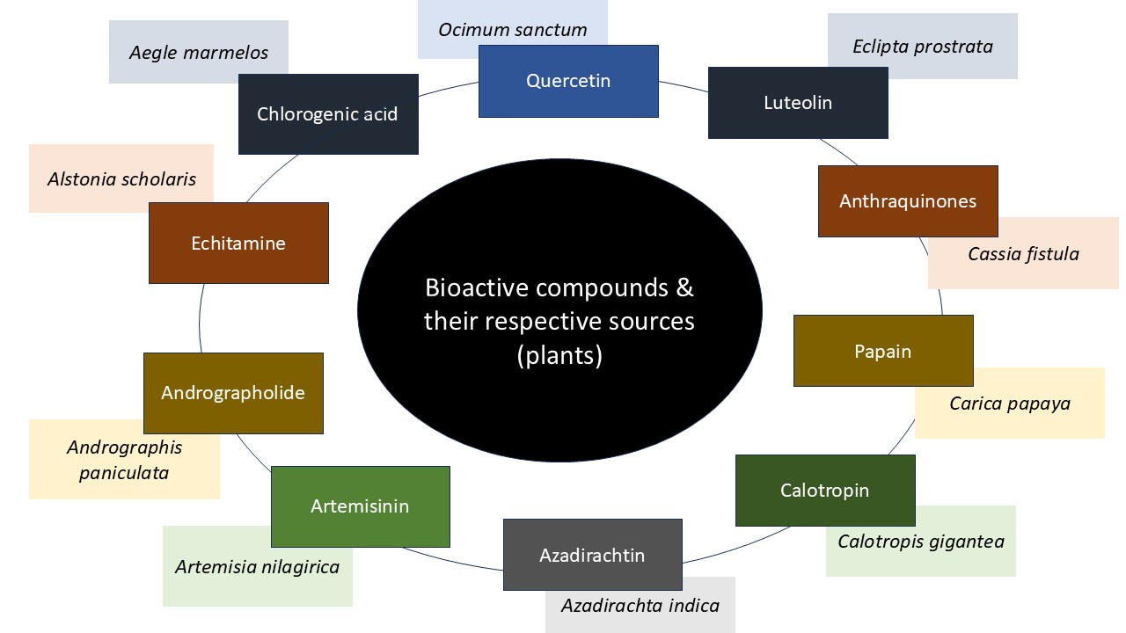
Figure 1: Phytochemicals with antimalarial potential and their source of plants
Table 2: Key antimalarial phytochemicals with their potential bioactivity
Botanical Name | Bioactive compounds | Potential bioactivity | Source(s)
Aegle marmelos | Chlorogenic acid, Rutin (Flavonoids, Phenolics) | Synergistic reduction of parasitemia and fever | Rajpoot & Kareti (2025), Gogoi et al. (2021)
Alstonia scholaris | Echitamine, Alstonine (Indole alkaloids) | Strong antiplasmodial and antipyretic activity | Behera et al. (2025), Rajpoot & Kareti (2025)
Andrographis paniculata | Andrographolide (Diterpenoid) | Inhibits chloroquine-sensitive and resistant P. falciparum strains | Behera et al. (2025), Singh et al. (2015)
Artemisia nilagirica | Artemisinin (Sesquiterpene lactone) | Generates free radicals; damages parasite membranes | Gogoi et al. (2021), Shankar et al. (2012)
Azadirachta indica | Azadirachtin, Nimbin, Nimbolide (Limonoids) | Inhibit parasite growth; boost immune defense | Raut et al. (2025), Behera et al. (2025)
Calotropis gigantea | Cardiac glycosides, Calotropin | Improves circulation; febrifuge effect | Behera et al. (2025), Mahato et al. (2024)
Carica papaya | Phenolic acids, Papain, Flavonoids |  | Mahato et al. (2024)
  Reduces fever; enhances immune response
Cassia fistula | Coumarins, Anthraquinones | Antipyretic; antioxidant and hepatoprotective | Iliya (2023), Behera et al. (2025)
Cinchona officinalis |  | Inhibit heme polymerization; disrupt Plasmodium metabolism | Singh BP et al. (2020), Behera et al. (2025)
  Quinine, Quinidine (Alkaloids)
Citrus maxima | Hesperidin, Naringin (Flavonoids) | Antioxidant and antiparasitic effects | Gogoi et al. (2021)
Cyperus articulatus | Phenolics, Terpenoids | Antipyretic; detoxifying properties | Mahato et al. (2024)
Desmodium oojeinense | Tannins, Saponins | Immunostimulant; antipyretic | Marndi et al. (2015)
Eclipta prostrata | Luteolin, Wedelolactone (Flavonoids, Coumarins) | Antipyretic; immunomodulatory activity | Laskar & Das (2025), Shankar et al. (2012)
Holarrhena pubescens |  | Strengthens immunity; reduces parasite load | Mahato et al. (2024), Marndi et al. (2015)
  Conessine (Alkaloid), Tannins
Nyctanthes arbor-tristis | Kaempferol, Quercetin (Flavonoids) | Antipyretic; reduces oxidative stress and parasitemia | Mahato et al. (2024), Saikia et al. (2021)
Ocimum sanctum | Quercetin, Luteolin (Flavonoids) | Antioxidant; interferes with parasite electron transport | Saikia et al. (2021), Laskar & Das (2025)
Phyllanthus niruri | Phyllanthin, Hypophyllanthin (Lignans, Coumarins) | Antiplasmodial; antioxidant and hepatoprotective | Iliya (2023), Singh et al. (2015)
Rauvolfia serpentina | Reserpine, Ajmaline (Indole alkaloids) | Suppress Plasmodium growth; act as febrifuge | Marndi et al. (2015), Behera et al. (2025)
Swertia chirata | Swertiamarin, Amarogentin (Glycosides) | Inhibit parasite maturation; potent febrifuge | Bahekar & Kale (2013), Behera et al. (2025)
Terminalia arjuna | Lupeol, Betulinic acid (Triterpenoids) | Antiplasmodial; antioxidant; strengthens immunity | Mahato et al. (2024), Singh BP et al. (2020)
Tinospora cordifolia | Berberine, Tinosporine (Alkaloids) | Inhibit merozoite invasion; immunostimulant | Singh BP et al. (2020), Singh et al. (2015)
Vitex negundo | Betulinic acid, Flavonoids | Reduces fever; antiplasmodial and antioxidant | Mahato et al. (2024), Behera et al. (2025)

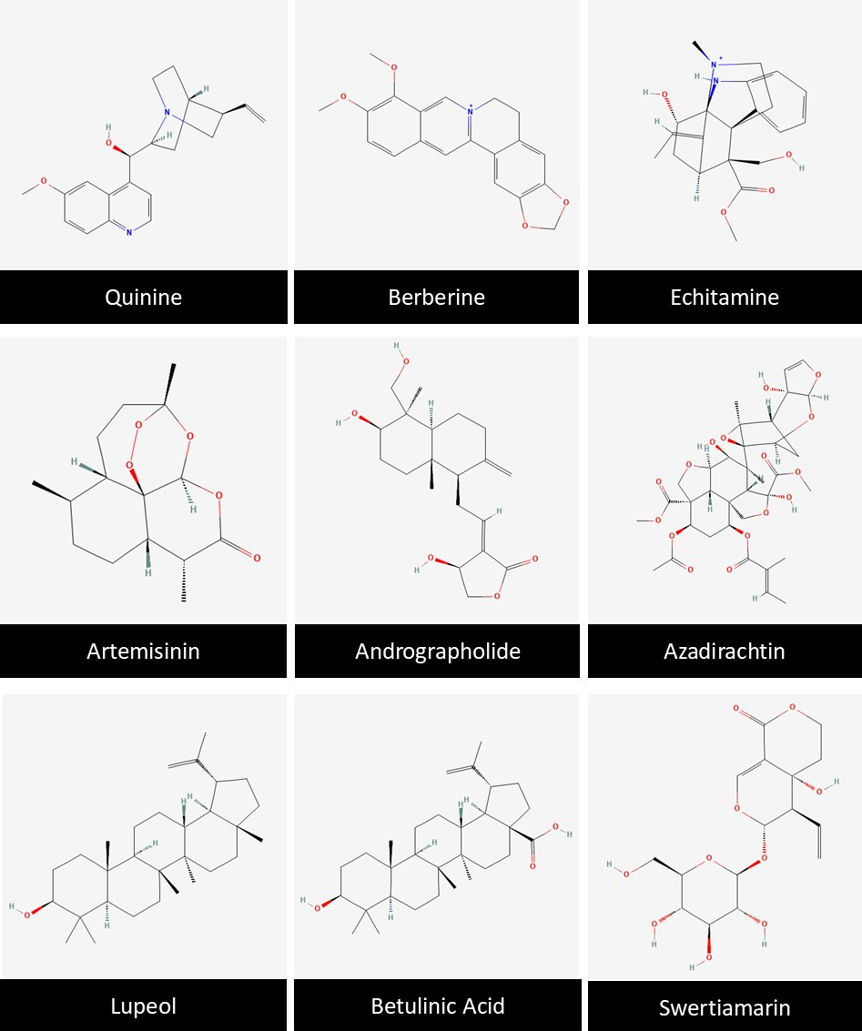
Figure 2: Chemical structures of some important bioactive compounds with antimalarial potential
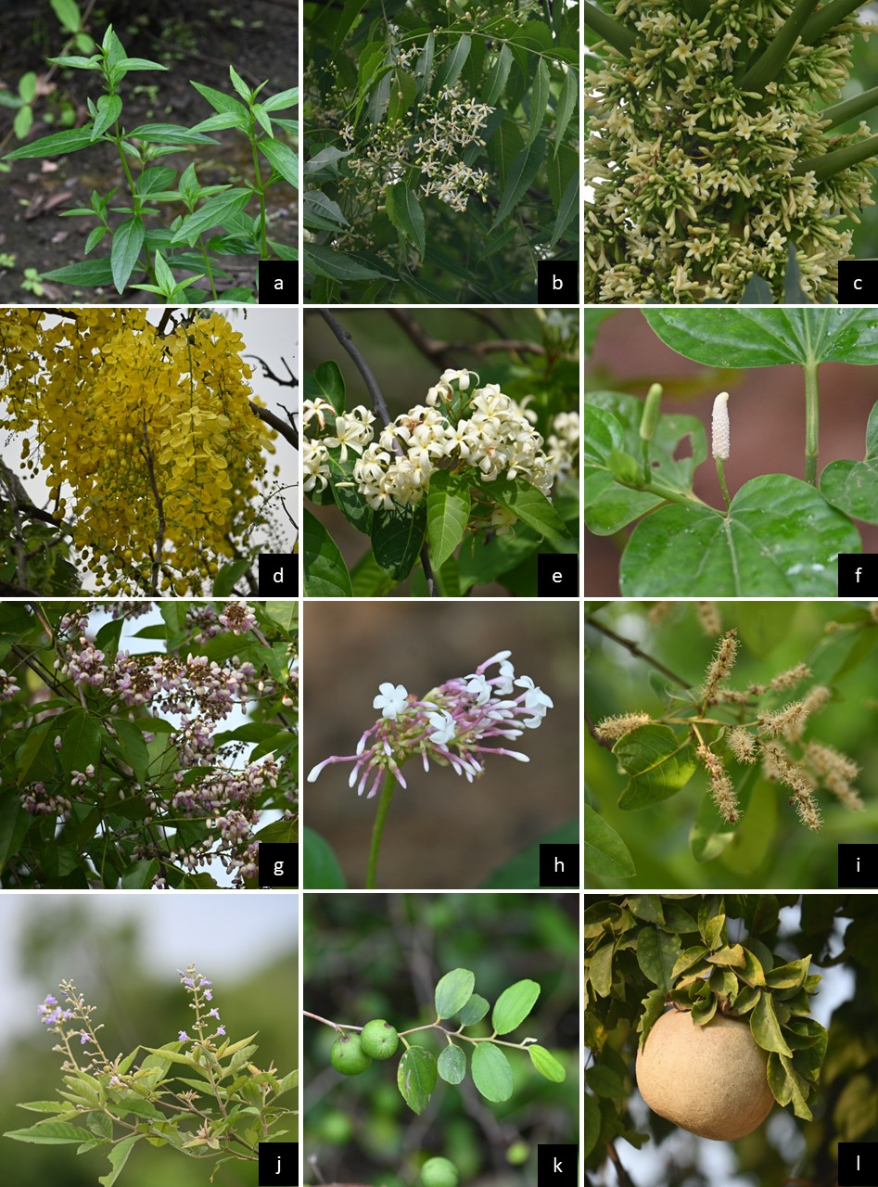
Figure 3: Important ethnomedicinal plants used in the treatment of malaria: a) Andrographis paniculata, b) Azadirachta indica, c) Carica papaya, d) Cassia fistula, e) Holarrhena pubescens, f) Piper longum, g) Pongamia pinnata, h) Rauvolfia serpentina, i) Terminalia arjuna, j) Vitex negundo, k) Ziziphus mauritiana, and l) Aegle marmelos
CONCLUSION
Malaria remains a major vector-borne disease in India, exacerbated by the emergence of drug-resistant strains of Plasmodium and limited access to healthcare in rural and tribal areas. Ethnomedicinal plants are a vital source of bioactive compounds, including alkaloids, terpenoids, and flavonoids, which have proven antiplasmodial, immunomodulatory, and symptomatic relief properties. Future research should focus on comprehensive pharmacological and phytochemical profiling of these ethnomedicinal plants, as well as the isolation and characterization of bioactive compounds to understand their molecular mechanisms against Plasmodium species. The use of advanced biotechnological methods, such as metabolomics, high-throughput screening, and targeted nanodelivery systems, can enhance the efficacy, bioavailability, and safety of plant-derived antimalarials. Furthermore, the standardization of polyherbal formulations and rigorous validation through preclinical and clinical studies are essential for translating traditional knowledge into evidence-based therapeutic strategies. Additionally, it is crucial to conserve medicinal plant biodiversity and actively collaborate with indigenous communities to ensure the sustainable use and long-term accessibility of these valuable natural resources for malaria control and management.

COMPETING INTERESTS DISCLAIMER:
Authors have declared that they have no known competing financial interests OR non-financial interests OR personal relationships that could have appeared to influence the work reported in this paper.

REFERENCES
Bahekar S and Kale R. (2013). Herbal plants used for the treatment of malaria- A literature review. Journal of Pharmacognosy and Phytochemistry. 1(6): 141-146.
Behera SK, Subudhi L, Mohapatra S and Panda AK. (2025). A review on the ethnomedicinal plants used for the traditional treatment of malaria in the Mayurbhanj district of Odisha, India. Malaria Journal. 24(228): 1-12.
Gogoi N, Gogoi B and Chetia D. (2021). In vitro antimalarial activity evaluation of two ethnomedicinal plants against chloroquine sensitive and resistant strains of Plasmodium falciparum. Clinical Phytoscience. 7(42): 1-10.
Iliya A. (2023). A review on medicinal plants used as alternative treatment for malaria: an anti- malarial drug. International Journal for Multidisciplinary Research. 5(6): 1-15.
Kumar S (2025). Data collection from literature for biological sciences, medicinal plants research, ethnobotany, and pharmacology: a methodological overview. Journal of Biodiversity and Conservation. 9(2): 167-169.
Laskar SAKA and Das AK. (2025). Ethnomedicinal plants are used for the treatment of malaria by Halam tribe of Hailakandi district, southern Assam, India. Annals of Ayurvedic Medicine. 14(3): 210-218.
Mahato RK, Mandal AK, Mallick SK and Sinhababu A. (2024). Investigation of medicinal plants used to treat malaria by the ethnic people of Purulia district, West Bengal, India. Pharmacognosy Research. 16(4): 810-816.
Marndi RR, Britto SJ and Soreng PK. (2015). Ethnomedicinal formulations used for treatment and prophylaxis of malaria by Oraon tribals of Palamu division, Jharkhand, India. International Journal of Pharmaceutical Research and Bio-Science. 4(6): 145-162.
Noronha M, Pawar V, Prajapati A and Subramanian RB. (2020). A literature review on traditional herbal medicines for malaria. South African Journal of Botany. 128: 292-303.
Rajpoot VS and Kareti SR. (2025). Ethnobotanical survey of medicinal plants used for the treatment of malaria by tribal communities of Anuppur district, Central India. Indian Journal of Traditional Knowledge. 24(2): 158-167.
Ram S and Sinha VS. (2015). An intensive survey of common medicinal plants used to cure malaria in west Singhbhum of Jharkhand, India. International Journal for Exchange of Knowledge. 2(2): 56-62.
Raut SS, Dhole YR and Deshmukh SP. (2025). Role of medicinal plant in treatment of malaria. GSC Biological and Pharmaceutical Sciences. 30(01): 178-185.
Saikia S, Begum RA and Buragohain A. (2021). Comprehensive list of anti-malarial plants used by different communities of Assam and Arunachal Pradesh, India. International Journal of Mosquito Research. 8(2): 63-69.
Shankar R, Deb S and Sharma BK. (2012). Antimalarial plants of northeast India: An overview. Journal of Ayurveda and Integrative Medicine. 3(1): 10-16.
Singh BP, Krishna A, Singh SC and Kumar S. (2020). Indian plants with antimalarial ingredients. International Journal of Current Microbiology and Applied Sciences. Special Issue 10: 345-358.
Singh N, Kaushik NK, Mohanakrishnan D, Tiwari SK and Sahal D. (2015). Antiplasmodial activity of medicinal plants from Chhotanagpur plateau, Jharkhand, India. Journal of Ethnopharmacology. 165: 152-162.
Fikadu, M., & Ashenafi, E. (2023). Malaria: an overview. Infection and Drug Resistance, 3339-3347.
Daily, J. P., Minuti, A., & Khan, N. (2022). Diagnosis, treatment, and prevention of malaria in the US: a review. Jama, 328(5), 460-471.
Kanatani, S., Stiffler, D., Bousema, T., Yenokyan, G., & Sinnis, P. (2024). Revisiting the Plasmodium sporozoite inoculum and elucidating the efficiency with which malaria parasites progress through the mosquito. Nature communications, 15(1), 748.
Loubens, M., Vincensini, L., Fernandes, P., Briquet, S., Marinach, C., & Silvie, O. (2021). Plasmodium sporozoites on the move: Switching from cell traversal to productive invasion of hepatocytes. Molecular Microbiology, 115(5), 870-881.

