Indigenous Knowledge Systems (IKS) and climate change mitigation: a tool to save the world

Abstract
Climate change poses as one of the most pressing challenges to ecosystems, livelihoods, and culture worldwide. While modern science has developed advanced tools to predict and address climate change, indigenous knowledge systems (IKS) provide time-tested, locally grounded strategies for resilience and adaptation. Keeping the importance of IKS in mind, field and literature survey was carried out during different floristic works in Eastern Ghats between 2010-2024. Data were collected and presented in this article. This study highlights the role of indigenous knowledge in climate change mitigation, focusing on practices such as sustainable resource management, biodiversity conservation, agroecological techniques, and community-based adaptation strategies. It discusses the integration of traditional ecological knowledge with scientific frameworks as a pathway toward holistic and sustainable climate governance. Additionally, the review addresses challenges, ethical considerations, and the potential for collaborative approaches. This communication aims to contribute towards efforts in mitigating the impact of climate change through IKS.
Keywords: Community-based adaptation, sustainable resource management, traditional ecological knowledge

Introduction
Climate change represents a significant global crisis with cascading impacts on ecosystems, livelihoods, health, and cultural systems (Teshome, 2024). It is characterised by rising global temperatures, unpredictable rainfall patterns, accelerated biodiversity loss, and increased intensity of extreme weather events (Ebi et al., 2021). These changes disproportionately impact vulnerable populations, particularly indigenous communities, who face varying risks due to their deep interdependence on nature and natural resources (Sahu et al., 2023). Despite often being excluded from mainstream climate policy discussions, indigenous people have invaluable ecological knowledge gained through centuries of observation, experimentation, and adaptation to their local environment (Das, 2024). These communities have rich and untapped wealth of ecological understanding (Redvers et al., 2023). Their practices not only enhance adaptation strategies but also significantly contribute to climate change mitigation by improving carbon sequestration, conserving biodiversity, and promoting sustainable land and water management practices (Hosen et al., 2020). Indigenous knowledge systems (IKS) are holistic in nature, integrating ecological, spiritual, and socio-cultural dimensions. Unlike conventional scientific models that tend to isolate variables, IKS emphasizes the interconnectedness of all life forms and the reciprocal relationship between human and nature. Their perspective fosters a deep respect for ecosystems and lays the foundation for sustainable resource use. Keeping this in view, present study aims to contribute to the ongoing discussion on climate change adaptation and mitigation by compiling and analysing traditional ecological knowledge and practices through field and literature survey during 2010-2024. This paper will also examine how these practices, which are deeply rooted in local ecosystems and socio-cultural traditions, can contribute to the development of broader climate action policies. This paper supports more inclusive, integrative, and sustainable traditional approaches to climate policies that acknowledge the knowledge and contribution of indigenous communities.
Significance of Indigenous Knowledge Systems (IKS)
Indigenous communities have a profound understanding of local ecosystems, developed over generations, which enables them to adapt to climate change (Dorji et al., 2024). Having lived in proximity to their lands for thousands of years, these communities have developed a highly specialized knowledge of local environmental conditions, including weather patterns, the behaviour of animals, birds, and insects, as well as water cycles and soil conditions (Redvers et al., 2023). This knowledge is derived from continuous experience, observation, and adaptation. Importantly, this understanding is dynamic which evolves in response to changing environmental conditions, allowing these communities to adapt more efficiently (Dorji et al., 2024). Their sustainable practices include controlled burns, traditional farming techniques, and water conservation methods, which contribute to their environmental resilience. Such conservation practices can help in the formation of modern climate adaptation efforts, especially in those regions where scientific data is scarce (Menatti et al., 2022). The knowledge of indigenous communities accentuates living in balance with nature and provides valuable insights into sustainable practices. The core belief of indigenous communities relies on the fact that humans are an integral part of nature, rather than separate from it. This perspective brings strong ethics of care and responsibility towards Mother Nature. These communities, instead of exploiting natural resources for short-term gains, often use resources in a way that ensures their regeneration and remain available for long-term use. The ecological models followed by indigenous communities promote ways to live well within ecological limits, rather than merely seeking sustainable solutions to address environmental degradation, biodiversity loss, and pollution (Brubacher et al., 2024). Their keen awareness allows them to predict upcoming environmental shifts and extreme weather events. Working in close association with indigenous communities will give scientists access to this grounded and specific knowledge, leading to more effective environmental research, policies, and disaster management strategies (Hosen et al., 2020).
The value of indigenous knowledge system
The Indigenous Knowledge System is a unique and valuable resource developed over thousands of years. This knowledge system embodies a profound understanding of the natural environment and their interconnectedness to all living beings. Indigenous knowledge emphasizes living in harmony with nature, rather than exerting dominance over it (Alum et al., 2024). This perspective provides valuable insights into sustainable practices such as sustainable forest management, agroforestry, and conservation (Figure 1).
Indigenous peoples’ efforts for global climate agreements
Following the adoption of the Kyoto Protocol in 1997, which aimed to reduce global greenhouse gas emissions, representatives of the indigenous communities began advocating for their inclusion in climate change agreements. Despite their efforts, they have often been marginalized in these discussions and policy frameworks (Etchart, 2017). One major source of frustration has been the framing of their involvement as that of victims affected by climate change, rather than their recognition as potential leaders and active participants in the quest to combat climate change (Etchart, 2017). By 2004, their participation gained backing from the United Nations Framework Convention on Climate Change (UNFCCC). This is an international environmental treaty that was negotiated at the Earth Summit in Rio de Janeiro from June 3 to 14, 1992 and entered into force on March 21, 1994 (Etchart, 2017). In December 2015, the Indigenous Peoples’ Centre for Documentation, Research, and Information (DOCIP) reiterated the connection between climate change and the rights of indigenous communities and clearly stated that “Indigenous peoples have been making this link for several decades, taking centre stage in its promotion” (Etchart, 2017).

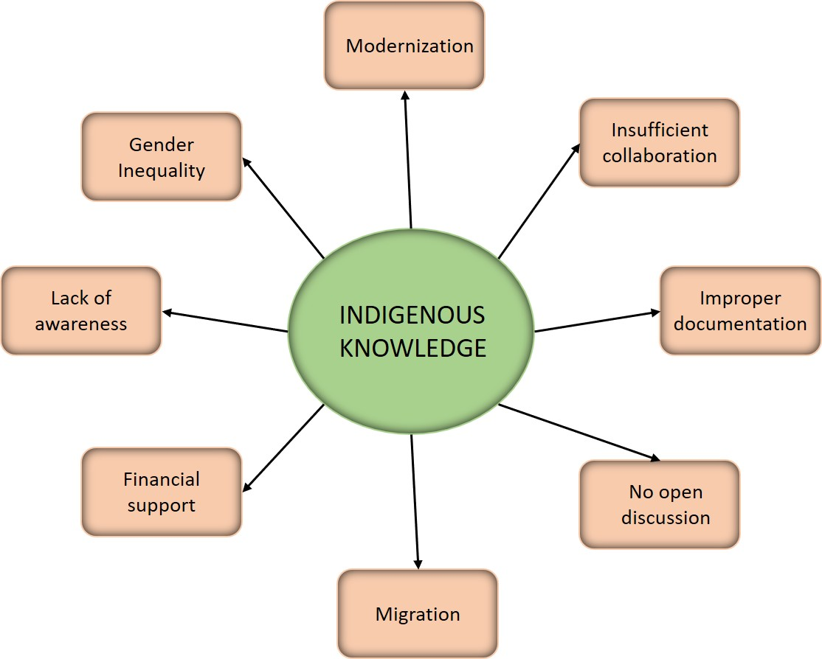
Figure 1: Various challenges associated with the erosion of traditional indigenous knowledge
The documented outcome of the United Nations Conference on Sustainable Development, Rio+20 (2012), emphasized the importance of indigenous people in achieving sustainable development and highlighted the relevance of the United Nations Declaration on the Rights of Indigenous Peoples (UNDRIP) in the implementation of sustainable development strategies. Indigenous groups expressed their disagreement over the omission of UNDRIP from global climate change agreements, particularly during the COP21 Climate Summit in Paris in December 2015 (Etchart, 2017). At this summit, representatives of indigenous communities organized their own side-events and created a platform called the Indigenous Peoples Forum on Climate Change (IIPFCC) (Etchart, 2017). During the United Nations Permanent Forum on Indigenous Issues (UNPFII) conference in 2017, indigenous peoples presented themselves as crucial contributors in the achievement of (SDGs) 13, 14 and 15, which focus on combating climate change, sustainably managing forests, and halting biodiversity loss (Etchart, 2017).
Indigenous knowledge system and climate change mitigation
Indigenous Knowledge Systems can play a significant role in mitigating climate change in various ways. For instance, indigenous communities have developed traditional practices that support carbon sequestration, such as reforestation and sustainable land use. Furthermore, indigenous knowledge can provide valuable awareness for climate-resilient agriculture, disaster preparedness, and sustainable water management (Luwesi et al., 2025).
Case study on mother earth and maya spirituality
The Maya people of the highlands of Chiapas have a cosmogonic worldview that explains the generative aspects of life. This worldview is reflected in their sophisticated calendric system, which tracks lunar and solar influences. The lunar calendar helps guide the seasonal times for ritual and ceremonial practices (Redvers et al., 2023). This value system connects all beings to Mother Earth, creating a web of relationships within a cosmic living system that involves all the elements like earth, fire, air, water, and the centre that encompasses them. Mayan traditional medicine incorporates these spiritual concepts into practices aimed at healing the imbalances that lead to disease (Redvers et al., 2023). Health, in this context, is not seen as a static state; rather, it is a dynamic balance that fosters coherence in human actions, which are deeply integrated into a cosmic cycle that interacts with various phenomena. Like many indigenous cultures, the Maya perceive well-being as the ability to cultivate connections and nourish interactions with all living beings. These notions of well-being promote the conservation and restoration of Mother Earth through practice, ensuring the continuation of life for all systems involved in planetary health (Redvers et al., 2023).
Food insecurity and climate change
Food insecurity refers to the inability to consistently access nutritious food, making it a significant global public health concern due to its strong connection to both mental and physical health. Inadequate access to quality food contributes to malnutrition and poor health outcomes. It is associated with several diet-related chronic diseases, such as obesity, diabetes, and hypertension (Kuhnlein et al., 2006). Indigenous people experience disproportionately high rates of food insecurity, largely because of settler-colonial practices, which include forced relocation and degradation of traditional subsistence patterns. Such forced reallocation separates indigenous people from their homelands, resulting in a complete disconnection from their own land and its food sources (Lynn et al., 2013). Food insecurity is a global health problem that impacts people across the globe, particularly in countries with agricultural systems that are vulnerable to climate change. Climate change causes variability in the rainfall, temperature, drought, and floods, which negatively affects agricultural systems, food availability, and indigenous ways of life. These factors further aggravate health disparities (Redvers et al., 2023). During field survey in Odisha state, authors collected many wild foods which are food in critical situation like famine (Figure 2).
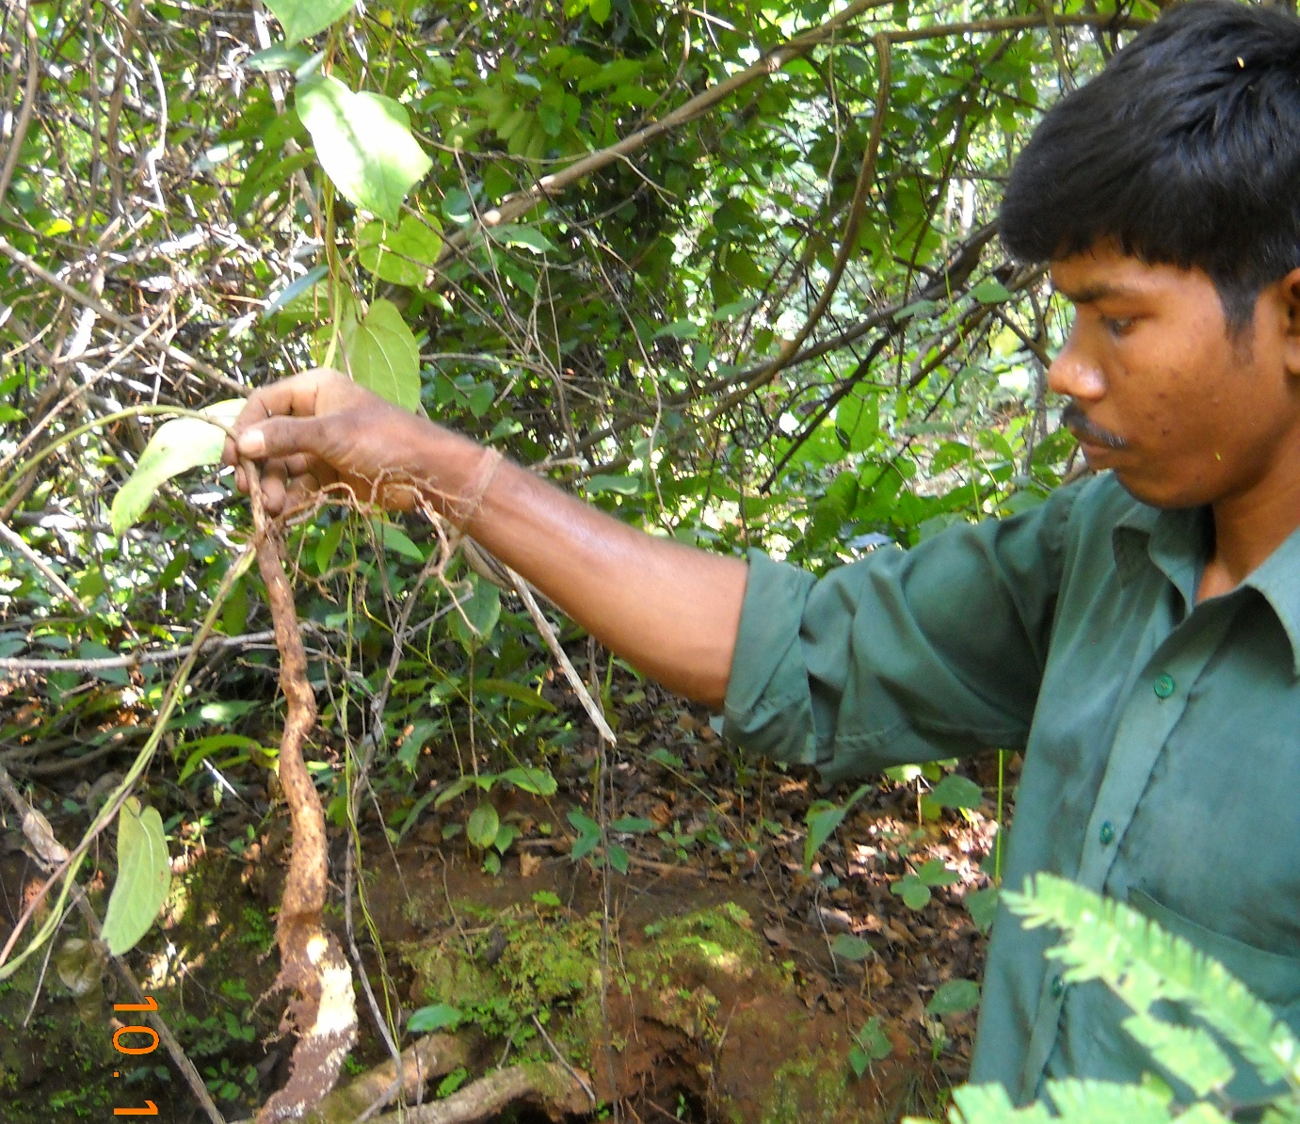
Figure 2: Food of critical time (Tuber of Dioscorea pubera)
Indigenous knowledge and leadership for climate change adaptation in nutrition
Adapting our food and nutrition systems to address climate change is essential for achieving sustainable development, particularly in the fight against hunger (SDG 2), while also promoting health and mitigating climate change (SDGs 3 and 13). The impact of climate change on nutrition availability is especially alarming in countries where essential needs are still unmet (Corvalan et al., 2017). To create effective adaptation, collaborative efforts are crucial. These policies should aim to enhance nutrition for indigenous communities while also supporting the sustainable development of countries. This involves reducing environmental harm, preserving cultural identity, and improving well-being and income opportunities for indigenous people (Zavaleta-Cortijo et al., 2024).
Ecosystem health
The ability of indigenous people to practice their culture and traditional ways of life depends on the health of the land. As ecosystems and water resources are increasingly exploited and converted for other uses, the availability of diverse traditional foods in these communities is at greater risk (Redvers et al., 2023). Changes in harvesting practices due to climate change, as well as the decline of essential pollinators, can also affect the production and access to traditional foods. Additionally, remaining ecosystems face further challenges from diseases, pollution, invasive species, and poor management practices. It is important to emphasize that indigenous traditional food systems and cultural practices are closely linked to the health of the land. As a result, indigenous health indicators are likely to be adversely affected by sustained changes in local climate patterns (Biles et al., 2024).
Indigenous knowledge and natural resource management
Forest conservation and carbon sequestration: Indigenous communities around the world manage forests through practices that regulate harvesting, preserve sacred groves, and maintain ecological integrity. Studies indicate that forests managed by indigenous people often have equal or greater carbon storage capacity compared to state-protected reserves. Sacred groves in India and community forests in the Amazon serve as crucial carbon sinks while also safeguarding biodiversity.
Water management: During the field survey, the authors observed that the tribal communities of Odisha harvest rainwater at the mountain tops and channel it through bamboo pipes, ensuring a year-round water supply naturally filtered by sand (Figure 3).
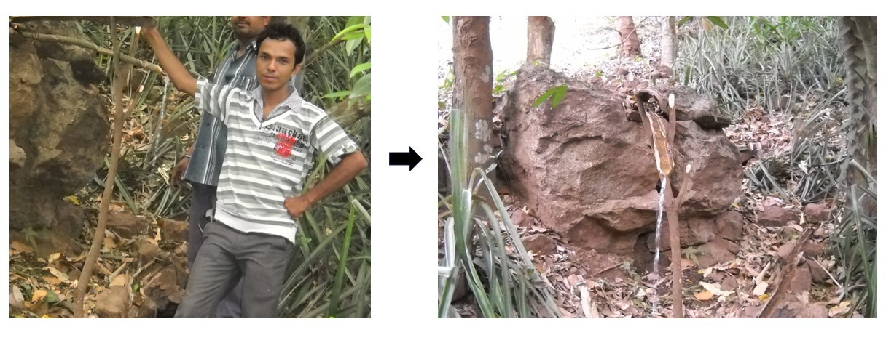
Figure 3: Collecting drinking water through bamboo pipes naturally filtered by sand
During the summer season, tribal communities extract water from the sand of forest streams to quench their thirst. This traditional practice provides clean drinking water, which they collect and drink using bowls made from Sal leaves (Figure 4).
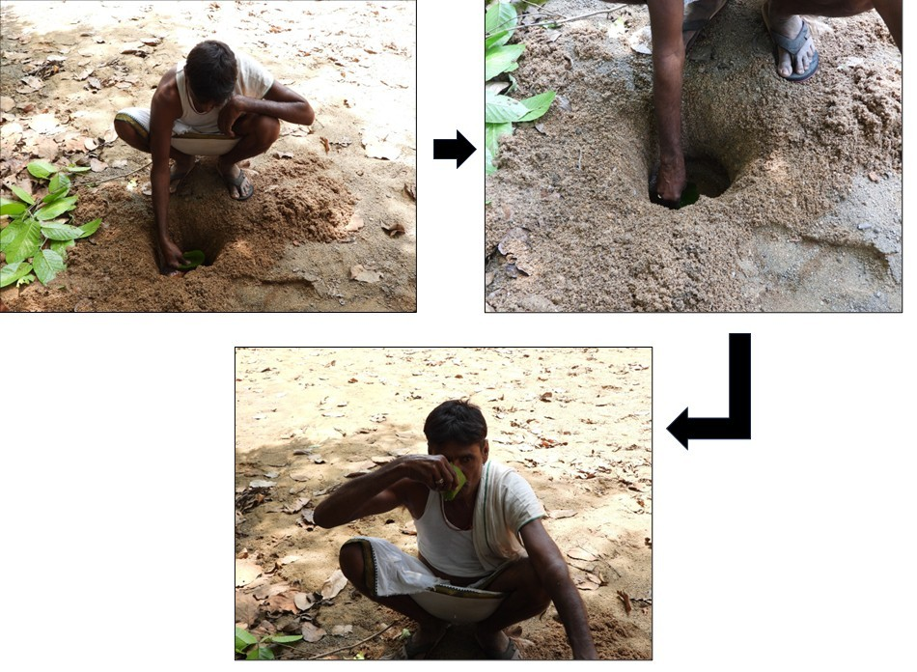
Figure 4: Traditional method of extracting drinking water from forest stream
Sustainable agriculture and food security: Indigenous farming systems, including shifting cultivation, polyculture, and agroforestry, promote soil fertility and reduce reliance on chemical inputs. The diversity of crops and the conservation of local landraces strengthen resilience to pests, diseases, and climatic variability, all while maintaining carbon-neutral food systems. Authors have observed organic traditional cultivation of sweet potato in Odisha state (Figure 5).
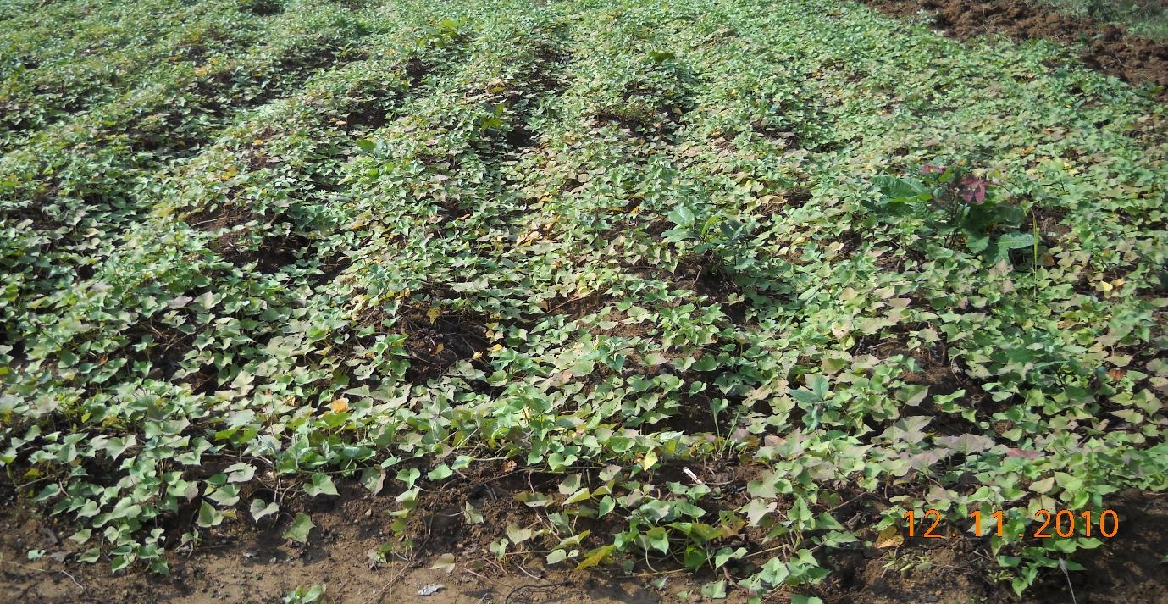
Figure 5: Traditional cultivation of sweet potato inside forest areas
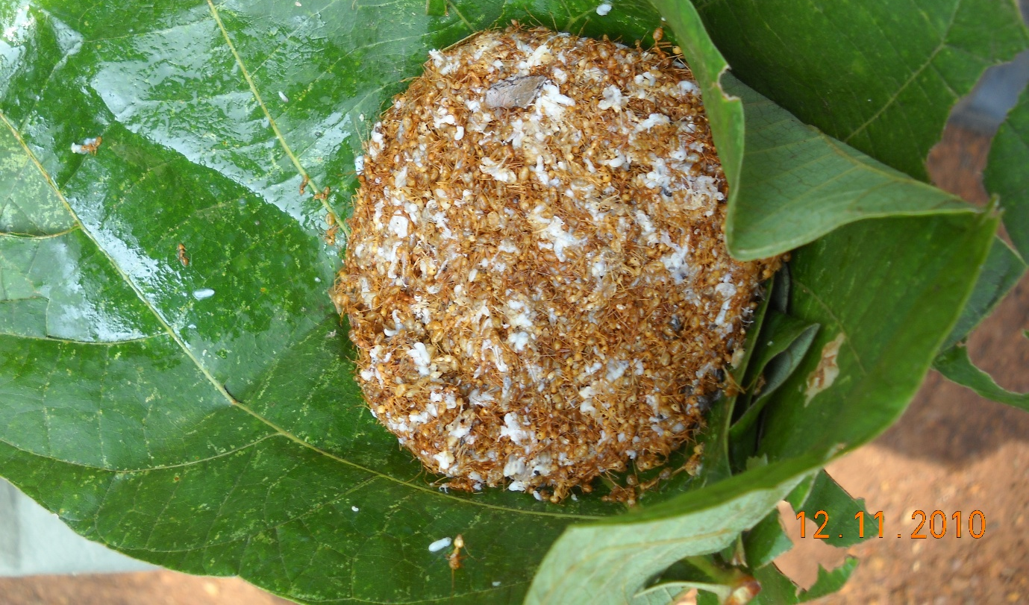
Figure 6: Collected red weaver ants from forest for nutritional purposes
Collection of minor faunal foods: Tribal communities also depend on seasonal minor faunal foods and they know the sustainable harvesting from the nature. These practices ensure the food security and balance the ecosystem. In Figure 6, authors showed red weaver ants collected by tribal communities of Odisha as a food.
Biodiversity conservation and ecological services: Indigenous knowledge plays a crucial role in the conservation of biodiversity, which supports climate mitigation efforts. Traditional seed banks, ethnobotanical knowledge, and community-based conservation initiatives help safeguard genetic diversity. These practices not only preserve adaptive traits that are valuable for future breeding but also contribute to maintaining essential ecosystem services such as pollination, soil fertility, and carbon cycling. Furthermore, indigenous practices of rotational grazing, seasonal fishing bans, and wildlife protection demonstrate effective strategies that prevent overexploitation and maintain ecological balance. These culturally embedded rules align closely with the modern principles of ecosystem-based management (Negi et al., 2023).
Indigenous knowledge system and climate governance
Complementarity with scientific approaches: Integrating indigenous and scientific knowledge can create powerful synergies for climate action. While remote sensing technologies can map forest cover, indigenous communities offer valuable insights into species behaviour, soil fertility, and microclimate changes. Combining these two knowledge systems enhances predictive accuracy and the relevance of policies (Yanou et al., 2023).
Policy recognition and rights: Global agreements such as the Paris Climate Accord and the UN Declaration on the Rights of Indigenous Peoples (UNDRIP) acknowledge the crucial role of indigenous people in climate action. However, implementation remains inconsistent due to limited representation, land tenure insecurities, and concerns regarding intellectual property. Effective climate governance demands participatory frameworks that respect indigenous rights and ensure equitable benefit sharing (Carmona et al., 2024).
Challenges and ethical considerations
Despite their contributions, indigenous knowledge systems encounter multiple significant challenges (Alum, 2024):
- Marginalization and knowledge loss: Many younger generations migrate or adopt modern lifestyles, which contributes to the erosion of traditional practices and knowledge.
- Climate disruptions beyond experience: Some extreme climate events exceed the coping capacities of Indigenous communities, making it difficult for them to adapt.
- Intellectual property and biopiracy: There are risks of misappropriation of indigenous knowledge, often without proper recognition or compensation.
- Integration barriers: Power imbalances and epistemological differences create obstacles to collaboration between scientists and indigenous communities.
Addressing these challenges requires ethical research practices, inclusive governance, and protection of indigenous intellectual sovereignty.
Future directions
- Co-production of knowledge: Collaboration between indigenous communities and scientists leads to the development of innovative, culturally sensitive strategies for climate adaptation and mitigation.
- Community-based carbon projects: Enhancing indigenous participation in Reducing Emissions from Deforestation and Degradation (REDD+) and carbon credit initiatives can have significant benefits.
- Digital documentation: Recording indigenous practices through participatory digital archives helps safeguard traditional knowledge.
- Policy mainstreaming: It is essential to integrate indigenous knowledge into climate action plans, educational curriculum, and development programs.
Recommendations
- It is essential to recognize and support the rights and self-determination of indigenous people in climate change decision-making.
- Sufficient funds and resources must be allocated to support climate change initiatives led by indigenous communities.
- Development of collaborative approaches for climate change mitigation and adaptation that incorporate the knowledge, perspectives, and belief systems of indigenous communities.
- Support the preservation of indigenous cultural heritage and traditional knowledge.

Conclusion
Indigenous Knowledge Systems provide a strong foundation for sustainable and climate-resilient practices that modern societies can learn from. This knowledge is rooted in long-term ecological observations and spiritual values, and offers low-cost, locally adapted, and culturally appropriate solutions for climate change adaptation and mitigation. However, for indigenous knowledge to make its fullest contribution, it must be recognized, respected, and integrated into climate policy through equitable and participatory frameworks. Bridging indigenous wisdom with modern science is not only essential for effective climate action but also for promoting social justice and preserving cultural heritage.

References
Alum EU. (2024). The role of indigenous knowledge in advancing the therapeutic use of medicinal plants: challenges and opportunities. Plant Signal Behav. 19(1):2439255. doi: 10.1080/15592324.2024.2439255.
Biles BJ, Serova N, Stanbrook G, Brady B, Kingsley J, Topp SM and Yashadhana A. (2024). What is Indigenous cultural health and wellbeing? A narrative review. Lancet Reg Health West Pac. 52:101220. doi: 10.1016/j.lanwpc.2024.101220.
Brubacher LJ, Peach L, Chen TT, Longboat S, Dodd W, Elliott SJ, Patterson K and Neufeld H. (2024). Climate change, biodiversity loss, and Indigenous Peoples' health and wellbeing: A systematic umbrella review. PLOS Glob Public Health. 4(3): e0002995. doi: 10.1371/journal.pgph.0002995
Carmona R, Reed G, Ford J, Thorsell S, Yon R, Carril F and Pickering K. (2024). Indigenous Peoples' rights in national climate governance: An analysis of Nationally Determined Contributions (NDCs). Ambio. 53(1):138-155. doi: 10.1007/s13280-023-01922-4.
Corvalán C, Garmendia M, Jones‐Smith J, Lutter C, Miranda JJ, Pedraza L, et al. Nutrition status of children in Latin America. Obesity reviews. 2017; 18:7–18.
Das, K. (2024). Traditional Agronomic practices: Understanding and mitigating the risks of climate change. In Recent Advancements in Sustainable Agricultural Practices: Harnessing Technology for Water Resources, Irrigation and Environmental Management. Springer Nature Singapore, 43-79.
Dorji T, Rinchen K, Morrison-Saunders A, Blake D, Banham V and Pelden S. (2024). Understanding How Indigenous Knowledge Contributes to Climate Change Adaptation and Resilience: A Systematic Literature Review. Environ Manage. 74(6):1101-1123.
Ebi KL, Vanos J, Baldwin JW, Bell JE, Hondula DM, Errett NA, Hayes K, Reid CE, Saha S, Spector J and Berry P. (2021). Extreme Weather and Climate Change: Population Health and Health System Implications. Annu Rev Public Health. 42: 293-315.
Etchart L. (2017). The role of indigenous peoples in combating climate change. Palgrave Commun. 3: 17085.
Hosen N, Nakamura H and Hamzah A. (2020). Adaptation to Climate Change: Does Traditional Ecological Knowledge Hold the Key?. Sustainability. 12(2): 676. https://doi.org/10.3390/su12020676
Kuhnlein H, Erasmus B, Creed-Kanashiro H, Englberger L, Okeke C, Turner N, et al. Indigenous peoples’ food systems for health: finding interventions that work. Public Health Nutr. 2006; 9(8): 1013–9
Luwesi, C.N., Ogega, O.M., Doke, D.A. (2025). Changing Patterns of Indigenous Knowledge Systems Used for Water Conservation and Adaptation to Climate Change in Mount Kenya Region (2012–2022). In: Leal Filho, W., Nagy, G.J., Ayal, D.Y. (eds) Handbook of Nature-Based Solutions to Mitigation and Adaptation to Climate Change. Springer, Cham. https://doi.org/10.1007/978-3-030-98067-2_130-1
Lynn K, Daigle J, Hoffman J, Lake F, Michelle N, Ranco D, et al. The impacts of climate change on tribal traditional foods. Climatic Change. 2013; 120(3): 545–56.
Menatti L, Bich L and Saborido C. (2022). Health and environment from adaptation to adaptivity: a situated relational account. Hist Philos Life Sci. 44(3):38. doi: 10.1007/s40656-022-00515-w.
Negi VS, Pathak R, Thakur S, Joshi RK, Bhatt ID and Rawal RS. (2023). Scoping the Need of Mainstreaming Indigenous Knowledge for Sustainable Use of Bioresources in the Indian Himalayan Region. Environ Manage. 2023 Jul;72(1):135-146. doi: 10.1007/s00267-021-01510-w.
Redvers N, Aubrey P, Celidwen Y and Hill K. (2023). Indigenous Peoples: Traditional knowledges, climate change, and health. PLOS Glob Public Health. 3(10): e0002474.
Redvers N, Aubrey P, Celidwen Y and Hill K. (2023). Indigenous Peoples: Traditional knowledges, climate change, and health. PLOS Glob Public Health. 3(10): e0002474. doi: 10.1371/journal.pgph.0002474.
Sahu M, Chattopadhyay B, Das R and Chaturvedi S. (2023). Measuring Impact of Climate Change on Indigenous Health in the Background of Multiple Disadvantages: A Scoping Review for Equitable Public Health Policy Formulation. Journal Prev. 44(4):421-456.
Teshome M. (2024). Charting the systemic and cascading impacts of climate change on marine food systems and human health. BMJ Glob Health. 8(3): e014638. doi: 10.1136/bmjgh-2023-014638.
Yanou MP, Ros-Tonen MAF, Reed J, Moombe K and Sunderland T. (2023). Integrating local and scientific knowledge: The need for decolonising knowledge for conservation and natural resource management. Heliyon. 9(11): e21785. doi: 10.1016/j.heliyon.2023.e21785
Zavaleta-Cortijo C, Silvera-Ccallo R, Lancha-Rucoba G, Chanchari J, Inuma N, Pizango M, Morales-Ancajima V, Miranda-Cuadros M, Aparco JP, Valdivia-Gago A, Nunta-Guimaraes R, Antazú T, Velez-Quevedo J, Fernandez-Neyra C, Carcamo C, Greenwood D, Cade J, Ford JD, Harper S and Miranda JJ. (2024). Indigenous knowledge and leadership for climate change adaptation in nutrition. PLOS Glob Public Health. 2024 Nov 14;4(11): e0003917.

