METAGENOMICS ASSAY OF GUT MICROBIOTA AND IMPACTS ON BODY WEIGHTS OF IMPROVED NIGERIAN INDIGENOUS CHICKENS (ALPHA FUNAAB) RAISED IN UYO, NIGERIA

ABSTRACT
A total of 200 DOC of improved NIC (Alpha Funaab) raised for 8weeks at the teaching and research farm of the department of Animal science, University of Uyo, were used in this study. This study metagenomically analyzed the microbiota obtained from the gut of the improved Nigerian Chickens. The study revealed that ceacal microbial composition were dominated by two phyla- the firmicutes and bacteriodates. Firmicutes was the most abundant microbes in the layer line (24.9%) followed by bacteriodates (13.7%). In broiler, bacteriodates was the most dominant (22.4%), followed by firmicutes (20.4%). Again, in the layer line, body weight BWT showed a strong correlation with Bacteroidia (0.977) Bacilli (0.944) and Clostridia (0.861) whereas in the broiler line, BWT had a week but positive correlation of 0.287 with Bacteroidia and a strong negative correlation of -0.099 with Bacilli and Clostridia (-0.967). This metagenomic approach in gastrointestinal microbiota studies has enhanced our understanding of the role of microbes in relations to growth.
Key words: Metagenomics, Microbiota, Gastrointestinal Tract, Ceacum, Correlation, Relative Abundance
INTRODUCTION
Indigenous chickens are widely distributed in the rural areas of tropical and sub-tropical countries where they are kept by the majority of the rural poor. Indigenous chickens in Africa are in general hardy, adaptive to rural environments, survive on little or no inputs and adjust to fluctuations in feed availability. Chickens largely dominate flock composition and make up about 98% (Adekoya et al.,2018) of the total poultry numbers kept in Africa.
Molecular genetics approaches in animal husbandry has been a recently deployed as a tool in achieving a more adaptable and productive livestock. This breakthrough will further consolidate on the gains of food security which remains one of most important challenges of the Food and Agriculture Organization (F.A.O) (Yuossao et al., 2012). Inevitably, in this sector of animal production, poultry breeding is an important opportunity to increase animal protein production in the developing countries. Nigeria poultry keepers have made poultry business one of the most popular enterprises adopted by all in the rural and urban setting (Adebambo, 2005). This has led to the improvement programs in traits of both broiler and local chickens in order to provide high quality meat at lower cost.
The indigenous chicken has proven to be a sustainable source of food security of animal protein and meat production, accounting for about 80% of the total rural chicken market. This ever-increasing demand has led to the development of an improved dual-purpose breed for meat and eggs of Nigeria indigenous chicken breed (FUNAAB Alpha). This breed of chicken has been registered by the National Center for Genetic Resource and Biotechnology in 2018 with National Code NGGD18:02. The breed was developed using the improved Naked neck and Frizzled feather chicken genotypes at the Federal University of Agriculture, Abeokuta, Nigeria over 6 generations of selection and inbreeding followed by 4 generations of crossbreeding with some exotic lines to improve its growth and carcass quality (Adedibu et al.,2018).
However, sustainable poultry meat and egg production is important to provide safe and quality protein sources in human nutrition worldwide. The gastrointestinal (GI) tract of poultry harbors a diverse and complex microbiota that plays a vital role in digestion and absorption of nutrients, immune system development and pathogen exclusion. The integrity, functionality, and health of the chicken gut depends on many factors including the environment, feed, and the GI microbiota. The symbiotic interactions between host and microbes are fundamental to poultry health and production and the diversity of the chicken GI microbiota is largely influenced by the age of the birds, location in the digestive tract and diet.
Until recently, research on the poultry GI microbiota relied on conventional microbiological techniques that can only culture a small proportion of the complex community comprising the GI microbiota. Metagenomics is an area that allows the study of microbial communities without prior cultivation. Metagenomics is basically dependent on sequencing; Sanga Sequencing, Next Generation sequencing and Short Gun Sequencing. Of these three, 16S rRNA based next generation sequencing is a powerful tool to investigate the biological and ecological roles of the GI microbiota in chicken. The 16S rRNA gene coding regions are commonly used in taxonomic resolutions to determine microbiome compositions. This is because these regions are highly variable, making them suitable for this purpose (Adenike et. al., 2025). Although several challenges remain in understanding the chicken GI microbiome, optimizing the taxonomic composition and biochemical functions of the GI microbiome is an attainable goal in the post-genomic era.

MATERIALS AND METHODS
The experimental site
The experiment was conducted at the poultry unit of the Department of Animal Science, University of Uyo, Uyo, Nigeria. Uyo lies between latitude 4°31N and 4°45N and between longitude 7°31 and 7°51E. With warm, cloudy wet seasons and hot, largely cloudy dry seasons, Uyo has a year-round oppressive environment with temperatures ranging from 20.6 °C to 30.6 °C. The average wind vector in Uyo is greatly influenced by terrain and other local characteristics. August is the windiest month, with an average wind speed of 6.4 miles per hour. The windier season lasts 4.4 months. The more tranquil period lasts 7.6 months, with December having the lowest average speed of 4.0 miles per hour.
Experimental Animals
A total of 200 Alpha-FUNAAB day-old-chicks (DOC) were purchased from the poultry breeding unit of the Federal University of Agriculture, Abeokuta, Nigeria. The birds were raised in intensive system as feed and water were be provided ad libitum for 8 weeks that the experiment lasted. To ensure that the experimental birds used for this research were healthy, the researcher weighed the birds and thoroughly examined them physically to identify any form of potential abnormality/abnormalities or early signs of illness.
Experimental procedures
The birds were raised in pens by their lines and fed accordingly. All body weights were taken using electronic weighing balance, Phillip Harries TM with capacity of 0.1g to 7000 g. Feed fed on daily basis were measured with the weighing scale while weekly body weights, linear body measurements; keel length, span length, wing length, Shank length, thigh length breast girth, were measured using the tailor tape. Data for metagenomics analyses were obtained by randomly choosing 6 birds per line at 8weeks. The randomly chosen birds were euthanized to collect ceacal samples. The collected samples were promptly placed in a DNA shield and stored for subsequent analyses. All procedures performed in this research were according to standards and established animal welfare guidelines.
Statistical analyses
Data on body weights and components were analyzed using simple descriptive statistics, correlation coefficients in a completely randomized design (CRD).
Data for metagenomics
A total of 12 gut samples were collected from the improved Normal Feathered Nigerian indigenous chickens at 8 weeks; 6 from broiler line and 6 from layer line, after slaughter and sent to Federal University of Agriculture, Abeokuta for DNA extraction using commercial kits (Zymo Research Bacterial and Fungal Extraction Kit) following the manufacturer’s instructions with some modifications. 0.5g of the ceacal from each slaughtered bird was treated with 25ml of lysozyme in lysis buffer (20mMTris-Cl. pH 8.0; 2mM EDTA, pH 8.0; 1% Triton X-100) for 30 minutes at 37 ⁰C. DNA concentration and quality were determined using NanoDrop ND2000 spectrometer (NanooDrop Technologies, DE, USA) and a gel electrophoresis, respectively. Samples were collected aseptically post-mortem, immediately stored in sterile cryovials, and preserved at -80°C until further processing at the Genetics and molecular laboratory, a commercial NGS service provider at Inqaba, South Africa.
DNA Extraction and Sequencing
DNA was extracted using the QIAGEN DNeasy PowerSoil Kit following the manufacturer’s protocol. DNA quality and concentration were assessed using a Nanodrop spectrophotometer and Qubit fluorometer. The V1-V9 region of the 16S rRNA gene was amplified using universal primers 27F (AGRGTTYGATYNTGGCTCAG) and 1492R (RGYTACCTTGTTACGACTT).
PCR products were purified using AMPure XP beads and quantified before sequencing. Amplicon sequencing was performed on an PacBIo platform, generating single-end reads (1350 bp).
Bioinformatics and Data Processing
FASTQ files were quality-checked using FastQC. Reads were trimmed, filtered, and merged using DADA2/QIIME2 pipeline. Chimeric sequences were removed, and Operational Taxonomic Units (OTUs)/Amplicon Sequence Variants (ASVs) were assigned. Taxonomic annotation was performed using SILVA database at 97% sequence identity. Microbial community structure was analyzed at different taxonomic levels (phylum, family, genus, and species).
Microbial Diversity and Statistical Analysis
Alpha Diversity Metrics (Shannon, Simpson, Chao1, pileous) were computed to assess species richness and evenness.
Beta Diversity Analysis (Bray-Curtis, Jaccard, UniFrac) was performed to evaluate microbial composition differences between groups.
PERMANOVA (via adonis in R) tested group differences in microbial community structure. LEfSe (Linear Discriminant Analysis Effect Size) was used to identify differentially abundant taxa.

RESULTS AND DISCUSIONS
Caecal Microbial Composition of Alpha Funaab chickens
Figures 1 and 2 showed the relative abundance of microbial community structure of the layer and broiler lines of improved Nigerian indigenous chickens raised in Uyo at 8 weeks of age. Similarly, Table 1 and table 2 displayed the average microbial content in the alpha funaab layer line and broiler line respectively. The Figures and Tables revealed that the microbes in the caeca of the NIC, layer line, are dominated by three phyla - Firmicutes 24.9%, Bacteriodetes 13.7%, and Verrucomicrobiota 4.0%. Other phyla present included Proteobacteria 2.5%, Actinobacteria 0,8% and Cyonobacteria 0.2%. The broiler line (Figure 2and table 2) showed Bacteroidata dominance with a relative abundance of 22.4%, followed by Firmicutes with 20.4% and Proteobacteria 1.7%. Firmicutes were the dominant phylum present in the layer line (24.9%) compared to broiler line (20.4%). The finding corroborated with the report in Nicky-Lee (2022), who reported higher Firmicutes in layers (37%) than broilers (20%). Summarily, the result obtained in this study agrees with the report of Adenaike (2025) who noted that Firmicutes are often more dominant in the gut of layer chickens compared to broilers. This difference in the values is primarily due to the distinct diets, environment and breeding practices for each type of poultry. Layer chickens, focused on egg production, may have diets higher in certain nutrients that favour Firmicutes growth. Broiler chickens, raised for meat, may have diets that are more conducive to different microbial compositions, potentially leading to a different dominance of bacterial phyla like Bacteroidetes. However, this study agrees with the report of Metzker (2020), who stated that Firmicutes can support growth in layers by influencing their gut health and overall well-being. Specifically, Firmicutes are known to produce short-chain fatty acids (SCFAs), like butyrate, which are beneficial for gut health and can have a positive impact on the host's metabolism, potentially enhancing growth. Additionally, some studies suggest that certain Firmicutes species can contribute to improved gut health and eggshell quality. Furthermore, Wei et al., 2020, argued that while not directly supporting eggshell growth, some Firmicutes strains like those belonging to Bacillus, have shown to positively impact eggshell quality by improving calcium absorption and gut health. Additionally, the use of antibiotics in broiler production can also impact the gut microbiome, potentially shifting the balance away from Firmicutes. For instance, Oakley et al. (2019), stated that in chickens, halquinol is an antibiotic that does not significantly alter the caecal microbiota, particularly the abundance of Firmicutes, compared to a control group. Other antibiotics, like enramycin and bacitracin, can cause changes in the caecal microbiota, including reducing the abundance of Firmicutes. Again, this result is in tandem with that recorded in Peter et al. (2022) who reported that Verrucomicrobiota phylum is absent in broiler but present in the layer line to the tune of 4%. The author further stated that the presence of Verrucomicrobiota in the gut contributes to overall gut health and may even be linked to certain diseases. Studies have shown that certain Verrucomicrobiota species can help with inflammation and even reduce body weight. Verrucomicrobiota is important in breaking down complex organic matter, especially plant-derived materials like hemicelluloses like xylan, and contribute to global carbon cycling. They also play a role in nutrient cycling and are associated with resource-limited soils and continuous vegetation cover. Their ability to degrade these complex compounds is crucial for nutrient cycling and the overall health of ecosystems. Some species like Akkermansia muciniphila, are important in the gut microbiota of animals. Actinobacteria was not identified in broiler line and was present (0.8%) in the layer line. Proteobacteria, 2.5% was present in layer line while not identified in broiler line. Adenaike (2025) added Actinobacteria and Cynobacteria to the list of microbes present at the caeca of normal feathered Alpha Funnab chickens. This inclusion contradicts the findings of this study which could be due to the fact that the researcher based the studies on the microbial content without any consideration on lines. Again, the discrepancy may be due to the varied conditions including the management system, feed and procedures in sample collections and sample analyses.
However, the result of this study agrees with the observation by Adenaike (2025) who further observed that microbial communities vary throughout the chicken’s gastrointestinal tract, with distinct microbial profiles found in the caecum and colon of broiler chickens. These microbiomes are crucial for devising methods to regulate composition, not only to enhance host health and performance, but also to manage zoonotic agents that may contaminate poultry products, thereby endangering consumers’ health. This study confirms the report by Wheto et al. (2020), which examined samples taken from fast developing broilers (Ross 308) and a slow growing free-range chicken breed (Sasso-T451A) at different ages (42 and 86 days, respectively) and concluded that three microbial phyla; Bacteriodetes, Firmicutes and Campylobacteria dominated the GI tract of chickens. The gastrointestinal compartments of chickens are densely populated with complex microbial communities (Bacteria, fungi, Archaea, Protozoa, and virus) but are dominated by Bacteria, Gullig et al., 2018 added. The interactions between the host and the chicken GI bacterial microbiome have been extensively studied and reviewed by many research groups (Kumar et al., 2018) and (Gilbert et al., 2018) are now considered to play important roles in bird nutrition, physiology and gut development.
Guillig et al. (2018) noted that chicken gut microbiota can form a protective barrier by attaching to the epithelial walls of the enterocyte and thus reduce the opportunity for the colonization of pathogenic bacteria. These bacteria produce vitamins (e.g., vitamin K and vitamin B groups), short chain fatty acids (acetic acid, butyric acid and propionic acid), organic acids (e.g., lactic acid) and antimicrobial compounds (e.g., Bacteriocins), lower triglyceride, and induce non-pathogenic immune responses, which provide both nutrition and protection for the animal (Su et al., 2021). The primary benefits that are provided by commensal microbiota are competitive exclusion of pathogens or non-indigenous microbes immune stimulation and programming, and contributions to host nutrition (Marcio et al., 2022). Earlier reports have established that conventionally raised animals are far less susceptible to pathogens when compared with germ-free animals (Kunin et al., 2015). Furthermore, commensal microbiota can stimulate the development of immune system including the mucus layer, epithelial monolayer, the intestinal immune cells (e.g., cytotoxic and helper T cells, immunoglobulin producing cells and phagocytic cells), and the lamina propria. These tissues build barriers between the host and the microbes and combat undesirable gut microorganisms. In the distal gut (i.e., ceca and colon), the microbiota also produces energy and nutrients such as vitamins, amino acids, and short chain fatty acids (SCFA) from the undigested feed, which eventually become available for the host (Aziz et al., 2018).
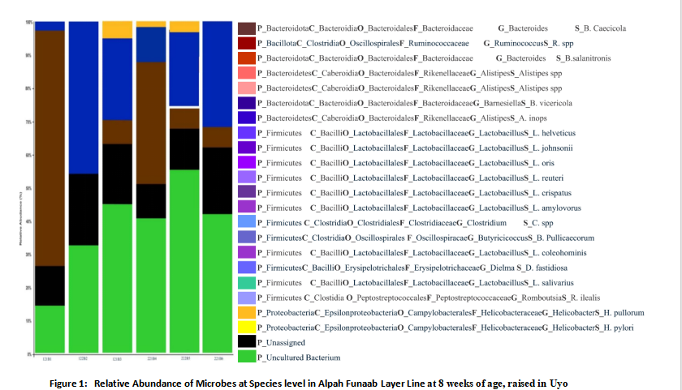
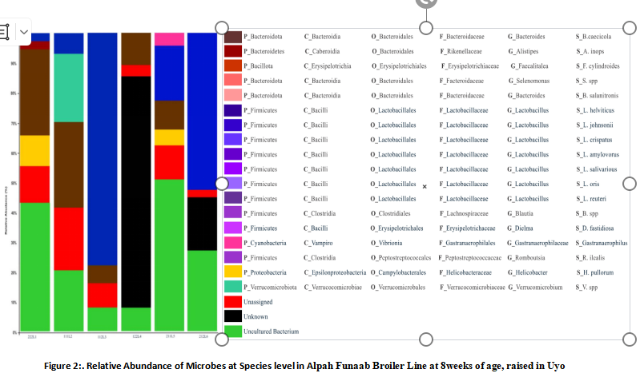
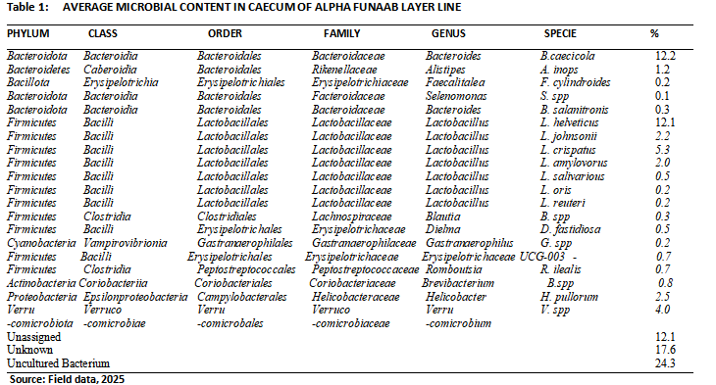

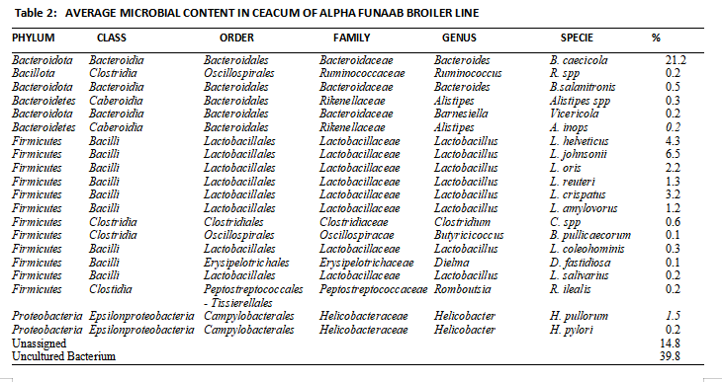

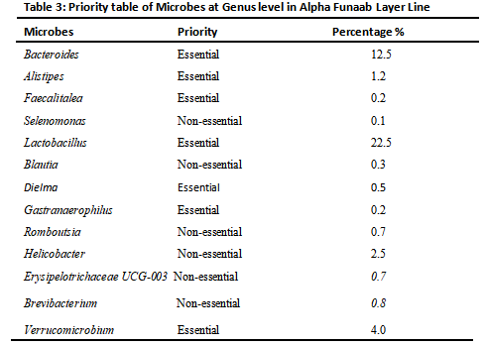
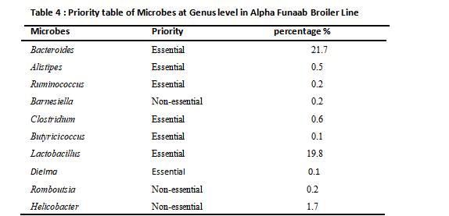

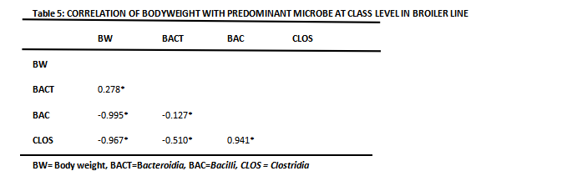
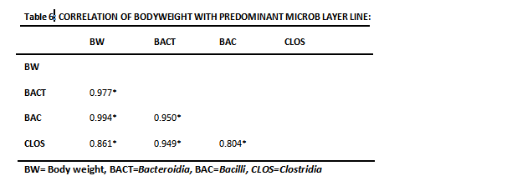
Evaluation of the Microbial Taxonomic Annotation in Alpha Funaab chickens
Relative frequency of abundance from phylum to genus for the 12 chickens, 6 for each line, sequenced along lines are shown from Figure 1 for layers and Figure 2 for broilers, revealed that the ceacal bacterial community in all the FUNAAB Alpha chicken broiler and layer lines were dominated by two major phyla: Firmicutes, Bacteroidetes and Campylobacteria. The gut microbiota was primarily composed of Firmicutes (47 %), Bacteroidetes (16 %), Campylobacteria (14 %) and Firmicutes (43 %), Bacteroidetes (14 %) Campylobacteria (17 %). Adenike, 2025 reported that the Frizzle feather contained three major phyla: Firmicutes, Bacteroidetes, and Actinobacteria. These phyla made up 76 %, 18 %, and 3 % of the total sequences, respectively. The predominant phyla in Naked neck were; Firmicutes (60 %), Bacteroidetes (25 %), Actinobacteria (5 %) and Campylobacteria (0.5 %). These showed that in the Nigerian indigenous chickens, the predominant microbial phyla are the Firmicutes followed by Bacteriodetes. These findings support the facts raised in Nakaruma et al., 2019 which states that the gastrointestinal (GI) tract of poultry is densely populated with microorganisms which closely and intensively interact with the host and ingested feed. The gut microbiome benefits the host by providing nutrients from otherwise poorly utilized dietary substrates and modulating the development and function of the digestive and immune system. In return, the host provides a permissive habitat and nutrients for bacterial colonization and growth. Gut microbiome can be affected by diet, and different dietary interventions are used by poultry producers to enhance bird growth and reduce risk of enteric infection by pathogens. There also exist extensive interactions among members of the gut microbiome. A comprehensive understanding of these interactions will help develop new dietary or managerial interventions that can enhance bird growth, maximize host feed utilization, and protect birds from enteric diseases caused by pathogenic bacteria.
Relative Abundance of bacterial class in the ceaca of NIC.
Figures 1 and 2 showed the relative abundance of bacterial species in the ceaca of the Alpa FUNAAb chickens. At the class level, Clostridia, Bacillia, Bacteroidia, Negativicutes and Camplobacteria dominated the ceacum with 40%, 36% 16%, 4% and 4% respectively. This finding does not differ significantly from the report from Finn et al. 2022, which states that Bacteroidia, Clostridia and Bacilli were the most dominant classes (39.32, 38.12 and 4.15%, respectively). At the class level, Adenike, 2025 maintained that Bacteroidia, Clostridia, Coriobacteria, Campylobacteria and Bacilli accounted for 43 %, 11 %, 9 %, 5 % and 3 % respectively, in Normal feather chickens, in Naked neck chickens, Bacilli, Bacteroidia, Coriobacteria, Clostridia and Campylobacteria accounted for 56 %, 24 %, 5 % and 4 %, respectively and in Frizzle feather, Bacilli, Bacteroidia, Clostridia and Coriobacteriia accounted for 72 %, 18 %, 3 % and 2 %, respectively. The discrepancies observed in the changes in the bacterial class from the researchers may be due to feed and the management regime utilized in the research. Importance of these microbes were amplified by several researchers and according to Adene, 2020, Firmicutes are an important marine phylum of gram-positive bacteria. Firmicutes have caught the attention of many researchers because of their wide ecological range and distinctive physiological, biochemical, and molecular properties. Bacillus is an important group that can tolerate high temperatures and is culturable in various mediums. Several secondary metabolites producing Bacillus spp. have been isolated from sediments and marine environments
Relative Abundance of bacterial order in the ceaca of NIC.
At the order level the dominant microbial family in the ceacum of broiler line were the Lactobacillales 32%, Clostridales 32%, Bacteriodales 16%, Campylobacterioles 8%, Lachnospirales 6%, Selemonadales 4%, Gastronearophinales 2%, while the layer lines had Clostridales 42%, Lactobacillales 28%, Bacteriodales 18%, Campylobacterioles 6%, Lachnospirales 2%, Selemonadales 4%. Adenike, 2025 gave the figures for the different gynotypes of NIC and stated that Lactobacillales (72 %) and Bacteroidales (18 %) from phylum Bacteroidetes accounted for most ceacal microbiota in Frizzle feather. Lactobacillales (56 %) and Bacteroidales (25 %) from phylum Bacteroidetes, and Coriobacteriales (5 %) from phylum Actinobacteria accounted for major ceacal microbiota in Naked neck. Bacteroidales (43 %) from phylum Bacteroidetes, Coriobacteriales (9 %) from phylum Actinobacteria and Lachnospirales (6 %) from phylum Firmicutes accounted for major ceacal microbiota in Normal feather. Kumar, 2020 further explained that lactobacillales belong to the lactioc acid and bacteria (LAB) and are precious Gram positive, catalase negative, non-spore forming, lactic acid producing bacteria, that belong to the order lactobacillales, characterized by being acid tolerant, and having a low-GC DNA-base composition of less than 53 mol% G + C. Famous genera under this order are lactobacillus, Lactococcus, streptococcus and enterococcus. Goltman et al, 2019 added that Clostridium butyricum can not only maintain the stability of the intestinal barrier, but can also improve the production performance of broiler chickens. Kumar et al, 2018 studied the effects of feeding C. butyricum alone, administration of coccidiosis vaccine alone, and the combined administration of C. butyricum and coccidiosis vaccine on body weight gain, feed consumption, and feed conversion ratio of broilers. The author’s conclusion agrees with the result of this study by concluding that Bacteriodales are abundant in and are important commensals in the chicken intestine. Bacteroides are essential complex carbohydrate degraders, and short-chain fatty acid (SCFA) producers that are highly adapted to the distal gut. Previous studies by Metges, 2000 have shown large variation in Bacteroides abundance in young chickens which aide in growth and good health. Obviously, the three dominant bacterial order are very important in maintaining the health of the chicken.
Relative abundance of ceacal microbes at the family level.
At the family level, Figures 1 and 2 highlights the dominance of Lactobacillaceae 44%, Lachnospiraceae 22%, in broiler line while the layer line had Lactobacillaceae 38%, Lachnospiraceae 28% as the dominant bacterial family in the ceacum. Kumar, (2021), Previously studied the importance of this family and stated that Lachnospiraceae comprise strictly anaerobic, spore forming bacteria with approximately 45% genomic GC content. These bacteria usually do not exhibit any specific growth and substrate preferences, Delcher et al., 2017 added. Although some Lachnospiraceae, e.g., Eubacterium hallii, Clostridium lactatifermentans, Clostridium saccharolyticum, Clostridium clostridioforme or Roseburia hominis can produce butyrate from acetyl-CoA, representatives of this family do represent the most important butyrate producers. Blautia species encode and express 5-methyltetrahydrofolate:corrinoid/iron-sulfur protein methyltransferase, acetyl-CoA synthase corrinoid activation protein and acetyl-CoA synthase corrinoid iron-sulfur protein, which allow them to consume CO₂ and H₂ to form acetate in a process called reductive acetogenesis. Similar to Desulfovibrio, Blautia is important for scavenging free hydrogen released by many anaerobes during fermentation. Adenike, 2025 stated that Lactobacillaceae (71 %) and Bacteroidaceae (18 %) from phylum Bacteroidetes accounted for most ceacal microbiota in Frizzle feather. Lactobacillales (56 %) and Bacteroidaceae (24 %) from phylum Bacteroidetes and Atopobiaceae (6 %) from phylum Actinobacteria accounted for major ceacal microbiota in Naked neck. Bacteroidaceae (35 %) from phylum Bacteroidetes, Atopobiaceae (7 %) from phylum Actinobacteria and Lachnospiraceae (6 %) from phylum Firmicutes accounted for major ceacal microbiota in Normal feather. It is important to note that Adenike worked on the genotypes of the improved NICs which may be the reason for the variations.

Relative abundance of ceacal microbes at the genus level.
At the genera level, Lactobacillus (60 %) and Bacteroides (18 %) from phylum Bacteroidetes accounted for most ceacal microbiota in broiler chickens. Lactobacillus (57 %) and Bacteroides (31%) from phylum Bacteroidetes accounted for major ceacal microbiota in layer line. According to Abbai et al, 2019, microbial communities are able to metabolize dietary tryptophan into indole and its derivatives. Many indole derivatives, such as indole-3-acetaldehyde, indoleacrylic acid, indole-3-acid-acetic, and indole-3-aldehyde, act as aryl hydrocarbon receptor (AhR) ligands and modulate local and distant host functions that include epithelial barrier physiology and immune system homeostasis. Finn et al, (2020) added that Clostridiaceae, Ruminococcaceae, and Lachnospiraceae contain diverse gene complements that encode enzymes involved in carbohydrate metabolism. The Ruminococcaceae are enriched in xylanase and cellulase genes, while both the Ruminococcaceae and Lachnospiraceae produce α-glucosidases and both α- and β-galactosidase. Members of the Lachnospiraceae and Ruminococcaceae families can cleave cellulose and hemicellulose to release sugars for utilization by both microbes and host; therefore, Lachnospiraceae and Ruminococcaceae may perform better than Clostridiaceae in degrading plant materials for the production of organic acids that are used by the host as energy sources

Correlation of Predominant Gut Microbes with Performance of the Two Lines of the Nigerian Indigenous Chickens
Tables 3 and 4 showed essential microbes found in the ceaca of the Alpha Funaab layer and broiler chickens respectively. Essential predominant microbes found at the ceacum of the birds were correlated with the body weights of layer and broiler lines as shown in Table 5 and Table 6 respectively. The results revealed that in the broiler line, BWT had a weak but positive correlation with Bacteroidia (0.278). However, it was observed that Bacilli had a very strong positive correlation of 0.941 with Clostridia and negatively correlated with Bacteroidia (-0.217). Though there is paucity of literature on this, it could be argued from the results that the undermining microbe in increase body weight in broilers compared to layers at the same age is the abundance of Bacteriodes. This phylum, according to Wen et al, (2021) is responsible for the increased body weight in broilers. In the layer line (Table 3) BWT showed positively and strong correlations with Bacteroidia .0977, Bacilli 0.944 and Clostridia 0.861. Argueably, the observed positive and high correlation between BWT in layers with the predominant microbes is to enhance the breeds’physiological function. Wen et al. (2021) in studies that examined the Firmicutes/Bacteroidetes ratio, suggests that an elevated presence of Firmicutes is associated with increased growth and body weight gain in broilers. Therefore, we can conclude that selection based on high positive correlated trait may lead to a correlated response in the other traits
CONCLUSION
The study revealed that differences exist between the caecal microbial composition of the alpha funaab layers and broiler birds. Firmicutes were the dominant phylum present in the layer line while the broiler line was dominated by Bacteriodetes. In broilers, BWT had a weak but positive correlation with Bacteroidia but has a strong negative correlation with Bacilli. In the layer line, BWT was positive and strongly correlated with Bacteroidia, Bacilli and Clostridia. Lines significantly impacted morphometric traits in the NIC, with broiler line often exhibiting higher values compared to layer line and the different organisms in the gut microbiome also interact with each other in many ways. By learning more about how these tiny organisms (microbes) work together, scientists can come up with new ways to feed chickens and manage their environment to help them grow faster, use food more efficiently, and keep the chickens healthy by avoiding infections from harmful bacteria.

REFERENCES
Abbai N. S., Govender A., Shaik R., Pillay B. (2019). Pyrosequence Analysis of Unamplified and Whole Genome Amplified DNA From Hydrocarbon-Contaminated Groundwater. Mol Biotechnol. 205.
Adebambo A. O. (2005). Indigenous poultry Breed Genetic Improvement for meat and eggs. Proceedings of International Poultry Summit, Feb., 2005. Ota, Ogun State, pp1-8
Adedibu, I. I., Ayorinde, K. L. and Musa, A. A. (2018). Mulifactorial Analysis of Morphological Traits of Extensively Reared Helmeted Guinea Fowls Numidia Meleagrisin Kaduna and Katina States of Nigeria. British Journal of Applied Science and Technology. 4(25): 3644 – 3652.
Adekoya, K. O., Oboh, B. O., Adefenwa, M. A. and Ogunkanmi, L. A. (2018). Morphological Characterization of five Nigerian indigenous chicken types. Journal of Science Resources and Development. 14:55-66.
Adene, D. F. (2020). Sustainable Indigenous Poultry Management and development Programme in Poultry health and Production: Principle and Practice. Sterling-Horden Publisher Nigerian Limited, Ibadan pp 285-292.
Bland C., Ramsey T. L., Sabree F., Lowe M., Brown K., Kyrpides N. C., Hugenholtz P. (2017). CRISPR Recognition Tool (CRT): A Tool for Automatic Detection of Clustered Regularly Interspaced Palindromic Repeats. BMC Bioinformatics. 8:209.

Delmont T. O., Robe P., Clark I., Simonet P., Vogel T. M. (2017). Metagenomic Comparison of Direct and Indirect Soil DNA Extraction Approaches. J Microbiol Methods. 86(3):397–400.
Finn R. D., Mistry J., Tate J., Coggill P., Heger A., Pollington J. E., Gavin O. L., Gunasekaran P., Ceric G., Forslund K., Holm L., Sonnhammer E. L., Eddy S. R., Bateman A. (2020). The Pfam Protein Families’ Database. Nucleic Acids Res. pp. D211–222.
Gilbert, A., Field, D., Swift, P., Thomas, S., Cummings, D., Temperton, B., Weynberg, K., Huse, S., Hughes, M., Joint, I., Somerfield, P. J., and Muhling, M. (2018b). The Taxonomic and Functional Diversity of Microbes at A Temperate Coastal Site: A 'Multi-Omic' Study of Seasonal and Diel Temporal Variation. PLoS One. 5(11)15545.

Goltsman D. S., Denef V. J., Singer S. W., VerBerkmoes N. C., Lefsrud M., Mueller R. S., Dick G. J., Sun C. L., Wheeler K. E., Zemla A., Baker B. J., Hauser L., Land M., Shah M. B., Thelen M. P., Hettich R. L., Banfield J. F. (2019). Community Genomic and Proteomic Analyses of Chemoautotrophic Iron-Oxidizing "Leptospirillum Rubarum" (Group II) And "Leptospirillum Ferrodiazotrophum" (Group III) Bacteria in Acid Mine Drainage Biofilms. Appl Environ Microbiol. 75(13):4599–4615.

Ishoey T., Woyke T., Stepanauskas R., Novotny M., Lasken R. S. (2018). Genomic Sequencing of Single Microbial Cells from Environmental Samples. Curr Opin Microbiol.11(3):198–204.
Kumar S. (2021). Molecular Evolution and Phylogenetics (New York (US): Oxford University Press.
Kumar S., Chen C., Indugu N., Werlang G. O., Singh M., Kim W. K., (2018). Effect of Antibiotic Withdrawal in Feed on Chicken Gut Microbial Dynamics, Immunity, Growth Performance and Prevalence of Foodborne Pathogens. PloS ONE 13: e0192450.
Metges C. C. (2000) Contribution of Microbial Amino Acids to Amino Acid Homeostasis of the Host. J Nutrit. 130:1857S−64S.

Metzker M. L. (2020). Sequencing Technologies - The Next Generation. Nat Rev Genet. 11(1):31–46.

Nakamura K., Oshima T., Morimoto T., Ikeda S., Yoshikawa H., Shiwa Y., Ishikawa S., Linak M. C., Hirai A., Takahashi H., Altaf-Ul-Amin M., Ogasawara N., Kanaya S. (2019). Sequence-Specific Error Profile of Illumina Sequencers. Nucleic Acids Res. 39(13): e90.

Niu B., Fu L., Sun S., Li W. (2020). Artificial And Natural Duplicates in Pyrosequencing Reads of Metagenomic Data. BMC Bioinformatics. 11:187.

Teal T. K., Schmidt T. M. (2020). Identifying and Removing Artificial Replicates From 454 Pyrosequencing Data. Cold Spring Harb Protoc. (4):pdb prot5409
Teirlynck E., Gussem M. E., Dewulf J., Haesebrouck F.., Ducatelle R, Van Immerseel F. (2011). Morphometric Evaluation of “Dysbacteriosis” In Broilers. Avian pathology 40:139–44.
Yuossoa, C. J., Chia, N., Jeraldo, P., Sipos, M., Goldenfeld, N. D., and White, B. A. (2018). The Microbiome of The Chicken Gastrointestinal Tract. Animal Health Research Review. 13:89–99.

Zheng H, Wu H. (2017). Short Prokaryotic DNA Fragment Binning Using A Hierarchical Classifier Based On Linear Discriminant Analysis And Principal Component Analysis. J Bioinform Comput Biol. 2017;8(6):995–1011.
Zhou W., Wang Y., Lin J. (2012). Functional Cloning and Characterization Of Antibiotic Resistance Genes From The Chicken Gut Microbiome. Appl Environ Microbiol. 78:3028–32.

