Studies on micropropagation of selected hybrid Tomato (Solanum lycopersicum L.) varieties using Shoot Tip Culture

Abstract
Tomato (Solanum lycopersicum L.) is one of the most important vegetable crops in the world. The use of hybrid varieties is a great option to increase its production but using F2 seed leads to lack of uniformity as a result of segregation. Therefore mass propagation using tissue culture could help to solve these problems. The objective of this study was to develop an optimum micropropagation protocol for Valouro, Uwezo and Shelter hybrid tomato varieties using shoot tip culture. Three successive experiments: shoot initiation; shoot multiplication and root inductions were conducted. Different concentrations of BAP (0.0, 0.25, 0.5, 0.75, 1.0 and 1.25 mg/l) and (0.0, 0.5, 1.0, 1.5, 2.0, 2.5 and 3 mg/l) were used for shoot initiation and shoot multiplication, respectively. While different concentrations of IBA (0.0, 0.25, 0.5, 0.75, 1.0, 1.25 and 1.5 mg/l) were used for root induction. The three separate experiments were laid out as factorial arranged in completely randomized design. The result of shoot initiation showed that the interaction of BAP*Varieties highly significant (P<0.01) effect. In the multiplication experiment, all parameters showed highly significant difference (P<0.01). In rooting experiment the interaction effect of IBA*Variety showed highly significant difference for the studied parameters. In conclusion MS medium without growth regulators was the optimum for shoot initiation. For shoot multiplication experiment 2mg/l, 0.5mg/l and 1.5mg/l of BAP was the optimum concentration for number of shoots per explant, shoot length, and leaf number respectively. For in vitro rooting MS medium containing 0.5 mg/l IBA was optimum for all varieties.
Key words: BAP, IBA, Micropropagation, Tomato

Introduction
Growing all over the world, tomatoes (Solanum lycopersicum L.) are one of the most significant vegetable crops (Devi et al., 2008). Based on Mamidala and Nanna's 2011 research, it is regarded as the second most popular and highly nutritious vegetable crop, right behind potatoes. It has 24 chromosomes and is diploid (2n=2x=24) (Banks, 1984).

The tomato evolved in the region that stretched from Ecuador to Chile on South America's western coastal plain Jenkins (1948). The top five tomato-producing nations worldwide are Egypt, Turkey, Turkey, India, and China. With an average yield of 37.09, 15.59, and 5.31 t ha-1, respectively, the total area under tomato production in the world, Africa, and Ethiopia is around 4.78 million ha, 1.27 million ha, and 5,235.19 ha (FAO STAT., 2016; CSA., 2018).
The crop provides important nutrients like lycopene, betacarotene, flavonoids and vitamins (Gerszberg et al. 2015).
It is used medicinally as cholagogues, mild aperients, blood purifiers, digestives, and in the manufacture of oral vaccinations. (Indrani et al. 2013). Red tomatoes are known to include a set of biochemicals with an antioxidant quality that lowers the risk of heart disease and numerous types of cancer. (Giovannucci., 1999), (Rick 1980). To increase resistance to biotic and abiotic stress, tomatoes are a model crop for functional genomics, proteomics, and metabolomics. (The Khuong group., 2013).

According to Gemechis and Emana (2012), smallholder farmers, commercial state farms, and private farms cultivate tomatoes as one of the most significant and extensively farmed vegetable crops in Ethiopia, both throughout the rainy and dry seasons. According to Gemechis et al. (2012), Ethiopia has a poor average tomato output, ranging from 6.5 to 24 metric tons/ha. The lack of adaptive hybrid varieties, low-quality seeds, disease and insect pests, significant post-harvest loss, and inadequate marketing mechanisms are the main obstacles to tomato production in Ethiopia (Debela et al., 2016).

Although using hybrid varieties is an excellent way to boost tomato yields, there are biotic and abiotic factors that lead to a loss in tomato yields as well as a decrease in the recovery of hybrid seeds from the field. The primary technique in tomato breeding, according to Cheema and Dhaliwal (2005), is manual emasculation and hand pollination to create F1 seeds, which are hybrid tomato seeds. This process takes a long time and requires a lot of specialized labor. As a result of segregation, utilizing F2 seed results in a lack of genetically true to type (Georgiev. 1991).
Furthermore, as irrigation infrastructure has expanded in Ethiopia in recent years, there has been a rise in demand for vegetable seeds in that country. However, hybrid seeds are imported from other nations and exchanged and grown in Ethiopia, according to Khasay (2016). The cost of hybrid seeds has increased due to all of the above listed issues; according to Bhatia (2003), it can reach as high as $104/g. As a result, tissue culture propagation may offer the greatest substitute for more conventional tomato propagation techniques.

One of the key biotechnology techniques is plant tissue culture, which enables the rapid generation of disease-free planting materials and a huge number of genetically identical plants on a big scale (Tileye et al., 2005). Numerous biotechnology techniques have been developed to improve tomato crops over the past 20 years (Mandal & Sheeja., 2003). Tomatoes have been employed in several biotechnological applications of in vitro culture. Applications included genetic transformation (Ling et al., 1998), pest and disease tolerance (Moghaieb et al., 2004), and increased production. Tissue culture is a better method of producing plants than traditional propagation techniques since it produces plants free of viruses and diseases.
Plants under in vitro conditions may exhibit significant variation in terms of shoot regeneration, shoot proliferation, and root induction despite the numerous studies on tomato micropropagation using shoot tip culture. These variables include genotype, explant type, composition of the culture media, presence of plant growth regulators (PGRs), and culture conditions Bhatia (2003). A micropropagation technique should be in place for each and every one of the more than 3000 tomato species that exist worldwide. Therefore, it is challenging to design a single, universal procedure for the in vitro growth of all tomato varieties due to the variations in each variety's morphogenic response. (Hnatuszko and Gerszberg.. 2015). Consequently, the goal of this research was to close this gap by creating the best possible methodology for the use of shoot tip culture in the micropropagation of particular hybrid tomato types.
General objective of the work was to develop of an optimum protocol for micropropagation of selected hybrid tomato varieties using shoot tip culture.
Specific objectives were to establish the optimal BAP concentration for shoot initiation, calculation of the ideal BAP concentration for shot multiplication, to establish the finest IBA concentration for root induction. And to evaluate the survival percentage of acclimatized plantlets under varied soil compositions.

Materials and methods

Plant materials
As test subjects, three hybrid tomato varieties—Valouro, Uwezo, and Shelter—were employed.

To get rid of any dust, the seeds were rinsed under running water for fifteen minutes. Following washing, the seeds were submerged in 70% ethanol for three minutes. They were then rinsed three times in a laminar air flow hood with sterilized distilled water for five minutes each. Following that, seeds were infected for 20 minutes using 20% commercial sofi bleach (1% active chlorine) (Chaudhry et al., 2004). After that, distilled water that had been sterilized was used three times to rinse the cleaned seeds, each time for five minutes. After all, the seeds were put into sterile Petri dishes for germination, with the interior surface covered in cotton soaked in sterile water. In a Petri plate, the seeds were cultivated until two fully formed leaves emerged.
Finally, shoot tips of 2 cm length were excised and used as an explant.

Media preparation
The growing conditions were treated with different plant growth regulators (Murashige and Skoog, 1962). Stock solutions were made by extracting 50/1000 macronutrients, 100/1000 micronutrients, 50/500 iron EDTA, 100/500 vitamins, and 50/500 calcium chloride. To keep out light, aluminum foil was placed over the iron EDTA (ethylene diamine tetra acetic acid) stock solution. Weighing the powder in a ratio of one milligram to one milliliter produced the growth regulators.
A drop of ethanol and cytokinin (BAP) were used to dissolve the plant growth regulator auxin (IBA) in NaOH. After that, distilled water was added to get the total volume down to 100 ml. finally, the solution was kept for later use at 4ºC in a refrigerator.

From the MS stock solutions, 20 ml/l of macro, 5 ml/l of micro, 10 ml/l of iron EDTA, 5 ml/l of vitamins, and 10 ml/l of calcium chloride were used to make the culture medium. The fluid was then supplemented with 3% sucrose as an energy source. Before adding agar, the pH of the medium was brought to 5.8 with NaOH or HCl. Then, 0.7% (w/v) agar was added to solidify the medium.
Growth regulators were added in accordance with the necessary concentration. Subsequently, 50 milliliters of medium were transferred into sterilized and cleaned culture jars, sealed, and appropriately labeled. After that, the medium was steam sterilized for 15 minutes at 121°C and 105 KPa of pressure in an autoclave room.

Culture conditions
The cultures were maintained in controlled growth room set at average of 25±2⁰C temperature, 60 to 70% of relative humidity (RH) and 200lux of light intensity under 16h light and 8h dark period.

Treatments and experimental design

Experiment 1: Optimizing different concentrations of BAP for shoot initiation
In order to initiate shoots, two-centimeter shoot tip explants that were removed from the in vitro produced seedlings were cultivated on MS media supplemented with varying BAP concentrations (0.0, 0.25, 0.5, 0.75, 1.0, and 1.25 mg/l). Completely Randomized Design (CRD) was used to set up the experiment, with five replications and a factorial combination of six levels of BAP* * three kinds.
Each replication consisted of five explants cultivated per jar. Days to shoot initiation and percentage of initiation were tracked. Days of shoot initiation were measured as the average number of days it took for the seedling to produce a new shoot, while percentage of initiation was calculated as the number of plants that showed initiation divided by the total number of cultured plants after fifteen days. There were 25 plants in each treatment, and data was obtained from all of them.
.

Experiment 2: Optimizing different concentration of BAP for shoot multiplication
To eliminate growth hormone carryover effects during the shoot multiplication experiment, the initiated shoots were removed from the culture medium and cultivated on hormone-free MS media. Shoots were then grown on fresh MS medium containing BAP at concentrations of 0.0, 0.5, 1, 1.5, 2.0, 2.5, and 3.0 mg/l to promote shoot growth. Four explants were cultivated per jar and per repetition. The experiment was designed using CRD in factorial combination (seven levels of BAP* three types) with four replications. Sub-culturing was performed twice, at fifteen-day intervals. A total of 16 plants per treatment were employed, and data were obtained from each one. The number of shoots/explant, leaves/shoot, and average shoot length were all recorded.

Experiment 3: Optimizing different concentrations of IBA for in vitro rooting
To eliminate carryover effects, well-developed shoots were removed from the culture tubes and recultured on hormone-free MS media for one week. The shoots were then moved to half strength MS media supplemented with IBA at concentrations of 0.0, 0.25, 0.5, 0.75, 1.0, 1.25, and 1.5 mg/l to induce root growth. Each treatment involved the cultivation of four explants per jar. The experiment was designed using CRD in factorial combinations (seven levels of IBA* three types) and three replications. A total of 12 plants per treatment were employed, and data were obtained from each one. This experiment collected data on days to rooting, rooting percentage, number of roots, and root length.
.

Acclimatization
53 in vitro rooted plantlets from each cultivar were used for acclimatization. Well-regenerated plantlets, including shoots, roots, and leaves, were gently removed from the culture jars, and the roots were rinsed in sterile water to remove any remnants of agar. The plants were then transplanted into plastic pots containing various ratios of oven sterilized top soil, sand, and compost, such as 1:2:1, 2:1:1, and 2:1:0. The pots were then covered with white plastic with a small hole and housed under a lathhouse for fifteen days. The plastic covers were then removed and the plants were brought to a greenhouse, where they were watered every morning until completely developed. After 30 days, data on survival rate (%) was collected.

Data analysis
The data was analyzed using analysis of variance (ANOVA) and the least significant difference test (LSD) at the P≤0.01 probability level, using SAS software (version 9.3).

The ANOVA model for the analyses using CRD was as follows:
In CRD Yijk = μ + Ti + YK + (TY) jk+ Eijk
Where
μ = over all mean effect
Ti = the effect of treatments at the i^{th} level
YK= the effect of treatments at the k^{th} level
(TY) jk = effect of treatment combinations at the j^{th} and k^{th} levels and
Eijk = a random error compared for whole factors

Results and Discussion

Effect of BAP on shoot initiation
The analysis of variance (ANOVA) revealed that the interaction effects of variety and BAP were highly significant for days till shoot initiation but not for percentage of initiation. Different BAP concentrations significantly altered the proportion of start (p≤0.01) (Appendix Table 1).

The earliest shoot initiation occurred in 5 days for the Valouro variety, 6.4 days for the Uwezo variety, and 5.2 days for the Shelter variety, all grown on MS medium without growth regulators. Shoot initiation occurred late (12.2 days for Valouro, 13.6 days for Uwezo, and 15 days for Shelter variety) in MS medium supplemented with 1.25 mg/l BAP. Days of shoot initiation increased from 5 to 15 days as BAP concentrations rose from 0.0 to 1.25 mg/l (Table 1).
Table 1. Effect of different concentration of BAP on shoot initiation
Days to shoot initiation
(Mean ± SD)
BAP (mg/l) | Valouro | Uwezo Shelter
0.0  0.25  0.5  0.75 | 5.00±1.22^{l} | 6.40± 1.43^{kj} 5.20±0.46^{l}
0.0  0.25  0.5  0.75 | 7.00± 0.50^{ij} | 7.20± 0.44^{ih} 6.00±0.25^{k}
0.0  0.25  0.5  0.75 | 7.80± 0.83^{gh} | 7.80± 0.57^{gh} 8.20±0.27^{gf}
0.0  0.25  0.5  0.75 | 8.80 ± 0.27^{f} | 9.60± 0.22e 9.90±0.54e
1.0  1.25 | 11.00± 0.35^{d}  12.20±0.27^{c} | 10.00± 0.35e 12.20±0.44^{c}  13.60±0.41^{b} 15.00±0.70ª
LSD | 0.78 | 0.78 0.78
CV% | 6.80 | 6.80 6.80
Note; the values assigned by the same letter are not significantly different (p ≤ 0.01)
In this investigation, the hormone-free MS medium yielded the greatest shoot initiation rate (92%). The MS medium supplemented with 1.25 mg/l BAP showed the lowest proportion of initiation (60%) (Figure 2). As a result, hormone-free MS medium was found to be the most effective for shoot initiation. In this investigation, the percentage of shoot initiation reduced as the BAP concentration increased. This could be attributed to the production of calluses at a greater level of BAP. This is primarily because at greater BAP levels, explants developed excessive callus and failed to improve the efficiency of shoot multiplication.
As a result, hormone-free medium is the best option for achieving the highest percentage of shoot initiation while also reducing the expense of PGRs. In this investigation, the percentage of shoot initiation reduced as the concentration of BAP increased. The efficacy of tomato regeneration response has been determined to be primarily dependent on genotype, explants, and the plant growth regulator utilized in the culture media.
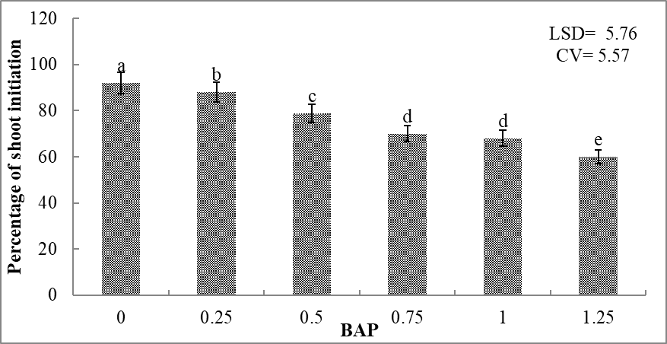
Bars represent error bar of standard deviation
Note: Values assigned by the same letters are not significantly different (p ≤ 0.01)

Figure 1. Effect of different concentrations of BAP on percentage of shoot initiation
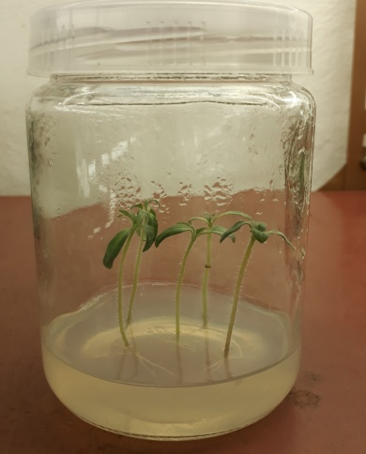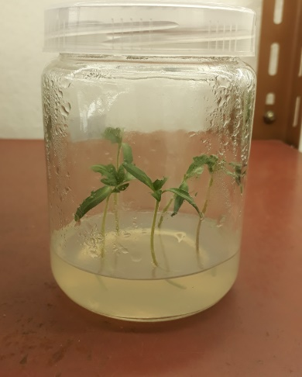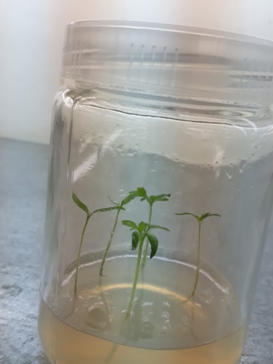
Shelter
Uwezo
Valouro

Figure 2. shoot initiation in the three tomato varieties on hormone free MS medium

Effect of BAP on shoot multiplication
The analysis of variance (ANOVA) for shoot multiplication revealed a very significant interaction between Varieties and BAP (P≤0.01) on number of shoots/explant, number of leaves/shot, and shoot length(Appendix Table 2).

On MS medium with 2 mg/l BAP, the Valouro and Uwezo varieties produced the most shoots per explant (5±0.08 and 4.3±0.08, respectively). Shelter variety produced the highest number of shoots per explant (4±0.07) on MS medium with 1.5 mg/l BAP (Table 2). MS medium supplemented with 2 mg/l BAP was optimal for the Valouro and Uwezo kinds, whereas 1.5 mg/l BAP was ideal for the Shelter variety. The Valouro and Uwezo cultivars produced varied shoot numbers at the same BAP concentration. This could be attributed to genetic heterogeneity in genotypes for in vitro response.
Tomato regeneration response to plant growth regulators (PGRs) has proven very genotype specific, so the type and concentration that works best for one genotype may not work for another. In this experiment, the number of shoots grew with increasing BAP concentration in all kinds until the optimum was reached, but then declined after 2.5 mg/l BAP. This could be owing to greater levels of cytokinin, which lower apical dominance, encourage shoot development, and release lateral buds. Furthermore, the toxic effect of growth regulators caused by accumulation has an impact on plant growth performance. During the current experiment, explants grown at greater BAP concentrations (after 2.5 mg/l) created excessive callus and failed to improve shoot multiplication efficiency.

MS medium supplemented with 0.5mg/l BAP resulted in maximum shoot length (5.8±0.08 cm, 5.3±0.11 cm, and 5±0.36 cm), while MS medium supplemented with 3 mg/l BAP resulted in minimum shoot length (2.69 ±0.1 cm, 2.81 ±0.17 cm, and 2.29±0.08 cm) in Valouro, Uwezo, and Shelter varieties. Lower BAP concentrations result in longer shoot lengths. This is because the use of BAP increases apical dominance while decreasing shoot length. In the current experiment, increasing the level of BAP above 0.5 mg/l resulted in a decrease in shoot length.
MS medium supplemented with 1.5 mg/l BAP resulted in the highest number of leaves/shoot (4±0.2 from Valouro, 3.6±0.04 from Uwezo, and 3.4±0.08 from Shelter variety), while MS medium supplemented with 3 mg/l BAP resulted in the lowest number of leaves/shoot (1.8±0.05, 1.91±0.11, and 1.45±0.04, respectively). This is because using BAP at the optimal level promotes cell division and increases the number of leaves.

Table 2. Effect of different concentration of BAP on shoot multiplication of tomato varieties
Variety | BAP (mg/l) |  | NS  (mean ±SD) | NL  (mean ± SD) | SL(cm)  (mean ± SD)
Valouro | 0.0  0.5  1.0  1.5  2.0  2.5  3.0 |  | 1.30±0.08^{l}  2.75±0.12^{g}  3.25±0.05e  3.67±0.06^{d}  5.00±0.14ª  3.00±0.16^{f}  1.87±0.14^{k} | 2.00±0.16^{kj}  2.60±0.08^{h}  2.85±0.12^{g}  4.00±0.2ª  3.02±0.05^{ef}  2.50±0.07^{ih}  1.8±0.05^{l} | 3.64±0.04^{l}  5.80±0.08ª  5.55±0.12^{b}  5.10±0.11^{dc}  4.80±0.08^{fe}  4.05±0.10^{k}  2.69±0.10º
Uwezo | 0.0  0.5  1.0  1.5  2.0  2.5  3.o |  | 0.80±0.08^{m}  2.43±0.12^{ih}  2.87±0.14^{gf}  3.50±0.08^{d}  4.30±0.13^{b}  2.56±0.12^{h}  1.81±0.08^{k} | 2.00±0.16^{kj}  2.86±0.008^{g}  3.15±0.12^{ed}  3.60±0.04^{b}  3.20±0.05^{d}  2.50±0.04^{ih}  1.91±0.11^{kl} | 3.30±0.04^{m}  5.30±0.11^{c} 4.68±0.16^{fg}  4.42±0.30^{hi}  4.10±0.31^{jk}  3.67±0.07^{l}  2.81±0.17º
Shelter | 0.0  0.5  1.0  1.5  2.0  2.5  3.0 |  | 0.50±0.20^{n}  2.25±0.12^{j}  2.31±0.23^{ij}  4.00±0.07^{c}  2.93±0.12^{f}  1.72±0.09^{k}  0.93±0.05^{m} | 2.06±0.10^{j}  2.09±0.06^{j}  2.57±0.09^{ih}  3.40±0.08^{c}  2.90±0.12^{gf}  2.45±0.12^{i}  1.45±0.04^{m} | 3.04±0.04^{n}  5.00±0.36de  4.57±0.05^{hg}  4.31±0.07^{ji}  4.00±0.16^{k}  3.50±0.07^{ml}  2.29±0.08^{p}
LSD  CV% |  |  | 0.22  4.94 | 0.14  4.06 | 0.18  3.79
Note; means with the same letter in the same column are not significantly different, where NS= number of shoots, NL = number of leaves and SL= shoot length.

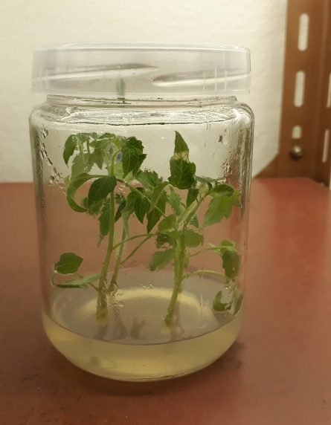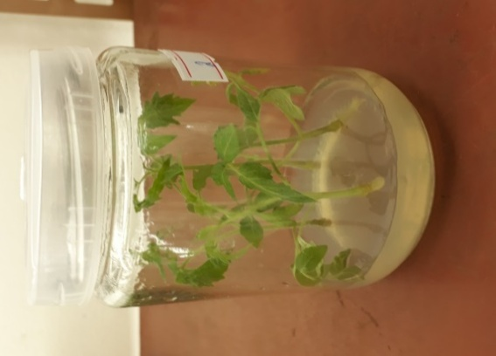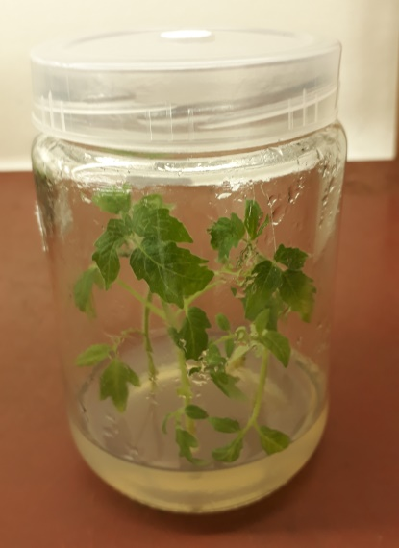
1.5mg/l BAP
2mg/l BAP
2mg/l BAP

Figure 3. In vitro shoot multiplication of Valouro, Uwezo and shelter tomato varieties after four weeks respectively

Effect of IBA on in Vitro rooting
The ANOVA demonstrated that the interaction between variety and IBA significantly (P<0.01) influenced days to rooting, number of roots/plantlet, and root length. The percentage of roots was significantly different (P≤0.05) (Appendix Table 3).
Early root induction was measured on MS medium without hormones and was 5 days for Valouro and Shelter cultivars and 7.67 days for Uwezo (Table 3). Late root induction (12.67 days for Valouro, 16 days for Uwezo, and 11 days for Shelter) was observed on half strength MS medium supplemented with 1.5 mg/l IBA. Early root induction was found in the control treatment, however with greater concentrations of IBA, roots were developed later.
This could be owing to the negative effect of auxins at higher concentrations on root development. The influence of ethylene on root growth is primarily mediated via the regulation of auxin production and transport-dependent local auxin distribution. Ethylene promotes auxin production and basipetal auxin transport toward the elongation zone, activating a local auxin response that inhibits cell elongation. Ethylene reduces primary root growth by controlling cell proliferation and elongation in the elongation zone.

On MS medium with 0.5 mg/l IBA, the Valouro, Uwezo, and Shelter varieties produced the most roots (15.36±0.35, 13.06±0.83, and 18.26±0.3, respectively). Valouro, Uwezo, and Shelter types had the fewest roots (3.3±0.2, 2.03±0.15, and 4.33±0.35) when grown in half strength MS medium with 1.5 mg/l IBA. The number of roots dropped as the concentration of IBA exceeded 0.5 mg/l. This could be attributed to an increase in the formation of the growth retardant chemical ethylene at high concentrations of auxins such as IBA.
Half strength MS medium containing 0.5 mg/l IBA resulted in maximum root lengths of 5.92 ±0.22 cm for Valouro, 5.5 ± 0.2 cm for Uwezo, and 6.55 ± 0.01 cm for Shelter variety. IBA doses of 0.0-0.5 mg/l resulted in the maximum rooting percentage (100.00±0.00) across all three kinds (Table 2). Therefore, utilizing IBA-free MS medium may be superior for minimizing the cost of PGRs. The Valouro, Uwezo, and Shelter cultivars had the lowest rooting percentages (56.67±3.51, 46.67±2.08, and 60.00±2) when grown on half strength MS medium with 1.5 mg/l IBA.
In the present finding, the minimum percentage of rooting was obtained at higher concentrations of IBA. This variation may be due to the different genotypes requiring different concentrations of auxin and their responses are dependent on the amount of their endogenous auxin concentration.

Table 3. Effect of different concentration of IBA on in vitro rooting of three tomato varieties
Variety |  | IBA (mg/l) | DR  (Means± SD) | NR  (Means± SD) | RL (cm) R%  (Mean ±SD) (mean ±SD)
Valouro |  | 0.0 | 5.00±1.00^{m} | 9.10±0.36^{gh} | 3.58± 0.03^{ji} 100.00±0.0ª
 |  | 0.25 | 7.00±1.00^{kl} | 12.86±0.15^{d} | 3.86± 0.05^{hg} 100.00±0.0ª
 |  | 0.5 | 8.33±0.57^{hij} | 15.36±0.35^{b} | 5.92± 0.22^{b} 100.00±0.0ª
 |  | 0.75 | 9.66±0.57^{egf} | 9.67±0.30^{gf} | 4.30± 0.20^{f} 93.3±2.51^{b}
 |  | 1.0  1.25  1.5 | 10.33±0.57^{ed}  11.00±1.00^{d}  12.67±0.57^{c} | 7.46±0.15^{i}  5.00±0.20^{k}  3.30±0.20^{m} | 3.47± 0.01^{jk} 86.67±4.16^{c}  2.70±0.08^{n} 76.67±3.21e  1.82±0.01^{q} 56.67±3.51^{g}
Uwezo |  | 0.0 | 7.67±0.57^{kji} | 6.00±0.20^{j} | 2.53±0.02º 100.00±0.0ª
 |  | 0.25 | 8.67±0.57^{hgi} | 10.00±1.00^{f} | 3.32±0.03^{lk} 100.00±0.0ª
 |  | 0.5 | 9.67±0.57^{egf} | 13.06±0.83^{d} | 5.50±0.20^{c} 100.00±0.0ª
 |  | 0.75 | 10.00±0.72^{edf} | 8.83±0.20^{h} | 3.73±0.05^{hi} 93.3 ±4.04^{b}
 |  | 1.0  1.25  1.5 | 11.00±1.00^{d}  14.33±0.57^{b}  16.00±1.00ª | 6.50±0.10^{j}  3.16±0.05^{m}  2.03±0.15^{n} | 3.20±0.08^{l} 85.3±3.51^{cd}  2.13±0.11^{p} 67.67±11.67^{f}  1.50±0.08^{r} 46.67±2.08^{h}
Shelter |  | 0.0  0.25  0.5  0.75  1.0  1.25  1.5 | 5.00±1.00^{m}  6.00±1.00^{ml}  7.33±0.57^{kj}  8.00±0.50^{hkji}  9.00±0.43^{hgf}  10.00±0.87^{edf}  11.00±0.20^{d} | 12.03±0.35e  14.5±0.43^{c}  18.26±0.30ª  13.49±0.49^{d}  10.10±0.10^{f}  7.50±0.10^{i}  4.33±0.35^{l} | 4.40±0.08^{f} 100.00±0.0ª  5.20±0.10^{d} 100.00±0.0ª  6.55±0.01ª 100.00±0.0ª  4.80±0.10e 93.3±3.21^{b}  3.93±0.02^{g} 88.67±4.5^{cb}  3.41±0.02^{jk} 80.0±4.58^{ed}  2.98±0.02^{m} 60.0±2.0^{g}
LSD 1.23 0.63 0.16 5.92
CV% 8.07 4.06 2.69 4.19
 | Note: means with the same letter in the same column are not significantly different, where DR= days to rooting, NR= number of root, RL= root length and R% rooting percentage.

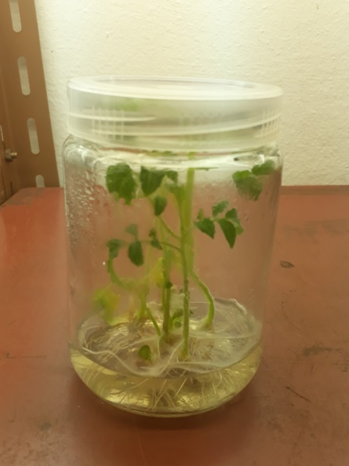
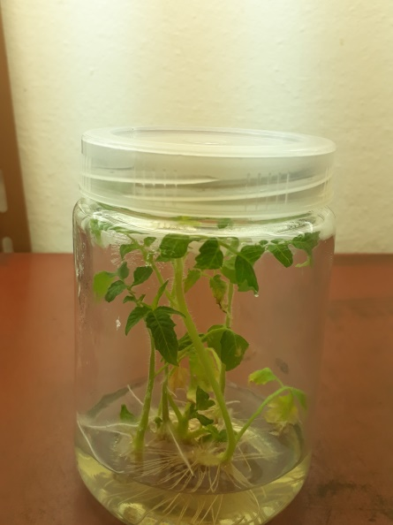
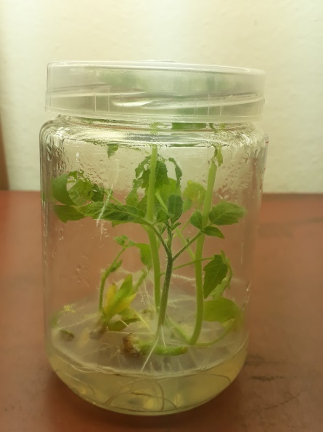

C
B
A

Figure 4. Invitro rooting of the three tomato varieties

3.4. Acclimatization
The survival percentages of fifty-three acclimatized plantlets were 81.13%, 73.58%, and 69.8% for Valouro, Uwezo, and Shelter types at a 1:2:1 ratio, respectively (Figure 5). The survival rate derived from a 2:1:1 ratio was 67.92%, 58.49%, and 62.26 for the Valouro Uwezo and Shelter types, respectively. Some plantlets did not survive after being moved to the lath house. This could be due to a shift in the environmental conditions, which may have influenced the plant's growth performance.
Table 4. Survival percentage of acclimatized plantlets on different soil composition
Varieties | 1:2:1 | 2:1:1 | 2:1:0
Valouro | 81.13% | 67.92% | 54.71%
Uwezo | 73:58% | 58.49% | 49.05%
Shelter | 69.8% | 62.26% | 56.6%
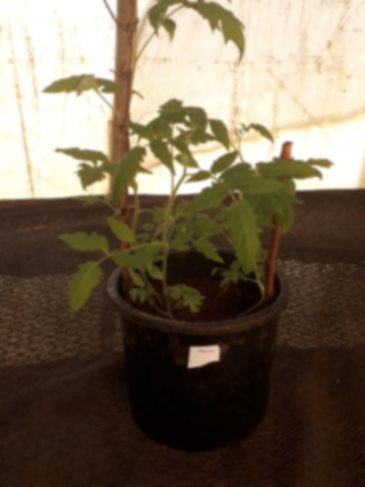
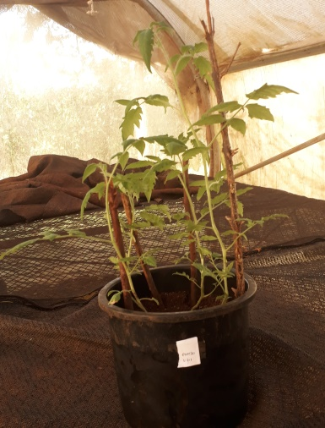
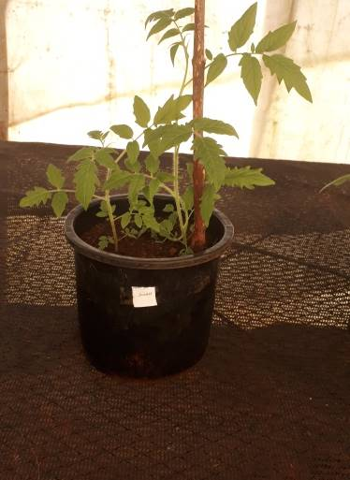

Shelter
Uwezo
Valouro
Figure 5. Acclimatized plantlets of three tomato varieties

Conclusions

This paper presents an essential in vitro micropropagation strategy for three hybrid tomato types. For the Valouro and Owezo types, the MS medium boosted with 2 mg/l BAP produced the most shoots (5 and 4.3, respectively). While shelter cultivars produced the greatest number of shoots (4), they were regenerated on MS medium enriched with 1.5mg/l BAP.
In conclusion, MS medium without growth regulators was optimum for shoot initiation. For For the Valouro and Uwezo cultivars, MS medium supplemented with 2 mg/l BAP was optimal for shoot multiplication. For the Shelter variety, MS medium supplemented with 1.5 mg/l BAP was ideal for shoot multiplication. For in vitro rooting, half strength MS medium with 0.5 mg/l IBA was shown to be the best for all three kinds.

Declaration of Manuscript Source
This manuscript is taken from thesis ‘Micropropagation of Selected Hybrid Tomato (Solanum lycopersicum L.) Varieties Using Shoot Tip Culture’ submitted to Jimma University as part of Masters course at the department of Horticulture and Plant Science. http://repository.ju.edu.et//handle/123456789/5709

References
Banks, P. (1984). A new diploid chromosome number for tomato (Lycopersicon esculentum). Canadian journal of genetics and cytology, 26(5): 636-639.
Bhatia, P. (2003). Regeneration, micropropagation, and somatic embryogenesis in tomato (Lycopersicon esculentum Mill.). A thesis submitted for the degree of Doctor of Philosophy, School of Biological and Environmental Sciences, Central Queensland University, Queensland, Australia.305p.
Bhatia, P., Ashwath, N. and Senaranta, T. (2004). Effect of cytokinins on organogenesis and callus induction in cotyledonary explants of tomato (Lycopersicon esculentum L). Enfield, 17-24p.
Chaudhry, Z., Abbas, S., Yasmin, A., Rashid, H., Ahmed, H. and Anjum, M.A. (2010). Tissue culture studies in tomato (Lycopersicon esculentum L.) var. moneymaker. Pakistan Journal of Botany, 42(1): 155-163.
Chaudhry, Z., Habib, D., Rashid, H. and Qureshi, A.S. (2004). Regeneration from various explants of in vitro seedling of tomato (Lycopersicon esculentum L., cv. Roma). Pakistan journal of biology. Sci, 7(2): 269-272.
Cheema, D.S. and Dhaliwal, M.S. (2005). Hybrid tomato breeding. Journal of New Seeds, 6(2-3): 1-14.
Debela, K.B., Belew, D. and Nego, J. (2016). Evaluation of tomato (Lycopersicon Esculentum Mill.) Varieties for Growth and Seed Quality under Jimma Condition, South Western Ethiopia. International Journal of Crop Science and Technology, 2(2).
Devi, R., Dhaliwal, M.S., Kaur, A. and Gosal, S.S. (2008). Effect of growth regulators on in vitro morphogenic response of tomato.
FAO STAT. (2018). Food and Agriculture Organization of the United Nations data.(http://www.fao.org/faostat/en/#data/QC/visualize (19/12/2017.
Gemechis, A.O., Struik, P.C. and Emana, B. (2012). Tomato production in Ethiopia: constraints and opportunities. Tropentag 2012, International Research on Food Security, Natural Resource Management and Rural Development. Resilience of Agricultural Systems against Crises: Book of Abstracts, (pp.373).
Georgiev, H. (1991). Heterosis in tomato breeding. In Genetic improvement of tomato. Springer, Berlin, Heidelberg. 83-98.
Gerszberg, A., Hnatuszko-Konka, K., Kowalczyk, T. and Kononowicz, A.K. (2015). Tomato (Solanum lycopersicum L.) in the service of Biotechnology. Plant Cell, Tissue and Organ Culture (PCTOC), 120(3), 881-902.
Indrani, C., Priyanka, S., Arijit, B., Priya, S., Sana, J. and Autashi, S. (2013). In vitro callus induction, regeneration and micropropagation of Solanum lycopersicum. International Journal of Current Microbiology and Applied Sciences, 2(12),192-197.
Jenkins, J.A. (1948). The origin of the cultivated tomato. Economic Botany, 2(4), 379-392.

Kahsay, Y. (2016). Open access Scope and Status of Vegetable Seed Production in Ethiopia. (pp. 1-15).
Khuong, T.T.H., Crété, P., Robaglia, C. and Caffarri, S. (2013). Optimization of tomato Micro-tom regeneration and selection on glufosinate/Basta and dependency of gene silencing on transgene copy number. Plant cell reports, 32(9), 1441-1454.
Ling, H.Q., Kriseleit, D. and Ganal, M.W. (1998). Effect of ticarcillin/potassium clavulanate on callus growth and shoot regeneration in Agrobacterium-mediated transformation of tomato (Lycopersicon esculentum Mill.). Plant cell reports, 17(11), 843-847.
Mamidala, P. and Nanna, R.S. (2011). Effect of genotype, explant source and medium on in vitro regeneration of tomato. International Journal of Genetics and Molecular Biology, 3(3): 45-50.
Mandal, A.B. and T. E. Sheeja. (2003). In vitro flowering and fruiting in tomato (Lycopersicon esculentum Mill.) Asia Pac.J.Mol.Biol.Biotechnology, 37-42.
Moghaieb, R.E., Saneoka, H. and Fujita, K. (2004). Shoot regeneration from GUS-transformed tomato (Lycopersicon esculentum) hairy root. Cellular and Molecular Biology Letters, 9(3), 439-450.
Rick, C. M. (1980). Hybridization of Crop Plants. Am. Soc. Agron./Crop Sci. Soc. Am. Madison, WI, USA, 669-680.
Shiferaw K. (2021). Micropropagation of Selected Hybrid Tomato (Solanum lycopersicum L.) Varieties Using Shoot Tip Culture. http://repository.ju.edu.et//handle/123456789/5709
Tilye, F., Welander, M. and Negash, L. (2005). Micropropagation of Hagenia abyssinica: a multipurpose tree. Plant cell, tissue and organ culture, 80(2): 119-127.

