A RETROSPECTIVE VALIDATION OF POPULATION PROJECTIONS BETWEEN SOUTHERN AND NORTHERN NIGERIA

ABSTRACT
Population size of Nigeria has gained global attention as one of the largest in the world, while the country remains one of the poorest. The actual population of Nigeria has been a subject of controversy because of her inability to conduct a census that is acceptable to all her citizens. Models have been developed through several studies to project Nigeria’s population in the absence of a reliable census. This research was therefore designed to investigate the internal composition, and as well cross – validate the projected population figures using public Primary School Enrolment and extent of Voters participation in general elections between 1999 and 2020. Data for the research were obtained from the records of Nigerian Bureau of Statistics (NBS), the National Population Commission, the Independent National Electoral Commission and the Federal Ministry of Education. The collected data were analyzed using SPSS package. Results from analysis showed that there has been a consistent proportional increase in population figures of both Northern and Southern Nigeria, despite that the growth rates has not always been in favour of one region. Between 1991 and 2006, the population growth rate of the Northern Nigeria was 4.2% and Southern Nigeria recorded 3.5%. From 2006 to 2016, Southern Nigeria has a higher population growth rate of 3.9% as compared to 3.6% for Northern Nigeria. For the entire nation, a growth rate of 3.85% and 3.77% were obtained for 1991 – 2006 and 2006 – 2016 periods, respectively. Findings also showed that public primary school enrolment data and records of voters’ participation in general elections did not display the same pattern of growth as observed in projected population figures. The need for an actual headcount is implied as an imperative by this study.

INTRODUCTION
Population growth models constitute a subset of the wider class of mathematical models that have found applications in diverse fields of human endeavor. From statistical theory and probability to applied statistics, models have become invaluable in optimizing human efforts. For instance, Nduka and Igabari (2007) proposed a modified generating function that could generate the moments of the attributes of a population distribution, while Matthew et al (2017) developed a general method for obtaining such moments. In epidemiological studies of populations, Mamadu et al (2020) used a numerical approach to analyse an SEIR compartmental disease transmission model while Aghanenu et al (2022) investigated the effect of control strategies in epidemic management using a mathematical model. Ehiwario et al (2023a) coupled a lifetime probability distribution with established survival and hazard rate functions while Ehiwario et al (2023b) applied the distribution to estimate recovery and mortality rates arising from the Covid-19 pandemic in Nigeria. In a similar vein, Onyemarin et al (2023) used a time series model to analyse infant mortality rates in some regions of Nigeria. All these are instances of use of mathematical models in explaining population related issues.
Knowing the size of the population of a community is important for economic development, since the growth of any population affect the demand for food, water, energy and other essential social services, such as education, health, transport and housing (National Bureau of Statistics. (2012. 2016, 2017)). The study of population growth is therefore crucial for any nation due to the effect it can have on the country’s planning and budget allocation generally. Many countries use census to get the actual number of their population. However the process is very costly since it involves a lot of people and technologies. According to Igabari (2017), general censuses may not easily be conducted in short periods of time, necessitating the use of projection models to regularly estimate present and future populations of a nation.
Population projection provides future estimates of population size needed by planners and policy makers. Projections contribute to the improvement of the quality of life of citizens through the provision of current and reliable data for policy formulation, development planning and service delivery, as well as for monitoring and evaluating national and international development frameworks (National Bureau of Statistics. (2012. 2016, 2017)).
According to Agog et al (2020), Nigeria’s population has been increasing steadily and drastically over the years without a corresponding increase in sustainable resources to cater for the population growth. To combat this ugly situation, the importance of population studies in Nigeria becomes more imperative to economic growth and sustainability of the population.
Different studies have been done over the years to explain the population growth of different countries including Nigeria which has in turn helped various individual and organizations in planning and predicting the future population expectation of their geographical location. Comparative studies have also been carried out on different models in order to develop suitable models that fittingly represent Nigeria. Among these are Ekakitie and Ekereke (2019) who investigated the growth sensitivity of the Nigerian population, Olanrewaju (2020) who performed a trend analysis on the Nigerian population, Wali et al (2011) who used a growth model to estimate the growth rate of the Rwandan population ane Wei et al (2015) whose work was on the growth indices of the Chinese population.
Kerry et al (2017) executed a comparative study of mathematical and statistical models for population projections in Nigeria. The study compared the exponential growth model and the regression model and found based on the predicted population values of their research that that the regression model yielded the best result. Also, Akanni and Uche (2014) analyzed issues of demographic dynamics and development in Nigeria and identified a number of issues about the population growth in Nigeria including politics, democracy, health and Education.
It is noteworthy however that most of these research works on population growth and models in Nigeria were analyzed considering Nigeria as a whole unit. Thus an analysis considering the Nigerian population different geographical regions and political divisions herein could play a pivotal role in gaining a more practical insight into the distribution and growth pattern of the Nigerian population. Additionally, a consideration of other population growth estimators such as voting statistics in general elections and Primary School Enrolment data can provide added information to validate the Nigerian population growth pattern.

Statement of the Problem
Nigeria’s inability to conduct a credible census and the subsequent dependence on projections over a long period of time is a cause for worry, presents the need to have a form of cross validation of projections. This work, therefore, analyzed the population growth patterns of Nigeria as two separate regions, namely. the Northern and Southern Nigeria and attempted to use election data and Primary School Enrolment data to validate population projections for the two major segments of the Nation.

Aim of the Study
The aim of this study therefore, is to analyze and compare the projected population growth patterns of the Northern and Southern Nigeria and to cross – validate the population projections with Primary School enrolment data and with Election voters’ participation data.
The Nigerian Population
Igabari (2017) admitted that the question of Nigeria’s actual population has remained a very sensitive one within the country because there are very obvious constitutional advantages of large populations conferred on constituent parts of the Nation. This sensitivity has made it increasingly difficult to conduct a credible census exercise, and this means having to depend on projections and estimates.
Nigeria is a relatively large country in West Africa. It is surrounded by countries like Benin, Togo and Ghana on its west surrounding; Chad, Burkina Faso and Cameroon on its North East surrounding while Niger on the north surrounding. Nigeria comprises of 36 states and its federal capital territory called Abuja with its largest city called Lagos. Nigeria has a total land mass of 923,768𝑘𝑚², i.e. 356669 square meters with its water percentage estimate at 1.4%. Nigeria gained her independence on the 1st of October 1960 and then later declared as a republic on the 1st of October 1963.
The current population of Nigeria is 210536787 as of Friday, may 14 2021, based on world meter elaboration of the latest UN data. (United Nations, 2021). Nigeria 2020 population is estimated at 206,139,589 people at mid-year according to UN data. Nigeria population is equivalent to 2.64 percent of the total world population. Nigeria ranks number 7 in the list of countries (and dependencies) by population. The population density in Nigeria is 226 persons per km² (586 people per square mile). The total land area is 910,770 km square (351650² miles). 52.0 percent of the population is urban (107,112,526 people in 2020). The median age in Nigeria is 18.1 years. (United Nations, 2021)
The Nigerian Nation is divided into Southern and Northern Regions. The Southern part of Nigeria is made up of 17 states: Enugu, Imo, Ebonyi, Abia, and Anambra, Oyo, Ekiti, Ondo, Osun, Ogun and Lagos, Bayelsa, Edo, Delta, Rivers, Cross River and Akwa Ibom. On the other hand the Northern part of Nigeria consists of 19 states which include Zamfara, Kano, Benue, Katsina, Sokoto, Kaduna, Jigawa, Niger, Adamawa,Kebbi, Borno, Bauchi, kogi, kwara, Nasarawa, Taraba, Yobe, Plateau and Gombe states.
Another classification of Nigeria is by geo-political zones. There are six of such zones namely North East (NE) having Adamawa, Bauchi, Borno, Gombe, Taraba and Yobe state; North West (NW) having Jigawa, Kaduna, Kano, Katsina, Kebbi, Sokoto, and Zamfara; North central (NC) with Kogi, Benue, Nassarawa, Niger, Kwara, Plateau and Kogi state; South South (SS) having Delta, Edo, Rivers, Cross River, Bayelsa and Akwa Ibom state; South East (SE) having Enugu, Imo, Ebonyi, Anambra and Abia state; and South West (SW) having Oyo, Ogun,Lagos, Osun, Ondo and Ekiti states.
Primary School Enrolment and Voters Participation in Nigeria
Akinwumi (2007) researched on trends in school enrolment of primary school between 1984 and 2002. He admitted that there has not been commensurate increase in other resources that will cater for the enrolment growth in primary school. Most public schools have dilapidated buildings in deplorable state and lacks adequate basic teaching/learning materials.
Over the years, enrolment rates of school aged children have significantly been declining in spite of the government effort to improve and increase primary school enrolment in the country (Okuneye and Olukayode, 2014). They also added that Primary school enrolment exhibit a strong predictive power in explaining variations in economic growth in Nigeria and that effective collaboration between the government and private sector is also considered indispensable for the development of the education sector in Nigeria. Undoubtedly, several factors contribute to the rate of primary school enrolment on a yearly basis ranging from lack of schools in some areas to parents attitude towards children education. Olanrewaju (2011) identified some determinants of child schooling in Nigeria. They include; the individual child characteristics such as age and his place of living, parents income and parents education among other things.
Population growth has also been considered as a factor that can affect the enrolment of school aged children. Using Yola – North as a case study, Emmanuel and Oaya (2018) explained that primary school enrolment was not increasing at a similar rate to that of the actual population.
With regards to the trends in Nigerian elections voters participation, Omotola and Aiyedogbon (2016) revealed that voters turn out since 1999 has generally been low, hovering around 50% or slightly below of the actual population. The study explained that the reason vary from one election to another. However, there are trends that cut across the various elections. These include ethno – regional considerations, the level of trust in electoral institutions and process at any point in time, the disposition of government (ruling party) towards free and fair elections, campaign issues, the level of political education and mobilization, etc.
Methodology
The required data for this study were collected from their respective sources such as National Bureau of Statistics of the Federal Republic of Nigeria, Federal Ministry of Education and the Independent National Electoral Commission (INEC). The collected data were analyzed using the SPSS statistical package.
Population growth rates were estimated using the formula below
$rate= \frac{average annual population difference}{initial population} × \frac{100}{1}$ 1
$$Average annual population different$$
$$= \frac{final population \left(p_{n}\right) -initial population (p_{0})}{time difference } 2$$
In validating the population figures, hypotheses of no significant difference in growth rates between the proposed population growth estimators and the actual population projection of Nigeria were formulated and tested. The hypothesis was tested using the chi - square goodness of fit test at 5% level of significance.
$${ X}^{2}= \sum{\frac{{\left(O_{ij}-E_{ij}\right)}^{2}}{E_{ij}}} 3$$
Where the $E_{ij}$ represents projected population growth rates and $O_{ij}$ represents corresponding growth rates from primary school enrolment data and from voters’ statistics.
Additionally, in developing the population growth model, we applied the logistic population growth equation in simulating population projections at three different population carrying capacities and compared with the projections from exponential growth model.

RESULTS
Data collected and subsequent analysis are presented as follows:
Table 1: Population of Northern and Southern Nigeria
Region | 1991 | % | 2006 | % | 2016 | %
North | 47,369,237 | 53 | 76,992,934 | 55 | 104,936555 | 54
South | 41,622,983 | 47 | 63,438,859 | 45 | 88,455,962 | 46
Total | 88,992,220 | 100 | 140,431,201 | 100 | 193,392,517 | 100
Source: National Bureau of Statistics. (2012. 2016, 2017).
Tables 1 shows the population figures of Northern and Southern Nigeria respectively for 1991 and 2006 population censuses as well as the population projection of 2016. The table shows that the Northern Nigeria has consistently produced higher population figures when compared to the Southern Nigeria. This is further illustrated in the following charts.

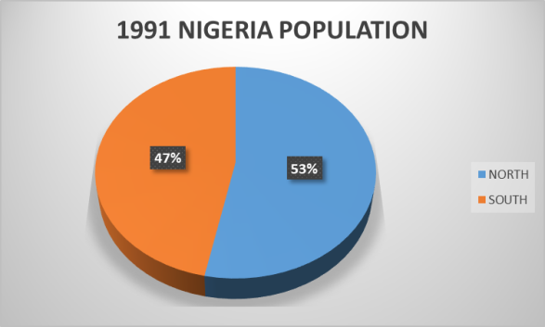 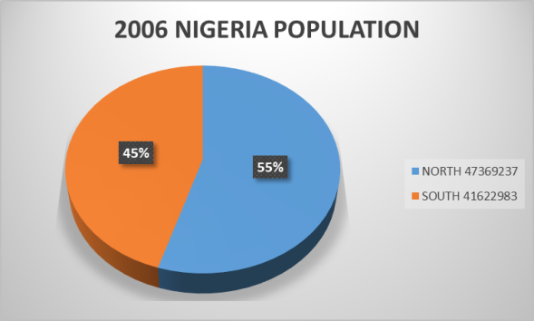Fig 1: Composition of Nigeria Population in 1991 Fig 2: Composition of Nigeria population in 2006

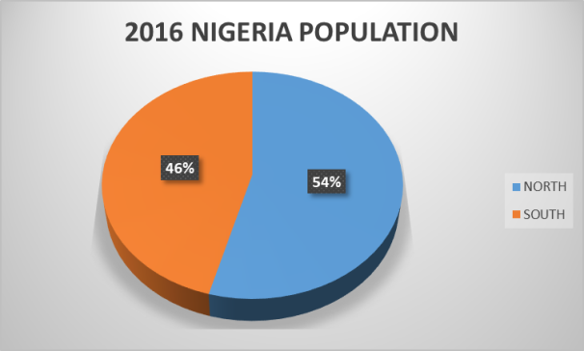
Fig 3: Composition of Nigeria population in 2016
As observed from the pie charts, in 1991 the percentages for population fractions were 53% to 47% for the Northern and Southern Nigeria respectively. In 2006 it was 55% to 45% for north and south respectively; while in 2016 it was 54% to 46% respectively for Northern and Southern Nigeria.
Estimating the population growth rate of Southern and Northern Nigeria.
From table 1, using equation 1 and 2, we estimated a 4.2% and 3.5% population growth rate respectively per annum between 1991 and 2006. Similarly, we estimated a population growth rate of 3.6% 3.9% for northern and southern Nigeria between 2006 and 2016. Additionally, for the estimation of the population growth rates for northern and southern Nigeria for the entire period of 1991 – 2016 (25years), we computed a population growth rate of 3.96% for Northern Nigeria and a corresponding 3.66% growth rate for Southern Nigeria. For the entire nation’s population, we estimated a population growth rate of 3.9% per annum between 1991 and 2006 and a growth rate of 3.8% per annum between 2006 and 2016 while for the entire period of 25 years (1991 – 2016 ) the estimated growth rate per annum is 3.86%.
A tabular presentation of all the population growth rates estimated is given below.
Table 2: Nigeria Population Growth Rates
Region | 1991 – 2006 | 2006 – 2016 | 1991 – 2016
North | 4.2 | 3.6 | 3.96
South | 3.5 | 3.9 | 3.66
Total | 3.9 | 3.8 | 3.85
Cross – Validation of population figures with Primary School Enrolment data
Table 3: Nigeria Primary School Enrolment
Region | 2006 |  | 2007 |  | 2008 |  | 2009 |  | 2010
Region | No | % | No | % | No | % | No | % | No | %
North | 13208847 | 65 | 11974902 | 56 | 12304843 | 58 | 11229507 | 59 | 13433478 | 65
South | 8436942 | 35 | 8494493 | 44 | 8989675 | 42 | 7750888 | 41 | 7230327 | 35
Total | 21717789 | 100 | 20468395 | 100 | 21294518 | 100 | 18980395 | 100 | 20663805 | 100
Source: NBS (2012)

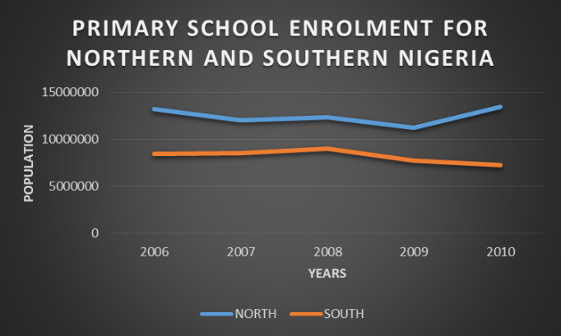
Fig 4: Primary School Enrolment Growth for Northern and Southern Nigeria from 2006 – 2010.
Table 3 shows the number of primary school enrolments for Northern and Southern Nigeria between the years of 2006 – 2010, while Fig. 4 illustratively shows the growth pattern of the yearly primary school enrolments in northern and southern Nigeria within 2006 – 2010.
In order to validate the population projections with primary school enrolment data, we compared the annual growth rates of the primary school enrolment data in Table 3 with those of the actual population projections around the same period of time and test for significant difference. The following table presents the actual projections for the Nigeria population.

Table 4: Nigeria population projections
Region | 2006 |  | 2007 |  | 2008 |  | 2009 |  | 2010
Region | No | % | No | % | No | % | No | % | No | %
North | 75269722 | 54 | 77771155 | 54 | 80362305 | 54 | 82962799 | 54 | 85795557 | 54
South | 65162068 | 46 | 67229129 | 46 | 69290177 | 46 | 71556785 | 46 | 73825671 | 46
Total | 140431790 | 100 | 145000284 | 100 | 149652482 | 100 | 154519584 | 100 | 159619228 | 100
Source: NBS (2012)

Table 5: Growth Rates for Public Primary School Enrolment
Region | 2006 / 2007 | 2007 / 2008 | 2008 / 2009 | 2009 / 2010
North | -9.34% | 2.76% | - 8.74% | 19.63%
South | 0.68 % | 5.83% | - 13.78% | - 6.72%

Table 6: Growth Rates for Population Projection
Region | 2006 / 2007 | 2007 / 2008 | 2008 / 2009 | 2009 / 2010
North | 3.32% | 3.33% | 3.24% | 3.41%
South | 3.17% | 3.07% | 3.27% | 3.17%

The result of the test of hypothesis that there is no significant difference in growth rates between primary school enrolment data and actual population projection at 5% level of significance is presented in table 7.
Table 7: Test for significant difference between population projection and Primary School Enrolment growth rates.
Rate | N | df | X² cal | p-value | Decision
Population projection | 8 | 7 | 17.6 | 0.025 | Significant*
School Enrolment | 8
*significant at p < 0.05
This means that there is a significance difference in the growth rates between primary school enrolment data and actual population projections. Hence, we conclude that primary school enrolment data did not validate the actual population growth rate.

Cross – Validation of population figures with Election voters’ participation data.
Table 8: Nigeria Election Participation for North and South
Region | 1999 | 2003 | 2007 | 2011 | 2015 | 2019
North | 15981164 | 23003844 | 18969110 | 22856778 | 16818691 | 17974104
South | 14298888 | 19014891 | 16338112 | 16612706 | 12613392 | 10639886
Total | 30280052 | 42018735 | 35307222 | 39469484 | 29432083 | 28613990
Source: Independent National Electoral Commission

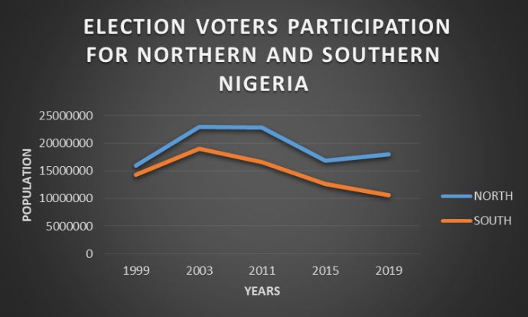
Fig 5: Graph of Voters Participation for Northern and Southern Nigeria

Table 8 shows the numbers of election voters’ participation for Northern and Southern Nigeria between the periods of 1999 – 2019 for all general presidential elections conducted in the regions.
Figures 5 illustratively shows the growth patterns observed in the Northern and Southern Nigeria for number of election voters that participated in the general elections from 1999 to 2019. Table 3.8 also presents a cumulative data of both Northern and Southern Nigeria for election voters’ participation together with the proportion of voters in percentages for both regions of the Nigerian population.
In a similar vein, we attempted to validate the population figures with Election Voters’ Participation through a goodness of fit test using Tables 4 and 8 to compute the respective growth rates as presented in Tables 9 and 10.
Table 9 Growth Rates from voters’ participation.
Region | 2003 / 2007 | 2007 / 2011 | 2011 / 2015 | 2015 /2019
North | 14.4% | - 17.8% | - 16.6% | 7.1%
South | 13.2% | -14.2% | - 16.0% | 115.6%

Table 10: Growth Rates from Population Projections
Region | 1991 – 2006 | 2006 – 2016 | 1991 – 2016
North | 4.2 | 3.6 | 3.96
South | 3.5 | 3.9 | 3.66
Total | 3.9 | 3.8 | 3.85

The Test for significant difference between population projections and voters’ participation growth rates is presented in Table 11:

Table 11: Test of Hypothesis
Rate | N | Df | X² cal | p-value | Decion
Population projection | 2 | 5 | 4.07 | 0.105 | Not Significant*
Voters Participation | 3
Significant at p < 0.05
This implies that there is significant difference in growth rates between election voters’ participation and population projection. We therefore conclude that election voters’ participation growth rates do not fit or validate the actual population growth rates.

DISCUSSION OF RESULTS
The results from these analysis show that there has been a consistent increase in the population figures in both Northern and Southern Nigeria, with the northern region, having consistently higher population figures than the southern region, averaging 54% to 46% of the population respectively.
The results also show that there has always been a steady positive growth rate in both regions of the country nevertheless, the growth rates has not always been in favor of the Northern Nigeria. The carefully computed growth rates above show that for the first 15 years (1991 – 2006), the population growth rate of the northern Nigeria was higher than that of the southern Nigeria with growth rates of 4.2% to 3.5% respectively; while for the next 10 years (2006 - 2016) Southern Nigeria has a higher population growth rate of 3.9 as compared to the 3.6% of the Northern Nigeria. For the entire nation, we estimated a positive growth rate of 3.85 between the two censuses in 1991 and 2006 while between 2006 and 2016, the growth rate was estimated to be 3.77. Between the entire periods of 25 year (1991 – 2016) it was estimated that the population has increased at a rate of 3.86% per annum.
Analyzing from another direction using primary school enrolment data, it was shown that the primary school enrolment data has not and cannot reliably predict the population growth pattern of the Nigerian population as a whole due to its gross inconsistency with projected population figures. After computation using the primary school enrolment data the growth rates were tested for significant difference with those of the actual population projections using chi – square test. The test result showed that the difference was significant. This shows that the primary school enrolment data does not fittingly describe the Nigerian population growth and thus, does not validate the Nigerian population and that generally; enrolment into primary school for children has been on the decline. Many children may not have been enrolled in school which has in turn led to high illiteracy rate in Nigeria in recent years. Same can also be observed using election voters’ participation. Following the same procedure, the test once again shows a significant difference in growth rates of voters’ participation and the population projections. This consequently indicates that election voters’ participation data is still not an ideal population growth rate estimator and thus does not validate the Nigerian population. This could be as a result of prospective voters disinterest in elections over the years (Ajakaiye, 2009).

CONCLUSION
In the course of this study, we have carefully analyzed the Nigerian population as two major regions and have attempted to cross – validate already existing population data with primary school enrolment data and election voters’ participation data as population growth rate estimators. The inferences drawn from this study has shown that the Nigerian population is increasing rapidly in both regions of the country. The growth rates also have been positively consistent and has slightly increased more in the Southern region than in the Northern region in recent years. Furthermore, it has been observed that primary school enrolment for children is on the decline; recording lower number of enrolment in successive years thus making the primary school enrolment data an unreliable estimator of population growth rate in Nigeria. Similarly, the election voters’ participation data was also shown to have significantly different growth rates in comparison to the actual growth rates from population projections which make it unreliable in describing the structure of the Nigerian population.
RECOMMENDATIONS
It is recommended that consideration should be given to the conduct of actual census in every decade so as to have reliable population figures to aid planning and National development. Causes of decline in school enrolment must be investigated and promptly addressed. It is also recommended that primary school education should be encouraged and facilitated to improve literacy rate and the associated benefits of basic education in the country.

REFERENCES
Aghanenu, E. O; Igabari, J. N; Jenije, R. and Arunaye, F. I. (2022). Simulating Models for the Transmission Dynamics of a Novel Corona Virus under the Administration of an Imperfect Vaccine in Nigeria. Journal of Mathematics and Computer Science. 12:155 https://doi.org/10.28919/jmcs/7254. ISSN: 1927-5307
Agog, N. S., Bako S. S., Bamanga M. A., Peter M. & Byeli U. (2020). On Logistic Growth Model for Forecasting Nigeria’s Population. Science World Journal 15(4):55 – 64.
Ajakainye, O.I. (2009). Participation in Nigerian Elections. JONKOPING International Business School. Jonkoping University.
Akanni, I.A. and Uche, C.I. (2014).Demographic Dynamics and Development in Nigeria: Issues and Perspectives, African Population Studies, 27(2):11 –17.
Akinwumi, F.S. (2007). Trends in School Enrolment of Primary School Education Between 1984 and 2002. Trends in School Enrolment of primary school Education, 15(5):159 – 164
Ehiwario, J. C; Igabari, J. N. and Ezimadu, P. E. (2023a). Theory and Applications of the Alpha Power Type II Topp – Leone – Generated Family of Distributions. Reliability Theory and Applications. 18(3.74): 785 – 807.
Ehiwario, J. C; Igabari, J. N. and Ezimadu, P. E. (2023b). The Alpha Power Topp – Leone Distribution: properties, simulations and applications. Journal of Applied Mathematics and Physics. 11(1): 316 – 331.
Ekakitie, O. & Ekereke, L. (2019). Growth Sensitivity of the Nigerian Population and a Prediction for the Future. International Journal of Applied Science and Mathematical Theory, 5(3)17 – 25. www.iiardpub.org
Emmanuel, T. & Oaya, P. (2018). Population Growth and Primary School Enrolment in Yola – North, Adamawa State, Nigeria. International Journal of Scientific Research and Management. 6(5)44 – 58
Igabari, J. N. (2017). The Population Question in Nigeria: Models and Reliable Projections. Asian Research Journal of Mathematics. 8(3): 1 – 10. DOI: 10.9734/ARJOM/2017/33989. www.sciencedomain.org
Independent National Electoral Commission. (2011) Election Reports. https//saharareporters.com/2011/04/17/presidential-election-results-live.
Independent National Electoral Commission. (2015) Election Reports. https//saharareporters.com/2015/03/28/presidential-election-results-live.
Independent National Electoral Commission. (2019) Election Reports. https//saharareporters.com/2019/02/23/presidential-election-results-live.
Kerry C.C., Subeno T., Ezeora, J.N. and Okafor J.I., (2017). A Comparative Study of Mathematical and Statistical Models for Population Projection of Nigeria. International Journal of Scientific and Engineering Research, 8(2): 777-785.
Mamadu, E. J.; Njoseh, I. N.; Okposo, N. I.; Ojarikre, H. I.; Igabari, J. N.; Ezimadu, P. E.; Ossaiugboh, M. I. and Jonathan, A. M. (2020). Numerical Approximation of the SEIR Epidemic Model using Variational Iteration Orthogonal Collocation Method and Mamadu – Njoseh Polynomials. Preprints. 2020090196. https//doi.org.10.20944/preprints/ 202009.0196.v1
Matthew C. M., Oyeka C. A., Ashinze M. A., and Igabari, J. N. (2017). Generalized Moment Generating Functions of Random Variables and their Probability Density Functions. America Journal of Applied Mathematics and Statistics. 5(2), 49-53. DOI: 10.12691/ajams-5-2-2.
National Bureau of Statistics of the Federal Republic of Nigeria. (2012). Annual Abstract of Statistics.
National Bureau of Statistics of the Federal Republic of Nigeria. (2016). Annual Abstract of Statistics.
National Bureau of Statistics of the Federal Republic of Nigeria. (2017). Annual Abstract of Statistics.
National Population Commission & ICF Macro (2014). Nigeria Demographic and Health Survey 2013. Abuja: NPC Federal Republic of Nigeria.
Nduka, E. C. and Igabari, J. N. (2007) A modified Generalized Generating Function. Global Journal of Mathematical Sciences. 6(2):93 – 95.
Okuneye, B.A. & Olukayode, M. (2014). Primary School Enrolment and Economic Growth in Nigeria. IISTE Journal and Books Hosting – conference and workshop solutions. 4(15):41 - 52
Olanrewaju, S.O (2011). The Determinants of Child Schooling in Nigeria. African economic Research Consortium, Nairobi, 217(1):1 – 57.
Olanrewaju, S.O. (2020). Modelling Nigeria Population Growth: A Trend Analysis Approach. International Journal of Innovative Science and Research Technology, 5 (4):52-56.
Omotola, J.S. & Aiyedogbon, G. (2016). Political Participation and Voters Turn – Out in Nigeria 2011 Election. Journal of African Elections, 11(7):54 – 73.
Onyemarin, N. N; Ojarikre H. I and Igabari, J. N. (2023). An ARMA modelling approach on infant mortality rate in Nigeria. Nigerian Journal of Science and Environment. 21 (1): 94 – 114.
Osemeke, R. F; Igabari, J. N. and Nwabenu, D. C. (2024). Model Violation and Multicolinearity: A preminary study. Journal of Mathematical Sciences and Computational Mathematics. ISSN 2644 – 3368 (online): 5(3): 233 – 250.
United Nations World Population Data. (2021) Nigerian population 1950 – 2021. Retrieved March 29, 2021. https//macrotrends.net/countries/NGA/Nigeria/population
Wali, A., Ntubabare, D., Mboniragira, V. (2011). Mathematical Modeling of Rwanda’s Population Growth. Appl. Math. Sci., 5(53): 2617–2628.
Wei, H., Jiang, Y. & Zhang, Y. (2015). A review of two Population Growth Models and an Analysis of Factors Affecting the Chinese Population Growth. Asian J. Economics and Models. 3(1): 8-20.

