Nutrient dynamics: Influence of nutrient cycles on web/chain
Abstract
Nutrient dynamics are essential in determining the structure, functionality, and long-term stability of food chains and food webs within ecosystems. Through major biogeochemical cycles, such as those of nitrogen, phosphorus, carbon, and sulphur; nutrients are continually cycled and exchanged between living organisms and their physical environment. These cycles govern the availability of critical nutrients necessary for primary producers, thereby shaping the foundational levels of trophic systems and driving the flow of energy through successive trophic levels. Changes in nutrient supply influence species diversity, trophic relationships, and the overall productivity of biomass. While balanced nutrient inputs support biodiversity and promote ecosystem stability, excessive nutrient loading can disrupt food web dynamics, triggering problems such as eutrophication, loss of species, and imbalances across trophic levels; commonly referred to as the "paradox of enrichment." Additionally, nutrient recycling through detritus-based processes and consumer activities creates feedback mechanisms that can either buffer or amplify ecological fluctuations depending on prevailing environmental factors. Overall, the interactions between nutrient cycles and trophic dynamics underscore the critical need to manage nutrient inputs carefully to preserve ecological health across both aquatic and terrestrial ecosystems.
Keywords
Nutrient dynamics, Biogeochemical cycles, Primary production, Nutrient enrichment, Detritus pathway, Ecosystem resilience
Introduction
Nutrients, in their broadest sense, refer to all chemical elements essential for biological processes such as growth, survival, and reproduction (DeAngelis et al., 1989). Organisms require macronutrients including carbon (C), hydrogen (H), nitrogen (N), phosphorus (P), potassium (K), sulfur (S), and calcium (Ca) in substantial amounts to carry out fundamental physiological functions. Additionally, elements like silicon (Si) play specialized roles in cellular and structural processes. Micronutrients, such as copper (Cu) and zinc (Zn), though needed in much smaller quantities, are equally critical for enzymatic and metabolic activities (Smith and Smith, 1998). In natural environments, the limitation of certain nutrients can constrain the primary productivity of ecosystems depending on spatial and temporal conditions. Notably, in aquatic systems, the availability, chemical form, and stoichiometric ratios of nitrogen (N) and phosphorus (P) are primary factors regulating productivity (Officer and Ryther, 1980).
The term nutrient dynamics broadly encompasses the mechanisms by which nutrients are absorbed, stored, transformed, and recycled within an ecosystem over time and space. Understanding these nutrient pathways is fundamental to maintaining ecological balance, enhancing ecosystem productivity, and promoting long-term sustainability in terrestrial, aquatic, and agro-ecological systems.
Aquatic Ecosystem
Nutrient dynamics in aquatic ecosystems refer to the study of how nutrients circulate and interact with biological communities within water bodies. This process is essential because it directly affects the growth and productivity of phytoplankton, the primary producers at the base of aquatic food webs. Phytoplankton play a foundational role in supporting trophic interactions and sustaining ecosystem function. Gaining insights into nutrient dynamics allows researchers to better understand the complex interactions within aquatic environments and to identify the environmental and biological factors that regulate nutrient availability and spatial distribution. These dynamics are fundamental to preserving the health of aquatic systems, as they significantly influence biological productivity, ecosystem stability, and water quality.
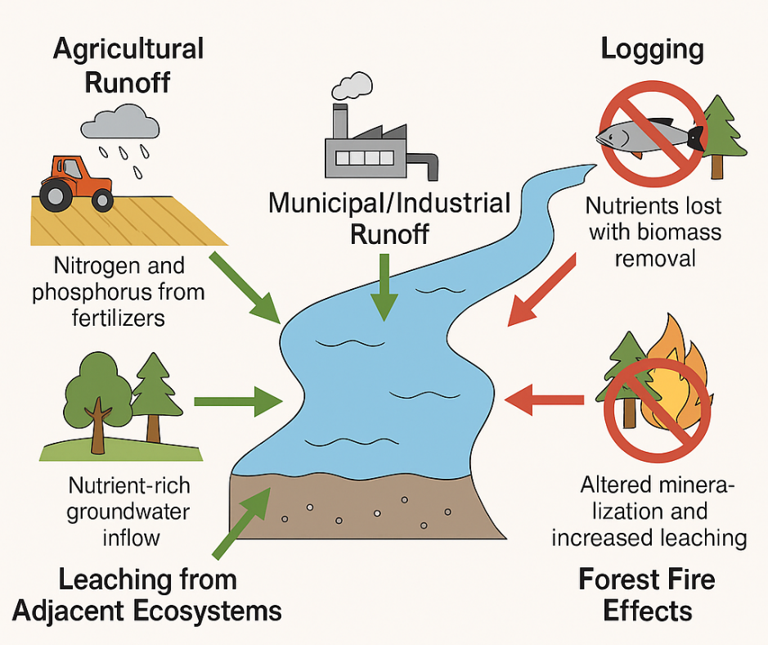
Fig.1 Import of Nutrients into Aquatic Ecosystems
Nutrient dynamics
Nutrient dynamics refer to the processes by which nutrients are absorbed, stored, transported, and recycled within ecosystems across both spatial and temporal scales (Hauer and Lamberti, 2006; Allan and Castillo, 2007). These processes are fundamental to comprehending the ecological equilibrium, biological productivity, and long-term sustainability of terrestrial, aquatic, and agricultural environments.
Aquatic Ecosystems
Nutrient dynamics in aquatic systems focus on how nutrients move through and affect living organisms within these environments. This process is especially important because it governs the growth of phytoplankton, which are critical to supporting aquatic food webs and maintaining ecosystem function. The circulation, transformation, and availability of key nutrients, such as nitrogen and phosphorus, its directly shape the structure of biological communities and influence energy flow across trophic levels. In this way, nutrient dynamics are vital to maintaining water quality, promoting biological productivity, and preserving the overall health and resilience of aquatic ecosystems. Nutrient dynamics within ecosystems are governed by a series of interconnected processes that determine the availability, mobility, and fate of essential elements. These processes include:
Processes in Nutrient Dynamics:
- Input Sources: Natural (weathering, atmospheric deposition) and anthropogenic (agricultural runoff, wastewater discharge).
- Transformation:
  - Nitrogen: Fixation, nitrification, denitrification.
  - Phosphorus: Sorption-desorption, mineralization, precipitation.
- Transport: Through surface runoff, groundwater flow, and sediment transport.
- Loss Pathways: Volatilization (for nitrogen), leaching, sedimentation.
Nutrient cycle
The nutrient cycle, or biogeochemical cycle, describes the ongoing circulation and recycling of nutrients within Earth's ecosystems, involving both biotic (living) and abiotic (non-living) components. These cycles are vital for sustaining life, as they control the supply of essential elements required for various biological functions. Nutrients are transformed, transported, and reused through a series of chemical, biological, and geological processes, including weathering, decomposition, and assimilation.
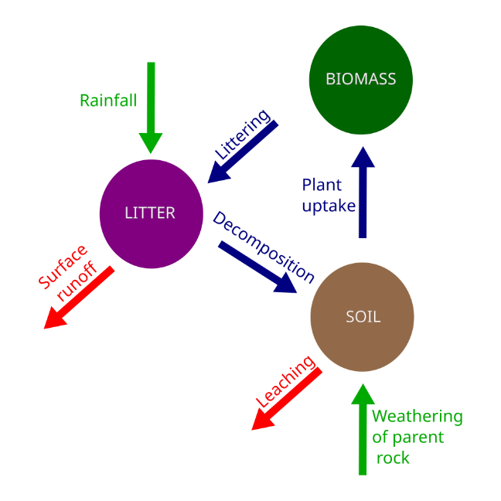
Fig.2 Nutrient cycle
Nutrient Cycling and Resource Availability
- The process of nutrient cycling enhances the supply of essential, often limiting, nutrients for primary producers by reusing mineral elements, thereby establishing a vital connection between all trophic levels and the foundational energy sources within food webs.
- In ecosystems where nutrients are scarce, this recycling mechanism can account for over half of the total nutrient input, significantly supporting the survival and continuity of species.
Influence of Nutrient Cycles on Food Chains and Webs
Nutrient cycling plays a critical role in shaping the stability and overall functioning of food webs. Given that food webs are fundamental to ecosystem operations, their structure and behaviour have been extensively examined using both experimental studies and theoretical models. A central focus in this research is identifying the food web features that help maintain essential ecosystem attributes, such as species diversity, primary productivity, and secondary productivity.
Models of food chains and food webs have been widely applied to explore these aspects. The recycling of vital mineral nutrients, particularly nitrogen and phosphorus is thought to closely influence food web behaviour and its ability to remain stable. Food web stability can be evaluated through several metrics:
The cycling of mineral nutrients such as nitrogen and phosphorus likely tightly interacts with food web dynamics and stability. Stability can be measured in different ways:
- Resilience: represents the ability of the system to return to its equilibrium after a disturbance
- Resistance: measures the degree to which a variable change after a disturbance and temporal variability represents the variance of population densities over time (McCann, 2000).
Impact of Nutrient Cycling on Food Web Stability via Various Mechanisms
Recycled nutrients supplement external mineral nutrient inputs, potentially causing an enrichment effect within ecosystems (Loreau, 2010). By enhancing nutrient availability, nutrient cycling promotes primary production (Loreau, 2010), which in turn increases energy flow to consumer organisms. This boost in energy transfer can support the survival of more species and help maintain higher trophic levels (Abrams, 1993; Binzer et al., 2011). However, nutrient cycling can also have destabilizing consequences for food web dynamics by elevating the availability of basal resources. When resource levels rise excessively, it may amplify population fluctuations, thereby raising the likelihood of species extinctions. In ecosystems where nutrients are limited, nutrient cycling typically enhances food web stability by promoting species survival and supporting upper trophic levels. Conversely, in nutrient-rich environments, this process may disrupt stability. Additionally, nutrient cycling introduces direct feedback mechanisms from all trophic levels back to the base of the food web. These feedback loops, beyond merely increasing nutrient levels, may significantly influence biomass fluctuations across the ecosystem.
Allometric Food Web Model
In an allometric food web model, multiple primary producers and consumers are interconnected through a complex web of interactions. Alongside these living components, the system also includes two non-living compartments: mineral nutrients and detritus. Organisms contribute to nutrient recycling either by directly releasing mineral nutrients or indirectly through the generation of decomposable detritus. The flow between the carbon-based biological components and the nutrient-based compartments is governed by stoichiometric principles that regulate the balance and conversion of elements.
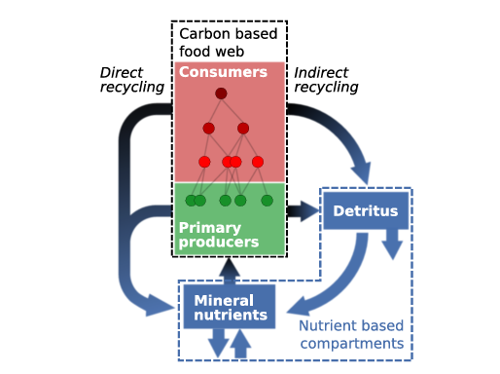
Fig.3 Schematic diagram of the modelled food web
Models incorporating allometric relationships have become increasingly popular for examining the dynamics and stability of food webs, as they can successfully replicate observed patterns and behaviors in complex ecosystems. Although the current model is calibrated for nitrogen, it can also be adapted to represent other essential limiting nutrients like phosphorus. A simplified version of this food web model is represented by a three-species food chain, consisting of a primary producer, an herbivore, and a carnivore. By including nutrient cycling in the model, it becomes possible to more effectively connect species population dynamics with broader ecosystem processes and functions.
Nutrient Cycling and Enrichment Effects
- The influence of nutrient cycling on food web stability is primarily driven by how it alters nutrient availability within ecosystems.
- This process creates an enrichment effect that supports species survival under low nutrient conditions but may disrupt ecosystem stability when nutrient levels are high.
- In nutrient-rich environments, excessive primary production can occur, often resulting in species loss and a decline in the overall complexity of the food web.
Influence of the Detrital Food Chain on Nutrient Distribution
Detritus acts as a vital nutrient reservoir that supports higher trophic levels, though it is frequently neglected in ecological research. It facilitates the return of nutrients to the grazing food chain by recycling organic materials.
The transformation of dead organic matter occurs in two main stages:
Decomposition – a stepwise breakdown process that eventually results in nutrient release.
Mineralization – the process of converting organic nutrients into inorganic mineral forms.
- The decomposition rate is largely influenced by environmental conditions such as temperature, oxygen levels, and moisture.
- The detritivore food chain consists of heterotrophs that consume decaying organic matter, thereby playing a key role in supplying nutrients that feed into and sustain the herbivore food chain.
Fragmenters:
Microfauna and Microflora – These organisms, typically under 2 mm in size, include millipedes, earthworms, snails, amphipods, and isopods. They break down large pieces of organic matter into smaller fragments, making it more accessible for decomposers.
Decomposers:
These include bacteria and fungi, which further break down fragmented organic material into simpler compounds through biochemical processes.

Decomposition in Aquatic Environments:
In aquatic systems, decomposition is influenced by environmental factors. Photosynthesis occurs primarily at the surface, while organic detritus sinks to the benthic zone. In this lower zone, reduced oxygen levels and cooler temperatures slow decomposition. Seasonal changes affect water movement stratification typically occurs in summer, creating distinct layers, while mixing happens during fall/autumn turnovers, redistributing nutrients and oxygen throughout the water column.
Conclusion
In an ecosystem model linking population dynamics in a food web to ecosystem functioning, we found strong effects of nutrient cycling on food web stability. Real ecosystems are known to differ by their dependence on external inputs of mineral nutrients, and ecosystems relying less on such inputs likely depend more on nutrient cycling than ecosystems depending more on external inputs. Therefore, nutrient cycling, as suggested by our results, could influence the food webs of these ecosystems in contrasted ways. It would also be interesting to compare food webs of different types of natural ecosystem with contrasting nutrient cycling and mineralisation rates. In fact, detritus is more than a transient pool for nutrients since, in real food webs, they are resources for decomposers and are recycled through the whole brown food web (Moore et al., 2004).
Reference
Harrison, M.D. (2016). Nutrient Dynamics. In: Kennish, M.J. (eds) Encyclopedia of Estuaries. Encyclopedia of Earth Sciences Series. Springer, Dordrecht. https://doi.org/10.1007/978-94-017-8801-4_75
Allan, J. D., Castillo, M. M., & Capps, K. A. (2021). Stream ecology: structure and function of running waters. Springer Nature.
Hauer, F. R., & Lamberti, G. (Eds.). (2017). Methods in stream ecology: Volume 1: Ecosystem structure. Academic press.
DeAngelis, D. L., Mulholland, P. J., Palumbo, A. V., Steinman, A. D., Huston, M. A., & Elwood, J. W. (1989). Nutrient dynamics and food-web stability. Annual review of Ecology and Systematics, 71-95.
Smith, R. L., Smith, R. L., Hickman, G. C., & Hickman, S. M. (1998). Elements of ecology.
Officer, C. B., & Ryther, J. H. (1980). The possible importance of silicon in marine eutrophication. Marine Ecology Progress Series, 3(1), 83-91.

