Short Research Article
Evaluation of Released Soybean (Glycine max L.merril) Varieties on Adaptability and Yield Performance in Hawassa Zuria and Halaba Zone
Abstract
In Ethiopia soybean is recognized as a key national oilseed crop because of its significant production of edible oil and the importance of its byproduct (soybean cake) as livestock feed. So, the selection of appropriate varieties is very important to achieve the national goal. Therefore, selecting suitable varieties is essential for achieving the national objective. Consequently, this study aimed to evaluate and identify the best soybean varieties based on adaptability and yield performance in the study areas. The trial was carried out during the main cropping season of 2023/24 at Hawassa Zuria and Halaba Zone using a randomized complete block design with three replications. Eighteen released soybean varieties were evaluated in two different environments. The yield and hundred seed weight of soybean varieties were adjusted at 12% moisture content and subjected to analysis of variance. The analysis of variance revealed significant variations for all tested treats. Among the tested soybean varieties, Gishama scored the highest mean grain yield (3162.60 kg per hectare) and showed consistent grain yield across the locations, followed by SCS-1 and Cocker-240 with the respective mean grain yields of 3053.86 and 3068.37 kg ha⁻¹. Soybean variety SCS-1 (3436.83 kg ha⁻¹) was a high yielder at Hawassa Zuria. On the other hand, varieties Clark63-k (3090.82 kg per hectare) and MelkoBonsa-1 (3088.16 kg per hectare) were recorded as the highest yielders at Halaba Zone; however, based on the combined yield result, variety Gishama (3162.60 kg per hectare) had a higher mean grain yield than the others tested in the environments.In terms of maturity time variety, Guda took a short day to mature (114 days to 95% maturity). In terms of seed size, Guda recorded the highest (20.73 g) hundred-seed weight, followed by Hawassa-04 (20.07 g). Overall, variety Gishama was recommended for its wider adaptation and yield performance across the locations, but in terms of specific adaptation, variety SCS-1 had performed better at Hawassa Zuria, whereas Clarck63-k and MelkoBonsa-1 had performed better at Halaba Zone.
Key words: Evaluation, soybean, Varieties and Performance
Introduction
The soybean (Glycine max L., 2n=40) is an important legume crop for food and feed, and it improves soil fertility by fixing atmospheric nitrogen (Worku and Astatike, 2011). Due to the dense composition of its nutrients, soybean is a highly demanded crop globally. It is a multipurpose crop used as a source of raw material for oil processing industries, since the seed oil content is very high, up to 20% oil (Zhang et al., 2018). It represented 59% of the world’s vegetable oilseed production (USDA, 2022). It is also very important for nutrition security, since this crop is protein enriched up to 40%, and it is one of the best ingredients for industrial food complexes (Singh et al., 2008).Growing soybeans is important to address the issue of malnutrition for our smallholder farmers because of the unaffordability of animal-sourced proteins. Currently in Ethiopia, soybean is one of the national strategic oilseed crops, due to its higher edible oil yield and cake for animal feed (CSA, 2019). The production of soybeans in Ethiopia offers considerable benefits for economic progress and ensuring food security (Afework and Adam, 2018). In the year 2021/22, soybean covers 75,938.9 hectares of land with the production of 1,855,222.3 quintals with the average productivity of 24.4 quintals per hectare (ESS, 2021), which had shown better progress in production as compared to the trend of soybean production for the past ten years in Ethiopia.
The Ethiopian research system has released more than twenty-seven improved soybean varieties across the country. Nonetheless, soybean production is not as widely recognized as other pulse crops, and farmers in the study areas have not extensively adopted these crop varieties. Additionally, research on selecting the appropriate varieties for optimal economic yield remains limited in these areas. Furthermore, there is a lack of market linkage established at the farmer level for this crop in both locations, hindering income generation. Considering these factors, the study aimed to evaluate and select the most suitable soybean varieties regarding adaptability and yield performance for the Sidama and Halaba growing environments.
Objective
- To evaluate and select best performed soybean varieties for potential growing environments in Ethiopia and contribute toward reduced for food and nutritional, household incomes, and agro industry of the country.
2. Materials and Methods
  - Description of the Experimental Site
The experiment was conducted at Hawassa research centers and Halaba on station during the main season in 2023/24GC. Description of the study has shown in (Table 1).
Table 1. Description of the study area.
No. | Location | Geographic coordinates
 |  | Altitude | Latitude
1 | Hawassa zuria | 1730 masl | 70 06′ N
2 | Halaba zone | 1900 masl | 70 16’ N
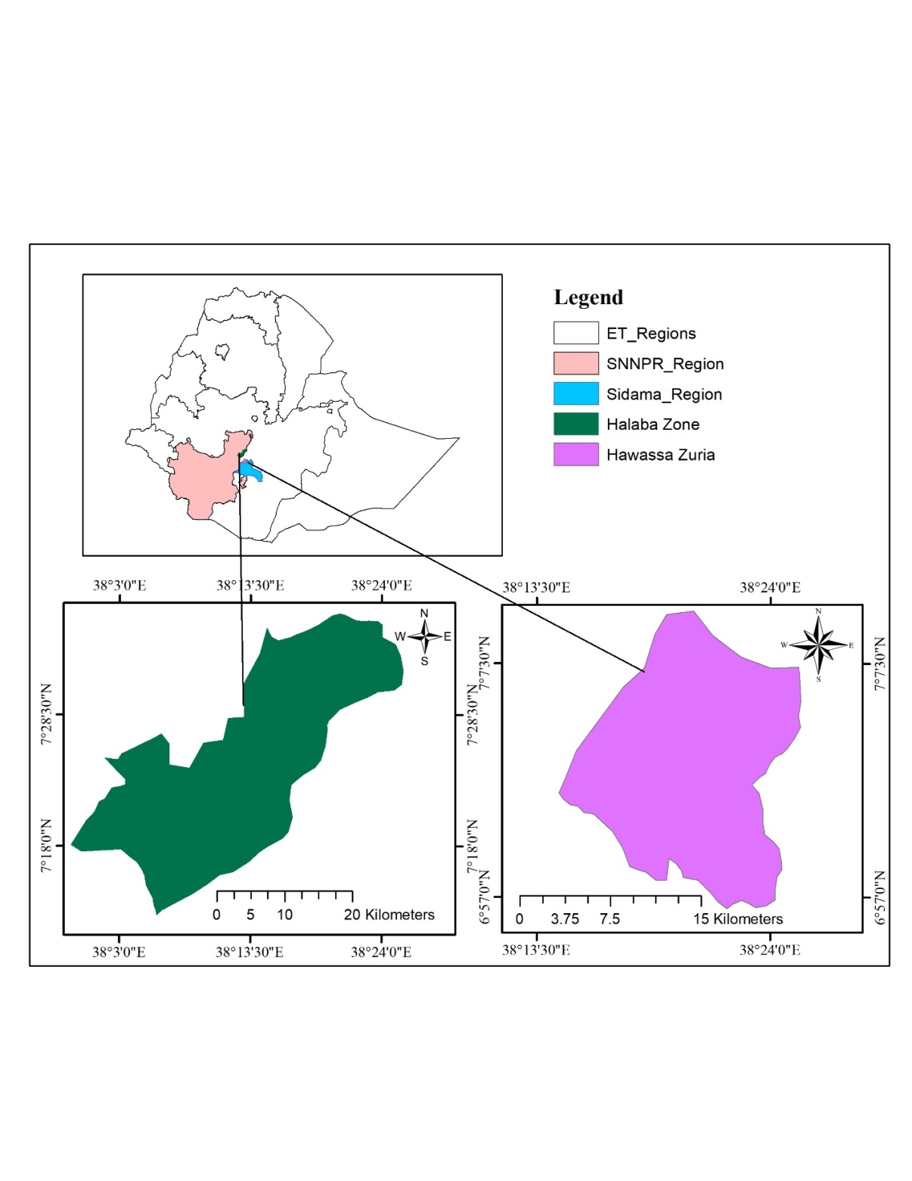
Fig 1- The image shows a map of Ethiopia highlighting the SNNPR region and Sidama region, with detailed maps of the Halaba Zone (green) and Hawassa Zuria (purple) areas within those regions
2.2 Experimental materials and its descriptions
Eighteen released soybean varieties were tested for their adaptability and yield performance in the year 2023/24. These improved varieties were released by federal and regional agricultural research centers. The descriptions of varieties presented in Table 2 below.
Table 2. Description of selected soybean varieties for evaluation
No. | Varieties | Year of release | Seed source | Maturity type
1 | Cheri | 2003 | BARC | Medium
2 | Didessa | 2008 | BARC | Medium
3 | Ketta | 2011 | BARC | Medium
4 | Korme | 2011 | BARC | Medium
5 | Hawassa-04 | 2012 | HARC | Medium
6 | AFGAT | 2007 | HARC | Medium
7 | Pawe-2 | 2013 | PARC | Medium
8 | Pawe-1 | 2015 | PARC | Medium
9 | Coker 2040 | 1982 | HARC | Medium
10 | Pawe-78 | 2015 | PARC | Early
11 | Andinet | 2019 | PARC | Medium
12 | Billo | 2020 | BARC | Medium
13 | Melko Bonsa-1 | 2020 | JARC | Medium
14 | Tana Beles | 2020 | PARC | Medium
15 | Clark-63-k | 1983 | JARC | Medium
16 | SCS-1 | 2021 | JARC | Medium
17 | Guda | 2021 | JARC | Early
18 | Gshama | 2010 | PARC | Medium
Note: BARC: Bako Agricultural Research Center, HARC:Hawassa Agricultural Research Center, PARC: Pawe Agricultural Research Center and JARC: Jimma Agricultural Research Center
Experimental design and procedures
The experiment was carried out in a Randomized Complete Block Design (RCBD) with three replications. The experimental plot consisted of four rows 60 cm apart. Each experimental plot area was 9.6 m² (2.4 m x 4 m), out of which the two central rows were used for data collection. 50 kg of NPS per hectare was used for the study. The whole amount of NPS was applied at planting. Following the recommendation, all agronomic management practices were applied uniformly across all the experimental plots. The variety trial conducted across locations (L) and over years (Y) was analyzed using the following modelYijkr = μ+ Gi + Lj + Yk + Br(LY) + (GL)ij + (GY)ik + (LY)jk + (GLY)ijk + eijkr
Data Collected
Data were collected both on a plot and plant basis. Five plants from the central rows were randomly taken for the data collection on a plant basis and the averages of the five plants in each experimental plot were used for statistical analysis for traits such as plant height, number of seeds per pod and number of seeds/plant, plant height and hundred seed weight. The moisture content was also measured, and the yield obtained was also adjusted at 10% moisture content.
Data Analysis
Analysis of variance was done using Proc GLM procedures of SAS Software 9.0 after testing the ANOVA assumptions. Mean separations were estimated using Least Significant Difference (LSD) for the comparison among the experimental varieties at 0.05 probability level. A combined analysis of variance for both years and seasons was done to test the response of varieties to both environment and seasons after testing the homogeneity of the data.
- Results and Discussion
Table 3: Mean grain yield performance of genotypes across locations
 | Hawassa/Wondotika |  |  |  | Halaba |  |  |  | Mean (kg/ha)
Name varieties | DF | DM | HSW | YLD | DF | DM | HSW | YLD
SCS-1 | 62 | 132 | 16.03 | 3436.83 | 69 | 122 | 13.63 | 2670.89 | 3053.86
Cocker-240 | 56 | 132 | 17.23 | 3255.69 | 66 | 129 | 14.27 | 2881.04 | 3068.37
Gishama | 75 | 148 | 13.96 | 3253.63 | 80 | 137 | 13.53 | 3071.56 | 3162.60
Pawe-2 | 66 | 140 | 17.23 | 3115.88 | 68 | 132 | 11.77 | 2659.69 | 2887.79
Didessa | 70 | 142 | 15.66 | 3097.20 | 73 | 143 | 11.50 | 2869.69 | 2983.45
Bilo | 75 | 142 | 15.03 | 3030.94 | 75 | 139 | 13.70 | 2782.33 | 2906.64
Tana Beles | 72 | 146 | 16.60 | 3015.10 | 78 | 132 | 10.53 | 2128.50 | 2571.80
AFGAT | 63 | 134 | 18.03 | 2932.97 | 61 | 132 | 13.63 | 2771.98 | 2852.48
Korme | 73 | 147 | 15.00 | 2633.48 | 72 | 137 | 10.17 | 2653.38 | 2643.43
Hawassa-04 | 62 | 137 | 20.07 | 2579.95 | 61 | 130 | 14.93 | 2935.99 | 2757.97
Katta | 73 | 148 | 14.13 | 2381.81 | 71 | 140 | 11.07 | 2780.91 | 2581.36
Pawe-1 | 69 | 145 | 16.23 | 2275.97 | 66 | 139 | 11.77 | 2378.26 | 2327.12
Clarck63-k | 64 | 137 | 16.70 | 2253.62 | 67 | 129 | 10.63 | 3090.82 | 2672.22
Cheri | 67 | 141 | 14.77 | 2189.56 | 71 | 143 | 9.67 | 2610.39 | 2399.98
MelkoBonsa-1 | 65 | 135 | 16.23 | 2047.59 | 63 | 131 | 13.40 | 3088.16 | 2567.88
Pawe-78 | 75 | 149 | 13.73 | 1813.54 | 85 | 141 | 13.63 | 2471.74 | 2142.64
Andinet | 69 | 144 | 14.07 | 1678.84 | 89 | 141 | 13.13 | 2075.62 | 1877.23
Guda | 54 | 116 | 20.73 | 1360.96 | 51 | 111 | 15.13 | 2398.26 | 1879.61
CV | 5.49 | 3.14 | 11.40 | 23.94 | 8.85 | 4.87 | 7.09 | 19.58
LSD | 3.70 | 4.23 | 1.85 | 616.54 | 6.23 | 6.27 | 0.88 | 329.87
Note: DF: Days to 50% flowering, DM: Days to 90% maturity, HSW: Hundred seed weight and YLD: Adjusted grain yield.
Statistical Significance
The Coefficient of Variation (CV) and Least Significant Difference (LSD) values indicate meaningful differences among varieties, especially in yield and seed weight. Yield showed high variability (CV: 23.94% in Hawassa), emphasizing the importance of genotype selection.
- Phenological data
  - Days to 50% flowering
The analysis of variance among the studied soybean varieties showed significant difference in days to 50% flowering. Guda and Cocker-240 flowered earlier (54–56 days in Hawassa), which is advantageous in drought-prone areas. Hawassa-04 (61 days) and AFGAT (61 days) was earlier in terms of days to 50% flowering.
  - Days to maturity 90%
The analysis of variance among the studied soybean varieties showed significant difference in days to 90% maturity. Pawe-78 and Gishama showed the longest maturity periods (149 days), however potentially important for biomass accumulation but it can cause yield penalty under terminal drought. Soybean variety Guda was earlier (111 and 116 days to 90% maturity) at Hawassa and Halaba respectively. As a result soybean variety Guda was important in drought prone areas, as well as suitable for relay cropping system especially at Hawassa zuria district and similar agro-ecologies. This result was in line with (Dembel and Melese, 2022), the study indicated significant variation among soybean varieties in terms days to maturity 90%.
- Hundred Seed Weight
Hundred seed weight showed significant variation among the tested soybean varieties. Soybean varieties Guda and Hawassa-04 had the highest hundred seed weight values (20.73 and 20.07 gram per hundred seed weight respectively in Hawassa), indicating potential for market preference due to larger seed size, while Korme and Cheri had lower hundred seed weight values, which may affect marketability despite other agronomic treats and preferences. The size of the seeds is one of the factors that influence the selling value of a variety. Large-sized soybeans have the opportunity to have a higher price per kilogram compared to varieties that have small seed sizes (Fattah, et al., 2024).
- Grain Yield (YLD)
Analysis of variance (ANOVA) among the tested soybean varieties was shown significant difference at 5% probability levels. Grain yield is very important in identifying cultivars that are adaptable and responsive to different climatic conditions (Dallo et al. 2019).
Gishama was the top performer in terms of mean yield (3162.60 kg/ha), showing consistent productivity across both locations (Halaba and Hawassa), followed by SCS-1 and Cocker-240 also demonstrated good yield potential (3053.86 and 3068.37 kg/ha respectively). In contrast, Guda, Andinet, and Pawe-78 recorded the lowest mean yields, suggesting limited adaptability or poor performance under the tested conditions. This result is in line with Yechalew et al. (2020), who reported the Cocker-240 variety as a high yielder among other tested varieties.
Soybean variety SCS-1 (3436.83kg/ha) was specifically well adapted at Hawassa Zuria and Gashama was well adapted at Halaba (3071.56kg/ha). Identifying cultivars with specific adaptation is an efficient way to exploit the potential yield of those varieties, favoring crops under normally unfavorable environmental conditions (Melo et al. 2023).
4. Location Influence
Hawassa/Wondotika generally showed higher yields for most varieties, possibly due to better soil fertility or favorable climatic conditions. While, Halaba was lower in yields for the majority of soybean varieties, still supported strong performance for varieties like Clarck63-k and MelkoBonsa-1, indicating location-specific adaptability. This is in line with Mesfin and Abush (2019) reported that varietal adaptability to environmental fluctuations is important for the stabilization of crop production over regions. This finding aligns with the earlier research of Mesfin and Abush (2019), who indicated that the adaptability of varieties to environmental changes is critical for stabilizing crop production across different regions.
- SUMMARY AND CONCLUSION
The soybean variety SCS-1 gave the highest yield at Hawassa Zuria, producing 3436.83 kg per hectare, while Clark63-k (3090.82 kg per hectare) and MelkoBonsa-1 (3088.16 kg per hectare) were the highest yielders in the Halaba zone. However, when looking at combined analysis results, the Gishama variety exhibited the best overall performance with a mean yield of 3162.60 kg per hectare. Regarding maturity, the Guda variety is categorized as early-maturing, taking 114 days to reach 95% maturity, making it particularly valuable for areas susceptible to terminal drought. In terms of seed weight, Guda had the highest hundred-seed weight, closely followed by Hawassa-04, which was weighed for a hundred seeds. The soybean variety Gishama was recommended due to its wider adaptability and yield performance across the locations. For specific adaptations, SCS-1 was recommended as the top yielder at Hawassa, while Clark63-k and MelkoBonsa-1 were selected in Halaba.
DISCLAIMER (ARTIFICIAL INTELLIGENCE)
Author(s) hereby declare that NO generative AI technologies such as Large Language Models (ChatGPT, COPILOT, etc.) and text-to-image generators have been used during the writing or editing of this manuscript.
ACKNOWLEDGEMENTS
We want to extend our thanks to the Hawassa Agricultural Research Center for their financial support. We would also like to thank Ahmed Mohammed for their significant contribution and assistance during the trial implementation.
COMPETING INTERESETS
Authors have declared that no competing interests exist.
References
Afework Hagos, A.H. and Adam Bekele, A.B., 2018. Cost and returns of soybean production in Assosa Zone of Benishangul Gumuz Region of Ethiopia.
CSA 2019. Agricultural Sample Survey 2018/19 (2011 E.C.), Volume 1, Report on Area and Production of Major Crops (Private Peasant Holdings, Meher Season), FDRE Statistical Bulletin 589, June 2019, Addis Ababa, Ethiopia.
Dallo SC, Zdziarski AD, Woyann LG, Milioli AS, Zanella R, Conte J and Benin G (2019) Across year and year-by-year GGE biplot analysis to evaluate soybean performance and stability in multi-environment trials. Eufítica 215: 1-12.
Dembele Ersulo and Melese Lema, 2022. Evaluation of soybean varieties at Arbaminch zuria district of Gamo zone in southern Ethiopia. International Journal of Science and ResearchArchive, 2022, 07(02), 100–106. Article DOI: https://doi.org/10.30574/ijsra.2022.7.2.0238
ESS 2021/22 (2014 E.C.) The Federal Democratic Republic of Ethiopia Ethiopian Statistics Service (Ess) Agricultural Sample Survey, Report on Farm Management Practices (Private Peasant Holdings, Meher Season)
Fattah A, Idaryani , Herniwati , Yasin M , Suriani Suriani, Salim, Basir Nappu M , Sahardi Mulia, Muh Fitrah Irawan Hannan, Heppy Suci Wulanningtyas, Sudjak Saenong , Wanti Dewayani , Suriany , Elisa Winanda , Sri Wahyuni Manwan , Muh Asaad , Warda , Nurjanani , Nurhafsah , Abdul Gaffar , Sunanto , Andi Yulyani Fadwiwati , Maryam Nurdin , Dahya , Andi Ella (2024). Performance and morphology of several soybean varieties and responses to pests and diseases in South Sulawesi. https://doi.org/10.1016/j.heliyon.2024.e25507.
Mesfin Hailemariam, Abush Tesfaye.2019. Genotype X Environment Interaction by AMMI and GGE-Biplot Stability Analysis in Grain Yield for Soybean [(Glycine Max L.) Merrill] in Ethiopia. International Journal of Forestry and Horticulture (IJFH). Volume 5, Issue 4, PP 10-21
Singh P, Kumar R, Sabapathy SN and Bawa AS (2008). Functional and edible uses of soya protein products. Reviews in Food Science and Food Safety, 7: 14–28
United States Department of Agriculture (USDA), 2020. Oilseeds: World Markets and Trade, USDA foreign Agricultural Service report.
Worku, M. and Astatkie, T., 2011. Row and plant spacing effects on yield and yield components of soya bean varieties under hot humid tropical environment of Ethiopia. Journal of Agronomy and Crop Science, 197 (1): 67-74.
Yechalew Sileshi, Masresha Yirga and Mesfin Hailemariam, 2020. Performance of Released Soybean Varieties at Jimma, South Western Ethiopia. ournal of Biology, Agriculture and Healthcare,
Zhang, J., Wang, X., Lu, Y., Bhusal, S.J., Song, Q, Cregan, P.B., Yen, Y., Brown, M. and Jiang, G.L., 2018. Genome-wide scan for seed composition provides insights into soybean quality improvement and the impacts of domestication and breeding. Molecular Plant, 11(3), pp.460- 472.

