Original Research Article

Performance evaluation of released soybean (Glycine max L.Merril) varieties in Hawassa Zuria and Halaba districts
Abstract
In Ethiopia soybean is one of the national strategic oil seed crops, due to its higher edible oil yield and cake for animal feed. So, selection of appropriate varieties is very important to achieve the national goal. Hence, the study was conducted with the objective of evaluating and selecting best performed soybean varieties for potential growing environments of Ethiopia. The study was done among 18 soybean varieties with three replications in 2023/24 GC main rainy season. Among the tested soybean varieties Gishama was the top performer in terms of mean yield (3162.60 kg/ha), showing consistent productivity across both locations (Halaba and Hawassa), followed by SCS-1 and Cocker-240 also demonstrated good yield potential (3053.86 and 3068.37 kg/ha respectively). Soybean variety SCS-1 (3436.83 kg/ha) was high yielder at Hawassa (W/tika) and Clarck63-k (3090.82 kg/ha) and MelkoBonsa-1 (3088.16kg/ha) was high yielder at Halaba, but the combined analysis result showed that the mean performance Gishama (3162.60kg/ha) variety is highest. In terms of maturity period Variety Guda was early maturing variety (114 days to 95% maturity). This variety is very important for terminal drought prone areas. In terms of seed size Guda was highest (20.73g weight of hundred seed) followed by Hawassa-04 (20.07gram per weight of hundred seed). So, Gishama was recommended for its wider adaptation. In terms of specific adaptation SCS-1 (3436.83 kg/ha) was high yielder at Hawassa and Clarck63-k (3090.82 kg/ha) and MelkoBonsa-1 (3088.16kg/ha) was high yielder at Halaba.
Key words: Evaluation, soybean, Varieties and Performance
Introduction
The soybean (Glycine max L., 2n=40) is an important legume crop for food, feed, and soil fertility improvement. Due to dense composition its nutrients soybean is highly demanded crop at the globally. It is multipurpose crop used as a source of raw material for oil processing industries, since the seed oil content is very high up to 20% oil (Zhang et al., 2018).). Soybean is also very important for nutrition security, since this crop is protein enriched up to 40% and it is one of the best ingredients for industrial food complexes (Singh et al., 2008).
Currently in Ethiopia Soybean is one of the national strategic oil seed crops, due to its higher edible oil yield and cake for animal feed. Currently, number of holders (177,940.0), area coverage (83,797.2 hectare) and annual soybean production (208,676.4 tons) with its productivity (2.5 ton/ha) has better progress as compared to the previous decade’s trend in Ethiopia (ESS, 2021).
However the area coverage and productivity showed increment progress, still lagging behind production potential. This is partly due the use of not suitable varieties. Hence this study was done with the following objectives.
Objective
- To evaluate and select best performed soybean varieties for potential growing environments in Ethiopia and contribute toward reduced for food and nutritional, household incomes, and agro industry of the country.
2. Materials and Methods
  - Description of the Experimental Site
The experiment was conducted at Hawassa research centers and Halaba on station during the main season in 2023/24GC. Description of the study has shown in (Table 1).
Table 1. Description of the study area.
No. |  | Hawassa | Halaba
1 | Altitude | 1730mas | 1900 mas
2 | Latitude | 7◦06′N” | N7⁰16’45”
3 | Longitude | 38◦23′E | E38⁰14’34”
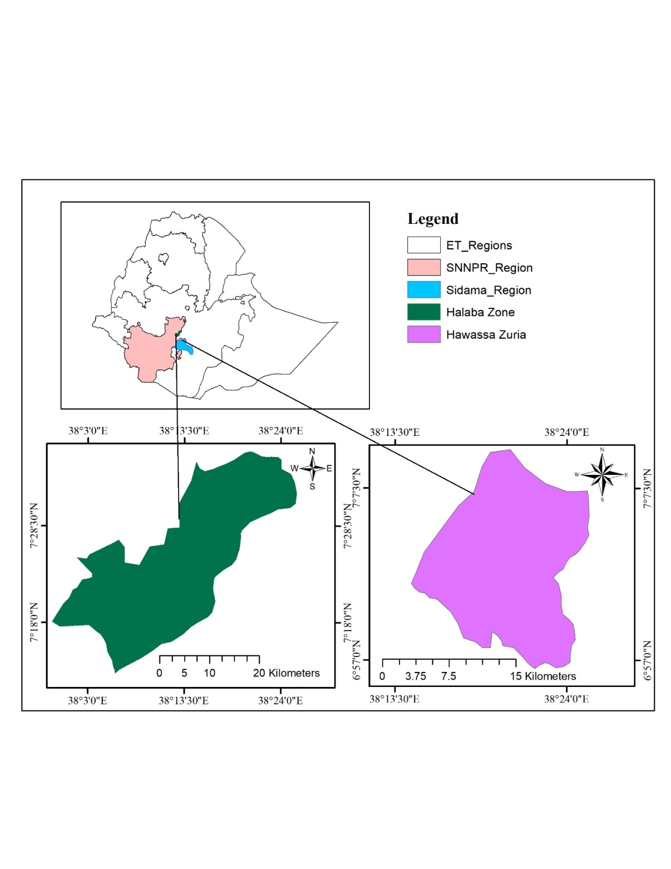
Fig 1- The image shows a map of Ethiopia highlighting the SNNPR region and Sidama region, with detailed maps of the Halaba Zone (green) and Hawassa Zuria (purple) areas within those regions
2.2 Treatment descriptions
Table 2. Description of selected soybean varieties for evaluation
No. | Varieties | Year of release | Seed source | Maturity type
1 | Cheri | 2003 | BARC | Medium
2 | Didessa | 2008 | BARC | Medium
3 | Ketta | 2011 | BARC | Medium
4 | Korme | 2011 | BARC | Medium
5 | Hawassa-04 | 2012 | HARC | Medium
6 | AFGAT | 2007 | HARC | Medium
7 | Pawe-2 | 2013 | PARC | Medium
8 | Pawe-1 | 2015 | PARC | Medium
9 | Coker 2040 | 1982 | HARC | Medium
10 | Pawe-78 | 2015 | PARC | Early
11 | Andinet | 2019 | PARC | Medium
12 | Billo | 2020 | BARC | Medium
13 | Melko Bonsa-1 | 2020 | JARC | Medium
14 | Tana Beles | 2020 | PARC | Medium
15 | Clark-63-k | 1983 | JARC | Medium
16 | SCS-1 | 2021 | JARC | Medium
17 | Guda | 2021 | JARC | Early
18 | Gshama | 2010 | PARC | Medium
Note: BARC: Bako Agricultural Research Center, HARC:Hawassa Agricultural Research Center, PARC: Pawe Agricultural Research Center and JARC: Jimma Agricultural Research Center
Methodology
A randomized complete block design (RCBD) with three replications was used for the study. The spacing between plants and rows was 10cm and 60cm, respectively. Each variety was planted in 4 rows 4m long where only the two central rows were used for before and after harvest data collection. Hand weeding was applied for weed management. The Number of pods per plant as well as the number of seeds per pod was taken from two middle rows of five sampled plants. Plant height also another agronomic data taken after the plant finished its growth. The moisture content was also measured and the yield obtained was also adjusted at 10% moisture content. Hundred seed weight is also weighted to identify good varieties in terms of their seed size. The variety trial conducted across locations (L) and over years(Y) was analyzed using the following model.
Yijkr = μ+ Gi + Lj + Yk + Br(LY) + (GL)ij + (GY)ik + (LY)jk + (GLY)ijk + eijkr
Data Collected
Data were collected both on a plot and plant basis. The two central rows were used for data collection based on plots, for seed yield (kg/ha). Five plants from the central rows were randomly taken for the data collection on a plant basis and the averages of the five plants in each experimental plot were used for statistical analysis for traits such as plant height, number of seeds/pod and number of seeds/plant, plant height and hundred seed weight.
Data Analysis
Analysis of variance was done using Proc GLM procedures of SAS Software 9.0 after testing the ANOVA assumptions. Mean separations were estimated using Least Significant Difference (LSD) for the comparison among the experimental varieties at 0.05 probability level. A combined analysis of variance for both years and seasons was done to test the response of varieties to both environment and seasons after testing the homogeneity of the data.
- Results and Discussion
Table : 3 Mean performance of Genotypes across location
 | Hawassa/Wondotika |  |  |  | Halaba |  |  |  | Mean (kg/ha)
Name varieties | DF | DM | HSW | YLD | DF | DM | HSW | YLD
SCS-1 | 62 | 132 | 16.03 | 3436.83 | 69 | 122 | 13.63 | 2670.89 | 3053.86
Cocker-240 | 56 | 132 | 17.23 | 3255.69 | 66 | 129 | 14.27 | 2881.04 | 3068.37
Gishama | 75 | 148 | 13.96 | 3253.63 | 80 | 137 | 13.53 | 3071.56 | 3162.60
Pawe-2 | 66 | 140 | 17.23 | 3115.88 | 68 | 132 | 11.77 | 2659.69 | 2887.79
Didessa | 70 | 142 | 15.66 | 3097.20 | 73 | 143 | 11.50 | 2869.69 | 2983.45
Bilo | 75 | 142 | 15.03 | 3030.94 | 75 | 139 | 13.70 | 2782.33 | 2906.64
Tana Beles | 72 | 146 | 16.60 | 3015.10 | 78 | 132 | 10.53 | 2128.50 | 2571.80
AFGAT | 63 | 134 | 18.03 | 2932.97 | 61 | 132 | 13.63 | 2771.98 | 2852.48
Korme | 73 | 147 | 15.00 | 2633.48 | 72 | 137 | 10.17 | 2653.38 | 2643.43
Hawassa-04 | 62 | 137 | 20.07 | 2579.95 | 61 | 130 | 14.93 | 2935.99 | 2757.97
Katta | 73 | 148 | 14.13 | 2381.81 | 71 | 140 | 11.07 | 2780.91 | 2581.36
Pawe-1 | 69 | 145 | 16.23 | 2275.97 | 66 | 139 | 11.77 | 2378.26 | 2327.12
Clarck63-k | 64 | 137 | 16.70 | 2253.62 | 67 | 129 | 10.63 | 3090.82 | 2672.22
Cheri | 67 | 141 | 14.77 | 2189.56 | 71 | 143 | 9.67 | 2610.39 | 2399.98
MelkoBonsa-1 | 65 | 135 | 16.23 | 2047.59 | 63 | 131 | 13.40 | 3088.16 | 2567.88
Pawe-78 | 75 | 149 | 13.73 | 1813.54 | 85 | 141 | 13.63 | 2471.74 | 2142.64
Andinet | 69 | 144 | 14.07 | 1678.84 | 89 | 141 | 13.13 | 2075.62 | 1877.23
Guda | 54 | 116 | 20.73 | 1360.96 | 51 | 111 | 15.13 | 2398.26 | 1879.61
CV | 5.49 | 3.14 | 11.40 | 23.94 | 8.85 | 4.87 | 7.09 | 19.58
LSD | 3.70 | 4.23 | 1.85 | 616.54 | 6.23 | 6.27 | 0.88 | 329.87
Note: DF: Days to 50% flowering, DM: Days to 90% maturity, HSW: Hundred seed weight and YLD: Adjusted grain yield.
Statistical Significance
The Coefficient of Variation (CV) and Least Significant Difference (LSD) values indicate meaningful differences among varieties, especially in yield and seed weight. Yield showed high variability (CV: 23.94% in Hawassa), emphasizing the importance of genotype selection.
- Phenological data
  - Days to 50% flowering
The analysis of variance among the studied soybean varieties showed significant difference in days to 50% flowering. Guda and Cocker-240 flowered earlier (54–56 days in Hawassa), which is advantageous in drought-prone areas. Hawassa-04 (61 days) and AFGAT (61 days) was earlier in terms of days to 50% flowering.
  - Days to maturity 90%
The analysis of variance among the studied soybean varieties showed significant difference in days to 90% maturity. Pawe-78 and Gishama showed the longest maturity periods (149 days), however potentially important for biomass accumulation but it can cause yield penalty under terminal drought. Soybean variety Guda was earlier (111 and 116 days to 90% maturity) at Hawassa and Halaba respectively. As a result soybean variety Guda was important in drought prone areas, as well as suitable for relay cropping system especially at Hawassa zuria district and similar agro-ecologies. This result was in line with (Dembel and Melese, 2022), the study indicated significant variation among soybean varieties in terms days to maturity 90%.
- Hundred Seed Weight
Hundred seed weight showed significant variation among the tested soybean varieties. Soybean varieties Guda and Hawassa-04 had the highest hundred seed weight values (20.73 and 20.07 gram per hundred seed weight respectively in Hawassa), indicating potential for market preference due to larger seed size, while Korme and Cheri had lower hundred seed weight values, which may affect marketability despite other agronomic treats and preferences.
- Grain Yield (YLD)
Analysis of variance (ANOVA) among the tested soybean varieties was shown significant difference at 5% probability levels.
Gishama emerged as the top performer in terms of mean yield (3162.60 kg/ha), showing consistent productivity across both locations (Halaba and Hawassa), followed by SCS-1 and Cocker-240 also demonstrated good yield potential (3053.86 and 3068.37 kg/ha respectively). In contrast, Guda, Andinet, and Pawe-78 recorded the lowest mean yields, suggesting limited adaptability or poor performance under the tested conditions. This result is in line with (Yechalew et al., 2020) study showed that variety Cocker-240 was high yielder.
4. Location Influence
Hawassa/Wondotika generally showed higher yields for most varieties, possibly due to better soil fertility or favorable climatic conditions. While, Halaba was lower in yields for the majority of soybean varieties, still supported strong performance for varieties like Clarck63-k and MelkoBonsa-1, indicating location-specific adaptability. This is in line with Mesfin and Abush (2019) reported that varietal adaptability to environmental fluctuations is important for the stabilization of crop production over regions.
Summary and Conclusion
Soybean variety SCS-1 (3436.83 kg/ha) was high yielder at W/tika and Clarck63-k (3090.82 kg/ha) and MelkoBonsa-1 (3088.16kg/ha) was high yielder at Halaba, but the combined analysis result showed that the mean performance Gishama (3162.60kg/ha) variety is highest.
In terms of maturity period Variety Guda was early maturing variety (114 days to 95% maturity). This variety is very important for terminal drought prone areas.
In terms of seed size Guda was highest (20.73g weight of hundred seed) followed by Hawassa-04 (20.07g weight of hundred seed).
Soybean variety Gishama was recommended for its wider adaptation. In terms of specific adaptation SCS-1 (3436.83 kg/ha) was high yielder at Hawassa and Clarck63-k (3090.82 kg/ha) and MelkoBonsa-1 (3088.16kg/ha) was high yielder at Halaba.
References
Dembele Ersulo and Melese Lema, 2022. Evaluation of soybean varieties at Arbaminch zuria district of Gamo zone in southern Ethiopia. International Journal of Science and ResearchArchive, 2022, 07(02), 100–106. Article DOI: https://doi.org/10.30574/ijsra.2022.7.2.0238
ESS 2021/22 (2014 E.C.) The Federal Democratic Republic of Ethiopia Ethiopian Statistics Service (Ess) Agricultural Sample Survey, Report on Farm Management Practices (Private Peasant Holdings, Meher Season)
Mesfin Hailemariam, Abush Tesfaye.2019. Genotype X Environment Interaction by AMMI and GGE-Biplot Stability Analysis in Grain Yield for Soybean [(Glycine Max L.) Merrill] in Ethiopia. International Journal of Forestry and Horticulture (IJFH). Volume 5, Issue 4, PP 10-21
Singh P, Kumar R, Sabapathy SN and Bawa AS (2008). Functional and edible uses of soya protein products. Reviews in Food Science and Food Safety, 7: 14–28
Yechalew Sileshi, Masresha Yirga and Mesfin Hailemariam, 2020. Performance of Released Soybean Varieties at Jimma, South Western Ethiopia. ournal of Biology, Agriculture and Healthcare,
Zhang, J., Wang, X., Lu, Y., Bhusal, S.J., Song, Q, Cregan, P.B., Yen, Y., Brown, M. and Jiang, G.L., 2018. Genome-wide scan for seed composition provides insights into soybean quality improvement and the impacts of domestication and breeding. Molecular Plant, 11(3), pp.460- 472.

