Larvicidal efficacy of eco-friendly zinc oxide and manganese dioxide nanoparticles: A comparative study

ABSTRACT

Mosquito act as a major vector in dispersal of infectious diseases which causes millions of deaths around the globe. Since the larval stage of mosquito is mainly dependent on stagnant water bodies, they can be controlled at this stage easily as compared to adult stage. Many synthetic or natural chemical agents are being used to control mosquito larvae, however, they often cause deleterious effects on other non-target aquatic species. Zinc oxide and manganese dioxide nanoparticles, fabricated using pomegranate (Punica granatum) leaves aqueous extract and ecofriendly nontoxic to aquatic animals, were assessed for their potential larvicidal activities in the present work. Mosquito larvae were subjected to varied doses of both the nanoparticles over a 96-hour exposure and percent mortality, if any, was recorded after every 24-hour time interval. The present work exhibits pomegranate mediated zinc oxide and manganese dioxide nanoparticles, both, to be effective larvicidal agents, though more profound activity (60% mortality) was recoded in zinc oxide nanoparticles by 96-hour exposure. Thus, the present work proposes ecofriendly nano-approaches for mosquito control.

Keywords: green synthesis, larvicidal activity, manganese dioxide nanoparticle, mosquito larvae, pomegranate leaves extract, zinc oxide nanoparticle

1. INTRODUCTION
Mosquito acts as a mechanical and/or biological vector for various infectious diseases like malaria, Japanese encephalitis, filariasis, chickengunya, dengue etc. Female Anopheles (malaria vector), Culex (vector for Japanese encephalitis and filariasis) and Aedes (vector for chickengunya and dengue) are the most dangerous mosquitos that spread the diseases and lead to epidemic waves. Most of these diseases, if not diagnosed well within time, can lead to death of the patient. Mosquitos complete their life cycle almost within 3 weeks encompassing egg, larva, pupa and adult stages. These are one of the most widespread insects that breed in stagnant water bodies. From egg to pupal stages, mosquitos are present in quite aquatic environment whereas the adults are non-aquatic, prefer land and air, thus can spread the infectious diseases from one animal to other (Onen et al., 2023). Since the adult stages are difficult to catch and kill, it is advisable to focus on the larval stages of mosquitos for controlling the same. Many chemical and herbal formulations are spread on stagnant water bodies so as to prevent the breeding of mosquitos or kill their larval and pupal stages. However, the chemical composition of these formulations often harm aquatic ecosystems by affecting non-target species. Also, the mosquitos may develop resistance to these chemicals over a period of time (Chatterjee et al., 2023). In recent years, metal-based nanoparticles (MNPs) have been developed as an alternative tool in the fight against mosquito vectors (Minwuyelet et al., 2025).

Currently, green synthesis of nanoparticles is on rise and demand, due to their ecofriendly sustainable nature with significant biological activities. Among various biological sources, plant-mediated synthesis using leaf extract has gained popularity owing to the rich presence of phytochemicals such as flavonoids, tannins, polyphenols and alkaloids, which act as natural reducing, stabilizing and capping agents during nanoparticle formation (Osman et al., 2024). Plants have been extensively explored for their several phytoconstituents with potential insecticidal activities. Since these phytoconstituents biodegrade quickly, insects do not get sufficient exposure to develop resistance against these. Most of these active phytochemicals may act as either attractants, anti-feedants, anti-molting hormones or molting hormones, thus interfere with insect body functioning (Souto et al., 2021). Pomegranate leaves extract has been widely recognized for its high content of bioactive compounds, including polyphenols, ellagic acid, and flavonoids (Salem et al., 2023). Pomegranate crude juice has been shown to be effective against cotton leaf worm (Farag & Emam, 2016). The phytochemicals of pomegranate plant facilitate the reduction of metal ions to nanoparticles with enhanced stability and biological properties (Yu et al., 2024; Saparbekova et al., 2023). A promising mosquito larvicidal activity of green synthesized magnesium oxide nanoparticles, generated using pomegranate fruit peel aqueous extract, has been reported recently (Fouda et al., 2023). Zinc oxide nanoparticles (ZnO NPs) synthesized using pomegranate leaf extracts exhibit excellent biocompatibility, antioxidant activity, and antibacterial potential with very low toxicity on zebrafish embryos, even at higher doses up to 1000 µg/mL (Bapte et al., 2025). The manganese dioxide nanoparticles (MnO₂ NPs), generated using pomegranate leaves aqueous extract, exhibited biomedical potential at par with the ZnO nanoparticles. However, MnO₂ NPs did not exhibit any toxicity to early developing zebrafish embryos, as compared to ZnO NPs, indicating no toxic effects on aquatic biota (Bapte et al., unpublished data). Thus, these green synthesized zinc and manganese dioxide nanoparticles exhibited several biomedical benefits along with either low toxicity or no toxicity to the aquatic life (Bapte et al., 2025).

There are a couple of studies that highlight larvicidal activities of plant mediated ZnO NPs (Mythili et al., 2024; Sivapunniyam et al., 2024; Chinnathambi et al., 2023; Rather et al., 2022). Besides plant mediated, mycogenic ZnO NPs also exhibited larvicidal efficacy against white grubs (Shukla et al., 2020). On the contrary, there are hardly any reports on evaluation of larvicidal activity of MnO₂ NPs so far. This study aimed to evaluate and compare the larvicidal efficacy of ZnO and MnO₂ nanoparticles, generated using Punica granatum leaf extract, against mosquito larvae with minimal impact on aquatic life. To the best of our knowledge, this is the first study that has assessed the larvicidal activity of green synthesized MnO₂ NPs and compared it with the ZnO NPs, generated using the same plant material i.e. pomegranate leaf extract.

2. experimental details
Procurement of mosquito larvae: Mosquito larvae (Aedes aegypti) were collected from the local ponds of Sangamner district, Ahilyanagar, Maharashtra, India. The larvae of same size were selected, washed with distilled water twice and randomly distributed into 15 beakers with 15 larvae in each. Each beaker contained 50 mL of distilled water. The mosquito larvae were maintained at room temperature throughout the experiment, under natural light: dark (12:12) photoperiod cycle. No ethical approval was required for the use of mosquito larvae for research purpose.

Preparation of treatment solutions: Characterized and confirmed spherical ZnO NPs averaging 80–90 nm in size (Bapte et al., 2025) and irregular shaped MnO₂ NPs with size varying between 10 to 40 nm (Bapte et al., unpublished data), fabricated using pomegranate (Punica granatum, BSI/WRC/Iden.Cer./2023/2904230016732) leaves, were obtained from the Zoology Department of the Sangamner college, carefully transferred into sterile labeled containers and transported under controlled conditions to ensure purity and stability of the same. Proper storage was maintained until further experimental application. ZnO and MnO₂ NPs were evenly dispersed (using stirrer) in separate vials to prepare stock solutions and then diluted in distilled water to prepare either 2 ppm, 4 ppm, 6 ppm, 8 ppm, 10 ppm, 20 ppm or 40 ppm doses of ZnO and MnO₂ NPs for the treatment purpose. Larvae kept in distilled water alone, without any NPs, served as controls for both the NP treatment groups. The mortality rate, if any, in the control and all treatment groups were recorded at 24 hour, 48 hour, 72 hour and 96 hour, and evaluated using probit analysis. Each experiment, right from collection of fresh larvae to treatment, was repeated at least thrice before drawing the conclusion.

3. RESULTS AND DISCUSSION
The present study evaluated the larvicidal activity of two metal oxide nanoparticles (ZnO and MnO₂ NPs), synthesized in similar manner using pomegranate leaves extract, on mosquito larvae. The percent live and dead larvae were measured at every 24 hours post treatment for next 4 days.
Larvicidal activity of ZnO NPs
ZnO NPs displayed no toxicity at low doses of 2 ppm and 4 ppm, and the percent live larvae in these groups were comparable with that of controls throughout the observation period of 96 hours (Figure 1). Even at 6 ppm, ZnO NPs did not exert observable toxic effects within first 24 hours. At high doses starting from 8 ppm onwards, the number of live larvae started declining as measured at each time point. ZnO NPs were found to cause 60% larval mortality by 72 hours at 40 ppm dose (Figure 1).

ZnO NPs have been shown to damage mosquito gut membrane, affecting physiological functions and thus causing death of mosquitos (Sivapunniyam et al., 2024). Rather and group (2022) were probably the first ones to report Lavandula angustifolia leaf extract mediated ZnO NPs to possess significant mosquito larvicidal activity against fourth instar larvae, with 100% mortality at 160 mg/L dose within 24 hour (Rather et al., 2022). Another study in 2023, prepared ZnO NPs using leaves of a medicinal plant, Tarenna asiatica and reported their larvicidal activity against dengue vector (Chinnathambi et al., 2023). The larvicidal activity of ZnO NPs generated using either methanolic or aqueous extracts of P. vulgaris exhibited prominent larvicidal activity in the NPs generated with aqueous extract as compared to methanol extract mediated NPs (Mythili et al., 2024). ZnO NPs fabricated using leaf extracts of Plectranthus amboinicus killed Anopheles stephensi larvae by damaging cells and tissues of the mid-gut of the larvae (Vijayakumar et al., 2015).
Larvicidal activity of MnO₂ NPs
MnO₂ NPs, prepared using pomegranate leaves extract, also exhibited larvicidal activity, though the deaths occurred only at high doses like 10 ppm, 20 ppm and 40 ppm within first 24 hours. These manganese dioxide nanoparticles exhibited no toxicity at 2 ppm throughout till 96 hours and the death rate was at par with the controls. The MnO₂ NPs displayed a dose related larvicidal activity and the number of live larvae went on decreasing with increasing doses of NPs, with about 60% live larvae at 40 ppm at the end of 96 hours (Figure 2).

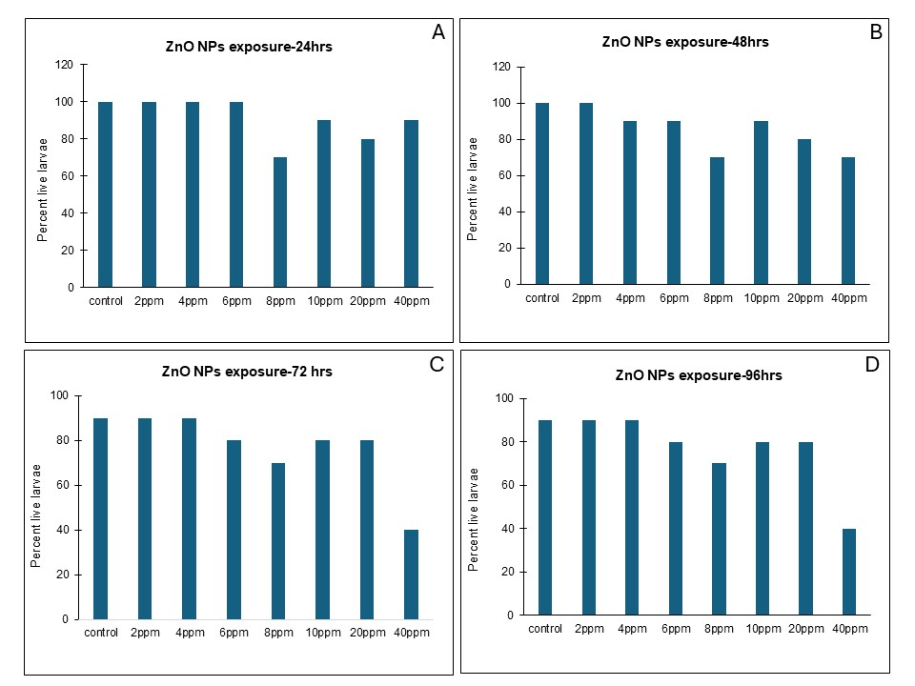

Figure 1: Larvicidal activity of ZnO NPs generated using pomegranate leaf extract: 24 hrs (A), 48 hrs (B), 72 hrs (C) and 96 hrs (D). Note lowest percent of live larvae at 40 ppm by 72 hrs and 96 hrs. Observe reduced percent of live larvae at all the treated doses from first 24 hours, more obvious at 8 ppm.
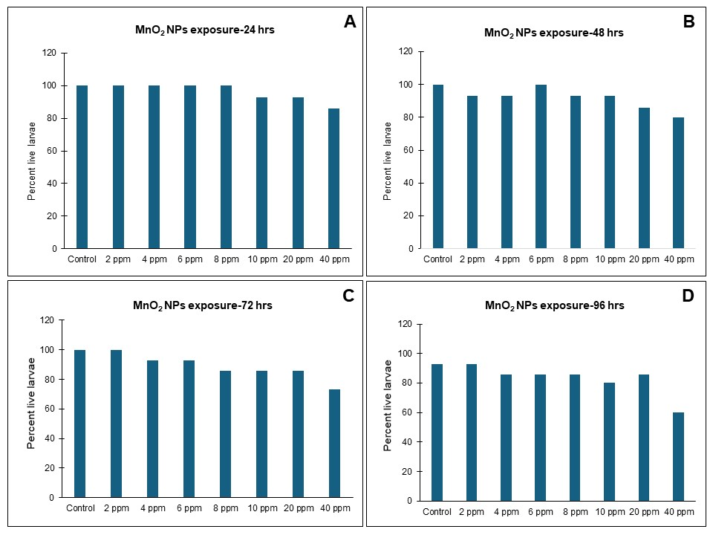

Figure 2: Larvicidal activity of MnO₂ NPs generated using pomegranate leaf extract: 24 hrs (A), 48 hrs (B), 72 hrs (C) and 96 hrs (D). Note reduction in percent live larvae with increasing doses.

Higher accumulation levels of Mn in water bodies are known to induce histopathological alterations in gonadal, digestive and other connective tissue organs of aquatic animals (Ibrahim et al., 2023). Thus, Mn in free ionic form causes toxicity at high levels. However, there are hardly any reports which state the effects of Mn in nanoparticle form on the aquatic life. The only report on MnO₂ nanoparticles, environment friendly generated using wet-chemical redox method, possessing larvicidal activity against mosquito larvae was published recently in 2021 (Naik et al., 2021). The present work used pomegranate leaf extract mediated MnO₂ nanoparticles with minimal toxicity to aquatic animals like zebrafish embryos (Bapte et al., unpublished work). Thus, the larvicidal activity of these ecofriendly and cost effective MnO₂ NPs, that are safer for other aquatic animals as compared to ZnO NPs, appears to be one of the best baits for mosquito larvae control.
Comparative analysis of larvicidal activity of ZnO and MnO₂ NPs

Till date, researchers have investigated the lethal effects, if any, of several metal and metal oxide nanoparticles like silver, palladium, titanium dioxide, gold, cobalt, copper, iron, selenium, magnesium oxide etc. on the adult, pupal and larval stages of several mosquito varieties, suggesting silver and copper to be most effective so far (Minwuyelet et al., 2025; Anil Kumar et al., 2016). Our results show that the nanoparticles generated using same plant material, posed varied toxicity depending on the metal i.e. either zinc or manganese. ZnO NPs possessed maximum larvicidal activity as compared to MnO₂ NPs at similar doses and time points as depicted in Figure 3. LC50 value for ZnO NPs was calculated to be 9.784 ppm whereas for MnO₂ NPs was 83.46 ppm for 96 hours as per the probit regression analysis.

As compared to other metal oxide nanoparticles, ZnO NPs have been shown to possess prominent larvicidal activities (Bharathi & Suseem, 2024) which is in accord with our results. ZnO NPs are known to enhance production of reactive oxygen species instigating oxidative stress, which in turn, damages cellular constituents like proteins, lipids and DNA, ultimately affecting cell function and survival of the mosquito larvae (Mir et al., 2020). A recent study supports these findings of Mir and group, and put forth ZnO NPs as a causative agent for the development of oxidative stress that elicits genotoxic effects and apoptosis in the larval stages of a silkworm, Bombyx mori (Belal and Gad, 2023). Besides this, ZnO NPs are also known to induce DNA damages in human epidermal cells (Sharma et al., 2009). Sargassum ilicifolium mediated ZnO NPs could impart protection to tomato plants against Tuta absoluta, a tomato plant insect pest (Mardani-Talaee et al., 2025). Negative effects of the ZnO NPs on survival of larval stages of G. mellonella have also been reported (Eskin & Nurullahoğlu, 2022). Spodoptera frugiperda (fall armyworm), a major pest of rice and sorghum, when subjected to varied concentrations of ZnO NPs exhibited deformed body structures, reduced oviposition with low fecundity and high mortality rates (Pittarate et al., 2021). In this way, researchers have highlighted ZnO NPs, generated through various methods, to possess significant larvicidal activities, which is in alignment with our observations.

MnO₂ NPs, generated using wet-chemical redox method, are shown to exhibit larvicidal activity against various mosquito species like Culex quinquefasciatus, Aedes aegypti, and Anopheles stephensi, with varying degrees of toxicity (Naik et al., 2021). These NPs are thought to disrupt the larval cell membrane leading to its rupture and eventually resulting in death. Another study suggests that the MnO₂ NPs may either induce oxidative stress and damage larval DNA and cellular components causing death, or disrupt the production and functioning of larval enzymes affecting larval growth. Mohamed and group proposed Mn₂O₃ NPs and MnCoO nanocomposites, synthesized using co-precipitation method, as mosquitocidal agents via altering the midgut, fat tissue and muscles of the third larval instar (Mohamed et al., 2023).

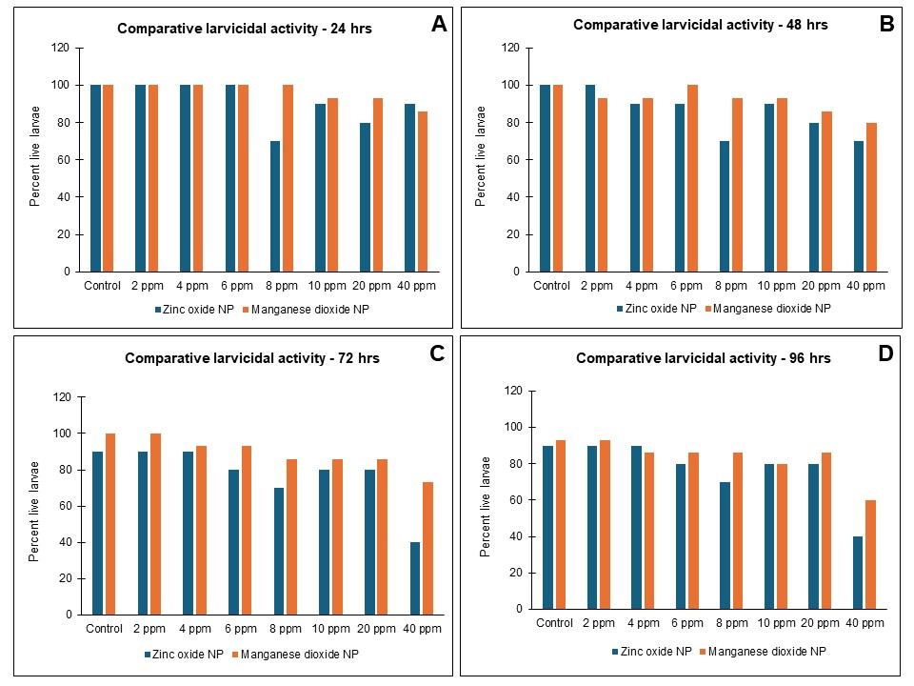

Figure 3: Comparison between the larvicidal activities of ZnO & MnO₂ NPs generated using pomegranate leaf extract: 24 hrs (A), 48 hrs (B), 72 hrs (C) and 96 hrs (D). Note low number of live larvae in ZnO NPs as compared MnO₂ NPs throughout, suggesting higher larvicidal activity of ZnO NPs.

In the present study, the ZnO NPs larvicidal efficacy was significant with LC50 value of 9.784 ppm as compared to MnO₂ NPs, generated using same material. However, the same ZnO NPs were more toxic for zebrafish embryos in contrast to the MnO₂ NPs suggesting its low ecotoxic nature. The present results, thus, highlight pomegranate leaf extract mediated MnO₂ NPs to be a more ecofriendly choice for mosquito control as compared to pomegranate leaf extract mediated ZnO NPs.

4. Conclusion
The present study investigated the larvicidal potential of ZnO and MnO₂ NPs produced in a green manner using the pomegranate leaves extract. ZnO NPs were found to possess higher larvicidal activity as compared to MnO₂ NPs, highlighting the role of metal in imparting biological properties or potentials to the NPs. Earlier studies have exhibited these NPs to possess antioxidant potential with antimicrobial activities, pro or anti-angiogenic in nature depending on the dose, and low toxic (ZnO NPs) or nontoxic (MnO₂ NPs) to aquatic animals (Bapte et al., 2025). Thus, the generated NPs display excellent potential to be used for mosquito larvae control because of their ecofriendly nature. Though ZnO NPs are more effective, MnO₂ NPs are safer to aquatic life, highlighting MnO₂ NPs as a more potent eco-friendly larvicidal agent. This study supports the development of plant-based nanotechnology as a sustainable alternative to chemical larvicides. Further studies on formulation, field application, and long-term ecological safety are recommended before large-scale deployment.

Consent (where ever applicable)
Not applicable.

Ethical approval (where ever applicable)
Not applicable.

DISCLAIMER (ARTIFICIAL INTELLIGENCE)
Author(s) hereby declare that NO generative AI technologies such as Large Language Models (ChatGPT, COPILOT, etc.) and text-to-image generators have been used during the writing or editing of this manuscript.

References
Anil Kumar, V., Ammani, K., Jobina, R., Parasuraman, P., & Siddhardha, B. (2016). Larvicidal Activity Of Green Synthesized Silver Nanoparticles Using Excoecaria Agallocha L. (Euphorbiaceae) Leaf Extract Against Aedes Aegypti. IET nanobiotechnology, 10(6), 382–388. https://doi.org/10.1049/iet-nbt.2015.0101
Bapte, P.S., Pansambal, S.S., Bardapurkar, P.P., Ghotekar, S., & Borgave, S. S. (2025). Eco-friendly synthesis of ZnO nanoparticles using pomegranate leaves and its antimicrobial, antioxidant, anticancer, angiogenic activity, and toxicity assessment. Results in Chemistry. 2025;16:102460.https://doi.org/10.1016/j.rechem.2025.102460
Belal, R. & Gad, A. (2023). Zinc oxide nanoparticles induce oxidative stress, genotoxicity, and apoptosis in the hemocytes of Bombyx mori larvae. Sci Rep. 13:3520 https://doi.org/10.1038/s41598-023-30444-y

Bharathi, J.D. & Suseem, S. R. (2024). Larvicidal activity of CuO and ZnO nanoparticles against Aedes aegypti and Anopheles stephensi mosquito vectors-a greener approach by Phaseolus vulgaris L. aqueous extract as bio-reductant. Results in Chemistry. 7, 101408. https://doi.org/10.1016/j.rechem.2024.101408
Chatterjee, S., Bag, S., Biswal, D., Sarkar Paria, D., Bandyopadhyay, R., Sarkar, B., Mandal, A., & Dangar, T. K. (2023). Neem-based products as potential eco-friendly mosquito control agents over conventional eco-toxic chemical pesticides-A review. Acta tropica, 240, 106858. https://doi.org/10.1016/j.actatropica.2023.106858
Chinnathambi, A., Ali Alharbi, S., Lavarti, R., Jhanani, G. K., On-Uma, R., Jutamas, K., & Anupong, W. (2023). Larvicidal and pupicidal activity of phyto-synthesized zinc oxide nanoparticles against dengue vector Aedes aegypti. Environmental research, 216(2), 114574. https://doi.org/10.1016/j.envres.2022.114574
Eskin, A. & Nurullahoğlu, Z.U. (2022). Effects of zinc oxide nanoparticles (ZnO NPs) on the biology of Galleria mellonella L. (Lepidoptera: Pyralidae). JoBAZ 83(54). https://doi.org/10.1186/s41936-022-00318-2
Farag, R. S., & Emam, S. S. (2016). Insecticidal Activities of Pomegranate Peels and Leave Crude Juices. International Journal For Research In Agricultural And Food Science, 2(1), 69–89. https://gnpublication.org/index.php/afs/article/view/349
Fouda, A., Alshallash, K. S., Alghonaim, M. I., Eid, A. M., Alemam, A. M., Awad, M. A., & Hamza, M. F. (2023). The Antimicrobial and Mosquitocidal Activity of Green Magnesium Oxide Nanoparticles Synthesized by an Aqueous Peel Extract of Punica granatum. Chemistry. 5(3), 2009-2024. https://doi.org/10.3390/chemistry5030136
Ibrahim, A.M., Abdel-Haleem, A.AS. & Taha, R.G. (2023). Biomonitoring of manganese metal pollution in water and its impacts on biological activities of Biomphalaria alexandrina snail and larvicidal potencies. Environ Sci Pollut Res. 30, 105967–105976. https://doi.org/10.1007/s11356-023-29786-x
Mardani-Talaee M, Razmjou J, Ajdari A, Serrão JE, Vivekanandhan P. (2025). Green synthesis of zinc oxide nanoparticles from Sargassum ilicifolium to enhance tomato resistance against Tuta absoluta. Sci Rep. 15(1):13596. https://doi.org/10.1038/s41598-025-97535-w
Minwuyelet, A., Yewhalaw, D., Aschale, Y., Sciarrettam, A., Atenafu, G. A. (2025). Global Systematic Review on the Potential of Metal-Based Nanoparticles in the Fight Against Mosquito Vectors. J Trop Med. 2025:2420073. https://doi.org/10.1155/jotm/2420073
Mir, A.H., Qamar, A., Qadir, I. et al. (2020). Accumulation and trafficking of zinc oxide nanoparticles in an invertebrate model, Bombyx mori, with insights on their effects on immuno-competent cells. Sci Rep.10:1617. https://doi.org/10.1038/s41598-020-58526-1
Mohamed, R. A., Kassem, L. M., Ghazali, N. M., Elgazzar, E., & Mostafa, W. A. (2023). Modulation of the Morphological Architecture of Mn₂O₃ Nanoparticles to MnCoO Nanoflakes by Loading Co³⁺ Via a Co-Precipitation Approach for Mosquitocidal Development. Micromachines, 14(3), 567. https://doi.org/10.3390/mi14030567
Mythili, G., Dhivyasri, S., Sujithra, Y., Swetha, S. & Saranraj, P. (2024). Larvicidal efficiency of zinc oxide nanoparticles against mosquito vectors. International Journal of Entomology Journal, 9(11), 200-203.
Naik, S.R., Javeer, D.S., Gawde, C.S., Palni, S.S., Koli, S.C., Jalmi, S.S., Ghotge, Y.V., Naik, N.U., Fernandes, R. & Velho-Pereira, S. (2021). Larvicidal activity of pristine α-MnO2 nanostructures: An environmentally benign approach for combating mosquito (Diptera: Culicidae) menace, Materials Today Communications. 27, 102184. https://doi.org/10.1016/j.mtcomm.2021.102184
Onen, H., Luzala, M.M., Kigozi, S., Sikumbili, R.M., Muanga, C.K,, Zola, E.N., Wendji, S.N., Buya, A.B., Balciunaitiene, A., Viškelis, J., Kaddumukasa, M.A., Memvanga, P.B. (2023). Mosquito-Borne Diseases and Their Control Strategies: An Overview Focused on Green Synthesized Plant-Based Metallic Nanoparticles. Insects.14(3):221. https://doi.org/10.3390/insects14030221
Osman, A.I., Zhang, Y., Farghali, M., Rashwan, A.K., Eltaweil, A.S., Abd El-Monaem, E.M. et al. (2024). Synthesis of green nanoparticles for energy, biomedical, environmental, agricultural, and food applications: A review. Environ Chem Lett 22, 841–887. https://doi.org/10.1007/s10311-023-01682-3
Pittarate, S., Rajula, J., Rahman, A., Vivekanandhan, P., Thungrabeab, M., Mekchay, S., & Krutmuang, P. (2021). Insecticidal Effect of Zinc Oxide Nanoparticles against Spodoptera frugiperda under Laboratory Conditions. Insects, 12(11), 1017. https://doi.org/10.3390/insects12111017
Rather, G.A., Nanda, A. and Ezhumalai, P. (2022). Mosquito Larvicidal Activity of ZnO Nanoparticles against Dengue Causing Vector Aedes Albopictus Using Leaf Extract of Lavandula angustifolia. Journal of Nanostructures, 12(3), 625-632. https://doi.org/10.22052/JNS.2022.03.016
Salem, A.M., Farag, S.M., Gad, H.A., Al-Sayed, E., El-Ahmady S.H. (2023). Anti-Culex pipiens activity of different pomegranate cultivars and determination of their bioactive compounds using LC-MS profiling. Phytochemical. https://doi.org/10.1002/pca.3307
Saparbekova, A.A., Kantureyeva, G.O., Kudasova, D.E., Konarbayeva, Z.K., & Latif, A.S. (2023). Potential of phenolic compounds from pomegranate (Punica granatum L.) by-product with significant antioxidant and therapeutic effects: A narrative review. Saudi journal of biological sciences. 30(2): 103553. https://doi.org/10.1016/j.sjbs.2022.103553
Sharma, V., Shukla, R. K., Saxena, N., Parmar, D., Das, M., & Dhawan, A. (2009). DNA damaging potential of zinc oxide nanoparticles in human epidermal cells. Toxicology letters, 185(3), 211–218. https://doi.org/10.1016/j.toxlet.2009.01.008
Shukla, G., Gaurav, S. S., & Singh, A. (2020). Synthesis of mycogenic zinc oxide nanoparticles and preliminary determination of its efficacy as a larvicide against white grubs (Holotrichia sp.). International Nano Letters, 10(2), 131-139.
Sivapunniyam, A., Perumal, T., Vasu, N., Kavidasan, T., Seetharaman, P., Raja, K. & Stalin, M. (2024). Zinc Oxide Nanoparticles Fabricated With Phytoextracts For The Control Of Mosquito Vectors-A Systemic Review. Journal of Advanced Zoology. 45(2):1663-1681
Souto, A.L., Sylvestre, M., Tölke, E.D., Tavares, J.F., Barbosa-Filho, J.M. & Cebrián-Torrejón, G. (2021). Plant-Derived Pesticides as an Alternative to Pest Management and Sustainable Agricultural Production: Prospects, Applications and Challenges. Molecules. 26(16):4835. https://doi.org/10.3390/molecules26164835
Vijayakumar, S., Vinoj, G., Malaikozhundan, B., Shanthi, S., & Vaseeharan, B. (2015). Plectranthus amboinicus leaf extract mediated synthesis of zinc oxide nanoparticles and its control of methicillin resistant Staphylococcus aureus biofilm and blood sucking mosquito larvae. Spectrochimica acta. Part A, Molecular and biomolecular spectroscopy. 137, 886–891. https://doi.org/10.1016/j.saa.2014.08.064
Yu, M., Gouvinhas, I., Chen, J., Zhu, Y., Deng, J., Xiang, Z., Oliveira, P., Xia, C. & Barros, A. (2024). Unlocking the therapeutic treasure of pomegranate leaf: A comprehensive review on phytochemical compounds, health benefits, and future prospects, Food Chemistry. 23:101587.https://doi.org/10.1016/j.fochx.2024.101587

