**Cyber-Physical Systems in Industrial Control: A Comprehensive Review for Industry 4.0**

# **Abstract**

Cyber-Physical Systems (CPS) transform industrial control by combining physical processes with smart computing for Industry 4.0. This paper reviews CPS architecture, which includes physical, cyber, and communication layers. The physical layer uses sensors and actuators to collect data and control machines. The cyber layer processes data with analytics and AI for decision-making. The communication layer connects systems using protocols like OPC UA and 5G networks. Applications in smart manufacturing, energy systems, and process control show CPS benefits. Smart factories use CPS for predictive maintenance to reduce downtime. Energy systems improve grid stability with real-time monitoring. Process control enhances safety and reduces waste in chemical plants. Challenges include cybersecurity risks, interoperability issues, and scalability limits. Cyberattacks can disrupt production or compromise safety. Future solutions involve artificial intelligence, edge computing, and 5G networks. These technologies enable autonomous systems, faster data processing, and better connectivity. This review highlights CPS’s role in building efficient, resilient, and sustainable industrial systems (Alur, 2015; Alguliyev et al., 2021).

**Keywords:** Cyber-Physical Systems, Industrial Control, Industry 4.0, Automation, Cybersecurity, Interoperability, Scalability.

# **1. Introduction**

Cyber-Physical Systems (CPS) have emerged as a transformative force in industrial control, redefining how industries operate by integrating computational intelligence with physical processes (Alur, 2015). These systems combine real-time data acquisition, advanced analytics, and automated control to create highly responsive, efficient, and adaptive industrial environments. By seamlessly bridging the digital and physical realms, CPS enables precise monitoring, dynamic optimization, and autonomous decision-making, positioning itself as a cornerstone of Industry 4.0 (Colombo et al., 2017). From smart manufacturing to energy management and process control, CPS is driving unprecedented advancements in operational efficiency, system resilience, and sustainability across diverse industrial sectors (Leitão et al., 2016). At the core of CPS lies the synergy between physical components—such as sensors, actuators, and machinery—and computational frameworks, including algorithms, artificial intelligence (AI), and data analytics. This integration allows industrial systems to respond to real-time changes, predict potential failures, and optimize resource utilization. For example, in smart factories, CPS facilitates interconnected production lines that adapt to demand fluctuations, minimize downtime through predictive maintenance, and enhance product quality through real-time quality control (Monostori et al., 2016).

In energy systems, CPS supports the integration of renewable energy sources, improves grid stability, and enables demand-response strategies (Yu & Xue, 2015). Similarly, in process industries like chemical manufacturing, CPS ensures precise control and monitoring, reducing waste and enhancing safety (Liu et al., 2017). The adoption of CPS in industrial control is driven by the need to address the increasing complexity and interconnectedness of modern industrial systems. As global industries face pressures to improve productivity, reduce environmental impact, and adapt to rapidly changing market demands, CPS offers a pathway to achieve these goals through data-driven insights and automation. However, the widespread implementation of CPS introduces significant challenges, including cybersecurity vulnerabilities due to the convergence of information technology (IT) and operational technology (OT), interoperability issues arising from heterogeneous devices and protocols, and scalability concerns for large-scale industrial deployments (Ding et al., 2018).

This paper provides a comprehensive analysis of CPS in industrial control, exploring their architectural components, key applications, and inherent challenges. It delves into the physical, cyber, and communication layers that define CPS, highlighting their roles in enabling seamless integration and real-time control. The paper also examines prominent applications, such as smart manufacturing, energy systems, and process control, illustrating how CPS transforms industrial operations. Furthermore, it addresses critical challenges, including cybersecurity risks, interoperability barriers, and scalability limitations, offering insights into potential solutions. Looking ahead, the paper explores future directions, such as the integration of AI for autonomous systems, edge computing for low-latency processing, and 5G networks for enhanced connectivity, which promise to further revolutionize industrial CPS (Zhang et al., 2019). By synthesizing these perspectives, this paper aims to underscore the transformative potential of CPS in shaping the future of industrial control and advancing the goals of Industry 4.0.

# **2. Architecture of Cyber-Physical Systems**

The architecture of Cyber-Physical Systems (CPS) in industrial control forms a sophisticated and integrated framework that seamlessly blends physical processes with computational intelligence to enable real-time monitoring, precise control, and dynamic optimization. This architecture is designed to address the complexities of modern industrial environments, supporting the goals of Industry 4.0 by delivering adaptability, efficiency, and resilience.

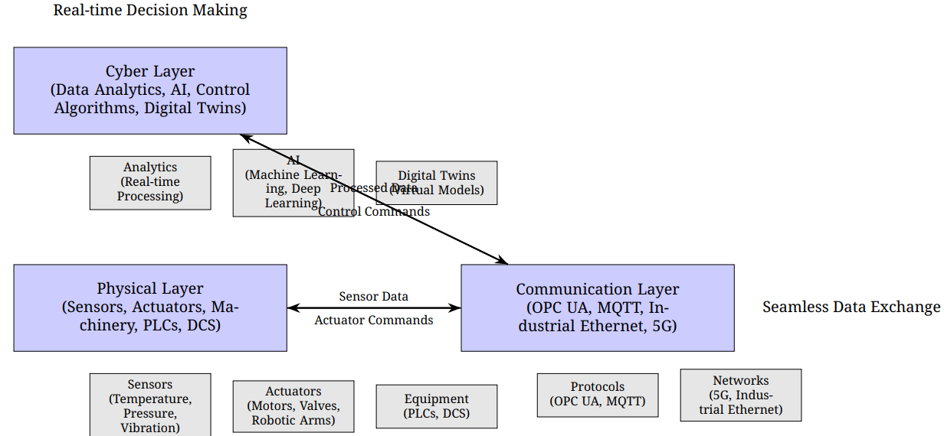

Fig 1: Architecture of Cyber-Physical Systems

Typically structured into three core layers—physical, cyber, and communication—the CPS architecture ensures a cohesive interaction between the tangible components of industrial systems and the digital systems that drive decision-making and automation. Each layer is intricately designed to perform specific functions while collaborating to create a unified system capable of responding to real-time demands. Understanding the roles, interactions, and challenges of these layers is fundamental to appreciating how CPS transforms industrial control, enabling smarter, more responsive, and sustainable industrial operations.

## **2.1. Physical Layer**

The physical layer serves as the foundation of CPS, encompassing the tangible components that directly interact with the industrial environment. This layer includes an array of hardware elements such as sensors, actuators, and machinery that collectively gather data and execute control actions. Sensors, ranging from temperature and pressure gauges to vibration and flow rate monitors, continuously collect real-time data from industrial processes, providing critical insights into system performance and environmental conditions. For example, in a manufacturing plant, sensors embedded in a conveyor system might detect variations in belt speed or material flow, generating data essential for process monitoring. Actuators, including motors, valves, pneumatic systems, and robotic arms, translate computational commands into physical actions, enabling precise adjustments to machinery operations. In an automotive assembly line, for instance, actuators might adjust robotic arms to align components accurately during assembly, ensuring product quality.

The reliability and precision of the physical layer are paramount, as they directly influence the quality of data fed into the CPS and the effectiveness of subsequent control actions. Advances in sensor technology, such as high-precision IoT devices, have enhanced the granularity and accuracy of data collection, enabling more detailed monitoring of complex industrial processes. However, challenges such as sensor calibration, environmental interference, and hardware degradation must be addressed to ensure consistent performance. The physical layer also includes industrial equipment like programmable logic controllers (PLCs) and distributed control systems (DCS), which interface with sensors and actuators to execute low-level control tasks, forming the operational backbone of CPS in industrial settings.

## **2.2. Cyber Layer**

The cyber layer represents the computational core of CPS, responsible for processing data from the physical layer to enable intelligent decision-making, predictive analytics, and optimized control. This layer encompasses a suite of software platforms, control algorithms, data analytics tools, and artificial intelligence (AI) models that analyze sensor data, model system behavior, and generate actionable control strategies. In industrial control, the cyber layer leverages real-time analytics to optimize processes, such as adjusting production parameters to minimize energy consumption or predicting equipment failures to schedule maintenance proactively. For example, in a chemical processing plant, the cyber layer might employ machine learning algorithms to analyze sensor data on temperature and pressure, optimizing reaction conditions to maximize yield while ensuring safety and compliance with regulatory standards.

The cyber layer’s ability to handle large volumes of data and perform complex computations in real time is critical to the adaptability and efficiency of CPS. Advanced techniques, such as digital twins—virtual replicas of physical systems—enable the cyber layer to simulate and optimize industrial processes before implementing changes, reducing risks and enhancing performance. In a smart factory, for instance, a digital twin of a production line can predict the impact of adjusting machine settings, allowing operators to optimize throughput without disrupting operations. However, the computational demands of the cyber layer require robust processing infrastructure, and challenges such as data latency, model accuracy, and integration with legacy systems must be addressed to ensure effective performance. The incorporation of AI, including deep learning and reinforcement learning, further enhances the cyber layer’s capabilities, enabling autonomous decision-making and self-optimizing systems that adapt to dynamic industrial conditions.

## **2.3. Communication Layer**

The communication layer acts as the critical bridge between the physical and cyber layers, ensuring seamless, reliable, and secure data exchange. This layer relies on industrial communication protocols, such as OPC UA, MQTT, and Industrial Ethernet, to transmit sensor data to the cyber layer for analysis and relay control commands back to the physical layer for execution. In industrial environments, where low latency, high reliability, and real-time coordination are essential, the communication layer must support robust and scalable data transfer. For example, in a smart factory, the communication layer enables real-time synchronization between distributed production units, ensuring that robotic systems, conveyors, and quality control stations operate in harmony across the facility.

Emerging technologies, such as 5G networks, are significantly enhancing the communication layer by providing ultra-low latency, high bandwidth, and massive device connectivity. In a large-scale industrial setting, 5G-enabled CPS can support real-time data exchange between thousands of IoT devices, enabling complex applications like autonomous material handling or distributed energy management. However, the communication layer must also address cybersecurity concerns, as the integration of IT and operational technology (OT) increases vulnerability to cyber threats, such as data interception or unauthorized access. Secure protocols, encryption, and intrusion detection systems are essential to protect data integrity and system reliability. Additionally, the communication layer must be scalable to accommodate growing numbers of devices and increasing data volumes, particularly in expansive industrial deployments like multi-site manufacturing or smart grids.

## **2.4. Integration and Interplay of Layers**

The interplay between the physical, cyber, and communication layers forms the backbone of CPS, enabling a cohesive system that transforms industrial control. The physical layer provides the raw data and control interfaces, the cyber layer processes this data to generate intelligent insights, and the communication layer ensures seamless connectivity between the two. This integrated architecture facilitates dynamic, data-driven decision-making that enhances operational efficiency, reduces costs, and improves system resilience. For instance, in a wind turbine farm, the physical layer monitors blade speed and wind conditions, the cyber layer predicts optimal turbine settings, and the communication layer ensures real-time data transfer across the grid, collectively optimizing energy production.

The architecture’s success hinges on the seamless integration of these layers, which requires addressing challenges such as system latency, data heterogeneity, and cybersecurity risks. Advances in hardware, software, and networking technologies are continually enhancing the CPS architecture, enabling more robust and scalable systems. By providing a framework for real-time data collection, advanced analytics, and reliable communication, the CPS architecture empowers industries to address the complexities of modern industrial systems, driving advancements in automation, optimization, and sustainability in the era of Industry 4.0.

# **3. Applications in Industrial Control**

Cyber-Physical Systems (CPS) have emerged as a transformative force in industrial control, revolutionizing how industries operate by seamlessly integrating physical processes with advanced computational intelligence. By leveraging real-time data acquisition, sophisticated analytics, and automated control mechanisms, CPS enables innovative applications that enhance operational efficiency, flexibility, and resilience across a wide range of industrial sectors.

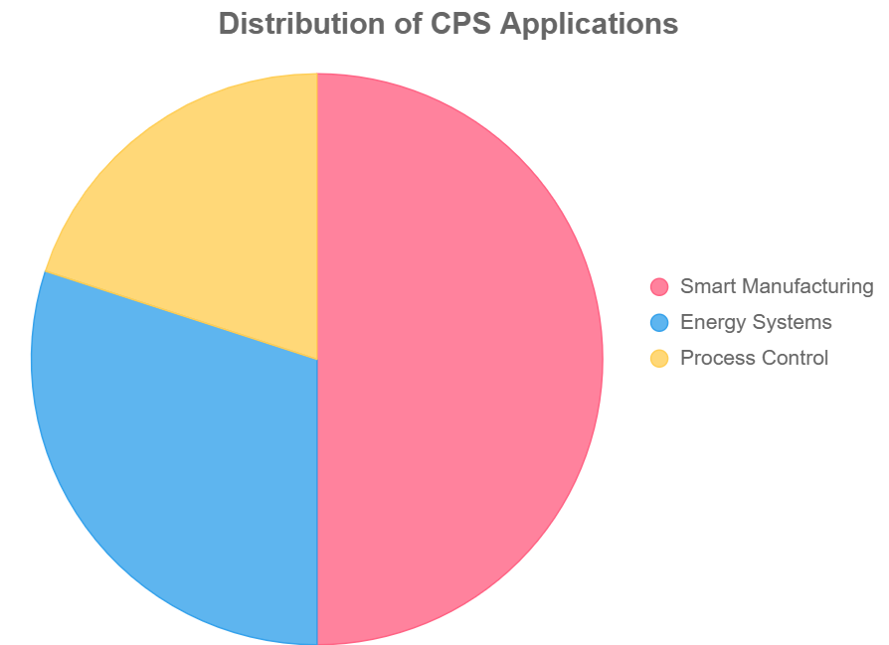

Fig 2: Disruption of CPS applications

These applications address the growing demands for adaptability, sustainability, and productivity in modern industrial systems, positioning CPS as a cornerstone of Industry 4.0. This section provides an in-depth exploration of key CPS applications in industrial control, focusing on smart manufacturing, energy systems, and process control. Through detailed examples and analysis, it illustrates how CPS drives innovation, supports sustainable practices, and shapes the future of industrial automation, while highlighting the critical role of CPS in overcoming complex industrial challenges.

## **3.1. Smart Manufacturing**

Smart manufacturing represents one of the most impactful applications of CPS, transforming traditional production processes into interconnected, intelligent systems capable of real-time monitoring, optimization, and adaptation. CPS enables the vision of the "smart factory," where machinery, sensors, actuators, and control systems communicate seamlessly to create a dynamic and responsive production environment. Sensors embedded in production equipment collect real-time data on parameters such as speed, temperature, vibration, and material flow, providing a comprehensive view of the manufacturing process. Actuators, such as robotic arms or automated conveyors, respond to computational commands to adjust operations, ensuring optimal performance. For example, in an automotive assembly plant, CPS can monitor the torque applied by robotic screwdrivers, adjusting settings instantly to maintain precision and prevent defects.

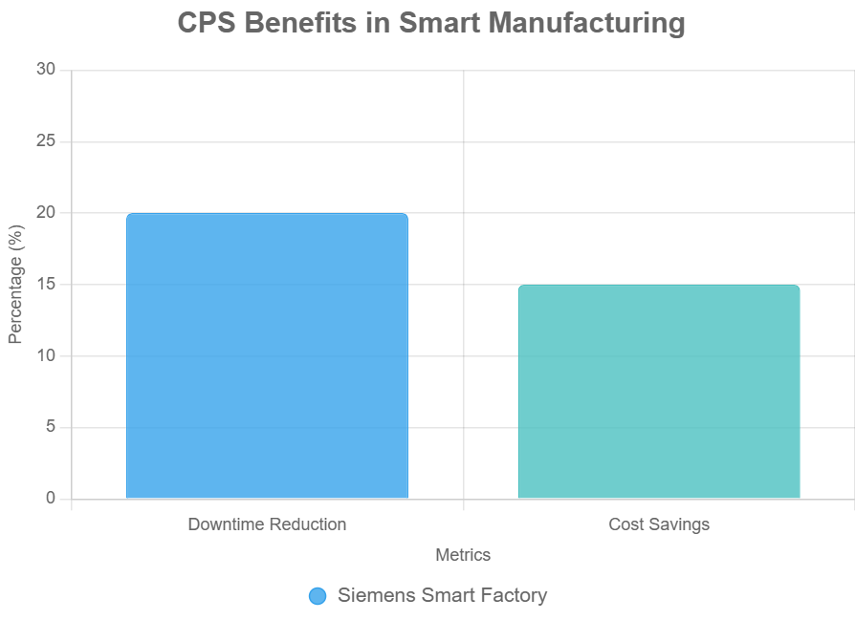

Fig 3: CPS benefits in smart manufacturing

A key advantage of CPS in smart manufacturing is predictive maintenance, which leverages data analytics and machine learning to anticipate equipment failures before they occur. By analyzing patterns in sensor data, such as unusual vibrations or temperature spikes, CPS can predict when a machine is likely to fail, enabling proactive maintenance that minimizes downtime and reduces repair costs. This capability is particularly valuable in high-volume production environments, where unplanned outages can lead to significant financial losses. Additionally, CPS supports flexible manufacturing by enabling rapid reconfiguration of production lines to accommodate new products, design changes, or demand fluctuations. For instance, in electronics manufacturing, CPS can dynamically adjust assembly processes to produce different smartphone models on the same line, enhancing efficiency and reducing waste. By integrating real-time data, predictive analytics, and automated control, CPS in smart manufacturing improves product quality, optimizes resource utilization, and drives the adaptability required for competitive, modern industrial operations.

## **3.2. Energy Systems**

In the realm of energy systems, CPS plays a pivotal role in the development and operation of smart grids, enabling efficient, reliable, and sustainable energy management. By integrating renewable energy sources—such as solar, wind, and hydroelectric power—with advanced control systems, CPS facilitates optimized energy distribution, load balancing, and fault detection. Sensors deployed across the grid collect real-time data on energy production, consumption, grid voltage, and environmental conditions, while the cyber layer processes this data to generate actionable insights. For example, CPS can dynamically adjust power distribution to balance supply and demand, ensuring grid stability even with the intermittent nature of renewable energy sources. In a wind farm, CPS might analyze wind speed data to optimize turbine output, while simultaneously coordinating with other grid components to prevent overloads.

CPS enhances energy system resilience by enabling rapid fault detection and recovery. For instance, if a sensor detects a fault in a transmission line, the cyber layer can reroute power flows to minimize disruptions, ensuring uninterrupted service. In industrial settings, CPS supports energy-efficient operations by optimizing power usage in manufacturing facilities. For example, in a steel production plant, CPS can monitor energy consumption across furnaces and rolling mills, adjusting operations to minimize peak load demands and reduce costs. This capability contributes to sustainability goals by lowering energy waste and supporting the integration of clean energy sources. Furthermore, CPS enables demand-response strategies, allowing industrial facilities to adjust energy usage in response to grid signals, enhancing overall grid efficiency. By providing real-time control and analytics, CPS in energy systems drives sustainability, reduces operational costs, and strengthens the reliability of modern energy infrastructure.

## **3.3. Process Control**

In industries such as chemical, pharmaceutical, and food processing, CPS facilitates precise and reliable process control, ensuring product quality, safety, and regulatory compliance. These industries rely on stringent monitoring and control of parameters like temperature, pressure, pH, and chemical composition to maintain optimal process conditions and prevent costly errors. CPS integrates sensor data with advanced control algorithms to monitor processes in real time, detect anomalies, and adjust operations dynamically. For example, in a pharmaceutical manufacturing facility, CPS can monitor the temperature and mixing speed of a bioreactor, adjusting parameters to ensure consistent drug quality while minimizing energy consumption and waste. The ability to perform real-time analytics enhances process efficiency, reduces resource consumption, and ensures adherence to strict safety and regulatory standards.

A significant advancement enabled by CPS in process control is the use of digital twins—virtual models of physical processes that allow operators to simulate and optimize operations before implementing changes. In a chemical plant, for instance, a digital twin can model the behavior of a reaction vessel under different conditions, enabling operators to test adjustments virtually and identify optimal settings without risking production disruptions. This capability improves reliability, reduces downtime, and enhances process safety by identifying potential issues in a virtual environment. Additionally, CPS supports adaptive control strategies, allowing processes to respond dynamically to variations, such as changes in raw material quality or environmental conditions. By integrating real-time data, advanced analytics, and digital modeling, CPS in process control drives precision, efficiency, and innovation, making it indispensable for industries with complex and sensitive production requirements.

## **3.4. Broader Implications and Integration**

The applications of CPS in industrial control—smart manufacturing, energy systems, and process control—demonstrate its transformative potential in addressing the complexities of modern industrial systems. By enabling real-time data integration, predictive analytics, and automated control, CPS enhances operational efficiency, adaptability, and sustainability, aligning with the core objectives of Industry 4.0. These applications are interconnected, as advancements in one area often benefit others. For instance, energy-efficient strategies developed for smart grids can be applied to manufacturing facilities, while digital twin technologies used in process control can enhance predictive maintenance in smart factories.

However, the successful implementation of these applications requires overcoming significant challenges, such as cybersecurity risks, interoperability issues, and scalability limitations. Ensuring secure data exchange, standardizing communication protocols, and developing scalable architectures are critical to realizing the full potential of CPS. As industries continue to adopt CPS, these applications will drive innovation, enabling smarter, more resilient, and sustainable industrial systems. The integration of emerging technologies, such as AI, edge computing, and 5G, will further enhance these applications, paving the way for a new era of industrial automation that is responsive to global demands for efficiency, sustainability, and competitiveness.

# **4. Challenges in CPS for Industrial Control**

The implementation of Cyber-Physical Systems (CPS) in industrial control holds immense potential to revolutionize automation, efficiency, and adaptability, aligning with the transformative vision of Industry 4.0. However, the integration of computational and physical processes in complex industrial environments introduces significant challenges that span technical, operational, and organizational domains. These challenges—cybersecurity, interoperability, and scalability—represent critical barriers to the widespread adoption of CPS and require innovative, multidisciplinary solutions to ensure reliability, security, and performance. This section provides an in-depth examination of these challenges, exploring their implications, real-world examples, and potential mitigation strategies. By addressing these hurdles, industries can unlock the full potential of CPS, driving sustainable and resilient industrial systems.

## **4.1. Cybersecurity**

The convergence of information technology (IT) and operational technology (OT) in CPS creates a complex and vulnerable attack surface, exposing industrial control systems to significant cybersecurity risks (Ding et al., 2018). Historically, industrial systems were isolated, relying on air-gapped environments to protect against external threats. However, CPS integrates these systems with networked environments, enabling real-time data exchange but also exposing them to cyber threats such as malware, ransomware, and unauthorized access, which can have catastrophic consequences, including disrupted production, equipment damage, compromised worker safety, and substantial economic losses (Humayed et al., 2017). For instance, a ransomware attack on a smart factory could halt production lines, leading to supply chain disruptions, while an attack on a smart grid could destabilize energy distribution, affecting entire communities (Ashibani & Mahmoud, 2017).

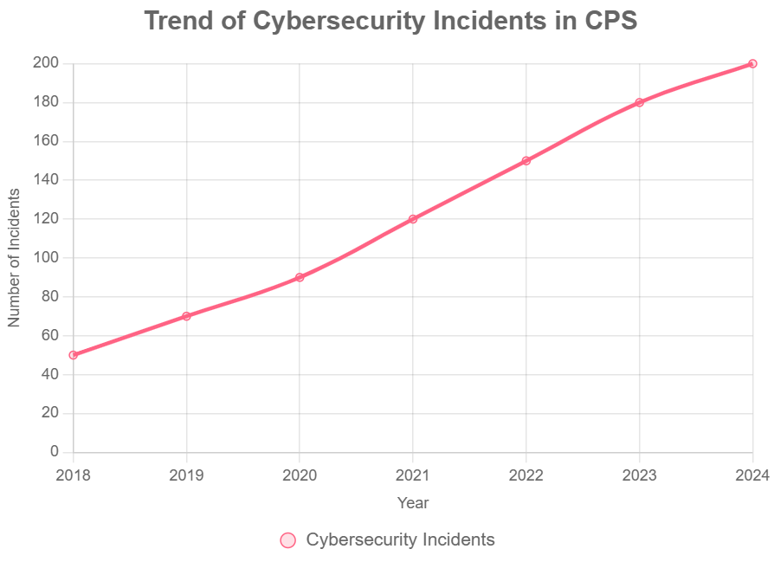

Fig 4: Trend of cybersecurity incidents in CPS

Ensuring robust cybersecurity in CPS requires tailored solutions that account for the unique demands of industrial environments, such as real-time processing and low-latency communication. Traditional IT security measures, such as firewalls and antivirus software, are often insufficient due to the complexity and diversity of CPS components. For example, industrial IoT devices may have limited processing power, making it challenging to implement resource-intensive encryption algorithms (Ding et al., 2018). Solutions include adopting secure communication protocols like OPC UA with built-in security features, implementing intrusion detection systems (IDS) designed for industrial networks, and using blockchain-based authentication to ensure data integrity. Additionally, regular security audits, employee training, and the development of incident response plans are critical to mitigating risks. The evolving nature of cyber threats necessitates continuous innovation in cybersecurity frameworks, ensuring CPS can operate securely in increasingly connected industrial ecosystems (Ding et al., 2018).

## **4.2. Interoperability**

Interoperability poses a significant challenge in CPS due to the heterogeneity of devices, protocols, and systems prevalent in industrial settings. Industrial environments often consist of a mix of legacy equipment, modern IoT devices, and proprietary systems from multiple vendors, each employing different communication protocols, data formats, and operational standards. This lack of standardization hinders seamless data exchange and system integration, limiting the effectiveness of CPS. For example, in a manufacturing facility, a legacy programmable logic controller (PLC) may use a proprietary protocol incompatible with modern IoT sensors, complicating the implementation of a unified CPS architecture. This challenge is particularly acute in brownfield industrial sites, where retrofitting existing infrastructure with CPS capabilities requires significant investment and technical expertise.

Achieving interoperability requires the adoption of standardized communication protocols, such as OPC UA, MQTT, or Industrial Ethernet, which enable seamless data exchange across diverse systems. However, industry-wide adoption of these standards remains uneven, as vendors often prioritize proprietary solutions to maintain market differentiation. Efforts to address interoperability include the development of middleware platforms that translate data between incompatible systems and the establishment of industry consortia, such as the Industrial Internet Consortium (IIC), to promote common standards. For instance, OPC UA’s platform-independent architecture supports interoperability by providing a unified framework for data exchange in industrial automation. Additionally, digital twins—virtual models of physical systems—can facilitate interoperability by providing a standardized interface for integrating heterogeneous components. Overcoming interoperability challenges requires collaboration among stakeholders, including equipment manufacturers, software developers, and industry regulators, to drive the adoption of open standards and ensure seamless CPS integration.

## **4.3. Scalability**

Scaling CPS to large, complex industrial systems presents significant challenges related to computational resources, network performance, and system management. Industrial CPS often involves thousands of sensors, actuators, and devices generating massive volumes of data, requiring substantial processing power, storage capacity, and network bandwidth. Real-time control demands low-latency communication and high reliability, which can strain network infrastructure, particularly in large-scale deployments. For example, a CPS managing a multi-site manufacturing operation must handle data from distributed factories while ensuring consistent performance and real-time coordination across geographically dispersed locations. The sheer volume of data and the need for rapid processing can overwhelm traditional centralized architectures, leading to bottlenecks and degraded performance.

Scalability also involves managing the complexity of integrating new devices, updating software, and maintaining system performance without disrupting ongoing operations. In dynamic industrial environments, where new equipment or processes are frequently introduced, CPS must be flexible enough to accommodate growth while maintaining reliability. Solutions to scalability challenges include leveraging edge computing to process data locally, reducing the burden on centralized servers and minimizing latency. For instance, in a smart factory, edge devices can analyze sensor data on-site to make real-time control decisions, reducing network congestion. Additionally, 5G networks offer high-speed, low-latency connectivity, enabling CPS to support large numbers of devices in expansive deployments. Advanced data management strategies, such as data compression and prioritization, can further enhance scalability by optimizing resource utilization. Developing modular and distributed architectures, where CPS components operate semi-autonomously, also supports scalability by allowing systems to grow incrementally without compromising performance.

## **4.4. Broader Implications and Mitigation Strategies**

The challenges of cybersecurity, interoperability, and scalability are interconnected, each amplifying the others’ impact on CPS implementation. For instance, addressing interoperability through standardized protocols can enhance cybersecurity by enabling secure data exchange, while scalable architectures like edge computing can reduce latency and improve system reliability. Overcoming these challenges requires a multidisciplinary approach that combines advancements in technology, industry collaboration, and organizational strategies. Research into secure system design, such as zero-trust architectures and AI-driven threat detection, can bolster cybersecurity. Industry-wide initiatives to promote open standards and interoperable frameworks can streamline integration, while investments in edge computing, 5G, and distributed architectures can address scalability needs.

Real-world examples highlight the urgency of addressing these challenges. The 2021 Colonial Pipeline ransomware attack demonstrated the devastating impact of cybersecurity vulnerabilities in industrial systems, disrupting fuel supply across the United States. Similarly, interoperability issues have slowed the adoption of CPS in older industrial facilities, where legacy systems require costly upgrades to integrate with modern CPS frameworks. Scalability challenges are evident in large-scale smart grid deployments, where managing data from thousands of distributed energy resources demands robust network infrastructure. By prioritizing solutions to these challenges, industries can ensure the reliability, security, and performance of CPS, unlocking their transformative potential.

The challenges of cybersecurity, interoperability, and scalability represent critical hurdles to the successful deployment of CPS in industrial control. Addressing these issues requires innovative technologies, standardized frameworks, and collaborative efforts across industry stakeholders. As CPS continues to drive automation and efficiency, overcoming these challenges will be essential to realizing the full potential of Industry 4.0, enabling resilient, secure, and scalable industrial systems that meet the demands of a rapidly evolving global landscape.

# **5. Future Directions**

The transformative potential of Cyber-Physical Systems (CPS) in industrial control continues to evolve, driven by rapid advancements in technology and the growing demands of Industry 4.0. As industries strive for greater efficiency, resilience, and sustainability, emerging technologies are poised to enhance the capabilities of CPS, addressing current limitations and unlocking new opportunities. This section explores key future directions for CPS in industrial control, focusing on the integration of artificial intelligence (AI), the adoption of edge computing, and the leveraging of 5G networks. These advancements promise to redefine industrial automation, enabling smarter, more adaptive, and scalable systems that can meet the challenges of modern industrial environments.

## **5.1. Artificial Intelligence**

The integration of artificial intelligence (AI) into CPS is set to revolutionize industrial control by enabling autonomous decision-making and advanced predictive analytics. AI-driven CPS can process vast amounts of sensor data in real time, identifying patterns, predicting system behavior, and optimizing operations with minimal human intervention. For example, in smart manufacturing, AI-powered CPS can use machine learning models to predict equipment failures with greater accuracy, enabling proactive maintenance that reduces downtime and extends equipment lifespan. In process control, AI can optimize complex industrial processes, such as chemical reactions, by dynamically adjusting parameters to maximize yield and minimize energy consumption. Furthermore, AI enhances the adaptability of CPS by enabling systems to learn from new data and respond to changing conditions, such as shifts in production demands or environmental factors. As AI technologies, such as deep learning and reinforcement learning, continue to advance, their integration into CPS will drive the development of self-optimizing and autonomous industrial systems, significantly enhancing efficiency and innovation.

## **5.2. Edge Computing**

Edge computing is emerging as a critical enabler for CPS in industrial control, addressing the challenges of latency, bandwidth, and scalability. By processing data closer to the source—such as sensors and actuators on the factory floor—edge computing reduces the need to transmit large volumes of data to centralized cloud servers, enabling faster decision-making and real-time control. This is particularly important in industrial applications where low-latency responses are critical, such as robotic automation or real-time process monitoring. For instance, in a smart factory, edge devices can analyze sensor data locally to detect anomalies and adjust operations instantly, improving responsiveness and reducing network congestion. Edge computing also enhances data security by minimizing data transmission over external networks, mitigating cybersecurity risks. As edge computing technologies mature, they will enable CPS to scale more effectively, supporting large-scale industrial deployments with distributed architectures that balance computational load and ensure reliable performance.

## **5.3. 5G Integration**

The advent of 5G networks promises to transform the communication layer of CPS, providing high-speed, low-latency, and reliable connectivity essential for large-scale industrial automation. Unlike traditional industrial communication protocols, 5G offers ultra-low latency and high bandwidth, enabling seamless data exchange between distributed sensors, actuators, and control systems. In industrial settings, 5G can support real-time coordination across multiple production units, facilitating synchronized operations in complex, multi-site manufacturing facilities. For example, in a smart grid, 5G-enabled CPS can rapidly transmit data from distributed energy sources to optimize load balancing and fault detection. Additionally, 5G’s ability to support massive device connectivity allows CPS to integrate thousands of IoT devices, enhancing system scalability. The integration of 5G also improves the reliability of CPS in challenging industrial environments, where interference or network congestion could otherwise disrupt operations. As 5G adoption grows, it will empower CPS to achieve unprecedented levels of connectivity and performance, driving the next wave of industrial innovation.

The future of CPS in industrial control lies in leveraging these emerging technologies—AI, edge computing, and 5G—to overcome existing challenges and unlock new possibilities. By enhancing decision-making, reducing latency, and improving connectivity, these advancements will enable CPS to deliver more efficient, resilient, and adaptive industrial systems. However, realizing these benefits will require addressing technical and organizational hurdles, such as developing robust AI models, ensuring secure edge architectures, and deploying 5G infrastructure in industrial settings. As these technologies converge, CPS will play a central role in shaping the future of Industry 4.0, driving innovation and sustainability across industrial sectors.

# **6. Conclusion**

Cyber-Physical Systems (CPS) have firmly established themselves as a cornerstone of industrial control, fundamentally transforming the operational landscape of industries worldwide by seamlessly integrating computational intelligence with physical processes. By enabling real-time monitoring, data-driven decision-making, and advanced automation, CPS has catalyzed significant advancements across diverse sectors, including smart manufacturing, energy systems, and process control. These systems align with the transformative objectives of Industry 4.0, fostering smarter, more efficient, and resilient industrial operations that respond dynamically to modern challenges. The robust architecture of CPS—comprising the physical layer of sensors and actuators, the cyber layer of analytics and AI, and the communication layer of networked protocols—facilitates a cohesive interaction between industrial equipment and sophisticated algorithms. This integration drives unprecedented levels of efficiency, adaptability, and sustainability, as evidenced by applications such as predictive maintenance in smart factories, optimized load balancing in smart grids, and precise control in chemical and pharmaceutical processing. These examples underscore the versatility and profound impact of CPS in addressing the complexities of contemporary industrial systems.

Despite their transformative potential, the adoption of CPS is not without significant challenges. The convergence of information technology (IT) and operational technology (OT) introduces cybersecurity vulnerabilities that threaten the integrity, safety, and reliability of industrial systems. High-profile incidents, such as ransomware attacks on critical infrastructure, highlight the urgent need for robust security frameworks tailored to the unique demands of CPS. Interoperability issues, stemming from the heterogeneity of legacy equipment, modern IoT devices, and proprietary systems, further complicate seamless integration, necessitating standardized protocols and industry-wide collaboration. Scalability remains a critical hurdle, as large-scale CPS deployments require substantial computational resources, low-latency communication, and efficient system management to handle vast data volumes and ensure consistent performance across distributed operations. These challenges demand innovative solutions, combining technological advancements, regulatory frameworks, and organizational strategies to ensure the successful implementation of CPS.

Looking forward, the future of CPS in industrial control is exceptionally promising, with emerging technologies poised to address current limitations and unlock new opportunities. Artificial intelligence (AI) is set to enhance CPS by enabling autonomous decision-making, predictive analytics, and self-optimizing systems that adapt to dynamic industrial conditions. For instance, AI-driven CPS can optimize production schedules in real time or predict equipment failures with greater precision, reducing costs and improving operational efficiency. Edge computing offers a solution to scalability and latency challenges by processing data locally, minimizing reliance on centralized cloud infrastructure and enhancing real-time control. The rollout of 5G networks, with their high-speed, low-latency, and massive device connectivity, will revolutionize the communication layer of CPS, enabling seamless coordination in large-scale industrial deployments, such as multi-site manufacturing or distributed energy systems. These technologies, when integrated with CPS, will drive the development of next-generation industrial systems that are more responsive, resilient, and sustainable.

The broader implications of CPS extend beyond technical advancements, influencing economic, environmental, and societal outcomes. By optimizing resource utilization and reducing energy consumption, CPS contributes to sustainability goals, supporting industries in meeting regulatory requirements and addressing global demands for environmentally responsible practices. The development of digital twins—virtual replicas of physical systems—enables industries to simulate and optimize processes, fostering innovation and reducing risks. Autonomous industrial systems, powered by CPS and AI, promise to redefine workforce dynamics, shifting human roles toward higher-level decision-making and system oversight while automating routine tasks. These advancements enhance industrial competitiveness, enabling companies to adapt to rapidly changing market demands and global supply chain complexities.

To fully realize the potential of CPS, stakeholders must adopt a proactive and collaborative approach. Interdisciplinary research is essential to develop secure system architectures, advanced analytics, and scalable infrastructure that address the unique challenges of industrial CPS. Industry-wide standards, promoted through consortia like the Industrial Internet Consortium (IIC), are critical to ensuring interoperability and fostering seamless integration across diverse systems. Cybersecurity must remain a priority, with investments in secure protocols, intrusion detection systems, and workforce training to mitigate evolving threats. Policymakers, industry leaders, and academia must work together to create regulatory frameworks that balance innovation with safety, ensuring that CPS deployments are both effective and secure. Public-private partnerships can further accelerate the adoption of CPS by supporting infrastructure development and technology transfer, particularly in emerging economies.

Ultimately, CPS will continue to shape the future of industrial control, driving innovation, sustainability, and competitiveness in the global industrial landscape. By addressing current challenges and leveraging emerging technologies, CPS will enable the creation of smarter, more resilient, and sustainable industrial systems that meet the evolving demands of Industry 4.0 and beyond. The journey toward widespread CPS adoption is complex, but the potential rewards—enhanced productivity, reduced environmental impact, and improved quality of life—make it a critical endeavor for the future of industry. As CPS continues to evolve, it will redefine the boundaries of industrial automation, paving the way for a new era of intelligent and interconnected industrial systems.

Disclaimer (Artificial intelligence)

Author(s) hereby declare that generative AI technologies have been used during the preparation of this manuscript. Details of the AI usage are given below:

Tool: Grok 3, created by xAI, version 3.0, accessed via grok.com.

Usage: Grok was used to generate concise summaries of referenced articles, such as Colombo et al. (2017), to aid in understanding CPS applications in smart manufacturing. The summaries were reviewed, edited, and integrated into the manuscript (e.g., Section 3.1) by the authors to ensure accuracy and relevance.

Tool: Grok 3, created by xAI, version 3.0, accessed via grok.com

Usage: Grok generated a summary of Ding et al. (2018) to inform the discussion on cybersecurity challenges in Section 4.1. The authors manually verified the summary against the original article and incorporated relevant points into the manuscript, ensuring proper citation.

Tool: Grok 3, created by xAI, version 3.0, accessed via grok.com.

Usage: Grok was used to summarize Alur (2015) to support the development of Section 2 (Architecture of Cyber-Physical Systems). The authors reviewed the summary, cross-referenced it with the source, and used it to inform the section’s content, including the description of physical, cyber, and communication layers.

# **7. References**

1. Alur, R. (2015). Principles of cyber-physical systems. MIT Press.
2. Baheti, R., & Gill, H. (2011). Cyber-physical systems. The Impact of Control Technology, 12(1), 161–166.
3. Colombo, A. W., Karnouskos, S., Kaynak, O., Shi, Y., & Yin, S. (2017). Industrial cyber-physical systems: A backbone of the fourth industrial revolution. IEEE Industrial Electronics Magazine, 11(1), 6–16.
4. Ding, D., Han, Q. L., Xiang, Y., Ge, X., & Zhang, X. M. (2018). A survey on security control and attack detection for industrial cyber-physical systems. Neurocomputing, 275, 1674–1683.
5. Gunes, V., Peter, S., Givargis, T., & Vahid, F. (2014). A survey on concepts, applications, and challenges in cyber-physical systems. KSII Transactions on Internet and Information Systems, 8(12), 4242–4268.
6. Humayed, A., Lin, J., Li, F., & Luo, B. (2017). Cyber-physical systems security: A survey. IEEE Internet of Things Journal, 4(6), 1802–1831.
7. Jazdi, N. (2014). Cyber physical systems in the context of Industry 4.0. IEEE International Conference on Automation, Quality and Testing, Robotics, 1–4.
8. Khaitan, S. K., & McCalley, J. D. (2015). Design techniques and applications of cyber-physical systems: A survey. IEEE Systems Journal, 9(2), 350–365.
9. Lee, E. A. (2008). Cyber physical systems: Design challenges. 11th IEEE International Symposium on Object and Component-Oriented Real-Time Distributed Computing (ISORC), 363–369.
10. Leitão, P., Colombo, A. W., & Karnouskos, S. (2016). Industrial automation based on cyber-physical systems technologies. Computers in Industry, 81, 11–25.
11. Liu, Y., Peng, Y., Wang, B., Yao, S., & Liu, Z. (2017). Review on cyber-physical systems. IEEE/CAA Journal of Automatica Sinica, 4(1), 27–40.
12. Monostori, L., Kádár, B., Bauernhansl, T., Kondoh, S., Kumara, S., Reinhart, G., Sauer, O., Schuh, G., Sihn, W., & Ueda, K. (2016). Cyber-physical systems in manufacturing. CIRP Annals, 65(2), 621–641.
13. Rajkumar, R., Lee, I., Sha, L., & Stankovic, J. (2010). Cyber-physical systems: The next computing revolution. 47th Design Automation Conference, 731–736.
14. Rao, S. K., & Prasad, R. (2019). Impact of 5G technologies on Industry 4.0. Wireless Personal Communications, 100(1), 145–159.
15. Sisinni, E., Saifullah, A., Han, S., Jennehag, U., & Gidlund, M. (2018). Industrial Internet of Things: Challenges, opportunities, and directions. IEEE Transactions on Industrial Informatics, 14(11), 4724–4734.
16. Wang, L., Törngren, M., & Onori, M. (2015). Cyber-physical systems in manufacturing: Challenges and opportunities. Journal of Manufacturing Systems, 36, 139–150.
17. Wollschlaeger, M., Sauter, T., & Jasperneite, J. (2017). The future of industrial communication. IEEE Industrial Electronics Magazine, 11(1), 30–42.
18. Yu, X., & Xue, Y. (2015). Smart grids: A cyber-physical systems perspective. Proceedings of the IEEE, 104(4), 1058–1070.
19. Zhang, Y., Xu, Z., & Zhou, J. (2019). Artificial intelligence in cyber-physical systems. IEEE Transactions on Industrial Informatics, 15(5), 2964–2973.
20. Zhong, R. Y., Xu, X., Klotz, E., & Newman, S. T. (2017). Intelligent manufacturing in the context of Industry 4.0: A review. Engineering, 3(5), 616–630.
21. Ashibani, Y., & Mahmoud, Q. H. (2017). Cyber physical systems security: Analysis, challenges and solutions. Computers & Security, 68, 81–97.
22. Kim, K.-D., & Kumar, P. R. (2012). Cyber-physical systems: A perspective at the centennial. Proceedings of the IEEE, 100(Special Centennial Issue), 1287–1308.
23. Lu, Y. (2017). Industry 4.0: A survey on technologies, applications and open research issues. Journal of Industrial Information Integration, 6, 1–10.