**Original Research Article**

**ETHNO-MEDICINAL PLANTS USED BY RURAL FOLKS OF MAPANAS, NORTHERN SAMAR, PHILIPPINES**

**ABSTRACT**

Ethnomedicinal studies plays crucial role in understanding use medicinal plants for traditional healing practices which can also be a precursor for drug discovery and medicinal conservation. A purposive sampling technique was used to identify plant species used by local inhabitants as alternative medicines in five selected barangays of Mapanas, Northern Samar. The study aimed at collecting and identifying plant species used as medicine by documenting the plant part used for the treatment of ailments. A total of 44 plant species belonging to 24 families were identified which were used as various medicinal applications. The most commonly used part of the plant were the leaves, which were usually prepared in a decoction. A variety of common ailments were reportedly cured by these plant species, ranging from wound cleansing/antiseptic, chest and body pains, cough and cold, diarrhea, diabetes, dengue fever, headache, ear infections, hypertension, menstrual cramps/pain, rheumatism, sore eyes, tooth and/or stomach ache, ulcer, and urinary tract infections. Some of the plants were also utilized in some rituals, like circumcision, or as purgative (dewormer), antidote for poisoning, ingredients in post-partum bath, or to combat swelling in sprains. These results imply that residents of the municipality of Mapanas, Northern Samar, Philippines, has a wealth of indigenous knowledge about plant species that possess medicinal attributes, utilizing them as alternatives to expensive commercial drugs. It is therefore recommended that strict conservation efforts be implemented to save these valuable resources, and that chemical screening of the plant parts for their secondary metabolites would be required for drug discovery in the future.

**KEYWORDS:** *Alternative Medicine, Indigenous Knowledge,* *Inventory, Medicinal Plants, Secondary Metabolites*

**INTRODUCTION**

Plants have long been valued for their medicinal properties, forming the foundation of traditional and modern healthcare systems. Traditional medicine systems such as Ayurveda, Traditional Chinese Medicine (TCM), and herbal remedies rely heavily on plant-based ingredients. Many pharmaceutical drugs originate from plant compounds (Pachaya, 2024).

Many substances utilized in our lives are plant products, and numerous medicines were first isolated from plant seeds and extracts, as well as several industrial products, such as rubber, paint bases, non-petroleum oils, gums, Sizing starches, also derived from seed plants. Most important of all, are the edible plants that are in the food base of human culture (Heneidy and Bidak, 2004).

Healing with medicinal plants is an old treatment method, as old as mankind itself (Petrovska, 2012). Awareness of medicinal plants’ usage is a result of the many years of struggle against diseases and man learned to pursue drugs in barks, seeds, fruits, and other parts of plants (Srivastava, 2018).

Sofowara, *et al*., (2013) defines a medicinal plant as any plant which, in one or more of its organs, contain substances that can be used for therapeutic purposes, or which are precursors for the synthesis of useful drugs. Secondary metabolites in plants have been shown to possess various biological effects, which provide the scientific bases for the use of herbs in traditional medicine among many ancient communities (Hussein and El-Anssary, 2018).

Thus, this study was initiated to document the plants used by local inhabitants in selected barangays of the municipality of Mapanas, Northern Samar, Philippines as traditional or alternative medicine for common ailments, identify the plant part used, including its method of preparation, and the ailments it reportedly cures, since no previous investigation of a similar nature has yet been done in the locality.

***Objectives of the Study:***

This study aims to ascertain the variety of plant species used by the local inhabitants in selected barangays in Mapanas, Northern Samar, Philippines. Specifically, it had the following objectives: (1) to identify medicinal plants use by local inhabitants in selected barangays of Mapanas, Northern Samar; and, (2) to document the different parts of the plants used against the cure of various ailments in folk medicine.

**LITERATURE REVIEW**

Various plant parts have been used in healthcare system since time immemorial by the aboriginal people over the world (Ozukum *et al*., 2019. Studies have been carried out globally to verify their efficacy and some of the findings have led to the production of plant-based medicines (Sofowora, *et al.,* 2013, Ozukum *et al.,* 2019).

The World Health Organization (WHO) has accounted about 60% of the world’s population relying on traditional medicine, and 80% of the population in developing countries depend almost entirely on traditional medical practices, in particular, herbal remedies, for their primary health (WHO 1999). In the Philippines, more than 1500 medicinal plants used by traditional healers have been documented, and 120 plants have been scientifically validated for safety and efficacy. However, a recent study found out that majority of the medicinal plants are threatened by anthropogenic factors (Dapar, *et al.,* 2020). This has led to the continued decline of traditional herbal medicine. There is, therefore, a need to adopt management strategies that enhance the conservation of these valuable natural resources (Dapar, *et al.,* 2020).

Likewise, plants/trees play a very important role in man’s life by fulfilling his food, fuel, timber, fibre, and medicinal needs. Plants/trees are helpful in the mitigation of environmental pollution, being the source of oxygen and a sink of carbon dioxide. Trees such as tamarind (*Tamarindus indicus*), ashok (*Polyalthia longifolia* Sonn.), and neem (*Azadirachta indica*) are very useful in the control of noise pollution. Plants/trees are also helpful in the restoration of degraded lands. Furthermore, plants are helpful in the removal of heavy metals from contaminated sites, and trees are helpful in the maintenance of ground water levels (Singh, 2022).

In Pakistan, Parveen, *et al.,* (2021), revealed that the Shahbaz Garhi Mardan, Khyber Pakhtunkhwa, area has a rich diversity of plants and the people use these plants and their products for medicinal, wood-fuel, ornament, food and timber purposes, as well as support for their livelihood and other needs.

In Mount Malinao, Albay, Philippines, the vegetation was represented by 27 endemic plants, 15 economically important plants, 15 medicinal plants, 9 ornamental plants, 3 poisonous plants, 3 newly-introduced plants to the locale, and 6 newly-introduced plants to the Philippines (De Guzman, *et al.,* 2014).

Prigge, *et al.,* (2005), reported 123 plant species belonging to 90 genera and 53 families documented to be used by the farmers in Leyte, Philippines, for 77 different purposes, including 42 for human ailments. The predominant life forms are trees and herbs, and more than 60% of all recorded species are native to the Philippines. These species are used for more than one purposes: eighty plants have medicinal value, 34 provide food and 32 serve for other uses.

Another study titled Ethnobotanical and ethnomedicinal research into medicinal plants in the Mt Stara Planina region (south-eastern Serbia, Western Balkans), identified 136 vascular medicinal plant taxa and one lichen species belonging to 53 families and 116 genera. Lamiaceae (19), Rosaceae (18), and Asteraceae (17) had the highest species diversity. The plant parts most commonly used to make a variety of herbal preparations were the aerial parts (54 citations), leaves (35 citations), fruits (20 citations), flowers (18 citations), and roots (16 citations), while the most common forms of preparation were teas (60.78%), consumption of fresh tubers, leaves, roots, and fructus (6.86%), compresses (5.88%), juices (5.39%), decoctions (3.92%), ‘travarica’ brandy (3.92%), and syrups (2.45%). Of the recorded species, 102 were administered orally, 17 topically, and 18 both orally and topically. The plants with a maximum use value (UV = 1) were Allium sativum, Allium ursinum, Gentiana asclepiadea, Gentiana cruciata, Gentiana lutea, Hypericum perforatum, Thymus serpyllum and Urtica dioica. The highest ICF value (ICF = 0.95) was recorded in the categories of Skin and Blood, Blood Forming Organs, and Immune Mechanism (Jarić, *et al,* 2024).

In Phatthalung Province, Peninsular Thailand, Maneenoon, *et al.,* (2015) concluded that even though conventional medicine is available, many people in local communities still continue to depend on traditional Thai medicine, and highly experienced traditional healers are still important to the communities. A total of 151 medicinal plants were documented and 98 of these are reported in the study. Local names, medicinal uses, parts used, modes of preparation, and the relationship between ailments and tastes of medicinal plant species were also presented.

From Ethiopia, Tuasha, (2018), recorded seventy-one medicinal plant species, belonging to 63 genera and 46 families, used to treat 39 human ailments. A high proportion of the medicinal plant species recovered were shrubs (35.2%); while 64.7% of medicinal plants were retrieved from the wild habitat. Leaves were the main parts of the medicinal plants used (42.9%), followed by fruits/seeds (13%); all preparations were made from fresh materials, and about 27.9% involved boiling. The frequent route of delivery was oral (77.9%), followed by the dermal (17.6%). About 40.8% of the medicinal plants were used for treating two or more ailments. About 19.7% of the MPs were used to treat malignancies, with *Sideroxylon oxyacanthum being the most* frequently used, while the species *Podocarpus* f*alcatus* and *Hagenia abyssinica* were preferred to treat jaundice and deworming in helminthiases, respectively.

In 2006, Muthu, and other researchers concluded that even though the accessibility of Western medicine for simple and complicated ailments is available, many people in the studied parts of the Kancheepuram district (Tamil Nadu, India) still continue to depend on medicinal plants, at least for the treatment of some simple diseases such as cold, cough, fever, headache, poisonous bites, skin diseases, and tooth infections. Well-knowledged healers have good interactions with patients and this improves the quality of healthcare delivery, but present-day traditional healers are very old. Due to lack of interest among the younger generation, as well as their tendency to migrate to cities for lucrative jobs, there is the possibility of losing this wealth of knowledge in the near future. It thus becomes necessary to acquire and preserve this traditional system of medicine by proper documentation and identification of specimens, they articulated.

In the province of Northern Samar, Philippines, several studies have been done to document plants with medicinal applications. For example, from the municipality of Mondragon, Bebita (2014), Balleta (2011), and Pedong (2010) reported 34 medicinal plants used to treat 17 illnesses, and that in most cases, the whole plant was utilized. These were usually prepared as decoction and drank by the patient, or poultice or hot compress, while others are eaten as food.

Similarly, in the municipality of San Roque, Nale, (2019) recorded 45 medicinal plant species, wherein the leaves, fruits, and roots, either fresh or dried, young or matured, ripe or unripe, were the plant parts used. Traditional methods of preparing these medicinal plants involves boiling (decoction), crushing, squeezing, heating, and soaking (infusion).

Diaz (2011) revealed a total of 39 medicinal plant species from the municipality of Catarman, and these were utilized against several infirmities or ailments, with either the fruits, bark, flowers, trunk, seeds, or the whole plant used. Decoction was the most common method for processing the plant.

In the municipality of Palapag, Chy (2011) concluded that there were 83 species of medicinal plants, and 9 species of medicinal animals belonging to 8 families, were collected and identified by the respondents as medicinal remedies to treat different illnesses, including common ailments of the respiratory tract, the circulatory and gastro-intestinal systems of man and his animals. Others were used to treat intestinal worms and parasites, for wound healing, promoting menstrual flow, relapse, insect and snake bites, spasms, urinary tract infection, diabetes, measles, dengue, sore eyes, burns, bodily injuries and rheumatism.

Balawang (2011) also reported 41 medicinal plant species collected and identified from Bobon, Northern Samar. These plants were used to treat common ailments like headache, cough and cold, fever, stomachache/abdominal pain, asthma, diarrhea, menstrual problems, skin diseases, diseased gums, inflammation and wounds, relapse (“bughat” or “pasma”), intestinal parasitism, agalactia, poisoning, and other body pains.

Meanwhile, in Calbayog City, Samar, and Rada, (2011) also documented 41 medicinal plant species used to cure common illnesses. Also treated were viral infections, such as mumps and measles; and other ailments such as paralysis and hypertension.

Moreover, A study conducted by Mekonnen and other researchers (2022), concluded a total of 89 species of medicinal plants were identified and collected with 82 genera and 44 families. Out of these, 60 species (67.42%) were used against human ailments, 10 species (11.24%) were used against livestock ailments, and 19 species (21.34%) were used to treat both human and livestock ailments. Herbs constituted the largest growth habit (40 species) followed by shrubs (33 species). The most frequently used plant part was leaves (39.9%), followed by roots (23.83%), and the condition of preparation was fresh plant materials (70.98%). The most widely used method of preparation was crushing (22.8%) followed by crushing-squeezing (11.39%). The most common route of administration was oral (49.74%) followed by dermal (30.05%). Ruta chalepensis was the predominant medicinal plant cited by most of the informants 62 (70%) followed by Ocimum lamiifolium 59 (67%). The disease category with the highest ICF value (0.90) was the evil eye. There was a high preference for Euphorbia abyssinica to treat stomachache. Ocimum lamiifolium was the most preferred species for the treatment of febrile illness. Anthropogenic factors are the major threats to medicinal plants. In general, the study area is rich in medicinal plants that have a significant role in the management of various human and livestock diseases.

Another study titled “Investigate the Ethnomedical Practices of Different Indigenous Communities: A literature Review” concludes that ethnomedical practices represent invaluable knowledge systems with the potential to complement modern healthcare by enhancing cultural sensitivity, expanding treatment options, and preserving indigenous heritage (Awoke and Codensey, 2025).

A study titled Ethnobotany and diversity of medicinal plants used among rural communities in Mina, Iloilo, Philippines: A quantitative study concluded that traditional medical practices used by the rural communities are greatly influenced by their experiences, cultural and spiritual beliefs transmitted through oral communications and handed down through generations. Modern or western medicine is gradually paving its way into rural communities, thus making indigenous practice vulnerable and at risk. The lack of interest in younger generations and the accessibility of over-the-counter drugs fueled the continuing disappearance of folkloric practices. Senior citizens or elderly people whose empirical knowledge of the use of medicinal plants in ethnomedicine is valued and respected should be properly documented. They have rich traditional knowledge and documentation of this knowledge has provided novel information and create additional treatment options for different ailments (Cordero, *et al*, 2023).

**METHODOLOGY**

*Study Locale*

This study was conducted in selected barangays of Mapanas, Northern Samar, particularly in Barangays Magtaon, Manaybanay, Naparasan, San Jose, and Siljagon.

The Municipality of Mapanas, Northern Samar is a 5th class municipality in the province of Northern Samar, Philippines which is subdivided into 13 barangays. The municipality has a land area of 117.85 square kilometers, or 45.50 square miles, which constitutes 3.19% of Northern Samar’s total area. According to the 2020 census, it has a population of 14,234 people, representing 2.23% of the total population of Northern Samar province, or 0.31% of the overall population of the Eastern Visayas region. Based on these figures, the population density is computed at 121 inhabitants per square kilometer or 313 inhabitants per square mile. The Municipality of Mapanas is located along the borders of the Pacific Ocean. This municipality is considered as one of the geographically isolated and disadvantaged areas (GIDA) in the Philippines because it is physically and socio-economically separated from the mainstream society. Fishing and farming are the main sources of livelihood (Commission on Audit, 2010).

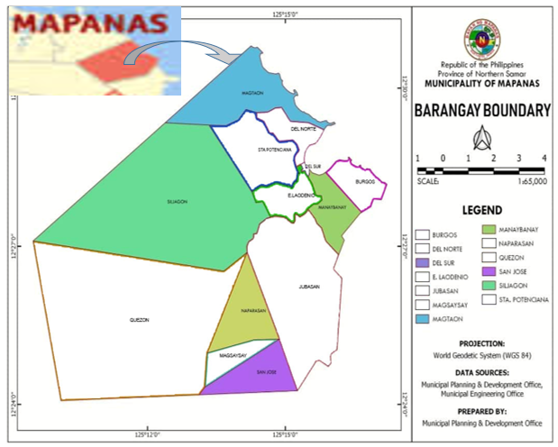

Figure 1. Map of the municipality of Mapanas, Northern Samar with sampling barangays highlighted in color.

*Research Design*

This study used the descriptive research design focusing on the identification of plants and their uses (Aggarwal and Ranganathan, 2019).

*Sampling Techniques*

This study utilized the purposive sampling technique, also called judgment sampling, is the deliberate choice of an informant due to the qualities the informant possesses, and it is a nonrandom technique that does not need underlying theories or a set number of informants (Tongco, 2007). Collection of plant specimen was done for identification purposes, and respondents were interviewed relative to the medicinal uses of plants to humans and animals. A field walk and data gathering was conducted during day time from morning until the afternoon.

*Data Gathering Procedures*

The researchers did a preliminary survey, and asked permission from the concerned barangay captains to conduct the study in their area and stayed in each barangay for two weekends to collect all the data needed to answer the objectives of the study.

An interview guide was used to gather data. The first part elicited information of the respondents; the last part determined the medicinal uses of the plants to the people of Mapanas, Northern Samar. Also included were questions or the identification of which part of the plants are useful and the process with which these plants are used.

The respondents were villagers of the five selected barangays of Mapanas, Northern Samar, aged at least 40 years old or older, either male or female and who have resided in the area for most of their lives, including the Barangay Health Workers (BHW), Barangay Health Stations (BHS) personnel, and Barangay Nutrition Scholars (BNS). Other groups of respondents were the “albularyos”, “manarams” and “manhihilot” in each of the barangay regardless of age or gender.

A field notebook was used to record important data for each specimen collected that would serve as guide in the identification.

***Specimen Collection***

The researchers collected at least three specimens for every species and each sample specimen subjected for preservation measured approximately 31cm (12 inches) like trees and shrubs, while for herbs and other smaller samples it measures approximately 15cm (6 inches) or less. Information tags were attached to every specimen.

***Preparation for Herbarium***

Preservation of the newly collected plant specimen followed the procedures of Guevarra (2005):

**Drying**

Plant specimens were dried by natural drying (sun-drying) for three weeks, and used newspapers in between specimens which was changed twice a day, taking care to prevent loss of parts of the specimen during the changing process.

**Poisoning**

The thoroughly dried specimens were preserved by treatment with a poisoning solution (Denatured alcohol) by painting it with the poisoning solution. In the latter case, both upper and lower surfaces are equally treated. This treatment preserves the specimen from insects and fungal attacks.

**Mounting**

The dried and poisoned specimens were mounted in standard sized (11 ½ x 16 ½ inches [29 x 49 cm]), white mounting sheets or cartolina of sufficient thickness. The specimens were mounted in upright position at the same time allowing ample space for the herbarium label. Detached plant parts such as seeds, flowers, leaves, tiny fruits were placed inside suitable packets and were pasted at a convenient place on the mounting sheet.

***Identification of Specimens***

Collected samples were brought to the College of Science, University of Eastern Philippines - Main Campus in Catarman, Northern Samar, where plant expert named Manuela Cecille G. Vicencio did the authentication of the pre-identified plant specimens.

**Labeling**

The label of each specimen was glued to the mounting sheets. The field label was placed in the upper left-hand corner and the smaller herbarium label, on the lower right-hand corner of the sheet.

**RESULTS AND DISCUSSION**

This section presents the medicinal plants found in the study area which are traditionally used by the residents.

Appendix Table 1 presents the 44 species of medicinal plants used by the respondents in the study area. They are classified to belong to 24 plant families, namely: Amaryllidaceae, Acanthaceae, Annonaceae, Apocynaceae, Araceae, Araliaceae, Arecaceae, Asparagaceae, Asteraceae, Celastraceae, Costaceae, Crassulaceae, Cucurbitaceae, Euphorbiaceae, Labiatae (Lamiaceae), Fabaceae, Lauraceae,

Lecythidaceae, Malvaceae, Myrtaceae, Poaceae (Graminae), Rutaceae, Sapotaceae, and Zingiberaceae. This implies that these families include plants that are traditionally important for their medicinal properties and are commonly used to treat ailments and diseases in the study area. Further, it shows a diversity of flora with medicinal application that may be evaluated for potential drug development.

These results are similar to the previous study of De Guzman, *et al.,* (2014) who found plants from similar families as being used to treat illnesses and diseases in Albay, Philippines. Similarly, Prigge, *et al.,* (2005) reported 123 plant species, belonging to 90 genera and 53 families, to be used by farmers in Leyte, Philippines for 77 different purposes, including 42 for human ailments.

The ailments and diseases said to be cured by the identified medicinal plants were mostly common ones like body pain, chest pain, cough, dengue, deworming, diabetes, diarrhea, ear infection, fever, headache, hypertension, menstruation, rheumatism, runny nose, sore eyes, sprain, stomachache, swelling, ulcer, and toothache. The plants were also used as antidote for poisons, postpartum bath, or as anti-microbial or wound rinse and for circumcision healing.

Moreover, the most common plant part used were the leaves other preparations utilizes the flowers, fruits, roots, or shoots of the plant. The most common method of processing was decoction, which was drank by the patient. Other methods of preparation include the use of fresh extract directly administered orally, eating the fruit, or by steam inhalation (“uslob”) [Appendix Table 2].

Medicinal plants such as Herba Buena (*Mentha arvensis* Linn) and Poliyo (*Moschosma tenuiflorum* (Burn) Heynh) were also reported to cure ailments and diseases of other animals, like dogs and chickens, particularly respiratory tract infections, fever, and poisoning. The leaves, prepared as decoction, was the most commonly used part and preparation method, while coconut milk with sugar was often made as cure for intoxication or poison ingestion for these animals.

**CONCLUSION**

Findings of the study concludes that a total of 44 species of medicinal plant species belonging to 24 plant families were present in the five (5) sampling barangays of Mapanas, Northern Samar. This indicate that , that the municipality harbors a diversity of plant species with traditionally important healing properties. The leaves are the most common parts of the plants used for treatment major ailments and the most common method of preparation is decoction. This implies that several common illnesses of the residents are remedied using plants with medicinal properties.

*Recommendations*

A replicate study be done in other sites to fill the information vacuum on plants used by local inhabitants in the treatment of several common illnesses, especially in remote areas of the province. Inasmuch as there is a decreasing number of individuals with knowledge and skills in utilizing plants with medicinal applications, it is imperative that an information repository for these plants, their uses, the methods of preparation, the parts used, and the illnesses treated or cured by such plants should be properly documented. The plant extracts may be tested to verify the existence of secondary products that could be the bases for drug discovery or drug development.

**COMPETING INTERESTS DISCLAIMER:**

Authors have declared that they have no known competing financial interests OR non-financial interests OR personal relationships that could have appeared to influence the work reported in this paper.

Disclaimer (Artificial intelligence)

Option 1:

Author(s) hereby declare that NO generative AI technologies such as Large Language Models (ChatGPT, manuscript.

Option 2:

Author(s) hereby declare that generative AI technologies such as Large Language Models, etc. have been used during the writing or editing of manuscripts. This explanation will include the name, version, model, and source of the generative AI technology and as well as all input prompts provided to the generative AI technology

Details of the AI usage are given below:

1.

2.

3.

**Reference**

Aggarwal R., P. Ranganathan. Study designs: Part 2 - Descriptive studies. Perspect Clin Res. 2019 Jan-Mar;10(1):34-36. doi: 10.4103/picr.PICR_154_18. PMID: 30834206; PMCID: PMC6371702.

Ahmad, M., S. Sultana, S. Fazl-i-Hadi, *et al.*, An Ethnobotanical study of Medicinal Plants in high mountainous region of Chail valley (District Swat- Pakistan). J Ethnobiology Ethnomedicine 10, 36 (2014).

Awoke, A., & Cosendey, B. (2025). Investigate the Ethnomedical Practices of Different Indigenous Communities: A literature Review. 2. 64-89. 10.33394/ijete.v2i1.13903.

Balawang, Myra P. “The Medicinal Plants in Selectted Barangays of Bobon, Northern Samar. Unpublished data. University of Eastern Philippines, University Town Catarman, Northern Samar.

Balleta, Lanie A. 2011. “Medicinal Plants in Selected Barangays of Mondragon, Northern Samar. Unpublished data. University of Eastern Philippines, University Town Catarman, Northern Samar.

Bayog, Maricris V. 2014. “Phytochemical Screening of *Selaginella plana* (KAMARIANG GUBAT) Leaf Extract. Unpublished data. University of Eastern Philippines, University Town, Catarman, Northern Samar

Bebita, Crisanto E. 2014. “The Medicinal Plants in Selected Barangays of Mondragon, Northern Samar. Unpublished data. University of Eastern Philippines, University Town Catarman, Northern Samar.

Chy, Catherine O. 2011. “The Use of Medicinal Plants and Animals in Folk Healing Practices in Palapag, Northern Samar. Unpublished data. University of Eastern Philippines, University Town Catarman, Northern Samar.

Cordero, C.S., Grecebio, U.M., Alejandro, J.D. 2023. Ethnobotany and diversity of medicinal plants used among rural communities in Mina, Iloilo, Philippines: A quantitative study. Journal of Asia-Pacific Biodiversity. Volume 16, Issue 1, Pages 96-117, ISSN 2287-884X. https://doi.org/10.1016/j.japb.2022.12.003.

De Guzman Gerard Q., Alma E. Nacua, Teresa Haide R. Belgica, Ken Joseph E. Clemente, and Grecebio Jonathan D. Alejandro. Assessment, Inventory and Ethnobotanical Survey of Medicinal Plants in Mount Malinao (Albay, Philippines). IJPTP, 2014, 5(3), 1014-1019.

Diaz, Corazon S. 2011. “The Medicinal Plants of Selected Barangays in Catarman, Northern Samar. Unpublished data. University of Eastern Philippines, University Town Catarman, Northern Samar.

Dos Santos, Lucilene Lima, *et al*., “Caatinga Ethnobotany: Anthropogenic Landscape Modification and Useful Species in Brazil’s Semi-Arid Northeast.” Economic Botany, vol. 63, no. 4, [New York Botanical Garden Press, Springer], 2009, pp. 363-374.

Eshete, M.A., E.L. Molla., Cultural significance of medicinal plants in healing human ailments among Guji semi-pastoralist people, Suro Barguda District, Ethiopia. *J Ethnobiology Ethnomedicine* **17**, 61 (2021).

Fitzpatrick, L.R., T. Woldemariam. 2017. Comprehensive Medicinal Chemistry III. <https://www.sciencedirect.com/referencework/9780128032015/comprehensive-medicinal-chemistry-iii>

Foster, S., and J.A Duke. 2000. A Field Guide to Medicinal Plants and Herbs of Eastern and Central North America. <https://scholar.google.com/scholar?hl=en&as_sdt=0%2C5&q=%22Foster%2C+S.%2C+and+J.A+Duke.+2000.+A+Field+Guide+to+Medicinal+Plants+and+Herbs+of+Eastern+and+Central+North+America.+%22&btnG>=

Heneidy, S., and L. Bidak. 2004. Potential Uses of Plant Species of the Coastal Mediterranean Region, Egypt. Pakistan Journal of Biological Sciences. 7. 10.3923/pjbs.2004.1010.1023.

Heneidy, S., M. Halmy, L. Bidak. 2017. The importance and conservation value of native plants in Eastern Arabian Peninsula. <https://scholar.google.com/scholar?hl=en&as_sdt=0%2C5&q=%22Heneidy%2C+S.%2C+M.+Halmy%2C+L.+Bidak.+2017.+The+importance+and+conservation+value+of+native+plants+in+Eastern+Arabian+Peninsula.++%22&btnG>=

[How Are Plants Important to Humans - Food, Fabrics, Medicines and Raw materials (byjus.com)](https://byjus.com/biology/importance-of-plants-to-humans/) accessed on: February 21, 2023. <https://byjus.com/biology/importance-of-plants-to-humans/>.

<https://commons.wikimedia.org/wiki/File:Ph_locator_northern_samar_mapanas.png>

<https://en.m.wikipedia.org/wiki/Mapanas>. Accessed: November 20, 2021.

[https://iwash.gov.ph/why-water-is-a-challenge-in-mapanasnothern-samar-and-how-it-is-addressed-by-the-integrated-wash approach-2/](https://iwash.gov.ph/why-water-is-a-challenge-in-mapanasnothern-samar-and-how-it-is-addressed-by-the-integrated-wash%20approach-2/).

<https://www.biologyonline.com/dictionary/medicinal-plant>.

<https://www.collinsdictionary.com/dictionsry/english/sterol>. Accessed: December 11, 2022.

<https://www.philatlas.com/visayas/r08/northern-samar/mapanas.html>

Hussein, R. A., and A.A El-Anssary. 2018. Plants Secondary Metabolites: The Key Drivers of the Pharmacological Actions of Medicinal Plants. In (Ed.), Herbal Medicine. IntechOpen.

Jarić, S., Kostić, O., Miletić, Z. et al. (2024). Ethnobotanical and ethnomedicinal research into medicinal plants in the Mt Stara Planina region (south-eastern Serbia, Western Balkans). J Ethnobiology Ethnomedicine 20, 7. https://doi.org/10.1186/s13002-024-00647-2

Maneenoon, K., C. Khuniad., Y. Teanuan, et al. 2015. Ethnomedicinal plants used by traditional healers in Phatthalung Province, Peninsular Thailand. J Ethnobiology Ethnomedicine 11, 43.

Mekonnen, A.B., Mohammed, A.S., Tefera, A.K. (2022). Ethnobotanical Study of Traditional Medicinal Plants Used to Treat Human and Animal Diseases in Sedie Muja District, South Gondar, Ethiopia. Evid Based Complement Alternat Med. 2022;2022:7328613. Published 2022 Sep 19. doi:10.1155/2022/7328613.

Muthu, C., M. Ayyanar., N. Raja., S. Ignacimuthu. 2006. Medicinal plants used by tractidional healers in Kancheepuram District of Tamil Nadu, India. doi: 10.1186/1746-4269-2-43.

Mwangi, J., J. Njoka., & H. Spaling, (2021). The cultural beliefs, values and utilization of East Africa Sandalwood Osyris lanceolata (Hochst &amp; Steudel) in and around Chyulu Hills Ecosystem, Kenya. Ethnobotany Research and Applications, 22, 1–18.

Nale, Nicole L. 2019. “Medicinal Plants in Selected Barangays of San Roque, Northern Samar”. Unpublished data. University of Eastern Philippines, University Town, Catarman, Northern Samar.

Naparasan. PhilAtlas. 2020. <https://www.philatlas.com/visayas/r08/northern-samar/mapanas/naparasan.html>..

National Center for Biotechnology Information (2022). PubChem Compound Summary for CID 6780, Anthraquinone. Retrieved August 10, 2022 from https://pubchem.ncbi.nlm.nih.gov/compound/Anthraquinone

Oakley, B.R. 2017. *Aspergillus nidulans.* Reference Module in Life Sciences. Retrieved from:

Pachaya, J.S. (2024). The Multifaceted Role of Plants in Ecosystem Services in Sustaining Life and Enhancing Human Well-being. IOSR Journal of Environmental Science, Toxicology and Food Technology (IOSR-JESTFT) e-ISSN: 2319-2402,p- ISSN: 2319-2399.Volume 18, Issue 8 Ser. I (August. 2024), PP 47-52. <https://www.iosrjournals.org/iosr-jestft/papers/Vol18-Issue8/Ser-1/1808014752.pdf>

Pedong, Pebble E. 2010. “The Medicinal Plants in Selected Barangays of Mondragon, Northern Samar. Unpublished data. University of Eastern Philippines, University Town Catarman, Northern Samar.

Petrovska, BB. Historical review of medicinal plants' usage. <https://scholar.google.com/scholar?hl=en&as_sdt=0%2C5&q=%22Petrovska%2C+BB.+Historical+review+of+medicinal+plants%27+usage.+%22&btnG>=

Pharmacogn Rev. 2012 Jan;6(11):1-5. doi: 10.4103/0973-7847.95849. PMID: 22654398; PMCID: PMC3358962.

PhilAtlas. 2020. <https://www.philatlas.com/visayas/r08/northern-samar/mapanas/san-jose.html>. Accessed: November 8, 2021.

PhilAtlas. 2020. <https://www.philatlas.com/visayas/r08/northern-samar/mapanas/siljagon.html> Accessed: February 22, 2022.

Prigge, V., Langenberger, G.,Martin, K. 2005. Ethnobotanical Survey among Farmers in Leyte, Philippines, and Comparison with Indigenous Filipino Plant Lore . Agroecology in the Tropics and Subtropics, Germany. <https://rainforestation.ph/wp-content/uploads/2022/04/Prigge_et_al_2005_Ethnobotanical_Survey.pdf>

Rada, Janice C. 2011. “The Medicinal Plants in Selected Barangays in Calbayog City. Unpublished data. University of Eastern Philippines, University Town Catarman, Northern Samar.

Santoso J.D., A. Prasetyaningsih., K. Madyaningrana. 2020. Potency of *Citrus reticulata* Peel Extract as Active Compound of Non-Alcohol Based Gel Hand Sanitizer. Vol. 1, No. 2:79-86.

Sapkota, Prakash. Religious Culture and Medicinal Plants: An Anthropological Study. 2014.

Schaal, B. 2019. Plants and People: Our Shared History and Future. [Plants and people: Our shared history and future - Schaal - 2019 - PLANTS, PEOPLE, PLANET - Wiley Online Library](https://nph.onlinelibrary.wiley.com/doi/full/10.1002/ppp3.12). Accessed: February 23, 2023.

Singh, Arvind. (2022). Re: What is importance of plants and trees in our life?. Retrieved from: <https://www.researchgate.net/post/What-is-importance-of-plants-and-trees-in-our-life/6327e0e40da38504b608abfe/citation/download>.

Sofowora A., E. Ogunbodede., A, Onayade. The role and place of medicinal plants in the strategies for disease prevention. Afr J Tradit Complement Altern Med. 2013 Aug 12;10(5):210-29. doi: 10.4314/ajtcam. v10i5.2. PMID: 24311829; PMCID: PMC3847409.

Srivastava A.K. 2018. “Synthesis of Medicinal Agents from Plants”.

Talkmore, N., Charlotte I.E.A. van’t Klooster., Joop T.V.M. de Jong., J.H. Van der Westhuizen. 2014. Medicinal plants used by traditional healers for the treatment of malaria in the Chipinge district in Zimbabwe.

Tilahun, T.J., M. Megersa.2018., "Ethnobotanical Study of Medicinal Plants Used to Treat Human Diseases in Berbere District, Bale Zone of Oromia Regional State, South East Ethiopia", Evidence-Based Complementary and Alternative Medicine, vol. 2018, Article ID 8602945, 16 pages.

Tongco, M.D.C. 2007. Purposive Sampling as a Tool for Informant Selection. Department of Botany, University of Hawai`i at Manoa, 3190 Maile Way, Honolulu, HI, 96822 U.S.A. and Institute of Biology, University of the Philippines, Diliman, Quezon City, 1101, PHILIPPINES.

Tuasha, N., B. Petros., and Z. Asfaw. 2018. Medicinal plants used by traditional healers to treat malignancies and other human ailments in Dalle District, Sidama Zone, Ethiopia. J Ethnobiology Ethnomedicine 14, 15.

Wang, D., Wang X.H., X, Yu., F. Cao., X. Cai., P. Chen., M. Li., Y. Feng., H. Li., and X. Wang. 2021. Pharmacokinetics of Anthraquinones form Medicinal Plant. <https://www.frontiersin.org/journals/pharmacology/articles/10.3389/fphar.2021.638s993/full>

Wink, M. 2015. Modes of Action of Herbal Medicines and Plant Secondary Metabolites. <https://scholar.google.com/scholar?hl=en&as_sdt=0%2C5&q=%22Wink%2C+M.+2015.+Modes+of+Action+of+Herbal+Medicines+and+Plant+Secondary+Metabolites.+doi%3A+10.3390%2Fmedicines2030251%22&btnG>= doi: 10.3390/medicines2030251.

Ozukum, A., Changkija, S., & Tripathi, S. K. (2019). Ethnobotanical studies on the Khiamniungan tribe in Tuensang district of Nagaland, Northeast India: Ethnomedicinal plants. Pleione, 13(1), 70-81.

WHO 1999. Consultation meeting on traditional medicine and modern medicine: harmonizing the two approaches. WHO, Geneva, Switzerland.

Appendix Table 1. Species Composition of Medicinal Plants in Selected Barangays of Mapanas, Northern Samar, Philippines

|  |  |  |  |  |  |  |  |
| --- | --- | --- | --- | --- | --- | --- | --- |
| SCIENTIFIC NAME | COMMON NAME | LOCAL NAME | SAMPLING SITES | | | | |
| 1 | 2 | 3 | 4 | 5 |
| *Andrographis paniculata* (Burm. F) Nees. | Marabillosa/ Serpentina | Marabillosa/ Serpentina | / | / | / | / | / |
| *Allium sativum* L. | Garlic | Lasona | / | / | / | / | / |
| *Allium odorum* L. | Ganda/Kutsay | Ganda/Kutsay | / | / | / | / | / |
| *Annona muricata* Linn. | Soursop | Dyatilis | / | / | / | / | / |
| *Catharanthus roseus* (L.) G. Don | Periwinkle | Rosas de Baybay | / | / | / | X | X |
| *Acorus calamus* L. | Sweet Flag | Lubigan | / | / | / | / | / |
| *Polyscias fruticosa* (L.) Harms | Ming arilia | Kamalunggay sa Halas | / | / | / | / | / |
| *Cocos nucifera* L. | Coconut | Lubi | / | / | / | / | / |
| *Sansevieria trifasciata* Prain | Snake plant/mother-in- law’s tongue | Sigbin sa Hangin | / | / | X | X | X |
| *Atremisia vulgaris* Linn | Herba Maria | Herba Maria | / | / | X | / | / |
| *Blumea balsamifera* (Linn) DC. | Sambong | Lakdan bulan | / | / | / | / | / |
| *Salacia korthalsiana* Miq. | Polipog | Polipog | X | X | / | / | / |
| *Costus woodsonii* Maas | Red button ginger | Insulin plant | X | X | / | / | / |
| *Kalanchoe pinnata* (Lam.) Pers. | Katakataka | Anghelikom | / | / | / | / | / |
| *Momordica charantia* L. | Bitter gourd | Ampalaya | / | / | / | / | / |
| *Euphorbia hirta* Linn | Snake weed | Tawa-tawa | / | X | X | / | / |
| *Jathropa curcas* Linn | Tubang bakod/Physic Nut | Tuba-tuba | / | / | / | / | / |
| *Leucaena leucocephala* (Lam.)  de Wit | River tamarind | Ipil-ipil | / | / | / | / | / |
| *Mimosa pudica* L. | Touch-me-not | Makahiya | / | / | / | / | / |
| *Senna occidentalis* (L.) Link | Septic weed/Coffee  senna | Sunting | / | / | / | / | / |
| *Cymbopogon citratus* (DC.) Stapf. | Lemon grass | Tanglad | / | / | / | / | / |
| *Coleus aromaticus* Benth | Oregano | Klabo | / | / | / | / | / |
| *Moschosma tenuiflorum*  (Burn) Heynh. | Poliyo | Poliyos | / | / | / | / | / |
| *Coleus blumei* Benth | Mayana | Bidyara | / | / | X | X | X |
| *Mentha arvensis* Linn | Herba buena | Herba Buena | / | / | / | / | / |
| *Ocimum tenuiflorum* L. | Holy basil | Kulong-kugong | / | X | X | / | X |
| *Ocimum* basilicum L. | Lemon basil | Sangig | / | / | / | / | / |
| *Vitex negundo* L. | Lagundi | Lagundi | / | / | / | / | / |
| *Persea americana* Mill. | Avocado | Avocado | / | / | / | / | / |
| *Petersianthus quadrialatus* (Merr.) | Bishop wood | Toog | X | X | / | / | / |
| *Urena lobata* L. | Caesar weed | Rukot-dukot | / | X | / | / | / |
| *Hibiscus rosa-sinensis* Linn | Gumamela | Gumamela | / | / | / | / | / |
| *Theobroma cacao* L. | Cacao | Kakaw | / | / | / | / | / |
| *Psidium guajava* Linn. | Guava | Bayabas | / | / | / | / | / |
| *Piper betle* Linn | Betel | Luba | / | X | X | X | X |
| *Eleusine indica* (Linn.) Gaertn. | Goosegrass | Bikang/Paragis | / | / | / | / | / |
| *Saccharum spontaneum* Linn. | Talahib | Puti | X | / | X | / | / |
| *Citrus maxima* (Burm)Merr | Pomelo | Suha | / | / | / | / | / |
| *Citrus microcarpa*(Bunge) Wijnands | Kalamansi | Lemon | / | / | / | / | / |
| *Citrus reticulata* Blanco | Dalandan | Dalandan | X | X | / | X | / |
| *Chrysophyllum cainito* L. | Kaimito | Kaimito | / | / | / | / | / |
| *Cucurma longa* Linn. | Turmeric/luyang dilaw | Dulaw | / | / | / | / | / |
| *Kaempferia galanga* Linn | Aromatic ginger | Kusol/Dusol | / | / | / | / | / |
| *Zingiber offinale* Roscoe | Ginger | Luya | / | / | / | / | / |

**Legend:** / = Present X = Absent

Sample Barangays: 1 - Manaybanay, 2 - Magtaon, 3 - Naparasan,

4 - San Jose, 5 - Siljagon.

Appendix Table 2. Ailments Treated by Medicinal Plants, the Part Used, and Method of Preparation

|  |  |  |  |
| --- | --- | --- | --- |
| **Medicinal Plant** | **Ailment Treated** | **Part Used** | **Preparation Method** |
| Bayabas | Anti-microbial Wound Rinse | Leaves | Pound or boil to get the juice and use for rinsing wound |
| Ganda | For Body Pains | Leaves | Heat and extract the juice and serve as a drink; rubbing the whole body as liniment (banyos). |
| Herba buena | Leaves | Extract the juice and apply to the body where the pain is located. |
| Lemon | For Chest Pains | Leaves | Boil the leaf and serve as drink |
| Suha | Leaves | Boil the leaf and serve as drink |
| Dalandan | Leaves | Boil the leaf and serve as drink |
| Bayabas | For Circumcision | Leaves | Rinse and chew then put in the wound |
| Polipog | Leaves | Rinse and chew and put in the wound |
| Toog | Bark | Scrape the bark off and rinse then put in the wound. |
| Lakdan bulan | For Cough | Leaves | Boil and serve as drink |
| Ganda | Leaves | Extract the juice as drink |
| Lagundi | Leaves | Boil and serve as drink |
| Klabo | Leaves | Extract the juice as drink |
| Kusol | Leaves | Extract the juice as drink |
| Puti | Shoot | Extract the juice as drink |
| Tawa-tawa | Body | Extract juice as drink |
| Polipog | Roots | Boil and serve as drink |
| Poliyo | Leaves | Pound to extract juice then drank by patient |
| Lemon | Fruit | Extract the juice, add hot water, and serve as drink |
| Dalandan | Fruit | Peel off the skin then eat the fruit. |
| Cacao | Leaves | Boil and then serve as drink |
| Tawa-tawa | For Dengue Fever | Leaves | Boil and serve as drink |
| Ipil-ipil | For Deworming | Young pods | Peel off the skin and eat |
| Ampalaya | Leaves | Boil and then serve as drink |
| Cacao | Leaves | Boil and then serve as drink |
| Marabillosa | For Diabetes | Leaves | Extract juice and then serve as drink |
| Ampalaya | Leaves | Boil and serve as drink |
| Fruit | Cook and eat |
| Sunting | For Diarrhea | Roots; leaves | Boil the roots and serve as drink or heat the leaves, then place over the stomach |
| Rosas de Baybay | Roots | Boil and serve as drink |
| Kaimito | Leaves | Boil the leaves and serve as drink |
| Bayabas | Leaves | Boil the leaves and serve as drink |
| Avocado | Leaves | Boil the leaves and serve as drink |
| Poliyo | For Ear Infection/  Pain | Leaves | Pound to extract juice then drank by patient |
| Katakataka | For Fever | Leaves | Heat and place in the forehead |
| Herba buena | Leaves | Extract juice and serve as drink |
| Ganda | Leaves | Extract juice and serve as drink |
| Lubigan | Leaves | Heat leaves, extract the juice and rub in the nose and head |

Appendix Table 2. Ailments Treated by Medicinal Plants . . . . (con’t)

|  |  |  |  |
| --- | --- | --- | --- |
| **Medicinal Plant** | **Ailment Treated** | **Part Used** | **Preparation Method** |
| Tawa-tawa | For Fever | Whole plant | Extract juice as drink |
| Klabo | Leaves | Extract juice and serve as drink |
| Puti | Shoot | Extract the juice as drink |
| Poliyo | Leaves | Pound to extract juice, then drank by patient |
| Sangig | Leaves | Extract juice, then serve as drink. |
| Lakdan bulan | For Headache | Leaves | Extract juice and serve as drink |
| Klabo | Leaves | Extract juice and serve as drink |
| Herba Maria | Leaves | Pound to extract juice, drank by patient |
| Suha | Leaves | Heat leaves and place in the head |
| Kamalunggay sa halas | Leaves | Heat the leaves and put in the head |
| Kulong-kugong | Leaves | Boil and serve as drink |
| Bidyara | Leaves | Extract juice as drink |
| Poliyo | Leaves | Pound to extract juice, then drank by patient |
| Herba buena | For Headache | Leaves | Extract juice, then apply to body part where pain is located. |
| Katakataka | Leaves | Heat the leaves and put in the head |
| Tanglad | For Hypertension | Leaves | Boil and serve as drink |
| Guyabano | Leaves | Boil and serve as drink |
| Bikang | Leaves | Extract juice and serve as drink |
| Red button ginger | Leaves | Chew the leaves or boil to extract juice and serve as drink |
| Lasona | Clove | Peel off skin, put inside the mouth for a few minutes |
| Lakdan bulan | For Menstruation | Leaves | Boil and serve as drink |
| Bidyara | Leaves | Extract juice and serve as drink |
| Klabo | Leaves | Extract juice and serve as drink |
| Coconut | For Poisoning | Coconut meat | Grate and extract milk, mix with sugar, then serve as drink. |
| Lemon | Fruit | Extract juice, add hot water and sugar, serve as drink. |
| Tanglad | For Postpartum Treatment | Leaves | Boil, transfer to a basin; cover patient with a blanket to allow steam inhalation/treatment (“uslob”) |
| Makahiya | Roots | Boil, transfer to a basin; cover patient with a blanket to allow steam inhalation/treatment (“uslob”) |
| Kamalunggay sa halas | Leaves | Boil, transfer to a basin; cover patient with a blanket to allow steam inhalation/treatment (“uslob”). May also be heated and placed directly on abdominal area. |
| Herba Maria | Leaves | Extract juice and serve as drink |
| Suha | Leaves | Boil the leaves, mix with water that will be used for bath |
| Bikang | For Rheumatism | Leaves | Extract juice and serve as drink |
| Luba | Leaves | Boil and serve as drink |
| Lubigan | For Runny Nose | Leaves | Heat leaves, extract the juice and rub on nasal area and head |
| Sangig | Leaves | Extract juice, add water, and serve as drink |

Appendix Table 2. Ailments Treated by Medicinal Plants . . . . (con’t)

|  |  |  |  |
| --- | --- | --- | --- |
| **Medicinal Plant** | **Ailment Treated** | **Part Used** | **Preparation Method** |
| Ganda | For Sore Eyes | Leaves | Extract juice and serve as drink |
| Tuba-tuba | For Sprain/Swelling | Leaves | Heat leaves with coconut oil, apply as heat compress on affected part. |
| Makahiya | Flower | Place in affected area to lessen swelling |
| Gumamela | Flower | Place in affected area to lessen swelling |
| Polipog | Leaves | Pound into small pieces and place in swollen part |
| Rukot-dukot | Flower | Rinse and place on swollen part |
| Luy-a | For Toothache | Rhizome | Peel, cut into small sizes, place onto aching tooth until pain is gone. |
| Lasona | Clove | Peel, cut into small sizes, place onto aching tooth until pain is gone. |
| Polipog | For Peptic Ulcer | Roots | Pound the roots, boil it, then serve as drink. |
| Ganda | For Stomachache | Leaves | Extract the juice as drink |
| Kusol | Leaves | Extract the juice as drink |
| Sunting | Roots or leaves | Boil the roots, serve as drink; or heat the leaves and then place over the stomach |
| Herba maria | Leaves | Extract juice and serve as drink |
| Makahiya | Flower or roots | Pound flowers to extract juice, then drink; boil the roots, serve as drink |
| Herba buena | Leaves | Extract the juice, apply on painful body part |
| Dulaw | Tuber | Heat over flame, then over the stomach to heal the pain |
| Marabillosa | Leaves, roots | Boil and then serve as drink |
| Sigbin sa hangin | Leaves | Heat and extract the juice then serve as drink |
| Lakdan bulan | For Urinary Tract Infections | Leaves | Extract juice and serve as drink |
| Coconut | Young coconut | Cut open portion of the young coconut, place over fire to heat the juice; then set outdoors overnight (“patun-ogan”), drink the juice the following day. |

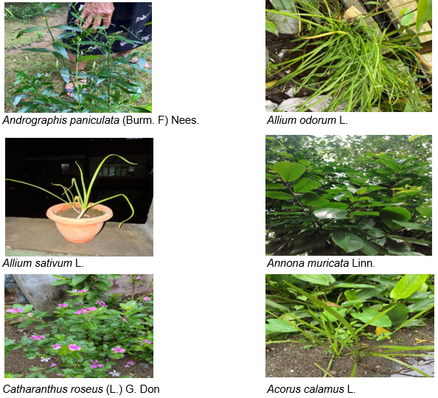

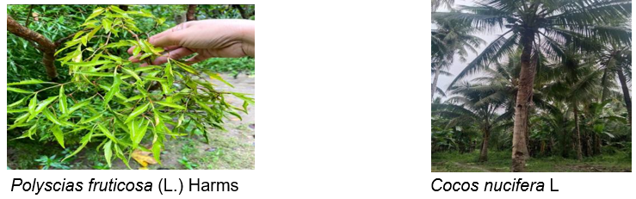

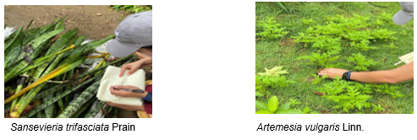

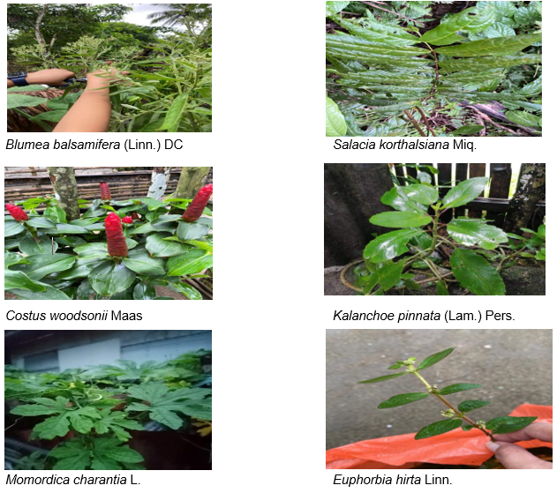

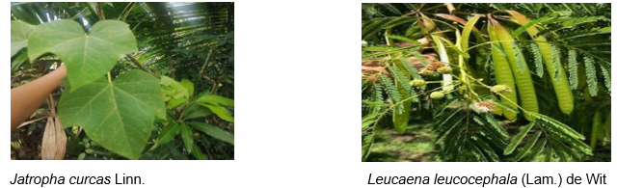

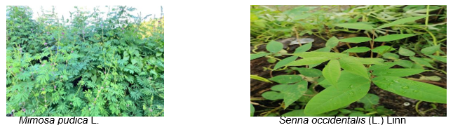

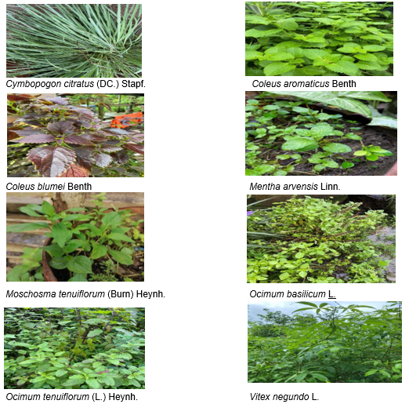

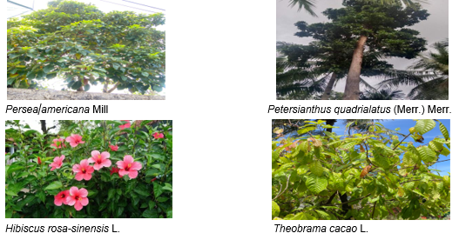

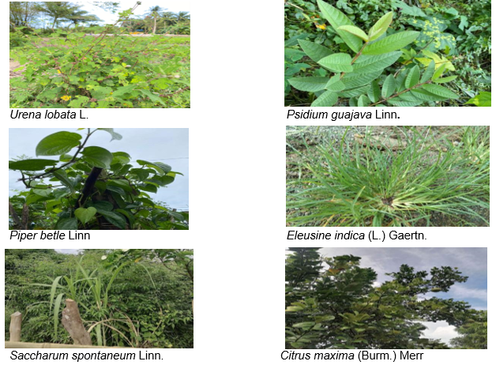

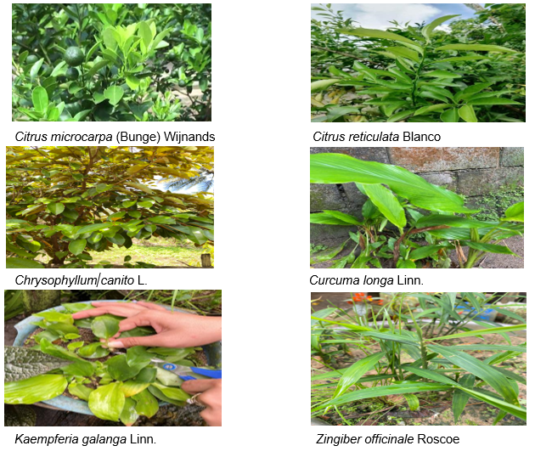

**FIG 2. PLANTS OF MEDICINAL SIGNIFICANCE**