**Original Research Article**

Strategic Statecraft vs. Liberal Peace: A Critical Analysis of Myanmar’s Diplomatic Achievements (2011–2015)

ABSTRACT

|  |
| --- |
| This article offers a critical re-examination of Myanmar’s diplomatic achievements from 2011 to 2015, a period often hailed as a transformative shift from international isolation to global reintegration. While previous analyses have celebrated these developments as a straightforward success story, this study argues that the government’s actions constituted a sophisticated form of strategic statecraft aimed at achieving specific diplomatic and economic goals rather than a genuine commitment to the “liberal peace” model. Drawing on a process-tracing methodology and a qualitative analysis of official communiqués, legislative texts, and international reports, we demonstrate how a series of calculated domestic political reforms catalysed a proactive diplomatic strategy. This strategy successfully secured the lifting of economic sanctions by the United States and the European Union, restored preferential trade status (GSP), and attracted a significant surge in foreign direct investment (FDI) during 2011-2015. However, this study also critically assesses the long-term fragility of these gains. The findings highlight the contingent nature of diplomatic success and provide a cautionary tale about the limits of conditionality in state-led transitions. The main objective of this article is to argue that the circumstances in Myanmar following the upcoming elections in late 2025 are likely to be similar to those experienced during the 2011-2015 period, to learn from the past experiences, and to implement a better future for the country. |

***Keywords****: Myanmar; diplomatic successes; 2011-2015; liberal peace; strategic statecraft; sanctions; foreign direct investment.*

1. INTRODUCTION

The period from 2011 to 2015 stands as a pivotal but contested chapter in Myanmar’s diplomatic history. Following a long era of the former government, international sanctions, and diplomatic isolation, the government of President Thein Sein embarked on a series of political and economic reforms that garnered widespread international praise and initiated a remarkable period of global reintegration. This era witnessed the lifting of long-standing Western sanctions, the restoration of preferential trade status, and an unprecedented influx of foreign direct investment (FDI) (Nyo, M.K. 2015).

While these achievements are well-documented, this article moves beyond a simple chronicle of events to provide a critical, data-driven of their underlying causes and long-term consequences. Previous scholarship views this period as a wonderful example of how constructive dialogue and supportive economic cooperation can inspire a nation’s leadership to peacefully and successfully pursue a more open political system. The findings paint an optimistic picture of a collaborative approach fostering a gentle but profound shift toward democratisation. We argue, however, that this interpretation oversimplifies a more complex process. This study posits that the diplomatic successes of 2011-2015 are better understood as a demonstration of strategic statecraft, a calculated effort by the new government to secure international legitimacy, economic resources, and a stronger geopolitical position, without fundamentally relinquishing control.

This research aims to answer the central question: How did Myanmar’s government strategically leverage limited political reforms to achieve significant diplomatic and economic reintegration between 2011 and 2015, and what does this process reveal about the limitations of the liberal peace framework in a state-led transition? By addressing this question, the article makes two key contributions to the existing literature. First, it offers a more nuanced theoretical interpretation of the period. Second, it contextualizes the “successes” of 2011-2015 with the subsequent collapse of the democratic transition, arguing that the foundations for reintegration were inherently fragile.

The remainder of the article is structured as follows: Section 2 provides a critical review of the relevant literature. Section 3 outlines the study’s methodological approach. Section 4 presents the core findings, analysing the lifting of sanctions, the restoration of GSP, and the surge in FDI. Section 5 discusses these findings within the framework of strategic statecraft and evaluates the legacy of this era, while the concluding section summarizes the article’s main arguments.

**2. LITERATURE REVIEW: THE CONTEXT OF MYANMAR’S REINTEGRATION**

The scholarly literature on Myanmar’s political transition can be broadly divided into three areas: studies on the effectiveness of sanctions, analyses of the democratization process, and research on the country’s evolving geopolitical role (Jones, L. 2014).

The efficacy of international sanctions against Myanmar has been a subject of intense debate. Proponents argued that sanctions were a crucial tool for isolating the former government and compelling reform. Their gradual lifting from 2012 onwards was seen as a direct validation of this policy. Conversely, critics maintained that sanctions were ineffective, hurting the civilian population while enabling the former government to consolidate its economic interests through illicit trade with neighbouring states (Stokke, K., Vakulchuk, R. and Øverland, I., 2018). This study seeks to move beyond this binary debate by examining the conditions and political manoeuvring that led to the timing and sequencing of their removal.

A second body of literature focuses on the “liberal peace” agenda, which posits that democratization, economic liberalization, and integration into global institutions are mutually reinforcing. In the Myanmar context, this framework was enthusiastically applied by international observers who viewed the government’s reforms as a genuine step toward a stable, democratic state. The release of political prisoners, dialogue with politicians, and the 2012 by-elections were all cited as evidence of a successful top-down transition. However, scholars have critiqued this perspective, arguing that the transition was a form of “managed liberalization” designed to maintain some influence (Bünte, M., & Dosch, J,2015). This article builds on this critical view by demonstrating how these reforms were not ends in themselves but instruments of a broader diplomatic strategy.

Finally, the geopolitical dimension of Myanmar’s reintegration has received significant attention. The opening to the West was widely interpreted as a strategy to counterbalance China’s overwhelming economic and political influence (Huang, C. C. 2015). The influx of FDI from Japan, Singapore, and Western countries was seen as a deliberate diversification of partnerships. This analysis will contextualize the FDI data within this geopolitical competition, arguing that the government adeptly played a game of “strategic hedging” to maximize its leverage on the world stage.

This article, therefore, synthesizes these strands of literature, using the framework of strategic statecraft to critically analyse Myanmar’s diplomatic achievements. By linking domestic reforms to international outcomes and positioning these events within a broader geopolitical context, this study offers a more robust and theoretically informed understanding of this transformative period.

**3. METHODOLOGY**

This study employs a qualitative, process-tracing methodology (Collier, D. 2011) to analyse the causal mechanisms linking the government’s reforms to its diplomatic achievements from 2011 to 2015. Process tracing is an ideal method for this research because it allows for a detailed examination of the sequence of events and the causal relationships between political decisions, diplomatic actions, and economic outcomes.

**3.1 Data Collection**

Primary data was gathered through a systematic documentary analysis. The sources included:

* Official government communiqués, press releases from the Ministry of Foreign Affairs, and legislative texts (e.g., the 2012 Foreign Investment Law).
* Reports from international bodies such as the IMF, World Bank, and the United Nations.
* Policy papers and reports from think tanks and organizations like the Japan External Trade Organization (JETRO).
* Scholarly articles from peer-reviewed journals.

**3.2 Analysis**

The analysis involved an examination of these documents to identify key policy shifts and diplomatic statements. We used a coding framework to categorize data points related to: (1) the conditions set by Western nations for lifting sanctions, (2) the timing and content of Myanmar’s political reforms, (3) the rhetoric of diplomatic engagement, and (4) economic indicators like FDI and trade figures. This process enabled the reconstruction of the causal pathways and the identification of a coherent strategic pattern behind the government’s actions.

**3.3 Limitations**

A key limitation of this approach is the reliance on publicly available documents, which may reflect the government’s official narrative and not its internal decision-making processes. To mitigate this, we triangulated information across multiple sources, including independent reports and scholarly critiques, to develop a more balanced and critical perspective. The longitudinal design, which tracks the same subject over a defined period, allows for a more robust analysis of the evolution from a policy of isolation to one of global engagement.

**4. RESULT: THE THREE PILLARS OF REINTEGRATION**

Our analysis reveals that the government’s diplomatic successes were not coincidental but were the result of a deliberate and carefully sequenced strategy built on three interconnected pillars.

**4.1 The Lifting of International Sanctions: A Game of Conditional Signalling**

The lifting of sanctions was the most significant diplomatic success, framed as a direct reward for political reform (Gelb, S., Calabrese, L., & Tang, X., 2017). The process was a carefully managed “game of conditional signalling” where the government made tactical concessions in response to Western demands. The key turning point was the suspension of the U.S. Investment Ban on November 16, 2012, following a series of symbolic gestures, including the release of over 400 political prisoners in 2012 and the participation of all political parties in the April 2012 by-elections. The European Union’s response was even more rapid, with sanctions (excluding the arms embargo) suspended on April 23, 2012, and officially lifted on April 22, 2013 (Nyo, M. K., 2015).

These decisions were not a response to a fundamental shift to democracy, but rather to a series of visible, high-impact reforms that allowed Western governments to justify a policy change. This provided the necessary political cover for a renewed sense of legitimacy for the government on the world stage, culminating in the landmark visit of U.S. President Barack Obama in November 2012 (Kipgen, N. 2013).

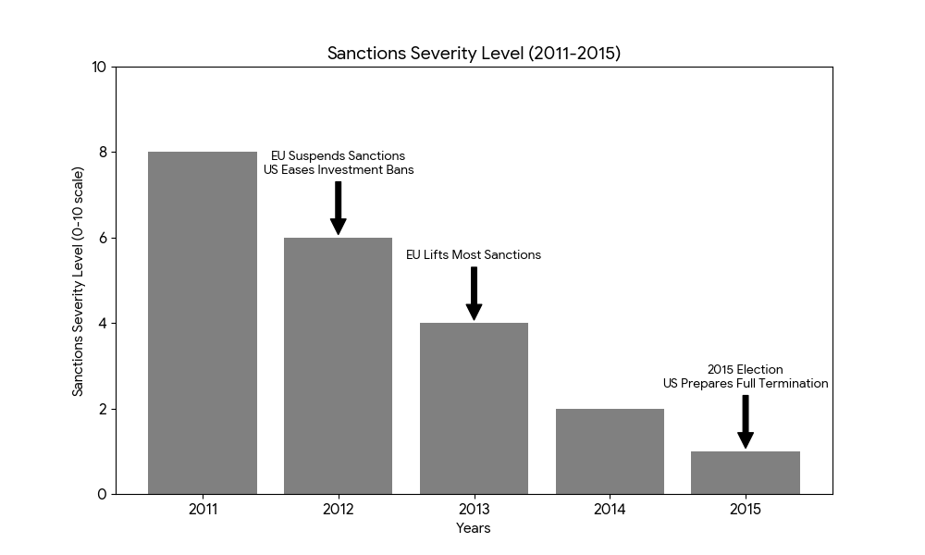

Fig 1: Sanctions Severity Level (2011-2015)

Table 1- **Key Events of Different Sanction Severity Levels**

| **Year** | **Sanctions Severity (0 = Full Sanctions → 10 = Fully Lifted)** | **Key Events** |
| --- | --- | --- |
| 2011 | 2/10 | **Start of reforms**: Political prisoners released (2010). Limited sanctions eased by Western nations. |
| 2012 | 6/10 | **Major suspensions**: - EU suspends all non-arm sanctions (Apr 2012). - US eases investment/export bans (Jul 2012). |
| 2013 | 8/10 | **EU lifts most sanctions** (Apr 2013) except arms embargo. Australia/Canada follow. US relaxes restrictions on financial services. |
| 2014 | 8/10 | **Stable progress**: Sanctions remain suspended. Focus shifts to trade/investment. No major new lifts. |
| 2015 | 9/10 | **The US further eased sanctions after the 2015 election (November** 2015). Broad economic bans terminated (2016). |

**4.2 Restoration of Preferential Trade Status: Securing New Markets**

The restoration of Myanmar’s Generalized System of Preferences (GSP) status was a major diplomatic achievement with tangible economic benefits. The EU officially reinstated Myanmar’s GSP status in July 2013 (Beke, L., & Hachez, N. 2015). This move was a direct consequence of the diplomatic momentum generated by the lifting of sanctions and had a profound impact on Myanmar’s burgeoning garment and textile sectors.

Following GSP restoration, exports to the EU grew dramatically. Garment exports to the EU, for instance, surged from almost nothing during the sanctions era to over €1.6 billion by 2016 (Aung, M. T. 2018). This rapid growth created hundreds of thousands of jobs and was a cornerstone of the country’s economic revitalization. This success was not merely an economic outcome but a deliberate diplomatic objective, as it diversified Myanmar’s export markets and reduced its reliance on neighbouring countries like China and Thailand(Gelb, S., Calabrese, L., & Tang, X., 2017).

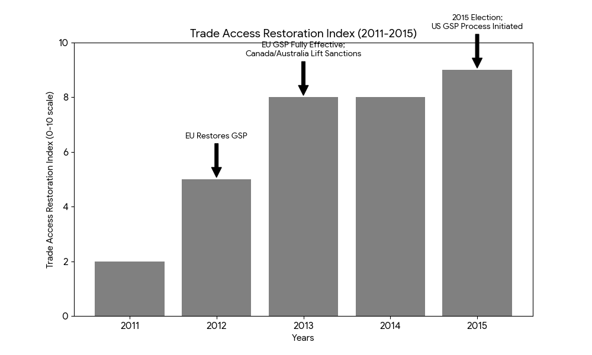

Fig 2: Trade Access Restoration Index (2011-2015)

*Critical Annotations:

- 2012: “EU Restores GSP”

- 2013: “EU GSP Fully Effective; Canada/Australia Lift Sanctions”

- 2015: “After 2015 Election; US GSP Process Initiated”

**4.3 Surge in Foreign Direct Investment (FDI): The Geopolitical Pivot**

The period from 2011 to 2015 was defined by an unprecedented surge in foreign direct investment (FDI), a direct outcome of successful diplomatic efforts and the legal and institutional reforms designed to attract foreign capital(Gelb, S., Calabrese, L., & Tang, X., 2017). The Myanmar Investment Law (MIL) and the Foreign Investment Law (FIL) were amended in 2012 to be more attractive to foreign capital. As shown in the table below, total approved FDI for the period 2011-2015 exceeded $25 billion, a staggering increase compared to the previous decade.

**Table 2: Approved FDI by Sector and Top Investor Countries (2011-2015)**

|  | Sector | Approved FDI (in billions USD) | Top Investor Countries |
| --- | --- | --- | --- |
|  | Power | ~$8.0 | China, Thailand |
|  | Oil and Gas | ~$7.5 | Singapore, Thailand, China |
|  | Manufacturing | ~$6.0 | China, Japan, Thailand |
|  | Real Estate | ~$3.5 | Singapore, Hong Kong |
|  | **Total** | **>$25.0** | - |

While Asian investors from China and Singapore continued to dominate, the diplomatic breakthroughs encouraged a new wave of investment from Japan and Western countries. Japan’s significant role in the Thilawa Special Economic Zone (SEZ), for example, symbolized a new era of international economic cooperation and was a clear signal of the government’s success in diversifying its economic partners and playing a game of strategic balancing (Walsh, J., 2015).

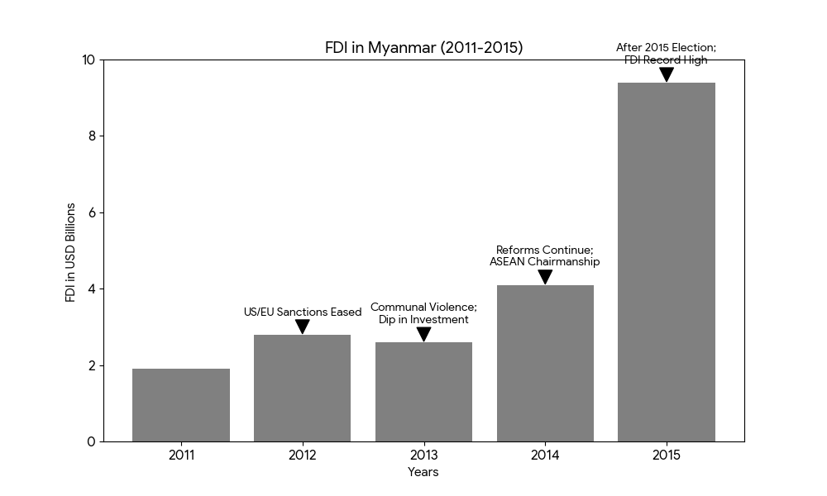

Fig 3: FDI in Myanmar (2011-2015)

**Table 3: FDI Growth Data:**

| **Year** | **FDI (USD Billion)** | **YoY Growth** | **Major Contributors** |
| --- | --- | --- | --- |
| 2011 | $1.9 | +533%* | Thailand, China |
| 2012 | $2.8 | +47% | EU, Singapore |
| 2013 | $2.6 | -7% | China, Hong Kong |
| 2014 | $4.1 | +58% | Japan, ASEAN |
| 2015 | $9.4 | +129% | Global Diversification |

*From $0.3B in 2010

**Resource:** According to reports from the government’s annual reports and the Directorate of Investment and Company Administration (DICA) covering the years 2011 to 2015, the tables and figures presented were developed based on writer ideas and various international articles by other authors.

**5. DISCUSSION: STRATEGIC STATECRAFT VS. LIBERAL PEACE**

The findings challenge the celebratory narrative of the liberal peace framework and instead support a more critical interpretation based on strategic statecraft. The government’s actions may not have indicated a wholesale embrace of democracy, but rather a calculated set of reforms designed to achieve specific diplomatic and economic ends. The release of political prisoners and the 2012 by-elections were powerful symbolic gestures that provided the necessary political cover for Western governments to justify lifting sanctions (Du Rocher, S. B. 2012). These reforms, however, were not followed by a genuine commitment to addressing the root causes of conflict, such as the military’s role in politics and the rights of ethnic minorities. The diplomatic gains were, therefore, secured through a performance of reform rather than its deep institutionalization.

Furthermore, the influx of FDI was not solely a function of economic liberalization but a direct result of a geopolitical pivot. By opening up to Western and Japanese investment, the government was able to reduce its strategic dependency on China, which had been the primary source of investment during the sanction’s era (Hong, Z. 2014). This strategy of hedging against a single dominant power demonstrated a sophisticated understanding of international relations.

Recognizing the delicate balance between progress and stability, the diplomatic achievements of 2011-2015 can be viewed as a crucial first step toward a more prosperous and equitable future for Myanmar. While the initial reforms may not have fully secured a stable political future, they undeniably laid the groundwork for future generations to build upon. The period demonstrated the country’s capacity for engagement with the international community, and the economic growth that followed, however fragile, proved the immense potential of the nation Thein, E. E., Inaba, K. (2023).

Instead of seeing the past as a harbinger of a return to old ways, it is possible to view it as a powerful lesson in the importance of good governance. The challenges of that era highlighted the necessity of building robust, inclusive, and transparent institutions. This understanding now provides a clear roadmap for future progress. By focusing on strengthening these foundational elements, Myanmar has the opportunity to create a more resilient and sustainable political and economic system.

The initial reforms brought about a newfound sense of hope and a more open society. These changes fostered a generation of leaders, entrepreneurs, and citizens who have experienced the benefits of greater openness and are committed to securing a future of peace and prosperity. The knowledge and experience gained from the 2011-2015 period serve as a powerful catalyst for positive change. By embracing the lessons of the past, Myanmar can forge a new path that not only builds on its diplomatic and economic successes but also ensures a truly stable and inclusive future for all its people.

**6. CONCLUSION**

The purpose of this paper is to contend that the political and social dynamics in Myanmar following the forthcoming elections in late 2025 are likely to exhibit significant parallels with the transformative period from 2011 to 2015. This earlier era, frequently celebrated as a triumphant shift from international isolation to global reintegration, is a straightforward success story of “liberal peace,” but as a sophisticated exercise in strategic statecraft. The government’s actions during this time, including a series of calculated domestic political reforms, were instrumental in achieving specific diplomatic and economic objectives.

Rather than serving as a harbinger of a return to past failures, the ultimate outcomes from this period offer a powerful and sobering lesson in the limits of conditionality in state-led transitions and the necessity of building robust, inclusive, and transparent institutions. The initial reforms brought about a newfound sense of hope and a more open society, fostering a generation of leaders and citizens who have experienced the benefits of greater openness and are committed to securing a future of peace and prosperity. By embracing the knowledge and experience gained from the 2011-2015 period, Myanmar has the opportunity to forge a new path that not only builds on its diplomatic and economic successes but also ensures a truly stable and inclusive future for all its people. The contingent nature of past diplomatic successes serves as a crucial roadmap for future progress.

Disclaimer (Artificial intelligence)

Author(s) hereby declare that generative AI technologies such as Large Language Models, etc. have been used during the writing or editing of manuscripts. This explanation will include the name, version, model, and source of the generative AI technology and as well as all input prompts provided to the generative AI technology

Details of the AI usage are given below:

1. Asked some questions relating to the academic writing form to be more complete.

2. Took some English grammar forms to compare the international standard articles.

3. Browsed some references when facing difficulties with the collected references.

**REFERENCES**

Aung, M. T. (2018). *A Study On The Export of Garment Industry In Myanmar (May Thu Aung, 2018)* (Doctoral dissertation, MERAL Portal), 14-37

Beke, L., & Hachez, N. (2015). The EU GSP: a preference for human rights and good governance? The case of Myanmar. In *Global Governance through Trade*, 185-213

Bünte, M., & Dosch, J. (2015). Myanmar: Political reforms and the recalibration of external relations. *Journal of Current Southeast Asian Affairs*, *34*(2), 3-19

Bünte, M., & Dosch, J. (2015). Myanmar: Political reforms and the recalibration of external relations. *Journal of Current Southeast Asian Affairs*, *34*(2), 3-19.

Collier, D. (2011). Understanding process tracing. *PS: political science & politics*, *44*(4), 823-830.

Directorate of Investment and Company Administration (DICA). (2017). *Cost of doing business in Myanmar: Survey report 2017*. [https://www.dica.gov.mm/wp-content/ uploads/ 2024/ 12/cost_of_doing_business_in_myanmar-survey_report_2017.pdf](https://www.dica.gov.mm/wp-content/%20uploads/%202024/%2012/cost_of_doing_business_in_myanmar-survey_report_2017.pdf)

Du Rocher, S. B. (2012). The European Union, Burma/Myanmar and ASEAN: A challenge to European norms and values or a new opportunity?. *Asia Europe Journal*, *10*(2), 165-180.

Gelb, S., Calabrese, L., & Tang, X, (2017). Foreign direct investment and economic transformation in Myanmar. *Supporting economic transformation*, 10-54.

Gelb, S., Calabrese, L., & Tang, X. (2017). Foreign direct investment and economic transformation in Myanmar. In L. Calabrese & X. Tang (Eds.), Supporting economic transformation, London, UK: Overseas Development Institute, 30-72

Grabo, L. (2016). The economic effects of EU sanctions imposed on Myanmar, 6-9

Hong, Z. (2014). Japan and China: Competing for good relations with Myanmar. *The Journal of East Asian Affairs*, *28*(2), 1.

Huang, C. C. (2015). Balance of relationship: the essence of Myanmar’s China policy. *The Pacific Review*, *28*(2), 189-210.

Jones, L. (2014). The political economy of Myanmar’s transition. *Journal of Contemporary Asia*, *44*(1), 144-170.

Kipgen, N. (2013). US–Burma Relations: Change of Politics under the Bush and Obama Administrations. *Strategic Analysis*, *37*(2), 203-216.

Naing, W. Y. P. (2020). The Dilemma of Sino-Myanmar Relations: The Case of Myitsone Hydropower Dam Project. Journal of International and Area Studies, 1(1), 379-389.

Nyo, M. K. (2015). *ASEAN Community 2015: Managing integration for better jobs and shared prosperity in Myanmar*. ILO, 9-37.

Passeri, A., & Marston, H. (2022). The Pendulum of Non-Alignment: Charting Myanmar’s Great Power Diplomacy (2011–2021). Journal of Current Southeast Asian Affairs, 41(2), 188-213.

Stokke, K., Vakulchuk, R. and Øverland, I., (2018). Myanmar: A political economy analysis. *Oslo: Norwegian Institute of International Affairs*, 52-63

Stokke, K., Vakulchuk, R., & Øverland, I. (2018). Myanmar: A political economy analysis. *Oslo: Norwegian Institute of International Affairs*, 8-44

Thein, E. E., Inaba, K. (2023) Sources of Myanmar’s economic growth during 2010–2015: input–output analysis. *Economic Structures* **12**, 15 (2023). https://doi.org/10.1186/s40008-023-00311-0

Walsh, J. (2015). Thilawa special economic zone and the single window. *International Journal of Services Technology and Management*, *21*(1-3), 27-39.