Review Article
A Review on the Valorization of Agricultural Biomass Wastes in Nigeria with Focus on Banana Pseudo-Stem, Empty Palm Bunch, and Rice Husk Applications

.
ABSTRACT

Biomass wastes (BW) have gained significant attention recently for their potential use in various industrial applications. This review reports the varieties of biomass wastes, ranging from agricultural to forest residues. The wastes are abundant and pose environmental and health risks despite their positive potentials. However, innovative approaches such as composting, anaerobic digestion, and thermochemical conversion have emerged to transform the wastes into valuable products such as organic fertilizers, biofuels, biochemicals, and feedstuff for animals. Globally, about 140 Gt of agricultural residues are generated each year, while about 517 million tons of this amount remains unexploited each year with over 60% being estimated to come from developing low-income countries like Nigeria. Nigeria is a major producer of agro-products such as bananas, oil palm, and rice in Africa, thereby generating great quantities of biomass wastes with specific reference to banana pseudo-stem, empty palm bunch, and rice hull/husk, respectively, and other wastes. These biomass wastes have been valorized in a number of ways including animal feed production, bioenergy generation, and soil enrichment. Their use as animal feed has been limited due to their poor nutritional balance, suggesting innovative approaches to improve their nutritional value. In conclusion, by promoting sustainable management practices and exploring innovative utilization approaches, biomass wastes, being abundant, can play a crucial role in mitigating environmental pollution, enhancing agricultural productivity, and fostering economic development.

Keywords: Biomass waste, Empty palm bunch, Banana pseudo-stem, Rice hull, Animal Feedstuff

1. INTRODUCTION

Biomass wastes (BW) have in recent times become the target of different scientific research all over the world, for their transformation into value added products for various industrial applications. Recent studies have particularly shown that various biomass wastes in the form of agricultural and forest residues could be processed into animal feedstuff and additives (Obasi, Obasi, Ezeokeke & Etuk, 2020; Okoli, 2020a; Ohanaka, 2022; Nwogu, 2022). The excessive cost of conventional feedstuffs, due to competition with human food and seasonal scarcity and shrinking pasture lands due to anthropogenic activities and the resultant conflicts between pastoralists and crop farmers have made livestock farmers and researchers to increasingly depend on alternative feedstuffs which are mostly biomass residues as potential sources of nutrients for livestock (Okoli et al., 2014; Ohanaka et al., 2017; Uchegbu et al., 2017). The term biomass has been defined as organic substances of non-fossil origin such as natural living organisms (flora and fauna), the resultant residues (e.g. animal excrements), dead (but not fossilized) phytomass, and organic matter, and substances generated through their transformation by means of technological applications and/or use of the materials or substances that result from the transformation (e.g. abattoir and organic household wastes). Biomass wastes therefore refer to organic materials of plant or animal origins that are no longer valued after the original product has been extracted. They commonly consist of forestry residues, agricultural wastes, animal wastes, industrial wastes, municipal solid wastes, food processing wastes etc. (Iwuaze et al., 2014; Hakeem et al., 2015; Jekayinfa et al., 2020).
Most crops are subjected to further processing that usually generates secondary and tertiary waste streams in addition to the primary biomass wastes generated in the field during harvest (Shah et al., 2018; Bhuvaneshvari et al., 2019). These wastes encompass various organic matter or carbon-containing compounds derived from living things such as plants and animals. Agricultural residues comprise remnants of crops such as stalks, husks, hulls, and stems left in the field after harvest, whereas forest residues consist of branches, treetops, bark, wood shavings and sawdust resulting from logging activities (Jekayinfo et al., 2020). Food wastes include discarded food, trimmings, and peels generated during food processing, distribution, and consumption, while animal manure refers to the waste produced by livestock farming, such as cow dung, poultry litter, and pig manure (Bonechi et al., 2017). Energy crops involve specifically cultivated plants like switchgrass, miscanthus, or fast-growing trees for biomass energy production (Unal and Alibas 2007), while aquatic biomass encompasses organic material sourced from aquatic environments, such as seaweed and algae (Bonechi et al., 2017). Energy crops involve specially cultivated plants like switch grass, miscanthus, or fast-growing trees for biomass energy production (Unal and Alibas, 2007), while aquatic biomass encompasses organic material sourced from aquatic environments such as seaweed and algae (Bonechi et al., 2017).
2. VOLUMES OF BIOMASS WASTES GENERATED IN NIGERIA

UNEP (2015) reported that about 140 Gt of agricultural residues are generated each year, while about 517 million tons of this remains unexploited each year. Jekayinfa et al. (2020) reported more recently that 2.8 Gt of cereal crops, 3.1Gt of 17 major kinds of cereals and legume and 3.8 Gt of 27 common food crop residues are produced globally. More than 60% of these agricultural residues have been estimated to come from the developing low-income countries like Nigeria (Duque-Aovede et al., 2020). UNEP (2015) have therefore projected the global production of agricultural residue to continue to increase with the global population, especially as intensification approaches are increasingly adopted for increased crop yield. Akorode et al. (2017) estimated that more than 94 million tons of agricultural biomass residues are produced in Nigeria and are distributed as shown in table.1, with cassava, yam, millet and plantain wastes being the major ones. Limited quantities of these agricultural residues applied to various traditional uses as animal feed, fertilizer, biofuel, building materials and artisanal crafts, while most of them are disposed inappropriately, resulting in environmental degradation, pollution, and nuisance (Subagyo and Chafide, 2020; Okoli, 2020a). Bos and Hamelink (2014) report that these agricultural wastes are usually discarded through incineration, landfills and wastes dump site and usually results in human health risk and dirty environments (Fapohunda and Oluwasegunota, 2019; Fapohunda, et al., 2021). Inappropriate disposal of crop wastes has been specifically reported by researchers to have negative influence on both human and animal health as well as environmental pollution, greenhouse gas (GHG) emission, and climate change (Bos and Hamelinck, 2014; Bharathiraja et al., 2017; Sadh et al., 2018). Excessive accumulation of agricultural wastes due to inappropriate disposal over large areas of land has particularly been reported to pollute the land and lead to eutrophication due to nitrogen and phosphorus accumulation and may result in phyto-toxicity (Yang et al., 2017). Such mineral accumulation may also contaminate surface and sub-terranean water sources, thereby compromising the quality of water meant for human and animal consumption (Liu et al., 2019).
Although these biomass wastes have been highly exploited in some part of the world for varied purposes, their utilization in Nigeria remains very low and almost negligible. They have however traditionally been converted to organic fertilizer through composting or anaerobic digestion, thereby enriching soil fertility and structure (Bhardwaj et al., 2014; Chew et al., 2019). Recently, they have been used as substrate for the production of mushrooms, livestock feeds, industrial chemicals and fiber production (Obasi, Obasi, Ezeokeke & Etuk, 2020; Uchegbu et al., 2017; Subagyo and Chafidz, 2018; Okoli, 2020a). They have also been converted into energy, through processes like combustion, anaerobic digestion, fermentation, pyrolysis, and gasification (Qiao et al., 2011; Gumisiriza et al., 2017). Biomass wastes can also serve as raw materials for other industrial processes, including the production of biofuels, biochemicals, bioplastics, and other bio-based materials.
In recent times, several innovative methods such as production of feed-grade ash, biochar and activated charcoal (Nwogu, 2022; Ohanaka, 2022), production of biogas, biofuel and briquettes (Edo, Ihejirika, Okeke, Okoli, Ukuli & Okoli, 2022) and processing into cost effective animal feedstuffs (Obasi, Obasi, Ezeokeke & Etuk, 2020; Uchegbu et al., 2017) have been tried in our station to enhance the value of locally available biomass wastes. Generally, the physicochemical characteristics of these biomass wastes make them potential feed raw materials, although more for ruminant livestock than monogastrics. The conversion of biomass wastes to value added products has therefore several environmental benefits, such as reducing greenhouse gas emissions, diverting waste from landfills, and promoting the use of renewable resources. It is however essential to implement sustainable management practices that prioritize responsible sourcing, efficient conversion technologies, and the consideration of the overall life cycle impacts associated with biomass utilization (Yu et al., 2022).
Table 1: Estimate of some crop residue production in Nigeria for 2014
Crop | Crop residue production (million metric tonnes)
Cassava | 29,000,000
Yam | 22,000,000
Millet | 11,000,000
Maize | 3,000,000
Rice | 1,800,000
Potato | 600,000
Cowpea | 4,050,000
Groundnut | 6,000,000
Oil palm | 400,000
Sugar cane | 300,000
Sweet potato | 2,000,000
Cocoyam | 1,500,000
Coffee | 400,000
Cashew | 300.000
Plantain | 9,450,000
Sorghum | 2,500,000
Source: Akorode et al. (2017)
2.1 Common Biomass Wastes in Nigeria
Nigeria, like many tropical countries, generates various types of biomass wastes from agricultural, forestry, industrial, and municipal activities (Olorunnisola, 2007). Jekayinfa et al. (2020) listed forest residues, crop stalks, leaves, roots, fruit peels, seeds/nut shells and animal wastes as the predominant biomass wastes/residues produced in the country. Akorode et al. (2017) reported that about 94.4 million tons of crop residues are produced in the country, with cassava, yam, millet, plantain and groundnut residues being the abundant. About 0.78 million tons of animal waste has also been estimated for the country, they also estimated that about 0.4 and 1.8 million tons of oil palm and rice wastes respectively are produced in the country.
Since Nigeria is a major producer of bananas, palm oil and rice, the quantity of wastes produced from these crops will be high, indicating the need for their conversion into beneficial products. The major biomass wastes derived from banana, oil palm and rice, which could be processed into animal feeds, using different technological approaches include the banana pseudo-stem; empty palm fruit bunch, and rice hulls respectively (Anyanwu et al., 2013; Iwuaze et al., 2014; Ishola et al., 2019; Jekayinfa et al., 2020).

2.1.1 Banana pseudo-stem (BPS)
The banana plant, also known as a banana tree (though it is technically a herbaceous plant), is a large perennial plant that belongs to the family Musacea and genus Musa and native to the Malasia, Indonesian region of Southeast Asia (Aziz et al., 2011; Ma, 2015). Bananas are widely produced in the tropical and sub-tropical countries of the world with Nigeria being the 2nd and 8th largest producer of banana and plantain respectively in Africa (FAOSTAT, 2018). The banana is a remarkable plant with a rich cultural, economic, and agricultural significance in the regions where it is cultivated. It provides not only nutritious fruits but also various materials and resources that are utilized in different ways. For example, after the harvest of the banana fruit bunch, the trunk or pseudo-stem and leaves are discarded as wastes. For each of banana fruit harvested about 4 tons of such wastes are produced, indicating four times more biomass than the fruits. The banana plant is characterized by its tall, sturdy stem, called a pseudo-stem, which is not actually made of wood like a tree trunk (Ma, 2015). The pseudo-stem consists of tightly overlapping leaf sheaths that provide support for the plant (Oladiji et al., 2010). The leaves are large, elongated, and arranged spirally at the top of the pseudo-stem. The plant produces clusters of fruits known as hands, which typically contains several individual banana fruits. After the flowering, the fruit develops facing down-wards in a process that can take several months (Kirchoff, 2017). There are numerous banana varieties, but the most widely cultivated and consumed is the Cavendish banana, partly because of its high productive capability, and tenacity, even in adverse climatic conditions (Okoli, 2020c; FAO, 2023). Banana plants are propagated through their rhizomes, which are underground stems. When a banana plant matures and bears fruit, it sends up a new shoot from the rhizome called a sucker which can be separated from the parent plant and replanted to grow a new banana plant (Mustaffa and Kumar, 2012; Madison, 2023). Bananas require warm temperatures, adequate rainfall, or irrigation, plenty of sunlight, and well-drained soil while they are sensitive to frost and cannot tolerate extreme cold, thus making the tropical environment ideal for their growth (Mustaffa and Kumar, 2012; Chand et al., 2021)
The pseudo-stem of a banana plant is not a true stem, but a collection of tightly packed leaf sheaths that form a strong and sturdy structure (Ma, 2015). Jayaprabha et al. (2011) reported that the number of pseudo-stem sheaths differ among varieties of the same type of banana species and further observed a minimum of 13 layers of sheath found in the pseudo-stem of all Nendran varieties. The banana plant grows vertically from the ground and can reach heights of up to 5 – 7.6 meters in some banana varieties (Nelson et al., 2006). The stem provides structural support to the banana plant and therefore helps the plant to withstand strong winds, while supporting the weight of the leaves, flowers, and fruit clusters (Ma, 2015). It also contains an inner tender core which is located in the middle of the stem and carries the immature inflorescence until eventually it emerges at the top (Subagyo and Chafidz, 2020). It is the most nutritious part of the stem and surrounded by the delicate emerging leaves (Lakshman et al., 2015). It also acts as a reservoir, for storing water and nutrients which can be used by the plant during periods of drought or unfavorable conditions (Ali, 2022). After harvesting the fruit, the pseudo-stem is usually cut down to make way for new suckers that will grow into mature plants and produce fruit in the future. The structure of the banana tree and pseudo-stem are shown in plate 1. Several studies have revealed the potential values of the various parts of banana such as the peels which could be converted to edible ash for cooking and as additive in livestock feed (Duruanyim, 2017; Hikal et al., 2022). The leaves are used as packaging material, for cooking, as feedstuff for livestock and for arts and crafts (Kamira et al., 2015; Thiet et al., 2022).
The pseudo-stem has been processed for its fiber which is being used in textile, paper, pulp ropes and arts and crafts production while they has been used to make confectionaries, liquid fertilizer and vermin-compost (Subagyo and Chafidz, 2020, Arafat et al., 2018; Matos et al., 2019; Parmar, Mor & Patel, 2019). The pseudo-stem is also traditionally fed to ruminants and pigs in many Asian countries and has recently received research attention as a potential cheap alternative feed raw material (Thiet et al., 2022; Wanga et al., 2016; Arjin et al., 2020).
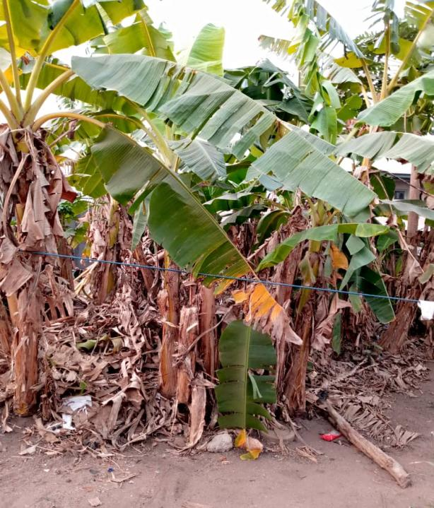  Banana trees | 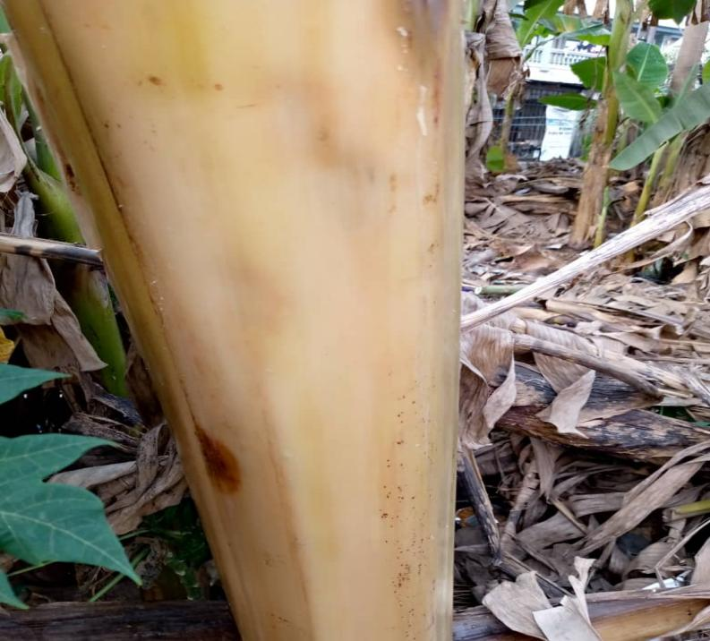  Banana pseudo-stem
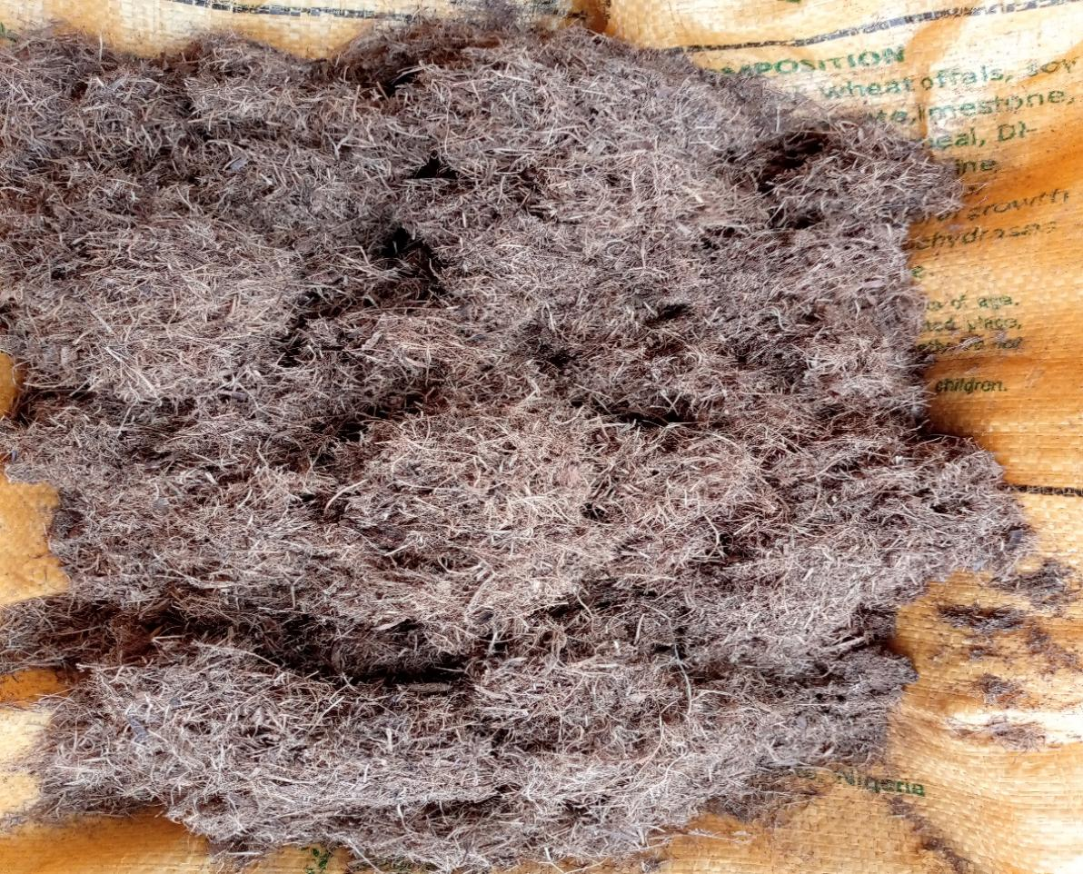
Milled banana pseudo-stem
Plate 1: The pictures of banana trees, banana pseudo-stem, and milled banana pseudo-stem (Picture series: Giwa, A. L., 2023, personal photograph)

2.1.2 Empty palm fruit bunch (EPFB)
Oil palm (Elaeis guineensis) is the most commercial perennial tree cultivated in the world as a source of oil. The oil palm tree being a tropical plant originated from West and Central Africa but has now spread extensively to diverse tropical locations worldwide, especially Asian countries such as Malaysia and Indonesia. The oil palm tree is known for its tall and slender trunk and grows up to 20 m in height. Their leaves are characterized by multiple leaflets arranged on both sides of the central leaf stem known as pinnate. These leaves can reach lengths of up to 5 meters and are arranged in a spiral pattern at the top of the trunk. In Africa, the oil palm is the source of a local fermented drink (palm wine) produced by tapping the male inflorescence or the trunk of the oil palm tree for its sap and fermenting the resulting sap to form palm wine (Mynepalli & Adeoluwa, 2009). Beneath the leaves of the oil palm tree are the palm bunches in which the oil palm fruits are produced.
Palm oil is the most widely used vegetable oil in the world, with 73.80 million tonnes being produced globally in 2021/2022, increasing from approximately 73.00 million tons in the 2020/2021 marketing year (Shahbandeh, 2023). Statista (2023) also report Nigeria is the 5th largest producer of palm oil in the world (1.40 million tons) and the largest producer in Africa. Palm oil production and processing are therefore major economic ventures in Nigeria, especially in the southern states where the palm trees grow in the wild and in plantations (Okoli, 2020f). The oil is highly versatile and widely used as edible oil for domestic cooking, food processing, cosmetics production, and a range of other industrial applications, such as biofuel production and manufacturing (Pande et al., 2012; Norhaizon et al., 2013). The palm nut extracted from the palm kernel also contains a lot of oil which is also extracted and used for cooking and several industrial applications (Bong et al., 2020). The oils account for only 10% of the oil palm’s biomass (Bauer and Kauffman, 2020), implying that about 90% of the oil palm biomass eventually becomes residues. These residues include the empty palm fruit bunch, palm kernel shells, trunk of the plant, press fibre, leaves, liquid effluents and others (Mynepalli and Adeoluwa, 2009). Specifically, about 70% of the fresh oil palm fruit bunch is turned into waste in the form of empty fruit bunch, fiber, shell and liguid fluent after palm oil extraction (Obuka, Onyechi and Okoli, 2018). Plate 2 shows the palm tree, its fruit bunch and the empty bunch after the extraction of the nuts.

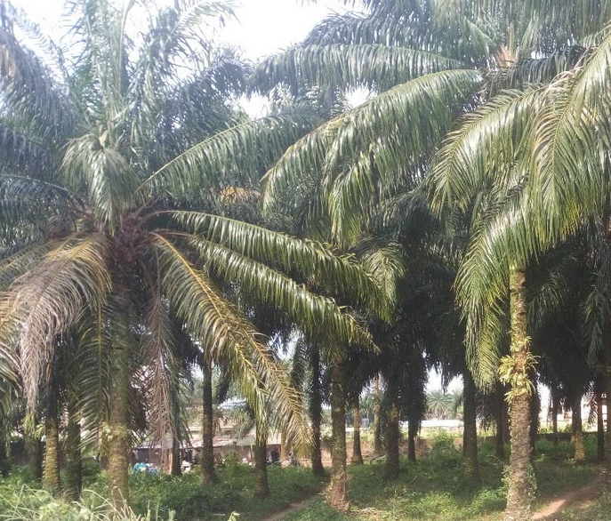  Palm plantation  (Source: Okoli 2020f) | 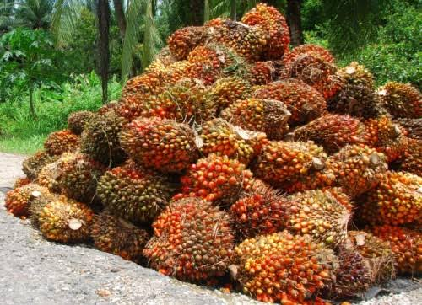  Heap of Palm fruit bunches  source: Google
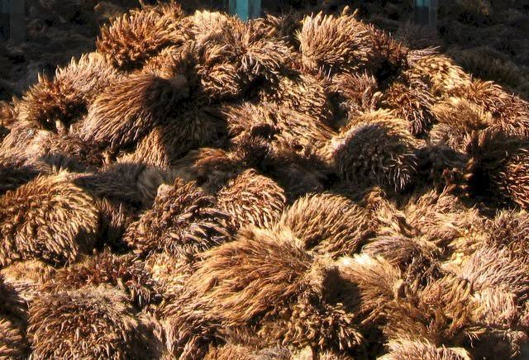  Heap of Empty palm bunches (EPB)  (Source: Giwa, A. L., 2023, personal photograph) | 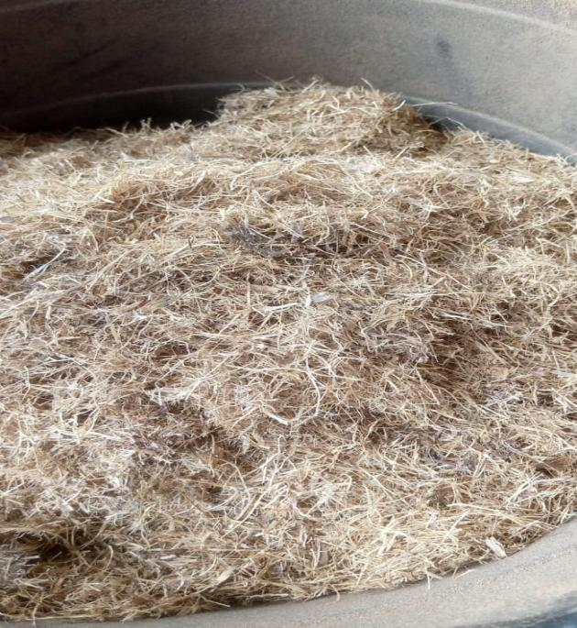  Milled empty palm bunch  (Source: Giwa, A. L., 2023, personal photograph)
Plate 2: Pictures of palm plantation, palm fruit bunches, empty palm bunches and milled empty palm bunch
The empty palm fruit bunch (EPFB) is the leftover or discarded portion of the oil palm fruit bunch after the palm nuts have been removed during the palm oil extraction process. EPFB is a major waste product produced in oil palm plantations, accounting for about 20 – 23% of the oil mill residue. Abdullah and Sulaiman (2013) specifically reported that the EPFB represents about 22 % of the fresh fruit bunch on wet basis and 14.6 % on dry weight basis. Noah (2022) reported that more than 22.4 million tons of EPFB are produced worldwide, thus posing disposal challenge. As a result, several approaches have been employed to reduce the volumes generated in local palm oil mills, through burning in open air or in a burner to generate energy. The ash produced from the burning of EPFB is rich in potassium and other minerals and have been utilized in soil enrichment, soap making and as edible bioash (Duruanyim, 2017; Afiana et al., 2021). Ujile and Okwakwam (2018) reported the use of the ash as absorbent to remove heavy metals in water while, Fapohunda et al. (2021) reported its use in attaining sustainability in structural concrete production and practice.
Empty palm fruit bunch has been combusted to produce feed-grade ash, biochar, and activated charcoal (Promraksa and Rakmak, 2020; Nwogu, 2022; Edo et al, 2022) and edible ash (Duruanyim, 2016). It has equally been used in the production of biogas, biofuel, and briquettes (Srisong et al., 2017; Suksong et al., 2020) to enhance the value of the material. Januari and Agustina (2022) reported that composting and anaerobic digestion are the alternative treatments that can be implemented by palm oil mills since both can reduce the EPFB waste and produce products that can be sold or reused. Mynepalli & Adeoluwa (2009) in their review also reported the valorization of EPFB in weeds and erosion control, the maintenance of soil moisture around young palm trees and also its use in the production of paper. Majesty and Herdiansyah (2019) reported the use of EPFB in the production of furfural, a bio-based chemical derived from the cellulose found in the empty palm fruit bunch. This bio-based substance serves as a foundational component for creating various valuable products such as the fuel additive methyltetrahydrofuran (MTHF), an eco-friendlier substitute for lead as an anti-knocking agent (Eseyin and steele, 2015). Zakaria et al. (2018) also reported the utilization of EPFB in the production of bio-phenolic resin, an alternative way to reduce the dependency of petroleum-based phenol. Okoli (2020f) revealed that the cellulose and hemicellulose derived from the empty palm fruit bunch can be hydrolyzed to sugars which could further be fermented to produce biofuels, organic acids, and enzymes among other products through thermo-chemical transformation.
Furthermore, EPFB has been reportedly used as a potential substrate for the production of feed-grade bio-proteins through solid-state fermentation, employing fungal organisms (Suksong et al., 2020). Such approach has also been used to improve the nutritional quality of EPFB for use as feedstuff for livestock (Nur-Nazratul et al., 2021). Studies by Tabi et al. (2008); Kavitha et al. (2013) and Lin et al. (2015) have also reported the efficient utilization of EPFB as substrate for the cultivation of mushrooms such as the oyster mushroom (Pleurotus ostreatus). Despite all these innovative uses of empty palm fruit bunch, the biomass material remains very much underutilized in many African countries where it constitutes environmental problems, ranging from fouling, attraction of pests, greenhouse gas emissions to soil acidification, and human health challenges.
2.1.3 Rice hulls/husks
Rice, scientifically known as Oryza sativa, is a type of nourishing starchy cereal grain that grows as a grass plant, belonging to the Poaceae family. The cultivated rice plant is an annual grass and grows to about 1.2 metres (4 feet) in height, has long and flattened leaves borne on hollow stems, broad fibrous root system and panicle, or inflorescence (flower cluster), made up of spikelets bearing flowers that produce the fruit, or grain. The major rice-producing countries in the world include China, India, Indonesia, and Bangladesh, while Nigeria is the largest producer in Africa and 14th in the world (FAOSTAT, 2018). The majority, or 95% of the rice harvest worldwide is consumed by humans (Bouman et al., 2007), particularly in Asia and Africa. Only three agricultural crops, namely rice, maize, and wheat, contribute almost 66% of the world's total energy intake from food (Jones & Ejeta, 2016). Of the overall 24.6 billion metric tons of rice produced in Africa in the 2020/2021 (Kamer, 2023), Nigeria accounted for 55%, while Egypt accounted for 30% of the total volume. Although rice majorly rice is majorly cultivated in the northern part of Nigeria, its production cuts across many zones in the country with Kano, Jigawa, Niger, Kwara, Kebbi, Ebonyi, Anambra, Ekiti Nasarawa, Ogun, Kaduna and cross river states being the major producers (Maduawuchi, 2020; Mba et al., 2021). These states are therefore the major locations where rice and its by-products could be found in abundance.
The production of rice generates many by-products starting at the field during harvest and during processing. At the field during harvest, the paddy rice is threshed out of the straw thereby leaving the straw as the waste, whereas during rice processing (milling), the by-products are majorly rice hulls and rice bran (James et al., 2017). Notably, the processing of paddy rice results in 68 - 72% production of the rice grain (endosperm) as the major product, while rice hull/husk (20%), rice bran (8-12%) and rice germ (2%) are the by-products (Esa et al., 2013; Samaddar et al., 2017). The annual worldwide production of rice hull is very substantial, approximating 100 million tons with 90% of this being produced in the developing countries (Glushankova et al., 2018). Plate 3 shows a paddy rice field, the rice straw generated after harvest and a mountain of rice hull at a rice processing location in Nigeria.

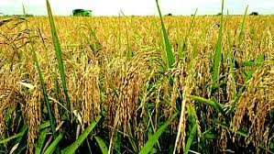  Rice field | 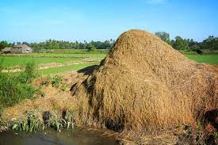  Heap of rice straw
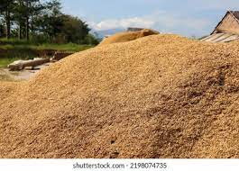
Heap of rice hull/husk
Plate 3: Rice field, a heap of rice straw in the field and heap of rice hull at a rice mill
(Pictures series: Google )
Rice hulls are the outer protective layer of the rice grains and are removed during the milling process. They are lightweight, voluminous, and often considered as waste by the rice farmers and most millers in Africa. Nigeria produces about one million tons of rice by-products annually (Muas et al., 2024), which pose disposal challenges and environmental concerns, necessitating innovative solutions for their management (Ejiofor et al., 2020). These husks are fibrous and have limited nutritive value for livestock, which restricts their use as animal feed. Consequently, rice hulls often accumulate at the rice-processing sites, leading to disposal challenges. Improper disposal methods, such as open burning or dumping in water bodies, not only contribute to environmental pollution but also pose health hazards due to the release of harmful gases and pollutants (Njoku et al., 2021). Despite the disposal challenges, rice hulls offer promising potential for various applications in agriculture, industry, and environmental management (Das et al., 2022).
For example, the ash produced from rice hulls has many applications in road construction (Patil et al., 2014) and cement production (Petal, 2019; Zaid et al., 2021; Liu et al., 2021). The hulls have been processed and mixed with other materials to create composites suitable for construction purposes. These composites can be used to make lightweight and eco-friendly building materials such as boards, panels, and insulators (Hasan et al., 2015). Through controlled pyrolysis, rice hulls can be converted into biochar (Herrera et al., 2022), a stable form of carbon that can improve soil quality, carbon sequestration, and nutrient retention in agricultural soils due to its absorptive properties (Singh et al., 2022). Rice hulls can also be used directly to enhance soil properties, such as water retention and aeration, when used as a soil amendment. They can be incorporated into soil to improve its structure and fertility, especially in regions with sandy soils (Singh et al., 2022). Darmawan et al. (2018) and Salisu et al. (2021) reported the use of rice hulls as source of biomass fuel to generate energy for heating, and electricity production, thus, contributing to rural electrification, and reducing the reliance on fossil fuels. This can be achieved by either gasification or direct combustion methods in order to efficiently utilize the rice hulls for energy production. Rice hulls can serve as bedding material for livestock, because as a good absorbent it can help in the management of odors and can therefore improve the overall hygiene of animal housing facilities. For example, carbonized rice husk has been employed by Shah et al. (2022) as an effective bedding material for broilers to reduce the burden of E. coli and ammonia production in the litter. Rice hulls have also been used as substrate for mushroom cultivation, providing a suitable medium for the growth of edible and medicinal mushrooms (Frimpong-Manso et al., 2011; Hanai et al., 2005; Okigbo et al., 2021).

3. CONCLUsion

This paper reveals the abundance of biomass wastes such as banana pseudo-stem, empty palm bunches, and rice hulls in Nigeria, which pose disposal challenges leading to environmental and human safety issues. These biomass wastes, however, have been valorized locally and in various industrial applications, particularly in animal feed production, bioenergy production, and the fertilizer production industry. Their abundance presents enormous opportunities for their transformation into high-value products, thereby mitigating environmental pollution and addressing challenges in livestock feed supplementation. However, despite their potential, biomass wastes are often underutilized, leading to environmental and health hazards.
I suggest that innovative technologies such as composting, anaerobic digestion, and thermochemical conversion of biomass wastes be intensively utilized to scale up their conversion into products that will contribute to sustainable agriculture, energy security, environmental and human health safety, economic opportunities, and resilience in the face of global resource constraints. The continued exploration and development of biomass waste utilization approaches hold promise for achieving a more sustainable and prosperous future.

Disclaimer (Artificial intelligence)
Option 1:
Author(s) hereby declare that NO generative AI technologies such as Large Language Models (ChatGPT, COPILOT, etc.) and text-to-image generators have been used during the writing or editing of this manuscript.
Option 2:
Author(s) hereby declare that generative AI technologies such as Large Language Models, etc. have been used during the writing or editing of manuscripts. This explanation will include the name, version, model, and source of the generative AI technology and as well as all input prompts provided to the generative AI technology
Details of the AI usage are given below:
1. We used meta Ai with Llama 4 to check the grammar and make correction in the abstract and conclusion
2. We also used ChatGPT based on the GPT-4o architecture to rearrange some reference in Apa 6th edition reference style

References

Abdullah, N. and Sulaiman, F. (2013). The oil palm wastes in Malaysia. InTech. Online Publication. http://dx.doi.org/10.5772/55302.
Akorode M.F., Ibrahim, O., Amuda, S.A., Otuoze, A.O. and Olufeagba, B. J. (2017). Current status and outlook of renewable energy development in nigeria. Nigerian Journal of Technology, 36(6), 196 - 212.
Ali, A. (2022). Banana Fiber: Environmentally Friendly Fabric: A way to Health and Wealth. International Journal for Research in Applied Science and Engineering Technology, https://doi.org/10.22214/ijraset.2022.45071.
Anyanwu, C. N., Ibeto, C. N., Eze, I. S. and Ezeoha, S. L. (2013). Present and prospective energy use potentials of selected agricultural wastes in Nigeria. Journal of Renewaable Sustainable Energy, 5, 03270. https://doi.org/10.1063/1.4808046.
Arafat, K. M. Y., Nayeem, J., Quadery, A. H., Quaiyyum, M. A. and Sarwar Jahan, M. (2018). Handmade paper from waste banana fibre. Bangladesh Journal of Scientific and Industrial Research, 53(2), 83 - 88.
Arfiana, Finalis, E. R., Noor, I., Murti, S. D. S., Suratno, H., Rosyadi, E., Saputra, H. and Noda, R. (2021). Oil palm empty fruit bunch ash as potassium source in the synthesis of NPK fertilizer. IOP Conference Series: Earth and Environmental Science, 729(2021) 012038.
Arjin, C., Souphannavong, C., Sartsook, A., Seel-Audom, M., Mekchay, S. and Sringarm, K. (2020). Efficiency of fresh and fermented banana stems in low protein diet on nutrient digestibility, productive performance and intestinal morphology of crossbred pig; (Thai native × Meishan) × Duroc. Veterinary Integrative sciences, 19(1), 51 – 64.
Aziz, M., Uemura, Y. and Sabil, K. (2011). Characterization of oil palm biomass as feed for torrefaction process. 2011 National Postgraduate Conference, Pp, 1 - 6. https://doi.org/10.1109/NATPC.2011.6136260.
Bauer, S. and Kauffman, L. (2020). The anatomy of an oil palm. Dialogue Earth. https://dialogue.earth/en/food/the-anatomy-of-an-oil-palm/.
Bharathiraja, S., Suriya, J., Krishnan, M., Manivasagan, P. and Kim, S. K. (2017). Chapter Six - Production of enzymes from agricultural wastes and their potential industrial applications. In: Kim, S. K. and Toldrá, F. (Eds.). Marine Enzymes Biotechnology: Production and Industrial Applications, Part III - Application of Marine Enzymes, Pp. 125 - 148. Academic Press. doi:10.1016/bs.afnr.2016.11.003.
Bhardwaja, D., Ansari, M. W., Sahoo, R. K., and Tuteja, N. (2014). Biofertilizers function as key player in sustainable agriculture by improving soil fertility, plant tolerance and crop productivity. Microbial Cell Factories, 13, 66. doi: 10.1186/1475-2859-13-66.
Bhuvaneshwari, S., Hettiarachchi, H. and Meegoda, J.N. (2019). Crop residue burning in India: Policy challenges and potential solutions. International Journal of Environmental Research and Public Health, 16, 832, doi:10.3390/ijerph16050832.
Bonechi, C., Consumi, M., Donati, A., Leone, G., Magnani, A., Tamasi, G., & Rossi, C. (2017). Biomass: An overview. In F. Dalena, A. Basile, & C. Rossi (Eds.), Bioenergy Systems for the Future: Prospects for Biofuels and Biohydrogen, 3 - 42. Elsevier Publishing.
Bong, A. M., Kor, N. M. and Ndifon, P. T. (2020). Cameroon green energy potentials: field survey of production, physico-chemical analysis of palm kernel oil for industrial applications. Green and Sustainable Chemistry, 10, 57 – 71.
Bos, A. and Hamelinck, C. (2014). Greenhouse gas impact of marginal fossil fuel use. Project number: BIENL14773 2014.
Bouman, B. A. M., Humphreys, E., Tuong, T. P., and Barker, R. (2007). Rice and water. In: D. L. Sparks (Ed.). Advances in Agronomy, (92), 187 - 237. Academic Press. doi: 10.1016/S0065-2113(04)92004-4.
Chand, K., Choudhary, K. and Nain, Y. (2021). Banana cultivation. Just Agriculture, 1(11), https://justagriculture.in/files/newsletter/2021/july/31.%20BANANA%20CULTIVATION.pdf
Chew, K. W., Chia, S. R., Yen, H. W., Nomanbhay, S., Ho, Y. C., and Show, P. L. (2019). Transformation of biomass waste into sustainable organic fertilizers. Sustainability, 11(8), 2266. https://doi.org/10.3390/su11082266.
Darmawan, A., Fitrianto, A., Aziz, M. and Tokimatsu, K. (2018). Integrated system of rice production and electricity generation. Applied Energy, https://doi.org/10.1016/J.APENERGY.2018.03.098.
Das, S. K., Adediran, A., Kaze, C. R., Mustakim, S. M. and Leklou, N. (2022). Production characteristics, and utilization of rice husk ash in alkaline activated materials: An overview of fresh and hardened state properties. Construction and Building Materials, 345, #128341.
Duque Acevedo, M., Belmonte Ureña, LJ., Yakovleva, N. and Camacho Ferre, F. (2020). Analysis of the circular economic production models and their approach in agriculture and agricultural waste biomass management. International Journal of Environmental Research and Public Health, 17, 9549. https:// doi. org/ 10. 3390/ ijerph1724 9549.
Duruanyim, V.O. (2017). Effects of plantain peels and oil palm bunch ash treatment on the physicochemical and organoleptic quality of beef. MSc. Thesis, Federal University of Technology Owerri, Nigeria.
Dzulkefli, N., & Zainol, N. (2018). Data on modeling mycelium growth in Pleurotus sp. cultivation by using agricultural wastes via two level factorial analysis. Data in Brief, 20, 1710 - 1720. https://doi.org/10.1016/j.dib.2018.09.008.
Edo, F. A., Ihejirika, C. E., Okeke, P. N., Okoli, C. G., Ukuli, M. A., & Okoli, I. C. (2022). The impact of co-pyrolysis of pig dung with palm kernel shell and empty plastic water sachets on its biochar and activated charcoal yield. Nigerian Journal of Animal Production, 49, 2160 – 2164.
Ejiofor, O. S., Okoro, P. A., Ogbuefi, U. C., Nnabuike, C. V. and Okeudu, K. E. (2020). Off-grid electricity generation in Nigeria based on rice husk gasification technology. Cleaner Engineering and Technology, 100009, 2020.
Esa, N. M., Ling, T. B., and Peng, L. S. (2013). By-products of rice processing: An overview of health benefits and applications. Journal of Rice Research, 1(1), 107. doi: 10.4172/jrr.1000107.
Eseyin, A. E. and Steele, P. H. (2015). An overview of the applications of fulfural and its derivatives. International journal of Advanced Chemistry, 3(2), 42.
FAO (2023). Banana facts and figures. Food and agricultural organization, Rome.
FAOSTAT (2018). Statistics database, Food and Agriculture Organization of the United Nations, Rome. http://www.fao.org/faostat/en/₦data/QC. Accessed 25th July 2020
Fapohunda C., A. Kilani, B., Adigo, L., Ajayi, B., Famodimu, O., Oladipupo, A. J. (2021). A Review of Some Agricultural Wastes in Nigeria for Sustainability in the Production of Structural Concrete. Nigerian Journal of Technological Development, 18 (2), 76 - 89.
Frimpong-Manso, J., Mary, O., Dzomeku, M. and Apertorgbor, M. M. (2011). Influence of rice husk on biological efficiency and nutrient content of Pleurotus ostreatus (Jacq. ex. Fr.) Kummer. International Food Research Journal, 18, 249 - 254.
Glushankova, I., Ketov, A., Krashnovskikh, M., Rudakova, L. and Vaisman, I. (2018). Rice hulls as a renewable complex material resource. Resources, 7(2), 31. Dio:10.3390/resources7020031.
Gumisiriza, R., Hawumba, J. F., Okure, M., and et al. (2017). Biomass waste-to-energy valorisation technologies: a review case for banana processing in Uganda. Biotechnology for Biofuels, 10, 11. doi: 10.1186/s13068-016-0689-5.
Hakeem, K. R., Jawaid, M. and Alothman, O. Y. (2015). Agricultural biomass based potential materials. Cham: Springer. https://books.google.com.ng/books?hl=enandlr=andid=Btn5BwAAQBAJandoi=fndandpg=PR10andots=_4aHqDvwH-andsig=YFbYJY_ 1te4NBNdfzVRFJ87ADMandredir_esc=y#v=onepageandqandf=false.
Hanai, H., Ishida, S., Saito, C., Maita, T., Kusano, M., Tamogami, S. and Noma, M. (2005). Stimulation of mycelia growth in several mushroom species by rice husks. Bioscience, Biotechnology, and Biochemistry, 69(1), 123 – 127.
Hasan, M., Arjmandi, R., Hassan, A., Majeed, K. and Zakaria, Z. (2015). Rice husk filled polymer composites. International Journal of Polymer Science, 501471. doi: 10.1155/2015/501471
Herrera, K., Morales, L. F., Tarazona, N. A., Aguado, R. and Saldarriaga, J. F. (2022). Use of biochar from rice husk pyrolysis: Part A: Recovery as an adsorbent in the removal of emerging compounds. ACS Omega, 7(9), 7625 - 7637.
Hikal, W. M., Said-Al Ahl, H. A. H., Bratovcic, A., Tkachenko, K. G., Sharifi-Rad, J., Kacaniova, M., Elhourri, M. and Atanassova, M. (2022). Banana peel: A waste treasure for human beings. Evidence Based Complementary and Alternative Medicine, 2022: 7616452. doi:10.1155/2022/7616452.
Ishola, K., Olawuyi, O. A., Bello, A. A., Etim, R. K., Yohanna, P. and Sani, J. E. (2019). Review of agricultural waste utilization as improvement additives for residual tropical soils. Arid Zone Journal of Engineering, Technology and Environment, 15(3), 733 – 749.
Iwuaze, U. P., Okewole, T. O. and Madu, I. K. (2014). Review of the utilization of waste biomaterial resources of selected food crops: Rice, cassava, cocoa, sorghum and oil palm. IMT Mines-Albi, Albi, France. 19 pages.
Iwuaze, U. P., Okewole, T. O. and Madu, I. K. (2014). Review of the utilization of waste biomaterial resources of selected food crops: Rice, cassava, cocoa, sorghum and oil palm. IMT Mines-Albi, Albi, France. 19 pages.
James, A., Mamai, E. A. and Bako, T. (2017). Rice waste conversion for economic empowerment in Taraba State, Nigeria: A review. International Journal of Trend in Research and Development, 4(5), 515.
Januari, A. D., and Agustina, H. (2022). Palm oil empty fruit bunches and the implementation of zero waste and renewable energy technologies. IOP Conference Series: Earth and Environmental Science, 1034(1), 012004. doi:10.1088/1755-1315/1034/1/012004
Jayaprabha, J. S.; Brahmakumar, M. and Manilal, V. B. (2011). Banana pseudostem characterization and its fiber property evaluation on physical and bioextraction. Journal of Natural Fibers, 8(3), 149 – 160.
Jekayinfa, S. O., Orisaleye, J. I. and Pecenka, R. (2020). An assessment of potential resources for biomass energy in Nigeria. Resources, 2020, 9, 92; doi:10.3390/resources9080092.
Jones, A. and Ejeta, G. (2016). A new global agenda for nutrition and health: the importance of agriculture and food systems. Bulletin of the World Health Organization, 94, 228 - 229.
Kamer, R. (2023). Production volume of rice in Africa 2017 – 2022. Statista Inc. New York, USA. https://www.statista.com/statistics/1294234/production-volume-of-rice-in-africa/.
Kamira, M., Sivirihauma, C., Ntamwira, J., Ocimati, W., Katungu, M. G., Bigabwa, J. B., and Blomme, G. (2015). Household uses of the banana plant in eastern Democratic Republic of Congo. Journal of Applied Biosciences, 95, 8915 - 8929.
Kavitha, B., Rajannan, G. and Jothimani, P. (2013). Utilization of empty fruit bunch of oil palm as alternate substrate for the cultivation of mushroom. International Journal of Science, Environment and Technology, 2 (5), 839 – 846.
Kirchoff, B. K. (2017). Inflorescence and flower development in Musa velutina H. Wendl. and Drude (Musaceae), with a consideration of developmental variability, restricted phyllotactic direction, and hand initiation. International Journal of Plant Science, 178(4), 259 – 272.
Lakshman, R., Ambrose, D. C. P. and Chelvame, D. (2015). Studies on the quality of banana centre core flour prepared by different drying methods. Current Agriculture Research, 3(1). doi : http://dx.doi.org/10.12944/CARJ.3.1.07.
Liu, X. Y., Bai, Z. K., Shi, H. D., Zhou, W. and Liu, X. C. (2019). Heavy metal pollution of soils from coal mines in China. Natural Hazards, 99, 1163 – 1177.
Liu, Y., Bheel, N., Awoyera, P., Shar, I. A., Sohu, S., Abbasi, S. A. and Krishna P., A. (2021). Mechanical properties of concrete incorporating rice husk ash and wheat straw ash as ternary cementitious material. Advances in Civil Engineering, 2977428. doi: 10.1155/2021/2977428.
Ma, J. (2015). Banana Pseudo-stem: properties nutritional composition and use as food. M. Sc Thesis/Dissertation, University of New South Wales, Sydney. DOI: https://doi.org/10.26190/unsworks/18672.
Madison, M. (2023). How to propagate banana trees. Home for the Harvest, https://www.homefortheharvest.com/how-to-propagate-banana-trees/. Accessed on 20th July, 2023.
Maduawuchi, O. (2020). Top 10 rice producing states in Nigeria currently. https://nigeriaguide.com.ng/top-10-rice-producing-states-in-nigeria-currently/.
Majesty, K. I., and Herdiansyah, H. (2019). The Empty palm oil fruit bunch as the potential source of biomass in furfural production in Indonesia: Preliminary process design and environmental perspective. Journal of Physics: Conference Series, 1363(1), 012096. doi:10.1088/1742-6596/1363/1/012096.
Matos, E. Silva, N. E., Lima, H. J. D., Valentim, J. K., Tossué, F. J. M., Bittencourt, T. M. and Velarde, J. M. D. (2019). Banana leaf in the diet of laying hens in cage free system. Acta Scientiarum. Animal Sciences, 41, e46908, 2019.
Mba, C. L., Madu, A. I., Ajaero, C. K. and Obetta, A. E. (2021). Patterns of rice production and yield in Southeastern Nigeria. African Journal of food, Agriculture, Nutrition and Development, 21(7), 18330 – 18348.
Musa, M. H., Agomuo, J. K., Dandago, M. A., Atanda, K. S., Nahemiah, D., & Terpase, A. (2024). Paddy rice (Oryza sativum) production and processing in Nigeria: A review. Dutse Journal of Pure and Applied Sciences, 10(1b), 282 – 292. https://doi.org/10.4314/dujopas.v10i1b.28.
Mustaffa, M. M. and Kumar, V. (2012). Banana production and productivity enhancement through spatial, water and nutrient management. Journal of Horticultural Science, 7(1), 1 - 28.
Mynepalli, S. and Adeoluwa, O. (2009). Palm oil industry residues. In: Biotechnology for agro-industrial residues utilisation: utilisation of agro-residues, Springer, Dordrecht, Pp, 341 - 355. ISBN: 978-1-4020-9941-0. doi: 10.1007/978-1-4020-9942-7_18.
Nelson, S. C., Ploetz, R. C. and Kepler, A. K. (2006). Musa species (banana and plantain). Species Profiles for Pacific Island Agroforestry, 15.
Njoku, I. J., Nwaukafor, P. and Okeke, N. K. (2021). Assessment of the contamination of rice husk ash of Izzi CP, Ikwo CP and Izzi R8 rice species of Southeastern Nigeria. Environmental Challenge, 5, 100232.
Noah, S. A. (2022). Oil palm empty fruit bunches (OPEFB) – Alternative fibre source for papermaking. IntechOpen. doi: 10.5772/intechopen.98256.
Norhaizan, M. E., Hosseini, S., Gangadaran, S., Lee, S. T., Kapourchali, F. R. and Moghadasian, M. H. (2013). Palm oil: Features and applications. Lipid Technology, 25(2), 39 – 42.
Nur-Nazratul F. M. Y., Rakib, M. R. M., Zailan, M. Z. and Yaakub, H. (2021). Enhancing in vitro ruminal digestibility of oil palm empty fruit bunch by biological pre-treatment with Ganoderma lucidum fungal culture. PLoS ONE, 16(9), e0258065. https://doi.org/10.1371/journal.pone.0258065.
Nwogu, C. M., Nwogu, R. K., & Okoli, C. I. (2022). Feed grade ash from empty palm bunch and its effects on layer performance. ASRIC Journal on Agricultural Sciences, 1, 17 – 25. Available online at http://www.asric.org
Obasi, I. U., Obasi, E. N., Ezeokeke, C. T., & Etuk, E. B. (2020). Physico-chemical composition of feed grade cassava peel meal fermented with different levels of baker’s yeast. Nigerian Journal of Animal Production, 45(3), 144 –. Https://doi.org/10.51791/njap.v45i3.450
Obuka, N. S. P., Onyechi, P. C., & Okoli, N. C. (2018,). Palm oil biomass waste: A renewable energy resource for power generation. Saudi Journal of Engineering and Technology, 3(12), 680–691. https://doi.org/10.21276/sjeat.2018.3.12.2.
Ohanaka, A. U. C. (2022). Morpho-Physiological responses and performance of chicken fed activated charcoal-aged palm sap (acaps) supplemented diets. (Unpublished Doctoral Thesis). Federal University of Technology, Owerri, Nigeria . https://repository.futo.edu.ng/handle/20.500.14562/1772.
Ohanaka, U. C., Duruanyim, V. O., Etuk, I. F., Uchegbu, M. C. and Okoli, I. C. (2017). Physico-chemical composition of palm kernel shell ash (PKSA) as a potential mineral supplement in livestock nutrition. Proceedings of 42nd Annual Conference of Nigerian Society for Animal Production, 26 – 30th March 2017, Landmark University, Omu-Aran, Pp, 785 – 789.
Okigbo, R. N., Muonyelu, N. E. and Egwu, A. E. (2021). Effect of using rice husk for cultivation of Pleurotus tuber-regium (Fr.) Singer. Journal of Basic and Applied Research International, 27(5), 1 - 10.
Okoli, I. C, Enyinnia, N.C., Elijah, A.G. and Okoli C.G. (2014). Cattle feeding management of pastoralists and conflict resolution strategies in tropical humid rain forest zone of Southeastern Nigeria. Journal of international science publication: Agriculture and food, 2: 16 – 17.
Okoli, I. C. (2020a). Agricultural residues: Abandoned wealth being recovered by tropical research. https://researchtropica.com/agricultural-residues-abandoned-wealth-being-recovered-by-tropical-research/. Accessed on 2nd April, 2023.
Okoli, I.C. (2020c). Oil palm tree wastes 1: Oil Processing and waste production. https://researchtropica.com/oil-palm-tree-wastes-1-oil-processing-and-waste-production/. Accessed on 19th November, 2023.
Oladiji, A. T., Idoko, A. S., Abodunrin, T. P. and Yakubu, M. T. (2010). Studies on the physicochemical properties and fatty acid composition of the oil from ripe plantain peel (Musa paradisiaca). African Scientist, 11(1), 73 - 78.
Olorunnisola, A. (2007). Production of Fuel Briquettes from Waste Paper and Coconut Husk Admixtures. Agricultural Engineering International: Commission Internationale du Génie Rural Journal, 9.
Pande, G., Akoh, C. C. and Lai, O.-M. (2012). 19 – Food uses of oil palm and its components. Palm oil; production, processing, characterization and uses. AOCS. Press, Pp, 561 – 586.
Parmar, H. C., Mor, V. B., & Patel, S. R. (2019). Vermicomposting of Banana Pseudostem and Maize Fodder (Waste) Using Eudrilus eugeniae. Current Journal of Applied Science and Technology, 36(1), 1–9. https://doi.org/10.9734/cjast/2019/v36i130215 .
Patil, A. H., Shirsat, A. R., Phadke, R. A., Mohire, A. A., Junawane, G. H., Hake, N. N. and Lunkad, H. (2014). Use of rice husk in road construction. Civil and Environmental Research, 6(3), 1. Retrieved from http://www.iiste.org.
Petal, H. (2019). Rice husk ash in concrete: Uses, pros and cons and its effect on properties of concrete. https://gharpedia.com/blog/rice-husk-ash-in-concrete-pros-cons/. Accessed on 30th August, 2023.
Promraksa, A. and Rakmak, N. (2020). Biochar production from palm oil mill residues and application of the biochar to adsorb carbon dioxide. Heliyon, 6(5), e04019. https://doi.org/10.1016/j.heliyon.2020.e04019
Qiao, W., Yan, X., Ye, J., Sun, Y., Wang, W., and Zhang, Z. (2011). Evaluation of biogas production from different biomass wastes with/without hydrothermal pretreatment. Renewable Energy, 36 (12), 3313 - 3318. doi: 10.1016/j.renene.2011.05.002.
Sadh, K. P., Duhan, S. and Duhain, S. J. (2018). Agro-industrial wastes and their utilization using solid state fermentation: A review: Bioresources and bioprocssing, 5(1).
Salisu, J., Gao, N. and Quan, C. (2021). Techno-economic assessment of co-gasification of rice husk and plastic waste as off-grid power source for small scale rice milling in Nigeria-An aspen plus model. Journal of Analytical and Applied Pyrolysis, 105157. https://doi.org/10.1016/J.JAAP.2021.105157.
Samaddar, A., Mohibbe A. M., Singaravadivel, K., Venkatachalapathy, N., Swain, B. B. and Mishra, P. (2017). Chapter 11 - Postharvest management and value addition of rice and its by-products. In: S. Mohanty, P.G. Chengappa, J.K. Ladha, S. Baruah, E. Kannan, A.V. Manjunatha (Eds.). The future rice strategy for India, Academic Press, Pp, 301 - 334.
Shah, M.S., Khan, M.N.S. and Kumar, V. (2018). Biomass residue characterization for their potential application as biofuels. Journal of Thermal Analysis and Calorimetry, https://doi.org/10.1007/s10973-018-7560-9(01
Shah, N., Yadav, R. K., Gautam, A., Shah S. and Gupta, M. (2022). Carbonized rice husk as an effective bedding material for broiler to reduce burden of E. coli through minimization of ammonia production from litter. Veterinary Sciences Research and Reviews, 8(1), 65 - 70. DOI | https://dx.doi.org/10.17582/journal.vsrr/2022.8.1.65.70.
Shahbandeh, M. (2023). Palm oil: Global production volume 2012/13-2022/23. Statista Inc, New York, USA.
Singh, K, D., Nagabovanalli, P., Sundara Rajoo, K., Fauziah Ishak, C., Abdu, A., Rosli, Z., Melissa Muharam, F. and Zulperi, D. (2022). An overview on the preparation of rice husk biochar, factors affecting its properties, and its agriculture application. Journal of the Saudi Society of Agricultural Sciences, 21(3), 149 - 159.
Srisang, S., Wongpitithawat, P., The-Eye, K., Wongkeaw, K. and Sinthoo, C. (2017). Production of biomass briquette from residual bleaching earth and empty palm bunch. Energy Procedia, 138, 1079 - 1084.
Statista (2023). Palm oil industry world-wide: statistics and facts. Statista Inc., New York, USA. https://www.statista.com/tropics/6079/global.palm-oil-industry/#tropicoverview.
Subagyo, A. and Chafidz, A. (2020). Banana pseudo-stem fiber: Preparation, characteristics, and applications. IntechOpen. DOI: http://dx.doi.org/10.5772/intechopen.82204.
Suksong, W., Tukanghan, W., Promnuan, K., Kongjan, P., Reungsang, A., Insam, H. and O-Thong, S. (2020). Biogas production from palm oil mill effluent and empty fruit bunches by coupled liquid and solid-state anaerobic digestion. Bioresource Technology, 296, 122304. https://doi.org/10.1016/j.biortech.2019.122304
Tabi, A. N. M., Zakil, F. A., Fauzai, W. N. F. M., Ali, N., and Hassan, O. (2008). The usage of empty fruit bunch (EFB) and palm pressed fibre (PPF) as substrates for the cultivation of Pleurotus ostreatus. Jurnal Teknologi, 49(F), 189 – 196.
Thiet, G., Binh, P. V., Nhan, N. T. H. and Ngu, N. T. (2022). Using banana leaf and pseudo-stem (Musa spp.) silage substituted rice bran in the diet of growing wild crossbred boar. Livestock Research for Rural Development, 34(7). http://www.lrrd.org/lrrd34/7/3458nthi.html.
Uchegbu, M. C., Okata, U.E., Omede, A.A. and Okoli, I.C. (2017). Indentification and utilization of some unconventional feedstuffs for poultry production. Proceedings of a NIPOFERD Workshop on “Knowledge Transfer Towards Cost-Effective Feeds Production from Processed Cassava Products to Improve the Productivity of Small-Scale Farmers in Nigeria” June 27 – July 1, 2016, Asaba, Nigeria. Pp: 22 – 64.
Ujile, A. and Okwakwam, C. (2018). Adsorption process of iron, cadmium, copper, lead from aqueous solution using palm bunch adsorbent. Chemical and Process Engineering Research, 11(2), 11 - 21.
Unal, H. and Alibas, K. (2007). Agricultural residues as biomass energy. Energy Sources, Part B. Economics, Planning, and Policy, 2(2), 123 - 140. doi: 10.1080/15567240600629401.
UNEP (2015). Converting waste agricultural biomass into a resource. United nations environment programme division of technology, industry and economics. International Environmental Technology Centre, Osaka/Shiga, Japan.
Wanga, C. F., Muhammada, A. U. R., Liua, Z. Y., Huangb, B. Z. and Cao, B. H. (2016). Effects of ensiling time on banana pseudo-stem silage chemical composition, fermentation and in sacco rumen degradation. The Journal of Animal and Plant Sciences, 26(2), 339 - 346.
Yang, Y., Ma, T., Ding, F., Ma, H., Duan, X., Gao, T. and Yao, J. (2017). Interactive zinc, iron, and copper-induced phytotoxicity in wheat roots. Environmental Science and Pollution Research International, 24(1), 395 – 404.
Yu, Z., Ma, H., Liu, X., Wang, M. and Wang, I. (2022). Review in life cycle assessment of biomass conversion through pyrolysis – issues and recommendations. Green Chemical Engineering, 3(4), 304 – 312.
Zaid, O., Ahmad, J., Siddique, M. S. and Aslam, F. (2021). Effect of incorporation of rice husk ash instead of cement on the performance of steel fibers reinforced concrete. Frontiers in Materials, 8, 665625. doi: 10.3389/fmats.2021.665625.
Zakaria, Z., Zakaria, S., Roslan, R., Chia, C. H., Jaafar, S. N. S. and Amran, U. A. (2018). Bio-phenolic resin from oil palm empty fruit bunches. In: The 2017 UKM FST postgraduate colloquium, 1940, 020018. American Institute of Physics Conference Series, doi:10.1063/1.5027933.

