Minireview Article

**Behçet's disease: a mini-review**

.

ABSTRACT

|  |
| --- |
| A chronic, recurrent, and remitting vasculitis with an unclear cause is Behçet's disease (BD). Because it can affect veins and arteries of all diameters, it can impact nearly every organ system and cause serious organ-threatening disease and mortality. Known historically as the "Silk Road" disease, it is a condition that occurs worldwide. Although genome-wide investigations reveal connections between human leukocyte antigens and non-human leukocyte antigens, the neuropathological processes underlying disease development in BD are still poorly understood. The autoimmune and auto-inflammatory nature of BD is suggested by the possibility that both hereditary and environmental factors contribute to the aetiopathogenetic pathways that cause the disease to develop. There is little evidence to support treatment, although new information is being discovered, and available therapies encompass a wide range of clinical presentations, from symptomatic care to biological and non-biological immunosuppressive medications. |

*Keywords: epidemiology, Behçet’s disease, symptoms,**cytokines, IL-17, interferon-alpha.*

1. INTRODUCTION

**1- Introduction:**

BD or Behçet's disease is a unique, chronic, relapsing, inflammatory condition that is mainly considered to be a variable vessel vasculitis. Mucocutaneous manifestation is the commonest symptom, which usually includes recurrent oral aphthous ulcers, genital ulcers and a variety of cutaneous lesions that frequently include erythema nodosum and pseudofolliculitis. Nevertheless, the manifestations of BD can be much beyond these typical features, and clinical presentation can involve almost any body system(1). The primary issues of complication appear when the disease impairs the eyes (leads to the uveitis and even blindness), the central nervous system (results in meningoencephalitis or stroke-like manifestations), the gastrointestinal tract (discloses itself in the severe colitis or ulcers), and the vascular system with both arterial and venous involvement blowing out into thrombosis or aneurysms. Less frequently observed, but with high morbidity and even mortality in certain cases, cardiopulmonary and genitourinary involvements are established(2).

It is also one of the primary difficulties with the treatment of BD, its diagnostic complexity. The disease does not have a specific laboratory test or biomarker, and its diagnosis is largely based on clinical grounds: the additional requirements suggested by the International Study Group (ISG) and International Criteria for Behçet's Disease (ICBD). The symptoms can be varied in the onset and duration, and thus these symptoms lead to a great delay in diagnosis(3,4). This slowness is further enhanced by the fact that many mimicking diseases like systemic lupus erythematosus, inflammatory bowel disease and multiple sclerosis have to be eliminated. Moreover, insufficient awareness of the health providers in the low-prevalence areas leads to underdiagnosis or misdiagnosis. It further complicates the clinical determination and decision on treatment that is made because of the inability to predict the course of the disease, which is characterised by both exacerbation and remission. Therefore, awareness, better diagnostics, and sensitive biomarkers development are still one of the significant unmet needs in the management of BD(5,6).

**2- Epidemiology:**

The predisposition of Behçet's disease is characterised by a startling geographical distribution, which is well correlated with the former Silk Road area. This route runs along East Asia, the Middle East and the Mediterranean. Its prevalence is highest in Turkey, where it can amount to 420 cases per 100,000 people. Iran and Japan are other endemic nations whose prevalence is between 70 and 360 per 100,000. In comparison, Northern and Western Europe, North America and sub-Saharan Africa much more rarely have BD, with prevalence a common 0.1 to 1 per 100,000 individuals. To be specific, in the United Kingdom, the frequency is estimated to be up to 0.64 cases per 100,000 population(7,8).

The pathology of Behçet is frequently manifested in the II-IV decades of life, and there are more and more cases of children and late onset. It seems that the distribution of sex differs in different countries: it is slightly biased by females in Western countries, and in high-prevalence regions encompassing Turkey and other Middle Eastern countries, young adult males seem to be more often and more profoundly affected, as shown in Figure 1. Extensive sickness has been seen in many more male patients in cases where vascular, ocular, and neurological involvement are present(9).

In spite of the fact that BD is termed a sporadic disease, a clustering of family members within selected populations has been observed, indicating a genetic susceptibility. It is most strongly linked with HLA-B51, found in around 60% of the endemic sufferers. Besides, GWAS has also revealed further susceptibility loci like the ERAP1 (endoplasmic reticulum aminopeptidase 1), previously implicating antigen-processing pathways in the pathogenesis of the disease. Nonetheless, the genetic predisposition cannot be discussed as the only factor. The environmental factors, such as microbial infections (e.g., Streptococcus sanguinis, herpes simplex virus), gut microbiota changes and imbalance of innate and adaptive immune systems, are the other factors shown to be triggers in genetically susceptible individuals(10,11).

Immunopathology of BD is noted by high concentrations of pro-inflammatory cytokines, including TNF-alpha, IL-6, IL-17, and IFN-gamma, enhanced neutrophil activities, and oxidative stress. These results, in combination with the responsiveness of the disease to immunosuppressive and biologic agents, indicate that BD occupies a place between autoinflammatory and autoimmune mechanisms. It still has to be studied further to understand how it should be classified and inform advances in its therapeutic barrier on a better understanding of its immunopathogenic pathways(11,12).

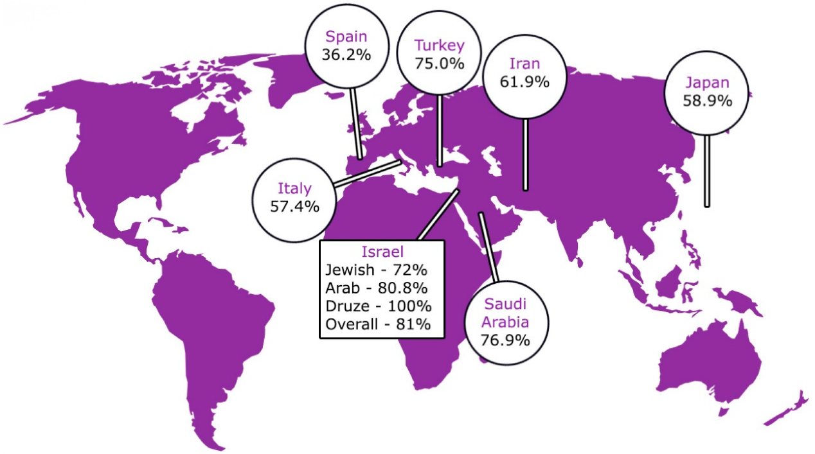

**Figure 1: Epidemiology of Behçet's disease (8)**

**3- Clinical manifestations:**

Due to its tendency to impact all arteries and veins, BD may have an impact on every organ system. Oral and vaginal ulcers are the disease's hallmarks, occurring in up to 97% and 60–90% of patients, respectively (13). Small (less than 10 mm), major (greater than 10 mm), and herpetiform (pinhead to 1–3 mm) oral ulcers are all possible in BD, and they may leave scars. They are similar to normal recurrent benign aphthous stomatitis. Most importantly, these ulcers are painful and might cause difficulty eating and swallowing. Genital ulcers can occur in any part of the genitourinary tract and can leave scars (14). They can take weeks to develop and are frequently found in the vulva in female patients and the scrotum in male patients (15). The other exclusions for oral ulcers include infections, cyclical neutropenia, medications, IBD, vitamin B12 deficiency, rheumatic diseases such as SLE, and autoinflammatory diseases such as PFAPA. Bullous dermatosis, Sweet’s syndrome, and imitators should also be excluded. Further, one needs to exclude other possible causes of genital ulcers, too. Trauma and neoplasm medication responses, sexual infections, and non-sexual genital ulcers may also be reactive to infection (16).

The BD manifestation characterised by oral and vaginal ulcers, not accompanied by other symptoms of BD, is referred to as complex aphthosis. The association between oral and genital ulcers and other complications includes recurrent neutropenia, adverse drug reactions, and MAGIC (mouth and genital ulcers with inflamed cartilage) syndrome (17). Papulonodular lesions, erythema nodosum-like lesions, pseudofolliculitis-like acneiform rashes, pyoderma gangrenosum, and in rare instances, erythema multiforme-like rashes are the acute manifestations of the cutaneous ailment (18). A papulopustular lesion forms at the site of needle injury during the biopsy within 24 to 48 hours, a symptom of Sweet's syndrome and pyoderma gangrenosa. In BD, cutaneous lesions may often be associated with arthritis (19). Gastrointestinal BD may mimic IBD, and they may have ulcers in the mouth, oesophagus, the ileocaecal, and the ascending colon. The most frequent symptoms are fever, diarrhoea, haemorrhage, and abdominal pain. They also believe that there are some risks, for instance, fistula and intestinal perforation can sometimes occur. Candidiasis is suspected in orofacial granulomatosis, granulomata in intestinal biopsy, and paper-cut genital sores. To map

the disease, endoscopic and radiographic investigations will be required (20). Neuro-Behçet's disease (NBD), which has a mortality rate of up to 10% (21), and parenchymal and non-parenchymal diseases are also possible in patients with severe instances. Parenchymal disease, which affects the cerebrum, brainstem, cerebellum, and spinal cord (figure 2), can result in focal and multifocal cerebral lesions, intra-axial cranial neuropathy, ophthalmoplegia, pyramidal disease, and other brainstem syndromes, depending on the extent of neuraxial involvement (22).

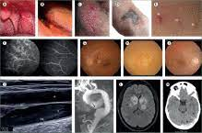

**Figure 2: Clinical manifestations of Behçet's disease (19)**

Parenchymal disease is a pathology of the brain tissue itself, while non-parenchymal disease includes: Brain venous sinus thrombosis, intracranial hypertension, and Recurrent Meningitis. However, migraine is the most frequent neurologic sign, and this also applies to non-BD migraine. Some of the radiological tests include magnetic resonance imaging (MRI), Computed axial tomography (CAT) scan or computed tomography (CT), and magnetic resonance imaging (MRI). (23).

EEG, MRV, CTV, CSF studies, and MRA may be indicated in certain conditions (24). Therefore, magnetic resonance spectroscopy combined with magnetic resonance diffusion imaging might help approach imaging in NBD, yet more study is needed. Vascular BD is different from other forms of BD because it affects venous circulation as well as arterial circulation. (25).

Constitutes one of the main causes of morbidity and mortality in vascular networks, ranging from small to large. Venous disease is more prevalent than arterial disease; this information was obtained from a survey. Aneurysms, ulceration, thrombosis, and stenosis comprise inflammatory arterial diseases, while venous disease mainly comprises venous thrombosis and thrombophlebitis (26). The thrombus cannot embolize, which is normally firmly adherent to the walls of the vessel. Doppler ultrasound investigations will require the correct imaging of the vascular CTV, MRI, MRA, and MRV (27). Like other inflammatory disorders, BD is severely accompanied by fatigue; however, effective disease management does not always result in fatigue (28).

**4- Approach to the diagnosis:**

The lack of a specific laboratory or a biomarker and the heterogeneous and, in many cases, nonspecific nature of the manifestations make the diagnosis of Behçet's disease (BD) a clinical challenge, particularly in cases where the disease overlaps with a large variety of other systemic disorders. Thus, a thorough and systematic diagnosis method may be necessary that consists of a detailed anamnesis, a thorough physical examination, and elimination of other possible causes with the assistance of the targeted investigations(29).

The history should be very detailed, describing the development, frequency, length, and course of symptoms in all organ systems. Physicians need to ask directly regarding recurrent oral and genital ulcers, eye complaints (including redness, pain, blurred vision), skin conditions, arthralgias, abdominal pain, diarrhoea, gastrointestinal bleeding, temporal headache, focal deficits, and personality changes in addition to vascular phenomena, including thrombosis and aneurysm. Due to episodic and long asymptomatic intervals, it is important to determine the sequence of events in terms of BD symptoms. Also, a thorough family history can reveal information, especially in endemic areas where the occurrence of family groups is common(30).

Differential diagnosis should be carefully made by avoiding overlooking any other disease that might have similar conditions to BD, because an inaccurate diagnosis might result in unsatisfactory or delayed intervention. Some of the most critical differential diagnoses include the inflammatory bowel disease (IBD), especially Crohn's disease, which can be characterised by the same type of gastrointestinal ulcerations, extraintestinal manifestations, and perianal disease. Celiac disease must also be kept in mind, especially in combination with gastrointestinal and non-intestinal manifestations, i.e. oral ulcers or dermatitis herpetiformis(31).

There are some diseases that may have mucocutaneous ulcers, such as BD. These are sexually transmitted diseases (STDs) which include herpes simplex virus (HSV), syphilis, gonorrhea, chlamydia and HIV. The others are infectious agents like cytomegalovirus, Epstein-Barr virus and hepatitis viruses. These possibilities can possibly be ruled out by a thorough sexual history and an inclusive choice of serologic testing or PCR-based tests(32).

Mucosal ulcerations caused by drugs may also be confused with BD, and the history of the patient should be checked in detail. There are several agents that have been reported to be involved in the formation of ulcers, and they include methotrexate, nicorandil, nonsteroidal anti-inflammatory drugs (NSAIDs), and some chemotherapeutic agents. Similarly, cyclic neutropenia or nutritional deficiencies (especially vitamin B12, folate and iron) can provoke common aphthous stomatitis and should be excluded by means of full blood count and micronutrient testing (33).

Unrelated autoimmune and autoinflammatory diseases are to be taken into consideration. As an example, systemic lupus erythematosus (SLE) can have mucocutaneous ulcers, arthritis, serositis, and neurologic manifestations. These conditions can be distinguished with the help of the tests of antinuclear antibody (ANA), anti-dsDNA, the level of complement, and other autoimmune panel tests. Another differential that has overlapping skin findings is Sweet syndrome (acute febrile neutrophilic dermatosis), which is more often associated with fever and neutrophilia; however, unlike BD, it usually is not characterised by recurrent oral and genital ulcers(34).

Imaging-based studies can be useful in the diagnosis of suspected vascular or neurologic cases. Deep vein thrombosis, aneurysms, or arterial stenoses can be seen in the Doppler ultrasonography or in the CT angiography. The brain and the spinal cord can be imaged by MRI, where parenchymal lesions or vascular inflammation can be identified when a patient has neuro-Behçet's disease. Slit- lamp examination and fluorescein angiography should be done in case of uveitis or retinal vasculitis(35).

BD diagnosis is a final diagnosis that is clinical and founded on the identified criteria. The International Study Group (ISG) criteria were first used in 1990 as a reference criterion, but they do not have a high degree of sensitivity, especially for early or atypical cases. More recent International Criteria for Behçet Disease (ICBD) (updated in 2014) are more sensitive and place weighted scores upon a variety of manifestations, such as oral and genital ulcers, ocular issues, skin lesions, vascular, and neurological implications, as well as a positive pathergy test. The ICBD system considers a score of 4 or more as diagnostic(36).

However, in spite of such criteria, diagnostic uncertainty can still exist, especially in early or incomplete disease. That is, expert clinical judgment is critical in such instances. A multidisciplinary examination might be necessitated by the input of rheumatologists, dermatologists, ophthalmologists, neurologists and infectious disease specialists. In other cases, the limitation can be a period of observation with longitudinal follow-up to give the entire clinical picture to come out(37).

An index of suspicion is also high when diagnosing BD in young adults living in endemic areas, who present signs and symptoms of recurrent orogenital ulcers and systemic conditions. The strategy should be thorough and start with the exclusion of mimicking conditions and end with the use of clinical criteria strengthened with laboratory and imaging results. Finally, the diagnosis has to be made based on pattern recognition, clinical acumen, and a wise way of ruling out other possible causes(38).

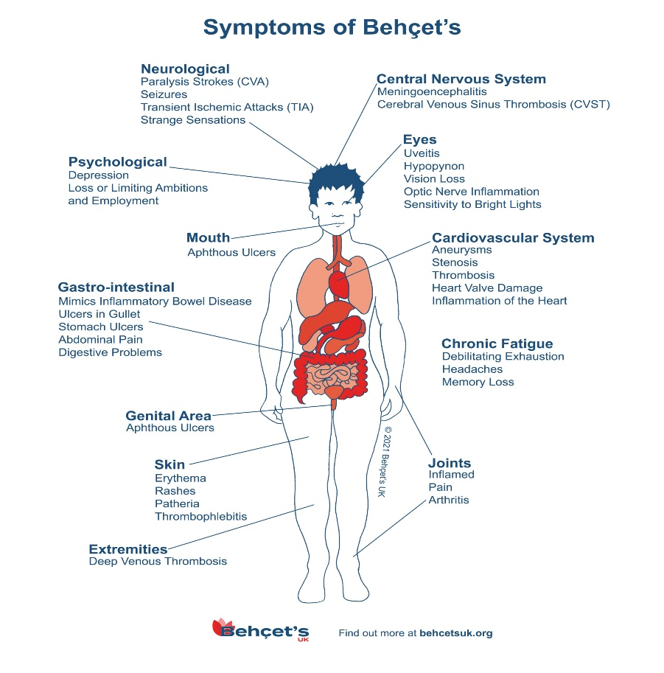

**Figure 3: Symptom of Behçet's disease (37)**

**5-** **The Role of Vitamin D in** **Behçet's disease:**

1. **Immunological Effect:** Low vitamin D and deficiency lower the activity of the innate and adaptive immune systems through their active metabolite, 1,25(OH)2D3. It inhibits Th17 and enhances the activity of regulatory T-cells (Treg). Inverse correlations between serum (OH) D level and disease activity in BD were demonstrated by studies(39).
2. **Supplementing Schedule:** Adult patients with BD and low levels of vitamin D (<20 ng/mL) are suggested to take cholecalciferol (1000-5000 IU/day). Others suggest larger doses with medical supervision, especially when calcium metabolism needs to be monitored and when adjunctive vitamin K2 supplementation is desired(40).
3. **Future Research:** More randomised controlled trials are needed to confirm the therapeutic effect of vitamin D, and to compare the effectiveness as well as safety of newer biologic medications over the long term. Cytokine profiling and genetic markers can be used to tailor treatment plans that could be better suited to handle BD(41).

**6- Standard and Biologic Treatments:**

1. **Corticosteroids and Immunosuppressants:** The first line is prednisone, azathioprine, cyclosporine, and colchicine, which are used to treat mucocutaneous and ocular manifestations. There is a systemic side effect that limits long-term use. (42)
2. **antiTNF Agents:** Infliximab and adalimumab have been effective in ocular, neurological and intestinal BD. The agents are very fast acting and are suggested in cases of severe/refractory cases. (43).
3. **Interferon-alpha:** Interferon alpha 2a and 2b have produced encouraging results in mucocutaneous and ocular manifestations. Its immunomodulatory and antiviral properties are able to achieve immune homeostasis(44).
4. **IL Inhibitors and Targeted Therapies:** The IL-6 receptor inhibitor tocilizumab, IL-17A inhibitor secukinumab and inhibitor of IL-12/23 ustekinumab have achieved mixed success in subsets of BD patients. JAK inhibitors, tofacitinib and baricitinib, have shown efficacy in early-phase trials in vascular and refractory BD(45).
5. **Apremilast:** A PDE4 inhibitor that is approved to treat oral ulcers BD. It affects inflammatory cytokine (e.g., TNF-α, IL-23) and allows for a steroid-sparing action(46).

**3. Materials and methods**

A systematic and structured literature review was carried out to buy prednisone online in this mini-review, where current publications on Behçet disease (BD), particularly focused on epidemiology, clinical manifestations, immunopathology, diagnostic criteria, and the treatment plans, have been reviewed. In cases where it had to follow the preferred reporting items for systematic reviews and meta-analyses (PRISMA), the review process did so.

**3.1 Literature Search Strategy**

A thorough search in the texts was conducted using the following databases: PubMed, Scopus, Web of Science, and Google Scholar. The search encompassed the articles that have been published in the English language between January 2025 and June 2025. Such important words used were:

Behçet disease,: vasculitis, oral ulcers, genital ulcers, uveitis, IL-17, cytokines, HLA B51, diagnosis of Behçets disease and biologic treatment in Behçets syndrome.

**3.2 Inclusion and Exclusion Criteria**

1. Inclusion criteria:
2. Peer-reviewed articles
3. Articles dealing with the pathogenesis, symptoms or treatment of BD discussed in detail and presented as clinical studies as well as reviews and case reports
4. Articles that contain revised immunological/ clinical/ therapeutic knowledge
5. Exclusion criteria:
6. Non-English papers
7. Abstracts that are short on information
8. Studies or papers on animals or not related to BD

**3.3 Data Extraction and Synthesis**

Information relevant to the chosen studies was gathered and was structured into large thematic areas:

1. Immunological and pathogenesis background
2. Clinical manifestation and systemic manifestation
3. Diagnosis and problems
4. The evolving therapies which includes biologic and immunomodulators

The authors reviewed the data extracted independently of each other and narratively synthesized it with tables and figures as needed. They focused on the recent results that could bring a fresh approach to the process of a disease or clinical practice.

**3.4 Quality Audit**

The quality of the methods of the involved studies was evaluated according to standardized instruments:

The AMSTAR 2 checklist used to review articles was that of review articles.

The STROBE (Strengthening the Reporting of Observational Studies in Epidemiology) criteria were utilised to appraise original clinical studies.

The disagreements were then guided through discussion between the reviewers.

-**Conclusions:**

All bodily systems may be profoundly impacted by BD, a chronic, recurrent vasculitis that can result in significant morbidity and mortality. Variable symptoms and a dearth of reliable biomarkers create a delay in diagnosis. Despite the identification of several biomarkers, none of them are reliable or valid enough to be applied in clinical practice for disease activity monitoring, diagnosis, and assessment. There is a huge research agenda because so little is known about BD. This includes basic science investigations into the possible pathophysiological mechanisms behind the disease (it is not surprising that treatment is subpar if we do not know the explanation), improved clinical condition phenotyping, and more successful treatment.

**Disclaimer (Artificial intelligence):** Author(s) hereby declare that NO generative AI technologies such as Large Language Models (ChatGPT, COPILOT, etc.) and text-to-image generators have been used during the writing or editing of this manuscript.

**-References: -**

**1-**Santangelo, A., Corsello, A., Gizzi, G., Lancieri, M., Diana, M. C., Trucco, F., ... & Raieli, V. (2024). Exploring headaches in pediatric Behçet disease: prevalence, clinical impact, and management. *Journal of Clinical Medicine*, *13*(13), 3659.

2-Choi, S. R., Shin, A., Ha, Y. J., Lee, Y. J., Lee, E. B., Lee, E. S., & Ha Kang, E. (2024). All-cause and cause-specific mortality in patients with Behçet disease versus the general population. *British Journal of Dermatology*, *190*(6), 858-866.

3-Peñuelas Leal, R., Labrandero Hoyos, C., Peñuelas Ruiz, J. A., Bagán, L., Zaragoza Ninet, V., Sánchez Carazo, J. L., ... & Alegre De Miquel, V. (2024). Treatment of Behçet disease with oral roflumilast: an observational study. *Clinical and Experimental Dermatology*, llae284.

4-Emmi, G., Bettiol, A., Hatemi, G., & Prisco, D. (2024). Behçet's syndrome. *The Lancet*, *403*(10431), 1093-1108.

5-Ulutas, Z., Tasolar, H., Karaagac, M., Hidayet, S., Karaca, Y., Bayramoglu, A., ... & Pekdemir, H. (2024). Evaluation of right ventricular function in patients with Behcet's disease by four‐dimensional echocardiography. *Echocardiography*, *41*(9), e15918.

6-Dhrif, O., Essouri, M., Elhaj, W. B., Teyeb, Z., Abbassi, M., Abdelhedi, H., & Khammessi, N. (2024). Ab0053 Disease Damage And Neurological Involvement Determine Quality Of Life In Behçet Disease Patients.

7-Hirahara, L., Kirino, Y., Soejima, Y., Iizuka, Y., Yoshimi, R., Fujieda, Y., ... & Nakajima, H. (2024). Association of high disease activity and serum IL-6 levels with the incidence of inflammatory major organ events in Behçet disease: a prospective registry study. *Frontiers in Immunology*, *15*, 1354969.

8-Yenmis, G., Sabancelebi, S., Atak, E., Yalinkilic, S. B., Soydas, T., & Sadikoglu, T. (2024). Association of IL-23R and IL-10 variations with Behçet disease: A genetic analysis study. *Immunologic Research*, *72*(2), 293-298.

9-Kim, D. Y. (2024). Mortality landscape of Behçet disease. *British Journal of Dermatology*, *190*(6), 784-784.

10-Abdul-Hafez, H. A., Hamdan, Y., Hamdeh, N. A. A., Khadija, H. A., Jaber, D., & Alnees, M. (2024). Enigmatic odyssey: A case of Behcet disease with atypical thrombotic complications. *International Journal of Surgery Case Reports*, 110389.

11-Takeno, M. (2022). The association of Behçet's syndrome with HLA-B51 as understood in 2021. *Current Opinion in Rheumatology*, *34*(1), 4-9.

12-Onofri, A., Pensato, U., Rosignoli, C., Wells-Gatnik, W., Stanyer, E., Ornello, R., ... & European Headache Federation School of Advanced Studies (EHF-SAS). (2023). Primary headache epidemiology in children and adolescents: a systematic review and meta-analysis. *The Journal of Headache and Pain*, *24*(1), 8.

13-Ustianowska, K., Ustianowski, Ł., Machaj, F., Gorący, A., Rosik, J., Szostak, B., ... & Pawlik, A. (2022). The role of the human microbiome in the pathogenesis of pain. *International Journal of Molecular Sciences*, *23*(21), 13267.

14-Majeed, H. T., Hasan, T. H., Aljanaby, A. A. J. (2020). Epidemiological Study In Women Infected With Toxoplasma Gondii, Rubella Virus, And Cytomegalovirus In Al-Najaf Governorate-Iraq. International Journal Of Pharmaceutical Research, 12, 1442-1447.

15-Shlash, S. A., Kadhum, H. A., Hasnawi, N. M., Hasan, T. H. (2023). Addressing environmental and parasitic contamination problem of the water and sediments of the Euphrates river by granular activated date (GAD) seeds and studying some physical and chemical properties in Al-Najaf governorate. Materials Today: Proceedings, 80, 3646-3654.

16-Shlash, S. A., Zwain, K. A., Khayoon, S. Q., Hasan, T. H. (2023). Vitamin D deficiency with Blastocystis hominis infection. AIP Conference Proceedings, 2845(1).

17-Tikki, K. A., Mohammed, E. H., Mahdi, A. A., & Hasan, T. H. (2022). The Effects of COVID-19 Infection on Hematologic Parameters. The Egyptian Journal of Hospital Medicine, 89(1), 5488-5492.

18-Abusaiba, T.H.H.(2020). Prevalence of hepatitis virus B and C in patients in Al Najaf governorate, Iraq. International Journal of Pharmaceutical Research, 2020, 12(3), pp. 1297–1303.

19-Santangelo, A., Corsello, A., Gizzi, G., Lancieri, M., Diana, M. C., Trucco, F., ... & Raieli, V. (2024). Exploring headaches in pediatric Behçet disease: prevalence, clinical impact, and management. *Journal of Clinical Medicine*, *13*(13), 3659.

20-Seyahi, E., Ugurlu, S., Amikishiyev, S., & Gul, A. (2023). Behçet disease, familial Mediterranean fever, and MEFV variations: more than just an association. *Clinical Immunology*, *251*, 109630.

21-Hasan, T. H., Aljanaby, I. A. J., Al-Labban, H. M. Y., Aljanaby, A. A. J. (2023). Antibiotic susceptibility pattern of E. coli causing urinary tract infection in pregnant women in Al-Najaf Province, Iraq. AIP Conference Proceedings, 2977(1).

22-Oguz, E., & Bektaş, M. (2023). Characteristics of patients with Behcet disease from the Van Province, Eastern Turkey: definition of disease clusters in a Tertiary Referral Center. *JCR: Journal of Clinical Rheumatology*, *29*(6), 285-290.

23-Alpsoy, E., Bozca, B. C., & Bilgic, A. (2021). Behçet disease: an update for dermatologists. *American Journal of Clinical Dermatology*, *22*(4), 477-502.

24-Rodríguez-Carrio, J., Nucera, V., Masala, I. F., & Atzeni, F. (2021). Behçet disease: from pathogenesis to novel therapeutic options. *Pharmacological Research*, *167*, 105593.

25-Standardization of Uveitis Nomenclature (SUN) Working Group. (2021). Classification criteria for Behçet disease uveitis. *American journal of ophthalmology*, *228*, 80-88.

26-Tanacan, E., Dinçer, D., Erdogan, F. G., & Gurler, A. (2021). A cutoff value for the Systemic Immune‐Inflammation Index in determining the activity of Behçet disease. *Clinical and experimental dermatology*, *46*(2), 286-291.

27- Sadeghi, A., Rostami, M., Amraei, G., Davatchi, F., Shahram, F., Karimi Moghaddam, A., Karimi Moghaddam, Z., & Zeraatchi, A. (2023). Clinical Manifestations of Behçet's Disease: A Retrospective Cross-Sectional Study. Mediterranean journal of rheumatology, 34(1), 53–60. https://doi.org/10.31138/mjr.34.1.53.

28-Rehermann B, Bertoletti A. Immune response and immune evasion in hepatitis B virus infection. Nat Rev Immunol. 2021;21(8):475-490. doi:10.1038/s41577-020-00436-4.

29-Zhang Z, et al. CXCL10 as a predictive marker of liver inflammation and treatment response in HBV infection. J Hepatol. 2022;76(4):772-785. doi:10.1016/j.jhep.2022.01.005.

30-Dooley S, ten Dijke P. TGF-β signaling in liver diseases: From molecular mechanisms to therapeutic targets. Hepatology. 2023;77(2):688-702. doi:10.1002/hep.32908.

31-Li X, Shen T, et al. IL-17 and liver pathology in viral hepatitis. Clin Immunol. 2021;227:108743. doi:10.1016/j.clim.2021.108743.

32-Hasan, T. H., Al-Harmoosh, R. A., Al-Khilkhali, H. J. B. (2020). Identification of HIV virus in Najaf city, Iraq. International Journal of Research in Pharmaceutical Sciences, 11(3), 4866-4871.

33-Hamuryudan V, et al. Interferon-alpha in the treatment of Behçet's syndrome: A randomized, placebo-controlled trial. Arthritis Rheum. 2002;46(11):2784-2795. doi:10.1002/art.10520.

34-Sulu B, Hatemi G. New therapeutic agents in Behçet's disease: Focus on biologics. Curr Opin Rheumatol. 2023;35(3):210-218. doi:10.1097/BOR.0000000000000921.

35-Hassan, L. A., Darweesh, M. F., & Hasan, T. H. (2023). The Immune-Modulator Activity of Pseudomonas aeruginosa Extracted Protein: Azurin Charming Protein. Latin American Journal of Pharmacy, 42(Special Issue), 245–251.

36-Hatemi G, et al. Apremilast for oral ulcers in Behçet's syndrome: A randomized, double-blind, placebo-controlled phase 3 trial. N Engl J Med. 2019;381(20):1918-1928. doi:10.1056/NEJMoa1907481.

37-Direskeneli H, et al. Vitamin D status and its association with disease activity in Behçet's disease. Rheumatol Int. 2022;42(5):865-872. doi:10.1007/s00296-021-05049-5.

38- Aljanaby, I. A. J., Al-Labban, H. M. Y., Hayder, T., Hasan, M. J. A., Aljanaby, A. A. J. (2023). Neural Cell Adhesion Molecule in Mycobacterium tuberculosis Patients. Latin American Journal of Pharmacy, 2023, 42(Special Issue), pp. 184–187.

39-Hasan, T. H. (2020). Extended spectrum beta-lactamase E. coli isolated from UTI Patients in Najaf Province, Iraq. International Journal of Pharmaceutical Research, 12(4), 673-677.

40-Huang Y, et al. Systemic immune-inflammation index as a noninvasive marker for liver fibrosis in HBV patients. BMC Gastroenterol. 2020;20(1):251. doi:10.1186/s12876-020-01382-2.

41-Pak, D., & Park, H. J. (2023). Behcet disease: an undifferentiating and complex vasculitis. *Postgraduate Medicine*, *135*(sup1), 33-43.

42-Hasan, T. H., Kadhum, H. A., Al-Khilkhali, H. J. B. (2023). Epidemiology of VZV virus in Najaf Government, Iraq. Latin American Journal of Pharmacy, 42(Special Issue), 188–190.

43-Adeeb F, et al. High-dose vitamin D therapy reduces inflammation in autoimmune diseases: A case series. Clin Rheumatol. 2017;36(6):1451-1455. doi:10.1007/s10067-017-3663-2.

44-Pujo, J., De Palma, G., Lu, J., Galipeau, H. J., Surette, M. G., Collins, S. M., & Bercik, P. (2023). Gut microbiota modulates visceral sensitivity through calcitonin gene-related peptide (CGRP) production. *Gut Microbes*, *15*(1), 2188874.

45-Alashqar, A., Shuaibi, S., Ahmed, S. F., AlThufairi, H., Owayed, S., AlHamdan, F., ... & Al-Hashel, J. Y. (2020). Impact of puberty in girls on the prevalence of primary headache disorder among female schoolchildren in Kuwait. *Frontiers in Neurology*, *11*, 594.

46-Lee, S., Kim, K. R., & Lee, W. (2024). Exploring the link between pediatric headaches and environmental noise exposure. *BMC pediatrics*, *24*(1), 94.