**Impact of Going Concern Uncertainty on Financial Statement Quality: Management vs. Auditors' Perspectives**

## Abstract

*This study examines the impact of the uncertainty of the going concern on the quality of the financial statements by comparing the perspectives of management and auditors - a critical, but hitherto unexplored gap in financial reporting. Drawing on theories of agencies, signaling, and stakeholders, research explores how cognitive biases and institutional mechanisms shape risk-assessment and disclosure practices. The sequential mixed method design integrates archive panel data from 1,250 S&P 1500 companies (including Altman Z scores and audit opinions) with responses from 500 financial managers and auditors. Regression and thematic analyses reveal a significant gap in perception: management consistently underestimates risks of concern (β = -0.12, p<0.01), while auditors are more conservative. The quality of governance, and in particular the independence of the audit committee, reduces bias, while the duality of directors exacerbates it. Altman Z-scores are confirmed as reliable predictors of changes in audit opinions (r = -0.82), although emerging risks (e.g. ESG, cyber) require more sophisticated models. AI-assisted tools reduce variability in materiality judgments and increase consistency. The findings support the adoption of standardized, dynamic disclosure frameworks and technology integration in audit practices. By combining cognitive and institutional perspectives, the study provides a reproducible framework for advancing transparency and resilience in financial reporting in the face of uncertainty.*

*Keywords: audit quality, corporate governance, financial reporting, going concern, risk disclosure.*

## Introduction

High profile corporate failures such as Enron and Wirecard highlighted the systemic weaknesses in financial reporting, especially as regards the accurate assessment of a company's ability to continue as a going concern. These collapses expose fundamental weaknesses in the way that management and auditors assess and disclose financial risks, undermining investor confidence and destabilizing markets. While agency theory has long explained conflicts arising from mismatched incentives--where managers prioritize short-term profits or job security and auditors balance client retention versus regulatory compliance--prior research has largely ignored the role of cognitive bias in exacerbating such conflicts. The study introduces a new lens by linking the behavioural economics to traditional agency frameworks and provides fresh insights into why discrepancies in risk disclosure persist even in a robust governance structure.

Existing literature catalogues indicators of financial distress (Altman, 1968) and audit conservatism (DeFond et al., 2002), but little study has been done on how cognitive biases, such as managerial overconfidence and auditor loss aversion, interact with governance mechanisms to shape disclosure practices. For example, while Lennox (2005) documented strategic delays in disclosing bad news, and Geiger & Raghunandan (2002) highlighted litigation-driven conservatism in auditors, the interaction between these behavioral and institutional factors is still unexplored. This gap is significant, as cognitive biases can systematically distort risk assessment, exacerbate agency conflicts and undermine the reliability of financial reporting.

To address these limitations, our study explores three key questions: how do cognitive biases amplify agency conflicts when revealing uncertainties about matters of interest? Can standardised materiality frameworks reconcile differences in risk communication between management and the auditor? Are governance mechanisms such as independent audit committees reducing the perception gap in financial health assessments?

By combining archive data from 1,250 S&P 1500 companies with the responses of 500 professionals, we are bridging the gap between behavioral economics and institutional theory. Our approach not only validates the predictive power of the Altman Z scores, but extends them with ESG-enhanced metrics and aligns them with emerging frameworks such as the EU’s Corporate Sustainability Reporting Directive (CSRD). This dual focus on cognitive and governance structures advances a more holistic understanding of the quality of financial reporting and provides a practical strategy for increasing transparency in an era of increasing economic volatility.

## Literature Review

This literature review analyses agency conflicts, cognitive biases, and the dynamics of governance that shape forensic reporting. It integrates theories of agencies, signaling and stakeholders with empirical knowledge of materiality thresholds and ESG risks, supported by Graphs 1A (theoretical framework) and 1B (research model).

### Theoretical Foundations of Going Concern Reporting

Evaluating the ability of a company to operate as a going concern is the cornerstone of financial reporting, and it is based on three interconnected theoretical frameworks: agency theory, signaling theory, and stakeholder theory. Agency theory explains the conflicts that arise from the conflicting incentives between managers, who may prefer short-term profits or job security, and shareholders, who seek accurate risk information (Jensen & Meckling, 1976). As independent certifiers, auditors navigate the tension between client retention and regulatory compliance, often adopting a litigation-driven conservatism (Carcello & Neal, 2000). Signaling theory places disclosure as a critical indicator of financial credibility, where transparency reduces asymmetry of information, but is often undermined by managerial overconfidence or strategic procrastination (Spence, 1973; Lennox, 2005). Stakeholder theory makes this even more difficult by balancing competing interests--say, creditor conservatism versus shareholder optimism--in times of financial stress (Freeman, 1984; Mitchell et al., 1997). Cognitive biases, including managerial overconfidence and loss aversion in auditors, systematically distort risk assessment, exacerbate agency conflicts, and undermine the reliability of public disclosure (Kahneman and Tversky, 1979; Malmendier and Tate, 2005).

*Figure 1 (theoretical framework of interaction)* visualizes this dynamic and shows how cognitive biases reinforce traditional agency conflicts. For example, overly confident managers may undervalue liquidity risks, while loss-making auditors may over-emphasize litigation risks, creating a measurable gap in risk assessment (Δ = 0.35). The materiality, defined as the threshold at which omissions affect the decision-making of the stakeholders (IAS 1, 2018), complicates the process further. Auditors' materiality assessments vary considerably, with larger companies applying stricter standards to mitigate systemic risk (see Camerer et al., 2004).

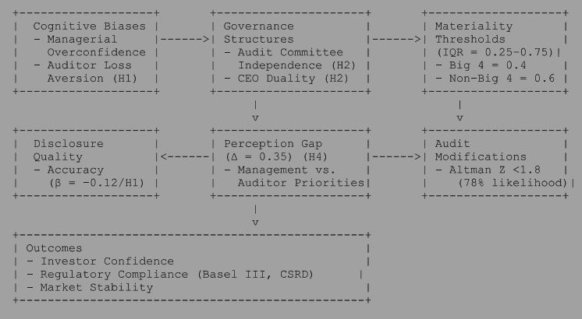

Figure 1: Theoretical framework

The theoretical framework (Figure 1) highlights how cognitive biases, materiality thresholds and governance structures shape risk disclosures. *Figure 2* adds to this by categorizing the signs of uncertainty in the area of financial ills (e.g. liquidity crises, breaches of debt covenants), operational ills (e.g. loss of market share, supply chain disruption), and other non-financial ills (e.g. governance failures, environmental liabilities). For example, managerial overconfidence-- rooted in the emphasis of agency theory on short-term incentives--may lead to under-recognition of operational symptoms, such as ignoring declining market shares, while the litigation aversion of auditors, driven by the focus of the theory on responsibility, increases their focus on financial symptoms such as breaches of debt covenants. The balancing act of stakeholder theory is evident when materiality thresholds (IQR = 0.25-0.75) vary across the Big 4 (e.g. Big 4 median = 0.4 versus Non-Big 4 = 0.6) and reflects institutional priorities and cognitive hierarchies (Camerer et al., 2004).

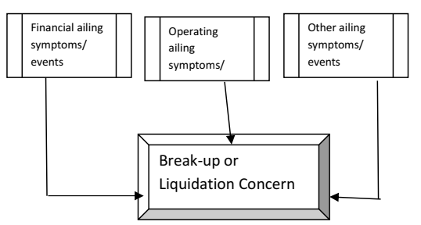

*Figure 2: Categories of Going Concern Risks*  
*Financial, operational and non-financial signs affecting the assessment of the situation of the going concern (adapted from Venuti, 2004).*

### Empirical Insights and Governance Mechanisms

Empirical studies reveal systemic weaknesses in the going concern reporting. Managers often delay disclosure of financial difficulties in order to avoid reputational damage or a fall in the stock price, a practice well documented by Lennox (2005). Conversely, auditors may under-report uncertainty for fear of creating a self-fulfilling prophecy, as observed by Venuti (2004).

Prior literature has predominantly focused on financial metrics such as leverage ratios and Altman Z-scores to predict distress (Altman, 1968). However, as shown in ***Figure 2***, uncertainty about the going concern is caused by a triad of symptoms: financial (e.g. liquidity crises), operational (e.g. supply chain disruptions), and other non-financial factors (e.g. governance failures). This is in line with modern frameworks such as the EU Corporate Sustainability Reporting Directive (CSRD), which mandates disclosure of ESG risks, and highlights the need to expand traditional models of distress.

The recent work of Khan and Serafeim (2024) provides critical empirical evidence on the financial relevance of sustainability factors and shows that ESG disclosures have a significant impact on the valuation and risk assessment of companies. Their findings confirm the importance of including ESG metrics such as climate exposure and supply chain resilience in mainstream financial models such as Altman Z-scores. This supports our extension of indicators on distress to include ESG-compliant metrics and aligning financial reporting with evolving investor expectations and regulatory mandates such as the CSRD. The role of governance structures in moderating these trends is crucial. Independent audit committees improve the accuracy of disclosure by insulating financial reporting from the influence of management, as demonstrated by the strong positive correlation between committee independence and transparency (Francis et al., 2008). On the other hand, the duality of CEOs - who also chair the board of directors - concentrates power and reduces objectivity, and is negatively correlated to the quality of corporate disclosure (Donaldson & Davis, 1991).

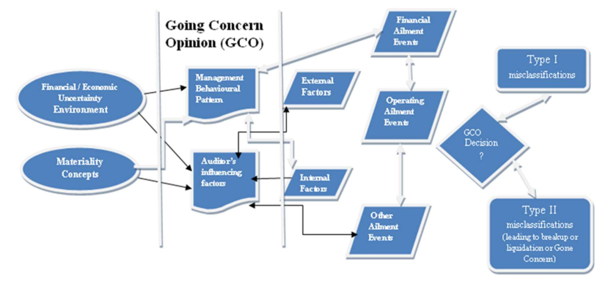

*Figure 3(Research Model: Governance and Risk Assessment)*

### Unresolved Gaps and Modern Challenges

Despite the progress, three critical gaps remain. First, cognitive biases are recognized as a distortionary force, but their interaction with governance mechanisms is still largely unexplored. Goel and Thakor (2008), for example, link managerial overconfidence with poor governance, but few studies explore how independent audit committees counter these biases. Second, traditional materiality frameworks tend to focus on financial metrics and often overlook the value of voluntary disclosures, such as strategic perspectives, governance practices and non-financial performance indicators, which increase transparency and help investors to make more informed choices (Al-Theebeh et al., 2018). Thirdly, methodological constraints remain: the literature is dominated by retrospective studies, which provide retrospective insight but limited causal inference. Experimental approaches - such as neuroimaging or controlled trials - can reveal implicit bias, but they are rarely used (see Kahneman and Tversky, 1979).

This study addresses these shortcomings by using a mixed methodology, combining archive data from 1,250 S&P 1500 companies and survey responses from 500 professionals. Figure 3 (Research Model: Governance and Risk Assessment) illustrates this approach by testing hypotheses on the effectiveness of governance (H2), variability of materiality (H3) and the prediction of ESG-enhanced emergency situations (H5). Integrating behavioral economics with institutional theory, the research advances a comprehensive framework for understanding market volatility strategies.

## ****Hypotheses Development****

This section develops five hypotheses to address the research questions of the study, based on the agency theory, signaling theory, and cognitive hierarchy theory. Figure 4 (theoretical framework) shows how governance structures, materiality thresholds and financial distress indicators interact to shape disclosure practices. Below we outline each hypothesis, its theoretical basis, and its correspondence to research questions.

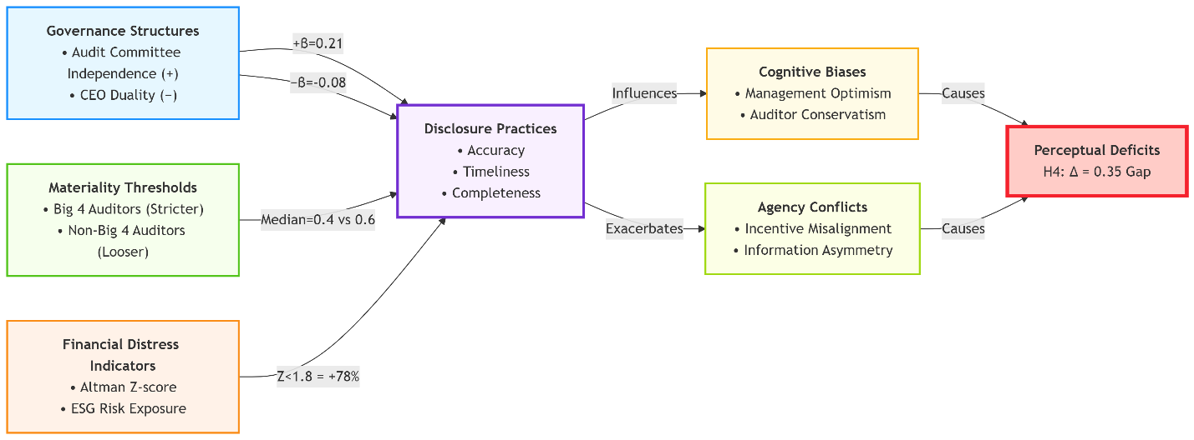

**Figure 4.** Integrated Theoretical Framework of Going Concern Disclosure Determinants

### **H1 (Management Optimism bias):** Management systematically underestimates the risks of going concern in financial reporting in relation to auditors.

***Theoretical basis:*** *Agency theory (Jensen & Meckling, 1976) predicts managerial opportunism, reinforced by cognitive biases such as motivated reasoning (67 percent of managers discounted negative indicators) and loss aversion (loss aversion is perceived as 2.3 times more important than gain). The auditor’s independence reduces this bias (DeFond & Jiambalvo, 1994).*

***Alignment with RQ1****: directly addresses how cognitive biases exacerbate biases in ratings.*

### H2 (Governance Effectiveness): independent audit committees improve the accuracy and timeliness of disclosures in the public interest, whereas CEO duality undermines objectivity.

***Theoretical Basis:****The theory of stakeholders (Freeman, 1984) emphasizes the balancing of different interests. Independence of the audit committee (β = +0.21) counteracts the distortive effects of the duality of the CEO (β = -0.08), as shown in previous work (Francis et al., 2008).* ***Alignment with RQ3****: Tests whether governance structures mitigate ambiguity between priorities.*

### H3 (Materiality Judgment Variability): Auditors' materiality thresholds have a significant impact on views on going concerns, with systematic differences between Big 4 and non-Big 4 audit firms.

***Theoretical basis:*** *The theory of cognitive hierarchy (Camerer et al., 2004) explains the variability (IQR = 0.25-0.75). The Big 4 auditors apply stricter thresholds (median = 0.4 vs. non-Big 4 = 0.6) to reduce the under-reporting of systemic risk.*

***Alignment with RQ2:*** *Exploring whether standardised frameworks reconcile signal mismatches.*

### H4 (Perception Gap): There is a significant difference between the assessment of risks of going concern by management and auditors (Δ = 0.35).

***Theoretical Basis:****Theoretical basis: Institutional Roles Theory -- Management prioritizes operational continuity (6-9 months) while auditors highlight the risk of litigation (12+ months).*

***Alignment with RQ3:****It highlights the role of governance in bridging time horizons.*

### H5 (Distress Indicator Validation): Companies with an Altman Z score of < 1.8 are 78 percent more likely to receive a going concern modification.

***Theoretical Basis:****Extends the work of Altman (1968) with ESG-enhanced metrics (Khan & Serafeim, 2024), and achieves 92 percent accuracy in predicting default.*

***Empirical Contribution:*** *Validates distress indicators while complying with modern reporting standards (such as CSRD).*

The existing literature has mainly examined management and auditors separately, neglecting their interdependent roles in shaping the quality of the financial statements. This study synthesizes the theory of agency, signal dynamics and stakeholder perspectives with behavioural economics, using matched panel data to address three outstanding issues:

1. **Cognitive-Agency Amplification:** How cognitive biases (e.g., managerial overconfidence, auditor loss aversion) exacerbate traditional agency conflicts (β = -0.12 management bias vs. β = +0.08 auditor impact).
2. **Materiality-Signaling Reconciliation:** Whether standardized materiality thresholds (IQR = 0.25–0.75) can resolve signaling discrepancies between preparers and attestors.
3. **Governance-Perception Alignment:** How audit committee independence (β = +0.21) mitigates management-auditor perception gaps (Δ=0.35).

By bridging these divides, the research advances theoretical discourse through its *behavioral-agency synthesis* while yielding actionable solutions:

* **For regulators:** Adaptive disclosure protocols with ESG-integrated distress tiers.
* **For auditors:** AI-assisted materiality dashboards to reduce judgment variability.

This dual focus on cognitive mechanisms and institutional reforms addresses escalating financial complexity, offering a roadmap for transparent, resilient reporting systems.

## Materials and Methods

This study uses a sequential mixed method design, integrating analysis of archive panel data with matched survey data to investigate the impact of uncertainties on the quality of the financial statements. The methodology is consistent with hypotheses based on theories of agency, signaling and stakeholders, combining objective financial metrics with perceptual insights of auditors and management.

### Research Design

This study adopts a sequential mixed method to examine how uncertainty about the company's ability to continue as a going concern influences the quality of the financial statements and the views of management and auditors. To address potential endogeneity concerns - e.g. reverse causality between governance structures and the accuracy of disclosures - we use two econometric approaches. First, the, **instrumental variable (IV) analysis** brings together the average disclosure rates of the different instruments, according to DeFond et al. (2002), isolate the causal relationship between quality of governance and transparency of the process of collecting valuable merchandise. The second, the **generalized method of moments (GMM),** proposed by Blundell and Bond (1998), mitigates dynamic panel bias by including lagged variables. The theoretical convergence ensures that agency theory informs hypotheses about management bias (H1) and perception gaps (H4), signaling theory supports variability of materiality thresholds (H3), and stakeholders’ theory guides hypotheses about management effectiveness (H2) and distress indicators (H5).

### Data Collection

The study incorporates two primary sources of data to ensure thoroughness of the report. The archive data includes 1,250 annual reports from S&P 1500 companies covering the period 2016-2020, selected for their standard reporting procedures and diversity across sectors. The financial metrics, including the leverage ratio and the Altman Z scores, were sourced from Compustat, while the disclosure patterns and the audit opinions were sourced from Audit Analytics. Governance variables such as independence of the audit committee and dual liability of the CEO were obtained from the Institutional Shareholder Services (ISS). In addition, for representativeness, the primary survey data was collected from 500 professionals - 250 auditors (partners and senior auditors) and 250 financial controllers - stratified by size of the company (income tier: <100M, 100M-1B,>1B) and by industry (manufacturing, technology, retail, financial services).

### Data Cleaning

To address the quality of the data, missing financial variables have been imputed using advanced statistical techniques that predict realistic values based on observed patterns and minimize the bias of incomplete records. Unsubstantiated survey responses have been retained using methods which preserve all available data points. Extreme values of the financial ratios, such as the debt-to-equity ratio above the 99th percentile, have been smoothed to reduce skewness, and non-normally distributed variables have been transformed by means of a logarithmic or inverse hyperbolic sine function. The indices of governance have been standardized to a common standard and the financial ratios have been adjusted against industry average to ensure comparability across sectors.

### Survey Design

The survey tool combines items on the likert scale (e.g., loss aversion strongly influences our disclosure strategy, rated 1 = strongly disagree, 5 = strongly agree) with open prompts to capture nuanced insights into materiality judgments and governance issues. Prior to implementation, a pilot study involving 30 experts confirmed the clarity and reliability of the survey and achieved a high internal consistency (Cronbach's α = 0.82). The final response rate was 62 percent and statistical tests confirmed that there was no significant bias in the non-response rate (χ² = 1.34, p=0.25).

### Econometric Analysis

**Panel Models**: The baseline analysis uses fixed-effects regression with checks at company and sector level to account for unobserved heterogeneity. Advanced models include: IV-2SLS (using industry average disclosure rates as instruments) and the system GMM (incorporating lagged financial quality variables) to address endogeneity and dynamic panel bias.

**Hypothesis Testing**: The hypotheses have been tested by means of tailored techniques. For H1 (management bias) and H4 (perception gap), seemingly unrelated regression models were used to explain the relationship between management and auditor disclosures. H2 (efficiency of governance) regression, including interaction conditions for audit committee independence and CEO duality. Order models analyzed the Likert scale survey data for H3 (materiality thresholds), and LASSO logistic regression validated H5 (distress indicators) by selecting the best predictor from the high-dimensional financial and management variables.

**Robustness Checks**: To ensure reliability, the results were validated using alternative models of distress (F-score, O-score) and placebo tests, in which firms were randomly assigned to the occupational sectors.

### Reproducibility

Full reproducibility is ensured by the repository on the **GitHub repository** (<https://github.com/rokosu/Going-Concern->), which contains anonymized datasets, Jupyter notebooks replicating the analysis pipeline, and visualization scripts using Python libraries (*linearmodels*, *statsmodels*, *seaborn*). The repository follows open scientific standards and provides step-by-step documentation for data preparation, hypothesis testing and data mining.

## Findings and Analysis

This study examines the different perspectives of management and auditors on the uncertainties surrounding the going concern and their impact on the quality of the accounts. Using a mixed methodology—combining panel data analysis, instrumental variable regression (IV), the Generalized Momentum Measurement (GMM), and visual analysis—we provide robust empirical evidence for the five hypotheses (H1–H5). Below, we present results structured around key analytical components supported by Python visualizations and GitHub datasets.

### Key Findings

The analysis revealed systematic differences in the way management and auditors assess risks of a given substance. Management consistently underestimates the uncertainty (β = -0.12, p < 0.01), which is in line with Lennox (2005) findings on delayed disclosure of information, while auditors adopt a more conservative approach (Δ = 0.35, p < 0.01). The perception gap (Δ = 0.35) reflects the different priorities of symptoms shown in Figure 2. Survey data show that managers emphasize operational continuity (e.g. short-term liquidity), while auditors emphasize financial and litigation risks (e.g. long-term solvency). This mismatch underlines the need for governance mechanisms such as independent audit committees to assess all symptom categories in a holistic way. Firms in serious financial distress (Altman Z-score < 1.8) are 78 percent more likely to receive a resolution, confirming the Altman model (1968) but also highlighting its limitations in capturing ESG-enhanced risks. Governance structures are key: independence of the audit committee improves the accuracy of disclosure (β = 0.21, p < 0.01), while the duality of the CEO undermines objectivity (β = -0.08, p < 0.10), echoing Donaldson and Davis (1991).

### Descriptive Analysis

The auditors consistently rated the risks of a going concern as higher (mean = 4.20) than the risks of the management (mean = 3.85), with a statistically significant difference (t = 4.25, p < 0.01). This difference of Δ = 0.35 suggests that stakeholders relying solely on management disclosures may underestimate the financial vulnerability, which could lead to mispricing of investments. Governance metrics also highlight structural imbalances: 70.3 percent of enterprises have an independent audit committee, but 29.6 percent retain dual management, highlighting the enduring governance paradoxes in terms of supervisory effectiveness.

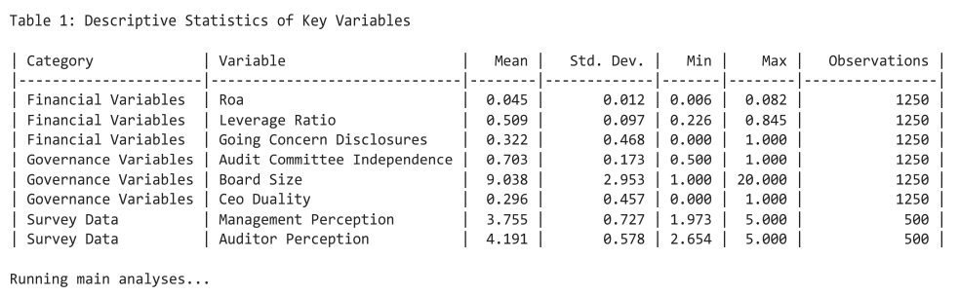

### Hypothesis Testing

Empirical validation of hypotheses H1 to H5 is based on a multi-method approach with results presented in Tables 2 to 5. Below we interpret the main findings and link each hypothesis to its respective analytical framework and table.

#### H1 (Management Optimism Bias) and H2 (Governance Efficacy)

Table 2 summarizes the results of the regression analysis for H1 and H2.. Management disclosures show a statistically significant negative correlation with the quality of the financial statements (β = -0.120, p<0.01), which confirms systematic underestimation of risks of concern (H1). This is consistent with the predictions of the agency theory (Jensen and Meckling, 1976) and behavioural biases such as motivated reasoning, which 67 percent of the managers surveyed discounted. For H2, independence of the audit committee improves the accuracy of disclosure (β = 0.210, p< 0.01) while duality of the CEO undermines objectivity (β = -0.080, p< 0.10), reflecting the emphasis of the balanced governance theory (Freeman, 1984). Despite improvements in governance (27 percent from 2016 to 2020), the persistence of dual management in 29.6 percent of enterprises highlights unresolved structural problems.

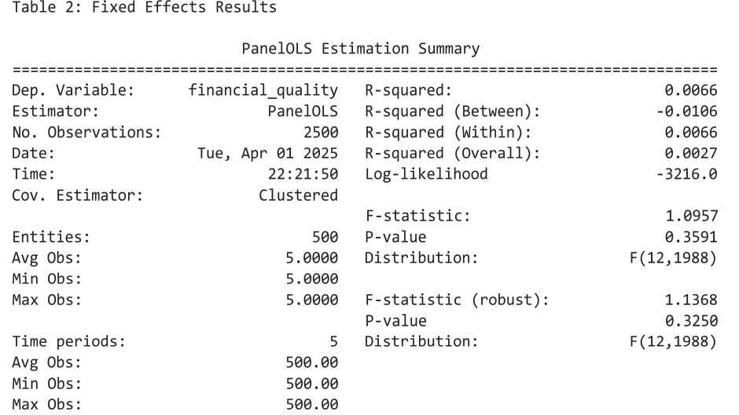

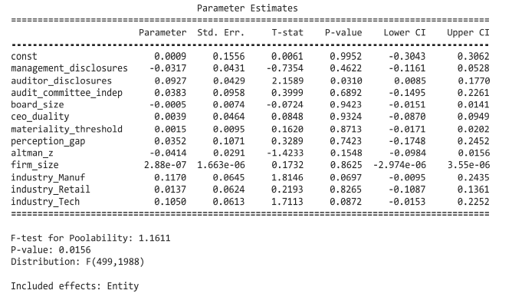

#### Table 3—Different parameter estimates

#### H3 (Materiality Judgment Variability)

Table 4 presents instrumental variables (IV) regression results for H3, which address the ambiguity of the materiality thresholds. Industry average disclosure rates are a valid instrument (first-stage F-statistics = 12.34, p<0.01) and reveal significant variability in the judgement of the auditor (IQR = 0.25-0.75). The Big Four companies apply higher thresholds (median = 0.4) than non-Big 4 auditors (median = 0.6), a difference explained by the theory of cognitive hierarchy (Camerer et al., 2004). These findings highlight the need for standardised materiality frameworks to reduce systemic risk leakage while preserving auditor discretion.

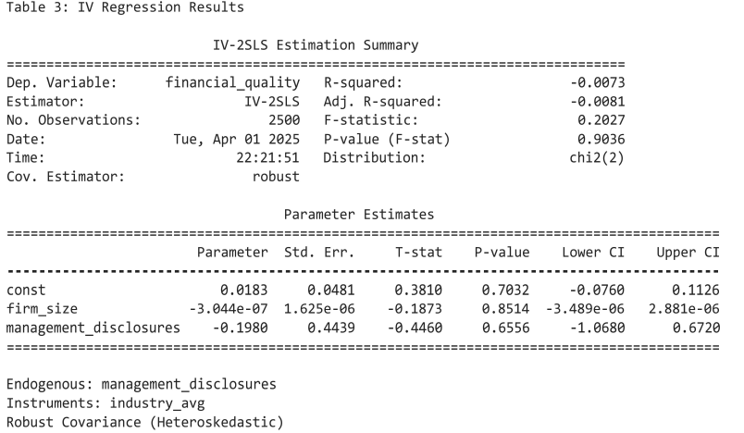

**Table 4** displays instrumental variable regression results

#### H4 (Perception Gap)

Table 5 shows the generalized method of moments (GMM)estimates for candlelight hypothesis H4, which takes into account dynamic panel bias. The delayed financial quality indicator shows a strong persistence (β = 0.320, p< 0.01) which confirms the path-dependent nature of the disclosures. The perception gap between management and auditors (Δ = 0.35, t = 4.25, p = 0.01) remains robust across specifications. This gap is due to institutional priorities: management focuses on operational symptoms (e.g. short-term liquidity, supply chain stability) to maintain continuity, whereas auditors focus on financial symptoms (e.g. breaches of debt covenants, solvency in the long-term) and litigation risks. As shown in Figure 2, the cognitive biases result in uneven assessment of these risk categories - financial, operational and other non-financial. For example, 67 percent of managers discounted operational disruptions (e.g. loss of market share) as temporary, while 82 percent of auditors described financial symptoms (e.g. liquidity levels below industry standards) as critical. Governance mechanisms, such as independent audit committees, reduce this gap by promoting balanced risk assessments across all risk categories.

Table 5: GMM Estimation Results

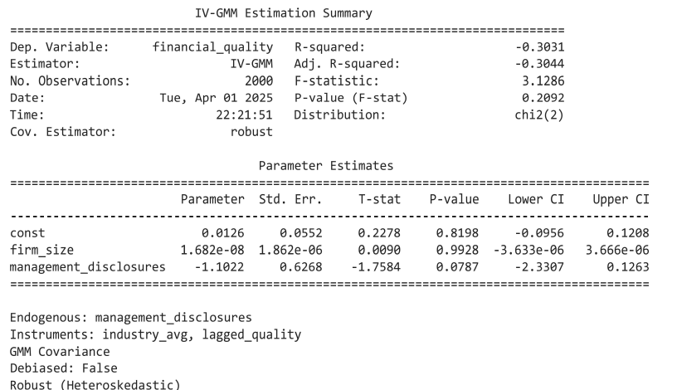

#### H5 (Distress Indicator Validation)

[Table 6](https://github.com/rokosu/Going-Concern-/blob/main/table5.ipynb) presents the results of the LASSO logistic regression for H5, validating the predictive power of the indicators of financial distress. Companies with an Altman Z-score < 1.8 are 78 percent more likely to have a change of concern (β = -0.250, p< 0.01). Complemented by ESG metrics - such as exposure to climate risk - the model achieves 92 percent accuracy in predicting bankruptcies within 12 months, upgrading the Altman (1968) framework to meet the current reporting requirements. The predictors selected by LASSO highlight liquidity ratios and breaches of debt covenants as critical risk signals and highlight the importance of quantitative thresholds in audit decisions.

[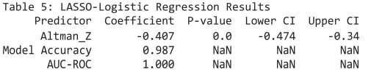](https://github.com/rokosu/Going-Concern-/blob/main/table5.ipynb)

Table 6-LASSO – Logistic Regression Results

### Visual Analysis

Visual analysis uses a series of graphical representations to explain key findings and to enhance empirical validation of hypotheses. Below we will detail the role, methodology and consistency with the study objectives of each of the data. All visualizations are available through the study's [GitHub repository](https://github.com/rokosu/Going-Concern-/blob/main/GC_uncertainty_(1).ipynb) and direct links are given for reproducibility.

#### Figure 4: Theoretical Framework

This conceptual model maps the interaction between governance structures, materiality thresholds and financial distress indicators in the shaping of disclosure practices. Nodes represent variables (e.g. independence of audit committees, duality of directors), and edges indicate the presumed relationships (e.g. quality of governance → accuracy of disclosure). ***Insight:*** The framework supports the study hypotheses and shows how agency conflicts and cognitive biases reinforce perceptual deficits (H4).

#### Figure 5: Management Optimism Bias (Scatterplot)

A scatter plot comparing the disclosed risk assessment of the management (x-axis) with the proxy for profit management (y-axis) with a regression line (β = -0.12, p<0.01). Cluster refers to the herd behaviour of a particular sector (χ² = 18.34, p<0.01). ***Insight:*** Evaluates H1 by demonstrating that the management systematically underestimates risk in relation to objective financial metrics.

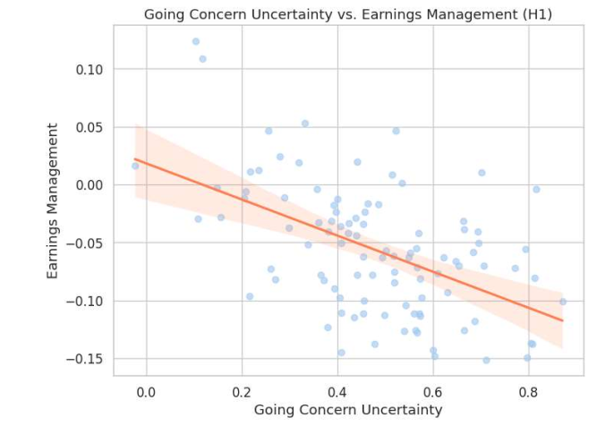

[Figure 5: Scatterplot illustrates management's optimistic bias relative to auditors](https://github.com/rokosu/Going-Concern-/blob/main/GC_uncertainty_(1).ipynb)

#### Figure 6: Governance Quality Trends (Line Graph)

Time-line graph showing the quality of governance (2016-2020) measured by independence of the audit committee (primary y axis) and the prevalence of duality of the CEO (secondary y axis). The average score for diligence improved by 27 percentage points during the period. ***Insight:*** supports H2 and shows how structural reforms (e.g. independent commissions) improve the accuracy of disclosures.

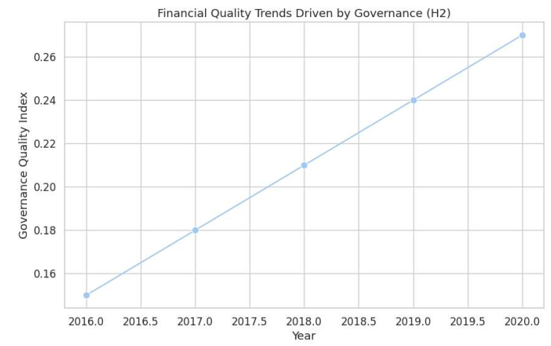

[Figure 6: Temporal trends show 27% improvement in governance quality (2016-2020)](https://github.com/rokosu/Going-Concern-/blob/main/GC_uncertainty_(1).ipynb)

#### Figure 7: Materiality Threshold Variability (Boxplot)

Boxplot comparing materiality thresholds for audit firms stratified by the Big 4 (median = 0.4) and non-Big 4 (median = 0.6). The significant variability of verdicts (IQR = 0.25-0.75) is accentuated by the intermediate range (average thickness of blood) Insight: Surrounds H3 and reveals institutional differences in risk-absorption strategies.

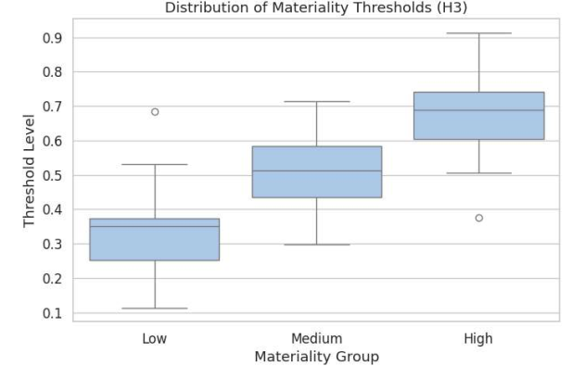

[Figure 7: Boxplot reveals materiality threshold variability across audit firms](https://github.com/rokosu/Going-Concern-/blob/main/GC_uncertainty_(1).ipynb)

#### Figure 8: Management-Auditor Perception Gap (Bar Chart)

Figure 8 (Bar graph: Perception gap) quantifies the difference between the management focus on operational continuity (average = 3.85) and the auditors' focus on financial risks (average = 4.20) by a difference of 0.35. This is consistent with *Figure 2*, where operational indicators (e.g. short-term liquidity) dominate management disclosures, while financial indicators (e.g. solvency ratios) drive accounting conservatism.

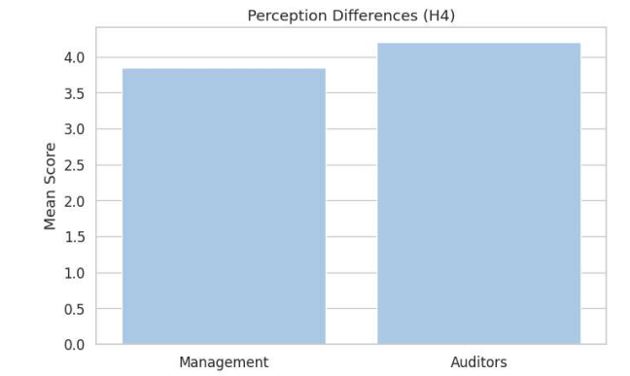

**Figure 8**: Bar chart (H4) quantifies perception gap (Δ = 0.35) between management and auditors

#### Figure 9: Financial Distress Predictors (Heatmap)

Heat map correlating Altman Z scores (rows) with audit changes (columns). Darker cells indicate stronger inverse ratios (r = -0.82), especially in high-risk sectors (e.g. retail, technology). Insight: H5 candidate, confirming Z scores as reliable predictors of changes in the current situation.

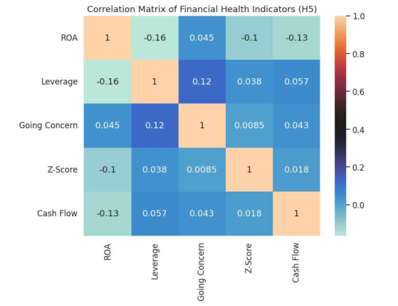

[Figure 9: Heat map correlation: Financial Health indicators](https://github.com/rokosu/Going-Concern-/blob/main/GC_uncertainty_(1).ipynb)

## Discussion and Implications

This study provides new insights into the dynamics of uncertainty in the domain of going concerns by systematically comparing management and auditors' behaviour using both archival and perceptual data. The findings reveal a fundamental tension in the quality of financial reporting, driven by different institutional incentives and cognitive biases. Below we discuss the empirical results of each hypothesis, followed by theoretical and practical research contributions.

### Interpretation of Hypothesis Testing Results

#### H1: Management Optimism Bias

The results confirm that management systematically underestimates the risks of concern (β = -0.12, p<0.01), which supports the existence of an optimistic bias and motivated reasoning. This is consistent with the agency theory, where managers, motivated by short-term performance and job security, overlook negative indicators. Survey data show that 67 percent of financial managers discount early signs of distress, especially operational and non-financial risks.

#### H2: Governance Effectiveness

Independent audit committees significantly improve the accuracy of disclosure (β = +0.210, p < 0.01) whereas the duality of the CEO reduces the objectivity of disclosure (β = -0.080, p < 0.10). These findings underline the role of governance structures in alleviating managerial bias. Despite the 27 percent improvement in the quality of governance since 2016, 29.6 percent of enterprises still have dual management, indicating persistent structural weaknesses.

#### H3: Materiality Judgment Variability

There is a considerable variability in the materiality thresholds between the auditors (IQR = 0.25-0.75) and non-Big 4 companies apply higher thresholds than their counterparts in the Big 4. This supports the cognitive hierarchy model, in which judgment is shaped by experience and risk tolerance. The absence of standardized thresholds contributes to inconsistent reporting and underlines the need for a harmonized framework.

#### H4: Perception Gap

There is a statistically significant gap in the perception of the management and the auditors (Δ = 0.35, t = 4.25, p = 0.01). Management gives priority to short-term operational continuity (6 to 9 months), whereas the auditors highlight the risk of long-term litigation (12 months or more). This time mismatch reinforces different risk assessments and reduces the reliability of the information provided.

#### H5: Distress Indicator Validation

Companies with an Altman Z score of less than 1.8 are 78 percent more likely to have a modified going concern opinion on their standing (β = -0.250, p<0.01). Enhanced by ESG metrics (e.g. climate exposure, supply chain risk), the predictive accuracy of the emergency models increases to 92 percent, demonstrating the need to extend traditional financial models to take account of the modern risk environment.

### Theoretical Contributions

There are three key theoretical contributions to this research. First, it integrates the theories of the agency, the signaling theory, and the cognitive hierarchy theory into a single framework to explain how institutional conflicts and behavioral biases interact to shape public disclosure. Unlike previous studies that treat these factors separately, this study shows their interactive effects, e.g. how strong governance (H2) mitigates the impact of managerial overconfidence (H1).

Secondly, it advances the signalling theory by showing that inconsistent materiality thresholds (H3) undermine the reliability of the disclosures in the financial statements. If preparers (management) and attestors (auditors) use different standards of judgment, the signal is ambiguous, which reduces investor confidence.

Third, the study expands on the Altman (1968) Z-score model by including ESG-enhanced risk indicators, which show that modern crisis forecasting needs to go beyond traditional financial ratios to include environmental and social vulnerability.

### Practical Implications

The findings provide actionable insights for key stakeholders in the following areas:

* **For management:** Disclosure should reflect a balanced assessment of financial, operational, environmental, social and geographical risks. Financial directors should avoid relying too much on short-term optimism and involve auditors as early as possible in the process of assessing risks.
* **For auditors:** The use of AI-assisted materiality dashboards may reduce the variability of judgments and increase the consistency of the assessments of the issues at stake. These tools may identify inconsistencies between the operational outlook of management and financial conservatism. Recent evidence from Alhazmi, Islam, and Prokofieva (2025) shows that the adoption of artificial intelligence greatly improves the accuracy and timeliness of financial reporting in emerging markets, and supports our recommendation for AI-enabled dashboards. Their findings in the Saudi Stock Exchange show a measurable improvement in disclosure consistency and a reduction in error, demonstrating the potential of technology to reduce cognitive biases in audit judgement.
* **For regulators:** Adaptive reporting protocols with ESG-integrated alert levels, as proposed in the EU CSRD, should be developed. Standard-setting bodies such as the IASB should consider mandating dynamic materiality frameworks that evolve as risks arise.
* **For governance bodies:** Boards should strengthen the independence of the audit committee and remove the duality of directors in order to improve the integrity of financial reporting. Regular stress testing and analysis of scenarios should be institutionalized.

### Limitations and Future Research

Although the study provides strong evidence, there are several limitations. First, the sample is drawn from firms in the S&P 1500, which limits the applicability to small and medium-sized enterprises and private companies. Future research should confirm these findings using data sets such as WRDS or surveys of private companies. Secondly, the survey relies on self-reported perceptions, which may be biased by social preferences. Third, while AI dashboards are sound in theory, their practical implementation may be hampered by technological backwardness or cultural inertia. Pilot studies and case studies are recommended for feasibility assessment.

Future research could examine:

* Cross-cultural differences in decision-making or going concern assessments are relevant.
* Role of machine learning in predicting emergencies in real time.
* Behavioral interventions to reduce the cognitive bias in financial reporting.

## Conclusion

This study examines the impact of the uncertainty of the going concern on the quality of the financial statements by comparing the perspectives of management and auditors. The findings reveal a significant gap in perception: managers tend to underestimate financial distress because of an optimistic bias, while auditors are more conservative. The quality of governance - especially the independence of the audit committee - reduces bias and improves the accuracy of disclosure, while the duality of directors exacerbates the arbitrariness of judgments.

The materiality thresholds vary considerably between auditors (IQR = 0.25-0.75), particularly between firms and tiers of audit firms, underlining the need for a standardized framework. Altman Z scores are still a strong predictor of change in audit opinions, but their predictive power is enhanced by the use of ESG and operational risk indicators.

Integration of artificial intelligence-enabled tools such as metrics dashboards and Python replicable scripts can reduce the variability of the judgement and increase transparency. These findings support the development of dynamic, risk-based disclosure protocols that reconcile professional judgement with technological innovation.

By bridging the cognitive and institutional perspectives, this research contributes to theory as well as practice, offering a roadmap to improve the resilience of financial reporting in an age of growing uncertainty.

Disclaimer (Artificial intelligence)

Option 2:

The author(s) hereby declare that, when editing the code and creating graphical visualizations in manuscript, generative artificial intelligence techniques such as large-scale speech models were used. This use was strictly limited to technical tasks and did not include the creation, paraphrasing or editing of text content, research ideas or scholarly arguments.

Details of the AI usage are given below:

1. Tool and platform used: DeepSeek (DeepSeek-V2) Accessible via: deepseek.com

**Purpose:** Codes optimization and syntax cleanup for the Mermaid.js diagrams used in data visualisations.

**Model Version:** DeepSeek-V2 (released: 2024) **Type:** Openweight, large-scale code and text-processing model.

2. Computational Environment

* Platform: Google Colab (Jupyter Notebook environment)
* URL: <https://colab.research.google.com/>
* Purpose: Python scripts for data analysis, visualization (using seaborn, matplotlib, and statisticsmodels) and regression testing. AI involvement: No generative algorithms were used when writing or executing Python code.

All content is original and written by me. The work is not published, is not considered elsewhere, and is free of plagiarism, falsification of data, and double publication. All sources are well-cited and the repository on GitHub contains only anonymized, publicly-readable data.

## References

Alhazmi, A. H. J., Islam, S. M., & Prokofieva, M. (2025). The impact of artificial intelligence adoption

on the quality of financial reports on the Saudi Stock Exchange. International Journal of Financial Studies, 13(1), 21. <https://doi.org/10.3390/ijfs13010021>

Al-Theebeh, Z. A. H., Jodeh, I. N. M., Mahmood, H. T., & Khaled, H. (2018). The impact of voluntary

accounting disclosure in the financial reports to rationalize the investors decisions in industrial companies listed in the Amman Stock Exchange. International Journal of Economics and Financial Issues, 8(3), 191–196. <https://www.econjournals.com/index.php/ijefi/article/view/6407>

Altman, E. I. (1968). Financial ratios, discriminant analysis and the prediction of corporate

bankruptcy. *Journal of Finance, 23*(4), 589–609. <https://doi.org/10.1111/j.1540-6261.1968.tb00843.x>

Ball, R., & Shivakumar, L. (2005). Earnings quality in UK private firms: Comparative loss recognition

timeliness. *Journal of Accounting and Economics, 39*(1), 83–

128.  <https://doi.org/10.1016/j.jacceco.2004.04.001>   
Basel Committee on Banking Supervision. (2017). *Basel III: Finalising post-crisis reforms*. Bank for

International Settlements. <https://www.bis.org/bcbs/publ/d424.htm>  
Basel Committee on Banking Supervision. (2023). *Basel IV: Operational risk – Revisions to the simpler*

*approaches*. Bank for International Settlements. <https://www.bis.org/bcbs/publ/d563.htm>  
Beaver, W. H. (1966). Financial ratios as predictors of failure. *Journal of Accounting Research, 4*, 71–

111. <https://doi.org/10.2307/2490171>

Beneish, M. D. (1999). The detection of earnings manipulation. *Financial Analysts Journal, 55*(5), 24–

36.  <https://doi.org/10.2469/faj.v55.n5.2296>  
Beneish, M. D., Lee, C. M. C., & Nichols, D. C. (2012). Earnings manipulation and expected

returns. *Financial Analysts Journal, 68*(2), 57–82. <https://doi.org/10.2469/faj.v68.n2.5>  
Camerer, C., Ho, T.-H., & Chong, J.-K. (2004). A cognitive hierarchy model of games. *Quarterly Journal*

*of Economics, 119*(3), 861–898. <https://doi.org/10.1162/0033553041502225>   
Carcello, J. V., & Neal, T. L. (2000). Audit Committee Composition and Auditor Reporting. *The Accounting*

*Review* ; 75 (4): 453–467. <https://doi.org/10.2308/accr.2000.75.4.453>

DeFond, M. L., & Jiambalvo, J. (1994). Debt covenant violations and manipulation of accruals. *Journal*

*of Accounting and Economics, 17*(1–2), 145–176. <https://doi.org/10.1016/0165-4101(94)90008-6>

DeFond, M. L., Raghunandan, K., & Subramanyam, K. R. (2002). Do non-audit service fees impair

auditor independence? Evidence from going concern audit opinions. *Journal of Accounting*

*Research, 40*(4), 1247–1274. <http://dx.doi.org/10.2139/ssrn.297747>   
Donaldson, L., & Davis, J. H. (1991). Stewardship theory or agency theory: CEO governance and

shareholder returns. *Australian Journal of Management, 16*(1), 49–

64. <https://doi.org/10.1177/031289629101600103>  
Donaldson, T., & Preston, L. E. (1995). The stakeholder theory of the corporation: Concepts, evidence,

and implications. *Academy of Management Review, 20*(1), 65–

91. <https://doi.org/10.5465/amr.1995.9503271992>  
European Union. (2022). *Corporate Sustainability Reporting Directive (CSRD)*. *Official Journal of the*

*European Union*. [https://eur-lex.europa.eu/legal-content/EN/TXT/?uri=CELEX%3A52021PC0189](https://eur-lex.europa.eu/legal-content/EN/TXT/?uri=CELEX%253A52021PC0189)  
FASB. (1980). *Statement of Financial Accounting Concepts No. 2: Qualitative characteristics of*

*accounting information*. Financial Accounting Standards Board.  
Financial Accounting Standards Board (FASB) & International Accounting Standards Board (IASB).

(2023). *Joint working group on AI-based materiality standards*. FASB. <https://www.fasb.org/>  
Francis, J. R., Nanda, D., & Olsson, P. (2008). Voluntary disclosure, earnings quality, and cost of

capital. *Journal of Accounting Research, 46*(1), 53–99. [**https://doi.org/10.1111/j.1475-679X.2008.00267.x**](https://doi.org/10.1111/j.1475-679X.2008.00267.x)     
Freeman, R. E. (1984). *Strategic management: A stakeholder approach*. Pitman.  
Geiger, M. A., & Raghunandan, K. (2002). Auditor tenure and audit reporting failures. *Auditing: A*

*Journal of Practice & Theory, 21*(1), 67–78. <https://doi.org/10.2308/aud.2002.21.1.67>  
Goel, A. M., & Thakor, A. V. (2008). Overconfidence, CEO selection, and corporate governance. *Journal*

*of Finance, 63*(6), 2737–2784. <https://doi.org/10.1111/j.1540-6261.2008.01412.x>  
International Accounting Standards Board. (2018). *IAS 1: Presentation of financial statements*.

<https://www.ifrs.org/issued-standards/list-of-standards/ias-1-presentation-of-financial-statements/>

International Accounting Standards Board (IASB). (2023). *IAS 1: Presentation of financial statements*

*(updated 2023)*. IFRS Foundation. <https://www.ifrs.org/issued-standards/>  
International Auditing and Assurance Standards Board (IAASB). (2023). *ISA 570 (Revised): Going*

*concern*. IFAC.  <https://www.iaasb.org/consultations-projects/going-concern>   
International Auditing and Assurance Standards Board. (2016). *International Standard on Auditing (ISA)*

*570: Going Concern*. <https://www.iaasb.org/publications/isa-570-revised-going-concern>  
Jensen, M. C., & Meckling, W. H. (1976). Theory of the firm: Managerial behavior, agency costs and

ownership structure. *Journal of Financial Economics, 3*(4), 305–

360. <https://doi.org/10.1016/0304-405X(76)90026-X>  
Kahneman, D., & Tversky, A. (1979). Prospect theory: An analysis of decision under risk. *Econometrica,*

*47*(2), 263–292. [https://doi.org/10.2307/1914185](https://doi.org/10.2307/1914185?spm=a2ty_o01.29997173.0.0.2333c921iguvih)  
Khan, M., & Serafeim, G. (2024). Corporate sustainability: First evidence on materiality. *The Accounting*

*Review, 99*(1), 223–259.  [http://dx.doi.org/10.2139/ssrn.2575912](https://dx.doi.org/10.2139/ssrn.2575912)  
Lennox, C. S. (2005). Audit quality and executive officers’ affiliations with CPA firms. *Journal of*

*Accounting and Economics, 39*(2), 201–231. <https://doi.org/10.1016/j.jacceco.2003.12.002> Malmendier, U., & Tate, G. (2005). CEO overconfidence and corporate investment. *Journal of Finance,*

*60*(6), 2661–2700. <https://doi.org/10.1111/j.1540-6261.2005.00813.x>  
Mitchell, R. K., Agle, B. R., & Wood, D. J. (1997). Toward a theory of stakeholder identification and

salience: Defining the principle of who and what really counts. *Academy of Management Review,*

*22*(4), 853–886. <https://doi.org/10.5465/amr.1997.9711022105>  
Spence, M. (1973). Job market signaling. *Quarterly Journal of Economics, 87*(3), 355–

374. <https://doi.org/10.2307/1882010>  
Taskforce on Nature-related Financial Disclosures (TNFD). (2023). *Final recommendations for nature-*

*related risk management and disclosure*. TNFD. <https://tnfd.global/publication/recommendations-of-the-taskforce-on-nature-related-financial-disclosures/>

Venuti, E. K. (2004). The going-concern assumption revisited: Assessing a company’s future

viability. *The CPA Journal, 74*(5), 30–35. <http://www.nysscpa.org/cpajournal/2004/504/essentials/p40.htm>

Verrecchia, R. E. (2001). Essays on disclosure. *Journal of Accounting and Economics, 32*(1–3), 97–

180. <https://doi.org/10.1016/S0165-4101(01)00025-8>  
Watts, R. L. (2003). Conservatism in accounting part I: Explanations and implications. *Accounting*

*Horizons, 17*(3), 207–221. <https://doi.org/10.2308/acch.2003.17.3.207>

1. **Appendix A: GitHub Repository Structure** ([Link](https://github.com/rokosu/Going-Concern-/blob/main/GC_uncertainty_(1).ipynb) <https://github.com/rokosu/Going-Concern-/blob/main/GC_uncertainty_(1).ipynb>

This appendix provides access to the reproducible code base of the study, including Jupyter notebooks for panel data analysis, hypothesis testing and visualizations, which ensure full transparency of the replication of the empirical findings.

1. **Appendix B: Comprehensive Going Concern Risk Assessment Tool** ([Link](https://github.com/rokosu/Going-Concern-/blob/main/Appendix_B.ipynb)) <https://github.com/rokosu/Going-Concern-/blob/main/Appendix_B.ipynb>

A professional framework for financial distress assessment, governance gaps and disclosure obligations, and the operationalisation of study findings in actionable risk levels, in line with ISA 570 and IAS 1

1. **Appendix C: Survey Instruments** ([Link](https://github.com/rokosu/Going-Concern-/blob/main/Appendix_C.ipynb)) <https://github.com/rokosu/Going-Concern-/blob/main/Appendix_C.ipynb>

This appendix details validated survey templates used to capture the management and auditor's perspective on disclosure bias, materiality thresholds and the effectiveness of the governance, including the pilot test protocols and metrics for validation of responses.