##### A study on the impact of magnetic field inclination and concentration on unsteady MHD stokes flow of a dusty fluid through moving channel of Riga plates

## Abstract

The study investigated the unsteady laminar flow of a heat-conducting dusty fluid between two parallel Riga plates. The upper plate is in continuous motion at a constant velocity, while the lower plate remains stationary. A similarity transformation is employed to convert the derived governing equations into their dimensionless form. Subsequently, the explicit finite difference method is utilized to obtain numerical solutions. Key analytical quantities, including the velocity of dust particles, the pressure distribution among others are examined. The impact of magnetic field inclination and concentration on the velocity and temperature distributions of both fluid and dust particles is analyzed and discussed. It was established that increasing the magnetic field intensity decreases the velocity of the fluid flow. It is also observed that flow temperature increases since kinetic energy is dissipated as heat. These findings offer a basis under which experimental validation and further analytical or numerical exploration can be undertaken. Furthermore the findings provide perspective to heat and mass transfer in electrically conducting fluids with suspended dust particles which are applicable in such systems as cooling technologies, chemical reactors and geothermal processes.

*keywords*: MHD, Riga Plate, Stokes.

## 1 Introduction

The demands of modern machinery have sparked interest in fluid flow studies, which involve the interaction of multiple phenomena. One area of study focuses on the flow of a viscous fluid over a porous surface, a topic with significant relevance to various engineering problems. For instance, it is crucial in understanding the flow of liquids in porous bearings, the behavior of water in riverbeds, and the movement of natural gas, oil, and water through oil reservoirs in petroleum technology. Additionally, this study is important in chemical engineering, particularly in filtration and purification processes, where the behavior of particle-laden fluids under the influence of magnetic fields plays a crucial role. Understanding how dusty fluid interacts with electromagnetic forces and heat transfer mechanisms can help improve the design of industrial equipment such as filters, separators, and reactors. The insights gained may contribute to developing more efficient methods for removing impurities, enhancing product quality, and optimizing energy usage in chemical processing systems.

The term MHD is derived from existence of a magnetic field and an electrically conducting liquid undergoing movement. The induced magnetic field appear to disturb both the original magnetic field and motion of an induced electric field [11]. When a fluid has low electrical conductivity, causing the Lorentz force to decrease exponentially, an external electric field must be applied to achieve efficient flow control. This process is known as Electro-Magneto-Hydrodynamic (EMHD) flow. Due to the critical role of magnetic fields, the Riga plate has become indispensable in various fields, including magneto-aerodynamics, civil engineering, mechanical engineering, chemical engineering, gas dust and fume control, biomechanics, and groundwater and oil remediation. The Riga plate is designed by combining electrodes and permanent magnets to create a plane surface, rather than relying on polarity and magnetization. This setup generates a wall-parallel Lorentz force, effectively controlling fluid flow. The concept of the Riga plate was first introduced by Gailitis and Leilausis [6]. This arrangement reduces the friction and pressure drag on submarines, helps prevent the separation of the boundary layer, and minimizes turbulence effects, resulting in an improved flow pattern. As the fluid flows, the Lorentz force is generated by the combined action of electrodes and permanent magnets embedded in the flat surface [10].

A dusty fluid consists of a uniform distribution of solid spherical particles suspended within the fluid. These flows exhibit a unique two-phase nature, evident in various situations, such as when raindrops mix with airborne dust particles or during the extraction of oil and gas from the ground. Due to the dominant viscous forces, dusty fluids typically have low velocities, a characteristic of what is known as Stokes flow. The influence of inclined Riga plates, with the upper plate moving at a uniform velocity, has been investigated, leaving a gap that this study aims to explore further. Yobo in [13], examined and discussed the thermal radiation effect on unsteady free-convective Couette flow of a conducting fluid under a transverse magnetic field, presenting both numerical and analytical solutions, with the numerical results aligning with the steady-state analytic solution. Hamza in [8] examined fluid flow in a channel influenced by suction and blowing, with velocity driven by the oscillations of the right plate and thermal effects from its heating. Fluid and dust particles exhibited complex velocities due to rotation, expressed as primary and secondary components. The governing fluid flow was modeled using partial differential equations, which were non-dimensionalized and reduced to ordinary differential equations through periodic solutions and solved via the Poincare–Lighthill perturbation technique. Engineering quantities such as the Nusselt number and skin friction are evaluated. Results reveal how parameters like suction, rotation, magnetic fields, and dusty fluid concentration affect skin friction and velocity profiles. Ali et al in [2] investigates two-phase MHD fluctuating flow of a Brinkman-type dusty fluid between two parallel plates, one stationary and the other oscillating, with emphasis on wall shear stress, heat, and mass transfer. Using the Poincare–Lighthill perturbation method, systematic solutions were derived by independently modeling fluid and dust particle equations. The effects of parameters such as the Grashof number, magnetic flux, heat flux, and dusty fluid variables on velocity, heat transfer, and skin friction were analyzed. Results showed that decreasing magnetic flux and shear force enhanced base fluid velocity.

Baoku et al in [4] investigated transient MHD Couette flow of an electrically conducting fluid through a porous medium under a transverse magnetic field and thermal radiation, used a Crank–Nicolson finite difference scheme to solve the governing equations, and found that thermal radiation significantly affected the velocity and temperature profiles for various parameters like Prandtl number, Nahme number, and Hartmann number. Ganesan et al in [7], studied and numerically solved the flow of a fluid with dusty particles past a semi-infinite inclined plate with constant heat flux using an implicit finite difference method, and found that both decreasing the inclination angle and increasing the dust concentration reduced the gas velocity.

## 2 Problem formulation

Consider an incompressible laminar flow of viscous dusty fluid between two horizontal parallel Riga plates, of which one is moving and the other is fixed. The lower plate is kept fixed at and the upper plate keeps moving at a distance with a velocity . The length of the Riga plate is approximated to be which imply that varies from 0 to 10 and the distance between the plates is taken to be 2 since the and . These plates are fixed and tilted at an angle from the horizontal plane. They are maintained at different temperatures, with the lower plate at a fixed temperature of T1 and the upper plate at T2, where . It is assumed that the temperatures of both fluid and dust particle is T1. Let the direction of the flow be taken along the axis. It is assumed that the dust particles have a spherical shape and are evenly spread within the fluid. They have no y-component of velocity.

• A constant pressure gradient

(1)

is applied.

• Lorentz force is a fundamental concept in MHD, where it describes the force exerted on a moving conductive fluid (like plasma or a conducting fluid) in the presence of a magnetic field. According to [7], Grinberg hypothesis defines Lorentz principle force as :

(2)

• When an MHD fluid with velocity passes through a magnetic field of strength inclined at an angle , an electric field is generated. The electric field is given by:

(3)

As the fluid moves, it also generates an electric current with density , which depends on the fluid’s electrical conductivity . The current density is expressed as:

(4)

Considering the flow occurs along the x-axis (), the current density simplifies to:

(5)

When this current flows through the inclined magnetic field, it generates a Lorentz force , calculated as:

(6)

This force acts in the x-direction and is influenced by the inclination of the magnetic field and the properties of the MHD fluid.

• The net dust effect on the fluid particles as observed by [3] is equivalent to the additional force per unit volume, written as

(7)

where is stokes constant given by as noted by [7] and is the average radius of dust particles. is the number of dust particles in the fluid.

With the assumptions of Stokes and Couette flow and boundary layer approximation, the continuity equation simplifies for the fluid phase to , and for the dusty phase to . Consequently, the momentum and energy equations for both clean fluid and the dust particles are given as:

(8)

(9)

(10)

(11)

where;

The dust particle equation (9) is governed by Newtons second law of motion as noted by [4].

### 2.1 Non - dimensionalisation

These parameters are used to perform non-dimensionalisation.

(12)

using (12) on equations (8), (9), (10) and (11) we get;

(13)

(14)

(15)

(16)

(17)

(18)

(19)

The boundary conditions iinvolved in the flow are;

(20)

Equations (16-19) are the dimensionalised equations for this model. From them, the following parameters are obtained;

(21)

substituting the parameters in equations (16-19) yields;

(22)

(23)

(24)

(25)

## 3 Method of solution

The explicit finite difference method is used to solve (22-25) having incorporated necessary boundary conditions. we have used j to represent space y and k refers to time t. The hats are dropped.

Equation (22) in finite difference form is expressed as;

(26)

The equation (23) of motion for dust particle is descretised as follows:

(27)

The discritized temperature equations (24 and 25) for fluid and dust particles are as below;

(28)

(29)

The non-dimensionalised boundary conditions of the flow become;

(30)

## 4 Results and discussions

The boundary conditions are used to graphically obtain results. Extensive discussions on various parameters such as pressure gradient (), Mordified Hartman number (), Prandtl number () and Joule parameter () is undertaken. From [7], the following are fixed as = 2, = 1.0, = 0.5, = 0.5, = 7.0, =0.8 =0.3, =0.2 and =0.4

### 4.1 Effect of magnetic field concentration on velocity

Increasing the values of **B** as seen in table 1 having fixed =1 shows that and decreases. This can also be observed in figure 1. The forces of Lorentz created by the presence of a magnetic field increase in intensity proportionally to increase in the magnetic field concentration [1]. According to [11] this force is resistive to MHD fluid motion as seen in figure 1 . As the fluid flow velocity is slowed down due to the magnetic drag, kinetic energy is dissipated as heat resulting to a rise in temperature of the flow as observed in figure 2. This heating effect is even stronger in fluids that are electric conductors and are sensitive to magnetic fields.

|  |  |  |
| --- | --- | --- |
| **Magnetic Field Concentration ()** | | |
|  |  |  |
| 0.1 | 1.136050 | 1.035013 |
| 0.3 | 1.111182 | 1.012177 |
| 0.7 | 1.061448 | 0.966505 |
|  | 1.024147 | 0.932250 |

Table 1: Effect of magnetic field concentration on velocity profiles

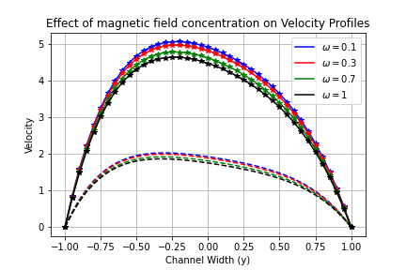

Figure 1: Effect of on Velocity u and

### 4.2 Effect of magnetic field concentration on temperature profiles

The concentration of Magnetic field has an effect on the temperature of the system.

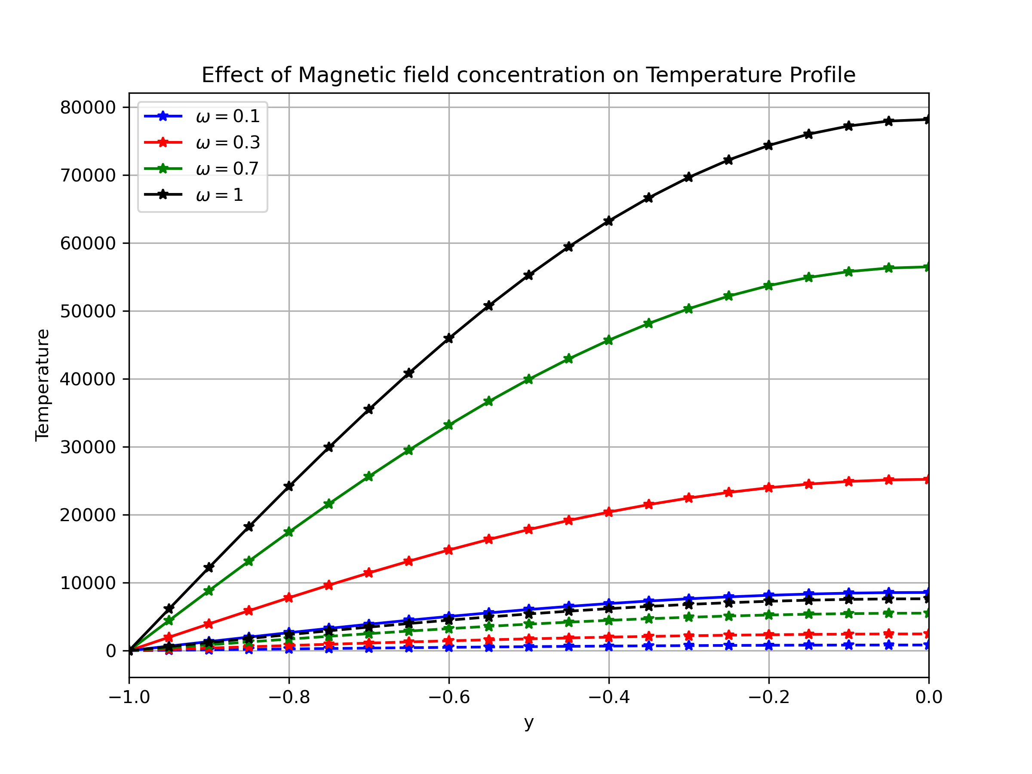

Figure 2: Effect of on Velocity u and

### 4.3 Effect of magnetic field inclination on velocity profiles

|  |  |  |  |  |  |
| --- | --- | --- | --- | --- | --- |
| **Magnetic Field inclination angle ()** | | | | | |
|  |  |  |  |  |  |
|  | 0.67 | 0.961978 | 0.875160 | 110963.73367 | 10849.064920 |
|  | 0.25 | 0.651136 | 0.589709 | 212088.31960 | 20736.128175 |
|  | 0.5 | 0.899810 | 0.818070 | 139570.14787 | 13645.948732 |
|  | 0.75 | 0.986846 | 0.897996 | 98347.758408 | 9615.585433 |
|  | 0.933 | 1.011713 | 0.920832 | 85061.263382 | 8316.548252 |
|  | 1 | 1.024147 | 0.932250 | 78166.570958 | 7642.445527 |

Table 2: Effect of magnetic field inclination on velocity profiles

The observations from Table 2 reveal interesting trends in the behavior of velocity and temperature profiles as the magnetic field inclination angle, , varies. The velocity components, and , generally increase with increasing inclination angle , except at , where they experience a noticeable drop. This suggests that at , there is a specific interaction that temporarily reduces the flow velocity. This reduction is attributed to an optimal balance between the applied forces. Beyond this point, the velocity increases again, indicating a general trend of velocity enhancement as increases as seen in figure 4. The highest velocity values for both and occur at , indicating that a perpendicular magnetic field orientation optimizes velocity. This suggests that aligning the magnetic field perpendicular to the flow direction reduces magnetic resistance, allowing for maximum fluid velocity. In contrast as from figure 3, the temperature components, and , show a decreasing trend as increases, implying that higher inclination angles contribute to enhanced heat dissipation. However, a deviation from this trend is observed at , where the temperature values are significantly higher than at other angles. This anomaly could be the result of an increase in flow resistance at this particular inclination.

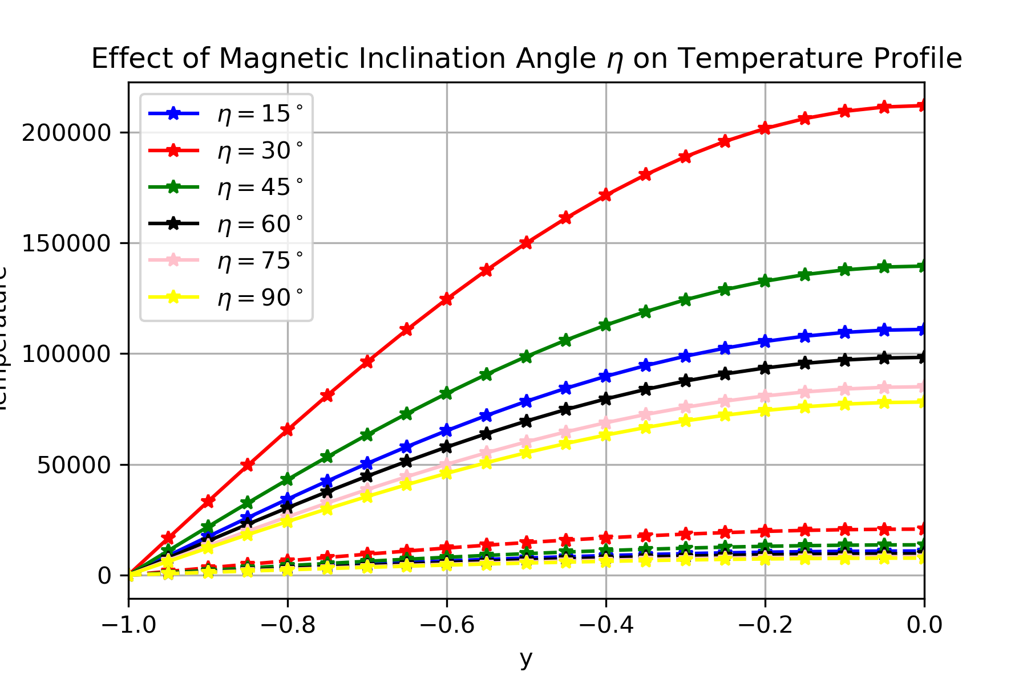

Figure 3: Effect of inclining magnetic field on temperature

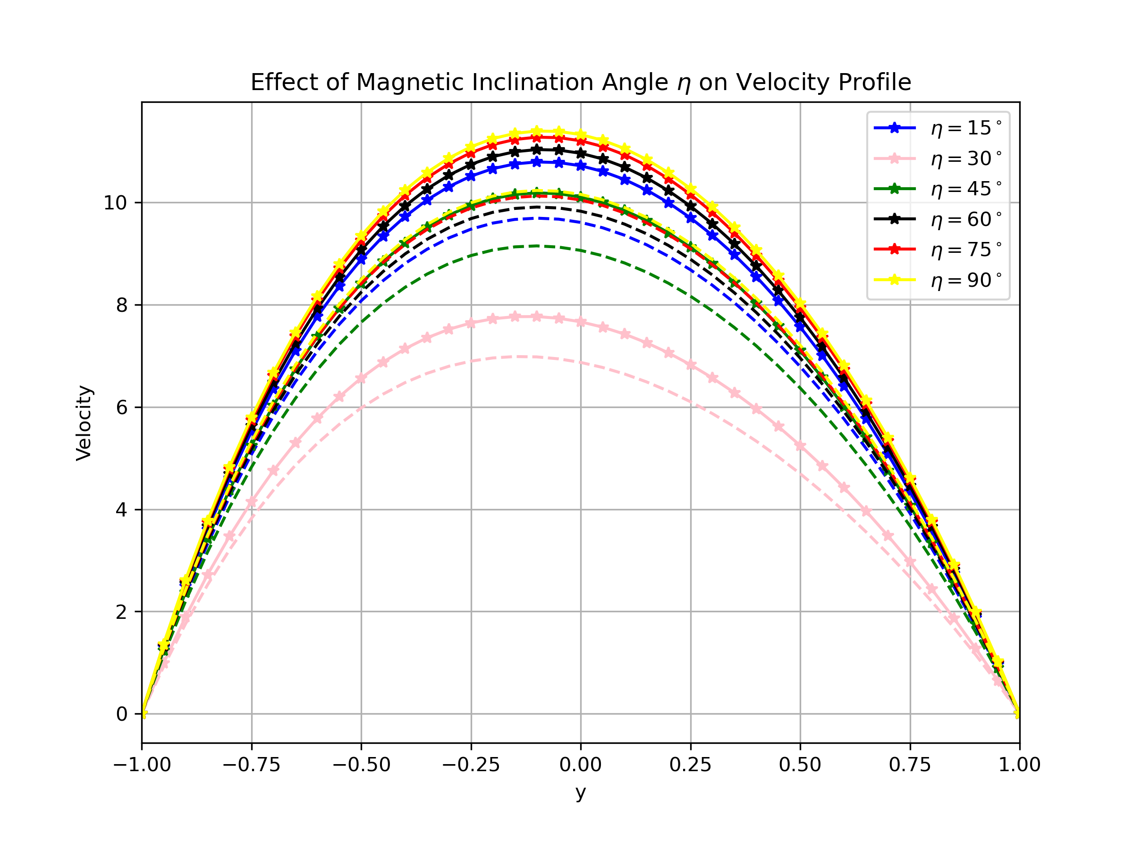

Figure 4: Effect of inclining magnetic field on Velocity u and

### 4.4 Effects of various parameters

#### 4.4.1 Effect of Modified Hartman number on velocity and temperature

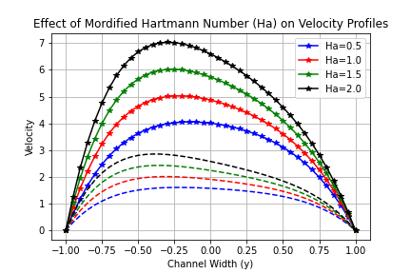

Figure 5: Effect of Modified Hartman number on Velocity u and

From figure 5, the velocity and increases with increase in Modified Hartman number. The use of Riga plates introduces an electromagnetic force that drives the fluid forward. This force is strong enough to overcome the natural resistance from viscosity, allowing both the clean fluid and the dust particles mixed in it to move faster. As a result, increasing the Hartmann number (Ha) boosts the velocity of both phases rather than restricting it

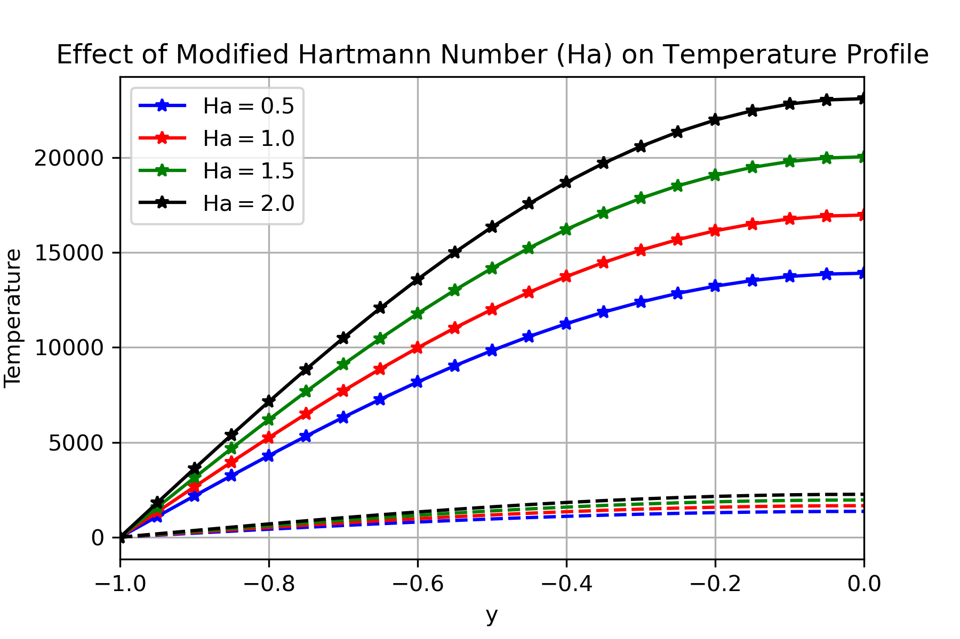

Figure 6: Effect of Modified Hartman number on temperature

Figure 6 illustrates that increase in Mordified Hartman number (Ha) results to increase in temperature of both fluid and dust particles. As observed by [10] this happens because the stronger electromagnetic force induces more motion, causing greater shear stress and frictional heating within the fluid. As the fluid moves faster under the influence of the Riga plate’s electromagnetic force, viscous dissipation also increases.

#### 4.4.2 Effect of pressure gradient on velocity and temperature

An increase in pressure gradient can be seen to increase the velocity as observed in figure 7. Pressure gradient acts as a driving force for the fluid and dust particles. Figure 8 illustrates the effect of pressure gradient on temperature. The increased velocity due to pressure gradient increase results in higher shear rates within the fluid, leading to increased viscous dissipation thereby raising the fluid’s temperature.

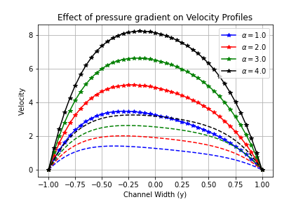

Figure 7: Effect of pressure gradient on Velocity u and

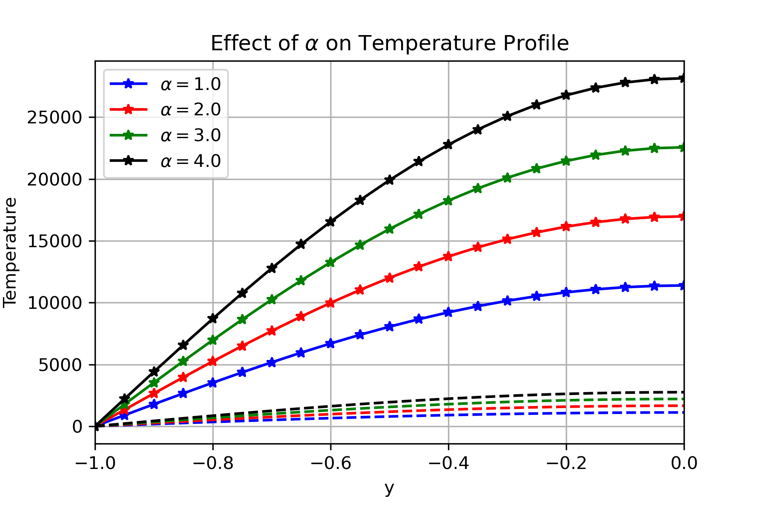

Figure 8: Effect of pressure gradient on temperature

### 4.5 Conclusion

The study has focused on the impact of magnetic field inclination and concentration on unsteady flow through parallel Riga plates where the upper plate is in motion. It has been established that increased concentration of the magnetic field decreases the velocity and increases the temperature of the flow. As the inclination angle increases, velocity generally rises, peaking at , while temperature decreases, indicating enhanced heat dissipation. However, presents an anomaly where both velocity drops and temperature spikes, suggesting a unique interaction affecting flow resistance and thermal behavior.

**Disclaimer (Artificial intelligence)**

Option 1:

Author(s) hereby declare that NO generative AI technologies such as Large Language Models and text-to-image generators have been used during the writing or editing of this manuscript.

**References**

1. Alam, M. S. (2016). Mathematical modelling for the effects of thermophoresis and heat generation/absorption on mhd convective flow along an inclined stretching sheet in the presence of dufour-soret effects. *Int. J. of Heat and Tech*, 3(3):119–128.
2. Ali, G., & Kumam, P. (2024). An exploration of heat and mass transfer for MHD flow of Brinkman type dusty fluid between fluctuating parallel vertical plates with arbitrary wall shear stress. *International Journal of Thermofluids*, *21*, 100529
3. Baoku, I., Israel-Cookey, C., and Olajuwon, B. (2012). Influence of thermal radiation on a transient mhd couette flow through a porous medium. *Journal of Applied Fluid Mechanics*, 5(1):81–87.
4. Chandrawat, R. K., Joshi, V., Tripathi, D., and Sadat, S. (2023). Numerical solutions of a time-dependent hydromagnetic micropolar dusty fluid between parallel plates through an inclined channel. *Pramana*, 97(1):24.
5. Das, U. (2017). Heat transfer to mhd oscillatory dusty visco-elastic fluid flow in an inclined channel filled with a porous medium. *Latin American Applied Research*, 47:145–150.
6. Gailitis, A. (1961). On a possibility to reduce the hydrodynamical resistance of a plate in an electrolyte. *Appl. Magnetohydrodyn.*, 12:143–146.
7. Ganesan, P. and Palani, G. (2004). Unsteady free convection flow of a dusty gas past a semi- infinite inclined plate with constant heat flux. *International Journal of Applied Mechanics and Engineering*, 9(3):483–492.
8. Hamza, M. M., Balarabe, A. Y., Ibrahim, M., Akpootu, D. O., & Sheriff, A. (2025). Transient fractional dusty fluid flow in a superhydrophobic microchannel. *The European Physical Journal Plus*, *140*(5), 366.
9. Islam, M. R. and Nasrin, S. (2020). Unsteady couette flow of dusty fluid past between two riga plates. *Authorea Preprints*.
10. Nasrin, S., Mondal, R., Alam, M., and Taylor, G. (2021). Unsteady couette flow past between two horizontal riga plates with hall and ion slip effects. *Math. Stat.*, 9(4):552–565.
11. Oroni, M. J., Richard, O., and David, A. (2024). Effect of inclined parallel riga plates and dusty particles on unsteady mhd stokes flow of a dusty fluid. *Int. J. Adv. Maths. and Mech*, 11:15–21.
12. Rafique, K., Alotaibi, H., Ibrar, N., and Khan, I. (2022). Stratified flow of micropolar nanofluid over riga plate: Numerical analysis. *Energies*, 15(1):316.
13. Sravan Kumar, T., Dinesh, P., and Makinde, O. (2020). Impact of lorentz force and viscous dissipation on unsteady nanofluid convection flow over an exponentially moving vertical plate. *Mathematical models and computer simulations*, 12:631–646.
14. Yabo, I. B., Jha, B. K., and Lin, J.-E. (2018). On a couette flow of conducting fluid. *International Journal of Theoretical and Applied Mathematics*, 4(1):8–21.