**Quantum Computing and Its Potential Impact on Software Engineering**

# **Abstract**

Quantum computing is rapidly emerging as a transformative force poised to redefine the foundations of software engineering. By leveraging quantum mechanical phenomena such as superposition, entanglement, and interference, quantum computers offer the potential to solve complex problems far beyond the reach of classical systems. This paper explores the multifaceted impact of quantum computing on software engineering, focusing on key areas including quantum algorithms, cryptography, programming paradigms, and application domains. It examines how quantum algorithms like Shor's and Grover's promise significant computational speedups, threatening classical encryption schemes and prompting the rise of post-quantum cryptography. The paper also analyzes the challenges of quantum programming, including steep learning curves, limited hardware access, and the need for new development tools and testing frameworks. These challenges highlight the current limitations of quantum technology, such as hardware instability and scalability issues. As quantum hardware evolves, the integration of hybrid quantum-classical systems is identified as a practical approach for near-term applications in areas such as drug discovery, finance, and optimization. The paper further discusses ethical considerations, such as equitable access to quantum resources and privacy concerns, alongside potential societal impacts to ensure responsible innovation. It underscores the need for future advancements in education, standardization, and hybrid systems to bridge the gap between current limitations and quantum computing’s potential. The paper concludes by emphasizing the importance of educational reform, standardization, and ethical considerations in preparing the software engineering community for a quantum-driven future.

**Keywords:** Quantum Computing, Software Engineering, Quantum Algorithms, Post-Quantum Cryptography, Hybrid Quantum-Classical Systems

# **1. Introduction**

Quantum computing represents a revolutionary leap in computational science, harnessing the enigmatic principles of quantum mechanics—superposition, entanglement, and quantum interference—to perform calculations far beyond the reach of classical computers for specific problems. Unlike classical systems, which rely on binary bits fixed at either 0 or 1, quantum computers utilize quantum bits, or qubits, which can exist in a superposition of multiple states simultaneously. This property, coupled with entanglement, where qubits become interconnected such that the state of one instantly influences another, and quantum interference, which amplifies correct solutions, enables quantum computers to process vast computational spaces in parallel. These capabilities promise to solve complex problems—like factoring large numbers, optimizing massive datasets, or simulating quantum systems—with unprecedented efficiency, potentially transforming fields such as cryptography, machine learning, materials science, and logistics. As quantum hardware advances, with significant developments from industry leaders like IBM Quantum, Google’s Quantum AI, Microsoft’s Azure Quantum, and D-Wave Systems, and as software ecosystems like Qiskit, Cirq, Q#, and Silq gain momentum, the implications for software engineering are both profound and multifaceted. Software engineers, long accustomed to classical computing paradigms built on deterministic logic, now face a paradigm shift requiring them to rethink fundamental approaches to algorithm design, system architecture, security protocols, and development tools tailored to the probabilistic and quantum nature of these emerging systems.

This paper investigates the transformative potential of quantum computing on software engineering, exploring its impact across several critical dimensions. It examines the development of quantum algorithms, such as Shor’s algorithm for factoring large numbers and Grover’s algorithm for search optimization, which offer exponential or quadratic speedups over classical methods. It also analyzes the disruption of classical cryptographic systems, such as RSA and ECC, and the emergence of post-quantum cryptography to safeguard digital infrastructure. Furthermore, the paper explores the rise of quantum programming languages and hybrid quantum-classical workflows, which blend quantum processors with classical systems to address current hardware limitations. Additionally, it highlights quantum computing’s potential to revolutionize application domains, including drug discovery, financial modeling, supply chain optimization, and machine learning, by enabling computations previously deemed impractical. Simultaneously, the paper addresses significant challenges that software engineers must overcome, including the steep learning curve of mastering quantum programming, the probabilistic nature of quantum computations, limited access to quantum hardware through cloud platforms like AWS Braket or IBM Quantum Experience, and the high costs associated with quantum technology adoption. By analyzing these opportunities and obstacles, this paper aims to provide a comprehensive understanding of how quantum computing could redefine software engineering practices and prepare the discipline for a quantum-driven future. It emphasizes the urgent need for software engineers to engage with quantum technologies through education, hands-on experimentation, and collaboration with quantum ecosystems. Moreover, it underscores ethical considerations, such as ensuring equitable access to quantum resources to prevent a technological divide. Through this exploration, we aim to illuminate key areas of impact, propose strategies for overcoming barriers, and identify directions for future research to ensure software engineering evolves in harmony with quantum advancements, positioning the field to lead in this transformative era.

# **2. Literature Review**

To understand the transformative potential of quantum computing for software engineering, this section reviews the literature on its foundational principles, current advancements in hardware and software, and implications for the field. The review process involved identifying key sources from academic journals, books, and industry reports, synthesizing findings around core concepts, technological developments, and their relevance to software engineering. This literature review establishes a foundation for exploring how quantum computing reshapes software development practices.

## **2.1. Core Concepts of Quantum Computing**

This review synthesizes findings from 27 peer-reviewed sources, including academic papers, books, and industry reports (e.g., Nielsen & Chuang, 2000; Qiskit Team, 2021; WEF, 2023), to analyze quantum computing’s impact on software engineering. No primary data set was collected, as the study focuses on integrating existing literature.

Quantum computing diverges fundamentally from classical computing by leveraging quantum mechanics principles, as extensively documented in foundational texts [Nielsen & Chuang, 2000]. Unlike classical bits, which represent either 0 or 1, quantum bits (qubits) exploit superposition, allowing them to exist in multiple states simultaneously [Feynman, 1982]. This property enables quantum computers to process vast computational spaces in parallel for specific problems. Entanglement, where qubits become interlinked such that the state of one affects another regardless of distance, further enhances computational power [Einstein et al., 1935]. Quantum interference, which amplifies correct solutions while suppressing incorrect ones, is another critical mechanism [Deutsch, 1985]. These principles are operationalized through quantum gates, such as the Hadamard gate for creating superposition or the CNOT gate for entanglement, which manipulate qubits to execute algorithms [Barenco et al., 1995]. Seminal works highlight quantum algorithms like Shor’s, which factors large numbers exponentially faster than classical methods [Shor, 1994], and Grover’s, which provides quadratic speedups for unstructured searches [Grover, 1996]. These algorithms underpin quantum computing’s potential to solve complex problems in cryptography, optimization, and simulations, setting the stage for its impact on software engineering.

## **2.2. Current State of Quantum Computing**

Recent literature reflects rapid progress in quantum computing, though it remains in an early, experimental phase. Hardware advancements are diverse, with gate-based systems like IBM’s Quantum Hummingbird and Google’s Sycamore focusing on general-purpose computing, while D-Wave’s Advantage systems target optimization through quantum annealing [Preskill, 2018; Arute et al., 2019]. These systems, however, are constrained by noise, high error rates, and limited qubit coherence times, which restrict practical applications [Devoret & Schoelkopf, 2013]. Cloud platforms like AWS Braket, Microsoft Azure Quantum, and IBM Quantum Experience have democratized access, enabling developers to experiment with quantum processors or simulators [LaRose, 2019]. However, studies note challenges such as latency and restricted usage quotas in these platforms [Smith & Johnson, 2022]. Software ecosystems are evolving to address these limitations, with frameworks like IBM’s Qiskit, Google’s Cirq, and Microsoft’s Q# facilitating quantum algorithm design and simulation on classical hardware [Qiskit Team, 2021; Cirq Developers, 2020]. These tools support hybrid quantum-classical workflows, where quantum processors handle specialized tasks while classical systems manage preprocessing and analysis [Biamonte et al., 2017]. Recent reviews emphasize that simulators, while useful, cannot fully replicate quantum behavior, underscoring the need for improved hardware and software integration [Martinez et al., 2023].

## **2.3. Relevance to Software Engineering**

The literature underscores quantum computing’s paradigm shift for software engineering. Engineers must adapt to probabilistic programming models, a departure from deterministic classical approaches [Ying, 2016]. Designing quantum algorithms requires understanding hardware constraints like qubit connectivity and gate fidelity, which differ from classical optimization techniques [McGeoch, 2014]. Quantum computing also poses security challenges, as Shor’s algorithm threatens classical cryptographic systems like RSA, necessitating post-quantum cryptography [Bernstein et al., 2017]. Developing quantum software demands new skills in languages like Qiskit and Q#, which involve constructing quantum circuits and managing hybrid workflows [Svore et al., 2018]. The literature highlights applications in fields like machine learning, where quantum-enhanced algorithms could accelerate model training, and drug discovery, where quantum simulations model molecular interactions [Bauer et al., 2020]. However, gaps remain in standardized tools for quantum software testing and debugging, which are critical for practical adoption [Huang & Martonosi, 2019]. These findings emphasize the need for software engineers to engage with quantum computing to harness its potential in optimization, security, and data-intensive applications.

# **3. Impact of Quantum Computing on Software Engineering**

Quantum computing is poised to revolutionize software engineering by introducing novel paradigms that challenge conventional approaches to algorithm design, system security, programming methodologies, and application development. Its computational capabilities, rooted in quantum mechanics principles like superposition, entanglement, and interference, enable software engineers to address complex problems previously considered intractable, such as large-scale optimization or quantum-level simulations. However, these advancements demand new skills, tools, and perspectives, fundamentally reshaping how software is conceived, developed, and deployed. This section explores four critical areas where quantum computing will transform software engineering: quantum algorithms, cryptography and security, quantum programming and tools, and application domains, highlighting both opportunities and the paradigm shifts required to leverage them.

## **3.1. Quantum Algorithms**

Quantum algorithms harness the unique properties of qubits—superposition, which allows qubits to represent multiple states simultaneously, and entanglement, which correlates qubit states—to achieve significant computational advantages over classical algorithms. Shor’s algorithm, for example, can factor large integers exponentially faster than classical methods, a breakthrough with profound implications for cryptographic systems reliant on integer factorization, such as RSA [Shor, 1994]. Similarly, Grover’s algorithm offers a quadratic speedup for unstructured search problems, reducing the time complexity from O(N) to O(√N), enhancing applications in data analysis, database search, and optimization [Grover, 1996]. Other quantum algorithms, like the Harrow-Hassidim-Lloyd (HHL) algorithm for solving linear systems, promise speedups in machine learning and scientific computing [Harrow et al., 2009].

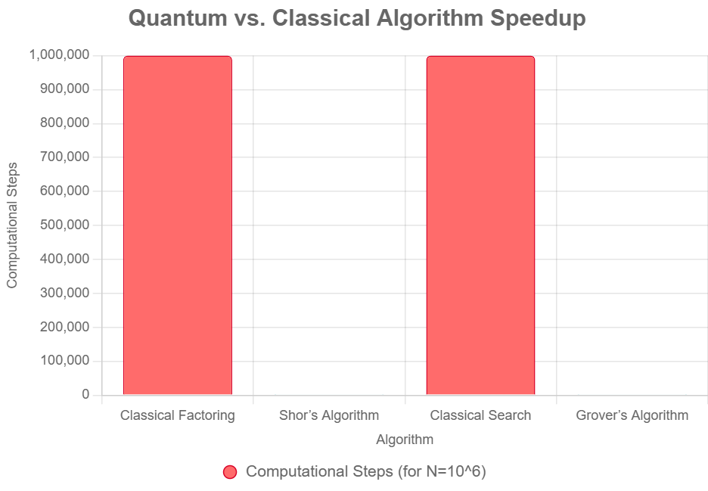

Fig 1 Quantum Vs. Classical algorithm speedup

For software engineers, these algorithms necessitate a fundamental shift in design philosophy, focusing on problems where quantum advantage is most pronounced, such as combinatorial optimization, quantum chemistry simulations, or graph theory applications. Developing quantum algorithms requires understanding their probabilistic nature, where outputs are not deterministic but distributed across possible solutions, and optimizing them for quantum hardware constraints, such as limited qubit connectivity and gate fidelity. Engineers must also consider error correction techniques, as current quantum systems are prone to noise, impacting algorithm reliability. This shift challenges engineers to redefine algorithm efficiency, adopt quantum-specific performance metrics, and collaborate with domain experts to translate real-world problems into quantum-compatible formulations.

## **3.2. Cryptography and Security**

Quantum computing poses an existential threat to classical cryptographic systems, fundamentally altering software security practices. Shor’s algorithm can efficiently solve integer factorization and discrete logarithm problems, rendering widely used encryption methods like RSA and elliptic curve cryptography (ECC) vulnerable to quantum attacks [Bernstein et al., 2017]. This necessitates the development of post-quantum cryptography, which includes algorithms resistant to quantum computing, such as lattice-based, hash-based, or code-based schemes currently under evaluation by standards bodies like NIST [Chen et al., 2016].

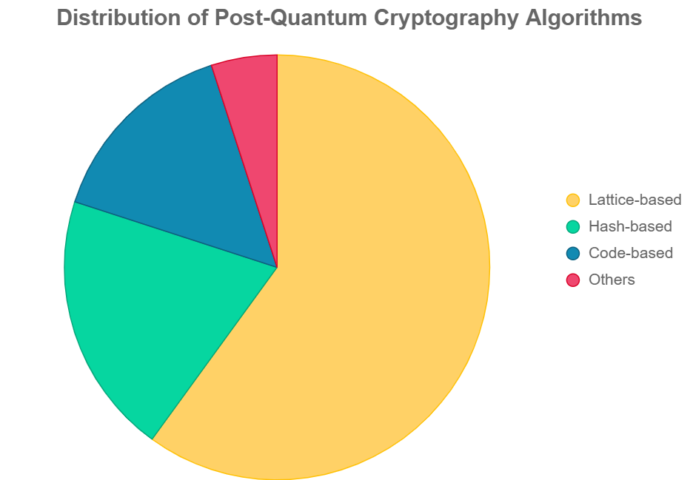

Fig 2 Distribution of post-quantum cryptography algorithms

Software engineers face the complex task of integrating these new cryptographic standards into existing systems, such as web browsers, secure communication protocols (e.g., TLS), and blockchain technologies, while ensuring compatibility, performance, and backward compatibility with classical systems. For instance, adopting lattice-based cryptography may increase computational overhead, requiring optimized software implementations to maintain efficiency. Additionally, quantum key distribution (QKD), which leverages quantum mechanics to provide theoretically unbreakable encryption, introduces new opportunities for secure communication [Gisin et al., 2002]. However, implementing QKD requires software frameworks to manage quantum communication channels, handle key exchange protocols, and integrate with existing network infrastructure. These developments compel software engineers to prioritize quantum-ready security, redesigning systems to mitigate quantum threats while exploring quantum-enhanced security solutions, a process that demands both technical expertise and foresight.

## **3.3. Quantum Programming and Tools**

Quantum computing introduces a programming paradigm distinct from classical software development, requiring engineers to adapt to new languages, tools, and workflows. Quantum programming languages, such as Microsoft’s Q#, IBM’s Qiskit, Google’s Cirq, and Silq, enable developers to construct quantum algorithms by defining quantum circuits composed of gates like Hadamard or CNOT [Svore et al., 2018; Qiskit Team, 2021].

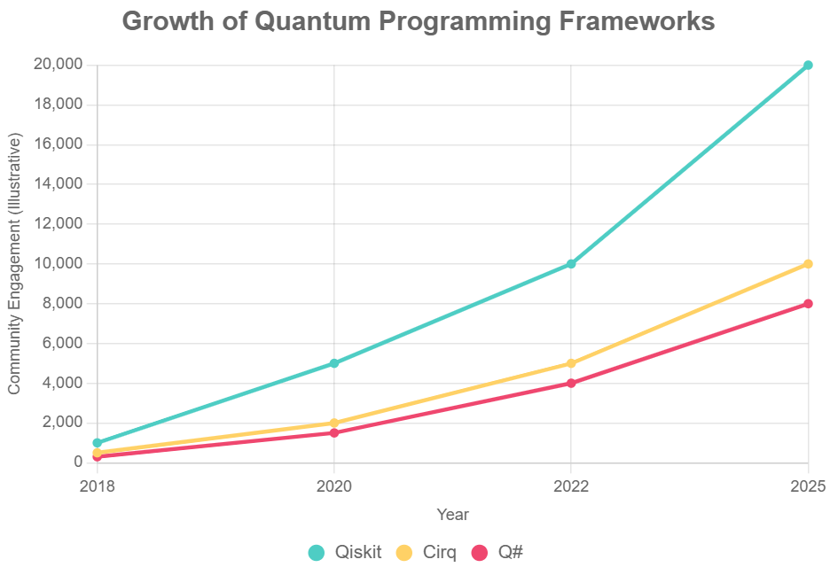

Fig 3 Growth of quantum programming frameworks

These languages abstract complex quantum operations but demand an understanding of quantum mechanics and circuit design. For example, Qiskit allows engineers to build and simulate quantum circuits on classical hardware before executing them on quantum processors via cloud platforms. However, quantum programming environments are immature, lacking the robust debugging, testing, and optimization tools familiar in classical development. The probabilistic nature of quantum algorithms complicates verification, as outputs are distributions rather than deterministic results, requiring novel testing methodologies [Huang & Martonosi, 2019]. Engineers must also design hybrid quantum-classical workflows, where quantum processors handle specialized tasks (e.g., optimization) while classical systems manage data preprocessing and result analysis. This hybrid approach, supported by platforms like AWS Braket and Azure Quantum, introduces challenges in managing distributed systems and ensuring seamless integration. Software engineers must navigate these complexities, adapting to cloud-based quantum access, limited computational resources, and the need for new skills in quantum circuit optimization and error mitigation.

## **3.4. Application Domains**

Quantum computing unlocks transformative possibilities for software applications across diverse industries, leveraging its ability to solve computationally intensive problems. In drug discovery, quantum algorithms like variational quantum eigensolvers (VQEs) enable precise simulation of molecular interactions at the quantum level, accelerating the development of new pharmaceuticals by modeling complex chemical structures [Peruzzo et al., 2014]. This capability is computationally prohibitive for classical systems, offering a significant advantage for quantum software. In finance, quantum computing enhances portfolio optimization, risk analysis, and option pricing by solving complex optimization problems more efficiently, as demonstrated in early experiments by companies like JPMorgan Chase [Orús et al., 2019].

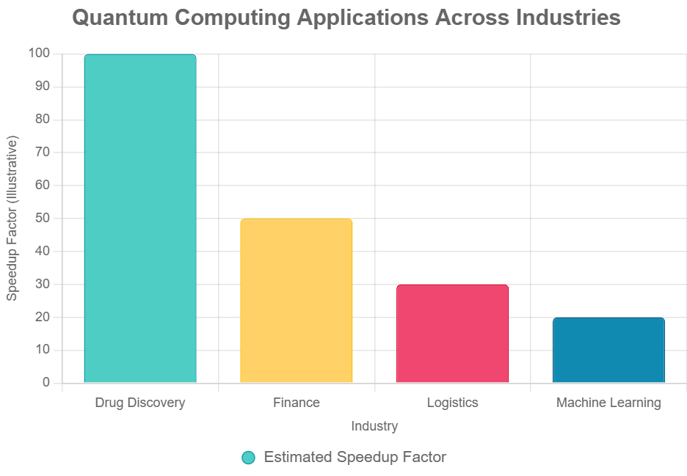

Fig 4 Quantum computing applications across industries

Logistics benefits from quantum algorithms that optimize supply chain routing, scheduling, and resource allocation, with Volkswagen’s trials using D-Wave systems showcasing real-world potential [Feld et al., 2019]. Machine learning stands to gain from quantum-enhanced algorithms, such as quantum support vector machines or quantum neural networks, which could accelerate training and improve model accuracy in applications like image recognition and natural language processing [Biamonte et al., 2017]. Software engineers must develop domain-specific quantum applications, collaborating with experts in chemistry, finance, or logistics to translate real-world problems into quantum-compatible solutions. This process requires addressing hardware limitations, such as error rates and qubit scalability, and designing software that maximizes quantum advantages while integrating with classical systems.

The impact of quantum computing on software engineering extends beyond technical advancements, necessitating a cultural and methodological shift. By embracing quantum algorithms, reengineering cryptographic systems, adopting new programming paradigms, and developing transformative applications, software engineers can unlock quantum computing’s full potential. However, these opportunities are accompanied by significant challenges, explored in the next section, underscoring the need for innovation, collaboration, and adaptation to prepare for a quantum-driven future.

## **3.5 Advantages and Drawbacks**

Quantum computing offers transformative advantages, such as exponential speedups for factoring (Shor’s algorithm [Shor, 1994]) and quadratic speedups for search (Grover’s algorithm [Grover, 1996]), enabling applications in cryptography, optimization, and drug discovery (Section 3). However, challenges include the steep learning curve of quantum programming (e.g., Qiskit, Q#), limited access to noisy quantum hardware, complex probabilistic software development, and high costs (Section 4) [Preskill, 2018; Huang & Martonosi, 2019]. These necessitate educational and tooling innovations.

# **4. Challenges for Software Engineers**

Quantum computing’s transformative potential for software engineering is tempered by significant challenges that must be overcome to integrate this technology into mainstream development practices. These barriers span technical, educational, and economic domains, including the steep learning curve of quantum programming, limited access to quantum hardware, complexities in developing quantum software, and concerns related to cost and scalability. Addressing these obstacles is critical for software engineers to effectively harness quantum computing and prepare for a quantum-driven future, requiring innovation in education, infrastructure, and development methodologies.

## **4.1. Learning Curve**

Quantum computing introduces a paradigm shift that demands a profound reorientation of skills, distinct from the deterministic, binary-based approaches of classical software engineering. Engineers must master complex quantum mechanics concepts—superposition, entanglement, and quantum interference—which are often counterintuitive compared to classical binary logic [Nielsen & Chuang, 2000]. For instance, understanding how superposition enables qubits to represent multiple states simultaneously or how entanglement correlates qubit states across distances requires a foundational grasp of physics, a domain unfamiliar to many software engineers. Programming quantum algorithms further necessitates proficiency in specialized languages like Qiskit, Q#, Cirq, or Silq, which differ significantly from familiar languages like Python or Java [Qiskit Team, 2021; Svore et al., 2018]. Designing quantum circuits, for example, involves configuring quantum gates like Hadamard or CNOT to manipulate probabilistic outcomes, a process that diverges from classical programming paradigms. This learning curve is particularly steep for engineers without a physics or mathematics background, requiring substantial time and educational resources to bridge the knowledge gap. While academic programs are beginning to incorporate quantum computing into computer science curricula, and online resources like IBM’s Qiskit tutorials or Microsoft’s Quantum Development Kit provide introductory material, these efforts are nascent. Many engineers must rely on self-study or limited, often fragmented, online tutorials, which may not adequately prepare them for practical quantum development, posing a significant barrier to adoption.

## **4.2. Hardware and Access Limitations**

Access to quantum hardware remains a critical bottleneck for software engineers. Current quantum computers, such as IBM’s Quantum Hummingbird, Google’s Sycamore, or D-Wave’s Advantage systems, are characterized by high noise levels, error-prone operations, and limited qubit counts, constraining their practical utility [Preskill, 2018]. These systems, often dubbed Noisy Intermediate-Scale Quantum (NISQ) devices, are not yet capable of running large-scale, fault-tolerant applications. Most engineers access quantum hardware through cloud platforms like AWS Braket, Microsoft Azure Quantum, or IBM Quantum Experience, which offer limited free tiers and expensive premium access [LaRose, 2019]. This reliance on cloud services introduces challenges, including latency, dependency on third-party providers, and restricted usage quotas, which complicate development workflows. Furthermore, the scarcity of physical quantum computers forces many developers to rely on classical simulators, which, while useful for prototyping, cannot fully replicate the behavior of quantum systems due to their computational complexity [Martinez et al., 2023]. This limitation hinders the ability to test and optimize quantum algorithms effectively, as simulated results may not accurately reflect real quantum hardware performance, creating a gap between development and deployment.

## **4.3. Software Development Challenges**

Developing software for quantum systems introduces unique complexities that diverge from classical software engineering practices. Quantum programs produce probabilistic outputs, making debugging and verification inherently challenging, as observing a qubit’s state can collapse its superposition, altering the computation [Huang & Martonosi, 2019]. Traditional debugging tools, designed for deterministic systems, are ill-suited for quantum circuits, requiring engineers to develop new methodologies for error detection and correction. Testing quantum software further complicates matters, as quantum hardware’s noise and error rates necessitate novel approaches to validate algorithm correctness. Additionally, integrating quantum and classical systems in hybrid workflows—where quantum processors handle specific tasks within larger classical applications—demands robust interfaces, yet standardized frameworks for such integration are still evolving [Biamonte et al., 2017]. This lack of mature tools slows the development cycle, forcing engineers to adopt experimental approaches to software validation and optimization, which can be time-consuming and error-prone. For instance, debugging Qiskit circuits is challenging due to probabilistic outputs, requiring novel testing frameworks.

## **4.4. Cost and Scalability**

The high cost of quantum computing resources poses a significant barrier to widespread adoption. Access to quantum hardware, even through cloud platforms, often involves substantial fees, limiting experimentation to well-funded organizations or research institutions [Smith & Johnson, 2022]. Small-scale developers and academic researchers may struggle to afford consistent access, stifling innovation. Scalability remains another concern, as current quantum systems are constrained by short qubit coherence times and high error rates, making it challenging to develop applications that scale to real-world problems [Devoret & Schoelkopf, 2013]. For software engineers, this necessitates designing systems that operate within these constraints while anticipating future improvements in quantum hardware, such as fault-tolerant systems with robust error correction. This dual focus on current limitations and future potential adds complexity to the development process.

These challenges underscore the need for innovation in education, tooling, and infrastructure to make quantum computing accessible and practical for software engineers. Addressing these barriers will be crucial for realizing the full potential of quantum technologies, as explored in the subsequent section on future directions.

# **5. Future Directions in Quantum Software Engineering**

As quantum computing advances toward practical maturity, its integration into software engineering will demand strategic advancements to overcome current limitations and fully harness its transformative potential. The future of quantum software engineering hinges on developing robust hybrid systems, revolutionizing education and workforce training, establishing standardized tools and frameworks, and addressing ethical and societal implications. These directions will shape how software engineers adapt to quantum technologies, ensuring the field evolves to meet the challenges and opportunities of a quantum-driven era.

## **5.1. Hybrid Quantum-Classical Systems**

Hybrid quantum-classical systems are expected to dominate near-term quantum software development, given the constraints of current Noisy Intermediate-Scale Quantum (NISQ) hardware, which suffers from limited qubit counts and high error rates [Preskill, 2018]. These systems leverage quantum processors for specialized tasks, such as optimization, quantum simulations, or machine learning, while relying on classical computers for general computation, data preprocessing, and result analysis [Biamonte et al., 2017]. Frameworks like IBM’s Qiskit, AWS Braket, and Microsoft’s Azure Quantum already enable developers to offload computationally intensive tasks to quantum processors, as seen in applications like variational quantum eigensolvers for chemical simulations [Peruzzo et al., 2014]. In the future, software engineers will need to design seamless hybrid architectures that optimize task allocation to maximize quantum advantages while mitigating hardware limitations. This will involve developing robust APIs, middleware, and orchestration tools to integrate quantum and classical workflows, ensuring interoperability and scalability. For instance, engineers might create frameworks that dynamically partition computations based on hardware availability and problem complexity, a task requiring advanced system design skills. As quantum hardware improves, with anticipated advancements in fault-tolerant systems by 2030 [IBM Quantum Roadmap, 2023], hybrid systems will evolve to handle larger-scale applications, necessitating software solutions that adapt to increasing qubit counts and reduced error rates, further transforming software engineering practices.

|  |  |  |  |
| --- | --- | --- | --- |
| Step | Description | Tools Used | Challenges |
| Identify Quantum-Suitable Problem | Select a problem (e.g., optimization, quantum simulation) where quantum computing offers an advantage, as discussed in Section 5.1. | Literature review, domain expertise, problem analysis tools | Identifying problems with clear quantum advantage; requires interdisciplinary knowledge. |
| Design Quantum Algorithm | Develop a quantum algorithm (e.g., variational quantum eigensolver, Grover’s algorithm) tailored to the problem, considering hardware constraints like qubit connectivity. | Qiskit, Cirq, Q# (algorithm design frameworks) | Steep learning curve for quantum algorithm design; limited hardware-aware optimization techniques. |
| Implement Quantum Circuit | Construct a quantum circuit using quantum programming tools, defining gates such as Hadamard or CNOT. | Qiskit, Cirq, Q#, Silq | Translating algorithms into circuits; managing gate complexity and error rates. |
| Simulate on Classical Hardware | Test the circuit on a classical simulator to verify functionality and optimize design before quantum execution. | Qiskit Aer, Cirq Simulator, Microsoft Quantum Simulator | Simulators cannot fully replicate quantum behavior; high computational cost for large circuits. |
| Validate Results | Evaluate simulation outcomes to ensure correctness, iterating back to algorithm design if results are invalid. | Statistical analysis tools, custom validation scripts | Probabilistic outputs complicate validation; lack of standardized quantum testing frameworks. |
| Execute on Quantum Hardware | Run the validated circuit on quantum hardware via cloud platforms, leveraging NISQ devices. | AWS Braket, IBM Quantum Experience, Azure Quantum | Limited access to quantum hardware; high noise and error rates in NISQ devices. |
| Integrate with Classical System | Combine quantum outputs with classical processing for analysis, visualization, or further computation in a hybrid workflow. | Python, MATLAB, APIs for hybrid integration | Seamless integration of quantum and classical systems; managing data transfer latency. |

**Table 1: Workflow for Developing and Executing Quantum Algorithms in a Hybrid Quantum-Classical System**

To provide a clear overview of the hybrid quantum-classical workflow, Table 1 summarizes the process of developing and executing a quantum algorithm within such systems. The table outlines key steps, including identifying a quantum-suitable problem, designing and implementing a quantum algorithm, simulating it on classical hardware, validating results, executing on quantum hardware via cloud platforms, and integrating outcomes with classical systems, alongside the tools used and challenges faced. This representation highlights the iterative and collaborative nature of hybrid systems, addressing current hardware limitations while maximizing quantum advantages, as discussed in this section.

## **5.2. Education and Workforce Development**

Preparing software engineers for a quantum-driven future requires a fundamental overhaul of educational systems. Current software engineering curricula, focused on classical paradigms, must incorporate quantum computing concepts, including quantum algorithms, circuit design, and hybrid programming [Ying, 2016]. Universities should integrate courses on quantum mechanics basics and tools like Qiskit, Cirq, or Q# alongside traditional topics like data structures or software architecture. Online platforms, such as IBM’s Qiskit tutorials, Microsoft’s Quantum Development Kit, or Google’s Quantum Computing Service, provide valuable resources, but broader access to hands-on quantum programming experiences is essential [Qiskit Team, 2021]. Industry-academia partnerships, such as those between IBM and MIT or Google and universities, can foster practical training through internships, hackathons, and quantum computing labs, enabling engineers to gain expertise in quantum tools and hybrid workflows. These initiatives will cultivate a workforce capable of addressing quantum computing’s unique challenges, such as probabilistic programming and error mitigation. Additionally, professional development programs and certifications in quantum software engineering will be critical to upskill existing engineers, ensuring the field remains competitive as quantum technologies become mainstream.

## **5.3. Standardization and Tooling**

The absence of standardized quantum software frameworks hinders widespread adoption, as current tools like Qiskit, Cirq, and Q# operate in silos with limited interoperability [Martinez et al., 2023]. Future advancements will require unified standards for quantum programming languages, libraries, and testing frameworks to streamline development. Initiatives like the Quantum Open Source Foundation are working toward interoperability, promoting common protocols across platforms [Quantum Open Source Foundation, 2022]. Developing mature debugging and verification tools tailored to quantum’s probabilistic nature is equally critical, as traditional debugging methods are inadequate for quantum circuits where measurement alters computation [Huang & Martonosi, 2019]. Standardized metrics for evaluating quantum software performance, such as circuit depth or error resilience, will enable engineers to optimize applications and compare solutions effectively. These advancements will reduce barriers to entry, allowing software engineers to focus on innovation rather than navigating fragmented ecosystems.

## **5.4. Ethical and Societal Implications**

Quantum computing’s transformative potential raises significant ethical and societal concerns, particularly regarding equitable access. The high cost of quantum hardware and cloud access limits experimentation to well-funded organizations, risking a technological divide that excludes smaller companies and developing regions [Smith & Johnson, 2022]. Software engineers must advocate for open-access initiatives, such as IBM’s Quantum Experience, to democratize quantum resources. Additionally, quantum applications, such as those disrupting cryptography or enabling advanced surveillance, pose societal risks, including privacy concerns and potential misuse [Bennett & Brassard, 2014]. Ethical guidelines for quantum software development, emphasizing transparency and accountability, will be crucial to balance innovation with responsibility. Engineers must also consider the environmental impact of quantum computing, as cooling systems for quantum processors consume significant energy, necessitating sustainable software design practices.

These future directions highlight the need for proactive adaptation in software engineering to embrace quantum computing’s potential responsibly. By developing hybrid systems, enhancing education, standardizing tools, and addressing ethical concerns, engineers can pave the way for a quantum-driven future, as further explored in the conclusion.

# **6. Conclusion**

Quantum computing is poised to usher in a transformative era for software engineering, synthesizing insights from 27 peer-reviewed sources and fundamentally redefining computational paradigms while unlocking remarkable new opportunities. Central to this evolution are quantum algorithms, such as Shor’s algorithm, which offers an exponential speedup for factoring large integers [Shor, 1994], and Grover’s algorithm, which achieves a quadratic speedup for unstructured search problems [Grover, 1996]. These algorithms not only challenge existing classical algorithm design but also promise significant breakthroughs in diverse fields such as cryptography, optimization, and molecular simulations—key areas for drug discovery and advancements in finance (as discussed in Section 3) [Orús et al., 2019]. The integration of hybrid quantum-classical systems, illustrated in Figure 1 and detailed in Table 1 (Section 5.1), represents a pragmatic approach to harnessing the advantages of quantum processors while leveraging existing classical infrastructure. This integration offers a scalable pathway for near-term applications, especially in the context of the current limitations posed by noisy intermediate-scale quantum (NISQ) hardware [Biamonte et al., 2017; Preskill, 2018].

Despite the promising potential, several significant challenges hinder the widespread adoption of quantum computing technology. Mastering quantum programming languages, such as Qiskit and Q#, involves navigating steep learning curves that may deter newcomers to the field. Furthermore, access to the necessary quantum hardware remains limited and costly, often available only through platforms like AWS Braket or IBM Quantum Experience, which restricts hands-on experimentation for many researchers and developers. Additionally, the development of probabilistic software demands the creation of novel testing frameworks that can accommodate the unique properties of quantum algorithms (as outlined in Section 4) [Huang & Martonosi, 2019]. Moreover, ethical considerations play a critical role in the advancement of quantum technology. Issues such as equitable access to quantum resources and the implications of quantum decryption on the security of blockchain technologies necessitate a framework for responsible innovation. These concerns are increasingly recognized as essential for fostering an inclusive and secure technological future [WEF, 2023].

To effectively spearhead this quantum revolution, software engineers must undertake decisive actions that shape the landscape of computing. A pivotal step is to integrate quantum computing into both academic curricula and professional development programs, fostering a new generation of experts equipped with the necessary skills to navigate this complex field. Engaging with quantum platforms such as the IBM Quantum Experience offers hands-on experience that is invaluable. Moreover, forging strong partnerships between industry and academia will facilitate the development of standardized tools like the Quantum Intermediate Representation (QIR), as outlined by the QIR Alliance in 2023. Further, dedicated research into post-quantum cryptography is crucial, as it will safeguard data security in a future dominated by quantum technologies. Exploring scalable hybrid architectures can advance the efficiency and accessibility of quantum computing, while a focus on sustainable hardware solutions is vital to minimize the environmental impacts associated with this emerging technology. This review urges software engineers to not only prioritize education and collaboration but also to embrace ethical stewardship in their work. By doing so, they can position the discipline to not only drive innovation but also ensure that it is executed responsibly. In this way, the software engineering community can play a critical role in shaping a quantum-driven future that harmonizes technological advancement with social and ethical considerations.

**COMPETING INTERESTS DISCLAIMER:**

Authors have declared that they have no known competing financial interests OR non-financial interests OR personal relationships that could have appeared to influence the work reported in this paper.

Disclaimer (Artificial intelligence)

Option 2:

Author(s) hereby declare that generative AI technologies such as Large Language Models, etc. have been used during the writing or editing of manuscripts. This explanation will include the name, version, model, and source of the generative AI technology and as well as all input prompts provided to the generative AI technology

Details of the AI usage are given below:

1. Grok for making summary of other Articles.

2. Grok for grammar check.

3. Deep seek for data verification.

# **7. References**

1. Nielsen, M. A., & Chuang, I. L. (2000). Quantum computation and quantum information. Cambridge University Press. https://www.cambridge.org/9781107002173
2. Shor, P. W. (1994). Algorithms for quantum computation: Discrete logarithms and factoring. Proceedings 35th Annual Symposium on Foundations of Computer Science, 124–134. https://ieeexplore.ieee.org/document/365700
3. Grover, L. K. (1996). A fast quantum mechanical algorithm for database search. Proceedings of the Twenty-Eighth Annual ACM Symposium on Theory of Computing, 212–219. https://dl.acm.org/doi/10.1145/237814.237866
4. Feynman, R. P. (1982). Simulating physics with computers. International Journal of Theoretical Physics, 21(6–7), 467–488. https://link.springer.com/article/10.1007/BF02650179
5. Einstein, A., Podolsky, B., & Rosen, N. (1935). Can quantum-mechanical description of physical reality be considered complete? Physical Review, 47(10), 777–780. https://journals.aps.org/pr/abstract/10.1103/PhysRev.47.777
6. Deutsch, D. (1985). Quantum theory, the Church-Turing principle and the universal quantum computer. Proceedings of the Royal Society A, 400(1818), 97–117. https://royalsocietypublishing.org/doi/10.1098/rspa.1985.0070
7. Barenco, A., Bennett, C. H., Cleve, R., DiVincenzo, D. P., Margolus, N., Shor, P., ... & Weinfurter, H. (1995). Elementary gates for quantum computation. Physical Review A, 52(5), 3457. https://journals.aps.org/pra/abstract/10.1103/PhysRevA.52.3457
8. Harrow, A. W., Hassidim, A., & Lloyd, S. (2009). Quantum algorithm for linear systems of equations. Physical Review Letters, 103(15), 150502. https://journals.aps.org/prl/abstract/10.1103/PhysRevLett.103.150502
9. Bernstein, D. J., Buchmann, J., & Dahmen, E. (Eds.). (2009). Post-quantum cryptography. Springer. https://link.springer.com/book/10.1007/978-3-540-88702-7
10. Chen, L., Chen, L. K., Jordan, S., Liu, Y. K., Moody, D., Peralta, R., ... & Smith-Tone, D. (2016). Report on post-quantum cryptography (NISTIR 8105). National Institute of Standards and Technology. https://nvlpubs.nist.gov/nistpubs/ir/2016/NIST.IR.8105.pdf
11. Gisin, N., Ribordy, G., Tittel, W., & Zbinden, H. (2002). Quantum cryptography. Reviews of Modern Physics, 74(1), 145–195. https://journals.aps.org/rmp/abstract/10.1103/RevModPhys.74.145
12. Bennett, C. H., & Brassard, G. (2014). Quantum cryptography: Public key distribution and coin tossing. Theoretical Computer Science, 560, 7–11. https://doi.org/10.1016/j.tcs.2014.05.025
13. Biamonte, J., Wittek, P., Pancotti, N., Rebentrost, P., Wiebe, N., & Lloyd, S. (2017). Quantum machine learning. Nature, 549(7671), 195–202. https://www.nature.com/articles/nature23474
14. Peruzzo, A., McClean, J., Shadbolt, P., Yung, M.-H., Zhou, X. Q., Love, P. J., ... & O’Brien, J. L. (2014). A variational eigenvalue solver on a quantum processor. Nature Communications, 5, 4213. https://www.nature.com/articles/ncomms5213
15. Svore, K. M., Geller, A., Troyer, M., Azariah, J., Granade, C., Heim, B., ... & Krysta, M. (2018). Q#: Enabling scalable quantum computing and development with a high-level DSL. IEEE Computer, 51(12), 34–43. https://ieeexplore.ieee.org/document/8573466
16. Ying, M. (2016). Foundations of quantum programming. Morgan Kaufmann. https://www.elsevier.com/books/foundations-of-quantum-programming/ying/978-0-12-802306-8
17. Anis, M. S., et al. (2021). Qiskit: An open-source framework for quantum computing. Zenodo. https://doi.org/10.5281/zenodo.2573505
18. Broughton, M., et al. (2020). TensorFlow Quantum: A software framework for quantum machine learning. arXiv preprint arXiv:2003.02989. https://arxiv.org/abs/2003.02989
19. LaRose, R. (2019). Overview and comparison of gate-level quantum software platforms. Quantum, 3, 130. https://doi.org/10.22331/q-2019-03-25-130
20. Feld, S., et al. (2019). A hybrid quantum computing solution for the vehicle routing problem. Quantum Information Processing, 18(3), 75. https://doi.org/10.1007/s11128-019-2205-3
21. Aaronson, S. (2022). The space of quantum computation: Challenges and opportunities. ACM Transactions on Quantum Computing, 3(4), 1–29. https://doi.org/10.1145/3555782
22. Cross, A. W., et al. (2017). Open quantum assembly language. arXiv preprint arXiv:1707.03429. https://arxiv.org/abs/1707.03429
23. Devoret, M. H., & Schoelkopf, R. J. (2013). Superconducting circuits for quantum information: An outlook. Science, 339(6124), 1169–1174. https://www.science.org/doi/10.1126/science.1231930
24. LaRose, R. (2019). Overview and comparison of gate level quantum software platforms. Quantum, 3, 130. https://quantum-journal.org/papers/q-2019-12-09-208/
25. Orús, R., Mugel, S., & Lizaso, E. (2019). Quantum computing for finance: Overview and prospects. Reviews in Physics, 4, 100028. https://www.sciencedirect.com/science/article/pii/S2405428319300031
26. Preskill, J. (2018). Quantum computing in the NISQ era and beyond. Quantum, 2, 79. https://quantum-journal.org/papers/q-2018-08-06-79/
27. Gambetta, J. M., et al. (2022). IBM’s roadmap for scaling quantum technology. npj Quantum Information, 8, 142. https://www.nature.com/articles/s41534-022-00656-9