CASE REPORT

POST-OPERATIVE PHYSIOTHERAPY INTERVENTION OF COMPLETE QUADRICEPS TENDON RUPTURE

ABSTRACT
Aims: The complete quadriceps tendon rupture is uncommon injury and there is limited data regarding the therapeutic intervention and it’s clinical outcomes. This case report describes a post-op rehabilitation of complete quadriceps tendon rupture to fast and safe return to normal of daily livings and work and attempts to fill the gap apparent in the existing literature.
Case Presentation: The patient was a middle aged man and had a complete rupture of right quadriceps as a result of sudden fall with hyperflexion of knee. On examination, his right knee was swollen, tenderness over the distal thigh, unable to straighten and ambulation. The plain radiograph revealed patella baja, thus ordered magnetic resonance imaging, which confirmed complete rupture of quadriceps. It was surgically repaired consequently referred to post-operative physiotherapy programme to reach potential functional outcomes. The well-structured postoperative physiotherapy was progressed gradually for returning to the routine works at 8 weeks, complete active range of motion at 16 weeks and get back to work at 24 weeks.
Discussion: The complete quadriceps tendon rupture is uncommon injury and there is limited data regarding the therapeutic intervention and its clinical outcomes. This case report supports the effectiveness of a well-structured rehabilitation exercise programme that focuses on joint mobility, muscular flexibility and strengthens in order to achieve a potential functional capacity that promotes the patient’s optimal health and socioeconomic wellbeing with the consistent in the limited complete quadriceps rupture rehabilitation current evidence.
Conclusion: This study recommends that early surgical intervention followed by a well-structured postoperative rehabilitation programme aids to get a full advantage of functional outcomes and safe return to work. Also it emphasises the importance of further research to establish the clinical relevance in long-term impact of these intervention and validation as a single case report is not sufficient for establishing broad conclusions.

Keywords: Quadriceps rupture, Therapeutic exercise, Post-operative protocol, Physiotherapy rehabilitation, Exercise therapy

INTRODUCTION

Acute knee pain is a common problem in the primary care clinical setting, mainly acute knee pain caused by injuries, which increases with the involvement of trauma. The quadriceps tendon rupture (QTR) is uncommon injury that significantly affects middle-aged males (Pope et al., 2025). This incidence is estimated around 0.1 in 100,000 in the first four decades of life and then climbing to 0.6 in 100,000 between 40 and 69 years of age (Coladonato et al., 2024). The most common cause of this injury is falls which happens after a powerful eccentric contraction of the quadriceps muscle when the knee is flexed and the foot stays firmly on the ground, however, there are number of other predisposing risk factors including body mass index varied between 30.0 ± 6.05 kg/m², associated comorbidities including diabetes mellitus, obesity, chronic renal failure, metabolic bone disease rheumatoid arthritis, gout and polyneuropathy may increase the risk of QTR (Pichone et al., 2024). Furthermore, corticosteroid injections in and around tendons are found to change the collagen composition and can cause spontaneous rupture, which was reported in 3.2% of cases. Long term use of quinolone antibiotic medication has also been linked with spontaneous quadriceps ruptures, however the exact mechanism is unclear (Morales et al., 2019). A few centimetres proximal to the superior pole of the patella at the osseotendinous junction were the most common sites where the tear was observed. A study revealed that three major vascular arcades provide blood supply to the quadriceps tendon though relatively hypovascular zone exists about 1–2 cm superior to the patella this likely makes this insertional tendon more susceptible to injury. It is observed in 65% of individuals, at the patellar tendon over the patella, 25% at the patellar quadriceps tendon insertion, and 10% at the patellar insertion over the tibial tuberosity (Nori, 2018).
The complete QTR is a well-described injury, however, there is a high rate of possibility to delay the QTR diagnosis due to both pain and swelling thus rely on radiological image is unavoidable. The plain x-ray clinical features of a low-riding patella or patella baja, obliteration of the quadriceps shadow, a supra patellar soft tissue mass because of the retracted tendon and an osseous avulsion fragment from the proximal pole of the patella reveal QTR (Venkatasamy et al., 2014) however, magnetic reasoning image is gold standard to precisie diagnosis of QTR (Barad et al., 2022). Early surgical intervention and post-operative rehabilitation of QTR has been shown to better outcomes of full range of motion and a return to complete functional capacity (Bae et al., 2021). There is limited data regarding the outcomes of complete QTR rehabilitation thus this case report provides the outcome of complete QTR followed by the surgical correction and structured post-op rehabilitation.

CASE REPORT

A 46 years male had history of fall on the street and was unable to straighten his leg with excruciating pain. He was taken to hospital, physical examination findings were swelling of right knee, a suprapatellar gap and ambulation was not possible this made an index suspicion of quadriceps rupture consequently referred to x-ray and magnetic resonance imaging (MRI) (Fig.1), which confirmed that the patella was enlocated and complete rupture of the quadriceps tendon from its insertion on the patella, there was a small oedematous tendon stump remaining attached to the superior pole of the patella measuring 16mm in length and the patellar tendon was intact, Consequently, he underwent quadriceps tendon reconstruction surgery and referred to physiotherapy rehabilitation following surgery. At 6months followup (Fig. 2), the patient carried out independent activity of livings and recruited into work return programme.

2.1 THERAPEUTIC INTERVENTION

2.1.1 Surgical Intervention
Standard medial parapatellar approach was taking care to achieve haemostatsis through dissection. Large amount of haematoma released from site of rupture. Rupture clearly visulalised and time taken to dissect to create adequate views of retinaculum tear for evaluation. Attention then shifted to patella where 2*2.5mm drill holes were created in patella. 5-0 Ethibond in Krackow suture technique used to repair quadriceps tendon to patella ensuring robust repair. Retinaculum rupture addressed again using 5-0 Ethibond with continuous suture at lateral aspect of knee and figure-of-eight sutures on medial aspect, again making certain full deficit adequately repaired and repair was robust through extension and flexion. The surgeon satisfied that both patellar tendon and knee retinaculum had been repaired then knee irrigated thoroughly with saline and aqueous chlorhexidine solution. The surgical incision closure was with Vicryl to deep fat, 2-0 Vicryl to subcutaneous tissue and staples to skin. Dressed with opsite, orthoban and crepe then keen was placed into Zimmer knee brace in extension.

2.2 FOLLOW-UP AND OUTCOMES

2.2.1 Post-operative rehabilitation program
Our case report presents a patient was active and in good health. Therefore, assisting the patient in reaching a safe and speedy recovery to his prior level of physical activness and manageing his expectations were some of the tasks related to the rehabilitation exercise program following surgery. Based on the examination, along with the recommendations of the surgeon and with the patint’s needs and preferences the physiotherapist set the specific goals through a well-structured rehabilitation regimen that focuses on joint mobility, muscular flexibility and strengthening lead to gain fast and safe optimal functional outcomes including activities of daily living, work-related tasks and recreational goals (Table 1).

DISCUSSION

This study is to describe a meticulous post-operative physiotherapy regimen to facilitate the return of normal routine activities and participation in workforce as fully as after the surgical treatment of complete quadriceps tendon rupture. The quadriceps tendon rupture usually occurs in middle age men either trauma or spontaneously caused by falls following a powerful eccentric contraction of the quadriceps muscle when the knee is suddenly flexed and the foot is planted on the ground and related to the chronic systemic illness, which includes diabetes, gout, rheumatoid arthritis (Zuke WA et al., 2017) and long term quinolone antibiotic or steroid medication (Pocock NA et al., 2008). A healthy 53-year-old man without any comorbidities, long term medication and no history of steroid injection participated in our study. The diagnosed of quadriceps rupture is based on appropriate mechanism of injury history and clinical presentation of acute pain, swelling, inability to extend knee or ambulation and a suprapatellar gap. When having index suspicion of QTR through physical examination precise diagnosis is confirmed by the MRI due to severity of pain and swelling (Yan B, 2012). Our victim had history of fall on the street and was unable to straighten his leg with excruciating pain, swelling, suprapatellar gap and inability to actively extend the knee also ambulation was not possible. His pain level was an 8/10 on visual analogue scale and there was a massive knee swelling thus ordered MRI to confirm the diagnosis, which revealed complete rupture of the distal quadriceps tendon without retraction there was a small oedematous tendon stump remaining attached to the superior pole of the patella measuring 16mm in length and the patellar tendon was intact. Most frequently, the tendon tears transversely in the tendon’s degenerative region, approximately 20mm from the superior pole of the patella (Grecomoro R et al., 2008).
For patients with complete QTR, the surgical correction of the quadriceps tendon is advised to decrease mainly the secondary complications and give a fast and safe prognosis (Saito T et al., 2015). It is found in a study that the primary cause for inadequate functional outcomes and increased risk of post-operative complications is delayed surgical intervention (Coladonato et al., 2024). In our patient, within 14 days following the injury, the surgical repair was performed, to provide optimisation of a full return of functional capacity and reduce the risk of overall post-operative complications. Remarkably, our patient resumed fully to routine activities in 12th week and resumed work in the 24th week following surgery. Krackow, Bunnell and Kessler for repairing a ruptured tendon are some of the recommended surgical techniques and sutures. According several biomechanical studies the Krackow suture has been found to have increased axial resistance in endurance, repair strength and durability compare to other sutures, however uisng the Krackow suture is technically more difficult (Manent G et al., 2017). In our study, Krackow suture technique was used to repair quadriceps tendon to patella ensuring robust repair.
A comprehensive goal-oriented post-operative physiotherapy is a vital to achieve and sustain rapid recovery and optimal functional outcomes (Coladonato et al., 2024). The patients in our case study, followed a comprehensive goal-oriented post-operative physiotherapy interventions twice a week for 8 weeks and effective scheduled home exercise regimen. It has been oberserved that in order to preserve tendon repair and permit full healing, in terms of post-operative rehabilitation, knee joint immobilisation in full extension is necesary for six weeks following surgical correction (Saito T et al., 2015). In the present case, the knee was immobilised with hinged knee brace for six weeks in full extension and gradually increased the flexion degrees of knee the brace until the 12th week then the knee brace was detached. The research suggests that knee immobilisation in a brace is safe for two to three months, or until the patient takes back the control over their muscles and their level of discomfort reduces although a number of literature advocates that use of brace immobilisation can be varied depending on the type of injury whether it is partial or complete rupture (Howard J et al., 2010). Protecting the suture repair is necessary, as a re-rupture can irreversibly affect the tendon rehabilitation prognosis. In majority of tendon re-rupture are treated surgically have a lenghtly recovery period and poor functional outcomes consequently a negative effect on both person physical wellbeing and socio-economical aspect because re-operation is usually more demanding the soft tissues and tendon, requiring a graft to re-build the destroyed anatomical construction (Plesser S et al., 2018).
Regaining the full range of motion (ROM) and increasing the weight bearing gradually on the knee through build strength and balance should be the main focus in rehabilitation. One week after the surgery, the ROM exercises can be initiated, staring with passive ROM exercises, and then followed by active ones (Saito T et al., 2015). A study has shown that involving passive ROM exercises during an initial post-operative phase have effectively restorated the extensor mechanism of the knee and reducing the secondary complications associated with joint immobilisation. The progressive active assisted and active ROM exercises are crucial to restore full ROM and functional capacity while avoiding secondary post-operative joint stiffness and muscular contracture complication. However, it is important that the patient should bear the level of pain to protect the integrity of the tendon (West R et al., 2008). As part of post-operative rehabilitation, gradually muscle strengthening is a important for regaining maximal muscle strength and knee stability during functional tasks related to knee. Therapeutic exercises should focus on joint mobility, muscular flexibility and strengthen in order to achieve a potential functional capacity that promotes the patient’s optimal health and socioeconomic wellbeing.

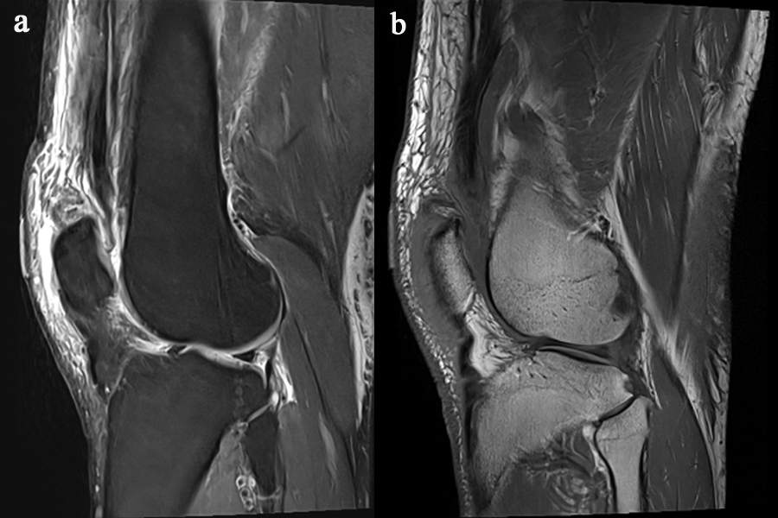

Fig. 1: Sagittal T1 and PD fat sat MRI demonstrating complete quadriceps tendon
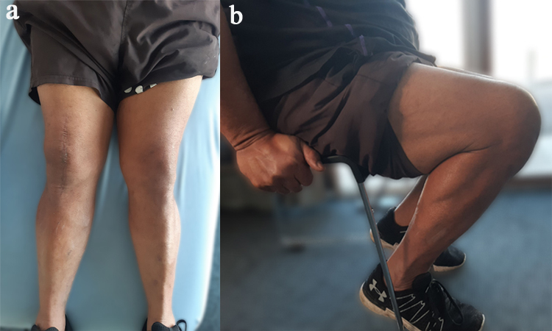

Fig.2: Primary healed scar and full knee extension(a) and right knee flexion compared to left (b) at six months post-operative physiotherapy follow up

CONCLUSION
The complete quadriceps tendon rupture is an uncommon injury in a healthy adult, however, early diagnosis, surgical correction and a subsequent well-structured rehabilitation regimen that focuses on joint mobility, muscular flexibility and strengthening lead to gain fast and safe optimal functional outcomes including activities of daily living, work-related tasks and recreational goals. This case report provides the detailed post-operative rehabilitation and attempts to fill the gap apparent in the contemporary literature.

DISCLOSURES
Ethical Approval
The author has confirmed that obtained relevant patient’s informed written consent. In the form, the patient has given their consent for their images and other clinical information to be reported in the journal by concealing their identity.

TABLE
Table 1: Followed the rehabilitation programme after reconstructing complete rupture of quadriceps tendon

REFERENCES

- Pope, J. D., El Bitar, Y., Mabrouk, A., & Plexousakis, M. P. (2025). Quadriceps Tendon Rupture.
- Coladonato, C., Hanna, A. J., Patel, N. K., Sonnier, J. H., Connors, G., Sabitsky, M., Johnson, E., Mazur, D. W., Brahmabhatt, S., & Freedman, K. B. (2024). Risk Factors Associated With Poor Outcomes After Quadriceps Tendon Repair. Orthopaedic Journal of Sports Medicine, 12(2). https://doi.org/10.1177/23259671241229105
- Pichone, A., Juvencio, E. L., Crespo, B., Gomes, C. P., de Souza Mendes, R., Godinho, M. R., Fernandes Ladeira, A. C., Leite, M., & Matheus Guimarães, J. A. (2024). Patellar and quadriceps tendon rupture are associated with hip fracture in hemodialysis patients with severe hyperparathyroidism. JBMR Plus, 8(2). https://doi.org/10.1093/jbmrpl/ziae008
- Morales, D. R., Slattery, J., Pacurariu, A., Pinheiro, L., McGettigan, P., & Kurz, X. (2019). Relative and Absolute Risk of Tendon Rupture with Fluoroquinolone and Concomitant Fluoroquinolone/Corticosteroid Therapy: Population-Based Nested Case–Control Study. Clinical Drug Investigation, 39(2). https://doi.org/10.1007/s40261-018-0729-y
- Nori, S. (2018). Quadriceps tendon rupture. Journal of Family Medicine and Primary Care, 7(1), 257–260. https://doi.org/10.4103/jfmpc.jfmpc_341_16
- Venkatasamy, A., Ehlinger, M., & Bierry, G. (2014). Acute traumatic knee radiographs: Beware of lesions of little expression but of great significance. In Diagnostic and Interventional Imaging (Vol. 95, Issue 6). https://doi.org/10.1016/j.diii.2013.09.012
- Barad, H. V., Patel, V., Patel, S., & Patel, M. (2022). To determine the role of ultrasonography as a primary imaging modality as compared to MRI in patients with shoulder pain. Journal of Family Medicine and Primary Care, 11(5). https://doi.org/10.4103/jfmpc.jfmpc_2509_20
- Bae, A. S., Collins, D. W., Jardaly, A. H., & Fernicola, P. J. (2021). Successful surgical repair of acute quadriceps tendon rupture utilizing cortical button fixation: A case report. American Journal of Case Reports, 22(1). https://doi.org/10.12659/AJCR.934238
- Zuke WA, Hallstrom B, & Murray MR. (2017). The quadriceps tendon: A functional and anatomical overview. Orthopaedic Journal, 45(2), 102–108.
- Pocock NA, Harris RD, & Ryan CJ. (2008). Long-term antibiotic use and tendon rupture: A clinical review. Clinical Medicine Review, 6(4), 224–232.
- Yan B. (2012). MRI diagnostics in sports injuries: A comparative study. Radiological Studies, 55(7), 122–130.
- Grecomoro R, Napoli A, & Mancuso G. (2008). Degenerative changes in the quadriceps tendon: A histological analysis. Histopathology Research, 49(11), 954–960.
- Saito T, Suzuki K, & Nakashima Y. (2015). Surgical outcomes of quadriceps tendon ruptures: A multicenter study. Surgical Techniques Journal, 64(3), 270–276.
- Manent G, López-Valverde A, & Monleon T. (2017). Biomechanical evaluation of suture techniques in tendon repairs. Journal of Orthopaedic Surgery, 25(6), 898–905.
- Howard J, Mattacola C, Romina M, & Lattermann C. (2010). Post-operative rehabilitation of quadriceps tendon injuries. American Journal of Sports Medicine, 38(5), 995–1000.
- Plesser S, Keener JD, & Hutchinson MR. (2018). Post-surgical rehabilitation of tendon injuries: A review. Journal of Orthopaedic Research, 36(2), 291–298.
- West R, Keene JS, & Kaplan LD. (2008). The importance of pain management in post-operative tendon rehabilitation. Pain Management Journal, 9(6), 459–465.
- Vasiliadis, A. V., Maris, A., Tsoupli, A., & Saridis, A. (2019). Rehabilitation exercise program after surgical treatment of quadriceps tendon rupture: A case report. Physical Therapy in Sport, 39, 82–89. https://doi.org/10.1016/j.ptsp.2019.07.001
Phase | Specific instructions | Goals | Interventions
Phase I  (1-2 weeks) | Partial weight bearing on crutches knee brace locked in full knee extension | Control pain/swelling and wound healing  Passive knee ROM  0-30 | Ice therapy  Elevation  Ankle pumps  Heel slides in and out  Isometric hamstring and gluteal sets
Phase II  (3-6 weeks) | Weight bearing on crutches  knee brace locked in full extension | Regain knee motion  Passive knee ROM  0- 45 | Continue swelling management  Patellar mobilizations  Isometric quadriceps, hamstring and gluteal sets  Hamstring/calf stretch
Phase III  (7-12 weeks) | Weight bearing without crutches and with knee brace locked in full extension  open to  week 8: 30  week 10: 60  week 12: 90 | Improve knee ROM  Restore muscle strengthening  Gait training  Passive knee ROM  0 -90  Active knee ROM from  week 8: 30  week 10: 60  week 12: 90 | Suggested therapeutic exercises (use of elastic resistance bands,  Stairs climbing (9th week)  Stationary bike (11th week)  Closed chain: light wall squats (0- 40)  Proprioceptive exercises: balance board
Phase IV  (13-16 weeks) | Normalize gait on all surfaces  _ Muscle strengthening | Active knee ROM from  0 - 130:  week 13: 110  week 16: 130  Weight bearing without crutches  and knee brace | Aquatic exercises that stimulate freestyle and breaststroke leg kicks with the use also of large fins  (14th week)

Table 1: Followed the rehabilitation programme after reconstructing complete rupture of quadriceps tendon (Vasiliadis, A. V et al., 2019)

