Larvicidal efficacy of eco-friendly zinc oxide and manganese dioxide nanoparticles: A comparative study

ABSTRACT

Mosquito act as a major vector in dispersal of infectious diseases which causes millions of deaths around the globe. Since the larval stage of mosquito is mainly dependent on stagnant water bodies, they can be controlled at this stage easily as compared to adult stage. Many synthetic or natural chemical agents are being used to control mosquito larvae, however, they often cause deleterious effects on other non-target aquatic species. Zinc oxide and manganese dioxide nanoparticles, fabricated using pomegranate leaves aqueous extract, and ecofriendly nontoxic to aquatic animals, were assessed for their potential larvicidal activities in the present work. Mosquito larvae were subjected to varied doses of both the nanoparticles over a 96-hour exposure and percent mortality, if any, was recorded after every 24-hour time interval. The present work exhibits pomegranate mediated zinc oxide and manganese dioxide nanoparticles, both, to be effective larvicidal agents, though more profound activity was recoded in zinc oxide nanoparticles. Thus, the proposed work proposes ecofriendly nano-approaches for mosquito control.

Keywords: green synthesis, larvicidal activity, manganese dioxide nanoparticle, mosquito larvae, pomegranate leaves extract, zinc oxide nanoparticle

1. INTRODUCTION
Mosquito acts as a mechanical and/or biological vector for various infectious diseases like malaria, Japanese encephalitis, filariasis, chickengunya, dengue etc. Most of these diseases, if not diagnosed well within time, can lead to death of the patient. Mosquitos complete their life cycle almost within 3 weeks encompassing egg, larva, pupa and adult stages. These are one of the most widespread insects that breed in stagnant water bodies. From egg to pupal stages, mosquitos can be found in quite aquatic environment whereas the adults are non-aquatic, prefer land and air, thus can spread the infectious diseases from one animal to other (Onen et al., 2023). Since the adult stages are difficult to catch and kill, it is advisable to focus on the larval stages of mosquitos for controlling the same. Many chemical and herbal formulations are spread on stagnant water bodies so as to prevent the breeding of mosquitos or kill their larval and pupal stages. However, the chemical composition of these formulations often harm aquatic ecosystems by affecting non-target species. Also, the mosquitos may develop resistance to these chemicals over a period of time (Chatterjee et al., 2023). In recent years, metal-based nanoparticles (MNPs) have developed as an alternative tool in the fight against mosquito vectors (Minwuyelet et al., 2025).

Now-a-days, green synthesis of nanoparticles is on rise and demand, due to their ecofriendly sustainable nature with significant biological activities. Among various biological sources, plant-mediated synthesis using leaf extracts has gained popularity owing to the rich presence of phytochemicals such as flavonoids, tannins, polyphenols and alkaloids, which act as natural reducing, stabilizing and capping agents during nanoparticle formation (Osman et al., 2024). Plants have been extensively explored for their several phytoconstituents with potential insecticidal activities. Since these phytoconstituents biodegrade quickly, insects do not get sufficient exposure to develop resistance against these. Most of these active phytochemicals may act as either attractants, anti-feedants, anti-molting hormones or molting hormones, thus interfere with insect body functioning (Souto et al., 2021). Pomegranate (Punica granatum) leaves extract has been widely recognized for its high content of bioactive compounds, including polyphenols, ellagic acid, and flavonoids (Salem et al., 2023). Pomegranate crude juice has been shown to be effective against cotton leaf worm (Farag & Emam, 2016). The phytochemicals of pomegranate plant facilitate the reduction of metal ions to nanoparticles with enhanced stability and biological properties (Yu et. al., 2024; Saparbekova et al., 2023). A promising insecticidal activity against mosquito larvae in the form of green magnesium oxide nanoparticles, generated using pomegranate fruit peel aqueous extract, has been reported recently (Fouda et al., 2023). Zinc oxide nanoparticles (ZnO NPs) synthesized using pomegranate leaf extracts exhibit excellent biocompatibility, antioxidant activity, and antibacterial potential with very low toxicity on zebrafish embryos, even at higher doses up to 1000 µg/mL (Bapte et al., 2025). The manganese dioxide nanoparticles (MnO₂ NPs), generated using pomegranate leaves aqueous extract, exhibited biomedical potential at par with the ZnO nanoparticles. However, MnO₂ NPs did not exhibit any toxicity to early developing zebrafish embryos, as compared to ZnO NPs, indicating no toxic effects on aquatic biota (Bapte et al., unpublished data). Thus, these green synthesized zinc and manganese dioxide nanoparticles exhibited several biomedical benefits along with either low toxicity or no toxicity to the aquatic life (Bapte et al., 2025). The present work was undertaken to investigate the larvicidal potential of pomegranate leaf mediated ZnO and MnO₂ NPs which may reduce the accumulation of toxic residues in the aquatic organisms and fetch effective control over mosquito larvae population by keeping the aquatic life stable.

2. experimental details
Procurement of mosquito larvae: Mosquito larvae were collected from the local ponds of Sangamner district, Ahilyanagar, Maharashtra, India. The larvae of same size were selected, washed with distilled water twice and randomly distributed into 15 beakers with 15 larvae in each. Each beaker contained 50 mL of distilled water.

Preparation of treatment solutions: Characterized and confirmed ZnO (Bapte et al., 2025) and MnO₂ NPs (Bapte et al., unpublished data), fabricated using pomegranate leaves, were obtained from the Zoology Department of the Sangamner college, carefully transferred into sterile labeled containers and transported under controlled conditions to ensure purity and stability of the same. Proper storage was maintained until further experimental application. ZnO and MnO₂ NPs were dispersed in separate vials to prepare stock solutions and then diluted in distilled water so as to prepare either 2 ppm, 4 ppm, 6 ppm, 8 ppm, 10 ppm, 20 ppm or 40 ppm doses of ZnO and MnO₂ NPs for the treatment purpose. Larvae kept in distilled water alone, without any NPs, served as controls for both the NP treatment groups. The mortality rate, if any, in the control and all treatment groups were recorded at 24 hour, 48 hour, 72 hour and 96 hour. Each experiment was repeated at least thrice before drawing the conclusion.

3. RESULTS AND DISCUSSION
The present study evaluated the larvicidal activity of two metal oxide nanoparticles (ZnO and MnO₂ NPs), synthesized in similar manner using pomegranate leaves extract, on mosquito larvae. The percent live and dead larvae were measured at every 24 hours post treatment for next 4 days.

ZnO NPs displayed no toxicity at low doses of 2 ppm and 4 ppm, and the percent live of larvae in these groups were comparable with that of controls throughout the observation period of 96 hours (Figure 1). Even at 6 ppm, ZnO NPs did not hamper the life process within first 24 hours. At high doses starting from 8 ppm onwards, the percent live larvae started decreasing as measured at each time point. ZnO NPs were found to cause death of about 60% larvae by 72 hours at 40 ppm dose (Figure 1).

ZnO NPs have been shown to damage mosquito gut membrane, hampering physiological functions and thus causing death of mosquitos (Sivapunniyam et al., 2024). Rather and group (2022) were probably the first ones to report Lavandula angustifolia leaf extract mediated ZnO NPs to possess significant mosquito larvicidal activity against fourth instar larvae, with 100% mortality at 160 mg/L dose within 24 hour (Rather et al., 2022). Another study in 2023, prepared ZnO NPs using leaves of a medicinal plant, Tarenna asiatica and reported their larvicidal activity against dengue vector (Chinnathambi et al., 2023). The larvicidal activity of ZnO NPs generated using either methanolic or aqueous extracts of P. vulgaris exhibited prominent larvicidal activity in the NPs generated with aqueous extract as compared to methanol extract mediated NPs (Mythili et al., 2024). ZnO NPs fabricated using leaf extracts of Plectranthus amboinicus killed Anopheles stephensi larvae by damaging cells and tissues of the mid-gut of the larvae (Vijayakumar et al., 2015).

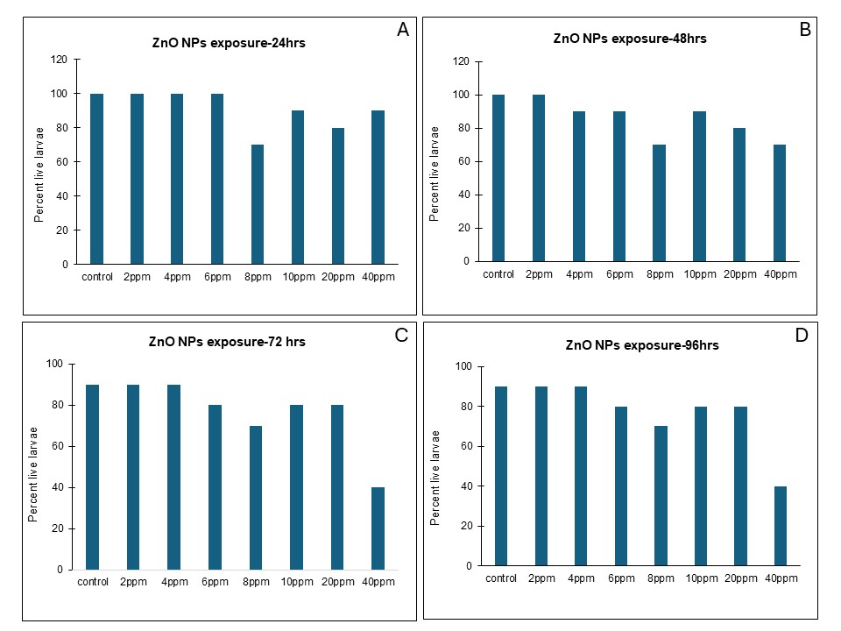

Figure 1: Larvicidal activity of ZnO NPs generated using pomegranate leaf extract: 24 hrs (A), 48 hrs (B), 72 hrs (C) and 96 hrs (D). Note lowest percent of live larvae at 40 ppm by 72 hrs and 96 hrs. Observe reduced percent of live larvae at all the treated doses from first 24 hours, more obvious at 8 ppm.

MnO₂ NPs, prepared using pomegranate leaves extract, also exhibited larvicidal activity, though the deaths occurred only at high doses like 10 ppm, 20 ppm and 40 ppm within first 24 hours. These manganese dioxide nanoparticles exhibited no toxicity at 2 ppm throughout till 96 hours and the percent live larvae were comparable to the controls. The MnO₂ NPs displayed a dose related larvicidal activity and the percent live larvae went on decreasing with increasing doses with about 60% live larvae at 40 ppm at the end of 96 hours (Figure 2).

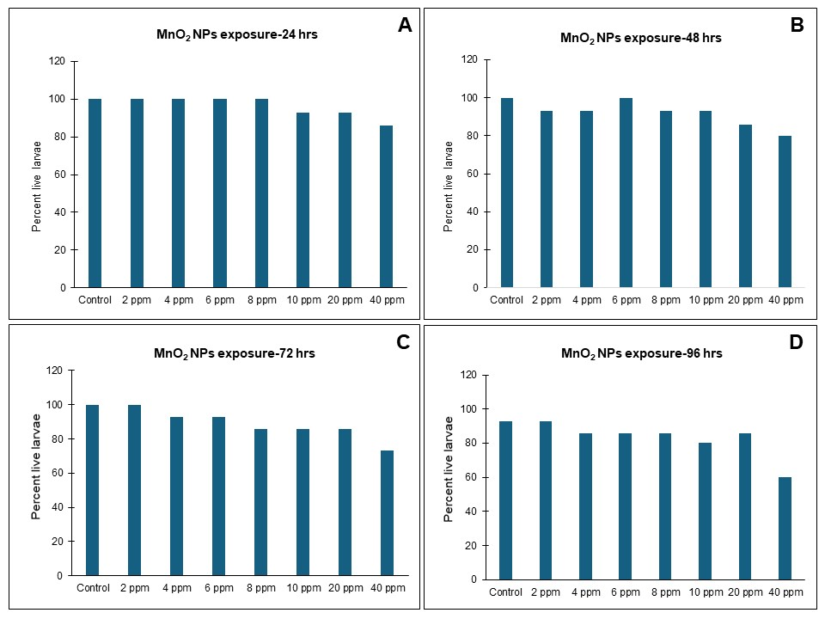

Figure 2: Larvicidal activity of MnO₂ NPs generated using pomegranate leaf extract: 24 hrs (A), 48 hrs (B), 72 hrs (C) and 96 hrs (D). Note reduction in percent live larvae with increasing doses.

Higher accumulation levels of Mn in water bodies are known to induce histopathological alterations in gonadal, digestive and other connective tissue organs of aquatic animals (Ibrahim et al., 2023). Thus Mn in free ionic form causes toxicity at high levels. However, there are hardly any reports which state the effects of Mn in nanoparticle form on the aquatic life. The only report on MnO₂ nanoparticles, environmental friendly generated using wet-chemical redox method, possessing larvicidal activity against mosquito larvae was published recently in 2021 (Naik et al., 2021). The present work used pomegranate leaves extract mediated MnO₂ nanoparticles, whose minimal toxicity was observed on aquatic animals using zebrafish as a model system (Bapte et al., unpublished work). Thus, the larvicidal activity of these ecofriendly and cost effective MnO₂ NPs, that are safer for other aquatic animals as compared to ZnO NPs, appears to be one of the best baits for mosquito larvae control.

Till date, researchers have investigated the lethal effects, if any, of several metal and metal oxide nanoparticles like silver, palladium, titanium dioxide, gold, cobalt, copper, iron, selenium, magnesium oxide etc. on the adult, pupal and larval stages of several mosquito varieties, suggesting silver and copper to be most effective so far (Minwuyelet et al., 2025; Anil Kumar et al., 2016). Our results show that the nanoparticles generated using same plant material, posed varied toxicity depending on the metal i.e. either zinc or manganese. ZnO NPs possessed maximum larvicidal activity as compared to MnO₂ NPs at similar doses and time points (Figure 3). LC50 value for ZnO NPs was calculated to be 9.784 ppm whereas for MnO₂ NPs was 83.46 ppm for 96 hours as per the regression statistics. As compared to other metal oxide nanoparticles, ZnO NPs have been shown to possess prominent larvicidal activities (Bharathi &. Suseem, 2024) which is in agreement with our results.

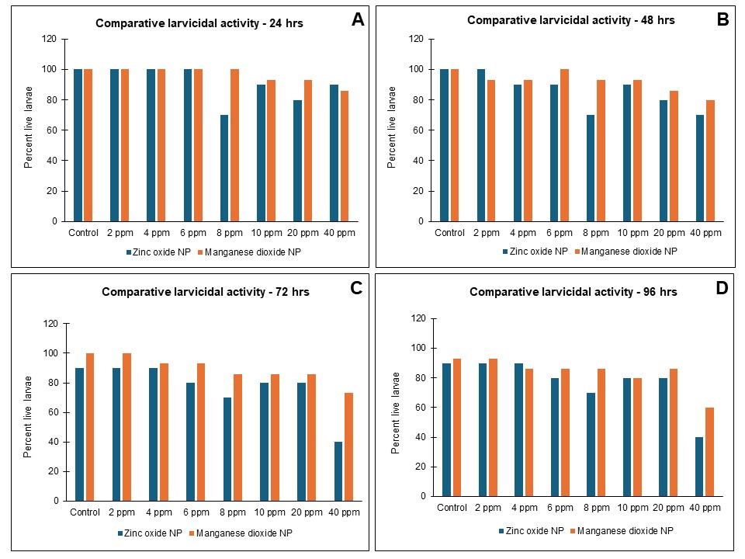

Figure 3: Comparison between the larvicidal activities of ZnO & MnO₂ NPs generated using pomegranate leaf extract: 24 hrs (A), 48 hrs (B), 72 hrs (C) and 96 hrs (D). Note low number of live larvae in ZnO NPs as compared MnO₂ NPs throughout, suggesting higher larvicidal activity of ZnO NPs.

4. Conclusion
The present study investigated the larvicidal potential of ZnO and MnO₂ NPs produced in a green manner using the same pomegranate leaves extract. ZnO NPs were found to possess higher larvicidal activity as compared to MnO₂ NPs, highlighting the role of metal in imparting biological properties or potentials to the NPs. Earlier studies on these NPs have proven to be antioxidants with antimicrobial activities, pro or anti-angiogenic depending on the dose with very low (ZnO NPs) or no toxicity (MnO₂ NPs) on aquatic animals (Bapte et al., 2025). Thus, our generated NPs possess excellent potential to be used for mosquito larvae control because of their ecofriendly nature, especially MnO₂ NPs.

Consent (where ever applicable)
Not applicable.

Ethical approval (where ever applicable)
Not applicable.

References
Anil Kumar, V., Ammani, K., Jobina, R., Parasuraman, P., & Siddhardha, B. (2016). Larvicidal Activity Of Green Synthesized Silver Nanoparticles Using Excoecaria Agallocha L. (Euphorbiaceae) Leaf Extract Against Aedes Aegypti. IET nanobiotechnology, 10(6), 382–388. https://doi.org/10.1049/iet-nbt.2015.0101
Bapte, P.S., Pansambal, S.S., Bardapurkar, P.P., Ghotekar, S., & Borgave, S. S. (2025). Eco-friendly synthesis of ZnO nanoparticles using pomegranate leaves and its antimicrobial, antioxidant, anticancer, angiogenic activity, and toxicity assessment. Results in Chemistry. 2025;16:102460.https://doi.org/10.1016/j.rechem.2025.102460

Bharathi, J.D. & Suseem, S. R. (2024). Larvicidal activity of CuO and ZnO nanoparticles against Aedes aegypti and Anopheles stephensi mosquito vectors-a greener approach by Phaseolus vulgaris L. aqueous extract as bio-reductant. Results in Chemistry. 7, 101408. https://doi.org/10.1016/j.rechem.2024.101408
Chatterjee, S., Bag, S., Biswal, D., Sarkar Paria, D., Bandyopadhyay, R., Sarkar, B., Mandal, A., & Dangar, T. K. (2023). Neem-based products as potential eco-friendly mosquito control agents over conventional eco-toxic chemical pesticides-A review. Acta tropica, 240, 106858. https://doi.org/10.1016/j.actatropica.2023.106858
Chinnathambi, A., Ali Alharbi, S., Lavarti, R., Jhanani, G. K., On-Uma, R., Jutamas, K., & Anupong, W. (2023). Larvicidal and pupicidal activity of phyto-synthesized zinc oxide nanoparticles against dengue vector Aedes aegypti. Environmental research, 216(2), 114574. https://doi.org/10.1016/j.envres.2022.114574
Farag, R. S., & Emam, S. S. (2016). Insecticidal Activities of Pomegranate Peels and Leave Crude Juices. International Journal For Research In Agricultural And Food Science, 2(1), 69–89. https://gnpublication.org/index.php/afs/article/view/349
Fouda, A., Alshallash, K. S., Alghonaim, M. I., Eid, A. M., Alemam, A. M., Awad, M. A., & Hamza, M. F. (2023). The Antimicrobial and Mosquitocidal Activity of Green Magnesium Oxide Nanoparticles Synthesized by an Aqueous Peel Extract of Punica granatum. Chemistry. 5(3), 2009-2024. https://doi.org/10.3390/chemistry5030136
Ibrahim, A.M., Abdel-Haleem, A.AS. & Taha, R.G. (2023). Biomonitoring of manganese metal pollution in water and its impacts on biological activities of Biomphalaria alexandrina snail and larvicidal potencies. Environ Sci Pollut Res. 30, 105967–105976. https://doi.org/10.1007/s11356-023-29786-x
Minwuyelet, A., Yewhalaw, D., Aschale, Y., Sciarrettam, A., Atenafu, G. A. (2025). Global Systematic Review on the Potential of Metal-Based Nanoparticles in the Fight Against Mosquito Vectors. J Trop Med. 2025:2420073. https://doi.org/10.1155/jotm/2420073
Mythili, G., Dhivyasri, S., Sujithra, Y., Swetha, S. & Saranraj, P. (2024). Larvicidal efficiency of zinc oxide nanoparticles against mosquito vectors. International Journal of Entomology Journal, 9(11), 200-203.
Naik, S.R., Javeer, D.S., Gawde, C.S., Palni, S.S., Koli, S.C., Jalmi, S.S., Ghotge, Y.V., Naik, N.U., Fernandes, R. & Velho-Pereira, S. (2021). Larvicidal activity of pristine α-MnO2 nanostructures: An environmentally benign approach for combating mosquito (Diptera: Culicidae) menace, Materials Today Communications. 27, 102184. https://doi.org/10.1016/j.mtcomm.2021.102184
Onen, H., Luzala, M.M., Kigozi, S., Sikumbili, R.M., Muanga, C.K,, Zola, E.N., Wendji, S.N., Buya, A.B., Balciunaitiene, A., Viškelis, J., Kaddumukasa, M.A., Memvanga, P.B. (2023). Mosquito-Borne Diseases and Their Control Strategies: An Overview Focused on Green Synthesized Plant-Based Metallic Nanoparticles. Insects.14(3):221. https://doi.org/10.3390/insects14030221
Osman, A.I., Zhang, Y., Farghali, M., Rashwan, A.K., Eltaweil, A.S., Abd El-Monaem, E.M. et al. (2024). Synthesis of green nanoparticles for energy, biomedical, environmental, agricultural, and food applications: A review. Environ Chem Lett 22, 841–887. https://doi.org/10.1007/s10311-023-01682-3
Rather, G.A., Nanda, A. and Ezhumalai, P. (2022). Mosquito Larvicidal Activity of ZnO Nanoparticles against Dengue Causing Vector Aedes Albopictus Using Leaf Extract of Lavandula angustifolia. Journal of Nanostructures, 12(3), 625-632. https://doi.org/10.22052/JNS.2022.03.016
Salem, A.M., Farag, S.M., Gad, H.A., Al-Sayed, E., El-Ahmady S.H. (2023). Anti-Culex pipiens activity of different pomegranate cultivars and determination of their bioactive compounds using LC-MS profiling. Phytochemical. https://doi.org/10.1002/pca.3307
Saparbekova, A.A., Kantureyeva, G.O., Kudasova, D.E., Konarbayeva, Z.K., & Latif, A.S. (2023). Potential of phenolic compounds from pomegranate (Punica granatum L.) by-product with significant antioxidant and therapeutic effects: A narrative review. Saudi journal of biological sciences. 30(2): 103553. https://doi.org/10.1016/j.sjbs.2022.103553
Sivapunniyam, A., Perumal, T., Vasu, N., Kavidasan, T., Seetharaman, P., Raja, K. & Stalin, M. (2024). Zinc Oxide Nanoparticles Fabricated With Phytoextracts For The Control Of Mosquito Vectors-A Systemic Review. Journal of Advanced Zoology. 45(2):1663-1681
Souto, A.L., Sylvestre, M., Tölke, E.D., Tavares, J.F., Barbosa-Filho, J.M. & Cebrián-Torrejón, G. (2021). Plant-Derived Pesticides as an Alternative to Pest Management and Sustainable Agricultural Production: Prospects, Applications and Challenges. Molecules. 26(16):4835. https://doi.org/10.3390/molecules26164835
Vijayakumar, S., Vinoj, G., Malaikozhundan, B., Shanthi, S., & Vaseeharan, B. (2015). Plectranthus amboinicus leaf extract mediated synthesis of zinc oxide nanoparticles and its control of methicillin resistant Staphylococcus aureus biofilm and blood sucking mosquito larvae. Spectrochimica acta. Part A, Molecular and biomolecular spectroscopy. 137, 886–891. https://doi.org/10.1016/j.saa.2014.08.064
Yu, M., Gouvinhas, I., Chen, J., Zhu, Y., Deng, J., Xiang, Z., Oliveira, P., Xia, C. & Barros, A. (2024). Unlocking the therapeutic treasure of pomegranate leaf: A comprehensive review on phytochemical compounds, health benefits, and future prospects, Food Chemistry. 23:101587.https://doi.org/10.1016/j.fochx.2024.101587

