**The Role of Pollinators in Boosting Agricultural Output**

**Abstract**

Pollinators are vital to agriculture, enhancing both crop yields and quality. Approximately 70% of global crops benefit from animal-mediated pollination, predominantly by bees, with some crops experiencing yield increases of up to 7.3% due to pollination. Diverse pollinator populations are crucial for maintaining crop productivity, as they contribute to better quality produce and improved shelf life. However, challenges such as habitat loss, pesticide use, and climate change pose significant threats to pollinator populations, endangering the ecosystem services they provide. Sustainable agricultural practices, including habitat conservation and reducing pesticide use, are essential to protect pollinators and ensure food security. Supporting research, policy advocacy, and community engagement further strengthens pollinator conservation efforts. A comprehensive approach that integrates ecological services provided by pollinators into agricultural systems is vital for sustainable food production, public health, and environmental resilience.

***Keywords : pollinators, agriculture, crop yield, ecosystem services, sustainable practices***

**1. Introduction**

Pollinators play an indispensable role in agriculture, significantly enhancing crop yields and quality while contributing to the nutritional value of food supplies. The interdependence between pollinators and agricultural productivity is underscored by the fact that approximately 70% of the world's major crops benefit from animal-mediated pollination, predominantly by bees (Khalifa *et al.,* 2021). This relationship is essential, as the economic value of pollination services is substantial; for instance, crops that rely on insect pollination can experience yield increases of up to 7.3% due to the activities of pollinators (Eilers *et al.,* 2011). Furthermore, the quality of produce, including attributes such as shelf life and market value, is markedly improved through effective pollination (Klatt *et al.,* 2014). The ecological dynamics of agricultural landscapes reveal that the presence of diverse pollinator communities can lead to enhanced crop production. Studies indicate that agricultural practices that maintain or enhance pollinator habitats—such as integrating wildflower plantings—can significantly increase the abundance of wild bees and the pollination services they provide (Blaauw and Isaacs, 2014). This is particularly relevant in regions where agricultural intensification has led to declines in pollinator diversity and abundance, which can compromise the reliability of pollination services (Deguines *et al.,* 2014).

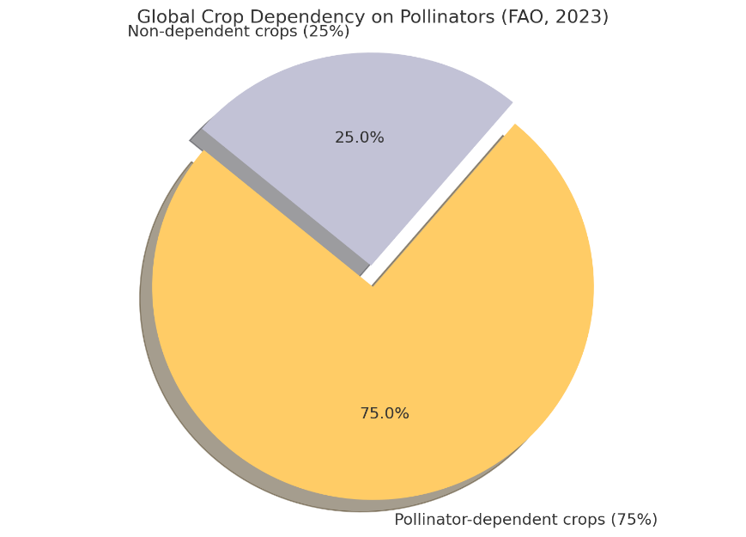

Picture 1- **Pie chart indicating the** **Global Crop Dependency on Pollinators**

In contrast, diversified agricultural systems that incorporate a variety of crops tend to support more robust pollinator populations, thereby mitigating the risks associated with pollination deficits (Aizen *et al.,* 2019). However, the benefits of pollination extend beyond mere yield increases; they also encompass the nutritional aspects of crops. Pollinator-mediated crops contribute significantly to the human food supply, providing essential vitamins and minerals, particularly folate, which is crucial for human health (Eilers *et al.,* 2011). The reliance on pollinators for the production of nutrient-rich crops highlights the critical intersection of agriculture, nutrition, and ecosystem services. Thus, the conservation and enhancement of pollinator populations are vital for agricultural productivity, public health, and food security. Lastly, the role of pollinators in agriculture is multifaceted, impacting crop yield, quality, and nutritional value. As agricultural practices evolve, recognizing and integrating the ecological services provided by pollinators will be essential for sustainable food production systems. The ongoing challenges posed by agricultural intensification and habitat loss necessitate a concerted effort to protect and enhance pollinator populations, ensuring that their invaluable contributions to agriculture continue to thrive.

**2. Understanding Pollinators: Types and Functions**

Understanding pollinators is essential for enhancing agricultural output, particularly in the context of crop production that relies heavily on these organisms for effective pollination. Pollinators, primarily insects such as bees, butterflies, and beetles, play a critical role in the reproductive processes of many flowering plants, which directly influences agricultural yields. The interaction between pollinators and crops can significantly affect both the quantity and quality of the produce, making it imperative to understand the types of pollinators and their functions within agricultural ecosystems. Various studies have highlighted the importance of different pollinator species in agricultural settings. For instance, honeybees (*Apis mellifera*) are among the most widely managed pollinators and have been shown to enhance crop yields significantly. Research indicates that honeybee pollination can increase yields in crops such as Nigella sativa by as much as 30.84% compared to plots without honeybee access (Tesfaye *et al.,* 2020). However, the effectiveness of honeybees can vary depending on the crop's compatibility with self-pollination. For example, managed honeybees effectively reduce pollination limitations in self-compatible crops but have a negligible impact on self-incompatible crops (Sáez *et al.,* 2022).

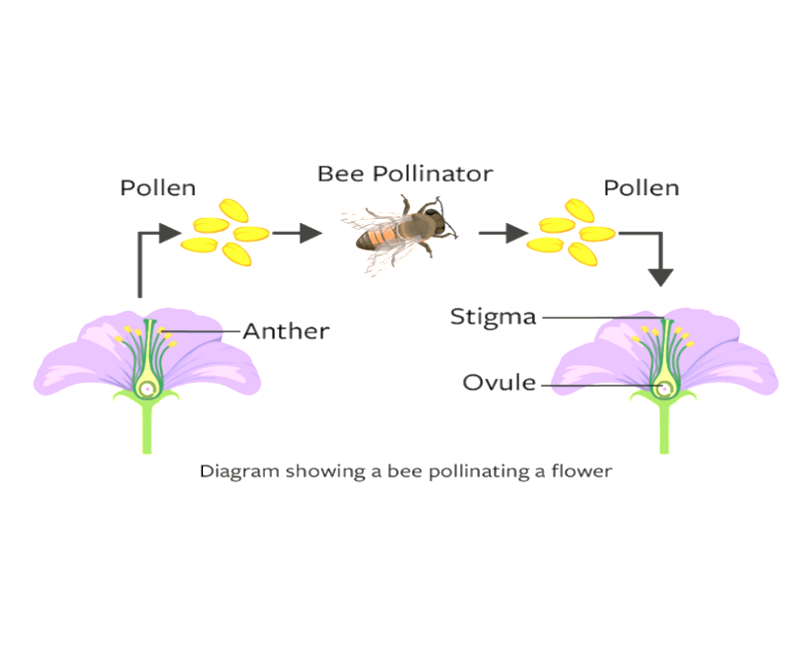

Fig.1.-A diagram illustrating the process of pollination, where a bee transfers pollen from the anther of one flower to the stigma of another, aiding in fertilization and seed formation.

This underscores the necessity of understanding the specific pollination needs of different crops to optimize pollinator management strategies. The presence of diverse pollinator species can enhance crop yields through complementary interactions. Studies have demonstrated that companion planting with pollinator-attracting species can lead to increased yields in crops like cucumbers and habanero peppers (Montoya *et al.,* 2020). This approach not only boosts pollinator populations but also enhances the overall ecosystem service provided by these organisms. The synergistic effects of pollination and other agricultural practices, such as soil fertilization, have also been documented, where optimal fertilization combined with abundant insect pollination can lead to significant yield increases in crops like sunflowers (Adelabu *et al.,* 2021). Understanding the dynamics of pollinator populations is crucial for maximizing agricultural output. Research indicates that agricultural intensification can negatively impact pollinator diversity and, consequently, crop pollination services (Deguines *et al.,* 2014). This relationship suggests that sustainable agricultural practices that promote biodiversity can enhance pollination services and stabilize crop yields. For instance, maintaining habitats that support wild pollinator populations can mitigate the risks associated with relying solely on managed pollinators (Garratt *et al.,* 2018). A comprehensive understanding of pollinators, their types, and their functions is vital for boosting agricultural output. By recognizing the specific needs of crops and the roles of various pollinator species, farmers can implement strategies that enhance pollination services, leading to improved yields and crop quality. The integration of pollinator management into agricultural practices represents a promising avenue for increasing food production sustainably.

**3. Pollinator-Plant Interactions: How They Enhance Crop Production**

Pollinator-plant interactions play a crucial role in enhancing crop production, significantly impacting agricultural output. The mutualistic relationship between pollinators, particularly bees, and flowering plants facilitates the transfer of pollen, which is essential for the fertilization of many crops. This interaction not only increases the quantity of produce but also improves its quality, shelf life, and commercial value. For instance, research indicates that bee pollination can enhance the yield of crops such as strawberries and tomatoes, which are highly dependent on animal pollination for optimal production (Klatt *et al.,* 2014; Junqueira *et al.,* 2021). Furthermore, studies have shown that insect pollination can lead to yield increases ranging from 18% to 71% across various crops, underscoring the economic importance of pollinators in agriculture (Tesfaye *et al.,* 2020). The diversity of pollinators also contributes to the stability and resilience of crop yields. Different species of pollinators, including both Apis (honeybees) and non-Apis bees, provide complementary services that can enhance pollination efficiency. For example, in sunflower crops, the presence of non-Apis bees has been shown to increase the duration of visits and the amount of pollen deposited, leading to improved pollination outcomes (Junqueira *et al.,* 2021). Additionally, a diverse pollinator assemblage can buffer against fluctuations in pollination services due to environmental changes, thereby stabilizing yields over time (Hünicken *et al.,* 2021; Rader *et al.,* 2015). This "response diversity" among pollinator species ensures that crop production remains robust even in the face of challenges such as habitat loss and climate change (Rader *et al.,* 2015; Giannini *et al.,* 2017. The economic value of pollination services is increasingly recognized in agricultural systems worldwide. In regions such as Benin, the expansion of pollinator-dependent crops has been linked to increased agricultural output, highlighting the direct correlation between pollinator health and crop productivity (Toni and Djossa, 2015).

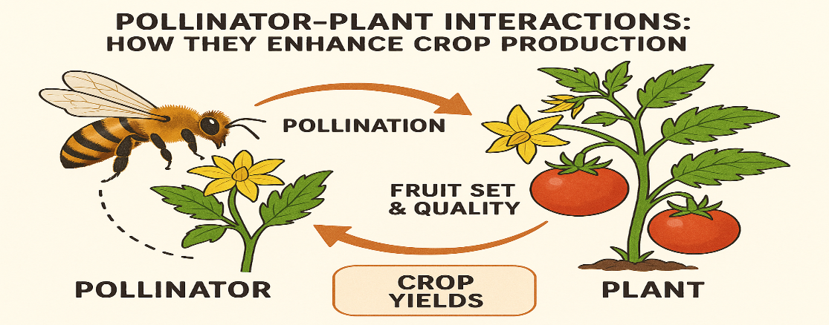

Fig.2.-Pollinator-plant interactions play a vital role in crop production by enabling pollination, which leads to improved fruit set, enhanced quality, and increased crop yields.

Pollinators contribute significantly to the production of fruits, vegetables, and nuts, which are vital for human nutrition and food security. Approximately 75% of all crop species benefit from animal pollination, emphasizing the critical role of pollinators in sustaining agricultural systems (Lautenbach *et al.,* 2012). The loss of pollinators could therefore have dire consequences for food production and nutritional quality globally.

**4. Current Secenerio**

Pollinators such as bees, butterflies, birds, and bats play a foundational role in global agriculture by facilitating the reproduction of nearly 75% of the world’s food crops, including fruits, vegetables, oilseeds, and nuts. Their ecosystem service not only ensures food availability but significantly boosts crop yield, quality, and resilience. According to the FAO and IPBES (2023), the global annual economic value of pollination is estimated at USD 400 billion, with major contributions from countries like China (USD 38 billion), the EU (USD 35 billion), and the USA (USD 20 billion). India benefits enormously too, with pollination adding over ₹1 lakh crore (≈USD 13.5 billion) annually to its agricultural GDP.

Pollinators enhance both the quantity and quality of produce—pollinated crops such as apples, tomatoes, and almonds often show up to 70% higher yields and better taste, shape, and shelf life. Scientific studies (e.g., *Science, 2023*) confirm that farms with greater pollinator diversity yield 24% more produce than those with minimal pollinator presence. However, pollinator populations are declining globally up to 40% in some regions due to habitat destruction, pesticide use, monoculture farming, and climate change. This decline threatens up to 23% of yields in pollinator-dependent crops. To mitigate this, countries are adopting pollinator-friendly practices, including conservation of native habitats, reduction of chemical inputs, and integration of flowering plants around farms. Initiatives like India’s National Beekeeping and Honey Mission aim to support apiculture and enhance pollination services. The bar chart above visualizes the economic importance of pollinators across major agricultural economies, emphasizing the urgent need to protect these unsung heroes for sustainable and productive farming systems.

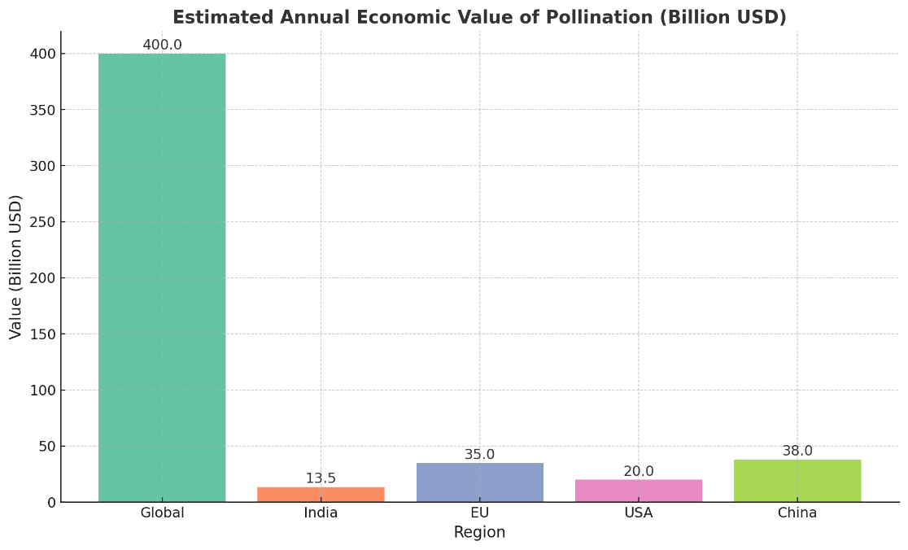

Fig.3- Pollination adds an estimated **$400 billion** annually to global agriculture, with major contributions from **China ($38B)**, **EU ($35B)**, **USA ($20B)**, and **India ($13.5B)**.

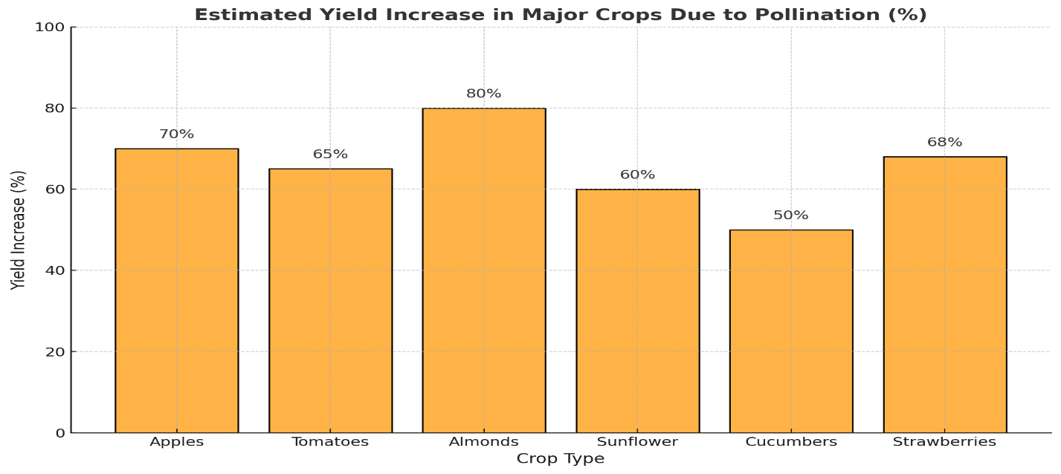

Fig.4.- bar graph showing how pollinators enhance yields in key crops. For instance, almonds and apples can see up to **80% and 70%** yield improvement respectively due to effective pollination.

**5. Challenges to Pollinator Populations and Their Impact on Agriculture**

* Pollinator populations, particularly bees, face numerous challenges that significantly impact agricultural productivity. These challenges stem from a combination of environmental stressors, including pesticide use, habitat loss, and climate change, which collectively threaten the viability of pollinator species and, consequently, the crops that rely on them for successful reproduction. One of the most pressing issues is the impact of pesticides on pollinator health. Research indicates that the use of neonicotinoid insecticides, even at sublethal levels, can adversely affect the reproductive success of solitary bees and disrupt their foraging behavior (Sandrock *et al.,* 2013; , Gill *et al.,* 2012). These chemicals can impair the ability of pollinators to make adaptive foraging decisions, which is crucial for maintaining effective pollination services (Gegear *et al.,* 2021; , Gill and Raine, 2014). Moreover, chronic exposure to pesticides not only diminishes individual bee health but also poses a risk to entire populations, as it can lead to reduced colony growth and increased vulnerability to diseases and parasites (Pettis *et al.,* 2013; , Tosi *et al.,* 2017). The reliance on pesticides in agricultural practices, particularly in monoculture systems, exacerbates these issues by diminishing the availability of diverse foraging resources that are essential for pollinator nutrition (Tosi *et al.,* 2017).
* Habitat loss is another critical factor contributing to the decline of pollinator populations. Intensive agricultural practices often result in the fragmentation of natural habitats, which reduces the availability of foraging resources and nesting sites for wild pollinators (Kleczkowski *et al.,* 2017; , Potts *et al.,* 2016). This loss of habitat not only decreases the diversity of pollinator species but also increases the dependency of agricultural systems on managed pollinators, such as honey bees (López‐Uribe *et al.,* 2020). The decline in wild pollinator populations can lead to a reliance on fewer species for pollination, which may not be sufficient to meet the increasing demands for pollination services in food production (Brittain *et al.,* 2012; , Bloom *et al.,* 2021).
* Climate change further complicates the situation by altering the phenology of flowering plants and the behavior of pollinators (Rader *et al.,* 2013). Changes in temperature and precipitation patterns can shift the timing of flower availability, potentially leading to mismatches between the flowering periods of crops and the activity periods of pollinators. Such mismatches can reduce the effectiveness of pollination and ultimately impact crop yields (Kleczkowski *et al.,* 2017; , López‐Uribe *et al.,* 2020). Additionally, climate change can exacerbate the effects of other stressors, such as habitat degradation and pesticide exposure, creating a compounded threat to pollinator health and agricultural productivity (Sandrock *et al.,* 2013; , Potts *et al.,* 2016).

The challenges facing pollinator populations, including pesticide exposure, habitat loss, and climate change, pose significant risks to agricultural output. The interplay of these factors not only threatens the health of pollinators but also jeopardizes the essential ecosystem services they provide, which are critical for sustaining food production systems worldwide.

**6. Conclusion**

In conclusion, safeguarding pollinators is essential for sustaining and enhancing agricultural output. Strategies to protect these vital species involve a multifaceted approach. First, promoting habitat conservation and restoration can provide pollinators with the resources they need to thrive. Implementing sustainable agricultural practices, such as reducing pesticide use and incorporating pollinator-friendly crops, also plays a crucial role. Additionally, supporting research and monitoring programs helps track pollinator health and inform targeted interventions. Engaging with local communities and policymakers to raise awareness and advocate for protective measures further strengthens efforts to ensure that pollinators continue to support agricultural productivity and ecosystem health. By addressing these areas, we can foster a resilient agricultural system that benefits from the invaluable contributions of pollinators.

**References:**

Adelabu, D., Bredenhand, E., Merwe, S., and Franke, A. (2021). Soil fertilization synergistically enhances the impact of pollination services in increasing seed yield of sunflower under dryland conditions. The Journal of Agricultural Science, 159(3-4), 258-271.

Aizen, M., Aguiar, S., Biesmeijer, J., Garibaldi, L., Inouye, D., Jung, C.,and Seymour, C. (2019). Global agricultural productivity is threatened by increasing pollinator dependence without a parallel increase in crop diversification. Global Change Biology, 25(10), 3516-3527.

Blaauw, B. and Isaacs, R. (2014). Flower plantings increase wild bee abundance and the pollination services provided to a pollination‐dependent crop. Journal of Applied Ecology, 51(4), 890-898.

Bloom, E., Graham, K., Haan, N., Heck, A., Gut, L., Landis, D.,and Isaacs, R. (2021). Responding to the us national pollinator plan: a case study in michigan. Frontiers in Ecology and the Environment, 20(2), 84-92.

Brittain, C., Kremen, C., and Klein, A. (2012). Biodiversity buffers pollination from changes in environmental conditions. Global Change Biology, 19(2), 540-547.

Deguines, N., Jono, C., Baude, M., Henry, M., Julliard, R., and Fontaine, C. (2014). Large‐scale trade‐off between agricultural intensification and crop pollination services. Frontiers in Ecology and the Environment, 12(4), 212-217.

Deguines, N., Jono, C., Baude, M., Henry, M., Julliard, R., and Fontaine, C. (2014). Large‐scale trade‐off between agricultural intensification and crop pollination services. Frontiers in Ecology and the Environment, 12(4), 212-217.

Eilers, E., Kremen, C., Greenleaf, S., Garber, A., and Klein, A. (2011). Contribution of pollinator-mediated crops to nutrients in the human food supply. Plos One, 6(6), 21363.

Elisante, F., Ndakidemi, P., Arnold, S., Belmain, S., Gurr, G., Darbyshire, I.,and Stevenson, P. (2020). Insect pollination is important in a smallholder bean farming system. Peerj, 8, e10102.

Garratt, M., Brown, R., Hartfield, C., Hart, A., and Potts, S. (2018). Integrated crop pollination to buffer spatial and temporal variability in pollinator activity. Basic and Applied Ecology, 32, 77-85.

Gegear, R., Heath, K., and Ryder, E. (2021). Modeling scale up of anthropogenic impacts from individual pollinator behavior to pollination systems. Conservation Biology, 35(5), 1519-1529.

Giannini, T., Costa, W., Cordeiro, G., Imperatriz-Fonseca, V., Saraiva, A., Biesmeijer, J.,and Garibaldi, L. (2017). Projected climate change threatens pollinators and crop production in brazil. Plos One, 12(8), e0182274.

Gill, R. and Raine, N. (2014). Chronic impairment of bumblebee natural foraging behaviour induced by sublethal pesticide exposure. Functional Ecology, 28(6), 1459-1471.

Gill, R., Ramos-Rodriguez, O., and Raine, N. (2012). Combined pesticide exposure severely affects individual- and colony-level traits in bees. Nature, 491(7422), 105-108.

Hünicken, P., Morales, C., Aizen, M., Anderson, G., García, N., and Garibaldi, L. (2021). Insect pollination enhances yield stability in two pollinator-dependent crops. Agriculture Ecosystems and Environment, 320, 107573.

Junqueira, C., Pereira, R., Silva, R., Kobal, R., Araújo, T., Prato, A.,and Augusto, S. (2021). Do apis and non‐apis bees provide a similar contribution to crop production with different levels of pollination dependency? a review using meta‐analysis. Ecological Entomology, 47(1), 76-83.

Khalifa, S., Elshafiey, E., Shetaia, A., El-Wahed, A., Algethami, A., Musharraf, S.,and El‐Seedi, H. (2021). Overview of bee pollination and its economic value for crop production. Insects, 12(8), 688.

Klatt, B., Holzschuh, A., Westphal, C., Clough, Y., Smit, I., Pawelzik, E.,and Tscharntke, T. (2014). Bee pollination improves crop quality, shelf life and commercial value. Proceedings of the Royal Society B Biological Sciences, 281(1775), 2013-2440. <https://doi.org/10.1098/rspb.2013.2440>

Klatt, B., Holzschuh, A., Westphal, C., Clough, Y., Smit, I., Pawelzik, E.,and Tscharntke, T. (2014). Bee pollination improves crop quality, shelf life and commercial value. Proceedings of the Royal Society B Biological Sciences, 281(1775), 20132440. https://doi.org/10.1098/rspb.2013.2440

Kleczkowski, A., Ellis, C., Hanley, N., and Goulson, D. (2017). Pesticides and bees: ecological-economic modelling of bee populations on farmland. Ecological Modelling, 360, 53-62. https://doi.org/10.1016/j.ecolmodel.2017.06.008

Lautenbach, S., Seppelt, R., Liebscher, J., and Dormann, C. (2012). Spatial and temporal trends of global pollination benefit. Plos One, 7(4), e35954.

López‐Uribe, M., Ricigliano, V., and Simone-Finstrom, M. (2020). Defining pollinator health: a holistic approach based on ecological, genetic, and physiological factors. Annual Review of Animal Biosciences, 8(1), 269-294.

Montoya, J., Arnold, M., Rangel, J., Stein, L., and Palma, M. (2020). Pollinator-attracting companion plantings increase crop yield of cucumbers and habanero peppers. Hortscience, 55(2), 164-169.

Pettis, J., Lichtenberg, E., Andree, M., Stitzinger, J., Rose, R., and vanEngelsdorp, D. (2013). Crop pollination exposes honey bees to pesticides which alters their susceptibility to the gut pathogen nosema ceranae. Plos One, 8(7), e70182.

Potts, S., Imperatriz-Fonseca, V., Ngo, H., Aizen, M., Biesmeijer, J., Breeze, T.,and Vanbergen, A. (2016). Safeguarding pollinators and their values to human well-being. Nature, 540(7632), 220-229.

Rader, R., Bartomeus, I., Garibaldi, L., Garratt, M., Howlett, B., Winfree, R.,and Woyciechowski, M. (2015). Non-bee insects are important contributors to global crop pollination. Proceedings of the National Academy of Sciences, 113(1), 146-151.

Rader, R., Reilly, J., Bartomeus, I., and Winfree, R. (2013). Native bees buffer the negative impact of climate warming on honey bee pollination of watermelon crops. Global Change Biology, 19(10), 3103-3110.

Sáez, A., Aguilar, R., Ashworth, L., Gleiser, G., Morales, C., Traveset, A.,and Aizen, M. (2022). Managed honeybees decrease pollination limitation in self-compatible but not in self-incompatible crops. Proceedings of the Royal Society B Biological Sciences, 289(1972). https://doi.org/10.1098/rspb.2022.0086

Sandrock, C., Tanadini, L., Pettis, J., Biesmeijer, J., Potts, S., and Neumann, P. (2013). Sublethal neonicotinoid insecticide exposure reduces solitary bee reproductive success. Agricultural and Forest Entomology, 16(2), 119-128.

Tesfaye, B., Gelgelu, T., and Lelisa, W. (2020). The effect of honeybee (andamp;lt;iandamp;gt;apismelliferaandamp;lt;/iandamp;gt;) pollination in enhancing yield of andamp;lt;iandamp;gt;nigella sativaandamp;lt;/iandamp;gt; (darbera variety) in the high land of bale. Bioprocess Engineering, 4(2), 47.

Tesfaye, B., Gelgelu, T., and Lelisa, W. (2020). The effect of honeybee (andamp;lt;iandamp;gt;apismelliferaandamp;lt;/iandamp;gt;) pollination in enhancing yield of andamp;lt;iandamp;gt;nigella sativaandamp;lt;/iandamp;gt; (darbera variety) in the high land of bale. Bioprocess Engineering, 4(2), 47.

Toni, H. and Djossa, B. (2015). Economic value of pollination services on crops in benin, west africa. International Journal of Biological and Chemical Sciences, 9(1), 225.

Tosi, S., Nieh, J., Sgolastra, F., Cabbri, R., and Mędrzycki, P. (2017). Neonicotinoid pesticides and nutritional stress synergistically reduce survival in honey bees. Proceedings of the Royal Society B Biological Sciences, 284(1869), 20171711. https://doi.org/10.1098/rspb.2017.1711