Minireview Article

**Behçet's disease: a mini-review**

.

ABSTRACT

|  |
| --- |
| A chronic, recurrent, and remitting vasculitis with an unclear cause is Behçet's disease (BD). Because it can affect veins and arteries of all diameters, it can impact nearly every organ system and cause serious organ-threatening illness and mortality. Known historically as the "Silk Road" disease, it occurs worldwide. Although genome-wide investigations reveal connections between human leukocyte antigens and non-human leukocyte antigens, the neuropathological processes underlying illness development in BD are still poorly understood. The autoimmune and auto-inflammatory nature of BD is suggested by the possibility that both hereditary and environmental factors contribute to the aetiopathogenetic pathways that cause the disease to develop. There is little evidence to support treatment, although new information is being discovered, and available treatments encompass a wide range of clinical presentations, from symptomatic care to biological and non-biological immunosuppressive medications. |

*Keywords: mtDNA, epidemiology, Behçet’s disease, symptoms*

1. INTRODUCTION

symptoms

**1- Introduction:**

BD is a distinct vasculitis that primarily affects the mucocutaneous system, presenting with orogenital ulcers and skin lesions, but has significant morbidity and mortality when it involves the musculoskeletal system, eye, nervous system, gastrointestinal tract, vascular beds, urogenital tract, and cardio-pulmonary system (1). Due to BD's diverse and occasionally intermittent symptoms, there is sometimes a considerable delay between the onset of symptoms and the diagnosis due to the need to rule out mimics, the lack of a particular blood test or marker for the illness, and, unfortunately, a general lack of awareness (2).

**2- Epidemiology:**

While BD is a geographically widespread disease, its clusters are mostly confined to geographical regions that are represented by the Silk Road. Turkey, Japan, and Iran have the highest prevalence (number of instances per 100,000): 100,000, but Iran has lower prevalences: 70–360 (3). Prevalence in populations in northern Europe and North America. (Figure 1). About 0.64 individuals per 100000 population are affected in the UK (4). It should, however, be noted that whilst BD is most common in patients between the ages of twenty and forty, it can also be present in young individuals and geriatric patients. The sex distribution is different in other countries; however, in the high-prevalence regions of Turkey and the Middle East, males have higher incidence rates. It is further manifested that young adult males usually develop a severe form of the condition. While BD is largely isolated, families are more likely to have clustering (5). The reasons are not clear, but there may have been genetic as well as environmental influences involved. The HLA-B51 genetic pattern is found in approximately 60% of cases. GWAS has identified two endoplasmic reticulum aminopeptidases (HLA-B51 and HLA ERAP1) as BD susceptibility genes (6). A vulnerable person may be injured by still other environmental factors, such as microbes and cellular and humoral immunity. The raised pro-inflammatory cytokines, the relapsing and remitting patterns of inflammation, and the therapeutic response to immunosuppressive agents indicate that BD is an autoinflammatory–autoimmune disease(7)

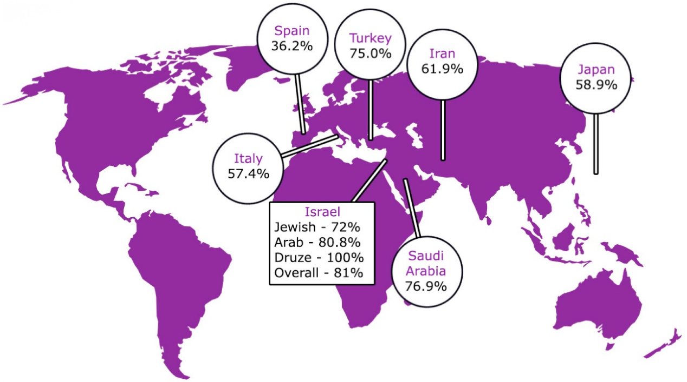

**Figure 1: Epidemiology of Behçet's disease (8)**

**3- Clinical manifestations:**

Due to its tendency to impact all arteries and veins, BD may have an impact on every organ system. Oral and vaginal ulcers are the disease's hallmarks, occurring in up to 97% and 60–90% of patients, respectively (9). Small (less than 10 mm), major (greater than 10 mm), and herpetiform (pinhead to 1–3 mm) oral ulcers are all possible in BD, and they may leave scars. They are similar to normal recurrent benign aphthous stomatitis. Most importantly, these ulcers are painful and might cause difficulty eating and swallowing. Genital ulcers can occur in any part of the genitourinary tract and can leave scars (10). They can take weeks to develop and are frequently found in the vulva in female patients and the scrotum in male patients (11). The other exclusions for oral ulcers include infections, cyclical neutropenia, medications, IBD, vitamin B12 deficiency, rheumatic diseases such as SLE, and autoinflammatory diseases such as PFAPA. Bullous dermatosis, Sweet’s syndrome, and imitators should also be excluded. Further, one needs to exclude other possible causes of genital ulcers, too. Trauma and neoplasm medication responses, sexual infections, and non-sexual genital ulcers may also be reactive to infection (12).

The BD manifestation characterized by oral and vaginal ulcers, not accompanied by other symptoms of BD definition is referred to as complex aphthosis. The association between oral and genital ulcers and other complications includes recurrent neutropenia, adverse drug reactions, and MAGIC (mouth and genital ulcers with inflamed cartilage) syndrome (13). Papulonodular lesions, erythema nodosum-like lesions, pseudofolliculitis-like acneiform rashes, pyoderma gangrenosum, and in rare instances, erythema multiforme-like rashes are the acute manifestations of the cutaneous ailment (14). A papulopustular lesion forms at the site of needle injury during the biopsy within 24 to 48 hours, a symptom of Sweet's syndrome and pyoderma gangrenosa. In BD, cutaneous lesions may often be associated with arthritis (15). Gastrointestinal BD may mimic IBD, and they may have ulcers in the mouth, esophagus, the ileocaecal, and the ascending colon. The most frequent symptoms are fever, diarrhea, hemorrhage, and abdominal pain. They also believe that there are some risks, for instance, fistula and intestinal perforation can sometimes occur. Candidiasis is suspected in orofacial granulomatosis, granulomata in intestinal biopsy, and paper-cut genital sores. To map

the illness, endoscopic and radiographic investigations will be required (16). Neuro-Behçet's disease (NBD), which has a mortality rate of up to 10% (17), and parenchymal and non-parenchymal illnesses are also possible in patients with severe instances. Parenchymal disease, which affects the cerebrum, brainstem, cerebellum, and spinal cord (figure 2), can result in focal and multifocal cerebral lesions, intra-axial cranial neuropathy, ophthalmoplegia, pyramidal disease, and other brainstem syndromes, depending on the extent of neuraxial involvement (18).

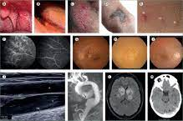

**Figure 2: Clinical manifestations of Behçet's disease (19)**

Parenchymal disease is a pathology of the brain tissue itself, while non-parenchymal disease includes: Brain venous sinus thrombosis, intracranial hypertension, and Recurrent Meningitis. However, migraine is the most frequent neurologic sign, and this also applies to non-BD migraine. Some of the radiological tests include magnetic resonance imaging (MRI), Computed axial tomography (CAT) scan or computed tomography (CT), and magnetic resonance imaging (MRI). (20).

EEG, MRV, CTV, CSF studies, and MRA may be indicated in certain conditions (21). Therefore, magnetic resonance spectroscopy combined with magnetic resonance diffusion imaging might help approach imaging in NBD, yet more study is needed. Vascular BD is different from other forms of BD because it affects venous circulation as well as arterial circulation. (22).

Constitutes one of the main causes of morbidity and mortality in vascular networks, ranging from small to large. Venous disease is more prevalent than arterial disease; this information was obtained from a survey. Aneurysms, ulceration, thrombosis, and stenosis comprise inflammatory arterial diseases, while venous illness mainly comprises venous thrombosis and thrombophlebitis (23). The thrombus can not embolize, which is normally firmly adherent to the walls of the vessel. Doppler ultrasound investigations will require the correct imaging of the vascular CTV, MRI, MRA, and MRV (24). Like other inflammatory disorders, BD is severely accompanied by fatigue; however, effective disease management does not always result in fatigue (25).

**4- Approach to the diagnosis:**

A detailed history of all systems and a detailed analysis of all appropriate conditions are needed for this case, and suitable investigations must be performed to eliminate differential diagnoses. It is described that IBD, celiac disease, drug exposure (methotrexate, nicorandil, and others), other STDs (HIV, gonorrhea, chlamydia, herpes virus), ulcers unrelated to sex, cyclical neutropenia, B12 deficiency, and Sweet’s syndrome may mimic BD and other systemic rheumatic disorders (SLE) (Figure 3). This diagnosis can be made under clinical indicators, signs, and other symptoms that mimic the disease and also exclude any probable cause. Last of all, professional judgment is needed (26).

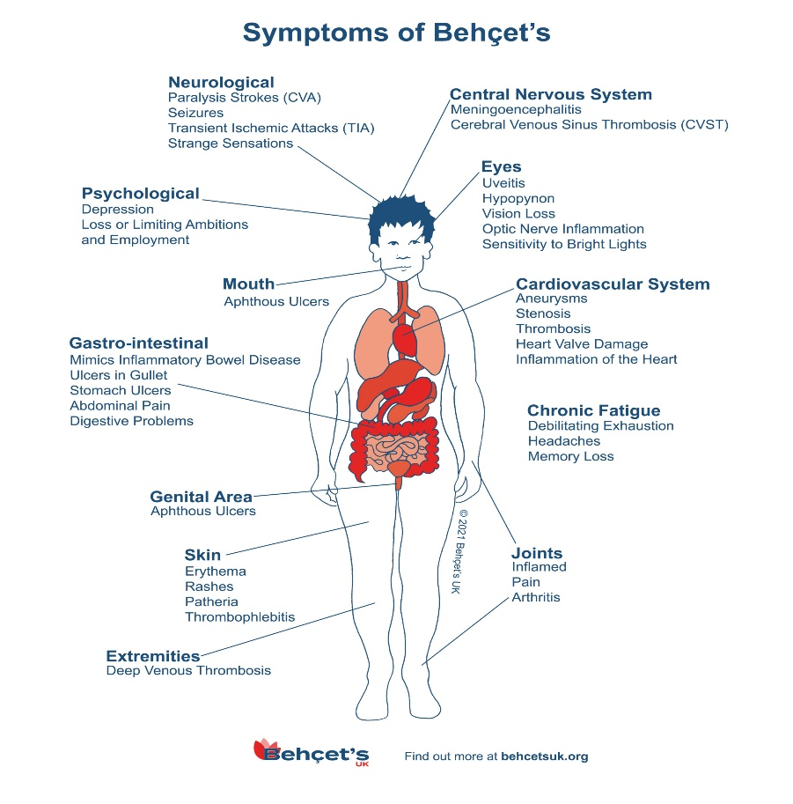

**Figure 3: Symptom of Behçet's disease (27)**

-**Conclusions:**

All bodily systems may be profoundly impacted by BD, a chronic, recurrent vasculitis that can result in significant morbidity and mortality. Variable symptoms and a dearth of reliable biomarkers create a delay in diagnosis. Despite the identification of several biomarkers, none of them are reliable or valid enough to be applied in clinical practice for disease activity monitoring, diagnosis, and assessment. There is a huge research agenda because so little is known about BD. This includes basic science investigations into the possible pathophysiological mechanisms behind the illness (it is not surprising that treatment is subpar if we do not know the explanation), improved clinical condition phenotyping, and more successful treatment.

**-References:-**

**1-**Santangelo, A., Corsello, A., Gizzi, G., Lancieri, M., Diana, M. C., Trucco, F., ... & Raieli, V. (2024). Exploring headaches in pediatric Behçet disease: prevalence, clinical impact, and management. *Journal of Clinical Medicine*, *13*(13), 3659.

2-Choi, S. R., Shin, A., Ha, Y. J., Lee, Y. J., Lee, E. B., Lee, E. S., & Ha Kang, E. (2024). All-cause and cause-specific mortality in patients with Behçet disease versus the general population. *British Journal of Dermatology*, *190*(6), 858-866.

3-Peñuelas Leal, R., Labrandero Hoyos, C., Peñuelas Ruiz, J. A., Bagán, L., Zaragoza Ninet, V., Sánchez Carazo, J. L., ... & Alegre De Miquel, V. (2024). Treatment of Behçet disease with oral roflumilast: an observational study. *Clinical and Experimental Dermatology*, llae284.

4-Emmi, G., Bettiol, A., Hatemi, G., & Prisco, D. (2024). Behçet's syndrome. *The Lancet*, *403*(10431), 1093-1108.

5-Ulutas, Z., Tasolar, H., Karaagac, M., Hidayet, S., Karaca, Y., Bayramoglu, A., ... & Pekdemir, H. (2024). Evaluation of right ventricular function in patients with Behcet's disease by four‐dimensional echocardiography. *Echocardiography*, *41*(9), e15918.

6-Dhrif, O., Essouri, M., Elhaj, W. B., Teyeb, Z., Abbassi, M., Abdelhedi, H., & Khammessi, N. (2024). Ab0053 Disease Damage And Neurological Involvement Determine Quality Of Life In Behçet Disease Patients.

7-Hirahara, L., Kirino, Y., Soejima, Y., Iizuka, Y., Yoshimi, R., Fujieda, Y., ... & Nakajima, H. (2024). Association of high disease activity and serum IL-6 levels with the incidence of inflammatory major organ events in Behçet disease: a prospective registry study. *Frontiers in Immunology*, *15*, 1354969.

8-Yenmis, G., Sabancelebi, S., Atak, E., Yalinkilic, S. B., Soydas, T., & Sadikoglu, T. (2024). Association of IL-23R and IL-10 variations with Behçet disease: A genetic analysis study. *Immunologic Research*, *72*(2), 293-298.

9-Kim, D. Y. (2024). Mortality landscape of Behçet disease. *British Journal of Dermatology*, *190*(6), 784-784.

10-Abdul-Hafez, H. A., Hamdan, Y., Hamdeh, N. A. A., Khadija, H. A., Jaber, D., & Alnees, M. (2024). Enigmatic odyssey: A case of Behcet disease with atypical thrombotic complications. *International Journal of Surgery Case Reports*, 110389.

11-Takeno, M. (2022). The association of Behçet's syndrome with HLA-B51 as understood in 2021. *Current Opinion in Rheumatology*, *34*(1), 4-9.

12-Onofri, A., Pensato, U., Rosignoli, C., Wells-Gatnik, W., Stanyer, E., Ornello, R., ... & European Headache Federation School of Advanced Studies (EHF-SAS). (2023). Primary headache epidemiology in children and adolescents: a systematic review and meta-analysis. *The Journal of Headache and Pain*, *24*(1), 8.

13-Ustianowska, K., Ustianowski, Ł., Machaj, F., Gorący, A., Rosik, J., Szostak, B., ... & Pawlik, A. (2022). The role of the human microbiome in the pathogenesis of pain. *International Journal of Molecular Sciences*, *23*(21), 13267.

14-Pujo, J., De Palma, G., Lu, J., Galipeau, H. J., Surette, M. G., Collins, S. M., & Bercik, P. (2023). Gut microbiota modulates visceral sensitivity through calcitonin gene-related peptide (CGRP) production. *Gut Microbes*, *15*(1), 2188874.

15-Alashqar, A., Shuaibi, S., Ahmed, S. F., AlThufairi, H., Owayed, S., AlHamdan, F., ... & Al-Hashel, J. Y. (2020). Impact of puberty in girls on the prevalence of primary headache disorder among female schoolchildren in Kuwait. *Frontiers in Neurology*, *11*, 594.

16-Alashqar, A., Shuaibi, S., Ahmed, S. F., AlThufairi, H., Owayed, S., AlHamdan, F., ... & Al-Hashel, J. Y. (2020). Impact of puberty in girls on prevalence of primary headache disorder among female schoolchildren in Kuwait. *Frontiers in Neurology*, *11*, 594.

17-Alashqar, A., Shuaibi, S., Ahmed, S. F., AlThufairi, H., Owayed, S., AlHamdan, F., ... & Al-Hashel, J. Y. (2020). Impact of puberty in girls on the prevalence of primary headache disorder among female schoolchildren in Kuwait. *Frontiers in Neurology*, *11*, 594.

18-Lee, S., Kim, K. R., & Lee, W. (2024). Exploring the link between pediatric headaches and environmental noise exposure. *BMC pediatrics*, *24*(1), 94.

19-Santangelo, A., Corsello, A., Gizzi, G., Lancieri, M., Diana, M. C., Trucco, F., ... & Raieli, V. (2024). Exploring headaches in pediatric Behçet disease: prevalence, clinical impact, and management. *Journal of Clinical Medicine*, *13*(13), 3659.

20-Seyahi, E., Ugurlu, S., Amikishiyev, S., & Gul, A. (2023). Behçet disease, familial Mediterranean fever, and MEFV variations: more than just an association. *Clinical Immunology*, *251*, 109630.

21-Pak, D., & Park, H. J. (2023). Behcet disease: an undifferentiating and complex vasculitis. *Postgraduate Medicine*, *135*(sup1), 33-43.

22-Oguz, E., & Bektaş, M. (2023). Characteristics of patients with Behcet disease from the Van Province, Eastern Turkey: definition of disease clusters in a Tertiary Referral Center. *JCR: Journal of Clinical Rheumatology*, *29*(6), 285-290.

23-Alpsoy, E., Bozca, B. C., & Bilgic, A. (2021). Behçet disease: an update for dermatologists. *American Journal of Clinical Dermatology*, *22*(4), 477-502.

24-Rodríguez-Carrio, J., Nucera, V., Masala, I. F., & Atzeni, F. (2021). Behçet disease: from pathogenesis to novel therapeutic options. *Pharmacological Research*, *167*, 105593.

25-Standardization of Uveitis Nomenclature (SUN) Working Group. (2021). Classification criteria for Behçet disease uveitis. *American journal of ophthalmology*, *228*, 80-88.

26-Tanacan, E., Dinçer, D., Erdogan, F. G., & Gurler, A. (2021). A cutoff value for the Systemic Immune‐Inflammation Index in determining the activity of Behçet disease. *Clinical and experimental dermatology*, *46*(2), 286-291.

27- Sadeghi, A., Rostami, M., Amraei, G., Davatchi, F., Shahram, F., Karimi Moghaddam, A., Karimi Moghaddam, Z., & Zeraatchi, A. (2023). Clinical Manifestations of Behçet's Disease: A Retrospective Cross-Sectional Study. Mediterranean journal of rheumatology, 34(1), 53–60. https://doi.org/10.31138/mjr.34.1.53