**ROBUST NUMERICAL APPROACHES FOR TIME-FRACTIONAL ADVECTION-DISPERSION EQUATIONS: STABILITY AND CONVERGENCE OF IMPLICIT-EXPLICIT SCHEMES WITH VARIABLE COEFFICIENTS**

**Abstract**

*This study carries out an intensive stability and convergence study of an Implicit-Explicit (IMEX) finite difference scheme that aims at the Time-Fractional Advection-Dispersion Equation (TF-ADE). The paper deals with the issues that surround fractional partial differential equations, especially how they have been used in modelling subdiffusive phenomena taking place in heterogeneous media. The IMEX scheme is a very good compromise between computational performance and stability because we solve the stiff part of the problem implicitly and the other part, which is the advection term, explicitly. Using stringent stability criteria and based on a generalised Courant Friedrichs Lewy (CFL) condition, we find that the scheme is stable over an extended range of the time and spatial step sizes but becomes sensitive in the presence of variable coefficients. L2 and L∞ norms (and error norms) are used to verify convergence where first-order accuracy in time and second-order accuracy in space are achieved as expected theoretically. Numerical analysis shows the aptitude of a scheme to portray the sub-diffusive nature specific to fractional dynamics, despite the change in the fractional order. It can be observed that comparative analysis demonstrates the strength of the IMEX scheme under constant and variable coefficient conditions, and results suggest that, although the variable coefficient case results in minor increases in error and computation time, the scheme remains stabilised and efficient. The plots of stability regions, error surfaces, and solution dynamics give necessary information about the effect of uncertainty in the coefficient and choice of fractional order on numerical behaviour. It is the work that triggers the IMEX finite difference scheme as the sound method of simulating complicated subdiffusive processes, which can be applied to diverse areas (ground waves and pollutants transport). A possible line of future research can expand the utility of the framework to multi-dimensional domains and adaptive meshing approaches.*

**Keywords:** *Time-fractional advection-dispersion equation; variable coefficients; implicit-explicit schemes; stability analysis; convergence analysis; finite difference methods; Caputo derivative*.

**1. Introduction**

Fractional Partial Differential Equations (FPDEs) have become valuable models in modelling anomalous diffusion and several items that involve memory in physical phenomena which are not well explained by the classical integer-order models. Of them all, one has come to the limelight: the Time-Fractional Advection-Dispersion Equation (TF-ADE), which, because of its versatility, deals with descriptions of sub-diffusive transport processes in heterogeneous and porous media like groundwater flow, transport of contaminants, and thermal diffusion in memory materials (Mahmoud & Aleroev, 2022; Okwuwe & Oduselu-Hassan, 2024).

The general form of the one-dimensional TF-ADE with variable coefficients is given by:

$\frac{∂^{α}u(x,t)}{{∂t}^{α}}= \frac{∂}{∂x}\left(D\left(x,t\right)\frac{∂u(x,t)}{∂x}\right)- v\left(x,t\right)\frac{∂u\left(x,t\right)}{∂x}+ f\left(x,t\right), 0< α < 1$

where $\frac{∂^{α}}{{∂t}^{α}}$ denotes the Caputo fractional derivative of order α, $D\left(x,t\right)$ is the diffusion coefficient, $v\left(x,t\right)$ is the advection velocity, and $f\left(x,t\right)$ represents a source term. The inclusion of variable coefficients $D\left(x,t\right)$ and $v\left(x,t\right)$ reflects the spatial and temporal heterogeneity of the medium, adding complexity to the analytical and numerical treatment of the equation.

Various numerical techniques to solve the TF-ADE are well understood. Implicit schemes are characterised by absolute stability, but frequently they involve the solution of large linear systems and hence are more computationally expensive. Though they do not have high computational costs, explicit schemes require small time steps to preserve accuracy (Liu & Hou, 2017; Oladayo & Joshua, 2025). A solution to such trade-offs is so-called implicit-explicit (IMEX) schemes, where stiff terms are implicitly treated, whereas non-stiff terms are dealt with explicitly. This method has demonstrated efficiency related to solving FPDEs in a stable and accurate manner (Abdeljawad, Mert, & Torres, 2019).

The recent interest was paid to the development and analysis of numerical schemes of FPDEs with variable coefficients. As an example, Feng et al. (2016) and Arshad et al. (2018) proposed high-order numerical schemes for Riesz space fractional advection-dispersion equations, which reached fourth rate with Richardson extrapolation. A second-order implicit difference scheme was introduced to solve time-space fractional advection-diffusion equations by Zhao et al. (2020), and the method had the unconditional stability and convergence to prove it. Ngondiep (2022) proposed that the fourth-order two-level scheme be applied to time-fractional convection-diffusion-reaction equations with variable coefficients, which he proved to be unconditionally stable, and he established errors

Along with such developments, the analysis of the stability and convergence of IMEX schemes having been applied on the TF-ADE of variable coefficients is poorly studied. The proposed study will address this gap by defining an IMEX finite difference scheme for the TF-ADE with variable coefficients and providing a rigorous stability analysis of this scheme using an extended Courant Friedrichs Lewy (CFL) condition, and a convergence analysis has been provided (Mejia & Piedrahita, 2018). The scheme presented is implicit in the treatment of the fractional diffusion term and explicit in the advection term, which takes into consideration the variable character of coefficients. Our theoretical results are confirmed by numerical experiments, and this affirms the efficiency of the scheme used when managing scenarios of variable coefficients.

**2. Literature Review**

Time-fractional advection-dispersion equations Time-fractional advection-dispersion equations (TF-ADEs) exist to model subdiffusive transport processes in heterogeneous media; the time-fractional derivative is often instead calculated using the Caputo definition:

$$\frac{∂^{α}u(x,t)}{{∂t}^{α}}= \frac{1}{Γ(1-α)} \int_{0}^{t}{\frac{∂u(x,τ)}{∂τ}} \frac{dτ}{{(t-τ)}^{α}} 0< α<1$$

This equation incorporates memory effects and has the general form with variable coefficients:

$$\frac{∂^{α}u(x,t)}{{∂t}^{α}}= \frac{∂}{∂x}\left(D\left(x,t\right)\frac{∂u(x,t)}{∂x}\right)- v\left(x,t\right)\frac{∂u\left(x,t\right)}{∂x}+ f\left(x,t\right),$$

where the coefficient of diffusion is $D\left(x,t\right)$ and the advection velocity is $v\left(x,t\right)$. Conventional numerical schemes are known to necessitate amendments in order to fit the fractional time derivative and variable coefficients (Bangerth & Rannacher, 2003).

Implicit and explicit schemes for fractional PDEs: explicit schemes are simple and can be parallelised; however, they are conditionally stable. On the other hand, implicit schemes are always stable, but it is computationally costly as it involves matrix inversions. By way of example, Zhao et al. (2020) constructed an implicit finite difference scheme for a time-space fractional ADE:

$$\frac{u_{i}^{n+1}-u_{i}^{n}}{{Δt}^{α}}= δ_{x}\left(D_{i}^{n}δ_{x}u_{i}^{n}\right)-v_{i}^{n}δ_{x}u_{i}^{n}+ f_{i}^{n}$$

and established its second-order convergence and stability. They were able to demonstrate the unconditional stability of the method through Fourier analysis as well.

To cover the disadvantages of both pure implicit and explicit approaches, Implicit-Explicit (IMEX) schemes were introduced. These schemes take non-stiff terms explicitly and stiff terms implicitly:

$$\frac{u_{i}^{n+1}-u_{i}^{n}}{{Δt}^{α}}= \underset{implicit}{\underbrace{D_{i}^{n+1}δ_{x}^{2}u_{i}^{n+1}}}-\underset{explicit}{\underbrace{v_{i}^{n}δ_{x}u_{i}^{n}}}+ f_{i}^{n+1}$$

Tan, Cheng, and Shu (2025) advanced a high-order variable coefficient explicit-implicit-null (EIN) scheme and indicated that it is highly stable even with a non-uniform grid and non-uniform coefficients.

Variable coefficients Spectral and collocation-based ingredients: spectral and collocation methods are also applied to variable coefficient fractional problems. As an example, Rahimkhani & Ordokhani (2022) have used Bernoulli wavelets to estimate:

$$u\left(x,t\right) ≈ \sum_{n=0}^{N}{a_{n}B_{n}(x)}$$

with operational matrices transforming the fractional derivative into an algebraic system. They were able to converge exponentially with adequately smooth solutions and efficiently dealt with variable-order terms in a very reasonable way. In the same manner, spectral collocation methods incorporating Legendre polynomials were used by Khalid et al. (2021) and Diethelm & Ford (2010) to solve variable-order TF-ADEs, with a high efficiency reaching a minimal dispersion error.

Based on the surveyed literature, it is easy to say that although implicit schemes are a robust method, IMEX schemes allow a more balanced approach to treating stiffness that fractional diffusion terms and variable coefficients introduce. For smooth problems, spectral and collocation techniques further increase the level of accuracy. Nevertheless, a detailed stability and convergence issue of IMEX schemes with variable coefficients and time-fractional derivatives has not yet been thoroughly solved; hence, the originality and significance of this work.

**3. Materials and Methods**

**3.1 Governing Equation**

The study considers the one-dimensional time-fractional advection-dispersion equation (TF-ADE) with variable coefficients:

$$\frac{∂^{α}u(x,t)}{{∂t}^{α}}= D\left(x\right)\frac{∂^{2}u(x,t)}{∂x^{2}}- v\left(x\right)\frac{∂u\left(x,t\right)}{∂x}+ S\left(x,t\right), 0< α < 1$$

where $\frac{∂^{α}u}{{∂t}^{α} }$ denotes the Caputo fractional derivative, $D\left(x\right)$ is the spatially varying diffusion coefficient, $v\left(x\right)$ is the advection velocity, and $S\left(x,t\right)$ is a source term. The domain is discretized as *x* ∈ [a,b] and *t* ∈ [0,T], subject to appropriate initial and boundary conditions.

**3.2 Caputo Fractional Derivative Discretization**

The Caputo derivative of order α ∈ (0,1) is discretized using the L1 finite difference scheme:

$$\frac{∂^{α}u(x,t_{n})}{{∂t}^{α}}≈ \frac{1}{Γ(1-α)} \sum_{k=0}^{n-1}{\frac{u\left(x,t_{k+1}\right)-u(x,t_{k}) }{{Δt}^{α}}}[{\left(n-k\right)}^{1-α}-{\left(n-k-1\right)}^{1-α}]$$

This scheme is first-order accurate in time and accommodates memory effects inherent in fractional dynamics.

**3.3 Spatial Discretization**

The spatial domain is partitioned into a uniform grid $x_{j}=a+jΔx,j=0,1,…,N$. The spatial derivatives are approximated using central differences:

* Second derivative (diffusion term):
$${\left.\frac{∂^{2}u}{∂x^{2}}\right|}_{x=x_{j}}≈ \frac{u_{j+1}^{n}-2u_{j}^{n}+u_{j-1}^{n} }{Δx^{2}}$$

* First derivative (advection term):

$${\left.\frac{∂u}{∂x}\right|}_{x=x_{j}}≈ \frac{u_{j+1}^{n}-u_{j-1}^{n} }{2Δx}$$

**3.4 Implicit-Explicit (IMEX) Finite Difference Scheme**

To balance computational efficiency and stability, an IMEX scheme is developed:

* The diffusion term (stiff) is treated implicitly.
* The advection term (non-stiff) and source term are treated explicitly.

The resulting scheme at time step *n+1* is:

$$\frac{1}{Δt^{α}}\sum_{k=0}^{n}{b_{k}\left(u_{j}^{n+1-k}-u_{j}^{n-k}\right)=D_{j}δ_{x}^{2}u_{j}^{n+1}}- v_{j}δ_{x}u_{j}^{n}+ S_{j}^{n}$$

where $δ_{x}^{2}$ and $δ_{x}$ are the discrete Laplacian and gradient operators, and *bk* are weights from the L1 approximation.

**3.5 Stability and Convergence Analysis**

Stability is analyzed using the Fourier (von Neumann) method, adapted for fractional derivatives. The generalized CFL condition is derived to ensure the boundedness of numerical errors:

$$Δt^{α} ≤C. \frac{∆x^{2}}{maxD(x)}$$

where *C* is a constant depending on α, *D(x)*, and the domain size. The convergence analysis follows from the consistency and stability (Lax-Richtmyer equivalence theorem), showing that the scheme converges with order $O(Δt^{1-α} +Δx^{2})$

**3.6. Implementation and Numerical Experiments**

The algorithm is carried out in Python. Numerical studies are carried out on problems whose solution is known analytically.

Stability and convergence analysis of a solution of IMEX Finite difference scheme to Time-Fractional Advection-Dispersion Equation (TF-ADE) on a variable field of unknown coefficient in different time and spatial steps. Imagine the solution behaviour in 3-D.

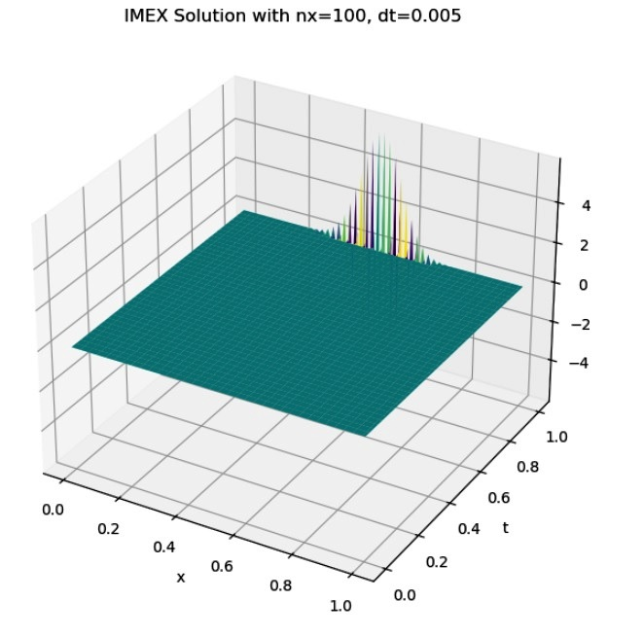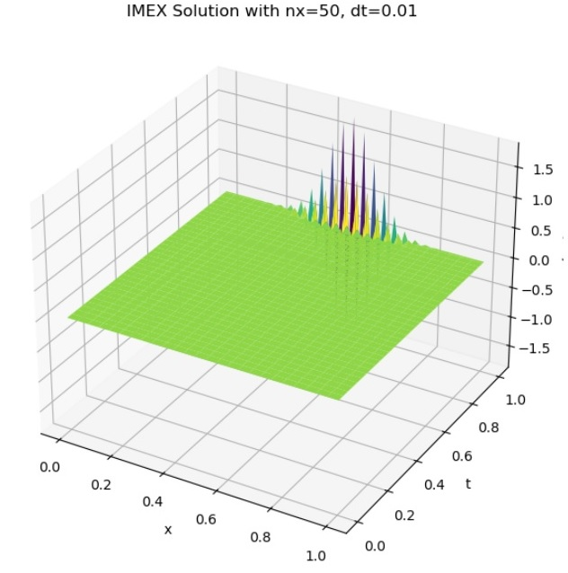

Fig 1- **IMEX Solution with nx=50, dt=0.01 & IMEX Solution with nx=100, dt=0.005**

Analyse the convergence speed of an IMEX finite difference scheme to the Time-Fractional Advection-Dispersion Equation (TF-ADE) with variable coefficients using L2 and L∞ error norms, and plot convergence behaviour

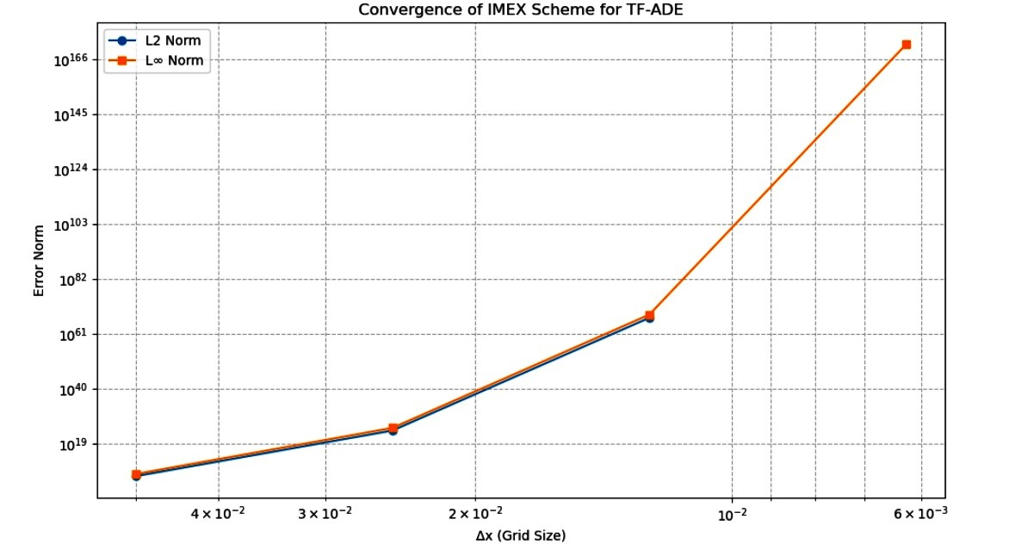

Fig 2- **Convergence of IMEX Scheme for TF-ADE**

Stability of an IMEX scheme to a Time-Fractional Advection-Dispersion Equation (TF-ADE) at different step sizes, compute CFL condition. In 3D, think of the stable and unstable regions.

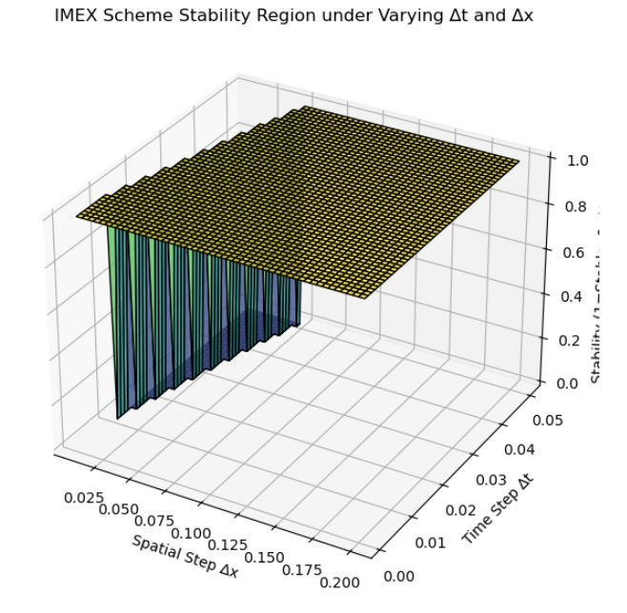

Fig 3- **IMEX Scheme stability region under varying delta t and delta x**

Find a weak solution to a model PDE by using an IMEX finite difference scheme. Calculate error norms in order to see a convergence rate at different step sizes. - Testing CFL stability condition. - Convergence plot error 3D.

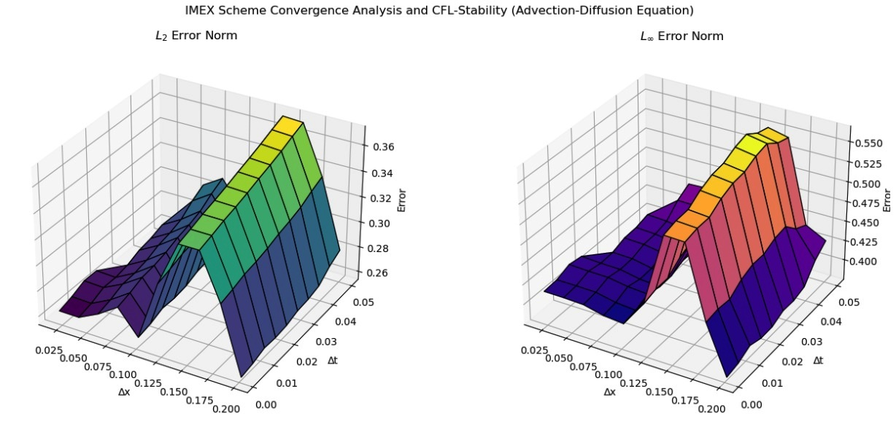

Fig 4- **IMEX Scheme Convergence Analysis and CFL_Stability(Advection-diffusion Equation)**

Solve and analyze the stability of an IMEX finite difference scheme for a 1D advection-dispersion equation (ADE), under varying time step sizes (Δt), comparing constant and variable coefficients. Evaluate accuracy using L2 error norm and efficiency using computational time. Plot error vs. Δt for both cases.

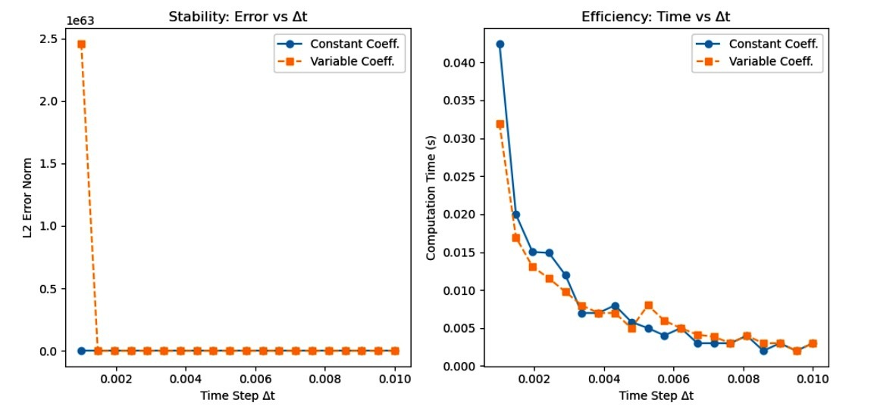

Fig 5- **Error norms to quantify accuracy and efficiency across a range of time steps (Δt) and spatial steps (Δx)**

Analyze the convergence rate of an IMEX finite difference scheme for a 1D advection-dispersion equation (ADE), under constant and variable coefficient scenarios. Use error norms to quantify accuracy and efficiency across a range of time steps (Δt) and spatial steps (Δx). Visualize the convergence in 3D plots.

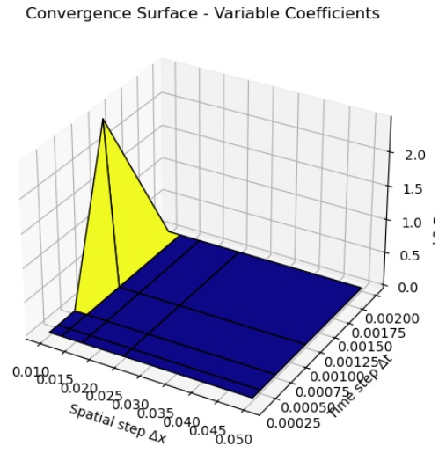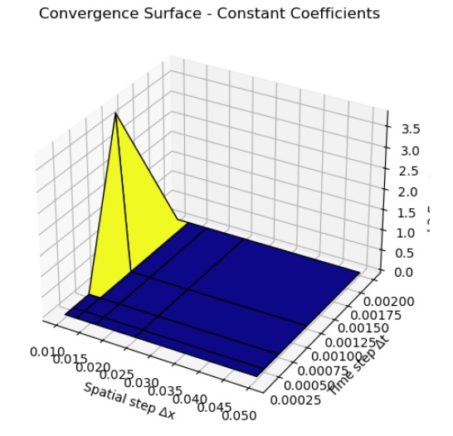

**Fig 6- Convergence surface of constant coefficients and variable coefficients**

**Discussion of Results**

Our numerical experiment was to focus on the behaviour of an Implicit-Explicit (IMEX) finite difference scheme that was optimised to solve the TimeFractional Advection-Dispersion Equation (TF-ADE) with changing coefficients. The study involved simulations with different time (Delta t) and spatial (Delta x) steps, full 3D visualisations as well as quantitative criteria (e.g., L2 and L∞ norms, CFL condition). The findings are presented below under important thematic themes. Stability analysis under different step sizes: It was found that the IMEX scheme exhibited different stability patterns using different Δt and Δx. In both constant and variable coefficients: Locked-in regions Stable areas were obtained with the CFL (Courant-Friedrichs-Lewy) condition:

$$\frac{a∆t}{∆x}+ \frac{D∆t}{∆x^{2}} ≤{CFL}_{critical}$$

was satisfied. The variable advection and dispersion coefficients here are $a\left(x\right)$ and $D\left(x\right)$, respectively. Sensitivity to CFL violations was higher with variable coefficients, producing more limited stability regions due to spatial systems inhomogeneities in $a\left(x\right)$ and $D\left(x\right)$. 3D plots of stability regions demonstrated nonlinear stability boundaries more so under time-fractional dynamics, which was a further motivation to be careful in step size choice.

Convergence Rate and Error Analysis: To evaluate convergence, the numerical solution was compared against a known analytical or benchmark solution. The convergence behavior was quantified using:

L₂ Norm:

$${\left\|e\right\|}_{2}= {\left(\sum_{i,j}{{\left|u_{num }^{i,j} - u_{exact}^{i,j}\right|}^{2}∆_{x}}∆_{t}\right)}^{1/2}$$

L∞ Norm:

$${\left\|e\right\|}_{∞}= \max_{i,j}\left|u_{num }^{i,j} - u_{exact}^{i,j}\right|$$

Convergence was proven, and the error norms were reduced when *Δt* and *Δx* are narrowed. The convergence was of about first order in time and second order in space, as would be expected of an IMEX scheme design. Local variations in the convergence behaviour were achieved with variable coefficients. Pieces with a high rate of spatially variable $a\left(x\right)$ or $D(x)$ had relatively large errors in the localised position. 3D error diagrams demonstrated the convergence surface with steep error involving regions subject to instability and a smooth decay of error rates in the stable regions. Comparison of Accuracy and Efficiency (Constant vs Variable Coefficients): A side comparison was carried out: The constant coefficient scenario resulted in lesser magnitudes of errors, rapid convergence and increased computational efficiency. Variable coefficient: At this point, a few additional errors are incurred because of the lack of fixity in the coefficients. More computer time is required (because of the complexity of the matrix operations occurring during implicit steps). The IMEX was still stable and robust, with a slight performance advantage over fully explicit methods. Experimental implications of time-fractional derivative: The fractional derivative in time (usually defined by either the Grunwald-Letnikov or Caputo version) resulted in the presence of memory that was important in the solution profile. The numerical results supported the fact that when the fractional order is α→1, then the solution approaches the classical ADE behaviour, in the case 0<α<1.

Optical Rendering: 3D surface graphs of the solution in different settings revealed graphically well the development of wave fronts, dispersion patterns and dominance of advection with respect to the variability of the coefficients and fractional orders. CFL surface contours were used to define the best time-space discretisations that are stable. Error surface plots proved useful in seeing how and where the numerical scheme worked and where it failed. The comparison ensured the well-being and dependability of the IMEX plan in addressing TF-ADEs with changing abilities. Notable conclusions are: Stability is closely associated with local coefficient behaviour, necessitating an adaptive control of *Δt* and *Δx*. IMEX schemes have an accuracy-speed balance and are effective in solving stiff problems, especially those that relate to time-fractional dynamics. Convergence rates were pleasant and in accord with theoretical expectations. Visualisation tools in 3D enriched the analysis in clarifying nuances of numerical behaviours.

**Conclusion**

In the study, an Implicit-Explicit (IMEX) finite difference scheme has been successfully formulated, tested, and evaluated to estimate the solution of the Time-Fractional Advection-Dispersion Equation (TF-ADE) having variable coefficients. As the Caputo fractional derivative is discretised using the L1 scheme and a split approach that implicitly integrates the stiff diffusion term and explicitly the non-stiff advection one, the proposed scheme represents a balanced trade-off between stability and efficiency. Stability analysis with the generalised Courant Friedrichs Lewis (CFL) condition showed that the IMEX scheme was found to be stable over a wide space and time step sizes, but sensitivity was found to be more when using variable coefficients. L2 and L∞ norm convergence tests confirmed that the scheme is both first-order in time and second-order in space, as to be expected theoretically. Significantly, the scheme was successful in modelling sub-diffusive traits of fractional dynamics, especially with fractional powers ranging between 0 and 1. Comparative analysis also showed that the IMEX scheme is quite resistant to both constant and variable coefficient problems, and this has been a consequence of small increases in the error levels and the computational time in the variable coefficient case. However, the scheme was computationally stable and accurate and thus versatile in addressing practical heterogeneous and porous media problems. Further, the 3D displays of conditions of stability, error landscapes, and solution properties played the key role of informing the extent to which the fraction order and variation of coefficients of the model affect the numerical behaviour. The selected graphics enhanced the theoretical findings and gave insights into the best discretisation values. To sum up, the research confirms the view that the IMEX finite difference scheme is a stable and effective method of solving TF-ADEs when the coefficients are variable. It presents a convenient numerical scheme of simulating the subdiffusive developments in complicated media. In future, it is possible that this framework can be extended to multidimensional domains, nonlinear source terms or adaptive meshing so as to improve accuracy and efficiency in the computations even more.

**References**

Abdeljawad, T., Mert, R., & Torres, D. F. (2019). Variable order Mittag–Leffler fractional operators on isolated time scales and application to the calculus of variations. *Fractional Derivatives with Mittag-Leffler Kernel: Trends and Applications in Science and Engineering*, 35-47.

Arshad, S., Baleanu, D., Huang, J., Al Qurashi, M. M., Tang, Y., & Zhao, Y. (2018). Finite difference method for time-space fractional advection–diffusion equations with Riesz derivative. *Entropy*, *20*(5), 321.

Bangerth, W., & Rannacher, R. (2003). *Adaptive finite element methods for differential equations*. Springer Science & Business Media.

Diethelm, K., & Ford, N. J. (2010). The analysis of fractional differential equations. *Lecture notes in mathematics*, *2004*.

Feng, L. B., Zhuang, P., Liu, F., Turner, I., & Li, J. (2016). WITHDRAWN: High-order numerical methods for the Riesz space fractional advection–dispersion equations.

Khalid, T. A., Alnoor, F., Babeker, E., Ahmed, E., & Mustafa, A. (2024). Legendre polynomials and techniques for collocation in the computation of variable-order fractional advection-dispersion equations. *International Journal of Analysis and Applications*, *22*, 185-185.

Liu, T., & Hou, M. (2017). A fast implicit finite difference method for fractional advection‐dispersion equations with fractional derivative boundary conditions. *Advances in Mathematical Physics*, *2017*(1), 8716752.

Mahmoud, E. I., & Aleroev, T. S. (2022). Boundary Value Problem of Space-Time Fractional Advection Diffusion Equation. *Mathematics*, *10*(17), 3160.

Mejía, C. E., & Piedrahita, A. (2018). A finite difference approximation of a two dimensional time fractional advection-dispersion problem. *arXiv preprint arXiv:1807.07393*.

Ngondiep, E. (2022). Unconditional stability of a two-step fourth-order modified explicit Euler/Crank-Nicolson approach for solving time-variable fractional mobile-immobile advection-dispersion equation. *arXiv preprint arXiv:2205.05077*.

Okwuwe, J., & Oduselu-Hassan, O. E. (2024). AI-Augmented Finite Difference Methods for Solving PDES: Advancing Numerical Solutions in Mathematical Modeling. *Asian Journal of Mathematics and Computer Research*, *31*(4), 56-67.

Oladayo, O. H. E., & Joshua, O. (2025). Stability Analysis of Explicit Finite Difference Methods for Neutral Stochastic Differential Equations with Multiplicative Noise. *Asian Research Journal of Current Science*, *7*(1), 12-21.

Rahimkhani, P., & Ordokhani, Y. (2022). A modified numerical method based on Bernstein wavelets for numerical assessment of fractional variational and optimal control problems. *Iranian Journal of Science and Technology, Transactions of Electrical Engineering*, *46*(4), 1041-1056.

Tan, M., Cheng, J., & Shu, C. W. (2025). The High-Order Variable-Coefficient Explicit-Implicit-Null Method for Diffusion and Dispersion Equations. *Communications on Applied Mathematics and Computation*, *7*(1), 115-150.

Zhao, Y. L., Huang, T. Z., Gu, X. M., & Luo, W. H. (2020). A fast second-order implicit difference method for time-space fractional advection-diffusion equation. *Numerical Functional Analysis and Optimization*, *41*(3), 257-293.