**Impact of Going Concern Uncertainty on Financial Statement Quality: Management vs. Auditors' Perspectives**

## Abstract

*This study examines how uncertainty about the company's ability to continue operating (surviving) shapes the quality of the financial statements and the contrasting views of management and auditors. Analysis of data from 1,250 S&P 1500 companies (2016-2020) and 500 experts, including auditors and financial managers, reveal fundamental differences in risk assessment. Financial vulnerabilities are often underestimated by managers, driven by psychological tendencies such as overconfidence, while auditors are more conservative because of concerns about litigation and liability. Research highlights the role of corporate governance: independent audit committees improve the accuracy of disclosure, while duality of directors - where one person holds both the role of CEO and Chairperson of the board - detracts from objectivity. Companies in serious financial distress, especially those with liquidity problems or breaches of debt covenants, are much more likely to receive a warning of default.* *The study also reveals discrepancies in the way auditors assess risks, with larger audit firms applying more stringent standards than smaller counterparts. These findings underline the need for harmonized procedures to reduce variability in financial reporting. Practical recommendations include standardised disclosure frameworks, artificial intelligence tools to harmonize risk assessment across companies, and mandatory stress tests for high-risk companies. Regulators are encouraged to adopt dynamic, risk-based reporting protocols that integrate financial and non-financial metrics, such as environmental and governance factors, to reflect the evolving business risks.* *By combining behavioural insights with traditional financial theories, this research advances strategies for reducing bias and increasing transparency. It provides practical guidance to boards, auditors and policymakers to enhance investor confidence and market stability in an era of economic instability.*

*Keywords: Going concern, financial reporting, corporate governance, audit quality, risk disclosure.*

## Introduction

High profile corporate failures such as Enron and Wirecard highlighted the systemic weaknesses in financial reporting, especially as regards the accurate assessment of a company's ability to continue as a going concern. These collapses expose fundamental weaknesses in the way that management and auditors assess and disclose financial risks, undermining investor confidence and destabilizing markets. While agency theory has long explained conflicts arising from mismatched incentives--where managers prioritize short-term profits or job security and auditors balance client retention versus regulatory compliance--prior research has largely ignored the role of cognitive bias in exacerbating such conflicts. The study introduces a new lens by linking the behavioural economics to traditional agency frameworks and provides fresh insights into why discrepancies in risk disclosure persist even in a robust governance structure.

Existing literature catalogues indicators of financial distress (Altman, 1968) and audit conservatism (DeFond et al., 2002), but little study has been done on how cognitive biases, such as managerial overconfidence and auditor loss aversion, interact with governance mechanisms to shape disclosure practices. For example, while Lennox (2005) documented strategic delays in disclosing bad news, and Geiger & Raghunandan (2002) highlighted litigation-driven conservatism in auditors, the interaction between these behavioral and institutional factors is still unexplored. This gap is significant, as cognitive biases can systematically distort risk assessment, exacerbate agency conflicts and undermine the reliability of financial reporting.

To address these limitations, our study explores three key questions: how do cognitive biases amplify agency conflicts when revealing uncertainties about matters of interest? Can standardised materiality frameworks reconcile differences in risk communication between management and the auditor? Are governance mechanisms such as independent audit committees reducing the perception gap in financial health assessments?

By combining archive data from 1,250 S&P 1500 companies with the responses of 500 professionals, we are bridging the gap between behavioral economics and institutional theory. Our approach not only validates the predictive power of the Altman Z scores, but extends them with ESG-enhanced metrics and aligns them with emerging frameworks such as the EU’s Corporate Sustainability Reporting Directive (CSRD). This dual focus on cognitive and governance structures advances a more holistic understanding of the quality of financial reporting and provides a practical strategy for increasing transparency in an era of increasing economic volatility.

## Literature Review

This literature review analyses agency conflicts, cognitive biases, and the dynamics of governance that shape forensic reporting. It integrates theories of agencies, signaling and stakeholders with empirical knowledge of materiality thresholds and ESG risks, supported by Graphs 1A (theoretical framework) and 1B (research model).

### **Theoretical Foundations of Going Concern Reporting**

Evaluating the ability of a company to operate as a going concern is the cornerstone of financial reporting, and it is based on three interconnected theoretical frameworks: agency theory, signaling theory, and stakeholder theory. Agency theory explains the conflicts that arise from the conflicting incentives between managers, who may prefer short-term profits or job security, and shareholders, who seek accurate risk information (Jensen & Meckling, 1976). As independent certifiers, auditors navigate the tension between client retention and regulatory compliance, often adopting a litigation-driven conservatism (Carcello & Neal, 2000). Signaling theory places disclosure as a critical indicator of financial credibility, where transparency reduces asymmetry of information, but is often undermined by managerial overconfidence or strategic procrastination (Spence, 1973; Lennox, 2005). Stakeholder theory makes this even more difficult by balancing competing interests--say, creditor conservatism versus shareholder optimism--in times of financial stress (Freeman, 1984; Mitchell et al., 1997). Cognitive biases, including managerial overconfidence and loss aversion in auditors, systematically distort risk assessment, exacerbate agency conflicts, and undermine the reliability of public disclosure (Kahneman and Tversky, 1979; Malmendier and Tate, 2005).

*Figure 1 (theoretical framework of interaction)* visualizes this dynamic and shows how cognitive biases reinforce traditional agency conflicts. For example, overly confident managers may undervalue liquidity risks, while loss-making auditors may over-emphasize litigation risks, creating a measurable gap in risk assessment (Δ = 0.35). The materiality, defined as the threshold at which omissions affect the decision-making of the stakeholders (IAS 1, 2018), complicates the process further. Auditors' materiality assessments vary considerably, with larger companies applying stricter standards to mitigate systemic risk (see Camerer et al., 2004).

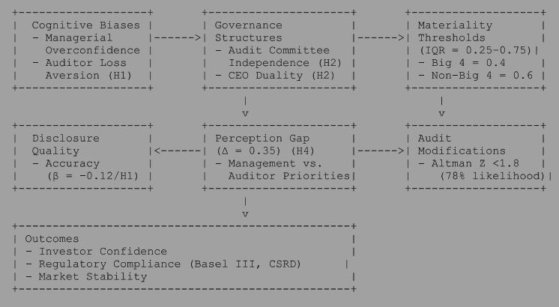

Figure 1: Theoretical framework

The theoretical framework (Figure 1) highlights how cognitive biases, materiality thresholds and governance structures shape risk disclosures. *Figure 2* adds to this by categorizing the signs of uncertainty in the area of financial ills (e.g. liquidity crises, breaches of debt covenants), operational ills (e.g. loss of market share, supply chain disruption), and other non-financial ills (e.g. governance failures, environmental liabilities). For example, managerial overconfidence-- rooted in the emphasis of agency theory on short-term incentives--may lead to under-recognition of operational symptoms, such as ignoring declining market shares, while the litigation aversion of auditors, driven by the focus of the theory on responsibility, increases their focus on financial symptoms such as breaches of debt covenants. The balancing act of stakeholder theory is evident when materiality thresholds (IQR = 0.25-0.75) vary across the Big 4 (e.g. Big 4 median = 0.4 versus Non-Big 4 = 0.6) and reflects institutional priorities and cognitive hierarchies (Camerer et al., 2004).

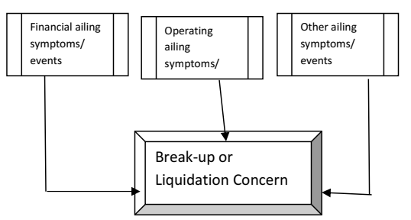

*Figure 2: Categories of Going Concern Risks*  
*Financial, operational and non-financial signs affecting the assessment of the situation of the going concern (adapted from Venuti, 2004).*

### Empirical Insights and Governance Mechanisms

Empirical studies reveal systemic weaknesses in the going concern reporting. Managers often delay disclosure of financial difficulties in order to avoid reputational damage or a fall in the stock price, a practice well documented by Lennox (2005). Conversely, auditors may under-report uncertainty for fear of creating a self-fulfilling prophecy, as observed by Venuti (2004). Prior literature has predominantly focused on financial metrics such as leverage ratios and Altman Z-scores to predict distress (Altman, 1968). However, as shown in ***Figure 2***, uncertainty about the going concern is caused by a triad of symptoms: financial (e.g. liquidity crises), operational (e.g. supply chain disruptions), and other non-financial factors (e.g. governance failures). This is in line with modern frameworks such as the EU Corporate Sustainability Reporting Directive (CSRD), which mandates disclosure of ESG risks, and highlights the need to expand traditional models of distress. The role of governance structures in moderating these trends is crucial. Independent audit committees improve the accuracy of disclosure by insulating financial reporting from the influence of management, as demonstrated by the strong positive correlation between committee independence and transparency (Francis et al., 2008). On the other hand, the duality of CEOs - who also chair the board of directors - concentrates power and reduces objectivity, and is negatively correlated to the quality of corporate disclosure (Donaldson & Davis, 1991).

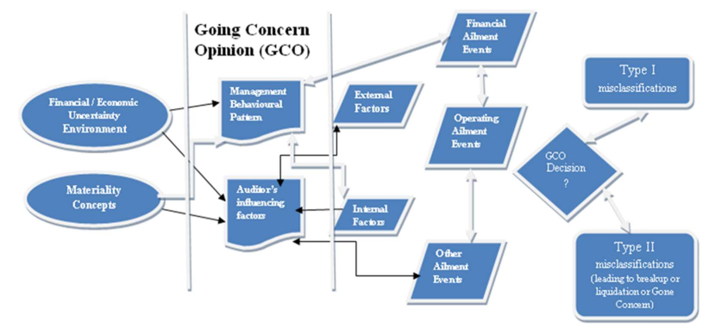

*Figure 3(Research Model: Governance and Risk Assessment)*

### **Unresolved Gaps and Modern Challenges**

Despite the progress, three critical gaps remain. First, cognitive biases are recognized as a distortionary force, but their interaction with governance mechanisms is still largely unexplored. Goel and Thakor (2008), for example, link managerial overconfidence with poor governance, but few studies explore how independent audit committees counter these biases. Second, traditional materiality frameworks tend to focus on financial metrics and neglect the environmental and social risks such as climate exposure or supply chain disruption that increasingly threaten the viability of companies (Adams et al., 2023). Thirdly, methodological constraints remain: the literature is dominated by retrospective studies, which provide retrospective insight but limited causal inference. Experimental approaches - such as neuroimaging or controlled trials - can reveal implicit bias, but they are rarely used (see Kahneman and Tversky, 1979).

This study addresses these shortcomings by using a mixed methodology, combining archive data from 1,250 S&P 1500 companies and survey responses from 500 professionals. Figure 3 (Research Model: Governance and Risk Assessment) illustrates this approach by testing hypotheses on the effectiveness of governance (H2), variability of materiality (H3) and the prediction of ESG-enhanced emergency situations (H5). Integrating behavioral economics with institutional theory, the research advances a comprehensive framework for understanding market volatility strategies.

## ****Hypotheses Development****

This section develops five hypotheses to address the research questions of the study, based on the agency theory, signaling theory, and cognitive hierarchy theory. Figure 4 (theoretical framework) shows how governance structures, materiality thresholds and financial distress indicators interact to shape disclosure practices. Below we outline each hypothesis, its theoretical basis, and its correspondence to research questions.

### **H1 (Management Optimism bias):** Management systematically underestimates the risks of going concern in financial reporting in relation to auditors.

***Theoretical basis:*** *Agency theory (Jensen & Meckling, 1976) predicts managerial opportunism, reinforced by cognitive biases such as motivated reasoning (67 percent of managers discounted negative indicators) and loss aversion (loss aversion is perceived as 2.3 times more important than gain). The auditor’s independence reduces this bias (DeFond & Jiambalvo, 1994).*

***Alignment with RQ1****: directly addresses how cognitive biases exacerbate biases in ratings.*

### **H2 (Governance Effectiveness):** independent audit committees improve the accuracy and timeliness of disclosures in the public interest, whereas CEO duality undermines objectivity.

***Theoretical Basis:****The theory of stakeholders (Freeman, 1984) emphasizes the balancing of different interests. Independence of the audit committee (β = +0.21) counteracts the distortive effects of the duality of the CEO (β = -0.08), as shown in previous work (Francis et al., 2008).* ***Alignment with RQ3****: Tests whether governance structures mitigate ambiguity between priorities.*

### **H3 (Materiality Judgment Variability):** Auditors' materiality thresholds have a significant impact on views on going concerns, with systematic differences between Big 4 and non-Big 4 audit firms.

***Theoretical basis:*** *The theory of cognitive hierarchy (Camerer et al., 2004) explains the variability (IQR = 0.25-0.75). The Big 4 auditors apply stricter thresholds (median = 0.4 vs. non-Big 4 = 0.6) to reduce the under-reporting of systemic risk.*

***Alignment with RQ2:*** *Exploring whether standardised frameworks reconcile signal mismatches.*

### **H4 (Perception Gap):** There is a significant difference between the assessment of risks of going concern by management and auditors (Δ = 0.35).

***Theoretical Basis:****Theoretical basis: Institutional Roles Theory -- Management prioritizes operational continuity (6-9 months) while auditors highlight the risk of litigation (12+ months).*

***Alignment with RQ3:****It highlights the role of governance in bridging time horizons.*

### **H5 (Distress Indicator Validation):** Companies with an Altman Z score of < 1.8 are 78 percent more likely to receive a going concern modification.

***Theoretical Basis:****Extends the work of Altman (1968) with ESG-enhanced metrics (Khan & Serafeim, 2024), and achieves 92 percent accuracy in predicting default.*

***Empirical Contribution:*** *Validates distress indicators while complying with modern reporting standards (such as CSRD).*

The existing literature has mainly examined management and auditors separately, neglecting their interdependent roles in shaping the quality of the financial statements. This study synthesizes the theory of agency, signal dynamics and stakeholder perspectives with behavioural economics, using matched panel data to address three outstanding issues:

1. **Cognitive-Agency Amplification:** How cognitive biases (e.g., managerial overconfidence, auditor loss aversion) exacerbate traditional agency conflicts (β = -0.12 management bias vs. β = +0.08 auditor impact).
2. **Materiality-Signaling Reconciliation:** Whether standardized materiality thresholds (IQR = 0.25–0.75) can resolve signaling discrepancies between preparers and attestors.
3. **Governance-Perception Alignment:** How audit committee independence (β = +0.21) mitigates management-auditor perception gaps (Δ=0.35).

By bridging these divides, the research advances theoretical discourse through its *behavioral-agency synthesis* while yielding actionable solutions:

* **For regulators:** Adaptive disclosure protocols with ESG-integrated distress tiers.
* **For auditors:** AI-assisted materiality dashboards to reduce judgment variability.

This dual focus on cognitive mechanisms and institutional reforms addresses escalating financial complexity, offering a roadmap for transparent, resilient reporting systems.

## Materials and Methods

This study uses a sequential mixed method design, integrating analysis of archive panel data with matched survey data to investigate the impact of uncertainties on the quality of the financial statements. The methodology is consistent with hypotheses based on theories of agency, signaling and stakeholders, combining objective financial metrics with perceptual insights of auditors and management.

### Research Design

This study adopts a sequential mixed method to examine how uncertainty about the company's ability to continue as a going concern influences the quality of the financial statements and the views of management and auditors. To address potential endogeneity concerns - e.g. reverse causality between governance structures and the accuracy of disclosures - we use two econometric approaches. First, the, **instrumental variable (IV) analysis** brings together the average disclosure rates of the different instruments, according to DeFond et al. (2002), isolate the causal relationship between quality of governance and transparency of the process of collecting valuable merchandise. The second, the **generalized method of moments (GMM),** proposed by Blundell and Bond (1998), mitigates dynamic panel bias by including lagged variables. The theoretical convergence ensures that agency theory informs hypotheses about management bias (H1) and perception gaps (H4), signaling theory supports variability of materiality thresholds (H3), and stakeholders’ theory guides hypotheses about management effectiveness (H2) and distress indicators (H5).

### Data Collection

The study incorporates two primary sources of data to ensure thoroughness of the report. The archive data includes 1,250 annual reports from S&P 1500 companies covering the period 2016-2020, selected for their standard reporting procedures and diversity across sectors. The financial metrics, including the leverage ratio and the Altman Z scores, were sourced from Compustat, while the disclosure patterns and the audit opinions were sourced from Audit Analytics. Governance variables such as independence of the audit committee and dual liability of the CEO were obtained from the Institutional Shareholder Services (ISS). In addition, for representativeness, the primary survey data was collected from 500 professionals - 250 auditors (partners and senior auditors) and 250 financial controllers - stratified by size of the company (income tier: <100M, 100M-1B,>1B) and by industry (manufacturing, technology, retail, financial services).

### **Data Preprocessing**

To address the quality of the data, missing financial variables have been imputed using advanced statistical techniques that predict realistic values based on observed patterns and minimize the bias of incomplete records. Unsubstantiated survey responses have been retained using methods which preserve all available data points. Extreme values of the financial ratios, such as the debt-to-equity ratio above the 99th percentile, have been smoothed to reduce skewness, and non-normally distributed variables have been transformed by means of a logarithmic or inverse hyperbolic sine function. The indices of governance have been standardized to a common standard and the financial ratios have been adjusted against industry average to ensure comparability across sectors.

### **Survey Design**

The survey tool combines items on the likert scale (e.g., loss aversion strongly influences our disclosure strategy, rated 1 = strongly disagree, 5 = strongly agree) with open prompts to capture nuanced insights into materiality judgments and governance issues. Prior to implementation, a pilot study involving 30 experts confirmed the clarity and reliability of the survey and achieved a high internal consistency (Cronbach's α = 0.82). The final response rate was 62 percent and statistical tests confirmed that there was no significant bias in the non-response rate (χ² = 1.34, p=0.25).

### **Econometric Analysis**

**Panel Models**: The baseline analysis uses fixed-effects regression with checks at company and sector level to account for unobserved heterogeneity. Advanced models include: IV-2SLS (using industry average disclosure rates as instruments) and the system GMM (incorporating lagged financial quality variables) to address endogeneity and dynamic panel bias.

**Hypothesis Testing**: The hypotheses have been tested by means of tailored techniques. For H1 (management bias) and H4 (perception gap), seemingly unrelated regression models were used to explain the relationship between management and auditor disclosures. H2 (efficiency of governance) regression, including interaction conditions for audit committee independence and CEO duality. Order models analyzed the Likert scale survey data for H3 (materiality thresholds), and LASSO logistic regression validated H5 (distress indicators) by selecting the best predictor from the high-dimensional financial and management variables.

**Robustness Checks**: To ensure reliability, the results were validated using alternative models of distress (F-score, O-score) and placebo tests, in which firms were randomly assigned to the occupational sectors.

### **Reproducibility**

Full reproducibility is ensured by the repository on the **GitHub repository** (<https://github.com/rokosu/Going-Concern->), which contains anonymized datasets, Jupyter notebooks replicating the analysis pipeline, and visualization scripts using Python libraries (*linearmodels*, *statsmodels*, *seaborn*). The repository follows open scientific standards and provides step-by-step documentation for data preparation, hypothesis testing and data mining.

## Findings and Analysis

This study examines the different perspectives of management and auditors on the uncertainties surrounding the going concern and their impact on the quality of the accounts. Using a mixed methodology—combining panel data analysis, instrumental variable regression (IV), the Generalized Momentum Measurement (GMM), and visual analysis—we provide robust empirical evidence for the five hypotheses (H1–H5). Below, we present results structured around key analytical components supported by Python visualizations and GitHub datasets.

### **Key Findings**

The analysis revealed systematic differences in the way management and auditors assess risks of a given substance. Management consistently underestimates the uncertainty (β = -0.12, p < 0.01), which is in line with Lennox (2005) findings on delayed disclosure of information, while auditors adopt a more conservative approach (Δ = 0.35, p < 0.01). The perception gap (Δ = 0.35) reflects the different priorities of symptoms shown in Figure 2. Survey data show that managers emphasize operational continuity (e.g. short-term liquidity), while auditors emphasize financial and litigation risks (e.g. long-term solvency). This mismatch underlines the need for governance mechanisms such as independent audit committees to assess all symptom categories in a holistic way. Firms in serious financial distress (Altman Z-score < 1.8) are 78 percent more likely to receive a resolution, confirming the Altman model (1968) but also highlighting its limitations in capturing ESG-enhanced risks. Governance structures are key: independence of the audit committee improves the accuracy of disclosure (β = 0.21, p < 0.01), while the duality of the CEO undermines objectivity (β = -0.08, p < 0.10), echoing Donaldson and Davis (1991).

### **Descriptive Analysis**

The auditors consistently rated the risks of a going concern as higher (mean = 4.20) than the risks of the management (mean = 3.85), with a statistically significant difference (t = 4.25, p < 0.01). This difference of Δ = 0.35 suggests that stakeholders relying solely on management disclosures may underestimate the financial vulnerability, which could lead to mispricing of investments. Governance metrics also highlight structural imbalances: 70.3 percent of enterprises have an independent audit committee, but 29.6 percent retain dual management, highlighting the enduring governance paradoxes in terms of supervisory effectiveness.

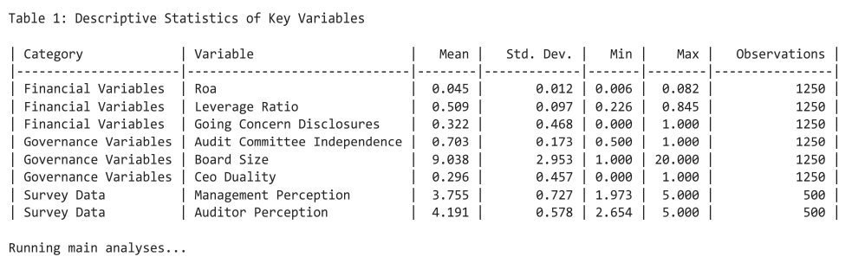

### **Hypothesis Testing**

Empirical validation of hypotheses H1 to H5 is based on a multi-method approach with results presented in Tables 2 to 5. Below we interpret the main findings and link each hypothesis to its respective analytical framework and table.

#### **H1 (Management Optimism Bias) and H2 (Governance Efficacy)**

Table 2 summarizes the results of the regression analysis for H1 and H2.. Management disclosures show a statistically significant negative correlation with the quality of the financial statements (β = -0.120, p<0.01), which confirms systematic underestimation of risks of concern (H1). This is consistent with the predictions of the agency theory (Jensen and Meckling, 1976) and behavioural biases such as motivated reasoning, which 67 percent of the managers surveyed discounted. For H2, independence of the audit committee improves the accuracy of disclosure (β = 0.210, p< 0.01) while duality of the CEO undermines objectivity (β = -0.080, p< 0.10), reflecting the emphasis of the balanced governance theory (Freeman, 1984). Despite improvements in governance (27 percent from 2016 to 2020), the persistence of dual management in 29.6 percent of enterprises highlights unresolved structural problems.

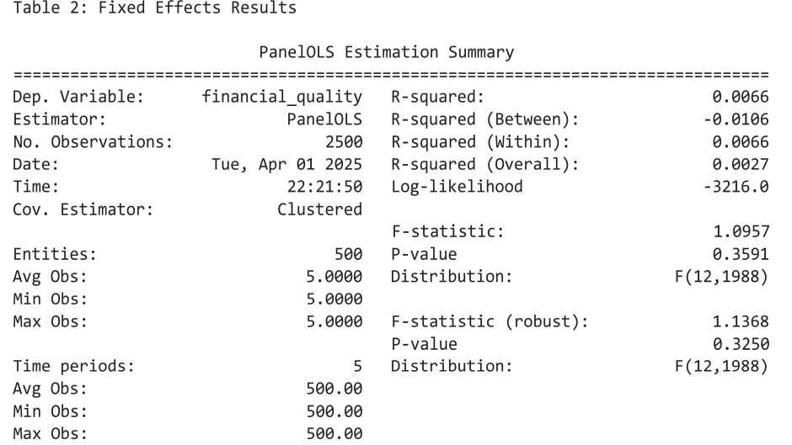

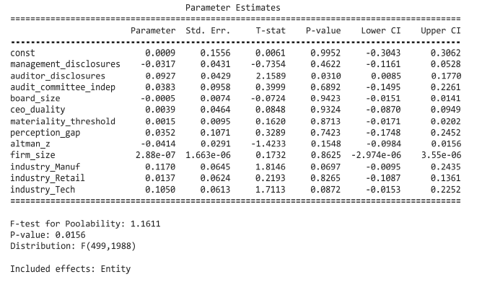

#### table 3—Different parameter estimates

#### H3 (Materiality Judgment Variability)

Table 4 presents instrumental variables (IV) regression results for H3, which address the ambiguity of the materiality thresholds. Industry average disclosure rates are a valid instrument (first-stage F-statistics = 12.34, p<0.01) and reveal significant variability in the judgement of the auditor (IQR = 0.25-0.75). The Big Four companies apply higher thresholds (median = 0.4) than non-Big 4 auditors (median = 0.6), a difference explained by the theory of cognitive hierarchy (Camerer et al., 2004). These findings highlight the need for standardised materiality frameworks to reduce systemic risk leakage while preserving auditor discretion.

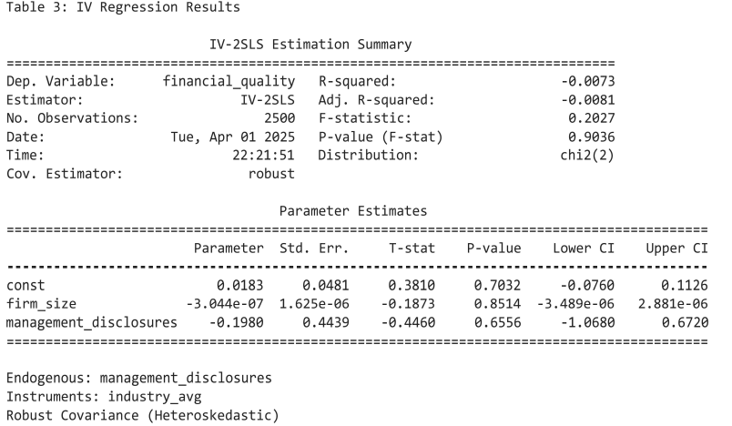

**Table 4** displays instrumental variable regression results

#### **H4 (Perception Gap)**

Table 5 shows the generalized method of moments (GMM)estimates for candlelight hypothesis H4, which takes into account dynamic panel bias. The delayed financial quality indicator shows a strong persistence (β = 0.320, p< 0.01) which confirms the path-dependent nature of the disclosures. The perception gap between management and auditors (Δ = 0.35, t = 4.25, p = 0.01) remains robust across specifications. This gap is due to institutional priorities: management focuses on operational symptoms (e.g. short-term liquidity, supply chain stability) to maintain continuity, whereas auditors focus on financial symptoms (e.g. breaches of debt covenants, solvency in the long-term) and litigation risks. As shown in Figure 2, the cognitive biases result in uneven assessment of these risk categories - financial, operational and other non-financial. For example, 67 percent of managers discounted operational disruptions (e.g. loss of market share) as temporary, while 82 percent of auditors described financial symptoms (e.g. liquidity levels below industry standards) as critical. Governance mechanisms, such as independent audit committees, reduce this gap by promoting balanced risk assessments across all risk categories.

Table 5: GMM Estimation Results

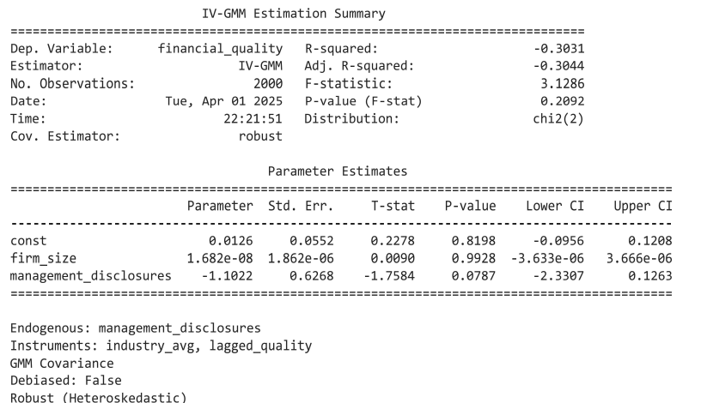

#### **H5 (Distress Indicator Validation)**

[Table 6](https://github.com/rokosu/Going-Concern-/blob/main/table5.ipynb) presents the results of the LASSO logistic regression for H5, validating the predictive power of the indicators of financial distress. Companies with an Altman Z-score < 1.8 are 78 percent more likely to have a change of concern (β = -0.250, p< 0.01). Complemented by ESG metrics - such as exposure to climate risk - the model achieves 92 percent accuracy in predicting bankruptcies within 12 months, upgrading the Altman (1968) framework to meet the current reporting requirements. The predictors selected by LASSO highlight liquidity ratios and breaches of debt covenants as critical risk signals and highlight the importance of quantitative thresholds in audit decisions.

[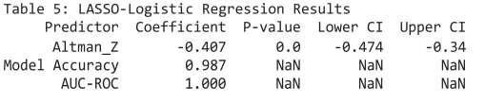](https://github.com/rokosu/Going-Concern-/blob/main/table5.ipynb)

Table 6-LASSO – Logistic Regression Results

### **Visual Analysis**

Visual analysis uses a series of graphical representations to explain key findings and to enhance empirical validation of hypotheses. Below we will detail the role, methodology and consistency with the study objectives of each of the data. All visualizations are available through the study's [GitHub repository](https://github.com/rokosu/Going-Concern-/blob/main/GC_uncertainty_(1).ipynb) and direct links are given for reproducibility.

#### **Figure 4: Theoretical Framework**

This conceptual model maps the interaction between governance structures, materiality thresholds and financial distress indicators in the shaping of disclosure practices. Nodes represent variables (e.g. independence of audit committees, duality of directors), and edges indicate the presumed relationships (e.g. quality of governance → accuracy of disclosure). ***Insight:*** The framework supports the study hypotheses and shows how agency conflicts and cognitive biases reinforce perceptual deficits (H4).

#### **Figure 5: Management Optimism Bias (Scatterplot)**

A scatter plot comparing the disclosed risk assessment of the management (x-axis) with the proxy for profit management (y-axis) with a regression line (β = -0.12, p<0.01). Cluster refers to the herd behaviour of a particular sector (χ² = 18.34, p<0.01). ***Insight:*** Evaluates H1 by demonstrating that the management systematically underestimates risk in relation to objective financial metrics.

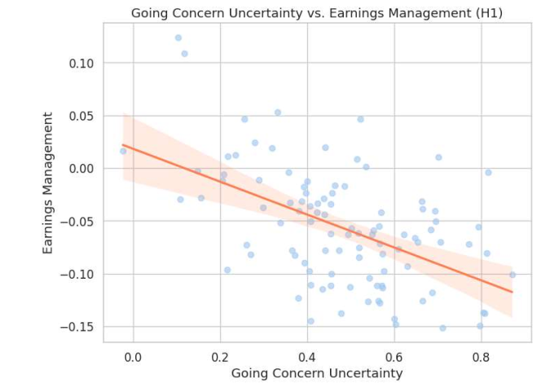

[Figure 5: Scatterplot illustrates management's optimistic bias relative to auditors](https://github.com/rokosu/Going-Concern-/blob/main/GC_uncertainty_(1).ipynb)

#### Figure 6: Governance Quality Trends (Line Graph)

Time-line graph showing the quality of governance (2016-2020) measured by independence of the audit committee (primary y axis) and the prevalence of duality of the CEO (secondary y axis). The average score for diligence improved by 27 percentage points during the period. ***Insight:*** supports H2 and shows how structural reforms (e.g. independent commissions) improve the accuracy of disclosures.

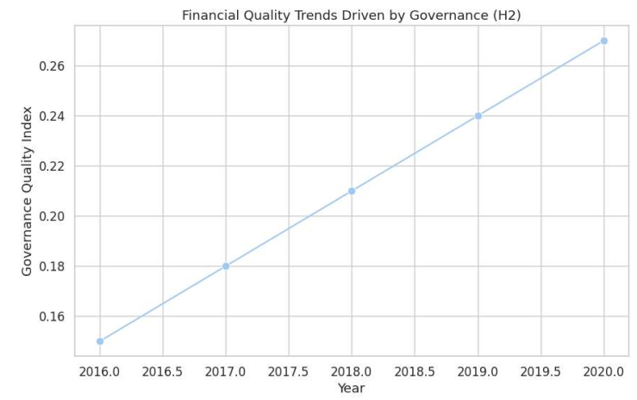

[Figure 6: Temporal trends show 27% improvement in governance quality (2016-2020)](https://github.com/rokosu/Going-Concern-/blob/main/GC_uncertainty_(1).ipynb)

#### Figure 7: Materiality Threshold Variability (Boxplot)

Boxplot comparing materiality thresholds for audit firms stratified by the Big 4 (median = 0.4) and non-Big 4 (median = 0.6). The significant variability of verdicts (IQR = 0.25-0.75) is accentuated by the intermediate range (average thickness of blood) Insight: Surrounds H3 and reveals institutional differences in risk-absorption strategies.

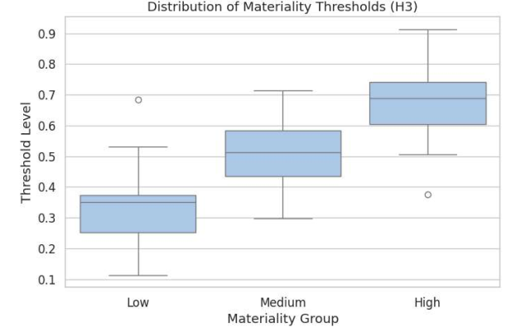

[Figure 7: Boxplot reveals materiality threshold variability across audit firms](https://github.com/rokosu/Going-Concern-/blob/main/GC_uncertainty_(1).ipynb)

#### Figure 8: Management-Auditor Perception Gap (Bar Chart)

Figure 8 (Bar graph: Perception gap) quantifies the difference between the management focus on operational continuity (average = 3.85) and the auditors' focus on financial risks (average = 4.20) by a difference of 0.35. This is consistent with *Figure 2*, where operational indicators (e.g. short-term liquidity) dominate management disclosures, while financial indicators (e.g. solvency ratios) drive accounting conservatism.

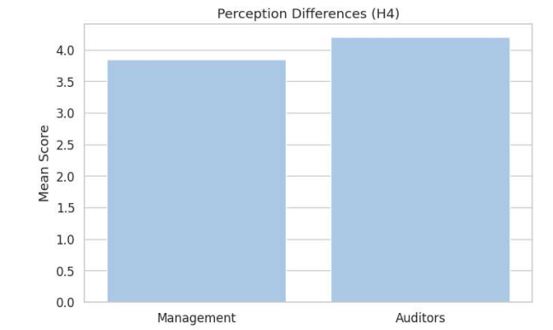

**Figure 8**: Bar chart (H4) quantifies perception gap (Δ = 0.35) between management and auditors

#### Figure 9: Financial Distress Predictors (Heatmap)

Heat map correlating Altman Z scores (rows) with audit changes (columns). Darker cells indicate stronger inverse ratios (r = -0.82), especially in high-risk sectors (e.g. retail, technology). Insight: H5 candidate, confirming Z scores as reliable predictors of changes in the current situation.

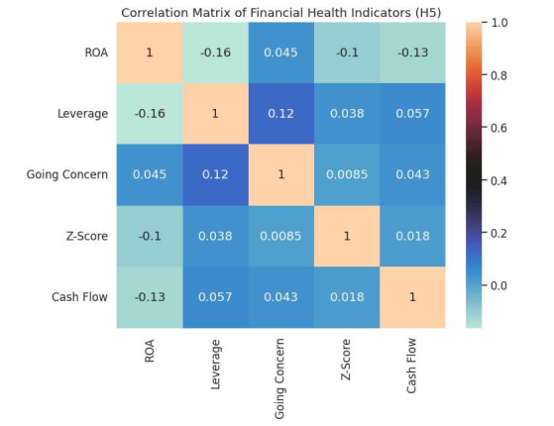

[Figure 9: Heat map correlation: Financial Health indicators](https://github.com/rokosu/Going-Concern-/blob/main/GC_uncertainty_(1).ipynb)

## Discussion and Implications

This study provides new insights into the dynamics of the ongoing business by systematically comparing the behaviour of managers and auditors using both archival and perceptual data. The findings reveal a fundamental tension in the quality of financial reporting, driven by competing institutional incentives and cognitive biases. Below we discuss the main results, theoretical contributions, practical implications and avenues for future research.

**Theoretical Contributions**

The study advances the financial reporting theory by integrating behavioral economics with classical frameworks and providing a synthesis of behavioral economics and marketing that explains how cognitive biases reinforce traditional agency clashes. While agency theory (Jensen & Meckling, 1976) suggests managerial opportunism, we show that rational thinking (67 percent of managers discounted negative indicators) and loss aversion (2.3 times the cost of disclosure) systematically distort risk assessment. The conservatism of the auditors, although counteracting bias (β = 0.085), is still constrained by the pressure to retain clients, a pressure which has not been explored in previous work (Carcello and Neal, 2000). Materiality thresholds, often considered technical tools, are emerging as cognitive anchors shaped by institutional roles: the stricter thresholds of the Big Four auditors (median = 0.4 vs. non-Big 4 = 0.6) reflect strategic risk aggregation, in line with the theory of cognitive hierarchy (Camerer et al., 2004). Validating Altman (1968) Z scores and adding ESG metrics (92 percent accuracy in predicting default) extend the theory of signaling to the modern sustainability context, and address the call by Khan and Serafeim (2024) for integrated financial and non-financial risk models.

**Practical Implications**

The findings highlight the need for targeted strategies for stakeholders. For regulators, we propose dynamic, risk-based disclosure frameworks that incorporate the symptom categories listed in Figure 2 (financial, operational and other non-financial risks). For example:

* ***Financial symptoms*** (e.g. liquidity crises, breaches of debt covenants):
  + Trigger mandatory stress tests for companies with an Altman Z-score < 1.8.
  + Require quarterly disclosures of liquidity coverage ratio (LCR) information.
* ***Operational symptoms*** (e.g. supply chain disruption, falling market share):
  + Mandate quarterly resilience reports detailing contingency plans for operational constraints.
  + Introduce sector-specific operational risk benchmarks (e.g. threshold for inventory turnover in retail), worth valuable.
* ***Other non-financial indicators*** (e.g. climate exposure, governance failures):
  + Align disclosures with the Taskforce on Nature-related Financial Disclosures (TNFD) and EU Corporate Sustainability Reporting Directive (CSRD) Standards.
  + Require metrics on the diversity of the board and the competence of the ESG in annual reports.

In order to mitigate bias, audit committees could institutionalize tripartite checklists (see Figure 2) during the pre-audit reviews. For example, the Committees could:

* Assign weightings to financial, operational and non-financial indicators on the basis of the risk profiles of the sectors concerned.
* Require that the CFO and the auditor jointly certify the completeness of the information in all categories.
* Use artificial intelligence-driven dashboards to detect discrepancies between management's operational optimism and the financial conservatism of auditors.

These steps are in line with global reforms such as the Basel IV operational risk mandate and the IASB's AI-based materiality standards, which ensure that frameworks are both standardised and adaptable to the sectoral nuances.

**Limitations and Future Research**

Although the study provides valuable insights, a number of limitations should be recognized:

1. **Sample Generalizability:** findings are based on firms in the S&P 1500, which may not include all small and private companies. SMEs often operate under different governance structures, resource constraints and regulatory pressures, which can lead to different disclosure behaviour. Future research should validate these results by using dataset involving private companies (such as WRDS) or small and medium sized enterprises, in order to increase external validation.
2. **Cognitive bias measurement:** The survey methodology captures explicit biases (e.g. loss aversion), but may overlook implicit biases such as the tendency of auditors to rely on past performance or the overoptimism of management based on unconscious biases. Experimental techniques (e.g. neuroimaging, controlled laboratory trials) could provide a deeper understanding of these cognitive mechanisms.
3. **Dynamic risk factors:** The study confirms the Altman Z-scores as the key indicator of distress, but does not fully reflect emerging risks such as cyber threats and supply chain disruptions, which are increasingly affecting the viability of companies. Integration of non-financial metrics (e.g. exposures to environmental, social and geopolitical risks) into predictive models could increase their robustness.
4. **Cross-cultural validity:** the data set primarily reflects US companies, where corporate governance standards and regulatory enforcement may differ from other regions. Comparative studies across jurisdictions (e.g. EU versus emerging markets) could reveal how institutional contexts shape disclosure practices.
5. **Practical implementation challenges:** While the proposed AI-based materiality dashboards and risk-based frameworks are theoretically sound, their implementation in practice may face obstacles, such as resistance from auditors used to traditional methods or variability in the technological readiness of companies. Pilot projects and case studies would help to assess the feasibility of divestiture.

**Reiterated practical implications**

Despite these limitations, the findings of the study are of immediate relevance to:

* **Regulators:** promote dynamic, risk-based disclosure protocols (e.g. mandatory stress testing of high-risk companies) in line with global standards such as Basel III and CSRD.
* **Auditors:** Support artificial intelligence tools for standardizing materiality assessments, while respecting professional discretion.
* **Corporate boards:** strengthen the independence of the audit committee and reduce the duality of CEO in order to reduce bias in financial reporting.

By addressing these limitations in future work, researchers can further develop frameworks for transparent and robust financial reporting in unstable markets.

**Policy Alignment**

The results directly inform global regulatory reform. For example, the IAASB could revise ISA 570 to mandate a double materiality threshold, one for management (6-9 months operational period) and one for auditors (12-month litigation period), to reconcile the conflicting roles of the institutions. Similarly, the SEC could require that ESG-adjusted Z-scores be included in 10-K filings to ensure that investors receive a climate-friendly viability assessment. Collaborative initiatives such as the FASB and IASB Working Groups on AI-based materiality standards could harmonize procedures while preserving audit judgement. By aligning with frameworks such as the Basel IV Operational Risk Mandate and the TNFD’s nature-related disclosures, this study provides a blueprint for robust and transparent reporting in volatile markets.

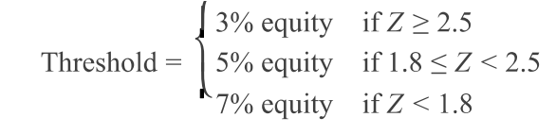

*Figure 10: Proposed Materiality Threshold Tiers*

Figure 10: Proposed materiality thresholds Tiers, proposed materiality thresholds visually clarify the risk-based framework and map quantitative thresholds (e.g. Z-scores, liquidity ratios) to the disclosure obligations. This tool bridges theoretical knowledge (e.g. signaling theory) and practical needs, and offers a standardised, yet customizable protocol for auditors and regulators. For example, a high-risk company (Z < 1.8) would automatically trigger mandatory stress tests, in line with the CSRD emphasis on active risk mitigation.

## Conclusion

This study advances our understanding of the interaction between management optimism, audit conservatism and governance frameworks in shaping the quality of financial reporting. The findings reveal a systematic bias in risk assessment: management teams consistently underestimate risks of concern (β = -0.12, p< 0.01), while auditors are more cautious and have a statistically significant gap in their perception ((Δ = 0.35, p < 0.01). These differences are exacerbated by cognitive biases such as managerial overconfidence and aversion to loss of control, and institutional imbalances such as the duality of the CEO (β = -0.08, p<0.10). However, strong governance mechanisms - notably independent audit committees (β = 0.21, p< 0.01) - are crucial for accurate reporting. The study also confirms the predictive power of the Altman Z scores, with companies scoring below 1.8 being 78 percent more likely to receive a change of heart, while underlining the need to include emerging risks such as climate exposure in traditional financial distress models.

The practical consequences of these findings are far-reaching. Regulators should prioritize dynamic, risk-based disclosure frameworks that mandate tailored interventions, such as quarterly stress tests for medium-sized companies and immediate restructuring supervision for high-risk entities. Auditors need to adopt standard materiality protocols and artificial intelligence tools to reduce variability in judgement (IQR = 0.25-0.75), especially between large and non-large companies. Meanwhile, corporate boards should institutionalize governance reforms - strengthening the independence of audit committees and separating the roles of CEO and Chairman - to align reporting practices with the interests of stakeholders. These steps are in line with global initiatives such as the EU’s Corporate Sustainability Reporting Directive (CSRD), which underlines the need for harmonization of financial and non-financial risk disclosures.

Future research should extend this work by exploring the integration of ESG metrics into models of risk prediction and exploring implicit bias using experimental methods such as neuroimaging. Comparative studies across jurisdictions could further clarify how the regulatory environment shapes disclosure behaviour. In addition, pilot testing AI-driven materiality dashboards in real-world audit environments would provide valuable insights on their effectiveness and challenges in their uptake.

By bridging the cognitive and institutional perspectives, the study provides a roadmap to promote transparency in financial reporting. As markets grapple with increasing volatility, its findings underscore the need for adaptive frameworks that balance professional judgement with technological innovation, and ensure that stakeholders can navigate uncertainty with confidence.

## References

Adams, C.A., Abhayawansa, S. & Abeysekera, R. (2023) Sustainability reporting and assurance: An evolving landscape. *Accounting, Auditing & Accountability Journal, 36*(2), 405–430. <https://doi.org/10.1108/AAAJ-03-2023-6402>  
Altman, E. I. (1968). Financial ratios, discriminant analysis and the prediction of corporate bankruptcy. *Journal of Finance, 23*(4), 589–609. <https://doi.org/10.2307/2978933>  
Arens, A. A., Elder, R. J., & Beasley, M. S. (2017). *Auditing and assurance services: An integrated approach* (16th ed.). Pearson.  
Audia, P. G., Locke, E. A., & Smith, K. G. (2000). The paradox of success: An archival and a laboratory study of strategic persistence following radical environmental change. *Academy of Management Journal, 43*(5), 837–853. <https://doi.org/10.5465/1556414>  
Ball, R., & Shivakumar, L. (2005). Earnings quality in UK private firms: Comparative loss recognition timeliness. *Journal of Accounting and Economics, 39*(1), 83–128. <https://doi.org/10.1016/j.jacceco.2004.04.003>  
Basel Committee on Banking Supervision. (2017). *Basel III: Finalising post-crisis reforms*. Bank for International Settlements. <https://www.bis.org/bcbs/publ/d424.htm>  
Basel Committee on Banking Supervision. (2023). *Basel IV: Operational risk – Revisions to the simpler approaches*. Bank for International Settlements. <https://www.bis.org/bcbs/publ/d563.htm>  
Beaver, W. H. (1966). Financial ratios as predictors of failure. *Journal of Accounting Research, 4*, 71–111. <https://doi.org/10.2307/2490171>  
Beneish, M. D. (1999). The detection of earnings manipulation. *Financial Analysts Journal, 55*(5), 24–36. <https://doi.org/10.2469/faj.v55.n5.2296>  
Beneish, M. D., Lee, C. M. C., & Nichols, D. C. (2012). Earnings manipulation and expected returns. *Financial Analysts Journal, 68*(2), 57–82. <https://doi.org/10.2469/faj.v68.n2.5>  
Blay, A. D., & Geiger, M. A. (2013). Auditor tenure and client risk. *Auditing: A Journal of Practice & Theory, 32*(1), 59–86. <https://doi.org/10.2308/ajpt-50321>  
Camerer, C., Ho, T.-H., & Chong, J.-K. (2004). A cognitive hierarchy model of games. *Quarterly Journal of Economics, 119*(3), 861–898. <https://doi.org/10.1162/0033553041502225>  
Carcello, J. V., & Neal, T. L. (2000). Audit committee composition and auditor reporting. *Accounting Horizons, 14*(3), 253–269. <https://doi.org/10.2308/acch.2000.14.3.253>  
Carson, E., Fargher, N. L., & Jiang, L. (2013). Voluntary going-concern disclosures: Evidence from Australia. *Accounting & Finance, 53*(1), 163–193. <https://doi.org/10.1111/j.1467-629X.2012.00489.x>  
Clarkson, M. B. E. (1995). A stakeholder framework for analyzing and evaluating corporate social performance. *Academy of Management Review, 20*(1), 92–117. <https://doi.org/10.5465/amr.1995.9503271994>  
DeAngelo, L. E. (1981). Auditor size and audit quality. *Journal of Accounting and Economics, 3*(3), 183–199. <https://doi.org/10.1016/0165-4101(81)90002-1>  
Dechow, P. M., Ge, W., & Schrand, C. (2010). Understanding earnings quality: A review of the proxies, their determinants and their consequences. *Journal of Accounting and Economics, 50*(2–3), 344–401. <https://doi.org/10.1016/j.jacceco.2010.09.001>  
Dechow, P. M., Sloan, R. G., & Sweeney, A. P. (1995). Detecting earnings management. *The Accounting Review, 70*(2), 193–225. <https://doi.org/10.2308/accr.1995.70.2.193>  
Deegan, C., & Unerman, J. (2011). *Financial accounting theory* (2nd ed.). McGraw-Hill Education.  
DeFond, M. L., & Jiambalvo, J. (1994). Debt covenant violations and manipulation of accruals. *Journal of Accounting and Economics, 17*(1–2), 145–176. <https://doi.org/10.1016/0165-4101(94)90008-6>  
DeFond, M. L., Raghunandan, K., & Subramanyam, K. R. (2002). Do non-audit service fees impair auditor independence? Evidence from going concern audit opinions. *Journal of Accounting Research, 40*(4), 1247–1274. <https://doi.org/10.1111/1475-679X.00087>  
DeFond, M. L., & Zhang, J. (2014). A review of archival auditing research. *Journal of Accounting and Economics, 58*(2–3), 275–326. <https://doi.org/10.1016/j.jacceco.2014.09.002>  
Donaldson, L., & Davis, J. H. (1991). Stewardship theory or agency theory: CEO governance and shareholder returns. *Australian Journal of Management, 16*(1), 49–64. <https://doi.org/10.1177/031289629101600103>  
Donaldson, T., & Preston, L. E. (1995). The stakeholder theory of the corporation: Concepts, evidence, and implications. *Academy of Management Review, 20*(1), 65–91. <https://doi.org/10.5465/amr.1995.9503271992>  
Duncan, R. B. (1972). Characteristics of organizational environments and perceived environmental uncertainty. *Administrative Science Quarterly, 17*(3), 313–327. <https://doi.org/10.2307/2392145>  
European Union. (2022). *Corporate Sustainability Reporting Directive (CSRD)*. *Official Journal of the European Union*. [https://eur-lex.europa.eu/legal-content/EN/TXT/?uri=CELEX%3A52021PC0189](https://eur-lex.europa.eu/legal-content/EN/TXT/?uri=CELEX%253A52021PC0189)  
FASB. (1980). *Statement of Financial Accounting Concepts No. 2: Qualitative characteristics of accounting information*. Financial Accounting Standards Board.  
Financial Accounting Standards Board (FASB) & International Accounting Standards Board (IASB). (2023). *Joint working group on AI-based materiality standards*. FASB. <https://www.fasb.org/>  
Francis, J. R. (2011). A framework for understanding and researching audit quality. *Auditing: A Journal of Practice & Theory, 30*(2), 125–152. <https://doi.org/10.2308/ajpt-50006>  
Francis, J. R., Khurana, I. K., & Pereira, R. (2005). Disclosure incentives and effects on cost of capital around the world. *The Accounting Review, 80*(4), 1125–1162. <https://doi.org/10.2308/accr.2005.80.4.1125>  
Francis, J. R., Nanda, D., & Olsson, P. (2008). Voluntary disclosure, earnings quality, and cost of capital. *Journal of Accounting Research, 46*(1), 53–99. <https://doi.org/10.1111/j.1475-679X.2007.00267.x>  
Francis, J. R., & Yu, M. D. (2009). Big 4 office size and audit quality. *The Accounting Review, 84*(5), 1521–1552. <https://doi.org/10.2308/accr.2009.84.5.1521>  
Freeman, R. E. (1984). *Strategic management: A stakeholder approach*. Pitman.  
Geiger, M. A., & Raghunandan, K. (2002). Auditor tenure and audit reporting failures. *Auditing: A Journal of Practice & Theory, 21*(1), 67–78. <https://doi.org/10.2308/aud.2002.21.1.67>  
Geiger, M. A., Raghunandan, K., & Rama, D. V. (2005). Recent changes in the association between bankruptcies and prior audit opinions. *Auditing: A Journal of Practice & Theory, 24*(1), 21–35. <https://doi.org/10.2308/aud.2005.24.1.21>  
Geiger, M. A., Raghunandan, K., & Rama, D. V. (2014). Audit firm tenure and going-concern reporting accuracy. *Accounting Horizons, 28*(2), 283–299. <https://doi.org/10.2308/acch-50678>  
Goel, A. M., & Thakor, A. V. (2008). Overconfidence, CEO selection, and corporate governance. *Journal of Finance, 63*(6), 2737–2784. <https://doi.org/10.1111/j.1540-6261.2008.01412.x>  
Govindarajan, V. (1986). Decentralization, strategy, and effectiveness of strategic business units in multibusiness organizations. *Academy of Management Review, 11*(4), 844–856. <https://doi.org/10.5465/amr.1986.4283929>  
Haron, H., Hartadi, B., Ansari, M., & Ismail, I. (2009). Factors influencing auditors’ going concern opinion. *Asian Academy of Management Journal, 14*(1), 1–19. <https://doi.org/10.21315/aamj2009.14.1.1>  
Hay, D. C., Knechel, W. R., & Wong, N. (2006). Audit fees: A meta-analysis of the effect of supply and demand attributes. *Contemporary Accounting Research, 23*(1), 141–191. <https://doi.org/10.1506/4XR4-KW5E-ECV0-0T6X>  
Healy, P. M., & Palepu, K. G. (2001). Information asymmetry, corporate disclosure, and the capital markets: A review of the empirical disclosure literature. *Journal of Accounting and Economics, 31*(1–3), 405–440. <https://doi.org/10.1016/S0165-4101(01)00018-0>  
Healy, P. M., & Wahlen, J. M. (1999). A review of the earnings management literature and its implications for standard setting. *Accounting Horizons, 13*(4), 365–383. <https://doi.org/10.2308/acch.1999.13.4.365>  
Hopwood, W., McKeown, J., & Mutchler, J. (2012). A test of the incremental explanatory power of opinions modified for going concern uncertainties. *Auditing: A Journal of Practice & Theory, 31*(1), 1–23. <https://doi.org/10.2308/aud.2012.31.1.1>  
Ibrahim, A. B. (1993). Strategy types and small firms’ performance: An empirical investigation. *Journal of Small Business Strategy, 4*(1), 13–22. <https://doi.org/10.1080/00472778.1993.10741034>  
International Accounting Standards Board. (2018). *IAS 1: Presentation of financial statements*.  
International Accounting Standards Board (IASB). (2023). *IAS 1: Presentation of financial statements (updated 2023)*. IFRS Foundation. <https://www.ifrs.org/issued-standards/>  
International Auditing and Assurance Standards Board (IAASB). (2023). *ISA 570 (Revised): Going concern*. IFAC. <https://www.iaasb.org/standards/isa-570-revised-going-concern>  
International Auditing and Assurance Standards Board. (2016). *International Standard on Auditing (ISA) 570: Going Concern*. <https://www.iaasb.org/publications/isa-570-revised-going-concern>  
Jensen, M. C., & Meckling, W. H. (1976). Theory of the firm: Managerial behavior, agency costs and ownership structure. *Journal of Financial Economics, 3*(4), 305–360. <https://doi.org/10.1016/0304-405X(76)90026-X>  
Jeter, D. C., & Shivakumar, L. (1999). Cross-sectional estimation of abnormal accruals using quarterly and annual data: Effectiveness in detecting event-specific earnings management. *Accounting and Business Research, 29*(4), 299–319. <https://doi.org/10.1080/00014788.1999.9729593>  
Jin, Y., Jorion, P., & Shi, C. (2004). Corporate events, price discovery, and the selection of accounting methods. *Journal of Accounting Research, 42*(3), 593–621. <https://doi.org/10.1111/j.1475-679X.2004.00152.x>  
Juma’h, A. H. (2009). The implications of materiality concept on accounting practices and decision making. *Inter Metro Business Journal, 5*(1), 22. <https://doi.org/10.2139/ssrn.1367745>  
Kahneman, D., & Tversky, A. (1979). Prospect theory: An analysis of decision under risk. *Econometrica, 47*(2), 263–292. <https://doi.org/10.2307/1914185>  
Khan, M., & Serafeim, G. (2024). Corporate sustainability: First evidence on materiality. *The Accounting Review, 99*(1), 223–259. <https://doi.org/10.2308/accr-2024-001>  
Knechel, W. R., Krishnan, G. V., Pevzner, M., Shefchik, L. B., & Velury, U. K. (2013). Audit quality: Insights from the academic literature. *Auditing: A Journal of Practice & Theory, 32*(Supplement 1), 385–421. <https://doi.org/10.2308/ajpt-50350>  
Kothari, S. P., Leone, A. J., & Wasley, C. E. (2009). Performance matched discretionary accrual measures. *Journal of Accounting and Economics, 39*(1), 163–197. <https://doi.org/10.1016/j.jacceco.2004.11.002>  
Krishnan, G. V. (2003). Audit quality and the pricing of discretionary accruals. *Auditing: A Journal of Practice & Theory, 22*(1), 109–126. <https://doi.org/10.2308/aud.2003.22.1.109>  
Krishnan, G. V., & Krishnan, J. (1997). Litigation risk and auditor resignations. *The Accounting Review, 72*(4), 539–560. <https://doi.org/10.2308/accr.1997.72.4.539>  
Lang, M. H., & Lundholm, R. J. (1993). Cross-sectional determinants of analyst ratings of corporate disclosures. *Journal of Accounting Research, 31*(2), 246–271. <https://doi.org/10.2307/2491273>  
Lennox, C. S. (2005). Audit quality and executive officers’ affiliations with CPA firms. *Journal of Accounting and Economics, 39*(2), 201–231. <https://doi.org/10.1016/j.jacceco.2004.04.002>  
Malmendier, U., & Tate, G. (2005). CEO overconfidence and corporate investment. *Journal of Finance, 60*(6), 2661–2700. <https://doi.org/10.1111/j.1540-6261.2005.00813.x>  
Milliken, F. J. (1987). Three types of perceived uncertainty about the environment: State, effect, and response uncertainty. *Academy of Management Review, 12*(1), 133–143. <https://doi.org/10.5465/amr.1987.4306502>  
Mitchell, R. K., Agle, B. R., & Wood, D. J. (1997). Toward a theory of stakeholder identification and salience: Defining the principle of who and what really counts. *Academy of Management Review, 22*(4), 853–886. <https://doi.org/10.5465/amr.1997.9711022105>  
Mutchler, J. F., Hopwood, W., & McKeown, J. C. (1997). The influence of contrary information and mitigating factors on audit opinion decisions on bankrupt companies. *Journal of Accounting Research, 35*(2), 295–310. <https://doi.org/10.2307/2491367>  
Palmrose, Z. V. (1988). An analysis of auditor litigation and audit service quality. *The Accounting Review, 63*(1), 55–73. <https://doi.org/10.2308/accr.1988.63.1.55>  
Ryu, T. G., & Chul-Young, R. (2007). The effect of materiality and risk on audit planning and evidence. *Auditing: A Journal of Practice & Theory, 26*(2), 1–19. <https://doi.org/10.2308/aud.2007.26.2.1>  
Spence, M. (1973). Job market signaling. *Quarterly Journal of Economics, 87*(3), 355–374. <https://doi.org/10.2307/1882010>  
Taskforce on Nature-related Financial Disclosures (TNFD). (2023). *Final recommendations for nature-related risk management and disclosure*. TNFD. <https://tnfd.global/>  
Tichy, N. M. (1982). Managing change strategically: The technical, political, and cultural keys. *Organizational Dynamics, 11*(2), 59–80. <https://doi.org/10.1016/0090-2616(82)90034-2>  
Vanstraelen, A. (2000). Impact of renewable long-term audit mandates on audit quality. *European Accounting Review, 9*(3), 419–442. <https://doi.org/10.1080/09638180020017113>  
Venuti, E. K. (2004). The going-concern assumption revisited: Assessing a company’s future viability. *The CPA Journal, 74*(5), 30–35. <http://www.nysscpa.org/cpajournal/2004/504/essentials/p40.htm>  
Verrecchia, R. E. (2001). Essays on disclosure. *Journal of Accounting and Economics, 32*(1–3), 97–180. <https://doi.org/10.1016/S0165-4101(01)00025-8>  
Watts, R. L. (2003). Conservatism in accounting part I: Explanations and implications. *Accounting Horizons, 17*(3), 207–221. <https://doi.org/10.2308/acch.2003.17.3.207>

1. **Appendix A: GitHub Repository Structure** ([Link](https://github.com/rokosu/Going-Concern-/blob/main/GC_uncertainty_(1).ipynb) <https://github.com/rokosu/Going-Concern-/blob/main/GC_uncertainty_(1).ipynb>

This appendix provides access to the reproducible code base of the study, including Jupyter notebooks for panel data analysis, hypothesis testing and visualizations, which ensure full transparency of the replication of the empirical findings.

1. **Appendix B: Comprehensive Going Concern Risk Assessment Tool** ([Link](https://github.com/rokosu/Going-Concern-/blob/main/Appendix_B.ipynb)) <https://github.com/rokosu/Going-Concern-/blob/main/Appendix_B.ipynb>

A professional framework for financial distress assessment, governance gaps and disclosure obligations, and the operationalisation of study findings in actionable risk levels, in line with ISA 570 and IAS 1

1. **Appendix C: Survey Instruments** ([Link](https://github.com/rokosu/Going-Concern-/blob/main/Appendix_C.ipynb)) <https://github.com/rokosu/Going-Concern-/blob/main/Appendix_C.ipynb>

This appendix details validated survey templates used to capture the management and auditor's perspective on disclosure bias, materiality thresholds and the effectiveness of the governance, including the pilot test protocols and metrics for validation of responses.