**Analysis of Seed Physiological Characterization in Mungbean (*Vigna radiata* L.) Genotypes**

# Abstract

The present investigation was conducted to evaluate the seed physiological parameters among twelve mungbean (*Vigna radiata* L.) genotypes. Significant differences were observed among genotypes for all traits studied, including germination percentage, root length, shoot length, seedling dry weight, seedling vigor index-I, seedling vigour index-II, and speed of germination. Genotype IC-436932 exhibited superior performance in most parameters, recording the highest germination (95.00%), seedling dry weight (0.85 g), seedling vigour index-I (3932.05), seedling vigor index-II (80.75), and speed of germination (49.66). In contrast, IC-252008 consistently showed the lowest values across these traits. The results highlight the existence of considerable genetic variability among the tested genotypes, suggesting potential for selection and improvement of seed quality traits in mungbean breeding programs.

**Keywords**: Mungbean, germination, seedling vigor, root and shoot length, speed of germination

**Introduction**

Mungbean (*Vigna radiata* L. Wilczek) is one of the most important short-duration pulse crops cultivated in India and other Asian countries. It is a self-pollinated, diploid legume crop known for its high protein content (22–24%), digestibility, and rich micronutrient profile. The crop plays a vital role in the Indian vegetarian diet and is also used in various processed food products. Beyond its nutritional value, mungbean improves soil fertility through symbiotic nitrogen fixation and fits well in multiple cropping systems due to its short growth cycle and adaptability to varied agro-climatic conditions (Singh et al., 2016).

Despite its multiple benefits, the average productivity of mungbean remains suboptimal due to poor seed quality, abiotic stress susceptibility, and inadequate crop establishment. One of the major bottlenecks in mungbean cultivation is the use of low-vigour seeds, which results in poor germination, weak seedlings, and uneven plant stands, ultimately affecting yield (Verma et al., 2018). Therefore, evaluating and improving seed physiological traits is crucial to enhance the initial stages of plant growth and ensure uniform crop establishment. (Priya et al., 2022) (Yadav et al., 2021) (Kumawat et al., 2020) (Patel & Patel, 2023) (Chauhan & Singh, 2024) (Meena et al., 2019)

Seed physiological parameters such as germination percentage, root length, shoot length, seedling dry weight, seedling vigour indices (SVI-I and SVI-II), and speed of germination serve as reliable indicators of seed quality and vigour. These traits are influenced by both genetic and environmental factors and are often used to screen genotypes for better field performance (Kumari et al., 2019). According to Maguire (1962), the speed of germination is a key measure of seed performance under stress and non-stress conditions. Similarly, seedling vigour indices integrate germination and seedling growth and are valuable tools in seed quality testing (Rao et al., 2017).

Several studies have reported significant genetic variability among mungbean genotypes for seedling traits, suggesting the potential for genetic improvement through selection and breeding (Saha et al., 2021; Singh & Ahmed, 2020). Keeping this in view, the present investigation was carried out to evaluate the genetic variability in seed physiological parameters among twelve mungbean genotypes under laboratory conditions. The results are expected to aid in the identification of superior lines with high seed quality, which can be utilized in breeding programs for mungbean improvement and sustainable pulse production.

**Materials and Methods**

The laboratory experiments were conducted in the Department of Seed Science & Technology, Institute of Agricultural Sciences, Bundelkhand University, Jhansi (Uttar Pradesh), during 2024-25. Twelve mung bean (*Vigna radiata* L.) genotypes were used in this study to evaluate seed physiological parameters. The experiment was laid out in a Completely Randomized Design (CRD) with three replications.

**Physiological Parameters:**

1. Germination Percentage (%):

It was calculated after 8 days of sowing by counting the number of normal seedlings and using the formula:

Germination (%) = (Number of germinated seeds / Total number of seeds sown) × 100

2. Root Length (cm):

The root length of ten randomly selected seedlings from each replication was measured from the root tip to the base of the stem and the average was recorded in centimeters.

3. Shoot Length (cm):

Shoot length was measured from the base of the stem to the tip of the primary leaf using a scale. The average shoot length was calculated for each replication.

4. Dry Weight (g):

The ten seedlings used for length measurements were dried in a hot air oven at 80°C for 24 hours and then weighed using a precision balance. The mean dry weight per seedling was calculated in grams.

5. Speed of Germination (SG):

Calculated using Maguire’s formula:

Speed of Germination = (n₁/t₁) + (n₂/t₂) + ... + (nₙ/tₙ)

Where:

n₁, n₂, ..., nₙ = number of seeds germinated on day t₁, t₂, ..., tₙ respectively

6. Seed Vigor Index-I (SVI-I) was calculated as:  
SVI-I = Germination (%) × Mean seedling length (cm)

Seed Vigor Index-II (SVI-II) was calculated as:  
SVI-II = Germination (%) × Seedling dry weight (g)

**Statistical Analysis**

The experimental data collected for seed physiological traits—germination percentage, root length (cm), shoot length (cm), dry weight (g), and speed of germination—were subjected to statistical analysis using the **Analysis of Variance (ANOVA)** technique appropriate for a **Completely Randomized Design (CRD)** with three replications. The significance of treatment effects was tested at **5% and 1% probability levels**.

The following statistical parameters were computed:

* **Standard Error of Mean (SEm):** Indicates the precision of the sample mean.
* **Critical Difference (CD):** The minimum difference required between two means to be considered significantly different at a specified probability level.
* **Coefficient of Variation (CV %):** Assesses the degree of variability relative to the mean and reflects the reliability of the experiment.

For assessing differences among the genotypes, the **F-test** was used. If the F-value was significant, **post-hoc comparison** was made using **CD at 5%** level to determine the significant differences between genotypes.

All calculations were performed using standard statistical procedures with the help of Microsoft Excel and OPSTAT software (developed by CCS HAU, Hisar). The interpretation of the results was done based on the significance of mean squares for the genotypes from the ANOVA table.

**Results and Discussion**

**Analysis of Variance (ANOVA)**

The analysis of variance (Table 1) revealed highly significant differences (p < 0.01) among the mungbean genotypes for all five seed physiological traits studied: germination percentage, root length, shoot length, dry weight, and speed of germination. This indicates substantial genetic variability among the genotypes for these traits, which is essential for selection and breeding programs.

**Germination Percentage and Seed Viability**

Germination is a crucial indicator of seed quality and planting value. The germination percentage of mungbean genotypes varied significantly, ranging from 62% (IC-252008) to 95% (IC-436932) (Table 2a). The average germination percentage was 83.3%. High germination observed in genotypes such as IC-282089, IHO-187, IC-436932, and IC-PMD-9 may be attributed to superior genetic makeup and better physiological seed conditions. Lower germination in IC-252008 could be due to poor seed storage conditions or lower inherent seed viability.

The variability observed in seed germination could also be influenced by environmental factors during seed production, harvesting, drying, and storage. Similar findings of genetic and environmental influence on germination have been reported by Tzortzakis (2009), Krishnappa et al. (2001) in finger millet, and Sarkar et al. (2015) in okra.

**Seedling Morphological Traits (Root and Shoot Length)**

The genotypes exhibited a wide range of variation for seedling root and shoot lengths. Root length ranged from 13.48 cm (IC-7646) to 18.06 cm (IC-282089), while shoot length ranged from 17.89 cm (IC-252008) to 25.46 cm (IC-436932) (Table 2a). These traits are vital for early seedling establishment and nutrient uptake.

Longer roots and shoots were observed in genotypes IC-282089, IC-76474, IC-436932, and IC-PMD-9, suggesting their potential for better field performance. Shorter seedling growth in other genotypes might reflect lower metabolic activity or seed vigour.

**Seedling Dry Weight and Vigour Indices**

Dry weight of seedlings showed significant genotypic variation, ranging from 0.59 g (IC-7646) to 0.85 g (IC-436932) (Table 2b). Seedling vigour index-I (SVI-I), which combines seedling length and germination percentage, ranged from 1971.60 to 3932.05, with IC-436932 showing the highest vigour. Similarly, seed vigour index-II (SVI-II), based on seedling dry weight and germination percentage, ranged from 42.34 to 80.75, again highest in IC-436932, followed by IC-282089 and IHO-187.

The higher values of SVI-I and SVI-II are attributed to longer seedlings and higher dry matter accumulation, which are direct indicators of seed quality. These indices were positively correlated with germination %, shoot/root length, and dry weight, confirming the findings of Kumar et al. (1989) in mungbean and Krishnappa et al. (2001) in finger millet.

**Speed of Germination**

Speed of germination is a measure of how quickly seeds sprout and is important for rapid field emergence. It ranged from 25.12 (IC-252008) to 49.66 (IC-436932). A faster germination speed was observed in IC-76388, IC-PMD-9, and IC-436932, indicating better metabolic activity and seed quality. Genotypes with higher germination speed also had higher seed vigour indices. These findings are in agreement with the reports of Negi (2015) and Krishnappa et al. (2001), which emphasized the significance of early and rapid germination as a seed vigour trait. (Priya et al., 2022) (Yadav et al., 2021) (Kumawat et al., 2020) (Patel & Patel, 2023) (Chauhan & Singh, 2024) (Meena et al., 2019)

Table:1The details of the mung bean genotypes evaluated are presented below:

|  |  |
| --- | --- |
| Genotype Code | Variety |
| G1 | IC-252008 |
| G2 | PMS-8 |
| G3 | IC-76474 |
| G4 | IC-282089 |
| G5 | IC-55444 |
| G6 | IC-420310 |
| G7 | IC-76453 |
| G8 | IC-7646 |
| G9 | IHO-187 |
| G10 | IC-76388 |
| G11 | IC-436932 |
| G12 | IC-PMD-9 |

Table-2: ANOVA for 5 seed physiological characters of mungbean genotypes

|  |  |  |  |  |  |  |
| --- | --- | --- | --- | --- | --- | --- |
| **Source of variation** | **d.f** | **Germination**  **%** | **Root length** | **Shoot length** | **Dry weight** | **Speed of germination** |
| Treatment | 11 | 185.916** | 2.414** | 9.746** | 0.008** | 91.879** |
| Error | 22 | 14.800 | 0.009 | 0.001 | 0.000 | 0.269 |
| SE(m) |  | 2.720 | 0.069 | 0.026 | 0.016 | 0.367 |
| SE(d) |  | 3.847 | 0.097 | 0.037 | 0.022 | 0.519 |
| C.D. |  | 8.081 | 0.204 | 0.078 | 0.046 | 1.089 |
| C.V. |  | 4.618 | 0.626 | 0.166 | 3.265 | 1.316 |

*Significant at 5% probability **Significant at 1% probability

Table-3(a): Mean performance of greengram genotypes for germination%, viability%, root length (cm) and shoot length (cm)

|  |  |  |  |  |
| --- | --- | --- | --- | --- |
| **Variety** | **Germination (%)** | **Viability (%)** | **Root length (cm)** | **Shoot length (cm)** |
| **IC-252008** | 62 | 86 | 13.91 | 17.89 |
| **PMS-8** | 82 | 99 | 16.43 | 22.04 |
| **IC-76474** | 84 | 96 | 17.03 | 23.65 |
| **IC-282089** | 90 | 95 | 18.06 | 24.11 |
| **IC-55444** | 74 | 100 | 14.56 | 19.16 |
| **IC-420310** | 81 | 100 | 14.87 | 21.80 |
| **IC-76453** | 89 | 100 | 15.65 | 22.11 |
| **IC-7646** | 73 | 92 | 13.48 | 18.53 |
| **IHO-187** | 93 | 76 | 16.60 | 24.23 |
| **IC-76388** | 89 | 99.5 | 14.28 | 22.36 |
| **IC-436932** | 95 | 100 | 15.93 | 25.46 |
| **IC-PMD-9** | 89 | 91 | 15.20 | 24.63 |
| **Mean** | 83.300 | 83.300 | 15.550 | 22.519 |
| **SE(m)** | 2.720 | 0.866 | 0.069 | 0.026 |
| **C.D.** | 8.081 | 2.581 | 0.204 | 0.078 |
| **C.V.** | 4.618 | 1.309 | 0.626 | 0.166 |

Table-3(b): Mean performance of 12 mungbean genotypes for dry weight(g), seed vigor index-I, seed vigor index-II and speed of germination

|  |  |  |  |  |
| --- | --- | --- | --- | --- |
|  | **Dry weight (g)** | **SVI 1** | **SVI 2** | **Speed of germination** |
| **IC-252008** | 0.683 | 1971.60 | 42.34 | 25.12 |
| **PMS-8** | 0.64 | 3154.54 | 52.48 | 36.50 |
| **IC-76474** | 0.72 | 3417.12 | 60.48 | 40.16 |
| **IC-282089** | 0.74 | 3795.30 | 66.60 | 40.25 |
| **IC-55444** | 0.68 | 2495.28 | 50.32 | 39.00 |
| **IC-420310** | 0.71 | 2970.27 | 57.51 | 34.51 |
| **IC-76453** | 0.65 | 3360.64 | 57.85 | 43.93 |
| **IC-7646** | 0.59 | 2336.73 | 43.80 | 34.75 |
| **IHO-187** | 0.75 | 3797.19 | 69.75 | 37.08 |
| **IC-76388** | 0.69 | 3260.96 | 61.41 | 47.33 |
| **IC-436932** | 0.85 | 3932.05 | 80.75 | 49.66 |
| **IC-PMD-9** | 0.62 | 3544.87 | 55.18 | 49.26 |
| **Mean** | 0.677 | 3195.350 | 56.691 | 39.405 |
| **SE(m)** | 0.016 | 24.049 | 0.514 | 0.367 |
| **C.D.** | 0.046 | 71.444 | 1.526 | 1.089 |
| **C.V.** | 3.265 | 1.064 | 1.282 | 1.316 |

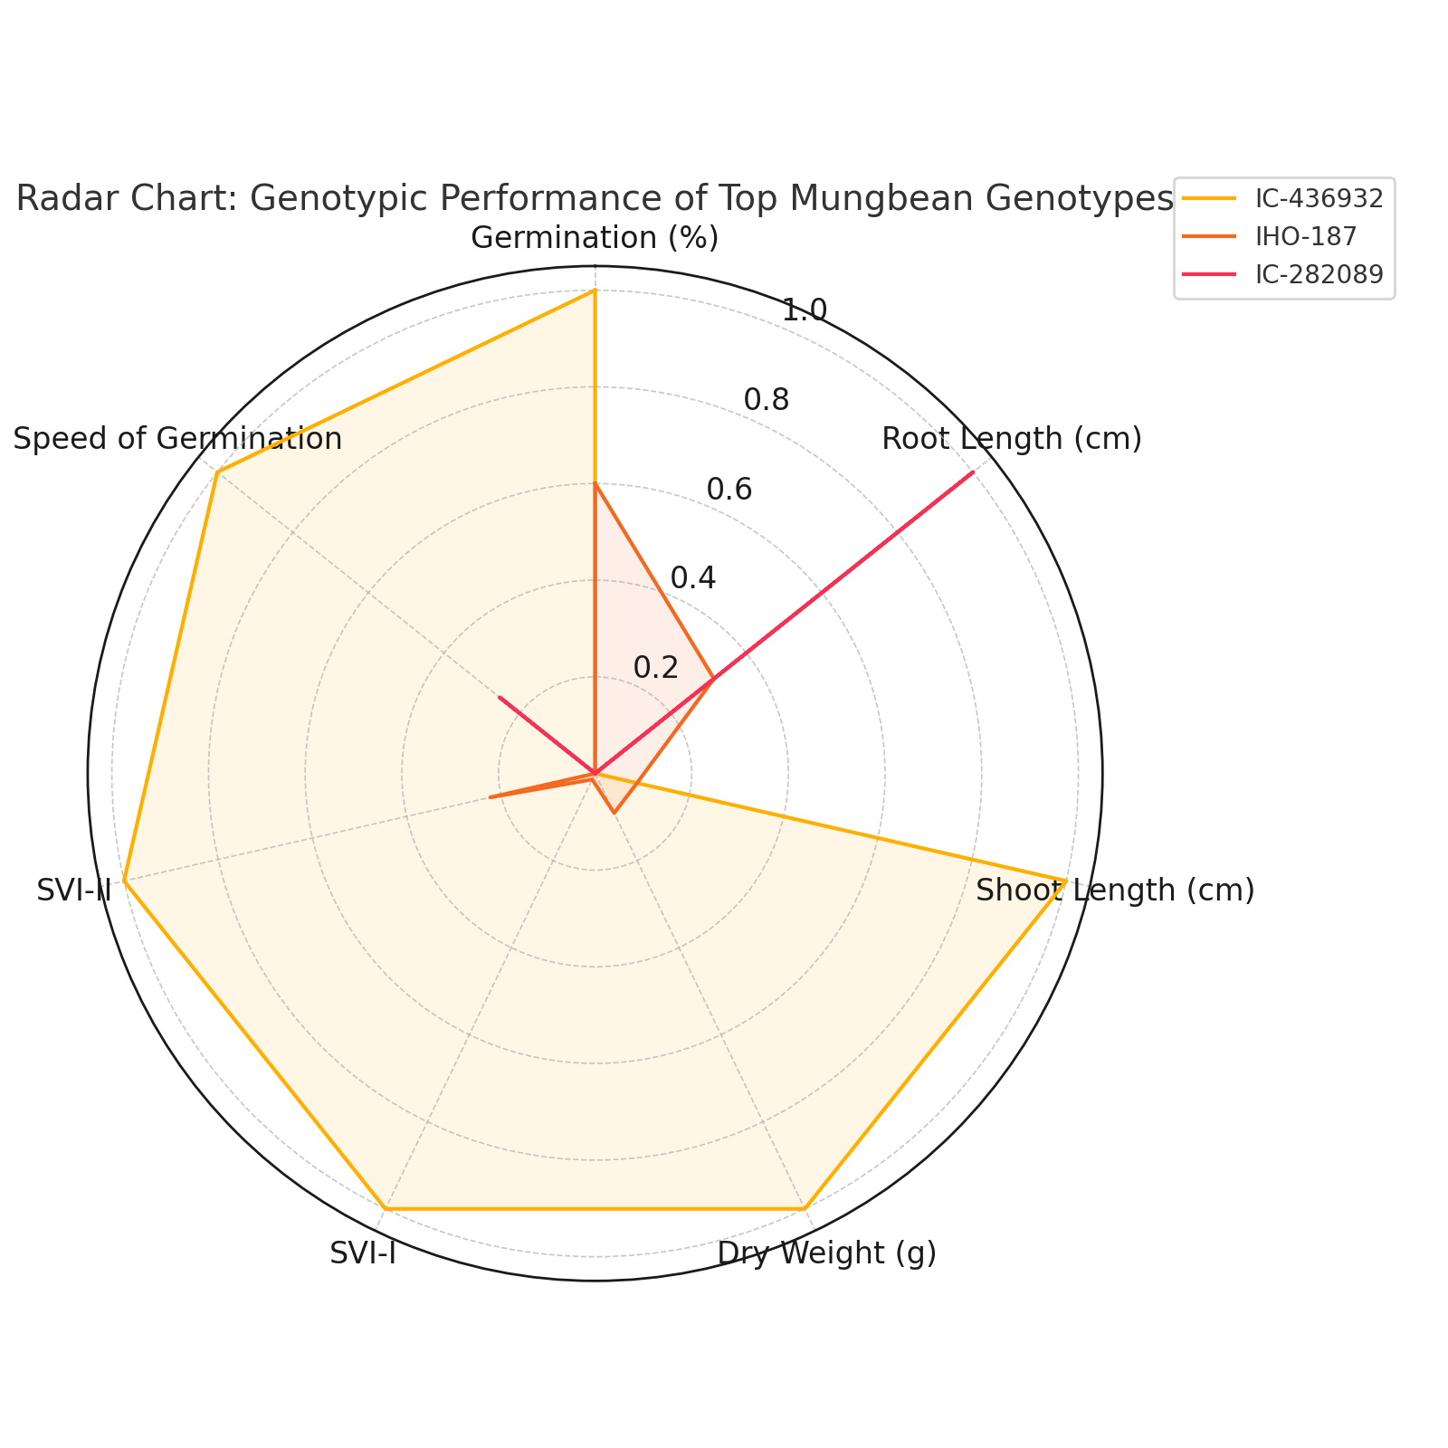

**Fig1:**

**Conclusion**

The present study revealed the twelve mungbean genotypes for seed physiological parameters such as germination percentage, root length, shoot length, seedling dry weight, seedling vigour indices (SVI-I and SVI-II), and speed of germination. Among all the genotypes, **IC-436932** consistently exhibited superior performance across most parameters, indicating its potential as a promising genotype for seed quality improvement. Conversely, **IC-252008** showed the lowest values in key traits, highlighting the need for enhancement in its seed quality attributes.

The observed variation suggests that seed physiological traits are largely influenced by genotypic differences and can be effectively used as selection criteria in mungbean breeding programs. High-vigour genotypes such as IC-436932 and IHO-187 can serve as valuable genetic resources for developing improved varieties with better field emergence and seedling establishment. These findings contribute valuable information for mungbean improvement efforts and can support the selection of high-performing genotypes for cultivation under diverse agro-climatic conditions.

Disclaimer (Artificial intelligence)

Option 1:

Author(s) hereby declare that NO generative AI technologies such as Large Language Models (ChatGPT, COPILOT, etc.) and text-to-image generators have been used during the writing or editing of this manuscript.

Option 2:

Author(s) hereby declare that generative AI technologies such as Large Language Models, etc. have been used during the writing or editing of manuscripts. This explanation will include the name, version, model, and source of the generative AI technology and as well as all input prompts provided to the generative AI technology

Details of the AI usage are given below:

1.

2.

3.

**References**

* **Chauhan, S., & Singh, V.** (2024). Morphological and physiological screening of mungbean genotypes for drought stress tolerance. Legume Genomics and Genetics, 15(1), 1–10.

• **Kumar, R., Kumar, A., & Kumar, M.** (1989). Seedling vigor in mungbean (Vigna radiata L. Wilczek): Its importance and correlation with seed yield. Indian Journal of Agricultural Sciences, **59**(5), 317–320.

• **Krishnappa N, Chandrakanthappa, Kammar, Lokesh K. and Narayanaswamy S.** 2001. Evalution of finger millet varieties for seed quality characters.Curr. Res. 39(5/6):93- 94,

• **Kumari, S., Meena, R. K., & Kumar, A.** (2019). Assessment of seed vigour and seedling traits in mungbean [Vigna radiata (L.) Wilczek] genotypes under controlled condition. Legume Research, **42**(4), 489–495.

• **Kumawat, R. N., Kumari, N., & Singh, P**. (2020). Genotypic evaluation for seed quality parameters in mungbean under PEG-induced drought. Seed Research, 48(2), 115–121.

• **Maguire JD.** 1962. Speed of germination aid in selection and evaluation for seedling emergence and vigour, Crop Science, 2: 176-177.

* **Meena, M. L., Rathore, M. P., & Solanki, R**. (2019). Character association and variability for seedling traits in mungbean under controlled conditions. International Journal of Chemical Studies, 7(6), 678–684.

• **Negi S.** (2015). Studies on morphological character, Seed quality parameters and genetic divergence in finger millet M.Sc. (Ag) Thesis, V.C.G.S Uttrakhand University of Horticulture & Forestry, Uttrakhand.

* **Patel, M., & Patel, R. N.** (2023). Seed germination and seedling vigour analysis in green gram [Vigna radiata (L.)] genotypes. Journal of Pharmacognosy and Phytochemistry, 12(1), 128–133.
* **Priya, A., Sharma, D., & Meena, R.** (2022). Evaluation of mungbean [Vigna radiata (L.) Wilczek] genotypes for seed vigour traits under laboratory conditions. Legume Research, 45(5), 678–684.

• **Rao, M. V., Shekhar, M., & Rao, B. R.** (2017). Evaluation of seed vigour indices in different seed lots of green gram [Vigna radiata (L.) Wilczek]. Journal of Pharmacognosy and Phytochemistry, **6**(6), 1171–1174.

• **Saha, D., Sarker, A., & Roy, A.** (2021). Genetic variability and character association of seedling traits in mungbean [Vigna radiata (L.) Wilczek] genotypes. Legume Genomics and Genetics, **12**(2), 9–16.

• **Sarkar, R. K., Das, S. K., & Ghosh, D. C.** (2015). Germination and seedling performance of okra [Abelmoschus esculentus (L.) Moench] genotypes under moisture stress. Indian Journal of Agricultural Sciences, **85**(3), 421–425.

• **Singh, A., & Ahmed, R.** (2020). Evaluation of mungbean genotypes for seedling traits under laboratory conditions. International Journal of Current Microbiology and Applied Sciences, **9**(2), 1552–1560.

• **Singh, B., Yadav, A., & Kumari, J.** (2016). Mungbean: A potential pulse for nutritional security. Indian Farming, **66**(6), 17–19.

• **Tzortzakis NB**. 2009. Effect of pre-sowing treatment on seed germination and seedling vigour in grain amaranths. Hort. Sci. 36(8): 117-125.

• **Verma, S., Sharma, A., & Chauhan, A.** (2018). Constraints in pulse production and strategies to overcome them. International Journal of Agriculture Sciences, **10**(12), 6277–6280.

* **Yadav, M., Choudhary, A. K., & Yadav, D. S**. (2021). Genetic diversity and trait association studies for seedling traits in mungbean under abiotic stress. Indian Journal of Genetics and Plant Breeding, 81(3), 452–457.