### Original Research Article

### GEOPHYSICAL ASSESSMENT OF SUBSURFACE CONDITIONS FOR FOUNDATION SUITABILITY IN ALAMO, OSUN STATE, NIGERIA.

**ABSTRACT**

This research focuses on a geophysical assessment aimed at evaluating the subsurface conditions for foundation development in Alamo, Oke-Ola, Gbongan, located in Osun State, southwestern Nigeria. The area has experienced a rise in structural failures, largely due to inadequate geotechnical investigations before construction. To tackle this issue, the study used an integrated geophysical method combining Vertical Electrical Sounding (VES) and 2D Electrical Resistivity Tomography, both cost-effective techniques ideal for mapping subsurface geoelectric layers and identifying weak zones.

Data collection was conducted using the ABEM SAS 300C Terrameter, utilizing Schlumberger and Dipole–Dipole array configurations across three survey lines. Processing was done with DIPROfWIN and WinRESIST software, resulting in 1D sounding profiles and 2D resistivity sections. The interpretation identified a four-layer geoelectric structure consisting of topsoil, a weathered horizon, a partly weathered or fractured basement, and a fresh basement

rock unit. Subsurface resistivity values ranged from 6 Ωm to 840 Ωm, reflecting considerable spatial variation both laterally and vertically.

Zones characterized by low resistivity (6–60 Ωm), typically indicative of clayey, water-saturated soils, were considered geotechnically unstable for direct foundation loading. Conversely, areas exhibiting resistivity values exceeding 200 Ωm especially those associated with the unweathered basement were deemed structurally competent. The alignment of results from both VES and ERT methods added reliability to the interpretations.

Overall, the study highlights the value of integrating geophysical techniques in evaluating subsurface conditions, particularly in geologically heterogeneous environments. Such assessments are essential for informed foundation design and can significantly reduce the likelihood of structural failure.

Keywords: *Electrical Resistivity Tomography (ERT); Foundation Suitability; Precambrian Basement Complex; Subsoil Competence; Vertical Electrical Sounding (VES)*

**1. INTRODUCTION**

The safety and durability of building foundations heavily rely on the nature of the subsurface materials, especially in regions where geological formations exhibit considerable variability. In Alamo, Oke-Ola, Gbongan, Osun State situated in Southwestern Nigeria, there has been a noticeable rise in cases of structural damage and building collapse. These failures are often linked to insufficient assessment of subsurface conditions prior to construction (Bremmer, 1999; Fakere et al., 2012). A major contributing factor is the complex interaction between the area's diverse geology and inadequate site investigation techniques, leading to the construction of structures on clay-dominated or extensively weathered soils with poor load-bearing capacity. Consequently, there is an urgent need for the adoption of more dependable methods for subsurface assessment.

Many studies have emphasized the efficiency of geophysical techniques, especially electrical resistivity methods, in mapping subsurface characteristics and detecting areas unsuitable for construction.(Samouëlian et al., 2005; Adepelumi & Olorunfemi, 2000; Akintorinwa & Adeusi, 2009, Ojo *et al* , 2024). Techniques such as Vertical Electrical Sounding (VES) and 2D Electrical Resistivity Tomography (ERT) have been recognized for their non-destructive, cost-effective nature, and ability to provide detailed insights into subsurface stratigraphy, heterogeneities, and moisture variations over large areas. Despite their proven utility in engineering and environmental studies, these geophysical tools remain underutilized in foundation site assessments across Nigeria, where reliance on limited borehole data persists.

A key challenge in Gbongan and surrounding areas is the geological intricacy of the Precambrian Basement Complex. This includes weathered rock profiles, fractured zones, and soil layers that may contain expansive clay. Such conditions contribute to foundation failure but are not always adequately identified through conventional geotechnical approaches (Oyelami & Van Rooy, 2016; Oyelami et al., 2023). Even though integrated geophysical investigations have shown success in comparable geological settings, there remains a notable gap in detailed, location-specific geophysical studies for this region—hindering effective construction planning.

To bridge this knowledge gap, the present study combines VES and 2D ERT methods to evaluate the subsurface integrity of Alamo, Gbongan. By distinguishing between soil layers such as the topsoil, weathered zones, fractured bedrock, and fresh basement, this research aims to provide detailed spatial information on subsoil variability. The findings are intended to guide foundation design, mitigate structural risks, and support safer infrastructure development in geologically complex basement terrains (Oyelami et al., 2023; Cosenza et al., 2006).

### ****1.1 Site location of the investigation****

Alamo community is located in Gbongan, the primary administrative center of Aiyedade local government area of Osun State, southwestern Nigeria. Geographically, Gbongan is positioned at approximately **latitude 7° 28′ 38″ N** and **longitude 4° 21′ 12″ E** (Figure 1).

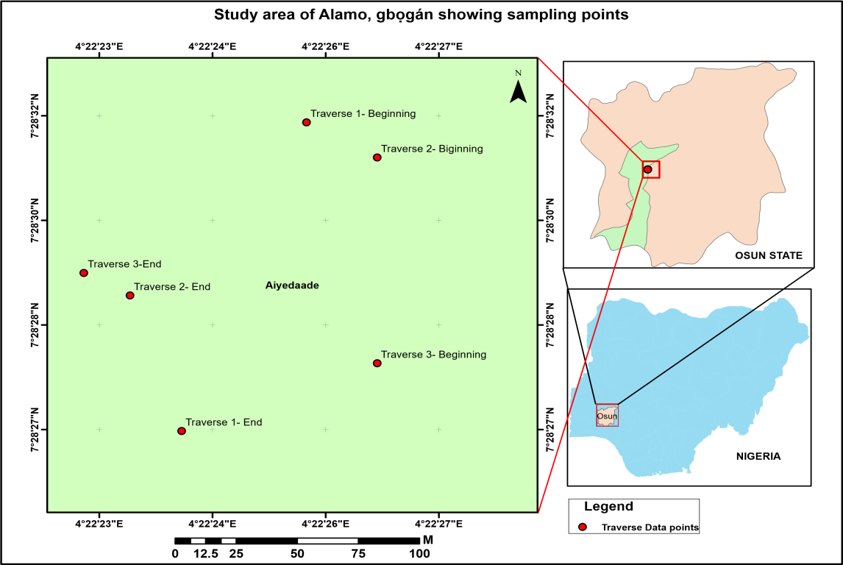

Figure 1: Location and data acquisition map of the study area

### ****1.2 Geological Setting of the Study Area****

Alamo, Oke-Ola in Gbongan, Osun State, is located in southwestern Nigeria between **latitude 7° 28′ 29″ N** and **longitude 4° 22′ 18″ E.** The area forms part of the **Precambrian Basement Complex** that characterizes much of southwestern Nigeria. Geologically, this region lies within the **Pan-African mobile belt**, bounded by the **West African Craton** to the west and the **Congo Craton** to the east (Tanko & Chime, 2021). The basement rocks in this terrain are diverse and are broadly categorized into four major units: the Archean to Early Proterozoic **gneiss–migmatite–quartzite complex**, the Proterozoic **supracrustal schist belts**, the **Neoproterozoic Pan-African granites and related granitoids,** and the younger **felsic and mafic intrusive rocks** from the late Neoproterozoic to Early Paleozoic periods (Rahaman, 2006).

The **gneiss–migmatite–quartzite complex** dominates the bedrock geology, with schist belts preserved as elongated strips within this framework (Whiteman). These older rock units are intruded by **Pan-African granitic bodies**, including **biotite and muscovite granites** as well as **granodiorites** (Rahaman, 2006). In addition, minor intrusive bodies such as **pegmatites, aplites, dolerites**, and **lamprophyres** occur as dykes and sills, cross-cutting all pre-existing rock types (Fakere et al., 2012; Oyelami & Van Rooy, 2016).

In Gbongan specifically, these geological divisions are well represented. The western section of the district is predominantly composed of the **gneiss–migmatite complex**, which appears in two north-south trending zones divided by a linear schist belt (Adepelumi & Olorunfemi, 2000). The schist units include **talc–tremolite–actinolite schists** and **amphibolites,** while Pan-African intrusives such as **biotite granite** and **granodiorite** are widespread throughout the region (Rahaman, 2006). Moreover, **dolerite dykes** intrude various parts of the bedrock, further emphasizing the structural complexity of the area (Burke *et al*., 1971).

This intricate geologic framework underscores the importance of detailed **geophysical investigations,** particularly for foundation studies. Diverse subsurface materials and structural discontinuities in the area may significantly influence foundation behavior and, if not properly assessed, pose serious risks to structural stability (Oyelami *et al*., 2023; Idornigie et al., 2006).

### ****2. Materials and Methods****

This geophysical investigation employed essential tools and equipment for conducting electrical resistivity surveys. The primary instrument used was the **ABEM SAS 300C Terrameter**, a well-regarded resistivity meter suitable for both **Vertical Electrical Sounding (VES)** and **2D Electrical Resistivity Tomography (ERT).** Additional field accessories included **electrodes, connecting cables, measuring tapes,** and **hammers** for electrode installation. A **handheld GPS device** was also utilized to accurately record and geo-reference the coordinates of all survey locations across the study traverses.

### ****2.1 Site Reconnaissance****

An initial site visit to **Alamo, Oke-Ola, Gbongan** was carried out to understand the general geological conditions, soil types, and existing infrastructure. GPS technology was used to plan and demarcate the survey layout. Three **traverses** each spaced **30 meters** apart and approximately **150 meters** long were established in the study area. Along each traverse, **survey stations** were set at **10-meter intervals**.

**2.2 Geophysical Survey**

#### ****2.2.1 Electrical Resistivity Tomography (ERT)****

A **2D electrical resistivity survey** was conducted along the selected traverses to investigate the stratification and physical properties of the subsurface and to locate potentially weak zones. Data acquisition was performed using the **ABEM SAS 300C TERRAMETER** in a **Dipole–Dipole array configuration**. Electrodes were systematically deployed along the profiles. The **Schlumberger configuration** was also employed for specific measurements. Data were processed and inverted using **DIPROfWIN** and **WinRESIST** software, which generated subsurface resistivity models indicating zones of high and low resistivity corresponding to solid and weak ground materials, respectively.

#### ****2.2.2 Vertical Electrical Sounding (VES)****

**One (1) VES** survey was conducted along **Traverse 2** using the **Schlumberger array** configuration. The current electrode spacing (**AB/2**) ranged from **1 meter to a maximum of 40 meters**. In addition to the VES, a combination of **Horizontal Profiling and Vertical Sounding** using the **Dipole–Dipole array** was applied across **Traverses 1, 2, and 3**. This dual approach helped identify subsurface structures and provided both vertical and lateral resistivity variations. An inter-electrode spacing (**a**) of **10 meters** was used, while the **inter-dipole separation factor (n)** varied from **1 to 5**. Apparent resistivity values were plotted at intersection points defined by 45° projections from the midpoints of the current and potential electrodes. These values were used to produce **2D resistivity sections**, which guided the selection of the VES point on Traverse 2 for more focused correlation.

**3.0 RESULTS AND DISCUSSION**

### ****3.1 Electrical Resistivity Method****

#### ****3.1.1 Depth Sounding Curves****

A **single Vertical Electrical Sounding (VES)** was carried out along **Traverse 2** within the study location. The interpreted result of the VES is summarized in **Table 1**, and the curve obtained corresponds to the **A-type** resistivity curve. As shown in **Figure 2**, this curve type is characterized by increasing resistivity with depth.

This configuration suggests that the **topsoil,** typically ranging from **0 to 0.4 meters**—the zone where shallow foundations are often placed—exhibits **lower resistivity values** compared to the layers beneath. Such low near-surface resistivity values indicate that the topsoil has **poor geotechnical strength** and may not be ideal for supporting engineering structures.

Table 1: Summary of findings from VES interpretation

|  |  |  |  |  |  |
| --- | --- | --- | --- | --- | --- |
| VES S/No | Layers | Resistivity Value (Ωm) | Thickness(m) | Lithological  Characteristics | Curve Type |
| 1 | 3 | 13.0  53.2    552.1 | 1.0  1.0    …. | Topsoil    Weathered Layer    Fresh Basement | A |

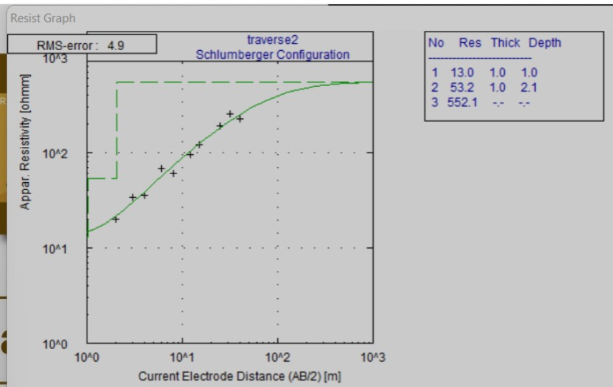

Figure 2:VES graphic interpretation (This study)

### ****3.2 Two-Dimensional (2D) Resistivity Structure****

The 2-D resistivity profiles derived from traverses 1, 2, and 3 in the study area are presented in Figures 3, 4, and 5. These profiles delineate four distinct subsurface layers: the topsoil, a weathered layer, a partially weathered or fractured basement, and the fresh basement rock. The topsoil is overlain by or merges with the low-resistivity weathered layer and exhibits very low resistivity values ranging between 6 and 60 ohm-m. This layer is represented by deep blue to green colour bands and occurs at depths and stations such as 2–7 (0–5 m), 7–9 (0–16 m), and 9–13 (0–6 m) along traverse 1 (Fig. 3); 2–6 (0–5 m), and 6–10 (0–5 m) along traverse 2 (Fig. 4); and 2–3 (0–5 m), 3–4 (0–5 m), 4–6 (0–9 m), 6–8 (0–5 m), and 8–11 (0–5 m) along traverse 3 (Fig. 5). These zones, dominated by clayey materials with high conductivity, are regarded as structurally weak and unsuitable for engineering foundations.

The second layer is the weathered zone, also marked by deep blue to green bands with resistivity values ranging from 6 to 54 ohm-m. The thickness of this layer varies across the profiles, ranging from 5 to 10 m at stations 7–8 on traverse 1; 1–3 m at stations 2–3, 4–6, and 6–10 on traverse 2; and 1–5 m at stations 2–3, 4–6, and 9–11 on traverse 3. Within this weathered layer, certain segments exhibit extremely low resistivity (8–27 ohm-m), indicating the presence of conductive clay-rich zones. These conductive features extend to depths between 1 and approximately 15 m at locations such as stations 7–9 (1–16 m) and 9–13 (1–6 m) along traverse 1; 2–6 (1–5 m) and 6–10 (1–5 m) on traverse 2; and 4–6 (1–9 m) on traverse 3. These highly conductive zones are also deemed geotechnically unstable for construction purposes.

The third subsurface unit is the fractured basement, identified by low resistivity values situated between solid basement rocks, particularly visible in Figures 3(iii) and 5(iii). These zones appear as bluish to greenish bands and have resistivity values ranging from 4 to 9 ohm-m. They occur within stations 7–8 (5–10 m depth) on traverse 1, 2–6 (1–5 m) on traverse 2, and 4–6 (1–9 m) on traverse 3. The fractured basement layer has a variable thickness of approximately 1 to 10 m and occurs at shallow depths (5–10 m), posing minimal risk to foundation integrity.

The fourth and deepest layer is the fresh basement bedrock, characterized by moderately high to very high resistivity values ranging from 66 to 252 ohm-m, indicated by yellow to red colouration. The depth to this competent basement rock ranges from less than 1 m to about 5 m across the traverses.



Figure 3: Traverse 1 2-D Dipole Dipole Interpretation

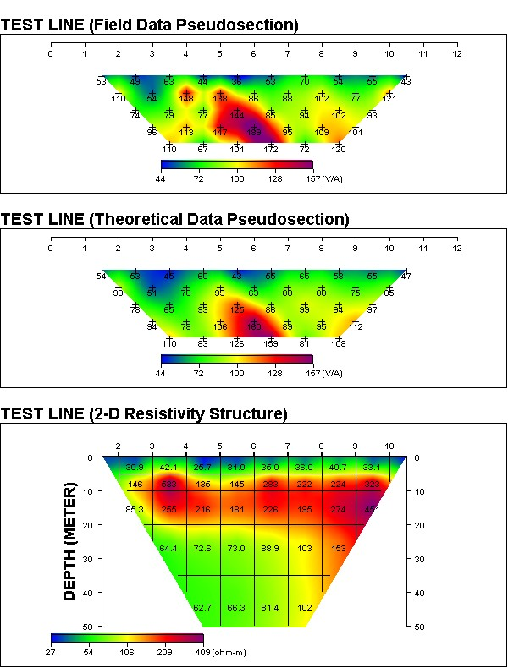

Figure 4: Traverse 2 2-D dipole dipole Interpretation

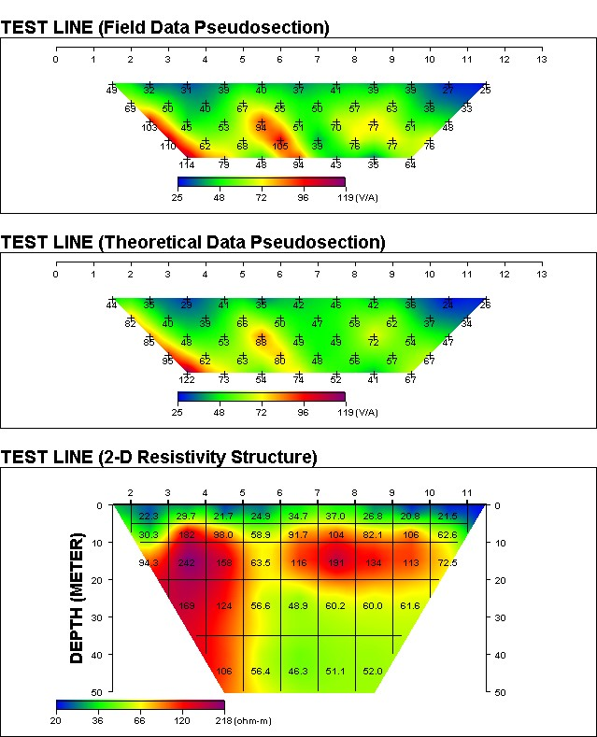

Figure 5: Traverse 3 2-D dipole dipole Interpretation

### ****3.3 Comparison of geophysical findings****

The outcomes from the **Vertical Electrical Sounding (VES)** and the **2D dipole–dipole resistivity imaging** were compared to validate the subsurface interpretation. The correlation is supported by data presented in **Tables 2 and 3** of the study. The VES results successfully outlined **partly weathered and fractured basement zones** beneath **Traverses 1, 2, and 3,** consistent with the anomalies identified in the 2D resistivity profiles.

The **2D resistivity sections** provided broader lateral and vertical coverage, mapping distinct **subsurface layers** across the three traverses. These layers include **topsoil, weathered zones, fractured basement**, and the **underlying fresh basement rock**. Within the weathered and fractured layers, several **low-resistivity anomalies** were detected typically associated with **conductive soils such as clay** or **moisture-rich materials**. These conductive zones, found at **relatively shallow depths**, are considered **geotechnically weak** and unsuitable for direct foundation siting.

Overall, the consistency observed between the **1D VES data** and the **2D resistivity imaging** confirms the of the subsurface interpretations. The integrated geophysical results provide a clear understanding of **zones with poor bearing capacity** and highlight **safer, more competent areas** for foundation development within the investigated terrain.

Table 2 VES resistivity interpretation

|  |  |  |  |  |
| --- | --- | --- | --- | --- |
| VES  S/No | Layering | Resistivity Value (Ωm) | Thickness (m) | Lithologic Description |
| 1 | Topsoil  Weathered layer  Basement rock  Fractured basement  Basement Bedrock | 13.0  53.2  552.1    6 - 72  840 | 0.4  1 - 5    …  5 - 10 | Sand and gravel, Clayey sand and Lateritic  Clay/Sandy Clay, Clayey sand and Lateritic  Fresh basement  Partly weathered and Fractured basement rock.  Fresh basement |

Table 3: Assessment of topsoil strength in the study area based on resistivity values

|  |  |  |  |  |
| --- | --- | --- | --- | --- |
| Layering | RESISTIVITY RANGE (ohm-m) | THICKNESS(M) | LITHOLOGIC DESCRIPTION | COMPETENCE  RATIING |
| Topsoil | 20 – 66    27 -106    6 - 75 | 0.4 – 3    3 – 4    4.5 - 5 | Clay    Silty sandy gravel    Basement | Incompetent    Moderately competent    Competent |

### ****3.4 Subsoil Characterization of the study area****

Both the **VES** and **2D dipole–dipole resistivity imaging** techniques delineated four key subsurface layers beneath the study location: the **topsoil, weathered layer, partly weathered/fractured basement,** and the **fresh basement rock.** The **topsoil,** typically found within a **depth range of 1–4 meters**, is the most common foundation zone for civil engineering projects. This layer primarily consists of **clay, sandy clay**, and **clayey sand** materials.

Across the study area, **resistivity values** range from as low as **6 ohm-m** to as high as **840 ohm-m**, reflecting significant variability in the subsoil's physical and geotechnical properties. The **resistivity values in the topsoil** were used to assess **subsoil competence,** following the classification system developed by **Idornigie (2006).**

Based on the data summarized in **Table 3**, much of the central portion of the study area displays **moderately low to moderately high resistivity values**, particularly in the range of **66–252 ohm-m** at depths of up to **5 meters**, indicating the presence of **fresh basement rock**. This section of the subsurface is considered **moderately competent to competent** and is therefore suitable for foundation support.

However, in areas where **lower resistivity values** dominate, caution is strongly advised for civil engineers involved in **foundation design and structural planning**. These **weak zones**, often saturated or clay-rich, present a higher risk of instability. Therefore, it is essential to exercise **increased care and precision** in foundation siting to prevent future structural problems.

**4.0 Conclusions**

The geophysical investigations using Vertical Electrical Sounding (VES) and 2D Electrical Resistivity Tomography (ERT) delineated a four-layer geoelectric structure across the surveyed area. These layers include the topsoil, a weathered horizon, a partially weathered or fractured basement, and the fresh basement rock. Significant lateral and vertical resistivity variations were observed across these layers, which are essential for evaluating subsoil stability for construction purposes.

The topsoil and weathered zones consistently exhibited low resistivity values ranging from 6 to 60 Ωm, signifying high conductivity and clay-rich compositions. These conditions indicate elevated moisture content and low mechanical strength, making them unsuitable for supporting shallow foundations. This is consistent with observations by Oyelami, who associated low resistivity values with expansive, high-plasticity soils that possess poor bearing capacity. Such conditions are particularly problematic in areas experiencing seasonal moisture changes, which can lead to soil swelling, shrinkage, and potential structural damage.

Conversely, zones with resistivity values greater than 200 Ωm typically corresponding to the fresh basement layer suggest the presence of geologically competent material capable of sustaining structural loads. The A-type VES curves, which show an increase in resistivity with depth, reflect a transition from weak surface materials to more stable subsurface formations. These results support the findings of Akintorinwa, who reported that properly characterized basement complex areas can provide reliable foundation grounds when high-resistivity bedrock is present near the surface.

The 2D resistivity imaging offered enhanced spatial resolution, enabling the identification of discontinuous conductive features within the weathered and fractured basement zones. These anomalies, possibly representing clay seams or zones of localized water saturation, are often linked to differential settlement hazards, as noted by Samouëlian. Detecting such features allows for better-informed decisions regarding structural placement, particularly in regions where borehole data may be insufficient to reveal subsurface variability.

In summary, the integrated geophysical approach confirmed the heterogeneous nature of the subsurface in the study area. The complementary use of VES and ERT techniques provided coherent and reliable information on the depth, extent, and geotechnical quality of the subsurface layers. These findings highlight the importance of detailed site-specific geophysical surveys especially in geologically complex settings like Gbongan for guiding safe and effective civil engineering development (Adepelumi & Olorunfemi, 2000; Akintorinwa & Adeusi, 2009).

**REFERENCES**

1. Bremmer, C. N. (1999). Developments in geomechanical research for infrastructural projects. In Geotechniek (Special Issue), Proceedings of the 12th European Conference on Soil Mechanics and Geotechnical Engineering pp. 52–55
2. Fakere, A. A., Fadairo, G. & Fakere, R. A. (2012). Assessment of Building Collapse in Nigeria: A Case of Naval Building, Abuja, Nigeria. *International Journal of Engineering and Technology, 2(4),* 584–591.
3. Samouëlian, A., Cousin, I., Tabbagh, A., Bruand, A., & Richard, G. (2005). *Electrical resistivity survey in soil science: a review.* *Soil and Tillage Research, 83(2),* 173–193. [DOI: 10.1016/j.still.2004.10.004.](DOI:%2010.1016/j.still.2004.10.004.)
4. Adepelumi, A. A. & Olorunfemi, M. O. (2000). Engineering geological and geophysical investigation of the reclaimed Lekki Peninsula, Lagos, South‑West Nigeria. *Bulletin of Engineering Geology and the Environment, 58,* 125–132. DOI: 10.1007/s100640050006
5. Akintorinwa O.J & Adeusi F.A, (2009). Integration of Geophysical and Geotechnical Investigations for a Proposed Lecture Room Complex at the Federal University of Technology, Akure, SW, Nigeria*, Ozean Journal of Applied Sciences* *2(3*), pp. 241- 254.
6. Ojo, O. T., Chiaka, I. J., & Mark, A. I. (2024). Geophysical subsurface mapping using the electrical resistivity technique: A comprehensive study of the Petroleum Training Institute main campus in Effurun. *Indonesian Journal of Earth Sciences, 4*(1), A846. https://doi.org/10.52562/injoes.2024.846
7. Oyelami, C. A. & Van Rooy, J. L. (2016),: Geotechnical characterisation of lateritic soils from south-western Nigeria as materials for cost-effective and energy-efficient building bricks*, Environmental Earth Sciences*, *Volume 75*, Article 1475. DOI: 10.1007/s12665-016-6274-1
8. Oyelami, C. A., Obaromi, O., Omoyajowo, B. T., Oluyemi, T. M., & Komolafe, O. A. (2023). Engineering subsoil characterization for shallow foundation using DCPT at the permanent site of the University of Medical Sciences, Ondo‑Town. *Nigeria Journal of Mining and Geology*, *59(2),* 103–116. DOI: 10.55518/fjpas.BJZK9266
9. Cosenza, P., Marmet, E., Rejiba, F., Cui, Y. J., Tabbagh, A., & Charlery, Y. (2006). Correlations between geotechnical and electrical data: A case study at Garchy in France. *Journal of Applied Geophysics,* *60*, 165–178. DOI: 10.1016/j.jappgeo.2006.02.003
10. **Tanko, I. Y., & Chime, P.** (2021). Geochemistry and mineralization of some selected pegmatite deposits in Panda, north-central Nigeria. *European Journal of Engineering and Technology Research, 6*(2), 58–66. <https://doi.org/10.24018/ejeng.2021.6.2.810>
11. **Rahaman, M. A. (2006*).*** Nigeria’s solid minerals endowment and sustainable development. *In O. Oshin (Ed.),* The Basement Complex of Nigeria and its Mineral Resources: A tribute to Prof. M. A. O. Rahaman *(pp. 1–190). Ibadan:* Akin Jinad & Co.
12. Whiteman, A. Nigeria: its petroleum geology, resources and potential. Volume 1. London, England: Graham & Trotman Ltd. <https://doi.org/10.1007/978-94-009-7361-9>
13. BURKE, K., DESSAUVAGIE, T. & WHITEMAN, A (1971). Opening of the Gulf of Guinea and Geological History of the Benue Depression and Niger Delta. *Nature Physical Science* *233*, 51–55). <https://doi.org/10.1038/physci233051a0>
14. Idornigie, A. I., Olorunfemi, M. O. & Omitogun, A. A. (2006). Electrical resistivity determination of subsurface layers, subsoil competence and soil corrosivity at an engineering site location in Akungba-Akoko, southwestern Nigeria. *Ife Journal of Science*, *8(2*), 159–177 DOI: [10.4314/ijs.v8i2.32216](https://doi.org/10.4314/ijs.v8i2.32216)
15. Osotuyi, A.G., Muraina Z.M., Isaac, R.A.& Adebayo, O.S. (2021). Assessment of geoelectric properties and localized geology as indicators on cocoa (Theobroma cacao) yield in a part of southwestern Nigeria. *Heliyon, 7*(12), DOI: <https://doi.org/10.1016/j.heliyon.2021.e08516>
16. Jegede, G., 1994. Engineering Geotechnical significance of Superficial Deposits in Carrington Hill Area, Country Conc, Ireland*. Nig. Journal Sciences*, *Vol. 28*, pp. 153 – 158.
17. Folahan, P. I., Ipinmoroti, F. V.., Salami, M., Akinwale, K. J., Taiwo, A. T. & Adetunji, A. R. 2013: Application of geophysical methods to building foundation studies. *International Journal of Geosciences*. *Vol. 4*, pp. 1256 – 1266.DOI: <https://doi.org/10.4236/ijg.2013.49120>