**Participatory Demonstration of Irrigation Scheduling under Solar Pump Irrigation for Sweet Potato (Ipomoea batatas L.) Production in Dijo** **Woreda, Halaba Zone, Ethiopia**

**Abstract**

A participatory field demonstration was conducted in Dijo Woreda, Halaba Zone, Central Ethiopia, to evaluate the effectiveness of irrigation scheduling under solar pump irrigation systems for sweet potato (Ipomoea batatas L.) production. The study aimed to promote water-efficient irrigation practices and enhance crop productivity through the active involvement of local farmers and stakeholders. A field experiment was conducted to evaluate the response of Orange Flesh Sweet Potato to different irrigation scheduling methods in combination with recommended 3t/ha vermi-compost rate. Two treatments were compared: 100% Maximum Allowable Depletion (MAD) with recommended 3t/ha vermi-compost and the local farmer’s irrigation practice with recommended vermi-compost. The study measured parameters such as number of roots per plant (NRPP), vein length (VL), root length (RL), root diameter (RD), marketable yield (MY), unmarketable yield (UMY), and total yield (TY). The results revealed that applying 100% MAD with recommended 3t/ha vermi-compost significantly increased root yield and morphological traits compared to the farmer's practice. The highest marketable yield (30,341.4 kg/ha) and total yield (32,345.6 kg/ha) were recorded under 100% MAD with 3t/ha vermi-compost. This suggests that combining scientific irrigation scheduling with organic soil amendments can enhance orange flesh sweet potato productivity in the study area.

***Keywords****: Orange Flesh Sweet Potato, Irrigation Scheduling, Maximum Allowable Depletion (MAD), Vermi-compost*

**Introduction**

Sweet potato (*Ipomoea batatas* L.) is an important root crop cultivated widely in Ethiopia, valued for its nutritional, economic, and food security contributions, especially in rural communities (Low et al., 2009; Lemaga et al., 2013). Despite its significance, sweet potato productivity remains low in many parts of the country due to suboptimal water management practices and limited access to improved irrigation technologies (Low et al. 2009; FAO, 2010). Efficient irrigation scheduling plays a crucial role in optimizing water use and enhancing crop yields, particularly in arid and semi-arid regions like the Halaba Zone, where rainfall is erratic and often insufficient for reliable crop production (Pereira *et al*., 2002).

The integration of solar-powered irrigation systems offers a promising solution to address both water scarcity and energy limitations in smallholder farming systems. Solar pump irrigation has been recognized for its sustainability, low operating costs, and environmental friendliness, making it an ideal option for regions with high solar radiation and limited grid access (IRENA, 2016). However, the adoption of solar irrigation technologies requires locally adapted irrigation scheduling practices to ensure water is applied efficiently and crop needs are adequately met.

Participatory demonstration approaches have proven effective in promoting the adoption of agricultural innovations, as they actively involve farmers in the evaluation and refinement of technologies based on real-world conditions and local knowledge. Explores participatory learning methods and shows how farmer involvement enhances the adoption and adaptation of innovations based on their knowledge and field realities. (Pretty et al., 1995). In this context, a participatory demonstration of irrigation scheduling under solar pump irrigation was conducted for sweet potato production in Dijo Woreda of Halaba Zone. This study aimed to evaluate the agronomic performance and water use efficiency of sweet potato under scientifically scheduled irrigation using solar pumps, and to enhance farmer awareness and capacity in sustainable irrigation management.

**Materials and Methods**

**Description of the study area**

The study was conducted in Simbita Kebele, Wera-Dijo Woreda of Halaba Zone, geographically located at an altitude ranging from 1,605 to 1,770 meters above sea level (a.s.l.), with a longitude range of 38˚00′30″ to 38˚36′30″ E and a latitude range of 07˚22′00″ to 07˚42′00″ N. The area receives an average annual precipitation of approximately 1,200 mm, with the majority occurring between February and June, and the remainder between July and September. Summer temperatures in the study area range from 22°C to 35°C, while winter temperatures range from 13°C to 20°C.

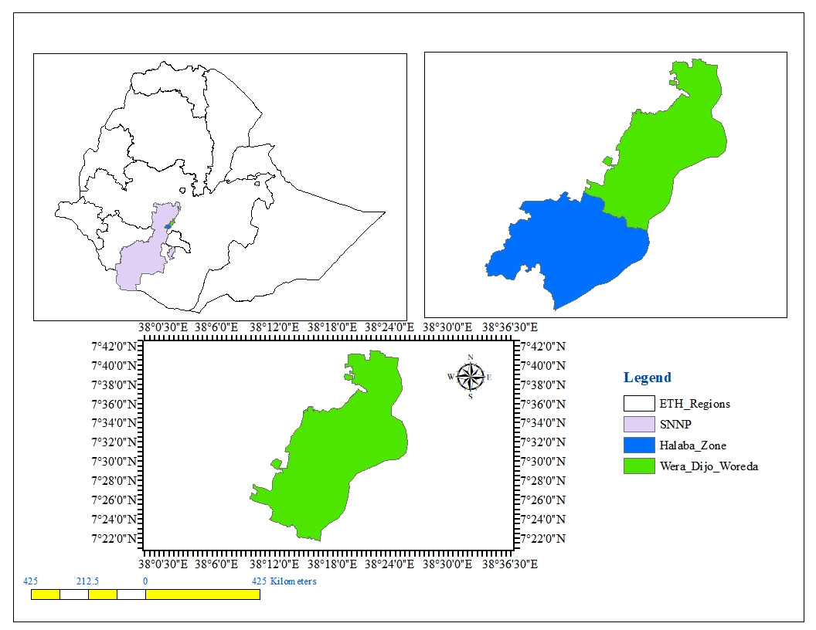

Figure 1:Map of the study area

**Climate data**

The average minimum and maximum temperature of the study area 10.8°C and 27.5°C respectively, and monthly average rainfall 89.7mm respectively. Annual Precipitation here averages 1043 mm. Average reference evaporation of the study area for orange flesh sweet potato is 4 mm/day.

Figure 2: Monthly climate data

**Crop data**

Throughout the growth season, orange flesh sweet potatoes need 500 to 700 mm of water to produce at their best. Potatoes have a maximum permitted depletion of 25% and a maximum effective root zone depth (RZD) of 50–60 cm (FAO, 2002). After adjusting for early, development, mid, and late season stages to be 0.4, 0.7, 1.05, and 0.85, respectively, the average Kc for orange flesh sweet potatoes would be determined. In the field, yield parameters such as total yield, unmarketable yield, and economical yield were measured.

**Crop Water Determination**

According to Allen et al. (1998), crop water need refers to the volume of water that must be supplied, whereas crop evapotranspiration refers to the amount of water lost by evapotranspiration. Based on the determination of crop water requirement, the effect of climate on crop water requirement, which is the reference crop evapotranspiration (ETo), and the effect of crop characteristics (Kc) are very important (Doorenbos and Pruitt, 1977). The long period and daily climate data such as maximum and minimum air temperature, relative humidity, wind speed, sunshine hours, and rainfall data of the study area were collected to determine reference evapotranspiration, crop data like crop coefficient, a growing season, and development stage, effective root depth, critical depletion factor of tomato and maximum infiltration rate and total available water of the soil was determined to calculate crop water requirement using cropwat model.

$$ETc=ETo*Kc$$

Where, ETc = crop evapotranspiration, Kc = crop coefficient and ETo = reference evapotranspiration

**Irrigation Water Management**

Total available water (TAW), stored in a unit volume of soil can be obtained from the equation:

$$TEW=(FC-PWP)*BD*Dz)/100$$

The depth of irrigation water supplied at any time was determined by the expression

$$Inet \left(mm\right)=ETc\left(mm\right)-Peff(mm)$$

The gross irrigation requirement will be found from the expression:

$$Ig=In/Ea$$

Ea =application efficiency of the furrows (60%)

The time required to distribute the desired depth of water into each furrow will be calculated using the equation:

$$t=(d*l*w)/(6*Q)$$

Where: t= application time (min), l= furrow length in (m), d= gross depth of water applied (cm), w= furrow spacing in (m), and Q= flow rate (discharge) (l/s)

**Data Collection**

To evaluate the performance of Orange Flesh Sweet Potato under different irrigation scheduling treatments, various agronomic and yield-related parameters were measured. The number of roots per plant (NRPP) was determined by manually counting roots from randomly selected plants within each plot. Vein length (VL) was measured in centimeters using a ruler, extending from the base to the tip of the main leaf vein. Root length (RL) and root diameter (RD) were recorded in centimeters using a tape measure and digital caliper, respectively, on representative harvested roots. Marketable yield (MY) and unmarketable yield (UMY) were assessed in kilograms per hectare using a digital field scale, following standard visual grading criteria. Finally, total yield (TY) was calculated as the sum of marketable and unmarketable yields.

**Statistical analysis**

Data were statistically analyzed using the Least Significant Difference (LSD) test at a 5% significance level to compare treatment means. The Coefficient of Variation (CV) was also calculated to assess variability within treatments and ensure data reliability.

**Results and Discussions**

**Physical and Chemical properties of Soil**

According to the USDA soil textural classification, the percent particle size determination for the experimental site revealed that the soil texture could be classified as sandy loam soil. Average bulk density of the experimental site was 1.3g/cm3 and the pH is 6.4. The bulk density shows a slight increase with depth. This could be because of a slight decrease of organic matter with depth and increase compaction due to the weight of the overlying soil layer (Brady and Weil, 2002).

Table.1. Input soil data for the CROPWAT model

|  |  |  |  |  |
| --- | --- | --- | --- | --- |
|  | Soil depth in (cm) | | | |
| Soil property | 0-15 | 15-30 | 30-60 | 60-90 |
| Textural class | Sandy loam | Sandy loam | Sandy loam | Sandy loam |
| Bulk density (g/cm3) | 1.21 | 1.26 | 1.28 | 1.35 |
| FC (Vol %) | 13.8 | 14 | 16 | 15.95 |
| PWP (Vol %) | 6.2 | 6 | 8 | 7.5 |
| TAW (mm/m) | 87.4 | 100.8 | 100.8 | 100.8 |
| pH | 5.68 | 5.73 | 5.79 | 5.75 |

The basic infiltration rate in this experiment was found to be 20 mm/hr. This means that a water layer of 20 mm on the soil surface will take one hour to infiltrate. In dry season soil, water infiltrates rapidly and as more water replaces the air in the pores, the water from the soil surface infiltrates more slowly and eventually reaches a basic infiltration rate. The amount of water required by orange flesh sweet potato was increased from the initial period to the mid-period. From the initial period to the development period, the orange flesh sweet potato attained its maximum crop coefficient and there was high reference evapotranspiration. In the late period, the water required was reduced due to the reduction of crop coefficient value.

The application of 100% MAD combined with recommended 3t/ha vermi-compost significantly improved the number of roots per plant (4.3) compared to the farmer practice (3.3). Vein length (229.3 cm), root length (16.71 cm), and root diameter (5.44 cm) were also higher under this treatment. In contrast, the farmer practice with compost resulted in lower measurements for all morphological traits.

The yield components showed similar trends. The highest marketable yield (30,341.4 kg/ha) and total yield (32,345.6 kg/ha) were obtained with 100% MAD and compost, outperforming the farmer practice by 1,866.5 kg/ha in total yield. The unmarketable yield was also slightly higher in the 100% MAD treatment, but the overall benefit in marketable yield outweighs this. Statistical analysis showed significant differences (p<0.05) in most parameters, with acceptable levels of variability (CV ranging from 2.6% to 31.3%).

These findings highlight the importance of adopting proper irrigation scheduling in orange flesh sweet potato production, especially when integrated with organic soil fertility management.

**Table 2-Reponses of Orange Flesh Sweet Potato for irrigation Scheduling**

|  |  |  |  |  |  |  |  |
| --- | --- | --- | --- | --- | --- | --- | --- |
| TRT | NRPP | VL (cm) | RL  (cm) | RD  (cm) | MY  (kg/ha) | UMY  (kg/ha) | TY  (kg/ha) |
| 100 %MAD + Recommended Vermi-Compost | 4.3 | 229.3 | 16.71 | 5.44 | 30341.4 | 2004.0 | 32345.6 |
| Farmer practice + Recommended Vermi- compost | 3.3 | 217.9 | 16.43 | 5.31 | 28818.1 | 1657.0 | 30475.7 |
| LSD(5%) | 1.1 | 12.5 | 1.16 | 0.25 | 992.4 | 750.3 | 1246.9 |
| CV | 21.8 | 4.3 | 5.40 | 3.60 | 2.6 | 31.3 | 3.03 |

*Note: NRPP= number of root per plant, VL = vein length, RL= root length, RD= root diameter, MY= marketable yield, UMY= unmarketable yield and TY= total yield.*

As table, shows that irrigation scheduling significantly affect agronomic and yield components of orange flesh sweet potato and for all parameter 100% MAD gives highest mean value. Under 100% manageable allowable depletion maximum (32.34t/ha) yield was obtained. As compared farmer practice with scheduled treatment yield and yield component results were reduced significantly.

**Farmer perception for Irrigation Scheduling**

Farmers who participated in the demonstration expressed a positive perception toward irrigation scheduling for Orange Flesh Sweet Potato production. They observed that applying water based on crop needs, particularly using the 100% MAD (Management Allowed Depletion) schedule, resulted in improved plant growth and higher yields compared to traditional practices. Many farmers appreciated the efficiency of water use and the reduction in labor and time associated with structured irrigation intervals. The integration of vermi-compost was also highly valued, as it enhanced soil fertility and contributed to better tuber development. Overall, farmers indicated a strong willingness to adopt irrigation scheduling practices, especially when supported by training and access to solar-powered irrigation systems. They also emphasized the need for continued technical support and access to affordable inputs to ensure sustainable adoption.

**Conclusions and Recommendations**

The study concludes that the use of 100% MAD irrigation scheduling along with recommended vermi-compost significantly improves both the yield and morphological characteristics of Orange Flesh Sweet Potato. This approach resulted in increased root size, number, and total production compared to traditional farmer practices. It is recommended that farmers adopt 100% MAD (Management Allowed Depletion) irrigation scheduling in combination with vermi-compost application to improve sweet potato productivity. To support this, agricultural extension services should promote targeted training programs focused on effective irrigation scheduling and the benefits of using organic compost.

**Disclaimer (Artificial intelligence)**

Author(s) hereby declare that NO generative AI technologies such as Large Language Models (ChatGPT, COPILOT, etc.) and text-to-image generators have been used during the writing or editing of this manuscript.

**References**

Allen, R. G., Pereira, L. S., Raes, D., & Smith, M. (1998). *Crop evapotranspiration: Guidelines for computing crop water requirements*. FAO Irrigation and Drainage Paper No. 56. Rome: Food and Agriculture Organization of the United Nations.

Doorenbos, J., & Pruitt, W. O. (1977). *Crop water requirements*. FAO Irrigation and Drainage Paper No. 24. Rome: Food and Agriculture Organization of the United Nations.

**FAO (Food and Agriculture Organization).** (2002). Crop water requirements. FAO Irrigation and Drainage Paper No. 56. <https://www.fao.org/3/x0490e/x0490e00.htm>

FAO (Food and Agriculture Organization). (2010). Climate-Smart Agriculture: Policies, Practices and Financing for Food Security, Adaptation and Mitigation.

IRENA. (2016). Solar pumping for irrigation: Improving livelihoods and sustainability. International Renewable Energy Agency.

Lemaga, B., Gichuki, S., & Ndolo, P. (2013). Sweetpotato in sub-Saharan Africa. In: Low, J., Nyongesa, M., Quinn, S., & Parker, M. (Eds.), Sweet potato postharvest assessment: Experiences from East Africa. Lima (Peru): International Potato Center (CIP).

Low, J. W., Walker, T., & Hijmans, R. J. (2009). The potential impact of orange-fleshed sweetpotatoes on vitamin A intake in Sub-Saharan Africa. Food and Nutrition Bulletin, 30(3 Suppl), S315–S323.

Low, J., Lynam, J., Lemaga, B., Crissman, C., Barker, I., Thiele, G., & Andrade, M. (2009). Sweetpotato in Sub-Saharan Africa. In: Loebenstein, G., & Thottappilly, G. (Eds.), The Sweetpotato (pp. 359–390). Springer.

Pereira, L. S., Oweis, T., & Zairi, A. (2002). Irrigation management under water scarcity. Agricultural Water Management, 57(3), 175–206. <https://doi.org/10.1016/S0378-3774(02)00075-6>

Pretty, J. N. (1995). Participatory learning for sustainable agriculture. World Development, 23(8), 1247–1263. <https://doi.org/10.1016/0305-750X(95)00046-F>