**Investigating the Interaction of Soil Microbes and Natural Enemies with Sweet Potatoes in Diversified Cropping Systems for Sweet Potato Weevil Control in Ethiopia**

**Abstract**

*The sweet potato weevil is a critical pest, causing up to 48% yield loss in sweet potato. Understanding the interactions of soil microbes and natural enemies within diversified cropping systems is essential for effective weevil control. This study evaluated the effectiveness of legume diversification for sweet potato weevil control and yield improvement in Dilla and Hawassa, Ethiopia, during the 2017 and 2018 cropping seasons. Treatments included sweet potato intercropped with various legumes (common bean, cowpea, desmodium, lablab, and soybean) alongside sweet potato sole cropping. Results indicated that sole cropping led to significantly (p < 0.05) higher leaf infestation (68.0% - 83.3%) and weevil colonization (72.0% - 80.7%) compared to intercropping. Notably, intercropping with cowpea and lablab significantly (p < 0.05) reduced leaf infestation (33%-39%) and weevil colonization (34%-36%), while also significantly (p < 0.05) increasing marketable tuber yield (0.87-1.2 kg/plant). Lower weevil numbers per kg of infested tubers in diverse systems suggest that crop mixtures enhance habitat diversity for arthropods, boosting predator and parasite populations. Therefore, integrating natural enemy interactions within diversified cropping systems should be considered a key component of integrated sweet potato weevil management for Ethiopian farmers.*

**Keywords: -**Sweet potato weevil, natural enemies, soil microbes, diversified cropping systems, Weevil control, Ethiopia

**Introduction: -**

Sweet potato (*Ipomoea batatas* L.) is an herbaceous dicot plant that belongs to the family *Convolvulaceae* (Purseglove, 1972). It is distributed throughout the tropics and warm temperate regions since it originated in Central Tropical America. Sweet potato is considered as poor people’s crop, and it is cultivated in 100 countries and used as a secure food crop. It can be grown from sea level to 2500 meters above sea level with low input requirements and less labour than other cereal crops. Sweet potatoes are the third-most significant root and tuber crop in eastern African nations, after yam and cassava, and the sixth-most significant crop globally and in sub-Saharan Africa (FAO, 2022).

Sweet potato plays a significant role as a food security crop in sub-Saharan Africa and Asia. Compared to other storage root crops, sweet potato has the advantages of high yield potential and adaptability to a wide range of agroecologies including drought-affected environments (Lebot, 2010; Wang *et al*., 2011).

Sweet potato is one of the globally important crops, ranking seventh and fifth in production in the world and Africa, respectively (Low et al., 2015). It is mainly grown for human consumption and animal feed. It produces a storage root markers study, and most likely, the center of origin, since the highest diversity was found in this region. Globally, China is the leading sweet potato-producing country with a production of 70,963,630 metric tons (MT), followed by Nigeria (3,478,270 MT), Tanzania (3,345,170 MT), and Ethiopia (2,701,599 MT) Gurmu, (2019). The world’s annual average yield of sweet potato is 15.9 tha-1, with average yields in Africa (9.6 t ha-1), China (22.0 t ha-1), and Ethiopia (8.0 t ha-1) (Nwankwo and Bassey, 2021).

In Ethiopia, sweet potato is grown around a densely populated area in the South, Southwestern, and Eastern parts of the country and is one of the most important crops for at least 20 million Ethiopians (Tofu, 2007). Over 95% of the production is obtained from the South, Southwestern, and Southeastern parts of the country (Belehu, 1987). About 62,116.56 ha of land is covered with sweet potato in the main rainy season of the 2020/2021 cropping season and about 15,988,38491.00 kg of tuber was produced in Ethiopia (CSA, 2022). Although the crop is increasingly introduced in different regions of Ethiopia and the country has very suitable climatic and edaphic factors for the production of sweet potato, the national average yield is only about 8 ha-1. This low productivity of the crop is associated with many factors. Among various factors, insect pests and diseases are the major ones that are known to cause a yield reduction as high as 98% (Kapinga *et al*., 2007). Among the pests, viruses are the second most significant constraint, followed by the sweet potato weevil (Qaim, 1999). Sweet potato weevils cause up to 48% yield loss. Several research activities have been conducted, such as the integration of insecticides, early planting, and earthing up three times from one month after planting highly reduced the percentage of infestation by the sweet potato weevil and increased root yield of sweet potato (Firdu *et al.,* 2009). An effort to identify the resistant or tolerant sweet potato germplasm against the sweet potato weevil has been made. There is a need to further screen the available germplasm of sweet potato against the sweet potato weevil (Dodiya *et al.,* 2023).

In Ethiopia, farmers often intercrop sweet potatoes with pulse crops for diverse harvests and risk aversion. However, previous field experiments have primarily focused on crop yield, overlooking the critical role of crop diversification in insect pest management. This diversification can enhance the presence of natural enemies, both below and above ground, and improve soil fertility. There is a need to explore the mechanisms of coexistence among soil organisms, including mutualism, proto-cooperation, commensalism, neutralism, antagonism, predation, and parasitism, to effectively integrate these relationships with root and tuber crops. Despite the known natural enemies of sweet potato weevils, such as certain ants and the antagonistic fungus *Beauveria bassiana*, there has been insufficient exploration of these agents in the context of integrated pest management (Dodiya and Barad, 2022). Additionally, the effects of intercropping various legume forage crops and other species on sweet potato weevil populations have not been well documented, indicating a significant gap in current research. Prior studies are necessary to investigate the interactions between these natural enemies and different cropping systems, which is essential for developing effective control techniques for sweet potato weevils. Therefore, this proposal aims to study the interactions of soil microbes and natural enemies with sweet potatoes within a diversified cropping system to enhance control strategies against sweet potato weevils.

**MATERIALS AND METHODS**

**Study Area Description**

Hawassa Agricultural Research Center, Hawassa Chefe Kote Jebesa Research Station is located in southern Ethiopia, about 219 kilometers from the capital city of Addis Ababa, at an altitude of 1700 m above sea level. The experimental site’s geographical coordinates are at 07° 03′ 54′′ N latitude and 38° 28′ 59′′ E longitude. Like Dilla sub-station, Hawassa Agricultural Research Center, Hawassa Chefe Kote Jebesa Research Station also experiences bimodal rain from March to the end of June, with the short rainy season (*belg*) accounting for 39% of the total annual rainfall and the main rainy season (*kiremt*) starting in June and continuing until the end of September, accounting for 48% of the total annual rainfall. The annual mean maximum and minimum temperatures are 30 °C and 17 °C, respectively, and the mean annual rainfall for the areas ranges from 800 to 1200 mm. Major crops grown in the area include potatoes, haricot beans, maize, sweet potatoes, and enset (*Ensete ventricosum*). Eutric fluvisols and malic andisols are the two most common types of soil in the growing area. They consist of a medium- to coarse-textured vitric that is exceptionally drained, very porous, and deep in sandy loam.

The Dilla sub-station of the research site is located in southern Ethiopia, about 365 km south of the capital, Addis Ababa, and 86km from the region of Hawassa, at an elevation of 1,500 meters above sea level. The research site is astronomically located at 6° 27’ 32" N latitude and 38° 17" 12 E longitude. Bimodal rain is the main characteristic feature of the location; the short rainy period is March to May, and the main rainy season period is July to December. The Dilla area receives an average annual rainfall of 1,245 mm, with monthly maximum and minimum temperatures of 21.5 and 12.6 °C, respectively (National Meteorological Agency, Hawassa branch, 2019). The area’s dominant soil type is Nitisol, characterized by a highly developed, deep soil profile. The topsoil (30 cm) of the study site was clay in texture and moderately acidic in reaction, with a pH of 5.8. Weather data for the two cropping seasons (2017 and 2018) is depicted in Figures 2 and 3 by Shiferaw et al. (2023) for distinctive study locations.

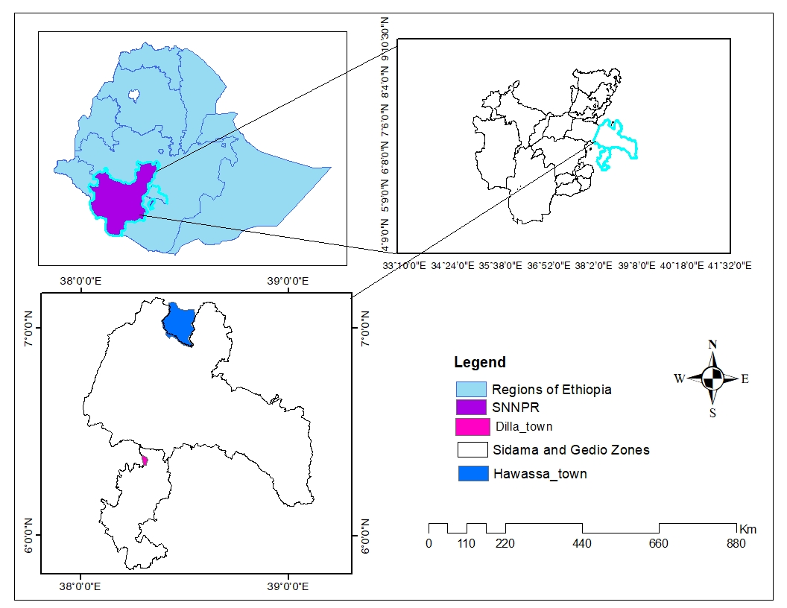**Figure 1**. Map of Ethiopian, Southern Nations, Nationality of Peoples' Region (SNNPR), and Dilla and Hawassa experimental site for sweet potato weevil management during the 2017 and 2018 cropping season.

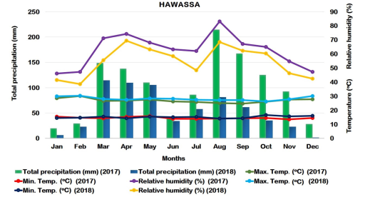**Figure 2.** Total precipitation (mm), mean monthly minimum and maximum temperatures, and relative humidity for Hawassa areas in southern Ethiopia during the 2017 and 2018 cropping season. **Source**: Shiferaw *et al*., (2023).

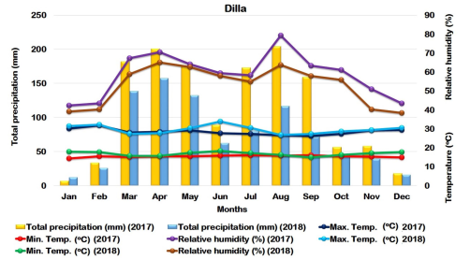**Figure 3**.Total precipitation (mm), mean monthly minimum and maximum temperatures, and relative humidity for Dilla areas in southern Ethiopia during the 2017 and 2018 cropping seasons. **Source**: Shiferaw *et al*. (2023).

The experiment was conducted at Hawassa Agricultural Research Center, Hawassa Chefe Kote Jebesa Research Station, and Dilla Sub-station testing sites in the 2017 and 2018 cropping seasons and laid out in an RCBD in three replications. The land was prepared very well before planting, as per the recommendation of the locality. The sweet potato variety Hawassa-83 was used, and the tip of the vine, which is 30cm in length and considered clean planting material, was used for planting. A plot size of 3 m by 3 m was used for each treatment. Immediately after sweet potato planting, legumes were planted between the rows of sweet potatoes. Sweet potato planting was at a spacing of 30cm between plants and 60cm between rows, and legumes were planted using the recommended spacing. Weeding was done according to the recommendations of the locality. Five different treatment combinations against sweet potato weevils were evaluated. These treatments included growing sweet potatoes with common beans, sweet potatoes with soybeans, sweet potatoes with desmodium, sweet potatoes with cowpeas, sweet potatoes with lablab, and growing solely sweet potatoes.

**Data Collection**: At both locations during the two cropping seasons, three middle rows of ten plants were counted to obtain data on weevil colonization of individual tubers, leaf infestation, marketable and non-marketable tuber yields, number of weevils per kilogram of infested roots, and total tuber yield.

**Data analysis**: - Leaf infestations, damage level or infestation of tuber yields, tuber colonization, and tuber yield of marketable and non-marketable data were subjected to analysis of variance (ANOVA) using SAS GLM procedure version 9.0 (SAS, 2004). Mean Data on weevil infestation and agronomic parameters were subjected to analysis of variance (ANOVA) to determine treatment effects using the general linear model procedure of SAS version 9.0 (SAS 2004). Mean separations between treatments were performed using Fisher’s protected LSD test at a 5% probability level (Gomez and Gomez 1984). The two locations and seasons were considered as different environments because of the heterogeneity of variances as tested using Bartlett’s test (Gomez and Gomez 1984). Thus, separate analyses were made for each location per year.

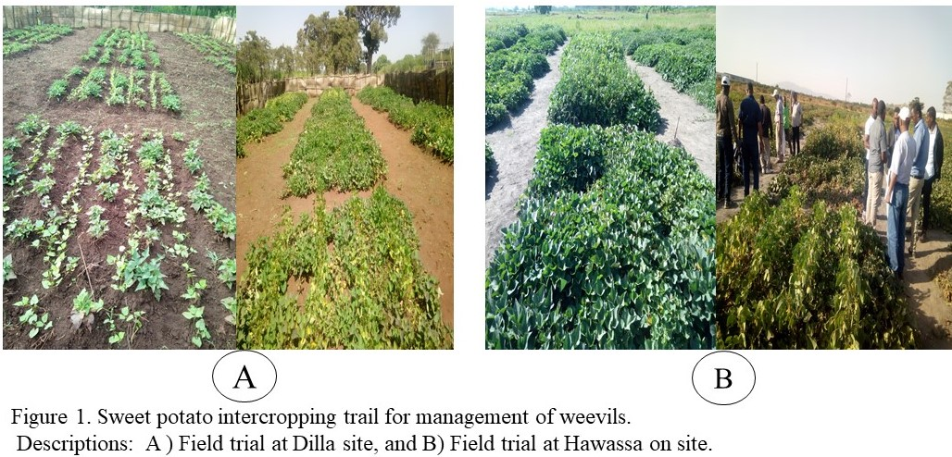 **Figure 4.** Sweet potato intercropping trial for management of sweet potato weevils. A). Field trial at Dilla site, B). Field trial at the Hawassa site. **Source:** Own trial image.

**RESULTS**

**Leaf Infestation Percentage (%)**

At the Dilla experimental site, the highest leaf infestation (69.7%, 83.3%) was observed in the sole cropping sweet potato plot of the 2017 and 2018 cropping seasons, respectively. Similarly, at the Hawassa Chefe Kote Jebesa Research Station, the highest sweet potato leaf infestation (68% & 71.7%) was recorded from the sole cropping of sweet potato plots, respectively. The lowest leaf infestation was recorded on cowpea (33.7% and 39%), lablab (36% and 38.3%), and desmodium (39% and 40.7%) in the 2017 and 2018 cropping seasons, respectively, at the Dilla site. The same trends were observed at Hawassa Chefe Jebessa on stations, and the lowest leaf infestation percentages were recorded on cowpea (34 and 36.7%), desmodium (37 and 40%), and lablab (33 and 40%). No significant difference was observed when compared at a significant level of probability (P < 0.05) on leaf infestation percentage among treatments of cowpea, desmodium, and lablab. Intercropping sweet potatoes with each other. Also, the treatment of soybean and common bean intercropping with sweet potato did not show a significant difference when compared to each other at the Dilla site and Hawassa Chefe Jebessa on the station during two consecutive cropping seasons (2017 and 2018). However, there is a significant difference in the sole cropping of sweet potato when compared with all other treatments (Tables 1 and 2).

**Weevil Colonization Percentage (%)**

Weevil colonization and leaf infection rates showed consistent patterns across various locations and years. During the 2017 and 2018 cropping seasons, the highest colonization rates were recorded in sweet potato monoculture, reaching 75.7% and 80.7% at Dilla, and 78.5% and 72% at Hawassa Chefe Jebessa. In contrast, the lowest colonization levels were observed in intercropped systems, specifically cowpea (35% and 47.3%), desmodium (35% and 54%), and lablab (36% and 52.3%) in 2017, and cowpea (34% and 40%), desmodium (39.3% and 33.3%), and lablab (36% and 38.7%) in 2018, with significant differences noted (P < 0.05).

While intercropping with soya bean and common bean did not show significant differences in weevil colonization at Dilla in 2017, these treatments did exhibit significant differences in leaf infestation compared to others. Overall, sweet potato weevil populations in intercropped plots were significantly lower than in monocultures. This finding suggests that diverse cropping systems enhance habitat diversity for arthropods, providing a greater abundance of prey and hosts for natural predators and parasites. Additionally, non-host plants likely disrupt the herbivore's host-finding cues, leading to reduced colonization of sweet potatoes. Therefore, intercropping sweet potatoes within diverse systems effectively minimizes pest colonization.

**Marketable Tuber Yield (Kg/plant)**

There were significant at (P<0.05) differences between diversified cropping systems and sole cropping in two consecutive years (2017 and 2018) across locations (Dilla and Hawassa) (Tables 1 and 2) for marketable tuber yield kg/plant. The maximum healthy tuber yield (1.05 kg/plant) was recorded at Dilla on cowpea intercropped with a sweet potato and followed by 1.01 kg/plant cowpea, and 0.9kg/plant, soyabean and lablab intercropped with a sweet potato, while the lowest marketable tuber yield (0.42 kg/plant) was revealed on sweet potato sole cropping. No significant difference in the treatment between desmodium and soybean intercropping with sweet potato and sweet potato sole cropping. No significant difference between lablab, cowpea, common bean, and desmodium intercropping with sweet potato compared to each other under a diversified cropping system while monocropping sweet potato favors weevils’ infestation and higher tuber damage.

**Non-Marketable Tuber Yield (Kg/plant)**

The effect of diversifying the cropping system of sweet potato with legume crops showed a significant (P < 0.05) difference for unmarketable tuber yield (kg/plant). Considering the diversified cropping system, the highest unmarketable tuber yield (1.05 kg/plant) was obtained from sole cropping sweet potato at the Hawassa site during the 2018 cropping season and followed by 1.03 kg/plant at the Dilla site during the 2017 cropping season with similar trends of marketable tuber yield (kg/plant) at two cropping seasons and across locations. Among the five tested intercropping combinations with sweet potato, there was no significant difference between cowpea and lablab, and desmodium, soybean, and common bean intercropping with sweet potato. The lowest unmarketable yield (0.12 kg/plant) was obtained, followed by 0.37 kg/plant on cowpea intercropping with sweet potato.

**Table 1.** Effect of legume diversification on leaf infestation (LI %), weevil colonization (WC %), marketable tuber yield kk/plant, and non-marketable tuber yield kg/plant of Dilla sub-station research site in the 2017 and 2018 cropping season.

|  |  |  |  |  |  |  |  |  |
| --- | --- | --- | --- | --- | --- | --- | --- | --- |
| Treatments | Year one (2017) Year two (2018) | | | | | | | |
|  | LI% | WC% | MTY (Kg/P) | NMTY (Kg/P) | LI % | WC% | MTY (Kg/P) | NMTY (Kg/P) |
| Sweet potato with common bean intercropping | 45.7b | 47.0b | 0.87a | 0.77b | 56.3b | 50.7b | 0.8ab | 0.76ab |
| Sweet potato with cowpea intercropping | 33.7d | 35.0c | 0.9a | 0.5c | 39.0d | 47.3b | 1.05a | 0.40c |
| Sweet potato with desmodium intercropping | 39.0bcd | 35.1c | 0.5ab | 0.7b | 40.7d | 54.0b | 0.64bc | 0.69b |
| Sweet potato with lablab intercropping | 36.0cd | 36.0c | 0.9a | 0.5c | 38.3d | 52.3b | 0.97a | 0.40c |
| Sweet potato with soya bean intercropping | 41.3bc | 50.0b | 0.5ab | 0.77b | 50.3c | 58.0b | 0.58bc | 0.70b |
| Sweet potato sole cropping | 69.7a | 75.7a | 0.43b | 1.03a | 83.3a | 80.7a | 0.35c | 1.00a |
| LSD (0.05) | 7.53 | 7.42 | 0.46 | 0.18 | 3.56 | 11.47 | 0.31 | 0.29 |
| CV (%) | 9.36 | 8.79 | 37.12 | 14.09 | 3.81 | 11.03 | 23.33 | 24.28 |

*LI: leaf infestation, WC: weevil colonization, MTY: marketable tuber yield, NMTY: non-marketable tuber yield, CV: coefficient variation, and LSD: list significant difference, Kg/P: kilogram per plant.* All values are means recorded from 10 plants in three middle rows and the tuber yields were taken from one plant of 10 plants mean. *Means with the same letters within the column are not significantly different at a 5% significance level.*

**Table 2.** Effect of legume diversification on leaf infestation (LI %), weevil colonization (WC %), marketable tuber yield kg/plant, and non-marketable tuber yield kg/plant of Hawassa Chefe Kote Jebesa Research Station in the 2017 and 2018 cropping season

|  |  |  |  |  |  |  |  |  |
| --- | --- | --- | --- | --- | --- | --- | --- | --- |
| Treatments | Year one (2017) Year two (2018) | | | | | | | |
|  | LI% | WC% | MTY(Kg/P) | NMTY(Kg/P) | LI % | WC% | MTY(Kg/P) | NMTY(Kg/P) |
| Sweet potato with common bean intercropping | 41.3bc | 46.7c | 0.90ab | 0.45b | 46.7bc | 48.3b | 0.83ab | 0.58bc |
| Sweet potato with cowpea intercropping | 34.0d | 34.0e | 1.01a | 0.12c | 36.7c | 40.0b | 1.20a | 0.37c |
| Sweet potato with desmodium intercropping | 37.0cd | 39.3d | 0.62ab | 0.25c | 40.0bc | 33.3b | 0.40c | 1.02a |
| Sweet potato with lablab intercropping | 33.0d | 36.0de | 0.87ab | 0.19c | 40.0bc | 38.7b | 0.87ab | 0.40bc |
| Sweet potato with soya bean intercropping | 43.3b | 54.7b | 0.43b | 0.40b | 50.0b | 46.7b | 0.53bc | 0.73ab |
| Sweet potato sole cropping | 68.0a | 78.0a | 0.42b | 0.78a | 71.7a | 72.0a | 0.40c | 1.05a |
| LSD (*0.05*) | 3.89 | 5.01 | 0.53 | 0.15 | 11.39 | 3.94 | 0.39 | 0.36 |
| CV (%) | 6.44 | 4.45 | 41.09 | 22.52 | 13.18 | 23.04 | 30.69 | 28.21 |

*LI: leaf infestation, WC: weevil colonization, MTY: marketable tuber yield, NMTY: non-marketable tuber yield, CV: coefficient variation, and LSD: list significant difference, Kg/P: kilogram per plant.* All values are means recorded from 10 plants in three middle rows and the tuber yields were taken from one plant of 10 plants mean. *Means with the same letters within the column are not significantly different at a 5% significance level.*

**Simple Correlation Analysis**

The weevil infestation parameters showed detectable differential levels of relationships with yield and yield-related components. At Dilla, weevil colonization had a positive and highly significant (p < 0.0001) association with nonmarketable tuber yield (NMTY) (*r* = 0.914** and 0.803**) and leaf infestation (*r* = 0.967** and 0.903**) and leaf infestation also had a positive and highly significant association with NMTY (*r* = 0.921** and *r* = 0.894**) during the 2017 and 2018 cropping years, respectively. Weevil colonization was negatively and significantly correlated with marketable tuber yield (*r* = - 0.591** and *r* = - 0.862**) and leaf infestation (*r* = - 0.581** and *r* = -0.791*) in 2017 and 2018, respectively (Table 3). Additionally, marketable tuber yield maintained a negative and highly significant (p ≤ 0.001) relationship with NMTY (*r* = - 0.747 *** and *r* = - 0.923**) in that order in the 2017 and 2018 cropping seasons.

At Hawassa areas, the weevil colonization was found to establish a positive and highly significant (*p* < 0.001) correlation with NMTY (*r* = 0.970*** and 0.444**) and leaf infestation (*r* = 0.981** *and 0.965**) in the 2017 and 2018 cropping seasons in that order of presentation (Table 4). Weevil colonization was negatively and significantly correlated with MTY (*r* = - 0.372** and *r* = - 0.711**) and leaf infestation (*r* = - 0.692* and *r* = -0.600*) in 2017 and 2018, respectively (Table 3). Additionally, marketable tuber yield maintained a negative and highly significant (p ≤ 0.001) relationship with NMTY (*r* = - 0.677** and *r* = - 0.903***) in 2017 and 2018 in order. Even though there was a negative relationship between TTY and weevil elements, it did not show a significant correlation with weevil colonization and leaf infestation components in the 2017 infestation season. Closely similar trends were noted in the relationships among weevil components and between infestation and root colonization and yield parameters in 2018 (Table 4).

**Table 3.** Coefficients of correlation (*r*) between sweet potato weevil root colonization, leaf infestation, and yield parameters of sweet potato under different cropping systems at Dilla, Southern Ethiopia, during the 2017 (above diagonal) and 2018 (below diagonal) cropping seasons

|  |  |  |  |  |  |
| --- | --- | --- | --- | --- | --- |
|  | TTY | NMTY | MTY | LI | WC |
| TTY | 1 | 0.182ns | 0.514ns | 0.327ns | 0.307ns |
| NMTY | -0.115ns | 1 | -0.747** | 0.921** | 0.914** |
| MTY | 0.485ns | -0.923** | 1 | -0.582** | -0.591** |
| LI | -0.019ns | 0.894** | -0.791** | 1 | 0.967** |
| WC | -0.403ns | 0.803** | -0.862** | 0.903** | 1 |

*TTY: total tuber yield(kg/plant), NMTY: nonmarketable tuber yield (kg/plant), MTY: marketable tuber yield (kg/plant), LI: leaf infestation in percentage, WC: weevil colonization in percentages, ns: not significance different, *, ** and *** refer to significance levels at <0.05, <0.01 and <0.001, respectively.*

**Table 4.** Coefficients of correlation (*r*) between sweet potato weevil root colonization, leaf infestation, and yield parameters of sweet potato under different cropping systems at Hawassa, Southern Ethiopia, during the 2017 (above diagonal) and 2018 (below diagonal) cropping seasons

|  |  |  |  |  |  |
| --- | --- | --- | --- | --- | --- |
|  | TTY | NMTY | MTY | LI | WC |
| TTY | 1 | 0.33ns | 0.465ns | 0.269ns | 0.180ns |
| NMTY | 0.007ns | 1 | -0.677** | 0.960 ** | 0.970*** |
| MTY | 0.361ns | -0.903*** | 1 | -0.692* | -0.711* |
| LI | -0.021ns | 0.635** | -0.600* | 1 | 0.981*** |
| WC | 0.114ns | 0.444** | -0.372** | 0.965** | 1 |

*TTY: total tuber yield(kg/plant), NMTY: nonmarketable tuber yield(kg/plant), MTY: marketable tuber yield (kg/plant), LI: leaf infestation in percentage, WC: weevil colonization in percentage, ns: not significance different, *, ** and *** refer to significance levels at <0.05, <0.01 and <0.001, respectively*

**DISCUSSIONS**

The sweet potato weevil is a significant pest capable of reducing sweet potato tuber yields by up to 48% or even completely under favorable conditions. Intercropping sweet potatoes with other crops can influence weevil infestation levels, impacting both marketable and unmarketable tuber yields. Specifically, intercropping may reduce weevil root colonization and leaf infestation, leading to higher marketable yields and fewer damaged tubers. However, the effects vary depending on the choice of intercrop species and environmental conditions.

To address this issue, field experiments were conducted at Dilla and Hawassa during the 2016–2017 and 2017–2018 growing seasons. These experiments explored the interactions between soil microbes and natural enemies within various agricultural systems. The current study found that intercropping with different legumes and forages significantly differed from sole sweet potato cultivation. Notably, the research indicated substantial differences in weevil leaf infestation, root colonization, and overall yield among the intercropping treatments.

These findings align with those of Taiwo et al. (2019), who demonstrated that barrier planting in intercropping systems effectively reduces damage from *C. formicarius*. This supports the notion that intercropping growing two or more crops simultaneously on the same land can enhance pest management (Sullivan, 2000). Intercropping is particularly common in tropical and subtropical regions, where small-scale farmers benefit from its multiple advantages. The report of (Tarekegn et al.,2014) intercropping maize/haircotbean with sweet potato highly used for control of sweet potato weevil management that research conducted in eastern Ethiopia.

The nitrogen fixation provided by grain legumes enhances soil fertility and supports sweet potato growth (Ossom et al., 2006; Hauggaard-Nielsen, 2006). Additionally, Altieri and Liebman (1986) emphasized that intercropping can significantly reduce insect pest problems by disrupting their activities and movement, decreasing host availability, and promoting natural pest enemies. Intercropping also creates physical barriers that hinder the spread of pests, affecting both adult and larval stages (Perrin, 1977; Cromatie, 1983). This disruption may confuse pests' olfactory and visual cues related to their hosts, potentially lowering insect populations and crop damage (Kareiva, 1983).

Research by Alexander et al. (1992) showed that sweet potato monoculture had about 21.9% fewer damaged tubers than intercropped systems, which had only 2.6% damaged tubers. This indicates that sweet potato weevils may spend more time searching for crops in intercropped environments, thus reducing overall damage (Kareiva, 1983). Similar trends were observed in India with cropping sequences like rice-sweet potato-cowpea and rice-sweet potato-rice, which significantly lowered sweet potato weevil infestations in lowland rice fields (Pillai et al., 1996).

Christerson (1995) reported a decrease in *A. fabae* populations when beets were intercropped with phacelia, further supporting the benefits of intercropping for pest management. In northeastern India, farmers utilize mixed cropping systems that incorporate sweet potatoes with crops such as yam, colocasia, maize, okra, and ginger. Rajasekhara Rao (2005) and co-authors noted how these systems interact with various insect pests, including the sweet potato weevil, resulting in lower infestation rates. Specifically, sweet potatoes intercropped with rice, cowpea, or colocasia showed a tenfold reduction in weevil populations, with infestations declining to 4.8-11.54 weevils per kg of tubers (Pillai et al., 1987). This pattern aligns with other intercropping systems, such as sweet potato-corn and sweet potato-soybean, which also reported significant decreases in weevil populations (Alexander, 1992). In Papua New Guinea, sweet potato monoculture faced severe damage, with infestations reaching 70%, while intercropping with soybean and corn reduced this to 23% and 10%, respectively (Sutherland, 1986b). Moreover, intercropping sweet potatoes with the legume red gram has been shown to lower weevil infestations (Nedunchezhiyan et al., 2010). Overall, data indicate that intercropped sweet potatoes consistently experience fewer weevils and a lower percentage of damaged tubers, with reductions ranging from modest to significant, up to a 16-fold decrease in weevil numbers per kg and a 19% reduction in damaged roots. This reinforces the effectiveness of intercropping as a sustainable strategy for managing sweet potato pests and enhancing agricultural productivity. In a study by Singh et al. (1984), intercropping sweet potatoes with proso-millet and sesame led to reduced weevil infestation rates, from 28% down to 9% and 6%. Lower tuber infection rates were also noted in Hyderabad (24.5%) and Dapoli (16.23%) using alternating row planting (1:1). While the study indicated less weevil damage in interplanted sweet potatoes, there remains uncertainty about whether these reductions impacted tuber yields.

In conclusion, intercropping is a vital strategy for managing sweet potato weevils, offering several key benefits. It can significantly lower pest infestation rates, resulting in healthier crops and improved yields. Additionally, diverse cropping systems enhance biodiversity by creating habitats for natural pest enemies, promoting biological control. The inclusion of legumes in intercropping also improves soil health through nitrogen fixation, thereby enhancing soil fertility and supporting better crop growth. Different crops can act as physical barriers, disrupting pests' movement and feeding patterns, which reduces their colonization of sweet potatoes. By minimizing damage, intercropping increases the proportion of marketable tubers.

Future research will focus on the pull-and-push strategy, intercropping, and the effects of selected intercrop species with sweet potatoes to further validate methods for controlling sweet potato weevils. This research aims to deepen our understanding of effective pest management techniques and promote sustainable agricultural practices.

**CONCLUSIONS**

The sweet potato weevil is a significant pest that can reduce sweet potato tuber yields by as much as 48%. Intercropping sweet potatoes with other crops has been shown to influence weevil infestations and affect both marketable and unmarketable yields. This practice may help decrease weevil colonization and leaf infestation, ultimately leading to improved marketable yields and fewer damaged tubers. However, the effectiveness of intercropping depends on the choice of intercrop species and environmental conditions.

Field trials conducted during the 2016-2018 cropping seasons indicated that diverse cropping systems can lower sweet potato weevil populations by enhancing habitats for natural enemies, thus increasing the variety and abundance of predators and parasites. Statistically significant differences were observed between sole cropping and systems involving natural enemies, although no significant differences were found among various intercropping treatments, with only notable numerical differences emerging.

The study recommends intercropping sweet potatoes with cowpeas and lablab as the most effective strategy for managing the sweet potato weevil. Future research should investigate the long-term effects of these intercropping systems on pest management and crop yields to better inform sustainable agricultural practices. Overall, the findings highlight the potential of intercropping legumes, forages, and other crops to enhance pest control in Ethiopia, contributing to improved agricultural sustainability

**DISCLAIMER (ARTIFICIAL INTELLIGENCE) Author(s)**

Hereby declare that NO generative AI technologies such as Large Language Models (ChatGPT, COPILOT, etc.) and text-to-image generators have been used during the writing or editing of this manuscript.

**REFERENCES**

Alexander, A. (1992). Effects of intercropping sweet potato on the population density of sweet potato weevil, Cylas formicarius (F.) (Coleoptera: Curculionidae). MSc. Thesis, McGill University, Canada.

Altieri, M.A. & Liebman, M. (1986). Insect, weed, and plant disease management in multiple cropping systems. *Multiple cropping systems*, Diversity Biology Control, Univ. California, Berkeley, CA.

Belehu, T. (2005). Agronomical and physiological factors affecting growth, development and yield of sweet potato in Ethiopia, Doctorial Thesis, University of Pretoria.

Central Statistics Agency (CSA). (2022). Agricultural sample survey of area and production of major crops (Private peasant holdings, Meher Season). https://www.statsethiopia.gov.et/. Vol. 1, Statistical Bulletins 590, Addis Ababa, Ethiopia.

Central Statistics Agency (CSA). (2019). Agricultural sample survey 2010/2011.*Report on the area and production of major crops*. Central Statistical Agency of Ethiopia, Addis Ababa, Ethiopia, 2011, pp. **126**.

Dodiya, R. D., & Barad, A. H. (2022). Effectiveness of biopesticides against *Spodoptera litura* infesting groundnut under field conditions. *The Pharma Innovation Journal*, 11(8), 1601.

Dodiya, R. D., Barad, A. H., Pathan, N. P., & Raghunandan, B. L. (2023). Trichogramma: a Promising Biocontrol Agent. *International Journal of Economic Plants*, 10(Aug, 3), 192-199.

Food and Agriculture Organization of the United Nations Statistics (FAO STAT). (2022). Crops/Regions/World List/Production Quantity for Barley. *Food and Agriculture Organization Corporate Statistical Database*

Ferdu, A., Baye, M., Emana, G., Temesgen, A., Eyobe, T., Mesele, G. & Biruk, W. (2009). Review of Entomological Research on Root and Tuber Crops in Ethiopia. Pp.1- 46. In: Abraham Tadesse(ed.). 2009. Increasing Crop Production through Improved Plant Protection- Volume II. Plant Protection Society of Ethiopia (PPSE). PPSE and EIAR, Addis Ababa, Ethiopia.

Gurmu, F. (2019). Sweet Potato Research and Development in Ethiopia: A Comprehensive Review.*Journal of Agriculture and Crop Research,* **7**(7):106-118.

Hauggaard-Nielsen, H.& Jensen, E.S. (2006). Facilitative root interactions in intercrops. *Plant Soil* **274**:237-250.

Kapinga, R., Ortiz, O., Ndunguru, J., Omiat, E. & Tumwegamire, S. (2007). Handbook of Sweet Potato Integrated Crop Management: Research Outputs and Programs for East Africa. International Potato Center (CIP). Uganda.

Lebot, V. (2010). Sweet potato. In: *Root and Tuber Crops*, Bradshaw, J. E. (Ed.). Springer Science+Business Media, LLC, New York, USA.

Low, J., Ball, A., Jaarsveld, P.J., Namutebi, A., Faber, M.& Grant, F.K. (2015). In: Low, J. (Ed.), Assessing Nutritional Value and Changing Behaviours Regarding Orange-fleshed Sweetpotato Use in Sub-Saharan Africa. Potato and Sweetpotato in Africa: Transforming the Value Chains for Food and Nutrition Security. CAB International, pp. 551-579.

National Meteorological Agency, Hawassa branch. (2019).National Meteorological of Ethiopia data report.

Nedunchezhiyan, M., Rajasekhara, R.K., Laxminarayana, K.& Satapathy, B.S. (2010). Effect of strip cropping involving sweet potato (*Ipomoea batatas* L.) on soil moisture conservation, weevil infestation, and crop productivity. *Journal of Root Crops* **36**(1):53-58.

Nwankwo, I. I.& Bassey, E. E. (2021). Evaluation of some advanced breeder lines of sweetpotato for root and fodder yields in Umudike, southeastern Nigeria. *Nigerian Journal of Agricultural Technology*, **18**:1-5.

Ossom, E.M. (2010).Influence of sweet potato/maize association on ecological properties and crop yields in Swaziland. *International Journal of Agriculture and Biology*. **12**(4): 481-488.

Perrin, R.M. (1977). Pest management in multiple cropping. Agro Ecosystems **3**: 93-118

Pillai, K.S., Palaniswami, M.S., Rajamma, P., Ravindran, C.S. & Premkumar, T. (1996). An IPM approach for sweet potato weevil.In: Kurup, G.T., Palaniswami, M.S., Potty, V.P., Padmaja, G., Kabeerathumma, S. and Pillai, S.V. (Eds.) Tropical tuber crops:Problems, Prospects and future strategies. Science Publishers,Inc. USA. p. 329-339

Purseglove, J. (1972). *Tropical Crops: Dicotyledons. Land on Long Man*, University of West Indies, Kingston, Jamaica.

Qaim, M. (1999). The Economic Effects of Genetically Modified Orphan Commodities: Projections for Sweet Potatoes in Kenya. ISAAA Brief No. 13. Ithaca: *The International Science for the Acquisition of Agri-biotech Applications*; Bonn: Center for Development Research.

Shiferaw, M., Fekadu, G. & Getachew, G. (2023). Reaction of introduced orange-fleshed sweetpotato (*Ipomoea batatas* L.) genotypes for virus disease resistance and storage root yield performance under field conditions in Dilla and Hawassa, southern Ethiopia, Indian Phytopathol.**76**(1): 243-259, doi: 10.1007/s42360-022-00590-w

Singh, B., S.S. Yazdani, R. Singh & Hameed. S.F. (1984). Effect of intercropping on the incidence of sweet potato weevil in sweet potato. *Journal of Entomology Research*. **16**(2): 13-195.

Stathers, T., Namanda, S., Mwanga, R.O.M., Khisa, G.& Kapinga, R. (2005). Manual for Sweet Potato Integrated Production and Pest Management Farmer Field Schools in Sub-Saharan Africa. *International Potato Center,* Kampala, Uganda. ISBN 9970-895-01-x.

Statistical Analysis Software Institute, SAS version 9.4.(2014).Output delivery system: User’s guide. SAS Institute.

Sutherland, J.A. 1986b • Damage by *Cylas formicarius* Fab. to sweet potato vines and tubers, and the effect of infestation on total yield in Papua New Guinea. Trop. Pest Manage. 32(4): 316-323

Taiwo, E.D., Jian, L., Anne, C. J, Mudassir, R.& Geoff, M.G. (2019). Screening barrier plants to reduce crop attack by sweet potato weevil (*Cylas formicarius*). *Pest Management Science,* pp.1-**7**

Tarekegn, F., Emana., and Waktole S. (2014). Integrated Management of Sweet Potato in Eastern Ethiopia. *Journal of Entomology*, **11**(4): 225-237.

Tofu, A., Anshebo, T., Tsegaye, E. & Tadesse, T. (2007). Summary of progress on orange-fleshed sweet potato research and 114 Gurmu, Hussein, and Laing development in Ethiopia. In: Proc. 13th International Society for Tropical Root Crops (ISTRC) Symposium, Arusha, Tanzania, and 9-15 November 2003. ISTRC, Arusha. Pp. 728-31.

Wang, Z., Li, J., Luo, Z., Huang, L., Chen, X.& Fang, B. (2011). Characterization and development of EST-derived SSR markers in cultivated sweet potato (*Ipomoea batatas*). *BMC Plant Biol.* **11**: 131-39.