**Assessment of the Anti-malarial Potential of *Gmelina arborea* in Suppressive and established infection study in Mice**

**Abstract**

*This study aims to investigate the potential of Gmelina arborea as an anti-malarial agent, exploring its therapeutic benefits and possible applications in malaria treatment.* Malaria being a disease of massive burden in Nigeria and Africa has wasted income and caused death in infants and pregnant women majorly. Plants have been the main source of medicine in Africa and traditionalists have used them in the management of malaria; *Gmelina arborea* (GA) has been used in the Eastern part of Nigeria in the treatment of malaria, but there is no scientific validation on its usage.

In this study, an acute toxicity test, and the antimalarial potential of GA were evaluated. *Plasmodium berghei* infected mice in a 4-day suppressive test and 7-day curative models using mice were used. Parameters assessed were post-treatment parasitemia, level of suppression, haematological indices and survival.

1. *arborea* did not show acute or delayed toxicity; the level of suppression was high at 300mg/kg and the level of parasitemia was low at the same dose. The extract at 300mg/kg produced elevated red blood cell (RBCs) and platelet counts, and an increase in haemoglobin and lymphocytes while 900mg/kg showed only increased platelet counts in the suppressive model. In the established infection, percentage inhibition (PI) was high and parasitemia (PP) was low from day 1-7 at 300mg/kg, while at 900mg/kg, PI was high only on day 1. Platelets and RBC counts were high at 300mg/kg while lymphocytes were high at 100mg/kg.

This indicated that *G. arborea* is a potential candidate for the management of malaria and there is a need for further studies to identify the bio-active principle(s) and mechanism of antimalarial action.

Keywords: antimalarial, suppressive, parasitemia, *Gmelina arborea,* curative

1. **Introduction**

Malaria is a tropical disease caused by a parasite (*Plasmodium sp),* it can infect humans through females’ mosquitos (*Anopheles sp*.) bite; over 200 species of *Plasmodium* has been discovered but 13 of them are known to be pathogenic to humans (Fikadu *et al*., 2023). Despite substantial progress in reducing malaria incidence and mortality through interventions such as insecticide-treated bed nets, antimalarial drugs, and indoor residual spraying, malaria continues to exact a heavy toll, particularly in sub-Saharan Africa where the majority of cases and deaths occur (Ounjaijean & Somsak, 2024). The emergence of drug-resistant malaria strains poses a significant threat to these gains, underscoring the urgent need for novel antimalarial agents and treatment strategies (Weiland, 2023).  According to WHO, in 2017, there were still around 219 million cases of malaria globally, with a mortality rate of 435,000 (Faloye *et al.*,2023); The rate of mortality and morbidity is still high, especially in developing countries (Irungu *et al.,* 2023). Malaria is highly lethal unless treated (Ezeani *et al.*,2022); it can be diagnosed by clinical signs and symptoms, microscopic detection of parasites in the blood smear and antigen-base rapid diagnostic test (Fikadu *et al.,* 2023).

The types of *Plasmodium* that initiate malaria in humans are *P. falciparum, P. vivax, P. ovale, P. malariae,* and *P. knowlesi*. The fatal *Plasmodium* type of malaria is *P. falciparum.* (Ogbole *et al.,*, 2016).

The increase in the rate of malaria infection increases the out-of-pocket expenses by individuals thereby contributing to the decrease in economic development (Andrade *et al.*, 2022).

The partial resistance of *P. falciparum* to artemisinin component-based therapy emerged in Southeast Asia and has spread to East Africa, this partial resistance is mediated mainly by mutation of Kelch protein K13 (PfK13) which is manifested as delayed malaria parasite clearance after therapy (Conrad *et al.*, 2023).

Antimalarial drug resistance can increase morbidity and mortality, especially in populations where the immunity is low and the climate change is favourable for breeding vectors (Ezeani *et al.*,2022; Leal *et al.,* 2023). This led to the need to develop new antimalarial agents, which are effective and accessible for developing countries, and wherever malarial infection is prevailing.

*Gmelina arborea Roxb* is one of the important medicinal plants most widely propagated and cultivated. It is commonly known as “K*ashmarya*” and is one of the herbs mentioned in all ancient scriptures of *Ayurveda* (Jajere *et al.*,2021). It grows up to 35 m tall having a diameter of 3 m. The tree produces multiple stems with a broad canopy under natural conditions (Barsola et al., 2024; Warrier et al. 2021).  This medicinal plant is highly valued from time immemorial because of its vast medicinal properties. In several countries in Africa and Asia, the *Lamiaceae* family plants are widely used as a traditional antimalarial herbal medicine including *G. arborea* in the south-eastern part of Nigeria (Odoh *et al.,* 2018). Several plants commonly used to treat malaria and several other plants from the *Lamiaceae* family have been investigated for their antimalarial efficacy both *in vitro* against *Plasmodium falciparum* or *in vivo* against *Plasmodium berghei* in animal-like mice, except *G. arborea. The objective of this study is to investigate the potential of Gmelina arborea as an anti-malarial agent, exploring its therapeutic benefits and possible applications in malaria treatment.*

**2.0 Material and Methods**

**2.1 Plant material**s

About 1000g of fresh leaves of *G. arborea* were collected from Kuje LGA, Abuja, Nigeria. The leaves were washed by rinsing in distilled water and air-dried completely at room temperature (30 ± 2ºC), protected from heat and direct sunlight for about 2 weeks. The dried leaves were homogenized to a fine powder using a Laboratory Hammer mill (Zhen Chang Equipment SFS P66) and extraction of the powder of the leaves would be done using 70% ethanol for 72 hours, and dried using a rotatory evaporator. The dried extract was transferred into air-tight glass vials and stored at 40C in a refrigerator.

**2.2 Acute Toxicity Study**

The animals were administered 2000mg/kg body weight of leaf extract and observed for 15 minutes, 30 minutes, 1 hour, 4 hours, and a week for signs of toxicity and mortality (OECD, 2024).

**2.3 Experimental Animals**

Thirty Swiss mice, weighing 20g-35g were sourced from the Animal Facility centre of the Department of Pharmacology and Toxicology, National Institute for Pharmaceutical Research and Development (NIPRD). The animals were maintained under standard environmental conditions (temperature 24 ± 2 °C) with free access to a standard rodent diet and water. The animals were acclimatized to laboratory conditions for two weeks before the studies. Ethical approval for animal experiments was collected from the Animal Care and Ethics Committee with an approval number.

**2.4 Parasite inoculation**

Eight days after the parasite inoculation of a healthy mouse, a Giemsa-stained thin blood film was prepared from its tail vein blood for the assessment of parasitemia. The donor mouse was anaesthetized, and blood was collected by cardiac puncture. The withdrawn blood sample was diluted with physiological saline such that 0.2 ml contained approximately 107 parasitized red blood cells based on the parasitemia level of the donor (Fidock *et al.,* 2004). Each experimental mouse was inoculated intraperitoneally with 0.2 ml of the diluted infected blood.

**2.4.1 *In vivo* suppressive test of extrac**t

The 4-day suppressive test model was used to measure the schizonticidal activity of the extract against *P. berghei-*infected mice (Ezeani *et al.,* 2023). A total of 30 mice was used in this study.

The mice were weighed and randomized by weight into five groups (I–VI) of five each. A 0.2 ml volume of dilute infected blood was used to inoculate test mice by intraperitoneal injection. After 4 h, animals received extract orally at graded doses of 100mg/kg, 300mg/kg and 900mg/kg once daily for 3 consecutive days starting from Day 0 for Groups I–V. Group I-II were negative control (distil water only), and positive control (Chloroquine only) respectively, and Group III-V were given extract. Thin blood smears were prepared from the tail vein blood of the mice on day 4 and fixed in methanol then stained using 10% Giemsa stain, counting parasites per 100 red blood cells in five fields under a microscope with immersion oil and 100 objective was done.

The percentage of parasitemia was determined by:

% parasitemia =Number of parasitized RBCs ×100

Total number of RBCs

And suppression (%) produced by test extracts was determined by:

% Suppression= % Parasitemia (control)-% Parasitemia (treated) ×100

% Parasitemia control

Based on the percentage suppression produced, the antiplasmodial activity would be classified as moderate for extract that suppressed parasitemia by equal to or greater than 50%. (Nardos and Makonnen, 2017).

**2.4.2 Screening of *G. arborea* hydroethanol extract in established infection (Curative**

**Antimalarial study**)

**2.4.3 Experimental design**

The curative antimalarial activity of *G. arborea* ethanol extract was carried out using a curative test model in mice (Fidock *et al.,* 2004). The experimental mice was weighed, randomized, and inoculated on the third day after establishing parasitemia in host mice. A total of 30 mice were inoculated and divided into groups 1-5 of 6 mice each. Positive control, negative control and treated groups of *G arborea* extract with doses 100mg/kg, 300mg/kg, and 900mg/kg groups. The administration was done orally. They were fed with Vital commercial feed once a day. The positive control groups received chloroquine (Sigma Aldrich, Germany) orally at 5 mg/kg once daily, while the negative control group received distilled water (10 ml/kg). Treatment was done for 5 days, from day 3 to day 7. Parasite load was determined on day 8 using thin smears of film stained with 10 % Giemsa solution. A total of 5 fields containing 100 red blood cells per field were counted under the microscope. The percentage of inhibition of the parasite growth (% I) of each dose extract was determined according to the following formula:

% I = [(parasite count of malaria control- parasite count of extract group)/

Parasite count of malaria control] ×100

Animals were kept for monitoring survival for 30 days.

**2.5 Haematological Parameters**

Blood was collected from the tail vein of the mice into EDTA tubes for the evaluation of haematological parameters using the automated haematology analyzer YNH7021 (Wincom Company Ltd, Hunan, China). Parameters evaluated are red blood cells, platelets, neutrophils, hemoglobin concentration, and lymphocytes.

**3. RESULTS**

**3.1 Acute Toxicity Study**

There was no acute or delayed toxicity at 2000mg/kg. The mice showed no sign of morbidity and no mortality even after 30 days.

**3.2 Suppressive Effects of *G.arborea* on malaria parasites**

In the suppressive study, the percentage of parasitemia at 300mg/kg is low compared to 100mg/kg and 900mg/kg respectively; and the percentage of suppression is high at 300mg/kg as described in Table 1 and Fig 1 respectively.

Table 1: Percentage of parasitic suppression

|  |  |  |
| --- | --- | --- |
| Groups | % Parasitemia | % Suppression |
| DW | 8.39 | - |
| CQ | 1.65 | 80.33 |
| GA 100mg/kg | 7.12 | 15.14 |
| GA 300mg/kg | 5.17 | 38.38 |
| GA 900mg/kg | 9.09 | -8.34 |

DW-Distilled water; CQ-Chloroquine; GA- *Gmelina arbroea*

Fig 1

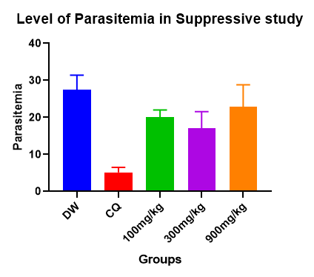

**3.4 Effects of ethanol extract of *G. arborea* on heamatological indices in suppressive study.**

The level of RBCs at 900mg/kg is lower compared to other groups (1.94±0.18) while those of 100mg/kg and 300mg/kg showed no significant difference compared to chloroquine and distilled water groups. There is an increase in the level of lymphocytes at 300mg/kg compared to 900mg/kg and 100mg/kg but lower to that of chloroquine group; while neutrophils level was lower in all the treated groups compared to distilled water group.

There was a decrease in the level of haemoglobin and platelets in other groups compared with normal groups but 100mg/kg showed lower values as described in Fig 2&3 below.

Fig 2-

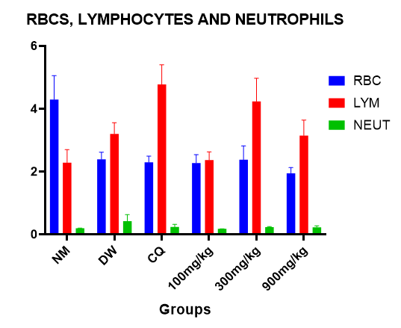

**Fig 3-**

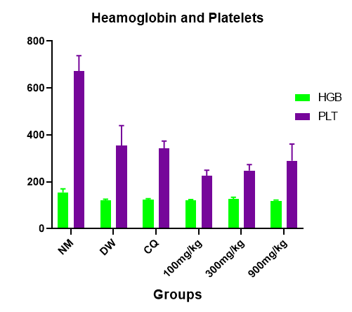

**3.5 Curative Effects of *G. arborea* on malaria parasites**

In the curative study, percentage inhibition was high at 900mg/kg on day 1 only, while at 300mg/kg, the percentage inhibition was high on days 3 and 7 in extract-treated groups as described in Table 2.

Table 2: Percentage inhibition of *G. arborea* on malaria parasites

|  |  |  |  |
| --- | --- | --- | --- |
| Groups | % inhibition day 1 | % inhibition day 3 | % inhibition day 7 |
| DW | 18.2 | 31.20 | 7.60 |
| CQ | 94 | 82.40 | 57.89 |
| GM 100mg/kg | 57.1 | 0.64 | -8.55 |
| GM 300mg/kg | 54.9 | 58.30 | 47.40 |
| GM 900mg/kg | 65.9 | -21.70 | 23.68 |

**Level of parasitemia in established infection**

On day 3 and 7, the level of parasitemia was low at 300mg/kg and high at 900mg/kg among the extract treated groups described in Fig 4&5 below.

Fig 4

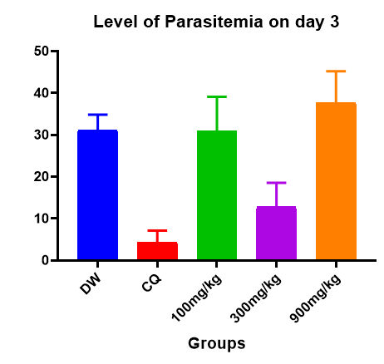

Fig 5

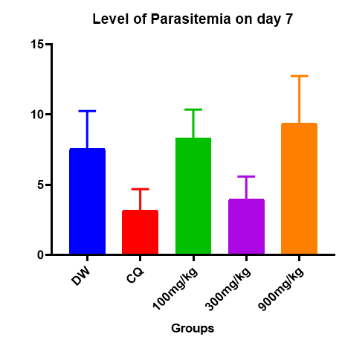

**Effects of ethanol extract of *G. arborea* on haematological indices in curative study**

The haematological analysis in the established infection study showed that the level of platelets and lymphocytes was high at 100mg/kg, while the level of RBC was high at 300mg/kg, but there was no significant difference in haemoglobin level in extract treated groups as shown in fig 6 and 7 below.

Fig 6

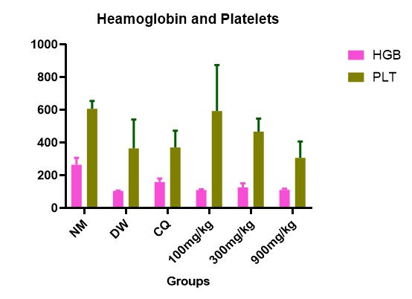

Fig 7-

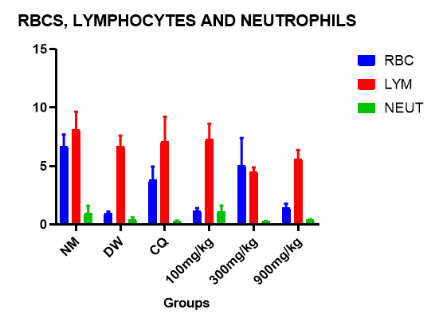

**Discussion**

Malaria is the highest cause of mortality due to the level of parasites in Africa especially in infants and pregnant women (Anyasodor *et al.,*2023; Ezenyi *et al.*, 2020); the causative agent (*Plasmodium* sp.) has developed resistance to drugs, and this makes the management or treatment of malaria a challenge (Igwenyi *et al.,* 2024). *G. arborea* is a medicinal plant that has been used as a diuretic, laxative, anti-haemorrhoid and antihelmintic (Idowu *et al.*, 2020), and was documented to be used in the management of malaria in the southeast of Nigeria (Odoh *et al.,* 2018). In this study, the anti-malaria effects of suppressive and curative infection are being evaluated.

Previous research showed that 300mg/kg of *Azadirachta indica* with chloroquine (20mg/kg) has antimalarial effects but this study demonstrated that only *G. arborea* at 300mg/kg has antimalarial potential (Zuleta-Castro, 2021); the previous study showed that *Chukrasia tabularis* also has suppressive effects on *Plasmodium falciparum* at high doses of 800mg/kg (Ogbole *et al.,* 2016) unlike *G. arborea* which exhibited suppression at 300mg/kg; though plants like *Fuerstia africana* and *Ludwigia erecta* has been demonstrated to also have suppressive effects against *Plasmodium falciparium* at low dose (100mg/kg) (Irungu *et al.*, 2023) but this is the first work done on *G. arborea* indicating its antimalarial suppressive effects at 300mg/kg.

The curative antimalarial effects of *G. arborea* were observed at 300mg/kg also, with a decrease level of parasitemia and high inhibition percentage from day 1-7; even though the percentage inhibition was high on day 1 at 900mg/kg but could not be sustained for prolong days, this implies that 900mg/kg as a single dose may have antimalarial effects and continuous usage may be overdose because haematological indices showed low RBCs and Hemoglobin; and the level of parasitemia was high on days 3 and 7; related work done by Zuleta-Castor (2021) and Ogoble (2016) showed that high dose of *A. indica* (1000mg/kg) and *C. tabularis* (800mg/kg) elicit antimalarial activities but not for prolong use.

The haematological indices revealed an increase in RBCs, at 300mg/kg compared to 100mg/kg and 900mg/kg which implies that there was no anaemia; the level of lymphocytes and platelets showed no significant difference when compared with that of chloroquine that shows there was no leucopenia and thrombocytopenia, this corroborates with a previous study that showed that 300mg/kg of *Cucurbita pepo* reduced same parameters when evaluating its antimalarial potentials in an established infection (Ezeani *et al.,* 2022); *Antrocaryon micraster* was also discovered to prevent thrombocytopenia, leucopenia and anaemia at 400mg/kg while evaluating its curative effect in malaria ( *P. berghei*) infected mice (Kumatia *et al.,* 2021). A study done by Njidda and Co showed that feeding large animals like ram and goats with *G. arborea* instead of Soybean did not affect the blood picture of the animals and they were normal (Njidda *et al.,* 2020).

The antimalarial activities shown by *Gmelina arborea* can be related to its phyto-compositions such as saponins, tanins, terpenoids, flavonoids, phenolics, triterpens, steroids, and most importantly iridoid glucosides (El Sayed *et al.,* 2023, Kumari *et al.,* 2024), because the antimalarial effects of the combination of *Azadirachta paniculata,* *Mangifera indica* and *Morinda lucida* was reported to be due to the phytochemical constituents like terpens, flavonoids and others in the plants (Abdulai *et al.,* 2023). *A. paniculata* dichloromethane fraction has a high antiplasmodial effect, and its potency has been attributed to the presence of terpenes (Olanlokun *et al.,* 2024); these reports showed that the phytochemical constituents of these plants are responsible for their antimalarial efficacy; and the potentials showed in this study by GA may have been conferred by the phyto-constituents.

**Conclusion**

This study showed that ethanol extract of *Gmelina arborea* has an antimalarial effect at 300mg/kg as a suppressant and curative potential in established infection which justifies its usage by traditional healers in the southeast of Nigeria, and this is reported herein for the first time. Further studies to isolate and characterize the bioactive constituents and identify the antimalarial mechanism are therefore required.

**Reference**

1. Abdulai SI, Ishola AA, Bewaji CO. Antimalarial activities of a therapeutic combination of *Azadirachta indica, Mangifera indica* and *Morinda lucida* leaves: a molecular view of its activity on *Plasmodium falciparum* proteins. Acta parasitologica. 2023;68(3):659-75.
2. Afolabi OJ, Simon-Oke IA, Oladokun OI. Antiplasmodial activity of ethanolic extract of neem leaf (Azadirachta indica) in Albino Mice infected with Plasmodium berghei. Int Arch Clin Pharmacol. 2021;7:24.
3. Andrade MV, Noronha K, Diniz BP, Guedes G, Carvalho LR, Silva VA. The economic burden of malaria: a systematic review. Malaria journal. 2022;21(1):283.
4. Anyasodor C, Onyido A, Ogbuefi E, Anyasodor E. Antimalarial effects of ethanolic leaf extracts of *Azadirachta indica* and *Ocimum gratissimum*, and their histologic effects on some organs (liver, kidney and heart) of *Plasmodium berghei* infected albino mice. Annual *Research & Review in Biology*. 2023;38(8):47-63.
5. Conrad MD, Asua V, Garg S, Giesbrecht D, Niaré K, Smith S. Evolution of partial resistance to artemisinins in malaria parasites in Uganda. New England Journal of Medicine. 2023;389(8):722-32.
6. El Sayed AM, El Hawary S, Elimam H, Saleh AM, Zokalih AH, Mohyeldin MM. ESI-LC-MS/MS based comparative multivariate metabolomic and biological profiling with dynamic molecular docking of *Gmelina arborea* Roxb different organs. *Fitoterapia*. 2023;168:105540.
7. Ezeani C, Ezenyi I, Erhunse N, Sahal D, Akunne T, Okoli C. Assessment of antimalarial medicinal plants used in Nigerian ethnomedicine reveals antimalarial potential of Cucurbita pepo leaf extract. Heliyon. 2022 Jul 1;8(7).
8. Ezenyi I, Verma V, Singh S, Okhale S, Adzu B. Ethnopharmacology-aided antiplasmodial evaluation of six selected plants used for malaria treatment in Nigeria. Journal of ethnopharmacology. 2020;254:112694.
9. Faloye KO, Adesida SA, Oguntimehin SA, Adewole AH, Omoyeni OB, Fajobi SJ. LC-MS analysis, computational investigation, and antimalarial studies of *Azadirachta indica* fruit. *Bioinformatics and Biology Insights.* 2023;17:11779322231154966.
10. Fidock DA, Rosenthal PJ, Croft SL, Brun R, Nwaka S. Antimalarial drug discovery: efficacy models for compound screening. Nature reviews Drug discovery. 2004 Jun 1;3(6):509-20.
11. Fikadu M, Ashenafi E. Malaria: an overview. Infection and Drug Resistance. 2023:3339-47.
12. Idowu PA, Ashiru AO, Idowu DO, Olaiya CO, Karigidi K. Phytochemical, antioxidant and antibacterial studies of extracts and chromatographic fractions of *Gmelina arborea* Roxb (Lamiaceae). *Journal of Pharmacy & Bioresources.* 2024;21(3):144-55.
13. Igwenyi IO, Onodugo CA, Aja PM, Elom SO, Awoke JN, Ibhadode OS. *Azadirachta indica* fruit juice clears malaria parasites and replenishes blood levels in Plasmodium berghei-infected mice. *Phytomedicine Plus*. 2024;4(4):100615.
14. Irungu B, Okari E, Nyangi M, Njeru S, Koech L. Potential of medicinal plants as antimalarial agents: a review of work done at Kenya Medical Research Institute. *Frontiers in Pharmacology.* 2023;14:1268924.
15. Jajere U, Mohammed M, Nuhu H, Anas A. Preliminary Phytochemical Screening and Antimicrobial Activity of the Methanol Fractions of the Leaf of *Gmelina Arborea* (Verbenaceae). *Bayero Journal of Pure and Applied Sciences.* 2021;14(2):125-33
16. Kumari S, Agrawal P, Sahal D, Sharma U. Evaluation of antiplasmodial potential of *Cissampelos pareira* L.: Characterization and quantification of isoquinoline alkaloids responsible for the biological activity. South African Journal of Botany. 2024;169:72-81.
17. Kumatia EK, Ayertey F, Appiah-Opong R, Bolah P, Ehun E, Dabo J. *Antrocaryon micraster* (A. Chev. And Guillaumin) stem bark extract demonstrated anti-malaria action and normalized hematological indices in *Plasmodium berghei* infested mice in the Rane's test. *Journal of Ethnopharmacology*. 2021;266:113427.
18. Leal Filho W, May J, May M, Nagy GJ. Climate change and malaria: some recent trends of malaria incidence rates and average annual temperature in selected sub-Saharan African countries from 2000 to 2018. Malaria journal. 2023;22(1):248.
19. Njidda A, Enoch A. Haematology and Serum Biochemical Parameters of Red Sokoto Bucks Fed *Gmelina arborea* Leaf Meal as a Substitute for Soya Bean Meal. Nigerian Journal of Animal Science and Technology (NJAST). 2020;3(3):86-100.
20. Odoh UE, Uzor PF, Eze CL, Akunne TC, Onyegbulam CM, Osadebe PO. Medicinal plants used by the people of Nsukka Local Government Area, south-eastern Nigeria for the treatment of malaria: An ethnobotanical survey. *Journal of ethnopharmacology.* 2018;218:1-15
21. Ogbole OO, Saka YA, Fasinu PS, Fadare AA, Ajaiyeoba EO. Antimalarial and cytotoxic properties of *Chukrasia tabularis A. Juss* and *Turraea vogelii* Hook F. Ex. Benth. *Parasitology research*. 2016;115:1667-74.
22. Olanlokun JO, Owolabi AB, Odedeyi A, Oderinde SO, Bodede O, Steenkamp P. Mechanism of antimalarial action and mitigation of infection-mediated mitochondrial dysfunction by phyto-constituents of *Andrographis paniculata* ((Burm f.) Wall. ex Nees) in *Plasmodium berghei*-infected mice. *Journal of Ethnopharmacology*. 2024;331:118241
23. Zuleta-Castro C, Ríos A, Durango D, Hoyos R, Pabón A, Orozco-Sánchez F. In vitro antiplasmodial activity of an *Azadirachta indica* cell culture extract. Proceedings of the National Academy of Sciences, India Section B: *Biological Sciences*. 2021;91(1):81-8.

24. Barsola, B., Kumar, A., Saklani, S., Sharma, R., & Kumari, P. (2024). Unravelling the composition, antioxidant, antimicrobial potential of Himalayan propolis and in vitro evaluation of its cytotoxicity against pancreatic PANC-1 cell lines. *Natural Product Research*, 1-6.

25. Warrier, R. R., Priya, S. M., & Kalaiselvi, R. (2021). Gmelina arborea–an indigenous timber species of India with high medicinal value: A review on its pharmacology, pharmacognosy and phytochemistry. *Journal of Ethnopharmacology*, *267*, 113593.

26. Ounjaijean, S., & Somsak, V. (2024). Exploring the Antimalarial Potential of Gnetum gnemon Leaf Extract Against Plasmodium berghei in Mice. *Journal of Tropical Medicine*, *2024*(1), 3471083.

27. Weiland, A. S. (2023). Recent advances in imported malaria pathogenesis, diagnosis, and management. *Current emergency and hospital medicine reports*, *11*(2), 49-57.