Observations of ionospheric scintillations over Koudougou and Bac Lieu.

Abstract
This paper aims to study the scintillations observed in ionospheric variations at Koudougou (Burkina Faso) and Bac Lieu (Vietnam) GPS stations. Ground receivers at the Koudougou and Bac Lieu stations record GNSS signals that are useful for studying ionospheric variations and the coupling effects between the magnetosphere and ionosphere. Total Electron Content (TEC) of both stations have been estimated by using the carrier phase method, a combination of code and phase measurements. The rate of change of the TEC index (ROTI) have been calculated as a function of time and its daily variations have been studied. The results show typical characteristics of diurnal and seasonal variations in ionospheric scintillation through the years 2012 to 2016 over Koudougou and from 2015 to 2019 over Bac Lieu. The strongest ionospheric scintillations are observed during equinoxes (spring and autumn) and the most intense are observed during spring equinoxes over the two stations. Strong phase scintillations are observed during night with high ROTI index ($ROTI ≥0,5 TECU/mn$) recorded before sunrise (0000 UT to 0200 UT) and after sunset (1930 UT to 2300 UT). The higher ROTI values at Koudougou ($\sim 2.5 TECU/mn)$ could be explained by the fact that, compared with Bac Lieu ($\sim 1.8 TECU/mn)$ Koudougou is closer to the magnetic equator.
Keywords : ionosphere, scintillations, GNSS, GPS station, seasons, TEC

Introduction
The ionosphere is an ionised layer of the Earth's atmosphere at an altitude of between 50 km and 600 km. Made up of plasma (a soup of neutral particles, positive ions and electrons), it is subdivided into three layers from bottom to top: layer D (between 50 and 90 km), layer E (from 90 to 150 km) and layer F (above 150 km), which is the densest region of the ionosphere. The electron density of the layer varies with altitude and reaches its maximum around 400 km, at the altitude of the F-layer peak¹ . Global Navigation Satellite Systems (GNSS) are excellent means of monitoring and studying the Earth's upper atmosphere. There are currently four: Global Positioning System (GPS), Galileo, GLONASS and Beidou.
GNSS data are used to study the ionosphere, in particular the Total Electronic Content (TEC). The TEC is the number of electrons contained in a vertical tube of cross-section$1 m²$ whose axis is the signal path from a GNSS satellite to a ground receiver² . The calculation is made using the range delay of dual-frequency GNSS satellite signals. The number of electrons in the plasmasphere also contributes to the measured TEC, ranging from around 10% during the day to more than 50% at night^{3–5}. The plasmasphere is a cold plasma layer located above the ionosphere with its outer boundary the plasmapause located at around two and six Earth radii from the centre of the Earth.
GPS receivers therefore contribute to the study of ionospheric irregularities in the equatorial region. Their ability to carry out this study was first presented by Aarons et al.⁶. Pi et al⁷, subsequently introduced the ROTI index based on the TEC. The ROTI index shows the phase fluctuation of GPS signals affected by ionospheric irregularities. The rate of change of this index is defined as the standard deviation of the rate of change of the TEC at five-minute intervals, which can be used to characterise the severity of GPS phase fluctuations and detect the presence of ionospheric irregularities, as well as to measure irregular structures. ROTI reveals the presence of ionospheric irregularities on a scale of a few kilometres or more^{8–10}
During strong solar flares, clouds of magnetised plasma can also encounter the Earth and produce ionospheric storms. These Solar Electron Precipitations (SEPs) are the source of ionospheric scintillation phenomena, which manifest themselves as rapid changes in the radio signal caused by small structures in the ionosphere. Ionospheric scintillations can also affect satellite communication, positioning and navigation systems. These scintillations can reach all latitudinal regions of the ionosphere; however it has been observed that their impacts are greatest at the equatorial anomaly ridges around latitudes of about$∓15°$ in the low latitude region (Cairns et al., 2020)
Knowledge of scintillation phenomena is of major interest for improving Satellite Based Augmentation System (SBAS) models that use the large-scale differential GPS technique¹²Previous studies have shown a decrease in electron density after sunset in the equatorial region. In contrast, other studies have shown that during certain plasma perturbations in the equatorial ionosphere (occurring at night) called equatorial plasma bubbles, there is an increase in electron density. These plasma bubbles, which can reach a size of around one hundred kilometres, are a major source of ionospheric scintillation.
Plasma bubbles cause loss of lock or telemetry errors in satellite signals. Ionospheric irregularities of various sizes coexist inside plasma bubbles. GNSS observation data, particularly TEC, can be used in coordination with other observations to conduct more in-depth studies of plasma bubble and scintillation prediction. Since 1981, Kane has observed significant changes in the TEC using the Faraday rotation method with data from a chain of low-altitude stations over India. Positive and negative increases in the TEC have been observed, but no clear relationship with specific phases or with the magnitude of geomagnetic storms has been identified.
TEC responses in geomagnetic storms depend on latitudinal and longitudinal regions. Spogli et al.¹³ studied the formation of ionospheric irregularities over Southeast Asia during the St. Patrick's storm and confirmed a strong regional dependence on storm development. A regional assessment is therefore needed to describe the effects of geomagnetic storms. The study of TEC and ionospheric scintillation responses obtained in Vietnam during geomagnetic storms has previously been conducted using a single GPS station or a continuous GNSS network^{14,15} . TEC increases were often observed as a function of local time, while ionospheric scintillations were strongly correlated with solar activity and geomagnetic responses. Others have studied variations in the TEC during disturbed geomagnetic activity and, in general, it has been found that variations in the TEC follow the trend in solar activity^{16–20}
In this article, we present the Koudougou GPS station installed the Norbert ZONGO University. We then present the methods used to calculate the TEC and ROTI. Finally, we present some preliminary results on variations in TEC and ROTI over five years, from 2012 to 2016 for the Koudougou station (Burkina Faso) and from 2015 to 2020 for the Bac Lieu GPS station (Vietnam).

Material and methods

Koudougou and Bac Lieu GPS station
As part of the AHI project, a GPS receiver was supplied by the Ecole Nationale de Télécommunication de Bretagne (ENST Bretagne), which is part of the Groupe d’Étude et de Recherche Europe Afrique (GIRGEA). This receiver has been installed on the 2nd floor of the R+2 building of the Training and Research Unit (Unité de Formation et de Recherche: UFR) Langues et Sciences Humaines (LSH) of the Université Norbert ZONGO (Geo Lat 12° 15'N; Geo Long: -2°20' E) since November 2008. The Koudougou GPS station consists of an antenna installed on the roof of the R+2 building and a receiver and data acquisition station.
Bac Lieu GPS station in Vietnam (Geo Lat 9° 29'N; Geo Long: 105°71' E) consists of an antenna, a receiver and a data acquisition station. It was installed in 2015.

Data
TEC Data used in this work are from Koudougou and Bac Lieu GPS stations. Both stations data have been used to calculate ROTI index which allowed to assess the intensity of observed scintillations.

Methods

TEC calculation method
The TEC is defined as the total number of electrons in the path from the satellite to the receiver in a cross-sectional area of a single square metre. It is the integral altitude parameter of electron density. The main contribution to maximum TEC in the ionosphere comes from the density of the F region, which mainly affects radio wave propagation^{21,22} . In the low latitude equatorial ionosphere in the F region, the ionisation density distribution is characterised by a trough at the equator and double peaks on either side of the equator, almost at about$±17$ ° magnetic latitude and are called the Equatorial Ionisation Anomaly (EIA) zone peaks. The Global Positioning System (GPS) signal propagating through the ionosphere is advanced in phase and delayed in time. This delay is a function of the electron density. This delay can be used to calculate the TEC if it is measured using a dual-frequency receiver.
The GPS receiver is one of the most practical tools for studying TEC^{23,24} . Ionospheric delay is the main source of error for single-frequency GNSS operation. The sensitivity of the ionospheric range delay to the TEC for the primary GPS signal is 0.162 m/TECU²⁵ . The TEC in the upper atmosphere plays a crucial role in determining range delays by electromagnetic signals as they traverse the ionosphere²⁶ . According to Chowdhary et al.²⁷ the regions around the EIA ridges have a higher ambient electron density than in the plunging equatorial region. As the TEC is closely related to the electron density, the TEC values in the two regions are also different. The TEC can be determined by several calculation methods. Equations 1 and 2 present the formulas for calculating STEC, considering amplitude (distance between satellite and receiver) and phase (angle of elevation of the satellite) respectively.
$STEC=\frac{1}{40,3}\frac{f_{1}^{2}f_{2}^{2}}{f_{1}^{2}-f_{2}^{2}}(p_{2j}^{i}-p_{1j}^{i}-\left(b_{p}^{i}+b_{pj}\right))$ (1)
$STEC=\frac{1}{40,3}\frac{f_{1}^{2}f_{2}^{2}}{f_{1}^{2}-f_{2}^{2}}\left[\left(L_{1j}^{i}-L_{2j}^{i}\right)-\left({ b}_{ϕ}^{i}+b_{ϕj}\right)-({λ_{1} N}_{1j}^{i}-{λ_{2} N}_{2j}^{i})\right]$ (2)
The components $\left(b_{p}^{i}+b_{pj}\right)$ and $\left({ b}_{ϕ}^{i}+b_{ϕj}\right)$ of equations 1 and 2 respectively are constants related to satellite and/or receiver error biases and the component $({λ_{1} N}_{1j}^{i}-{λ_{2} N}_{2j}^{i})$ of equation 2 is related to errors due to satellite and/or receiver ambiguities. These variables values have been considered insignifiant; hence equations 3 and 4.
${STEC}_{p}=(\frac{1}{40,3}\frac{f_{1}^{2}f_{2}^{2}}{f_{1}^{2}-f_{2}^{2}})(p_{2j}^{i}-p_{1j}^{i})$ (3)
${STEC}_{ϕ}=(\frac{1}{40,3}\frac{f_{1}^{2}f_{2}^{2}}{f_{1}^{2}-f_{2}^{2}})(L_{1j}^{i}-L_{2j}^{i})$ (4)
According to Radicella et al. ²⁸, the vertical total electron content (VTEC) is calculated by a mathematically adjust of the observed STEC at the sub-ionospheric point (SIP), which is the reference point for the VTEC. Therefore, those authors proposed the secant law as follow.
$VTEC=STEC×\sqrt{1-{(\frac{R_{T}\cos{e}}{R_{T}+h_{ref}})}^{2}}$ (5)
$R_{T}$is the radius of the Earth;$e$ is the elevation angle of the satellite.$h_{ref}$ is the reference altitude and varies between$350 km$ and$500 km$ . At this altitude the electron density is at its highest.

ROTI calculation method
The ROTI index (Rate of change Of Total electron content Index) was proposed by Pi et al⁷ to statistically present ionospheric irregularities through the GPS monitoring system based on the GPS/GNSS network. In addition, the ROTI index obtained from widely dispersed International GNSS Service IGS) stations making dual-frequency GPS satellite observations can be used particularly in the equatorial zone as an indicator of the presence of scintillations causing small-scale ionospheric irregularities²⁹ . The ROTI index is calculated every 30 s from the standard deviation of the ROT index over a 10-minute period with a minimum of 10 points⁷ :
$ROTI=\sqrt{〈{ROT}^{2}〉-{〈ROT〉}^{2}}$
With $〈ROT〉$ the average value
ROT "Rate Of TEC" is the STEC gradient calculated from the phase measurements on the RINEX files every 30 s :
$ROT=\frac{{STEC}_{k+1}-{STEC}_{k}}{{time}_{k+1}-{time}_{k}}×60$
- STEC is the oblique TEC;
- $k$ is a time of day between 0 and 86400s and k+1 is the time 30s later
The ROTI index, like the ROT, is expressed in$TECU/mn$ . The threshold for the presence of ionospheric irregularities at scale lengths of a few kilometres is$ROTI=0,5 TECU/mn$ (Ma and Maruyama, 2006).

Results and discussion

Results
Figure1 shows the ROTI index data for the years 2012 to 2016, calculated using RINEX data from the Koudougou GPS station. In this figure, the x-axis shows the hours of the day in Universal Time (UT) and the y-axis represents the days of the year. At this station, local time (TL) corresponds to Universal Time (UT). Figure 2 shows the ROTI index data for the years 2015 to 2019, calculated using RINEX data from the Bac Lieu GPS station. In this figure, the x-axis represents the hours of the day in Universal Time (UT+7) and the y-axis represents the days of the year. At this station, local time (TL) corresponds to Universal Time (TU+7).
Figure1 and Figure 2 give us an overall view of the intensity of ionospheric scintillations resulting from phase fluctuations in the GPS signals from the Koudougou and Bac Lieu stations. In these figures, the light blue bands represent the index values $0< ROTI < 0,5 TECU/mn$ characteristic of the absence of phase scintillations and the orange and dark yellow bands represent the index values$ROTI≥ 0,5 TECU/mn$ characteristic of the presence of phase scintillations. This limit value ($ROTI≥0,5 TECU/mn$ ), which indicates the presence of ionospheric irregularities at scale lengths of a few kilometres responsible for phase scintillations, was proposed by Ma et al.³⁰ . Finally, the dark blue bands indicate that the value of the ROTI index is zero.

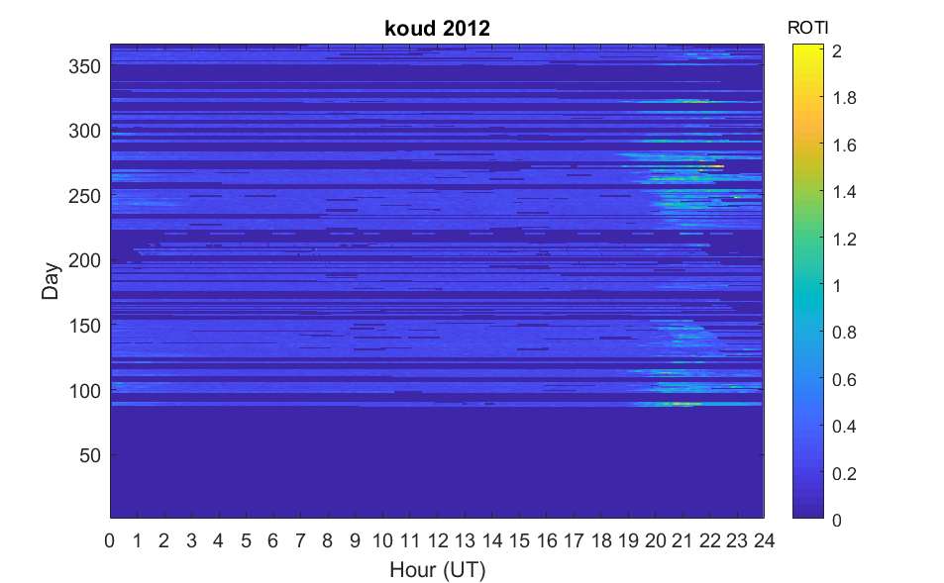 | 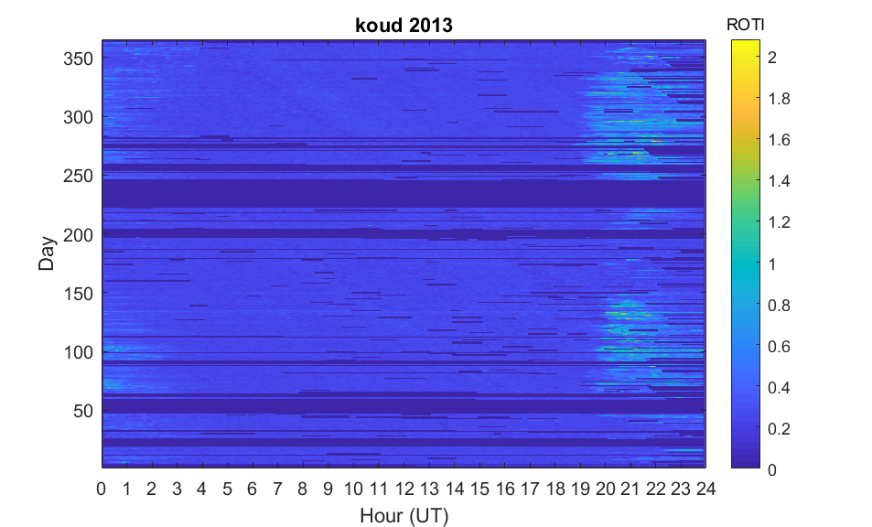
a | b
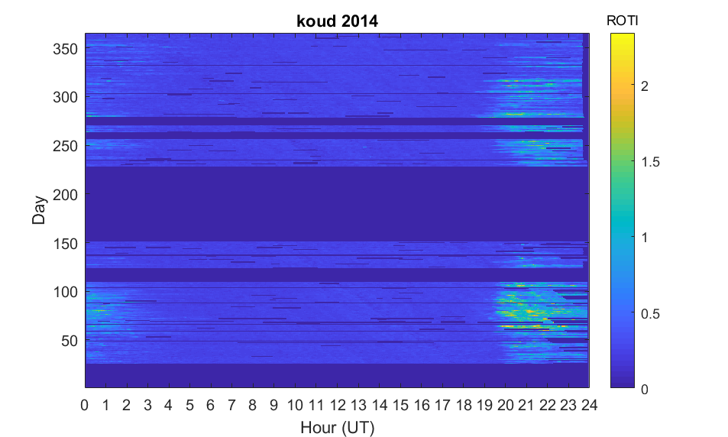 | 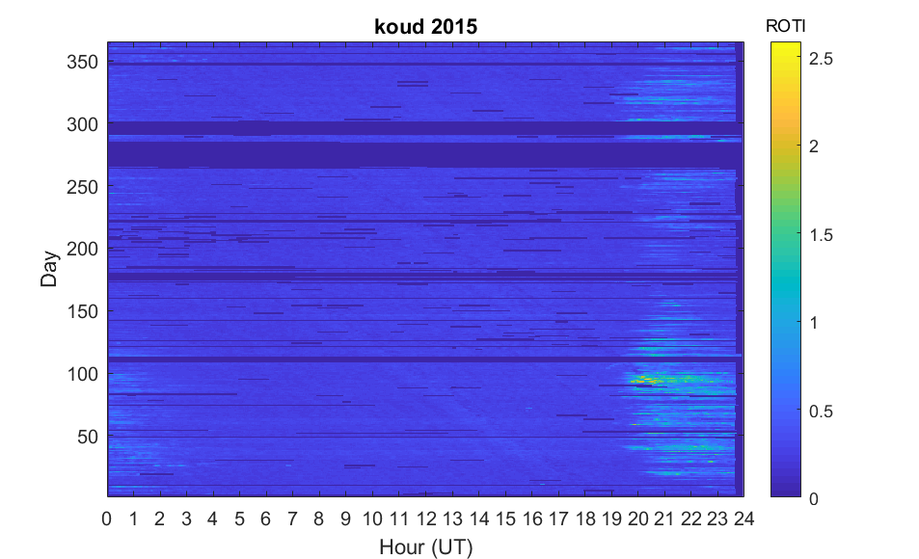
c | d
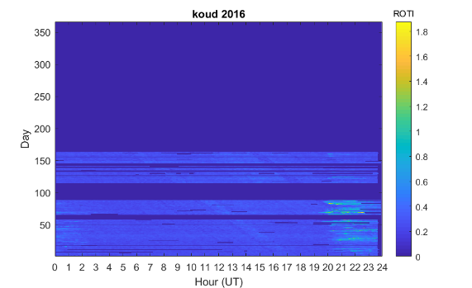
e
Figure1 : Variations in the ROTI index obtained from the Koudougou GPS station from 2012 to 2016
In Figure1 and Figure 2 , low ROTI values are generally observed from 0200 UT to 1930 UT in all years, with ROTI values ranging from 0 to $0,4 TECU/mn$ and are shown in light blue. The time interval during which the low values of the ROTI index are recorded can vary; it can start early (before 0200 UT) and end early (before 1930 UT) or late (after 1930 UT). These low ROTI values were observed on all days from 2012 to 2019. The general observation is an absence of phase scintillations on all days from 0200 UT to 19:30 from 2012 to 2016
The maximum values of the ROTI index are recorded after sunset and are represented by the dark orange and yellow bands. These maximum ROTI values are greater than or equal to $0,5 TECU/mn$, synonymous with the presence of phase scintillation. They generally range from 0.5 to $1.8 TECU/mn$, with maximum values sometimes reaching $2,5 TECU/mn$ . Strong phase scintillations are generally observed during the time intervals between the ^{60th} and ^{150th} day of the year corresponding to the spring equinox (March, April and May) and the ^{244th} to ^{334th} day of the year corresponding to the autumn equinox (September, October and November). These strong scintillations occur between 0000 UT and 0200 UT and from 1930 UT to 2300 UT. This shows that phase scintillation is a night-time phenomenon and occurs preferentially during the equinoxes. The observations also show that the beginning of January is marked by an absence of phase scintillations (in 2012 and 2014) and by the presence of weak phase scintillations (in 2013 and 2016). Generally speaking, equatorial ionospheric scintillations resulting from phase fluctuations in GPS signals occur mainly at night (0000 UT to 0200 UT and from 1930 UT to 2300 UT).
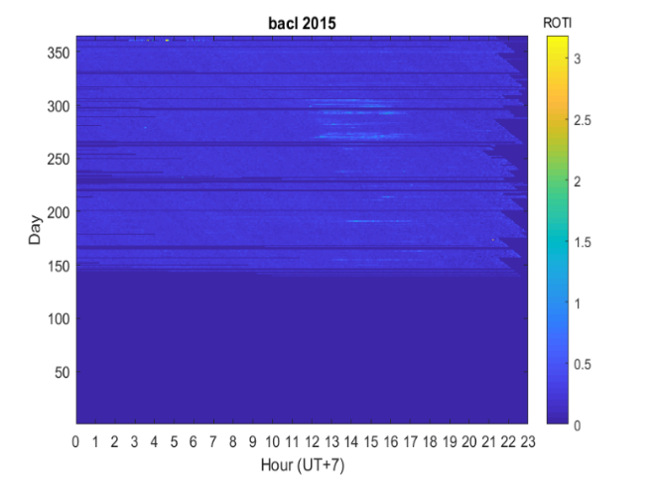 | 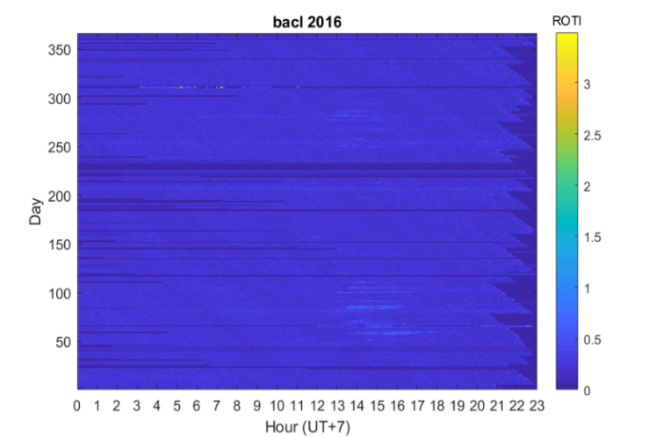
a | b
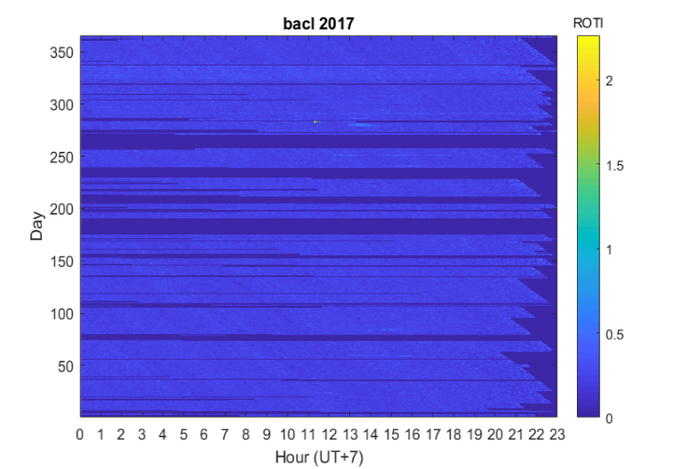 | 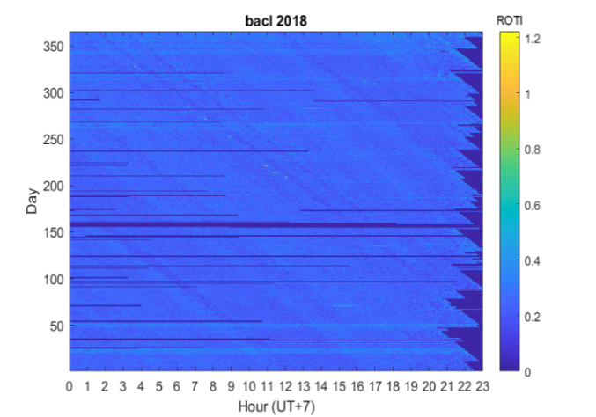
c | d
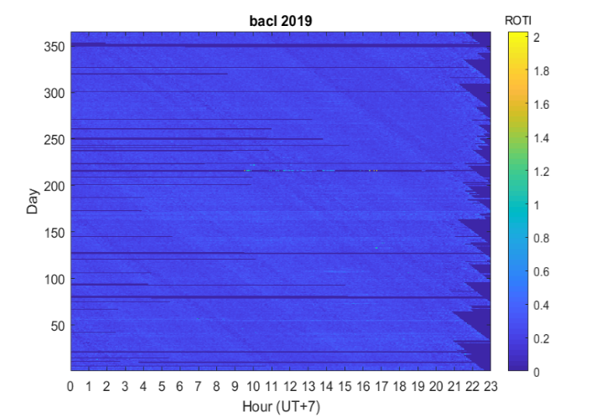
e
Figure2 : Changes in the ROTI index obtained from the Bac Lieu GPS station from 2015 to 2019

Discussion
An analysis of scintillations from 2012 to 2019 shows that:
- The high ROTI values ($ROTI ≥0,5 TECU/mn$ ) are recorded before sunrise (0000 UT to 0200 UT) and after sunset (19:30 UT to 23:00 UT), indicating the presence of strong phase scintillations, and that this is a nocturnal phenomenon. These results are in agreement with those found by a number of researchers, including Ackah et al (2011) ; Kahindo et al.³¹ ); Akala et al. (^{32,33} in the African equatorial ionosphere region. Studies by Lassudrie-Ducchesne et al.³⁴ ; Olwendo et al.³⁵ , Amabayo et al.³⁶ . According to Balan et al.³⁷ ; Amaechi et al.³⁸ ; the ionosphere has a regular distribution of ionisation density during the day but after sunset, plasma irregularities of various sizes ranging from centimetres to hundreds of kilometres can be generated in the ionosphere. Ionospheric scintillations are driven by ionospheric irregularities Spogli et al.³⁹ . The same approach was taken by Ackah et al (2011), who showed that ionospheric scintillation phenomena are caused by irregularities in the electron density inside plasma bubbles. The Rayleigh-Taylor instability mechanism is the main cause of ionisation irregularities in the ionosphere that develop after sunset in the equatorial region.^{40–42}
- The strongest scintillations are observed during the two equinoxes (spring and autumn) and that the strongest ionospheric scintillations are recorded during the spring equinox. Previous studies have also shown that strong ionospheric scintillations occur at the equinoxes, but with a maximum at the spring equinox in African sectors and in the equatorial ionosphere. According to Kahindo et al. ³¹ , Akala et al⁴³ plasma bubbles occur at higher rates at the spring equinox than at the autumn equinox. This could explain the fact that strong ionospheric scintillations are recorded at the spring equinox at our study station, since plasma bubbles are responsible for ionospheric scintillations. During this time of year, the ionosphere is strongly disturbed, causing large fluctuations in the amplitude and phase of GPS signals received⁴⁴ . According to Tsunoda⁴⁵ , when the alignment of the solar terminator with the geomagnetic meridian is close, ionospheric scintillations are most likely to occur during these times of the year. And it is during the equinoxes that the angle between the geomagnetic declination and the azimuth of the day-night solar terminator approaches zero. This is because the solar terminator is a moving boundary between the regions on the day side and the regions on the night side. It is an additional source of ionospheric irregularities.
- ROTI peaks are generally observed at 2100 TL in both Koudougou (2.5 TECU/mn) and Bac Lieu (1.5 TECU/mn) (corresponding to TU+7). The higher ROTI values at Koudougou (magnetic inclination $I=-1.8$°) could be explained by the fact that, compared with Bac Lieu (magnetic inclination $I = 2.56°$), Koudougou is closer to the magnetic equator. This is explained by the equatorial fountain phenomenon, which generates a high gradient of electron density away from the equator (Kelley, 1989)⁴⁶.

Conclusion
Strong equatorial ionospheric scintillations occur mainly before sunrise between 0000 TL and 0200 TL and after sunset between 1930 TL and 2300TL with ROTI values greater than or equal to$0,5 TECU/mn$ ($ROTI ≥0,5 TECU/mn$ ). Equatorial ionospheric scintillations are nocturnal phenomena. They are caused by ionospheric irregularities in general and by irregularities in the electron density inside equatorial plasma bubbles in particular. In the equatorial region, it is accepted that the Rayleigh-Taylor instability mechanism is the main cause of the ionisation irregularities that develop after sunset. In addition, the strongest scintillations are observed during the equinoxes (spring and autumn) and the strongest at the spring equinox. The presence of strong ionospheric scintillations at the equinoxes is justified by the fact that the solar terminator is closest to the magnetic equator during this period of the year, providing an additional source of ionospheric irregularities.

Disclaimer (Artificial intelligence)
Authors hereby declare that NO generative AI technologies such as Large Language Models (ChatGPT, COPILOT, etc.) and text-to-image generators have been used during the writing or editing of this manuscript.

References
(1) Hank, F.; Kara, M. Z. E. Identification de l’instabilité Du Tec Dans Un Réseau de Stations GPS., Université de Jijel, 2013.
(2) Ciraolo, L. Evaluation of GPS L2-L1 Biases and Related Daily TEC Profiles. In Proceedings of the GPS/ionosphere workshop, Neustrelitz; 1993; pp 90–97.
(3) Kersley, L.; Pryse, S. E.; Lunt, N.; Jones, D. G.; Walker, I. K.; PHYSICS, U. C. O. W. A. D. O. TEC Measurements for GPS Comparisons and Ionospheric Tomography; University College of Wales, Department of Physics, 1999.
(4) Balan, N.; Otsuka, Y.; Tsugawa, T.; Miyazaki, S.; Ogawa, T.; Shiokawa, K. Plasmaspheric Electron Content in the GPS Ray Paths over Japan under Magnetically Quiet Conditions at High Solar Activity. Earth Planets Space 2002, 54, 71–79.
(5) Chen, P.; Yao, Y. Research on Global Plasmaspheric Electron Content by Using LEO Occultation and GPS Data. Adv. Space Res. 2015, 55 (9), 2248–2255.
(6) Aarons, J.; Mendillo, M.; Yantosca, R.; Kudeki, E. GPS Phase Fluctuations in the Equatorial Region during the MISETA 1994 Campaign. J. Geophys. Res. Space Phys. 1996, 101 (A12), 26851–26862.
(7) Pi, X.; Mannucci, A. J.; Lindqwister, U. J.; Ho, C. M. Monitoring of Global Ionospheric Irregularities Using the Worldwide GPS Network. Geophys. Res. Lett. 1997, 24 (18), 2283–2286.
(8) Ma, G.; Maruyama, T. Derivation of TEC and Estimation of Instrumental Biases from GEONET in Japan. In Annales Geophysicae; Copernicus Publications Göttingen, Germany, 2003; Vol. 21, pp 2083–2093.
(9) Leitinger, R.; Ciraolo, L.; Kersley, L.; Kouris, S. S.; Spalla, P. Relations between Electron Contentand Peak Density: Regular and Extreme Behaviour. Ann. Geophys. 2004.
(10) Nishioka, M.; Saito, A.; Tsugawa, T. Occurrence Characteristics of Plasma Bubble Derived from Global Ground‐based GPS Receiver Networks. J. Geophys. Res. Space Phys. 2008, 113 (A5).
(11) Cairns, I. H.; Kozarev, K. A.; Nitta, N. V.; Agueda, N.; Markus, B.; Carley, E. P.; Dresing, N.; Gómez-Herrero, R.; Klein, K.-L.; Lario, D.; Pomoell, J.; Salas-Matamoros, C.; Veronig, A. M.; Li, B.; McCauley, P. Comprehensive Characterization of Solar Eruptions with Remote and In-Situ Observations, and Modeling: The Major Solar Events on 4 November 2015. Springer 2020, 295 (2), 1–48.
(12) Arenas, J.; Sardón, E.; Sainz, A.; Ochoa, B.; Magdaleno, S. Low-Latitude Ionospheric Effects on SBAS. Radio Sci. 2016, 51 (6), 603–618.
(13) Spogli, L.; Cesaroni, C.; Di Mauro, D.; Pezzopane, M.; Alfonsi, L.; Musicò, E.; Povero, G.; Pini, M.; Dovis, F.; Romero, R. Formation of Ionospheric Irregularities over Southeast Asia during the 2015 St. Patrick’s Day Storm. J. Geophys. Res. Space Phys. 2016, 121 (12), 12,211-12,233.
(14) Carter, B. A.; Pradipta, R.; Dao, T.; Currie, J. L.; Choy, S.; Wilkinson, P.; Maher, P.; Marshall, R.; Harima, K.; Le Huy, M. The Ionospheric Effects of the 2022 Hunga Tonga Volcano Eruption and the Associated Impacts on GPS Precise Point Positioning across the Australian Region. Space Weather 2023, 21 (5), e2023SW003476.
(15) Hoang, H. M.; Dao, C. X.; Huy Ngo, H.; Okamoto, T.; Matsubara, C.; Do, S. N.; Bui, G. T.-H.; Bui, H. Q.; Duong, N. T.; Nguyen, N. T. Efficacy of Compliance with Ventilator-Associated Pneumonia Care Bundle: A 24-Month Longitudinal Study at Bach Mai Hospital, Vietnam. SAGE Open Med. 2024, 12, 20503121231223467.
(16) Ouattara, F.; Zoundi, C.; Mazaudier, C. A.; Fleury, R.; Duchesne, P. L. Détermination du contenu électronique total à partir des pseudo distances (Pd) ou pseudo range (Pr) a la station de Koudougou au Burkina Faso. 2011.
(17) Zoundi, C.; Bazi, N.; Kabor, Mb.; Ouattara, F. Total Electron Content (TEC) Seasonal Variability under Fluctuating Activity, from 2000 to 2002, at Niamey Station. Int. J. Phys. Sci. 2021, 16 (4), 138–145.
(18) Verkhoglyadova, O. P.; Tsurutani, B. T.; Mannucci, A. J.; Mlynczak, M. G.; Hunt, L. A.; Paxton, L. J. Ionospheric TEC, Thermospheric Cooling and Σ [O/N2] Compositional Changes during the 6–17 March 2012 Magnetic Storm Interval (CAWSES II). J. Atmospheric Sol.-Terr. Phys. 2014, 115, 41–51.
(19) Akhoondzadeh, M. Support Vector Machines for TEC Seismo-Ionospheric Anomalies Detection; Copernicus GmbH, 2013; Vol. 31, pp 173–186.
(20) Bolzan, M.; Tardelli, A.; Pillat, V.; Fagundes, P.; Rosa, R. Multifractal Analysis of Vertical Total Electron Content (VTEC) at Equatorial Region and Low Latitude, during Low Solar Activity; Copernicus GmbH, 2013; Vol. 31, pp 127–133.
(21) Appleton, E. V. The Anomalous Equatorial Belt in the F2-Layer. J. Atmospheric Terr. Phys. 1954, 5 (1–6), 348–351.
(22) Martyn, D. F. Atmospheric Tides in the Ionosphere-I. Solar Tides in the F 2 Region. Proc. R. Soc. Lond. Ser. Math. Phys. Sci. 1947, 189 (1017), 241–260.
(23) Hofmann-Wellenhof, B.; Lichtenegger, H.; Collins, J. Global Positioning System: Theory and Practice. It Springer-Verlag. N. Y. 1992, 327.
(24) Fedrizzi, M.; de Paula, E. R.; Kantor, I. J.; Langley, R. B.; Santos, M. C.; Komjathy, A. Mapping the Low-Latitude Ionosphere with GPS. GPS WORLD 2002, 13 (2), 41–47.
(25) Langley, R. S. The Response of Two-Dimensional Periodic Structures to Point Harmonic Forcing. J. Sound Vib. 1996, 197 (4), 447–469.
(26) Rao, P. R.; Venkatesh, K.; Prasad, D.; Niranjan, K. On the Uncertainties in the Measurement of Absolute (True) TEC over Indian Equatorial and Low Latitude Sectors. Adv. Space Res. 2013, 51 (7), 1238–1252.
(27) Chowdhary, V. R.; Tripathi, N. K.; Arunpold, S.; Raju, D. K. Variations of Total Electron Content in the Equatorial Anomaly Region in Thailand. Adv. Space Res. 2015, 55 (1), 231–242.
(28) Kersley, L.; Malan, D.; Pryse, S. E.; Cander, L. R.; Bamford, R. A.; Belehaki, A.; Leitinger, R.; Radicella, S. M.; Mitchell, C. N.; Spencer, P. S. Total Electron Content-A Key Parameterin Propagation: Measurement and Usein Ionospheric Imaging. Ann. Geophys. 2004.
(29) Basu, S.; Taylor, A. M. Business Cycles in International Historical Perspective. J. Econ. Perspect. 1999, 13 (2), 45–68.
(30) Ma, G.; Maruyama, T. A Super Bubble Detected by Dense GPS Network at East Asian Longitudes. Geophys. Res. Lett. 2006, 33 (21).
(31) Kahindo, B.; Bantu, A. K. M.; Fleury, R.; Keto, F. T.; Ndontoni, A. Z.; Kaniki, M. K.; Amory-Mazaudier, C.; Groves, K. Contribution à l’étude de La Scintillation Ionosphérique Équatoriale Sur La Crête Sud de l’Afrique. J. Sci. 2017, 17 (2), 27–47.
(32) Akala, A. O.; Somoye, E. O.; Adewale, A. O.; Ojutalayo, E. W.; Karia, S. P.; Idolor, R. O.; Okoh, D.; Doherty, P. H. Comparison of GPS-TEC Observations over Addis Ababa with IRI-2012 Model Predictions during 2010–2013. Adv. Space Res. 2015, 56 (8), 1686–1698.
(33) Akala, A. O.; Ejalonibu, A. H.; Doherty, P. H.; Radicella, S. M.; Groves, K. M.; Carrano, C. S.; Bridgwood, C. T.; Stoneback, R. A. Characterization of GNSS Amplitude Scintillations over Addis Ababa during 2009–2013. Adv. Space Res. 2017, 59 (8), 1969–1983.
(34) Duchesne, P. L.; Béniguel, Y.; Bourdillon, A.; Fleury, R.; Valette, J.-J.; Le Huy, M.; Thi, L. T. Les Effets de La Scintillation Ionosphérique Sur Le GPS. Navigation 2010, 58 (231), 17–34.
(35) Olwendo, O. J.; Yamazaki, Y.; Cilliers, P. J.; Baki, P.; Doherty, P. A Study on the Variability of Ionospheric Total Electron Content over the East African Low‐latitude Region and Storm Time Ionospheric Variations. Radio Sci. 2016, 51 (9), 1503–1518.
(36) Amabayo, E. B.; Edward, J.; Cilliers, P. J.; Habarulema, J. B. Climatology of Ionospheric Scintillations and TEC Trend over the Ugandan Region. Adv. Space Res. 2014, 53 (5), 734–743.
(37) Balan, N.; Liu, L.; Le, H. A Brief Review of Equatorial Ionization Anomaly and Ionospheric Irregularities. Earth Planet. Phys. 2018, 2 (4), 257–275.
(38) Amaechi, P. O.; Oyeyemi, E. O.; Akala, A. O.; Amory‐Mazaudier, C. Geomagnetic Activity Control of Irregularities Occurrences over the Crests of the African EIA. Earth Space Sci. 2020, 7 (7), e2020EA001183.
(39) Spogli, L.; Alfonsi, L.; Cilliers, P. J.; Correia, E.; De Franceschi, G.; Mitchell, C. N.; Romano, V.; Kinrade, J.; Cabrera, M. A. GPS Scintillations and Total Electron Content Climatology in the Southern Low, Middle and High Latitude Regions. Ann. Geophys. 2013.
(40) Sultan, P. J. Linear Theory and Modeling of the Rayleigh‐Taylor Instability Leading to the Occurrence of Equatorial Spread F. J. Geophys. Res. Space Phys. 1996, 101 (A12), 26875–26891.
(41) Fejer, B. G.; Scherliess, L.; De Paula, E. R. Effects of the Vertical Plasma Drift Velocity on the Generation and Evolution of Equatorial Spread F. J. Geophys. Res. Space Phys. 1999, 104 (A9), 19859–19869.
(42) Prikryl, P.; Jayachandran, P. T.; Mushini, S. C.; Pokhotelov, D.; MacDougall, J. W.; Donovan, E.; Spanswick, E.; St. -Maurice, J.-P. GPS TEC, Scintillation and Cycle Slips Observed at High Latitudes during Solar Minimum. In Annales Geophysicae; Copernicus Publications Göttingen, Germany, 2010; Vol. 28, pp 1307–1316.
(43) Akala, A. O.; Oyeyemi, E. O.; Amaechi, P. O.; Radicella, S. M.; Nava, B.; Amory‐Mazaudier, C. Longitudinal Responses of the Equatorial/Low‐latitude Ionosphere over the Oceanic Regions to Geomagnetic Storms of May and September 2017. J. Geophys. Res. Space Phys. 2020, 125 (8), e2020JA027963.
(44) Povero, G.; Alfonsi, L.; Spogli, L.; Di Mauro, D.; Cesaroni, C.; Dovis, F.; Romero, R.; Abadi, P.; Le Huy, M.; La The, V. Ionosphere Monitoring in South East Asia in the ERICA Study. Navig. J. Inst. Navig. 2017, 64 (2), 273–287.
(45) Tsunoda, R. T. Control of the Seasonal and Longitudinal Occurrence of Equatorial Scintillations by the Longitudinal Gradient in Integrated E Region Pedersen Conductivity. J. Geophys. Res. Space Phys. 1985, 90 (A1), 447–456.
(46) Kelley, M. C, The Earth’s Ionosphere, Plasma Physics and electrodynamics, Second Edition, 2009.

