Original Research Article

PREVALENCE OF SOME GASTROINTESTINAL NEMATODES IN CATTLE SLAUGHTERED IN JALINGO ABATTOIR, TARABA STATE, NIGERIA

ABSTRACT
Gastrointestinal nematodes are a group of parasitic worms that can infect the gastrointestinal tract of various animal species, including humans. Gastrointestinal nematodes have serious consequences on the agricultural and food industries. The study aimed to determine the prevalence of gastrointestinal nematode burden in Jalingo abattoir. Faecal samples from slaughtered cattle in the Jalingo abattoir for this study were collected systematically and at random from cattle slaughtered at the abattoir between August 2022 and September 2022. Standard parasitological methods were used to analyse the samples for the presence of gastrointestinal nematodes and quantify their numbers. The study found that among the 385 sampled cattle, gastrointestinal nematode infections accounted for 30.1%. Trichostrongylus species, Strongyloides species, and Toxocara vitulorum were the nematodes identified. Seventy-five of them were Trichostrongylus species (19.5%), 31 were Strongyloides species (8.1%) and 10 were Toxocara vitulorum (2.6%). The infection rate was higher in cows (21.6%) than in (8.6%) in bulls. There was statistical significant association between age of the cattle and the prevalence of gastrointestinal nematodes, with an increased prevalence in older cattle (20%) compared to younger ones (10.0%). The infection rate did not differ significantly based on the breed of cattle, the animal's body condition score, or the sex of the slaughtered cattle. These results highlight the presence of gastrointestinal nematode burden on cattle and the need for continuous monitoring and management techniques to reduce the negative effects of gastrointestinal nematode infections on livestock populations in the research area.
Keywords: Bovine; Gastrointestinal; Nematodes; Parasites; Prevalence

1.0 INTRODUCTION
The gastrointestinal tract is one of the organ systems that can become infected by a variety of pathogenic organisms, and it is particularly susceptible to parasite infection that feed on nutrients and leaves the body vulnerable to secondary infections (Sufian et al. 2022). Parasites, and particularly gastrointestinal parasites that infect ruminants and reduce their productivity (Adedipe et al. 2014; Obi et al. 2020), are a major veterinary and public health concern worldwide (Abubakar et al. 2020; Mansur et al. 2020).
Gastrointestinal parasites affect cattle in different regions in Nigeria (Adedipe et al. 2014; Obi et al. 2020). It would be impossible to overestimate the importance of the cattle industry in Nigeria, which supplies critical sources of animal protein, raw materials, cash, farm power, jobs, and organic waste (Umar et al. 2021). The livestock industry in Nigeria accounts for 5.2% of Gross Domestic Product (GDP), with cattle being the most frequent livestock (Lawal-Adebowale, 2012; Adedipe et al. 2014). The cattle population is put at over 19 million, and they account for half of the country's entire meat production. They are concentrated in the Northern region of Nigeria (Lawal-Adebowale, 2012; Adedipe et al. 2014).
Mortality and diseases, which lead to lower productivity and higher treatment costs, are major contributors to the fact that livestock in Nigeria produce significantly less meat and income than is needed to meet national demands (Bolajoko et al. 2011). Other losses include a decline in the quantity and quality of protein produced via milk, meat, dairy products, wool, and hide and skin damage. According to Ademola and Eloff (2010), gastrointestinal helminths are widely present in Nigeria and are known to affect ruminants, which are significant sources of revenue.
Abattoirs serve as tools for ensuring the quality of animal products and meat, as well as for supplying livestock-related industries with slaughterhouse byproducts. More significantly, abattoirs are used to monitor diseases that are transmitted by animals and zoonotic pathogens. It is impossible to overstate the value of abattoir information in analyzing prevalence rates and developing control strategies for animal diseases (Awah-Ndukum et al. 2010).
Understanding the prevalence and diversity of gastrointestinal parasites is crucial for implementing appropriate control strategies. This study aimed to determine the prevalence and potential animal health implications of gastrointestinal parasitic infections in cattle slaughtered at Jalingo abattoir, Taraba State, Nigeria.
2.0 MATERIALS AND METHODS
2.1 Study location:
The research was carried out in Jalingo, the capital of Taraba State. Jalingo is located at Latitude: 8° 53' 37.21" N and Longitude: 11° 21' 34.56" E. The year is divided into two seasons: dry and rainy. The months of November through March make up the dry season, whereas the months of April through October make up the wet season. Approximately 1,350 millimeters of precipitation fall each year on average. Jalingo is located on the savanna-covered slopes of the Shebshi Mountains, some 40 kilometers southeast of the Benue River. Lau Local Government Area (LGA) forms its northern border, Yorro LGA forms its eastern border, and Ardo-Kola LGA forms its southern and western borders. Jalingo has a total land area of about 195 km² (Taraba State Government, 2022).
2.2 Study population:
The study population was cattle slaughtered at Jalingo abattoir.
2.3 Study design:
A cross-sectional study was carried out on the slaughtered cattle at Jalingo abattoir in Jalingo, Taraba State, Nigeria, between August and September 2022.
2.4 Sample size and sampling:
With a 95% level of confidence, a prevalence of 50.68% (Karshima and Adeyeye, 2010), and a desired absolute precision of 5%, the minimum sample size (n) needed was calculated in accordance with Thrusfield's (2007) methodology.
n = Z² p (1-p)/d² = 385 cattle.
A systematic random sampling technique was used for cattle selection. 45–55 cattle were slaughtered daily in the Jalingo abattoir. Based on the calculated sampling interval of five, every fifth cattle slaughtered during the study period was sampled.
2.5 Sample Collection:
Data of the sampled cattle such as sex and breed were determined and documented as described by Nwankwo et al. (2019). Aging of the cattle was termed young or adult, this was performed at the abattoir after the animal had been slaughtered, utilising the time of appearance as well as the degree of wear on both the temporary and permanent teeth as described by Ron et al. (2003). According to prior descriptions by Adedipe et al. (2014), the body condition was rated as lean, moderate, and good.
The faecal samples were collected directly from the rectum of the slaughtered cattle and placed in appropriately labeled, sterile universal bottle, and were transported in a flask with ice packs to the Parasitology laboratory, Federal Medical Centre Jalingo, where the faeceal samples were processed and examined immediately.

2.6 Parasitological procedure:
The parasitological screening was carried out using flotation techniques to identify the eggs of the nematodes in accordance with the standard procedures described by Krishi (2015).
2.7 Statistical Analysis:
Statistical Package for the Social Sciences (SPSS) Version 25 (IBM Statistics) was used to perform descriptive and inferential statistics. The data obtained were presented using frequency and percentage. The prevalence of gastrointestinal nematodes was calculated by comparing the percentage of slaughtered cattle with gastrointestinal nematodes found during postmortem examination to the total number of cattle slaughtered during the time periods under consideration. Chi-square test at the 95% level of significance was used to determine the associations of breed, age, sex and body condition score of the slaughtered cattle with the prevalence of gastrointestinal nematodes in cattle inspected during the abattoir survey and a value of p<0.05 were considered statistically significant.
3.0 RESULTS
3.1 Result Presentation
Out of the 385 cattle sampled, 116 (30.1%) cattle were positive for one or more gastrointestinal nematodes. The nematodes parasites identified were Trichostrongylus spp., Strongyloides spp., and Toxocara vitulorum. Out of these Trichostrongylus spp. were prevalent 75 (19.5%), while Strongyloides spp 31 (8.1%) followed by Toxocara vitulorum 10 (2.6%) as seen in (Table 1) and (Figure 1, 2 & 3).
Out of the 385 cattle sampled during the study period, 299 of adult cattle had gastrointestinal nematodes infection rate of 77 (20%), while 86 were young cattle with infection rate of 39 (10.1%), and age of the cattle was statistical significantly associated with the incidence of gastrointestinal nematodes. The prevalence of gastrointestinal nematodes based on sex of the cattle revealed that female cattle 83 (21.6%) were more infected with the gastrointestinal nematodes than bulls 33 (8.6%) as seen in (Table 1).
In the study, White Fulani cattle breed were more infected with gastrointestinal nematodes 75 (19.5%) than rest of the cattle breed that had 5.5%, 2.3%, and 2.9% for Red Bororo, Adamawa Gudali, and Sokoto Gudali cattle breeds respectively. Cattle with good body condition score (109) had gastrointestinal nematodes infection prevalence of 33 (8.6%), while cattle with Moderate body condition score (197) had a higher prevalence 55 (14.3%), and cattle with Lean body condition score had a gastrointestinal nematodes infection of 28 (7.3%). There was no statistical significance between gastrointestinal nematodes infection and the sampled cattle variables such as the sex, breed, and body condition score of the cattle (Table 1).
Table 1: Prevalence of Gastrointestinal Nematodes encountered at Jalingo Abattoir, Taraba State, Nigeria
Variables | No. of Cattle Examined | No. of Cattle with Trichostrongylus spp (%) | No. of Cattle with Strongyloides spp (%) | No. of Cattle with Toxocara vitulorum (%) | Chi-square (ᵡ²) | p– valve
Age |  |  |  |  | 12.183 | 0.000
Young | 86 | 22 (25.6) | 8 (9.3) | 9 (10.5)
Adult | 299 | 53 (17.7) | 23 (7.7) | 1 (0.3)
Sex |  |  |  |  | 0.070 | 0.792
Male | 106 | 17 (16.0) | 10 (9.4) | 6 (5.7)
Female | 279 | 58(20.8) | 21 (7.5) | 4 (1.4)
Breed |  |  |  |  | 1.658 | 0.646
White Fulani | 234 | 48 (20.5) | 20 (8.5) | 7 (2.9)
Red Borroro | 71 | 14 (19.7) | 5 (7.0) | 2 (2.8)
Adamawa Gudali | 40 | 6 (15) | 2 (5.0) | 1 (2.5)
Sokoto  Gudali | 40 | 7 (17.5) | 4 (10.0) | 0 (0)
Body Condition Score |  |  |  |  | 1.518 | 0.468
Good | 109 | 24 (22.0) | 8 (7.3) | 1 (0.9)
Moderate | 197 | 35 (17.8) | 16 (8.1) | 4 (2.0)
Lean | 79 | 16 (20.3) | 7 (8.9) | 5 (6.3)

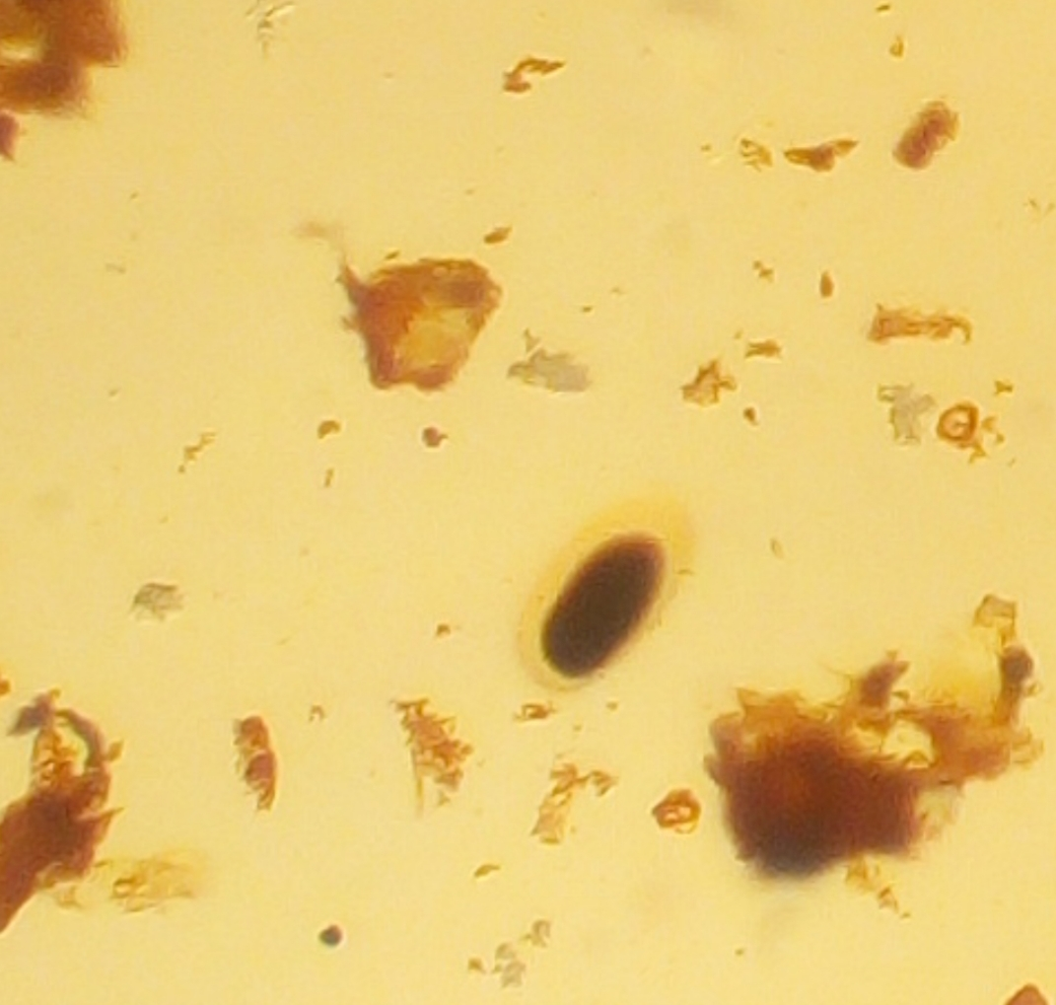
Figure 1: Trichostrongylus egg (Black arrow)
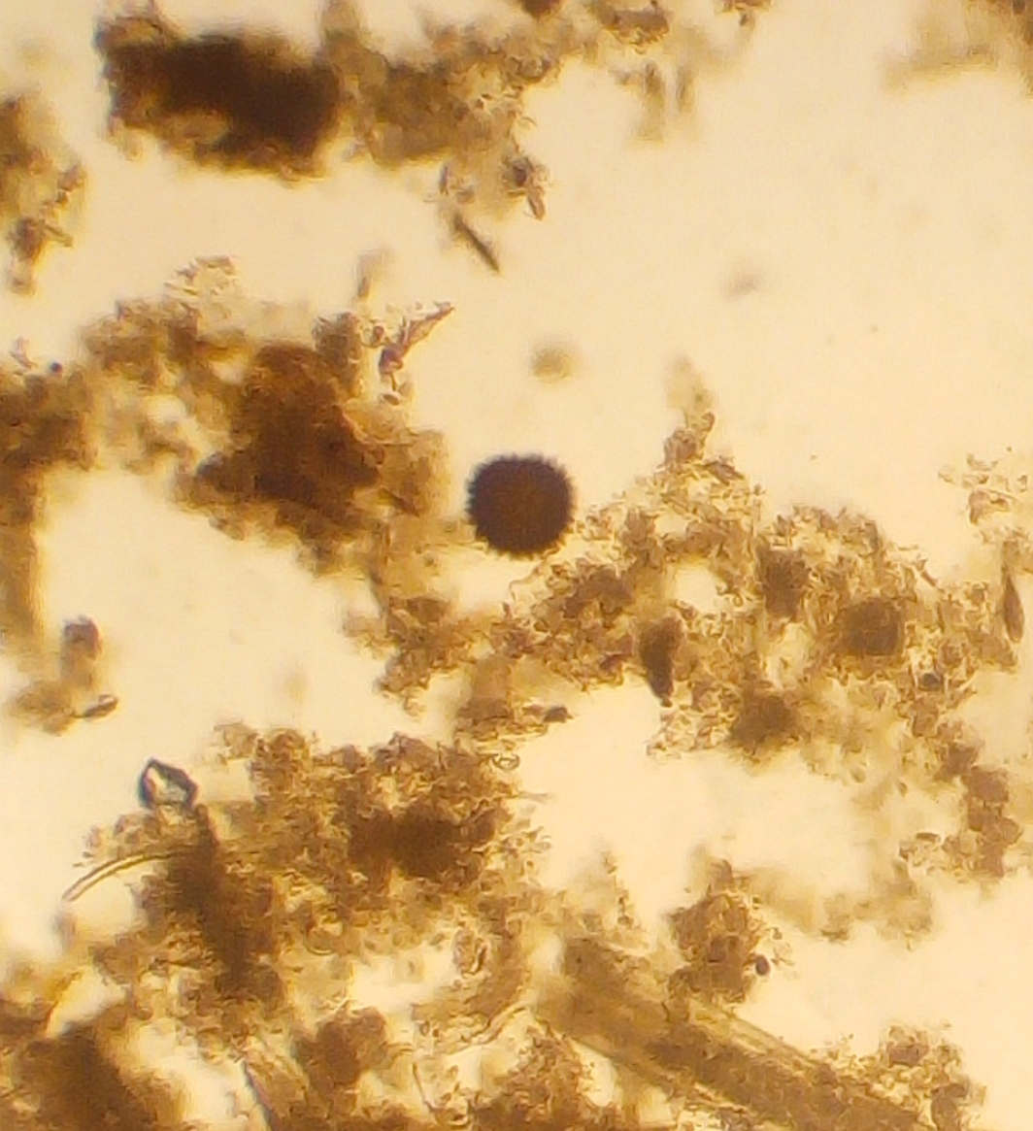
Figure 2: Toxocara vitulorum egg (Black arrow)

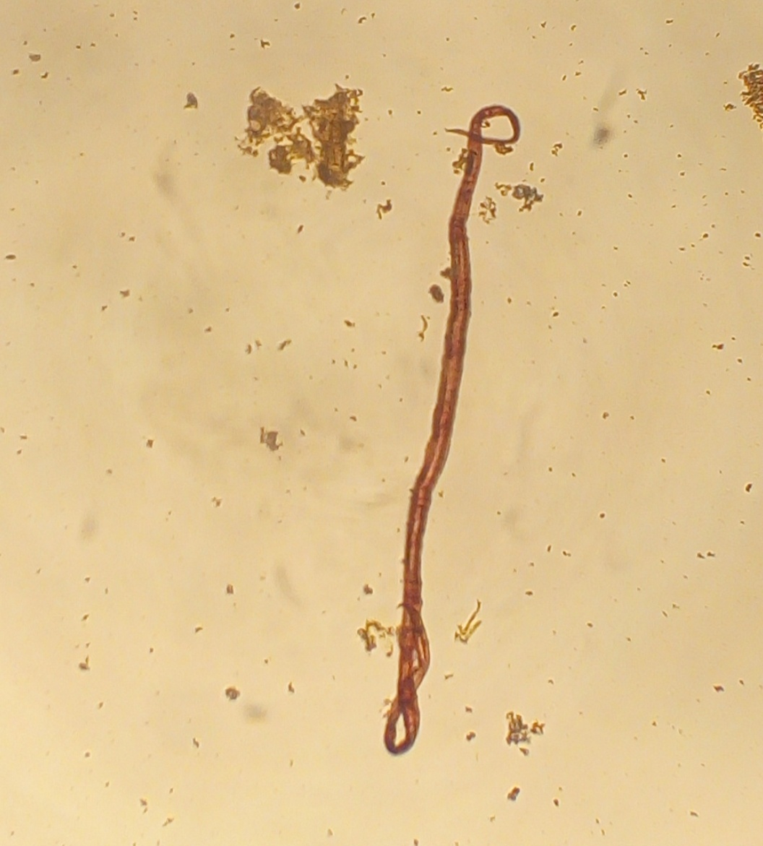
Figure 3: Strongyloides worm (Black arrow)
3.2 Discussion
Livestock production suffers greatly when animals are infected with gastrointestinal nematodes (Nwosu et al. 2007; Ekong et al. 2012).
The current study provides useful information on the burden of gastrointestinal nematodes among cattle in Jalingo, Taraba State, showing that 30.1% of the cattle sampled were afflicted with one or more gastrointestinal nematodes. Trichostrongylus spp. was found to have a prevalence of 19.5%, followed by Strongyloides spp. at 8.1% and Toxocara vitulorum at 2.6%, according to the current study's findings on gastrointestinal nematodes.
Because of their resistance to seasonal changes, Trichostrongylus spp. is able to persist and reinfect throughout the year (Silva et al. 2012). Larvae of Trichostrongylus spp. like humid and warm conditions. They thrive in hot, humid climates and tend to flourish in certain areas. These parasites are more common in the tropics and subtropics, which explains why these diseases are more common there.
The findings demonstrate that cattle in the Jalingo Metropolitan Area of Taraba State, Northeastern Nigeria, are susceptible to gastrointestinal nematodes. This study found a higher prevalence of gastrointestinal nematodes in cattle at the Jalingo abattoir (30.1%), this finding in this current study is shown to be higher than the prevalence of 17.5% gastrointestinal nematodes in cattle which was reported by Abubakar et al. (2022) in the Bogoro Local Government Area of Bauchi State. While 62.1% of cattle in Minna, Niger State, were infected with gastrointestinal nematodes was reported by Eke et al. (2021) who found a higher prevalence in their study. Umar et al. (2021) found that 56.5% of cattle slaughtered in the Azare Katagum LGA of Bauchi State, Nigeria, had gastrointestinal nematodes. Biu Local Government Area of Borno State also has a higher frequency of gastrointestinal nematodes (66.1%), as reported by Usman et al. 2023.
Gastrointestinal nematodes are common due to the fact that their life cycles often consist of multiple phases but only a few of them require an intermediate host. Hence, nematodes can infect at any time of the year, since they have free-living stages, they can survive on pasture all year. Our results may differ from those reported elsewhere due to differences in sample size, sample selection, cattle breed(s), climatic conditions, management practices, cattle grazing habits, farmer education level, availability of intermediate hosts, and study period (Ola-Fadunsin et al. 2020; Umar et al. 2021).
The prevalence of gastrointestinal nematodes was found to be greater in mature cattle compared to younger ones; this association was also statistically significant. Previous research by Usman et al. (2023), Eke et al. (2021), and Yuguda et al. (2018) all corroborated these results. They hypothesised that because of the longer periods of exposure, the worms in adult animals might have already developed. Contrary to the results of other studies (Taswar et al. 2010; Dagnachew et al. 2011), who stated that helminthic infections in older cattle are less severe as the animals age and mature; they develop acquired immunity that helps the animals rid themselves of the parasite before parasites can establish themselves in the gastrointestinal system.
Female cattle were shown to have greater parasite infection rates than males in this investigation, agrees with the findings of Usman et al. (2023), Eke et al. (2021), and Bisimwa et al. (2018) who reported that female cattle demonstrated higher parasite infection than males despite the same management practice. Female animals may be more prone to infection than males because of biological differences between the sexes; these differences typically manifest as stress factors that lower the animals' immunity to infection (Aliyu et al. 2020). Therefore, sex is a critical element that affects parasite prevalence. Adedipe et al. (2014), however, reported that infection with gastrointestinal helminths occurs with comparable frequency in males and females. The fact that both bulls and female cattle in the typical Nigerian environment are vulnerable to helminth infections due to poor feeding and veterinary treatment is a likely explanation.
White Fulani cattle had the highest levels of parasites in their digestive systems, which corroborated the findings of Adedipe et al. (2014), who found that White Fulani were more susceptible to helminth infection than Red Bororo and Sokoto Gudali in Ibadan, South-Western Nigeria. Qadeer et al. (2015) also found a similar pattern in the northern Nigerian state of Adamawa. Research by Umar et al. (2021) in Azare, Katagum Local Government Area, Bauchi State, found the opposite; he found that, compared to White Fulani breed and Sokoto Gudali cattle breed. Red Bororo breeds had significantly higher rates of gastrointestinal helminth infection. Qadeer et al. (2015) stated that the differences in prevalence could be caused by the environmental conditions that are needed for the infectious larval stage of most helminths to live and grow, as well as the type of livestock management system the cattle are put through. But the results of this study could just as easily be explained by the fact that White Fulani cattle were the most frequently represented breed in the sample.
Moderately fat cattle were more infected with gastrointestinal nematodes than lean and well-nourished cattle. This could be because the research took place during the rainy season. Cattle typically have access to more plentiful and nutritious feed during the rainy season because of the resulting rise in plant growth. This has the potential to boost diet and stoke weight growth. More so, the cattle were not heavily burdened with nematodes in their guts.
Factors like age, breed, health, pregnancy, and previous infections may all play a role in a cattle's vulnerability to gastrointestinal parasites (Pfukenyi and Mukaratirwa, 2013). However, sex, breed, and body condition score of the cattle were not statistically associated with the prevalence of gastrointestinal nematodes in this study; only age of the cattle was statistically associated with the occurrence of gastrointestinal nematodes.
Cattle in Nigeria, as well as in other areas of the world (Telila et al. 2014; Bisimwa et al. 2018), are very susceptible to nematode infection (Nnabuife et al. 2013; Ola-Fadunsin et al. 2020; Umar et al. 2021). Reduced meat, milk, hide products, wool, and stamina of working animals all result from high nematode infection, which in turn reduces production potentials like slow growth rate, weight loss and emaciation in young growing calves, and late maturity (Swai et al. 2006; Ola-Fadunsin et al. 2020).
4.0 CONCLUSION
The study found that gastrointestinal nematodes are common and continue to be a major problem in cattle populations, especially during the wetter months of the year. This finding highlights the critical importance of implementing efficient and all-encompassing management methods to lessen the toll these parasitic diseases take on animal health in the study area. A major hazard to animal health and welfare is posed by the widespread presence of gastrointestinal nematodes, which can cause decreased meat and milk output, increased morbidity, and even death. Regular surveillance, specific treatment techniques, and stringent biosecurity measures at the farm and abattoir levels are all necessary to solve this problem comprehensively.
In order to guarantee the production of nutritious meat and to promote the welfare of the animals in the research area, it is proposed that mass administration of anthelmintic medications and education of the livestock farmers be implemented. Nematode transmission can be lowered by encouraging good animal husbandry practices such as rotational grazing and pasture management.

COMPETING INTERESTS DISCLAIMER:
Authors have declared that they have no known competing financial interests OR non-financial interests OR personal relationships that could have appeared to influence the work reported in this paper.
Ethical Considerations
There were no ethical considerations to be considered in this research.
Disclaimer (Artificial intelligence)
Author(s) hereby declare that NO generative AI technologies such as Large Language Models (ChatGPT, COPILOT, etc.) and text-to-image generators have been used during the writing or editing of this manuscript.
REFERENCE
Abubakar B.M., Wabi A.A., Gagman H.A. and Mohammed U.A. (2020). Prevalence of helminths parasites in vegetables sold in Jama’are Metropolis, Bauchi State, Nigeria. Bima Journal of Science and Technology., 3, 40-47. Retrieved from https://journals.gjbeacademia.com/index.php/bimajst/article/view/142
Abubakar B.M., Amos V., Moi I.M. and Gagman H.A. (2022). Epidemiological studies of gastrointestinal helminths affecting cattle in Bogoro Local Government Areas of Bauchi State, North-east Nigeria. Gadau Journal of Pure and Allied Sciences. 1, 115–120. https://doi.org/10.54117/gjpas.v1i2.20
Adedipe O.D., Uwalaka E.C., Akinseye V.O., Adediran O.A. and Cadmus S.I.B. (2014). Gastrointestinal Helminths in slaughtered cattle in Ibadan, South-Western Nigeria. Journal of veterinary medicine. 11, 923561. https://doi.org/10.1155/2014/923561
Ademola I.O. and Eloff J.N. (2010). In vitro anthelmintic activity of Combretummolle (R. Br. ex G. Don) (Combretaceae) against Haemonchuscontortus ova and larvae. Veterinary Parasitology. 169, 198-203. https://doi.org/10.1016/j.vetpar.2009.12.036
Aliyu A.A., Ewah F.O., Maikenti J.I., Ayuba S.O., Aimankhu O.P. and Ahmed H.O. (2020). Helminth Parasites of Goats and Sheep at Slaughter House in Lafia, Nasarawa State, Nigeria. FUDMA Journal of Sciences (FJS). 4, 34 – 40. https://doi.org/10.33003/fjs-2020-0402-154
Awah-Ndukum J., Kudi A.C., Bradley G., Ane-Anyangwe I.N., Fon-Tebug S. and Tchoumboue J. (2010). Prevalence of bovine tuberculosis in abattoirs of the littoral and Western highland regions of cameroon: a cause for public health concern. Veterinary Medicine International. 8,495015. https://doi.org/10.4061/2010/495015
Bisimwa N., Lugano R., Bwihangane B., Wasso S., Kinimi E. and Banswe G. (2018). Prevalence of gastrointestinal helminths in slaughtered cattle in Walungu territory, South Kivu Province, Eastern Democratic Republic of Congo.Austin Journal of Veterinary Science and Animal Husbandry. 5, 1039.
Bolajoko M.B., Moses G.D., Gambari-Bolajoko K.O., Ifende V.I., Emenna P. and Bala A. (2011). Participatory rural appraisal of livestock diseases among the Fulani community of the BarkinLadi local government area. Journal of Veterinary Medicine and Animal Health. 3, 11-13. Retrieved from http://www.academicjournals.org/JVMAH
Dagnachew S., Amamute A. and Temesgen W. (2011). Epidemiology of Gastrointestinal Helminthiasis of Small Ruminants in Selected Sites of North Gondar Zone, Northwest Ethiopia. Ethiopia Vet J. 15, 57- 68. https://doi.org/10.4314/evj.v15i2.67694
Eke S.S., Kamaldeen I.K., Omalu I.C.J., Nwokocha F.A., Otuu C.A. and Udeh E.O. (2021). Infection of gastrointestinal parasites among slaughtered cattle (Bostaurus) in Modern Abattoir, Minna, Niger State. Journal of Animal Science and Veterinary Medicine. 6, 8-13. https://doi.org/10.31248/JASVM2020.199
Ekong P.S., Juryit R., Dika N.M., Nguku P. and Musenero M. (2012). Prevalence and risk factors for zoonotic helminth infection among humans and animals-Jos, Nigeria, 2005-2009. Pan African Medical Journal. 12, 50-63
Karshima S.N. and Adeyeye A.A. (2010). Analysis of Parasitic Diseases of Livestock Presented to the State Veterinary Hospital, Jalingo, North-eastern Nigeria (1998 - 2008). Nig. J. Appl. Biol. 11, 167-171.
Krishi S. (2015). “Common Flotation Solutions”. General Veterinary Parasitology and Helmintology. 3, 124-125.
Lawal-Adebowale O. (2012). Dynamics of ruminant livestock management in the context of the Nigerian agricultural system. Livestock production. 4, 1-20. https://doi.org/10.5772/52923
Mansur S., Abubakar B.M., Hassan I. and Aliyu U. (2020). Prevalence of Soil-Transmitted HelminthsAmong Primary School Children in Yana, Bauchi State, Nigeria. Bima Journal of Science and Technology. 3, 96-105. Retrieved from https://journals.gjbeacademia.com/index.php/bimajst/article/view/148
Nnabuife H.E., Dakul A., Dogo G., Egwu O., Weka P. and Ogo I. (2013). Study on helminthiasis of cattle herds in Kachia grazing reserve (KGR) of Kaduna state, Nigeria. 6, 936-940. retrieved www.veterinaryworld.org/Vol.6/Nov-2013/22.
Nwankwo I.O., Onunkwo J.I. and Onyema C.V. (2019). Postmortem prevalence of fasciolosisand contagious bovine pleuropneumonia (CBP) and economic losses in cattle at Nsukkaabattoir, Nigeria Animal Research International. 16, 3418 – 3426.
Nwosu C., Madu P., and Richards W. (2007). Prevalence and seasonal changes in the population of gastrointestinal nematodes of small ruminants in the semi-arid zone of northeastern Nigeria. Veterinary parasitology. 144, 118-124. https://doi.org/10.1016/j.vetpar.2006.09.004
Obi C.., Akata M., and Ezubelu O. (2020). Prevalence of gastrointestinal helminth parasites of trade cattle in Aguata and Orumba South Local Government Areas, Southeastern Nigeria. Journal of Parasitic Diseases. 44, 546-552. https://doi.org/10.1007/s12639-020-01227-3
Ola-Fadunsin S.D., Ganiyu I.A., Rabiu M., Hussain K., Sanda I.M. and Baba A.Y. (2020). Helminth infections of great concern among cattle in Nigeria: Insight to its prevalence, species diversity, patterns of infections and risk factors. Veterinary World. 13, 338. https://doi.org/10.14202/vetworld.2020.338-344
Pfukenyi D.M. and Mukaratirwa S. (2013). A review of the epidemiology and control of gastrointestinal nematode infections in cattle in Zimbabwe. Onderstepoort Journal of Veterinary Research. 80, 12. https://doi.org/10.4102/ojvr.v80i1.612
Qadeer M., Gumel M., Chessed G., Nganjiwa J., Bernard K. and Vandi P. (2015). Cross Sectional Study On The Gastrointestinal And Haemoparasites Of Trade cattle in Girei and Yola North Local Government Areas of Adamawa State, Nigeria. IOSR J. Agric. Vet. Sci. 8, 3-5. https://doi.org/10.9790/2380-08410305
Ron T., Ben B., Bill K. and Ken C. (2003). Methods of determining Age in cattle producer’s library- CL. 712, 1-3.
Silva J.B., Rangel C.P., Fonseca A.H. and Soares J.P.G. (2012). Gastrointestinal helminths in calves and cows in an organic milk production system.RevistaBrasileira de ParasitologiaVeterinária. 21, 87-91. https://doi.org/10.1590/s1984-29612012000200003
Sufian A.J., Teyib A.A., Sadik Z.A., Rashid H.G., Lenco A.H. and Sureshkumar P.N. (2022). Review on epidemiology, pathogenesis, treatment,control and prevention of gastrointestinal parasite of poultry. International Journal of Veterinary Sciences and Animal Husbandry. 7, 26-34. https://doi.org/10.22271/veterinary.2022.v7.i5a.439
Taraba State Government (TSG); Taraba State Government at a Glance (TSG), (2022). https://www.tarabastate.gov.ng/about/2839002 Accessed Oct. 2023.
Taswar Z., Ahmad S., Lashari M.H. and Hayat C.S. (2010). Prevalence of Haemonchuscontortus in sheep at Research Centre for Conservation of Sahiwal Cattle (RCCSC) Jehangirabad, District Khanewal Punjab, Pakistan. Pakistan J Zoo. 42, 735-739.
Telila C., Abera B., Lemma D. and Eticha E. (2014). Prevalence of Gastrointestinal Parasitism of cattle in East Showa Zone, Oromia regional state, Central Ethiopia. Journal of Veterinary Medicine and Animal Health. 6, 54-62. https://doi.org/10.5897/JVMAH2013.0260
Umar M., Abubakar B.M., Gagman H.A. and Yusuf A.S. (2021). The Occurence of Gastrointestinal Helminths in Slaughtered Cattle in Azare, North-East Nigeria. Journal of Zoological Research. 3, 1-8. https://doi.org/10.30564/JZR.V3I1.2619
Usman A.M., Fidelis A.V. and Victor J.G. (2023). Studies On The Prevalence Of Gastro-Intestinal Nematodes In Ruminant Animals Slaughtered In Biu Local Government Abattoirs, Borno State, Nigeria. FUDMA Journal of Sciences (FJS). 7, 141 – 145. https://doi.org/10.33003/fjs-2023-0702-1707
Yuguda A.U., Samaila A.B. and Panda S.M. (2018). Gastrointestinal Helminths of Slaughtered Cattle in BauchiCentral Abattoir, Bauchi State, Nigeria. GSC Biological and Pharmaceutical Sciences. 4, 58–65. https://doi.org/10.30574/gscbps.2018.4.2.0036

