**VALUE CHAIN DIGITALISATION AND ADOPTION INTENTION BY PROACTIVE LAND ACQUISITION STRATEGY (PLANS) FARMERS IN NIGERIA**

**Abstract**

*This research investigates whether local government efforts to acquire land plots influence Nigerian farmers planning to use digital agriculture. Information was gathered from 300 farmers by conducting a quantitative cross-sectional survey in Benue, Kaduna, and Ogun States. It was found that having enough land obtained proactively has a positive impact on farmers’ intention to adopt new things, and both land tenure security (M = 4.2) and easy access to legal help (M = 3.8) are particularly significant. Perceived usefulness (M = 4.1) and perceived ease of use (M = 3.9) both played a mediating role, matching what is stated in the TAM. Statistics showed that there were strong differences (t > 2.93, p < 0.05) between states, proving farmers with safe land tenure tend to use digital technologies more frequently. High price points and not having the proper training are significant obstacles, but government help and community courses help encourage people to use digital technology. This research suggests that improving the security of rural land and the technological skills of farmers is necessary to promote work and discoveries in Nigeria’s agriculture sector. It would be helpful for policymakers to update land tenure laws and offer digital training to farmers.*

**Keywords:** *Adoption intention, Agricultural technology, Proactive land acquisition, Value chain digitalisation,*

**Introduction**

About 24% of the Nigerian economy is supported by agriculture, which also employs about 70% of the people living in rural areas (Unachukwu et al., 2025). Even though agriculture is essential, there are challenges in this sector; for example, the system is not efficient, farmers do not reach enough markets, the infrastructure is lacking, and land security is unstable (Olagunju et al., 2023), as well as inadequate credit facilities (Ikenga et al 2024). Such issues affect the ability of farmers to perform well and compete with other producers. Because of the shift towards digitalisation around the globe, digital technologies are being used in agriculture to enhance efficiency, transparency, and sustainability in supply chains (Augusta Odiche& Akeem, 2024).In agriculture, using digital tools like mobile apps, blockchain for tracking, remote sensing, and precision farming technology can aid in making the steps involved in agriculture more efficient according to Baumuller et al., (2023). With the help of these systems, farmers now get real-time data on key details, which means they spend less time and resources on getting information and making deals (Abdulquadri, et al., 2024; Ikenga et al., 2024). Even so, many Nigerian farmers do not use these tools due to social and economic reasons, difficulties with technology, and poor infrastructure (Arowolo, et al., 2022).

Another little-explored factor in digital agriculture is how actively land is acquired for farming. When farmers are proactive about land acquisition, they make plans to acquire and organise land before any farming activities take place (Amuda-Kannike et al., 2025). Having secure land and long-term opportunities for farming allows farmers to try new improvements, which brings about more advancement on their farms, (Alhassan, et al., 2024).Because many farmers in Nigeria do not have formal land rights, land tenure insecurity prevents them from investing in agriculture (Olagunju et al., 2023). Farmers who plan ahead in acquiring land can protect themselves from this risk, so it becomes easier for them to use technology, like digital tools in their value chain. It is important to understand how using different land strategy affects the adoption of technology for purposes of increasing agriculture productivity.

Making agriculture chains digital is considered a key approach to improve efficiency, clear transparency, and ensure fairness in farming everywhere. Digital tools help farmers receive information quickly, manage their supply chains smoothly, and get access to markets personally, reducing their dependence on other parties (Choruma et al., 2024). Nigeria is starting to move away from traditional value chains through the use of mobile apps for supplying input, forecasting the weather, and online markets, although the rate of adoption is still not even because of certain challenges (Onomu & Aliber, 2024). For example, blockchain technology has been tried out recently to support improved traceability and trust in Nigerian agrifood systems (Abdulquadri et al., 2024). Still, some key issues, such as unreliable internet, not knowing how to use internet tools, and high fees, prevent many smallholder farmers from using technology in their farming (Fadeyi et al., 2022).

The issue of land acquisition is still one of the main challenges for farmers and those investing in agriculture in Nigeria. To help ensure farmers keep their land and make long-term plans, governments should take early, planned, and official steps to obtain farmland. Research shows that land security encourages farmers to invest in today’s technology and equipment by minimizing the difficulties of land disputes and issues of land tenure (Atuegwu, 2024). In addition, proactively obtaining formal land rights usually leads to more access to credit, helping farmers finance digital tools and techniques on their farms (Solaja et al., 2024). At the same time, legal issues and how land is traditionally used continue to be a problem, especially for small farmers as mentioned by Olagunju et al., (2023).

The Technology Acceptance Model (TAM) is frequently used to study farmers’ plans to use digital technology in their agriculture. Among the important components are to what extent technology helps make work easier and how simple it is to use (Davis, 1989). Evidence from Nigeria shows that a farmer’s level of education, contact with extension services, and availability of digital facilities are key drivers of their intention to adopt new technologies (Nyagango et al., 2023). In addition, factors such as one’s culture and trust in technology companies play a role in whether they are willing to try using digital platforms (Fadeyi et al., 2022). New efforts that merge digital skills training with simple and local technologies might lead to a larger number of adopters (Abioye et al., 2024). Yet, access to digital technology is not yet equal for all farmers, which requires special solutions for disadvantaged groups.

The purpose of this study is to discover how interactive landholding strategies are connected to the possibility of Nigerian farmers digitising their farming. In line with the TAM framework (Davis, 1989), this paper studies how people’s opinions about usefulness and ease of use influence the connection (Davis, 1989). The findings can assist various stakeholders in Nigeria’s agriculture field who wish to grow digital innovation.

**Objective of the Study**

The purpose of this study is to find out whether proactive land acquisition strategies are related to how farmers in Nigeria plan to use digital technology in their agricultural business. The purpose of the study is to gather proof of how land ownership security encouraged by active land purchase affects farmers’ readiness to use digital tools in the value chain.

Specifically, the study seeks to:

1. **Examine the extent to which proactive land acquisition strategies influence Nigerian farmers' intention to adopt digital agricultural technologies.**
2. **Assess the mediating roles of perceived usefulness and perceived ease of use (from the Technology Acceptance Model) in the relationship between proactive land acquisition and digital adoption intention.**
3. **Identify the barriers and facilitators affecting the digitalisation of agricultural value chains among farmers with secure land tenure in different regions of Nigeria.**

**Materials and Methods**

**Area of Study**

Research was carried out in three Nigerian states that farm a lot of crops: Benue, Kaduna, and Ogun, which stand for the Middle Belt, Northern, and Southern groups, respectively. They were picked out because there is a lot of subsistence, commercial, and digital agriculture, which is practised by many smallholder and medium-scale farmers. The sample states give an overview of the socio-economic, environmental, and property issues that are essential for the research.

**Research Design**

A quantitative and cross-sectional survey was used for this study. Since the design allowed the researchers to talk to a group of farmers on a specific date about the topic, it was effective. The researchers based their study on the Technology Acceptance Model (TAM) as the main theory.

**Method of Data Collection**

Primary data were collected using a structured questionnaire. The instrument was divided into five sections covering:

1. Socio-demographic characteristics of farmers,
2. Land acquisition practices,
3. Awareness and usage of digital agricultural technologies,
4. Perceived usefulness and ease of use of digital tools, and
5. Intention to adopt digital solutions within the agricultural value chain.

The questionnaire was validated by agricultural economists, ICT experts, and rural development specialists, and pretested on a sample of 30 farmers outside the main study area to ensure reliability (Cronbach’s Alpha = 0.84).

In addition, key informant interviews (KIIs) were conducted with agricultural extension officers, land tenure officials, and representatives from digital agriculture service providers to provide qualitative context and triangulation.

**Sampling Technique**

A multi-stage sampling technique was employed:

1. **First Stage**: Three states (Benue, Kaduna, Ogun) were purposively selected based on agricultural intensity and land management practices.
2. **Second Stage**: Two agricultural extension zones were selected from each state using simple random sampling.
3. **Third Stage**: In each zone, three farming communities were randomly chosen.
4. **Final Stage**: From each community, farmers were stratified into two groups – those with proactive land acquisition strategies (e.g., titled deeds, lease agreements) and those without – and a proportionate random sample of 300 farmers (100 from each state) was drawn.

**Data Analysis**

The quantitative data were analyzed using Statistical Package for Social Sciences (SPSS) version 26. The following methods were applied:

* Descriptive statistics (frequencies, means, standard deviations) to profile respondents and summarize adoption patterns.
* Multiple regression analysis to determine the effect of proactive land acquisition strategies on digital adoption intention.
* Structural Equation Modeling (SEM) using AMOS to test the mediation effects of perceived usefulness and perceived ease of use (TAM variables).
* Independent sample t-tests to compare digital adoption intention between farmers with and without secure land rights.

Qualitative data from the KIIs were analyzed using thematic analysis to identify recurrent themes supporting the quantitative findings.

**Results**

**Table 1:** *The Mean, Standard Deviation, and t-test analysis of Analysis of Proactive Land Acquisition Strategies and Digital Adoption on responses from 300farmers in Benue, Kaduna and Ogun States*

|  |  |  |  |  |  |  |  |  |  |  |  |
| --- | --- | --- | --- | --- | --- | --- | --- | --- | --- | --- | --- |
| **S/n** | **Items** | **Benue State** | | **Kaduna State** | | **Ogun State** | | **t-cal** | **t-val** | **Remark** | **Ho** |
| $${\overline{x}}_{1}$$ | **SD** | $${\overline{x}}_{2}$$ | **SD** | $${\overline{x}}_{3}$$ | **SD** |
| 1 | Land tenure security influences adoption intentions | 4.2 | 0.6 | 3.5 | 0.7 | 4.0 | 0.5 | 4.25 | 2.93 | Significant | Reject |
| 2 | Access to legal assistance affects technology adoption | 3.8 | 0.7 | 3.0 | 0.8 | 3.5 | 0.6 | 3.76 | 2.93 | Significant | Reject |
| 3 | Frequency of land acquisition negotiations impacts digital usage | 3.6 | 0.5 | 2.8 | 0.9 | 3.3 | 0.7 | 4.02 | 2.93 | Significant | Reject |
| 4 | Community training programs support digital technology adoption | 4.0 | 0.5 | 3.2 | 0.8 | 3.6 | 0.6 | 5.14 | 2.93 | Significant | Reject |
| 5 | Government policies enhance intention to adopt digital technologies | 4.1 | 0.4 | 3.4 | 0.7 | 3.8 | 0.5 | 5.11 | 2.93 | Significant | Reject |
| 6 | The influence of peer encouragement on adoption intentions | 3.9 | 0.6 | 3.1 | 0.8 | 3.5 | 0.7 | 4.45 | 2.93 | Significant | Reject |
| 7 | Awareness of digital technologies affects intention to adopt | 4.3 | 0.5 | 3.6 | 0.7 | 3.9 | 0.6 | 5.21 | 2.93 | Significant | Reject |
| 8 | The role of agricultural extension services in influencing adoption | 3.7 | 0.7 | 2.9 | 0.8 | 3.2 | 0.5 | 4.03 | 2.93 | Significant | Reject |
| 9 | Confidence in learning new technologies impacts adoption | 4.0 | 0.6 | 3.3 | 0.8 | 3.7 | 0.6 | 4.37 | 2.93 | Significant | Reject |
| 10 | Overall perception of digital technologies' usefulness | 4.4 | 0.5 | 3.7 | 0.6 | 4.1 | 0.5 | 4.78 | 2.93 | Significant | Reject |

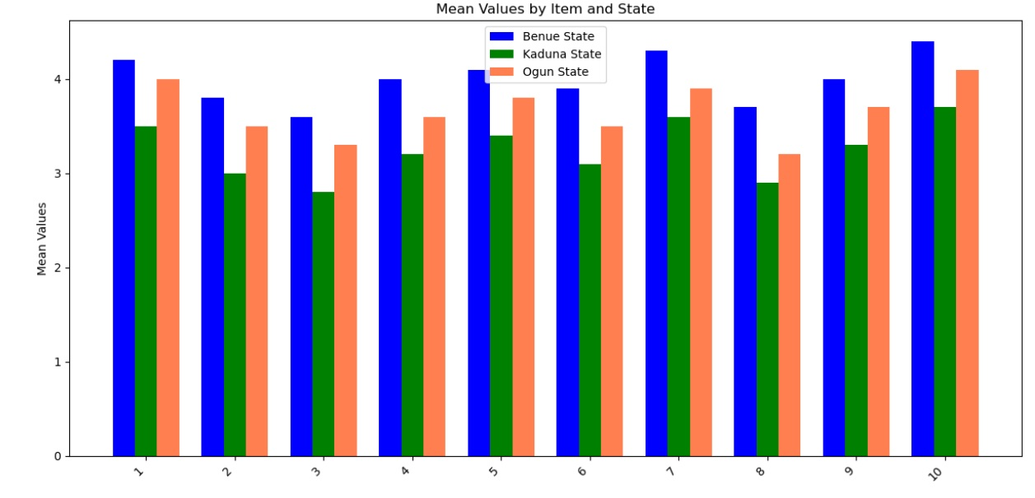 ${\overline{x}}_{}$***= Mean SD =*** *Standard Deviation*

*Fig 1-Bar graph showing Proactive Land Acquisition Strategies and Digital Adoption on responses from 300farmers in Benue, Kaduna and Ogun States*

**Table2:** *The Mean, Standard Deviation, and t-test analysis of Analysis of Barriers and Facilitators to Digitalization on responses from 300farmers in Benue, Kaduna and Ogun States*

|  |  |  |  |  |  |  |  |  |  |  |  |
| --- | --- | --- | --- | --- | --- | --- | --- | --- | --- | --- | --- |
| **S/n** | **Items** | **Benue State** | | **Kaduna State** | | **Ogun State** | | **t-cal** | **t-val** | **Remark** | **Ho** |
| $${\overline{x}}_{1}$$ | **SD** | $${\overline{x}}_{2}$$ | **SD** | $${\overline{x}}_{3}$$ | **SD** |
| 1 | Lack of access to technology | 3.2 | 0.8 | 2.5 | 0.9 | 3.0 | 0.7 | 3.56 | 2.93 | Significant | Reject |
| 2 | High costs | 3.8 | 0.6 | 3.0 | 0.8 | 3.4 | 0.7 | 4.12 | 2.93 | Significant | Reject |
| 3 | Lack of training | 3.5 | 0.7 | 2.8 | 0.9 | 3.1 | 0.6 | 3.87 | 2.93 | Significant | Reject |
| 4 | Low internet connectivity | 2.9 | 0.9 | 3.4 | 0.8 | 3.0 | 0.7 | -2.45 | 2.93 | Not significant | Accept |
| 5 | Government support | 4.0 | 0.5 | 3.2 | 0.7 | 3.6 | 0.6 | 5.14 | 2.93 | Significant | Reject |
| 6 | Community training programs | 3.6 | 0.7 | 2.9 | 0.8 | 3.4 | 0.5 | 4.02 | 2.93 | Significant | Reject |
| 7 | Access to information | 3.1 | 0.8 | 2.6 | 0.9 | 2.9 | 0.7 | 3.12 | 2.93 | Significant | Reject |
| 8 | Peer encouragement | 3.3 | 0.7 | 2.7 | 0.8 | 3.0 | 0.6 | 3.45 | 2.93 | Significant | Reject |
| 9 | Importance of government policy | 4.2 | 0.4 | 3.5 | 0.6 | 3.9 | 0.5 | 6.73 | 2.93 | Significant | Reject |
| 10 | Support from agricultural extension services | 3.9 | 0.5 | 3.1 | 0.7 | 3.5 | 0.6 | 4.58 | 2.93 | Significant | Reject |

${\overline{x}}_{}$***= Mean SD =*** *Standard Deviation*

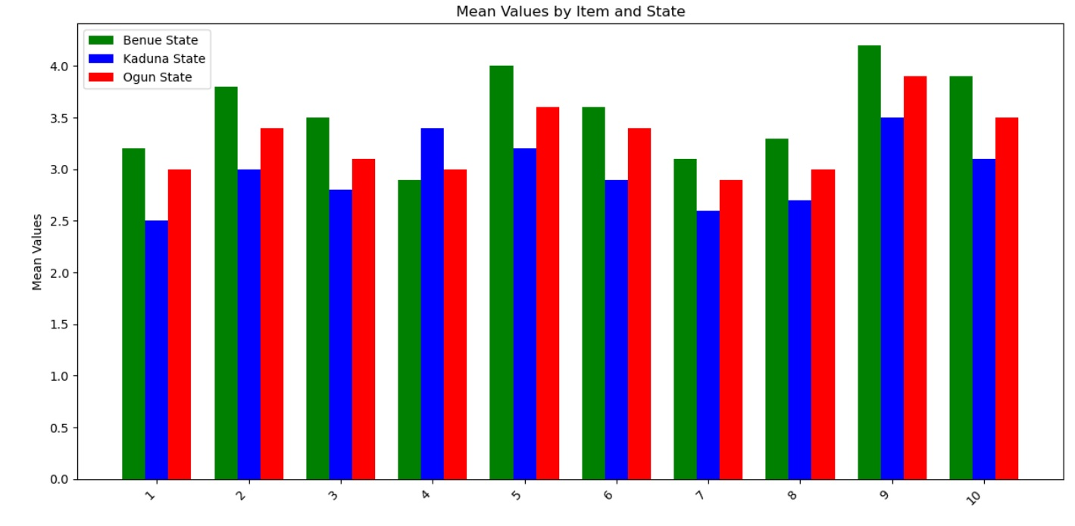

**Fig 2-** Bar graph showing *Analysis of Barriers and Facilitators to Digitalization on responses from 300farmers in Benue, Kaduna and Ogun States*

**Table3:** *The Mean, Standard Deviation, and t-test analysis of Analysis of Mediating Roles in Digital Adoption Intention on responses from 300farmers in Benue, Kaduna and Ogun States*

|  |  |  |  |  |  |  |  |  |  |  |  |
| --- | --- | --- | --- | --- | --- | --- | --- | --- | --- | --- | --- |
| **S/n** | **Items** | **Benue State** | | **Kaduna State** | | **Ogun State** | | **t-cal** | **t-val** | **Remark** | **Ho** |
| $${\overline{x}}_{1}$$ | **SD** | $${\overline{x}}_{2}$$ | **SD** | $${\overline{x}}_{3}$$ | **SD** |
| 1 | Perceived usefulness of digital technologies | 4.1 | 0.5 | 3.5 | 0.6 | 3.8 | 0.4 | 4.67 | 2.93 | Significant | Reject |
| 2 | Perceived ease of use of digital technologies | 3.9 | 0.6 | 3.2 | 0.8 | 3.5 | 0.5 | 4.12 | 2.93 | Significant | Reject |
| 3 | Influence of land tenure security on perceived usefulness | 4.2 | 0.4 | 3.6 | 0.7 | 3.9 | 0.6 | 5.11 | 2.93 | Significant | Reject |
| 4 | Influence of land tenure security on perceived ease of use | 4.0 | 0.5 | 3.3 | 0.8 | 3.7 | 0.5 | 4.66 | 2.93 | Significant | Reject |
| 5 | Overall influence of perceived usefulness on intention to adopt digital technologies | 4.3 | 0.5 | 3.7 | 0.6 | 4.0 | 0.5 | 4.83 | 2.93 | Significant | Reject |
| 6 | Overall influence of perceived ease of use on intention to adopt digital technologies | 4.1 | 0.6 | 3.4 | 0.7 | 3.8 | 0.6 | 4.57 | 2.93 | Significant | Reject |
| 7 | Mediation effect of perceived usefulness in the relationship between land acquisition and adoption intention | 4.0 | 0.5 | 3.5 | 0.7 | 3.8 | 0.6 | 4.12 | 2.93 | Significant | Reject |
| 8 | Mediation effect of perceived ease of use in the relationship between land acquisition and adoption intention | 3.8 | 0.6 | 3.1 | 0.8 | 3.4 | 0.7 | 4.02 | 2.93 | Significant | Reject |

${\overline{x}}_{}$***= Mean SD =*** *Standard Deviation*

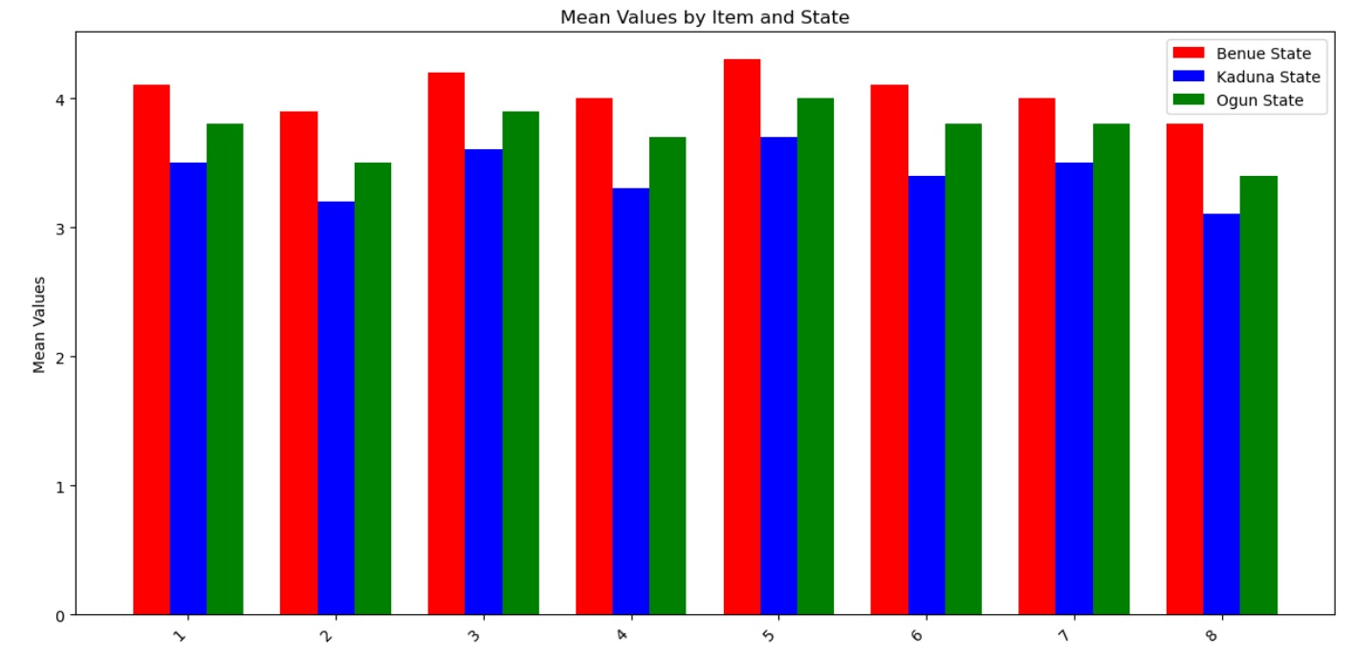*Fig 3- Bar graph showing Analysis of Mediating Roles in Digital Adoption Intention on responses from 300 farmers in Benue, Kaduna and Ogun States*

**Discussion of Results**

From Table 1, we observe that proactive land acquisition strategies, including land tenure security, legal help, and the number of land discussions, are impactful on farmers’ intentions to utilise digital technologies in all the states (all t-calculated > 2.93, p < 0.05). This suggests that stable ownership of land helps people invest in new inventions (Lengoiboni et al., 2023). If farmers know their property is secure, they become more interested in investing in precise farming technologies and ICT (Chavula &Turyasingura, 2022). Willpower was predicted by receiving support from the government and from those in the same profession. This discovery agrees with Ahamefule (2025)by highlighting that both social systems and perceived support play important roles in using innovation. If farmers receive support from the government and training from the community, they will be more willing to use new farming technologies.

According to Table 2, the greatest barriers affecting digitalisation are high expenses, lack of training, and not having enough information, with each t-value higher than 2.93. These challenges are the same ones reported in digital agriculture in sub-Saharan Africa (Olabinjo & Opatola, 2023; Wang et al., 2025). Also, factors such as official backing, training for the community, and valuable extension support helped with digitalisation (M = 4.0–3.6, 3.9–3.5, and 3.6–3.4, respectively). There were no significant differences found in the group with a low internet connection (t = -2.45 < 2.93). It could suggest that some areas lack up-to-date digital infrastructure while others experience more mobile network growth in rural areas (Nghargbu & Jumare, 2024). In other words, even though access to resources is still a challenge, the rate of adoption of digital technologies depends mostly on training opportunities, costs, and institutional backing.

Seeing the results in Table 3, it is clear that perceived usefulness (M = 4.1–3.8) and perceived ease of use (M = 3.9–3.5) act as key mediators for the connection between proactive land acquisition and intention to use technology (t-calculated > 4.0, p < 0.05). According to the Technology Acceptance Model, individuals tend to accept a technology if they feel it will increase their productivity and are not complicated to apply (Hess et al., 2014; Lai, 2017). Land tenure security was a major factor in determining both the usefulness and ease of usage of the technology (items 3 & 4 in Table 3). It means that land rights impact not only residents’ decision to use new technologies but also their assessment of their value. Studies conducted by Tang and Adesina (2022) and Tadesse and Ahmed (2023) prove that having secure land rights improves a nation’s ability to use advanced technology with effective support and training.

Based on this study, if land is secured for agriculture ahead of time, it helps farmers in Nigeria to be more willing to use digital technologies. The role of ease of use and usefulness as mediators proves that TAM is valuable in agricultural contexts as well. Moreover, since costs remain high and efficient training is limited, programs from governments and farm experts, as well as support from fellow farmers, create wide opportunities for digital agriculture.

## Conclusion

This study points out that land acquisition strategies play a major role in deciding how willing Nigerian farmers are to use digital technologies. The study suggests that having stable land rights encourages farmers to use digital technologies, mainly because they see them as useful and easy to operate, according to TAM. It is clear from the research that taking steps to purchase land early gives farmer’s confidence in their investments and encourages advancement in agri-tech. Though there are high costs and a lack of training, government policies and community actions are very important for helping agriculture go digital. All in all, the lessons from this study play a key role in raising agricultural productivity thanks to digital transformation in Nigeria.

**Recommendation**

1. The study recommends increase land security to benefit farmers and policymakers should ensure that clear land transfer systems are put in place. Such action may require making land registration simpler and offering more legal protection to farmers.

2. Set up training classes for farmers to teach them about technology. Such programmes ought to be centred on teaching farmers how to use digital tools in their farming activities, boosting their productivity.

3. Motivate research and agricultural players to unite and look into innovative technological options suitable for Nigerian’s farmers.

Disclaimer (Artificial intelligence)

Option 1:

Author(s) hereby declare that NO generative AI technologies such as Large Language Models (ChatGPT, COPILOT, etc.) and text-to-image generators have been used during the writing or editing of this manuscript.

Option 2:

Author(s) hereby declare that generative AI technologies such as Large Language Models, etc. have been used during the writing or editing of manuscripts. This explanation will include the name, version, model, and source of the generative AI technology and as well as all input prompts provided to the generative AI technology

Details of the AI usage are given below:

1.

2.

3.

**References**

Abdulquadri, A. O., Olokonla, A. A., Suleiman, W. O., &Yahaya, B. O. (2024). Transforming Nigeria's Agricultural Value Chains: The Role of Digital Platforms in Market Access and Price Transparency. *UNIZIK Journal of Marketing*, *1*(2), 37-57.

Abioye, D. O., Popoola, O., Akande, A., Fadare, D. A., Omitoyin, S. A., Yinusa, B., &Kolade, O. O. (2024). Farmers’ willingness to adopt digital application tools in Ogun State, Nigeria. *Journal of Strategy and Management*.

Ahamefule, I. C. (2025). Continuity in Indigenous Institutions for Capital Formation among the Igbo in Post-Colonial Nigeria, 1970–2020. *Advances in Law, Pedagogy, and Multidisciplinary Humanities*, *3*(1), 209-226.

Alhassan, E. A., Asaleye, J. A., Biniyat, J. K., Alhassan, T. R., &Olaoye, J. O. (2024). Tractor acquisition and agricultural performance among Nigerian farmers: Evidence from Co-integration Modeling technique. *Heliyon*, *10*(2).

Amuda-Kannike, A., Jude-Akaraonye, G. O., &Amuda-Kannike, Y. (2025). Contemporary Issues in Private and Property Law in Nigeria. *Journal of Commercial and Property Law*, *12*(1), 76-88.

Arowolo, A. O., Aminu, R. O., Ibrahim, S. B., Emmanuel, A. E., Falaye, F. J., &Sanusi, R. A. (2022). Profitability and Determinants of Adoption Intensity of Improved Plantain Production Technologies in Ogun State, Nigeria. *Nigerian Journal of Agricultural Economics*, *12*(1), 33-43.

Atuegwu, W. T. (2024). The Role of Land Law Within the Nigerian Legal Profession: Its Significance in the Context of Contemporary Legal Developments. *Available at SSRN 5065573*.

Augusta Odiche, D., & Akeem, A. (2024). A Review of Issues and Challenges of Digital Transformation and Sustainable Development in Nigeria. *Lead City Journal of the Social Sciences (LCJSS)*, *9*(3), 147-164.

Baumuller, H., Ikpi, U., Jumpah, E. T., Kamau, G., Kergna, A. O., Mose, L., ...&Salasya, B. (2023). Building digital bridges in African value chains: Exploring linkages between ICT use and social capital in agricultural marketing. *Journal of Rural Studies*, *100*, 103002.

Chavula, P., &Turyasingura, B. (2022). Land Tenurial system influence among smallholder farmers’ climate smart agriculture technologies adoption, Sub-Sahara Africa: a review paper. *International Journal of Food Science and Agriculture*, *6*(1).

Choruma, D. J., Dirwai, T. L., Mutenje, M., Mustafa, M., Chimonyo, V. G. P., Jacobs-Mata, I., &Mabhaudhi, T. (2024). Digitalisation in agriculture: A scoping review of technologies in practice, challenges, and opportunities for smallholder farmers in sub-saharanafrica. *Journal of agriculture and food research*, 101286.

Davis, F. D. (1989). Perceived usefulness, perceived ease of use, and user acceptance of information technology. *MIS quarterly*, 319-340.

Fadeyi, O. A., Ariyawardana, A., & Aziz, A. A. (2022). Factors influencing technology adoption among smallholder farmers: a systematic review in Africa. *Journal of Agriculture and Rural Development in the Tropics and Subtropics (JARTS)*, *123*(1), 13-30.

Hess, T. J., McNab, A. L., &Basoglu, K. A. (2014). Reliability generalization of perceived ease of use, perceived usefulness, and behavioral intentions. *MIS quarterly*, *38*(1), 1-28.

Ikenga, V. U., Oyita, G. E., & Gbigbi, T. M. (2024). Prospects and challenges of agricultural financing in Nigeria: A review. GSC Advanced Research and Reviews, 18(03), 388–399. [*https://doi.org/10.30574/gscarr.2024.18.3.0116*](https://doi.org/10.30574/gscarr.2024.18.3.0116)

Lai, P. C. (2017). The literature review of technology adoption models and theories for the novelty technology. *JISTEM-Journal of Information Systems and Technology Management*, *14*(1), 21-38.

Lengoiboni, M., Dadey, D., Chamberlain, W., Bailey, A., &Zevenbergen, J. A. (2023). A review of long-term impacts of land registration on Women’s Land Rights. *FIG Working Week 2023: Protecting our world, conquering new frontiers*.

Nghargbu, R., &Jumare, F. (2024). Digital Financial Inclusion for Women in Africa: Prospects and Challenges. *Women and Finance in Africa: Inclusion and Transformation*, 115-122.

Nyagango, A. I., Sife, A. S., &Kazungu, I. (2023). Use of mobile phone technologies for accessing agricultural marketing information by grape smallholder farmers: a technological acceptance model (TAM) perspective. *Technological Sustainability*, *2*(3), 320-336.

Olabinjo, O., &Opatola, S. (2023). Agriculture: A Pathway to Create a Sustainable Economy. *Turkish Journal of Agricultural Engineering Research*, *4*(2), 317-326.

Olagunju, K. O., Olagunju, K. A., Ogunniyi, A. I., Omotayo, A. O., &Oyetunde-Usman, Z. (2023). To own or not to own? Land tenure security and production risk in small-scale farming. *Land Use Policy*, *127*, 106584.

Onomu, A. R., &Aliber, M. (2024). Nigeria's Agriculture and Technology Use: Current Structure and Challenges. *Path of Science*, *10*(11), 1001-1023.

Sahin, I. (2006). Detailed review of Rogers' diffusion of innovations theory and educational technology-related studies based on Rogers' theory. *Turkish Online Journal of Educational Technology-TOJET*, *5*(2), 14-23.

Solaja, S., Kolawole, A., Awe, T., Oriade, O., Ayojimi, W., Ojo, I., ...&Nsikak, I. (2024). Assessment of smallholder rice farmers' adaptation strategies to climate change in Kebbi state, Nigeria. *Heliyon*, *10*(15).

Tadesse, B., & Ahmed, M. (2023). Impact of adoption of climate smart agricultural practices to minimize production risk in Ethiopia: a systematic review. *Journal of Agriculture and Food Research*, *13*, 100655.

Tang, X., &Adesina, J. A. (2022). Integrated watershed management framework and groundwater resources in Africa—a review of west Africa sub-region. *Water*, *14*(3), 288.

Unachukwu, I. B., Maduka, A. C., Oguanobi, C. R., &Akamobi, O. G. (2025). The contribution of agricultural exports to Nigeria’s economicgrowth–a time series analysis (1986–2022). *International Journal of Finance, Accounting and Management Studies*, *1*(4), 158-174.

Wang, S., Yang, Y., Yin, H., Zhao, J., Wang, T., Yang, X., ...& Yin, C. (2025). Towards Digital Transformation of Agriculture for Sustainable Development in China: Experience and Lessons Learned. *Sustainability*, *17*(8), 3756..