**Numerical Analysis of Magnetohydrodynamics of Casson nanofluid flow over a rotating** **disk from Mathematical Physics Perspective**

**Abstract**

This study examines the key characteristics of Casson nanofluid flow across a rotating disk, incorporating the effects of Brownian motion and thermophoresis. Additionally, the analysis considers the impact of thermal radiation and the Soret effect. Efficient heat transfer plays a crucial role in various industries, including transportation, manufacturing, and thermal power generation. However, a key challenge in designing heat transfer systems is the low thermal efficiency of conventional working fluids. Given the limited thermal efficiency of traditional fluids, nanofluids have gained considerable attention in recent years due to their enhanced heat transfer capabilities, making them valuable in various industrial and engineering applications. The research is motivated by its broad relevance in technological and engineering fields. The governing equations for fluid flow are converted into a system of nonlinear ordinary differential equations (ODEs) using appropriate similarity transformations. A numerical solution for these nonlinear ODEs is obtained through the numerical method via Shooting method combined with six order Runge Kutta Scheme. The computational process is implemented and executed using Maple software for numerical simulation. The results obtained through Maple simulations are validated by comparing with existing results in the literature and the results show excellent agreement. Graphical representations demonstrate how dimensionless physical parameters influence velocity, temperature, and concentration profiles. The numerical study examines the influence of Soret and multiple slip effects on magnetized Casson nanofluid flow over a rotating disk. Given its relevance to engineering and industrial applications, this research holds significant practical value. The findings reveal that thermal slip reduces fluid velocity, while an increase in the velocity slip factor leads to a decline in temperature distribution.

**Keywords**: Magnetohydrodynamics, Casson nanofluid flow, ordinary differential equations, Runge Kutta Scheme

1.0 **Introduction**

In recent years, the enhancement of heat transmission and thermal conductivity has become a major focus for researchers. As technology continues to evolve, efficient heat transfer plays a crucial role in various industries, including transportation, manufacturing, and thermal power generation. However, a key challenge in designing heat transfer systems is the low thermal efficiency of conventional working fluids. To address this issue, scientists have explored innovative methods to improve thermal conductivity, with nanofluids—working fluids infused with nanoparticles—emerging as a promising solution. Research has demonstrated that nanofluids exhibit superior thermal properties compared to traditional fluids. The concept of nanofluids was first introduced by Choi (1995), sparking significant interest in their potential applications. Recent studies, such as those by Bacha *et al*. (2024), have reviewed the heat transfer enhancement capabilities of nanoliquids. Rafique *et al*. (2024) conducted numerical analyses on energy and mass transfer in nanofluid flows, while Kumar et al. (2021) investigated the stability of hybrid nanofluids under thermal radiation effects. Additionally, Waqas *et al*. (2021) found that hybrid nanofluids improve heat transfer efficiency in flat tubes, and Song *et al*. (2021) examined heat transport in nanofluids containing diverse nanoparticles. Non-Newtonian fluid theory is being widely adopted in view of its applicable features. A non Newtonian fluid exerts nonlinear relationships between the shear stress and rate of shear strain. In nature, a Non-Newtonian fluid acts as elastic solid, i.e. the flow does not occur with small shear stress. Casson fluid is one such model in Newtonian fluids (Suresh Kumar et al., 2023).

The study of Casson fluid flow over a rotating disk has gained attention in fluid dynamics, particularly due to its non-Newtonian behavior. Casson fluids exhibit unique properties—such as high yield stress, causing them to behave like solids under low stress and liquids under high stress—making them valuable in biomedical engineering, food processing, and industrial applications. The innovation is occupying on the viscous diversion for a non-Newtonian Casson, and the effectiveness of synthetic processes carried on by nanoparticle migrations in the field of producing warmth micropolar nanofluid sample infused in an absorptive medium and exposed to a magnetic field, warmth radiation, and a change in velocity aspect (Ramya and Deivanayaki, 2023, 2024).

Several researchers have contributed to this field: Jawad *et al*. (2021) compared the electrical conductivity and radiative properties of Casson nanofluids. Ali *et al*. (2024) numerically analyzed heat and mass transfer in Casson nanoliquid flows. Jyothi *et al*. (2021) explored Marangoni flow in Casson nanofluids with heat generation/absorption and chemical reactions.

Saeed et al. (2019) studied convective boundary effects using Laplace transforms, while Khan *et al*. (2020) examined porous media flow between deformable disks. Further investigations by Shah et al. (2019, 2018, 2018, 2019, 2019, 2019) focused on magnetohydrodynamic (MHD) heat transfer in nanofluids with microstructural variations. Khan *et al*. (2021) analyzed Maxwell nanofluids with thermal radiation and activation energy effects, whereas Waqas et al. (2021) studied time-dependent MHD flow in Oldroyd-B fluids with heat generation. Nadeem *et al*. (2021) investigated thermal radiation effects on stretched surfaces, and Makinde *et al*. (2018) analyzed viscosity variations in magnetized nanofluids. Hafeez *et al*. (2020) examined Soret and Dufour effects in porous media flows. Mustafa M. MHD nanofluid flow over a rotating disk with partial slip effects: Buongiorno model.

This work extends Khan *et el.* (2021) and Nadeem (2021) from two-dimensional to the three-dimensional boundary layer flow of Casson nanofluid over a rotating disk, incorporating thermal radiation and Soret effects in the mass transfer equation. The numerical method is employed for numerical solutions, and graphical analyses are presented to illustrate the impacts of key parameters—such as magnetic fields, thermal slip, thermophoresis, and Brownian motion—on velocity, temperature, and concentration profiles. This study examines the key characteristics of Casson nanofluid flow across a rotating disk, incorporating the effects of Brownian motion and thermophoresis.

2.0 **Problem formulation**

The study examines the flow of Casson nanoliquid over a rotating disk. A cylindrical coordinate system (*r*, *ϕ*, *z*) is employed for the analysis, with the disk situated at *z*=0. The region *z*>0 is occupied by an electrically conducting, incompressible nanofluid. Slip effects are also incorporated into the model. A uniform magnetic field of strength *B*0​ is applied in the axial direction. Due to the low magnetic Reynolds number, the induced magnetic field is neglected. The wall temperature *Tw*​ is maintained higher than the ambient temperature *T*∞​ (i.e., *Tw*​>*T*∞​). Given the axial symmetry of the problem, all derivatives with respect to *ϕ* are disregarded.

The governing equations for this flow configuration are as follows:

 (1)

 (2)

 (3)

 (4)

 (5)

 (6)

The boundary condition attached to the governing equations above is

 (7)

Under the Rosseland approximation, the radiative heat flux (qᵣ) can be expressed as

 (8)

Here, **σ\*** represents the Stefan-Boltzmann constant, and **k\*** denotes the mean absorption coefficient. By expanding **T⁴** in a Taylor series around **T∞** and neglecting higher-order terms, we obtain:

 (9)

Our analysis focuses on the set of similarity transformations outlined below

 (10)

With the help of Eq. (10), the equations (2), (3), (5), and (6) are transformed into the following

 (11)

 (12)

 (13)

 (14)

The boundary settings are converted into

 (15)

Where

 (16)

In this context, the tangential stress  and radial stress  are respectively expressed as

 (17)

On the other hand, the local skin friction coefficient  and Nussselt are respectively transform to.

 (18)

 (19)

**3.0 Numerical Solution**

The system of strongly nonlinear partial differential equations—given by Equations (11) to Equation (14)—along with the boundary conditions specified in Equation (15), is solved numerically. A shooting method integrated with a sixth-order Runge-Kutta scheme is applied to investigate the behavior of the system across a range of moderate flow, heat, and mass transfer parameters. To improve the precision of initial estimates and guarantee that the far-field boundary conditions are met, the Broyden quasi-Newton method is incorporated. The computational process is implemented and executed using Maple software for numerical simulation. The results obtained through Maple simulations are validated by comparing with existing results in literature and the results show excellent agreement.

**4.0 Results and Discussion**

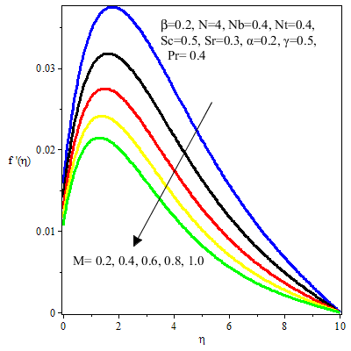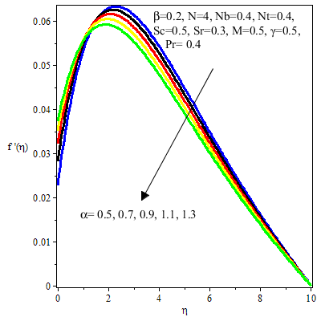

Fig 1: Impact of M on  Fig 2: Impact of  on 

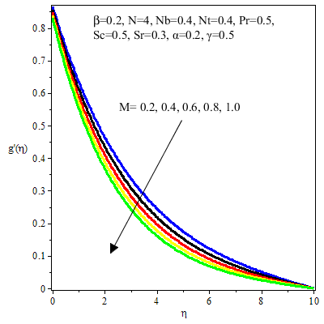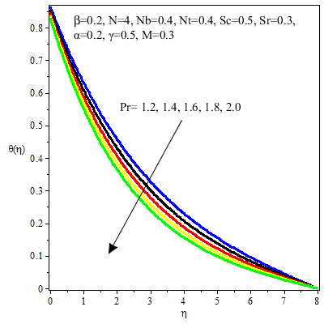

Fig 3: Impact of  on  Fig 4: Impact of  on 

The coupled nonlinear ordinary differential equations (11–14) under boundary conditions (15) were solved numerically, and the effects of key parameters—including the magnetic field (**M**), Prandtl number (**Pr**), Soret number (**Sr**), Brownian motion (**Nb**), radiation (**N**), Soret factor (**Sr**), and thermophoresis (**Nt**)—were analyzed. To validate the results, comparisons with published data (Table 1) showed strong agreement, while variations in energy transfer rates

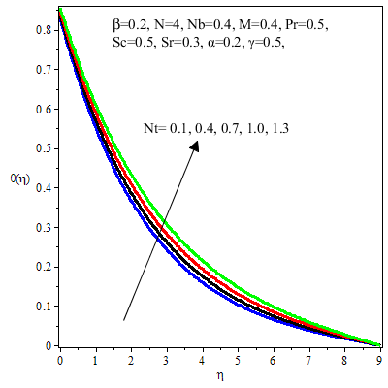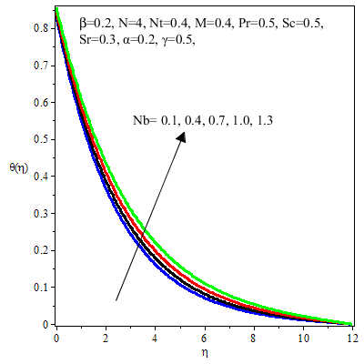

Fig 5: Impact of  on  Fig 6: Impact of  on 

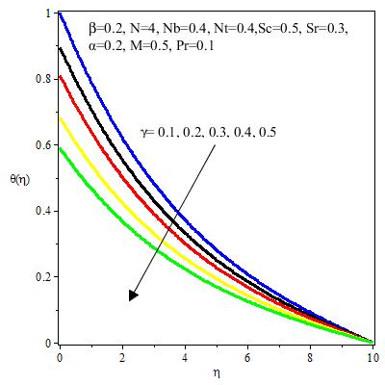 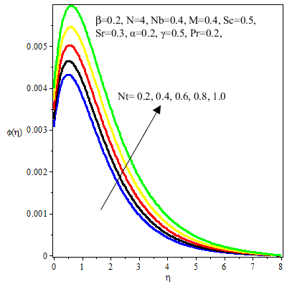

Fig 7: Impact of  on  Fig 8: Impact of  on 

under different conditions were also examined (Table 2). The study revealed that thermophoresis enhances energy transfer due to deeper nanoparticle penetration, which thickens the thermal boundary layer, whereas an increase in the thermal slip coefficient (**α**) reduces the local Nusselt number. Additionally, higher **Pr** values correspond to lower thermal diffusivity, leading to a steeper thermal gradient near the wall and a slightly thicker boundary layer compared to fluids with lower **Pr**.

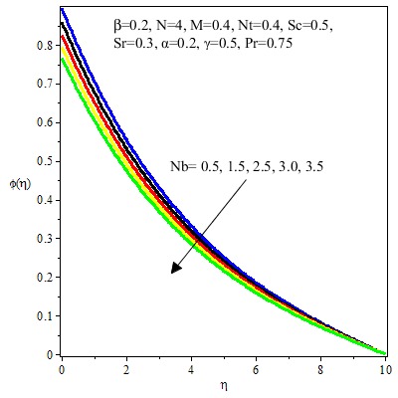 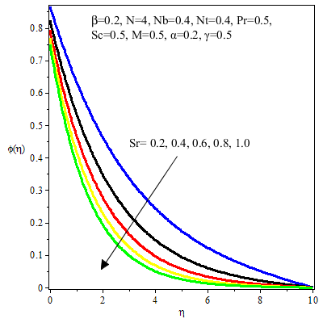

Fig 9: Impact of  on  Fig 10: Impact of  on 

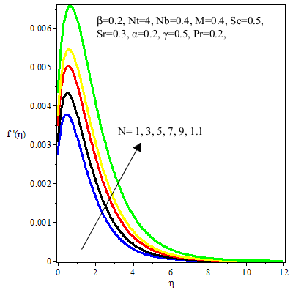

Fig 11: Impact of  on 

The influence of the magnetic field (**M**) on velocity was investigated in Fig. 1, showing that Lorentz forces reduce radial velocity, while Fig. 2 demonstrates that azimuthal velocity decreases with increasing thermal slip (**α**). Fig. 3 further confirms an inverse relationship between azimuthal velocity and **M**, whereas Fig. 4 illustrates that higher **Pr** values result in weaker temperature profiles. The impact of thermophoresis (**Nt**) on temperature distribution was examined in Fig. 5, revealing stronger thermal gradients at higher **Nt**, while Fig. 6 shows that Brownian motion (**Nb**) elevates the temperature profile **θ(η)**. Meanwhile, Fig. 7 indicates that temperature decreases with increasing **γ**, and Fig. 8 highlights how **Nt** expands the concentration distribution.

Table 1: Validation of Present result with existing result in the literature

|  |  |  |  |  |  |  |  |
| --- | --- | --- | --- | --- | --- | --- | --- |
|  |  | Khuarm *et al*. (2025) | | | Present Result | | |
| M |  |  |  |  |  |  |  |
| 0 | 0.25 | 0.0648 | 0.2595 | -0.4167 | 0.0649 | 0.2596 | -0.4167 |
| 0.2 | 0.25 | 0.0477 | 0.1911 | -0.5095 | 0.0478 | 0.1912 | -0.5096 |
| 0.4 | 0.25 | 0.0365 | 0.1460 | -0.5995 | 0.0365 | 0.1461 | -0.5993 |
| 0.6 | 0.25 | 0.0291 | 0.1166 | -0.6803 | 0.0290 | 0.1167 | -0.6804 |
| 0.8 | 0.25 | 0.0241 | 0.0967 | -0.7515 | 0.0241 | 0.0967 | -0.7515 |
| 0.5 | 0 | 0 | 0.2186 | -0.7559 | 0 | 0.2186 | -0.7559 |
| 0.5 | 0.2 | 0.0286 | 0.1430 | -0.6621 | 0.0286 | 0.1430 | -0.6620 |
| 0.5 | 0.2 | 0.0396 | 0.0991 | -0.5845 | 0.0397 | 0.0991 | -0.5846 |
| 0.5 | 0.6 | 0.0431 | 0.0719 | -0.5220 | 0.0432 | 0.0719 | -0.5221 |

Table 2: Computational value of  against Nb, Nt, Pr, Sc, M, ,,

|  |  |  |  |  |  |  |  |  |
| --- | --- | --- | --- | --- | --- | --- | --- | --- |
| Nb | Nt | Pr | Sc | M |  |  |  |  |
| 0.2 | 0.2 | 7.3 | 6.0 | 0.2 | 0.2 | 0.2 | 0.6 | 0.9864 |
| 0.4 | 0.2 | 7.3 | 6.0 | 0.2 | 0.2 | 0.2 | 0.6 | 0.8543 |
| 0.2 | 0,4 | 7.3 | 6.0 | 0.2 | 0.2 | 0.2 | 0.6 | 0.9763 |
| 0.2 | 0.2 | 9.0 | 6.0 | 0.2 | 0.2 | 0.2 | 0.6 | 0.8421 |
| 0.2 | 0.2 | 7.3 | 9 | 0.2 | 0.2 | 0.2 | 0.6 | 0.8144 |
| 0.2 | 0.2 | 7.3 | 6.0 | 0.6 | 0.2 | 0.2 | 0.6 | 0.7531 |
| 0.2 | 0.2 | 7.3 | 6.0 | 0.2 | 0.6 | 0.2 | 0.6 | 0.7994 |
| 0.2 | 0.2 | 7.3 | 6.0 | 0.2 | 0.2 | 1.5 | 0.6 | 0.9421 |
| 0.2 | 0.2 | 7.3 | 6.0 | 0.2 | 0.2 | 0.2 | 2.6 | 0.8901 |

The concentration profile **ϕ(η)** was found to decrease with higher **Nb** (Fig. 9), exhibiting an inverse relationship, while Fig. 10 demonstrates that larger Soret numbers (**Sr**) suppress concentration. Finally, Fig. 11 examines the effect of radiation (**N**), showing that increased radiative heat generation raises fluid temperature by accelerating particle motion and enhancing thermal energy.

**Conclusions**

This numerical study examines the influence of Soret and multiple slip effects on magnetized Casson nanofluid flow over a rotating disk. Given its relevance to engineering and industrial applications, this research holds significant practical value. The flow model was initially developed, and the governing partial differential equations (PDEs) were transformed into nonlinear ordinary differential equations (ODEs) using similarity variables. The numerical method was employed to obtain numerical solutions.

**Summary**

Key findings from this investigation include:

**i.Velocity reduction**: The Casson parameter suppresses fluid velocity.  
**ii.Thermal enhancement**: Temperature rises with increased thermal radiation.  
**iii. Heat transfer improvement:** The energy transmission rate escalates with higher Casson factor values.  
iv. **Magnetic damping:** Stronger magnetic effects decelerate fluid motion.  
v.**Mass transfer impact**: A higher Schmidt number boosts the energy flow rate.

Disclaimer (Artificial intelligence)

Option 1:

Author(s) hereby declare that NO generative AI technologies such as Large Language Models (ChatGPT, COPILOT, etc.) and text-to-image generators have been used during the writing or editing of this manuscript.

Option 2:

Author(s) hereby declare that generative AI technologies such as Large Language Models, etc. have been used during the writing or editing of manuscripts. This explanation will include the name, version, model, and source of the generative AI technology and as well as all input prompts provided to the generative AI technology

Details of the AI usage are given below:

1.

2.

3.

**Reference**

Ali AR, Rafique K, Imtiaz M, Jan R, Alotaibi H, Mekawy I. (2024). Exploring magnetic and thermal effects on MHD bio-viscosity flow at the lower stagnation point of a solid sphere using Keller box technique. *Part Differ Equ Appl Math*. 9, 100601.

Bacha H. B, Ullah N, Hamid A, Shah N.A. (2024). A comprehensive review on nanofluids: synthesis, cutting-edge applications, and future prospects. *Int J Thermofluids*, 100595.

Choi S.U, Eastman J. A. (1995). *Enhancing Thermal Conductivity of Fluids with Nanoparticles (No. ANL/MSD/CP-84938; CONF-951135-29)*. Argonne, ILUnited States: Argonne National Lab.(ANL); 1995.

Hafeez A, Khan M, Ahmed J, Ahmed A, Iqbal Z. (2020) Flow of Oldroyd-B fluid over a rotating disk through porous medium with Soret–Dufour effects. *Arab J Sci Eng*. 45(7):5949–5957.

Jawad M, Saeed A, Khan A, Islam S. (2021). MHD bioconvection Darcy-Forchheimer flow of Casson nanofluid over a rotating disk with entropy optimization. *Heat Transfer*. 2021;50(3):2168–2196.

Jyothi AM, Naveen Kumar R, Punith Gowda RJ, Veeranna Y, Prasannakumara BC. (2021). Impact of activation energy and gyrotactic microorganisms on flow of Casson hybrid nanofluid over a rotating moving disk. *Heat Transfer*. 50(6):5380–5399.

Khan M. I, Waqas H, Khan S. U. (2021). Slip flow of micropolar nanofluid over a porous rotating disk with motile microorganisms, nonlinear thermal radiation and activation energy. *Int Commun Heat Mass Transfer*.122, 105161.

Khan N, Riaz I, Hashmi MS, (2020). Aspects of chemical entropy generation in flow of Casson nanofluid between radiative stretching disks. *Entropy* ;22(5):495.

Khuram, R. Aisha, M.A., Ayesha, R., Najla, A.M. and Ilyas K. (2025). Continuum flow mod         el of MHD Casson nanofluid over a rotating disk with multiple slips. Partial Differential Equatios in Applied Mathematics. 13, 101068

Kumar K.G, Hani E.H,B, Assad M.E.H, Rahimi-Gorji M, Nadeem S. A. (2021). Novel approach for investigation of heat transfer enhancement with ferromagnetic hybrid nanofluid by considering solar radiation. *Microsyst Technol*. 27:97–104.

Makinde O.D, Mahanthesh B, Gireesha B.J, Shashikumar NS, Monaledi R.L, Tshehla M.S. (2018). *MHD nanofluid flow past a rotating disk with thermal radiation in the presence of aluminum and titanium alloy nanoparticles*. In: *Defect and Diffusion Forum*. 384. Trans Tech Publications Ltd: 69–79. 21

Mustafa M. (2017). MHD nanofluid flow over a rotating disk with partial slip effects: Buongiorno model. *Int J Heat Mass Transf*. 108:1910–1916.

Nadeem S, Ijaz M, Ayub M. (2021). Darcy–Forchheimer flow under rotating disk and entropy generation with thermal radiation and heat source/sink. *J Therm Anal Calorim*.143:2313–2328.

Rafique K, Elkahlout G, Rehman A, Kanwal S. (2024) Bio convection heat transfer in Sisko nanofluid past a stretching cylinder with Soret and Dufour effects. *Edelweiss Appl Sci Technol*;8(6):5236–5253.

Saeed A, Shah Z, Islam S. (2019). Three-dimensional Casson nanofluid thin film flow over an inclined rotating disk with the impact of heat generation/consumption and thermal radiation. *Coatings*. 9(4): 248.

Shah Z, Bonyah E, Islam S, Gul T. Impact of thermal radiation on electrical MHD rotating flow of Carbon nanotubes over a stretching sheet. *AIP Adv*. 2019;9(1).

Shah Z, Dawar A, Islam S, Khan I, Ching DLC. (2018). Darcy-Forchheimer flow of radiative carbon nanotubes with microstructure and inertial characteristics in the rotating frame. *Case Stud Therm Eng*. 12:823–832.

Shah Z, Dawar A, Khan I, Islam S, Ching D.L.C, Khan AZ. (2019). Cattaneo-Christov model for electrical magnetite micropoler Casson ferrofluid over a stretching/shrinking sheet using effective thermal conductivity model. *Case Stud Therm Eng*.13, 100352.

Shah Z, Islam S, Ayaz H, Khan S. (2019). Radiative heat and mass transfer analysis of micropolar nanofluid flow of Casson fluid between two rotating parallel plates with effects of Hall current. *J Heat Transfer*.141(2), 022401.

Shah Z, Islam S, Gul T, Bonyah E, Khan M. A. (2018). The electrical MHD and hall current impact on micropolar nanofluid flow between rotating parallel plates. *Results Phys*. 9:1201–1214.

Shah Z, Tassaddiq A, Islam S, Alklaibi AM, Khan I. (2019). Cattaneo–Christov heat flux model for three-dimensional rotating flow of SWCNT and MWCNT Nanofluid with Darcy– Forchheimer porous medium induced by a linearly stretchable surface. *Symmetry (Basel)*. 11(3):331.

Song YQ, Khan SA, Imran M, (2021). Applications of modified Darcy law and nonlinear thermal radiation in bioconvection flow of micropolar nanofluid over an off centered rotating disk. *Alexandria Eng J*. ;60(5):4607–4618.

Waqas H, Farooq U, Naseem R, Hussain S, Alghamdi M. (2021). Impact of MHD radiative flow of hybrid nanofluid over a rotating disk. *Case Stud Therm Eng*.;26, 101015.

Waqas H, Imran M, Muhammad T, Sait S.M, Ellahi R. (2021). Numerical investigation on bioconvection flow of Oldroyd-B nanofluid with nonlinear thermal radiation and motile microorganisms over rotating disk. *J Therm Anal Calorim*. 145:523–539.

Ramya, N., & Deivanayaki, M. (2023). Numerical simulation of Casson micropolar fluid flow over an inclined surface through porous medium. Journal of Mines, Metals and Fuels, 2143-2149.

Ramya, N., & Deivanayaki, M. (2024). Heat Radiation on Casson Nanofluid Flow over an Inclined Stretching Surface with Heat and Mass Diffusions. In International Conference on Recent Advancements in Materials Science and Technology (pp. 355-367). Cham: Springer Nature Switzerland.

Suresh Kumar, Y., Hussain, S., Raghunath, K., Ali, F., Guedri, K., Eldin, S. M., & Khan, M. I. (2023). Numerical analysis of magnetohydrodynamics Casson nanofluid flow with activation energy, Hall current and thermal radiation. Scientific Reports, 13(1), 4021.