**APPLICATION OF ITO’S THEOREM ON THE VALUE OF ECONOMIC VARIABLES OF BUSINESS CYCLES.**

**ABSTRACT**

To effectively manage an investment depends mainly on the value of each economic variables. Stochastic Differential Equation (SDE) is prevailing mathematical equation used for such prediction. Four systems of SDE were re-formulated from Bouali’s firm model to value economic variables of business cycles and solved using the Ito’s lemma. The detailed and coincided conditions are effectively achieved which gave rise to the valuation of profits, reinvestments, flow of borrowing and value of profits as a result of quadratic function with periodic influences in time varying investment. From the stochastic analysis, the results showed as follows: (i) an increase in reinvestments and flow of borrowing increases the value of profits over time (ii) the value of profit over time in the economic structural circuit shows positive linear trend of the investment, (iii) increase in the variations of yearly reassessment rate of the business increases the value of reinvestments over time. (iv) the value of profits as a quadratic function with periodic influences grows exponentially over time. Notwithstanding, the effects of the value of the economic variables were analyzed and ic solutions of economic variables and other relevant parameters were discussed within the investment cycles. The results presented here will be beneficial to investors in taken vital decisions based on the levels of their investments.

**Keywords: Business, finance, stochastic analysis, SDE, Profit and reinvestments**.

**INTRODUCTION**

The investment of assets in businesses creates room where returns or profits is used for management of daily cost of running businesses in financial investments. An investor might potentially require more capital investment in order to bring about the improvement of the investment proceedings. Accordingly, financial resources are invested in essence to obtain more asset investments for the purpose of expansion and growth of the business. This creates room for improved unit productivities, creation of innovativeness for new products or bring in values to the investments and to look for modern technology that improves on productivity and minimizes cost and replace outdated assets. If capital assets are skipped, stock exchange will definitely be confronted with the challenges of getting off the ground. There has been progressive growth of stock market activities and performances in the financial market as investors earn incomes to have a living.

At the same time, the stock market is typically avowed for its high returns. Returns on investment for some capital market are approaches for aptly evaluating returns on an investment. Investors adopt these measures to evaluate or assess the significance of expenditure [1]. In the capital market, the fluctuations of stock prices are caused by changes in the values over time. As a result, it is absolutely essential to understand properly the type of physical quantities to model so that realistic results of the stock variables could be obtained; [2] looked at the stochastic model of price changes on the floor of stock market. Thus far, the equilibrium price and the market growth rate of assets were found out. [3] considered the stochastic analysis of stock market expected returns and growth-rates. The precise conditions for obtaining the drifts, volatilities, Growth-Rates of four different assets were considered. [4] considered the stochastic model of the changes or variations of stock market prices. Conditions for finding out the equilibrium price, adequate circumstances for dynamic stability and convergence to equilibrium of growth rate of value function of shares. Furthermore, [5] considered the unstable nature of stock market forces using proposed differential equation model. [6] considered the stochastic analysis of the behavior of stock prices. Results showed that the proposed model is efficient for the prediction of stock prices. [7] considered the solution of differential equations and stochastic differential equations of time-varying investment returns; where precise conditions were obtained which governs stock return rates through multiplicative effect and multiplicative inverse trends series. [8] considered the stochastic model of some selected stocks in the Nigerian Stock Exchange (NSE), in this study, the drift and volatility coefficients for the stochastic differential equations were determined. [9] worked on the problem of stock price fluctuations using stochastic differential equations, [10] considered the stochastic analysis of stock market prices. Lots of scholars have written extensively on stochastic analysis such as [11-21] etc.

More so, the aim of this paper is to develop mathematical model that can assess the value of economic variables of business. It is well known that investors are primarily affected by their personal decisions due to expected rate of returns. This interested the authors of this paper to develop a good approach that can stand in terms of decisions.

It is understandable that [11] has considered Boual’s firm model of ordinary differential equations to assess some economic variables of business cycles gathering the variables of profits, reinvestments and financial flow of borrowing. The benefit of current paper over [11] is that Ito’s theorem is used to value economic variables of business cycles. In particular, Bouali’s firm models of economic variables of business cycles were re-formulated to System of Stochastic Differential Equation. Our novel idea compliments previous efforts in this dynamic area of mathematical finance.

The arrangement of this paper is set as follows: Section 2.1 is Mathematical framework, Section 3.1 Results and Discussion and conclusion are seen in Section 4.1.

**2.1 Mathematical Framework**

**Stochastic Differential Equation (SDE):** A stochastic differential equation is a differential equation with stochastic term. let  be a probability space with filtration  and  an m-dimensional Brownian motion on the given probability space. We have a stochastic differential equation in coefficient functions of f and g as follows:



$X\left(0\right)=x_{o}$

Where is an n-dimensional random variable and coefficient functions are in the form ${f:[0,T]×R}^{n}$ and ${g:[0,T]×R^{n}→R}^{n×n}$. SDE can also be written in the form of integral as follows:

# 



Where  are terms known as stochastic differentials in $R^{n}$ and  a valued stochastic process.

Let  be the price of some risky asset at time , and  ,an expected rate of returns on the stock and  as a relative change during the trading days such that the stock follows a random walk which is govern by a stochastic differential equation.

 (1)

**Theorem 1.1**: (Ito’s formula) Let  be a filtered probability space be an adaptive stochastic process on  possessing a quadratic variation with SDE defined as:



 and for ${u=u(t, X(t)∈C}^{1×2}π×R^{n})$



Using theorem 1.1 and equation (1) comfortably solves the SDE with a solution given below:



**2.2.1 Problem Formulation**

Here, we consider system of Stochastic Differential Equations (SDEs) which values economic variable structures of a company. The value of this structural variables are divided into four interacting classes of profits **,** Reinvestments **,** Financial flow of borrowings****and profits as quadratic function with a periodic influences**.** However, the reinvestments****and the flow of borrowings  are assumed to be in the domain of profit creation. The reinvestments****are made of a fraction of profits according to the proportion in and of the capitalization of reinvestments which are reassessed yearly at rate  , in this circumstances, when the profits reaches the value 1, then becomes null and the yearly reinvestments now remain at a constant trend  . the remainder of the profits as well as the capital added value are distributed as dividend. In as far as the profits does not reach unity threshold, the profits will be injected into the financial circuit of the firm; which must be greater than one. In the sequel, the firm can choose an increase of its capital by borrowing according to the debt rate  proportional to self-financing and by deducting a fraction of profits according to the interest rate  Finally the investor also assume profits as a quadratic function with periodic influences, all at time  .Thus the stochastic process describing the process is of the form:

 (2)

 (3)

 (4)

 (5)

where  are underlying dynamical variables in the system to be valued. with the following initial conditions:

 (6)

Where, represents rate of profits,  the volatility of the economic structural variable of company, is a Brownian motion or Wiener’s process,  as a relative change during the trading days

**2.2.2. Method of Solution**

The model (2)-(5) is made up of a system of variable coefficient stochastic differential equations whose solutions are not trivial. We implement the methods of Ito’s lemma in solving for to grab this problem we note that we can forecast the future worth of the economic structural variable with sureness. The expressionwhich contains the randomness is certainly called a Wiener process or Brownian motion.

 (7)

So, the smaller  becomes, the more certain is equal to . Suppose that is a smooth function of and forget for the moment that  is stochastic. If we vary by a small amount  then clearly  also varied by a small amount provided we are not close to singularities of . Applying Taylor series expansion we can write

 (8)

From (2) and squaring both sides





But 



Since

Substituting (8) and retaining only those terms which are at least as large as using the definition offrom (2), we find that



 (9)

Thus, generalizing from (2) and considering a function , of the random variable  and of time,. There are two independent variables  and, , hence it has to do with partial derivatives. Expansion of in a Taylor series about gives

 (10)

Substituting (2) in (10) gives





Now considering the SDE in (2) and



 (11)

following Theorem 1.1 (Ito’s), substituting (2) and simplifying gives

 (12)

Since the RHS of (12) is independent of , the stochastic is computed as follows:



 (13)

This is the complete solution of profits equation.

Thus, generalizing from (3) and considering a function, of the random variable  and of time, . There are two independent variables  and , hence it has to do with partial derivatives. Expansion of in a Taylor series about gives

 (14)

Substituting (3) in (14) gives





Now considering the SDE in (3)



 (15)

following theorem 1.1(Ito’s), substituting (15) and simplifying gives

 (16)

Since the RHS of (16) is independent of  ,the stochastic is computed as follows:



 (17)

This is the complete solution of reinvestments equation. .

Thus, generalizing from (4) and considering a function, of the random variable  and of time . There are two independent variables  and , hence it has to do with partial derivatives. Expansion of in a Taylor series about gives

 (18)

Substituting (4) in (18) gives





Now considering the SDE in (3)



 (19)

following theorem 1.1 (Ito’s), substituting (19) and simplifying gives

 (20)

Since the RHS of (20) is independent of , the stochastic is computed as follows:



 (21)

This is the complete solution of flow of borrowing equation.

Now considering the SDE in (18) and



 (22)

following Theorem 1.1 (Ito’s), substituting (22) and simplifying gives

 (23)

Since the RHS of (23) is independent of  ,the stochastic is computed as follows:



 (24)

This is the complete solution of profits equation which follows quadratic function with periodic influences.

**2.2.3 The summary solutions of economic structural variables of a company are:**









. **3.1 Results and Discussion**

This Section present the ical results for the problems in (2)-(5) whose solutions are in (13), (17), (21) and (24). Hence the following parameter values were used in the simulation study:



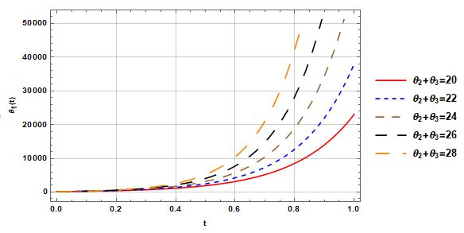

**Figure`1: The value of profits over time, with variations of reinvestments and flow of borrowings.**

Figure 1, describes the value of profit made overtime with respect to investment and all monies borrowed so far. It also shows increase on the level of reinvestment and borrowing more money for an investment, also increases the value of profit within the economic cycle in time varying investment without the commitment of liabilities. The remark in a business can lead to more employees and customers for job opportunities in the investment.

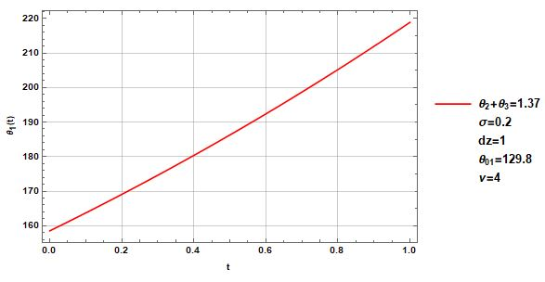

**Figure`2: The value of profits over time  in the economic structural circuit.**

Figure 2, describes perfect positive value overtime in the economic structural cycle. It indicates good positive relationship between the economic variables as the value of the independent variable increases, the mean of the dependent variable also tends to increase as well in the business cycle. This solution informs an investor to make viable decision based on the level of their business.

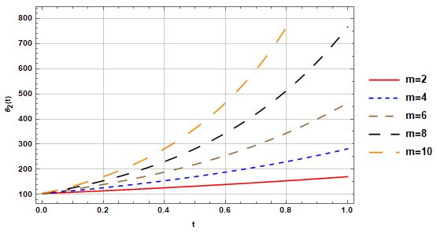

**Figure`3: The value of reinvestments over time  with variations of constant trends.**

Figure 3 denotes the value of the reinvestment with some fraction of profit according to the proportion of the investment during the business cycle as can be seen that increase on the level of proportion of profit also increase in the value of the reinvestment. This is realistic because increasing profit daily will automatically enable organization to invest more in term of portfolio of investment et. This remark shows that the investment is doing well in every ramification. Therefore, a higher profit margin will increase the value of the reinvested business and more on the investor to accumulate wealth.

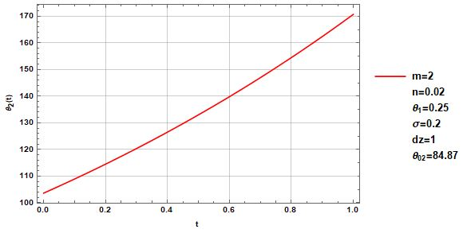

**Figure`4: The value of profits over time  in the economic structural circuit.**

The explanation of 2 holds for Figure 4 respectively.

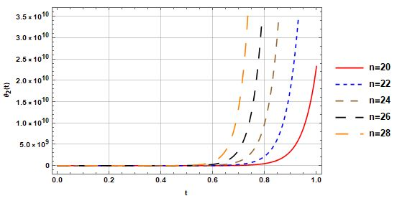

**Figure`5: The value of reinvestments over time  with variations of yearly rate  .**

Figure 5 describes the value of reinvestment with variation of yearly reassessment rate of the business. As the business is being reassessed yearly, it strengthens the financial power of the investment overtime. This scenario is profitable because within reassessment brings a lot feature into the business during the trading days.

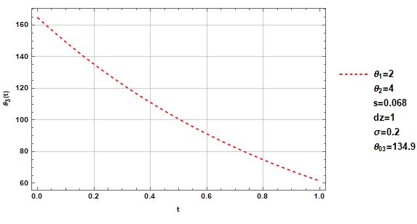

**Figure`6: The value of reinvestments over time  in the economic structural circuit.**

In Figure 6, we see a situation where the value of reinvestment funds (funds that are reinvested into an asset or investment rather than being withdrawn) is declining over time. It also indicates that the asset or investment is not generating enough fund returns to offset the effect of inflation or other factors, resulting in a net decrease in wealth over time.

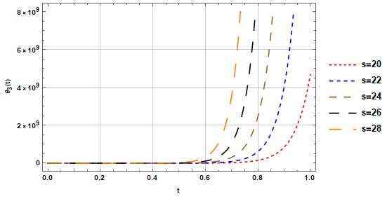

**Figure`7: The value of flow of borrowing over time  with variations of debt rate**

In Figure 7, the plot shows the value of capital borrowing according to debt rate. This situation allows investment in more sales, creating more profits. Therefore, working capital is in encourage in business cycle flowing keeping cash flowing and use investment to make more than it cost to borrow.

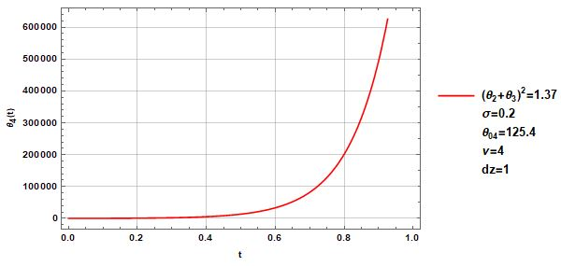

**Figure 8: The value of profits as quadratic function with a periodic influence over time  .**

Figure 8 is the value of profit as a quadratic function with periodic influences over the business cycles. This implies that the business will grow exponentially with available fund. This form of business cycle is invested in millions of naira during its seasonal period.

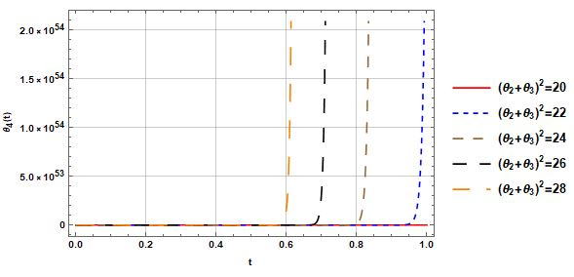

**Figure`9: The profits as quadratic function with a periodic influence over time  with variations of reinvestments and flow of borrowings.**

Figure 9 which describes the value of profit with periodic influences against reinvestment and borrowing more money to support business. When reinvestment is done by increasing fund, it gives financial boost to the business.

**4.1 Conclusion**

The application of Ito’s theorem was use to value economic variables of business cycles. In particular, Bouali’s firm models of economic variables of business cycles were re-formulated to System of Stochastic Differential Equation. The wide detailed and coincided conditions are effectively achieved which gave rise to the valuation of profits, reinvestments, flow of borrowing and value of profits as a result of quadratic function with periodic influences in time varying investment were all established. The effects of the value of the economic variables such as profits, reinvestments, financial flow of borrowings and their periodic effects were wonderfully analyzed; the ical solutions of economic variables and other relevant parameters were discussed within the investment cycles. In the next study we shall be looking at empirical case of this study.

Disclaimer (Artificial intelligence)

Option 1:

Author(s) hereby declare that NO generative AI technologies such as Large Language Models (ChatGPT, COPILOT, etc.) and text-to-image generators have been used during the writing or editing of this manuscript.

Option 2:

Author(s) hereby declare that generative AI technologies such as Large Language Models, etc. have been used during the writing or editing of manuscripts. This explanation will include the name, version, model, and source of the generative AI technology and as well as all input prompts provided to the generative AI technology

Details of the AI usage are given below:

1.

2.

3.

**REFERENCE**

[1] Amadi, I. U. and Charles, A, (2022). An Analytical Method for the Assessment of asset price changes in capital market. *International journal of Applied science and Mathematical Theory*.vol.8(2) : 1-

[2] Ugbebor, O. O., Onah, S. F. and Ojowo, O. (2001). An Empirical Stochastic Model of Stock Price Changes. *Journal of the Nigerian Mathematical Society. Vol. 20*: 95-101.

[3] Amadi, I. U., Igbudu, R. and Azor, P. A. (2020). Stochastic Analysis of the Impact of Growth-Rates on Stock Market Prices in Nigeria*. Asian Journal of Economics, Business and Accounting. Vol*. 21 (24): 9-21.

[4] Osu, B. O. and Amadi, l. U. (2022). A stochastic Analysis of stock Market price Fluctuation for capital market. *journal of applied Mathematics and computation. Vol. 6*(1):85- 95.

[5] Davies, I., Amadi, I. U. and Ndu, R. I. (2019). Stability Analysis of Stochastic Model for Stock Market Prices. *International Journal of Mathematics and Computational Methods. Vol.4*: 79-86.

[6] Adeosun, M. E., Edeki, S. O. and Ugbebor, O. O. (2015). Stochastic Analysis of Stock Market Price Models: A Case Study of the Nigerian Stock Exchange (NSE). *WSEAS Transactions on Mathematics. Vol. 14*: 353-363.

[7] Amadi, I. U. and Charles, A. (2022). Stochastic analysis of time -varying investment returns in capital market domain*. International Journal of mathematics and statistics studies, Vol.10* (3): 28-38.

[8] Ofomata, A. I. O., Inyama, S. C., Umana, R. A., and Omane, A. O. (2017). A stochastic model of the dynamics of stock price for forecasting. *Journal of Advance in Mathematics and computer science, Vol.25*(6) :1-24.

[9] Wokoma, D. S. A. (Bishop), Amadi, I. U. and Aboko, I. S. (2022). A Stochastic Model for Stock Market Price Variation*. Asian Research Journal of Mathematics. Vol. 21* (4): 41- 49.

[10] Amadi, I. U., Ogbogbo, C. P. and Osu, B. O. (2022). Stochastic Analysis of Stock Price Changes as Markov Chain in Finite States. *Global Journal of Pure and Applied Sciences. Vol.* 28: 91-98.

[11] Duarte,J.,Januario. C., Martins, N.(2016). Analytical Solutions of an Economic Model by Homotopy Analysis Method*. Applied Mathematical Science*, vol.10,50, 2483-2490.

[12] Amadi, I.U. and Okpoye, O.T.(2022). Stochastic Analysis Model in Estimation of Stock Return rates in Capital Market Investment , *International Journal of Mathematics Analysis Modeling,* 5, issue 1, 108 – 120.

[13] Amadi, innocent Uchenna, Igbudu Richard and Azor Promise A. (2022). Stochastic Analysis of the Impact of Growth-Rates on Stock Market Prices . *Asian Journal of Economic, Business and Accounting*

[14] Davies, I, Amadi, I.U and Ndu, R. I (2019). Stability Analysis of Stochastic Model for Stock Market Prices. *International journal of mathematics and computational* *methods*, 4,79-86.

[15] Ekakaa, E.N., Nwobi, F.N. and Amadi, I.U. (2016). The impact analysis of growth rate on securities. *Journal of Nigeria Association of Mathematical Physics,* 38, 279-284.

[16] Osu, B.O, Okoroafor, A.C. and Olunkwa, C. (2009). Stability Analysis of Stochastic model of Stock market price. *African journal of mathematics and computer science* 2(6), 98 – 103.

[17] Osu, B.O. (2010). A stochastic model of the variation of the capital market price*. International Journal of trade, Economics and Finance,* Vol.1,No3),pp.297-302*.*

[18] Osu, B.O. (2010). A Stochastic Model of the variation of the capital market price. *International journal of trade, economics and finance*, 1, 3, 329 – 302.

[19] Osu, B.O. and Amadi, I.U. (2022). A Stochastic Analysis of Stock Market Price Fluctuations for Capital market. *Journal of applied mathematics and computation*

[20] Sunil, K. K, Prakriti, T. S. K, Nisha, D. (2011). Using Artificial Neural-Networks in Stochastic Differential Equations Based Software Reliability Growth Modelling. *Journal of software engineering and applications, vol. 4.No. 10.*

[21] Yamada, s and Tamura, Y (2006). A flexible Stochastic Differential Equation Model in Distributed Development Environment. *European journal of operational research. Vol. 168, N0.1. 143-152.*