**Economic and Ecological Insights into Aquatic Ecosystem Services: Exploring Multifunctional Benefits**

**Abstract**

Aquatic ecosystems are fundamental to sustaining biodiversity, regulating the climate, and supporting human societies and economies. However, these systems are increasingly threatened by pollution, habitat degradation, overexploitation, and climate change. This review summarizes the state of knowledge about the categorization, economic assessment, and policy frameworks supporting the various advantages that aquatic ecosystems offer. It highlights the application of both market-based and non-market valuation methods, which have revealed the immense-yet often underappreciated-economic value of these environments. Innovative approaches such as blue carbon credits and payment for ecosystem services are gaining traction, offering new pathways for conservation finance. Achieving sustainable management will require not only improved data collection and more robust valuation techniques, but also the meaningful integration of local and Indigenous knowledge into policy and decision-making. Safeguarding aquatic ecosystems is essential for long-term ecological resilience and human well-being.

**Keywords**: Aquatic Ecosystems, Ecosystem Services, Economic Valuation, Environmental Policy, Sustainability

**1. Introduction**

Aquatic ecosystems-including rivers, lakes, wetlands, estuaries, and oceans-play a central role in sustaining life on Earth through a wide range of ecological functions. Maintaining global biogeochemical cycles and sustaining terrestrial and aquatic life depend on these ecosystems' substantial contributions to oxygen production, carbon sequestration, and freshwater supplies. (Duarte et al., 2013; Mitsch & Gosselink, 2015). For example, wetlands are important carbon sinks that slow down climate change because they store between 20 and 30 percent of the world's soil carbon, although making up only around 6 percent of the planet's land surface (Bridgham et al., 2006; Mitsch et al., 2015).

Biodiversity within aquatic habitats is exceptionally rich and diverse. Despite making up less than 1% of the ocean floor, coral reefs are hotspots for biodiversity because they are home to around 25% of all marine life, including fish, invertebrates, and algae (Spalding et al., 2001). Similarly, freshwater ecosystems, which cover a small fraction of the Earth’s surface, support about 10% of all known species, many of which are endemic and highly specialized (Dudgeon et al., 2006). These ecosystems maintain complex food webs and ecological interactions that are vital for ecosystem resilience and function.

Beyond their ecological importance, aquatic ecosystems provide numerous ecosystem services that are crucial for human well-being. They supply clean drinking water, support fisheries and aquaculture that feed millions, regulate floods, purify water, and offer recreational and cultural benefits (Costanza et al., 2014; Barbier et al., 2013). Fisheries alone contribute to the livelihoods of over 56 million people worldwide and are a primary protein source for billions, especially in developing countries (FAO, 2022). Moreover, aquatic ecosystems contribute to mental health and cultural identity, underscoring their multifaceted value to societies (MEA, 2005).

Despite these intrinsic benefits, human activities have increasingly compromised aquatic ecosystem health. Pollution, overfishing, land-use change, dam construction, and climate change have led to habitat degradation, loss of biodiversity, and diminished ecosystem services (Reid et al., 2019). For example, coral reefs are experiencing widespread bleaching due to ocean warming and acidification, threatening the species they support and the livelihoods dependent on them (Hughes et al., 2017). Wetlands have been drained at alarming rates for agriculture and urban development, reducing their capacity to store carbon and regulate hydrological cycles (Davidson, 2014).

Recognizing the economic and social value embedded in aquatic ecosystems is crucial for fostering conservation policies that are both scientifically informed and economically rational. Valuation studies estimate that the global value of ecosystem services from coastal and marine systems alone ranges from $21 trillion to $87 trillion annually, emphasizing the immense benefits these ecosystems provide (Costanza et al., 2014). Integrating ecological science with economic valuation supports evidence-based policymaking that prioritizes sustainable management and restoration, ensuring the continued provision of these vital services for future generations (Barbier et al., 2013).

**1.1 Classification of Aquatic Ecosystem Services**

Multiple frameworks, such as those proposed by the Millennium Ecosystem Assessment (MEA, 2005) and the Intergovernmental Science-Policy Platform on Biodiversity and Ecosystem Services (IPBES), broadly classify ecosystem services into four categories:

* Provisioning Services: These include tangible goods like fisheries, freshwater, and raw materials for consumption and industry (FAO, 2023).
* Regulating Services: Functions such as climate moderation, water purification, and flood mitigation fall under this category. For example, wetlands naturally filter pollutants and control floods (Mitsch & Gosselink, 2015).
* Cultural Services: These nonmaterial benefits range from recreation and tourism to spiritual and aesthetic values (Chan et al., 2012).
* Supporting Services: Fundamental processes including nutrient cycling, primary production, and habitat formation that underpin other services (MEA, 2005).

**1.2 Aquatic Ecosystems and Global Stability**

Oceans and inland waters contribute to global stability by absorbing carbon dioxide and regulating hydrological cycles. For instance, oceans sequester roughly 25–30% of anthropogenic CO₂, buffering global warming impacts (IPCC, 2023). Similarly, wetlands and mangroves provide exceptional carbon storage capacities—sometimes up to five times that of tropical forests while also diminishing flood risks (Alongi, 2014; Duarte et al., 2013). Even though freshwaters account for a relatively small percentage of the Earth’s water, they are home to a disproportionately high number of vertebrate species (IPBES, 2019).

**1.3 Threats to Aquatic Ecosystems**

Aquatic habitats are increasingly threatened by various human-induced stressors:

* Pollution: Industrial discharge, plastic debris, and agricultural runoff have led to widespread eutrophication, oxygen depletion, and biodiversity loss (Diaz & Rosenberg, 2008).
* Climate Change: Shifts in temperature, rising sea levels, and acidification disrupt delicate marine processes and coral stability (IPCC, 2023).
* Overfishing and Habitat Destruction: Unsustainable fishing practices and coastal development jeopardize species resilience and ecosystem integrity (FAO, 2023).
* Water Overextraction: Excessive freshwater withdrawals for agriculture, industry, and urban growth are stressing already scarce resources, as highlighted by studies on global water footprints (Hoekstra et al., 2012).

The estimated global value of ecosystem services now reaches into the tens of trillions of dollars annually; yet, many aquatic benefits remain underrepresented in policy and economic decisions (Costanza et al., 2014). Comprehensive valuation and the incorporation of these figures into national accounts are essential for catalyzing effective conservation measures.

**2. Provisioning Services**

Aquatic ecosystems supply a multitude of tangible goods that are foundational to human well-being and economic activity. These provisioning services are providing food, freshwater, raw materials, and genetic resources, all of which are critical for livelihoods, nutrition, and innovation (FAO, 2022; Bartley et al., 2015; Alongi, 2014).

**2.1 Fisheries and Aquaculture**

Aquatic resources are indispensable for global food security. Fish and other aquatic foods provide nearly 20% of animal protein consumed by more than 3 billion people, with this proportion rising significantly in many coastal and developing countries (FAO, 2022; World Bank, 2013). The fisheries and aquaculture sector supports the livelihoods of over 60 million people directly, and many more through associated industries (FAO, 2022).

* **Marine Fisheries:** Marine capture fisheries remain the cornerstone of global fish production. Key species such as tuna, cod, herring, and anchovies contribute substantially to both industrial and small-scale fisheries, underpinning nutrition and economic stability in many regions (FAO, 2022). In 2020, global marine capture fisheries produced approximately 78 million tonnes, with Asia accounting for the largest share (FAO, 2022).
* **Freshwater Fisheries:** Inland fisheries, which operate in rivers, lakes, and floodplains, are vital for food security and local economies, especially in Africa and Asia. Species such as tilapia, catfish, and carp are central to rural diets and provide affordable protein and micronutrients (Bartley et al., 2015; FAO, 2022). These fisheries are often small-scale but collectively yield over 12 million tonnes annually (FAO, 2022).
* **Aquaculture:** With increasing pressure on wild stocks, aquaculture has become the fastest-growing food production sector globally. For the first time in history, aquaculture surpassed capture fisheries in total production in 2020, now providing over half of all fish consumed by humans (FAO, 2022). The expansion of aquaculture, particularly in Asia, has been pivotal in meeting rising demand and reducing pressure on wild populations (FAO, 2022).

**2.2 Freshwater Supply**

Aquifers, lakes, and rivers are necessary to maintain industry, support agriculture, and supply drinking water. Nearly 8 billion people rely on these freshwater resources, yet around 2.2 billion still lack access to safely managed drinking water, underscoring the urgent need for improved water management and infrastructure (UN-Water, 2023; FAO, 2022). Additionally, aquatic ecosystems are essential for nutrient cycling, sediment retention, and natural water purification—all of which are critical for preserving the availability and quality of water (Vörösmarty et al., 2010).

**2.3 Raw Materials and Biogenetic Resources**

Beyond food and water, aquatic systems provide a range of raw materials and biogenetic resources. Mangrove forests, for example, supply wood for fuel, construction, and traditional uses, supporting both subsistence and commercial economies in tropical regions (Alongi, 2014). Furthermore, aquatic biodiversity is a reservoir of genetic material crucial for pharmaceutical and biotechnological innovation. Numerous bioactive substances, such as antibiotics, antivirals, and anticancer drugs, have been produced by marine organisms, underscoring the significance of preserving aquatic genetic diversity for upcoming discoveries (Alongi, 2014).

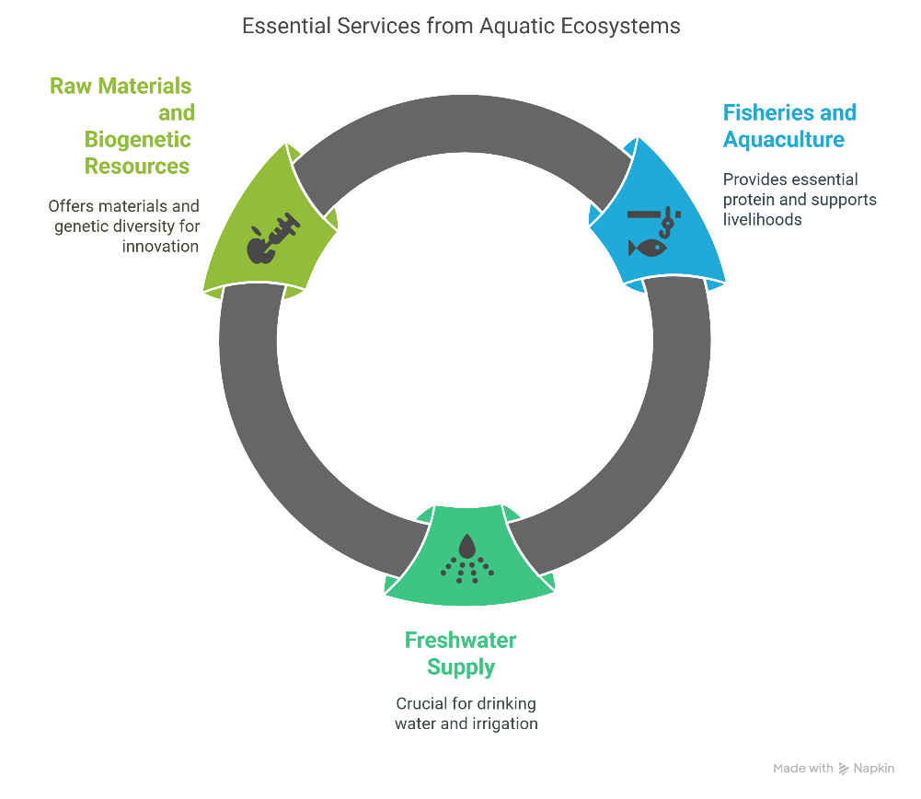

Fig. 1 Essential Provisioning services

**3. Regulating Services**

Aquatic ecosystems provide a suite of regulating services that are essential for environmental stability and human well-being. These services provide climate regulation, water purification, flood and erosion control, and disease regulation, all of which are mediated by the ecological processes and biodiversity within aquatic habitats (Mitsch & Gosselink, 2015; Duarte et al., 2013; Doney et al., 2009).

**3.1 Climate Regulation**

Oceans and coastal ecosystems play a dual role in climate regulation. The global ocean acts as a major carbon sink, absorbing approximately one-quarter of anthropogenic CO₂ emissions annually and thus moderating atmospheric greenhouse gas concentrations (IPCC, 2023). Coastal vegetated habitats-such as mangroves, salt marshes, and seagrass meadows-are particularly efficient at sequestering “blue carbon,” storing carbon at rates per unit area that far exceed most terrestrial ecosystems (Duarte et al., 2013). However, ocean acidification and rising sea temperatures are threatening these regulatory services by impairing the physiological processes of marine organisms and altering the dynamics of carbon cycling and storage (Doney et al., 2009).

**3.2 Water Purification**

Wetlands, river systems, and mangroves serve as natural water treatment systems, removing nutrients, sediments, and pollutants from water through a combination of physical, chemical, and biological processes (Mitsch & Gosselink, 2015). Wetland plants and microbial communities facilitate the breakdown and transformation of organic matter, the uptake and storage of nutrients such as nitrogen and phosphorus, and the removal of heavy metals and other contaminants (Mitsch & Gosselink, 2015).

**3.3 Flood and Erosion Control**

Coastal and riparian habitats such as mangroves, salt marshes, and wetlands provide critical protection against floods and erosion. Mangrove forests, for example, have been shown to reduce wave energy by up to 66% and decrease shoreline erosion, acting as natural buffers during storm surges and extreme weather events (Friess et al., 2016). Wetlands absorb and store excess rainfall, reducing the severity and frequency of floods, while also stabilizing soils and preventing sediment loss (Mitsch & Gosselink, 2015; UN-Water, 2023).

**3.4 Disease Regulation**

Healthy aquatic ecosystems contribute to disease regulation by supporting biodiversity and natural predator populations that control disease vectors. Wetlands, for instance, provide habitat for fish and invertebrates that prey on mosquito larvae, thereby reducing the risk of mosquito-borne diseases such as malaria (Lafferty, 2009). Conversely, the degradation of aquatic habitats can disrupt these natural controls, leading to increased incidence of waterborne and vector-borne diseases (Lafferty, 2009).

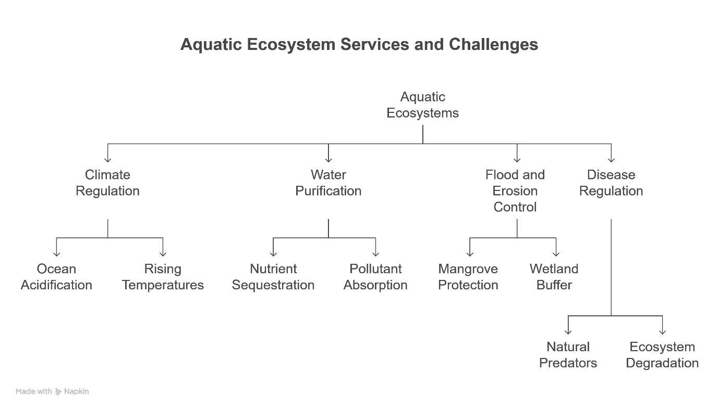

Fig. 2 Regulating services

**4. Cultural Services**

Aquatic ecosystems provide a wealth of nonmaterial benefits that enrich human societies and individual well-being. These cultural services encompass recreation, tourism, spiritual values, heritage, and psychological health, all of which are integral to quality of life and social identity.

**4.1 Recreational and Tourism Benefits**

Aquatic environments are focal points for recreation and tourism, supporting activities such as boating, angling, swimming, diving, and wildlife observation. In addition to improving individual well-being, these pursuits have a significant positive economic impact on both the local and national economies. On a global scale, coastal and marine tourism is a major economic sector, generating hundreds of billions of dollars and supporting millions of jobs, particularly in coastal regions (Spalding et al., 2017). The attractiveness of clean, biodiverse aquatic environments is a key driver for tourism, and the loss or degradation of these systems can result in significant economic and social costs.

**4.2 Spiritual and Heritage Values**

Water bodies hold profound spiritual, religious, and cultural significance for societies worldwide. Many rivers and lakes are revered as sacred sites or are central to traditional rituals and beliefs. The Ganges River in India, for example, is both a vital water resource and a sacred symbol in Hinduism, playing a central role in religious ceremonies and cultural identity (Alley, 2002).

**4.3 Aesthetic and Psychological Well-Being**

Access to aquatic environments also provides significant aesthetic and psychological benefits. The concept of "blue space" refers to the positive effects of proximity to water on mental health and well-being. Regular exposure to aquatic environments has been linked to decreased levels of stress, anxiety, and depression as well as better cognitive performance, according to empirical study (Gascon et al., 2017; White et al., 2020). These restorative effects are attributed to the visual, auditory, and experiential qualities of water bodies, which foster relaxation, inspiration, and a sense of place (White et al., 2020). Such benefits underscore the importance of maintaining healthy aquatic ecosystems not only for ecological and economic reasons but also for human flourishing.

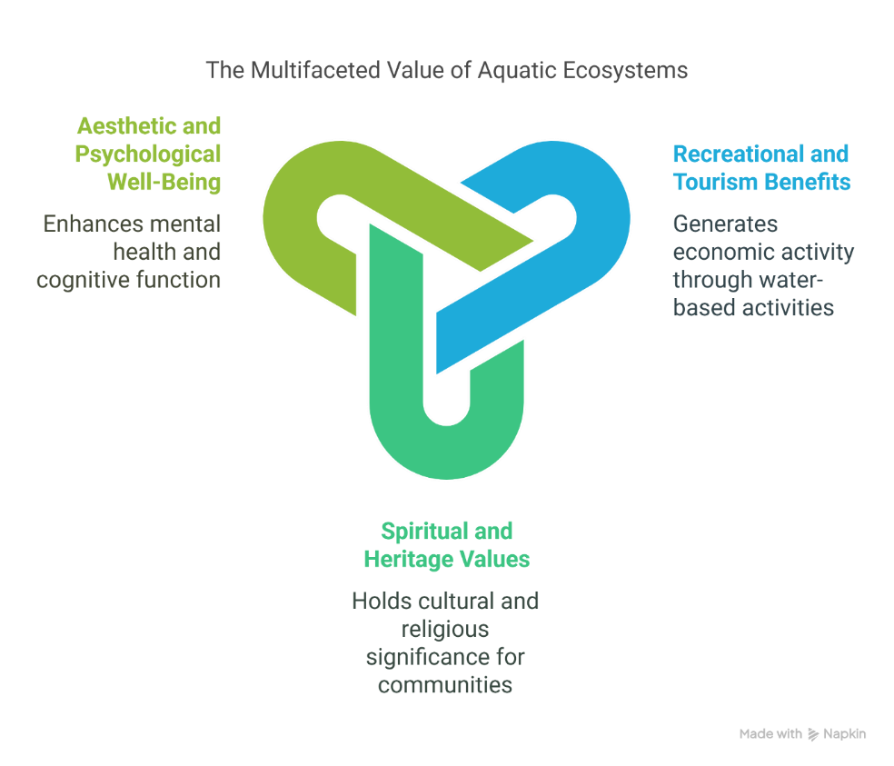

Fig. 3 Cultural services

**5. Supporting Services**

The foundational ecological processes provided by aquatic ecosystems underpin all other ecosystem services. These supporting services provide nutrient cycling, primary production, habitat provision, and the maintenance of biodiversity, which are essential for the functioning and resilience of aquatic environments (MEA, 2005; Frontiers in Ecology and Evolution, 2021).

**5.1 Nutrient Cycling and Primary Production**

Primary production in aquatic systems is primarily driven by phytoplankton and aquatic plants, which convert solar energy and inorganic nutrients into organic matter through photosynthesis. This process not only forms the base of aquatic food webs but also contributes significantly to global oxygen production and carbon cycling (Field et al., 1998; MEA, 2005). Phytoplankton alone are estimated to be responsible for nearly half of the world’s net primary production, highlighting their central role in sustaining aquatic and terrestrial life (Field et al., 1998).

Nutrient cycling-especially of nitrogen and phosphorus-is mediated by complex microbial processes such as nitrogen fixation, nitrification, and denitrification, which regulate the availability of essential elements in aquatic ecosystems (Gruber & Galloway, 2008; Elser & Bennett, 2011). Efficient cycling of these nutrients is crucial for maintaining ecosystem productivity and preventing problems like harmful algal blooms, which can arise from nutrient imbalances (Elser & Bennett, 2011; MEA, 2005).

**5.2 Habitat Provision and Biodiversity Maintenance**

Aquatic habitats-ranging from coral reefs and mangroves to inland wetlands and rivers-are essential for the preservation of biodiversity (MEA, 2005; Pinsky et al., 2020). These environments provide breeding grounds, nurseries, and refuges for a vast array of species, supporting complex food webs and enhancing ecosystem resilience (MEA, 2005; Pinsky et al., 2020). For example, coral reefs and mangroves serve as critical nursery habitats for numerous fish and invertebrate species, while freshwater wetlands support high levels of endemism and species richness (MEA, 2005; IGB, 2025).

Biodiversity within aquatic systems is closely linked to ecosystem stability and the capacity to recover from disturbances. Diverse communities are more likely to maintain ecosystem functions in the face of environmental change, as different species can compensate for one another’s roles (Frontiers in Ecology and Evolution, 2021). The conservation and restoration of aquatic habitats are thus vital for sustaining the entire spectrum of ecosystem services that benefit both nature and society (MEA, 2005; IGB, 2025).

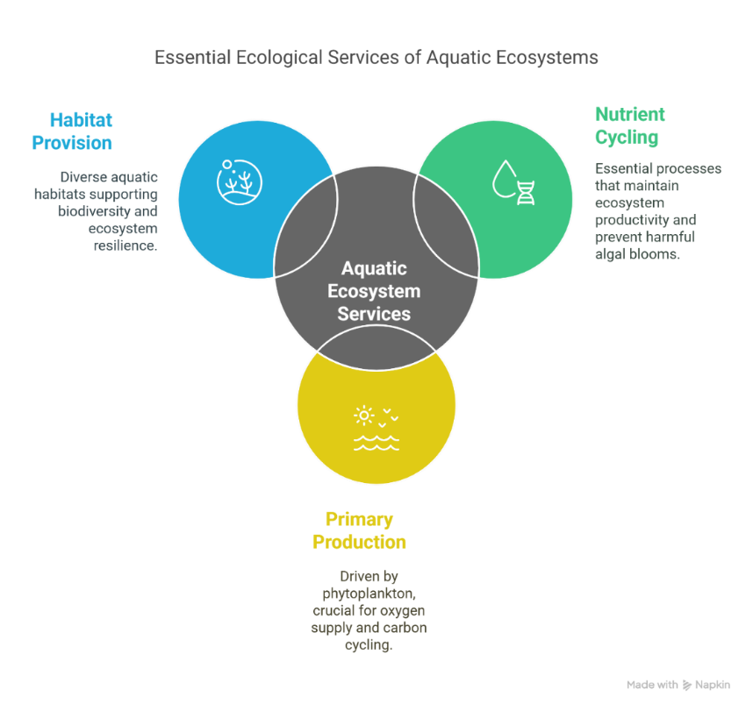

Fig. 4 Essential ecological services of aquatic ecosystems

**6. Economic Valuation of Ecosystem Services**

A range of techniques is used to estimate the value of ecosystem services, each suited to different types of services and policy contexts:

* **Market-Based Valuation:** This approach uses actual market prices to estimate the value of goods and services that are traded, such as fishery yields, shellfish harvests, and tourism receipts. For example, the economic contribution of commercial fisheries can be calculated by multiplying catch volumes by prevailing market prices
* **Revealed Preference Techniques:** These methods infer value from observed behavior. The travel cost method estimates recreational value by analyzing how much people spend to access aquatic sites, while hedonic pricing assesses how environmental attributes (like water quality or proximity to lakes) affect property values
* **Stated Preference Approaches:** When market data are unavailable, stated preference methods such as contingent valuation and choice experiments are used. These surveys ask individuals their willingness to pay for hypothetical improvements or to avoid losses in ecosystem services, providing monetary estimates for non-market benefits like biodiversity or water quality.

**6.2 Global Economic Estimates**

Recent global syntheses estimate that coastal and marine ecosystems contribute trillions of dollars annually to the world economy through fisheries, coastal protection, tourism, and other services (Costanza et al., 2014; Brander et al., 2024). For example, Costanza et al. (2014) estimated the annual value of coral reefs at $36,794 per hectare and mangroves at $193,845 per hectare, reflecting their roles in supporting fisheries, preventing erosion, and attracting tourism. The loss or degradation of these systems could result in substantial economic costs, including reduced fishery yields, increased vulnerability to storms, and higher water treatment expenses (Costanza et al., 2014; World Bank, 2023).

**6.3 Policy Integration**

Integrating ecosystem service values into policy and national accounting frameworks is increasingly recognized as best practice for sustainable development (Barbier et al, 2013; UN, 2023). Initiatives such as the United Nations System of Environmental-Economic Accounting (SEEA) provide standardized approaches to include natural capital in economic planning (UN, 2023). Market-based instruments like Payment for Ecosystem Services (PES) and blue carbon credits offer financial incentives to conserve and restore aquatic habitats, aligning economic rewards with environmental stewardship (Barbier et al, 2013; Brander et al., 2024). Such mechanisms help ensure that the true value of ecosystem services is reflected in decision-making and resource management.

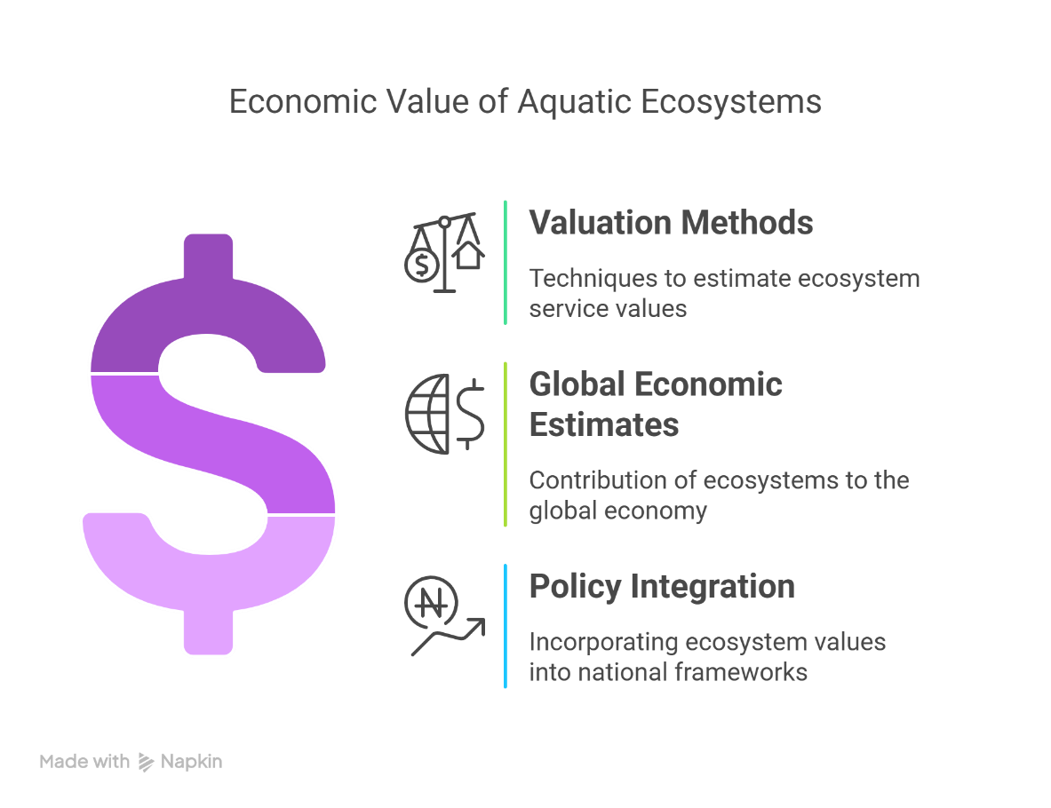

Fig. 5 Economic essentials for Aquatic Ecosystems

**7. Policy Implications and Sustainable Development**

Effective management of aquatic ecosystems requires robust policy frameworks that integrate scientific assessments, economic valuation, and local and Indigenous knowledge. Such integration is essential for sustaining ecosystem services, supporting livelihoods, and achieving global development goals.

**7.1 International and National Frameworks**

Global agreements and frameworks provide the foundation for integrated aquatic ecosystem management. The United Nations Sustainable Development Goals-specifically SDG 6 (Clean Water and Sanitation) and SDG 14 (Life Below Water)-explicitly urge that freshwater and marine resources be protected and used sustainably (UN, 2023; UN, 2024; UN-Water, 2023). The Ramsar Convention on Wetlands promotes the conservation and wise use of wetlands, while the Paris Agreement addresses the impacts of climate change on aquatic systems (Ramsar Convention Secretariat, 2018; UNFCCC, 2015).

**7.2 Policy Instruments**

A range of policy instruments is employed to promote sustainable aquatic ecosystem management. Market-based mechanisms-including fishing quotas, tradable permits, and Payment for Ecosystem Services (PES) schemes-offer financial incentives for sustainable resource use (Mitsch & Gosselink, 2015). Regulatory approaches, such as the designation of Marine Protected Areas (MPAs) and the enforcement of stricter pollution controls, are critical for preserving aquatic health and biodiversity (Friess et al., 2016). These instruments are most effective when combined with monitoring, adaptive management, and stakeholder engagement.

**7.3 Community and Indigenous Approaches**

Local and Indigenous management practices have long contributed to the stewardship of aquatic environments. Case studies from the Pacific Islands show that Locally Managed Marine Areas (LMMAs) can enhance fish stocks and biodiversity through community-based rules and traditional ecological knowledge (Jupiter et al., 2014). In New Zealand, Māori river guardianship (kaitiakitanga) integrates cultural values and scientific approaches for holistic river management (Berkes, 1999). Recent research emphasizes the importance of co-producing knowledge and involving Indigenous and local communities in decision-making to ensure management strategies are contextually relevant, equitable, and sustainable (Rivers et al., 2023).

**8. Conclusion**

Our planet depends on aquatic ecosystems because they provide necessary functions that keep human societies afloat. They support food security through fisheries and aquaculture, offer clean water for drinking and agriculture, and supply raw materials and genetic resources. These ecosystems regulate the climate by sequestering carbon, purify water, mitigate floods and erosion, and help control disease, all of which safeguard environmental and public health. They also contribute to recreation, tourism, cultural identity, and psychological well-being through the restorative power of blue spaces.

Aquatic ecosystems are being threatened by overexploitation, pollution, habitat loss, and climate change, notwithstanding their significance. These difficulties jeopardize global economies and food security in addition to reducing their ability to deliver essential services. For well-informed policymaking, it is essential to quantify the economic value of these services. We can match financial incentives with conservation objectives by integrating these values into national accounting and policies such as ecological payments and blue carbon credits. Sustainable management requires strong governance, market-based mechanisms, and the inclusion of local and Indigenous knowledge. Protecting and restoring aquatic habitats is essential to ensuring that these ecosystems continue to support human well-being and global resilience.

References:

Alley, K. D. (2002). *On the banks of the Ganga: When wastewater meets a sacred river*. University of Michigan Press. <https://doi.org/10.3998/mpub.12072>

Alongi, D. M. (2014). Carbon cycling and storage in mangrove forests. *Annual Review of Marine Science, 6*, 195–219. <https://doi.org/10.1146/annurev-marine-010213-135020>

Barbier, E. B., Georgiou, I. Y., Enchelmeyer, B., & Reed, D. J. (2013). The value of wetlands in protecting southeast Louisiana from hurricane storm surges. *PloS one*, *8*(3), e58715.

Bartley, D. M., De Graaf, G. J., Valbo‐Jørgensen, J., & Marmulla, G. (2015). Inland capture fisheries: status and data issues. *Fisheries Management and Ecology*, *22*(1), 71-77.

Berkes, F., & Ecology, S. (1999). Traditional ecological knowledge and resource management. *Philadelphia and London: Taylor and Francis*.

Brander, L. M., De Groot, R., Schägner, J. P., Guisado-Goñi, V., Van't Hoff, V., Solomonides, S., ... & Thomas, R. (2024). Economic values for ecosystem services: A global synthesis and way forward. *Ecosystem Services*, *66*, 101606.

Bridgham, S. D., Megonigal, J. P., Keller, J. K., Bliss, N. B., & Trettin, C. (2006). The carbon balance of North American wetlands. *Wetlands*, *26*(4), 889-916.

Chan, K. M., Satterfield, T., & Goldstein, J. (2012). Rethinking ecosystem services to better address and navigate cultural values. *Ecological economics*, *74*, 8-18.

Costanza, R., De Groot, R., Sutton, P., Van der Ploeg, S., Anderson, S. J., Kubiszewski, I., ... & Turner, R. K. (2014). Changes in the global value of ecosystem services. *Global environmental change*, *26*, 152-158.

Davidson, N. C. (2014). How much wetland has the world lost? Long-term and recent trends in global wetland area. *Marine and Freshwater Research*, *65*(10), 934-941.

Diaz, R. J., & Rosenberg, R. (2008). Spreading dead zones and consequences for marine ecosystems. *science*, *321*(5891), 926-929.

Doney, S. C., Fabry, V. J., Feely, R. A., & Kleypas, J. A. (2009). Ocean acidification: the other CO2 problem. *Annual review of marine science*, *1*(1), 169-192.

Duarte, C. M., Losada, I. J., Hendriks, I. E., Mazarrasa, I., & Marbà, N. (2013). The role of coastal plant communities for climate change mitigation and adaptation. *Nature climate change*, *3*(11), 961-968.

Dudgeon, D., Arthington, A. H., Gessner, M. O., Kawabata, Z. I., Knowler, D. J., Lévêque, C., ... & Sullivan, C. A. (2006). Freshwater biodiversity: importance, threats, status and conservation challenges. *Biological reviews*, *81*(2), 163-182.

Elser, J., & Bennett, E. (2011). A broken biogeochemical cycle. *Nature*, *478*(7367), 29-31.

Field, C. B., Behrenfeld, M. J., Randerson, J. T., & Falkowski, P. (1998). Primary production of the biosphere: integrating terrestrial and oceanic components. *science*, *281*(5374), 237-240.

Food and Agriculture Organization of the United Nations. (2022). The state of world fisheries and aquaculture 2022: Towards blue transformation. FAO. <https://doi.org/10.4060/cc0461en>

Food and Agriculture Organization of the United Nations. (2023). *The state of world fisheries and aquaculture 2023: Sustainability in action*. FAO. <https://www.fao.org/publications>

Friess, D. A., Thompson, B. S., Brown, B., Amir, A. A., Cameron, C., Koldewey, H. J., ... & Sidik, F. (2016). Policy challenges and approaches for the conservation of mangrove forests in Southeast Asia. *Conservation Biology*, *30*(5), 933-949.

Frontiers in Ecology and Evolution. (2021). *Intersecting ecosystem services across the aquatic continuum*. *Frontiers in Ecology and Evolution, 9*, 628658. <https://doi.org/10.3389/fevo.2021.628658>

Gruber, N., & Galloway, J. N. (2008). An Earth-system perspective of the global nitrogen cycle. *Nature*, *451*(7176), 293-296.

Hoekstra, A. Y., & Mekonnen, M. M. (2012). The water footprint of humanity. *Proceedings of the national academy of sciences*, *109*(9), 3232-3237.

Hughes, T. P., Kerry, J. T., Álvarez-Noriega, M., Álvarez-Romero, J. G., Anderson, K. D., Baird, A. H., ... & Wilson, S. K. (2017). Global warming and recurrent mass bleaching of corals. *Nature*, *543*(7645), 373-377.

IGB. (2025). *Ecosystem services for a sustainable future*. Leibniz-Institute of Freshwater Ecology and Inland Fisheries.

Intergovernmental Panel on Climate Change. (2023). *Climate change 2023: Synthesis report. Contribution of Working Groups I, II and III to the Sixth Assessment Report of the Intergovernmental Panel on Climate Change* [Core Writing Team, H. Lee & J. Romero (Eds.)]. IPCC. <https://www.ipcc.ch/report/sixth-assessment-synthesis-report/>

Intergovernmental Science-Policy Platform on Biodiversity and Ecosystem Services. (2019). *Global assessment report on biodiversity and ecosystem services*. IPBES. <https://ipbes.net/global-assessment>

Jupiter, S. D., Cohen, P. J., Weeks, R., Tawake, A., & Govan, H. (2014). Locally-managed marine areas: multiple objectives and diverse strategies. *Pacific Conservation Biology*, *20*(2), 165-179.

Lafferty, K. D. (2009). The ecology of climate change and infectious diseases. *Ecology*, *90*(4), 888-900.

Millennium Ecosystem Assessment. (2005). *Ecosystems and human well-being: Synthesis*. Island Press. <https://www.millenniumassessment.org/documents/document.356.aspx.pdf>

Mitsch, W. J., & Gosselink, J. G. (2015). *Wetlands*. John wiley & sons.

Mitsch, W. J., Bernal, B., & Hernandez, M. E. (2015). Ecosystem services of wetlands. *International Journal of Biodiversity Science, Ecosystem Services & Management*, *11*(1), 1-4.

Pinsky, M. L., Selden, R. L., & Kitchel, Z. J. (2020). Climate-driven shifts in marine species ranges: scaling from organisms to communities. *Annual review of marine science*, *12*(1), 153-179.

Ramsar Convention Secretariat. (2018). *The Ramsar Convention on Wetlands*. Ramsar Convention Secretariat.

Reid, A. J., Carlson, A. K., Creed, I. F., Eliason, E. J., Gell, P. A., Johnson, P. T., ... & Cooke, S. J. (2019). Emerging threats and persistent conservation challenges for freshwater biodiversity. *Biological reviews*, *94*(3), 849-873.

Rivers, N., Strand, M., Fernandes, M., Metuge, D., Lemahieu, A., Nonyane, C. L., ... & Snow, B. (2023). Pathways to integrate Indigenous and local knowledge in ocean governance processes: Lessons from the Algoa Bay Project, South Africa. *Frontiers in Marine Science*, *9*, 1084674.

Spalding, M., Burke, L., Wood, S. A., Ashpole, J., Hutchison, J., & Zu Ermgassen, P. (2017). Mapping the global value and distribution of coral reef tourism. *Marine Policy*, *82*, 104-113.

Spalding, M., Ravilious, C., & Green, E. P. (2001). *World atlas of coral reefs*. Univ of California Press.

United Nations Framework Convention on Climate Change. (2015). *The Paris Agreement*. <https://unfccc.int/sites/default/files/english_paris_agreement.pdf>

United Nations. (2023). *Sustainable Development Goals*. United Nations. <https://sdgs.un.org/goals>

United Nations. (2023). *System of Environmental-Economic Accounting–Ecosystem Accounting (SEEA EA)*. United Nations Statistics Division. <https://unstats.un.org/unsd/envaccounting/seea.asp>

United Nations. (2024). *Oceans – United Nations Sustainable Development*. United Nations.

UN-Water. (2023). *Summary progress update 2023: SDG 6 – Water and sanitation for all*. UN-Water. <https://www.unwater.org/publications/summary-progress-update-2023-sdg-6-water-and-sanitation-all>

Vörösmarty, C. J., McIntyre, P. B., Gessner, M. O., Dudgeon, D., Prusevich, A., Green, P., ... & Davies, P. (2010). Global threats to human water security and river biodiversity. *nature*, *467*(7315), 555-561.

White, M. P., Elliott, L. R., Gascon, M., Roberts, B., & Fleming, L. E. (2020). Blue space, health and well-being: A narrative overview and synthesis of potential benefits. *Environmental research*, *191*, 110169.

World Bank. (2013). *Fish to 2030: Prospects for fisheries and aquaculture* (Report No. 83177-GLB). World Bank. <https://documents.worldbank.org/en/publication/documents-reports/documentdetail/458631468152376668/fish-to-2030-prospects-for-fisheries-and-aquaculture>

World Bank. (2023). *Fisheries and aquaculture highlights*. World Bank.