**Performance Analysis of Grid Connected Wind Turbine Generators under System Disturbances Using MATLAB**

**Abstract**

*The stability of 11kV, 50Hz, grid-connected 30 MW wind energy conversion system using permanent magnet synchronous generator (PMSG) and doubly fed induction generator (DFIG) wind turbines was examined under steady state and transient operating conditions by MATLAB simulations and the results under the studied conditions were compared for the two wind turbine generator types, for better performances under similar conditions. The results indicated that PMSG systems provide better fault ride-through (FRT) capability and voltage stability than the DFIG, making them more robust against grid disturbances*

**Keywords: MATLAB, PMSG, DFIG, FACTS**

1. **INTRODUCTION**

Renewable energy sources, solar and wind, have gained momentous focus in past years owing to their potential to mitigate GHG emission and reduce dependence on fossil fuels (Chen *et al*., 2020; IEA, 2021). However, the intermittent nature of these sources poses challenges to their effective integration into the power grid (Zhang *et al*, 2022).

The consideration on citing a wave generation system not only depend on wind speed but also on its interconnectivity to existing power grid network (Agbetuyi*et al*, 2012).Wind turbine converts wind energy to electrical energy. However, the integration of wind turbine generators to the grid possesses some technical challenges which renewable energy designers need to address before tie-in to existing grid network (Machowski*et al*, 2014). Due to wind energy intermittency and grid integration issues, IEEE 1547 provides requirements for power conditioning (Barelli*et al* 2023). To select the most efficient wind turbine for a certain application or site, assessment of the most common wind turbine types is essential. Bindhu and Divya(2017), did a comparative study of diverse types of wind turbine generators and found the most common wind turbine generators as permanent magnet synchronous generator (PMSG) and doubly fed induction generator (DFIG).

**Objectives**

The are to:

i. Examine the effect of faults on wind turbine generators performances.

ii. Formulate the governing wind turbine equations to enable the study of wind turbine performance during system disturbances

iii. Assess the performances of grid connected 30 MW wind energy conversion system for PMSG and DFIG turbine generators during steady and transient state conditions.

**Literature Review**

In recent years, there had been significant increase in wind turbine generator deployment to meet energy demand. As such, there has been many studies on wind turbine control and grid integration impact on power systems. Integration of wind power plant with existing utility has been on the increase with a 75 GW per annum average forecast over the period 2021 to 2026. In view of this, it is important to research new ways of stabilizing the wind energy penetration on power grids for smooth operation (Okedu. 2022). With the growing larger capacity wind turbines being installed and integrated to the grid, the growing concern on the effect of wind power penetration on grid transient and frequency stability by maintaining voltage dip and frequency within acceptable envelops still need further research (Okedu, 2018).

Wu *et al* (2016) studied the dynamic behaviours of wind turbine covering the mechanical and electrical systems of wind energy conversion system (WECS) using ADAMS for the wind turbine mechanical dynamics, FAST for blade dynamics and MATLAB for the PMSG generation system to enhance stability and reliability of the WECS when connected to the grid.

Leila *et al.* (2017) modelled a MATLAB control system of a wind turbine using a doubly fed induction generator (DFIG). The results showed that both the reactive and active power of the DFIG wind system could be controlled independently to achieve optimal active power dispatch to the grid network.

To unravel transient stability challenges posed by wind energy integration to grid at fault conditions, Okedu and Barghash (2021) presented an improvement of PMSG wind turbine generators stability and control performance using the insulated gate bipolar transistors (IGBT) excitation parameters on a wind turbine generator. The study was conducted using the switching (turn-on and turn-off) resistance scenarios of the IGBT of the power converters of the turbine generator with and without DC-chopper overvoltage protection incorporated. For comparison, the results from PMSG was compared with that of doubly fed induction generator (DFIG) wind turbine. The evaluation was done using the power system computer “aided” design and electromagnetic transient including DC (PSCAD/EMTDC) tool. The results showed the PMSG turbine power converter IGBT high turn-on resistance could help improve the wind turbine performance during system disturbances, as the high resistance helps to limit the circulating current that occurs during transient condition. The result also showed the PMSG performance to be better with a slightly higher turn-on resistance than that of the DFIG turbine generator when subjected to same transient conditions. As part of impending scope, the authors mentioned an optimization method using dragon fly algorithm as a future work to be researched on for best performance.

Nguyen *et al.* (2023) presented the control (employing the modified conventional servo-compensator theory) of doubly fed induction generator connected to a grid through a feeder. The proposed control strategy was applied to a 1.5 MW wind farm exporting power to a grid through a 25kV, 60Hz, 30 km line/feeder. The modelling was done in MATLAB with a wind speed of 15 m/s for the DFIG and PID controller for the rotor torque at turbine speed of 1.2 p.u. maintained constant for each parameter. The reactive power of the wind turbine network was regulated at zero MVAR at grid side. To run the simulation, the proposed controller voltage at grid side was monitored from 1.0 p.u. to 0.5 p. u. for time interval of t = 0.23s and voltage ramped up to 1.0 p. u. after 0.1s. The results showed the grid voltage dropped from 1 to 0.4 p.u. between 0.23s to 0.33s. As future work, the paper suggested investigation of the modified conventional servo-compensator theory on other wind turbine generator model.

Okedu (2022) presented a supercapacitor control model for improving DFIG wind turbine connected to grid under transient state fault conditions as a component to compensate for voltage dips and oscillation damping on the power system. The proposed control model was compared with conventional parallel capacitor DFIG scheme using same parameters – resistance, inductance and capacitance. The results showed poor performance of DC-link voltage and grid voltage switching during transient state at low R-L-C parameters.

Gidwani (2015) carried out a comparative power quality study of DFIG and PMSG based WECS by comparing the performance of grid connected WECS with back-to-back converter system and unconventional power electronics Interface (UPEI) system on power quality and harmonics. Transient simulation was done using MATLAB under short circuit disturbance conditions while measurements were taken for both systems by comparing the active power, reactive power and speed control. It was observed that the WECS using PMSG turbine connected via UPEI was most effective in improving power quality and total harmonic distortion among the cases considered.

In a bid to expand the performance of wind turbines during grid disturbances, Okedu. (2022) presented the augmentation of the DFIG and PMSG wind turbines using different fault current limiters considering the Bridge Fault Current Limiter (BFCL), Capacitive Bridge Fault Current Limiter (CBFCL) under steady state and grid disturbance or fault conditions on three phase system.The modelling and simulation was carried out using Power System Computer-Aided Design and Electromagnetic Transient including DC (PSCAD/EMTDC) tools.

Both DFIG and PMSG wind turbines were subjected to grid fault conditions in the model while considering the insertion and no insertion of SDBR and BCLL respectively. From the results, both DFIG and PMSG were affected by the insertion of the FCLs in their stator circuit under fault conditions with the influence of the FCLs being more on the PMSG turbine compared to the DFIG. When no FCLs was inserted on the wind turbine system, a critical situation leading to voltage dip of almost 0.0 pu. was observed at the DC-link with an overshoot of 10 % and settling time about 0.4 s for the DFIG and a volt dip of 0.4 pu., an overshoot of 30 % and settling time about 0.5 s for the PMSG. The results indicated DFIG turbine performance to be better than the PMSG using SDBR when compared with BFCL and CBFL schemes which gave a better performance of 8% overshoot, 0.7 pu dip and 0.3 s settling time for the DFIG. When CBFL was used, the performance of the PMSG was better with an observed result of 0.8pu dip on the DC-link, 9 % overshoot and 0.35 s settling time. The paper recommended the use of FCL with DFIG and PMSG with turbines to improve transient stability performance during fault conditions in grid connected wind turbine systems.

Finally, to further evaluate the behavior of wind turbines during grid disturbances, Okedu (2023) presented an investigation on the improvement of PMSG wind turbine love voltage ride through (LVRT) during steady state and transient conditions, using the Series Dynamic Braking Resistor (SDBR), and the Bridge fault current limiter (BFCL). The PMSG turbine operating mode was made constant at same conditions and at its rated wind speed for both SDBR and BFCL schemes. For comparison sake, the grid voltage was used as set value for the switching signal of the IGBTs of both FCLs. The simulation was done using PSCAD/EMTDC) tools. The scenarios investigated for the PMSG turbine covers no control scenario with SDBR or BFCL at the grid side converter respectively. The results showed the BFCL has better performance than SDBR during transient state, making the BFCL better option to help solve fault ride through capability for PMSG wind farms.

**Faults in Grid Connected WECS**

In WECS, faults can occur from the turbine system itself or from the grid connection. Faults from the machine can be turbine, gear box, generator, converter systems or the grid network itself. The type of system faults common in grid connected power systems are listed on Table 1 below

Table 1: Frequency of occurrence of system faults(Nwaniki*et al.* 2017).

|  |  |
| --- | --- |
| Type of fault | % of occurrence |
| One phase to ground fault | 70 - 85 |
| Two phase fault | 8 - 15 |
| Two phase to ground fault | 4 - 10 |
| Three phase fault | 3 - 5 |

Grid integration requirements expect wind farms coupled to the grid to have excellent performance under grid fault conditions for optimal voltage control. Operating wind farms integrated to the grid smoothly under system disturbances requires some intricacies and dexterity.

Thus, it is important to proffer solutions to mitigate such challenges and complexity, leveraging on new technologies (Okedu&Barghash, 2021).

**DFIG Response to Faults**

Voltage sag and swells induces large voltage unto the rotor circuit from the transient stator flux. The inject surge current on the rotor circuit can damage the power electronic converter (PEC) semiconductor devices. Similarly, the low voltage experienced at the PCC reduces the GSC capacity to transfer power to the grid. This leads to excess power dumped on the DC-link capacitor resulting in increased DC-link voltage. The passive crowbar protection system when installed ensures the high current and voltage does not damage the RSC and DC-link capacitor.

The integration of wind turbine into power grid introduces large power output fluctuations resulting in system oscillations, making protection relays connected to wind farms mal-operate leading to voltage and frequency instability(Ngamroo, 2017)

**PMSG Response to Faults**

Some of the common control strategy employed in PMSG performance during grid transient states include peak current limiter, maximum power point tracking (MPPT), superconducting fault current limiter (SFCL), static synchronous compensator (STATCOM), dynamic voltage restorer, DC breaking chopper fault ride through and Fuzzy Logic soft computing solutions among others (Okedu&Barghash, 2021). Although, these schemes have capability to improve wind turbines performance during system disturbances, they added more complex electronic circuitries to the PMSG wind turbine system.

**Research Gaps**

The reviewed work indicated the performances of PMSG and DFIG had been investigated in the past. However, there is gap on optimizing the performances of the turbine generators during transient fault conditions. This paper will assess how to optimize and control the two turbine generators _PMSG and DFIG) during steady and transient system disturbances and compare the results with reviewed works

1. **MATERIALS AND METHOD**

**Materials**

Here is list of materials used in carrying out this research work

1. Excel
2. MATLAB

**Method**

In assessing the transient state performance of PMSG and DFIG turbine generators, the power converters excitation parameters will be used as a cost-effective solution to control the wind turbine generator.

The study will investigate the effect of excitation parameters (turn-on and turn-off resistances) of the wind turbine PMSG power converter’s IGBT during transient conditions of three-phase to ground fault on the network. Three scenarios of the IGBT turn-on resistance shall be observed. The evaluation shall be performed using MATLAB/Simulink module.

This assessment shall be repeated under same scenario and conditions using a similar DFIG wind turbine machine. The PMSG results obtained shall be compared with values gotten using the DFIG wind turbine system.

**The PMSG Wind Turbine Control Model**

In order to achieve maximum point of power tracking (MPPT) for the PMSG turbine generator, the machine side converter (MSC) is used to regulate the turbine speed while the grid side converter (GSC) controls the DC-link stabilization and power quality regulation.

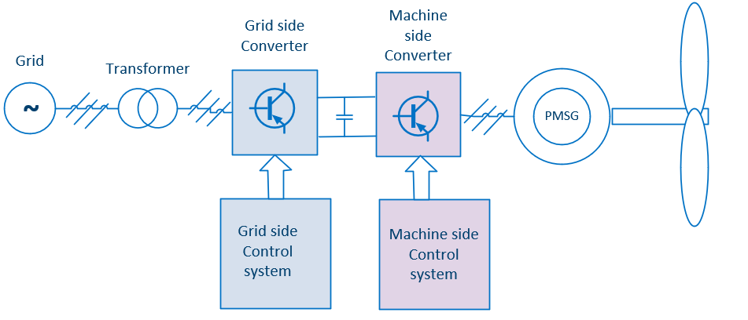Figure 1: Typical Wind Turbine Generator control strategy(Okedu&Barghash, 2021)

For this study, the electrical data of the PMSG wind turbine generator is given in table 2.

Table 2: Parameters of the PMSG turbine generator

|  |  |
| --- | --- |
| Parameters | Rating |
| Rated Power | 1.5 MW |
| Resistance of stator | 0.01 pu |
| d-axis reactance | 1.0 pu |
| q-axis reactance | 0.7 pu |
| Machine inertia (H) | 3.0 |
| Effective DC-link protection | 0.2 ohms |
| Over-voltage protection system | 110% |
| Cut-in speed | 2 - 4 m/s |

The extracted mechanical power by the PMSG wind turbine as a function of the wind is expressed as (Okedu&Barghash, 2021).

$P_{w}=\frac{1}{2}{ρπR}^{2}{V_{w}}^{3}C_{p}\left(λ, β\right)$ (1)

Where,

Pw is the captured wind powerin(W);

ρ air density expressed in (kg/m3);

R expressed in (m) is the rotor radius; and

Vw is wind speed expressed in (m/s).

Cp is the wind turbine power coefficient and is correlated to the tip speed ratio (λ) and the pitch angle (β), respectively, as indicated in Equation2

$C_{p}\left(λ, β\right)=c_{1}\left[\frac{c_{2}}{λ_{i}}-c_{3}β-c_{4}\right]e^{-\frac{c_{5}}{λ_{i}}}+ c_{6}λ$ (2)

$\frac{1}{λ_{i}}=\frac{1}{λ-0.08β}- \frac{0.035}{β^{3}+1}$ (3)

In Equation2, c1 to c6 are the distinctive coefficients of the wind turbine. In the PMSG wind generator, the MPPT is related to the rotor speed and the peak power is expressed by

$P_{MPPT}=\frac{1}{2}{ρπR}^{2}{\left(\frac{ω_{r}R}{λ_{opt}}\right)}^{3}+c_{p_opt}$ (4)

where the ideal value of λ is λopt and ωr is the projected wind generator rotor speed.

The dynamic equations of the PMSG wind turbine in d–q reference rotating frame is expressed as

$\frac{d(Ѱ_{sd})}{dt}=-V_{sd}-R_{s}I_{sd}-ω_{e}Ѱ_{sq}$ (5)

$\frac{d(Ѱ_{sq})}{dt}=-V_{sq}-R_{s}I_{sq}-ω_{e}Ѱ_{sd}$ (6)

- (7)

$Ѱ_{sq}=\left(L_{sq}+ L_{mq}\right)I_{sq}$ (8)

Where,

Vsd and Vsq represent the d and q voltages of the stator circuit,

Rs is the stator winding resistance,

Isd and Isq represent the currents in the stator on the transformed d and q reference frames,

ωe is therotational speed of the wind generator,

Ѱsd and Ѱsq are the stator circuit flux linkages,

Lsd and Lsq are the winding leakage inductances of the stator,

Lmd and Lmq are the magnetizing inductances, and

Ѱm is the linkage of the turbine permanent magnet

By substituting equations 7 and 8 into 5 and 6, gives the PMSG wind turbine differential equations as

$L_{d}\frac{d(I_{sd})}{dt}=-V_{sd}-R_{s}I_{sd}-ω_{e}L_{q}L_{sq}$ (9)

$L_{q}\frac{d(I_{sq})}{dt}=-V_{sq}-R_{s}I_{sq}+ω_{e}L_{d}L_{sd}+ ω_{w}Ѱ_{m}$ (10)

$L_{d}=\left(L_{sd}+ L_{md}\right)$ (11)

$L_{q}=\left(L_{sq}+ L_{mq}\right)$ (12)

Similarly, the PMSG active and reactive powers are given as

$P_{s}= V_{sd}I_{sd}+V_{sq}I_{sq}$ (13)

$Q_{s}= V_{sq}I_{sd}-V_{sd}I_{sq}$ (14)

The machine side controller (MSC) of the PMSG which controls the wind turbine active and reactive power can be represented as shown in figure 2 below.

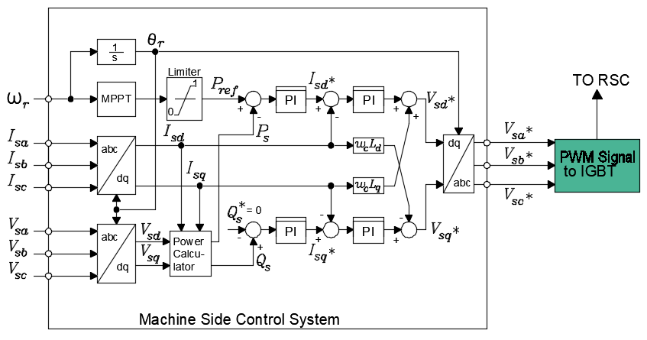

Figure 2: Machine side converter control of the PMSG wind turbine

Similarly, the grid side controller (GSC) of the PMSG which controls the wind turbine DC-link stabilization and power quality regulation can be represented as shown in figure 3.

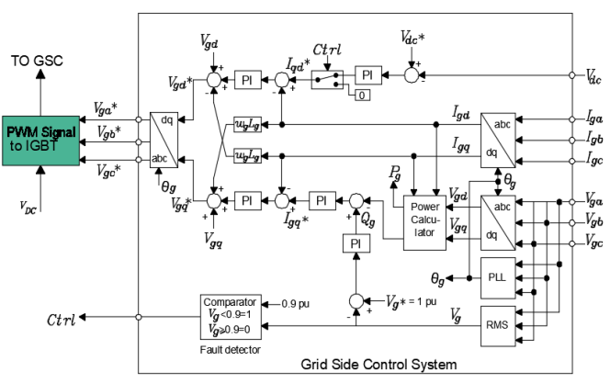

Figure 3: Grid side converter control of the PMSG wind turbine

The IGBT excitation parameters and ratings of the turn-on and turn-off resistances including the forward breakover and reverse withstand voltages examined in this study for the three cases are shown in table 3.

Table 3: Excitation Parameters of the IGBT

|  |  |  |  |
| --- | --- | --- | --- |
| **Parameters** | **Case 1** | **Case 2** | **Case 3** |
| IGBT turn on resistance (ohm) | 0.001 | 0.002 | 0.003 |
| IGBT turn off resistance (ohm) | 1.0E6 | 1.0E6 | 1.0E6 |
| Forward break over voltage (kV) | 1.0E5 | 1.0E5 | 1.0E5 |
| Revers withstand voltage (kV) | 1.0E5 | 1.0E5 | 1.0E5 |

**i. PMSG MSC Algorithm:**

The steps below represent the MSC algorithm for the transient control of PMSG wind turbine speed to achieve MPPT optimization.

**Step 1**

1. Input values (generator parameters see Table 2)
2. initialize ωe, Isa, Isb, Isc, Vsa, Vsb, Vsc
3. Set reference Qs = 0
4. Initialize the referenced d-q axis voltages Vsd, Vsq
5. Set IGBT turn on resistance k = 0.001,………n, incremental of 0.001

**Step 2**

1. Perform abc to d-q transformation on ωe, Isa, Isb, Isc, Vsa, Vsb, Vsc to Өr, Isd, Isq, Vsd, Vsq
2. Introduce a three phase fault on the network of 5kA
3. Regulate Isd to compute Ps
4. Compare Pref with Ps
5. PMW switch Isq*, Isq* to generate Vsa*, Vsb*, Vsc*
6. Calculate active power delivered Ps = eqn13
7. Calculate reactive power delivered Qs = eqn14

**Step 3**

1. Compute the d-q axis error signals ($Δd\left(t\right)$& $Δ$ q(t)

Where $Δ$ d(t) = Isd* - Isd&q(t) = Isq* - Isq

**Step 4**

1. Optimized the controller current Isd, Isq using ωcLd. ωcLq
2. &q(t) are the input values that minimize error for MPPT optimization

**Step 5**

1. Predict future Ps, Qs for $Δd\left(t\right)$& $Δ$ q(t)

**Step 6**

1. Optimize control signals ωe, Isa, Isb, Isc, Vsa, Vsb, Vsc and input to the system
2. Otherwise, set k = k + 0.001
3. Repeat from Step 2 to step 6

**Step 7**

1. Stop

**ii. PMSG GSC Algorithm**

The steps below represent the GSC algorithm for the transient control of PMSG wind turbine speed to achieve MPPT optimization.

**Step 1**

1. Input values (generator parameters see Table2)
2. initialize Vdc, Iga, Igb, Igc, Vga, Vgb, Vgc
3. Set reference Vg* = 1 pu
4. Initialize the referenced d-q axis voltages Vgd, Vgq
5. Set IGBT turn on resistance k = 0.001,………n, incremental of 0.001

**Step 2**

1. Effect abc to d-q transformation on Vdc, Iga, Igb, Igc, Vga, Vgb, Vgc to Өg, Igd, Igq, Vsd, Vgq
2. Introduce a three phase fault on the network of 5kA
3. Regulate Igd to compute Pg
4. Compare Vg* with Vg
5. PMW switch Igq*, Igq* to generate Vga*, Vgb*, Vgc*
6. Calculate active power delivered Pg = eqn13
7. Calculate reactive power delivered Qg = eqn14

**Step 3**

1. Compute the d-q axis error signals ($Δd\left(t\right)$& Δq(t)

Where Δd(t) = Igd* - Igd&Δq(t) = Igq* - Igq

**Step 4**

1. Optimized the controller current Igd, Igq using ωgLd. ωgLq
2. &Δq(t) are the input values that minimize error for MPPT optimization

**Step 5**

1. Predict future Pg, Qg for $Δd\left(t\right)$&Δq(t)

**Step 6**

1. Optimize control signals Vdc, Iga, Igb, Igc, Vga, Vgb, Vgc and input to the system
2. Otherwise, set k = k + 0.001
3. Repeat from Step 2 to step 6

**Step 7**

1. Stop

**The DFIG Wind Turbine Control Model**

In the DFIG turbine system, variable voltage and frequency output from the machine rotor circuit is impressed with the steady grid voltage and frequency via a bi-directional back-to-back voltage source converter connected through a capacitor. The grid is directly connected to the DFIG stator terminals (Pidikiti& Das, 2019).

Figure 4 below shows a typical DFIG wind turbine generator configuration indicating the power flows

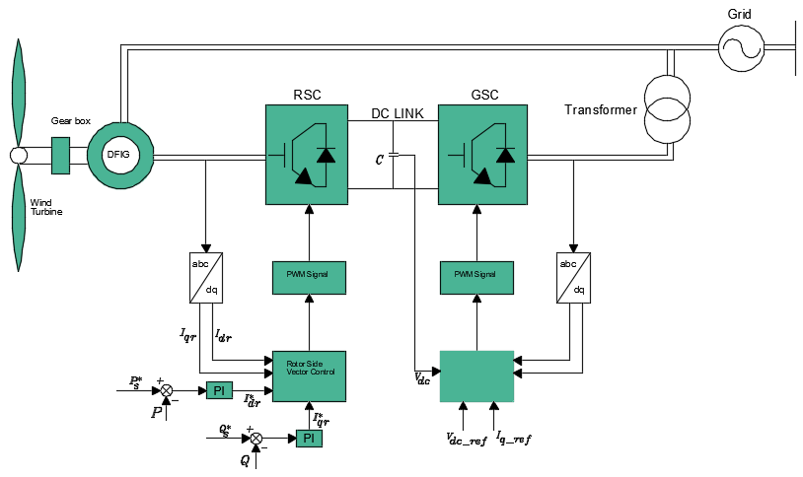

Figure 4: Overall block diagram of the DFIG wind turbine control

DFIG can be controlled using the Direct Torque Control (DTC) or Direct Power Control (DPC) techniques. In DTC method, the torque and flux variables are taken as two control parameters with a switching vector selected to obtain the desired operation. DPC technique on the other hand, works on selecting the best switching table subject to the errors signal occurring between the active and reactive powers s well as their references for switching the converter states (Shehu A.F *et al.* 2019).

For this study, the electrical parameters of the DFIG wind turbine generator is given in table 4.

Table 4: Parameters of the DFIG turbine generator

|  |  |
| --- | --- |
| Parameters | Rating |
| Rated Power | 1.5 MW |
| Rated voltage | 690 V |
| Stator resistance | 0.01 pu |
| Stator leakage reactance | 0.15 pu |
| Magnetizing reactance | 3.5 pu |
| Rotor resistance | 0.01 pu |
| Rotor leakage reactance | 0.15 pu |
| Inertia constant | 1.5 seconds |
| Cut-in speed | 4 m/s |

The rotor side controls have two variables: rotor current and duty cycle. The DC-linked voltage alongside these two parameters are used to model the rotor/generator side converters using equations (15) and (16):

$V_{s(dq)}=D_{dq}V_{DC}$ (15)

$I_{dc}=D_{d}I_{sd}D_{q}I_{sq}$ (16)

Where,

D is the duty ratio,

VDC is the DC-link voltage,

Idc is the current flow into DC link,

Isis the stator current

Vs is the stator voltage.

The grid side converter model uses the grid voltage, resistance and inductance of the grid side filter as inputs as expounded by Equations (16)–(17),

$L_{f}\frac{d(I_{gd})}{dt}+ R_{f}i_{gd}=ωL_{f}i_{gq}+ V_{conv_d}-V_{grid_d}$ (16)

$L_{f}\frac{d(I_{gq})}{dt}+ R_{f}i_{gq}=-ωL_{f}i_{gd}+ V_{conv_q}-V_{grid_q}$ (17)

$C_{DC}\frac{d(V_{DC})}{dt}=i_{DC}-k(i_{gd}D_{d}+i_{gq}D_{q})$ (18)

Where,

k is reliant on the conversion technique used to convert the abc values to d-q axis values. k = 1 for normalized Clarke transformation and 3/2 for non-normalized transformation

VDC is the DC-link voltage,

ig is the grid current,

Rf is the filter resistance,

D is the duty cycle,

CDC is the DC-linked capacitor,

Lf is inductance of filter andVgrid is the grid voltage.

The stator active and reactive power in the orthogonal coordinate system can be written in the form

$\left\{\begin{aligned}P_{s}=\frac{3}{2}\left(V_{ds}I_{ds}+V_{qs}I_{qs}\right) \\ Q_{s}=\frac{3}{2}\left(V_{qs}I_{ds}-V_{ds}I_{qs}\right)\end{aligned}\right.$ (19)

And the rotor active and reactive powers are depicted as

$\left\{\begin{aligned}P_{r}=\frac{3}{2}\left(V_{dr}I_{dr}+V_{qr}I_{qr}\right) \\ Q_{r}=\frac{3}{2}\left(V_{qr}I_{dr}-V_{dr}I_{qr}\right)\end{aligned}\right.$ (20)

In this model, the GSC is controlled with the grid voltage in the d-q reference frame. The reactive power which is transferred to the grid by the GSC and is controlled by the igq. Likewise, by keeping the DC-link voltage constant, active power transferred to the grid is controlled by igb current. Both the GSC and RSC controller have the same limiting algorithms and modulation to achieve IGBT switching.

The IGBT excitation parameters and ratings of the turn-on and turn-off resistances including the forward breakover and reverse withstand voltages examined in this study for the three cases are shown in table 3 above.Considering the IGBT turn-on resistance is the major parameter affecting the response of the DFIG turbine variables, its effect is the subject of this study. The other three parameters can be ignored as they are either negligible or has no effect.

**i. DFIG RSC Algorithm**

The steps below represent the RSC algorithm for the transient control of DFIG wind turbine speed to achieve MPPT optimization.

**Step 1**

1. Input values (generator parameters see Table 4)
2. initialize ωm, Ird, Irq, VDC
3. Set reference Qgen* = 0
4. Set IGBT turn on resistance k = 0.001,………n, incremental value of 0.001

**Step 2**

1. Effect abc to d-q transformation on ωm, Ird, Irq, Vsd, Vsq to Өr, Ids, Iqs, Vds, Vqs

Effect abc to d-q transformation on ωm,Qgen*

1. Generate reference torque Tref and current (Irq_ref, Ird_ref)
2. Introduce a three phase fault on the network of 5kA

**Step 3**

1. Compute the d-q axis error signals (Δ $d\left(t\right)$& Δq(t)

Where Δd(t) = Ird_ref - Ird&Δq(t) = Irq_ref - Irq

**Step 4**

1. Generate from Ird_ref the Vrd_ref; and Irq_ref the Vrq_ref by the PI controller
2. Use $Δd\left(t\right)$&Δq(t) as the input values that minimize error for MPPT optimization

**Step 5**

1. Predict future Ps, Qs for $Δd\left(t\right)$&Δq(t)
2. Regulate Ird and Irq to compute Ps and Qs
3. PMW switch Vrq_ref, Vrd_ref to generate Vsdq
4. Transform Vsdq, VDC to PMW switching signal Dsdq to the IGBT
5. Calculate active power delivered Ps = eqn19
6. Calculate reactive power delivered Qs = eqn19

**Step 6**

1. Optimize control signals ωm, Ird, Irq, VDC and input to the system
2. Otherwise, set k = k + 0.001
3. Repeat from Step 2 to step 6

**Step 7**

1. Stop

**ii. DFIG GSC Algorithm**

The steps below represent the GSC algorithm for the transient control of DFIG wind turbine speed to achieve MPPT optimization.

**Step 1**

1. Input values (generator parameters see Table 4)
2. initialize VDC, Igd, Igq, Qgrid *
3. Set reference VDC*, Qgrid*
4. Set kx = 1 (assumed normalized transformation)
5. Set IGBT turn on resistance k = 0.001,………n

**Step 2**

1. Effect abc to d-q transformation on VDC, Igd, Igq, Vgrid, Ggrid* to VDC_ref, Igq_ref, Igd_ref
2. Generate grid powers (Qsgrid, Psgrid) from (Igq, Igd)
3. Introduce a three phase fault on the network of 5kA

**Step 3**

1. Compute the d-q axis error signals ($Δd\left(t\right)$& Δq(t)

Where Δd(t) = Igd_ref - Igd&Δq(t) = Igq_ref - Igq

**Step 4**

1. Generate from Igd_ref the Vgd_ref; Igq_ref the Vgq_ref by the PI controller
2. Use $Δd\left(t\right)$&Δq(t) as the input values that minimize error for MPPT optimization

**Step 5**

1. Predict future Ps, Qs for $Δd\left(t\right)$& $Δ$ q(t)
2. Regulate Igd and Igq to compute Psgrid and Qsgrid
3. PMW switch Vgq_ref, Vgd_ref to generate Vsdq
4. Transform Vsdq, VDC to PMW switching signal Dsdq to the IGBT
5. Calculate active power delivered Psgrid = eqn19
6. Calculate reactive power delivered Qsgrid = eqn19

**Step 6**

1. Optimize control signals Qgen*, Igd, Igq, VDC and input to the system
2. Otherwise, set k = k + 0.001
3. Repeat from Step 2 to step 6

**Step 7**

1. Stop
2. **RESULTS AND DISCUSSION**

**i. Result of PMSG and DFIG Turbines During Steady State Conditions**

Figure 5 show the performance plot of Permanent Magnet Synchronous Generator (PMSG) wind turbine operating under normal conditions. The power, voltage, and current plot shows a stable and consistent behavior throughout the simulation period.

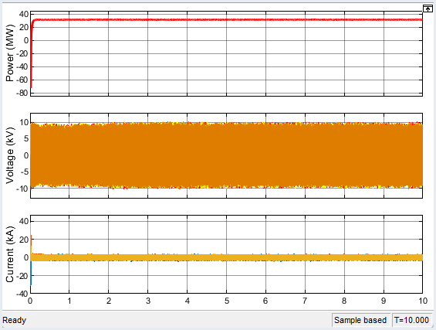

Figure 5Performance of PMSG Wind Energy Conversion System

The power plot shows a smooth and steady output of 30 MW, reflecting efficient and uninterrupted wind energy conversion under constant wind and grid conditions. A cursory look at the plots shows there are no sudden dips or spikes, indicating that the generator maintains a reliable power delivery to the grid without any faults or fluctuations. The voltage plot remains sinusoidal and symmetrical, centered on its nominal value of 11kV, with no visible distortions or sags. This stability suggests that the grid connection is strong, and the PMSG’s voltage control system is performing well, keeping the terminal voltage within acceptable limits.

Similarly, the current plot shows balanced and smooth waveforms with constant amplitude, confirming that the generator is operating under steady load conditions. The absence of oscillations, transients, or current spikes further confirms the system's health and the effectiveness of the converter control in regulating stator currents. In overall, the plots indicate a well-regulated, disturbance-free environment where the PMSG wind turbine operates efficiently, providing clean and stable power.

Figure 6 plots power, voltage, and current plots of a Doubly-Fed Induction Generator (DFIG) wind turbine under normal conditions’

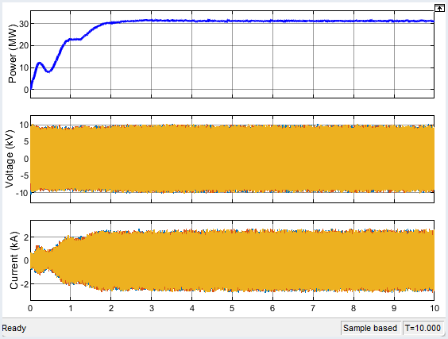

Figure 6Performance of DFIG Wind Energy Conversion System

A cursory look at the DFIG power plot, shows that it exhibited significant transient oscillations before stabilizing at 30 MW. This transient behavior is attributed to its partial power converter, which allows bidirectional power flow but also makes it more susceptible to grid disturbances and wind speed variations. Additionally, its reliance on rotor-side converters and slip control introduces dynamic fluctuations during wind speed changes, further affecting power stability.

The voltage plot remains sinusoidal on its nominal value of 11kV indicating proper synchronization and grid stability. Both stator and rotor currents exhibited significant transient oscillations before stabilizing highlighting the system’s balanced and controlled electrical performance. Overall, the plots reflect the DFIG’s reliable behavior and optimal control under steady-state conditions, despite its sensitivity to initial transients

**ii. Result of PMSG and DFIG Turbines DuringTransient State Conditions**

Figure 7show the dynamic response of a permanent magnet synchronous generator (PMSG) wind turbine system during disturbance

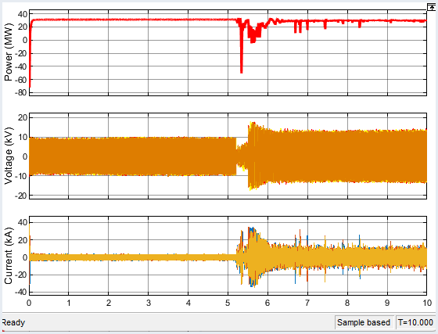

Figure 7Performance of PMSG Wind Turbine System during Disturbance

The power plot at the top indicates that the PMSG wind turbine initially delivers a steady active power output of 30 MW, reflecting normal operation. At around 5.5 seconds, a sudden power drop is observed, dipping below zero, which suggests the turbine experienced a severe disturbance or fault. The power output becomes highly erratic and negative for a short duration, then gradually stabilizes but does not fully return to the initial level, indicating a change in operating conditions or partial fault recovery to 30 MW within 0.5 seconds.

In the voltage plot, the voltage remains stable at about 11kV before the disturbance. At around 5.5 seconds into the simulation a significant voltage sag occurs, consistent with a symmetrical fault. The voltage becomes distorted with notable oscillations, and begins to recover, although it remains somewhat unstable throughout the remaining simulation time, showing signs of poor post-fault voltage regulation.

The current plot reveals that current level was stable under normal operation. However, during fault event at about 5.5 seconds into the simulation, the PMSG exhibits a distinct current surge, reaching peaks close to 20k A. This spike is due to the system's response to the fault, where the sudden voltage drop leads to large inrush currents. The current then oscillates and slowly damps out, but it does not fully return to the pre-disturbance steady state, indicating the system is still stabilizing or operating under a new condition.

The PMSG wind turbine shows the ability to partially ride through the fault but experiences significant power fluctuation, voltage distortion, and current overshoot during and after the disturbance and it took about 4 seconds for the system to recover after the fault. These behaviors highlight the importance of robust control strategies and protection mechanisms in PMSG systems to ensure compliance and operational stability during faults.

Figure 8shows the dynamic response of a Doubly-Fed Induction Generator (DFIG) wind turbine during fault event at about 5.5 seconds into the simulation.

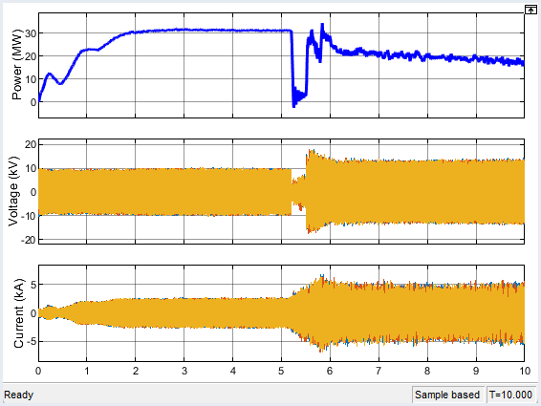

Figure 8Performance of DFIG Wind Turbine System during Disturbance

The active power output initially rises steadily to around 30 MW, indicating normal operation, but drops sharply near 5.5 seconds due to a fault, before partially recovering to around 20 MW in 1 seconds with some oscillations further down the line.

The voltage remains stable at approximately 11 kV until the same disturbance, where a significant voltage dip occurs, suggesting a symmetric fault. Although the voltage partially recovers, it stabilizes at a slightly reduced level which could cause maloperation of protection devices.

The current, which had increased gradually during normal operation, experiences a sudden spike during the fault. The current remains oscillatory and distorted, indicating the system’s attempt to stabilize. This behavior highlights the DFIG’s fault ride-through capability, where protection mechanisms like crowbar circuits and converter control respond to maintain partial operation during and after faults.

In conclusion, the stability of grid-connected PMSG and DFIG wind turbines was evaluated using MATLAB under different operating conditions. Results indicate that PMSG systems provide better fault ride-through (FRT) capability and voltage stability, making them more robust against grid disturbances. Conversely, DFIG-based systems are more vulnerable to voltage sags and frequency variations, requiring additional FACTS devices or controllers to enhance grid stability.

**Discussion:** The results here align with those gotten by Gidwani (2015) and Okedu and Barghash (2021); indicating the PMSG has better post-fault recovery performance than the DFIG during system disturbances.

1. **CONCLUSION**

The stability of grid-connected PMSG and DFIG wind turbines was evaluated under different operating conditions using MATLAB simulations. The results indicated that PMSG systems provide better fault ride-through (FRT) capability and voltage stability, making them more robust against grid disturbances. Conversely, DFIG-based systems are more vulnerable to voltage sags and frequency variations, requiring additional FACTS devices or controllers to enhance grid stability.

The use of Flexible AC Transmission Systems (FACTS) and advanced controllers should be explored to improve voltage stability and mitigate power fluctuations, particularly for DFIG-based wind farms.

Area of further study is to explore advanced control techniques for improving the performance of **PMSG and DFIG-based wind turbines** under grid disturbances.

**REFERENCES**

Agbetuyi, A. F., Akinbulire, T. O., Abdulkareem, A., &Awosope, C. O. A. (2012). “Wind Energy Potential in Nigeria”. *Journal: International Electrical Engineering, 3(*1), 595-601.

Barelli L., Bidini1 G., Ciupageanu D.A., Ottaviano A., Pelosi D., Gallorini F., Alessandri G, & Cruz M.A. (2023). An effective solution to boost generation from winds: Benefits of a hybrid energy storage system integration to wind energy converter in grid-connected systems, <https://doi.org/10.12688/openreseurope.14062.2>

Bindhu B. &Divya S. (2017). Comparative study of different types of generators used in wind turbine and reactive power compensation. IOSR Journal of Electrical and Electronics Engineering (IOSR-JEEE) e-ISSN: 2278-1676,p-ISSN: 2320-3331, PP 95-99

Chen, C., Pinar, M., and Stengos, T. (2020). Renewable Energy Consumption and Economic Growth Nexus: Evidence from a Threshold Model. Energy policy 139, 111295. doi:10.1016/j.enpol.2020.111295

GidwaniLata (2015). A Comparative Power Quality Study of DFIG and PMSG Based Wind Energy Conversion System

International Energy Agency (2021) report

Leila M., Amel Q., Wafa T,.& Salah S. (2019). Modeling and Control of Wind Turbine Doubly-Fed Induction Generator with Matlab Simulink, 4rd Global Conference on Computer Science, Software, Networks and Engineering, 28 – 30 August 2017, Istanbul, Turkey

Machowski J., Robak S., Kacejko P., Miller P. &Wancerz M. (2014). Short-circuit power as important reliability factor for power system planning

NgamrooIssarachai (2017). Review of DFIG Wind Turbine Impact on Power System Dynamic Performances. IEEJ Trans 2017; 12: 301–311

Nguyen V.C., Netto M. &damm G. (2023). Control of a DFIG-based Wind Turbine Using Modified Conditional Servo-Compensator

Nwaniki J., Lin H. &Daiz Z. (2017). A Concise Presentation of Doubly Fed Induction Generator Wind Energy Conversion Systems Challenges and Solutions.

Okedu, K.E. (2022). Augmentation of DFIG and PMSG Wind Turbines Transient Performance Using Different Fault Current Limiters. Energies 2022, 15, 4817.

<https://doi.org/10.3390/en15134817>

Okedu, K.E. (2018). Introductory Chapter: Stability Control and Reliable Performance of Wind Turbines. <http://dx.doi.org/10.5772/intechopen.80237>.

Okedu K.E. &Barghash H. (2021). Enhancing the Transient State Performance of Permanent Magnet Synchronous Generator Based Variable Speed Wind Turbines Using Power Converters Excitation Parameters. Front. Energy Res. 9:655051. doi: 10.3389/fenrg.2021.655051

Okedu K.E. (2022). Improved performance of doubly-fed induction generator wind turbine during transient state considering supercapacitor control strategy,” Electrica., 22(2), 198-210, 2022

Okedu K.E. (2023). Performance of DFIG and PMSG Wind Turbines. First edition by CRC Press 6000 Broken Sound Parkway NW, Suite 300, Boca Raton, FL 33487-2742

Pidikiti Tripura. &Tulai R. Das G. (2019). Analysis and Performance Evaluation of DFIG and PMSG Based Wind Energy Systems

Shehu A.F, Abubakar A.S, Musayyibi S. & Idris K (2019). Doubly Fed Induction Generator Based Wind Energy Conversion System: A Review.

Wu Y-K. Hu Y-L, & Chiang M-H. (2016). Development of PMSG-Based Wind Turbine Modelling by ADAMS, FAST and MATLAB.

Zhang Z. Xia P. & Zhang X., (2022). A complex grid investment decision method considering source-grid-load-storage integration