**Research Article**

**GEOMAGNETIC FIELD VARIATIONS ALONG THE AFRICAN GEOMAGNETIC EQUATOR DURING RECOVERY PHASES OF 5TH JULY 2011 AND 16TH JULY 2012 GEOMAGNETIC STORMS**

**Abstract**

This paper presents results on an investigation on storm time variation of Earth’s magnetic field along the African geomagnetic equator during the recovery phases of the 5th July 2011 and 16th July 2012 geomagnetic storms. Magnetic field measurements were obtained from the International Real-time Magnetic Observatory Network (INTERMAGNET) stations in Ethiopia, Addis Ababa (AAE) and Mbour (MBO) in Senegal and African Meridian B-field Education and Research (AMBER) arrays data at Yaoundé (CMRN) in Cameroon. The storm time daily variations were derived by subtracting the baseline of three days before the storm and after the storm days of the 5th July 2011 and16th July 2012 geomagnetic storms from each disturbed day. The obtained disturbance daily variations were used to calculate the perturbations of the recovery phases of the storms. The results showed that all the three stations displayed variations in storm time behavior during the recovery phases of the 5th July 2011 and 16th July 2012 geomagnetic storms, which were linked to the effect of Equatorial Electrojet current and the influence of meridional winds and tidal waves. There was also a noticeable reduction in the storm time variation of geomagnetic field at local noon (11:00 - 13:00LT) over the all the three stations during the recovery phases of both storms. This was attributed to the effect of equatorial electrojet (EEJ) and the disturbance dynamo electric fields (DDEF) coming from the high-latitude regions. The reduction in the depth of the storm time variation of geomagnetic field depended on the strength of the storm. The storm time variations of geomagnetic field over the three stations also displayed small irregular and inconsistent patterns (perturbations), which were associated with the ionospheric disturbances coming from the effects of the geomagnetic storms, such as ring current decay, solar wind and Interplanetary magnetic field (IMF) effect and wave-particle interactions.

**Introduction**

Geomagnetic storms are disturbances of the Earth’s magnetic field resulting from perturbations in the interplanetary magnetic field (IMF) (Pokharia et al., 2018). A standard geomagnetic storm usually has 3 phases: the initial phase, main phase and recovery phase. The initial phase is usually caused by an enhancement of the solar wind behind shock wave. The main phase is characterized by the depression of Horizontal (H) component of the Earth’s magnetic field, and is followed by the recovery phase which is characterized by the slow and quiet return of the H component of the magnetic field to its pre-storm level (Burns et al, 1991). The degree of depression of the H component of the geomagnetic field during geomagnetic storms varies, depending on the magnetic local time. In this case, the maximum depression of the H component of geomagnetic field strength is seen on the night to dusk side, while the minimum depression of the H component is seen on the day to dawn side. This is as a result of the asymmetrical flow of the ring current. Generally, the recovery phase of any storm takes longer duration than the initial and main phases (Gonzalez et al, 1994).

Geomagnetic field is the observed magnetic field on Earth caused by the interference of magnetic field produced either by a magnetic dynamo in the Earth's liquid or by the electric currents in the ionosphere and magnetosphere (Akpaneno et al, 2015). The time variations are divided into long and short term variations. The long term (secular) variations come from the dynamics of Earth's interior while short term variations have an external origin (Lanza & Meloni, 2006). The short term variations last from within seconds up to a year. They are often intense and are mainly produced by currents in the magnetosphere and ionosphere (Okwesili et al, 2023; Lakhina & Tsurutani, 2016). Studying the storm time variations of the Earth’s magnetic field during the recovery phase of a geomagnetic storm is important in improving space weather impact predictions and technological and infrastructure protection in the low and mid latitude regions. Storm time variations of the Earth’s Magnetic field are determined by examining the fluctuations of the magnetic field during geomagnetic storm occurrences. During some days, the Earth’s magnetic field undergoes smooth and regular variations while on some other days they undergo irregular changes (Chapman & Bartels, 1940). Recently, researchers have investigated the various aspects of geomagnetic field variation giving information on the variability in the past solar cycles 23 and 24. Chia et al, (2019) carried out a cross correlation analysis on the IMF and solar wind effects on the geomagnetic H component during the storms on geomagnetic field. They used data from four stations on low latitude to investigate the relationship between the horizontal component and the density of solar wind and interplanetary magnetic field (IMF) for the strongest solar cycle and strongest moderate storms of cycle 23. The results showed a unique response of the magnetosphere to the various sources without it since a dawn to dusk variation was not observed in the profile. There was however, a superposition of the profiles of the cross correlation coefficients and the time gap. Haines et al, (2019) studied the geomagnetic storm variation in time span with its intensity using a long running global geomagnetic disturbance index. They analyzed how connected the intensity of the storm was and its duration. Their results showed a nonlinear relationship between the two and the duration was longer for the storms of very high intensity than for those of a shorter intensity. Despite studies on storm time variations of geomagnetic field having been carried out, limited studies have been done over African equatorial regions, during recovery phase of geomagnetic storms. This study aims at determining the geomagnetic field variation over three African equatorial stations: Mbour (MBO), Yaunde (CMRN), and Addis Ababa (AAE) during recovery phases of the 5th July 2011 and 16th July 2012 geomagnetic storms. The results from this study will bring out a better understanding of the interactions between geomagnetic disturbances and diurnal variations of the Earth’s magnetic field along the African geomagnetic equator.

**2.0 Data acquisition and methodology**

**2.1 Data sources**

**2.1.1 Geomagnetic indices data**

In this study, the geomagnetic indices: kp and Dst indices were obtained from Omniweb website: [*https://omniweb.gsfc.nasa.gov/form/dx1.html*](https://omniweb.gsfc.nasa.gov/form/dx1.html)*.*

**2.1.2 Magnetic field data**

Magnetic field measurements from International Real-time Magnetic Observatory Network  
(INTERMAGNET) stations in Ethiopia, Addis Ababa and Mbour in Senegal and African  
Meridian B-field Education and Research (AMBER) arrays data at Yaoundé in Cameroon were used.

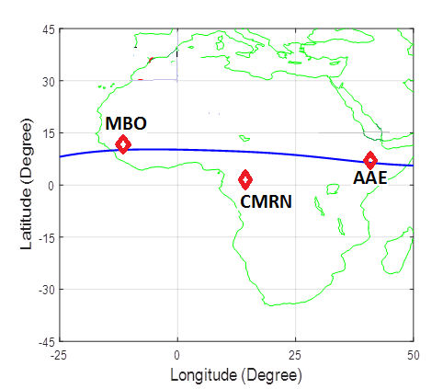

Figure 1: Plot of geomagnetic locations of magnetometer network for: MBO, CMRN and AAE

Geographic and geomagnetic location information of Magnetometer network for: AAE, ETHI, CMRN and MBO were used in this study is given in Table 1:

Table 1: Geographic and geomagnetic locations of AAE, ETHI, CMRN and MBO

|  |  |  |  |  |  |  |
| --- | --- | --- | --- | --- | --- | --- |
| STATION ID | STATION NAME | Geographic Latitude | Geographic Longitude | Geomagnetic Latitude | Geomagnetic Longitude | Local Time (LT) |
| AAE | Addis Ababa | 9.0oN | 38.8oE | 0.9oN | 110.5oE | LT=UT+3 |
| CMRN | Yaunde | 3.87oN | 11.52oE | 5.30oS | 83.12oE | LT=UT+1 |
| MBO | Mbour | 14.43oN | 16..97oW | 2.06oN | 58.24oW | LT=UT+0 |

**2.2 Methodology**

The selected storm days were selected from the Kp and Dst index values obtained from Omniweb website and are given in Table 1.

**Table 1: Selected storm days and their corresponding maximum kp values and highest negative Dst values**

|  |  |  |
| --- | --- | --- |
| Selected storm days | Maximum kp value | Highest negative Dst values |
| 5th July 2011 | 4.5 | -59nT |
| 16th July 2012 | 6.2 | -113nT |

The storm time daily variations (Sd) were derived by subtracting the baseline of three days before the storm and after the storm for the 5th July 2011 and16th July 2012 geomagnetic storms, from the geomagnetic field for each of the disturbed days (Hd). The selected days were between 2nd to 8th July 2011 and 13th to 19th July 2012.

The storm time daily variation was obtained by equation (1),

: (1)

where Sd is the disturbance daily variation, Hd is the geomagnetic field intensity of a disturbed  
day and H0 is the quietest day baseline. The obtained disturbance daily variation was used to  
calculate the perturbation of the storm using equation (2)

 (2)

where SD is the perturbation of the storm, Sd represents the disturbance daily variation and  
Sq stands for the solar quiet variation.

The storm time perturbations for the recovery phases of 5th July 2011 and 16th July 2022 were calculated and plotted as shown in Figures 3 and 4.

1. **Results and discussions**

**3.1 Variation of kp and Dst indices between 2nd to 8th July 2011 and 13th to 19th July 2012.**

Figures 2(a) and 2(b) shows the variation of kp and Dst indices for the 5th July 2011 and 16th July 2012 geomagnetic storms. In Figure 2(a), the kp index values varied between 1 and 4.5, with some fluctuations being noted. The Dst index was observed to drop below -60nT on 5th July and later recovered. The recovery phase was relatively faster, with Dst value returning to ~ -20nT within a day. The shorter recovery phase was an indicator of a shorter energy input period (Daglis et al, 1999; Liemohn et al, 2001). In Figure 2(b), the kp index began at low kp values of between ~0 to 1 and significantly increased on 14th July, reaching a peak of ~6.5 on 15th July. After the peak it gradually decreased over the next few days. The Dst index showed a sharp drop on 15th July, reaching values below -130nT at 18:00 UT. The recovery phase of the storm began immediately after the minimum Dst value and lasted for more than 2 days, meaning that the recovery was slow and prolonged. A comparison of Figures 2(a) and 2(b) shows that the 16th July 2012 geomagnetic storm was significantly stronger than the 5th July 2011 geomagnetic storm as shown in both kp and Dst indices. However geomagnetic storms showed a typical structure both storms where sharp Dst decreased followed by a gradual recovery phase (Turner et al, 2001; Rastatter et al, 2013).

Various researchers have studied the recovery phases of the July 2011 and July 2012 geomagnetic storms. Kumar & Kumar, (2022) in their study of geomagnetic storm effect on F2-Region ionosphere during 2012 at low and mid latitude stations in the southern hemisphere analyzed the low and mid-latitude ionospheric disturbances during the recovery phase of the 16th July, (2012). Astafyeva et al, (2012) studied the prompt and long lasting ionospheric response to the July 2012 geomagnetic storm, where they highlighted the role of electrodynamics and thermospheric composition during the recovery phase of the 16th July 2012 geomagnetic storm. From the above studies, was noted that the recovery phases of geomagnetic storms displayed unique magnetospheric and ionospheric features resulting from the gradual energy loss of storm induced disturbances.

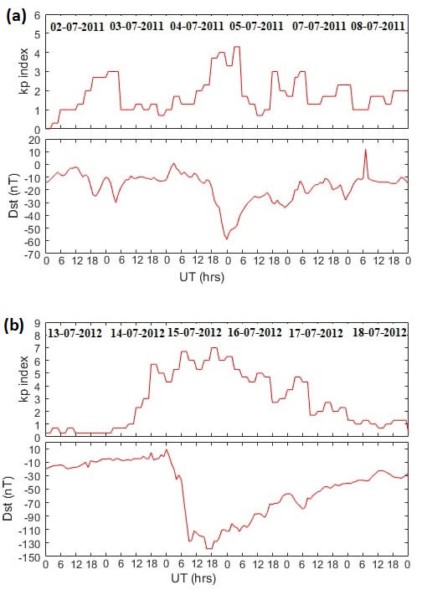

Figure 2: kp and Dst indices for: (a) between 2nd and 8th July 2011 (b) between 13th and 19th July 2012

**3.2 Storm time variations of the geomagnetic field on 5th July 2011 and 16th July 2012.**

Figure 3(a), 3(b) and 3(c) shows storm time variations of magnetic field over AAE, CMRN and MBO respectively for the recovery phase of the 5th July 2011 geomagnetic storm. In Figure 3(a), at AAE, increasing values of SD were noted from 0000LT to around 11:00LT attaining a maximum value of 10nT, after which it recorded a rapid drop reaching a minimum value of -10nT at around 14:00LT. The SD value however increased again and reached a highest value of 5nT at 24:00LT, with a slight data gap being noted in between. At CMRN, there was an increase in magnitude of SD variation from about -20nT at 00:00LT to ~ -5nT at about 10000LT as indicated by Figure 3(b). However there was no data after 12:00LT. For MBO, the value of SD rose from about -42nT at 00:00LT to about -25nT at 1000LT. It dropped slightly to about -35nT before rising again to -30nT at 1600LT and dropping to -40nT at 2400LT as indicated in Figure 3(c).

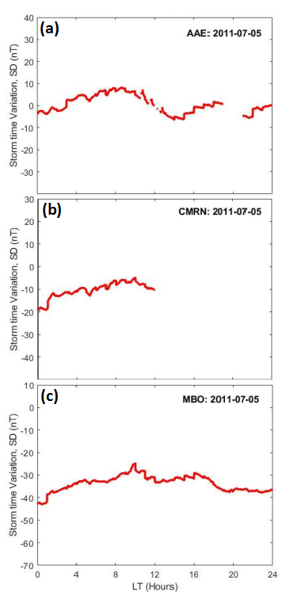

Figure 3: Storm time variations of the geomagnetic field during recovery phase of 5th July, 2011 geomagnetic storm over: (a) AAE, (b) CMRN and (c) MBO.

Figures 4(a), 4(b) and 4(c) show storm time variations of geomagnetic field over AAE, MBO and CMRN for the recovery phase of the July 16th, 2012 geomagnetic storm. In Figure 4(a), the geomagnetic field storm variation at AAE showed a strong positive impulse in the local morning hours. These values dropped rapidly, attaining a minimum value SD of -170nT at around local noon and rising to -120nT at 24:00LT. At MBO, the SD values began increasing from -100nT at 00:00UT, reaching its minimum of about -95nT at around 14:00LT as indicated by Figure 4(b). At CMRN the SD began dropping from -100nT at 03:00LT, reaching its lowest of -115nT at 13:00LT and rising to -100nT at 24:00LT as indicated by Figure 4(c).

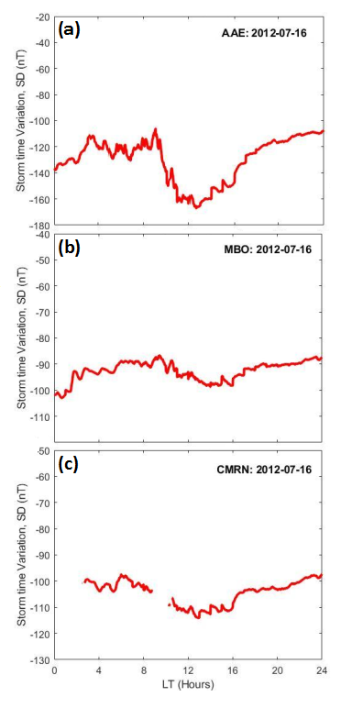

Figure 4: Storm time variations of geomagnetic field during recovery phase of the 16th July, 2012 geomagnetic storm over: (a) AAE, (b) MBO and (c) CMRN.

Figures 3(a), 3(b), 3(c), 4(a), 4(b) and 4(c) display a reduction in the storm time variation of geomagnetic field at local noon (11:00 - 13:00LT) over all the stations. This is attributed to the fact that during the recovery phase, at local noon the EEJ temporarily became suppressed (reduces) as a result of the westward disturbance dynamo electric fields (DDEF) coming from the high-latitude regions, which oppose the normal eastward electric field. This leads to a reduction of storm time variation at all stations at the geomagnetic equator at the local noon (Oyama et al, 2023; Fejer et al, 2011). However, the reduction depth of the storm time variation of geomagnetic field depended on the strength of the storm where the 5th July 2011 geomagnetic storm displayed smaller depth (Figures 3(a), 3(b) and 3(c)) as compared to the 16th July 2012 geomagnetic storm (Figures 4(a), 4(b) and 4(c)). This variation in the depth of storm time magnetic field perturbations during the recovery phase was attributed to the strength of the ring current where intense storms leads to increased injections of charged particles into current, hence larger suppression as compared to the less intense storms (Daglis et al, 1999).

All the three stations showed variations in storm time behavior during the recovery phases of the 5th July 2011 and 16th July 2012 geomagnetic storms. The differences in these values were linked to the effect of Equatorial Electrojet current and the influence of meridional winds and tidal waves. Studies by Srinivasan & Paul, (2011); Chau & Woodman, (2005); Kelley, (2009); Foster & Vo, (2002); Liu & Chao, (2000); Hargreaves. (1992); Basu et al, (1981) have highlighted the role played by EEJ, meridional winds and tidal winds in influencing storm time variations of geomagnetic field during the recovery phase of a geomagnetic storm. In their studies, they have highlighted that as the storm induced electric fields dissipate during the recovery phase, the EEJ still remain stronger and hence generates magnetic fields which influence local geomagnetic fields near the geomagnetic equator Obuya et al, (2024). They also observed that the interaction between EEJ and meridional winds modifies the EEJ flow, hence pushing ionospheric plasma away from the equator towards higher latitudes during recovery phase. This alters magnetic field responses at different latitude, which then influences storm time variations. Similarly, they highlight the effect of tidal waves during the recovery phase, where the tidal waves from the lower mesosphere and thermosphere cause variations in ionospheric plasma density by inducing vertical plasma motion, thereby influencing storm time variations.

Generally, the storm time variation showed small irregular and inconsistent patterns (perturbations) for all the stations during the recovery phases of both storms as indicated in Figures 3(a), 3(b), 3(c), 4(a), 4(b) and 4(c). These perturbations might be associated with the disturbance of the ionosphere which comes from the effects of the geomagnetic storms such as ring current decay (Daglis et al, 1999), solar wind and Interplanetary magnetic field (IMF) effect (O’Brien & McPherron, 2000) and wave-particle interactions (Summer et al, 2007; Jordanova et al, 2003). Akasofu, (2015) observed that storm time variations of geomagnetic field during the recovery phase result from the decay of the ring current as energetic particles are lost through wave-particle interactions, charge exchange or through precipitation into the atmosphere. These observations were further supported by studies by Sandhu et al, (2019) on sub-storm and ring current coupling and Kalmoni et al, (2019) on the dynamics of geomagnetic sub storms with a low-order non-linear model of the nightside magnetosphere (WINDMI model). The irregular perturbation electric fields deviates the geomagnetic field patterns from the quiet time patterns. The SD values at the equatorial stations are observed to intensify with decreasing latitudes up to the dip equator showing that in addition to the magnetospheric ring currents, the effects of storms at the equatorial latitudes also depend on ionospheric currents like Equatorial Electrojets (EEJ) and Auroral Electrojets (AEJ) which are brought up by the magnetosphere-ionosphere coupling. During the recovery phase of a geomagnetic storm, these currents can fluctuate, leading to storm time variations of the geomagnetic field Baker et al, (2001). Thus the equatorial magnetic storms are due to the combined effects of disturbance ring currents and the interplanetary magnetic fields (IMF) (Blanchard & McPherron 1993). Storm time variation has a latitudinal dependence at the equatorial region with perturbation magnitude increasing to the lowest negative at the dip equator. This is attributed to the behavior of EEJ which is more pronounced at the dip equator, where the current flows directly due to the magnetic field lines being horizontal (Maurice & Otsuka, 2002; Aarons, 1982) and also due to the vertical structure of the ionosphere in which the dip equator is also largely affected by storm time anomalies and enhancements (Zhao & Zhang, 2014; Foster & Vo, 2002; Yizengaw & Zhang, 2016; Basu et al, 1981).

**Conclusions**

We have investigated the storm time variation of geomagnetic fields during recovery phases of the 5th July 2011 and 16th July 2012 geomagnetic storms. The findings of this study are summarized below.

* All the three stations displayed variations in storm time behavior during the recovery phases of the 5th July 2011 and 16th July 2012 geomagnetic storms. The displayed disparities were linked to the effect of Equatorial Electrojet current and the influence of meridional winds and tidal waves during the recovery phases of the geomagnetic storms.
* All the three stations displayed a reduction in the storm time variation of geomagnetic field at local noon (11:00 - 13:00LT), during the recovery phases of both storms. This was attributed to the fact that during the recovery phase, at local noon the EEJ temporarily became suppressed due to the westward disturbance dynamo electric fields (DDEF) coming from the high-latitude regions, which oppose the normal eastward electric field. This leads to a reduction of storm time variation at all stations at the geomagnetic equator at the local noon. However, the reduction depth of the storm time variation of geomagnetic field depended on the strength of the storm where the 5th July 2011 geomagnetic storm displayed smaller depth as compared to the 16th July 2012 geomagnetic storm. This variation in the depth of storm time magnetic field perturbations during the recovery phase was attributed to the strength of the ring current where intense storms leads to increased injections of charged particles into current, hence larger suppression as compared to the less intense storms.
* The storm time variations over the three stations showed small irregular and inconsistent patterns (perturbations), which were believed to be associated with the ionospheric disturbances coming from the effects of the geomagnetic storms. Storm time variations of geomagnetic field during the recovery phase result from the decay of the ring current as energetic particles are lost through wave-particle interactions, charge exchange or through precipitation into the atmosphere.
* Storm time variation has a latitudinal dependence at the equatorial region with perturbation magnitude increasing to the lowest negative at the dip equator. This is attributed to the behavior of EEJ which is more pronounced at the dip equator, where the current flows directly due to the magnetic field lines being horizontal and also due to the vertical structure of the ionosphere in which the dip equator is also largely affected by storm time anomalies and enhancements.

**Competing Interests**

The authors have no relevant financial or non-financial interests to disclose.

**Author Contributions**

This work was carried out in collaboration among all authors. All authors read and approved the final manuscript

**Acknowledgements**

The authors thank the International Real-time Magnetic Observatory Network (INTERMAGNET) and the African Meridian B-field Education and Research (AMBER) array team for availing the magnetometer data resources that were used in this work. They also thank Omniweb website: [*https://omniweb.gsfc.nasa.gov/form/dx1.html*](https://omniweb.gsfc.nasa.gov/form/dx1.html)*.*for the Kp and Dst index data used in this research.

# **References**

Aarons J (1982). The role of equatorial electrojet in the production of ionospheric irregularities. Reviews of Geophysics, 20(2), 299-317. DOI:10.1029/RG020i002p00299.

AkpanenoA, Adimula I, Cyril A (2015). Disturbed Day Variation of Geomagnetic H-Field along the Magnetic Equator. Advances in Physics Theories and Applications. Vol.48, ISSN 2224-719X (Paper) ISSN 2225-0638 (Online).

Astafyeva E , Zakharenkova I , Alken A. (2012). Prompt and long lasting ionospheric response to the July 2012 geomagnetic storm. Journal of Geophysical Research: Space physics. DOI: 10.1029/2012JA018051.

Baker D N, Turner N E, Pulkkinen T I (2001). Energy transport and dissipation in the magnetosphere during geomagnetic storms. Journal of Atmospheric and solar –Terrestrial Physics. 63(5), 421-429. DOI: 10.1016/S1364-6826(00)00169-3.

Basu S, MacKenzie E & Basu S. (1981). Storm time effects on the equatorial ionosphere: Observations and model results. Geophysical Research letters, 8(10), 1067-1070. DOI: 10.1029/GLOO8i010p01067.

Blanchard G, McPherron G. (1993). A bimodal representation of the response of function relating to the solar wind electric field to the al index. J. Adv spacers 13(17):71-74. DOI: 10.1016/0273-1177(93)90232-H.

Burns A G, Killeen T L, Crowley G, Emery B A, Roble R G (1991). On the mechanisms responsible for high-latitude thermospheric composition variations during the recovery phase of a Geomagnetic storm. Journal of Geophysical Research: Space physics, 96(A8), 14153-14167. DOI: 10.1029/91JA01661.

Chapman S & Bartels J. (1940). Geomagnetism. Vol.1. Oxford University press. ISBN 978-0-19-851692-8.

Chau J L & Woodman R F (2005). Equatorial and low latitude ionospheric irregularities during the recovery phase of geomagnetic storms. Annales Geophysicae, 23(7), 2505-2513. DOI: 10.5194/angeo-23-2505-2005.

Chia, S. O., Ugonabo, O. J., & Okpala, K. C. (2019). A study on the effects of solar wind and  
interplanetary magnetic field on geomagnetic H-component during geomagnetic storms.  
International Journal of Physical Sciences, 14(11), 108-116. DOI: 10.5897/IJPS2019.4798.

Daglis I A, Thorne R M, Baumjohann W, Orsini S (1999). The Terrestrial ring current: origin, formation and decay. Reviews of Geophysics, 37(4), 407-438. Doi:10.1029/1999RG900009.

Fejer B G, de Paula E R, Abdu M A , Woodman F W. (2011). Equatorial ionospheric electric fields during geomagnetic storms. Geophysical Research Letters. DOI: 10.1029/2011GL048469. DOI: 10.1029/2011GLO48469.

Foster J C & Vo H (2002). Equatorial ionospheric plasma bubbles and their relationship to mesospheric storms. Journal of Geophysical Research: Space physics, 107(A10), 1233. DOI: 10.1007/s11207-019-1402-8.

Gonzalez W D, Joselyn J A, Kamide Y, Kroehl H W, Rostoker G, Tsurutani B T, Vasyliunas V M (1994). What is a geomagnetic storm? Journal of Geophysical Research, 99(A4), 5771-5792. DOI: 10.1016/0273-1177(92)90335-6.

Hargreaves J K. (1992). The solar-Terrestrial Environment. Cambridge university Press. ISBN:9780511628924.

Haines C, Owens M. J, Barnard L, Lockwood M, Ruffenach A (2019). Variation of Geomagnetic Storm duration with Intensity. Solar physics, 294(145) DOI: 10.1007/s11207-019-1546-z.

Jordana V K, Miyoshi Y, Kozyr J U et al, (2003). Ring current development during the 19th October 1988 storm: Comparisons between multi-spacecraft observations and kinetic model. Journal of Geophysical Research: Space physics, 108(A10), 1361. Doi: 10.1029/2003JA009841.

Kalmoni M A, Milan S E, Rae I J (2019). The dynamics of geomagnetic sub-storms with WINDMI Model. Earth, Planets and Space. DOI:10.1186/s40623-019-0978-6.

Kelley M C. (2009). The Earth’s ionosphere: Plasma physics and electrodynamics. Academic press. ISBN: 978-0120884254.

Kumar E A, Kumar S (2022). Geomagnetic storm effect on F2-Region ionosphere during 2012 at low and mid-latitude stations in the Southern hemisphere. Atmosphere, Vol 13(3) DOI; 10.3390/atmos13030480.

Lakhina G S, Tsurutani B T (2016). Geomagnetic storms: Historical perspective to modern view. Geoscience Letters, 3(1), 5. https://doi.org/10.1186/s40562-016-0037-4.

Lanza, R and Meloni, A. (2006). The Earth's magnetism. An introduction for Geologist. Wurzburg: Springer. DOI: 10.1007/978-3-540-27980-8.

Liemohn M W, Kozyra J U, Ridley A J et al, (2001). Computational analysis of the near-earth ring current during the 19-21 October 1998 storm. Journal of Geophysical Research: Space physics., 106(A12), 29531-29551. Doi: 10.1029/2001JA000045.

Liu H & Chao J K.(2000). Meridional wind effects on the equatorial ionosphere during geomagnetic storms. Geophysical research letters, 27(6), 837-840. DOI: 10.1029/1999GL003733.

Maurice J P & Otsuka Y (2002). The equatorial electrojet and the ionospheric dynamics during magnetic storms. Journal of Geophysical research: Space physics, 107(A12), 1475. DOI: 10.1029/2001JA000252.

O’Brien T P, McPherron R L (2000). An empirical phase space analysis of ring current dynamics: Solar wind control of injection and decay. Journal of Geophysical Research: Space physics, 105(A40, 7707-7719. Doi: 10.1029/1998JA000437.

Obuya L, George O, Andrew O, Edward U, Valence H (2024). Seasonal and Annual Variations of Equatorial Electrojet and Counter Elecrojet Strength During the Ascending Phase of Solar Cycle 24. International Astronomy and Astrophysics Research Journal 6(1):93-101. <https://doi.org/10.9734/iaarj/2024/v6i1107>.

Okwesili N A, Okeke F N, Awucha I E (2023). Contribution of solar quiet (Sq) daily current variations to the deep earth conductivity within the Southern African Region. International Journal of physical sciences, vol. 18(4): 116-128. DOI: 10.5897/IJPS2023.5027.

Pokharia M., Prasad, Bhoj C., Mathpal, C.(2018). A study of geomagnetic storms and solar and Interplanetary parameters for solar cycles 22 and 24. Solar Phys, 293:126  
<https://doi.org/10.1007/s11207-018-1345-y>.

Rastatter L, Kuznetsova M, Glocer A, et l (2013). Geospace environment modeling 2008-2009 mchallenge: Dst index. Space weather, 11(4), 187-205. Doi: 10.1002/swe.20036.

Sandhu N S, Watt E J, Man I R, Reeves L G (2019). Sub storm and Ring current coupling: A comparison of isolated and compound sub storms. Journal of Geophysical Research: Space physics. DOI:10.1029/2019JA026766.

Summers D, Ni B, Meredith N P (2007). Timescales for radiation belt electron acceleration and loss due to resonant wave-particle interactions: 1 Theory. Journal of Geophyical Research: Space physics, 112(A4), A04206. DOI: 10.1029/2006JA011801.

Turner N E, Baker D N, Pulkkinen T I et al (2001). Energy content in the storm time ring current. Journal of Geophysical Research: Space physics, 106(A9), 19149-19156. Doi: 10.1029/2000JA003025.

Yizengav E & Zhang H (2016). Ionospheric storm time response and its latitudinal variations over the African sector. Annales Geophysicae, 34(2), 179-190. DOI: 10.5194/angeo-34-179-2016.

Zhao B & Zhang S (2014). The role of neutral winds and electric fields in the latitudinal distribution of ionospheric storm time perturbations. Geophysical research letters, 41(5), 1462-1468. DOI: 10.1002/2013GLO59160.