Evaluation of alternate, fixed and conventional furrow irrigation systems on tomato (Solanum lycopersicum L.) yield and water use efficiency in Wolita area, Southern Ethiopia

ABSTRACT

Water scarcity is one of the most important factors influencing sustainable agricultural production in arid and semi-arid regions. Insufficient water supply for irrigation was the norm rather than the exception, and irrigation management has been shifting from emphasizing production per unit area to maximizing the production per unit of water consumed, the water productivity. To cope with scarce water supplies, applying irrigation water below full crop-water requirements is an important tool to achieve the goal of reducing irrigation water use and increase water use efficiency (WUE). The objective of this research was to evaluate the three furrow irrigation systems on tomato yield and water use efficiency and identify the furrow irrigation method which allows achieving optimum tomato yield. The experiment was arranged in randomized complete block design with three treatments and six replications. The irrigation treatments were alternate furrow irrigation (AFI), fixed furrow irrigation (FFI), and conventional furrow irrigation (CFI) method. The results indicated significant differences (p < 0.05) in yield and water use efficiency. CFI irrigation method had maximum fruit yield (32 ton/ha), while AFI method showed both the highest water use efficiency (8.82 kg/m³) and marginal return rate. Therefore, in area where enough water available, applying water at CFI system through growing season is advisable to obtain maximum tomato yield and in water scarce area applying irrigation water through AFI system is found to be economical feasible with the highest water use efficiency.
KEY WORDS: crop water requirement, evapotranspiration, furrow irrigation method, water use efficiency
- Introduction
In Ethiopia, tomato is one of the most widely cultivated vegetables with an annual production volume of about 41,948 tons (FAOSTAT, 2020). The importance of tomato is increasing since it is a high value commodity, and has been given top priority in vegetable research in Ethiopia. Small-scale farmers and commercial growers could grow the crop for its fruits in different regions of the country. It is produced both during the rainy and dry seasons under supplemental irrigation (Lemma, 2002). While, on a global scale, water resources are still ample, serious water shortages are developing in the arid and semiarid regions as existing water resources reach full exploitation. The great challenge for the coming decades will, therefore, be the task of increasing food production with less water, particularly in countries with limited water, land resources and inefficient water use (FAO, 2002). As water scarcity intensifies in many regions of the world, better management of water is becoming an issue of paramount importance (Lorite et al, 2007) because; it is the most severe constraint for development of agriculture particularly in arid and semiarid areas of the world.
Agriculture is the main pillar of the Ethiopian economy, contributing to 42% of the national gross domestic product (GDP), 70% of export earnings and 80% of employment. The bulk of production in the agriculture sector (90%) comes from smallholder farmers. The country has huge potential for agricultural development, but the sector has issues of poor production and productivity. Rainfall variability, land and soil degradation, and poor agricultural water management along with traditional farming systems contribute to these issues (Langan et al., 2015).
Alternate furrow irrigation (AFI) is the technique of irrigation water application in which one of the two neighboring furrows alternately irrigated during consecutive watering. This system saves quite a good amount of water and is very useful and crucial in areas of water scarcity. Alternate furrow irrigation of cotton plantings was studied and water savings was 25% with yield losses of 20% compared to conventional furrow irrigation (Einsenhaver and Youth, 1992). Soil evaporation of AFI is lower than that of conventional furrow irrigation (CFI) for the same treatment. The difference in soil evaporation between AFI and CFI would become smaller and smaller with the increase of the lower limit value of soil moisture (Majumdar, 2002).
It is possible to make efficient use of water and bring more area under irrigation using the available water resources. This can be achieved by introducing advanced methods of irrigation and improved water management practice (Zaman et al., 2001). Many studies have been carried out worldwide regarding the effects of deficit irrigation on yield of mainly horticultural crops (Fabeiroet al., 2003; Olalla et al., 2004; Sezen et al., 2008). The yield reduction resulted by deficit irrigation will be insignificant compared with the benefits gained through diverting the saved water to irrigate additional cropped area (Kirda, 2002; Gijón et al., 2007).

Similar studies on onion by Samson and Tilahun (2007) that deficit irrigation throughout the growing season as 50% and 75 % of ETc reduced yields from full irrigation and resulted in the highest water saving and crop water use efficiency.
Among the surface irrigation methods, furrow irrigation technique is known to have better efficiency and can be used in situations where water shortage is critical. Recently, furrow irrigation is becoming most popular for both small- and large-scale irrigation schemes (FAO, 2001).
Most of the research results indicate that AFI has the potential to save water and labor and ensure high water use efficiency, although they recommended conducting similar experiments for other vegetable and food??? crops (Deribew, 2006; Woldesenbet, 2005; Mitslal, 2008). A serious of water shortage, poor water management, application of the right amount of water at the right time, and unwise use of irrigation water causes low crop water productivity and high production cost. The study aimed to identify furrow irrigation methods at which irrigation water saving is needed for production of tomato, and increase water productivity.

Materials and Methods

Description of the Study Area
The study was conducted at Humbo woreda, woliyta zone of southern nation nationality and peoples of Ethiopia, which is located 327 km south of Addis Abeba. The experimental station is located at approximately 37°48′ E longitude and 06°44′ N latitude with an altitude of 1611 masl, as shown in Figure 1. The experimental field was irrigated using the furrow irrigation system with water sourced from Ella River. The study area experiences two main cropping seasons due to its bimodal rainfall system. The first cropping season, called Belg, extends from March to June, whereas the second season, called Meher, extends from the last week of August to November. According to national meteorological data, the mean annual rainfall in the area is 1001 mm. Mean maximum temperature varies from 23.1 ⁰C to 29.81⁰C while the mean minimum temperature varies from 14⁰C to 15.3⁰C. The main grown crop in the woreda are tomato (Solanum lycopersicon ), onion (Allium cepa L.), Pepper (Piper nigrum), pigeon pea (Cajanus cajan), ginger (Zingiber officinale), maize (Zea mays), haricot-bean, sorghum, teff, Sesame, and cabbage, are also among the widely cultivated crops in the area (Alemayehuet al., 2016).
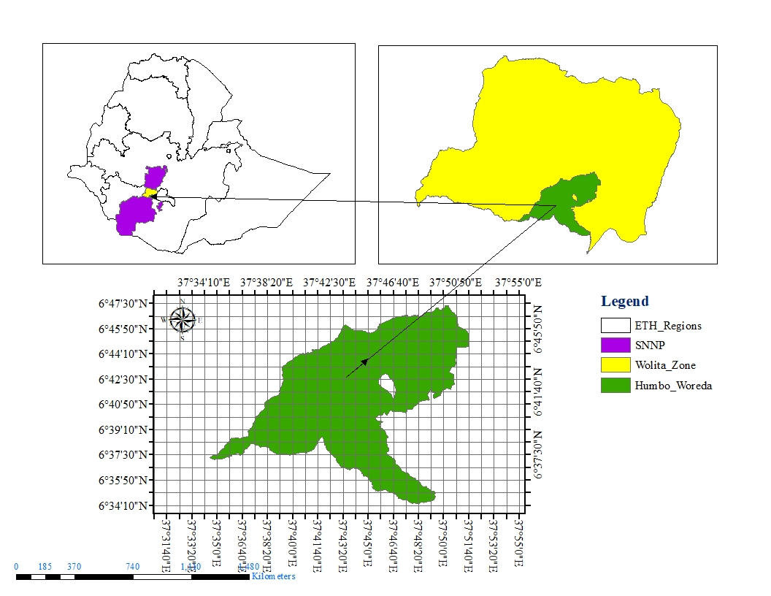
Figure 1. Study area Map
  - Experimental treatment and design
The experiment had three treatments with six replications and arranged in randomized complete block design. The treatments were alternate furrow irrigation (AFI), fixed furrow (FFI) and conventional furrow irrigation (CFI). The CFI with 100 % ETc =all furrow get full water requirement, FFI with 100 % ETc = fixed open furrow get full water requirement and AFI irrigation with 100% ETc = alternate open furrow get full water requirement. Each treatment had six replications making a total of 18 experimental plots. Each plot had 20 m² (5.0 m x 4.0 m), space between plots and replications were 1 m and 1.5 m respectively; within each plot there are six furrows with five ridges, and single row tomato with spacing of 30 cm between plants and 90 cm between rows was used.
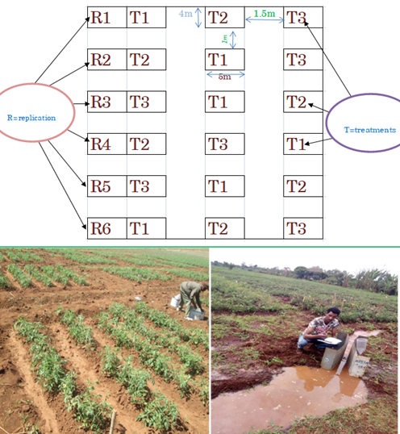
a
b
Figure 1: Experimental layout plan (a) and water application and measurement (b).

2.3 Crop establishment and management practices
Tomato seeds Roma VF variety was selected based on farmer interest and market acceptability. The selected variety was sown on 1 m width and 10 m length seed bed. At the morning and night at two days interval irrigation water was applied to the nursery seed using bucket. Transplanting is usually done to the field 5 to 6 weeks after sowing. A week before transplanting reduced the applied water to resist the new environment and the applied treatment. However, 12-14 hours before they are taken out of the seed bed they should be thoroughly watered again to avoid excessive damage to the roots. Seedlings of 15-25 cm tall with 3-5 true leaves are most suitable for transplanting. Transplanting was done in the afternoon or on a cloudy day to reduce the transplanting shock (Shankaraet al., 2005). The seedlings were then transplanted on well prepared experimental plots on one sides of furrow ridge at row and plant spacing of 90cm and 30cm, respectively. According to agronomy and soil feasibility report (ASFR, 2007), single fertilization with NPS at transplanting and split application of Urea at transplanting and 45 days after transplanting was done by hand placement at a rate of 100 kg/ha and 100kg/ha, respectively and mancozeb was sprayed 3 kg/ha in seven-day interval to prevent late blight disease and 0.4 l/ha karate was sprayed to control bollworm, Whitefly and aphids pest diseases condition.
  - Soil sampling and analysis
Composite soil samples were collected from four depths 0-20 cm, 20-40 cm, 40-60cm, 60-100 cm at five points of the experimental field. The soil was analyzed in laboratory, gravimetric method, pH meter method, soil and water ratio method and titration method were used to determine soil moisture content, PH value, electrical conductivity and organic matter content respectively. Hydrometer method was used for analysing particle size distribution and the textural class of the soil was determined using USDA textural triangle following the procedures indicated by Derek et al., (2015).
The soil bulk density was determined from undisturbed soil samples which were collected by core samplers. Undisturbed soil samples were collected by using a cylindrical soil sampler with known volume. The samples were dried in an oven at 105 ⁰C for 24 hours and the bulk density was calculated using the equation given by Hillel (2004).
$ρ_{b}=\frac{\text{Ws}}{\text{Vc}}$

Where $ρ_{b}$is soil bulk density (g/ cm³), Ws is mass of dry soil (g) and Vc is volume of soil in the core (cm ³)
The pH of the soil was measured by means of pH meter in the supernatant suspension of 1:2.5, soil: liquid mixture as described by (Batjes. 1995). Electrical conductivity (EC) of 1:5 soils to water ratio extracts was carried out with a conductivity meter (Yangboet al.,2012). Organic matter content titration method was used, which is oxidation under standardized condition with potassium dichromate in sulpheric acid, was followed for organic carbon determination. Finally, conversion of organic carbon to organic matter was obtained by multiplying percentage organic carbon by 1.724 as described by Bianchi et al (2008).
Field capacity and permanent wilting point of soil sample analysis were analized at Ethiopian Construction Design and Supervision Work Corporation Research Laboratory and Training Center of Addis Abeba.Soil samples were saturated for two days and using a pressure plate apparatus of a pressure of 1/3 bar for field capacity and 15 bar for permanent wilting pointwas provided until no further change in soil moisture content be observed (Werner, 2002). After getting soil moisture values corresponding to these constants, available water holding capacity of the soil was calculated. The total available water (TAW) for the use by the plant in the root zone was estimated as the difference in moisture content between field capacity and permanent wilting point using the following equation (Allen et al., 1998).
$\text{TAW}=\frac{(\text{Fc}−\text{PWP})}{\text{100}}∗\text{BD}∗\text{Dz}$

Where, FC = field capacity, PWP= permanent wilting point, BD = bulk density of the soil in gm cm⁻³, and Dz = maximum effective root zone depth in mm.
Soil samples were regularly collected from experimental plots before and after irrigation for gravimetric method. The weight of collected sample soil was measured before and after oven dried, and gravimetric water content was determined using the following equation (Cuenca, 1989). The gravimetric water content was calculated by the equation:
$$θm=\frac{\text{Wws}−\text{Ws}}{\text{Ws}}∗\text{100}$$
Where, $θm=$ water content expressed on weight basis in (%), $\text{Wws}=$ weight of wet soil (g) and $\text{Ws}=$weight of dry soil (g).
Volumetric water content
$$θv=\frac{ρb}{ρw}∗θm$$
Where, $θv=$volumetric moisture content in (%), $ρb=$soil bulk density (gcm⁻³) and$ρw=$ water density (gcm⁻³).

2.5 Soil infiltration rate
Infiltration rate of the soil in the experimental field was determined using double ring infiltrometer before experimental work is started. The test was conducted at three representative locations of the experimental field. It was installed the inner and outer ring with the cutting edge facing down on the ground and put the driving plate on top of the inner ring and the outer ring. Use the impact-absorbing hammer to insert the inner and outer ring about 5 cm vertically into the soil and measuring ruler inside the inner ring. It was fill the outer ring and the inner ring with water simultaneously using bucket. The water inside the outer ring was avoid lateral movement of water from the inner ring. Recording was done immediately to determine the initial water level inside the inner cylinder and start the stop watch. Record the change in water level inside the inner cylinder at time intervals and the procedure was repeated until consecutive uniform infiltration depth was observed (Walker 2003).

2.6 Climate data
Long term climate data such as maximum and minimum air temperature, relative humidity, wind speed, sunshine hours, and rainfall were collected from National Meteorological Agency for determination of reference evapotranspiration (ETo), planning irrigation schedule and crop water requirement. The daily weather data during the growing period were collected from meteorological station and plastic rain gauge was installed to measure rainfall in the experimental field.
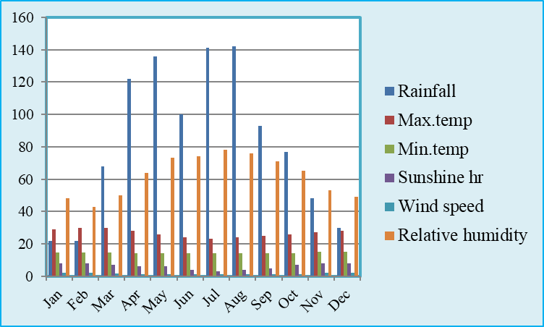
Figure 3: Average climate data of the study site
Where, Max.temp = maximum temperature (0_{C}), Min.temp = minimum temperature (0_{C}), Rainfall (mm), Wind speed (m/s) and Relative humidity (%).

2.7 Crop data
As indicated in Table 1, length of growing season, crop coefficient (Kc), rooting depth (m) average soil depletion fraction (p) and yield response (Ky) were the necessary crop data for determination of crop water requirement.
Table 1: Crop data required for CWR determination
 | Growth stage
Crop data | Initial | Development | Mid | Late
Length of growing season(days) | 30(19) | 40(25) | 40(28) | 25(18)
Crop coefficient(Kc) | 0.6(0.6) | 0.89(0.89) | 1.15(1.15) | 0.8(0.8)
Rooting depth(m) | 0.7(0.7) | 0.98(0.85) | 1.5(1) | 1.5(1)
Average soil water depletion fraction(p) | 0.4(0.4) | 0.4(0.4) | 0.4(0.4) | 0.4(0.4)
Yield response (Ky) | 0.5(0.5) | 0.6(0.6) | 1.1(1.1) | 0.8(0.8)
*Source: FAO 56(Allen et al., 1998) and ( ?) data were from Areka Agricultural Research center

2.8 Crop water requirement
The amount of water needed (CWR) to compensate the amount of water lost through evapotranspiration (ETc), requires reference evapotranspiration (ETo) and tomato crop coefficient (Kc) is given by Allen et al. (1998) as 0.6 for the initial stage, 0.6 <Kc< 1.15 for the development stage, 1.15 for the mid-season stage and 1.15 >Kc> 0.8 for the late season stage. As indicated in section 2.4 crop water requirements were calculated from ETo and Kc.
The net irrigation requirement was calculated using the CROPWAT computer program basedon Allen et al. (1998) as follows:
IR = CWR – Pe
Where, IR =Irrigation requirement (mm), CWR= crop water requirement in mm and Pe = effective rainfall (mm) which is part of the rainfall that enters into the soil and makes available for crop production.
The effective rainfall (Pe) is estimated using the method given by (Allen et al., 1998) as.
$\text{Pe}=0\text{.}6∗P−\text{10}$For Pmonth ≤ 70 mm
$\text{Pe}=0\text{.}8∗P−\text{24}$For Pmonth > 70 mm
Where: Pe (mm) = effective rainfall and P (mm) = total rain fall.

Gross irrigation requirement
Taking application efficiency of a short, end diked furrow as 60% (Brouwer and Prins, 1989), the gross irrigation requirement was obtained as:
$I_{g}=\frac{I_{n}}{E_{a}}$
where, Ig = the gross irrigation depth in mm, In??? and Ea=the furrow application efficiency (%).
The time required to deliver the desired depth of water into each furrow was calculated using the equation given byMichael (2008):
$$t=\frac{I_{g}∗l∗w}{6∗Q}$$
where, Ig = gross depth of water applied (cm), t = application time (min), l= furrow length (m), w= furrow spacing (m), and Q= flow rate (l/s).
The total amount of water estimated using the CROPWAT model was diverted to the furrow with calibrated Parshall Flume. As indicated appendix Table 5, free flow discharge values for different size of Parshall Flumes outlined by (Kandiah, 1981). The time of application was monitored using stopwatch during each irrigation water application in order to assess the treatment effects. The irrigation water to be applied to the plots was measured using a 3 inch Parshall Flume installed at the upper stream near the experimental field.

2.9 Observation of crop yield and components
During harvesting Stand count, weight of marketable yield, weight of unmarketable yield were measured from the net harvested area of each plot. Unmarketable fruit yield was obtained from the fruit that were affected by pest, bird attack, rotten, and under size. The weight of total (marketable and unmarketable) fruit yields per plot at harvesting from the net area were recorded and summed up to estimate yield per hectare.

2.10 Water use efficiency
The water use efficiency (kg/m³) was estimated by dividing harvested yield in kilogram to unit volume of water in cubic-meter. Crop water use efficiency was obtained by the marketable yield harvested in kilogram per total water used (Micheal,2008).
$$\text{WUE}=\frac{Y}{\text{ETc}}$$
where, WUE = crop water use efficiency (kg/m³), Y = yield (kg/ha), and ETc is the amount of water used by the crop (m????).

2.11 Crop response factor
The upper limits for yield are set by soil fertility, climatic conditions and management practices (Bauder et al., 1988). Where all of these are optimal throughout the growing season, yield reaches the maximum value as does evapotranspiration (ETm) Soil Water Storage (SWS) has an impact on water availability (WA) for a crop and, subsequently, on actual yield and actual evapotranspiration (ETa) (English, 1990). Fereres and Soriano (2007) stated that when water deficit occurs during a specific crop development period, the yield response can vary depending on crop sensitivity at that growth stage. The degree of sensitivity also varies with amount of water deficit and with crop type. Therefore, knowledge of crop response factor for water deficit and time of irrigation is a tool for scheduling irrigation where a scarce supply of water is available. Although it is difficult to measure the actual evapotranspiration values during the experimental season, water applied in the total growing season for full irrigated treatment, was taken as the maximum evapotranspiration (ETm), and the deficit water applications values were taken as actual evapotranspiration (ETa). A standard formulation equation relates these four parameters (Ya, Ym, ETa, ETm) to yield response factor (Ky), which links relative yield decrease to relative evapotranspiration deficit (Vaus and Pruitt, 1983):
$$\text{ky}=\frac{(1−\frac{\text{ya}}{\text{ym}})}{(1−\frac{\text{ETa}}{\text{ETM}})}$$
Where, Ky = yield response factor was already defined, ya = actual yield (kg/ha), ym = maximum yield (kg/ha), ETa = actual evapotranspiration (mm), ETm = maximum evapotranspiration (mm),.
Ky relates relative yield decrease to relative evapotranspiration deficit. Two series of Ky values obtained from FAO data sets and from (IAEA) and (CRP) showed a wide range of variation for this parameter. 0.20 < Ky < 1.15 (FAO, 2002), and 0.08 < Ky < 1.75 (IAEA) (Moutonnet, 2002; Kipkorir et al., 2002). According to (Steduto et al., 2012), the Ky values are crop specific and vary over the growing season. For Ky > 1, crop response is very sensitive to water deficit with proportional larger yield reductions when water use is reduced. For Ky < 1, crop is more tolerant to water deficit, and recovers partially from stress, exhibiting less than proportional reductions in yield with reduced water use. For Ky =1, yield reduction is directly proportional to reduced water use.
2.12 Economic analysis

Economic evaluation is analyzing the cost that invested during growing season and benefit gained from yield produced by application of water. Marginal Rate of Return (MRR) was used for analysis following the CYMMYT method (CIMMYT, 1988). Economic water productivity was calculated based on the information obtained at the study site: the size of irrigable area, the price of water applied and the income gained from the sale of tomato yield by considering the local market price.

Yield and economic data were collected to evaluate the benefits of application of water in different irrigation systems and treatments. Economic data includes input cost like cost for water (water pricing), seeds, fertilizers, fuel and labor. However, cost of water price and labor are the cost that varies between treatments. The net income (NI) treatments were calculated by subtracting total cost (TC) from gross income (GI) and were computed as:

$$\text{NI}=\text{GI}−\text{TC}$$

The difference between net income of a treatment and its next higher variable cost treatment termed as change in net income (ΔNI). Higher net benefits may not be attractive if they require very much higher costs (CIMMYT, 1988). Hence, it is required to calculate marginal costs with the extra marginal net income. The marginal rate of return (MRR) indicates the increase of the net income, which is produced by each additional unit of expenditures and it is computed as follows:

$$\text{MRR}=\frac{Δ\text{NI}}{Δ\text{VC}}$$

Where, MRR was already defined, ΔNI= change in net income, ΔVC= change in variable cost

2.13 Statistical Analysis
The collected data were analyzed using Statistical Agricultural Software (SAS 9.0) and least significance difference (LSD) at 5% was employed to see a mean difference between treatments.

3. RESULTS AND DISCUSSIONS

3.1 Experimental field Soil
The laboratory result showed that the mean composition of sand, silt and clay percentages were 24.5%, 9% and 66.5%, respectively. Thus, according to the USDA soil textural classification, the percent particle size determination for experimental site revealed that the soil texture could be classified as clay soil. The top soil surface had slightly lower bulk density (1.15g/cm³) than the subsurface (1.34g/cm³). This could be because of slight decrease of organic matter with depth and compaction due to the weight of the overlying soil layer (Brady and Weil, 2002). The critical value of bulk density for restricting root growth varies with soil type (Hunt and Gilkes,1992) but the general bulk density greater than 1.6 g/cm³ tend to restrict root growth(McKenzie et al., 2004). Moisture content at field capacity of the experimental site soils were 34.49%, 32.67%, 32% and 31% at 0-20cm, 20-40cm, 40-60cm and 60-100cm soil depth respectively. Moisture content at permanent wilting point also shows variation with depth and has values 18%, 17.2%, 16% and 14.05% at 0-20cm, 20-40cm, 40-60cm and 60-100cm soil depths respectively. The totalaverage available water (TAW) is directly related to variation in FC and PWP. The representative value of TAW was 206.1 mm/m and the TAW range of 190 – 260 mm/m is the characteristic for clay soil (Brouweret al., 1985)
Table 2: Physical characteristics of the soil at the study area
Soil property |  | Soil depth in (cm)
 |  | 0-20 | 20-40 | 40-60 | 60-100 | Mean
Particle size  Distribution | Sand (%) | 26 | 30 | 20 | 22 | 24.5
Particle size  Distribution | Silt (%) | 12 | 6 | 10 | 8 | 9
Particle size  Distribution | Clay (%) | 62 | 64 | 70 | 70 | 66.5
Textural class |  | Clay | Clay | Clay | Clay | Clay
Bulk density (g/cm³) |  | 1.15 | 1.26 | 1.32 | 1.34 | 1.27
FC (Vol %) |  | 34.49 | 32.67 | 32 | 31 | 32.54
PWP (Vol %) |  | 18 | 17.2 | 16 | 14.05 | 16.31
TAW (mm/m) |  | 189.6 | 194.9 | 211.2 | 227.1 | 206.1

Infiltration rate of the soil

The basic infiltration rate of the experiment site was found to be 4.8 mm/hr which is in the lower range of clay soil (1-5mm/hr) (Hillel, 2004). This means that a water layer of 4.8 mm on the soil surface was take one hour to infiltrate.

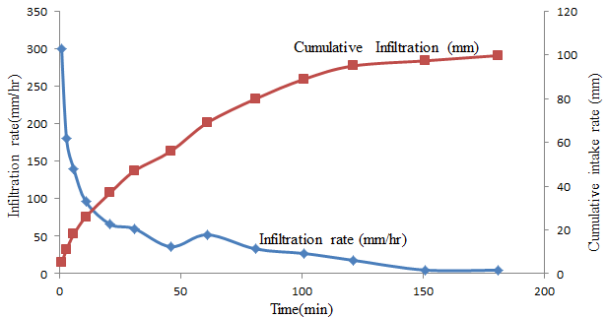
Figure 2: Cumulative Intake Depth and Cumulative Infiltration Rate of Experimental Soil

The average pH value of the experimental site through the analyzed depth was found to be slightly acidic, with average value of 5.71. Tomato can be grown on a wide range of soil but a well-drained, with pH of 5 to 7 is preferred (Doorenboset al., 1979). The experimental soil had an average electrical conductivity of 1.1dS/m through 100 cm profile which is below the threshold value for yield reduction that is 1.2 dS/m (Smith et al., 2011). The organic matter content and organic carbon content of the soil had average values of 5.6 % and 3.2 %, respectively.
Table 3: Soil chemical properties
Soil property | Soil depth
Soil property | 0-20 cm | 20-40 cm | 40-60 cm | 60-100 cm | Average
pH | 5.68 | 5.73 | 5.79 | 5.64 | 5.71
EC(ds/m) | 1.18 | 1.06 | 1.18 | 1.05 | 1.1
OM (%) | 6.6 | 6.3 | 5.6 | 4 | 5.6
OC | 3.7 | 3.7 | 3.3 | 2.3 | 3.2

3.2 Crop and irrigation water requirements of tomato
Figure 5 shows the reference evapotraspiration (ETo) value of the study site was found to be ranged between 4.88 mm/day in January, 5.38 mm/day in February and 5.04 mm/day in march, with an average of 5.1 mm/day for the whole growth period.
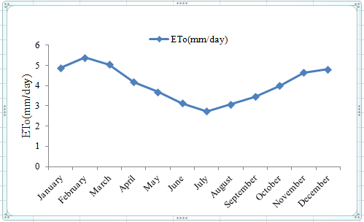
Figure 5: ETo of the experimental site
In the absence of rainfall and considering tomato Roma VF variety with crop coefficient at initial stage 0.6, mid stage 1.15 and late stage 0.8 as shown in the Figure 6, root depth 0.7 to 1m, allowable critical depletion 40%, clay soil with total soil available moisture 206.1 mm/m, the seasonal irrigation requirement was found to be 415.7 mm. This amount needed for full irrigation throughout the growing season.
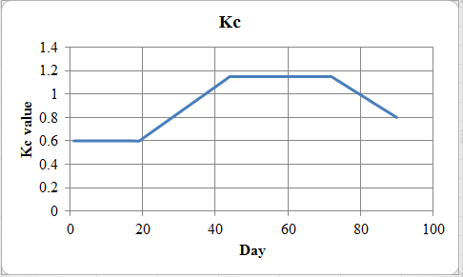
Figure 6: Crop coefficient value of Tomato

The amount of water required by tomato was increasing from initial period to mid period. The maximum irrigation water (41.2mm) was required at mid-March of mid stage. In this stage tomato was attained its maximum crop coefficient and there was high reference evapotranspiration. At late period the water required was reduced due to reduction crop coefficient value.
Table 4: Crop and irrigation water requirement for tomato at four days interval
Date | Stage | Kc | ETo  (mm/period) | Etc  (mm/period) | IRn  (mm) | IRg  (mm)
4-Jan | Init | 0.6 | 19.52 | 11.7 | 11.7 | 19.5
8-Jan | Init | 0.6 | 19.52 | 11.7 | 11.7 | 19.5
12-Jan | Init | 0.6 | 19.52 | 11.7 | 11.7 | 19.5
16-Jan | Init | 0.6 | 19.52 | 11.7 | 11.7 | 19.5
20-Jan | Dev | 0.60 | 19.52 | 11.7 | 11.7 | 19.5
24-Jan | Dev | 0.67 | 19.52 | 13.1 | 13.1 | 21.8
28-Jan | Dev | 0.77 | 19.52 | 15.0 | 15.0 | 25.1
1-Feb | Dev | 0.85 | 21.52 | 18.3 | 18.3 | 30.5
5-Feb | Dev | 0.94 | 21.52 | 20.2 | 20.2 | 33.7
9-Feb | Dev | 1.03 | 21.52 | 22.2 | 22.2 | 36.9
13-Feb | Dev | 1.12 | 21.52 | 24.1 | 24.1 | 40.2
17-Feb | Mid | 1.15 | 21.52 | 24.7 | 24.7 | 41.2
21-Feb | Mid | 1.15 | 21.52 | 24.7 | 24.7 | 41.2
25-Feb | Mid | 1.15 | 21.52 | 24.7 | 24.7 | 41.2
1-Mar | Mid | 1.15 | 20.16 | 23.2 | 23.2 | 38.6
5-Mar | Mid | 1.15 | 20.16 | 23.2 | 23.2 | 38.6
9-Mar | Mid | 1.15 | 20.16 | 23.2 | 23.2 | 38.6
13-Mar | Mid | 1.15 | 20.16 | 23.2 | 23.2 | 38.6
17-Mar | End | 1.1 | 20.16 | 22.2 | 22.2 | 37.0
21-Mar | End | 0.98 | 20.16 | 19.8 | 19.8 | 32.9
25-Mar | End | 0.95 | 20.16 | 19.2 | 19.2 | 31.9
29-Mar | End | 0.80 | 20.16 | 16.1 | 16.1 | 26.9
Total |  |  | 448.56 | 415.7 | 415.7 | 692.8
ETo = reference evapotranspiration, ETc = crop water requirement, IRn = net irrigation requirement, IRg = gross irrigation requirement, kc = crop coefficient, Init = initial stage, Dev = development stage and Mid = middle stage.

3.3 Effects of furrow irrigation systems of tomato yield
The result in the Table shows that marketable yield was significantly affected by the amount of water applied to the crop and the methods of furrow irrigation systems. The highest marketable yield (24 tons/ha) was obtained from CFI while the minimum marketable yield (14.4 tons/ha) was obtained from FFI. Marketable fruit numbers also showed significant differences between the treatments and had consistency with marketable yield. The maximum (448,958) and minimum (296, 250) fruit number was recorded in CFI and FFI irrigation treatments, respectively. AFI gives a relatively better yield than FFI. In this research, unmarketable yield means that the fruits that were affected by pest attack, bird attack, rotten, and size. The result revealed that unmarketable yield was statistically non-significant between the treatments. The unmarketable yield of 8.1 ton/ha, 7.9 ton/ha, and 7.0 ton/ha was obtained from CFI, FFI, and AFI systems, respectively. Total yield is the sum of marketable and unmarketable fruit yield. The result also showed that the highest total fruit yield (32 tons/ha) was obtained from CFI and the minimum total yield (22.3 tons/ha) was gained from FFI.
Table 5: Water use efficiency and Tomato response to furrow irrigation systems
TRT | MY(ton/ha) | MFNO | UY(ton/ha) | UMFNO | TY(ton/ha) | WUE(kg/m³)
AFI | 18.3^{b} | 353125^{ba} | 7.0 | 193125.0 | 25.4^{b} | 8.82ª
FFI | 14.4^{c} | 296250^{b} | 7.9 | 214166.7 | 22.3^{b} | 6.91^{b}
CFI | 24.0ª | 448958ª | 8.1 | 242916.7 | 32.0ª | 5.76^{b}
CV (%) | 11.5 | 18.0 | 19.0 | 19.8 | 12.8 | 12.5
MS error | 4.7 | 4.4 | 2.2 | 1.8 | 11.6 | 1.7
LSD (0.05) | 3.8 | 114648 | NS | NS | 5.9 | 1.15
TRT = treatment, MY = marketable yield, MFNO = marketable fruit number, UY = unmarketable yield, UMFNO = unmarketable fruit number, TY = total yield, WUE = water use efficiency.

3.4 Water use efficiency
The analysis of variance indicated that the types of furrow irrigation systems were significantly (p<0.05) affected the irrigation water use efficiency of tomato. The result in the table : shows that highest and the lowest mean value of irrigation water use efficiency for AFI was observed to be 8.82 kg/m³ and 5.76 kg/m³ for CFI. The water use efficiency of CFI and FFI was statistically non-significant, but FFI saved more water. This is because of the difference in percentage of water actually converted to evapotranspiration out of the total amount applied. This is consistent with the significant improvements in CWUE that have been associated with AFI (Zhang et al., 2000). As indicated in Table 8 the yield reduction at alternative furrow irrigation was 23.5% and 39.9% at alternative furrow irrigation.
Table 6: Water use efficiency and amount of water saved
TRT | MY (kg/ha) | CWR (mm) | AW (mm) | Saved water (mm) | Yield reduction (%) | WUE (kg/m³) | Rank in WUE
CFI | 23958 | 415.7 | 415.7 | 0 | 0 | 5.76 | 3
AFI | 18333 | 415.7 | 207.85 | 207.85 | 23.5 | 8.82 | 1
FFI | 14375 | 415.7 | 207.85 | 207.85 | 39.9 | 6.91 | 2
TRT= treatment, CWR = crop water requirement AW= applied water and WUE = water use efficiency
3.5 Yield response factor
Table indicates that the yield of tomato was not sensitive to water deficit that happen in alternative and fixed irrigation systems, since yield response factor (ky) is less than one. That is tomato tolerate some degree of water stress through growing season.
Table 7:Yield response factor (ky)
Trt | Actual yield in kg/ha | Maximum  yield in kg/ha | Actual Eta (mm) | Maximum ETm (mm) | Yield response factor (ky)
CFI |  | 23958 |  | 415.7
AFI | 18333 |  | 207.85 |  | 0.5
FFI | 14375 |  | 207.85 |  | 0.8
ETa=actual evapotranspiration, ETm=maximum evapotranspiration, CFI= conventional

4.7 Economic analysis
The application of water in a water-saving irrigation system could be economically attractive to minimize drought hazards in water-shortage areas.
At the time of harvest, the market price of tomato was 10 birr per kg and the cost of irrigation water was 7 birr/m3 (by considering the cost of drinking water as the cost of irrigation water). To analyze by the producer of dominance analysis, the treatments were set in their sort of increasing variable cost, and their equivalent benefits were put aside. FFI and CFI showed the minimum and maximum variable costs respectively. Based on the current prices of tomato yield produced and input costs required for production, the economic analysis was carried out. The highest net income (193,081 birr/ha) was obtained under CFI and the least net income (111,801 birr/ha) was obtained under FFI. However, as indicated in Table 8, the largest MRR (3858 %) was acquired under AFI and the smallest MRR (315.14%) was obtained under CFI. Therefore, the highest economic return was observed at AFI with a net income of 150,381 birr/ha and MRR of 3858 %. The MRR tells us the amount of additional income obtained for every 1 birr spent. Hence, AFI acquired an additional 38.58 birr for every 1 birr spent.
Table 8: Economic analysis
TRT | AW | OY | GI | FC | VC | TC | NI | MRR
TRT | (m³/ha) | (kg/ha) | (birr/ha) | (birr/ha) | (birr/ha) | (birr/ha) | (birr/ha | (%)
FFI | 2078.5 | 14375 | 143750 | 17400 | 14549.5 | 31949.5 | 111801 | 0
AFI | 2078.5 | 18333 | 183330 | 17400 | 15549.5 | 32949.5 | 150381 | 3858
CFI | 4157 | 23958 | 239580 | 17400 | 29099 | 46499 | 193081 | 315.14
TRT= treatment, AW= Applied water, OY=Observed Yield, GI=Gross income, FC= Fixed cost, VC=Variable cost, TC=Total cost, NI=Net income, MRR=Marginal rate of return
- Conclusion and recommendation
Maximum fruit yield of 32 tons/ha and the highest economic return with net income of 193081 birr/ha was obtained under conventional furrow irrigation i.e., irrigating all furrows during consecutive watering. Irrigation water application in which one of the two neighboring furrows alternately irrigated during consecutive watering gives a relatively better yield i.e. 25.4 ton/ha than irrigation fixed to one of the two neighboring furrows through the growing season that yields 22.3 ton/ha. The highest water use efficiency (8.82 kg/m3) was obtained under alternative furrow irrigation and saved 50 % water and the minimum water use efficiency (5.76 kg/m3) was obtained during the conventional furrow irrigation system. Alternative furrow irrigation was also economically feasible because of its higher return rates. In areas where enough water is available, applying water to a conventional furrow irrigation system through the growing season is advisable to obtain maximum tomato yield. However, in water-scarce areas, applying irrigation water through an alternative furrow irrigation system is advisable with a minimum reduction of yield.
Competing interests
We confirm that the manuscript has been read and approved by authors and that there are no other persons who fulfill the criteria for authorship but are not listed. We further confirm that we have approved the order of authors listed in the manuscript. We wish to confirm that there are no known conflicts of interest associated with this publication and there has been no significant financial support for this work that could have influenced its outcome. We understand that the Corresponding Author is the sole contact for the Editorial process (including Editorial Manager and direct communications with the office). He is responsible for communicating with the other authors about progress, submissions of revisions, and final approval of proofs. We confirm that we have provided a current, correct email address which is accessible by the Corresponding Author.

REFERNCES
Alemayehu,A.,Derib,W. and Taye, B.,(2016).Onion Market Chain Analysis in Humbo District of Wolaita Zone, Southern Ethiopia. InternationalJournal of Scientific Research & Engineering Trends, 2(1),9.
Allen, .R., Pereira, L.A., Raes, .D. andSimth, M., (1998).Crop Evapotranspiration Guidelines for Computing Crop Water Requirement. FAO Irrigation and Drainage Paper Number 56, FAO, Rome, Italy.
Batjes, N. H.,(1995). A global data set of soil pH properties. international soil reference and information center.Technical paper 27.
Bauder ,J. W., Bauder ,T., Cardon, G. and Schneekloth. J., (1988). Guide to choosing crop well-suited to limited irrigation. Montano State University, Colorado State University and Utah State University.
Bianchi, S.R., Miyazawa, M., Iveira, E.L. and Pavan, M. A. (2008). Relationship between the Mass of Organic Matter and Carbon in Soil. An international journal ofBrazilian Archives of Biology and Technology, 51(2), 263-269.
Brouwer, C. and Prins, K.,(1989). Irrigation Water Management: Irrigation Scheduling.Training manual no. 4. FAO. Rome, Italy.
Brouwer, C., Goffeau, A. and Heibloem, M., (1985). Irrigation Water Management: Introductionto irrigation. Training manual no. 1. FAO. Rome, Italy.
Cimmity(1988). From Agronomic data to Farmer Recommendations: An Economics Training Manual. Completely Revised Edition. Mexico. D.F.
CSA (Central Statistical Authority), (2007).Area and Production of Major Crops. Sample Enumeration Survey. Addis Ababa, Ethiopia. 122p.
Cuenca, R.H., 1989. Irrigation system Design: An Engineering Approach. Prentice-Hall Inc. NJ. 552p.
Derek G. G., Ferre, T. P.A. , Thorp ,K.R. and Rice, A.K.,(2015). Hydrologic-Process-Based Soil Texture Classifications for Improved Visualization of Landscape Function. doi:10.1371/journal.pone.0131299
Deribew Shanko, (2006). Performance evaluation of alternate, fixed and conventional furrow irrigation systems for onion production. MSc Thesis Presented to the School of Graduate Studies of Haramaya University, Harer, 103p.
Dirksen, C., (1999). Soil Physics Measurements. Catena Verlag, Reiskirchen, Germany, 154 p.
Einsenhaver, D.E. and Youth, C.D., (1992). Managing Furrow Irrigation System. Central Plains Irrigation. Nebraska, USA.
English M (1990). Deficit irrigation I: Analytical framework. J. Irrigation Drainage Eng., 116(3), 399-411.
Fabeiro C, Olalla, F.J. and Opezurrea, R. L., (2003). Production´ of garlic (Alliumsativum L.)under controlled deficit irrigation in a semi-arid climate. Agricultural Water Management,59 (2), 155–167.
FAO(1989). Guidelines for Designing and Evaluating Surface Irrigation Systems. Irrigation and Drainage Paper Number 45, Rome, Italy.
FAO (Food and Agricultural Organization), (2001). AQUASTAT-FAO’s information systems on water and agriculture. http://www.wcainfonet.org/cds_static/en/qstat_fao_information system_water_ethiopia_en_569_14376 (Online 5/24/2012).
FAO (Food and Agricultural organization), (2002). Deficit irrigation practices. Water reports 22. Food and Agricultural Organization of the United Nations. Rome, Italy.
FAO (Food and Agriculture Organization of the United Nations), (2012). Coping with Water Scarcity: AnAction Framework for Agriculture and Food Security. Water Reports 38, Rome, Italy.
FAOSTAT (2020). Statistical Database. Food and Agriculture Organization of the United Nations, Rome.
Fereres, E. and Soriano, M.A. (2007). Deficit irrigation for reducing agricultural water use. Journal Experimental Botany, 58 (2), 147–159.
Gijón, M.C., Guerrero, J., Couceiro, J.F., Moriana, A., (2007). Deficit irrigation without reducing yield or nut splitting in pistachio (Pistaciavera cv. Kerman on Pistaciaterebinthus L.). Agricultural Water Management, 96 (1), 12-22.
Hillel, D., (2004). Introduction to environmental soil physics. University of Massachusetts, ELESIVIER Academic Press. New York. 493p.
Hunt, N. and Gilkes, R., (1992) Farm Monitering Hand Book. The University of Western Australia: Nedlands, WA.
Langan, S.; Kebede, H.; Tadesse, D.; Terefe, B. (Eds.). (2015). Proceedings of the Launching Workshop of the Agricultural Water Management Platform, Addis Ababa, Ethiopia, 15-16 January 2015. Colombo, Sri
Lemma Dessalegn(2002). Tomatoes. Research Experience and Production Prospects. Research Report # 43, Ethiopia Agricultural Research Organization, EARO.
Kandiah, A.,(1981). Guide for Measurement of Irrigation Water Using Parshall Flumes and Siphons, Technical Bulletin Number 1, Irrigation Agronomy Section, MelkaWerer Research Station, Institute of Agricultural Research, Ethiopia, Addis Ababa
Kirda, C.2002. Deficit irrigation scheduling based on plant growth stages showing water stress
Lorite, I.J., Mateos, L.,Orgaz, F. and Fereres, E., (2007).Assessing deficit irrigation strategies at the level of an irrigation district. Agricultural water management, 91, 51 – 60.
Majumdar, D. K., (2002). Irrigation Water Management, Principles and practice. New Delhi, India. 487p.
McKenzie, N., Coughlan, K. and Cresswell, H., (2002).Soil Physical Measurement and Interpretation for Land Evaluation. CSIRO Publishing. Collingwood, Victoria.
Michael, A. M., (2008). Irrigation theory and Practice, Second edition VIKAS Publishing house Pvt Ltd. India.768p.
Mitslal Gebreslassie, 2008. Performance of alternate and conventional furrow irrigation methods on maize (Zea mays L.) production.MSc Thesis Presented to the School of Graduate Studies of Alemaya University, Harer,86p.
Moutonnet, P., (2002). Yield response factors of field crops to deficit irrigation. International Atomic Energy Agency, Joint FAO/IAEA Division, Vienna, Austria; In: Deficit irrigation practices. FAO water report 22. Food and Agricultural Organization of the United Nations. Rome, Italy.
Olalla, FJ., Dominguez-Padilla, A., and Lopez, R. (2004). Production and quality of the onion crop (Allium cepa L.) cultivated under deficit irrigation conditions in a semi-arid climate. Agric. Water Mange., 68, 77-89.
Samson Bekele and KetemaTilahun.(2007).Regulated deficit irrigation scheduling of onion in a semiarid region of Ethiopia.Agricultural water management, 89,148-152.
Sezen, S. M.,Yazar, A.,Akyildiz, A., Dasgan, H. Y., and Gencel, B.,(2008). Yield and quality response of drip irrigated green beans under full and deficit irrigation.ScientiaHorticulturae, 117(2), 95-102.
Shankara.N.,Lidetde,J., Goffau, M., Hilmi, M. and VanDam B.,(2005).Cultivation of Tomato Production, Processing and Marketing.Agrodok-series, 17, 93p.
Smith, K.A. and Mulins, C.E., (1991). Soil analysis, physical methods. Edinburgh school of Agriculture, Edinburgh, Scotland, Marcel Dekker, INC, 111p.
Vaus H.J., Pruit, W.O., (1983).Crop water production functions. In: Hillel D. (Ed.) advance in irrigation. Academic Press New York, 2: 61-97
Walker, W. R., (2003). Guidlines for Designing and Evaluating Surface Irrigation Systems. FAO Irrigation and Drainage Paper Number 45. Food and Agricultural Organization of the United Nations. Rome,Italy.
Werner, H.,(2002). Measuring Soil Moisture for Irrigation Water Management. http://agbiopubs.sdstate.edu/articles/FS876.
WoldesenbetGebre. (2005).Evaluating Alternate furrow irrigation for potato production in sub-humid area of east gojam. Degree of master of science in soil and water engineering.Ale maya University, Alemaya, 92p.
Yangbo,H., DeSutter, T., Prunty,L., Hopkins, D.(2012). Evaluation of 1:5 soil to water extract electrical conductivity methods. DOI: 10.1016/j.geoderma.2012.03.022.
Zaman W.U., Arshad M, and Saleem K.,(2001).Distribution of nitrate-nitrogen in the soil profile under different irrigation methods.International, J. Agri. Biol., 2, 208-9.
Zhang, J., Kang, S., Liang, Z., Pan, Y.Z., Shi, P., Pan, Y. H., Liang Z. S. and Hu, X. T. ( 2000). Soil water distribution, uniformity and water use efficiency under alternate furrow irrigation in arid areas. Irrigation Science, 19, 181-190.

