**STORM TIME VARIATION OF EARTH’S MAGNETIC FIELD ALONG AFRICAN GEOMAGNETIC EQUATOR DURING RECOVERY PHASES OF JULY 2011 AND 2012 GEOMAGNETIC STORMS**

**Abstract**

The storm time variation of Earth’s magnetic field along the African geomagnetic equator has during the recovery phases of the 5th July 2011 and 16th July 202 geomagnetic storms has been investigated. We used magnetic field measurements obtained from International Real-time Magnetic Observatory Network (INTERMAGNET) stations in Ethiopia, Addis Ababa (AAE) and Mbour (MBO) in Senegal and African Meridian B-field Education and Research (AMBER) arrays data at Yaoundé (CMRN), Cameroon and Adigrat (ETHI), Ethiopia for the data ranging from January 2009 to December 2014. The results showed that all the four stations displayed disparities in storm time variations during the recovery phases of the 5th July 2011 and 16th July 2012 geomagnetic storms, which were linked to the effect of Equatorial Electrojet current and the influence of meridional winds and tidal waves during the recovery phases of the geomagnetic storms. There was alsoa reduction in the storm time variation of geomagnetic field at local noon (11:00 - 13:00LT) over the all the four stations during the recovery phases of both storms. This was attributed to the effect of equatorial electrojet (EEJ) and the disturbance dynamo electric fields (DDEF) coming from the high-latitude regions. The reduction in the depth of the storm time variation of geomagnetic field depended on the strength of the storm. The storm time variations of geomagnetic field over the four stations also displayed small irregular and inconsistent patterns (perturbations), which were believed to be associated with the ionospheric disturbances coming from the effects of the geomagnetic storms.

**Introduction**

Geomagnetic storms are disturbances of the Earth’s magnetic field as a result of perturbations in the interplanetary magnetic field (IMF) (Pokharia et al., 2018). A standard geomagnetic storm usually has 3 phases: the initial phase, main phase and recovery phase. The initial phase is usually caused by an enhancement of the solarwind behind shock wave. The main phase is characterized by the depression of Horizontal (H) component of the Earth’s magnetic field, and is followed by the recovery phase which is characterized by the slow and quiet return of the H component of the magnetic field to its pre-storm level (Saroso, 2009). The degree of depression of the H component of the geomagnetic field during geomagnetic storms varies, depending on the magnetic local time. In this case, the maximum depression of the H component of geomagnetic field strength is seen on the night to dusk side, while the minimum depression of the H component is seen on the day to dawn side. This is as a result of the asymmetrical flow of the ring current (Tsutomu, 2020). Generally, the recovery phase of any storm takes longer duration than the initial and main phases. Studying the storm time variations of the Earth’s magnetic field during the recovery phase of a geomagnetic storm is important in improving space weather impact predictions in the low and mid latitude regions. Storm time variations of the Earth’s Magnetic field are determined by examining the fluctuations of the magnetic field during geomagnetic storm occurrences. During some days, the Earth’s magnetic field undergoes smooth and regular variations while on some other days they undergo irregular changes (Chapman & Bartels, 1940). Various researchers have investigated the various aspects of geomagnetic field variation giving information on the variability in the past solar cycles 23 and 24. Chiaha et al, (2019) carried out a cross correlation analysis on the IMF and solar wind effects on the geomagnetic H component during the storms on geomagnetic field. They used data from four stations on low latitude with 1450 to 2150 longitudinal separation to investigate the relationship between the horizontal component and the density of solar wind and interplanetary magnetic field (IMF) for the strongest solar cycle and strongest moderate storms of cycle 23. The results showed a unique response of the magnetosphere to the various sources without it since a dawn to dusk variation was not observed in the profile. There was however, a superposition of the profiles of the cross correlation coefficients and the time gap. Haines & Owens, (2019) studied the geomagnetic storm variation in time span with its intensity using a long running global geomagnetic disturbance index. They analyzed how connected the intensity of the storm was and its duration. Their results showed a nonlinear relationship between the two and the duration was longer for the storms of very high intensity than for those of a shorter intensity. Mandrikova et al, (2014), proposed a method to describe the geomagnetic field variations based on wavelet. They developed an algorithm to select the decomposition level of wavelet and adjustable set up of the neutral network. They carried out a collective Earth’s magnetic field and cosmic rays examination for the times when the geomagnetic storms were strongest. Their results showed perturbations being very strong during times when there were anomalies in the variations in levels of cosmic rays. The studies of storm time variations of geomagnetic field over African equatorial regions, during the recovery phase of a geomagnetic storm are limited. This study aims at determining the geomagnetic field variation over four African equatorial stations: Mbour (MBO), Yaunde (CMRN), Adigrat (ETHI) and Addis Ababa (AAE) during recovery phases of the 5th July 2011 and 16th July 2012 geomagnetic storms. The results from this study will bring out a better understanding of the interactions between geomagnetic disturbances and diurnal variations of the Earth’s magnetic field.

**2.0 Data acquisition and methodology**

**2.1 Data sources**

**2.1.1 Geomagnetic indices data**

In this study, the variations of Solar wind Parameters: Z-component of Interplanetary magnetic field (IMF-Bz), Y component of Interplanetary Electric Field (IEF-Ey), kp and Dst indices were obtained from Omniweb website: [*https://omniweb.gsfc.nasa.gov/form/dx1.html*](https://omniweb.gsfc.nasa.gov/form/dx1.html)*.*

**2.1.2 Magnetic field data**

Magnetic field measurements from International Real-time Magnetic Observatory Network  
(INTERMAGNET) stations in Ethiopia, Addis Ababa and Mbour in Senegal and African  
Meridian B-field Education and Research (AMBER) arrays data at Yaoundé Cameroon and  
Adigrat Ethiopia for the duration from January 2009 to December the year 2014 were used.

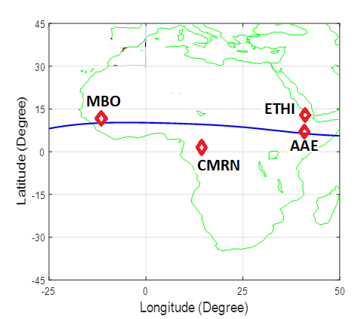

Figure 1: Plot of geomagnetic locations of magnetometer network for: AAE, ETHI, CMRN and MBO

Geographic and geomagnetic location information of Magnetometer network for: AAE, ETHI, CMRN and MBO were used in this study is given in Table 1:

Table 1: Geographic and geomagnetic locations of AAE, ETHI, CMRN and MBO

|  |  |  |  |  |  |  |
| --- | --- | --- | --- | --- | --- | --- |
| STATION ID | STATION NAME | Geographic Latitude | Geographic Longitude | Geomagnetic Latitude | Geographic Longitude | Local Time (LT) |
| AAE | Addis Ababa | 9.0oN | 38.8oE | 0.9oN | 110.5oE | LT=UT+3 |
| ETHI | Adigrat | 14.3oN | 39.5oE | 5.80oN | 111.06oE | LT=UT+3 |
| CMRN | Yaunde | 3.87oN | 11.52oE | 5.30oS | 83.12oE | LT=UT+1 |
| MBO | Mbour | 14.43oN | 16..97oW | 2.06oN | 58.24oW | LT=UT+0 |

**2.2 Methodology**

The storm days were selected from the Kp and Dst index values listed by world data centre, Kyoto website: [http://wdc.kugi.kyoto-u.ac.jp/](http://wdc.kugi.kyoto-u.ac.jp/cgi-bin/kp-cgi). The selected storm days and their corresponding maximum Kp and highest negative Dst values are given in Table 2 below.

**Table 2: Selected storm days and their corresponding maximum kp values and highest negative Dst values**

|  |  |  |
| --- | --- | --- |
| Selected storm days | Maximum kp value | Highest negative Dst values |
| 5th July 2011 | 4.5 | -59nT |
| 16th July 2012 | 6.2 | -113nT |

The storm time daily variation (Sd) was derived by subtracting the baseline of the quietest day for a particular month from the geomagnetic field of the disturbed day for each of the disturbed days (Hd). The selected days were between 2009 and 2014. This was done for all the months according to Maeda, (1968).That is;

: t=1, 2, ………., 24 (1)

where Sd is the disturbance daily variation, Hd is the geomagnetic field intensity of a disturbed  
day and H0 is the quietest day baseline. The obtained disturbance daily variation was used to  
calculate the perturbation of the storm as;

 (2)

where SD is the perturbation of the storm, Sd represents the disturbance daily variation and  
Sq stands for the solar quiet variation.

The storm time perturbations were calculated and plotted in Figures 3 and 4.

1. **Results and discussions**

**3.1 Variation of kp and Dst indices on 5th July 2011 and 16th July 2012.**

Figures 2(a) and 2(b) shows the variation of kp and Dst indices During the recovery phases of the 5th July 2011 and 16th July 2012 geomagnetic storms. The recovery phase is associated with loss of ring current ions resulting from charge exchange with the neutral exosphere. In Figure 2(a), the kp index value rose from 3.2 at 00:00UT and reached a maximum value of 4.5between 03:00-05:00UT. The kp index values however dropped drastically and reached its lowest value of 0.5 between 11:00-13:00UT. The kp value rose to 3 between 18:00-20:00UT. The Dst index values rose from -59nT at 00:00UT and reached its peak value of -35nT. Similarly, in Figure 2(b), the kp index value dropped form 6.2 at 00:00UT, reaching its lowest value of 3 at between 18:00-21:00UT. The Dst index value began at -113nT at 00:00UT and increased, reaching its maximum value of -57nT at between 22:00-24:00UT.

The plots in Figure 2 clearly indicate that the geomagnetic storm of 5th July 2011 was an active storm (maximum kp index = 4.5) while the 16th July 2012 was a moderate storm (Maximum kp index = 6.2).

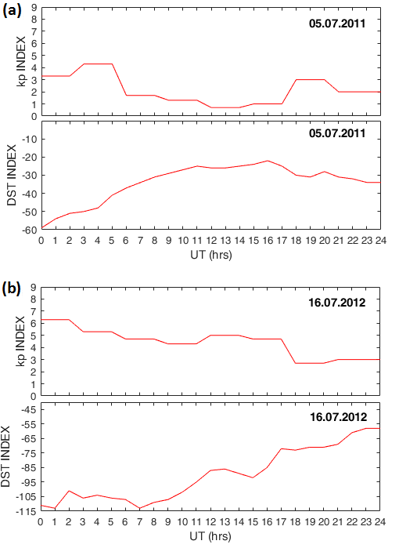

Figure 2: kp and Dst indices for: (a) 5th July 2011 (b) 16th July 2012

The 5th July 2011 and 16th July 2012 geomagnetic storms showed delayed recovery phases. Liu et al, (2017) in their study on the ionospheric response to the July 2012 geomagnetic storm. Insights from GPS TEC and Ionosonde data explored the temporal and spatial evolution of the ionosphere during the recovery phase of the 16th July 2012 geomagnetic storm. Kumar & Kumar. (2022) in their study of geomagnetic storm effect on F2-Region ionosphere during 2012 at low and mid latitude stations in the southern hemisphere analyzed the low and mid-latitude ionospheric disturbances during the recovery phase of the 16th July, (2012). Astafyeva et al, (2012) studied the prompt and long lasting ionospheric response to the July 2012 geomagnetic storm, where they highlighted the role of electrodynamics and thermospheric composition during the recovery phase of the 16th July 2012 geomagnetic storm. From the above studies, it is noted that the recovery phases of geomagnetic storms display unique magnetospheric and ionospheric features resulting from the gradual energy loss of storm induced disturbances.

**3.2 Storm time variations of the geomagnetic field on 5th July 2011 and 16th July 2012.**

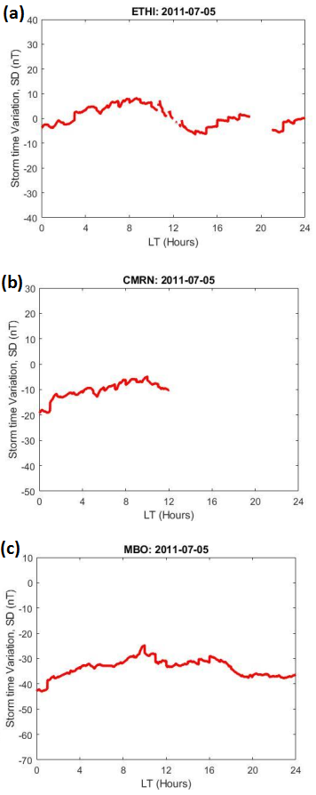

Figure 3: Storm time variations of the geomagnetic field on 5th July, 2011 for: (a) ETHI, (b) CMRN and (c) MBO.

Figure 3(a), 3(b), and 3(c) shows storm time variations of magnetic field for ETHI, CMRN and MBO respectively on 5th July 2011. In Figure 3(a), at ETHI, increasing values of SD were noted from 0000LT to around 1100LT attaining a maximum value of 10nT, after which it recorded a rapid drop reaching a minimum value of -10nT at around 14:00LT. The SD value however increased again and reached a high value of 5nT at 24:00LT, with a slight data gap being noted. At CMRN, there was an increase in magnitude of SD variation from about -20nT at 00:00LT to~ -5nT at about 10000LT as indicated by Figure 3(b).However there was no data after 12:00LT. For MBO, the value of SD rose from about -42nT at 00:00LT to about -25nT at 1000LT. It dropped slightly to about -35nT before rising again to -30nT at 1600LT and dropping to -40nT at 2400LT as indicated in Figure 3(c).

Figures 4(a), 4(b), and 4(c) shows storm time variations of geomagnetic field for AAE, MBO and CMRN on July 16th, 2012. In Figure 4(a), the geomagnetic field storm variation at AAE showed a strong positive impulse in the local morning hours. These values dropped rapidly, attaining a minimum value SD of -170nT at around local noon and rising to -120nT at 24:00LT. At MBO, the SD values began increasing from -100nT at 00:00UT, reaching its minimum of about -95nT at around 1400LT as indicated by Figure 4(b). At CMRN the SD began dropping from -100nT at 03:00LT, reaching its lowest of -115nT at 13:00LT and rising to -100nT at 24:00LT as indicated by Figure 4(c).

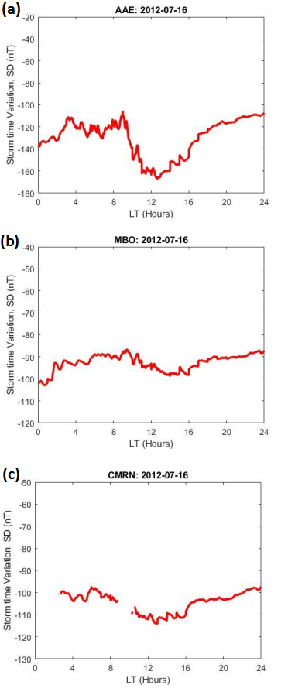

Figure 4: Storm time variations of geomagnetic field on 16th July, 2012 for: (a) AAE, (b) MBO, and (c) CMRN.

Figures 3(a), 3(b), 3(c), 4(a), 4(b), and 4(c) display a reduction in the storm time variation of geomagnetic field at local noon (11:00 - 13:00LT) over all the stations. This is attributed to the fact that during the recovery phase, at local noon the EEJ temporarily became suppressed (reduces) as a result of the westward disturbance dynamo electric fields (DDEF) coming from the high-latitude regions, which oppose the normal eastward electric field. This leads to a reduction of storm time variation at all stations at the geomagnetic equator at the local noon (Oyama et al, 2023; Tariq et al, 2023; Fejer et al, 2011; Abdu et al, 2008). However, the reduction depth of the storm time variation of geomagnetic field depended on the strength of the storm where the 5th July 2011 geomagnetic storm displayed smaller depth (Figures 3(a), 3(b) and 3(c)) as compared to the 16th July 2012 geomagnetic storm (Figures 4(a), 4(b), and 4(c)). This variation in the depth of storm time magnetic field perturbations during the recovery phase was attributed to the strength of the ring current where intense storms leads to increased injections of charged particles into current, hence larger suppression as compared to the less intense storms (Abdu et al, 2008).

All the four stations showed disparities in storm time variations during the recovery phases of the 5th July 2011 and 16th July 2012 geomagnetic storms. The differences in these values can be linked to the effect of Equatorial Electrojet current and the influence of meridional winds and tidal waves. Studies by Srinivasan & Paul, (2011); Chau & Woodman, (2005); Kelley, (2009); Foster & Vo, (2002); Liu & Chao, (2000); Hargreaves. (1992); Mitra, (1990); Basu et al, (1981) have highlighted the role played by EEJ, meridional winds and tidal winds in influencing storm time variations of geomagnetic field during the recovery phase of a geomagnetic storm. In their studies, they have highlighted that as the storm induced electric fields dissipate during the recovery phase, the EEJ still remain stronger and hence generates magnetic fields which influence local geomagnetic fields near the geomagnetic equator. They also observed that the interaction between EEJ and meridional winds modifies the EEJ flow, hence pushing ionospheric plasma away from the equator towards higher latitudes during recovery phase. This alters magnetic field responses at different latitude, which then influences storm time variations. Similarly, they highlight the effect of tidal waves during the recovery phase, where the tidal waves from the lower mesosphere and thermosphere cause variations in ionopsheric plasma density by inducing vertical plasma motion, thereby influencing storm time variations.

Generally the storm time variation showed small irregular and inconsistent patterns (perturbations) for all the stations during the recovery phases of both storms as indicated in Figures 3(a), 3(b), 3(c), 4(a), 4(b), and 4(c). These perturbations were associated with the disturbance of the ionosphere which comes from the effects of the geomagnetic storms. Akasofu, (2015) observed that storm time variations of geomagnetic field during the recovery phase result from the decay of the ring current as energetic particles are lost through wave-particle interactions, charge exchange or through precipitation into the atmosphere. These observations were further supported by studies by Sandhu et al, (2019) on sub-storm and ring current coupling and Kalmoni et al, (2019) on the dynamics og geomagnetic sub storms with a low-order non-linear model of the nightside magnetosphere (WINDMI model). The irregular perturbation electric fields deviates the geomagnetic field patterns from the quiet time patterns. The SD values at the equatorial stations are observed to intensify with decreasing latitudes up to the dip equator showing that in addition to the magnetospheric ring currents, the effects of storms at the equatorial latitudes also depend on ionospheric currents like Equatorial Electrojets (EEJ) and Auroral Electrojets (AEJ) which are brought up by the magnetosphere-ionosphere coupling. During the recovery phase of a geomagnetic storm, these currents can fluctuate, leading to storm time variations of the geomagnetic field Akasofu, (2015). Thus the equatorial magnetic storms are due to the combined effects of disturbance ring currents and the interplanetary magnetic fields (IMF) (Blanchard & McPherron 1993). Storm time variation has a latitudinal dependence at the equatorial region with perturbation magnitude increasing to the lowest negative at the dip equator. This is attributed to the behavior of EEJ which is more pronounced at the dip equator, where the current flows directly due to the magnetic field lines being horizontal (Maurice & Otsuka, 2002; Aarons, 1982) and also due to the vertical structure of the ionosphere in which the dip equator is also largely affected by storm time anomalies and enhancements (Zhao & Zhang, 2014; Foster & Vo, 2002; Yizengaw & Zhang, 2016; Basu et al, 1981).

**Conclusions**

We have investigated the storm time variation of geomagnetic fields during recovery phases of the 5th July 2011 and 16th July 2012 geomagnetic storms. The findings of this study are summarized below.

* All the four stations displayed disparities in storm time variations during the recovery phases of the 5th July 2011 and 16th July 2012 geomagnetic storms. The displayed disparities were linked to the effect of Equatorial Electrojet current and the influence of meridional winds and tidal waves during the recovery phases of the geomagnetic storms.
* All the four stations displayed a reduction in the storm time variation of geomagnetic field at local noon (11:00 - 13:00LT), during the recovery phases of both storms. This was attributed to the fact that during the recovery phase, at local noon the EEJ temporarily became suppressed due to the westward disturbance dynamo electric fields (DDEF) coming from the high-latitude regions, which oppose the normal eastward electric field. This leads to a reduction of storm time variation at all stations at the geomagnetic equator at the local noon. However, the reduction depth of the storm time variation of geomagnetic field depended on the strength of the storm where the 5th July 2011 geomagnetic storm displayed smaller depth as compared to the 16th July 2012 geomagnetic storm. This variation in the depth of storm time magnetic field perturbations during the recovery phase was attributed to the strength of the ring current where intense storms leads to increased injections of charged particles into current, hence larger suppression as compared to the less intense storms.
* The storm time variations over the four stations showed small irregular and inconsistent patterns (perturbations), which were believed to be associated with the ionospheric disturbances coming from the effects of the geomagnetic storms. Storm time variations of geomagnetic field during the recovery phase result from the decay of the ring current as energetic particles are lost through wave-particle interactions, charge exchange or through precipitation into the atmosphere.
* Storm time variation has a latitudinal dependence at the equatorial region with perturbation magnitude increasing to the lowest negative at the dip equator. This is attributed to the behavior of EEJ which is more pronounced at the dip equator, where the current flows directly due to the magnetic field lines being horizontal and also due to the vertical structure of the ionosphere in which the dip equator is also largely affected by storm time anomalies and enhancements.

# **References**

Aarons J (1982). The role of equatorial electrojet in the production of ionospheric irregularities. Reviews of Geophysic, 20(2), 299-317.

Abdu M A, Santos I P, Humberto J , Sobral A et al (2008). Prompt penetration electric fields and disturbance dynamo effects over South American equatorial and low latitude regions during intense geomagnetic storms. Journal of Atmospheric and solar terrestrial physics, DOI: 10.1016/j/jastp.2007.08.036.

AstafyevaE , Zakharenkova I , Alken A. (2012). Prompt and long lasting ionospheric response to the July 2012 geomagnetic storm. Journal of Geophysical Research: Space physics. DOI: 10.1029/2012JA018051.

Akasofu S (2015). Energy Dissipation and Current Systems in Geomagnetic storm. Journal of Earth Sciences & Geophysics.

Basu S, MacKenzie E & Basu S. (1981). Storm time effects on the equatorial ionosphere: Observations and model results. Geophysical Research letters, 8(10), 1067-1070.

Blanchard G, McPherron G. (1993). A bimodal representation of the response of function relating to the solar wind electric field to the al index. J. Adv spacers 13(17):71-74.

Chapman S & Bartels J. (1940). Geomagnetism. Vol.1. Oxford University press.

Chau J L & Woodman R F (2005). Equatorial and low latitude ionospheric irregularities during the recovery phase of geomagnetic storms. Annales Geophysicae, 23(7), 2505-2513.

Chiaha, S. O., Ugonabo, O. J., & Okpala, K. C. (2019). A study on the effects of solar wind and  
interplanetary magnetic field on geomagnetic H-component during geomagnetic storms.  
*International Journal of Physical Sciences* , 38 -44.

Fejer B G, de Paula E R, Abdu M A , Woodman F W. (2011). Equatorial ionospheric electric fields during geomagnetic storms. Geophysical Research Letters. DOI: 10.1029/2011GL048469.

Foster J C & Vo H (2002). Equatorial ionospheric plasma bubbles and their relationship to mesospheric storms. Journal of Geophysical Research: Space physics, 107(A10), 1233.

Hargreaves J K. (1992). The solar-Terrestrial Environment. Cambridge university Press.

Haines, C., & Owens, M. J. (2019). Variation of Geomagnetic Storm duration with Intensity.  
*Solar physics* , 294.

Kalmoni M A, Milan S E, Rae I J (2019). The dynamics of geomagnetic sub-storms with WINDMI Model. Earth, Plants and Space.DOI:10.1186/s40623-019-0978-6.

Kelley M C. (2009). The Earth’s ionosphere: Plasma physics and electrodynamics. Elsevier.

Kumar E A, Kumar S (2022). Geomagnetic storm effect on F2-Region ionosphere during 2012 at low and mid-latitude stations in the Southern hemisphere. Atmosphere, Vol 13(3) DOI; 10.3390/atmos13030480.

Liu L, Kuai J, et al (2017). Ionospheric response to the July 2012 geomagnetic storm: Insights from GPS TEC and ionosonde dat. Conference paper presented the JpGU-AGU meeting 2017.

Liu H & Chao J K.(2000). Meridional wind effects on the equatorial ionosphere during geomagnetic storms. Geophysical research letters, 27(6), 837-840.

Maeda, H. (1968). Variation of Geomagnetic Field. *Space Science Reviews, 8* (4), 555-590.

Maurice J P & Otsuka Y (2002). The equatorial electrojet and the ionospheric dynamics during magnetic storms. Journal of Gephysical research: Space physics, 107(A12), 1475.

Mandrikova, O. V., Solovev, I. S., & Zalyaev, T. L. (2014). Methods of Analysis of  
Geomagnetic field Variations and Cosmic ray data. *Earth, Planet and Space* , 66.

Mitra A P (1990) Ionospheric effects of geomagnetic storms. Space science reviews, 55(3), 209-232.

Oyama K I, Liu J Y et al (2023). Thermospheric and ionospheric responses to geomagnetic storms over equatorial regions. Satellite naviagation.

Pokharia M., Prasad, Bhoj C., Mathpal, C.(2018). A study of geomagnetic storms and solar and Interplanetary parameters for solar cycles 22 and 24. Solar Phys, 293:126  
<https://doi.org/10.1007/s11207-018-1345-y>.

Sandhu N S, Watt E J, Man I R, Reeves L G (2019). Sub storm and Ring current coupling: A comparison of isolated and compound sub storms. Journal of Geophysical Research: Space physics. DOI:10.1029/2019JA026766.

Saroso S (2009). Studies on large scale geomagnetic storms during solar cycle 22 and 23. Jurnal Sains Dirgantara, vol.7: 213-219

Srinivasan N & Paul S. (2011). Role of tidal waves in ionospheric storm time response and recovery phase. Annales Geophysica, 29,(4), 613-619.

Tariq N, Tariq A, Rafiq M (2023). Multi-instrument observation of the ionospheric irregularities and disturbances during the March 2023 geomagnetic storm. MDPI Atmosphere.

Tsutomu N (2002). Geomagnetic storms. Journal of the Communications Research Laboratory Vol.49 No.3 2002.

Yizengav E & Zhang H (2016). Ionospheric storm time response and its latitudinal variations over the African sector. Annales Geophysicae, 34(2), 179-190.

Zhao B & Zhang S (2014). The role of neutral winds and electric fields in the latitudinal distribution of ionospheric storm time perturbations. Geophysical research letters, 41(5), 1462-1468.