**Hepatoprotective Effects of Euphorbia hirta in Paracetamol-Induced Liver Injury Bridging Modern Pharmacology and Ethnobotanical Use**

**ABSTRACT**

Liver diseases caused by drug toxicity or chronic conditions remain a significant global health concern. Paracetamol overdose is a leading cause of hepatotoxicity, resulting in liver dysfunction and apoptotic damage. While synthetic hepatoprotective drugs exist, their associated side effects necessitate the search for safer alternatives. *Euphorbia hirta*, known for its hepatoprotective and anti-inflammatory properties, has been explored for its potential in mitigating liver damage. This study investigates the protective effects of *E. hirta* leaf extracts on paracetamol-induced hepatotoxicity in Wistar rats.

Fresh *E. hirta* leaves were collected, air-dried, and pulverized before aqueous extraction. The extract was obtained by soaking 250 g of powdered leaves in 2.5 L of distilled water for 72 hours, followed by filtration, concentration, and drying. Acute toxicity tests classified the extract as practically non-toxic, with an LD₅₀ exceeding 5000 mg/kg. Thirty-five male Wistar rats (150–220 g) were randomized into five groups (n=5 per group). The normal control group received standard feed and water, while the negative control group was administered paracetamol (150 mg/kg orally) to induce hepatotoxicity. A positive control group received paracetamol and silymarin (150 mg/kg / 50 mg/kg), while two treatment groups received paracetamol alongside *E. hirta* extracts at doses of 125 mg/kg and 250 mg/kg, respectively. Treatments were administered orally for seven days.

Liver function, oxidative stress, and inflammatory markers were assessed through biochemical and histological analyses. Serum alanine aminotransferase (ALT) and aspartate aminotransferase (AST) levels were measured, while histopathological examination and immunohistochemical analysis of Bax protein expression were conducted. Results showed a significant (p<0.05) reduction in ALT and AST levels in treated groups compared to the paracetamol-only group. Histological findings indicated preserved liver architecture and reduced Bax protein expression, confirming *E. hirta*’s hepatoprotective potential.

This study suggests that *E. hirta* could serve as a natural hepatoprotective alternative. Further research should focus on isolating active compounds and conducting clinical trials to validate its efficacy and safety for potential pharmaceutical applications.

**Keywords**: Hepatoprotection, Paracetamol-induced hepatotoxicity, *Euphorbia hirta*, Liver function biomarkers, Histopathology, and Immunohistochemistry.

**INTRODUCTION**

Traditional medicine utilizes a vast array of medicinal plants to treat and prevent various illnesses. Medicinal plants have long been recognized for their therapeutic potential, with different plant parts—including roots, leaves, fruits, seeds, bark, and flowers—being used as sources of bioactive compounds with physiological effects in living organisms. Many of these bioactive compounds exhibit direct or indirect therapeutic properties, making them valuable in drug development (Wadood et al., 2013). Plant-derived compounds have shown promise in reducing mortality rates associated with chronic diseases, including liver disorders, due to their ability to mitigate disease progression (Rasool et al., 2012).

Liver disease is a global health concern affecting individuals across different demographics. It is characterized by fibrosis, cytological alterations, and the formation of degenerative nodules, often leading to cirrhosis with severe clinical implications (Saab et al., 2016). According to the most recent WHO data released in 2018, Nigeria ranks second globally in liver disease-related mortality, with 60,044 deaths, accounting for 3.1% of total deaths, and an age-adjusted mortality rate of 64.44 per 100,000 people.

Paracetamol, widely used as an analgesic and antipyretic, is well documented for its potential hepatotoxic effects when consumed beyond therapeutic limits (Laura et al., 2020). The increasing use of combination formulations that incorporate paracetamol with antihistamines and other pain relievers complicates its identification and contributes to its significant role in acute hepatotoxicity worldwide (Laura et al., 2020).

*Euphorbia hirta*, commonly known as "asthma weed" or "gatas-gatas," has a long history in traditional medicine (Kumar et al., 2017). It contains diverse bioactive compounds, including flavonoids and alkaloids, which have demonstrated anti-inflammatory and antioxidant properties, suggesting a potential hepatoprotective role in mitigating oxidative stress and liver injury (Verma, 2017). This study investigates the hepatoprotective potential of *E. hirta* against paracetamol-induced liver toxicity.

**RESULTS**

**Plant Sample**

Fresh *E. hirta* leaves were collected from the Anatomy Department of Ladoke Akintola University of Technology (LAUTECH) in August 2022. Identification and authentication were conducted at the Botany Section of the Department of Pure and Applied Biology, LAUTECH, where a voucher specimen (LHO 902) was deposited for reference. The acute toxicity test determined that *E. hirta* has an LD₅₀ greater than 5000 mg/kg, classifying it as non-toxic (Yuet Ping et al., 2013).

**Chemicals and Reagents**

Laboratory kits for the quantitative in vivo determination of liver function markers, including aspartate aminotransferase (AST) and alanine aminotransferase (ALT), were sourced from Beacon Diagnostics PVT. LTD, India, and Bridge Biotech Limited, Ilorin, Nigeria. Additional reagents, including hydrogen peroxide, trichloroacetic acid (TCA), and absolute ethanol, were of analytical grade to ensure accuracy and reliability.

**Experimental Animals**

Thirty-five male Wistar albino rats (150–180 g) were obtained from LAUTECH's commercial animal breeding unit. The rats were housed under standard laboratory conditions, allowed to acclimatize for two weeks before the experiment, and randomly assigned to five groups (n = 5 per group). The ethical handling and care of the animals adhered to internationally established research standards.

**Methods**

**Preparation of Plant Extract**

*Euphorbia hirta* leaves were air-dried until a constant weight was achieved, then pulverized using an electric blender. The powdered leaves (250 g) were subjected to cold maceration in 2500 mL of distilled water for 72 hours with intermittent shaking. The resulting mixture was filtered using Whatman No. 1 filter paper, and the filtrate was concentrated using a freeze dryer at 35°C.

**Experimental Design**

The animals were divided into five groups, each consisting of five rats, and were treated for seven days as outlined Table 1**:** :

**Table 1: Animal Grouping**

|  |
| --- |
| **Group A (Normal Control):** Received only standard feed and water. |
| **Group B (Hepatotoxin Group):** Received a single oral dose of paracetamol (150 mg/kg) on day 7 without pretreatment. |
| **Group C (Standard Control):** Received silymarin (50 mg/kg) daily for seven days, followed by paracetamol on day 7. |
| **Group D (Treatment Group 1):** Received *E. hirta* extract (125 mg/kg) orally for seven days, followed by paracetamol on day 7. |
| **Group E (Treatment Group 2):** Received *E. hirta* extract (250 mg/kg) orally for seven days, followed by paracetamol on day 7. |

**Sample Collection and Preparation**

Twenty-four hours after the final administration of the extract and toxicant, the rats were humanely sacrificed via cervical dislocation. Each animal was carefully dissected, and the liver was immediately excised, rinsed in ice-cold normal saline, and weighed. The organs were stored in plain polyethylene bags and frozen in a deep freezer for subsequent biochemical analysis.

For histological and immunohistochemical analysis, portions of the liver from each group were fixed in 10% formalin to preserve tissue integrity. Throughout the procedure, care was taken to prevent tissue degradation and ensure optimal sample quality.

**Preparation of Serum and Liver Homogenate**

Blood samples were collected from each animal into plain sample bottles, allowed to clot, and centrifuged at 3000 rpm for 15 minutes. The resulting serum was carefully separated and stored under cold conditions for further biochemical analysis.

For liver homogenate preparation, liver tissues were homogenized in ice-cold phosphate buffer (pH 7.2) to obtain a 10% homogenate solution. The homogenates were then centrifuged at 2000 rpm for 10 minutes, and the supernatants were stored in a deep freezer for biochemical evaluations. These samples were subsequently used to assess biochemical markers and enzyme levels in serum and liver tissues.

**Biochemical Analysis**

**Determination of Liver Function Parameters**

Serum enzyme markers of liver function, including bilirubin, aspartate aminotransferase (AST), and alanine aminotransferase (ALT), were quantified using commercially available diagnostic kits (Tietz et al., 2012).

**Aspartate Aminotransferase (AST) Estimation**

**Principle**

AST catalyzes the transfer of an amino group from L-aspartate to 2-oxoglutarate, producing oxaloacetate and L-glutamate. In the presence of NADH and malate dehydrogenase (MDH), oxaloacetate is reduced to L-malate, leading to the oxidation of NADH to NAD. The reaction is monitored by measuring the decrease in absorbance at 340 nm due to NADH oxidation. To eliminate interference from endogenous pyruvate, lactate dehydrogenase (LDH) is added to ensure its rapid and complete reduction (Moss, 2009).

**Procedure**

A 500 µL aliquot of the working reagent (AST enzyme and substrate reagent) was mixed with 50 µL of the sample. The initial absorbance was recorded at 340 nm after one minute, and subsequent readings were taken every one and two minutes. The mean absorbance change was calculated for further analysis.

**Alanine Aminotransferase (ALT) Estimation**

**Principle**

ALT catalyzes the transfer of an amino group from alanine to 2-oxoglutarate, producing pyruvate and L-glutamate. Pyruvate is subsequently reduced to lactate by LDH in the reagent, with the simultaneous oxidation of NADH to NAD. The reaction progress is monitored by measuring the rate of decrease in absorbance at 340 nm. To prevent interference from endogenous pyruvate, LDH rapidly reduces it during the initial incubation period (Evans, 2009).

**Procedure**

ALT was measured using both normal and high linear procedures with a 1 cm cuvette at an absorbance of 340 nm. Absorbance readings were taken every one and two minutes, and the mean absorbance change was calculated for analysis.

Calculations of ALT

Normal procedure factor:

$ALT activity \left(\frac{U}{L}\right)= Δ(A/min) ×1746$ =

High linear procedure factor:

$$ALT activity \left(\frac{U}{L}\right)=Δ(A/min⁡ )x 8199$$

**Histopathological and Immunohistochemical Analysis of Liver Samples**

**Histopathological Examination**

For histopathological analysis, male Wistar rats from all experimental groups were humanely sacrificed via cervical dislocation. The liver tissues were excised, washed in 0.9% saline solution, and fixed in 10% buffered formalin for 48 hours to preserve tissue integrity and assess drug-induced damage using hematoxylin and eosin (H&E) staining (Saccomano, 2019).

**Tissue Processing**

Liver tissues were observed, cut into small pieces (≤4 mm thick), and placed in pre-labeled cassettes. These samples were further immersed in 10% formal saline for 24 hours for fixation. Tissue processing was performed using an automated tissue processor (Leica TP 1020). The samples passed through the following reagents:Fixation: 10% formal saline (stations 1 & 2). Dehydration: Alcohol solutions (70%, 80%, 90%, 95%, absolute I & II) (stations 3–7). Clearing: Xylene (stations 8 & 9). Infiltration: Three wax baths. The process ran for 12 hours, with tissues remaining in each station for one hour.

**Embedding and Sectioning**

Processed tissues were embedded in paraffin wax to provide solid support using a semi-automatic embedding center. The molten paraffin was dispensed into metal molds, and tissues were oriented, labeled, and transferred to a cold plate for solidification. The resulting tissue blocks were sectioned at 4 µm thickness using a rotary microtome. The ribbon sections were floated on a 55°C water bath (Raymond Lamb) and mounted onto clean labeled slides.

**Hematoxylin and Eosin (H&E) Staining Procedure**

The slides were deparaffinized in xylene for 15 minutes, then rehydrated through absolute alcohol (95% and 70%), followed by rinsing in water. Samples were stained in Harris hematoxylin for 5 minutes, rinsed, and briefly differentiated in 1% acid alcohol. Bluing was performed under running tap water for 10 minutes. The sections were counterstained with 1% aqueous eosin for 2 minutes, dehydrated through ascending alcohol grades, cleared in xylene, and mounted in DPX. Under microscopy, nuclei appeared blue, while cytoplasm appeared pink.

**Immunohistochemical Analysis**

For immunohistochemical staining, formalin-fixed, paraffin-embedded tissue sections were deparaffinized in xylene (twice for 5 minutes each), followed by sequential hydration in 100%, 95%, and 70% alcohol for 3 minutes each. The slides were rinsed in wash buffer (twice for 5 minutes each).

**Antigen Retrieval and Staining Procedure**

Antigen retrieval was performed by incubating slides in preheated citrate buffer (pH 6.0) or EDTA buffer (pH 9.0) at 95–100°C for 10–20 minutes. The slides were cooled for 20 minutes and washed twice with buffer. Blocking buffer (10% fetal bovine serum or 3% H₂O₂) was applied for 15 minutes in a humidified chamber. The buffer was drained, and slides were washed before applying 130 µL of primary antibody solution, incubated for one hour at room temperature. After washing, an antibody amplifier and polymer-HRP secondary antibody were applied for 15 minutes. The slides were washed and incubated with a DAB substrate solution (0.05% DAB – 0.015% H₂O₂ in PBS) for color development (<5 minutes). After washing, the slides were counterstained with hematoxylin, rinsed, dehydrated, cleared in xylene, and mounted. The slides were examined under a microscope for antibody-stained tissue sections.

**Results**

**Effects of *Euphorbia hirta* Extract on Paracetamol-Induced Liver Toxicity**

Table 2 presents the serum activities of aspartate aminotransferase (AST) and alanine aminotransferase (ALT) following paracetamol and *Euphorbia hirta* extract administration. A significant increase (p < 0.05) in AST and ALT levels was observed in the group administered a toxic dose of paracetamol (150 mg/kg body weight) compared to the normal control group, indicating liver injury. However, no significant (p > 0.05) difference was observed in the serum AST and ALT levels in the group pre-administered *Euphorbia hirta* extract (250 mg/kg body weight) before paracetamol administration compared to the normal control group. This suggests that *E. hirta* extract exhibited hepatoprotective effects by preventing liver enzyme elevation, thereby mitigating hepatotoxicity.

**Table 2 Effects of Paracetamol on selected hepatic parameters of rats treated with aqueous extracts of *Euphorbia hirta***

|  |  |  |
| --- | --- | --- |
| **GROUP** | **AST (µ/l)** | **ALT (µ/l)** |
| **Group A: Normal Control** | 0.87±0.00a | 1.16±0.29a |
| **Group B: PCM**  **(150mg/kg b.w)** | 2.90±0.0.38b | 3.20±0.29 b |
| **Group C: Paracetamol (150mg/kg b.w) +Sylimarin**  **(2mg/kg b.w)** | 0.87±0.00 a | 0.87±0.00 a |
| **Group D: PCM (150mg/kg b.w) +**  ***Euphorbia hirta* (125mg/kg b.w)**  **Group E: PCM(150mg/kg b.w) +**  ***Euphorbia hirta* (250mg/kg b.w** | 1.16±0.29 a  1.46±0.30a | 1.16±0.30 a  1.16±0.29 a |

**Values were expressed as Mean ± SEM Different alphabets superscripts denote significant difference at p<0.05**

**Effects of *Euphorbia hirta* Extract and Paracetamol Administration on Liver Histology in Rats**

As shown in Figure 1, rats administered paracetamol exhibited severe hepatic damage characterized by chronic hepatic steatosis (blue arrow), fat infiltration (white arrow), and extensive necrosis. Additionally, these untreated rats showed intense vascular congestion, steatohepatitis, karyopyknosis, and nuclear alterations, indicating significant hepatocellular injury. In contrast, the group pre-treated with *Euphorbia hirta* extract at 250 mg/kg displayed improved liver architecture with no significant histological alterations. Although mild cytoplasmic hydropic degeneration was observed, overall liver parenchyma appeared well-preserved. Similarly, the group pre-treated with *Euphorbia hirta* extract at 125 mg/kg showed normal central venules (white arrow), intact hepatocyte morphology (blue arrow), and a localized area of mild inflammatory cell aggregation (slender arrow). These findings suggest that *Euphorbia hirta* exhibits hepatoprotective properties by mitigating paracetamol-induced liver damage and preserving hepatic structure.

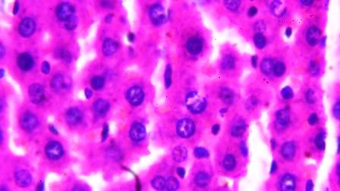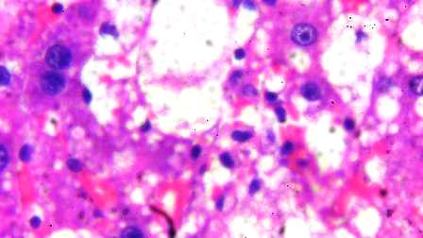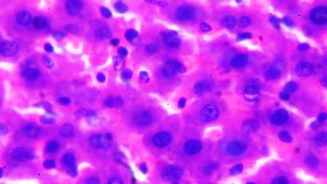

**A Normal control B Paracetamol Only.** **PCM+ Silymarin**

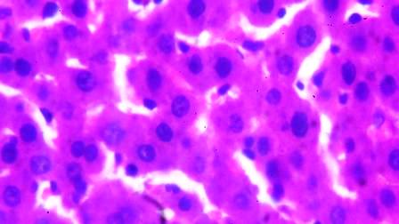 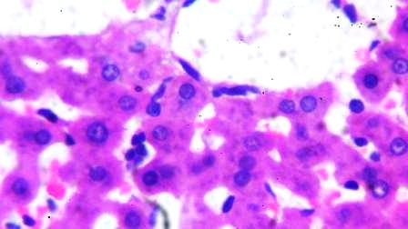

**PCM *+Euphorbia hirta* 250mg/kg PCM+ *Euphorbia hirta* 125mg/kg**

**Fig. 1: Photomicrographs of liver section stain by haematoxylin and eosin (400X) of A (normal control), B (PCM only), C (PCM+ *Euphorbia hirta* 125mg/kg body weight), E (PCM+ *Euphorbia hirta* 250mg/kg body weight). PCM=Paracetamol, AEEH=Aqueous leaf extract of *Euphorbia hirta.***

**Effects of extracts and paracetamol administration on immunohistochemical studies using Bax**

Quantitative analysis using Image J as shown in figure 2 and Table 3 confirmed a significant increase in Bax levels in rats exposed to paracetamol. However, no significant difference in Bax expression was observed between the silymarin and 250 mg/kg *Euphorbia hirta* extract similarly as that of 125mg/kg. The effects of paracetamol on experimental animals pretreated with aqueous extract of *Euphorbia hirta* leaves extracts on immunohistochemical analysis which reveals moderate Bax expression compared to the normal control group. The administration of paracetamol only led to a significant (p<0.05) severe expression of Bcl-2- associated X protein (Bax) in livers of rats exposed to paracetamol overdose.

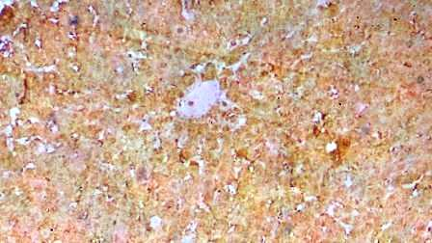 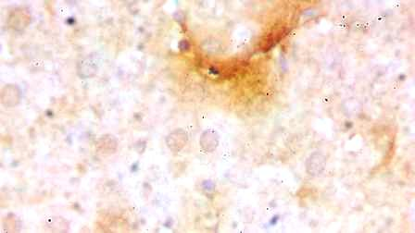

Normal control Paracetamol only (150mg/kg b.w.)

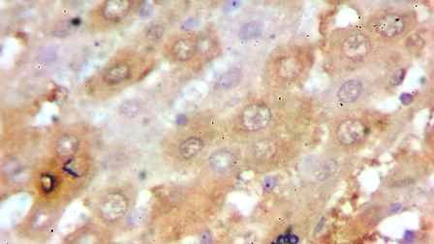 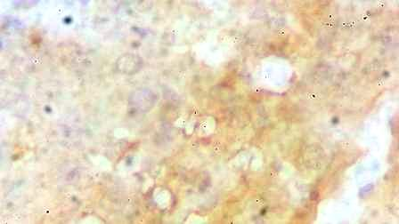

Paracetamol +Silymarin group Paracetamol+*Euphorbia hirta* (125mg/kg b.w)

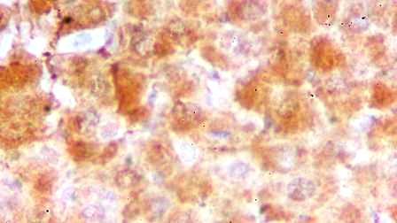

PCM+ *Euphorbia hirta* (250mg/kg b.w)

**Figure 2: Photomicrographs of liver section stain by immunohistochemistry (400X) of A (normal control), B (PCM only), C (PCM+ *Euphorbia hirta* 125mg/kg body weight), E (PCM+ *Euphorbia hirta* 250mg/kg body weight). PCM=Paracetamol, AEEH=Aqueous leaf extract of *Euphorbia hirta.***

**Table 3: Expression of Bax protein levels in paracetamol-induced Wistar rats using Image J image processing program**

|  |  |
| --- | --- |
| **Groups** | **Bax protein level (µM** |
| **Group A: Normal Control** | 70.55±0.07 a |
| **Group B: Paracetamol (150mg/kg b.w)** | 73.29±0.11b |
| **Group C Paracetamol (150mg/kg b.w) +Sylimarin**  **(2mg/kg b.w)** | 68.87±0.10 a |
| **Group D : Paracetamol (150mg/kg b.w)**  ***Euphorbia hirta* (125mg/kg b.w)**  **Group E : Paracetamol (150mg/kg b.w)**  **Euphorbia hirta (250mg/kg b.w)** | 67.01±0.08a  68.25±0.08a |

**Values were expressed as mean ±SEM (n=5). Different alphabet superscripts denote significant difference P. Bax =Bcl-2-associated X protein.**

**DISCUSSION**

The search for novel hepatoprotective agents remains a critical area of research due to the limitations and adverse effects associated with conventional hepatoprotective drugs. While various studies have documented the phytochemical and pharmacological properties of *Euphorbia hirta*, little scientific evidence exists regarding its hepatoprotective potential against paracetamol-induced hepatotoxicity in Wistar rats (Saccomano, 2019). This study provides novel insights into the efficacy of *Euphorbia hirta* leaf extract in mitigating liver damage caused by paracetamol overdose.

Paracetamol-induced hepatotoxicity is characterized by elevated serum transaminases, coagulopathy, hypoglycemia, and lactic acidosis, with peak liver enzyme levels occurring 2–3 days post-overdose (Bunchorntavakul et al., 2013). Despite treatment, 12–13% of acute overdoses result in hepatotoxicity, with 2–5% progressing to liver failure and 0.2–0.5% leading to mortality (Buckley et al., 2022). The present study employed a multi-parameter approach, including liver function tests, histological analysis, and immunohistochemistry, to assess the protective effects of *Euphorbia hirta*.

**Liver Function Biomarkers and Hepatoprotection**

Alanine aminotransferase (ALT) and aspartate aminotransferase (AST) are critical biomarkers used to assess liver integrity. Elevated AST levels indicate liver injury and predict hepatotoxic effects associated with paracetamol overdose. While AST elevation may also reflect muscle damage, ALT is more liver-specific, making it a key marker of hepatic injury (Kausar et al., 2010). ALT production occurs in the bile ducts, and its elevation in serum is commonly observed in intrahepatic and extrahepatic biliary obstruction (Motto et al., 2021). A significant increase (p < 0.05) in AST and ALT levels was observed in rats exposed to paracetamol overdose, confirming hepatic injury.

Pre-treatment with *Euphorbia hirta* extract at 250 mg/kg and 125 mg/kg resulted in a dose-dependent reduction in these hepatic enzymes, indicating protection against liver damage. This reduction suggests that the extract preserves normal hepatic function and mitigates paracetamol-induced hepatocellular damage. The hepatoprotective effects observed in this study align with findings by Almasi et al. (2024), where methanolic leaf extract of *Jatropha tanjorensis* at similar doses significantly reversed paracetamol-induced hepatocellular injury by reducing serum transaminase levels.

**Histopathological Analysis and Liver Tissue Preservation**

Histopathological examination is a gold standard for evaluating cellular and structural damage in hepatotoxicity models. In the paracetamol-only group, severe hepatic steatosis, intense centrilobular necrosis, vacuolization, and macrovesicular fatty changes were evident, consistent with previous reports on paracetamol-induced hepatotoxicity (Polyak et al., 2010). Conversely, normal hepatocyte morphology was observed in the control group, and rats pre-treated with *Euphorbia hirta* at 250 mg/kg exhibited near-normal hepatic architecture.

Mild centrilobular necrosis was observed in the 125 mg/kg-treated group, indicating partial but significant hepatoprotection. Similar findings were reported by Oluwole et al. (2023) in a study evaluating the hepatoprotective effects of *Euphorbia neriifolia* against paracetamol-induced hepatotoxicity. This suggests that the protective effects of *Euphorbia hirta* may be linked to antioxidant-rich bioactive compounds, such as flavonoids and phenolic compounds, which scavenge reactive oxygen species (ROS) and mitigate oxidative stress.

**Immunohistochemical Analysis and Pro-Apoptotic Regulation**

Immunohistochemical (IHC) analysis provides molecular insights into liver damage by detecting specific proteins involved in apoptosis and inflammation. Bax (Bcl-2-associated X protein), a pro-apoptotic protein, plays a crucial role in programmed cell death (Abdullah et al., 2017). The results from this study revealed that Bax expression was significantly elevated in the paracetamol-only group, confirming apoptotic hepatocellular damage. However, *Euphorbia hirta* extract pre-treatment downregulated Bax expression, demonstrating its ability to counteract paracetamol-induced apoptosis.

ImageJ analysis further confirmed that paracetamol exposure led to increased Bax expression, while *Euphorbia hirta* administration at 125 mg/kg and 250 mg/kg significantly reduced Bax levels. These findings align with the results of Abdullah et al. (2017), indicating that the hepatoprotective effects of *Euphorbia hirta* are associated with its ability to modulate apoptotic pathways and oxidative stress markers.

**Therapeutic Potential of *Euphorbia hirta* in Hepatoprotection**

The ability of hepatoprotective agents to resist the toxic effects of paracetamol is a crucial therapeutic strategy. The results of this study demonstrate that *Euphorbia hirta* possesses strong hepatoprotective properties, particularly at 250 mg/kg, where significant reductions in liver enzyme markers and histopathological amelioration were observed. The presence of bioactive compounds, including flavonoids and phenolics, likely contributes to its protective effects by enhancing liver antioxidant defenses and regulating apoptotic pathways.

These findings support the ethnomedicinal use of *Euphorbia hirta* in West African traditional medicine for treating liver disorders. Based on pharmacological screening, *Euphorbia hirta* shows promise in managing conditions such as cirrhosis, hepatitis, steatosis, and necrosis, making it a potential candidate for herbal hepatoprotective drug development.

**CONCLUSION**

This study confirms that the aqueous extract of *Euphorbia hirta* exhibits potent hepatoprotective activity by significantly reducing paracetamol-induced elevation in AST and ALT levels. Histopathological findings further support its ability to preserve liver architecture and mitigate hepatic necrosis.

Additionally, immunohistochemical analysis revealed reduced Bax expression, highlighting the extract’s potential to regulate apoptosis and oxidative stress markers. The hepatoprotective effects observed at 125 mg/kg and 250 mg/kg demonstrate its dose-dependent efficacy in reversing paracetamol-induced hepatotoxicity.

**RECOMMENDATIONS**

Phytochemical Characterization – Further studies should be conducted to isolate and characterize the active compounds responsible for hepatoprotection. Future clinical trials are necessary to evaluate the safety and efficacy of *Euphorbia hirta* in human subjects with liver disordersThe development of a standardized herbal hepatoprotective drug using *Euphorbia hirta* could offer a safer alternative to conventional hepatoprotective agents.

**Acknowledgment**: The authors would like to express our sincere gratitude to Dr Oladipo Kolawole for generously allowing us to utilize certain laboratory software essential to the completion of our research project.

**Data Availability Statement:**  
The authors declare that all data utilized in the preparation of this manuscript are fully included within the main text and the supplementary data.

**Animal Ethics declaration**: All animal procedures in this study were performed according to the guidelines of the research and ethics committee, Ladoke Akintola University of Technology (LAUTECH) for the use of laboratory animals. The study received ethical approval from the Faculty of Basic Medical Sciences ethics committee at LAUTECH (Approval No. FBMSERN/2023_BCH_458).

**Clinical trial number:** Not applicable

**Consent to participate**: Not applicable

**Consent to publish:** The authors authorize the Journal to publish the work.

**Authors Contribution:** TEA**:** Methodology, result analysis, formatting, literature review; research administration, writing the first draft AA**:** conceptualization, supervision, methodology, validation, writing, and editing; ABA: result analysis, formatting, literature review; research administration: TDO: Supervision, formatting; literature review; methodology and validation. GEA: Supervision, formatting; literature review; and validation.

**Funding:** No funding was provided by any funding agent for this study

**Competing Interest:** The authors have no financial, personal, or professional conflicts that could influence the work's integrity, ensuring transparency and credibility in the research process.

**References**

Abdullah, A., Phern, T. C., Rahim, N. F. H. M., Zaharuddin, N. I., Salihin, N. M., & Yusof, A. H. (2017). The effects of *Cosmos caudatus* (*Ulam Raja*) on the levels of expression of BAX target genes in mice liver. *Journal of Pharmacy and Nutrition Sciences, 7*(4), 147–157.

Almasi, F., Khazaei, M., Chehrei, S., & Ghanbari, A. (2024). Hepatoprotective effects of *Tribulus terrestris* hydro-alcoholic extract on non-alcoholic fatty liver-induced rats. *International Journal of Morphology, 35*(1), 345-350.

Bunchorntavakul, C., & Reddy, K. R. (2013). Acetaminophen-related hepatotoxicity. *Clinics in Liver Disease, 17*(4), 587–607. <https://doi.org/10.1016/j.cld.2013.07.005>

Buckley, N., Calear, A., Cairns, R., & Department of Health and Aged Care (Therapeutic Goods Administration). (2022). *Independent expert report on the risks of intentional self-poisoning with paracetamol.* Canberra, Australia.

Kumar, S., Malhotra, P., & Kumar, D. (2017). Medicinal plants with hepatoprotective potential against acetaminophen-induced liver toxicity: A review. *Frontiers in Pharmacology, 8*, 77. <https://doi.org/10.3389/fphar.2017.00077>

Laura, R., & Nikolaos, P. (2020). Liver injury induced by paracetamol and challenges associated with intentional and unintentional use. *World Journal of Hepatology, 12*(4), 125-136. <https://doi.org/10.4254/wjh.v12.i4.125>

Moore, K. L., & Dalley, A. F. (2006). *Clinically oriented anatomy* (5th ed.). Lippincott Williams & Wilkins.

Moss, D. W., & Henderson, A. R. (2009). Clinical enzymology. In C. A. Burtis & E. R. Ashwood (Eds.), *Tietz textbook of clinical chemistry* (3rd ed., pp. 617-721). W.B. Saunders.

Motto, A. E., Lawson-Evi, P., Bakoma, B., Eklu-Gadegbeku, K., & Aklikokou, K. (2021). Antihyperlipidemic and antioxidant properties of hydro-alcoholic extracts from *Euphorbia* species. *Heliyon, 7*(4), e06648. <https://doi.org/10.1016/j.heliyon.2021.e06648>

Oluwole, T. D. (2023). Lipid-modulating properties of saponins. *International Journal of Medicinal Plants Research, 13*(5), 345-356.

Polyak, S. J., Morishima, C., Lohmann, V., Pal, S., Lee, D. Y., & Liu, Y. (2010). Identification of hepatoprotective flavonolignans from silymarin. *Proceedings of the National Academy of Sciences of the United States of America, 107*(14), 5995–5999. <https://doi.org/10.1073/pnas.0914009107>

Ramachandran, A., & Jaeschke, H. (2020). A mitochondrial journey through acetaminophen hepatotoxicity. *Food and Chemical Toxicology, 140*, 111282. <https://doi.org/10.1016/j.fct.2020.111282>

Rasool, H., & Bassam, A. (2012). Traditional medicinal plants in modern drug discovery. *Pharmaceutical Analysis Acta, 3*(10), e13. <https://doi.org/10.4172/2153-2435.1000e13>

Saccomano, S. J. (2019). Acute acetaminophen toxicity in adults. *The Nurse Practitioner, 44*(11), 42–47. <https://doi.org/10.1097/01.NPR.0000586020.15798.c6>

Saab, S., Manne, V., Nieto, J., Schwimmer, J. B., & Chalasani, N. P. (2015). Nonalcoholic fatty liver disease in Latinos. *Clinical Gastroenterology and Hepatology, 13*(4), 1203–1210. <https://doi.org/10.1016/j.cgh.2015.05.001>

Tietz, C. A., & Ashwood, E. R. (2012). *Tietz textbook of clinical chemistry* (5th ed.). Elsevier.

Verma, P. K., Raina, R., Sultana, M., Singh, M., & Kumar, P. (2016). Acetaminophen-induced oxidative and histopathological alterations in hepatic tissue: Protective effects of *Alstonia scholaris* leaf extracts. *Pharmacognosy Journal, 8*(4), 385-391. <https://doi.org/10.5530/pj.2016.4.9>

Wadood, A., Ghufran, M., Jamal, S. B., Naeem, M., Khan, A., et al. (2013). Phytochemical analysis of medicinal plants occurring in the local area of Mardan. *Biochemistry & Analytical Biochemistry, 2*(144). <https://doi.org/10.4172/2161-1009.1000144>