**Temperature Dependent Blood Flow Of Tapered Porous Artery Characterized With Mild Stenosis**

**ABSTRACT**

Temperature dependent blood flow of tapered porous artery characterized with mild stenosis was investigated analyticallyin an inclined stenotic artery under the influenced of magnetic field . Blood is an electrically conducting Newtonian fluid. The artery was constricted at the region of stenosis , thereby having maximum flow at the centre of the stenosis due to temperature difference resulting from influence if magnetic field. The Physics of the problems was described by the usual MHD equations alongside with the boundary conditions. Analytical expression of the volumetric flow rate, velocity profile, wall shear stress, pressure gradient was derived. We computed the blood flow rate as we varied different parameters and was observed that at the diverging region the velocity profile reduces the flow rate while the blood viscosity increases.the inhibition of the stenosis led to increase in magnetic field. It was also observed that the increase of various parameter of Grashof, Reynolds, Nusselt and Prandtl number resulted in clockwise direction of the flow rate.

**INTRODUCTION**

Blood flow in arteries is a complex phenomenon, influenced by various factors such as viscousity, temperature, and magnetic fields. Constricted arteries can lead to cardiovascular diseases, such as atherosclerosis and hypertension. Understanding the transient flow behaviour of blood in constricted arteries is crucial for diagnosis and treatment of cardiovascular diseases.

Medical science has shown that some individuals have their arteries constricted as a result of lumen deposition on the wall of the arteries. The constriction of the artery may arise as a result of the eating habit of the person, Hasi moto (1976) and Linon and Shahar(1978). Those who are used to eating food with high level cholesterol and fat with little or no exercise may gradually have residual particles deposited on the wall of their arteries. The continuous and gradual deposition of such particles may result in the formation of a harden tissue on the wall of the artery John and Erica (2009). Such tissue is usually referred to as stenosis medically. The constriction known as stenosis will subsequently reduce the diameter or radius of the affected artery. This will subsequently inhibit the free flow of blood fluid through the affected artery. According to medical experts there are various forms of stenosis some of which includes: Aortic, Carotid, Renal and Spinal depending on the part of the artery where the constriction occurs. Neetu Srivastava (2014). No matter where it occurs the constriction may result in the narrowing of the artery thereby limiting the amount of blood flowing through such artery. The medical expert says it is dangerous to the person having such constriction.

In some instances, an individual with constricted artery may undergo scanning or chest X-ray. This equipment is associated with high magnetic field and heat. Studies have shown that magnetic field has tremendous effect on the transport of fluid through arteries, (Barnothy, 1969).What therefore is the blood flow situation, when an individual with constricted artery is subjected to magnetic field? This study will examine among others the effect of magnetic field on the transport of blood fluid in a constricted channel or tube to mimic the situation of a patient undergoing Nuclear Magnetic Resonance (NMR) as a form of medical therapy. The study would be subsequently extended to include the effect of transient heat transfer on the flow of a viscous fluid in a constricted porous channel. Sometimes magnetic field and heat is applied to the individual in pulses. The time interval between successive pulses is usually very small in the order of a few seconds. This makes the flow of heat into the tissue transient.

**METHOD OF SOLUTION**

The equations governing the motion of the fluid in the constricted tube shall be solved analytically by means of the general perturbation method and homotopy. For easy analysis, the problem shall be approached in three formats. These are the entry flow region, the flow around the constricted zone and the flow after the constricted zone which is referred to as out flow. In the entry region of the tube, because of the narrowing it is regarded as a tube whose radius is collapsing to the centre of the constriction. In this case, the flow is seen to be converging. The radius of the tube shall then be represented as r = R0 f (αz) that is, r = R0 exp(-αz). On the other hand, from the centre of the constriction, the radius of the tube is seen to be rising gradually to a maximum radius R0. In this case, the tube is seen to be diverging. The situation can be represented mathematically as r = R0 exp (+αz). These are illustrated in picture (1a, b, c). The governing equations for this work are: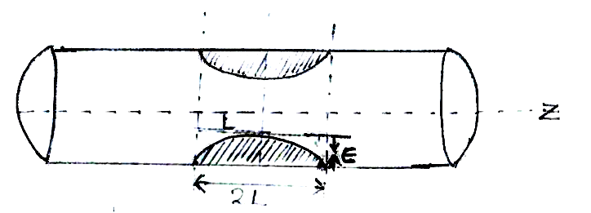

picture. 1a

From Hagen Pousieulle

1- $∂$

r(~~z~~)

picture 1d

Flow in a converging region

$$r(z) = R_{o}e^{α_{1}z}$$

$$r(z) = R_{o}e^{α_{2}z}$$

picture 1c

Flow in a diverging region

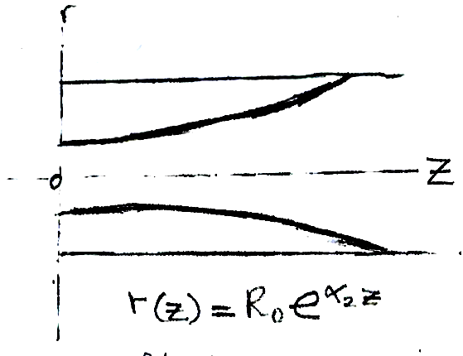

~~Z~~

r

**Dimensionless Governing Models**

 (3.30)

 (3.31)

 (3.32)

 (3.33)

Equation of motion

Introducing the non-dimensional variables as follows:

$x=\frac{x^{'}}{d}, y=\frac{y^{'}}{d}, u=\frac{u^{'}}{u}, t=t^{'}\frac{v}{d} ,$

$\frac{dq'}{dy'}=4∝^{2}\left(T^{'}-{T'}_{∞}\right)$

$T= \frac{T- T_{∞}}{T^{'}- T_{w}}, C= \frac{C^{'}- {C'}_{o}}{C_{w}- C_{∞}}$

$M=Bod (\frac{δ}{μ})^{1/2}, P= \frac{p^{'}}{p_{o}}$

$t^{'}=ωt, \frac{\left(r^{'}, z\right)}{R_{o}}=\left(r, z\right)$

$R= \frac{l_{o}}{R_{o}}$

$θ_{ω}= \frac{T^{1}-T_{0}}{T_{w}-T^{∞}}$

$\left(u, ω\right)= \frac{{u,}^{'}w'}{u˳}$

$r= \frac{r'}{r} i.e r^{'}=rR˳$

$u= \frac{u'}{u˳} i.e u^{'}=uU˳$

$ω= \frac{w'}{u˳} i.e w^{'}=wU˳$

$Z= \frac{Z'}{R˳} i. e Z^{'}=ZR˳$

$p= \frac{p'}{p˳} i.e p^{'}=Pp˳$

$R_{e}= \frac{μ Ro^{2}}{ut_{o}}$

$\frac{R^{2}˳}{μ} \left\{\frac{μ}{k_{r}}\right\}= r^{2}$

$N^{2}= \frac{Ro^{2}}{k_{r}} \frac{Q_{o}}{φcρ}$; $N_{r}^{2}= \frac{16 δ x_{r} T^{3}R^{2}}{k_{o}}$

$N_{I}^{2}= N^{2}+ N^{2}r$

The boundary conditions are:

 (3.34)

From equation (3.30),

 (3.35)

Solving equation (3.35), we have:

 (3.36)

Equation (3.36) shows that the velocity shall be a function of two independent variables.

Differentiating equation (3.35), we have:

 (3.37)

Substituting equation (3.37) into equations (3.31)-(3.34), we have:

 (3.38)

 (3.39)

 (3.40)

The boundary conditions are:

 (3.41)

**Method of Solution**

Following Bunonyo et al. (2021), the oscillatory nature of the flow due to the pumping action of the heart entails that the flow profiles can be expressed in the form;

 (3.42)

Applying the oscillatory perturbation in equation (3.42) into equations (3.38)-(3.40), we obtained,

 (3.43)

 (3.44)

 (3.45)

The boundary conditions are:

 (3.46)

where

The blood momentum is being impacted by temperature and mass concentration, let’s recall equations (3.44) and (3.45) respectively as;

 (3.47)

 (3.48)

The homogenous part of equations (3.47) and (3.48) are:

 (3.49)

 (3.50)

 (3.51)

 (3.52)

The particular solution equations (3.47) and (3.48) are:

 (3.53)

 (3.54)

The general solutions of equations (3.46) and (3.47) are

 (3.55)

 (3.56)

Since the solution to equations is finite, then, equations (3.54) and (3.55) reduce to:

 (3.57)

 (3.58)

Applying the boundary conditions in equation (3.46) on equations (3.57) and (3.58), we have:

 (3.57)

Solving equations (3.57) and (3.58) using the boundary conditions in equation (3.46), we have:

 (3.59)

 (3.60)

where  are the modified Bessel function of the first and second kind of order n with $x$ as the argument.





Substituting equations (3.59) and (3.60) into equations (3.57) and (3.58) respectively;

 (3.61)

 (3.62)

To investigate the impact of the temperature and mass concentration on blood momentum through a constricted artery, let’s substitute equations (3.61) and (3.62) into equation (3.43), we have:

 (3.63)

The homogenous function of equation 93.63), we have:

 (3.64)

Solving equation (3.63), we have:

 (3.65)

The particular solution of equation (117) can be stated as:

 (3.66)

Differentiating equation (146) according to order of equation (117), we have:

 (3.67)

 (3.68)

The general solution of equation (3.63), we have:

 (3.69)

Solving equation (3.69) using the boundary condition in equation (3.64), we have:

 (3.70)

 (3.70)

 (3.70)

where

**Volumetric Flow Rate**

The volumetric flow rate can be stated mathematically as

 (3.71)

Substituting equation (3.70) into equation (3.71), we obtain

 (3.72)

Simplifying equation (3.72), we have:

 (3.73)

Note that: then equation (3.73) gives:

 (3.74)

Simplifying equation (3.74), we have:

 (3.75)

**Rate of Heat Transfer (Nusselt Number)**

The rate of heat transfer can be stated mathematically as

 (3.75)

Differentiating equation (3.57), we have:

 (3.76)

Substituting equation (3.76) into equation (3.75), we have:

 (3.77)

**Rate of Mass Transfer (Sherwood Number)**

The rate of heat transfer can be stated mathematically as

 (3.78)

Differentiating equation (3.58), we have:

 (3.79)

Substituting equation (3.79) into equation (3.78), we have:

 (3.80)

**Shear Stress at the Walls of Blood Vessel**

The rate of shear stress can be defined mathematically as

 (3.81)

Differentiate equation (3.69) we have:

 (3.82)

Substitute equation (3.82) into equation (3.81), we have:

 (3.83)

**Skin Friction Coefficient**

The skin friction coefficient can be calculated mathematically as;

 (3.84)

Substituting equation (3.83) into equation (3.84), we have:

 (3.85)

**RESULTS AND DISCUSSION**

**Blood Velocity Profile**

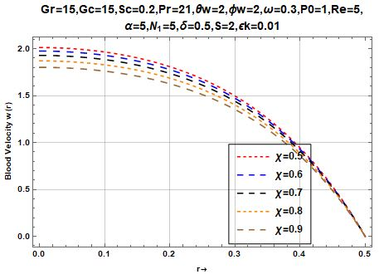

Figure1: depicts the effect of permeability on the shear stress for different values of $Χ$ parameters

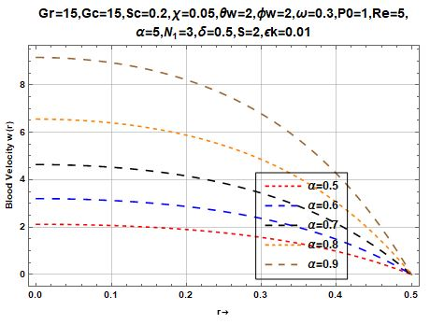

Figure 2: shows the effect of temperature profile on the angular velocity $α$

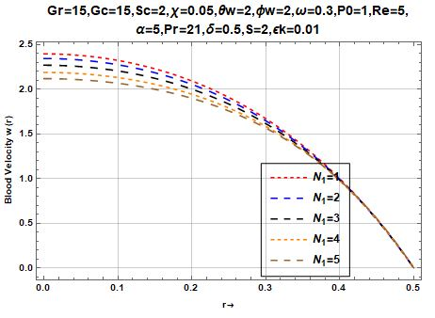

Figure 3: shows the effect of artery inclination on the Nusselt number.

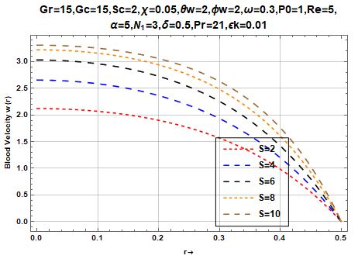

Figure 4: depicts the effect of smidt number on the blood velocity

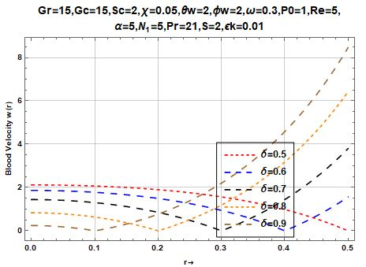

Figure 5: Represents the effect of the height of stenosis on the blood velocity

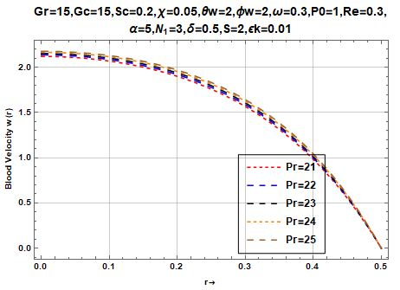

Figure 6: depicts the effect of Prandtl number on the blood velocity

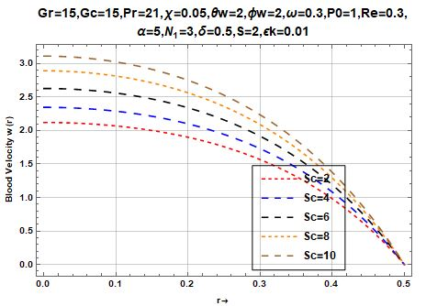

Figure 7: Represents the effect of the Schmidt number on the blood velocity

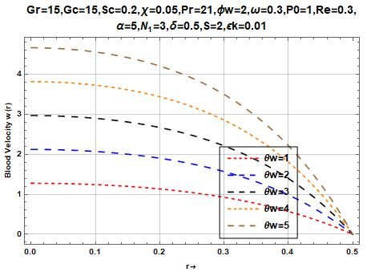

Figure 8: Represents the effect of the temperature difference at the wall on the blood velocity

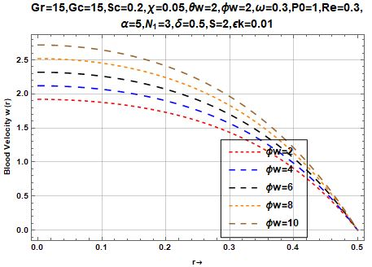

Figure 9 : : Represents the effect of the concentration difference at the wall on the blood velocity

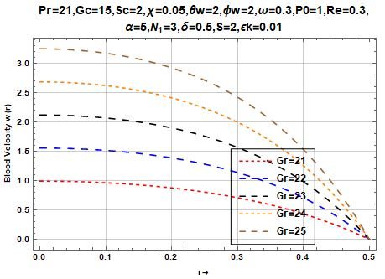

Figure 10: Variation ofGrasshof temperature on the blood velocity

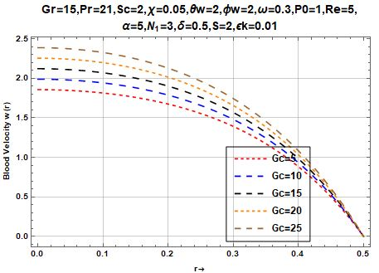

Figure 11: Variation of Grashof concentration on blood velocity

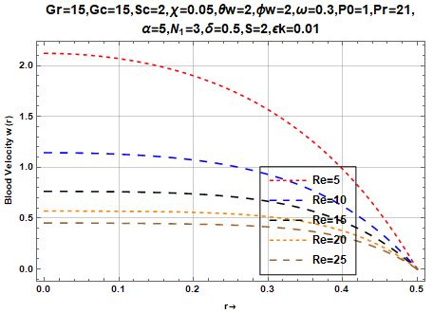

Figure 12: Effect of Reynolds number on the blood velocity

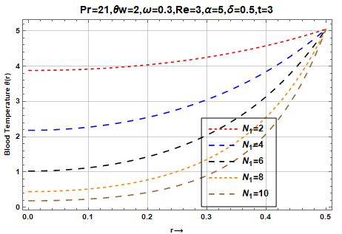

Figure 13: effect of Nusselt number on the blood temperature

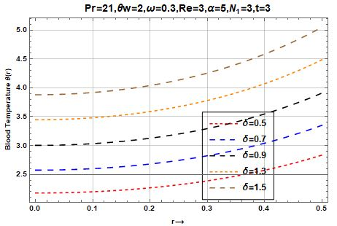

Figure 14: Effect of height of stenosis on the blood temperature

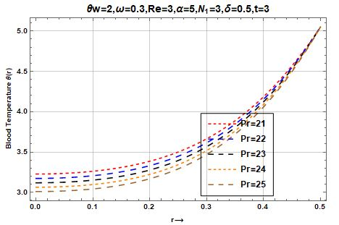

Figure 15: The effect Prandtl number on the blood temperature

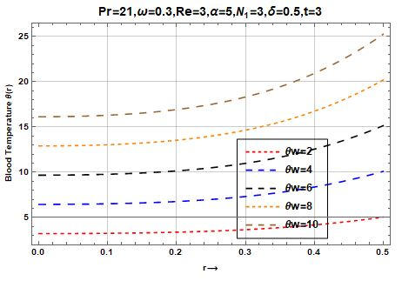

Figure 16; Effect of blood temperature on the walls of artery

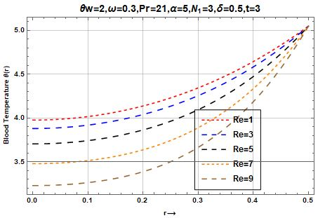

Figure 17:Effect of blood temperature on the Reynolds number.

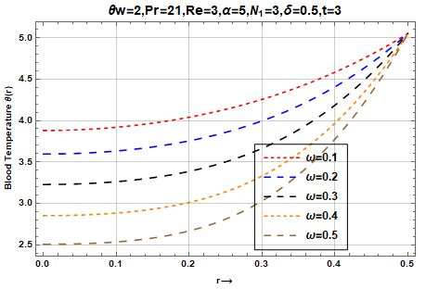

Figure 18: Effect of angular velocity $(ω)$ on the blood temperature

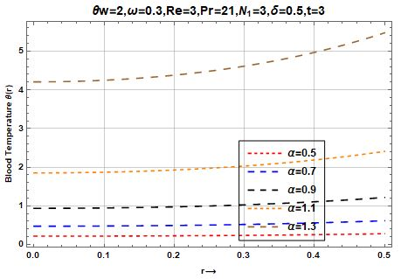

Figure 19:The effect of angle of inclination $(α)$ on the blood temperature

**4.3 Concentration Profile**

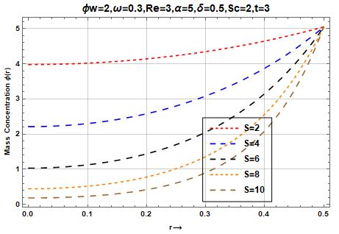

Figure 20: Effect of the Smidt number on the mass concentration

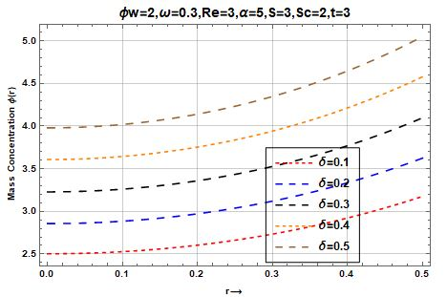

Figure 21: Effect of angle of inclination ( $δ)$ on the mass concentration

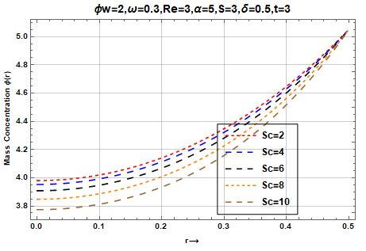

Figure 22: Effect of Schmidt number ( Sc) on the mass concentration

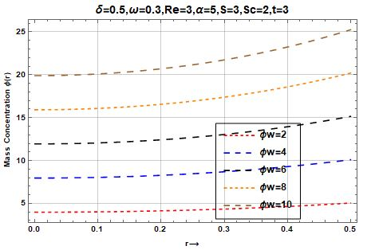

Figure 23: the effect of angle of concentration difference at the wall ( $∅_{w}$) on the mass concentration

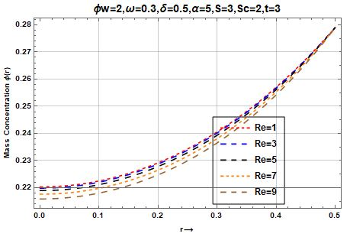

Figure 24: The effect of Reynolds number on the mass concentration

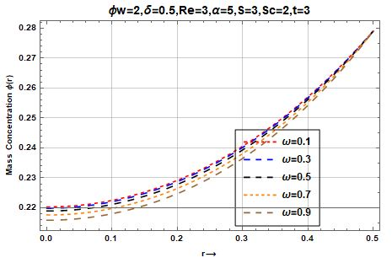

Figure 25: Effect of angular velocity ( $ω)$ on the mass concentration

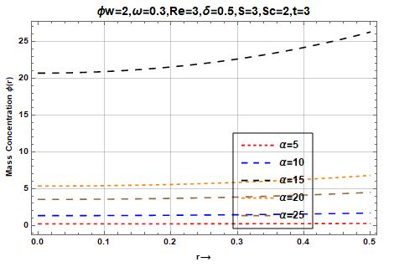

Figure 26: Effect of angle of inclination of the artery on the mass concentration

The significance of the problem under consideration is discussed with realistic values for the leading parameter. Blood flow at the region of converging and diverging was tapered and inhibited by the magnetic field force. The inclination of the angle $θ$ as well as the magnetic field N1 on the flow characteristics such as velocity profile, shear stress, and volumetric flow rate were numerically computed. All graphs are plotted for the values of Grashof number, Nusselt number, Shearwood number, Prandtl number, Reynolds number, etc.

**Figure 1:** Shows the influence of the porosity term on the blood velocity w(r). It is observed that increase in the porosity term $χ, from χ=0.5 to 0.9$ leads to increase in other flow parameters.  **Figure 2:** Represents the behaviour of the inclination of angular velocity of the artery to other flow parameters. It was observed that increase in angular velocity of the artery led to increase in blood velocity w(r).

**Figure 3:** shows the effect of the heat absorption parameter N1 on the body of an individual whose artery is constricted (stenosized). The individual feels heat at night when temperature of the environment is low and feels cool in the afternoon when the environment is high. It means that the individual is characterized with exothermic reaction.

**Figure 4** : shows the result of the Soret (S) effect on the blood velocity. The result shows that increase in soret number leads to increase in other flow parameters. This illustrate that thermal buoyancy force enhances the blood velocity.

**Figure 5:** shows the effect of the height of stenosis ($δ$) on the blood velocity .It was observed that increase in the height of stenosis leads to decrease in the blood velocity at some point and later led to a shift at the tapered region. It means that at the region of the constriction both at the converging and diverging region there was no flow at all. It further means that an individual with constricted artery must be exposed to a magnetic field before such patient blood can flow freely.

**Figure 6** represents the behaviour of the Prandtl number on the blood velocity. It was observed that increase in Prandtl number led to increase on the other flow characteristics.

**Figure 7** represents the effect of Schmidt number on the blood velocity. It was observed that increase on Schmidt number lead to increase on the blood velocity.

**Figure 8**: shows the results of the temperature on the walls of artery to the blood velocity.

The results shows that as the temperature on the walls increases progressively, so also the blood intensity increases.

**Figure 9** represents the effect of the concentration on the wall to the velocity profile. It was observed that increase on the concentration of the wall led to increase on the velocity profile.

**Figure 10**: depicts the effect of Grashof number of the temperature on the velocity profile. The results shows that increase in Grashof number of the temperature leads to increase on the velocity profile of the blood.

**Figure 11:** depicts the effect of Grashof number of the concentration on the velocity profile. The results shows that increase in Grashof number of the concentration leads to increase on the velocity profile of the blood.

**Figure 12**: depicts the effect of Reynolds number on the velocity profile. The results shows that increase in Reynolds number led to increase on the velocity profile of the blood.

that increase in Nusselt number to decrease on the temperature profile of the blood.

**Figure 13** represents the effect of the porosity term on the profile. The results shows that increase in the porosity term led to decrease on the temperature profile of the blood.

**Figure 14**: depicts the effect Prandtl number on the temperature profile. The results shows that increase in Prandtl number led to a very low temperature of the blood.

**Figure 15**: shows the effect of temperature at wall to that of the blood temperature . The results shows that increase in the temperature on the walls of artery resulted to no significant increase on the blood temperature.

**Figure 16:** depicts the effect of Reynolds number (Re) on the blood temperature. The result shows that increase in Reynolds number led to increase blood temperature.

**Figure 17**: depicts the effect angular velocity ($ω)$ on the blood temperature. The results shows that increase in angular velocity ( $ω) leads to increase$ on the blood temperature.

**Figure 18:** depicts the effect of angle of inclination ( $α$) on the blood temperature on the velocity profile. The results shows that increase in angle of inclination led to no significant increase in the blood temperature.

**Figure 19**: depicts the effect of Smidt number on the mass concentration . The results shows that increase in Smidt number progressively leads to increase mass concentration

**Fi**gure 20: represents the effect of the height of stenosis on the blood tem mass concentration . It was observed that increase in the height of stenosis led to no significant increase in the blood temperature .

**Fi**gure 21: depicts the effect of Schmidt number on the mass concentration . The results shows that increase in Schmidt number leads to increase in mass concentration.

**Fi**gure 22 represents the effect of concentration difference at the wall on the mass concentration . It was observed that increase in the angle of inclination of the artery at the wall led to no significant increase in the mass concentration .

**Fi**gure 23 represents the effect of the Reynolds number on the mass concentration . It was observed that increase in Reynolds number led to a decrease in the mass concentration.

**Fi**gure 24 represents the effect of the Reynolds number on the mass concentration . It was observed that increase in Reynolds number led to a decrease in the mass concentration.

**Fi**gure 25 represents the effect of the angular velocity ( $ω)$ on the mass concentration. It was observed that increase in angular led to a decrease in the mass concentration.

Figure 26: Represents the effect of the angle of inclination of artery on the mass concentration. The result shows that increase in the angle of inclination of the artery has no significant difference on the mass concentration. It means that the patient with constricted artery will need to be exposed to magnetic resonance before blood can flow through the artery of such Patient.

**RECOMMENDATION**

* The development of a numerical model that accounts for viscousity-temperature dependence and magnetic field effects should be made.
* There should be an investigation of the transient flow behaviour in constricted arteries, which is a critical aspect of cardiovascular diseases.
* Analysis of the impact of constrictions on the flow dynamics, which can provide insights into the diagnosis and treatment of cardiovascular diseases.

**CONCLUSION**

The governing equations for unsteady MHD convective heat and mass transfer past a semi-infinite vertical permeable moving plate embedded in a porous medium with heat absorption was formulated. The plate velocity was maintained at a constant value and the flow was subject to a transverse magnetic field. The computed values obtained from analytical solutions for the velocity, temperature, concentration fields as well as skin-friction coefficient, Nusselt number and the Sherwood number with their amplitude and phase are presented graphically and in tabular form. After a suitable transformation, the governing partial differential equations were transformed to ordinary differential ones. Theses equations were solved analytically by using two-term harmonic and non-harmonic functions. We conclude the following after analyzing the graphs: The velocity decreases with increasing the Prandtl number, and magnetic field parameter whereas reverse trend is seen with increasing the heat generation parameter, radiation parameter, porous parameter, Soret number, thermal and solutal Grashof numbers. The temperature decreases as the values of Prandtl number increase and reverse trend is seen by increasing the values of th tuermal radiation parameter, heat source parameter. The concentration decreases as the values of the chemical reaction parameter and B Schmidt number whereas concentration increases with increase in the value of Soret number.

**REFERENCES**

1. N.Srivastava, *Analysis of Flow Characteristics of the Blood Flowing Through an Inclined Tapered Porous Artery with Mild Stenosis under the Influence of an Inclined Magnetic Field* Amrita Vishwa Vidyapeetham (University), Karnataka 560 035, India, 2014.
2. H.C. Brinkman, “A calculation of the viscous force exerted by a flowing fluid on a dense swarm of particles,” *Applied Scientific Research,* vol. 1, no. 1, pp. 27-34, 1949.
3. A Kolin, “Electromagnetic flow meter: principle of method and its applications to blood flow measurement,” *in Proceedings of the Society for Experimental Biology and Madicine,* vol. 35, pp. 53-56, 1936.
4. H.Darcy, *The Flow of Fluids Through Porous Media,* Mc-Graw Hill, New York, NY, USA, 1937.
5. E. M. Korchevskii and L. S. Marochnik, “Magnetohydrodynamic version of movement of blood,” *Biophysics,* vol. 10, no. 2, pp. 411-414,1965.
6. V. A. Vardanyan, “Effect of a magnetic field on blood flow,” *Biophysics,* vol. 18, no. 3, pp. 515-521, 1973.
7. V. K. Sud, P. K. Suri, and R. K. Mishra, “Effect of magnetic field on oscillating blood flow in arteries,” *Studia Biophysica,* vol. 46, no. 3, pp. 163-171, 1974.
8. P. K. Suri and R. Suri Pushpa, “Blood flow in a branched arteries,” *Indian Journal of Pure and Applied Mathematics,* vol. 12, pp. 907-918, 1981.
9. U. S. Chakraborty, D. Biswas, and M. Paul, “Suspension model blood flow through an inclined tube with an axially non-symmetrical stenosis,” *Korea Australia Rheology Journal,* vol. 23, no. 1, pp. 25-32, 2011.
10. I. M. Eldesoky, “Slip effects on the unsteady MHD pulsatile Blood flow through porous medium in an artery under the effect of body acceleration,” *International Journal of Mathematics and Mathematical Sciences,* vol. 2012, Article ID 860239, 26 pages, 2012.
11. R. Bali and U. Awasthi, “Mathematical model of blood flow in the small blood vessel in presence of magnetic field,” *Applied Mathematics,* vol. 2, pp. 264-269, 2011.
12. M. Jain, G. C. Sharma, and R. Singh, “Mathematical modelling of blood flow in a stenosed artery under MHD effect through porous medium, “*International Journal of Engineering, Transations B,* vol. 23, no. 3-4, pp. 243-251, 2010.
13. P.K. Mandal, “An unsteady analysis of non-Newtonian blood flow through tapered arteries with a stenosis,” *International Journal of Non-Linear Mechanics,* vol.40, no. 1, pp. 151-164, 2005.
14. K. S. Mekheimer and M. A. E. Kot, “The micropolar fluid model for blood flow through a tapered artery with a stenosis,” *Acta Mechanica Sinica,* vol. 24, no. 6, pp. 637-644, 2008.
15. G. Ramamurty and B. Shanker, “Magnetohydrodynamic effects on blood flow through a porous channel,” *Medical, Bioengineering and Computing,* vol. 32, no. 6, pp. 655-659, 1994.
16. L. M. Srivastava, “Flow of couple stress fluid through stenotic blood vessels,” *Journal of Biomechanics,* vol.18, no. 7, pp. 479-485, 1985.
17. D. Tripathi, “A mathematical model for blood flow through an inclined artery under the influence of an inclined magnetic field,” *Journal of Mechanics in Medicine and Biology,* vol. 12, pp. 1-18, 2012.
18. E.E. Tzirtzilakis, “A mathematical model for blood flow in magnetic field,” Physics of Fluids, vol. 17, no. 7, 15pages, 2005.
19. N. Verma and R. S. Parihar, “Effect of Magnetohydrodynamics and hematocrit on blood flow in an artery with a multiple mild stenosis,” *International Journal of Applied Mathematics and Computation,* vol. 1, no. 1, pp. 30-46, 2009.
20. D. F. Young, “Fluid mechanics of arterial stenosis,” *Journal of Biomechanical Engineering ASME,* vol. 101, pp. 157-175, 1968.
21. P. Chaturani and R. N. Pralhad, “Blood flow in tapered tubes with biorheological applications,” *Biorheology,* vol. 22, no. 4, pp. 303-314,1985.