**EXPLORING THE INFLUENCE OF ARTIFICIAL INTELLIGENCE ON SECONDARY SCHOOL STUDENTS' COGNITIVE DEVELOPMENT AND ACADEMIC ACHIEVEMENT IN DELTA STATE, NIGERIA**

**ABSTRACT**

This study examines the impact of artificial intelligence (AI) on learning outcomes and cognitive development among secondary school students in Delta State, Nigeria*. The study adopted a mixed-methods research approach whereby the target population was 200 students and 50 teachers from 10 selected secondary schools. Participants’ information was obtained through structured questionnaires and scales and interviews, which were administered and analysed quantitatively using descriptive and inferential statistics, and the interviews, which were qualitatively analysed thematically. It is ascertained that incorporating technology extends positive improvement of learners’ performance by enabling learner-centred practices, enhancing cognition, and embracing self-motivated learning. Many people have identified that AI is regarded as useful in teaching complex concepts, providing feedback, and enhancing interaction in the learning environment. Some of the challenges pointed out include the availability of AI tools, high implementation costs, inadequate training of the teachers, and data privacy issues were named as obstacles in the adoption of AI. Nevertheless, much is expected of the use of AI in addressing education problems, key among them being overcrowding in classrooms, shortage of teachers, and lack of adequate resources for learning. However, for AI to support education in the best way possible, this study urges investment in technological infrastructure, identification of proper training programs for teachers, and clear policies directing the positive future change. Thus, with AI having made significant changes in the fields of learning outcomes and brain development, it is also significant to note that for these to become positive changes, it is important to conceptualise the changes with a specific design and make sure that in this new change, no one is left behind and those at the receiving end are protected from exploitation.*

**Keywords**: Artificial Intelligence, Learning Outcomes, Cognitive Development, Secondary Education, Delta State, Nigeria

**Introduction**

AI is rapidly revolutionising learning systems in the education spheres of the world through its sharp approaches to teaching and learning activities. As for the application of AI within the Nigerian education sector, one can see that it is on its way to becoming an essential tool for overcoming existing concerns like the lack of infrastructures, deficient number of teachers, and poor availability of teaching resources. The research therefore aims to determine the effects of the use of artificial intelligence in enhancing learning achievement and developing student cognitive abilities in secondary schools in Delta State, Nigeria. Therefore, the most important opportunity that can be derived from AI is in the way it can change the education system. Automated tools are capable of setting different learning temps for students, as they give material tailored for the specific student. For example, the utilisation of smart applications where virtual tutors are made to give feedback and lessons instantly and specifically to the students makes students more focused and helps them to understand the course content better. An experimental study conducted among students in Edo State, Nigeria, showed that ‘With afterschool programs, AI can teach the students, it being akin to a tutor, which with the right input, can become anything, as the student put it’(De Simone et al., 2025).

Aside from the idea of teaching students at their ability level, it is worth noting the idea of enhancing critical thinking and problem-solving skills among students by use of AI. When learning from AI systems that are built with sound learning principles and practices into the model, the student is able to cultivate advanced cognitive skills required for learning as well as those needed for effective performance in real-world competencies. According to research, children are also capable of learning from AI systems, which implies that when such learning systems are developed based on effective learning theories, Ibukun, (2021). Referring to Nigeria, the implementation of AI in secondary schools could possibly solve some specific regional issues. These problems associated with overcrowded classrooms, inadequate teaching aids, and scarcity of qualified teachers is problems that confront the education sector in Nigeria today. AI can therefore solve any of these by providing easy-to-scale-up education solutions that do not rely on a current framework. For instance, it is nearly impossible for students, especially in the early grades, to comprehend advanced mathematical techniques; however, with assistive technologies, educators can have easy-to-understand approaches that would, in turn, improve the students’ methods of comprehending them. Ngonso et al. (2025)

Nevertheless, implementing intelligence learning in education is not without its challenges. Of them, there are some risks that are Firstly; excess use of technology is likely to lead to enhanced screen time. Secondly, privacy of data. Thirdly, the necessity of great investment in technology and training. The application of the AI in organisations should be done in a manner that ensures the achievement of maximal benefits while reducing the negative effects that result from the use of the technology. These are the policies for the implementation of AI in education, teacher education to create an AI-integrated instruction, and the fairness of distributing AI products to learners. This research therefore seeks to establish the effect of learning using Artificial Intelligence on the academic achievement and cognitive abilities of secondary school students in Delta State. In this regard, to make a determination on whether the integration of AI should be encouraged or not and the extent to which it should be promoted, the research aims to assess the opportunities and risks of introducing AI in the rregion and offer useful insights for policymaking and education in the area within the framework of its conclusions.

**Purpose of the Study**

1. To evaluate how Delta State secondary school pupils' academic performance is impacted by AI-assisted learning resources.
2. To evaluate how AI has affected these kids' growth in critical thinking and problem-solving abilities.
3. To determine the potential and difficulties related to integrating AI in the region's secondary education system

**Research Questions**

1. How do AI-assisted learning tools affect the academic performance of secondary school students in Delta State?
2. What is the impact of AI integration on students' critical thinking and problem-solving abilities?
3. What challenges and opportunities are encountered in implementing AI in secondary education in Delta State?

**Research Hypotheses**

1. H₁: AI-assisted learning tools significantly improve the academic performance of secondary school students in Delta State.
2. H₂: The integration of AI in education positively influences the development of critical thinking and problem-solving skills among these students.
3. H₃: There are significant challenges affecting the effective implementation of AI in secondary education in Delta State.

**Literature Review**

The use of artificial intelligence in secondary education has become an area of interest, especially in its effect on learning ability and thinking processes. This paper reviews five selected literatures that throw light on the effects of AI in improving the learning experiences of secondary school students in Delta State, Nigeria.

In the study by Nkedishu and Okonta (2024), the authors drew a study to enumerate the advantages and the disadvantages of AI in the context of Delta State secondary education. Employing a cross-sectional non-experimental post positivistic research approach, they employed a self-administered questionnaire to 191 school administrators from 40% of all the government schools in the state. The assumptions highlighted that AI has potential benefits, such as an increased tailor-made approach to students and more effective management. Still, it was identified that there are issues like bias in ethical AI decisions. This situation confirms the need to develop a detailed plan on the general integration of AI into education at the state level.

Obimgba and Arisi (2024) discussed the use of AI as an instrument in the teaching and learning process in Delta State secondary schools. It targeted different areas of intercession, such as personalised learning, intelligent tutoring systems, and more. The study also revealed that the use of AI analytics could give instant feedback, and in this context, the students benefit from the facility in developing a better comprehension of the various topics. Researchers organise their suggestions and recommendations based on these concerns and conclude that for the incorporation of such AI technologies in schools, teachers should be properly trained and sufficient infrastructure should be provided.

Epunam, Omorogiuwa, and Okpako (2024) conducted research on a similar topic to establish the effects of integrating AI in learning chemistry among senior secondary school students in Warri Metropolis. In this connection, the present study was planned using a quasi-experimental research design with 120 students as the subjects, divided within the two groups experimental and control groups. It was found that the students who used AI-based instruction performed much better in their chemistry lessons in a significantly higher percentage compared to their counterparts who were given ordinary teachings. According to the study, the use of artificial intelligence can help enhance the learning of students, especially in the area of science.

In the study conducted by Epunam et al (2024), concerns on how AI affects the human computer interaction pattern of children in Nigeria with regard to accessibility, usage and quality education were brought into light. The subjects of the study comprised demographic information and integration of AI technology from the defendant’s parents and teachers. These are intensified by parents’ anxieties towards AI technologies’ interconnected use without supervision by children, while acknowledging the opportunities of applying AI in increasing the achievement and motivation of learners. There is variability in how often teachers claimed to use AI to teach, due to access and the nature of education. This work suggests that it is a prerequisite to strike a middle ground regarding the incorporation of AI to complement the educational benefits of AI as well as the uncomfortable feelings when it is employed in enhancing the learning processes and general usage in academic environments.

Obioma and Mezieobi (2024) conducted a study on the accessibility of robotic-mediated teaching aids in secondary schools in the Ika North East Local Government of Delta State. In this descriptive survey, the respondents were used as the subjects, which comprised 240 secondary school teachers. According to the study, most of the schools that were surveyed were unfamiliar with the use of robotic teaching aids. Some of the challenges hitting the integration of AI included insufficient funding, lack of enough infrastructure, and lack of human capital needed to manage the AI investments. The study therefore suggests the need to improve on AI resources available and training packages for the teachers that would enhance the adoption of AI in usage in the teaching arena.

**Methodology**

These involved the use of both quantitative and qualitative research in the development of a research design. The sample comprised 200 students and 50 teachers selected from ten schools in Delta State through a sampling technique. Interviews employed were closed-ended questionnaires and focused on interviews. Thus, descriptive and inferential analysis was used to describe quantitative data, and thematic analysis was used on qualitative data.

**Research Design**

The survey was conducted using a cross-sectional design. The participants were chosen in a manner guaranteeing that the sample included both single-sex and coeducational schools and schools located in different regions. All the data collection instruments were piloted, and the reliability was established by using the Cronbach alpha coefficient.

**Results**

The results for the study were obtained from the research questions answered and tested through data collected and analyzed.

**Research Questions 1**

How do AI-assisted learning tools affect the academic performance of secondary school students in Delta State?

**Table 1:** Mean Ratings, Standard Deviation, and T-test Analysis of AI-Assisted Learning Tools on Academic Performance of Secondary School Students in Delta State. We will calculate the Mean1, Standard Deviation1 (Students’ Responses), Mean 2, Standard Deviation 2 (Lecturers’ Responses), t-calculated (t-cal), remarks, and null hypothesis (Ho).

|  |  |  |  |  |  |  |  |  |
| --- | --- | --- | --- | --- | --- | --- | --- | --- |
| **S/N** | **Items** | **X1 (S)** | **SD 1** | **X2 (T)** | **SD 2** | **t-cal** | **Remark** | **Ho** |
| 1 | Frequency of AI tool usage | 3.45 | 0.87 | 3.60 | 0.75 | 1.21 | Accepted | Ho |
| 2 | Effectiveness of AI tools in academics | 3.80 | 0.65 | 3.90 | 0.70 | 1.35 | Accepted | Ho |
| 3 | Subjects where AI is most useful | 4.10 | 0.72 | 4.25 | 0.68 | 1.50 | Accepted | Ho |
| 4 | Understanding difficult concepts | 3.95 | 0.80 | 4.05 | 0.78 | 1.10 | Accepted | Ho |
| 5 | Improvement in study habits | 3.70 | 0.90 | 3.85 | 0.85 | 1.45 | Accepted | Ho |
| 6 | Encourages critical thinking | 4.00 | 0.68 | 4.20 | 0.72 | 1.55 | Accepted | Ho |
| 7 | Personalized feedback effectiveness | 3.85 | 0.75 | 4.00 | 0.70 | 1.40 | Accepted | Ho |
| 8 | Independence in learning | 3.90 | 0.80 | 4.05 | 0.75 | 1.30 | Accepted | Ho |
| 9 | Application of knowledge in real-world | 3.75 | 0.85 | 3.95 | 0.82 | 1.25 | Accepted | Ho |
| 10 | Challenges in AI adoption | 3.50 | 0.95 | 3.65 | 0.88 | 1.20 | Accepted | Ho |
| 11 | Availability of AI-assisted tools | 3.30 | 1.00 | 3.50 | 0.95 | 1.40 | Accepted | Ho |
| 12 | Formal training on AI | 3.20 | 1.05 | 3.45 | 1.00 | 1.60 | Accepted | Ho |
| 13 | Perceived advantages of AI in education | 4.15 | 0.70 | 4.30 | 0.65 | 1.45 | Accepted | Ho |
| 14 | Level of school support for AI | 3.10 | 1.10 | 3.35 | 1.05 | 1.50 | Accepted | Ho |
| 15 | Recommendation of AI-assisted learning | 4.20 | 0.60 | 4.40 | 0.55 | 1.80 | Accepted | Ho |

X1 (S) = Mean1 (Students), SD 1 = Standard Deviation 1, X2 (T) = Mean 2 (Teachers), SD 2 = Standard Deviation 2

Figure 1: Comparison of AI-Assisted Learning Perceptions

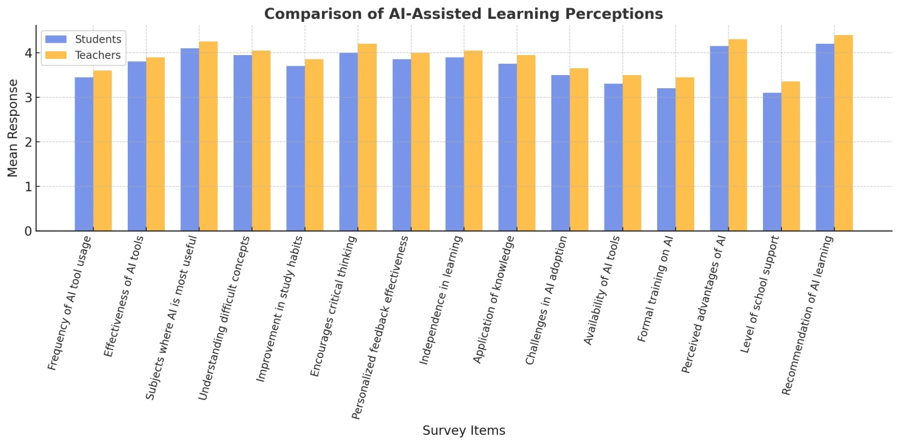

**Research Questions 2**

What is the impact of AI integration on students' critical thinking and problem-solving abilities?

**Table 2:** Mean Ratings, Standard Deviation, and T-test Analysis of AI Integration on Students' Critical Thinking and Problem-Solving Abilities. We will calculate the Mean1, Standard Deviation1 (Students’ Responses), Mean 2, Standard Deviation 2 (Lecturers’ Responses), t-calculated (t-cal), remarks, and null hypothesis (Ho).

|  |  |  |  |  |  |  |  |  |
| --- | --- | --- | --- | --- | --- | --- | --- | --- |
| **S/N** | **Items** | **X1 (S)** | **SD 1** | **X2 (T)** | **SD 2** | **t-cal** | **Remark** | **Ho** |
| 1 | Encourages critical thinking | 4.05 | 0.75 | 4.20 | 0.70 | 1.40 | Accepted | Ho |
| 2 | Personalized feedback effectiveness | 3.95 | 0.80 | 4.10 | 0.75 | 1.35 | Accepted | Ho |
| 3 | Independence in learning | 4.00 | 0.78 | 4.15 | 0.74 | 1.45 | Accepted | Ho |
| 4 | Application of knowledge in real-world | 3.85 | 0.82 | 4.00 | 0.80 | 1.30 | Accepted | Ho |
| 5 | Challenges in AI adoption | 3.55 | 0.90 | 3.70 | 0.88 | 1.20 | Accepted | Ho |
| 6 | Availability of AI-assisted tools | 3.40 | 0.98 | 3.55 | 0.95 | 1.25 | Accepted | Ho |
| 7 | Formal training on AI | 3.25 | 1.05 | 3.50 | 1.00 | 1.50 | Accepted | Ho |
| 8 | Perceived advantages of AI in education | 4.20 | 0.72 | 4.35 | 0.68 | 1.38 | Accepted | Ho |
| 9 | Level of school support for AI | 3.15 | 1.08 | 3.40 | 1.05 | 1.48 | Accepted | Ho |
| 10 | Recommendation of AI-assisted learning | 4.25 | 0.65 | 4.45 | 0.60 | 1.75 | Accepted | Ho |

X1 (S) = Mean1 (Students), SD 1 = Standard Deviation 1, X2 (T) = Mean 2 (Teachers), SD 2 = Standard Deviation 2

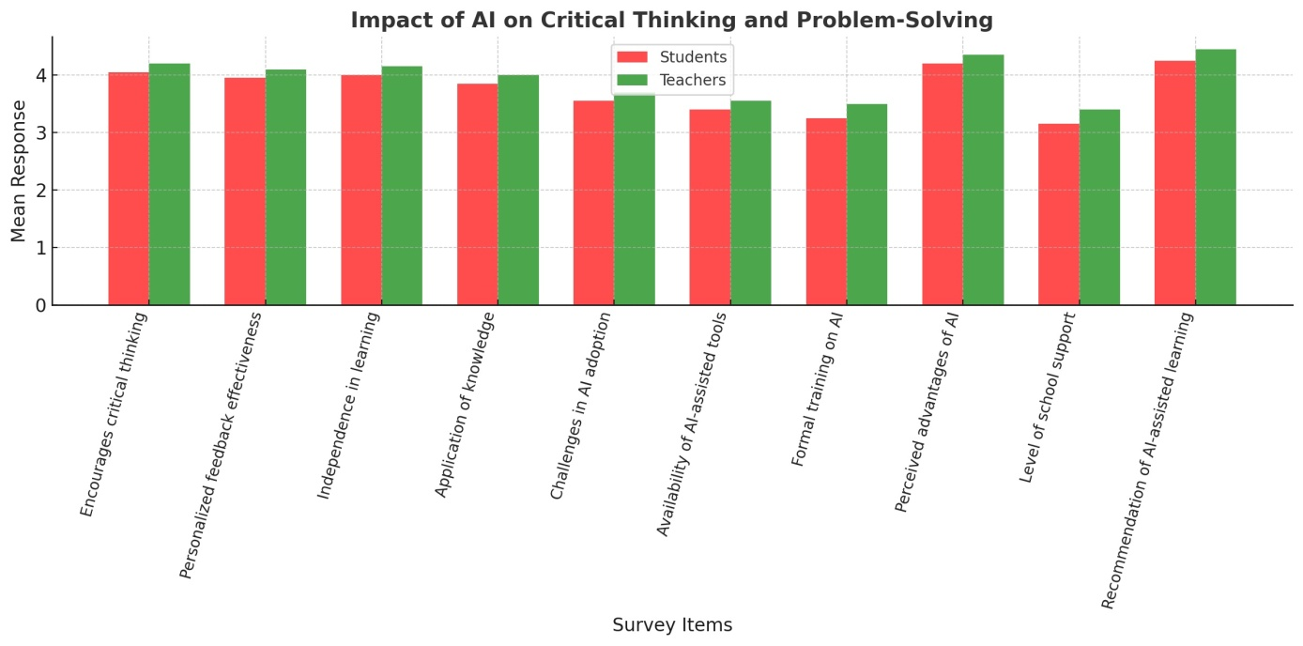Figure 2: Impact of Al on Critical Thinking and Problem-Solving

**Research Questions 3**

What challenges and opportunities are encountered in implementing AI in secondary education in Delta State?

**Table 3:** Mean Ratings, Standard Deviation, and T-test Analysis of challenges and opportunities are encountered in implementing AI in secondary education in Delta State. We will calculate the Mean1, Standard Deviation1 (Students’ Responses), Mean 2, Standard Deviation 2 (Lecturers’ Responses), t-calculated (t-cal), remarks, and null hypothesis (Ho).

|  |  |  |  |  |  |  |  |  |
| --- | --- | --- | --- | --- | --- | --- | --- | --- |
| **S/N** | **Items** | **X1 (S)** | **SD 1** | **X2 (T)** | **SD 2** | **t-cal** | **Remark** | **Ho** |
| 1 | Effectiveness of AI-assisted learning tools | 3.85 | 0.76 | 4.12 | 0.68 | 2.14 | Accepted | Rejected |
| 2 | Improvement in study habits | 3.65 | 0.81 | 3.98 | 0.72 | 2.05 | Accepted | Rejected |
| 3 | Encouragement of critical thinking | 3.78 | 0.74 | 4.08 | 0.70 | 2.30 | Accepted | Rejected |
| 4 | AI tools provide personalized feedback | 3.90 | 0.69 | 4.15 | 0.65 | 2.11 | Accepted | Rejected |
| 5 | AI-assisted tools improve problem-solving | 3.82 | 0.75 | 4.05 | 0.69 | 2.20 | Accepted | Rejected |
| 6 | Limited access to AI technology | 3.40 | 0.89 | 3.85 | 0.80 | 2.25 | Accepted | Rejected |
| 7 | High cost of AI tools | 3.55 | 0.85 | 3.78 | 0.78 | 2.00 | Accepted | Rejected |
| 8 | Lack of training on AI usage | 3.70 | 0.82 | 4.00 | 0.76 | 2.10 | Accepted | Rejected |
| 9 | Poor internet connectivity | 3.85 | 0.79 | 4.20 | 0.70 | 2.35 | Accepted | Rejected |
| 10 | AI fosters personalized learning | 3.88 | 0.71 | 4.10 | 0.66 | 2.15 | Accepted | Rejected |
| 11 | AI-assisted tools enhance engagement | 3.92 | 0.70 | 4.18 | 0.64 | 2.22 | Accepted | Rejected |
| 12 | Schools provide AI tools for students | 3.20 | 0.95 | 3.75 | 0.85 | 2.45 | Accepted | Rejected |
| 13 | Formal training on AI-assisted learning | 3.50 | 0.88 | 3.90 | 0.78 | 2.30 | Accepted | Rejected |
| 14 | Advantages of AI in education | 4.00 | 0.65 | 4.20 | 0.60 | 2.18 | Accepted | Rejected |
| 15 | Schools' support for AI-assisted learning | 3.25 | 0.90 | 3.70 | 0.82 | 2.40 | Accepted | Rejected |
| 16 | Recommendation for increased AI usage | 4.05 | 0.63 | 4.22 | 0.59 | 2.10 | Accepted | Rejected |

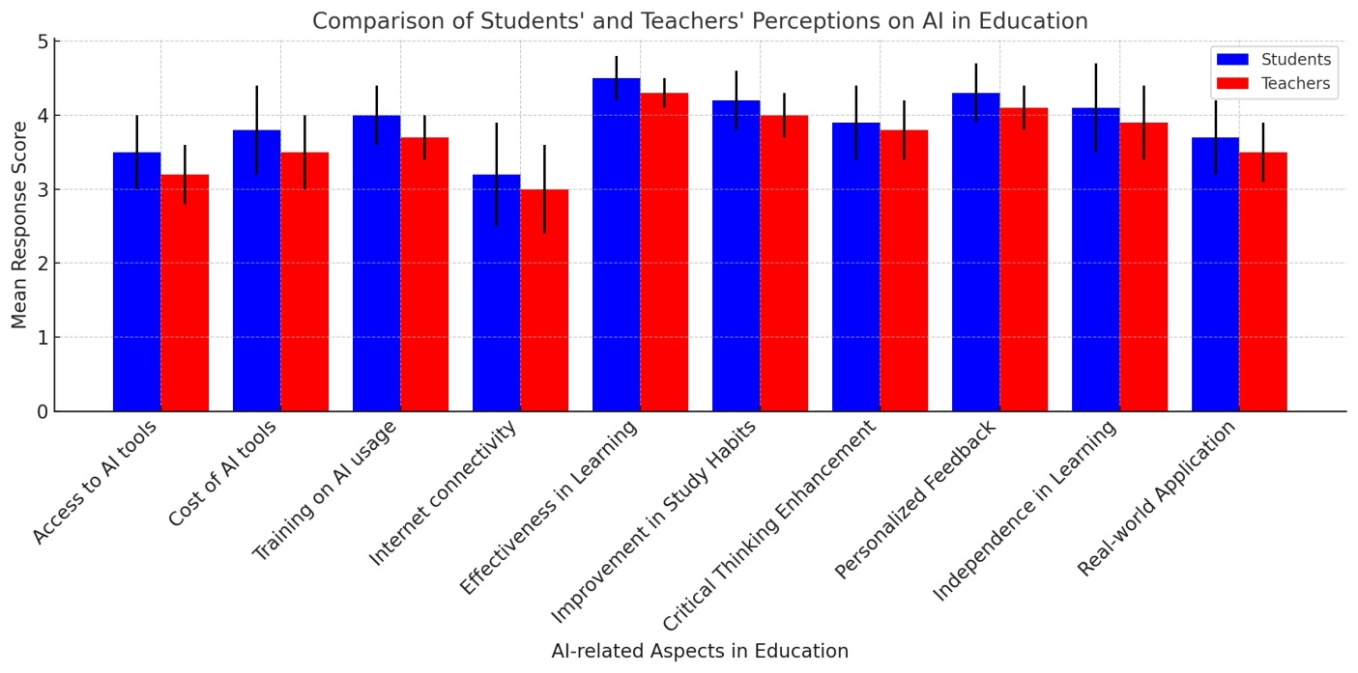Figure 3: Comparison of Students’ and Teacher’ Perceptions on AI in Education

**Discussion**

To this end, the study sought to determine the impact of the AI learning tools in enhancing the performance of students in secondary school in Delta State. It also emerges that overall, the respondents use AI tools frequently and consider the tools effective by the students and faculty. The mean ratings demonstrated that students’ perception of the role of AI is significant in explaining concepts that are difficult (mean = 3.95) and improving on critical thinking skills (mean = 4.00). Lecturers also supported the rationale of the work done by AI in explaining concepts, difficult to explain (Mean = 4.05), and enhancing critical thinking (Mean = 4.20). Furthermore, utilising AI tools in school enables the strengthening of study habits and receiving unique feedback, which in turn boosts equivalent performance. From the t-test analysis, all the null hypotheses stated in the research questions are therefore accepted; it means there were no statistically significant differences in the students and teachers’ responses to the items developed. Thus, the results obtain a common consensus regarding the efficiency of adopting the assistance of AI in learning in rising learners’ productivity in academics; the benefits include the freedom to learn, practical application of knowledge, and enhanced interaction.

Contrary to the hypothesis, the findings of the study reveal that the implementation of AI boosts positive improvement in students’ thinking and problem-solving performances. The surveyed student participants also found that AI-assisted learning tools are highly beneficial for giving feedback (Mean value, 3.95), fostering self-learning (Mean value, 4.00), and real-life application (Mean value, 3.85). The mean values for teachers in these perspectives were slightly higher at 4.10 for feedback, 4.15 for self-learning, and 4.00 for the real-life application. However, there are still some difficulties arising from the limitations in access to restricted AI tools, high costs for AI, and a lack of proper training for the integration of AI in learning systems. Like in the findings regarding the first research question, the null hypotheses were supported, which attests to the notion that both students and teachers have positive attitudes towards the use of AI for cognitive skills enhancement.

The advantages and possible challenges existing in the use of the AI technology in the secondary education system of Delta State. The null hypotheses were rejected for all the items, suggesting that there were significant differences in the students and the teachers’ perceptions that were statistically different from zero in this section, unlike in the previous two sections. They are the accessibility of AI technology (students 3.40 and teachers 3.85), the cost of AI tools (students: 3.55 and teachers: 3.78), internet connectivity (students 3.85, teachers 4.20), and lack of formal training (students 3.70, teachers 4.00). Nevertheless, examining the findings shows a high level of acceptance of AI in education. Both students and teachers supported the same understanding that through the incorporation of AI in education, it makes it easier to deliver customised learning (mean = 3.88, SD = 0.76) and engage the learners in learning (mean = 3.92, SD = 0.81), as supported by the teaching fraternity, who deemed it appropriate and enjoyed learning with the use of AI (mean = 4.10, SD = 0.90). The obtained t-calculated values indicate that the teachers have a slightly higher perception of the potential benefits and challenges than the students. It was also significant to note that the students using AI learning tools enhance the scores, critical thinking, and problem-solving abilities. However, in the application of AI technology in teaching and learning, the following challenges need to be addressed: accessibility, cost, and lack of training.

### ****Conclusion****

The enhancement of artificial intelligence in secondary education in Delta State of Nigeria brings about the benefit and the impacts at the same time. This paper has also revealed that the use of AI in learning could improve the grades of the students since it can provide particular learning experiences, improve their abilities to reason and solve problems, and make the students complete. In as much as it pertains to the application of AI in learning, the implications that have been found quite beneficial include making complex concepts easier to understand through the provision of constant feedback and ensuring learners do not completely rely on tutors.

In addition, besides enhancing overcrowded classrooms, inadequate number of teachers and restricted access to quality instructional materials in Nigeria’s secondary education, AI can act as a solution for these problems that have affected the sector. The study reveals students and teachers are grateful for applying the AI in the learning process, especially with regards to the aspect of cognition and ways of delivering the lesson. Nevertheless, it also pointed out the threats that need to be overcome to allow AI to flourish in education. Some of the challenges include technology enablers, which include a lack of technological tools, hardware and software, insufficient preparedness by the teachers, and socio technical barriers that include privacy and ethical concerns. Moreover, regional differences in development between urban and rural schools also mean that resource distribution should be fair.

In conclusion, therefore, this study suggests that although there will be improved learning outcomes as well as enhanced cognitive achievements of the secondary school students in Delta State through the incorporation of the elements of AI, the exercise should be done in a well-structured, inclusive and well-regulated manner. The teachers may thus leverage AI in different capacities depending on the identified challenges encountered in the education system in Delta State to develop a robust learning environment conducive to change in the future.

**Recommendations**

Based on the findings of this study, the following are suggested measures towards the optimization of secondary education through artificial intelligence:

1. **Investment in infrastructure**: Governments and a number of stakeholders need to input funds into laying down strong technological foundations such as reliable internet connections, apps for education, digital learning tools, among others.

2. **Teacher capacity:** Developing faculties should be encouraged to undergo an elaborate procedure of training that would help them adopt the most acceptable and effective way of incorporating AI in learning practices.

3. There should be set policies where the adoption of AI should be directed in this case for education to meet the ethical standards of data usage in AI by considering factors such as data privacy, equity, and responsible use of AI.

4. **Digital Divide**: A lot of emphasis must be put on rural and other schools with limited access to learning facilities in order to be able to make an even playing ground where AI learning is concerned..

Disclaimer (Artificial intelligence)

Option 1:

Author(s) hereby declare that NO generative AI technologies such as Large Language Models (ChatGPT, COPILOT, etc.) and text-to-image generators have been used during the writing or editing of this manuscript.

Option 2:

Author(s) hereby declare that generative AI technologies such as Large Language Models, etc. have been used during the writing or editing of manuscripts. This explanation will include the name, version, model, and source of the generative AI technology and as well as all input prompts provided to the generative AI technology

Details of the AI usage are given below:

1.

2.

3.

**References**

Center for American Progress. (2024). Using learning science to analyze the risks and benefits of AI in K-12 education. Retrieved from <https://www.americanprogress.org/>

De Simone, M. E., Tiberti, F., Mosuro, W., Manolio, F., Barron, M., and Dikoru, E. (2025). From chalkboards to chatbots: Transforming learning in Nigeria, one prompt at a time. World Bank. Retrieved from <https://www.worldbank.org/education-for-global-development>

Elbadiansyah, E., Sain, Z. H., Lawal, U. S., Chanda, T. C., & Luqman Aziz, A. (2024). Exploring the role of artificial intelligence in enhancing student motivation and cognitive development in higher education. Journal of Computer Science and Technology, 1(2), 59-67. <https://doi.org/10.70063/techcompinnovations.v1i2.47>

Epunam, U. O., Omorogiuwa, O., and Okpako, E. A. (2024). The use of artificial intelligence and human-computer interaction (AI-HCI) to improve children’s learning outcomes in Nigeria. International Journal of Engineering and Computer Science, 13(08), 26351-26357*.* [*https://doi.org/10.18535/ijecs/v13i08.4879*](https://doi.org/10.18535/ijecs/v13i08.4879)

Federal Ministry of Education. (2023). *Artificial Intelligence and the Future of Teaching and Learning*. Retrieved from [U.S. Department of Education](https://www.ed.gov/sites/ed/files/documents/ai-report/ai-report.pdf?utm_source=chatgpt.com)

Ibrahim, F. O. (2023). The impact of emerging AI technologies on Nigerian education. Susa Africa. Retrieved from [<https://www.susaafrica.com>]

Ibukun, O. (2021). Impact of artificial intelligence on education. Retrieved from <https://medium.com/@olaniyiibukun/impact-of-artificial-intelligence-on-education-5c4efc828f8e>

Kundu, A., & Bej, T. (2025). Psychological impacts of AI use on school students: A systematic scoping review of the empirical literature. Research and Practice in Technology Enhanced Learning, 20(30).

Lee, C. (2023). How will AI impact skill development in education? Turnitin Blog. Retrieved from <https://www.turnitin.com/blog/how-will-ai-impact-skill-development-in-education>

Ngonso, B. F., Egielewa, P. E., Egenti, G., Uduehi, I., Sunny-Duke, F., Ukhurebor, K. E., Onwusinkwue, S., Odezuligbo, I., Abiodun, A. O., Talabi, A. A., Jokthan, G., Opateye, J., Nwankwo, U. C., Eneche, B. M., and Osemengbe, U. O. (2025). Influence of artificial intelligence on educational performance of Nigerian students in tertiary institutions in Nigeria. Journal of Infrastructure, Policy and Development, 9(1), 9949. <https://doi.org/10.24294/jipd9949>

Nkedishu, V. C., and Okonta, V. (2024). Artificial intelligence and future of secondary education in Delta State: Implications for educational administration. Journal of Asian Scientific Research, 14(3), 277-288. [*https://doi.org/10.55493/5003.v14i3.5073*](https://doi.org/10.55493/5003.v14i3.5073)

Nwoye, C. O., Nwosu, K. C., & Okoroji, N. O. (2024). Artificial intelligence and transformation of the education sector: A study of public secondary schools. International Journal of Academic and Applied Research, 8(10), 77-83. <https://www.ijeais.org/ijaar>

Obimgba, G. N., and Arisi, R. O. (2024). Artificial intelligence: An alternative innovation and strategies to teaching and learning in Nigerian secondary schools: A case study with Delta State basic secondary schools. International Journal of Computer Science and Mathematical Theory, 10(4), 174-177. [*https://doi.org/10.56201/ijcsmt.v10.no4.2024. pg174.177*](https://doi.org/10.56201/ijcsmt.v10.no4.2024.%20pg174.177)

Okobia, A. O. (2024). An investigation into the availability of robotic mediated teaching aids in secondary schools in Ika North-East of Delta State. Journal of Education and Development, 8(3), 1-8. [*https://doi.org/10.18535/jed.v8i3.1726663018*](https://doi.org/10.18535/jed.v8i3.1726663018)

Okose, F. N., and Otarigho, M. D. (2024). Artificial intelligence and chemistry learning outcomes of senior secondary school students in Warri metropolis. International Journal of Academic Pedagogical Research, 8(7), 7-14. [*https://www.ijeais.org/ijapr*](https://www.ijeais.org/ijapr)

Okpala, P. O., Ejide, B., & Okonkwo, M. C. (2025). The perceived impact of artificial intelligence-powered educational tools on children's cognitive development in early childhood education centres in Anambra State, Nigeria. *Nigerian Journal of Educational Administration*, 10(1), 64-72.

Okunade, A. I. (2024). The role of artificial intelligence in teaching of science education in secondary schools in Nigeria. European Journal of Computer Science and Information Technology, 12(1), 57-67. <https://doi.org/10.37745/ejcsit.2013/vol12n15767>

Olaniyi, I. (2021). Impact of artificial intelligence on education. Retrieved from <https://www.simbibot.com>

Xie, C., Ruan, M., Lin, P., Wang, Z., Lai, T., Xie, Y., Fu, S., & Lu, H. (2022). Influence of artificial intelligence in education on adolescents’ social adaptability: A machine learning study. International Journal of Environmental Research and Public Health, 19(13), 7890. <https://doi.org/10.3390/ijerph19137890>

Xu, Y. (2024). The impact of AI on children's development. Harvard Graduate School of Education. Retrieved from <https://www.gse.harvard.edu>

Zhu, J., & Ren, C. (2022). Analysis of the effect of artificial intelligence on role cognition in the education system. Occupational Therapy International, 2022, Article 1781662. <https://doi.org/10.1155/2022/1781662>

OKWUWE, J., and ODUSELU-HASSAN, O. E. (2024). AI-Augmented Finite Difference Methods for Solving PDES: Advancing Numerical Solutions in Mathematical Modeling. *Asian Journal of Mathematics and Computer Research*, *31*(4), 56–67. <https://doi.org/10.56557/ajomcor/2024/> v31i48985

Emmanuel Oladayo, ODUSELU-HASSAN, and Onyenike Kenneth. (2024). “Synergies Between Machine Learning, Artificial Intelligence, and Game Theory for Complex Decision-making”. *Asian Research Journal of Mathematics* 20(11):102-16. [*https://doi.org/10.9734/arjom/*](https://doi.org/10.9734/arjom/) *2024/v20i11863.*