**ECONOMIC IMPACT OF CLIMATE CHANGE ON AGRICULTURE AND FOOD SECURITY: A COMPARATIVE STUDY OF SMALLHOLDER FARMERS IN NIGERIA AND GHANA**

**Abstract**

*Climate change therefore brings a threat of poor production and food production in the Sub-Saharan region, especially in Nigeria and Ghana, to the smallholder farmers. This paper seeks to compare the economic losses resulting from climate variability on these farmers with regards to crop yields, farm income, and food security. The study uses both a survey with 200 smallholder farmers, 100 of them from Nigeria and the other 100 from Ghana, and in-depth interviews as a method of data collection. Reports indicate that climate change has caused fluctuating rainfall patterns, reduced rainfall duration, high temperatures, and severe weather, which all affect agricultural productivity. Temperature and irregular rainfall were cited as having the more negative impacts on the crop yields, and farmers from both countries also complained of reduced yields. The study also confirms the availability hypothesis, a hypothesis stating that there is a strong positive relationship between low yields of agricultural production, famine, high prices, and low food supply in the household. Secondly, fluctuating prices, crop failures, and now a decline in farm incomes imply that many farmers are leaving farming in search of other employment, which increases the level of poverty within the rural regions. Even though some strategies like the use of drought-resistant crops, mixed cropping, agroforestry, and rainwater management have been put into practice by many smallholder farmers, they lack climate information, adequate support both from the government and NGOs, and capital to support them in the matter of climate change. The research finds that policy advocacy is compelling to promote policy innovations that would encourage and sustainably build up on climate change resilience in agriculture, increase the availability of climate change resources, and support institutions for small-scale producers.* *The following recommendations were made; Extend Climate Information Services, Strengthen Climate Adaptation Policies, Government and non-government organisations should supplement funding and technical assistance to the smallholder farmers to improve their capabilities, more on Climate Change Training and Securing Diversified Farmers’ Income. The social aspect comprises improving irrigation systems for climate-smart farming, capacity development, and financial support to enhance food production and the steadiness of the economic state in the concerned region.*

**Keywords**: Climate change, agricultural productivity, food security, smallholder farmers, adaptation strategies, Nigeria, Ghana, Sub-Saharan Africa.

**Introduction**

Climate change has over the years become one of the aggravated problems that are notable for largely impacting diverse fields, including the agricultural field. The conditions for agriculture in SSA are also important because the agriculture sectors in the SSA are not only significant sources of food and cash incomes but also livelihood sources for a large part of the population. In Nigeria and other such countries, the smallholder farmer populace is more vulnerable to the impacts of climate variation (Ikenga, Ogisi & Gbigbi, 2023). It is therefore important to assess the effect of climate change on the productivity of agriculture and food security in these areas to enable the formulation of sound policies in the fight against climate change.

Agriculture plays a vital role in both countries. In Nigeria, crop and animal products provide food for the nation’s population, and about thirty-eight percent of the populace is involved in agricultural activities (Donmez, et. al., 2024; Hall, et. al., 2017). Just in the same way, the economy of this country depends on agriculture, with cocoa production being of utmost importance. Despite this, the following years have seen some drawbacks, such as climate change, diseases, and locally known as illegal mining of gold, affecting the production of cocoa. For the 2023/24 production year, Ghana was able to supply 370,000 metric tonnes only, and this was due to a shutdown in output, which reached its two-decade low level (Adetayo, 2024;Khan, et. al., 2025).

Effects of climate change according to the Intergovernmental Panel on Climate Change (IPCC), Sub-Saharan Africa is susceptible to climate change as it is mostly involved in rain agriculture and has poor coping mechanisms. Yahaya, et. al., (2024) states that today almost three quarters of the earth’s land area have witnessed a rise in aridity throughout the last three decades, areas of drylands have expanded, and currently they cover 40% of the earth’s surface, excluding Antarctica. This has had repercussions in the economic loss through effects on gross domestic product; according to a survey, Africa lost 11.1% of its GDP between 1990 and 2015 from aridity, and the future impacts are higher, (Darkoh, 1998; File, et. al., 2023).

Food Security, in view of the above, climate change affects agricultural yield and therefore food security. Nigerians, for instance, witnessed severe flooding in Borno State due to the collapsed dam that displaced several individuals and damaged large agricultural land, hence escalating the food crisis due to high prices, eradicating infrastructure, and withdrawal of fuel subsidies, Kotir, (2011). The acute food insecurity has affected 25 million people, and it is projected to reach 33 million by mid-next year (Adetayo, 2024). Likewise, in the case of Ghana, reduced cocoa production has consequences that go beyond the deputy minister to affecting the well-being of the farmers, economy, and food security.

Adaptive Strategies and Challenges, Nigerian and Ghanaian smallholder farmers mostly apply various adaptive options to reduce the effects of climate change. Some other programs, such as those managed by ThriveAgric, are piloted with an expectation of fruit trees to be planted alongside staple foods like corn, rice, and soybeans in Nigeria. These trees will reduce storage of carbon, enable the farmers to be paid for carbon credits, and encourage sustainable farming. Nevertheless, the practical use of these strategies may not be very successful due to some barriers, which include resource constraints, lack of assistance, and more extended social issues, (Hidalgo-Arestegui et. al.,2024).

Justification for the Study: Based on the fact that food security depends highly on smallholder farmers and the fact that these groups are highly susceptible to climatic shocks, this study desires to estimate how climatic change affects productivity and food security in Nigeria & Ghana. In this regard, the study aims at comparing the various experiences and drawing a comprehensive comparison of the various challenges faced by the smallholder farmers in these countries and the feasibility of their coping mechanisms. The results will extend to policy implications and appropriate intervention measures conducive for fortifying and sustainability in the agriculture sector of Sub-Saharan Africa.

**Research Questions**

1. How has climate change affected agricultural productivity among smallholder farmers in Nigeria and Ghana?
2. What is the relationship between changes in agricultural productivity and food security in these countries?
3. What adaptive strategies are smallholder farmers in Nigeria and Ghana implementing to cope with the impacts of climate change?

**Literature Review**

Climate change must be feared as it influences agricultural productivity in the Sub-Saharan region, especially for the smallholder farmers in Nigeria and Ghana. It has been evidenced from previous research that high temperatures and violating rainfall patterns have negative impacts on the yields. For example, it shows that climate variability results in lower yields in farming food insecurity, hence consequently taking a toll on poverty-stricken individuals. Onyeakaet. al. (2024).

Kilungoet. al. (2024). Food insecurity remains a real thing in Sub-Saharan Africa, particularly due to climate change, which worsens food insecurity. This has made food a list in the county due to poor carrying capacity, unfavourable natural conditions for agriculture, and a slow rate of economic development. People have attributed climate change to crop failure that also leads to high prices of food, thus the unavailability of food, (Sambo and Sule, 2024; McGovernor, 2009).

This paper explores the various coping strategies being adopted by smallholder farmers, identified as the use of adaptive strategies, in Nigeria and Ghana, and the following are the adaptive strategies: In Ghana, for instance, the incidence of climate change has led to a shift in the time of planting and diversification of crops to be grown. However, these strategies do not work effectively in most cases because of constraints like information and resource inadequacy (Jones and Mensah, 2022; Watts, 1987; Oyem, et. al., 2024).

Nigeria and Ghana are both countries with comparable climate change manifestations; however, their approaches differ with consideration of their socioeconomic differences and institutions. In Nigeria, the latest floods have impacted food security, making many people homeless while farmlands and crops were battered. Some of the vices prevalent in Ghana include a spot of the illegality of gold mining that has shifted focus from agriculture and worsened food insecurity (Financial Times, 2023; Von Braun, 2008)

**Research Hypotheses**

1. Climate change has a significant negative impact on agricultural productivity among smallholder farmers in Nigeria and Ghana.
2. Decreased agricultural productivity due to climate change leads to increased food insecurity in these regions.
3. The adaptive strategies employed by smallholder farmers in Nigeria and Ghana differ in effectiveness due to varying socio-economic contexts.

**Materials and Method**

In this study, both quantitative and qualitative data were collected, and both types were utilised in forming the analysis for the study.

1. **Quantitative Findings**

Therefore, it was noted that increased temperatures hurt crop yield in Nigeria and Ghana. Some of the consequences of erratic rainfall were poor yields in crops, hence fluctuations in the food supply or expensive food prices.

**2. Qualitative Findings**

The farmers established that they experienced changes in the weather conditions in the last decade that have affected their planting and harvesting cycles, such as delayed rains or early arrival to a point of drought.Some practices mentioned included changing planting dates, diversification in crops, and use of water for irrigation. Nevertheless, the identified tactics were not always successful; some difficulties include lack of sources and insufficient services.

**Results**

The biodata responses of farmers in Nigeria and Ghana based on 100 farmers each.

**Table 1**

*Frequency and Percentage distribution of farmers’ Biodata in Nigeria and Ghana (Nigerian Farmers, n = 100, Ghana farmers n = 100)*

|  |  |  |  |  |  |
| --- | --- | --- | --- | --- | --- |
| **S/n** | **Variables** | **Nigeria**  **(N=100)** | **Frequency**  **(%)** | **Ghana**  **(N=100)** | **Frequency**  **(%)** |
| **1** | **Age** | | | | |
|  | Below 25 | 10 | 10% | 12 | 12% |
| 25-34 | 25 | 25% | 20 | 20% |
| 35-44 | 30 | 30% | 28 | 28% |
| 45-54 | 20 | 20% | 22 | 22% |
| 55 and above | 15 | 15% | 18 | 18% |
|  | | | | | |
| 2 | **Gender** | | | | |
|  | Male | 70 | 70% | 65 | 65% |
|  | Female | 30 | 30% | 35 | 35% |
|  | | | | | |
| 3 | **Highest Level of Education** | | | | |
|  | No formal Education | 20 | 20% | 18 | 18% |
|  | Primary Education | 30 | 30% | 35 | 35% |
|  | Secondary Education | 35 | 35% | 30 | 30% |
|  | Tertiary Education | 15 | 15% | 17 | 17% |
|  | | | | | |
| 4 | **Size of Farmland** | | | | |
|  | Less than 1 hectare | 25 | 25% | 22 | 22% |
|  | 1-2 hectares | 35 | 35% | 38 | 38% |
|  | 3-5 hectares | 30 | 30% | 28 | 28% |
|  | More than 5 hectares | 10 | 10% | 12 | 12% |
|  |  |  |  |  |  |
| 5 | **Years Engaged in Farming** | | | | |
|  | Less than 5 years | 15 | 15% | 18 | 18% |
|  | 5-10 years | 30 | 30% | 25 | 25% |
|  | 11-20 years | 35 | 35% | 38 | 38% |
|  | More than 20 years | 20 | 20% | 19 | 19% |

**Fig 1: Age Distribution in Nigeria and Ghana**

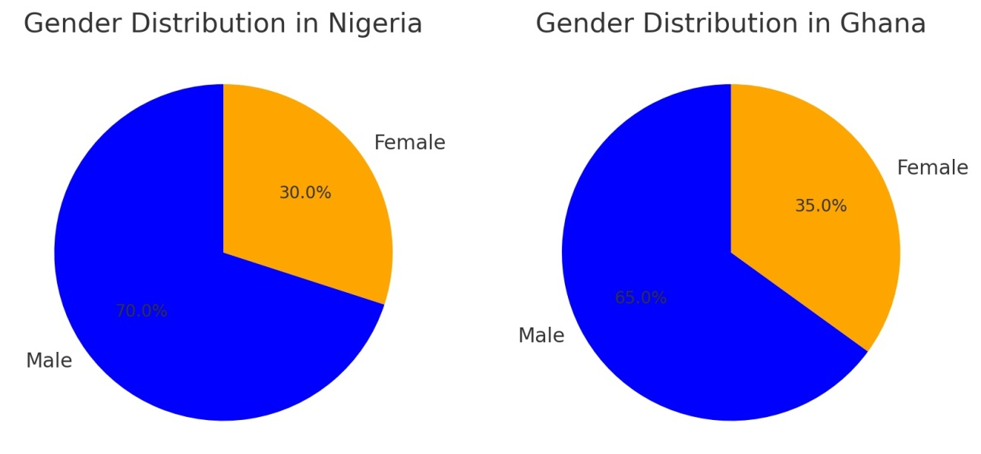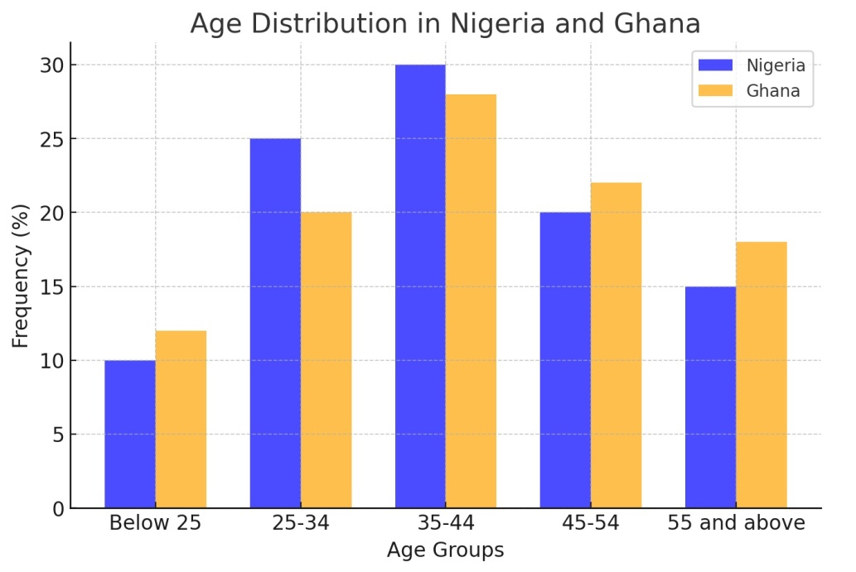Fig 2 Gender Distribution in Nigeria and Ghana

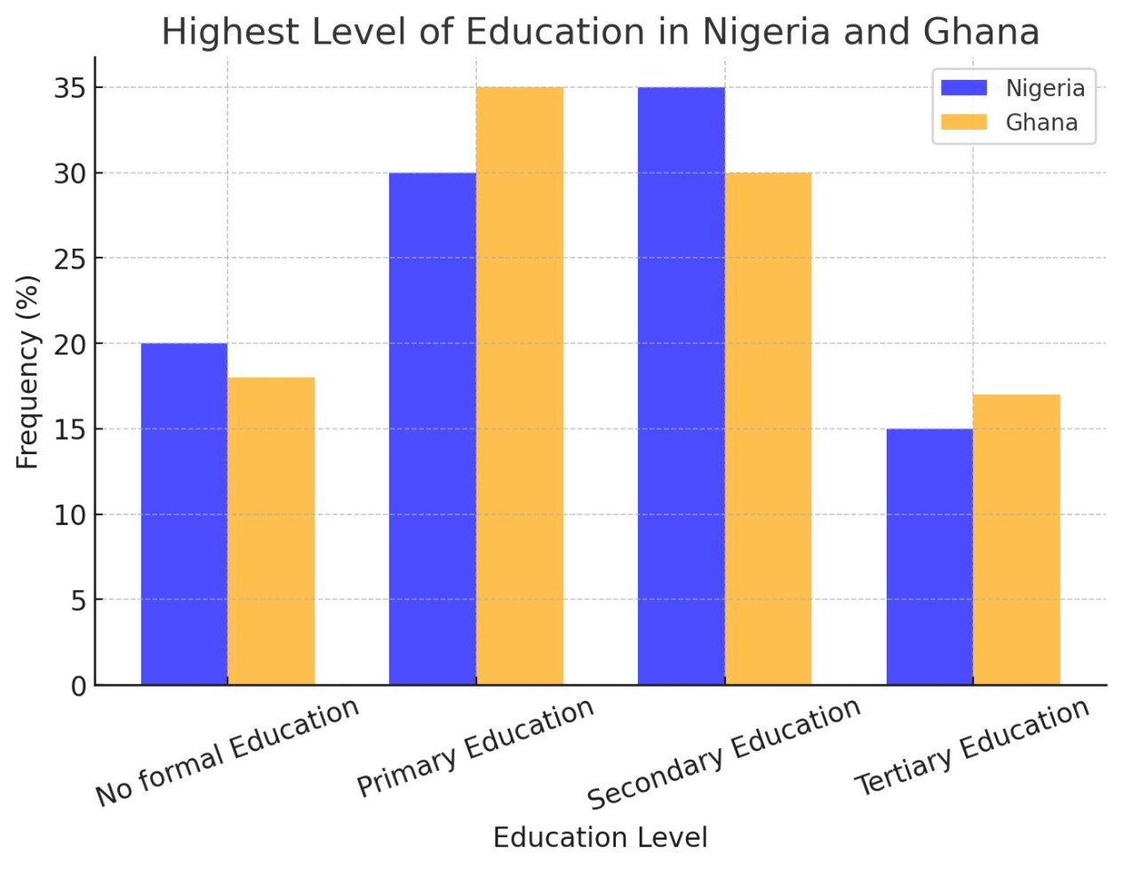

Fig 3: Highest level of education in Nigeria and Ghana

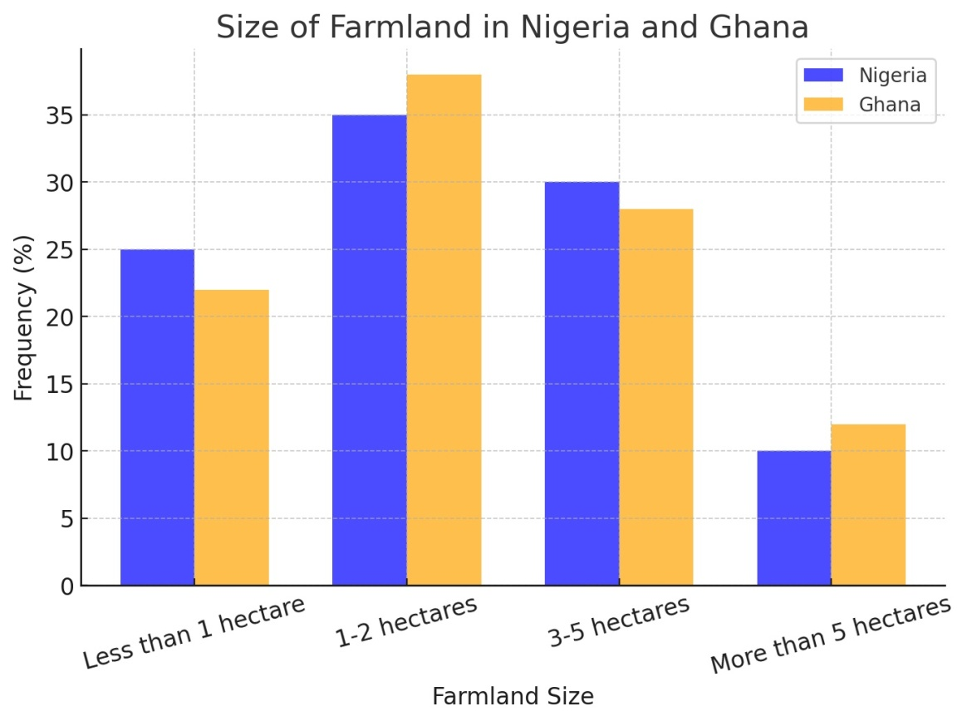

**Fig 4: size of farmland in Nigeria and Ghana**

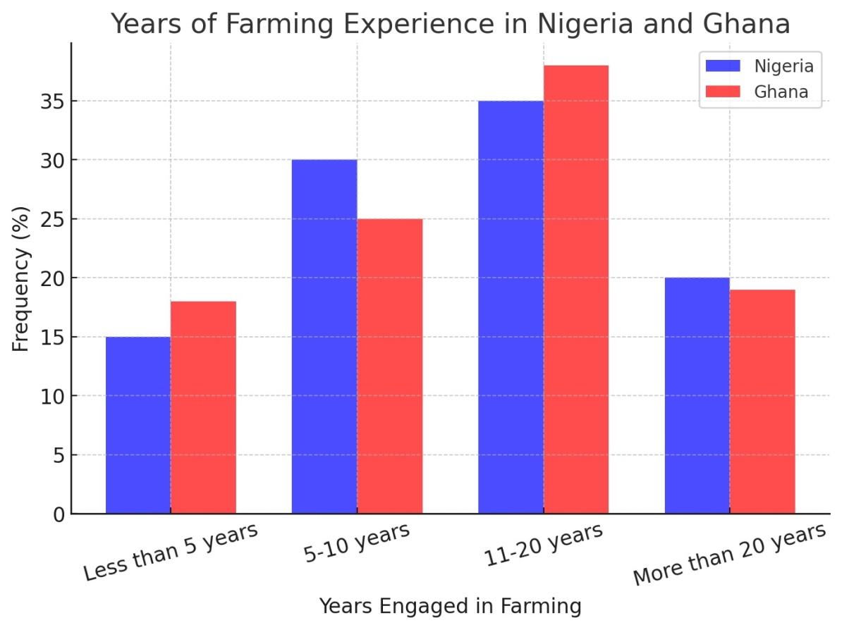

**Fig 5: Years of Farming experience in Nigeria and Ghana**

**Research Question 1**

How has climate change affected agricultural productivity among smallholder farmers in Nigeria and Ghana?

**Table 2**

*Mean ($\overline{x}$) and Standard Deviation Values of the climate change affected agricultural productivity among smallholder farmers in Nigeria and Ghana. The table includes Mean, Standard Deviation, and Decision for both country using (Nigeria Farmers n = 100, Ghana Farmers n = 100)*

|  |  |  |  |  |  |  |  |
| --- | --- | --- | --- | --- | --- | --- | --- |
| **S/N** | **Items** | **NIGERIA** | | | **GHANA** | | |
|  |  | **Mean** | **Std. Dev** | **Decision** | **Mean** | **Std. Dev** | **Decision** |
| 1 | Changes in rainfall patterns over the past decade (Yes=1, No=0) | 0.85 | 0.36 | Significant impact | 0.90 | 0.30 | Significant impact |
| 2 | Temperature changes affected yield (1=Increased, 2=Reduced, 3=No impact) | 2.40 | 0.65 | Reduced yield | 2.35 | 0.60 | Reduced yield |
| 3 | Most affected climatic factor (1=Rainfall, 2=Temperature, 3=Flooding, 4=Drought) | 2.85 | 1.10 | Temperature/Drought dominant | 2.95 | 1.05 | Temperature/Drought dominant |
| 4 | More frequent extreme weather events (Yes=1, No=0) | 0.78 | 0.42 | Increased frequency | 0.82 | 0.39 | Increased frequency |
| 5 | Climate change effect on crop yield (1=Increased significantly, 2=Slight increase, 3=No change, 4=Slight decrease, 5=Decreased significantly) | 4.10 | 0.85 | Significant decline | 4.05 | 0.88 | Significant decline |
| 6 | Change in agricultural productivity affecting household food availability (1=Improved, 2=No change, 3=Reduced) | 2.80 | 0.70 | Reduced food security | 2.75 | 0.72 | Reduced food security |
| 7 | Food shortages due to poor harvests (1=Never, 2=Rarely, 3=Occasionally, 4=Frequently) | 3.25 | 0.85 | Food shortages frequent | 3.30 | 0.88 | Food shortages frequent |
| 8 | Agricultural productivity impact on income (1=Income increased, 2=No impact, 3=Income decreased) | 2.75 | 0.65 | Decreased income | 2.80 | 0.67 | Decreased income |
| 9 | Alternative income sources explored (1=Yes, 0=No) | 0.68 | 0.47 | Many seek alternatives | 0.72 | 0.45 | Many seek alternatives |
| 10 | Access to climate-related information (1=Very accessible, 2=Moderately accessible, 3=Not accessible) | 2.20 | 0.75 | Limited access | 2.15 | 0.72 | Limited access |

Source: Field Work (2025)

**Research Question 2**

What is the relationship between changes in agricultural productivity and food security in these countries?

**Table 3**

*Mean ($\overline{x}$) and Standard Deviation Values of the relationship between changes in agricultural productivity and food security in Nigeria and Ghana. The table includes Mean, Standard Deviation, and Decision for both country using (Nigeria Farmers n = 100, Ghana Farmers n = 100)*

|  |  |  |  |  |  |  |  |
| --- | --- | --- | --- | --- | --- | --- | --- |
| **S/N** | **Items** | **NIGERIA** | | | **GHANA** | | |
|  |  | **Mean** | **Std. Dev** | **Decision** | **Mean** | **Std. Dev** | **Decision** |
| 1 | Change in agricultural productivity affecting household food availability (1=Improved, 2=No change, 3=Reduced) | 2.75 | 0.70 | Reduced food security | 2.70 | 0.72 | Reduced food security |
| 2 | Frequency of food shortages due to poor harvests (1=Never, 2=Rarely, 3=Occasionally, 4=Frequently) | 3.20 | 0.85 | Food shortages frequent | 3.30 | 0.88 | Food shortages frequent |
| 3 | Impact of agricultural productivity on income (1=Income increased, 2=No impact, 3=Income decreased) | 2.80 | 0.65 | Decreased income | 2.85 | 0.67 | Decreased income |
| 4 | Alternative income sources explored due to climate change (1=Yes, 0=No) | 0.65 | 0.48 | Many seek alternatives | 0.70 | 0.46 | Many seek alternatives |
| 5 | Accessibility of climate-related information (1=Very accessible, 2=Moderately accessible, 3=Not accessible) | 2.25 | 0.75 | Limited access | 2.20 | 0.72 | Limited access |

Source: Field Work (2025)

**Research Question 3**

What adaptive strategies are smallholder farmers in Nigeria and Ghana implementing to cope with the impacts of climate change

**Table 4**

*Mean ($\overline{x}$) and Standard Deviation Values of the adaptive strategies smallholder farmers in Nigeria and Ghana are implementing to cope with climate change. The table includes Mean, Standard Deviation, and Decision for both country using (Nigeria Farmers n = 100, Ghana Farmers n = 100)*

|  |  |  |  |  |  |  |  |
| --- | --- | --- | --- | --- | --- | --- | --- |
| **S/N** | **Items** | **NIGERIA** | | | **GHANA** | | |
|  |  | **Mean** | **Std. Dev** | **Decision** | **Mean** | **Std. Dev** | **Decision** |
| 1 | Use of drought-resistant crops (1=Yes, 0=No) | 0.72 | 0.45 | Commonly used | 0.78 | 0.42 | Commonly used |
| 2 | Agroforestry (1=Yes, 0=No) | 0.55 | 0.50 | Moderately used | 0.60 | 0.49 | Moderately used |
| 3 | Rainwater harvesting (1=Yes, 0=No) | 0.50 | 0.51 | Moderately used | 0.65 | 0.48 | Moderately used |
| 4 | Use of irrigation (1=Yes, 0=No) | 0.45 | 0.50 | Less commonly used | 0.52 | 0.50 | Less commonly used |
| 5 | Mixed cropping (1=Yes, 0=No) | 0.80 | 0.40 | Widely used | 0.85 | 0.36 | Widely used |
| 6 | Government/NGO support for climate adaptation (1=Yes, 0=No) | 0.35 | 0.48 | Limited support | 0.40 | 0.49 | Limited support |
| 7 | Training on climate adaptation (1=Yes, 0=No) | 0.40 | 0.49 | Limited training | 0.45 | 0.50 | Limited training |
| 8 | Accessibility of climate-related information (1=Very accessible, 2=Moderately accessible, 3=Not accessible) | 2.10 | 0.80 | Moderately accessible | 2.00 | 0.75 | Moderately accessible |

Source: Field Work (2025)

**Discussion**

From the Table 1 evidence, it is observed that the age distribution of farmers in Nigeria and Ghana in the study is almost in the same range of between 25 and 54 years. Here also, the gender shows that farming is predominantly practiced by male farmers, even though the percentage of female farmers is slightly higher in Ghana (35%) than Nigeria (30%). Education level also differs a little; more Nigerian farmers received their education at the secondary level (35%) than the farmers in Ghana (30%), whereas more farmers in Ghana received their education at the primary level (35%) than the farmers in Nigeria (30%). This could also affect how farming is practiced concerning climate change by farmers in each respective country. The distribution of the size of the farms of these countries’ farmers has been determined to assess the likeliness of them becoming nucleus farmers: most farmers in the two countries have small farms of 1-2 hectares in size. Similarly, the years of farming experience also fall into a similar pattern, with more than one-third of the farmers practicing for between 11 and 20 years.

Analysing the source of information from Table 2, it can be deduced that climate change has had an influence on agriculture in both Nigeria and Ghana. Most of the farmers in the two countries, which are 85% in Nigeria and 90% in Ghana, determine that the rainfall has changed, and this has affected productivity. It has been observed that temperature has a negative effect on yields of crops (mean = 2.40 for Nigeria, 2.35 for Ghana). Temperature and drought were the most cited climatic risks that affected farms in both Nigeria and Ghana (mean = 2.85 and 2.95). Other factors, such as intense flooding and long durations of droughtiness, have continued to occur more frequently, thus exerting pressure on agricultural systems.

In accordance with the findings (Mean =4.10, 4.05), the surveyed Nigerian and Ghanaian farmers complained about their crop yield reduction as a result of climate change. This has given rise to low household food security (mean = 2.80 in Nigeria and 2.75 in Ghana) as well as high incidences of food insecurity (mean = 3.25 in Nigeria and 3.30 in Ghana). Many farmers have also been affected by declining income, which was at a mean of 2.75 in Nigeria and 2.80 in Ghana, hence they have to look for sources of income. Some of the information-related factors include: The farmers still find it difficult to obtain adequate information on climate change, as depicted by the mean of 2.20 for Nigeria and 2.15 for Ghana for the climate adaptation information.

This information also proves that Nigeria and Ghana are food insecure since agricultural productivity is inverse to the food security levels; since there is low agricultural productivity, food availability in the households is also low (mean = 2.75 in Nigeria and 2.70 in Ghana). The availability of food was indicated to be a challenge with a mean frequency of 3.20 in Nigeria and 3.30 in Ghana, a clear indication of the penetration of the problem. Yields are also low, and as a result, the income level has been pulled down, hence enhancing food insecurity. The pressure towards seeking other forms of revenues has therefore intensified (mean = 0.65 in Nigeria, 0.70 in Ghana). There is relatively moderate restriction in relying on climate information for adaptation, which might prove a major drawback.

Some adaptive measures for dealing with climate change effects among farmers in Nigeria and Ghana include: Drought-resistant crops: This seems to be a frequently used adaptation practice by farmers both in Nigeria (mean = 0.72) and Ghana (mean = 0.78) because the farmers are practicing crop varieties that can withstand drought. The use of these two strategies is below average, though slightly higher in Ghana than Nigeria; the mean score for agroforestry is 0.60 while that for rainwater harvesting is 0.65 in Ghana; similarly for Nigeria the mean scores are 0.55 for agroforestry and 0.50 for rainwater harvesting. The use of irrigation: This indicated that irrigation is impractical or limited to use by both nations (mean = 0.45 in Nigeria and 0.52 for Ghana).

Mixed Cropping: This has an average of 0.80 in Nigeria and 0.85 in Ghana, showing that cropped plants were being intercropped to reduce risks of crop failure. In the aspect of support from government/NGOs, it is still very low (0.35 for Nigeria and 0.40 for Ghana). Climate change training options are also limited (mean = 0.40 in Nigeria, 0.45 in Ghana), thus implying the need for enhanced capacity development for adaptation initiatives. Climate information concern: Farmers were found to have a moderate level of concern on climate information (mean = 2.10 in Nigeria, 2.00 in Ghana), hence the need for enhancement of the provision of climate forecasts and practices for adaptation.

**Conclusion**

From the findings, it can therefore be deduced that climate change has greatly affected especially the farming sector and food security in Nigeria and Ghana. The following are the findings: Reduction in yields because of changes in the pattern of rainfall and an increase in temperature. Evident from the above-detailed results, most farmers had little food available at home and frequently experienced times when they had nothing to eat due to extreme poverty. Lack of information and poor governmental and NGO help aggravate the capacity to adapt. Conservative measures like drought-tolerant planting, condensation, and intercropping are well used, whereas irrigation and trees for food improvement have low adoption because of high cost and lack of structures.

Disclaimer (Artificial intelligence)

Option 1:

Author(s) hereby declare that NO generative AI technologies such as Large Language Models (ChatGPT, COPILOT, etc.) and text-to-image generators have been used during the writing or editing of this manuscript.

Option 2:

Author(s) hereby declare that generative AI technologies such as Large Language Models, etc. have been used during the writing or editing of manuscripts. This explanation will include the name, version, model, and source of the generative AI technology and as well as all input prompts provided to the generative AI technology

Details of the AI usage are given below:

1.

2.

3.

**Recommendations**:

1. **Extend Climate Information Services**: It is also time, that governments and the agricultural organisations extend climate-smart advisory services to the farmers to facilitate a constant provision of climate change data.

2. **Strengthen Climate Adaptation Policies**: Convert into practice the areas concerning agriculturally productive lands by increasing incentives of subsidies for drought-tolerant crops and improved irrigation.

3. Government and non-government organisations should supplement funding and technical assistance to the smallholder farmers to improve their capabilities.

4. **More on Climate Change Training**: Farmers require more training and awareness creation on appropriate farming practices that are suitable for the changing mean climate, more on skills sharing and training.

5. **Securing Diversified Farmers’ Income:** Venturing into other income-generating activities like rearing animals such as chickens or engaging in the sale of agricultural produce could assist in reducing losses.

The above strategies will help the smallholder farmers in Nigeria and Ghana to respond to climate change and improve agricultural productivity and food security.

**Reference**

Adetayo, O. (2024). Millions of Nigerians go hungry as floods compound hardship. Reuters. [*https://www.reuters.com/article/nigeria-floods-hunger*](https://www.reuters.com/article/nigeria-floods-hunger)

Darkoh, M. B. (1998). The nature, causes and consequences of desertification in the drylands of Africa. *Land Degradation & Development*, *9*(1), 1-20.

Donmez, D., Isak, M. A., Izgu, T., & Şimşek, O. (2024). Green Horizons: Navigating the future of agriculture through sustainable practices. *Sustainability*, *16*(8), 3505.

File, D. J. M. B., Jarawura, F. X., & Derbile, E. K. (2023). Adapting to climate change: Perspectives from smallholder farmers in North-western Ghana. *Cogent Social Sciences*, *9*(1). <https://doi.org/10.1080/23311886.2023.2228064>

Financial Times (FT). (2023). *Food Security in Nigeria and Ghana: The Role of Climate Change and Socioeconomic Factors.* Financial Times Climate Reports. https://www.ft.com/content/57b7148c-0cf9-48b9-bcb6-29885f2dacff

Hall, C., Dawson, T. P., Macdiarmid, J. I., Matthews, R. B., & Smith, P. (2017). The impact of population growth and climate change on food security in Africa: looking ahead to 2050. *International Journal of Agricultural Sustainability*, *15*(2), 124-135.

Harvey, F. (2024). Drylands now make up 40% of land on Earth, excluding Antarctica, study says. The Guardian. [*https://www.theguardian.com/environment /2024/dec/09/drylands-study*](https://www.theguardian.com/environment%20/2024/dec/09/drylands-study)

Hidalgo-Arestegui, A., Justino, P., Monteiro, G. F., Oliveira, R. C., &Sianyeuka, B. (2024). *The gendered effects of climate shocks on labour and welfare in Zambia* (No. 2024/86). WIDER Working Paper

Ikenga, V. U., Ogisi, O. D., and Gbigbi, T. M. (2023). Climate Change Adaptation measures of Aquaculture Enterrises in Delta State, Nigeria. *Journal of Agriculture and Food Environment, 10(3), 24-29*

Jones, P. L., & Mensah, T. (2022). *Adaptation Strategies to Climate Change: A Case Study of Smallholder Farmers in Ghana and Nigeria.* Journal of Climate Resilience, 8(2), 121-140. [*https://pmc.ncbi.nlm.nih.gov/articles/PMC9142845*](https://pmc.ncbi.nlm.nih.gov/articles/PMC9142845)

Khan, M., Zhang, Y., & Khan, S. (2025). Echoes of Survival: Climate Change Impact & Typologies of Adaptation among Vulnerable Communities toward Climate-Induced Food Insecurity in Pakistan. *Research on World Agricultural Economy*, 290-318.

Kilungo, A., Chukwuonye, G. N., Okpanachi, V., and Hussein, M. (2024). Preparedness of Sub-Saharan African Countries to Address Climate Change and Health Impact: A Scoping Review. *medRxiv*, 2024-11.

Kluger, J. (2024). UkaEje: CEO, ThriveAgric. TIME. [*https://time.com/100-climate-2024/uka-eje*](https://time.com/100-climate-2024/uka-eje)

Kotir, J. H. (2011). Climate change and variability in Sub-Saharan Africa: a review of current and future trends and impacts on agriculture and food security. *Environment, Development and Sustainability*, *13*, 587-605.

McGovern, P. E. (2009). *Uncorking the past: the quest for wine, beer, and other alcoholic beverages*. Univ of California Press.

Onyeaka, H., Nwauzoma, U. M., Akinsemolu, A. A., Tamasiga, P., Duan, K., Al-Sharify, Z. T., and Siyanbola, K. F. (2024). The ripple effects of climate change on agricultural sustainability and food security in Africa. *Food and Energy Security*, *13*(5), e567. <https://doi.org/10.1002/fes3.567>

Oyem, A., Owigho, O., Tibi, K. N., &Ikenga, V. U. (2024). Assessing the performance and activities of farmers’ cooperative groups on cassava production in Ukwani Local Government Area of Delta State, Nigeria. GSC Advanced Research and Reviews, 21(02), 456–463. [*https://doi.org/10.30574/gscarr.2024.21.2.0442*](https://doi.org/10.30574/gscarr.2024.21.2.0442)

Sambo, U., & Sule, B. (2024). Impact of climate change on food security in Northern Nigeria. *Green and Low-Carbon Economy*, *2*(1), 49-61.

Von Braun, J. (2008). Rising food prices: what should be done? Steigende Nahrungsmittelpreise: Was solltegetanwerden? Rising food prices: What should we do? *EuroChoices* , *7* (2), 30-35.

Watts, M. (1987). Drought, environment and food security: some reflections on peasants, pastoralists and commoditization in dryland West Africa. *Drought and hunger in Africa*, 171-211.

[Yahaya, M.](https://www.emerald.com/insight/search?q=Mumuni%20Yahaya), [Mensah, C.](https://www.emerald.com/insight/search?q=Caleb%20Mensah), [Addaney, M.](https://www.emerald.com/insight/search?q=Michael%20Addaney), [Damoah-Afari, P.](https://www.emerald.com/insight/search?q=Peter%20Damoah-Afari) and [Kumi, N.](https://www.emerald.com/insight/search?q=Naomi%20Kumi) (2024), "Climate change and adaptation strategies in rural Ghana: a study on smallholder farmers in the Mamprugu-Moaduridistrict", [*International Journal of Climate Change Strategies and Management*](https://www.emerald.com/insight/publication/issn/1756-8692), Vol. 16 No. 1, pp. 112-139. <https://doi.org/10.1108/IJCCSM-08-2022-0110>