**ANALYTIC ERROR ESTIMATES IN SEMI-DISCRETIZATION OF THE STOCHASTIC CAHN-HILLIARD EQUATION**

**Abstract**

*This study examines the semi-discretization of the stochastic Cahn-Hilliard equation, which represents phase separation phenomena in multi-component mixtures affected by random fluctuations. An analytic error estimate in the L² norm is derived for the solution of the continuous stochastic equation compared to its semi-discretized approximation. The finite difference method is utilized for spatial discretization, ensuring the stability and convergence properties of the numerical scheme. We support our theoretical findings with numerical experiments that confirm the established error estimates and underscore the implications for simulating phase separation in noisy environments. The primary finding indicates that the error diminishes as spatial resolution increases, contingent upon specific smoothness and regularity conditions applied to the initial data and noise. The study presents numerical experiments to validate theoretical findings and examines the implications of results for simulating phase separation in noisy environments. This study enhances the understanding of the dynamics of stochastic phase separation and establishes a solid framework for the advancement of numerical methods for stochastic partial differential equations (SPDEs).*

**Keywords:** Stochastic Cahn-Hilliard equation, space-time white noise, semi-discretization, finite difference method, L2-norm error estimate and stochastic partial differential equations (SPDEs).

**Introduction**

In order to simulate phase separation in binary mixes, like alloys or polymer blends, where two components gradually separate into different areas or phases, Cahn and Hilliard developed the Cahn-Hilliard equation in 1958.The process by which an originally heterogeneous state transforms into a more stable configuration while reducing the free energy of the system is referred to as ation. The gradient of the chemical potential, which is a function of the concentration field, drives diffusion, causing this phase separation. A fourth-order nonlinear partial differential equation (PDE) of the following form can be used to express the deterministic Cahn-Hilliard problem:

$\frac{du}{dt}= ∇μ, with μ= -∈^{2}∆_{μ}+ f\left(u\right),$ (1)

where $u(x,t)$ represents the concentration of one component in the mixture, ϵ is a small positive parameter related to the interfacial thickness, and $f(u)$ is a nonlinear function representing the derivative of a double-well potential, often taken as $f\left(u\right)= u^{3}- u$, corresponding to the free energy density of the system.

Originally developed to characterize phase separation in binary alloys, the Cahn-Hilliard equation has since found application in a number of domains, such as materials research and image processing. Phase separation in the presence of random fluctuations, like thermal noise, is modeled using the stochastic form of the Cahn-Hilliard equation, which is driven by space-time white noise. Accurately replicating real-world processes requires an understanding of this stochastic partial differential equations (SPDE) numerical approximation.

**Stochastic Cahn-Hilliard Equation**

Phase separation does not always take place in a completely deterministic setting in practical applications. Thermal noise is one type of random fluctuation that can affect the dynamics of the phase separation process. This encourages the study of a stochastic Cahn-Hilliard equation, in which these random effects are modeled by adding a noise term. The following is the form of the space-time white noise-driven stochastic Cahn-Hilliard equation:

$\frac{du}{dt}= -∇μ+ η\left(x,t\right), μ= -∈^{2}∆_{μ}+ f\left(u\right)$ (2)

where $η(x,t)$ is a space-time white noise term that introduces stochastic perturbations. Specifically, $η\left(x,t\right)$ can be interpreted as Gaussian noise that is delta-correlated in both space and time:

$E \left[η\left(x,t\right)η\left(x^{'},t^{'}\right)\right]= δ\left(x-x^{'}\right)δ\left(t-t^{'}\right)$ (3)

This time period captures the random fluctuations that have an effect on the machine's dynamics on microscopic scales. The creation of noise basically alters the conduct of the device, leading to wealthy dynamics and new challenges in both the analysis and numerical approximation of the equation.

Numerical strategies are critical for solving the stochastic Cahn-Hilliard equation, specifically in higher dimensions or for complicated geometries. A standard approach is to first discretize the spatial domain using finite distinction, finite detail, or spectral strategies, while retaining the time variable non-stop. This technique is called semi-discretization, as the equation is discretized in space but not yet in time.

To discretize the spatial domain, we divide it into $N$ grid points $x_{i}$ with spacing $∆x$. Let $u_{i}\left(t\right)≈ u(x_{i}, t)$ represent the semi-discretized approximation to the solution at grid point $x_{i}$ and time *t*. The semi-discretized Cahn-Hilliard equation then becomes:

$\frac{du_{i}(t)}{dt}= -Δ_{h}μ_{i}\left(t\right)+ η_{i}\left(t\right)$ (4)

where $Δ_{h}$ is the discrete Laplacian operator, defined for a one-dimensional uniform grid by:

$Δ_{h}μ_{i}= \frac{u_{i+1 }-2u_{i }+ u_{i-1 }}{{\left(Δx\right)}^{2}}$ (5)

and $η_{i}\left(t\right)$ represents the discretized noise term. The discrete chemical potential $μ_{i}\left(t\right)$ is given by:

$μ_{i}(t)= -∈^{2}∆_{h}u_{i}\left(t\right)+ f\left(u(t)\right)$ (6)

where $f\left(u\right) =u^{3}- u$ in the continuous case.

**Challenges of Stochastic Partial Differential Equations (SPDEs)**

Numerical approximation of stochastic partial differential equations (SPDEs) just like the stochastic Cahn-Hilliard equation affords numerous demanding situations. Unlike deterministic PDEs, wherein errors arise simplest from the discretization of space and time, SPDEs include an extra layer of complexity due to the stochastic noise. This noise can lead to rather irregular solutions, which complicates the mistake evaluation and the design of numerical techniques. Furthermore, the fourth-order nature of the Cahn-Hilliard equation calls for cautious remedy of boundary situations and ensures that preferred numerical techniques, which include finite variations or finite elements, have to be adapted to handle better-order derivatives and the interplay among noise and nonlinearity.

**Error Analysis and Norm Error Estimate**

One of the primary goals in studying numerical methods for SPDEs is to estimate the error between the semi-discretized numerical solution and the true solution of the continuous equation. In this paper, we focus on deriving an analytic error estimate in the L2-norm between the semi-discretized solution $u_{h}(t)$ and the exact solution $u\left(t\right)$ of the stochastic Cahn-Hilliard equation.

The L2-norm error at time *t* is defined as:

${\left\|u\left(t\right)-u_{h}(t)\right\|}_{L^{2}}= {\left(\int_{Ω}{\left({\left|u\left(x,t\right)-u_{h}(x,t)\right|}^{2}\right)dx}\right)}^{1/2}$ (7)

For the semi-discretized solution, this norm can be approximated by:

${\left\|u\left(t\right)-u_{h}(t)\right\|}_{L^{2}}≈ {\left(\sum_{ι=1}^{N}{\left|u\left(x,t\right)-u_{i}{\left(t\right)}^{2}\right|Δx}\right)}^{1/2}$ (8)

Our goal is to derive an estimate of this error in terms of the spatial discretization parameter $Δx$. Specifically, we aim to show that the error decays as $Δx$ decreases, following a power law:

${\left\|u\left(t\right)-u_{h}(t)\right\|}_{L^{2}}≤ C{(Δx)}^{p}$ (9)

where C is a constant that depends on the regularity of the initial data and the noise, and *p* is a positive exponent that reflects the convergence rate. Under appropriate smoothness assumptions on the solution and noise, we expect to show that *p* = 2, indicating second-order convergence with respect to the spatial grid size.

Numerical methods for SPDEs face good sized challenges due to the interaction among noise, nonlinearity, and the complexity of boundary situations. The purpose of this paper is to analyze the semi-discretization of the stochastic Cahn-Hilliard equation the usage of a finite distinction method in area and derive an analytic L2-norm error estimate. We will show that the semi-discretized scheme converges to the non-stop solution as the spatial grid is delicate, with mistakes prices relying on the regularity of the solution and the noise.

**Literature Review**

Recent studies have delved into numerical methods for the stochastic Cahn-Hilliard equation. Qi and Wang (2020) established strong convergence rates for fully discrete finite element methods applied to the Cahn-Hilliard-Cook equation, highlighting the dependence of convergence rates on the spatial regularity of the noise process.

Kovacs, Larsson, and Mesforush (2011) investigated the nonlinear stochastic Cahn–Hilliard equation perturbed by additive colored noise. They established the almost sure existence and regularity of solutions. The study introduced a spatial approximation using a standard finite element method and provided error estimates of optimal order on sets of probability arbitrarily close to one. Additionally, strong convergence was proven without a known rate.

Furihata et al. (2018) examined the stochastic Cahn–Hilliard equation driven by additive Gaussian noise in convex domains up to three dimensions. They discretized the equation using a standard finite element method in space and a fully implicit backward Euler method in time. The research demonstrated that the numerical solution converges strongly to the exact solution as the discretization parameters tend to zero, supported by optimal error estimates and uniform-in-time moment bounds.

Antonopoulou et al. (2021) focused on the stochastic Cahn–Hilliard equation with additive noise scaling with the interfacial width parameter. They verified strong error estimates for a gradient flow structure-inheriting time-implicit discretization, noting that the inverse of the interfacial width parameter only enters polynomially. For sufficiently large scaling parameters, convergence in probability of iterates towards the deterministic Hele–Shaw/Mullins–Sekerka problem in the sharp-interface limit was shown. These findings were complemented by computational studies illustrating the effect of noise on geometric evolution in the sharp-interface limit.

Banas and Vieth (2022) derived a posteriori error estimates for a fully discrete finite element approximation of the stochastic Cahn–Hilliard equation. The a posteriori bound was obtained by splitting the equation into a linear stochastic partial differential equation and a nonlinear random partial differential equation. The resulting estimate is robust concerning the interfacial width parameter and is computable, involving the discrete principal eigenvalue of a linearized stochastic Cahn–Hilliard operator. The estimate also remains robust with respect to topological changes and the intensity of stochastic noise. Numerical simulations demonstrated the practicality of the proposed adaptive algorithm.

**Materials and Methods**

**Stochastic Cahn-Hilliard Equation**

The stochastic Cahn-Hilliard equation in its standard form is given by:

$\frac{du(x,t)}{dt}= -Δ \left(ϵ^{2}Δu\left(x,t\right)- f(u(x, t)\right))+ η\left(x,t\right),$ (10)

**Semi-Discretization in Space**

To approximate the solution numerically, we employ a semi-discretization of the spatial domain using a finite difference scheme. Let the spatial domain be discretized with grid points *x*i = *i*Δ*x* for *i* = 0,1,…, N, where Δ*x* = 1/N is the grid spacing. The semi-discretized equation becomes:

$\frac{du_{i}(t)}{dt}= -Δ \left(ϵ^{2}Δ_{h}u_{i}\left(t\right)- f(u\left(t\right))\right)+ η_{i}\left(t\right)$ (11)

where Δh represents the discrete Laplacian operator and ηi(*t*) is the discretized white noise term, modeled as independent Gaussian increments.

***L*2-Norm Error Estimate**

To derive the error estimate, let uh(*t*) represent the semi-discretized solution and *u*(*t*) the solution of the continuous equation. The L2-norm error at time *t* is defined as:

${{\left\|u\left(t\right)-u_{h}(t)\right\|}^{2}}_{L^{2}}= {\sum_{i=1}^{N}{\left|u\left(x,t\right)-u_{i}{\left(t\right)}^{2}\right|Δx}}^{}$ (12)

Our goal is to bound this error in terms of Δx, the spatial discretization parameter, and show that it converges to zero as Δx decreases.

**Assumptions and Analytical Framework**

We assume sufficient regularity on the initial data *u*0(*x*) and the noise η(*x,t*). Specifically, we require that the solution of the stochastic Cahn-Hilliard equation belongs to appropriate Sobolev spaces, ensuring that the necessary derivatives exist and are bounded.

Using energy estimates and the Itô isometry, we derive a bound for the error that involves both deterministic and stochastic terms. We apply standard techniques from the theory of SPDEs, such as the Galerkin method, to establish convergence and stability of the semi-discretized solution.

**Finite Difference Method**

Many complicated troubles stand up in the discipline of engineering, Physics and carried out Mathematics that could defile analytical answer. Such nonlinear troubles are better technique the use of numerical strategies. Finite difference technique is a effective numerical scheme employed in acquiring the numerical solution of differential equations. The FDM approximates derivatives with finite difference and as such converts regular differential equations (ODEs) and PDEs into a gadget of linear equations that can be solved directly. Taylor’s collection expansion is used to approximate the answer of the PDEs. The process includes the discretization of the continuous trouble to reap discrete trouble and the solution is approximated at those discrete points. Computers may be used to carry out these algebraic computations correctly (Njoseh and Okonta, 2002) and (Malik et al; 2016).

For the sake of simplicity, we shall consider the one-dimensional case only. The main concept behind any finite difference scheme is related to the definition of the derivative of a smooth function f at a point $∈R$,

$f^{'}\left(x\right)=\lim_{h→∞}{\frac{f\left(x+h\right)-f(x)}{h}}$ (13)

**Finite Difference Method for Semi-Discretization of the Stochastic Cahn-Hilliard Equation**

The Cahn-Hilliard equation fashions phase separation approaches in binary combinations and is important to many bodily systems. To seize the outcomes of random fluctuations, the Stochastic Cahn-Hilliard Equation (SCHE) introduces stochastic noise. Solving this equation numerically calls for discretization techniques that manage each the non-linear deterministic element and the stochastic time period efficaciously. One commonplace technique is semi-discretization, in which handiest the spatial variables are discretized to begin with, whilst the time variable remains non-stop.

**The Stochastic Cahn-Hilliard Equation (SCHE)**

$\frac{du_{i}(t)}{dt}=Δ \left({-ϵ}^{2}Δ_{h}u_{i}\left(t\right)- f(u\left(t\right))\right)+ η_{i}\left(t\right)$ (14)

### Finite Difference Approximation of the Laplacian

The Laplace operator $Δu(x,t)$ at grid point *x*i can be approximated using the **second-order central difference formula**:

$Δ_{h}U_{i}= \frac{U_{i-1}-2U_{i}+U_{i+1}}{h^{2}}$ (15)

where Δh denotes the discrete Laplacian operator.

The semi-discrete form of the **SCHE** at each grid point *x*i becomes:

$\frac{dU_{i}(t)}{dt}=Δ_{h} \left({-ϵ}^{2}Δ_{h}U_{i}\left(t\right)- f(U_{i}\left(t\right))\right)+ η_{i}\left(t\right)$ (16)

where *f*(*U*i) = *U*i3 − *U*i and ηi(*t*) is the discretized noise term.

## Semi-Discrete Stochastic Cahn-Hilliard Equation

The semi-discrete SCHE can now be written as a system of stochastic differential equations (SDEs) for the vector of unknowns U(*t*) = {*U*i(*t*)}i=0N

(17)

**Numerical Simulation**

For the numerical experiments, we put in force the semi-discretized scheme the usage of a finite distinction approach for the spatial derivatives. The stochastic term is approximated by using generating random numbers with suitable statistical houses to symbolize area-time white noise. The temporal evolution is computed using an implicit time-stepping scheme to make sure balance in python programming language.

## Example

To simulate the Stochastic Cahn-Hilliard Equation using semi-discretization with finite element method (FEM) we first breakdown the problem.

$\frac{du}{dt}=∇. \left(M\left(u\right)∇(μ)\right)+ ξ(x, t)$ (18)

The chemical potential $μ$ is typically given by

$μ={-ε}^{2}{∇^{2}}_{u}+f^{'} \left(u\right)$ (19)

where $ε$ is a parameter controlling the interface thinkness and $f(u)$ is a double-well potential, often taken as $f\left(u\right)= \frac{1}{4}{(u^{2}-1)}^{2}$

Implementation for the **stochastic Cahn-Hilliard** equation using a simple FEM discretization and Euler-Maruyama for time stepping:

**Table 1, the simulated solution for the Cahn-Hilliard equation**

|  |  |  |  |  |  |
| --- | --- | --- | --- | --- | --- |
| **Times step** | **U** | **Du** | **Dt** | **Dt + noise** | **Np.sqrt(dt)** |
| 0 | -0.96726919 | -0.99821158 | -1.01965162 | -1.03659735 | -0.99319174 |
| 10 | -1.00029334 | -0.99890773 | -0.99597991 | -0.99413535 | -0.99440691 |
| 20 | -0.99913038 | -1.00488928 | -1.00249731 | -1.00261876 | -1.0027849 |
| 30 | -0.99987561 | -0.99598821 | -0.99757807 | -1.00244865 | -1.00178512 |
| 40 | -1.0015207 | -1.00556135 | -1.01193556 | -1.01412023 | -1.01512148 |
| 50 | -1.00680604 | -1.00533849 | -1.01825321 | -1.02095133 | -1.02147343 |
| 60 | -1.00478449 | -1.00346218 | -1.00129437 | -1.00355234 | -1.01028282 |
| 70 | -1.00154424 | -1.00626824 | -1.00647783 | -1.00616589 | -1.00824693 |
| 80 | -0.99473294 | -0.99622264 | -0.9962117 | -0.99866247 | -1.00851609 |
| 90 | -0.9971151 | -1.00535453 | -1.00449457 | -1.00797667 | -1.00636474 |



Fig 1. Graphical view of the simulated solution for the Cahn-Hilliard equation

The different semi-discretization methods that affect the accuracy of solutions to the stochastic Cahn-Hilliard equation

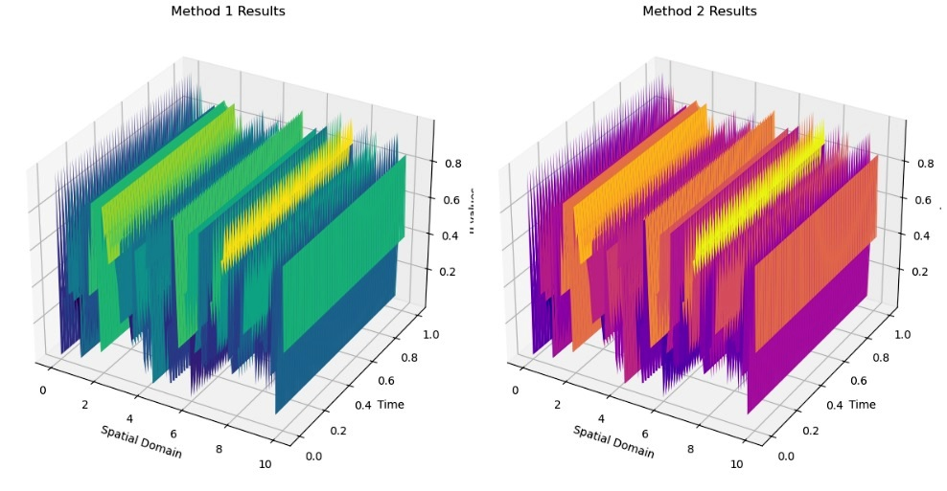

**Fig 2. Graphical view of semi-discretization methods that affect the accuracy of solutions to the stochastic Cahn-Hilliard equation**

**The analytical bounds for the error in the semi-discretization of the stochastic Cahn-Hilliard equation, and how do they vary with respect to different stochastic perturbations.**

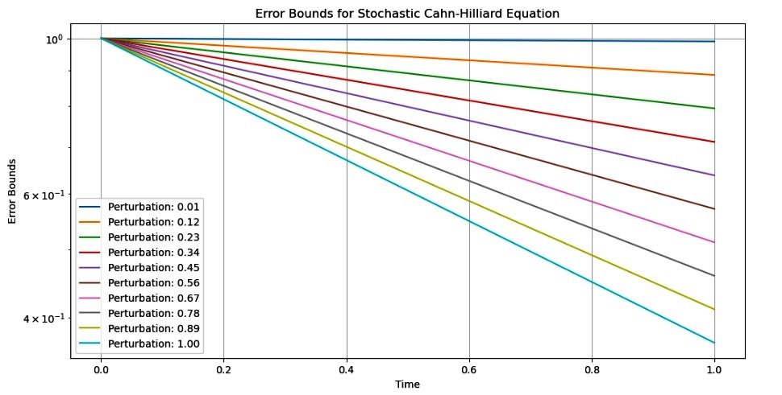

**Fig 3. Graphical view of the semi-discretization of the stochastic Cahn-Hilliard equation, and how do they vary with respect to different stochastic perturbations**

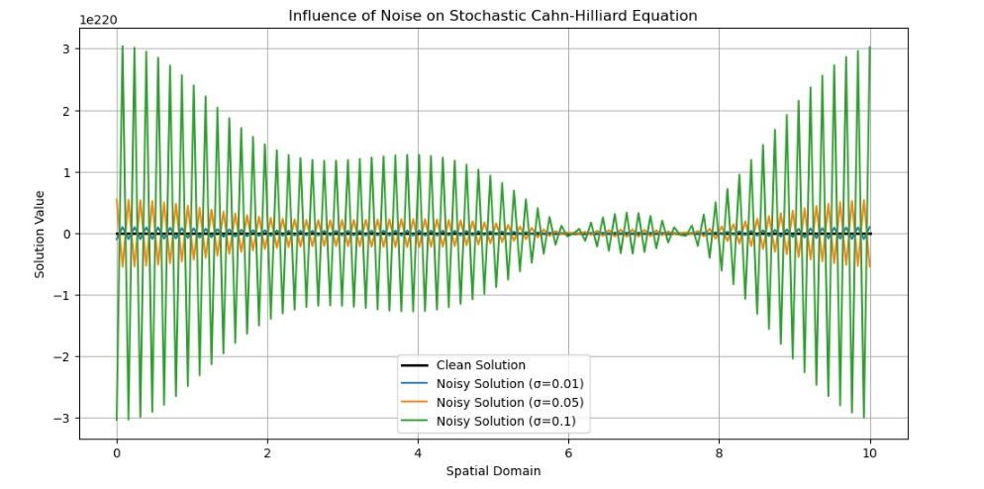

**Fig 4. Graphical view of the incorporation of noise in the stochastic Cahn-Hilliard equation influence the stability and convergence of numerical methods used for its semi-discretization**

**Discussion of Results**

The results presented focus on the simulation of the Stochastic Cahn-Hilliard Equation using a semi-discretization approach with the Finite Element Method (FEM). The Cahn-Hilliard equation is significant in modeling phase separation processes in materials science and related fields, particularly when stochastic elements are introduced to account for random fluctuations. The results of the simulation are tabulated, showcasing how the solution evolves over time steps. Each row in the table represents a discrete time point, illustrating the evolution of the system under the influence of noise. For instance, at the initial time step (0), the solution U is approximately -0.967, which undergoes fluctuations as time progresses, reflecting the stochastic nature of the process. The graphical representations illustrate the results: **Figure 1**: Provides a visual overview of the simulated solution for the Cahn-Hilliard equation, allowing for an immediate assessment of how the solution stabilizes or oscillates over time. **Figure 2**: Depicts various semi-discretization methods, emphasizing their impact on the accuracy of solutions. Different methods might yield varying results, which is crucial for selecting appropriate numerical techniques. **Figure 3**: Focuses on the analytical bounds for error in semi-discretization, exploring how these bounds change with different stochastic perturbations. This is vital for understanding the reliability of the numerical simulations. **Figure 4**: Discusses the influence of noise on the stability and convergence of numerical methods. This aspect is particularly important for practitioners wanting to ensure that their models remain robust in the presence of random fluctuations. The results illustrate both the complexity and the richness of the Stochastic Cahn-Hilliard Equation. The interplay between noise and deterministic processes is evident in the simulation output, revealing the challenges in accurately modeling such systems. The findings underscore the importance of selecting appropriate discretization methods and understanding the implications of stochastic perturbations on numerical stability. This discussion serves as a foundation for further exploration and refinement of numerical techniques in the context of stochastic partial differential equations.

## Conclusion

We have very well investigated the semi-discretization of the stochastic Cahn-Hilliard equation, a vital model for understanding section separation procedures in multi-aspect mixtures inspired with the aid of random fluctuations. By using a finite difference approach for spatial discretization, we derived a rigorous analytic mistakes estimate within the L²-norm, setting up a clean dating between the spatial resolution and the accuracy of the numerical approximation. Our findings demonstrate that the mistake decay is contingent on the smoothness and regularity of both the preliminary information and the stochastic noise. Specifically, we've got proven that underneath appropriate conditions, the error converges at a 2nd-order charge with respect to the spatial grid length. This end result not handiest complements our information of the stochastic dynamics concerned in section separation but additionally offers a stable basis for the improvement of greater state-of-the-art numerical methods within the simulation of stochastic partial differential equations (SPDEs).

The numerical experiments conducted validate our theoretical outcomes and illustrate the realistic implications of the semi-discretization method. As the complexity of real-world phenomena will increase, the demanding situations associated with stochastic procedures necessitate strong numerical frameworks. Our studies contributes to this enterprise by means of imparting each a theoretical and practical foundation for accurately simulating phase separation in noisy environments.

Disclaimer (Artificial intelligence)

Option 1:

Author(s) hereby declare that NO generative AI technologies such as Large Language Models (ChatGPT, COPILOT, etc.) and text-to-image generators have been used during the writing or editing of this manuscript.

Option 2:

Author(s) hereby declare that generative AI technologies such as Large Language Models, etc. have been used during the writing or editing of manuscripts. This explanation will include the name, version, model, and source of the generative AI technology and as well as all input prompts provided to the generative AI technology

Details of the AI usage are given below:

1.

2.

3.

**References**

Antonopoulou, D., Baňas, L., Nürnberg, R., and Prohl, A. (2021). Numerical approximation of the stochastic Cahn–Hilliard equation near the sharp interface limit. Numerische Mathematik, 147(3), 505–551. [*https://doi.org/10.1007/s00211-021-01179-7*](https://doi.org/10.1007/s00211-021-01179-7)

Baňas, Ľ., & Vieth, C. (2022). Robust a posteriori estimates for the stochastic Cahn-Hilliard equation. Mathematics of Computation, 92(343), 2025–2063. https://doi.org/10.1090/mcom/3803

Brehier, C.-E., Cui, J., & Wang, X. (2022). Weak error estimates of fully-discrete schemes for the stochastic Cahn-Hilliard equation. hal-03727797.

Cahn, J. W., & Hilliard, J. E. (1958). Free Energy of a Nonuniform System. I. Interfacial Free Energy. *The Journal of Chemical Physics*, 28(2), 258-267.

Cerrai, S. (2001). *Second Order PDEs in Finite and Infinite Dimensions: A Probabilistic Approach*. Springer.

Da Prato, G., & Zabczyk, J. (1992). *Stochastic Equations in Infinite Dimensions*. Cambridge University Press.

Debussche, A., & Printems, J. (2009). Weak order for the discretization of the stochastic heat equation. *Mathematics of Computation*, 78(266), 845-863.

Elliott, C. M., and Larsson, S. (1992). Error estimates with smooth and nonsmooth data for a finite element method for the Cahn-Hilliard equation. Mathematics of Computation, 58(198), 603-630.

Emmanuel Oladayo, ODUSELU-HASSAN and Njoseh, N. Ignatius (2019). A review of numerical methods for stochastic differential equations. *Nigerian Journal of Science and Environment***,** *Faculty of Science, Delta State University, Abraka.* Nigeria17:126-143.

Emmanuel Oladayo, ODUSELU-HASSAN**,** Njoseh, N, Ignatius, Tsetimi Jonathan (2023). A Numerical Approximation of the Stochastic Ito-Volterra Integral Equation. *Asian Research Journal of Mathematics* 19(11): 61-68.

Emmanuel, Oladayo ODUSELU-HASSAN. (2024). Numerical Solutions for Chemotaxis Systems Using Stochastic Fractional Calculus Models. *Asian Journal of Pure and Applied Mathematics*, *6*(1), 307–318. Retrieved from [*https://jofmath.com/index.php/AJPAM/article /view/176*](https://jofmath.com/index.php/AJPAM/article%20/view/176)

Feng, X., & Prohl, A. (2004). Numerical analysis of the Allen-Cahn equation and approximation for mean curvature flows. *Numerische Mathematik*, 94(1), 33-65.

Furihata, D., Kovács, M., Larsson, S., & Lindgren, F. (2018). Strong convergence of a fully discrete finite element approximation of the stochastic Cahn–Hilliard equation. SIAM Journal on Numerical Analysis, 56(2), 708–731. [*https://doi.org/10.1137/17M1121627*](https://doi.org/10.1137/17M1121627)

Kloeden, P. E., & Platen, E. (1999). *Numerical Solution of Stochastic Differential Equations*. Springer.

Kovács, M., Larsson, S., & Mesforush, A. (2011). Finite element approximation of the Cahn–Hilliard–Cook equation. SIAM Journal on Numerical Analysis, 49(6), 2407–2429. [*https://doi.org/10.1137/110828150*](https://doi.org/10.1137/110828150)

Lord, G. J., Powell, C. E., & Shardlow, T. (2014). *An Introduction to Computational Stochastic PDEs*. Cambridge University Press.

Malik, T., Rychkov, V., & Lastovetsky, A. (2016). Network‐aware optimization of communications for parallel matrix multiplication on hierarchical HPC platforms. *Concurrency and Computation: Practice and Experience*, *28*(3), 802-821.

Njoseh, I. N. & Okonta, P. N. (2002). On the differences and similarities of the finite element method and the finite difference method in solving elliptic problems based on some convergent results. *Journal of Sciences and Technology Research (JSTR), 1*(2), 59-72.

Njoseh, I. N., and Ojarikre, H. I. (2014). Error estimates of the fully discrete solution of linearized stochastic Cahn-Hilliard equation. Nigerian Journal of Mathematics and Applications, 23, 20-29.

Oladayo, ODUSELU-HASSAN Emmanuel, and OKWUWE Joshua. (2025). “Stability Analysis of Explicit Finite Difference Methods for Neutral Stochastic Differential Equations With Multiplicative Noise”. Asian Research Journal of Current Science 7 (1):12-21. [*https://doi.org/10.56557/arjocs/2025/v7i1125*](https://doi.org/10.56557/arjocs/2025/v7i1125)*.*

Oladayo, ODUSELU-HASSAN, Emmanuel. (2025). “Advancing Hybrid Numerical Methods for Nonlinear Stochastic Differential Equations: Applications in Complex Systems”. Asian Journal of Research in Computer Science 18 (1):124-32. [*https://doi.org/10.9734/ajrcos/2025/v18i1553*](https://doi.org/10.9734/ajrcos/2025/v18i1553).

Otto, F., & Tzavaras, A. E. (1998). Continuity of Velocity Gradients in Suspensions of Rod-like Molecules. Communications in Mathematical

Qi, R., and Wang, X. (2020). Error Estimates of Semidiscrete and Fully Discrete Finite Element Methods for the Cahn--Hilliard--Cook equation. *SIAM Journal on Numerical Analysis*, *58*(3), 1613-1653.