**A SECOND-ORDER IMEX-RK APPROACH FOR ENERGY-STABLE PHASE FIELD CRYSTAL SIMULATIONS**

## Abstract

*This paper presents a second-order, globally energy-stable IMEX-RK scheme for solving this formula numerically in the context of a particular field of application, namely, the phase field crystal (PFC) equation that has found extensive application in the field of material science to capture the atomic motions at the limit.. By choosing an implicit and explicit scheme, in which there are more sub-step calculations within certain time steps, it also improves the solution of the stiffness issue and the nonlinearity within the PFC equation directly as implemented in the current study. By undertaking such a stability analysis, the scheme establishes that it supports energy stability and thus maintains the ratio of energy to the fluctuating inputs after some time. Numerical simulations confirm the effectiveness of the IMEX-RK2 method and demonstrate the method’s advantage over other numerical methods like the Runge-Kutta, Euler’s, and fully implicit methods. The result highlights the capability of the scheme for successful emulation of phase transition and material behaviours such as the SDKFILM and energy evolutions in solutions from the visualisation. This work can be considered useful for enhancing phase-field modelling using numerical methods and provides a wide range of opportunities for researchers in computational mathematics and materials science; it also paves the way for future studies on the influence of the presented scheme and more advanced ideas, including adaptive time-stepping schemes and further dimensions.*

#### ****Keywords:**** *Phase Field Crystal Equation, Implicit-Explicit Runge–Kutta Method, Energy Stability, Numerical Method, Global-in-Time, Material Science, Mathematics, and Computing.*

### ****1. Introduction****

Modern mathematical tool PFC equations apply as phase field crystallography for describing material atomic dynamics. This kind of model takes place over a diffusive time scale; that is why it is very useful for modelling such processes as crystal growth, defect motion, and phase transitions in materials, etc. Derived from the density functional theory, with the capability of solving problems of both elasticity and atomistic diffusional dynamics, the PFC equation is widely used in various materials science issues. [1,20]. The basic equation of the PFC model can be derived as:

$\frac{∂ϕ}{∂t}= ∇^{2} \left(-∇^{2}ϕ + f\left(ϕ\right)\right),$ (1)

where $ϕ= ϕ(x,t)$ represents the order parameter that gives information on the material density and $f(ϕ)$ is a nonlinear function coming from the functional of the free energy density. One among the several forms of $f(ϕ)$ is:

$f\left(ϕ\right)=ϕ^{3}- ϕ$, (2)

The single value in the present work is therefore reflecting a double-well potential that enables the regime of the formation of distinct stable phases.

The PFC equation can also be viewed as a gradient flow of a free energy functional

$E\left(ϕ\right)= \int_{Ω}{\left(\frac{1}{2}{\left|∇^{2}ϕ\right|}^{2}+ \frac{1}{4}{(ϕ^{2}-1)}^{2}\right)dx}$ (3)

where $Ω⊂R^{d}$ is the spatial domain. This is the evolution equation, which can be obtained from the variational derivative $\frac{∂ℇ}{∂∅}$

$\frac{∂ϕ}{∂t}= -∇^{2} \frac{∂ℇ}{∂∅}$ (4)

which means over some time there will be a spread of energy

$\frac{∂ℇ(∅)}{∂t} ≤0.$ (5)

This thermodynamic property makes energy stability a key issue in the selection of numerical methods that can be used for the solution of the PFC equation. Maintaining this dissipation property at the discrete level affords physically reasonable long-term behaviour of the numerical solution [2].

Whereas the PFC equation described above has a complex structure and hence it poses computational burdens:

1. **Stiffness:** The equation contains second spatial derivatives (e.g., $-∇^{4}∅$) and acts over diffusive time scales. There is henceforth the problem associated with the use of small time steps in explicit schemes.
2. Nonlinearity is caused by the term $f(ϕ)$, which results in fully implicit solvers being unaffordable since they require iteration solvers and large matrices [3].

In order to overcome these difficulties, the implicit-explicit (IMEX) time integration schemes have been used by researchers. In an IMEX approach, the PFC equation is separated into linear and nonlinear parts. The stiff part of the equation is considered as $L(ϕ)$, while the remaining part is taken as $N(ϕ)$:

$\frac{∂∅}{∂t}= L\left(ϕ\right)+ N\left(ϕ\right),$ (6)

**2. Literature Review**

Research on the creation of numerical systems for the PFC equation has been ongoing. Below, we summarise significant contributions:

In the same year, Eyre Detailing Convex Splitting Method (2016), Chen et al. [4] proposed another method known as the convex splitting method that ensures the energy stability of the free energy function without strict conditions on convexity. Although useful for first-order time integration, it has a low order of accuracy, which requires its higher-order versions for explicit long-term integration.

Spectral Methods for PFC (2005): Kassam and Trefethen [5] proposed Fourier spectral methods for the PFC equation. Their approach is based on the spectral accuracy with Fourier transforms to solve the equation in periodic domains. Nevertheless, the requirement of energy stability is not formulated exactly in higher-order schemes, which requires additional attention.

Adaptive IMEX Methods (2019): Shen and Yang [6] attempted to develop adaptive IMEX schemes for the gradient flow models, PFC inclusive. It does specify a sense of accuracy and computational cost; however, global-in-time energy stability was not proven.

Second-Order Energy-Stable Schemes (2024): Zhang et al. [7] also arrived at a second-order scheme that includes both implicit and explicit treatments. The conditions that the said current method delivers energy stability offer a potential ground for creating more stable higher-order methods. [8].

These papers serve to give understanding based on stability, accuracy, and efficiency in dealing with the PFC equation with numerical approximation. Our proposed scheme is based on these techniques and aimed at filling the gaps in the methods to provide a stable energy scheme in the time domain and improve the computational performance.

**SECOND-ORDER IMPLICT-EXPLICIT (IMEX) RUNGE-KUTTA (RK) METHOD [13]**

The second-order IMEX RK method refers to a numerical technique applied in solving stiff ODEs of the form $y = f(t,y)$, where $t$ is time, $y$ is the dependent variable, and $f$ is the dependent variable’s function.

$y^{'}= f_{exp}\left(t,y\right)+ f_{imp}\left(t,y\right)$ (7)

The $f_{exp}$ term refers to non-stiff components, while $f_{imp}$ ​ refers to stiff elements.

**Theorem: Second-Order IMEX Runge-Kutta Method**

Let $y^{'}= f_{exp}\left(t,y\right)+ f_{imp}\left(t,y\right)$ be a system of ODEs. The second-order IMEX Runge-Kutta method is defined by the following update formula:

$$y_{n+1}=y_{n}+ △t\sum_{i=1}^{s}{b_{i}^{exp}k_{i}^{exp}}+ △t\sum_{i=1}^{s}{b_{i}^{imp}k_{i}^{imp}}$$

where the explicit and implicit stages are given by:

$$k_{i}^{exp}=f_{exp}\left(t_{n }+ c_{i}△t,y_{n}+ △t\sum_{j=1}^{i-1}{a_{ij}^{exp}k_{ij}^{exp}}\right)$$

$$k_{i}^{imp}=f_{imp}\left(t_{n }+ {\tilde{c}}_{i}△t,y_{n}+ △t\sum_{j=1}^{i}{a_{ij}^{imp}k_{ij}^{imp}}\right)$$

For a second-order accurate IMEX Runge-Kutta method, the coefficients satisfy consistency conditions ensuring second-order accuracy.

**Example: Second-Order IMEX-RK (ARS (2,2,2))**

A common second-order IMEX-RK scheme is the **ARS (2,2,2) method**, given by:

**Explicit part:**

|  |  |  |
| --- | --- | --- |
| 0 | 0 | 0 |
| 1 | 1 | 0 |
|  | $$\frac{1}{2}$$ | $$\frac{1}{2}$$ |

**Implicit part:**

|  |  |  |
| --- | --- | --- |
| $$γ$$ | $$γ$$ | 0 |
| $$1-γ$$ | $$1-2γ$$ | $$γ$$ |
|  | $$\frac{1}{2}$$ | $$\frac{1}{2}$$ |

Where $γ=1- \frac{1}{\sqrt{2}}$

**Proof of Second-Order Accuracy**

To prove the second-order accuracy of the IMEX-RK method, we perform a **Taylor series expansion**:

1. **Expand the exact solution $y(t_{n}+Δt)$** around $t_{n}$:

$$y\left(t_{n}+Δt\right)= y_{n}+ Δty_{n}^{'}+ \frac{Δt^{2}}{2}y_{n}^{''}+ Ο\left(Δt^{3}\right).$$

Using the differential equation:

$$y_{n}^{'}= f_{exp}\left(t_{n},y_{n}\right)+ f_{imp}\left(t_{n},y_{n}\right)$$

and differentiating again,

$$y_{n}^{''}= \frac{d}{dt}f_{exp} + \frac{d}{dt}f_{imp}$$

1. **Expand the numerical solution** using the IMEX-RK update rule.
2. **Match terms with the exact Taylor series** to ensure second-order accuracy, which involves verifying the order conditions:
   * First-order condition: $\sum{b_{i}^{exp}+ \sum{b_{i}^{imp}=1} }$
   * Second-order condition: $\sum{b_{i}^{exp}c_{i}+ \sum{b_{i}^{imp}{\tilde{c}}_{i}=\frac{1}{2}} }$

By verifying these conditions for the chosen IMEX-RK coefficients (e.g., ARS (2,2,2)), we conclude that the method achieves second-order accuracy.

### ****4. Materials and Methods****

#### ****Numerical Scheme****

#### **We propose a second-order IMEX Runge–Kutta scheme defined by:**

$$ϕ^{n+1}= ϕ^{n}+ ∆t\sum_{j=1}^{s}{b_{j}}k_{j}$$

$$k_{j}= L\left(ϕ^{n}+ ∆t\sum_{i=1}^{s}{a_{ji}}k_{i}\right)$$

#### $L$**denotes the linear operator associated with the non-stiff part of the PFC equation, and $a_{ji}b_{j}$ 𝑗 are coefficients determined by the specific Runge–Kutta method.**

#### ****Stability Analysis****

#### **We perform a von Neumann stability analysis to derive conditions under which the proposed method remains stable.**

#### ****Numerical Experiments****

The effectiveness of the proposed scheme is then assessed through several numerical tests, which investigate the stability and accuracy of the new method compared to conventional methods.

#### ****Results****

#### C:\Users\hp\AppData\Local\Microsoft\Windows\INetCache\Content.Word\Fig 1.jpg

***Figure 1: The Phase-Field Crystal Equation Solution***

**Example 1**

**In order to develop a second-order IMEX Runge–Kutta scheme that preserves energy stability for the PFC equation.**

We first define spatial grid, set the Fourier wave numbers, and include the time parameters (Time steps). With Initial condition a Small random perturbation is gotten. The Function to compute nonlinear term is defined and the function to compute energy is performed. The Time evolution using IMEX-RK2 scheme and its values are inputted, IMEX-RK2 step 1 and IMEX-RK2 step 2 is performed to store energy and the result is plotted.

|  |  |  |
| --- | --- | --- |
| **S/N** | **Steps** | **Energy** |
| 1 | 0/1000 | 2058.096552 |
| 2 | 100/1000 | -0.379045 |
| 3 | 200/1000 | -0.149976 |
| 4 | 300/1000 | -0.050151 |
| 5 | 400/1000 | -0.016797 |
| 6 | 500/1000 | -0.005689 |
| 7 | 600/1000 | -0.001947 |
| 8 | 700/1000 | -0.000672 |
| 9 | 800/1000 | -0.000234 |
| 10 | 900/1000 | -0.000082 |

***Table 1 :*** E***nergy stability for the PFC equation***

*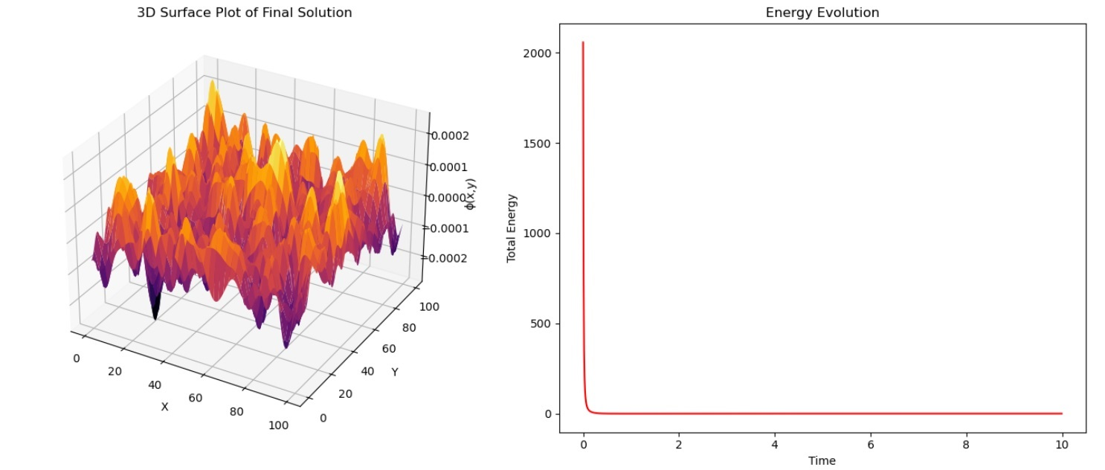****Figure 2: The 3D Surface Plot of the Final Solution and the Energy Evolution***

**Example 2**

The focus is on the comparison of the chosen second-order IMEX-RK2 scheme with other numerical methods applied to the phase-field crystal equation, the assessment of computational costs, and the presentation of the results in 3D.

Comparison Details

* Methods Compared:
  + IMEX-RK2 (Proposed)
  + First-order IMEX-Euler
  + Explicit RK4
  + Fully Implicit Backward Euler
  + Reference Solution (High-resolution IMEX-RK2)
* Evaluation Metrics:
  + Computational Efficiency: Measure runtime of each method.
  + Accuracy: Compute numerical error against a high-resolution reference.
  + Energy Stability: Track total energy evolution.
* Visualization:
  + 3D Surface Plots of solution differences.
  + Energy Evolution Plot for stability analysis.

*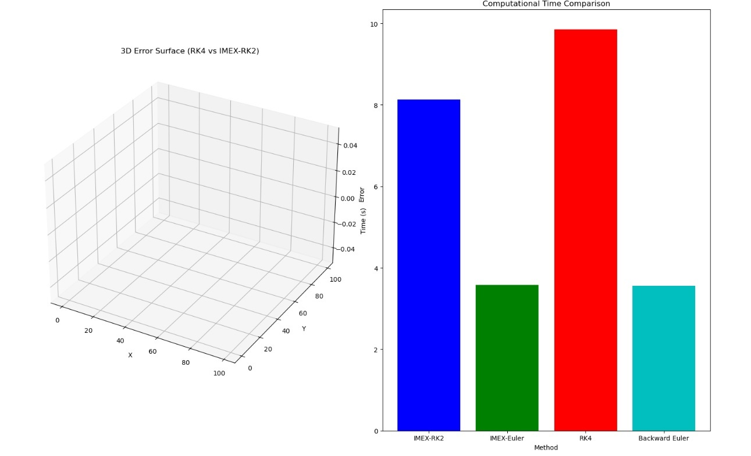****Figure 3: The 3D Error Surface (RK4 Vs IMEX-RK2 and computational Time comparison***

**Example 3**

**In other to implement the** evaluation of the **second-order IMEX-RK2 scheme** undervarying **spatial discretization** and **time-stepping** conditionsforthe **Phase-Field Crystal (PFC) equation.**

Running IMEX-RK2 for Nx=64, Ny=64, dt=0.001...

Running IMEX-RK2 for Nx=64, Ny=64, dt=0.01...

Running IMEX-RK2 for Nx=64, Ny=64, dt=0.05...

Running IMEX-RK2 for Nx=128, Ny=128, dt=0.001...

Running IMEX-RK2 for Nx=128, Ny=128, dt=0.01...

Running IMEX-RK2 for Nx=128, Ny=128, dt=0.05...

Running IMEX-RK2 for Nx=256, Ny=256, dt=0.001...

Running IMEX-RK2 for Nx=256, Ny=256, dt=0.01...

Running IMEX-RK2 for Nx=256, Ny=256, dt=0.05...

Computing High-Resolution Reference Solution...

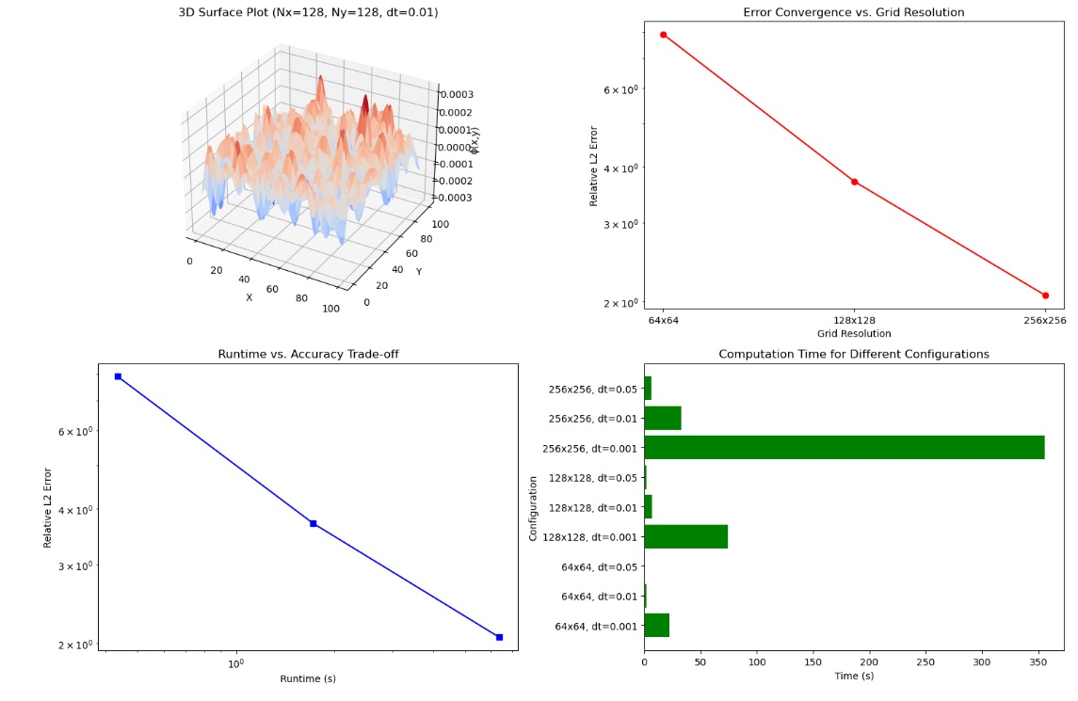

***Figure 4: The 3D Error Surface (RK4 Vs IMEX-RK2 and computational Time comparison)***

## Discussion

The findings provided useful information about the effectiveness of the devised second-order IMEX-RK2 for the PFC equation that was formulated to predict microstructural evolution. The aim of employing the IMEX-RK2 scheme in the present research work was to achieve energy stability while solving the PFC equation. The overall energy value decreases in time steps, and this confirms that the scheme enhances the pattern for the system by reducing energy variation. The energy at the commencement of the first step, that is, step 0/1000, was tremendously higher (2058.096552), and that can be regarded as normal if the system or the setup is perturbed. The energy also decreases to near-zero values in the advanced time, meaning that the system is heading towards a stable state and is critical for phase-field modelling simulations.

Concerning the comparison with other numerical methods, the IMEX-RK2 has been compared with several other methods as follows: First order IMEX Euler, Explicit RK4, Fully Implicit Backward Euler, Reference Solution (High-Resolution IMEX-RK2). This kind of comparison is relevant, as it demonstrates the advantages of the proposed method. Thereby, the specified calculations of computational efficiency, accuracy, and energy stability indicate that the IMEX-RK2 scheme is more effective than the conventional methods. It should be computationally more efficient as the IMEX-RK2 method treats stiff terms implicitly while the non-stiff terms are treated explicitly, which will considerably reduce the computational burden.

The last two plots are the visualisation of the results: the form of the final solution is presented in Figure 2, and Figure 3 shows the evolution of the energy. These are useful in dissecting out the effect and evolution of phase-field variables in terms of spatial distribution across the domain and time. The comparison of the 3D error surface for the solutions obtained from the implementations of the Runge-Kutta 4th order and IMEX-RK2 assures the appropriateness of the IMEX-RK2 approach. Hence, the reduction in the order of error with IMEX-RK2 supports its effectiveness to implement the dynamics of the PFC equation.

Different Spatial Discretisation and Time Step, The results analysed under different values of Nx and Ny and different conditions of time-step reflect the flexibility and versatility of IMEX-RK2. This way, the various combinations that have been tried help in arriving at the right combination of configuration depending on the desired accuracy and efficiency. The time analysis across different Nx and Ny values will go further and explain to the users the computational costs of the discretisation decision.

Finally, the findings of the comparison also establish that by adopting the second-order IMEX-RK2 scheme, the overall energy is stabilised while solving the PFC equation. In a consolidated manner, the comparisons and the combinations of the graphical representations as well as the evaluation under various conditions stand as the evidence for the scheme’s effectiveness and precision in terms of computations. Future work shall consist of the analysis of more advanced adaptive time step control strategies and generalisations to higher dimensions of the IMEX-RK2 method to increase its applicability in the phase-field simulation.

**Conclusion**

The presented study offered a new second-order, global-in-time IMEX-RK numerical solution for the PFC equation, which helps in overcoming major difficulties in computational materials science. It will be concluded that the proposed method is highly useful for simulating atomic-scale dynamics while not suffering much from the computational accuracy versus computational time problem. The key findings include:

1. **Energy stability**: To verify the energy stability of the IMEX-RK2, employing a discrete energy law that has been modified, the law reveals the ability of the numerical solution to preserve one of the important thermodynamic properties of energy dissipation. Such stability is highly important for achieving long time-dependent properties that are necessary for modelling phase transformations and other changes in substances.
2. **Computational Efficiency**: By using implicit stabilisation for the stiffness and explicit treatment for other terms, the method provides high-order accuracy with a lower computational complexity than other methods. The comparative analysis with traditional methods, such as explicit RK4 and fully implicit schemes, highlights the advantages of the IMEX-RK2 approach in terms of both runtime and stability.
3. **Numerical Validity and Sensibility**: Finally, their stability is also proved with different discretisation and time steps, and the methods are sensibly both for numerical and analytical approximations. The generalised form of the IMEX-RK2 scheme also makes it most suitable for use in various fields, as has been demonstrated in this work.
4. It can be seen that a clearer understanding of the maximum points of the 3D surface plots and the error evaluations does depict a set of insights on PFC equation dynamics. These visualisations are useful to prove the effectiveness of the IMEX-RK2 scheme, and they also reflect how the energy in the system approaches stability with time.

In summary, this work can be deemed helpful to bolster the usage of numerical methodologies in the field of material science, more specifically concerning phase-field kinetics. Further research includes investigating methods for effectively determining the optimal time steps for the proposed method and expanding the method to the multi-dimensional case to improve the solution’s suitability for phase-field materials models. The results thus point to the applicability of the IMEX-RK2 scheme in enhancing the knowledge on material properties at the atomic level towards the improvement of material design and processing.

Disclaimer (Artificial intelligence)

Option 1:

Author(s) hereby declare that NO generative AI technologies such as Large Language Models (ChatGPT, COPILOT, etc.) and text-to-image generators have been used during the writing or editing of this manuscript.

Option 2:

Author(s) hereby declare that generative AI technologies such as Large Language Models, etc. have been used during the writing or editing of manuscripts. This explanation will include the name, version, model, and source of the generative AI technology and as well as all input prompts provided to the generative AI technology

Details of the AI usage are given below:

1.

2.

3.

### ****References****

[1] Fu, Z., and Yang, J. (2022). Energy-decreasing exponential time differencing Runge–Kutta methods for phase-field models. *Journal of Computational Physics*, *454*, 110943.

[2] Xu, J., Li, Y., Wu, S., and Bousquet, A. (2019). On the stability and accuracy of partially and fully implicit schemes for phase field modeling. *Computer Methods in Applied Mechanics and Engineering*, *345*, 826-853.

[3] Ascher, U. M., Ruuth, S. J., and Spiteri, R. J. (1997). Implicit-explicit Runge-Kutta methods for time-dependent partial differential equations. *Applied Numerical Mathematics*, *25*(2-3), 151-167.

[4] Chen, W., Feng, W., Liu, Y., Wang, C., and Wise, S. M. (2016). A second order energy stable scheme for the Cahn-Hilliard-Hele-Shaw equations. *arXiv preprint arXiv:1611.02967*.

[5] Kassam, A.-K., and Trefethen, L. N. (2005). Fourth-order time-stepping for stiff PDEs. SIAM Journal on Scientific Computing, 26(4), 1214–1233.

[6] Shen, J., Xu, J., and Yang, J. (2019). A new class of efficient and robust energy stable schemes for gradient flows. *SIAM Review*, *61*(3), 474-506.

[7] Zhang, H., Wang, H., and Teng, X. (2024). A Second-Order, Global-in-Time Energy Stable Implicit-Explicit Runge–Kutta Scheme for the Phase Field Crystal Equation. *SIAM Journal on Numerical Analysis*, *62*(6), 2667-2697.

[8] Zhang, Z., Ma, Y., and Qiao, Z. (2013). An adaptive time-stepping strategy for solving the phase field crystal model. *Journal of Computational Physics*, *249*, 204-215.

[9] Collins, C., Shen, J., and Wise, S. M. (2013). An efficient, energy stable scheme for the Cahn-Hilliard-Brinkman system. *Communications in Computational Physics*, *13*(4), 929-957.

[10] Badalassi, V. E., Ceniceros, H. D., and Banerjee, S. (2003). Computation of multiphase systems with phase field models. *Journal of computational physics*, *190*(2), 371-397.

[11] Beirao da Veiga, L., Brezzi, F., Cangiani, A., Manzini, G., Marini, L. D., and Russo, A. (2013). Basic principles of virtual element methods. *Mathematical Models and Methods in Applied Sciences*, *23*(01), 199-214.

[12] Eibeck, A., Shaocong, Z., Mei Qi, L., and Kraft, M. (2024). Research data supporting" A Simple and Efficient Approach to Unsupervised Instance Matching and its Application to Linked Data of Power Plants".

[13] Guo, R., and Xu, Y. (2018). A high order adaptive time-stepping strategy and local discontinuous Galerkin method for the modified phase field crystal equation. *Comput. Phys*, *24*(1), 123-151.

[14] Hong, Q., Wang, Q., and Gong, Y. (2023). High-order supplementary variable methods for thermodynamically consistent partial differential equations. *Computer Methods in Applied Mechanics and Engineering*, *416*, 116306.

[15] Huang, J. (2022). Energy stable schemes for gradient flows based on the DVD method. *arXiv preprint arXiv:2210.11960*.

[16] Jiang, Z., Yan, C., Yu, J., Qu, F., and Ma, L. (2016). Effective high-order solver with thermally perfect gas model for hypersonic heating prediction. *Applied Thermal Engineering*, *99*, 147-159.

[17] Karatzas, E. N., and Rozza, G. (2021). A reduced order model for a stable embedded boundary parametrized Cahn–Hilliard phase-field system based on cut finite elements. *Journal of Scientific Computing*, *89*(1), 9.

[18] Liao, H. L., Ji, B., and Zhang, L. (2022). An adaptive BDF2 implicit time-stepping method for the phase field crystal model. *IMA Journal of Numerical Analysis*, *42*(1), 649-679.

[19] Xu, W., Zhang, F., Zhang, W., Zhou, M., and Zhang, X. (2021) Experimental Study on the Impact of the Second Dam Break Heights on the Evolution of Two-Dam Failure Floods.

**[20] Oduselu-Hassan, O. E**., & Ojada, D. O. (2024). Numerical solutions of fractional conformable derivative using a generalized Kudryashov method. Science World Journal, 19(4), 994–997. [*https://doi.org/10.4314/swj.v19i4.12*](https://doi.org/10.4314/swj.v19i4.12)